**Supplementary Materials**

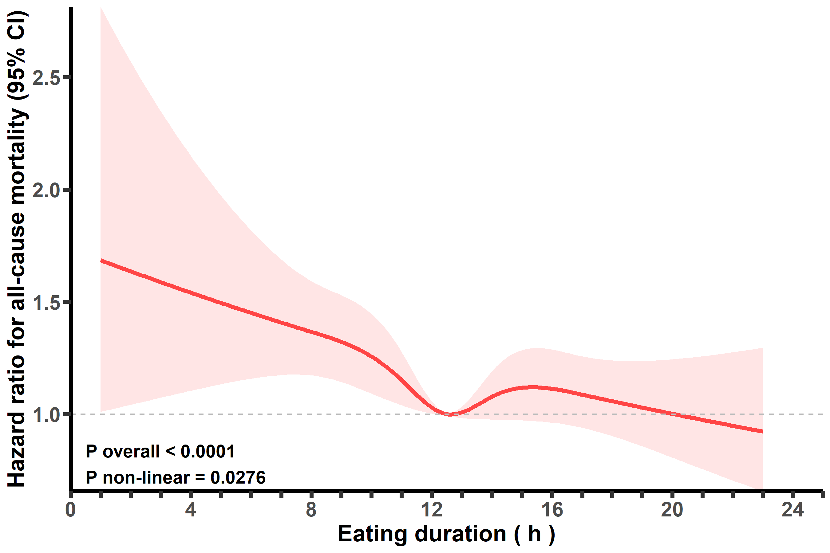

**Supplemental Figure 1 Associations between eating duration and all-cause mortality excluding participants with a follow-up time of < 2 years.**

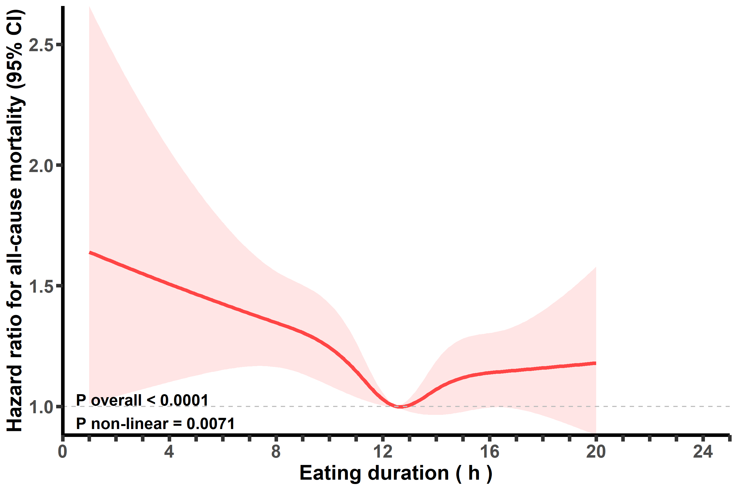

**Supplemental Figure 2 Associations between eating duration and all-cause mortality excluding early morning eaters (eating duration >20 h).**

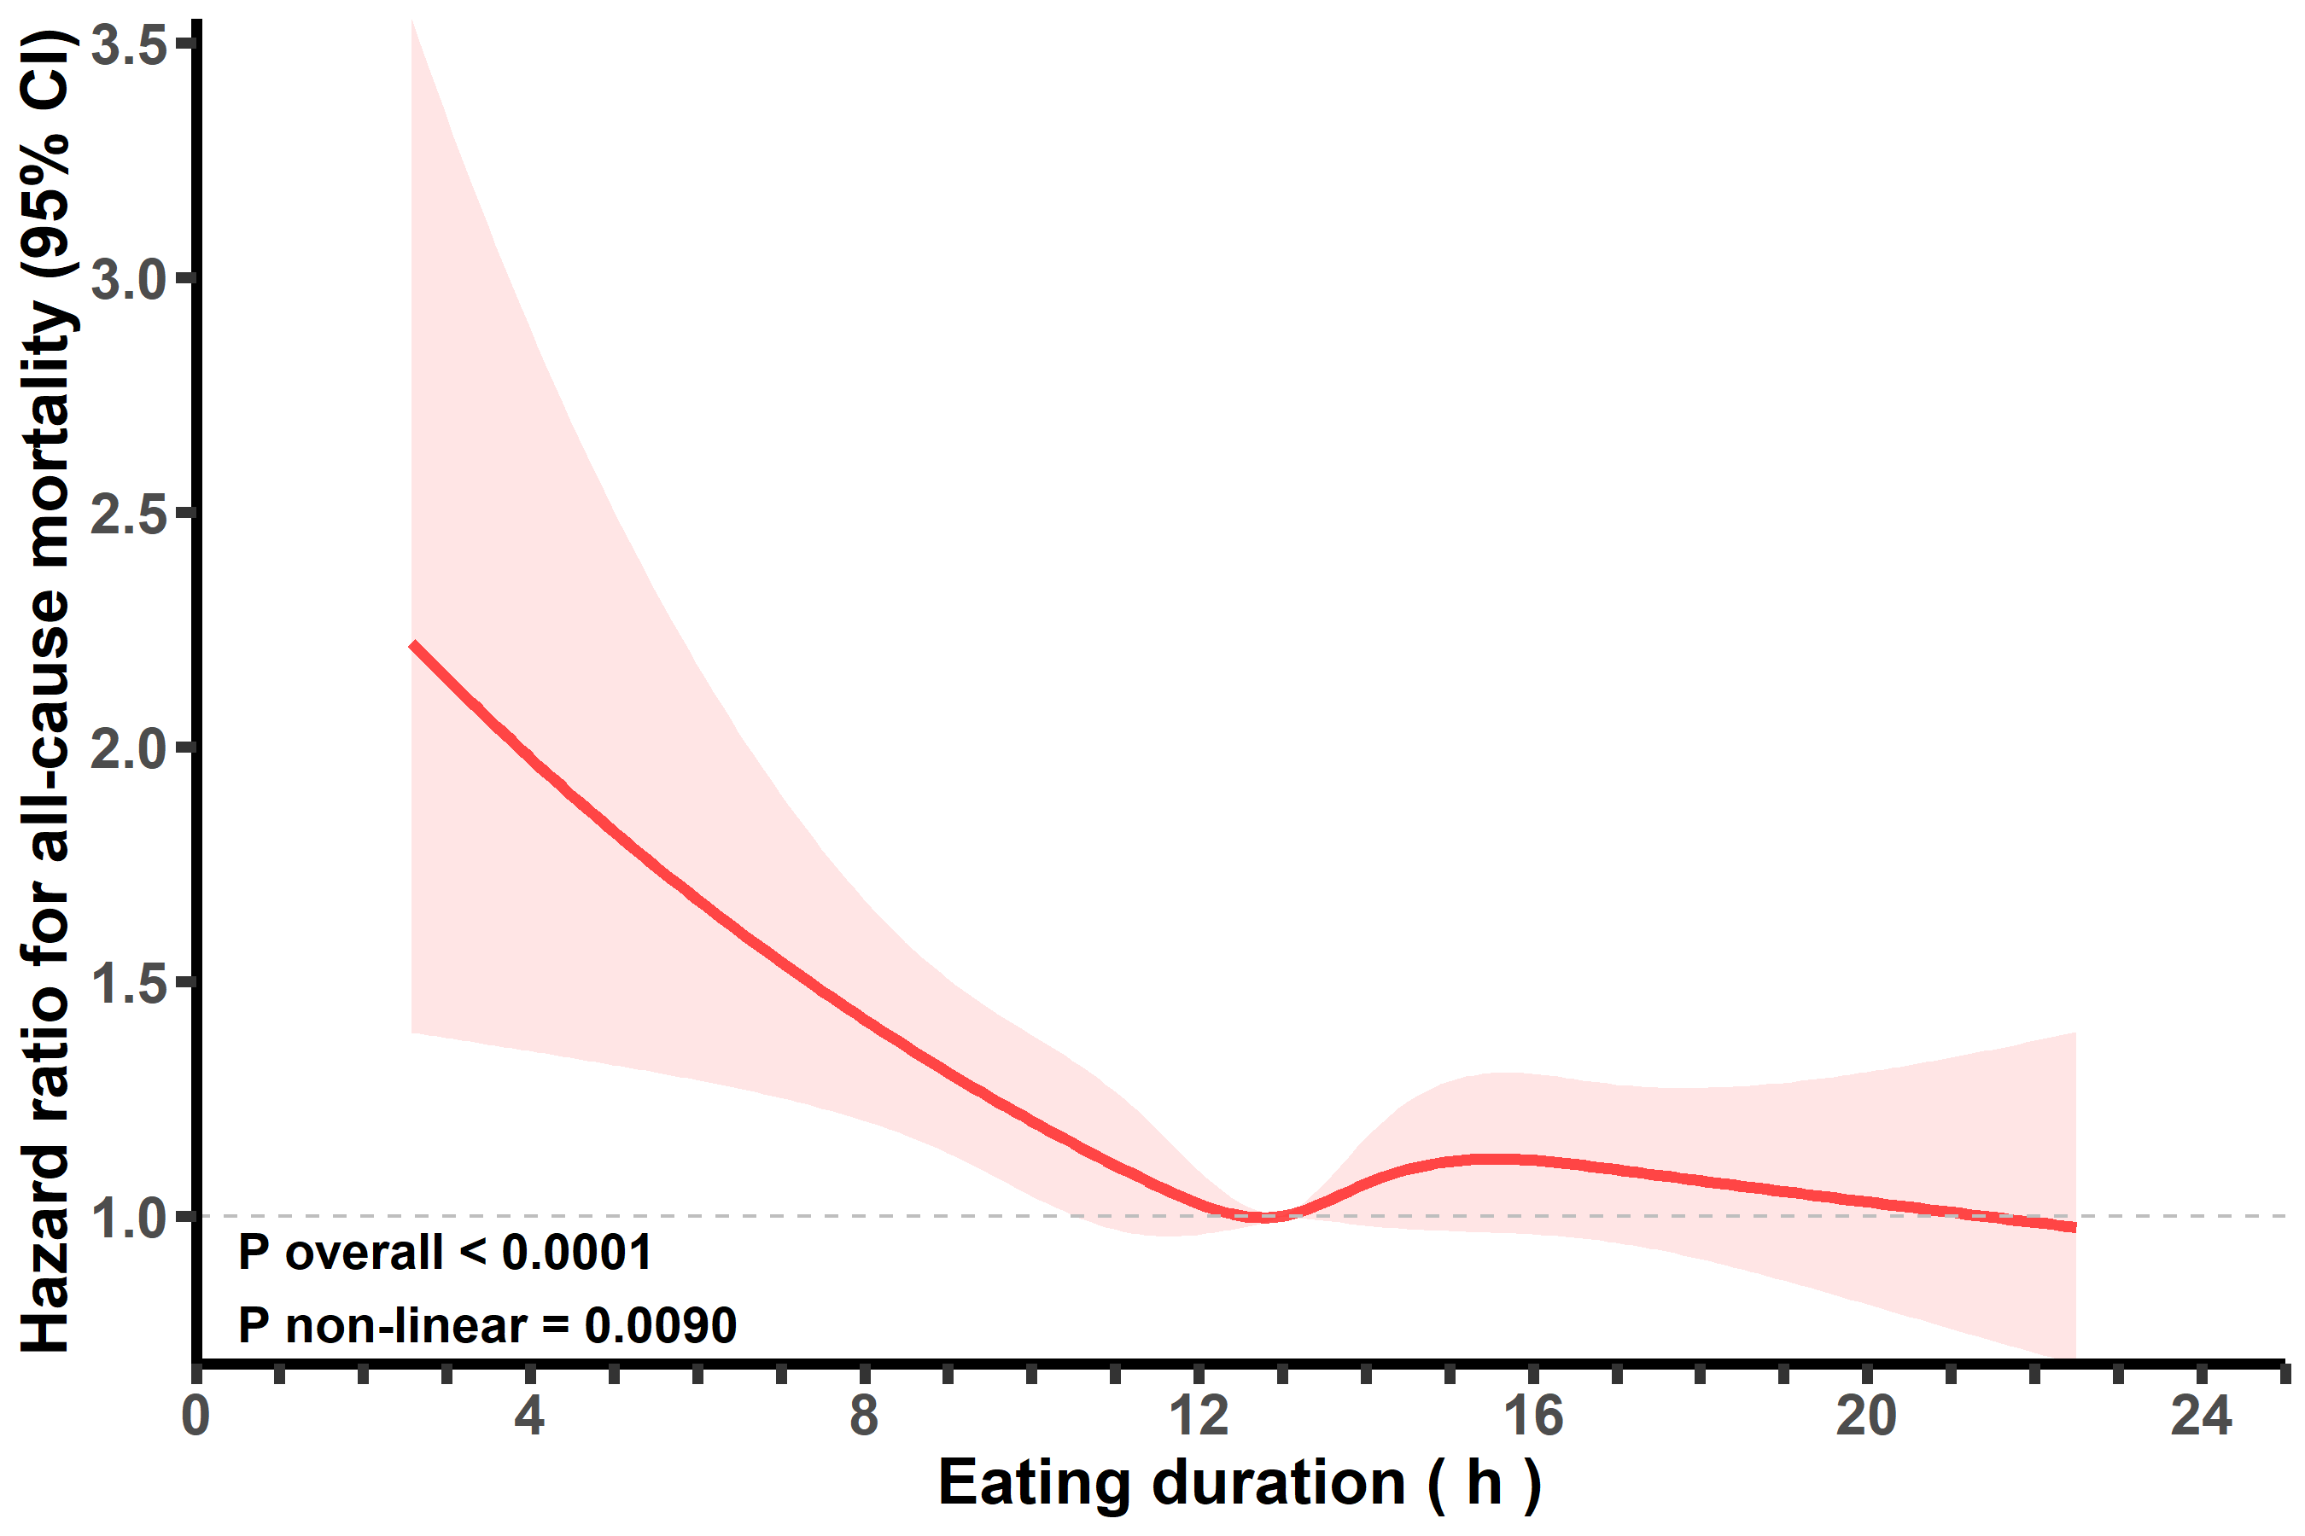

**Supplemental Figure 3 Associations between eating duration and all-cause mortality** **excluding participants with unusual first meal times (< 6:00 AM or > 11:00 AM).**

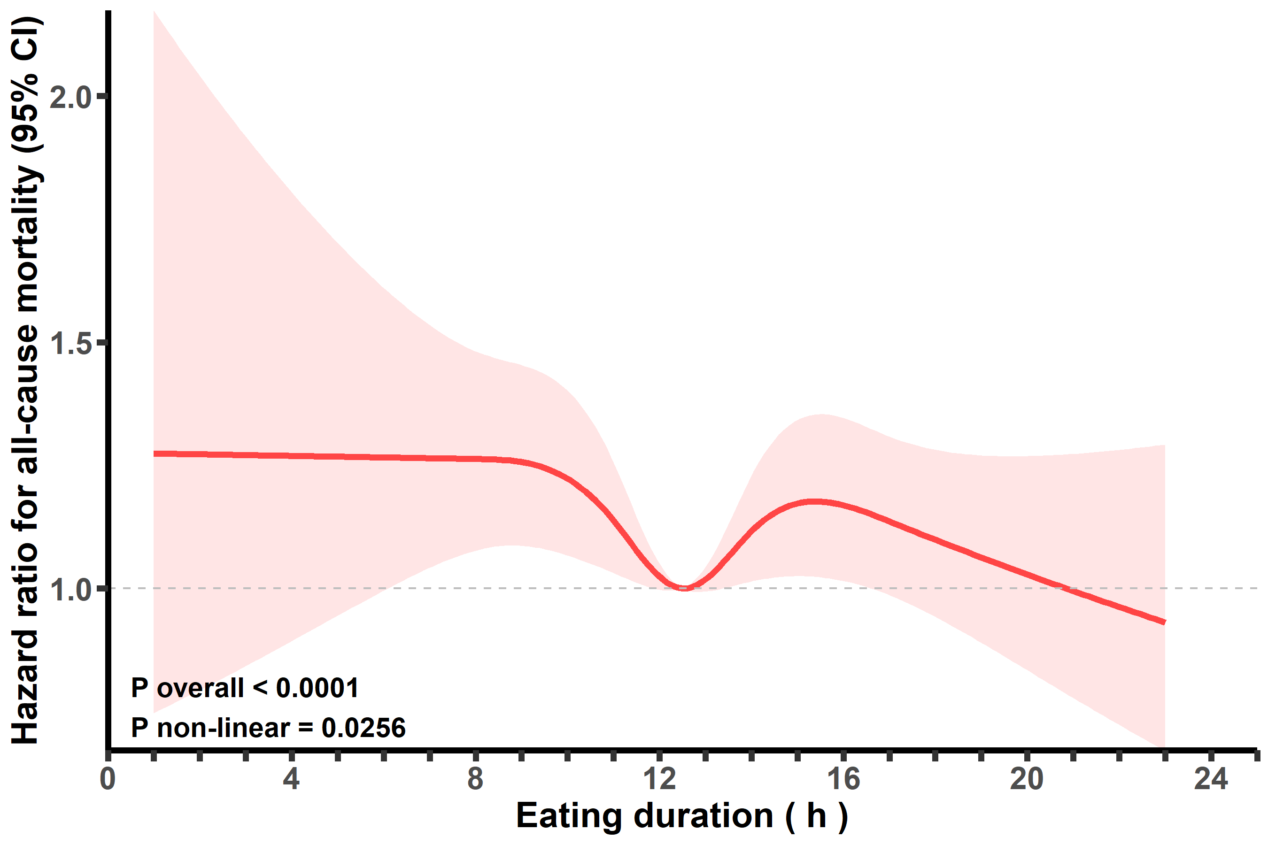

**Supplemental Figure 4 Associations between eating duration and all-cause mortality with further adjustment for the first mealtime.**

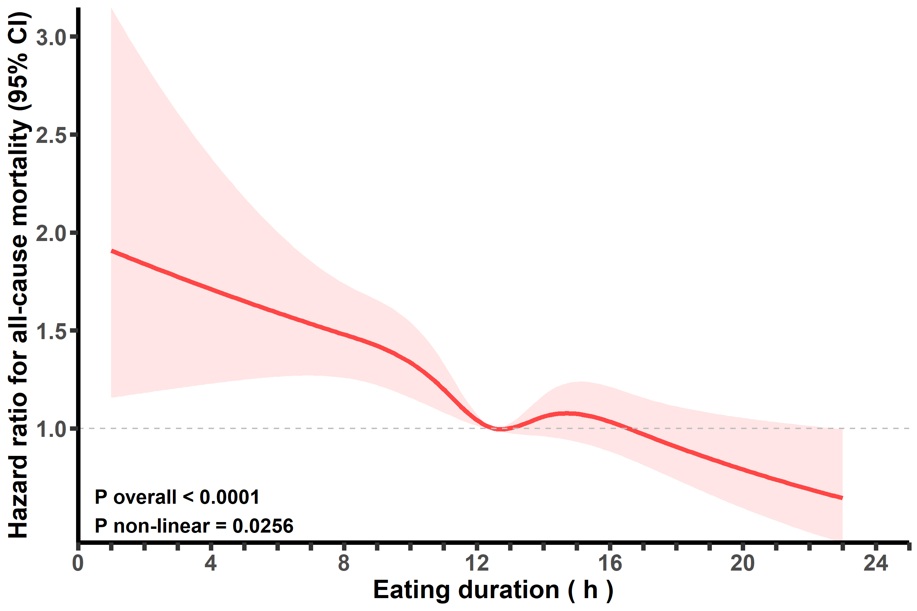

**Supplemental Figure 5 Associations between eating duration and all-cause mortality with further adjustment for the last mealtime.**

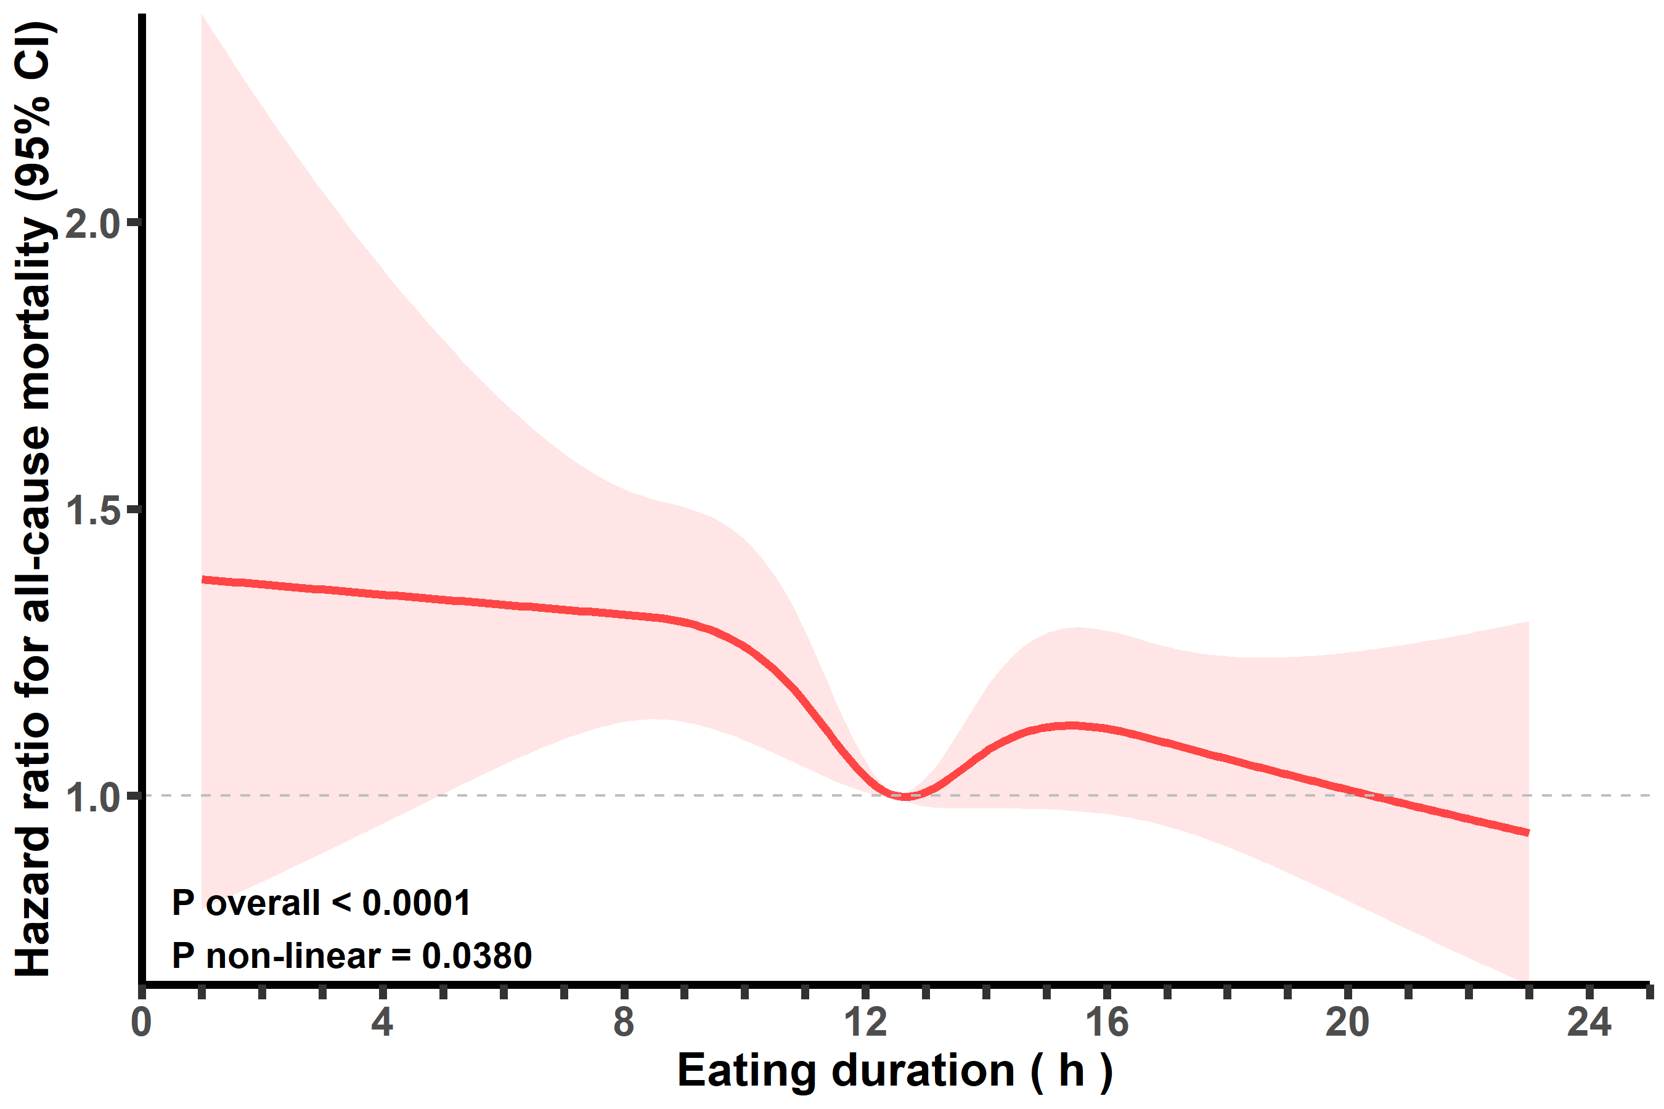

**Supplemental Figure 6 Associations between eating duration and all-cause mortality among participants with any one of the metabolic diseases (diabetes, hyperlipidemia, hypertension, and obesity).**