**Supplementary online content**

**eFigure 1**: PRISMA flow diagram

**eFigure 2.** Split between direct and indirect evidence for the primary outcome ‘mean serum vitamin D concentrations at 0-6 months’

**eFigure 3.** Direct Evidence from the pair wise comparisons for the primary outcome ‘mean serum vitamin D concentrations at 0-6 months’

**eFigure 4**: Sensitivity analysis for the primary outcome ‘mean serum vitamin D concentrations at 0-6 months’ based on baseline vitamin D status of study neonates – VDI (Vitamin D < 30 ng/mL) versus VDD (Vitamin D < 20 ng/mL)

**eFigure 5.** League plot depicting the network estimate [RR (95% CrI)] for the primary outcome ‘proportion of infants with VDI at 0-6 months’

**eFigure 6.** Direct Evidence from the pair wise comparisons for the primary outcome ‘proportion of infants with VDI at 0-6 months’

**eFigure 7:** Sensitivity analysis for the primary outcome ‘proportion of infants with VDI at 0-6 months’ based on baseline vitamin D status of study neonates – VDI (Vitamin D < 30 ng/mL) versus VDD (Vitamin D < 20 ng/mL)

**eFigure 8:** Proportion of infants with VDD (Vitamin D concentration < 20 ng/mL) at 0-6 months. **A.** Network plot; **B.** Forest plot depicting the network estimates [RR (95% CrI)] of the various interventions with ‘Control’ as the common comparator; **C.** SUCRA plot

**eFigure 9.** League plot depicting the network estimate [RR (95% CrI)] for the outcome ‘proportion of infants with VDD (Vitamin D concentration < 20 ng/mL) at 0-6 months’

**eFigure 10**: Split between direct and indirect evidence for the outcome ‘proportion of infants with VDD (Vitamin D concentration < 20 ng/mL) at 0-6 months’

**eFigure 11**: Direct Evidence from the pair wise comparisons for the outcome ‘proportion of infants with VDD (Vitamin D concentration < 20 ng/mL) at 0-6 months’

**eFigure 12.** Proportion of infants with severe VDD (Vitamin D concentration < 10-15 ng/mL) at 0-6 months. **A.** Network plot; **B.** Forest plot depicting the network estimates [RR (95% CrI)] of the various interventions with ‘Control’ as the common comparator; **C.** SUCRA plot

**eFigure 13.** League plot depicting the network estimate [RR (95% CrI)] for the outcome ‘proportion of infants with severe VDD (Vitamin D concentration < 10-15 ng/mL) at 0-6 months’

**eFigure 14**: Split between direct and indirect evidence for the outcome ‘proportion of infants with severe VDD (Vitamin D concentration < 10-15 ng/mL) at 0-6 months’

**eFigure 15.** Direct Evidence from the pair wise comparisons for the outcome ‘proportion of infants with severe VDD (Vitamin D concentration < 10-15 ng/mL) at 0-6 months’

**eFigure 16**: Hypervitaminosis D at 0-6 months. **A.** Network plot; **B.** Forest plot depicting the network estimates [RR (95% CrI)] of the various interventions with ‘Control’ as the common comparator; **C.** SUCRA plot

**eFigure 17.** League plot depicting the network estimate [RR (95% CrI)] for the outcome ‘Hypervitaminosis D at 0-6 months’

**eFigure 18.** Direct Evidence from the pair wise comparisons for the outcome ‘Hypervitaminosis D at 0-6 months’

**eFigure 19**: Hypercalcemia at 0-6 months. **A.** Network plot; **B.** Forest plot depicting the network estimates [RR (95% CrI)] of the various interventions with ‘Control’ as the common comparator; **C.** SUCRA plot

**eFigure 20.** League plot depicting the network estimate [RR (95% CrI)] for the outcome ‘Hypercalcemia at 0-6 months’

**eFigure 21.** Direct Evidence from the pair wise comparisons for the outcome ‘Hypercalcemia at 0-6 months’

**eFigure 22.** Direct Evidence from the pairwise comparisons for the outcome ‘Hypercalcuria’ at 0-6 months

**eFigure 23.** Direct Evidence from the pair wise comparisons for the outcome ‘bone mineral density at 0-6 months’

**eFigure 24**: Clinical rickets at 0-6 months. **A.** Network plot; **B.** Forest plot depicting the network estimates [RR (95% CrI)] of the various interventions with ‘Control’ as the common comparator; **C.** SUCRA plot

**eFigure 25.** League plot depicting the network estimate [RR (95% CrI)] for the outcome ‘clinical rickets at 0-6 months’

**eFigure 26**: Split between direct and indirect evidence for the outcome ‘clinical rickets at 0-6 months’

**eFigure 27.** Direct Evidence from the pair wise comparisons for the outcome ‘clinical rickets at 0-6 months’

**eFigure 28.** Direct Evidence from the pair wise comparisons for the outcome ‘All-cause mortality at 0-6 months’

**eFigure 29**: Mean serum vitamin D concentrations at 7-12 months. **A.** Network plot; **B.** Forest plot depicting the network estimates [RR (95% CrI)] of the various interventions with ‘Control’ as the common comparator; **C.** SUCRA plot

**eFigure 30.** League plot depicting the network estimate [RR (95% CrI)] for the outcome ‘mean vitamin D concentrations at 7-12 months’

**eFigure 31**: Split between direct and indirect evidence for the outcome ‘mean vitamin D concentrations at 7-12 months’

**eFigure 32.** Direct Evidence from the pair wise comparisons for the outcome ‘mean vitamin D concentrations at 7-12 months’

**eFigure 33.** Direct Evidence from the pair wise comparisons for the outcome ‘proportion of infants with VDI at 7-12 months’

**eFigure 34.** Proportion of infants with VDD (Vitamin D concentration < 20 ng/mL) at 7-12 months. **A.** Network plot; **B.** Forest plot depicting the network estimates [RR (95% CrI)] of the various interventions with ‘Control’ as the common comparator; **C.** SUCRA plot

**eFigure 35.** League plot depicting the network estimate [RR (95% CrI)] for the outcome ‘proportion of infants with VDD (Vitamin D concentration < 20 ng/mL) at 7-12 months’

**eFigure 36**. Direct Evidence from the pair wise comparisons for the outcome ‘proportion of infants with VDD (Vitamin D concentration < 20 ng/mL) at 7-12 months’

**eFigure 37.** Proportion of infants with severe VDD (Vitamin D concentration < 10-15 ng/mL) at 7-12 months. **A.** Network plot; **B.** Forest plot depicting the network estimates [RR (95% CrI)] of the various interventions with ‘Control’ as the common comparator; **C.** SUCRA plot

**eFigure 38.** League plot depicting the network estimate [RR (95% CrI)] for the outcome ‘proportion of infants with severe VDD (Vitamin D concentration < 10-15 ng/mL) at 7-12 months’

**eFigure 39.** Direct Evidence from the pairwise comparisons for the outcome ‘Hypercalcemia at 7-12 months’

**eFigure 40.** Direct Evidence from the pair wise comparisons for the outcome ‘bone mineral density at 7-12 months’

**eFigure 41.** Direct Evidence from the pair wise comparisons for the outcome ‘clinical rickets at 7-12 months’

**eFigure 42.** Direct Evidence from the pair wise comparisons for the outcome ‘Neurodevelopmental disability at ≥ 1 year’

**eTable 1.** Literature search strategy for all electronic databases - Medline, Embase, CENTRAL

**eTable 2.** Risk of bias for included studies using Cochrane ROB 2.0

**eFigure 1**: PRISMA flow diagram

Records identified from*:

Databases (n = 8373)

MEDLINE (n = 1906)

EMBASE (n = 3798)

CENTRAL (n = 2669)

Records removed *before screening*:

Duplicate records removed

(n = 4280)

**Identification**

Records excluded by title and abstract screening

(n = 3823)

Records screened

(n = 4093)

**Screening**

Reports excluded (n = 224)

Wrong study design (n = 64)

Wrong intervention (n = 61)

Wrong population (n = 53)

Wrong publication type (n = 37)

Others (n = 9)

Reports assessed for eligibility

(n = 261)

Studies included in review

(n = 29)

Reports of included studies

(n = 37)

**Included**

**eFigure 2.** Split between direct and indirect evidence for the primary outcome ‘mean serum vitamin D concentrations at 0-6 months’

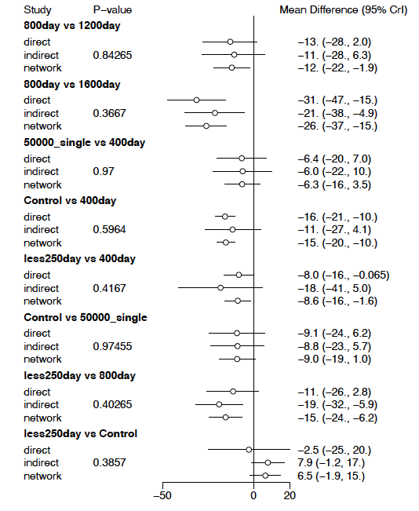

**eFigure 3.** Direct Evidence from the pair wise comparisons for the primary outcome ‘mean serum vitamin D concentrations at 0-6 months’

A. 400day vs. control

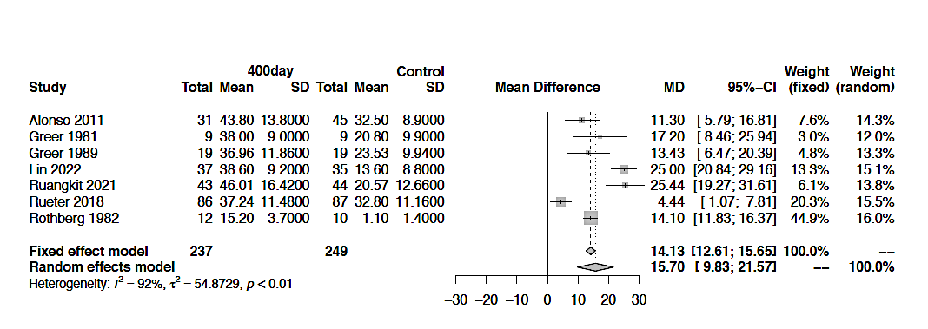

B. 1400week vs. Control

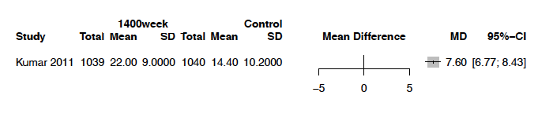

C. 50000_single vs. Control

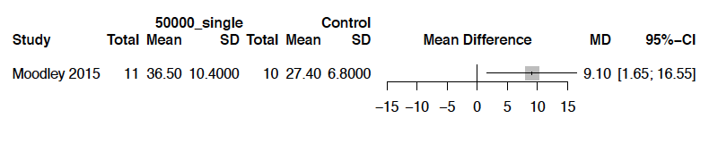

D. 400day vs. 600day

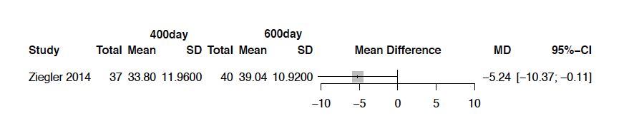

E. 400day vs. 800day

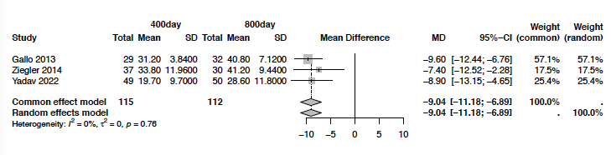

F. 600day vs. 800day

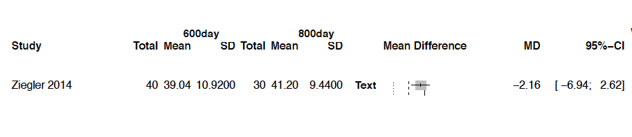

G. 400day vs. 1000day

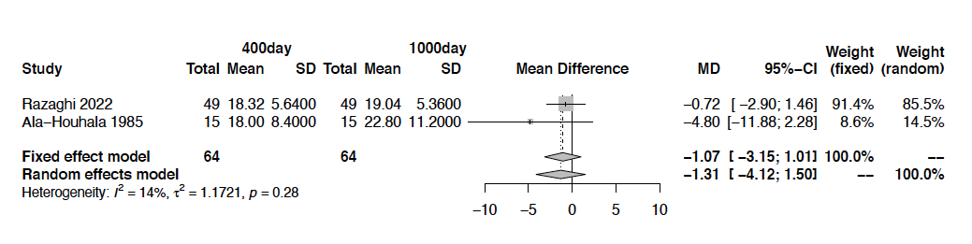

H. 400day vs. 1200day

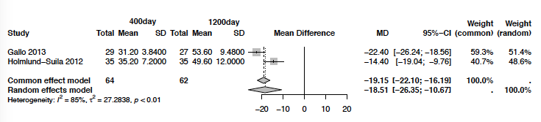

I. 400day vs. 1600day

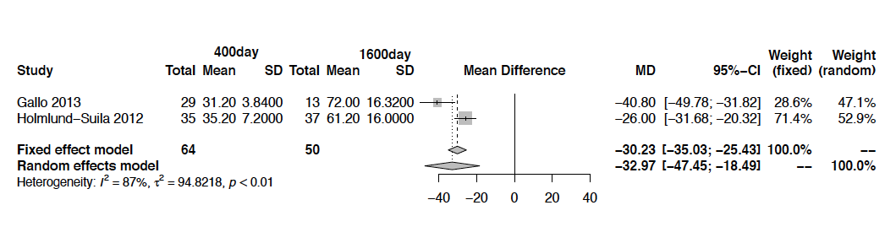

J. 400day vs. 50000_single

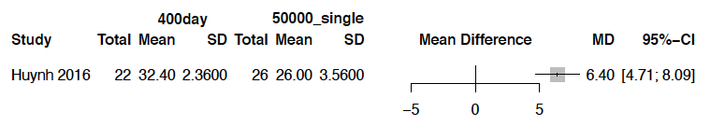

K. 800day vs. 1200day

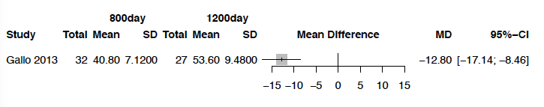

L. 1200day vs. 1600day

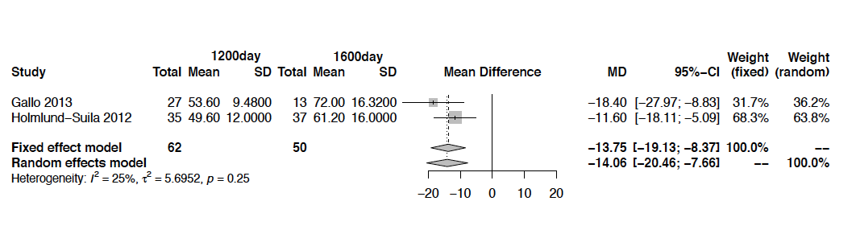

M. 400day vs. 50000_2mon

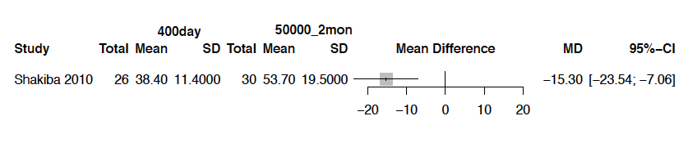

N. 1lac_single vs. 400day

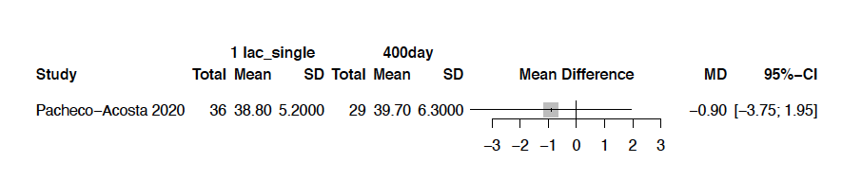

O. less250day vs. 500day

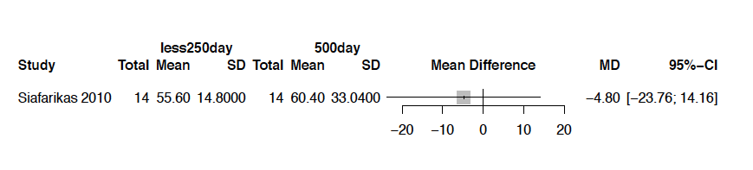

P. less250day vs. 800day

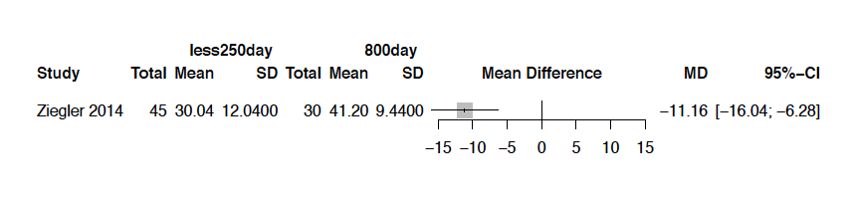

Q. less250day vs. 50000_2mon

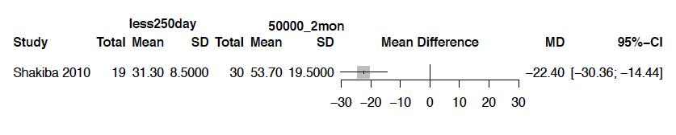

R. less250day vs. Control

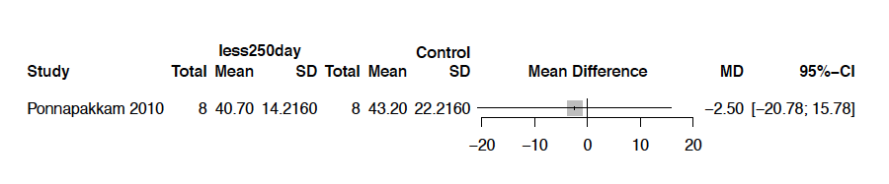

S. less250day vs. 400day

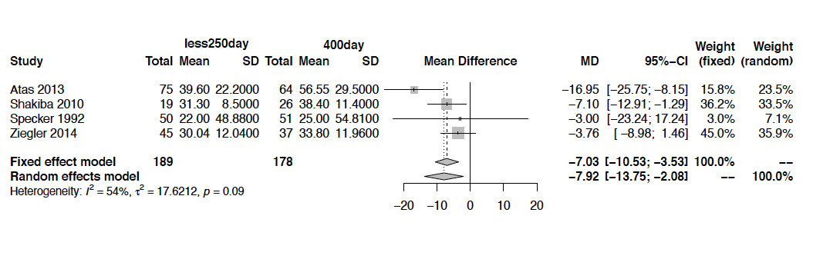

T. less250day vs. 600day

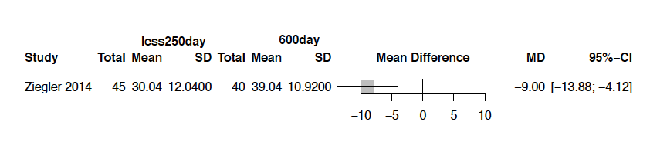

U. 800day vs. 1600day

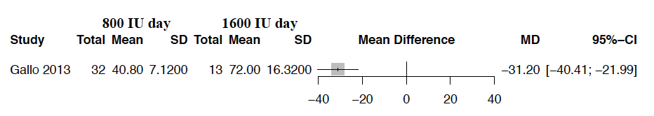

V. 6lac_Single vs. 2lac_Single

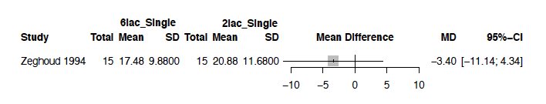

**eFigure 4**: Sensitivity analysis for the primary outcome ‘mean serum vitamin D concentrations at 0-6 months’ based on baseline vitamin D status of study neonates – VDI (Vitamin D <30 ng/mL) versus VDD (Vitamin D <20 ng/mL)

**A: Baseline: VDI**

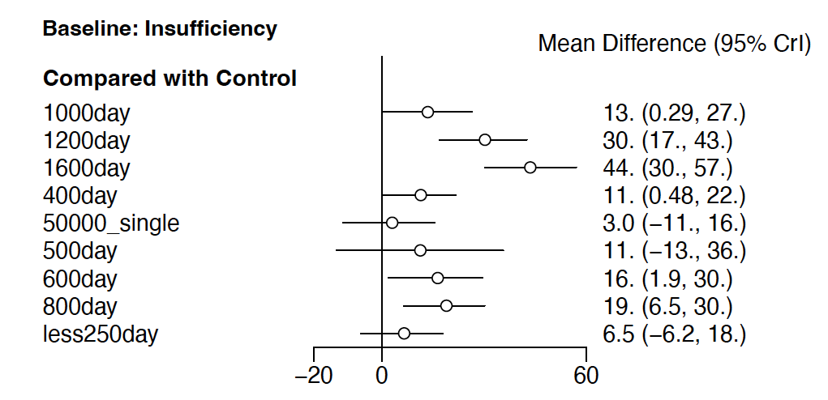

**B. Baseline: VDD**

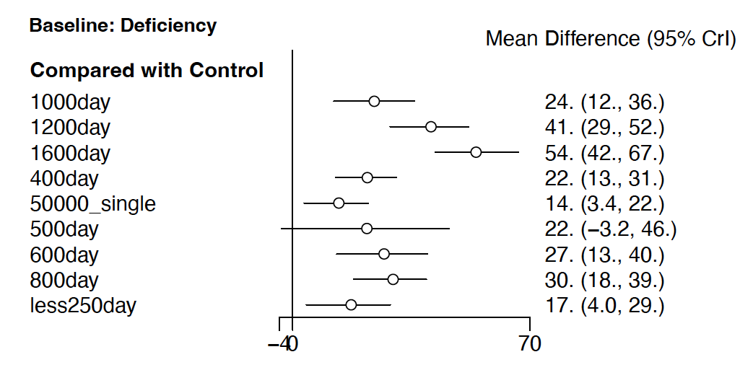

**eFigure 5.** League plot depicting the network estimate [RR (95% CrI)] for the primary outcome ‘proportion of infants with VDI at 0-6 months’

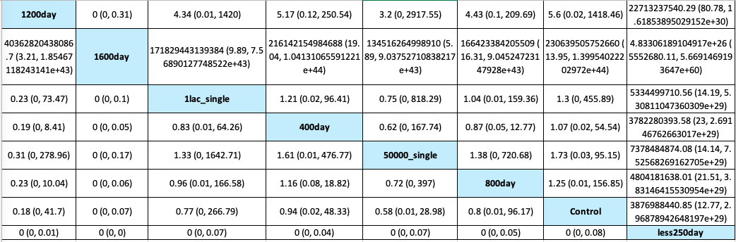

**eFigure 6.** Direct Evidence from the pair wise comparisons for the primary outcome ‘proportion of infants with VDI at 0-6 months’



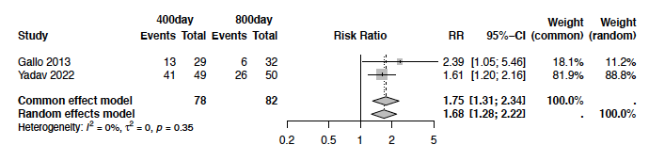

**eFigure 7:** Sensitivity analysis for the primary outcome ‘proportion of infants with VDI at 0-6 months’ based on baseline vitamin D status of study neonates –VDI (Vitamin D <30 ng/mL) versus VDD (Vitamin D <20 ng/mL)

**A: Baseline: VDI**

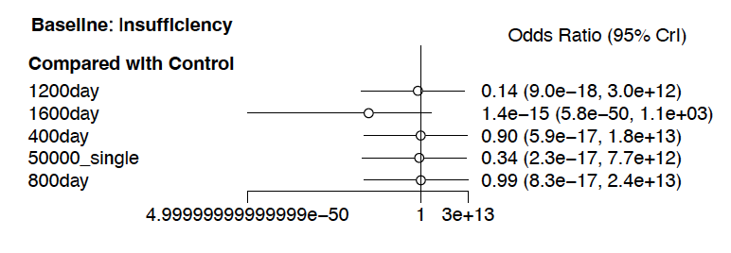

**B: Baseline: VDD**

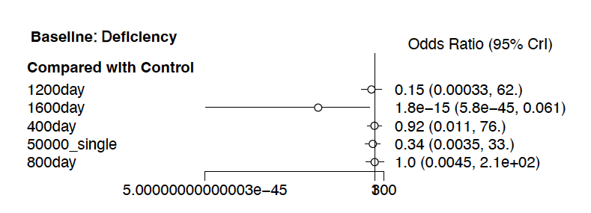

**eFigure 8.** Proportion of infants with VDD (Vitamin D concentration <20 ng/mL) at 0-6 months. **A.** Network plot; **B.** Forest plot depicting the network estimates [RR (95% CrI)] of the various interventions with ‘Control’ as the common comparator; **C.** SUCRA plot

**A.** Network plot



**B.** Forest plot depicting the network estimates [RR (95% CrI)] of the various interventions with ‘Control’ as the common comparator



**C.** SUCRA plot



**eFigure 9.** League plot depicting the network estimate [RR (95% CrI)] for the outcome ‘proportion of infants with VDD (Vitamin D concentration <20 ng/mL) at 0-6 months’

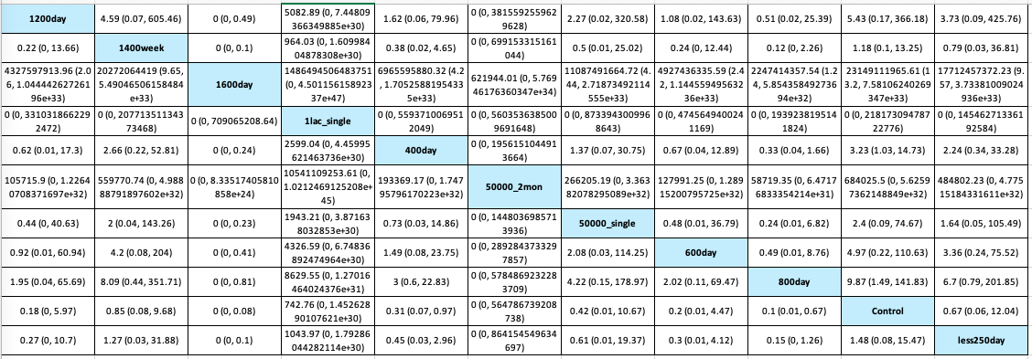

**eFigure 10**: Split between direct and indirect evidence for the outcome ‘proportion of infants with VDD (Vitamin D concentration <20 ng/mL) at 0-6 months’



**eFigure 11**: Direct Evidence from the pair wise comparisons for the outcome ‘proportion of infants with VDD (Vitamin D concentration <20 ng/mL) at 0-6 months’

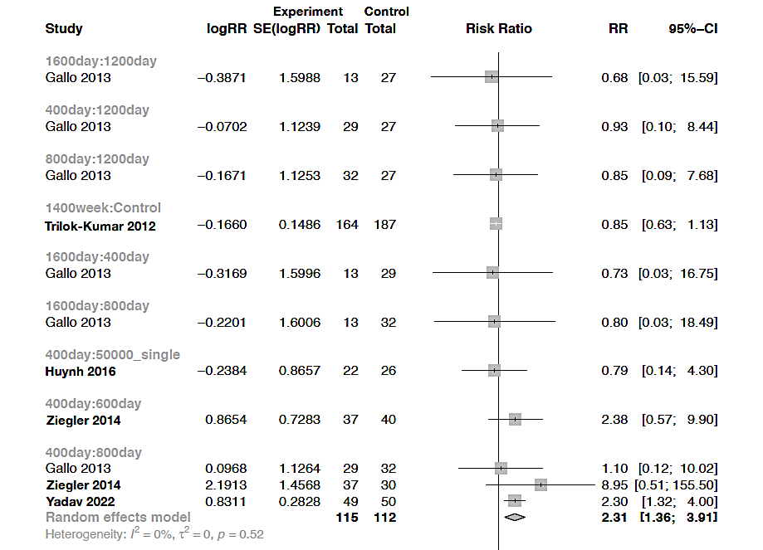

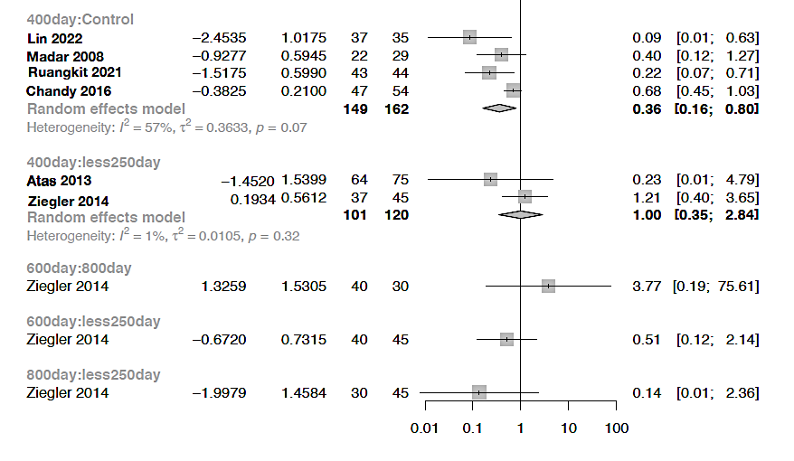

**eFigure 12.** Proportion of infants with severe VDD (Vitamin D concentration <10-15 ng/mL) at 0-6 months. **A.** Network plot; **B.** Forest plot depicting the network estimates [RR (95% CrI)] of the various interventions with ‘Control’ as the common comparator; **C.** SUCRA plot

**A.** Network plot



**B.** Forest plot depicting the network estimates [RR (95% CrI)] of the various interventions with ‘Control’ as the common comparator



**C.** SUCRA plot



**eFigure 13.** League plot depicting the network estimate [RR (95% CrI)] for the outcome ‘proportion of infants with severe VDD (Vitamin D concentration <10-15 ng/mL) at 0-6 months’

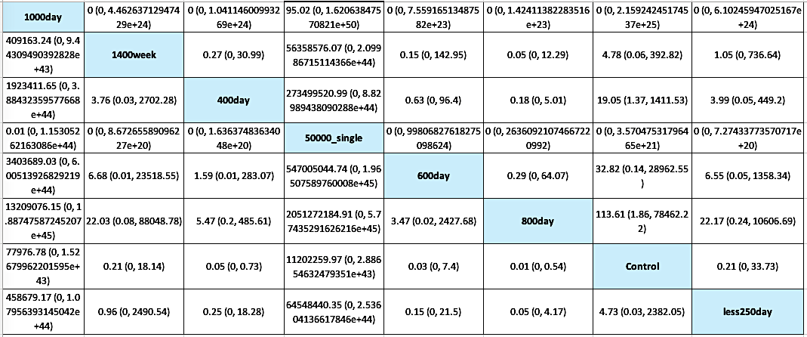

**eFigure 14**: Split between direct and indirect evidence for the outcome ‘proportion of infants with severe VDD (Vitamin D concentration <10-15 ng/mL) at 0-6 months’



**eFigure 15.** Direct Evidence from the pair wise comparisons for the outcome ‘proportion of infants with severe VDD (Vitamin D concentration <10-15 ng/mL) at 0-6 months’

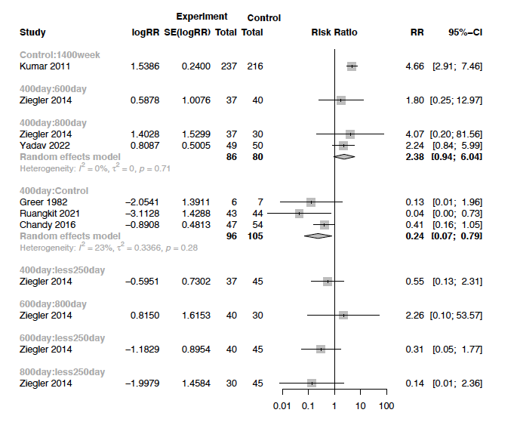

**eFigure 16**: Hypervitaminosis D at 0-6 months. **A.** Network plot; **B.** Forest plot depicting the network estimates [RR (95% CrI)] of the various interventions with ‘400day’ as the common comparator; **C.** SUCRA plot

**A.** Network plot



**B.** Forest plot depicting the network estimates [RR (95% CrI)] of the various interventions with ‘400day’ as the common comparator



**C.** SUCRA plot



**eFigure 17.** League plot depicting the network estimate [RR (95% CrI)] for the outcome ‘Hypervitaminosis D at 0-6 months’



**eFigure 18.** Direct Evidence from the pair wise comparisons for the outcome ‘Hypervitaminosis D at 0-6 months’

A. 1lac_single vs. 400day

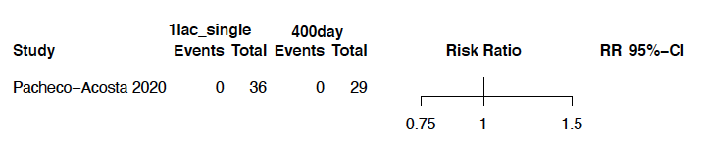

B. 400day vs. 50000_2mon

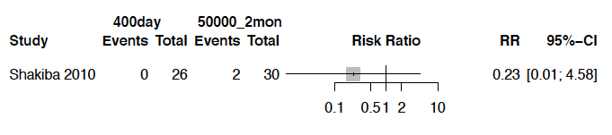

C. 400day vs. 50000_single

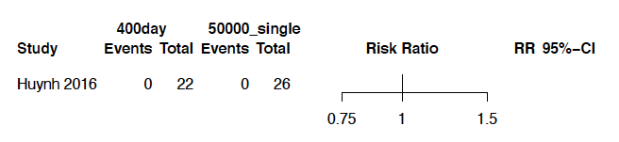

D. 400day vs. 800day

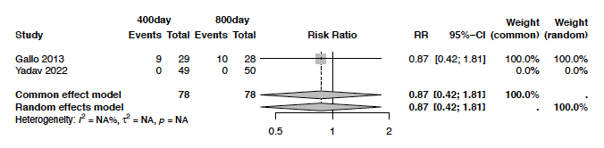

E. 400day vs. 1200day

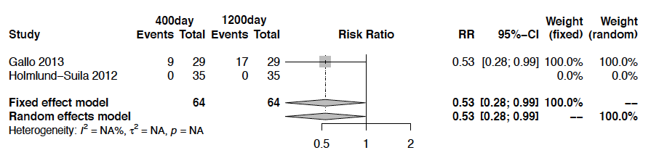

F. 400day vs. 1600day

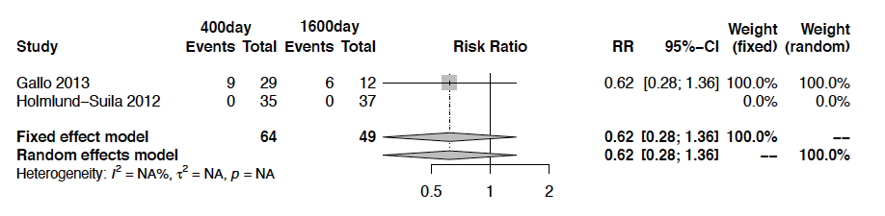

G. 800day vs. 1200day

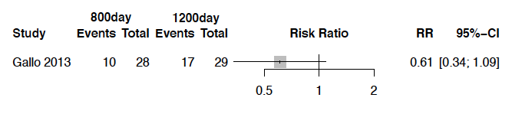

H. 800day vs. 1600day

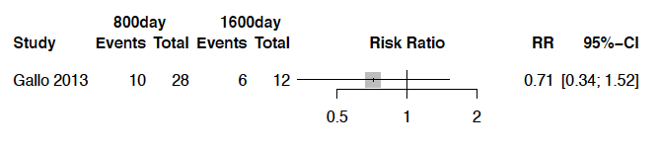

I. 1200day vs. 1600day

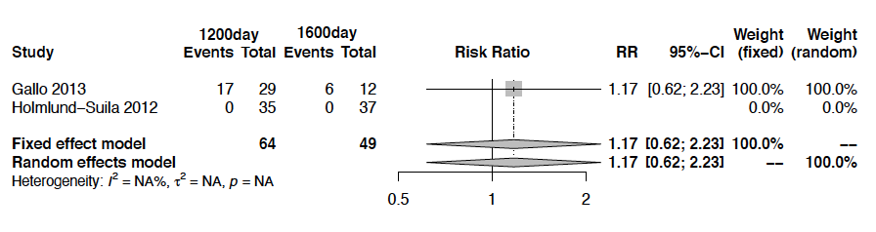

I. Less250day vs. 50000_2mon

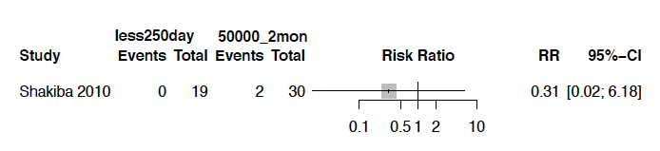

I. Less250day vs. 400day

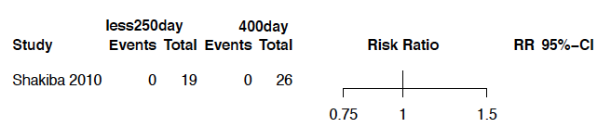

**eFigure 19**: Hypercalcemia at 0-6 months. **A.** Network plot; **B.** Forest plot depicting the network estimates [RR (95% CrI)] of the various interventions with ‘Control’ as the common comparator; **C.** SUCRA plot

**A.** Network plot



**B.** NMAForest plot



**C.** SUCRA plot



**eFigure 20.** League plot depicting the network estimate [RR (95% CrI)] for the outcome ‘Hypercalcemia at 0-6 months’

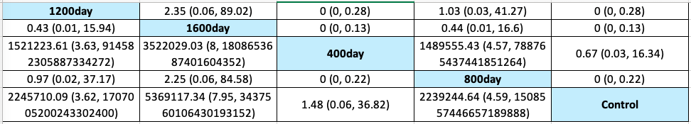

**eFigure 21.** Direct Evidence from the pair wise comparisons for the outcome ‘Hypercalcemia at 0-6 months’

A. 400day vs. Control

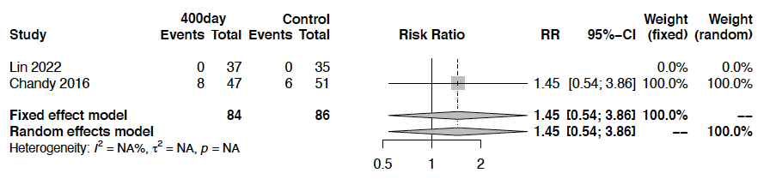

B. 400day vs. 800day

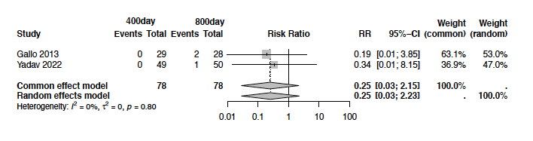

C. 400day vs. 1200day

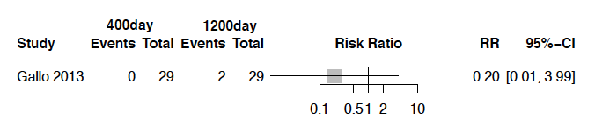

D. 400day vs. 1600day

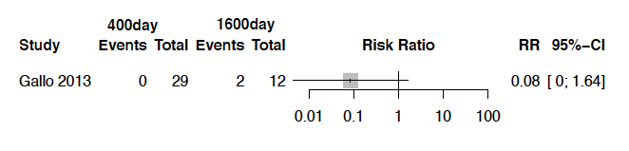

E. 800day vs. 1200day

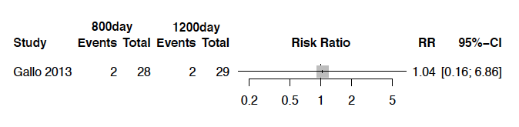

F. 800day vs. 1600day

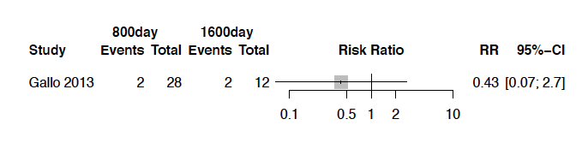

G. 1200day vs. 1600day

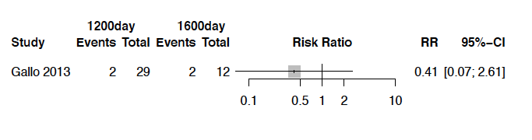

**eFigure 22.** Direct Evidence from the pairwise comparisons for the outcome ‘Hypercalcuria’ at 0-6 months

A. 400day vs. 800day



B. 400day vs. 1200day



C. 400day vs. 1600day



D. 800day vs. 1200day



E. 800day vs. 1600day

F. 1200day vs. 1600day



**eFigure 23.** Direct Evidence from the pair wise comparisons for the outcome ‘bone mineral density at 0-6 months’

A. Less250day vs. 800day

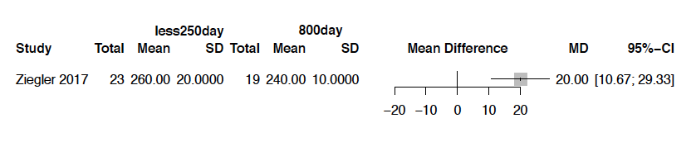

B. Less250day vs. 600day

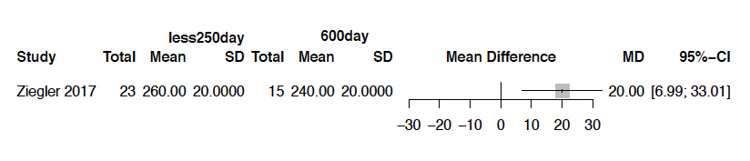

C. Less250day vs. 400day

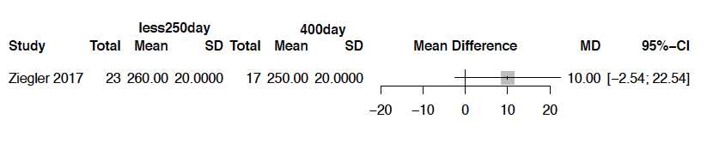

D. 600day vs. 800day

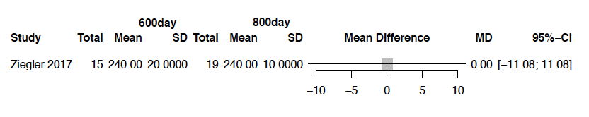

E. 400day vs. 800day

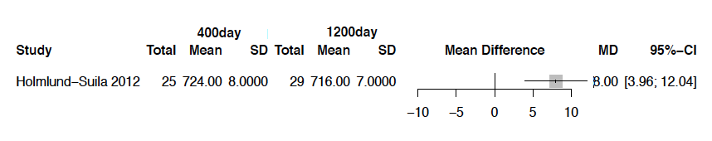

F. 400day vs. Control

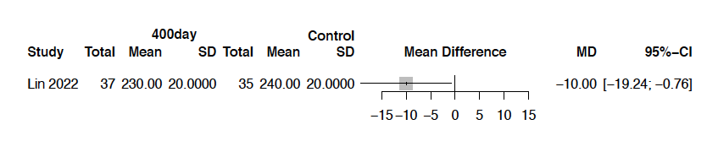

G. 400day vs. 600day

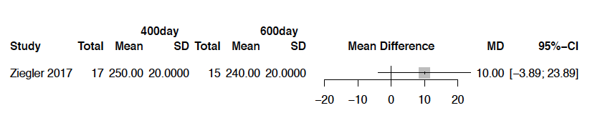

G. 400day vs. 800day

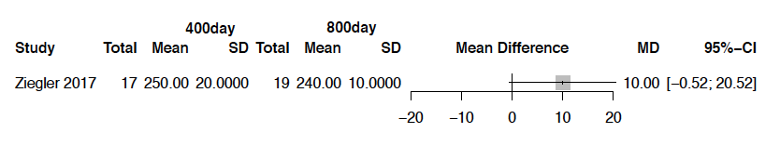

G. 400day vs. 1200day

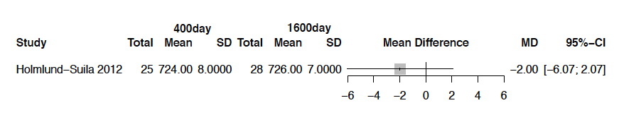

G. 1200day vs. 1600day

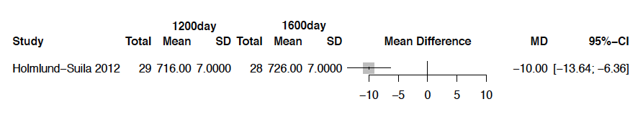

**eFigure 24**: Clinical rickets at 0-6 months. **A.** Network plot; **B.** Forest plot depicting the network estimates [RR (95% CrI)] of the various interventions with ‘Control’ as the common comparator; **C.** SUCRA plot

**A.** Network plot



**B.** Forest plot depicting the network estimates [RR (95% CrI)] of the various interventions with ‘Control’ as the common comparator



**C.** SUCRA plot



**eFigure 25.** League plot depicting the network estimate [RR (95% CrI)] for the outcome ‘clinical rickets at 0-6 months’

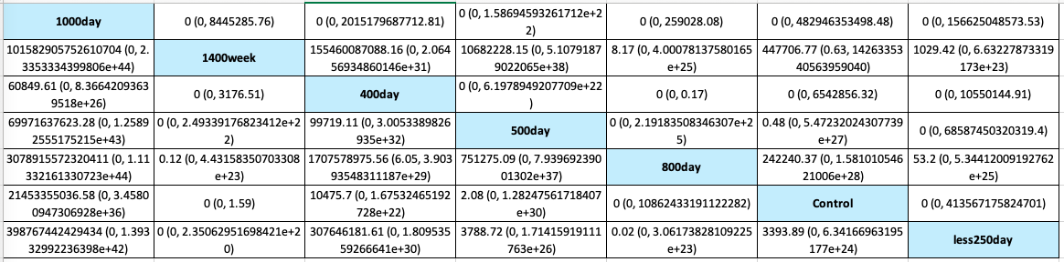

**eFigure 26**: Split between direct and indirect evidence for the outcome ‘clinical rickets at 0-6 months’



**eFigure 27.** Direct Evidence from the pair wise comparisons for the outcome ‘clinical rickets at 0-6 months’

A. Less250day vs. 400day

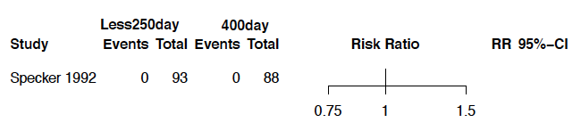

B. Less250day vs. 500day

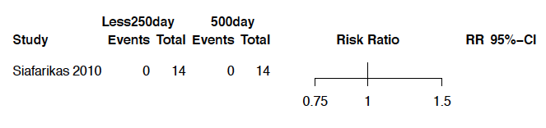

C. Less250day vs. Control

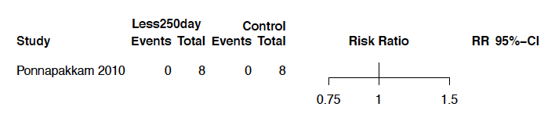

D. 1400week vs. Control

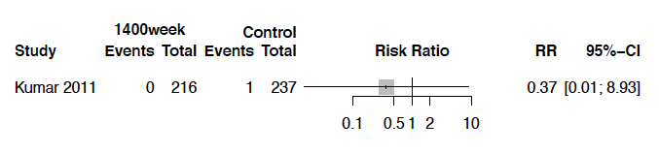

E. 400day vs. Control

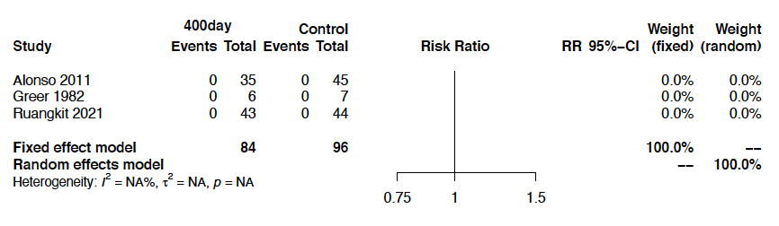

F. 400day vs. 1000day

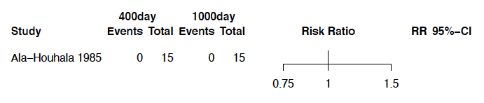

G. 800day vs. 400day

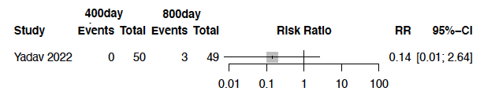

**eFigure 28.** Direct Evidence from the pair wise comparisons for the outcome ‘All-cause mortality at 0-6 months’

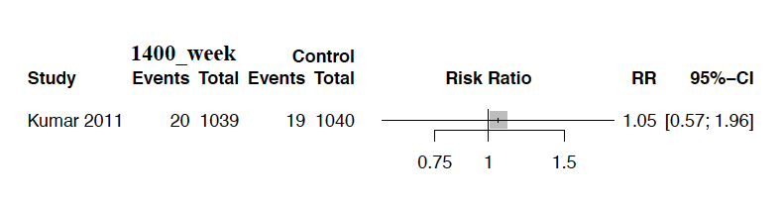

**eFigure 29**: Mean serum vitamin D concentrations at 7-12 months. **A.** Network plot; **B.** Forest plot depicting the network estimates [RR (95% CrI)] of the various interventions with ‘Control’ as the common comparator; **C.** SUCRA plot

A. Network plot plot



B. Forest plot depicting the network estimates [RR (95% CrI)] of the various interventions with ‘Control’ as the common comparator



C. SUCRA plot



**eFigure 30.** League plot depicting the network estimate [RR (95% CrI)] for the outcome ‘mean vitamin D concentrations at 7-12 months’



**eFigure 31**: Split between direct and indirect evidence for the outcome ‘mean vitamin D concentrations at 7-12 months’



**eFigure 32.** Direct Evidence from the pair wise comparisons for the outcome ‘mean vitamin D concentrations at 7-12 months’

A. 600day vs. less250day

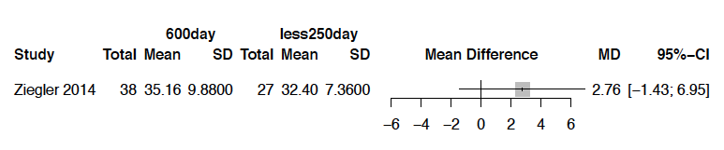

B. 800day vs. less250day

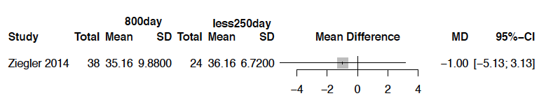

C. 400day vs. 600day

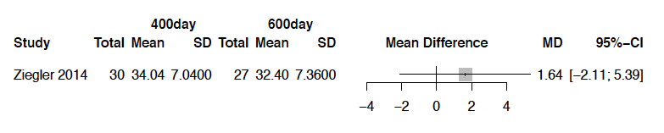

D. 400day vs. Control

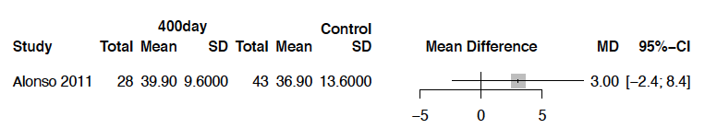

E. 400day vs. 800day

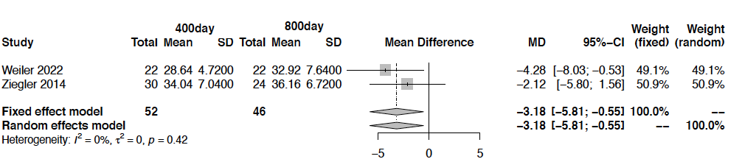

F. 600day vs. 800day

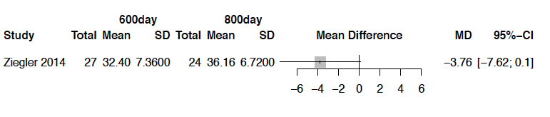

G. 800day vs. 1200day

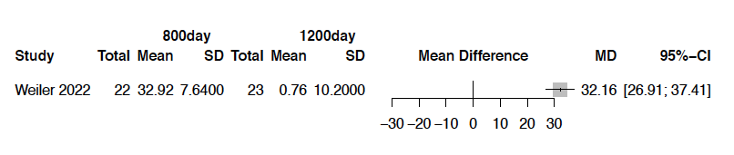

H. 400day vs. 1200day

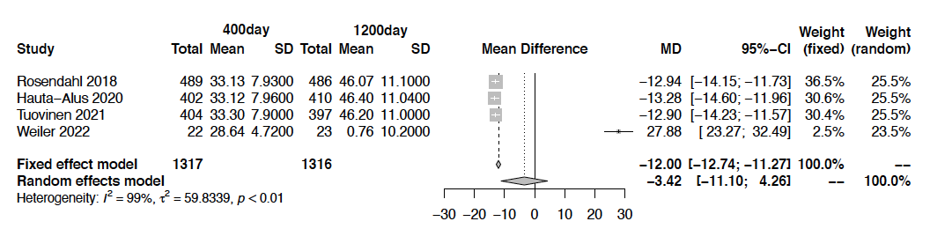

I. Less250day vs. 400day

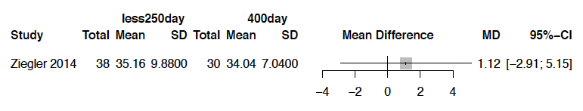

**eFigure 33.** Direct Evidence from the pair wise comparisons for the outcome ‘proportion of infants with VDI (vitamin D concentrations <30 ng/mL) at 7-12 months’

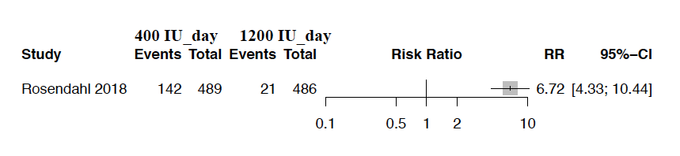

**eFigure 34.** Proportion of infants with VDD (Vitamin D concentration <20 ng/mL) at 7-12 months. **A.** Network plot; **B.** Forest plot depicting the network estimates [RR (95% CrI)] of the various interventions with ‘Control’ as the common comparator; **C.** SUCRA plot

1. Network plot



**B.** Forest plot depicting the network estimates [RR (95% CrI)] of the various interventions with ‘Control’ as the common comparator



1. SUCRA plot



**eFigure 35.** League plot depicting the network estimate [RR (95% CrI)] for the outcome ‘proportion of infants with VDD (Vitamin D concentration <20 ng/mL) at 7-12 months’

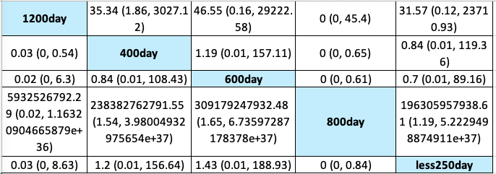

**eFigure 36**. Direct Evidence from the pair wise comparisons for the outcome ‘proportion of infants with VDD (Vitamin D concentration < 20 ng/mL) at 7-12 months’

1. 400day vs. 600day

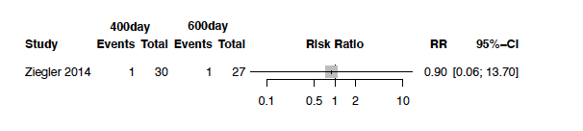

1. 400day vs. 800day

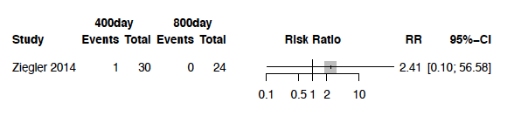

1. 400day vs. 1200day

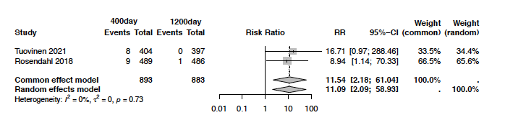

1. 600day vs. 800day

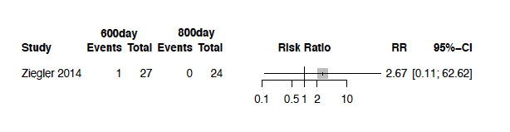

1. Less250day vs. 600day

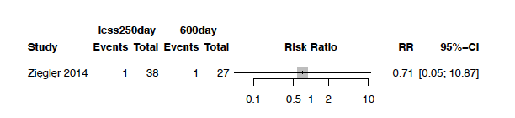

1. Less250day vs. 800day

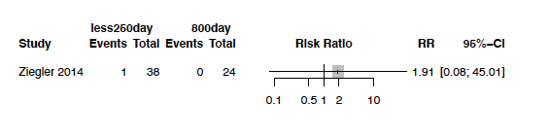

1. Less250day vs. 400day

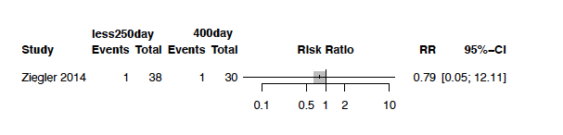

**eFigure 37.** Proportion of infants with severe VDD (Vitamin D concentration <10-15 ng/mL) at 7-12 months. **A.** Network plot; **B.** Forest plot depicting the network estimates [RR (95% CrI)] of the various interventions with ‘Control’ as the common comparator; **C.** SUCRA plot

**A.** Network plot



**B.** Forest plot depicting the network estimates [RR (95% CrI)] of the various interventions with ‘Control’ as the common comparator



1. SUCRA plot



**eFigure 38.** League plot depicting the network estimate [RR (95% CrI)] for the outcome ‘proportion of infants with severe VDD (Vitamin D concentration <10-15 ng/mL) at 7-12 months’

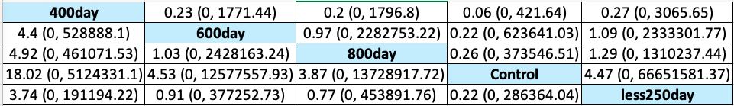

**eFigure 39.** Direct Evidence from the pairwise comparisons for the outcome ‘Hypercalcemia at 7-12 months’



**eFigure 40.** Direct Evidence from the pair wise comparisons for the outcome ‘bone mineral density at 7-12 months’

A. 400day vs. 800day

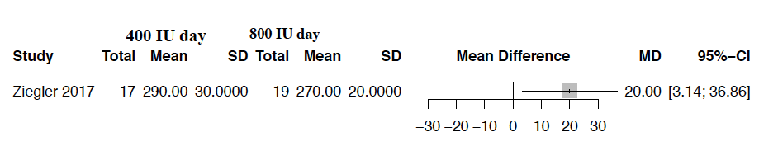

B. 400day vs. 600day

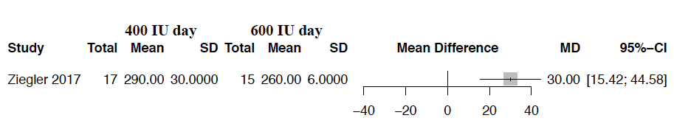

C. 600day vs. 800day

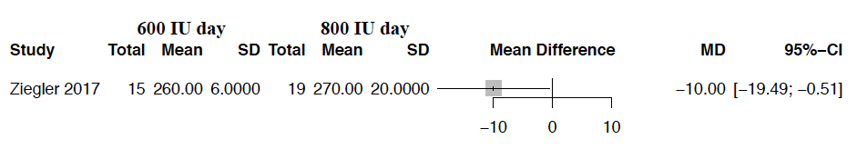

D. less250day vs. 400day

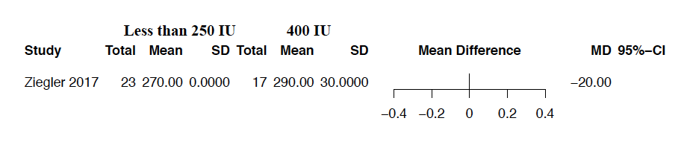

E. less250day vs. 600day

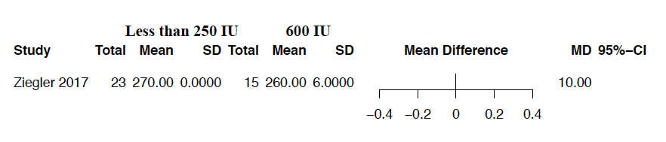

F. less250day vs. 800day

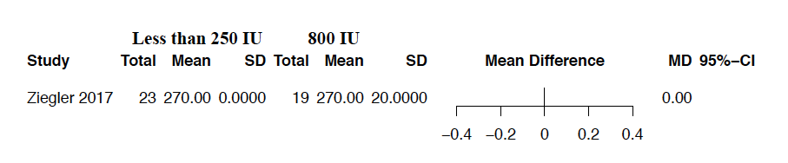

**eFigure 41.** Direct Evidence from the pair wise comparisons for the outcome ‘clinical rickets at 7-12 months’

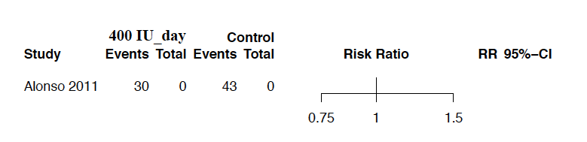

**eFigure 42.** Direct Evidence from the pair wise comparisons for the outcome ‘Neurodevelopmental disability at ≥1 year’

1. 1400week vs. Control

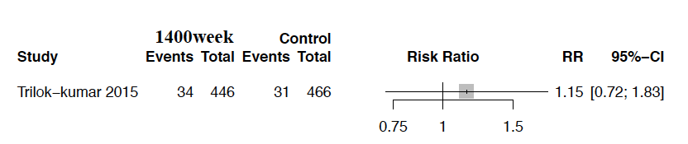

1. 400day vs. 1200day

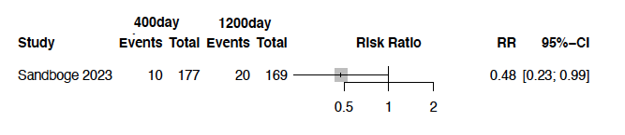

**Search Strategies: Vitamin D Supplements-infants**

(The search was updated on March 04, 2024, from the initial search in March 2022)

Database(s): Ovid MEDLINE(R) ALL 1946 to March 04, 2024

|  |  |  |
| --- | --- | --- |
| # | Searches | Results |
| 1 | exp Vitamin D/ or exp Vitamin D Deficiency/ | 83176 |
| 2 | (vitamin* adj2 (d or d3)).mp. | 96559 |
| 3 | (cholecalciferol* or calciol* or calciferol* or calcifediol* or calcidiol or ergocalciferol* or hydroxycholecalciferol* or "hydroxyvitamin d3" or "dihydroxyvitamin d" or dihydroxycholecalciferol* or 25ohd or "25 ohd").mp. | 30767 |
| 4 | (((Bone adj3 health) or bone) adj3 mineral*).mp. | 75750 |
| 5 | exp Infant/ | 1268517 |
| 6 | (infan* or newborn* or new-born* or neonat* or neo-nat* or baby or babies or late preterm).mp. | 1700331 |
| 7 | exp Breast Feeding/ | 44888 |
| 8 | (breastfeed* or "breast feed*" or "breast feeding*" or breastfed).mp. | 68572 |
| 9 | exp Lactation/ | 49009 |
| 10 | (lactation or lactating).mp. | 79316 |
| 11 | exp Pregnancy/ | 1025334 |
| 12 | exp pregnant women/ | 15625 |
| 13 | (pregnant or pregnancy).mp. | 1139094 |
| 14 | exp Mothers/ | 58113 |
| 15 | (maternal or mother or mothers or antenatal* or perinatal* or prenatal* or postnatal).mp. | 823726 |
| 16 | 1 or 2 or 3 or 4 | 178867 |
| 17 | 5 or 6 or 7 or 8 or 9 or 10 or 11 or 12 or 13 or 14 or 15 | 2771605 |
| 18 | 16 and 17 | 17768 |
| 19 | randomized controlled trial.mp. or exp randomized controlled trial/ | 658992 |
| 20 | (randomized control trial or controlled clinical trial).mp. | 121944 |
| 21 | (random* adj3 (group* or placebo or trial* or team*)).mp. | 1019801 |
| 22 | (control* adj3 (group* or placebo or trial* or team*)).mp. | 1609959 |
| 23 | 19 or 20 or 21 or 22 | 1696474 |
| 24 | animal/ not human.mp. | 6245311 |
| 25 | 23 not 24 | 1482634 |
| 26 | 18 and 25 | 1863 |
| 27 | limit 26 to dt=20220912-20241231 (on march 5, 2024) | 153 |

Database(s): Embase 1974 to 2024 March 04

|  |  |  |
| --- | --- | --- |
| # | Searches | Results |
| 1 | exp Vitamin D/ or exp Vitamin D Deficiency/ | 188301 |
| 2 | (vitamin* adj2 (d or d3)).mp. | 172252 |
| 3 | (cholecalciferol* or calciol* or calciferol* or calcifediol* or calcidiol or ergocalciferol* or hydroxycholecalciferol* or "hydroxyvitamin d3" or "dihydroxyvitamin d" or dihydroxycholecalciferol* or 25ohd or "25 ohd").mp. | 37935 |
| 4 | (((Bone adj3 health) or bone) adj3 mineral*).mp. | 122430 |
| 5 | exp Infant/ | 1160599 |
| 6 | (infan* or newborn* or new-born* or neonat* or neo-nat* or baby or babies or late preterm).mp. | 1646531 |
| 7 | exp Breast Feeding/ | 68486 |
| 8 | (breastfeed* or "breast feed*" or "breast feeding*" or breastfed).mp. | 87954 |
| 9 | exp Lactation/ | 61107 |
| 10 | (lactation or lactating).mp. | 85026 |
| 11 | exp Pregnancy/ | 792564 |
| 12 | exp pregnant women/ | 118156 |
| 13 | (pregnant or pregnancy).mp. | 1111746 |
| 14 | exp Mothers/ | 176100 |
| 15 | (maternal or mother or mothers or antenatal* or perinatal* or prenatal* or postnatal).mp. | 1095777 |
| 16 | 1 or 2 or 3 or 4 | 309252 |
| 17 | 5 or 6 or 7 or 8 or 9 or 10 or 11 or 12 or 13 or 14 or 15 | 2869931 |
| 18 | 16 and 17 | 29384 |
| 19 | randomized controlled trial.mp. or exp randomized controlled trial/ | 1098104 |
| 20 | (randomized control trial or controlled clinical trial).mp. | 513467 |
| 21 | (random* adj3 (group* or placebo or trial* or team*)).mp. | 1364941 |
| 22 | (control* adj3 (group* or placebo or trial* or team*)).mp. | 2293723 |
| 23 | 19 or 20 or 21 or 22 | 2428876 |
| 24 | animal/ not human.mp. | 1169098 |
| 25 | 23 not 24 | 2374823 |
| 26 | 18 and 25 | 3713 |
| 27 | limit 26 to dc=20220912-20241231 (on march 5, 2024) | 517 |
| 28 | limit 27 to (conference abstracts or embase) | 487 |

Cochrane Library: Trial only Date Run: 05/03/2024 19:19:00

|  |  |  |
| --- | --- | --- |
| ID | Search | Hits |
| #1 | MeSH descriptor: [Vitamin D] explode all trees | 7880 |
| #2 | vitamin* NEAR (d or d3) | 17105 |
| #3 | cholecalciferol* or calciol* or calciferol* or calcifediol* or calcidiol or ergocalciferol* or hydroxycholecalciferol* or "hydroxyvitamin d3" or "dihydroxyvitamin d" or dihydroxycholecalciferol* or 25ohd or "25 ohd" | 6469 |
| #4 | (bone NEAR/3 health*) or (bone NEAR/3 mineral*) | 13867 |
| #5 | #1 OR #2 OR #3 OR #4 | 28804 |
| #6 | MeSH descriptor: [Infant, Newborn] explode all trees | 23918 |
| #7 | infan* or newborn* or new-born* or neonat* or neo-nat* or baby or babies or "late pre term*" or "late preterm*" | 102158 |
| #8 | MeSH descriptor: [Breast Feeding] explode all trees | 2885 |
| #9 | breastfeed* OR “breast feed*” OR breastfed | 9874 |
| #10 | MeSH descriptor: [Lactates] explode all trees | 3986 |
| #11 | lactation or lactating | 6117 |
| #12 | MeSH descriptor: [Pregnancy] explode all trees | 33824 |
| #13 | pregnan* | 90441 |
| #14 | MeSH descriptor: [Mothers] 3 tree(s) exploded | 3285 |
| #15 | maternal or mother or mothers or antenatal* or perinatal* or prenatal* or postnatal | 58403 |
| #16 | MeSH descriptor: [Pregnant Women] explode all trees | 1001 |
| #17 | {or #6-#16} | 182245 |
| #18 | #5 AND #17 with Publication date Between Sep 2022 and Dec 2024. 261 trials and 256 reviews) | 517 |

Database(s): **Embase Classic+Embase** 1947 to 2022 September 12

|  |  |  |
| --- | --- | --- |
| **#** | **Searches** | **Results** |
| 1 | exp Vitamin D/ or exp Vitamin D Deficiency/ | 177330 |
| 2 | (vitamin* adj2 (d or d3)).mp. [mp=title, abstract, heading word, drug trade name, original title, device manufacturer, drug manufacturer, device trade name, keyword heading word, floating subheading word, candidate term word] | 161781 |
| 3 | (cholecalciferol* or calciol* or calciferol* or calcifediol* or calcidiol or ergocalciferol* or hydroxycholecalciferol* or "hydroxyvitamin d3" or "dihydroxyvitamin d" or dihydroxycholecalciferol* or 25ohd or "25 ohd").mp. [mp=title, abstract, heading word, drug trade name, original title, device manufacturer, drug manufacturer, device trade name, keyword heading word, floating subheading word, candidate term word] | 37377 |
| 4 | (((Bone adj3 health) or bone) adj3 mineral*).mp. [mp=title, abstract, heading word, drug trade name, original title, device manufacturer, drug manufacturer, device trade name, keyword heading word, floating subheading word, candidate term word] | 116100 |
| 5 | exp Infant/ | 1264629 |
| 6 | (infan* or newborn* or new-born* or neonat* or neo-nat* or baby or babies or late preterm).mp. [mp=title, abstract, heading word, drug trade name, original title, device manufacturer, drug manufacturer, device trade name, keyword heading word, floating subheading word, candidate term word] | 1753485 |
| 7 | exp Breast Feeding/ | 63918 |
| 8 | (breastfeed* or "breast feed*" or "breast feeding*" or breastfed).mp. [mp=title, abstract, heading word, drug trade name, original title, device manufacturer, drug manufacturer, device trade name, keyword heading word, floating subheading word, candidate term word] | 82083 |
| 9 | exp Lactation/ | 62899 |
| 10 | (lactation or lactating).mp. [mp=title, abstract, heading word, drug trade name, original title, device manufacturer, drug manufacturer, device trade name, keyword heading word, floating subheading word, candidate term word] | 86387 |
| 11 | exp Pregnancy/ | 877451 |
| 12 | exp pregnant women/ | 108346 |
| 13 | (pregnant or pregnancy).mp. [mp=title, abstract, heading word, drug trade name, original title, device manufacturer, drug manufacturer, device trade name, keyword heading word, floating subheading word, candidate term word] | 1178816 |
| 14 | exp Mothers/ | 188137 |
| 15 | (maternal or mother or mothers or antenatal* or perinatal* or prenatal* or postnatal).mp. [mp=title, abstract, heading word, drug trade name, original title, device manufacturer, drug manufacturer, device trade name, keyword heading word, floating subheading word, candidate term word] | 1080411 |
| 16 | 1 or 2 or 3 or 4 | 292806 |
| 17 | 5 or 6 or 7 or 8 or 9 or 10 or 11 or 12 or 13 or 14 or 15 | 3038493 |
| 18 | 16 and 17 | 27764 |
| 19 | randomized controlled trial.mp. or exp randomized controlled trial/ | 980100 |
| 20 | (randomized control trial or controlled clinical trial).mp. | 503251 |
| 21 | (random* adj3 (group* or placebo or trial* or team*)).mp. [mp=title, abstract, heading word, drug trade name, original title, device manufacturer, drug manufacturer, device trade name, keyword heading word, floating subheading word, candidate term word] | 1229430 |
| 22 | (control* adj3 (group* or placebo or trial* or team*)).mp. [mp=title, abstract, heading word, drug trade name, original title, device manufacturer, drug manufacturer, device trade name, keyword heading word, floating subheading word, candidate term word] | 2104152 |
| 23 | 19 or 20 or 21 or 22 | 2231118 |
| 24 | animal/ not human.mp. [mp=title, abstract, heading word, drug trade name, original title, device manufacturer, drug manufacturer, device trade name, keyword heading word, floating subheading word, candidate term word] | 1530027 |
| 25 | 23 not 24 | 2179886 |
| 26 | 18 and 25 | 3249 |
| 27 | Search updated on 13/09/2023 | 205 |

Cochrane Library: trial only Date Run: 14/09/2022 00:26:20

|  |  |  |
| --- | --- | --- |
| ID | Search | Hits |
| #1 | MeSH descriptor: [Vitamin D] explode all trees | 6163 |
| #2 | vitamin* NEAR (d or d3) | 15470 |
| #3 | cholecalciferol* or calciol* or calciferol* or calcifediol* or calcidiol or ergocalciferol* or hydroxycholecalciferol* or "hydroxyvitamin d3" or "dihydroxyvitamin d" or dihydroxycholecalciferol* or 25ohd or "25 ohd" | 5853 |
| #4 | (bone NEAR/3 health*) or (bone NEAR/3 mineral*) | 12874 |
| #5 | #1 OR #2 OR #3 OR #4 | 26235 |
| #6 | MeSH descriptor: [Infant, Newborn] explode all trees | 17651 |
| #7 | infan* or newborn* or new-born* or neonat* or neo-nat* or baby or babies or "late pre term*" or "late preterm*" | 91682 |
| #8 | MeSH descriptor: [Breast Feeding] explode all trees | 2121 |
| #9 | breastfeed* OR “breast feed*” OR breastfed | 8638 |
| #10 | MeSH descriptor: [Lactates] explode all trees | 3271 |
| #11 | lactation or lactating | 5450 |
| #12 | MeSH descriptor: [Pregnancy] explode all trees | 24789 |
| #13 | pregnan* | 78412 |
| #14 | MeSH descriptor: [Mothers] explode all trees | 2222 |
| #15 | maternal or mother or mothers or antenatal* or perinatal* or prenatal* or postnatal | 51556 |
| #16 | MeSH descriptor: [Pregnant Women] explode all trees | 496 |
| #17 | {or #6-#16} | 161618 |
| #18 | #5 AND #17 Search updated on 14/09/2023 | 62 |

**eTable 2.** Risk of bias for included studies using Cochrane ROB 2.0

