# ***Supplementary data, le Foll et al.***

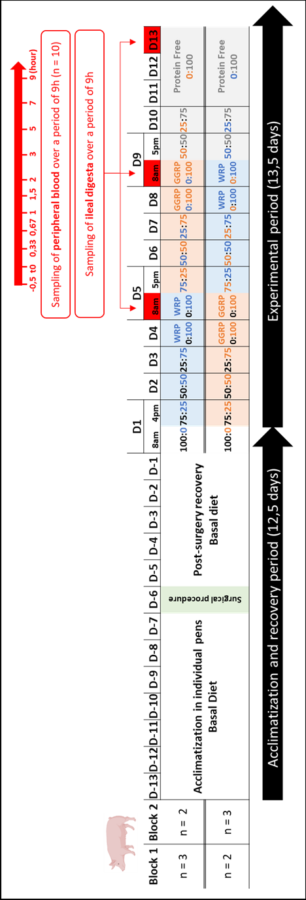

**Figure S1.** **Experimental design**. Pigs were acclimatized for 7 days in individual pens with slatted floors. One week before the start of the experimental period, the pigs were surgically fitted, with a T-shaped cannula in the ileum and a catheter in the jugular vein. During the acclimatization and recovery period, pigs were fed a basal diet. During the diet test period (experimental period), each pig received successively both diets (WRP and GGRP) for 4.5 days each, following a cross-over design, and then the protein-free diet also for 4.5 days. The animals were divided in two blocks. Block 1 consisted of 3 pigs first receiving the WRP diet, then GGRP diet, and finally protein-free diet; 2 pigs receiving first the GGRP diet, then WRP diet, and finally protein-free diet. Block 2 consisted in the opposite way, of 2 pigs receiving first the WRP diet, then GGRP diet, and finally protein-free diet; 3 pigs receiving first the GGRP diet, then WRP diet, and finally protein-free diet. In order to facilitate the consumption of the test diet on the sampling day (in red), an adaptation period was carried out during the 3.5 days preceding the sampling day, giving an increasing proportion of the diet to be tested (diet2) and a decreasing proportion of the diet previously tested (diet1) as follows: 75:25; 50:50; 25:75; 0:100 (diet1:diet2, % w:w). In total, the experimental period lasted 13.5 days for each animal, comprising, for each diet, 3.5 days of adaptation to the diet and 1 sampling day. Digesta were collected continuously over 9 h postprandial; blood samples were collected at 10 times over the same period. The total study lasted 26 days for each animal.

D, day; WRP, water recovered proteins; GGRP, greasy greaves recovered proteins.

**Table S1.** Apparent ileal digestibility of N and AA in growing pigs fed either Water recovered proteins (WRP) or Greasy greaves recovered proteins (GGRP) diet. *

|  |  |  |  |  |  |  |  |
| --- | --- | --- | --- | --- | --- | --- | --- |
| Items | **WRP** | | |  | **GGRP** | | |
| **Total N (%)** | 70,85 | ± | 4,27 |  | 68,72 | ± | 2,58 |
| **Essential AA (%)** |  |  |  |  |  |  |  |
| **Cys** | 13,93 | ± | 6,39 |  | 54,24 | ± | 2,64 |
| **His** | 81,37 | ± | 2,63 |  | 72,32 | ± | 1,67 |
| **Ile** | 66,78 | ± | 2,66 |  | 73,55 | ± | 1,56 |
| **Leu** | 72,83 | ± | 2,65 |  | 76,35 | ± | 1,44 |
| **Lys** | 78,18 | ± | 2,00 |  | 76,50 | ± | 1,15 |
| **Met** | 57,95 | ± | 6,11 |  | 76,13 | ± | 1,73 |
| **Phe** | 72,21 | ± | 2,28 |  | 76,66 | ± | 1,58 |
| **Tyr** | 57,43 | ± | 3,83 |  | 71,85 | ± | 1,64 |
| **Thr** | 54,61 | ± | 3,39 |  | 64,84 | ± | 1,62 |
| **Trp** | -80,70 | ± | 13,04 |  | 50,94 | ± | 2,78 |
| **Val** | 69,52 | ± | 3,51 |  | 74,85 | ± | 1,88 |
| ***Mean*** | 49,46 | ± | 3,56 |  | 69,84 | ± | 1,71 |
| **Non-essential AA (%)** |  |  |  |  |  |  |  |
| **Ala** | 85,55 | ± | 2,36 |  | 77,55 | ± | 1,76 |
| **Arg** | 89,87 | ± | 1,12 |  | 86,28 | ± | 0,97 |
| **Asp** | 51,94 | ± | 7,32 |  | 51,29 | ± | 3,40 |
| **Glu** | 80,85 | ± | 2,28 |  | 72,59 | ± | 1,79 |
| **Gly** | 85,34 | ± | 3,50 |  | 75,89 | ± | 3,21 |
| **Pro** | 78,27 | ± | 6,20 |  | 68,22 | ± | 6,82 |
| **HyPro** | 86,14 | ± | 4,25 |  | 79,98 | ± | 3,62 |
| **Ser** | 71,42 | ± | 3,48 |  | 69,86 | ± | 1,82 |
| ***Mean*** | 78,67 | ± | 3,68 |  | 72,71 | ± | 2,67 |

AA, amino acid; WRP, water recovered proteins; GGRP, greasy greaves recovered proteins; N, nitrogen. Asx, Asn + Asp; Glx, Gln + Glu.

* Data are means (n=8 for pigs fed WRP; n=10 for pigs fed GGRP).

**Table S2.** DIAA reference ratio and DIAAS for Water recovered proteins (WRP) and Greasy greaves recovered proteins (GGRP) on the basis of the protein content calculated by adding the masses of the constituent AA residues.

|  |  |  |
| --- | --- | --- |
| Items | **WRP** | **GGRP** |
| DIAA reference ratio (%) - *Undernourished child (0.5 - 5-years old)* | | |
| His | 113 | 60 |
| Ile | 48 | 79 |
| Leu | 53 | 81 |
| Lys | 63 | 76 |
| SAA (Cys + Met) | 31 | 74 |
| AAA (Phe + Tyr) | 46 | 77 |
| Thr | 54 | 77 |
| Trp | 7 | 54 |
| Val | 56 | 92 |
| DIAAS (%) † |  |  |
| *Undernourished child (0.5 - 5-years old)* | 7 (Trp) | 54 (Trp) |
| DIAA reference ratio (%) - *Healthy child (0.5 - 3-years old)* | | |
| His | 136 | 72 |
| Ile | 51 | 84 |
| Leu | 56 | 85 |
| Lys | 72 | 87 |
| SAA (Cys + Met) | 35 | 84 |
| AAA (Phe + Tyr) | 55 | 93 |
| Thr | 63 | 90 |
| Trp | 9 | 64 |
| Val | 56 | 98 |
| DIAAS (%) ‡ |  |  |
| *Healthy child (0.5 - 3-years old)* | 9 (Trp) | 64 (Trp) |
| DIAA reference ratio (%) - *Older child (>3 years), adolescent, adult* | | |
| His | 170 | 90 |
| Ile | 54 | 90 |
| Leu | 61 | 92 |
| Lys | 85 | 03 |
| SAA (Cys + Met) | 42 | 99 |
| AAA (Phe + Tyr) | 70 | 118 |
| Thr | 78 | 111 |
| Trp | 11 | 82 |
| Val | 64 | 106 |
| DIAAS (%) § |  |  |
| *Older child (>3 years), adolescent, adult* | 11 (Trp) | 82 (Trp) |

SAA, sulphur amino acids; AAA, aromatic amino acids; DIAAS, digestible indispensable amino acid score (with first-limiting AA in brackets).

The data are presented as the mean (n=8 for pigs fed WRP; n=10 for pigs fed GGRP).

**†**DIAAS were calculated using the recommended amino acid scoring patterns for undernourished child (0.5 - 5- years old) as mg AA/g protein: His, 24; Ile, 34; Leu, 70; Lys, 65; SAA, 31; AAA, 63; Thr, 36; Trp, 10; Val, 46(27).

**‡**DIAAS were calculated using the recommended amino acid scoring patterns for healthy children (0.5 - 3-years old) as mg AA/g protein: His, 20; Ile, 32; Leu, 66; Lys, 57; SAA, 27; AAA, 52; Thr, 31; Trp, 8.5; Val, 43(7).

§DIAAS were calculated using the recommended amino acid scoring patterns for older children (>3 years), adolescent and adult as mg AA/g protein: His, 16; Ile, 30; Leu, 61; Lys, 48; SAA, 23; AAA, 41; Thr, 25; Trp, 6.6; Val, 40(7).