Supplementary Files
Table S1 | Search strategy for article selection
Table S2 | Criteria for quality of evidence classification in included meta-analysis studies
Table S3 | Descriptive characteristics of the included meta-analyses in this umbrella review
Table S4 | The detail scores of AMSTAR-2 for meta-analyses included in the umbrella review
Figure S1 | Summary of the quality assessment score of the included systematic reviews and meta-analyses assessed with AMSTAR 2 checklist
Figure S2 | Forest plots illustrating the impact of seven dietary patterns on circulating CRP levels in the general adult population
Figure S3 | Forest plots showing the impact of the Mediterranean diet on circulating CRP levels in the general adult population, segregated by study designs
Figure S4 | Forest plots showing the impact of the Vegetarian/Vegan diets on circulating CRP levels in the general adult population, segregated by study designs
Figure S5 | Forest plots showing the impact of the Ketogenic diets on circulating CRP levels in the general adult population, segregated by study designs
Figure S6 | Funnel plot analysis of the impact of the Mediterranean diet on circulating CRP levels in the general adult population
Figure S7 | Funnel plot analysis of the impact of the Vegetarian/Vegan diets on circulating CRP levels in the general adult population
 | References

Table S1. Database search strategy
Database | Search strategy | Number of results
PUBMED | (((("diet"[MeSH Terms] OR "diet"[All Fields]) AND ("c reactive protein"[MeSH Terms] OR ("c reactive"[All Fields] AND "protein"[All Fields]) OR "c reactive protein"[All Fields] OR "c reactive protein"[All Fields])) OR ("c reactive protein"[MeSH Terms] OR ("c reactive"[All Fields] AND "protein"[All Fields]) OR "c reactive protein"[All Fields] OR "hscrp"[All Fields]) OR ("c reactive protein"[MeSH Terms] OR ("c reactive"[All Fields] AND "protein"[All Fields]) OR "c reactive protein"[All Fields] OR "high sensitivity c reactive protein"[All Fields]) OR ("c reactive protein"[MeSH Terms] OR ("c reactive"[All Fields] AND "protein"[All Fields]) OR "c reactive protein"[All Fields] OR "high sensitivity c reactive protein"[All Fields]) OR ("c reactive protein"[MeSH Terms] OR ("c reactive"[All Fields] AND "protein"[All Fields]) OR "c reactive protein"[All Fields] OR ("hs"[All Fields] AND "crp"[All Fields]) OR "hs crp"[All Fields]) OR (("diet"[MeSH Terms] OR "diet"[All Fields] OR "dietary"[All Fields] OR "dietaries"[All Fields]) AND ("inflammatories"[All Fields] OR "inflammatory"[All Fields]) AND ("abstracting and indexing"[MeSH Terms] OR ("abstracting"[All Fields] AND "indexing"[All Fields]) OR "abstracting and indexing"[All Fields] OR "index"[All Fields] OR "indexed"[All Fields] OR "indexes"[All Fields] OR "indexing"[All Fields] OR "indexation"[All Fields] OR "indexations"[All Fields] OR "indexe"[All Fields] OR "indexer"[All Fields] OR "indexers"[All Fields] OR "indexs"[All Fields])) OR (("anti inflammatory agents"[Pharmacological Action] OR "anti inflammatory agents"[MeSH Terms] OR ("anti inflammatory"[All Fields] AND "agents"[All Fields]) OR "anti inflammatory agents"[All Fields] OR ("anti"[All Fields] AND "inflammatory"[All Fields]) OR "anti inflammatory"[All Fields]) AND ("diet"[MeSH Terms] OR "diet"[All Fields])) OR (("inflammatories"[All Fields] OR "inflammatory"[All Fields]) AND ("diet"[MeSH Terms] OR "diet"[All Fields]))) AND ("meta analysis"[Publication Type] OR "meta analysis as topic"[MeSH Terms] OR "meta analysis"[All Fields]) AND "meta analysis"[Publication Type]) AND (meta-analysis[Filter] OR systematicreview[Filter]) | 2,021
SCOPUS | TITLE-ABS-KEY ( ( ( ( ( ( ( ( ( ( diet ) AND ( c AND reactive AND protein ) ) OR ( hscrp ) ) OR ( high AND sensitivity AND c-reactive AND protein ) ) OR ( high AND sensitivity AND c AND reactive AND protein ) ) OR ( hs-crp ) ) OR ( dietary AND inflammatory AND index ) ) OR ( anti-inflammatory AND diet ) ) OR ( inflammatory AND diet ) AND ( meta-analysis ) ) ) AND ( LIMIT-TO ( DOCTYPE , "re" ) ) AND ( LIMIT-TO ( EXACTKEYWORD , "Systematic Review" ) OR LIMIT-TO ( EXACTKEYWORD , "Meta Analysis" ) ) AND ( LIMIT-TO ( LANGUAGE , "English" ) ) AND ( LIMIT-TO ( SRCTYPE , "j" ) ) AND ( LIMIT-TO ( PUBSTAGE , "final" ) ) | 954
Epistemonikos | (title:(Full query: (((((((((diet) AND (C Reactive Protein)) OR (hsCRP)) OR (High Sensitivity C-Reactive Protein)) OR (High Sensitivity C Reactive Protein)) OR (hs-CRP)) OR (dietary inflammatory index)) OR (anti-inflammatory diet)) OR (inflammatory diet) AND (Meta-Analysis)) OR abstract:(Full query: (((((((((diet) AND (C Reactive Protein)) OR (hsCRP)) OR (High Sensitivity C-Reactive Protein)) OR (High Sensitivity C Reactive Protein)) OR (hs-CRP)) OR (dietary inflammatory index)) OR (anti-inflammatory diet)) OR (inflammatory diet) AND (Meta-Analysis))) | 1,875
 | Total | 4,850

Table S2 - Criteria for quality of evidence classification in included
meta-analysis studies. (1, 2)
Classification | Criteria
Convincing evidence  (class I) | - >1000 Cases  - Significant summary associations (P < 1 × 10⁻⁶) per random-effects calculations  - No evidence of small-study effects  - No evidence of excess of significance bias  - Prediction intervals not including the null value  - Largest study nominally significant (P < .05)  - No large heterogeneity (ie, I² < 50%)
Highly suggestive evidence  (class II) | - >1000 Cases  - Significant summary associations (P < 1 × 10⁻⁶) per random-effects calculation  - Largest study nominally significant (P < .05)
Suggestive evidence  (class III) | - >1000 Cases  - Significant summary associations (P < 1 × 10⁻³) per random-effects calculations
Weak evidence  (class IV) | - All other associations with P ≤ .05
Nonsignificant association  (NS) | - All associations with P > .05

Table S3 - Descriptive characteristics of the included meta-analyses in this umbrella review
 | Author & Published Year | Study Design | Database searched | Year of search initiation from database inception | Registed number | Funded by | Countries | Dietary intervention | Re-categorised dietary intervention | Studied biomarkers | Participants | Primary studies | Total sample | N of intervention | Control groups | N of control | Mean ages | Mean difference (MD)/ mg/l | CI lower (mg/l) | CI upper (mg/l) | P | I2 (%) | P of heterpgeneity | Egger’s P | Begg's test
1 | Juliane Menzel (2020a) (3) | Cross-sectional | PubMed, Embase | Up to April 2020 | CRD42018079220 | Projekt DEAL | Chile, Slovak Republic, China, Taiwan, Republic of Korea, Italy, United Kingdom, Brazil, India, Germany, | Vegetarian diet | Vegetarian/Vegan diets | CRP | General | 19 | 7099 | 2058 | Omnivorous diet | 5041 | 46.2 | -0.25 | -0.49 | 0 | 0.05 | 80.00 | <0.00001 | 0.86 | N/A
 | Juliane Menzel (2020b) (3) | Cross-sectional | PubMed, Embase | Up to April 2020 | CRD42018079220 | Projekt DEAL | Slovak Republic, Brazil, Germany | Vegan diet | Vegetarian/Vegan diets | CRP | General | 3 | 266 | 111 | Omnivorous diet | 155 | 46.2 | -0.54 | -0.79 | -0.28 | <0.0001 | 0 | 0.49 | N/A | N/A
2 | Ehsan Ghaedi (2019) (4) | Randomized control trials | PubMed, ISI Web of Science, Scopus, Google Scholar | Up to August 2018 | None | Nutrition and Food Security Research Center, Shahid Sadoughi University of Medical Sciences, Yazd, Iran | Netherlands, United States, Sweden, and Australia | Paleolithic diet | Paleolithic diet | CRP | General | 5 | 165 | 79 | Omnivorous diet | 86 | 53 | -0.48 | -0.79 | -0.16 | 0.003 | 0 | 0.604 | 0.41 | 0.8
3 | Xiaoli Wang (2020a) (5) | Randomized control trials | Web of sciences, PubMed, SCOPUS, Google Scholar | Up to June 2019 | None | National Natural Science Foundation of China (Grant no. 81660149) | United States, the United Kingdom, the Republic of Korea, Iran, Australia, Denmark, Brazil, the Netherlands, Germany | Intermittent fasting diet | Intermittent fasting diet | CRP | General | 10 | 520 | 293 | Omnivorous diet | 227 | 39.96 | -0.029 | -0.058 | 0 | N/A | 17.9 | 0.278 | 0.441 | N/A
 | Xiaoli Wang (2020b) (5) | Randomized control trials | Web of sciences, PubMed, SCOPUS, Google Scholar | Up to June 2019 | None | National Natural Science Foundation of China (Grant no. 81660149) | United States, the United Kingdom, the Republic of Korea, Iran, Australia, Denmark, Brazil, the Netherlands, Germany | Energy-restricted diet | Energy-restricted diet | CRP | General | 8 | 261 | 144 | Omnivorous diet | 117 | 46.60 | -0.001 | -0.037 | 0.034 | N/A | 0 | 0.733 | 0.441 | N/A
4 | Indira Kemalasari (2022) (6) | Randomized control trials | PubMed/MEDLINE, ProQuest, EBSCOhost, Embase, SCOPUS | Up to October 2020 | CRD42020201319 | Research and Society Services Directorate, Universitas Indonesia. | United States, Italy, Denmark, Netherlands, South Korea | Calorie-restricted diet | Energy-restricted diet | CRP | Obese patients | 11 | 882 | 480 | Omnivorous diet | 402 | 55.94 | -0.22 | -0.4 | -0.04 | 0.02 | 57 | 0.006 | N/A | N/A
5 | Fahimeh Haghighatdoost (2017) (7) | Cross-sectional | Science Direct, Proquest, MEDLINE, Google Scholar | Up to June 2016 | None | Food Security Research Center, Isfahan University of Medical Sciences, Isfahan, Iran. | Italy, China, Taiwan, USA, Slovakia, Ivory Coast, Germany, Chile | Vegan, vegetarian, lactovegetarian, ovovegetarian and lacto-ovovegetarian | Vegetarian/Vegan diets | hs-CRP | General | 17 | 2537 | 1247 | Omnivorous diet | 1290 | 44.5 | -0.15 | -0.35 | 0.05 | 0.2 | 75.6 | <0.01 | 0.26 | 0.6
6 | L. Schwingshackl (2014) (8) | Randomized control trials | MEDLINE, EMBASE, Cochrane Library | Up to February 2014 | None | Not reported | United States, Finland, Italy, Spain, Australia, Denmark, Sweden | Mediterranean diet | Mediterranean diet | CRP | Chronic diseases | 17 | 1942 | 1120 | Omnivorous diet | 822 | 25-77 | -0.98 | -1.48 | -0.49 | < 0.0001 | 91 | < 0.00001 | 0.945 | 0.547
7 | Pei-Yu Wu (2021) (9) | Cross-sectional | PubMed, Embase, Web of Science, Scopus, Cochrane Library, Cumulative Index to Nursing and Allied Health Literature (CINAHL), ProQuest | Up to June 2020 | CRD42020140145 | Kaohsiung Medical University Research Center (grant KMU-TC108B02). | China, Italy, United States, Spain, Germany | Mediterranean diet | Mediterranean diet | CRP | General | 5 | 5069 | 3779 | Omnivorous diet | 1290 | ≥65 | -0.26 | -0.41 | -0.11 | < 0.001 | 79 | N/A | 0.8 | 1
8 | Nico Steckhan (2016) (10) | Randomized control trials | Medline/PubMed, Scopus, Cochrane Library | Up to September 2014 | None | Corona-Foundation | United States, United Arab Emirates, Australia | Low-carbohydrate diets | Ketogenic diets | CRP | Chronic diseases | 3 | 126 | 65 | Omnivorous diet | 61 | 18-52 | 0.44 | -0.47 | 1.34 | 0.34 | 76 | 0.02 | N/A | N/A
9 | Joel C Craddock (2019) (11) | Cross-sectional | PubMed, Medline, Cochrane | Up to December 2017 | CRD42016039043 | No specific grant | Brazil, Poland, Taiwan, United States, Nigeria, Slovakia, Germany, Chile, Italy, Thailand, India, Hong Kong, China | Vegetarian diet | Vegetarian/Vegan diets | CRP | General | 18 | 6582 | 1844 | Omnivorous diet | 4738 | 18-63.3 | -0.61 | -0.91 | -0.32 | < 0.0001 | 100 | < 0.00001 | 0.2118 | N/A
10 | Hannah L. Mayr (2018) (12) | Randomized control trials | PubMed, Scopus, Web of Science, Cochrane Library | Up to October 2016 | CRD42016050970 | No specific grant | United States, Spain, Brazil | Mediterranean diet | Mediterranean diet | CRP | Coronary heart disease (CHD) | 4 | 1128 | 561 | Low-fat control diet | 567 | 55-60 | -0.11 | -0.36 | 0.15 | 0.41 | 90 | < 0.00001 | N/A | N/A
11 | Jun Jiao (2015) (13) | Randomized control trials | PubMed, Cochrane library, ClinicalTrials.gov | Up to April 2014 | None | Natural Science Foundation of China  (No. NSFC-81302425; 81273067), the Basic Research Programs of  Natural Science Foundation of Jiangsu Province (No. BK20130334), the  Priority Academic Program Development (PAPD) and Collaborative  Innovation Center of Radiation Medicine of Jiangsu Higher Education  Institutions | United States, Brazil, Canada, Sweden, Denmark, Finland | Dietary fiber or fiber-rich foods | Vegetarian/Vegan diets | CRP | Overweight and Obesity | 10 | 728 | 407 | Omnivorous diet | 321 | 21-70 | -0.37 | -0.74 | 0 | 0.05 | 4 | 0.41 | 0.17 | 0.35
12 | Alain J. Nordmann (2011) (14) | Randomized control trials | MEDLINE, EMBASE, Biosis, Web of Science, the Cochrane Central Register of Controlled Trials | Up to January 2011 | None | Basel Institute for Clinical Epidemiology and Biostatistics | Italy, Israel, United States, Spain | Mediterranean diets | Mediterranean diet | hs-CRP | Overweight and Obesity | 5 | 3650 | 2140 | Low-fat diets | 1510 | 35-68 | -1 | -1.5 | -0.5 | N/A | 82 | < 0.001 | N/A | N/A
13 | Liselot Koelman (2022a) (15) | Randomized control trials | PubMed, Medline, Web of Science | Up to October 2020 | CRD42021218829 | No specific grant | Australia, Spain, Poland, USA, Iran, Greece, United Kingdom, Italy, Sweden, Denmark, Brazil | Mediterranean diet | Mediterranean diet | CRP | General | 11 | 1800 | 904 | Omnivorous diet | 896 | 41-71 | -1 | -2.02 | 0.01 | >0.05 | 97 | <0.01 | 0.14 | N/A
 | Liselot Koelman (2022b) (15) | Randomized control trials | PubMed, Medline, Web of Science | Up to October 2020 | CRD42021218829 | No specific grant | Sweden,United States | Vegetarian/vegan diets | Vegetarian/Vegan diets | CRP | General | 4 | 459 | 218 | Omnivorous diet | 241 | 41-71 | -0.78 | -1.8 | 0.25 | >0.05 | 97 | <0.001 | N/A | N/A
14 | Roya Sakhaei (2019) (16) | Randomized control trials | PubMed, ISI Web of Science, Scopus, Google Scholar | Up to October 2017 | CRD42017058095 | Nutrition and Food Security Research Center, Shahid Sadoughi University of Medical Sciences | Sweden, Denmark, Finland | Nordic diet | Nordic diet | CRP | General | 6 | 610 | 327 | Omnivorous diet | 283 | 39-60.3 | -0.17 | -0.69 | 0.35 | 0.529 | 68.2 | 0.004 | 0.333 | 0.23
15 | Nassib Bezerra Bueno (2013) (17) | Randomized control trials | MEDLINE, CENTRAL, ScienceDirect, Scopus, LILACS, SciELO, ClinicalTrials.gov | Up to August 2012 | CRD42012002408 | Conselho Nacional de Pesquisa e Desenvolvimento Científico e Tecnológico | Australia, United States, Israel | Ketogenic diets | Ketogenic diets | CRP | General | 4 | 355 | 169 | Low-fat diet | 186 | 47-51.5 | -1.85 | -6.66 | 2.96 | 0.45 | 0 | 0.55 | N/A | N/A
16 | Mohammad Hassan Sohouli (2022) (18) | Randomized control trials | PubMed/Medline, Scopus, Cochrane Databases, Google Scholar, Web of Science, Embase | Up to June 2020 | CRD42019146180 | Student Research Committee, Fac-ulty of Public Health, Iran University of Medical Sciences, Tehran, Iran | Netherlands, Sweden | Paleolithic diet | Paleolithic diet | CRP | Chronic diseases | 3 | 108 | 65 | Omnivorous diet | 43 | 52-64 | -0.84 | -1.62 | -0.06 | 0.034 | 73.4 | 0.023 | N/A | N/A
17 | F. L. Santos (2012) (19) | Controlled Clinical Trials | PubMed, Cochrane Central Register of Controlled Trials, Scopus | Up to March 2011 | None | Not reported | United States | Low-carbohydrate diet | Ketogenic diets | CRP | General | 5 | 411 | 163 | Omnivorous diet | 248 | 40.5-49 | -0.22 | -0.33 | -0.11 | 0.00001 | 41 | 0.15 | N/A | N/A
18 | Angeliki Papadaki (2020) (20) | Controlled Clinical Trials | Pubmed, Embase, Cumulative Index to Nursing and Allied Health Literature (CINAHL), Web of Science | Up to June 2019 | CRD42019141459 | No specific grant | Spain, Italy, Israel, United States, Australia, Chile, Brazil, Sweden | Mediterranean Diet | Mediterranean diet | CRP | General | 13 | 1134 | 570 | Omnivorous diet | 564 | 34.2-66.7 | -0.77 | -1.14 | -0.39 | <0.001 | 92.6 | < 0.001 | 0.728 | N/A
19 | Paraskevi Massara (2022) (21) | Randomized control trials | MEDLINE, EMBASE, The Cochrane Library | Up to March 2021 | NCT04094194 | Diabetes and Nutrition Study Group of the EASD Clinical Practice | Denmark, Sweden, Iceland, Finland | Nordic dietary patterns | Nordic diet | CRP | General | 5 | 806 | 381 | Omnivorous diet | 425 | 49–57 | -1.91 | -6.37 | 2.55 | 0.4 | 66 | 0.02 | N/A | N/A
20 | Jonathan P. Bonnet (2020) (22) | Randomized control trials | PubMed, Cochrane, the Cumulative Index to Nursing and Allied Health Literature, Embase | Up to October 2018 | CRD42018110858 | No specific grant | United Kingdom | Breakfast Skipping | Intermittent fasting diet | CRP | General | 2 | 56 | 28 | Omnivorous diet | 28 | 36-44 | 0.04 | -0.36 | 0.45 | N/A | 0 | 0.851 | N/A | N/A
21 | Jihyun Park (2020) (23) | Randomized control trials | PubMed, EMBASE, Cochrane | Up to December 2019 | None | No specific grant | United States, South Korea, Australia | Alternate-day fasting | Intermittent fasting diet | hs-CRP | Overweight and Obesity | 3 | 277 | 141 | Omnivorous diet | 136 | 20-65 | -0.16 | -0.53 | 0.21 | N/A | 54.2 | 0.112 | N/A | N/A
22 | Laura Chiavaroli (2018) (24) | Randomized control trials | MEDLINE, EMBASE, The Cochrane Library | Up to April 2018 | NCT03534414 | The Diabetes and Nutrition Study Group (DNSG) of the European Association for the Study of Diabetes (EASD), Canadian Institutes of Health Research | Canada | Portfolio Dietary Pattern | Vegetarian/Vegan diets | CRP | Overweight and Obesity | 7 | 464 | 276 | Omnivorous diet | 188 | 54.7–65 | -0.58 | -1.01 | -0.15 | 0.008 | 33 | 0.18 | N/A | N/A
23 | Laurent Turner (2023) (25) | Randomized control trials | PubMed, Scopus, Cochrane CENTRAL, Web of Science | Up to June 2023 | CRD42022358162 | University of Adelaide Research Scholarship, Australian Government Research Training Program Scholarship, Spanish Ministry of Education, Culture and Sport | United States, Italy, Iran, China | Time-restricted eating | Intermittent fasting diet | CRP | General | 9 | 365 | 208 | Omnivorous diet | 157 | 19-40 | -0.11 | -0.33 | 0.12 | N/A | 19.7 | 0.274 | 0.3 | N/A
24 | Mazuin Kamarul Zaman (2023) (26) | Randomized crossover trial and | Medline, Scopus, Web of Science, Academic Search Complete, Cochrane Library | Up to May 2022 | CRD42022341232 | No specific grant | United States, Brazil | Time-restricted eating | Intermittent fasting diet | CRP | General | 3 | 69 | 39 | Omnivorous diet | 30 | 32.2-45 | -0.35 | -1.79 | 1.08 | 0.63 | 0 | 0.6 | N/A | N/A
25 | Andrew N. Reynolds (2020) (27) | Randomized control trials | OVID Medline, Embase, PubMed, the Cochrane Central Register of Controlled Trials | Up to January 2019 | CRD42018089162 | Department of Medicine at the University of Otago, New Zealand (ANR, APA), the Healthier Lives National Science Challenge, New Zealand (JM), and the Edgar Diabetes and Obesity Research Centre, New Zealand (ANR, JM) | Iran, United States, Canada, Korea, Japan | High-fibre diets | Vegetarian/Vegan diets | CRP | General | 7 | 346 | 174 | Omnivorous diet | 172 | 49.5-68.1 | -2.8 | -4.52 | -1.09 | N/A | 96.9 | < 0.001 | 0.081 | N/A
26 | Alireza Amanollahi (2023) (28) | Controlled Clinical Trials | PubMed, Web of Science, SCOPUS, Google Scholar | Up to July 2022 | CRD42021269692 | Student Research Committee, Kerman  University of Medical Sciences, | Indonesia, United States, United Kingdom, Iran, Germany,Korea | Ketogenic Diets | Ketogenic diets | CRP | Cancer | 7 | 290 | 144 | Omnivorous diet | 146 | 40-71.25 | 0.26 | -0.66 | 1.18 | 0.583 | 59.4 | 0.022 | N/A | N/A
27 | N Santesso (2012) (29) | Randomized control trials | Medline, EMBASE, the Cochrane Central Register of Controlled Trials Register, CENTRAL | Up to July 2011 | None | Barilla, SpA, Parma, Italy | United States, Canada | High protein diet | Paleolithic diet | CRP | General | 10 | 1822 | 907 | Omnivorous diet | 915 | 45 | -0.26 | -0.59 | 0.07 | 0.55 | 91 | < 0.00001 | N/A | N/A

Table S4. The detail scores of AMSTAR-2 for meta-analyses included in the umbrella review
No. | Author and Year | Question 1 | Question 2 | Question 3 | Question 4 | Question 5 | Question 6 | Question 7 | Question 8 | Question 9 | Question 10 | Question 11 | Question 12 | Question 13 | Question 14 | Question 15 | Question 16 | Overall assessment quality
1 | Juliane Menzel (2020a) (3) | Yes | Yes | Yes | Yes | Yes | Yes | No | Yes | Yes | No | Yes | Yes | Yes | Yes | Yes | Yes | High
 | Juliane Menzel (2020b) (3) | Yes | Yes | Yes | Yes | Yes | Yes | No | Yes | Yes | No | Yes | Yes | Yes | Yes | Yes | Yes | High
2 | Ehsan Ghaedi (2019) (4) | No | No | No | Partially Yes | Yes | Yes | Yes | Yes | Yes | No | Yes | No | Yes | Yes | Yes | Yes | Low
3 | Xiaoli Wang (2020a) (5) | Yes | No | Yes | Partial Yes | Yes | Yes | No | Partially Yes | Partially Yes | No | Yes | Yes | Yes | Yes | Yes | Yes | Low
 | Xiaoli Wang (2020b) (5) | Yes | No | Yes | Partial Yes | Yes | Yes | No | Partially Yes | Partially Yes | No | Yes | Yes | Yes | Yes | Yes | Yes | Low
4 | Indira Kemalasari (2022) (6) | Yes | Yes | Yes | Yes | No | Yes | Partially Yes | Yes | Yes | No | Yes | Yes | Yes | Yes | Yes | Yes | Moderate
5 | Fahimeh Haghighatdoost (2017) (7) | Yes | Partially Yes | Yes | Yes | Yes | Yes | Partially Yes | Yes | Yes | No | Yes | Yes | Yes | Yes | Yes | Yes | High
6 | L. Schwingshackl (2014) (8) | Yes | No | Yes | Yes | Yes | Yes | Partially Yes | Yes | Yes | No | Yes | Yes | Yes | Yes | Yes | Yes | Low
7 | Pei-Yu Wu (2021) (9) | Yes | Yes | No | Yes | Yes | Yes | Partially Yes | Yes | Yes | No | Yes | Yes | Yes | Yes | Yes | Yes | High
8 | Nico Steckhan (2016) (10) | Yes | No | No | Partially Yes | No | Yes | No | Partially Yes | Yes | No | Yes | Yes | Yes | Yes | Yes | Yes | Low
9 | Joel C Craddock (2019) (11) | Yes | Yes | Yes | Partially Yes | No | Yes | Partially Yes | Yes | Yes | No | Yes | Yes | Yes | Yes | Yes | Yes | Moderate
10 | Hannah L. Mayr (2018) (12) | Yes | Yes | No | Partially Yes | Yes | Yes | Partially Yes | Yes | Yes | Yes | Yes | Yes | Yes | Yes | Yes | Yes | High
11 | Jun Jiao (2015) (13) | Yes | No | Yes | Yes | Yes | Yes | Partially Yes | Yes | Yes | Yes | Yes | Yes | Yes | Yes | Yes | Yes | Moderate
12 | Alain J. Nordmann (2011) (14) | Yes | No | No | Partially Yes | Yes | Yes | No | No | Partially Yes | No | Yes | No | No | Yes | Yes | Yes | Critically low
13 | Liselot Koelman (2022a) (15) | Yes | Yes | No | Partially Yes | Yes | No | Partially Yes | Yes | Yes | No | Yes | Yes | Yes | Yes | Yes | Yes | High
 | Liselot Koelman (2022b) (15) | Yes | Yes | No | Partially Yes | Yes | No | Partially Yes | Yes | Yes | No | Yes | Yes | Yes | Yes | Yes | Yes | High
14 | Roya Sakhaei (2019) (16) | Yes | Yes | No | Partially Yes | Yes | Yes | Partially Yes | Yes | Yes | Yes | Yes | Yes | Yes | Yes | Yes | Yes | High
15 | Nassib Bezerra Bueno (2013) (17) | Yes | Yes | No | Partially Yes | Yes | Yes | Yes | No | Yes | No | Yes | Yes | Yes | Yes | Yes | Yes | High
16 | Mohammad Hassan Sohouli (2022) (18) | Yes | Yes | Yes | Partially Yes | Yes | No | Partially Yes | Yes | Yes | Yes | Yes | Yes | Yes | Yes | Yes | Yes | High
17 | F. L. Santos (2012) (19) | Yes | No | Yes | Partially Yes | Yes | Yes | Yes | No | No | No | No | No | No | No | No | Yes | Critically low
18 | Angeliki Papadaki (2020) (20) | Yes | Yes | Yes | Partially Yes | Yes | Yes | Yes | Yes | Yes | No | Yes | Yes | Yes | Yes | Yes | Yes | High
19 | Paraskevi Massara (2022) (21) | Yes | Yes | No | Yes | Yes | No | Yes | Yes | No | Yes | Yes | Yes | No | Yes | Yes | Yes | Moderate
20 | Jonathan P. Bonnet (2020) (22) | Yes | Yes | Yes | Partially Yes | Yes | No | Partially Yes | Yes | Yes | Yes | Yes | Yes | No | Yes | Yes | Yes | Low
21 | Jihyun Park (2020) (23) | Yes | No | Yes | Partially Yes | Yes | Yes | Partially Yes | Yes | Yes | No | Yes | Yes | Yes | No | Yes | Yes | Low
22 | Laura Chiavaroli (2018) (24) | No | Yes | No | Partially Yes | No | Yes | No | Yes | Yes | Yes | Yes | Yes | Yes | Yes | Yes | Yes | High
23 | Laurent Turner (2023) (25) | Yes | Yes | Yes | Partially Yes | Yes | Yes | Partially Yes | Yes | Yes | No | Yes | Yes | Yes | Yes | Yes | Yes | High
24 | Mazuin Kamarul Zaman (2023) (26) | Yes | Yes | No | Partially Yes | Yes | Yes | Partially Yes | Yes | Yes | No | Yes | Yes | Yes | Yes | Yes | Yes | Moderate
25 | Andrew N. Reynolds (2020) (27) | Yes | Yes | Yes | Yes | Yes | Yes | Partially Yes | Yes | Yes | No | Yes | Yes | Yes | Yes | Yes | Yes | High
26 | Alireza Amanollahi (2023) (28) | Yes | Yes | Yes | Partially Yes | Yes | Yes | Partially Yes | Yes | Yes | No | Yes | Yes | Yes | Yes | Yes | Yes | High
27 | N Santesso (2012) (29) | Yes | No | No | Partially Yes | Yes | No | No | Partially Yes | No | No | Yes | No | No | Yes | Yes | Yes | Critically low

- For full description of each individual item, access https://amstar.ca/Amstar_Checklist.php

Figure S1. Summary of the quality assessment score of the included systematic reviews and meta-analyses assessed with AMSTAR 2 checklist
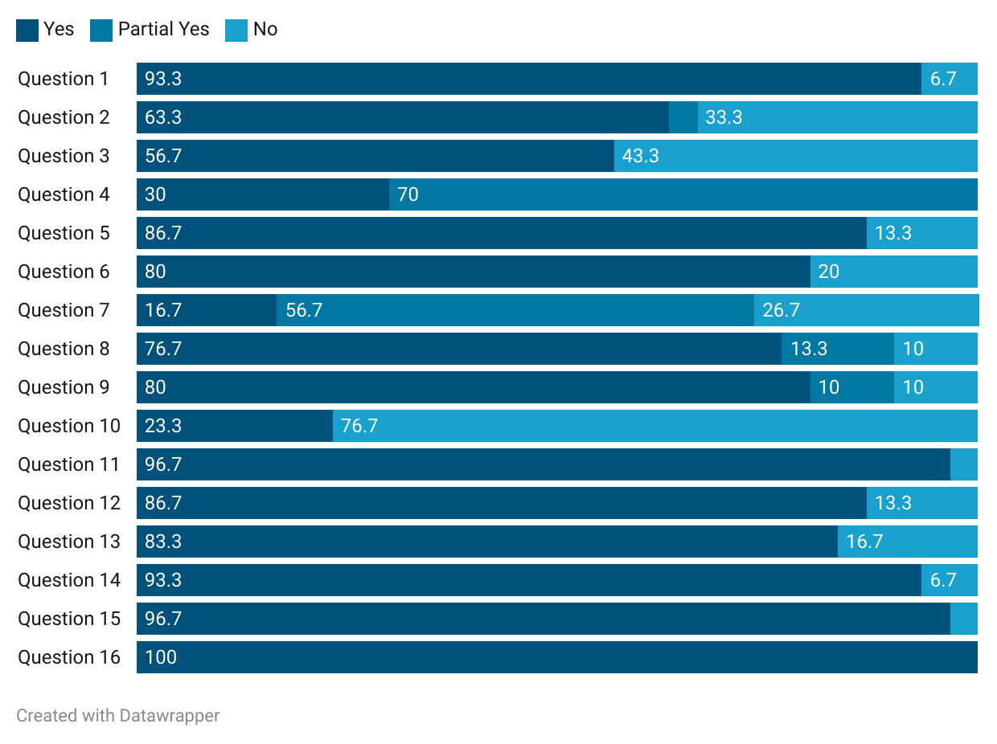

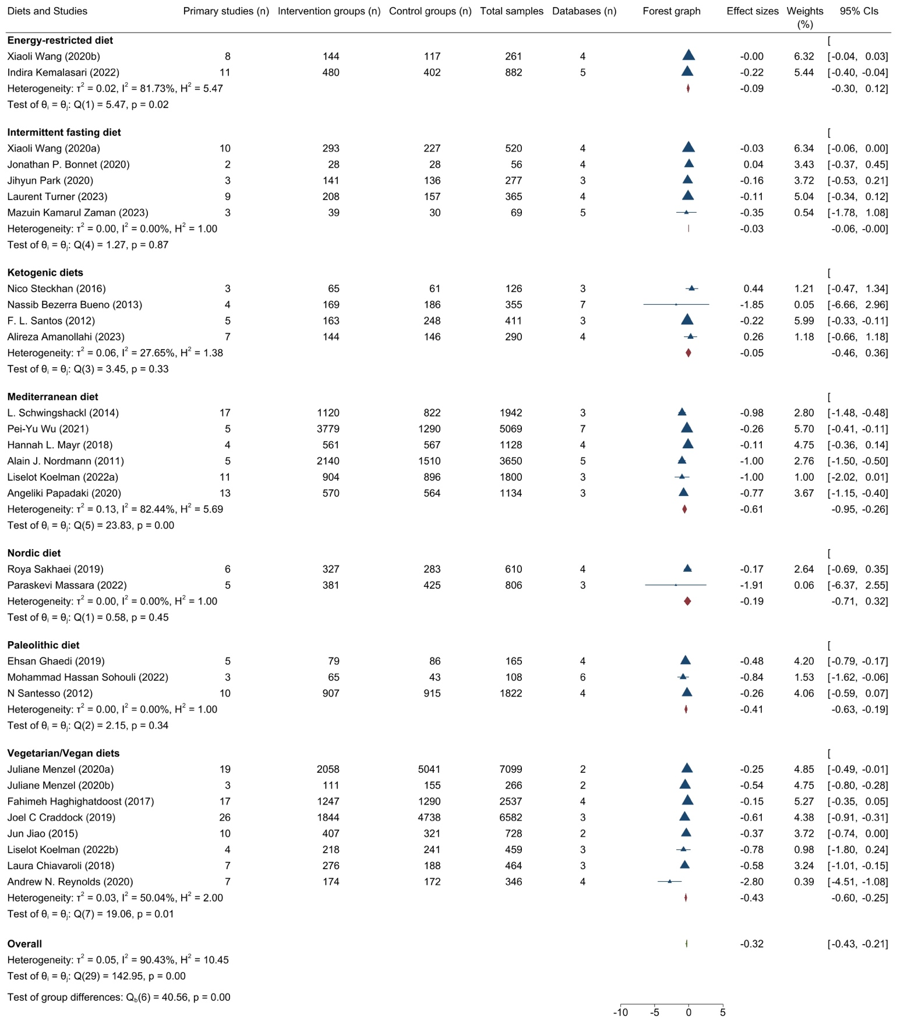
Figure S2. Forest plots illustrating the impact of seven dietary patterns on circulating CRP levels in the general adult population
Results are presented as mean difference (MD) (95%-CI). The study-specific MD and 95%-CI are represented by the blue triangle and horizontal line, respectively. The center of the triangle and the vertical dashed line represent the overall effect size of all studies; the width of the red triangle represents the overall pooled 95%-CI. Unit of CRP levels in effect size calculations: mg/L.

Figure S3. Forest plots showing the impact of the Mediterranean diet on circulating CRP levels in the general adult population, segregated by study designs
Results are presented as mean difference (MD) (95%-CI). The study-specific MD and 95%-CI are represented by the blue triangle and horizontal line, respectively. The center of the triangle and the vertical dashed line represent the overall effect size of all studies; the width of the red triangle represents the overall pooled 95%-CI. Unit of CRP levels in effect size calculations: mg/L.

Figure S4. Forest plots showing the impact of the Vegetarian/Vegan diets on circulating CRP levels in the general adult population, segregated by study designs

Results are presented as mean difference (MD) (95%-CI). The study-specific MD and 95%-CI are represented by the blue triangle and horizontal line, respectively. The center of the triangle and the vertical dashed line represent the overall effect size of all studies; the width of the red triangle represents the overall pooled 95%-CI. Unit of CRP levels in effect size calculations: mg/L.

Figure S5. Forest plots showing the impact of the Ketogenic diets on circulating CRP levels in the general adult population, segregated by study designs

Results are presented as mean difference (MD) (95%-CI). The study-specific MD and 95%-CI are represented by the blue triangle and horizontal line, respectively. The center of the triangle and the vertical dashed line represent the overall effect size of all studies; the width of the red triangle represents the overall pooled 95%-CI. Unit of CRP levels in effect size calculations: mg/L.

Figure S6. Funnel plot analysis of the impact of the Mediterranean diet on circulating CRP levels in the general adult population

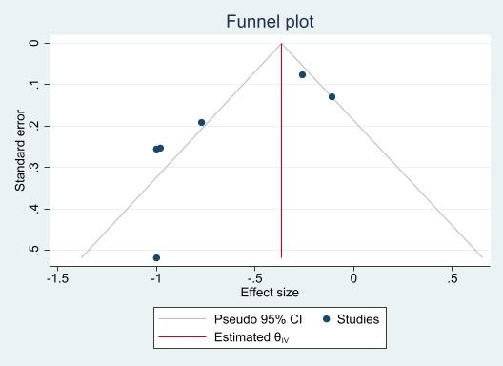

Figure S7. Funnel plot analysis of the impact of the Vegetarian/Vegan diets on circulating CRP levels in the general adult population

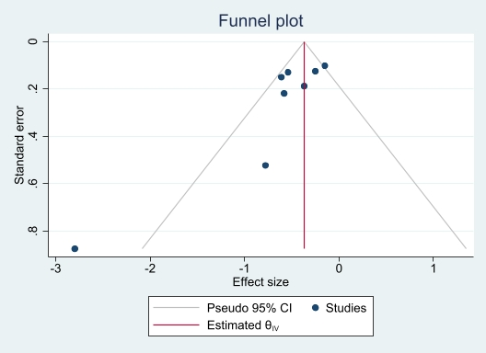

References

1. Fusar-Poli P, Radua J. Ten simple rules for conducting umbrella reviews. Evid Based Ment Health. 2018;21(3):95-100.
2. Veettil SK, Wong TY, Loo YS, Playdon MC, Lai NM, Giovannucci EL, et al. Role of Diet in Colorectal Cancer Incidence: Umbrella Review of Meta-analyses of Prospective Observational Studies. JAMA Netw Open. 2021;4(2):e2037341.
3. Menzel J, Jabakhanji A, Biemann R, Mai K, Abraham K, Weikert C. Systematic review and meta-analysis of the associations of vegan and vegetarian diets with inflammatory biomarkers. Scientific Reports. 2020;10(1):21736.
4. Ghaedi E, Mohammadi M, Mohammadi H, Ramezani-Jolfaie N, Malekzadeh J, Hosseinzadeh M, et al. Effects of a Paleolithic Diet on Cardiovascular Disease Risk Factors: A Systematic Review and Meta-Analysis of Randomized Controlled Trials. Advances in Nutrition. 2019;10(4):634-46.
5. Wang X, Yan Q, Liao Q, Li M, Zhang P, Santos HO, et al. Effects of intermittent fasting diets on plasma concentrations of inflammatory biomarkers: A systematic review and meta-analysis of randomized controlled trials. Nutrition. 2020;79-80.
6. Kemalasari I, Fitri NA, Sinto R, Tahapary DL, Harbuwono DS. Effect of calorie restriction diet on levels of C reactive protein (CRP) in obesity: A systematic review and meta-analysis of randomized controlled trials. Diabetes and Metabolic Syndrome: Clinical Research and Reviews. 2022;16(3).
7. Haghighatdoost F, Bellissimo N, Totosy De Zepetnek JO, Rouhani MH. Association of vegetarian diet with inflammatory biomarkers: A systematic review and meta-analysis of observational studies. Public Health Nutrition. 2017;20(15):2713-21.
8. Schwingshackl L, Hoffmann G. Mediterranean dietary pattern, inflammation and endothelial function: a systematic review and meta-analysis of intervention trials. Nutr Metab Cardiovasc Dis. 2014;24(9):929-39.
9. Wu PY, Chen KM, Tsai WC. The Mediterranean Dietary Pattern and Inflammation in Older Adults: A Systematic Review and Meta-Analysis. Advances in Nutrition. 2021;12(2):363-73.
10. Steckhan N, Hohmann CD, Kessler C, Dobos G, Michalsen A, Cramer H. Effects of different dietary approaches on inflammatory markers in patients with metabolic syndrome: A systematic review and meta-analysis. Nutrition. 2016;32(3):338-48.
11. Craddock JC, Neale EP, Peoples GE, Probst YC. Vegetarian-Based Dietary Patterns and their Relation with Inflammatory and Immune Biomarkers: A Systematic Review and Meta-Analysis. Advances in Nutrition. 2019;10(3):433-51.
12. Mayr HL, Tierney AC, Thomas CJ, Ruiz-Canela M, Radcliffe J, Itsiopoulos C. Mediterranean-type diets and inflammatory markers in patients with coronary heart disease: a systematic review and meta-analysis. Nutrition Research. 2018;50:10-24.
13. Jiao J, Xu JY, Zhang W, Han S, Qin LQ. Effect of dietary fiber on circulating C-reactive protein in overweight and obese adults: a meta-analysis of randomized controlled trials. Int J Food Sci Nutr. 2015;66(1):114-9.
14. Nordmann AJ, Suter-Zimmermann K, Bucher HC, Shai I, Tuttle KR, Estruch R, et al. Meta-analysis comparing Mediterranean to low-fat diets for modification of cardiovascular risk factors. Am J Med. 2011;124(9):841-51.e2.
15. Koelman L, Egea Rodrigues C, Aleksandrova K. Effects of Dietary Patterns on Biomarkers of Inflammation and Immune Responses: A Systematic Review and Meta-Analysis of Randomized Controlled Trials. Advances in Nutrition. 2022;13(1):101-15.
16. Sakhaei R, Ramezani-Jolfaie N, Mohammadi M, Salehi-Abargouei A. The healthy Nordic dietary pattern has no effect on inflammatory markers: A systematic review and meta-analysis of randomized controlled clinical trials. Nutrition. 2019;58:140-8.
17. Bueno NB, de Melo IS, de Oliveira SL, da Rocha Ataide T. Very-low-carbohydrate ketogenic diet v. low-fat diet for long-term weight loss: a meta-analysis of randomised controlled trials. Br J Nutr. 2013;110(7):1178-87.
18. Sohouli MH, Fatahi S, Lari A, Lotfi M, Seifishahpar M, Găman MA, et al. The effect of paleolithic diet on glucose metabolism and lipid profile among patients with metabolic disorders: a systematic review and meta-analysis of randomized controlled trials. Critical Reviews in Food Science and Nutrition. 2022;62(17):4551-62.
19. Santos FL, Esteves SS, da Costa Pereira A, Yancy WS, Jr., Nunes JP. Systematic review and meta-analysis of clinical trials of the effects of low carbohydrate diets on cardiovascular risk factors. Obes Rev. 2012;13(11):1048-66.
20. Papadaki A, Nolen-Doerr E, Mantzoros CS. The effect of the mediterranean diet on metabolic health: A systematic review and meta-analysis of controlled trials in adults. Nutrients. 2020;12(11):1-21.
21. Massara P, Zurbau A, Glenn AJ, Chiavaroli L, Khan TA, Viguiliouk E, et al. Nordic dietary patterns and cardiometabolic outcomes: a systematic review and meta-analysis of prospective cohort studies and randomised controlled trials. Diabetologia. 2022;65(12):2011-31.
22. Bonnet JP, Cardel MI, Cellini J, Hu FB, Guasch-Ferré M. Breakfast Skipping, Body Composition, and Cardiometabolic Risk: A Systematic Review and Meta-Analysis of Randomized Trials. Obesity (Silver Spring). 2020;28(6):1098-109.
23. Park J, Seo YG, Paek YJ, Song HJ, Park KH, Noh HM. Effect of alternate-day fasting on obesity and cardiometabolic risk: A systematic review and meta-analysis. Metabolism: Clinical and Experimental. 2020;111.
24. Chiavaroli L, Nishi SK, Khan TA, Braunstein CR, Glenn AJ, Mejia SB, et al. Portfolio Dietary Pattern and Cardiovascular Disease: A Systematic Review and Meta-analysis of Controlled Trials. Progress in Cardiovascular Diseases. 2018;61(1):43-53.
25. Turner L, Charrouf R, Martínez-Vizcaíno V, Hutchison A, Heilbronn LK, Fernández-Rodríguez R. The effects of time-restricted eating versus habitual diet on inflammatory cytokines and adipokines in the general adult population: a systematic review with meta-analysis. LID - S0002-9165(23)66183-0 [pii] LID - 10.1016/j.ajcnut.2023.10.009 [doi]. (1938-3207 (Electronic)).
26. Kamarul Zaman M, Teng N, Kasim SS, Juliana N, Alshawsh MA. Effects of time-restricted eating with different eating duration on anthropometrics and cardiometabolic health: A systematic review and meta-analysis. (1949-8462 (Print)).
27. Reynolds AN, Akerman AP, Mann J. Dietary fibre and whole grains in diabetes management: Systematic review and meta-analyses. PLoS Med. 2020;17(3):e1003053.
28. Amanollahi A, Khazdouz M, Malekahmadi M, Klement RJ, Lee D, Khodabakhshi A. Effect of Ketogenic Diets on Cardio-Metabolic Outcomes in Cancer Patients: A Systematic Review and Meta-Analysis of Controlled Clinical Trials. Nutr Cancer. 2023;75(1):95-111.
29. Santesso N, Akl EA, Bianchi M, Mente A, Mustafa R, Heels-Ansdell D, et al. Effects of higher-versus lower-protein diets on health outcomes: A systematic review and meta-analysis. European Journal of Clinical Nutrition. 2012;66(7):780-8.

