**Supplementary Appendix**

This appendix has been provided by the authors to bring readers additional information about their work.

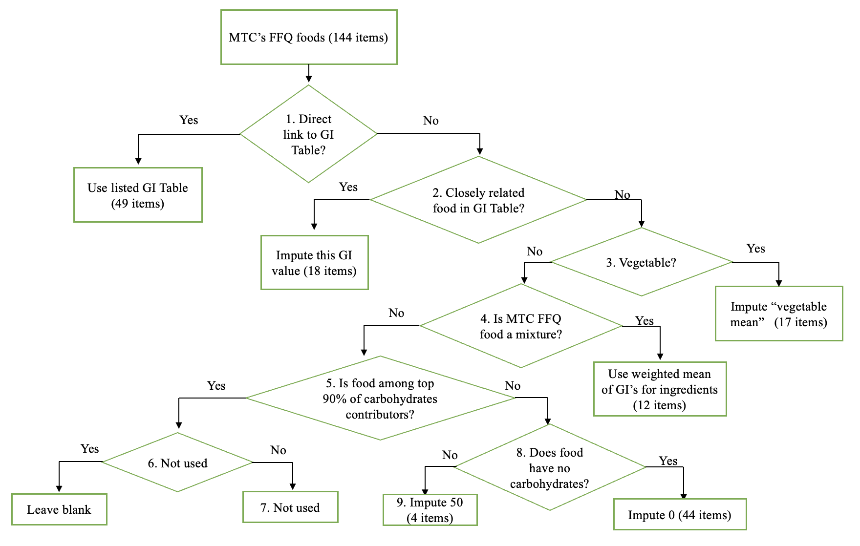

**Figure S1** Nine-step Glycemic Index (GI) algorithm used to assign GI values to foods to MTC food-frequency questionnaire. Steps: 1: determined if the food item in the MTC FFQ had a direct link to a food in international glycemic index tables; 2: Determined if there was a closely related food in the international glycemic index tables; 3: Determined if the food item was a vegetable; 4: Determined if the food item was a simple mixture of foods in the international glycemic index tables or if the food item was a mixed dish; 5: Determined if the food item was in a food group that was in the top 90% of carbohydrate-contributing food groups to the diet as measured by the MTC FFQ; 8: For foods without carbohydrate content, assigned a GI value of zero; 9: Imputed a medium GI value of 50. Adapted from Flood, *et al.*, 2005(19)

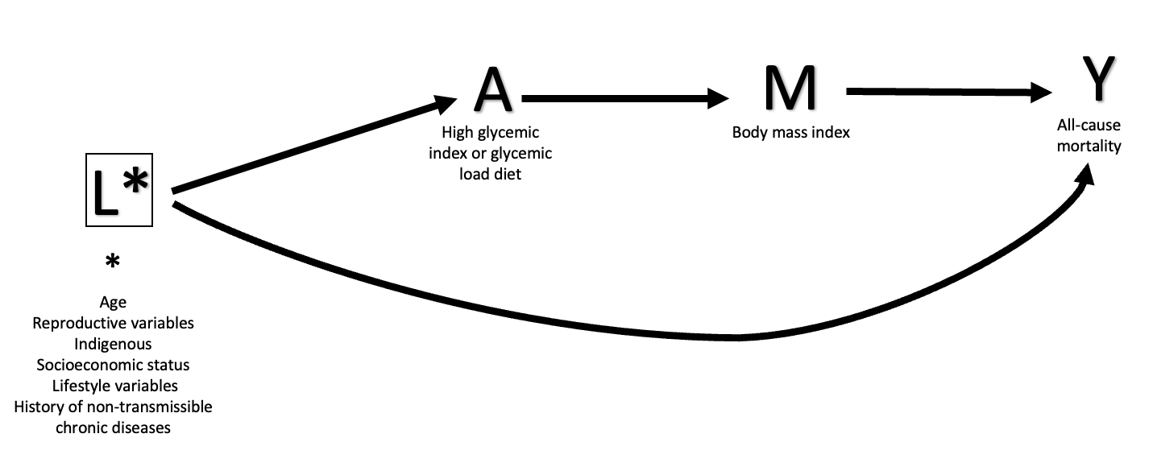

**Figure S2A** Directed acyclic graph showing how confounding by some determinants can be addressed when estimating the total causal effect of a nutritional exposure (high glycemic index and/or glycemic load diet) on an outcome (all-cause mortality).

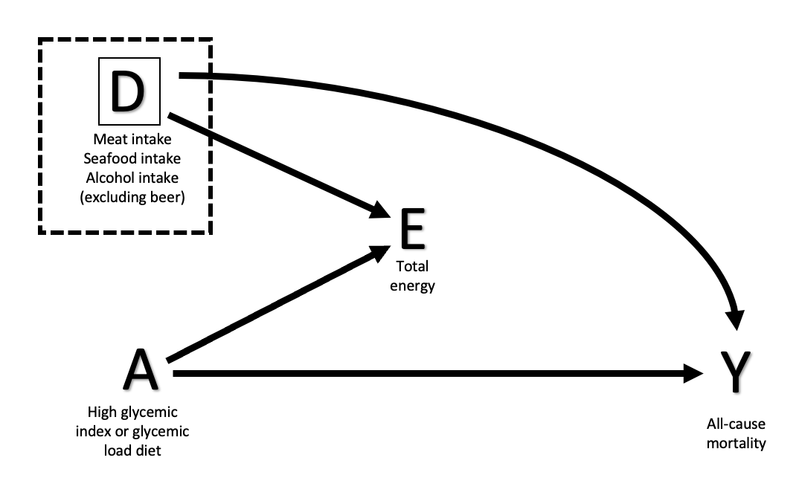

**Figure S2B** Directed acyclic graph showing the compositional nature of nutritional data. Total energy intake is determined by the energy intake from meat, seafood, and alcohol, as well as items include in the GI and GL.

|  |  |  |  |  |
| --- | --- | --- | --- | --- |
| **TABLE S1** Glycemic index values and share of dietary glycemic load from the MTC’s food frequency questionnaire. 2006-08 | | | | |
|  | **Item** | **Glycemic Index** | **Glycemic Load** | **%Dietary Glycemic**  **Load** |
|  |
| 1 | Corn tortilla, nixtamal process | 52 | 8.4 | 10.45 |
| 2 | Fruit flavored beverage | 65 | 9.3 | 4.95 |
| 3 | Rice long grain, average | 62 | 17.7 | 4.28 |
| 4 | Carbonated beverage, cola, contains caffeine (average) | 63 | 21.4 | 4.20 |
| 5 | Bananas, raw/Banana, ripe (all yellow) | 49 | 19.7 | 3.89 |
| 6 | Bread, white baguette like | 57 | 20.7 | 3.89 |
| 7 | Water of hibiscus, sweetened | 65 | 18.8 | 3.84 |
| 8 | White wheat flour bread, mean of 24 studies | 72 | 28.0 | 3.73 |
| 9 | Ready-to-eat cereals (Cornflakes, average) | 78 | 19.7 | 3.22 |
| 10 | Bread, sweet | 50 | 12.0 | 3.13 |
| 11 | Oranges & tangerines (navel) raw, average | 40 | 10.1 | 2.93 |
| 12 | Orange juice, average | 50 | 13.9 | 2.76 |
| 13 | Corn, sweet, white, raw, cooked | 48 | 36.1 | 2.71 |
| 14 | Carb beverage not cola, average | 64 | 25.0 | 2.33 |
| 15 | Candy, hard | 70 | 20.6 | 2.04 |
| 16 | Apples, raw, with skin, average | 40 | 7.7 | 1.90 |
| 17 | Doughnut, wheat dough, deep-fried | 75 | 19.7 | 1.89 |
| 18 | Whole wheat flour bread, average | 74 | 10.7 | 1.83 |
| 19 | Tamales, made from maize, average | 72 | 38.1 | 1.76 |
| 20 | Mangos,raw (Chin-Hwang Mango) | 43 | 13.5 | 1.74 |
| 21 | Boiled potato, mean of 29 studies | 71 | 11.6 | 1.70 |
| 22 | Bran flakes, averaged | 63 | 21.4 | 1.66 |
| 23 | Pineapple, raw (Ananas comosus) | 66 | 13.0 | 1.43 |
| 24 | Porridge made from rolled oats, average | 58 | 11.5 | 1.40 |
| 25 | Milk, full-fat, average | 40 | 4.6 | 1.33 |
| 26 | Atole without milk, average | 67 | 34.2 | 1.30 |
| 27 | Paw paw and papaya, raw (Carica papaya) | 65 | 6.5 | 1.29 |
| 28 | Maize meal porridge, refined, maize-meal | 58 | 17.2 | 1.15 |
| 29 | Reduced-fat or low-fat milk, average | 45 | 5.4 | 1.14 |
| 30 | Cake, average | 42 | 27.8 | 1.01 |
| 31 | Yambean (jicama), raw | 66 | 9.5 | 0.97 |
| 32 | Fast food, Burger King & McDonald's, hamburger average | 66 | 36.4 | 0.93 |
| 33 | Cookies, Sweet biscuit, average | 69 | 7.5 | 0.90 |
| 34 | Beans, black, mature seeds & refried beans | 14 | 2.7 | 0.89 |
| 35 | Fried snack average (chips, pretzels, cheese puffs) | 57 | 13.1 | 0.86 |
| 36 | Pear, Williams, raw, under ripe/crunchy | 29 | 6.2 | 0.79 |
| 37 | Breakfast cereal bars, average | 57 | 9.7 | 0.77 |
| 38 | Apricots & peaches (Prunus persica), raw | 55 | 8.5 | 0.71 |
| 39 | Wheat tortilla | 30 | 5.2 | 0.70 |
| 40 | Desserts, flan, caramel custard, prepared-from-recipe | 33 | 6.6 | 0.70 |
| 41 | Black, yellow, green, white sapote, sapodilla, average | 50 | 34.6 | 0.63 |
| 42 | Sapote, mamey, raw | 50 | 25.3 | 0.62 |
| 43 | Chocolate, milk, plain, average | 47 | 9.9 | 0.61 |
| 44 | Ice cream, Premium (high fat), average | 57 | 12.1 | 0.60 |
| 45 | Melon (Cucumis melon) | 60 | 6.0 | 0.60 |
| 46 | Yakult, fermented milk drink | 58 | 6.8 | 0.59 |
| 47 | Carrots (raw, diced, ground, peeled, boiled), average | 47 | 3.3 | 0.53 |
| 48 | Prickly pears, raw | 50 | 7.8 | 0.51 |
| 49 | Tacos without frying, average | 47 | 9.8 | 0.51 |
| 50 | Milk, red fat, fluid, 2% milkfat | 27 | 3.1 | 0.51 |

The MTC, the Mexican Teachers Cohort.

|  |  |  |  |
| --- | --- | --- | --- |
| **TABLE S2** |  |  |  |
| Participant characteristics by baseline database without prevalent cases(I), I without non-valid questionnaires(II), only non-valid questionnaires (III) in the Mexican women from the MTC* | | | |
|  | I | II | III |
| Participants, *n* | 106,847 | 86,610 | 20,237 |
| Overall Glycemic Index † | 52.7(4.6) | 52.9(4.3) | 51.2(6.0) |
| Dietary Glycemic load † | 129.0(84.2) | 130.1(72.5) | 115.6(238.9) |
| Age at questionnaire, years | 42.3 ± 7.5 | 42.3 ± 7.4 | 42.3 ± 7.9 |
| Socioeconomic status tertile |  |  |  |
| Low tertile | 32.0 | 30.8 | 37.4 |
| High tertile | 38.8 | 39.9 | 34.2 |
| Indigenous, | 8.2 | 7.8 | 9.3 |
| Family history of hypertension | 66.4 | 66.6 | 65.4 |
| Family history of type 2 diabetes | 53.7 | 53.5 | 54.2 |
| Family history of heart attack | 25.4 | 25.1 | 27.1 |
| Age at menarche |  |  |  |
| Lower than 11 years, | 24.1 | 24.2 | 24.3 |
| Mean age at menarche | 12.5 ± 1.5 | 12.5 ± 1.5 | 12.6 ± 1.6 |
| Breastfeeding |  |  |  |
| Nulliparous | 16.4 | 16.2 | 17.8 |
| < 6 months | 25.6 | 25.3 | 26.7 |
| ≥ 6 months | 57.9 | 58.5 | 55.5 |
| Postmenopausal | 15.2 | 15.0 | 16.2 |
| Postmenopausal hormone use | 8.8 | 8.9 | 8.7 |
| Hypertension | 14.9 | 14.4 | 13.5 |
| Hypercholesterolemia | 15.6 | 16.1 | 13.5 |
| Mean total intensity exercise, MET/hours/week | 32.3 ± 30 | 32.4 ± 29.5 | 31.9 ± 32.2 |
| Smoking status |  |  |  |
| Never | 77.1 | 76.2 | 78.0 |
| Current & Past | 23.8 | 23.8 | 23.8 |
| Alcohol consumption, servings/semana | 0.4 ± 1.4 | 0.4 ± 1.0 | 0.6 ±2.6 |
| Body mass index, kg/m2 | 27.2 ± 4.6 | 27.2 ± 4.6 | 27.1(4.7) |
| Body mass index, categories |  |  |  |
| Normal | 35.6 | 35.4 | 36.5 |
| Overweight | 41.6 | 41.9 | 40.4 |
| Obesity | 22.8 | 22.7 | 23.2 |
| Total energy, kcal/day | 1,926 ± 1,200 | 1,817 ± 626 | 2,452 ± 2,470 |
| Red meat consumption, servings/d | 1.5 ± 1.4 | 1.4 ± 0.9 | 1.8± 2.9 |
| Seafood consumption, servings/d | 0.4 ± 0.9 | 0.3 ± 0.4 | 0.6 ± 1.9 |
| Carbohydrate, by difference, grams/d | 279.8 ± 182.9 | 263.8 ± 103.6 | 355.8 ± 367.1 |
| * Values are means ± SDs or percentages unless stated otherwise and are standardized to the age distribution | | | |
| of the study population. Values of polytomous variables may not sum to 100% due to rounding. | | | |
| MET, Metabolic equivalent from recreational and leisure-time activities; the MTC, the Mexican Teachers Cohort. | | | |
| † Median (interquartile range). |  |  |  |

|  |  |  |  |  |  |  |  |  |  |
| --- | --- | --- | --- | --- | --- | --- | --- | --- | --- |
| **TABLE S3** |  |  |  |  |  |  |  |  |  |
| Hazard ratios (HR) and 95% confidence intervals (95% CIs) for all-cause mortality by quintiles (Q) of dietary glycemic index (GI) and glycemic load (GL) without alcohol in 86,610 Mexican women from the MTC (2006-2008)* | | | | | | | | | |
|  |  |  |  |  |  |  |  |  |  |
|  | Quintile of dietary glycemic index and load score | | | | | | |  |  |
|  | 1(lowest) | 2 |  | 3 |  | 4 |  | 5 (highest) | |
| *Dietary GI original* |  |  |  |  |  |  |  |  |  |
| Median (interquartile range) | 47.4(3.6) | 50.8(1.1) | | 52.6(0.9) | | 54.4(1.0) | | 57.4(2.4)) | |
| No. of deaths | 274 | 243 |  | 245 |  | 206 |  | 230 |  |
| Multivariable HR† | 1 | 1.04 | (0.87,1.25) | 1.13 | (0.94,1.35) | 0.98 | (0.81,1.19) | 1.12 | (0.93,1.35) |
| *Dietary GI without alcohol* | |  |  |  |  |  |  |  |  |
| Median (interquartile range) | 47.4(3.6) | 50.8(1.1) | | 52.6(0.9) | | 54.4(1.0) | | 57.3(2.4) | |
| No. of deaths | 271 | 249 |  | 231 |  | 217 |  | 230 |  |
| Multivariable HR† | 1 | 1.08 | (0.90,1.29) | 1.08 | (0.90,1.29) | 1.05 | (0.87,1.26) | 1.13 | (0.94,1.37) |
| *Dietary GL original* |  |  |  |  |  |  |  |  |  |
| Median (interquartile range) | 48.4(6.2) | 73.9(26.5) | | 111.3(16.4) | | 146.0(20.0) | | 202.6(48.8) | |
| No. of deaths | 310 | 247 |  | 203 |  | 219 |  | 219 |  |
| Multivariable HR† | 1 | 1.09 | (0.89,1.34) | 1.01 | (0.79,1.30) | 1.11 | (0.86,1.42) | 1.12 | (0.87,1.44) |
| *Dietary GL without alcohol)* | |  |  |  |  |  |  |  |  |
| Median (interquartile range) | 74.0(21.4) | 104.2(12.8) | | 130.2(13.5) | | 160.9(18.4) | | 214.6(46.3) | |
| No. of deaths | 248 | 230 |  | 252 |  | 231 |  | 237 |  |
| Multivariable HR† | 1 | 0.96 | (0.81,1.16) | 1.06 | (0.89,1.27) | 0.96 | (0.80,1.16) | 0.98 | (0.82,1.18) |
| * HRs and 95% CIs estimated from Cox proportional hazard model. The MTC, the Mexican Teachers Cohort. | | | | | | | | | |
| † Includes the following: age, socioeconomic status, indigenous, age at menarche (≤11 years, ≥12), breastfeeding | | | | | | | | | |
| (nulliparous, < 6 months, ≥ 6 months), menopausal status (premenopausal, postmenopausal, don't know), family history | | | | | | | | | |
| of hypertension, of diabetes, of heart attack and of breast cancer (no, yes), smoking status (never, ex-smoker, current), | | | | | | | | | |
| total intensity exercise, red meat, and seafood intake (servings/d), and alcohol consumption (excluding beer, servings/week). | | | | | | | | | |

|  |  |  |  |  |  |  |  |  |  |
| --- | --- | --- | --- | --- | --- | --- | --- | --- | --- |
| **TABLE S4** |  |  |  |  |  |  |  |  |  |
| Hazard ratios (HR) and 95% confidence intervals (95% CIs) for all-cause mortality by quintiles (Q) of dietary glycemic index (GI) and glycemic load (GL) in the Mexican women from the MTC, including Body Mass Index (kg/m2) and Total Energy (kcal/d)* | | | | | | | | | |
|  |  |  |  |  |  |  |  |  |  |
|  | Quintile of dietary glycemic index an load score | | | | |  |  |  |  |
|  | 1(lowest) | 2 |  | 3 |  | 4 |  | 5 (highest) | |
| *Dietary GI* |  |  |  |  |  |  |  |  |  |
| Multivariable HR† + BMI | 1 | 1.04 | (0.87,1.24) | 1.12 | (0.93,1.34) | 0.97 | (0.80,1.17) | 1.10 | (0.91,1.32) |
| Multivariable HR† + Total Energy | 1 | 1.04 | (0.87,1.24) | 1.13 | (0.94,1.35) | 0.98 | (0.81,1.19) | 1.12 | (0.93,1.35) |
| *Dietary GL* |  |  |  |  |  |  |  |  |  |
| Multivariable HR† + BMI | 1 | 1.08 | (0.88,1.32) | 1.00 | (0.78,1.29) | 1.10 | (0.86,1.41) | 1.11 | (0.86,1.42) |
| Multivariable HR† + Total Energy | 1 | 1.08 | (0.88,1.33) | 1.03 | (0.80,1.33) | 1.15 | (0.89,1.50) | 1.22 | (0.90,1.64) |
| * HRs and 95% CIs estimated from Cox proportional hazard model. The MTC, the Mexican Teachers Cohort. | | | | | | | | |  |
| † Includes the following: age, socioeconomic status, indigenous, age at menarche (≤11 years, ≥12), breastfeeding (nulliparous, < 6 months, ≥ 6 months), | | | | | | | | | |
| menopausal status (premenopausal, postmenopausal, don't know), family history of hypertension, of diabetes, of heart attack, and of breast cancer | | | | | | | | | |
| (no, yes), smoking status (never, ex-smoker, current), total intensity exercise, red meat, and seafood intake (servings/d), | | | | | | | | | |
| and alcohol consumption (excluding beer, servings/week). | | | |  |  |  |  |  |  |

|  |  |  |  |  |  |  |  |  |  |
| --- | --- | --- | --- | --- | --- | --- | --- | --- | --- |
| **TABLE S5** |  |  |  |  |  |  |  |  |  |
| Hazard ratios (HR) and 95% confidence intervals (95% CIs) for all-cause mortality by quintiles (Q) of dietary glycemic index (GI) and glycemic load (GL) calculated by a 7-category approach from the MTC (2006-2008)* | | | | | | | | | |
|  |  |  |  |  |  |  |  |  |  |
|  | Quintile of dietary glycemic index and load score | | | | | | |  |  |
|  | 1(lowest) | 2 |  | 3 |  | 4 |  | 5 (highest) | |
| *Dietary GI original* |  |  |  |  |  |  |  |  |  |
| Median (interquartile range) | 47.7(3.6) | 50.9(1.1) | | 52.7(0.9) | | 54.5(1.0) | | 57.4(2.4) | |
| No. of deaths | 274 | 243 |  | 245 |  | 206 |  | 230 |  |
| Multivariable HR† | 1 | 1.04 | (0.87,1.25) | 1.13 | (0.94,1.35) | 0.98 | (0.81,1.19) | 1.12 | (0.93,1.35) |
| *Dietary GI by category approach* | |  |  |  |  |  |  |  |  |
| Median (interquartile range) | 49.1(3.0) | 52.4(1.2) | | 54.5(0.96) | | 56.5(1.1) | | 59.3(2.3) | |
| No. of deaths | 292 | 254 |  | 232 |  | 218 |  | 202 |  |
| Multivariable HR† | 1 | 1.02 | (0.86,1.21) | 1.02 | (0.85,1.23) | 1.01 | (0.84,1.22) | 0.95 | (0.78,1.16) |
| *Dietary GL original* |  |  |  |  |  |  |  |  |  |
| Median (interquartile range) | 48.4(6.2) | 73.9(26.5) | | 111.3(16.4) | | 146.0(20.0) | | 202.6(48.8) | |
| No. of deaths | 310 | 247 |  | 203 |  | 219 |  | 219 |  |
| Multivariable HR† | 1 | 1.09 | (0.89,1.34) | 1.01 | (0.79,1.30) | 1.11 | (0.86,1.42) | 1.12 | (0.87,1.44) |
| *Dietary GL by category approach* | | |  |  |  |  |  |  |  |
| Median (interquartile range) | 77.4(22.3) | 108.6(13.4) | | 135.0(13.8) | | 166.2(19.0) | | 220.2(46.7) | |
| No. of deaths | 257 | 224 |  | 255 |  | 228 |  | 234 |  |
| Multivariable HR† | 1 | 0.91 | (0.76,1.09) | 1.03 | (0.87,1.23) | 0.93 | (0.78,1.12) | 0.94 | (0.78,1.12) |
| * HRs and 95% CIs estimated from Cox proportional hazard model. The MTC, the Mexican Teachers Cohort. | | | | | | | | | |
| † Includes the following: age, socioeconomic status, indigenous, age at menarche (≤11 years, ≥12), breastfeeding | | | | | | | | | |
| (nulliparous, < 6 months, ≥ 6 months), menopausal status (premenopausal, postmenopausal, don't know), family history | | | | | | | | | |
| of hypertension, of diabetes, of heart attack and of breast cancer (no, yes), smoking status (never, ex-smoker, current), | | | | | | | | | |
| total intensity exercise, red meat, and seafood intake (servings/d), and alcohol consumption (excluding beer, servings/week). | | | | | | | | | |

|  |  |  |  |  |  |  |  |  |  |
| --- | --- | --- | --- | --- | --- | --- | --- | --- | --- |
| **TABLE S6** |  |  |  |  |  |  |  |  |  |
| Hazard ratios (HR) and 95% confidence intervals (95% CIs) for all-cause mortality by quintiles (Q) of food groups (servings/week) in 86,610 Mexican women from the MTC (2006-2008)* | | | | | | | | | |
|  |  |  |  |  |  |  |  |  |  |
|  | Quintile of food groups | | |  |  |  |  |  |  |
|  | 1(lowest) | 2 |  | 3 |  | 4 |  | 5 (highest) | |
| *Fruits* |  |  |  |  |  |  |  |  |  |
| Median (interquartile range) | 7.1(3.6) | 13.5(3.1) | | 20.1(3.6) | | 28.7(5.5) | | 46.4(18.6) | |
| No. of deaths | 214 | 245 |  | 238 |  | 253 |  | 248 |  |
| Multivariable HR† | 1 | 1.14 | (0.95,1.37) | 1.07 | (0.89,1.29) | 1.09 | (0.91,1.31) | 1.01 | (0.84,1.22) |
| *Non-carbonated sugar sweetened beverages* | |  |  |  |  |  |  |  |  |
| Median (interquartile range) | 0.8(0.7) | 3.2(1.4) |  | 6.0(1.1) |  | 9.0(3.0) |  | 20.7(13.8) | |
| No. of deaths | 251 | 239 |  | 250 |  | 225 |  | 233 |  |
| Multivariable HR† | 1 | 1.00 | (0.84,1.20) | 1.00 | (0.84,1.19) | 0.93 | (0.77,1.11) | 0.90 | (0.75,1.07) |
| *Carbonated sugar sweetened beverages* |  |  |  |  |  |  |  |  |  |
| Median (interquartile range) | 0.2(0.2) | 1(0.3) |  | 1.2(0.1) |  | 3.2(2.0) |  | 7(4.0) |  |
| No. of deaths | 208 | 281 |  | 209 |  | 249 |  | 251 |  |
| Multivariable HR† | 1 | 0.89 | (0.74,1.06) | 1.06 | (0.87,1.28) | 1.06 | (0.88,1.27) | 1.21 | (1.00,1.45) |
| *Corn tortilla* |  |  |  |  |  |  |  |  |  |
| Median (interquartile range) | 3.0(2.4) | 5.5(0.0) |  | 7(0.0) |  | 17.5(0.0) | | 31.5(10.5) | |
| No. of deaths | 324 | 241 |  | 190 |  | 351 |  | 92 |  |
| Multivariable HR† | 1 | 1.24 | (1.05,1.47) | 0.97 | (0.81,1.16) | 0.84 | (0.72,0.98) | 1.06 | (0.84,1.33) |
| * HRs and 95% CIs estimated from Cox proportional hazard model. The MTC, the Mexican Teachers Cohort. | | | | | | | |  |  |
| † Includes the following: age, socioeconomic status, indigenous, age at menarche (≤11 years, ≥12), breastfeeding (nulliparous, < 6 months, ≥ 6 months), | | | | | | | | | |
| menopausal status (premenopausal, postmenopausal, don't know), family history of hypertension, of diabetes, of heart attack, and of breast cancer | | | | | | | | | |
| (no, yes), smoking status (never, ex-smoker, current), total intensity exercise. | | | | |  |  |  |  |  |