Supplementary Information
Supplementary Table I. Descriptive characteristics of older adults in China, WHO SAGE Wave 1 2007-2010: Included and Excluded cases (n=13408)
 | Included  (n=9541) | Excluded  (n=3867) | P-value
Age, y, mean (SD), range | 62.9 (9.3), 50-95 | 63.8 (9.9), 50-99  (n=3826) | <0.0001
Gender, n(%) |  | n=3828
Men | 4450 (46.6) | 1824 (47.7) | 0.279
Women | 5091 (53.4) | 2002 (52.3)
Fruit Intake, serves/day, mean (SD) | 2.4 (2.2) | 2.5 (2.2)  (n=2530) | 0.169
Vegetable Intake, serves/day, mean (SD) | 6.9 (3.9) | 7.2 (4.2) | 0.0006
Education, n (%) |  | n=3867
No formal education | 2305 (24.2) | 1264 (32.7) | <0.001
Less than primary | 1733 (18.2) | 616 (15.9)
Completed primary | 1883 (19.7) | 712 (18.4)
Completed secondary | 1998 (20.9) | 613 (15.8)
Completed high school | 1223 (12.8) | 461 (11.9)
Completed college/university/ post graduate | 399 (4.2) | 201 (5.2)
Financially Secure, n (%) |  | n=2920
Yes | 6757 (70.8) | 2049 (70.2) | 0.50
No | 2784 (29.2) | 871 (29.8)
Home Ownership, n (%) |  | n=3775
Family-owned | 8439 (88.5) | 3561 (94.3) | <0.001
Rented | 583 (6.1) | 94 (2.5)
Other | 519 (5.4) | 120 (3.2)
Marital Status, n (%) |  | n=3816
Partnered | 7973 (83.6) | 3210 (81.8) | 0.012
Un-partnered | 1568 (16.4) | 696 (18.2)
Social Participation | 14.9 (3.6) | 14.9 (3.6)  (n=3336) | 0.611
Location, n (%) |  | n=3867
Urban | 4808 (50.4) | 1777 (45.9) | <0.001
Rural | 4733 (49.6) | 2090 (54.1)
Language |  | n=3435
Chinese, Mandarin | 9508 (99.6) | 3423 (99.6) | 0.282
Chinese, other | 27 (0.3) | 12 (0.4)
Other | 6 (0.1) | 0 (0)
Angina, n (%) |  | n=3411
Yes | 1390 (14.6) | 523 (15.3) | 0.280
No | 8151 (85.4) | 2888 (84.7)
Diabetes, n (%) |  | n=3381
Yes | 623 (6.5) | 222 (6.6) | 0.941
No | 8918 (93.5) | 3159 (93.4)
Stroke, n (%) |  | n=3407
Yes | 468 (4.9) | 190 (5.6) | 0.125
No | 9073 (95.1) | 3217 (94.4)
Disability Status, n (%) |  | n=2643
Not | 7786 (81.6) | 2066 (78.2) | <0.001
Severe/Extreme | 1755 (18.4) | 577 (21.8)
Self-Rated Health, n (%) |  | n=3414
Good | 3210 (33.6) | 1163 (34.1) | 0.283
Moderate | 4396 (46.1) | 1524 (44.6)
Bad | 1935 (20.3) | 727 (21.3)
BMI, kg/m², mean (SD) | 23.7 (3.4) | 23.9 (3.4)  (n=2748) | 0.0377
BMI, kg/m², n (%) |  | n=2748
Underweight | 423 (4.4) | 97 (3.5) | 0.073
Normal | 3729 (39.1) | 1039 (37.8)
Increased risk | 4070 (42.7) | 1226 (44.6)
High risk | 1319 (13.8) | 386 (14.1)
Alcohol Consumption, n (%) |  | n=3368
No, never | 6552 (68.7) | 2386 (70.8) | 0.021
Yes, not recently | 987 (10.3) | 350 (10.4)
Yes | 2002 (21.0) | 632 (18.4)
Smoking Status, n (%) |  | n=3383
No | 6942 (72.8) | 2496 (73.8) | 0.250
Yes | 2599 (27.2) | 887 (26.2)
Physical Activity (moderate-vigorous), min/week, mean (SD) | 706 (718) | 561 (714)  (n=3094) | <0.0001
Sedentary Behaviour, min/week, mean (SD) | 1558 (939) | 1634 (957)  n=3094 | 0.0001

Supplementary Figures 1-7: Directed Acyclic Graph Adjustment Models for exposures age, education, financial security, home ownership, marital status, social participation, and urban/rural location
Figure 1
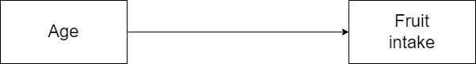

Figure 2
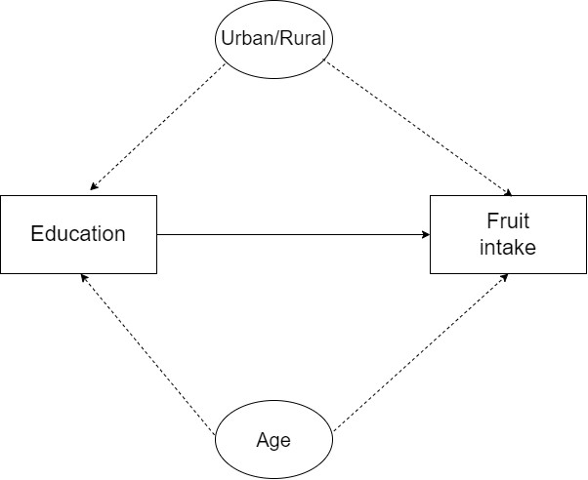

Figure 3
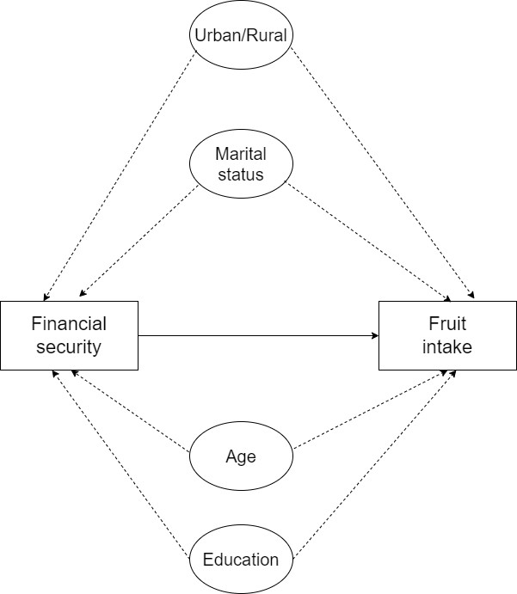

Figure 4
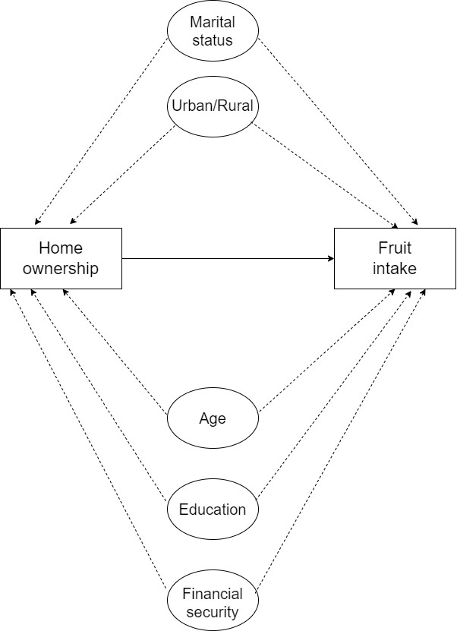

Figure 5
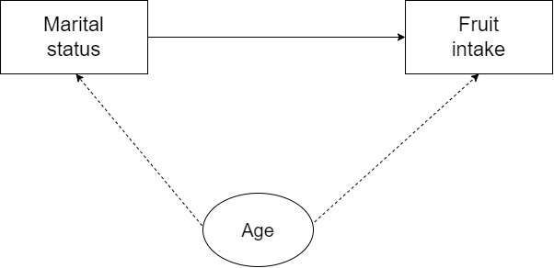

Figure 6
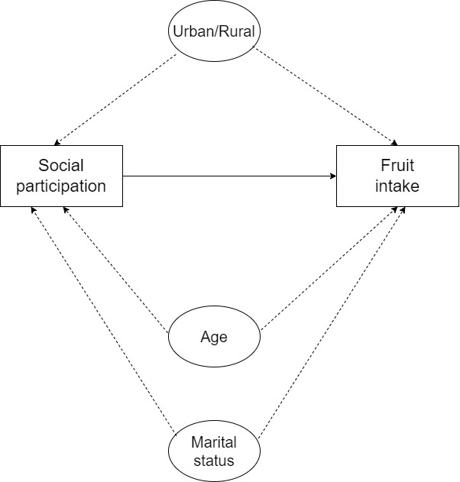

Figure 7

