Supplementary materials for:

**A randomized controlled intervention trial to study the effect of a personalized lifestyle program on cancer-related fatigue among colorectal cancer survivors: protocol for the SoFiT study.**

***Judith de Vries – ten Have et al.***

**Supplementary materials that are included are:**

**Figure S1: Description of the lifestyle program of the SoFiT study**

**Table S1. Brochures and cookbooks and their sources in Dutch [English] used during the coaching**

**Table S2. Approach for changing determinants with behaviour change techniques**

**Figure S2. Research timeline of the SoFiT study**

**Supplementary material: Questionnaire behavioural determinants**

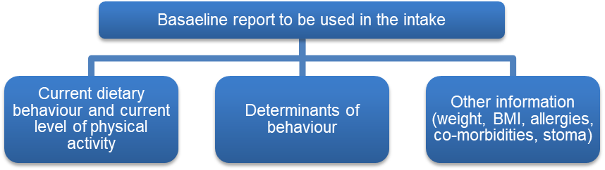

**Participant receives handbook with:**

* Introduction to the lifestyle coaches, researchers, and program
* Information on the WCRF guidelines and its health benefits
* Information on the house visits and measurements
* Weekly fill-in schemes for goal setting, action planning and self-monitoring.
* Brochures (Table S1)

**Session 1. Intake: goals**

* Build relationship & gain trust of the participant.
* Explain the lifestyle program and what cancer-related fatigue entails.
* Obtain a clear picture of the participant and his/her cancer journey (e.g., who does the cooking, who is the partner, how did they experience the cancer journey etc.).
* Discuss mutual expectations of the lifestyle coaching & encourage participant to indicate anything that is not satisfactory during the coaching.
* Discuss baseline report.
* Set goals for the short-term and start with 2 or 3 on behaviour of at least one is a goal on physical activity and one on nutrition. Also set long-term goals (2 or 3 on outcomes of behaviour). Visualize the outcomes: where does the participant see him/her at the end of the six months? Let the participant self-monitor their goals.
* Let participant make an action plan for the next two weeks.
* Get commitment of the participants by asking if participants are willing to go on this journey with the lifestyle coach and whether they had enough motivation to make lifestyle changes.

**Sessions 2-7. Visit/calls: goals**

* Evaluate and monitor progress on goals and provide feedback on the self-monitored behaviour of the participant, set new goals, or adapt goals, add goals if possible.
* Let participant make an action plan and create implementation intentions if needed for changing habitual behaviour (often also already explained during intake).
* Find barriers for changing health behaviours and make action plans for solving these.
* Encourage participant.

Months

0



6

Apply additional behaviour change techniques matched to determinants or if applicable (Table S2)

Apply additional behaviour change techniques matched to determinants or if applicable (Table S2)

Figure S1. Description of the lifestyle program of the SoFiT study

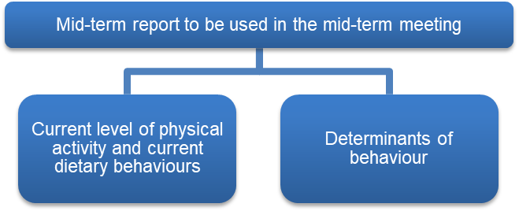

Months

3



6

**Sessions 9-11. Visit/calls**

* Work on goals: monitor goals and give feedback on self-monitored behaviour of the participant, set new goals or adapt goals, add goals if possible.
* Set-up dietary and physical activity plan together with participant for after the intervention period.
* Find issues for changing health behaviours and use behaviour change techniques matched to determinants from report used in the intake to work on these.
* Encourage participant.
* Apply implementation intention.
* Relapse prevention: how to maintain the behaviour after 6 months.

Apply additional behaviour change techniques matched to determinants or if applicable (Table S2)

Apply additional behaviour change techniques matched to determinants or if applicable (Table S2)

**Session 8. Mid-term results meeting**

Looking back

* Recap on the last three months: what has been achieved?
* Review goals based on the mid-term report. If goals are not reached: positive formulation of what has been reached (i.e., focus on past success).
* Check both short- and long-term goals.

Looking forward

* Obtain further commitment of the participants.
* Adjust or maintain goals.
* Find issues for changing health behaviours and use behaviour change techniques matched to determinants from report used in the intake to work on these.

**Session 12. Last call\***

Looking back:

* What has been done, what was aimed to be achieved and what has been achieved? What has become habits and what are still points for attention?
* Evaluation of the SoFiT program: what is their opinion on the coaching and program and did it match with the expectations?

Looking forward

* Relapse prevention: how to maintain the behaviour without relapsing (after the program is finished).
* Action plan after the program finished (i.e., long-term planning).

*These topics are often also discussed during the last house visit which is 2 to 4 weeks before the last call.

**General throughout the entire coaching: person-centred approach**

Consider the preferences, opportunities, and disease-related barriers of the participant.

* Take preferences and opportunities of the participant into account when setting goals and making action plans. Ask participants what type of physical activity they prefer and what they like in terms of foods and drinks. Decide together how goals will be targeted considering challenges participants might have (e.g., lack of financial resources or having no access to sports facilities in the neighbourhood).
* Attention for disease-related barriers such as mental aspects of the disease/treatment (e.g., anxiety, gaining trust in body, acceptance of disease/stoma, dealing with lack of understanding about fatigue of social surroundings), mainly for when these aspects are a barrier for making positive lifestyle behaviours.

Other

* If the participant is experiencing significant mental health issues such as depression, anxiety, or other psychological disorders that may impact their ability to engage in and benefit from the program, the coach may recommend contacting a specialist for additional help (e.g., psychologist or general practitioner).
* Some participants will receive advice on finding a balance between rest and activity.
* Specific brochures, cookbooks and information are given if applicable (Table S1).

General remarks

Apply additional behaviour change techniques matched to determinants or if applicable (Table S2)

Months

6

6

Table S1. Brochures and cookbooks and their sources in Dutch [English] used during the coaching.

|  |  |
| --- | --- |
| Brochures and cookbooks for all participants | Source |
| Hoe verklein ik mijn kans op kanker? [How to reduce my risk of cancer?]* | Wereld Kanker Onderzoek Fonds (WKOF) [World Cancer Research Fund (WCRF)] |
| Gezond eten, de hele dag door! [Healthy eating, all day long!] | WKOF [WCRF] |
| Bewegen & trainen bij kanker [Exercise & training for cancer] | WKOF [WCRF] |
| Kanker en vermoeidheid [Cancer and Fatigue] | KWF kankerbestrijding [Dutch Cancer Society] |
| Breng Beweging in je dag [Bring movement into your day] | Kenniscentrum sport & bewegen [Knowledge centre sport and physical activity] |
| Verfrissend anders [Refreshingly different] | WKOF [WCRF] |
| Happy hapjes [Happy snacks] | WKOF [WCRF] |
| Wat kan ik zelf doen aan mijn vermoeidheid? [What can I do to reduce my fatigue?] | Helen Dowling Institute (HDI) |
| Beweegtips [Exercise tips] | Remission coach A. plus educations |
| Brochures and cookbooks when applicable for a specific participant | **Source** |
| Feestelijk alcoholvrij [Festive alcohol-free] | WKOF [WCRF] |
| Boodschappenlijstje (voor gezonde keuzes) [Shopping list (for making healthy choices)] | WKOF [WCRF] |
| Salade maker en slazaadjes [Salad maker and lettuce seeds] | WKOF [WCRF] |
| Smoothies en sapjes [Smoothies and juices] | WKOF [WCRF] |
| Exercise for strengthening of bones and muscles | Health Council (2017) Physical activity recommendations  World Health Organization: WHO guidelines on physical activity and sedentary behaviour: at a glance.  Hoeveel moet je bewegen volgens de beweegrichtlijnen? [How much physical activity should you do according to the physical activity recommendations?]: https://www.allesoversport.nl |
| Voedingstips bij stoma of Pouch [Nutrition tips for stoma or pouch] | Stomavereniging [Stoma Association] |
| Sportief bewegen [Physical activity tips for people with a stoma] | Stomavereniging [Stoma Association] |
| Other sources used during the coaching |  |
| Website of The Netherlands Nutrition Centre (e.g., ‘de Eetwissel’) | Voedingscentrum [The Netherlands Nutrition Centre] |
| Recipes from Voeding en Kanker info | Voeding en Kanker info website [Nutrition and Cancer info] |
| Clip about fatigue | Antoni van Leeuwenhoek |

*In this brochure the cancer prevention recommendations of the World Cancer Research Fund are explained, which are also applicable for the CRC survivors in our study.

Table S2. Approach for changing determinants with behaviour change techniques.

|  |  |  |
| --- | --- | --- |
| Receiver with solid fillReceiver with solid fillReceiver with solid fillReceiver with solid fillHouse with solid fillReceiver with solid fillDeterminants  **12. Last call**  Looking back:   * What has been done and what has been achieved?   Looking forward   * Relapse prevention: how to maintain the behaviour without relapsing (after the program is finished). * Action plan after the program finished (i.e. long-term planning). | Approach changing determinants with examples of specific behaviour change techniques* to choose from. | Example of practical application in the SoFiT study |
| Generally applied | Several behaviour change techniques are generally applied as these are applicable for the health behaviour change of all participants. This involves behaviour change techniques around:   * Setting, reviewing, and adjusting goals:   Goal setting behaviour, 1.3 Goal setting outcome, 1.5 Review of behavioural goals, 1.6 Discrepancy between current behaviour and goal, 1.7 Review outcome goals, 8.7 Graded tasks.   * Identifying and solving barriers for changing behaviours:   Problem solving, 1.4 Action planning.   * Self-monitoring and giving feedback on behaviour:   2.2 Feedback on behaviour, 2.3 Self-monitoring of behaviour, 2.7 Feedback on outcome(s) of behaviour.   * Providing information:   4.2 Information about antecedents, 5.1 Information about health consequences.   * Other:   1.9 Commitment, 8.6 Generalisation of the target behaviour, 9.1 Credible source. | *Set goals on behaviour during the intake, review these throughout the program by looking at reported physical activity levels and dietary intake or by looking at self-monitoring forms and adjust or add goals when applicable. Couple these goals with concrete action or coping plans. If behaviour needs to be automatic, create implementation intentions.* |
| Knowledge | Behaviour change techniques that could be applied to increase knowledge about health behaviours and its consequences are:  2.6 Biofeedback, 4.1 Instruction on how to perform the behaviour, 4.2 Information about antecedents, 5.1 Information about health consequences. | *Explain what cancer-related fatigue is and that it can be diminished by adopting healthy lifestyle behaviours.* |
| Motivation | Changing motivation can have different approaches with corresponding behaviour change techniques to choose from:   * Identifying and solving barriers for changing behaviours:   1.2 Problem solving, 1.4 Action planning.   * Reviewing and adjusting goals:   1.5 Review behaviour goals, 1.6 Discrepancy between current behaviour and goal, 1.7 Review outcome goals, 8.7 Graded tasks.   * Finding social support:   General, practical, and emotional (3.1-3.3).   * Using rewards:   Non-specific, social, self and imaginary reward (10.3, 10.4, 10.9, 16.2).   * Compare outcomes:   9.2 Pros and cons, 9.3 Comparative imagining of future outcomes.   * Focus on identity:   13.2 Framing/reframing, 13.5 Identity associated with changed behaviour.   * Increasing belief in self:   15.2 Mental rehearsal of successful performance, 15.3 Focus on past success, 15.4 Self-talk. | *Prompt the person to tell themselves that a walk will be energising and prompt them to imagine and compare likely or possible outcomes following being more active versus being sedentary.* |
| Attitude | Changing the attitude towards healthy lifestyle behaviours can be done by using for example the following behaviour change techniques:  5.1 Information about health consequences, 9.2 Pros and cons, 13.2 Framing/reframing. | *Make a list of pros and cons together with the participant of the advantages and disadvantages of reducing alcohol intake.* |
| Task and barrier self-efficacy | The trust of a person in his or her own capacity to adhere to healthy lifestyle behaviours (despite barriers) can be increased by multiple approaches with corresponding behaviour change techniques to choose from:   * Setting, reviewing, and adjusting goals:   1.1 Goal setting behaviour, 1.5 Review of behavioural goals, 1.6 Discrepancy between current behaviour and goal, 8.7 Graded tasks.   * Identifying and solving barriers for changing behaviours:   Problem solving, 1.4 Action planning.   * Self-monitoring and giving feedback on behaviour:   2.2 Feedback on behaviour, 2.3 Self-monitoring of behaviour.   * Finding social support:   General, practical, and emotional (3.1-3.3).   * Practical help for performing behaviours:   4.1 Instruction on how to perform the behaviour, 6.1 Demonstration of behaviour, 8.1 Behavioural practice/rehearsal.   * Increasing belief in self:   15.3 Focus on past success, 15.4 Self-talk. | *Set tasks that are easy to perform and making them increasingly difficult, but attainable until goal is reached. For example, let the person start with eating 3 pieces of fruit each week, then increase it to one piece daily and continue until the person eats 2 pieces of fruit every day.* |
| Skills | Skills for performing healthy lifestyle behaviours can be increased by multiple approaches and corresponding behaviour change techniques to choose from:   * Setting of goals:   1.1 Goal setting behaviour, 8.7 Graded tasks.   * Identifying and solving barriers for changing behaviours:   1.2 Problem solving, 1.4 Action planning.   * Monitoring and giving feedback on behaviour:   2.1 Monitoring of behaviour of others without feedback, 2.3 Self-monitoring of behaviour.   * Practical help for performing behaviours and creating long-lasting healthy habits:   4.1 Instruction on how to perform the behaviour, 6.1 Demonstration of behaviour, 8.1 behavioural, 8.2 Behavioural substitution, 8.6 Generalisation of target behaviour. | *Instruct participant on how to do abdominal exercises and let the participant read cooking tips and watch cooking tips videos from the Dutch Nutrition Centre (https://www.voedingscentrum.nl/nl/gezonde-recepten/kookhulp.aspx) and let them practice this at home.* |
| Perceived outcomes/benefits | The perception of achieved or to be achieved outcomes and benefits of adopting healthy lifestyle behaviours can be approached in several manners with corresponding behaviour change techniques to choose from:   * Providing feedback:   2.2 Feedback on behaviour, 2.6 Biofeedback, 2.7 Feedback on outcome(s) of behaviour.   * Give information about consequences of health behaviours:   5.1 Information about health consequences, 5.6 Information about emotional consequences.   * Compare outcomes:   9.2 Pros and cons, 9.3 Comparative imagining of future outcomes.   * Increasing belief in self:   15.1 Verbal persuasion about capability, 15.2 Mental rehearsal of successful performance.   * Covert learning:   16.2 Imaginary reward, 16.3 Vicarious consequences. | *Let the participant imagine and compare possible outcomes following going for a walk daily versus not going for a walk daily*. |
| Physical environment | The physical environment of participants can be changed to facilitate the adoption of healthy lifestyle behaviours in two ways:   * Finding practical social support (3.2). * Targeting antecedents in the physical environment:   12.1 Restructuring the physical environment, 12.3 Avoidance/reducing exposure to cues for the behaviour, 12.5 Adding objects to the environment. | *Suggest putting unhealthy snacks in a cupboard in the kitchen that is inconvenient to get to, while a bowl of fruit is placed in the centre of the living room.* |
| Social influence | Positive social influences for changing health behaviours can be addressed by:   * Finding social support:   General, practical, and emotional (3.1-3.3).   * Comparing behaviour:   6.1 Demonstration of the behaviour, 6.2 Social comparison, 6.3 Information about others approval.   * Social influence of the lifestyle coach:   9.1 Credible source, 10.4 Social reward. | *Actively involve the partner of the participant in the intake appointment and make agreements on how he/she can support the participant.* |
| Habits | New healthier lifestyle behaviours can be adopted in several ways with corresponding behaviour change techniques to choose from:   * Repetition and substitution:   8.1 Behavioural practice/rehearsal, 8.2 Behaviour substitution, 8.3 Habit formation, 8.4 Habit reversal.   * Targeting antecedents:   12.1 Restructuring the physical environment, 12.3 Avoidance/reducing exposure to cues for the behaviour, 12.4 Distraction,12.5 Adding objects to the environment, 12.6 Body changes.   * Other:   1.4 Action planning, 2.3 Self-monitoring of behaviour, 7.1 Prompts/cues, 14.7 Reward incompatible behaviour. | *Advise the participant to eat a healthy snack in the afternoon instead of an unhealthy snack and create an implementation intention to support this action, e.g., “If I drink tea in the afternoon, then I will pick a piece of fruit from the bowl”.* |
| Identity  /values/norms | To change perceptions about the own identity, values and norms that influence the adoption of healthy lifestyle behaviours, the coaches can for example choose from the following behaviour change techniques:   * Focus on identity:   13.2 Framing/reframing, 13.5 Identity associated with changed behaviour.   * Increasing belief in self:   15.1 Verbal persuasion about capability, 15.2 Mental rehearsal of successful performance, 15.3 Focus on past success, 15.4 Self-talk. | *Let the participant construct a new identity for him or herself such as “someone who likes to be active”.* |
| Other issues (e.g., mental health-related issues) | Apart from the determinants, there are also issues that need to be addressed before lifestyle changes can be made. This could be for example issues related to mental health and sleep (see general remarks in figure S1). These can be addressed by for example using the following techniques: Social support (3.1-3.3), 11.2 reduce negative emotions. | *Identify negative emotions or psychological barriers associated with exercising. Introduce and explain stress-reducing techniques (e.g., mindfulness techniques) and hand over a handbook containing relaxation exercises. Create an action plan of how to integrate these exercises into daily life.* |

*\*Behaviour change techniques are used from the behaviour change taxonomy* (Michie et al., 2013)

**Reference:** Michie, S., Richardson, M., Johnston, M., Abraham, C., Francis, J., Hardeman, W., Eccles, M. P., Cane, J., & Wood, C. E. (2013). The behavior change technique taxonomy (v1) of 93 hierarchically clustered techniques: Building an international consensus for the reporting of behavior change interventions. *Annals of Behavioral Medicine*, *46*(1), 81–95. https://doi.org/10.1007/s12160-013-9486-6

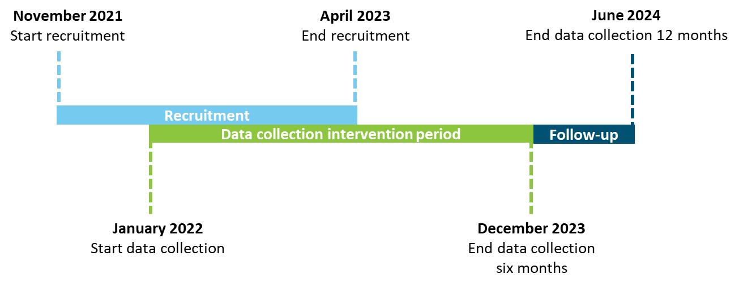

Figure S2. Research timeline of the SoFiT study

## Supplementary material: Questionnaire behavioural determinants

Each question is asked on a 7-point scale ranging from 1 'completely disagree' to 7 'completely agree'.

**Knowledge**

1. I know exactly what the World Cancer Research Fund (WCRF) guidelines entail.
2. I am aware of the reasons why I should follow the WCRF guidelines.
3. I have never read about the WCRF guidelines before.*

First, carefully read through the WCRF guidelines:

1. Maintain a healthy weight

Keep your weight within healthy limits and prevent weight gain in adulthood.

1. Get moving

Make physical activity a part of your daily life - walk more and sit less.

1. Eat plenty of whole grains, vegetables, fruits, and legumes

Make whole grains, vegetables, fruits, and legumes, such as brown beans and lentils, an important part of your daily diet.

1. Eat as little fast food and other processed foods high in fat, starch, and sugar as possible

Limiting these products helps you consume fewer calories and keep your weight healthy.

1. Limit the consumption of red and processed meats

Eat little red meat, such as beef, pork, and lamb. Eat little or no processed meat.

1. Drink as few sugary drinks as possible

Drink mainly water and unsweetened drinks.

1. Drink as little alcohol as possible

For cancer prevention, it is best not to drink alcohol.

Note/pop-up for control group: as you know, you will have the opportunity to work with a lifestyle coach in 6 months.

**Motivation**

1. I intend to follow the WCRF guidelines.
2. I don't feel like following the WCRF guidelines.*
3. I am motivated to follow the WCRF guidelines.

**Attitude**

1. I enjoy living healthily.
2. I find it important to live healthily.
3. There are more advantages than disadvantages to following the WCRF guidelines.

**Task self-efficacy**

1. I am confident that I can follow the WCRF guidelines.
2. I am confident that I can reduce my fatigue.
3. I think it is easy to follow the WCRF guidelines.
4. I will be able to follow the WCRF guidelines.

**Barrier self-efficacy**

1. I am confident that I can live healthily despite my fatigue.
2. I am confident that I can live healthily despite daily limitations (time, weather, costs).
3. I am confident that I can live healthily despite emotional limitations (stress, anxiety, concentration problems, sadness).
4. I am confident that I can live healthily despite disease- and/or treatment-related limitations (stoma, neuropathy, diarrhea).

**Skills**

1. I have the skills to follow the WCRF guidelines.
2. I know how to follow the WCRF guidelines.
3. I am capable of cooking healthy and doing the necessary grocery shopping.

**Perceived outcomes/benefits**

1. If I follow the WCRF guidelines, I will experience **short-term** benefits (for example, feeling fitter and mentally better).
2. If I follow the WCRF guidelines, I will experience **long-term** benefits (for example, decrease in fatigue and better condition).
3. I think following the WCRF guidelines will benefit my life.

**Physical environment**

1. I have facilities or aids available to help me follow the WCRF guidelines.
2. There are enough places in my environment to be able to exercise/sport.
3. There are enough places in my environment where I can eat healthily or buy healthy food.

**Social influence**

1. The people in my surroundings who are important to me believe that I should live healthily.
2. The people in my surroundings who are important to me support me or encourage me to live healthily.
3. The people in my surroundings who are important to me live healthily.
4. I have someone in my surroundings who is important to me, who exercises with me, cooks healthily, or eats healthily with me.

**Habits nutrition**

1. Eating healthily is something I do automatically.
2. Eating healthily is something I do without consciously thinking about it.
3. Eating healthily is something I do without thinking about it.
4. Eating healthily is something I start doing before realizing that I am doing it.

**Habits physical activity**

1. Getting enough exercise is something I do automatically.
2. Getting enough exercise is something I do without consciously thinking about it.
3. Getting enough exercise is something I do without thinking about it.
4. Getting enough exercise is something I start doing before realizing that I am doing it.

**Identity/value/norms**

1. I see myself as an active person.
2. I see myself as someone who eats healthily.
3. I think I live healthily.

**Scoring:** questions are given points from 1-7. For each determinant you calculate the average over those questions. The two questions with * are reversed questions and should be rewarded opposite points (1=7, 2=6, 3=5, 4=4, 5=3, 6=2, 7=1). Example:

Knowledge question 1: answer =3

Knowledge question 2: answer =4

Knowledge question 3: answer =5 🡪 reversed = 3

Final average score determinant knowledge = 3.3