1. The effect of CLA supplementation on A) TAG (mg/dl)

D:\1 Articles\meta analysis\5 running\CLA and CVD and CVD\Figures CLA and CVD and CVD\TG.emf

1. The effect of CLA supplementation on TC (mg/dl)

D:\1 Articles\meta analysis\5 running\CLA and CVD and CVD\Figures CLA and CVD and CVD\TC.emf

1. The effect of CLA supplementation on LDL (mg/dl)

D:\1 Articles\meta analysis\5 running\CLA and CVD and CVD\Figures CLA and CVD and CVD\LDL.emf

1. The effect of CLA supplementation on HDL (mg/dl)

D:\1 Articles\meta analysis\5 running\CLA and CVD and CVD\Figures CLA and CVD and CVD\HDL.emf

1. The effect of CLA supplementation on SBP (mmHg)

D:\1 Articles\meta analysis\5 running\CLA and CVD and CVD\Figures CLA and CVD and CVD\SBP.emf

1. The effect of CLA supplementation on DBP (mmHg)

D:\1 Articles\meta analysis\5 running\CLA and CVD and CVD\Figures CLA and CVD and CVD\DBP.emf

1. The effect of CLA supplementation on WC (cm)

D:\1 Articles\meta analysis\5 running\CLA and CVD and CVD\Figures CLA and CVD and CVD\WC.emf

1. The effect of CLA supplementation on FFM (kg)

D:\1 Articles\meta analysis\5 running\CLA and CVD and CVD\Figures CLA and CVD and CVD\FFM.emf

**Supplemental file 1.** Forest plot detailing weighted mean difference and 95% confidence intervals (CIs) for the effect of CLA supplementation on A) TAG (mg/dl); B) TC (mg/dl); C) LDL (mg/dl); D) HDL (mg/dl); E) SBP (mmHg); F) DBP (mmHg); G) WC (cm); and H) FFM (kg).

*Effect in the figures is effect size that shows level of changes in variables after supplementation with CLA compared with control group.

A)

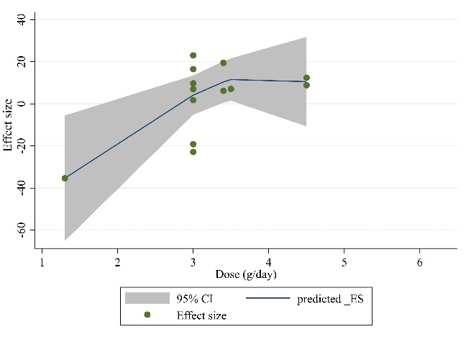

B)

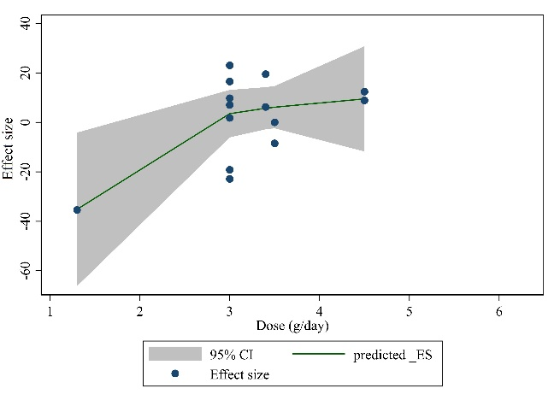

C)

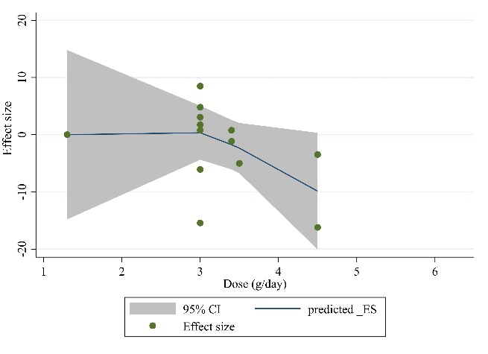

D)

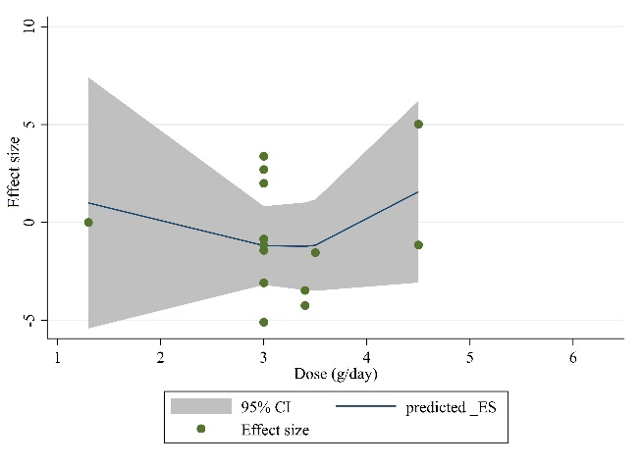

E)

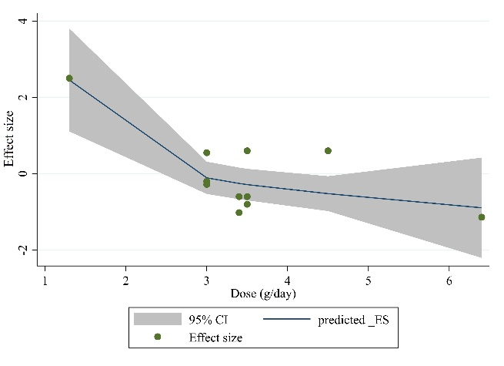

F)

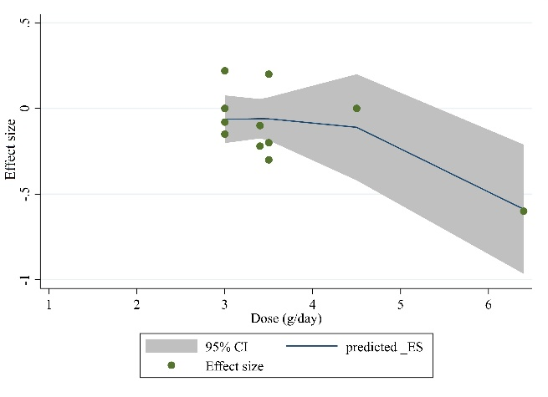

**Supplemental file 2.** Non-linear dose-response relations between CLA supplementation and absolute mean differences. Dose-response relations between dose (mg/day) and absolute mean differences in on A) TAG (mg/dl); B) TC (mg/dl); C) LDL (mg/dl); D) HDL (mg/dl); E) body weight (kg); and F) BMI (kg/m2).

A)

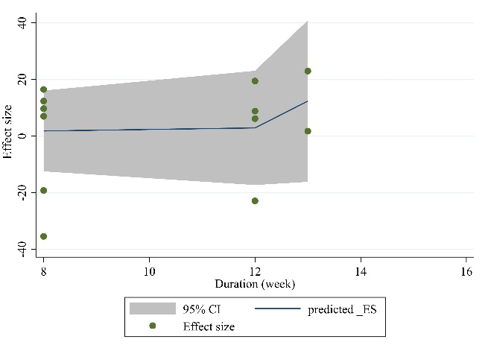

B)

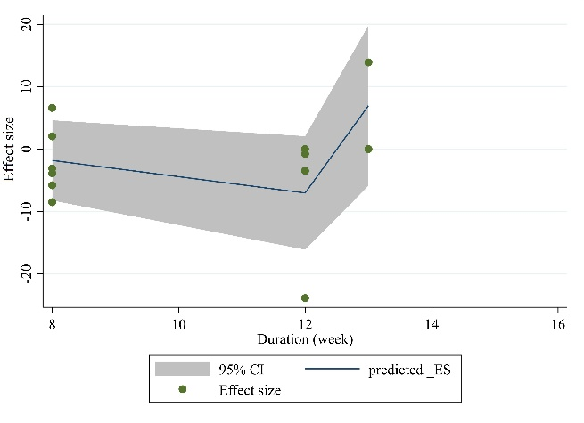

C)

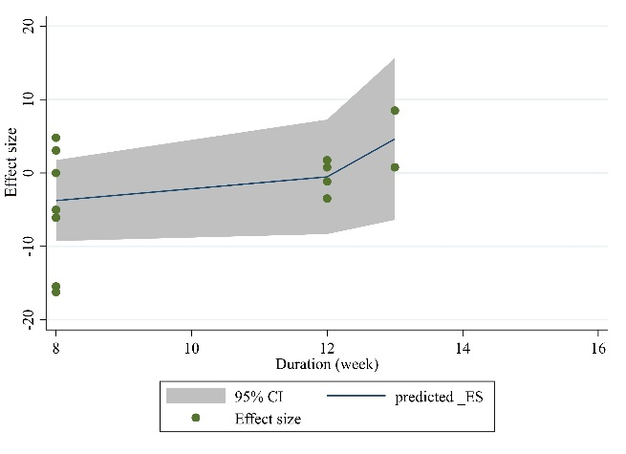

D)

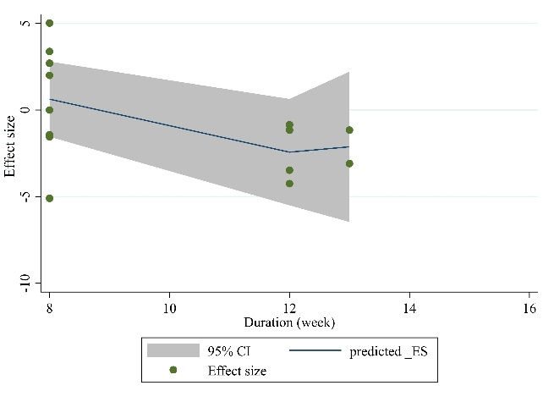

E)

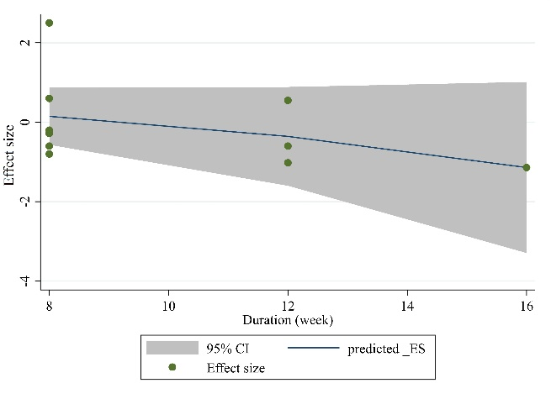

F)

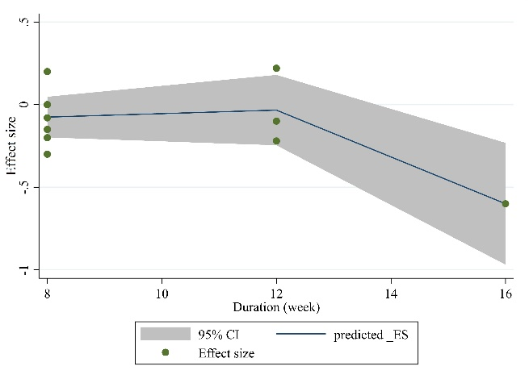

**Supplemental file 3.** Non-linear dose-response relations between CLA supplementation and absolute mean differences. Dose-response relations between duration of intervention (week) and absolute mean differences in A) TAG (mg/dl); B) TC (mg/dl); C) LDL (mg/dl); D) HDL (mg/dl); E) body weight (kg); and F) BMI (kg/m2).

A)



B)



C)



D)



E)



F)



**Supplemental file 4.** Linear dose-response relations between CLA supplementation and absolute mean differences. Dose-response relations between dose (mg/day) and absolute mean differences in A) TAG (mg/dl); B) TC (mg/dl); C) LDL (mg/dl); D) HDL (mg/dl); E) body weight (kg); and F) BMI (kg/m2).

A)



B)



C)



D)



E)



F)



**Supplemental file 5.** Linear dose-response relations between CLA supplementation and absolute mean differences. Dose-response relations between duration of intervention (week) and absolute mean differences in A) TAG (mg/dl); B) TC (mg/dl); C) LDL (mg/dl); D) HDL (mg/dl); E) body weight (kg); and F) BMI (kg/m2).