Maternal pre-pregnancy diet and prenatal depression: The mediating role of pre-pregnancy weight status and prenatal inflammation
Supplementary Materials

Pre-pregnancy Diet and prenatal depression: Mediation through pre-pregnancy BMI
When BMI was treated as a categorical variable, white individuals in the first and second MED tertile had significantly higher rates of overweight/obesity compared to those in the third tertile (OR=2.02, 95% CI, 1.38, 2.94; OR=1.47, 95% CI, 1.003, 2.17, respectively). There was no significant association between MED tertiles and BMI categories among people of color. We found no significant association between pre-pregnancy DII tertiles and BMI category in white individuals or people of color. In the pooled analyses where race was included as an additional covariate, those in the first MED tertile were at higher risk of overweight/obesity that those in the third MED tertile (OR=1.94, 95% CI, 1.36, 2.77). No significant association was observed between DII tertiles and BMI categories in the pooled analyses. Among people of color, those with underweight had significantly greater depressive symptoms compared to individuals with normal weight (MD=5.00, 95% CI, 1.37, 8.27) and overweight/obesity (MD=4.71, 95% CI, 1.29, 8.13). In the pooled analyses where race was included as an additional covariate, we found no significant association between BMI category and prenatal depressive symptoms (F (2, 1057) = 1.34, P= 0.261).

Supplementary Table 1. Components of the DII available from the APrON pre-pregnancy FFQ
No. | DII component | No. | DII component | No. | DII component
1 | Alcohol (g) | 11 | Folic acid (μg) | 21 | Saturated fat (g)
2 | Vitamin B₁₂ (μg) | 12 | Fe (mg) | 22 | Se (μg)
3 | Vitamin B₆ (mg) | 13 | Mg (mg) | 23 | Thiamin (mg)
4 | β-Carotene (μg) | 14 | MUFA (g) | 24 | Trans fat (g)
5 | Caffeine (g) | 15 | Niacin (mg) | 25 | Vitamin A (RE)
6 | Carbohydrate (g) | 16 | n-3 Fatty acids (g) | 26 | Vitamin C (mg)
7 | Cholesterol (mg) | 17 | n-6 Fatty acids (g) | 27 | Vitamin D (μg)
8 | Energy (kcal) | 18 | Protein (g) | 28 | Vitamin E (mg)
9 | Total fat (g) | 19 | PUFA (g) | 29 | Zn (mg)
10 | Fiber (g) | 20 | Riboflavin (mg)
DII, Dietary inflammatory index; APrON, Alberta Pregnancy Outcomes and Nutrition; FFQ, Food Frequency Questionnaire; Fe, Iron; Se, Selenium; Mg, Magnesium; MUFA, Monounsaturated Fatty Acids; PUFA, Polyunsaturated Fatty Acids; Zn, Zinc.

Supplementary Table 2 presents the comparison of the characteristics of the APrON study participants included in the current study (N=1141) to those not included (N=1048) (due to not meeting inclusion criteria or their lack of data on the main study variables). Those included in the analyses were slightly older (31.41 vs. 30.79) and had lower pre-pregnancy BMI (23.64 vs. 25.08). Moreover, significantly greater percentage of participants included in this study had completed a university degree or higher and had annual income over $70,000. There was no significant difference between individuals included and those not included in the study analyses in terms of parity.
Supplementary Table 2. Characteristics of the APrON study participants included in the analyses compared to those not included
Variables | Included  (N=1141) | Not included (N=1048) | P
Age, mean (SD), y | 31.41 (4.09) | 30.79 (4.89) | 0.002
Education, n (%)
Less than high school | 12 (1.1) | 47 (4.8) | <0.001
Completed high school diploma | 80 (7.0) | 123 (12.4)
Completed trade, technical diploma | 204 (18.0) | 203 (20.5)
Completed university degree | 566 (49.9) | 415 (42.0)
Completed postgraduate degree | 273 (24.1) | 201 (20.3)
Household income, n (%)
<$20,000 | 16 (1.4) | 51 (5.3) | <0.001
$20, 000–$39,999 | 39 (3.4) | 85 (8.8)
$40,000–$69,999 | 152 (13.4) | 130 (13.5)
$70,000–$99,999 | 264 (23.3) | 202 (20.9)
≥$100,000 | 660 (58.4) | 498 (51.6)
Parity, no siblings | 637 (56.3) | 538 (56.1) | 0.48
Pre-pregnancy BMI, mean (SD), Kg/m² | 23.64 (4.24) | 25.08 (5.46) | <0.001
BMI, Body mass index; ANOVA, Analysis of variance
* Based on One-way ANOVA
† Based on Chi-square test

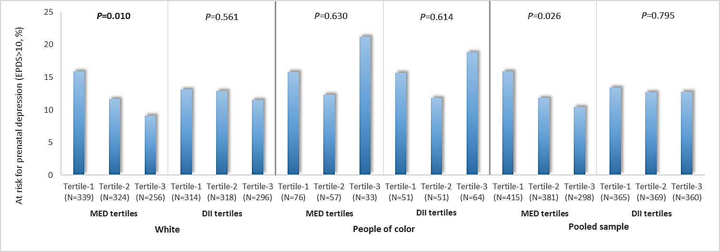
Supplementary Figure 1. The percentage of individuals at risk for prenatal depression, within each tertile of MED and DII scores. Note: Results are based on Chi-Square test (Linear-by-Linear association). Data are presented as percentage. EPDS, Edinburgh postpartum depression scale; MED, Mediterranean adherence; DII, Dietary inflammatory index.

