**Supplementary file 2 –** Based on Oustric et al (2020)

Selection and validation of the food pictures

1. Creation of a long list of common foods varying in both texture and temperature. Four nutrition specialists and physicians reviewed the listing and selected a list of 32 foods that matched the recommendations of the STEP 1 of Oustric et al (2020) and in the Table 3 of this article. We also tried to match energy content and macronutrients repartition (Table 1, rejected foods are not incuded). Even if characteristics of the created questionnaire were not related to energy content or macronutrient repartition, it was important to select foods that matched (STEP 2) in order to not create an unbalance between groups and generated choice that were related to high energy density for example. We also included sweet and savory foods in each group. However, energy content was logically lower in fluid foods since they contained more water.

**Table 1 –** Nutritional composition of included foods

|  |  |  |  |  |
| --- | --- | --- | --- | --- |
|  | kcal/100 g | % carbohydrates | % fat | % protein |
| Cold-Solid |  |  |  |  |
| Eggs Mimosa | 134 | 2 | 58 | 40 |
| Taboulleh | 193 | 53 | 37 | 10 |
| Banana | 94 | 92 | 2 | 5 |
| Madeleine | 447 | 49 | 45 | 6 |
| Cold-Fluid |  |  |  |  |
| Gaspacho | 46 | 37 | 55 | 8 |
| Guacamole | 182 | 10 | 85 | 5 |
| Stewed apples | 94 | 96 | 2 | 1 |
| Cream dessert | 125 | 63 | 28 | 10 |
| Warm-solid |  |  |  |  |
| Paella | 169 | 54 | 25 | 21 |
| French fries | 136 | 63 | 29 | 8 |
| Churros | 348 | 45 | 50 | 5 |
| Lava cake | 445 | 37 | 58 | 5 |
| Warm-fluid |  |  |  |  |
| Tomato soup | 46 | 67 | 18 | 15 |
| Purée | 116 | 43 | 49 | 8 |
| Crème brûlée | 300 | 22 | 73 | 6 |
| Hot chocolate | 76 | 62 | 20 | 18 |
| Cold-solid | 217 | 49 | 36 | 16 |
| Cold-fluid | 112 | 52 | 43 | 6 |
| Warm-solid | 275 | 50 | 41 | 10 |
| Warm-fluid | 135 | 48 | 40 | 12 |

1. Creation of the food pictures (STEP 3): all foods were photographed using the same angle and the same background using a regular portion for each food.

|  |  |  |  |  |
| --- | --- | --- | --- | --- |
|  | **Fluid** | | **Solid** | |
| **Warm** | Crème brulée  C:\Users\Keyne\AppData\Local\Microsoft\Windows\INetCache\Content.Word\Crème-brulée-FluHot.jpg | Tomato soup  C:\Users\Keyne\AppData\Local\Microsoft\Windows\INetCache\Content.Word\Tomatoes-soup-FluHot.jpg | ChurrosC:\Users\Keyne\AppData\Local\Microsoft\Windows\INetCache\Content.Word\Churros-SolHot.jpg | PaëllaC:\Users\Keyne\AppData\Local\Microsoft\Windows\INetCache\Content.Word\Paella-SolHot.jpg |
| Hot chocolate  C:\Users\Keyne\AppData\Local\Microsoft\Windows\INetCache\Content.Word\Hot-Chocolate-FluHot.jpg | Purée C:\Users\Keyne\AppData\Local\Microsoft\Windows\INetCache\Content.Word\Purée-FluHot.jpg | Lava cake  C:\Users\Keyne\AppData\Local\Microsoft\Windows\INetCache\Content.Word\Lava-cake-SolHot.jpg | French fries  C:\Users\Keyne\AppData\Local\Microsoft\Windows\INetCache\Content.Word\French-fries SolHot.jpg |
| **Cold** | Cream dessert  C:\Users\Keyne\AppData\Local\Microsoft\Windows\INetCache\Content.Word\Cream-dessert-FluCold.jpg | Gaspacho  C:\Users\Keyne\AppData\Local\Microsoft\Windows\INetCache\Content.Word\Gaspacho-tomatoes-FluCold.jpg | Banana  C:\Users\Keyne\AppData\Local\Microsoft\Windows\INetCache\Content.Word\Banana-SolCold.jpg | Tabbouleh  C:\Users\Keyne\AppData\Local\Microsoft\Windows\INetCache\Content.Word\Taboulé-SolCold.jpg |
| Stewed apples  Stewed-Apples-FluCold | Guacamole  C:\Users\Keyne\AppData\Local\Microsoft\Windows\INetCache\Content.Word\Guacamole-FluCold.jpg | Madeleines  C:\Users\Keyne\AppData\Local\Microsoft\Windows\INetCache\Content.Word\madeleine-SolCold.jpg | Eggs mimosa  C:\Users\Keyne\AppData\Local\Microsoft\Windows\INetCache\Content.Word\Hard-boiled-eggs-SolCold.jpg |

1. Validation (STEP 3): 111 participants (59% women, age: 41.3 ± 10.3 yo) answered an questionnaire in the Institut de Recherche Biomédicale des Armées (IRBA, Brétigny France) to assess the level of recognition of the photographs, the level of cultural appropriation, the frequency of consumption, their palatability and if they were correctly perceived as fluid/solid and warm/cold (Oustric et al 2020). The results are presented in the Table 2 (rejected foods are not included).

**Table 2 –** Results of the validation of the food images (n = 111)

|  |  |  |  |  |  |  |  |  |
| --- | --- | --- | --- | --- | --- | --- | --- | --- |
| Food | Recognition | Frequency | Liking | Temperature | Texture | Morning | Afternoon | Evening |
| Cold-Solid |  |  |  |  |  |  |  |  |
| Eggs Mimosa | 100.0 | 2.53 | 70.09 | 1946 | 82.25 | 41.35 | 83.06 | 80.54 |
| Taboulleh | 96.4 | 2.35 | 71.53 | 15.05 | 78.38 | 16.49 | 87.48 | 83.78 |
| Banana | 100.0 | 2.72 | 82.34 | 28.02 | 77.84 | 82.25 | 87.39 | 72.61 |
| Madeleine | 100.0 | 2.17 | 77.84 | 23.33 | 79.28 | 77.93 | 59.64 | 53.15 |
| Cold-Fluid |  |  |  |  |  |  |  |  |
| Gaspacho | 92.8 | 1.75 | 69.82 | 13.87 | 17.30 | 21.62 | 76.58 | 78.29 |
| Guacamole | 92.8 | 2.27 | 81.71 | 16.04 | 47.84 | 20.54 | 84.14 | 87.84 |
| Stewed apples | 100.0 | 2.76 | 84.68 | 23.78 | 40.81 | 82.16 | 88.65 | 88.83 |
| Cream dessert | 87.4 | 1.28 | 60.63 | 13.87 | 32.34 | 33.15 | 69.73 | 69.19 |
| Warm-solid |  |  |  |  |  |  |  |  |
| Paella | 99.1 | 1.84 | 72.72 | 95.68 | 85.95 | 11.98 | 83.87 | 74.68 |
| French fries | 100.0 | 2.86 | 80.63 | 96.76 | 84.05 | 14.50 | 90.09 | 74.68 |
| Churros | 92.8 | 1.39 | 73.69 | 82.61 | 78.92 | 30.72 | 65.14 | 55.50 |
| Lava cake | 98.2 | 1.95 | 81.35 | 75.05 | 62.97 | 36.76 | 81.26 | 73.78 |
| Warm-fluid |  |  |  |  |  |  |  |  |
| Tomato soup | 91.9 | 1.99 | 68.11 | 88.20 | 15.77 | 15.32 | 58.65 | 82.43 |
| Purée | 99.1 | 2.60 | 75.05 | 93.42 | 53.15 | 14.59 | 86.76 | 84.41 |
| Crème brûlée | 99.1 | 2.09 | 82.88 | 44.86 | 53.15 | 36.94 | 83.87 | 80.90 |
| Hot chocolate | 86.5 | 1.74 | 75.05 | 86.58 | 13.96 | 73.60 | 36.76 | 50.63 |
| Mean Cold-Solid | 99.1 | 2.44 | 75.45 | 21.47 | 79.44 | 54.51 | 79.39 | 72.52 |
| Mean Cold –Fluid | 93.2 | 2.00 | 74.21 | 16.89 | 34.57 | 39.37 | 79.78 | 76.24 |
| Mean Warm-Solid | 97.5 | 2.01 | 77.09 | 87.53 | 77.97 | 23.49 | 80.09 | 69.66 |
| Mean Warm-Fluid | 94.2 | 2.11 | 75.27 | 78.27 | 34.01 | 35.11 | 66.51 | 74.59 |

Cut-off proposed by Oustric et al (2020) were used:

Correctly recognised > 80%; Habitually consumed > 2 (it was impossible to match this cut-off value for some foods); Liked > 60: Correctly recognised as Cold and Warm < 40 and >60 (crème brulée did not respected it); Correctly recognised as Fluid and Solid < 40 and >60 (Cut-off for Fluidity was in fact closer to 50); Appropriate time >60 (almost respected for afternoon and Evening but not for Breakfast).

Thus, these proposed cut-offs were respected for mean values in each group. It was however impossible to match all these propositions for a small amount of foods. The graphical representation is presented in Figure 1.

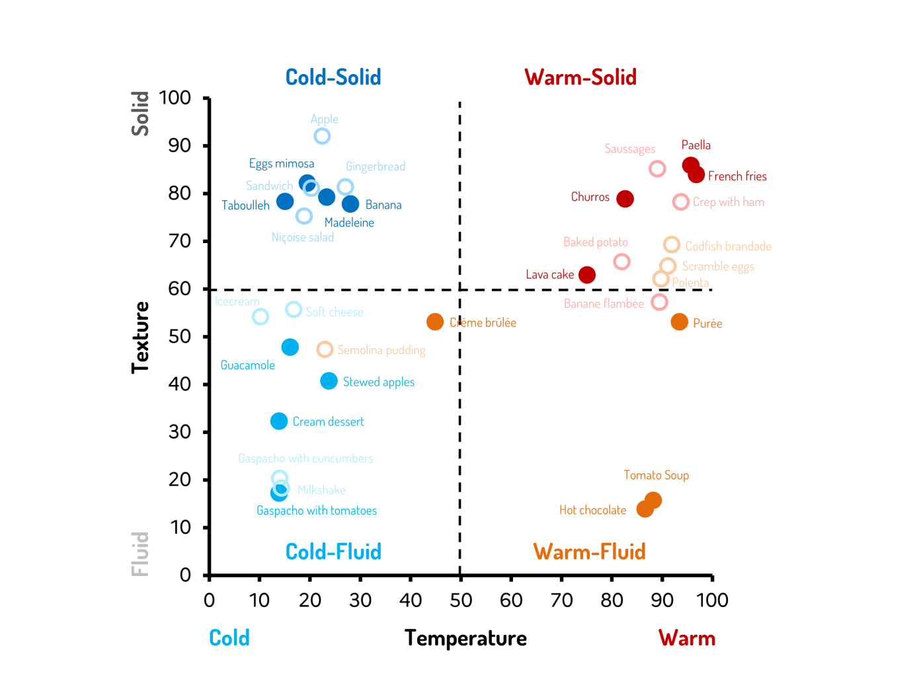

**Figure 1-** Scatter plot depicting the mean Texture and Temperature scores for each proposed foods. Open circle represented the excluded foods (these foods could have been excluded for other reasons than inappropriate Texture and Temperature score (ex: incorrectly recognised).