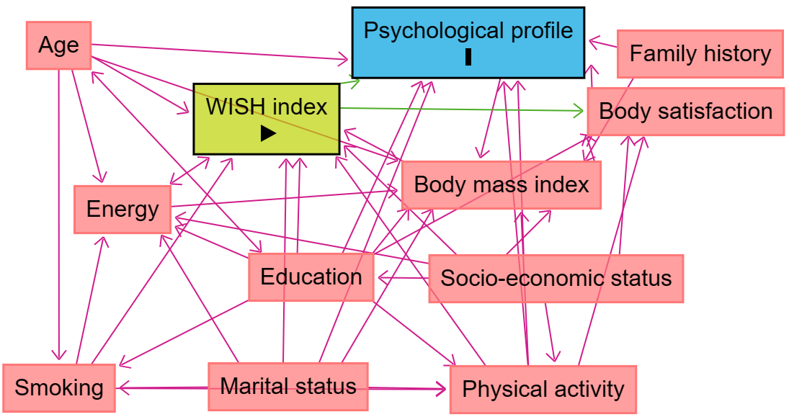

**Supplementary Figure 1**. Directed Acyclic Graph (DAG) for the evaluation of covariates in the association between the WISH index and psychological profiles.