Table S1. Nutrient intake and dietary patterns according to gender and stroke and their association with stroke risk
 | Men (n=20,293) |  | Women (n=38,408) |  | Adjusted ORs and 95% CI
 | Health (n=19189) | Stroke (n=235) | Health (n=36294) | Stroke (n=437)
Energy intake¹ | 89.5±0.29^{b} | 85.7±1.63^{b} | 99.7±0.19ª | 98.8±1.74^{a***+} | 0.841 (0.710-0.995)
Carbohydrate² | 72.3±0.06ª | 72.5±0.35ª | 71.5±0.04^{c} | 72.7±0.38^{b++} | 0.868 (0.737-1.023)
Fat³ | 13.6±0.05^{b} | 13.4±0.35^{b} | 13.9±0.03ª | 13.8±0.25^{ab**} | 0.735 (0.560-0.965)
Protein⁴ | 13.1±0.02^{b} | 12.9±0.17^{b} | 13.6±0.02ª | 13.5±0.12^{b***} | 0.967 (0.795-1.174)
BCAA⁵ | 15.1+0.03^{b} | 14.8+0.23^{b} | 15.9+0.02ª | 16.0+0.17^{a***} | 1.102 (0.885-1.371)
Fiber ⁶ | 15.1±0.09ª | 15.7±0.62ª | 14.5±0.06^{b} | 14.3±0.46^{ab*} | 1.193 (0.969-1.469)
Calcium⁷ | 411±2.43^{b} | 415±16.9^{b} | 459±1.57ª | 470±12.3^{a**} | 1.020 (0.838-1.243)
Sodium⁸ | 2.53±0.01 | 2.61±0.09 | 2.38±0.01 | 2.35±0.07 | 0.882 (0.739-1.052)
Vitamin C⁹ | 97.1±0.63^{b} | 102±4.41^{b} | 110±0.41ª | 111±3.22^{a**} | 1.021 (0.856-1.220)
Vitamin D¹⁰ | 5.17±0.05^{b} | 5.11±0.27^{b} | 7.08±0.03ª | 6.63±0.28^{a***} | 1.042 (0.850-1.278)
Cholesterol¹¹ | 163±1.17^{b} | 164±8.17^{b} | 172±0.76ª | 179±5.97^{a*} | 1.134 (0.934-1.376)
DII ¹² | -19.6±0.15^{b} | -19.5±1.03^{ab} | -20.1±0.10ª | -20.7±0.75^{ab**} | 1.116 (0.927-1.344)
Flavonoids ¹³ | 31.2±0.27^{b} | 30.5±1.55^{b} | 42.3±0.18ª | 41.5±1.66^{a***} | 0.945 (0.785-1.138)
Glycemic index¹⁴ | 51.1±0.09ª | 50.8±0.64ª | 47.6±0.06^{b} | 47.1±0.47^{b***} | 0.886 (0.742-1.057)
Glycemic load¹⁵ | 160±0.32ª | 159±2.23ª | 146±0.21^{b} | 145±1.62^{b***} | 1.055 (0.872-1.277)
KBD (Yes, %)¹⁶ | 138 (1.20) | 97 (1.23) | 306 (1.19) | 131(1.18) | 0.965 (0.808-1.152)
PBD (Yes, %)¹⁶ | 183 (1.19) | 52 (1.30) | 265 (1.22) | 172(1.15) | 1.000 (0.835-1.197)
WSD (Yes, %)¹⁶ | 108 (1.16) | 127 (1.25) | 288 (1.21) | 149(1.15) | 1.076 (0.902-1.283)
RMD (Yes, %)¹⁶ | 163 (1.23) | 72 (1.16) | 288 (1.21) | 149 (1.15) | 0.981 (0.827-1.165)
The values represent means ± standard errors or number of the subjects (percentage of each group). Adjusted odds ratio (ORs) and 95 % confidence intervals (CI) with the covariates of adjusting for age, gender, BMI, residence area, physical activity, education, smoking, and intake of alcohol, dietary fiber and energy. The cutoff points of the reference were as follows: ¹estimated energy requirement (EER), ²65 energy percent (en%); ³15 en%; ⁴13 En%; ⁵18.6 g/day; ⁶15 g/day; ⁷500 mg/day; ⁸2.5 g/day; ⁹100 mg/day; ¹⁰10 ug/day; ¹¹250 mg/day; ¹²33th percentiles; ¹³45 mg/day; ¹⁴41; ¹⁵127; ¹⁶75th percentiles.
*Significantly different from the Low-PC group at P<0.05 and ** P<0.01. BCAA: Branched chain amino acids; DII, dietary inflammatory index; KBD: Korean balanced diet; PBD, plant-based diet; WSD, Western-style diet; RMD : Rice main diet

Table S2. Adjust means of the metabolic parameters according to genders and stroke
 | Men |  | Women |  | Adjusted ORs and 95% CI
 | Health (n=19613) | Stroke (n=368) | Health (n=37597) | Stroke (n=314)
MetS (N, %) | 190 (1.19) | 45(1.31) | 391 (1.21) | 46 (1.03) | 1.000 (0.780-1.282)
BMI (kg/m²) ¹ | 24.4±0.03ª | 24.1±0.19ª | 23.6±0.02^{b} | 23.7±0.14^{b***} | 0.915 (0.772-1.086)
Waist circumference² | 85.4±0.07ª | 84.6±0.51ª | 78.3±0.05^{b} | 78.0±0.37^{b***} | 0.887 (0.726-1.084)
Fasting serum glucose (mg/dl)³ | 97.5±0.19ª | 95.6±1.29ª | 93.9±0.12^{b} | 92.4±0.96^{b***+} | 0.798 (0.590-1.080)
HbA1c (%)⁴ | 5.68±0.01 | 5.63±0.07 | 5.73±0.01 | 5.67±0.05 | 0.986 (0.666-1.460)
Total-C (mg/dl)⁵ | 189±0.34^{b} | 192±2.36^{b} | 202±0.22ª | 201±1.72^{a***} | 0.986 (0.814-1.194)
LDL-C (mg/dl)⁶ | 113±0.31^{b} | 114±2.17^{b} | 122±0.2ª | 120±1.58^{a***} | 0.891 (0.709-1.120)
HDL-C (mg/dl)⁷ | 49.7±0.12^{b} | 49.2±0.82^{b} | 55.9±0.08ª | 56.8±0.7^{a***} | 0.980 (0.821-1.171)
TG (mg/dl)⁸ | 133±0.78^{b} | 147±5.43ª | 121±0.51^{c} | 122±3.97^{c***+} | 1.149 (0.965-1.368)
SBP (mmHg)⁹ | 125±0.13ª | 126±0.92ª | 121±0.09^{b} | 120±0.67^{b***} | 0.889 (0.745-1.059)
DBP (mmHg)¹⁰ | 78.0±0.09^{b} | 78.8±0.62^{b} | 74.5±0.06ª | 73.9±0.45^{a***} | 0.823 (0.610-1.111)
eGFR¹¹ | 83.8±0.15^{b} | 84.5±1.02^{ab} | 87.0±0.10ª | 87.6±0.74^{a***} | 0.900 (0.708-1.144)
Serum ALT¹² | 25.6±0.21ª | 25.8±1.46ª | 20.7±0.14^{b} | 20.8±1.09^{b***} | 0.970 (0.747-1.259)
Serum AST¹³ | 24.8±0.22 | 24.9±1.52 | 23.2±0.14 | 23.1±1.13 | 0.995 (0.673-1.470)
Serum CRP¹⁴ | 0.14±0.004 | 0.11±0.03 | 0.14±0.003 | 0.15±0.02 | 0.910 (0.451-1.836)
WBC¹⁵ | 5.77±0.02 | 5.58±0.12 | 5.66±0.01 | 5.60±0.09 | 0.888 (0.748-1.054)
Values represented adjusted means and standard errors after adjusting for covariates of age, BMI, residence area, income, education, smoking and drinking status, and physical activity. The values represent means ± standard errors or number of the subjects (percentage of each group). Adjusted odds ratio (ORs) and 95 % confidence intervals (CI) with the covariates of adjusting for age, gender, BMI, residence area, physical activity, education, smoking, and intake of alcohol, dietary fiber and energy. The cutoff points of the reference were as follows: ¹< 25 kg/m2; ²< 90 cm for men and 85 cm for women; ³ <110 mg/dL plus anti-diabetic medication; ⁴ <6.5 % plus anti-diabetic medication;⁵ <230 mg/dL plus dyslipidemia medication; ⁶<160 mg/dL plus dyslipidemia medication; ⁷ <40 mg/dL for men and <50 mg/dL for women plus dyslipidemia medication; ⁸<150 mg/dL plus dyslipidemia medication; ⁹<140 mmHg plus hypertension medication; ¹⁰ <90 mmHg plus hypertension medication; ¹¹ < 70; ¹² <35 IU/L; ¹³ < 40 IU/L; ¹⁴ <1.0 mg/dL; ¹⁵<5.6X10⁹ /L. *Significantly different from the Non-MetS (Normal-control) group at P<0.05, ** P<0.01, and *** P<0.001. eGFR, estimated glomerular filtration rate; SBP: Systolic blood pressure; DBP: Diastolic blood pressure; Total-C, total cholesterol; HDL-C: High density lipoprotein cholesterol; LDL-C: Low density lipoprotein cholesterol; TG: Triglycerides; HbA1c: Glycosylated hemoglobin. * Significantly different by gender at P<0.05, ** at P<0.01, and *** at P<0.001. ⁺ Significantly different by stroke at P<0.05.

Table S3. Binding energy of food components with CYP1A1 rs143070677 wild (WT) and mutated types (MT)
 | WT | MT |  | WT | MT
Cyanidin 3-dicaffeoyl-sophoroside 5-glucoside | -7.9 | -10.2 | Dimalonylawobanin | -10 | -8.1
Theaflavate A | -8.5 | -10.5 | Lepidine E | -10.1 | -8.9
Artobiloxanthone | -8.2 | -10.5 | cis-Geranylgeranylbixin | -10.5 | -8.6
Delphinidin 3,5-di(6''-malonylglucoside) | -6.7 | -10 | Zucchini factor B | -10 | -8.1
Gambiriin B3 | -8.3 | -10.5 | Isoscoparin 7-glucoside | -10.7 | -8.2
(9Z,9'Z)-7,7',8,8'-Tetrahydrolycopene | -8.9 | -10.4 | Epoxyfumitremorgin C | -10.2 | -8.6
Acrimarine N | -8.7 | -11.6 | Avenalumin II | -10.4 | -8.9

Supplementary Figure S1. The distribution of genetic variants related to stroke risk
- Manhattan plot of genetic variants related to stroke risk
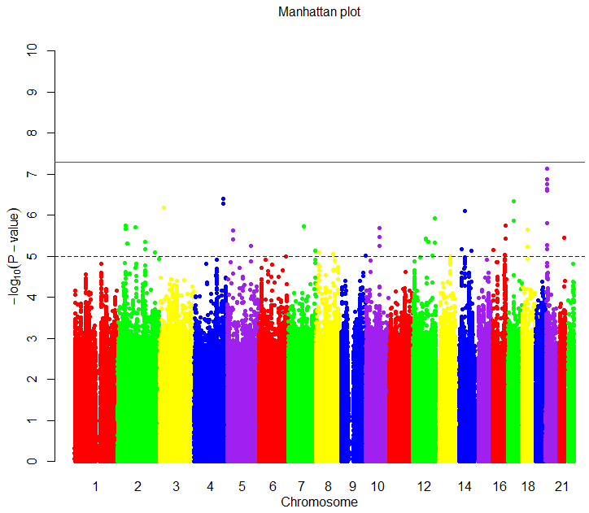
- Q-Q plot of genetic variants related to stroke risk
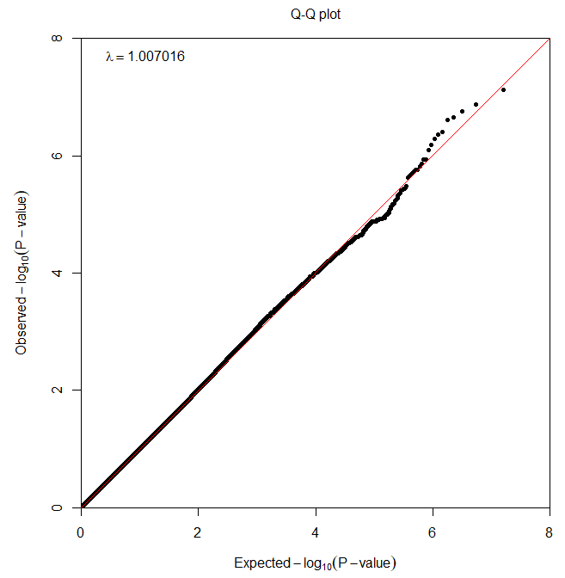

Figure S2. Gene expression according to the alleles of the selected SNPs for stroke risk in different tissues
A B
C D
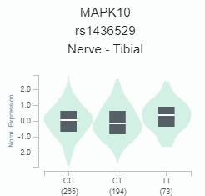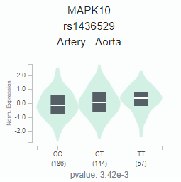
E F
