Figure S1. Flow chart of selecting eligible participants from NHANES 2007-2012. BMI, body mass index; PUFAs, polyunsaturated fatty acids

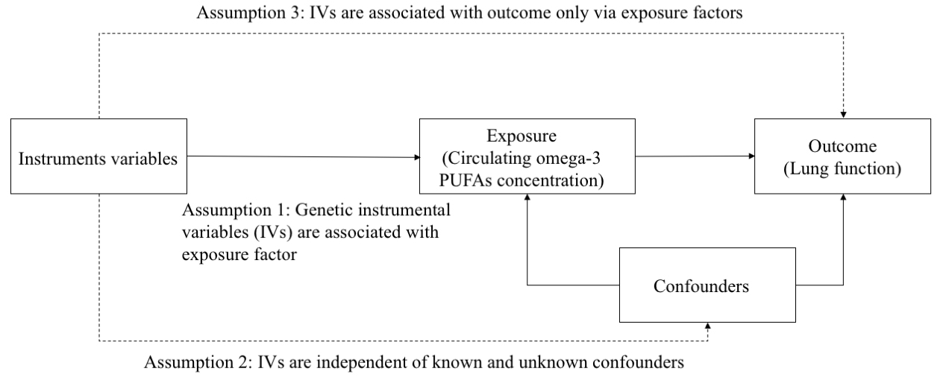
Figure S2. Schematic Diagram of the Mendelian Randomization Assumptions.

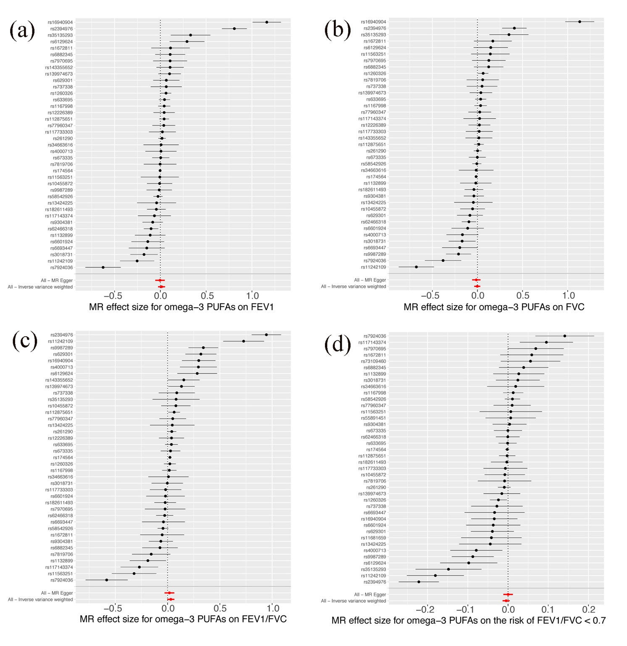Figure S3. Forest plot for MR analyses of causal associations between each circulating omega-3 PUFAs concentration SNP and lung function. FEV1, forced expiratory volume in one second; FVC, forced vital capacity; MR, Mendelian randomization; SNP, single-nucleotide polymorphism; PUFAs, polyunsaturated fatty acids.
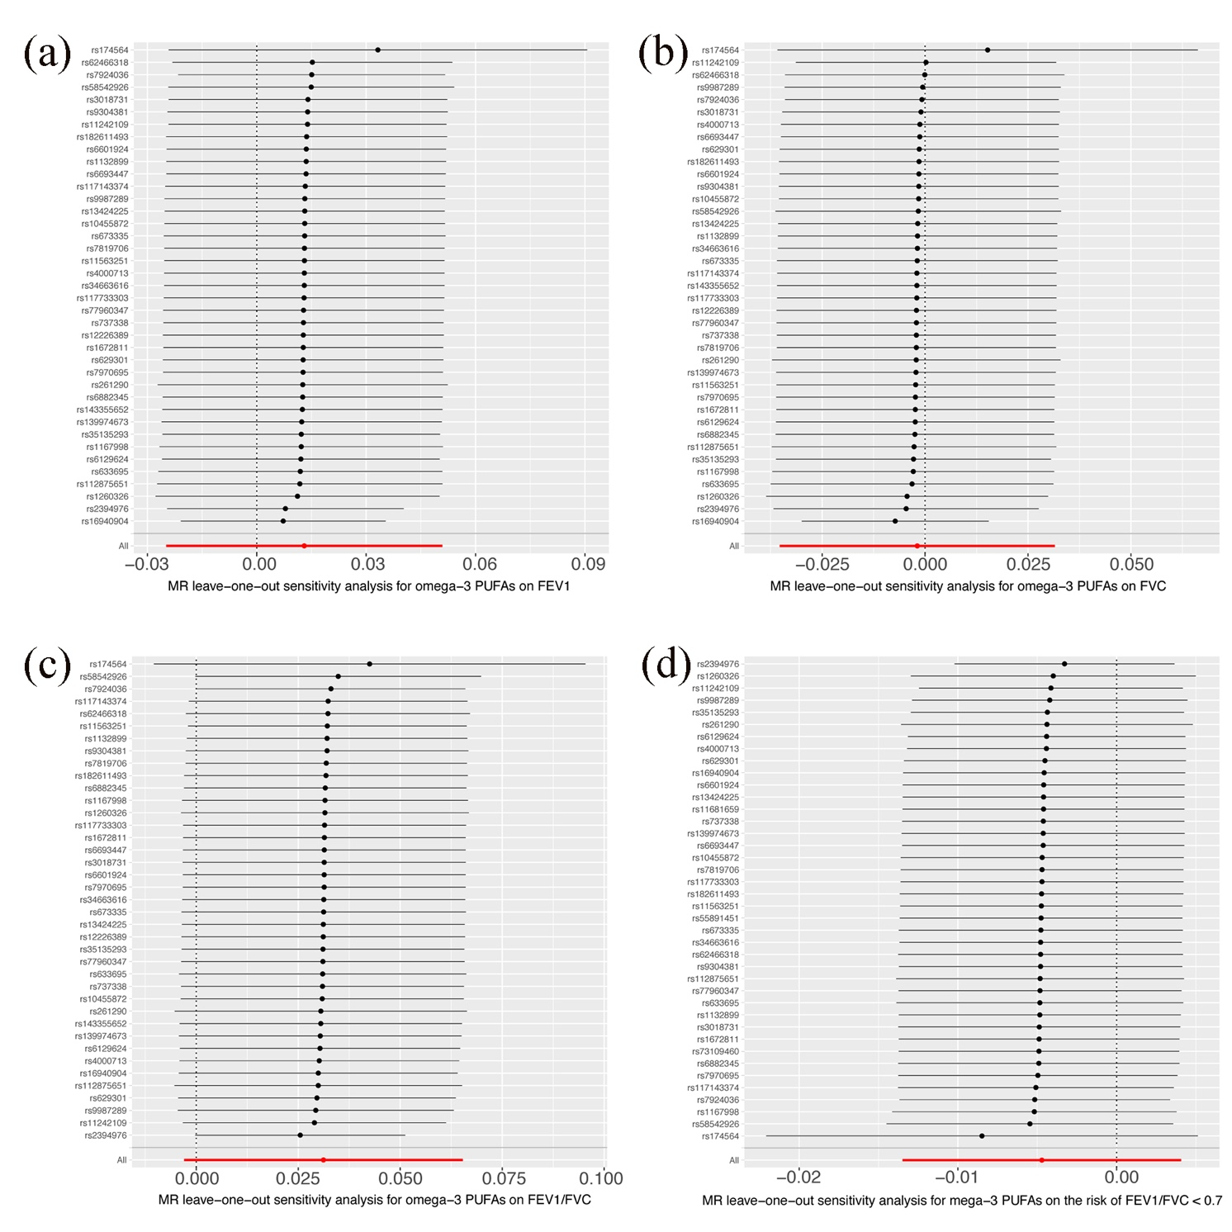Figure S4. Leave-one-out sensitivity analysis for the association of circulating omega-3 PUFAs concentration with lung function. FEV1, forced expiratory volume in one second; FVC, forced vital capacity; MR, Mendelian randomization; PUFAs, polyunsaturated fatty acids.

Table S1. Stratified association between omega-3 PUFAs intake and lung function by smoking status among participants in NHANES 2007-2012
Smoking status | Omega-3 PUFAs Intake Quartile (mg/kg/days) | FEV₁ (mL) |  | FVC (mL) |  | % predicted FEV₁ |  | % predicted FVC
 |  | β (95% CI) | p | β (95% CI) | p | β (95% CI) | p | β (95% CI) |  | p
Model 1
Current | Q1 | 1.00 (Ref.) |  | 1.00 (Ref.) |  | 1.00 (Ref.) |  | 1.00 (Ref.)
 | Q2 | 6.19 (-103.37-115.74) | 0.912 | 28.85 (-99.47-157.16) | 0.659 | -0.59 (-2.49-1.32) | 0.547 | -0.36 (-2.02-1.31) |  | 0.675
 | Q3 | 123.59 (12.96-234.23) | 0.029 | 234.63 (74.65-333.82) | 0.002 | 0.10 (-1.82-2.02) | 0.919 | 0.74 (-0.94-2.42) |  | 0.389
 | Q4 | 222.78 (115.71-329.85) | <0.001 | 305.49 (193.99-444.80) | <0.001 | 1.67 (-0.19-3.53) | 0.078 | 2.41 (0.78-4.04) |  | 0.004
Former | Q1 | 1.00 (Ref.) |  | 1.00 (Ref.) |  | 1.00 (Ref.) |  | 1.00 (Ref.)
 | Q2 | 169.35 (60.12-278.57) | 0.002 | 241.49 (110.82-372.15) | <0.001 | 2.48 (0.49-4.48) | 0.015 | 3.00 (1.24-4.77) |  | 0.001
 | Q3 | 228.22 (117.58-338.86) | <0.001 | 297.62 (165.27-429.98) | <0.001 | 3.65 (1.63-5.67) | <0.001 | 3.71 (1.92-5.50) |  | <0.001
 | Q4 | 271.29 (160.50-382.09) | <0.001 | 352.74 (220.20-484.29) | <0.001 | 4.66 (2.63-6.68) | <0.001 | 5.18 (3.38-6.97) |  | <0.001
Never | Q1 | 1.00 (Ref.) |  | 1.00 (Ref.) |  | 1.00 (Ref.) |  | 1.00 (Ref.)
 | Q2 | 101.57 (33.69-169.45) | 0.003 | 114.72 (32.38-197.06) | 0.006 | 0.99 (-0.09-2.07) | 0.072 | 0.86 (-0.17-1.90) |  | 0.101
 | Q3 | 189.37 (122.07-256.68) | <0.001 | 239.26 (157.62-320.91) | <0.001 | 0.71 (-0.36-1.78) | 0.192 | 1.12 (0.10-2.14) |  | 0.032
 | Q4 | 226.13 (158.06-294.19) | <0.001 | 284.61 (202.05-367.18) | <0.001 | 0.84 (-0.24-1.92) | 0.128 | 1.50 (0.47-2.54) |  | 0.004
Model 2
Current | Q1 | 1.00 (Ref.) |  | 1.00 (Ref.) |  | 1.00 (Ref.) |  | 1.00 (Ref.)
 | Q2 | -41.06 (-110.10-27.98) | 0.244 | -67.37 (-152.60-17.85) | 0.121 | -0.75 (-2.57-1.08) | 0.423 | -0.97 (-2.60-0.65) |  | 0.24
 | Q3 | -31.21 (-110.10-27.98) | 0.392 | -61.72 (-149.89-26.45) | 0.170 | 0.25 (-1.64-2.14) | 0.796 | 0.46 (-1.64-1.73) |  | 0.96
 | Q4 | -38.62 (-109.86-32.63) | 0.288 | -65.98 (-153.92-21.97) | 0.141 | 0.61 (-1.27-2.49) | 0.527 | 0.35 (-1.33-2.03) |  | 0.68
Former | Q1 | 1.00 (Ref.) |  | 1.00 (Ref.) |  | 1.00 (Ref.) |  | 1.00 (Ref.)
 | Q2 | -3.97 (-71.01-63.08) | 0.908 | 18.06 (-65.55-101.66) | 0.672 | 0.62 (-1.35-2.60) | 0.538 | 0.92 (-0.81-2.65) |  | 0.30
 | Q3 | 12.92 (-56.04-81.88) | 0.713 | 15.99 (-70.00-101.99) | 0.715 | 1.36 (-0.67-3.39 | 0.189 | 1.10 (-0.68-2.88) |  | 0.23
 | Q4 | 11.85 (-59.43-83.13) | 0.744 | 25.68 (-63.21-114.56) | 0.571 | 1.28 (-0.82-3.38) | 0.233 | 1.31 (-0.53-3.15) |  | 0.16
Never | Q1 | 1.00 (Ref.) |  | 1.00 (Ref.) |  | 1.00 (Ref.) |  | 1.00 (Ref.)
 | Q2 | 8.66 (-32.80-50.12) | 0.682 | -0.18(-52.51-52.15) | 0.995 | 0.48 (-0.60-1.56) | 0.387 | 0.18 (-0.84-1.21) |  | 0.73
 | Q3 | -3.75 (-46.03-38.54) | 0.862 | 4.10 (-49.28-57.48) | 0.880 | -0.06 (-1.16-1.04) | 0.916 | 0.02 (-1.03-1.06) |  | 0.98
 | Q4 | -51.02 (-95.18--6.85) | 0.024 | -54.06 (-109.811.69) | 0.057 | -0.30 (-1.45-0.85) | 0.612 | -0.12 (-1.21-0.97) |  | 0.83
NHANES, National Health and Nutrition Examination Survey; β, partial regression coefficient; CI, confidence interval. Model 1 is the univariate model that assesses the association without adjustments. Model 2 adjusts for potential confounders including age, gender, race, educational level, poverty-income ratio, BMI, drinking, smoking, diabetes, and hypertension.

Table S2. Association between omega-3 PUFAs intake excluding ALA and lung function among participants in NHANES 2007-2012
Omega-3 PUFAs Intake Quartile (mg/kg/days) | FEV₁ (mL) |  | FVC (mL) |  | % predicted FEV₁ |  | % predicted FVC
 | β (95% CI) | p | β (95% CI) | p | β (95% CI) | p | β (95% CI) | p
Model 1
Q1 | 1.00 (Ref.) |  | 1.00 (Ref.) |  | 1.00 (Ref.) |  | 1.00 (Ref.)
Q2 | 101.49 (50.35-152.63) | 0.107 | 129.92 (68.34-191.50) | <0.001 | 1.21 (0.35-2.08) | 0.006 | -0.19 (-0.69-0.31) | 0.462
Q3 | 198.43 (147.41-249.44) | 0.337 | 237.61 (176.17-299.04) | <0.001 | 0.65 (-0.22-1.51) | 0.144 | 0.36 (-0.14-0.86) | 0.156
Q4 | 142.24 (91.27-193.20) | 0.091 | 186.29 (124.92-247.67) | <0.001 | 0.77 (-0.09-1.64) | 0.080 | 0.45 (-0.54-0.95) | 0.074
Model 2
Q1 | 1.00 (Ref.) |  | 1.00 (Ref.) |  | 1.00 (Ref.) |  | 1.00 (Ref.)
Q2 | 17.15 (-14.11-48.40) | 0.282 | 31.99 (-6.96-70.93) | 0.107 | 1.10 (0.25-1.94) | 0.011 | 1.51 (0.74-2.28) | <0.001
Q3 | -10.55 (-41.98-20.87) | 0.510 | -19.19 (-58.34-19.96) | 0.337 | 0.59 (-0.26-1.44) | 0.176 | 0.54 (-0.23-1.32) | 0.168
Q4 | -17.05 (-48.50-14.40) | 0.288 | -33.81 (-72.99-5.37) | 0.091 | 0.76 (-0.09-1.60) | 0.082 | 0.62 (-0.16-1.39) | 0.117

Table S3. Genetic instruments used in our Mendelian randomization studies.
Exposures | Outcomes | SNPs | EA | OA | EAF | Beta | SE | p | R2 | F-statistic
Omega-3 PUFAs | FEV1 | rs10455872 | G | A | 0.078988 | -0.0629576 | 0.00753435 | 2.80E-17 | 5.77E-04 | 66
 |  | rs11242109 | T | G | 0.479016 | 0.0240622 | 0.0040658 | 2.40E-09 | 2.89E-04 | 33
 |  | rs112875651 | A | G | 0.392346 | -0.0873719 | 0.00422001 | 3.50E-98 | 3.64E-03 | 420
 |  | rs1132899 | C | T | 0.509603 | 0.0270834 | 0.00410188 | 8.60E-11 | 3.67E-04 | 42
 |  | rs11563251 | T | C | 0.110601 | 0.0349727 | 0.00647476 | 3.20E-08 | 2.41E-04 | 28
 |  | rs1167998 | A | C | 0.644674 | 0.0713574 | 0.00425038 | 3.60E-66 | 2.33E-03 | 269
 |  | rs117143374 | C | T | 0.142254 | -0.0370966 | 0.005847 | 2.20E-10 | 3.36E-04 | 39
 |  | rs117733303 | G | A | 0.018513 | -0.115945 | 0.0150731 | 1.40E-15 | 4.89E-04 | 56
 |  | rs12226389 | C | T | 0.18582 | -0.050608 | 0.00524839 | 1.10E-22 | 7.75E-04 | 89
 |  | rs1260326 | C | T | 0.60401 | -0.0820592 | 0.0041534 | 8.40E-88 | 3.22E-03 | 372
 |  | rs13424225 | T | G | 0.449809 | 0.0221268 | 0.00408591 | 2.20E-08 | 2.42E-04 | 28
 |  | rs139974673 | C | T | 0.025918 | 0.117987 | 0.0128075 | 2.30E-21 | 7.03E-04 | 81
 |  | rs143355652 | T | C | 0.010467 | -0.154138 | 0.0204073 | 9.40E-14 | 4.92E-04 | 57
 |  | rs1672811 | C | T | 0.748488 | 0.0251849 | 0.0046967 | 3.00E-08 | 2.39E-04 | 27
 |  | rs16940904 | T | C | 0.226571 | -0.0355285 | 0.0048772 | 3.90E-14 | 4.42E-04 | 51
 |  | rs174564 | G | A | 0.347013 | -0.337094 | 0.00424185 | 1.00E-200 | 5.15E-02 | 6244
 |  | rs182611493 | G | A | 0.012519 | -0.209571 | 0.0195777 | 1.10E-27 | 1.09E-03 | 125
 |  | rs2394976 | T | G | 0.161648 | -0.0461429 | 0.00550837 | 1.20E-15 | 5.77E-04 | 66
 |  | rs261290 | C | T | 0.654653 | -0.114383 | 0.00428189 | 3.90E-161 | 5.92E-03 | 684
 |  | rs3018731 | G | A | 0.717549 | -0.0353357 | 0.00456603 | 2.00E-14 | 5.06E-04 | 58
 |  | rs34663616 | A | C | 0.137654 | 0.0356728 | 0.00602277 | 4.40E-10 | 3.02E-04 | 35
 |  | rs35135293 | T | C | 0.51675 | -0.0208868 | 0.00408348 | 3.90E-08 | 2.18E-04 | 25
 |  | rs4000713 | A | G | 0.295408 | -0.0288196 | 0.00446039 | 1.00E-11 | 3.46E-04 | 40
 |  | rs58542926 | T | C | 0.074383 | -0.171666 | 0.00775231 | 1.40E-113 | 4.06E-03 | 469
 |  | rs6129624 | A | G | 0.335237 | -0.0257607 | 0.00437946 | 5.10E-10 | 2.96E-04 | 34
 |  | rs62466318 | T | C | 0.204178 | -0.0721329 | 0.00506371 | 1.20E-45 | 1.69E-03 | 195
 |  | rs629301 | T | G | 0.778033 | 0.0382887 | 0.00488385 | 1.30E-14 | 5.06E-04 | 58
 |  | rs633695 | G | A | 0.292348 | 0.0840069 | 0.00448287 | 9.10E-80 | 2.92E-03 | 337
 |  | rs6601924 | C | T | 0.845765 | 0.0350603 | 0.00563873 | 8.50E-10 | 3.21E-04 | 37
 |  | rs6693447 | G | T | 0.461686 | 0.0229488 | 0.00407772 | 4.80E-09 | 2.62E-04 | 30
 |  | rs673335 | C | T | 0.159762 | -0.0669996 | 0.00554146 | 1.10E-34 | 1.21E-03 | 139
 |  | rs6882345 | A | G | 0.632863 | 0.0288844 | 0.00421159 | 1.90E-13 | 3.88E-04 | 45
 |  | rs737338 | T | C | 0.035186 | -0.0726631 | 0.0110354 | 3.50E-11 | 3.58E-04 | 41
 |  | rs77960347 | G | A | 0.013239 | 0.161749 | 0.0177574 | 7.20E-22 | 6.84E-04 | 79
 |  | rs7819706 | G | A | 0.118291 | -0.0396447 | 0.00628878 | 1.80E-10 | 3.28E-04 | 38
 |  | rs7924036 | T | G | 0.504205 | 0.0233527 | 0.00406452 | 5.50E-10 | 2.73E-04 | 31
 |  | rs7970695 | A | G | 0.620549 | -0.0253039 | 0.00419603 | 1.20E-10 | 3.02E-04 | 35
 |  | rs9304381 | T | C | 0.818434 | 0.0528854 | 0.00527814 | 5.20E-24 | 8.31E-04 | 96
 |  | rs9987289 | G | A | 0.909151 | 0.0566995 | 0.00707191 | 3.20E-16 | 5.31E-04 | 61
Omega-3 PUFAs | FVC | rs9987289 | G | A | 0.909151 | 0.0566995 | 0.00707191 | 3.20E-16 | 5.31E-04 | 61
 |  | rs9304381 | T | C | 0.818434 | 0.0528854 | 0.00527814 | 5.20E-24 | 8.31E-04 | 96
 |  | rs7970695 | A | G | 0.620549 | -0.0253039 | 0.00419603 | 1.20E-10 | 3.02E-04 | 35
 |  | rs7924036 | T | G | 0.504205 | 0.0233527 | 0.00406452 | 5.50E-10 | 2.73E-04 | 31
 |  | rs7819706 | G | A | 0.118291 | -0.0396447 | 0.00628878 | 1.80E-10 | 3.28E-04 | 38
 |  | rs77960347 | G | A | 0.013239 | 0.161749 | 0.0177574 | 7.20E-22 | 6.84E-04 | 79
 |  | rs737338 | T | C | 0.035186 | -0.0726631 | 0.0110354 | 3.50E-11 | 3.58E-04 | 41
 |  | rs6882345 | A | G | 0.632863 | 0.0288844 | 0.00421159 | 1.90E-13 | 3.88E-04 | 45
 |  | rs673335 | C | T | 0.159762 | -0.0669996 | 0.00554146 | 1.10E-34 | 1.21E-03 | 138
 |  | rs6693447 | G | T | 0.461686 | 0.0229488 | 0.00407772 | 4.80E-09 | 2.62E-04 | 30
 |  | rs6601924 | C | T | 0.845765 | 0.0350603 | 0.00563873 | 8.50E-10 | 3.21E-04 | 37
 |  | rs633695 | G | A | 0.292348 | 0.0840069 | 0.00448287 | 9.10E-80 | 2.92E-03 | 335
 |  | rs629301 | T | G | 0.778033 | 0.0382887 | 0.00488385 | 1.30E-14 | 5.06E-04 | 58
 |  | rs62466318 | T | C | 0.204178 | -0.0721329 | 0.00506371 | 1.20E-45 | 1.69E-03 | 194
 |  | rs6129624 | A | G | 0.335237 | -0.0257607 | 0.00437946 | 5.10E-10 | 2.96E-04 | 34
 |  | rs58542926 | T | C | 0.074383 | -0.171666 | 0.00775231 | 1.40E-113 | 4.06E-03 | 465
 |  | rs4000713 | A | G | 0.295408 | -0.0288196 | 0.00446039 | 1.00E-11 | 3.46E-04 | 40
 |  | rs35135293 | T | C | 0.51675 | -0.0208868 | 0.00408348 | 3.90E-08 | 2.18E-04 | 25
 |  | rs34663616 | A | C | 0.137654 | 0.0356728 | 0.00602277 | 4.40E-10 | 3.02E-04 | 35
 |  | rs3018731 | G | A | 0.717549 | -0.0353357 | 0.00456603 | 2.00E-14 | 5.06E-04 | 58
 |  | rs261290 | C | T | 0.654653 | -0.114383 | 0.00428189 | 3.90E-161 | 5.92E-03 | 676
 |  | rs2394976 | T | G | 0.161648 | -0.0461429 | 0.00550837 | 1.20E-15 | 5.77E-04 | 66
 |  | rs182611493 | G | A | 0.012519 | -0.209571 | 0.0195777 | 1.10E-27 | 1.09E-03 | 125
 |  | rs174564 | G | A | 0.347013 | -0.337094 | 0.00424185 | 1.00E-200 | 5.15E-02 | 5617
 |  | rs16940904 | T | C | 0.226571 | -0.0355285 | 0.0048772 | 3.90E-14 | 4.42E-04 | 51
 |  | rs1672811 | C | T | 0.748488 | 0.0251849 | 0.0046967 | 3.00E-08 | 2.39E-04 | 27
 |  | rs143355652 | T | C | 0.010467 | -0.154138 | 0.0204073 | 9.40E-14 | 4.92E-04 | 57
 |  | rs139974673 | C | T | 0.025918 | 0.117987 | 0.0128075 | 2.30E-21 | 7.03E-04 | 81
 |  | rs13424225 | T | G | 0.449809 | 0.0221268 | 0.00408591 | 2.20E-08 | 2.42E-04 | 28
 |  | rs1260326 | C | T | 0.60401 | -0.0820592 | 0.0041534 | 8.40E-88 | 3.22E-03 | 369
 |  | rs12226389 | C | T | 0.18582 | -0.050608 | 0.00524839 | 1.10E-22 | 7.75E-04 | 89
 |  | rs117733303 | G | A | 0.018513 | -0.115945 | 0.0150731 | 1.40E-15 | 4.89E-04 | 56
 |  | rs117143374 | C | T | 0.142254 | -0.0370966 | 0.005847 | 2.20E-10 | 3.36E-04 | 39
 |  | rs1167998 | A | C | 0.644674 | 0.0713574 | 0.00425038 | 3.60E-66 | 2.33E-03 | 268
 |  | rs11563251 | T | C | 0.110601 | 0.0349727 | 0.00647476 | 3.20E-08 | 2.41E-04 | 28
 |  | rs1132899 | C | T | 0.509603 | 0.0270834 | 0.00410188 | 8.60E-11 | 3.67E-04 | 42
 |  | rs112875651 | A | G | 0.392346 | -0.0873719 | 0.00422001 | 3.50E-98 | 3.64E-03 | 417
 |  | rs11242109 | T | G | 0.479016 | 0.0240622 | 0.0040658 | 2.40E-09 | 2.89E-04 | 33
 |  | rs10455872 | G | A | 0.078988 | -0.0629576 | 0.00753435 | 2.80E-17 | 5.77E-04 | 66
Omega-3 PUFAs | FEV1/FVC | rs10455872 | G | A | 0.078988 | -0.0629576 | 0.00753435 | 2.80E-17 | 5.77E-04 | 66
 |  | rs11242109 | T | G | 0.479016 | 0.0240622 | 0.0040658 | 2.40E-09 | 2.89E-04 | 33
 |  | rs112875651 | A | G | 0.392346 | -0.0873719 | 0.00422001 | 3.50E-98 | 3.64E-03 | 420
 |  | rs1132899 | C | T | 0.509603 | 0.0270834 | 0.00410188 | 8.60E-11 | 3.67E-04 | 42
 |  | rs11563251 | T | C | 0.110601 | 0.0349727 | 0.00647476 | 3.20E-08 | 2.41E-04 | 28
 |  | rs1167998 | A | C | 0.644674 | 0.0713574 | 0.00425038 | 3.60E-66 | 2.33E-03 | 269
 |  | rs117143374 | C | T | 0.142254 | -0.0370966 | 0.005847 | 2.20E-10 | 3.36E-04 | 39
 |  | rs117733303 | G | A | 0.018513 | -0.115945 | 0.0150731 | 1.40E-15 | 4.89E-04 | 56
 |  | rs12226389 | C | T | 0.18582 | -0.050608 | 0.00524839 | 1.10E-22 | 7.75E-04 | 89
 |  | rs1260326 | C | T | 0.60401 | -0.0820592 | 0.0041534 | 8.40E-88 | 3.22E-03 | 372
 |  | rs13424225 | T | G | 0.449809 | 0.0221268 | 0.00408591 | 2.20E-08 | 2.42E-04 | 28
 |  | rs139974673 | C | T | 0.025918 | 0.117987 | 0.0128075 | 2.30E-21 | 7.03E-04 | 81
 |  | rs143355652 | T | C | 0.010467 | -0.154138 | 0.0204073 | 9.40E-14 | 4.92E-04 | 57
 |  | rs1672811 | C | T | 0.748488 | 0.0251849 | 0.0046967 | 3.00E-08 | 2.39E-04 | 27
 |  | rs16940904 | T | C | 0.226571 | -0.0355285 | 0.0048772 | 3.90E-14 | 4.42E-04 | 51
 |  | rs174564 | G | A | 0.347013 | -0.337094 | 0.00424185 | 1.00E-200 | 5.15E-02 | 6244
 |  | rs182611493 | G | A | 0.012519 | -0.209571 | 0.0195777 | 1.10E-27 | 1.09E-03 | 125
 |  | rs2394976 | T | G | 0.161648 | -0.0461429 | 0.00550837 | 1.20E-15 | 5.77E-04 | 66
 |  | rs261290 | C | T | 0.654653 | -0.114383 | 0.00428189 | 3.90E-161 | 5.92E-03 | 684
 |  | rs3018731 | G | A | 0.717549 | -0.0353357 | 0.00456603 | 2.00E-14 | 5.06E-04 | 58
 |  | rs34663616 | A | C | 0.137654 | 0.0356728 | 0.00602277 | 4.40E-10 | 3.02E-04 | 35
 |  | rs35135293 | T | C | 0.51675 | -0.0208868 | 0.00408348 | 3.90E-08 | 2.18E-04 | 25
 |  | rs4000713 | A | G | 0.295408 | -0.0288196 | 0.00446039 | 1.00E-11 | 3.46E-04 | 40
 |  | rs58542926 | T | C | 0.074383 | -0.171666 | 0.00775231 | 1.40E-113 | 4.06E-03 | 469
 |  | rs6129624 | A | G | 0.335237 | -0.0257607 | 0.00437946 | 5.10E-10 | 2.96E-04 | 34
 |  | rs62466318 | T | C | 0.204178 | -0.0721329 | 0.00506371 | 1.20E-45 | 1.69E-03 | 195
 |  | rs629301 | T | G | 0.778033 | 0.0382887 | 0.00488385 | 1.30E-14 | 5.06E-04 | 58
 |  | rs633695 | G | A | 0.292348 | 0.0840069 | 0.00448287 | 9.10E-80 | 2.92E-03 | 337
 |  | rs6601924 | C | T | 0.845765 | 0.0350603 | 0.00563873 | 8.50E-10 | 3.21E-04 | 37
 |  | rs6693447 | G | T | 0.461686 | 0.0229488 | 0.00407772 | 4.80E-09 | 2.62E-04 | 30
 |  | rs673335 | C | T | 0.159762 | -0.0669996 | 0.00554146 | 1.10E-34 | 1.21E-03 | 139
 |  | rs6882345 | A | G | 0.632863 | 0.0288844 | 0.00421159 | 1.90E-13 | 3.88E-04 | 45
 |  | rs737338 | T | C | 0.035186 | -0.0726631 | 0.0110354 | 3.50E-11 | 3.58E-04 | 41
 |  | rs77960347 | G | A | 0.013239 | 0.161749 | 0.0177574 | 7.20E-22 | 6.84E-04 | 79
 |  | rs7819706 | G | A | 0.118291 | -0.0396447 | 0.00628878 | 1.80E-10 | 3.28E-04 | 38
 |  | rs7924036 | T | G | 0.504205 | 0.0233527 | 0.00406452 | 5.50E-10 | 2.73E-04 | 31
 |  | rs7970695 | A | G | 0.620549 | -0.0253039 | 0.00419603 | 1.20E-10 | 3.02E-04 | 35
 |  | rs9304381 | T | C | 0.818434 | 0.0528854 | 0.00527814 | 5.20E-24 | 8.31E-04 | 96
 |  | rs9987289 | G | A | 0.909151 | 0.0566995 | 0.00707191 | 3.20E-16 | 5.31E-04 | 61
Omega-3 PUFAs | the risk of FEV1/FVC < 0.7 | rs10455872 | G | A | -0.0629576 | 0.078988 | 0.00753435 | 2.80E-17 | 5.77E-04 | 66
 |  | rs11242109 | T | G | 0.0240622 | 0.479016 | 0.0040658 | 2.40E-09 | 2.89E-04 | 33
 |  | rs112875651 | A | G | -0.0873719 | 0.392346 | 0.00422001 | 3.50E-98 | 3.64E-03 | 420
 |  | rs1132899 | C | T | 0.0270834 | 0.509603 | 0.00410188 | 8.60E-11 | 3.67E-04 | 42
 |  | rs11563251 | T | C | 0.0349727 | 0.110601 | 0.00647476 | 3.20E-08 | 2.41E-04 | 28
 |  | rs1167998 | A | C | 0.0713574 | 0.644674 | 0.00425038 | 3.60E-66 | 2.33E-03 | 269
 |  | rs11681659 | T | C | -0.0251255 | 0.716465 | 0.004486 | 2.00E-08 | 2.56E-04 | 30
 |  | rs117143374 | C | T | -0.0370966 | 0.142254 | 0.005847 | 2.20E-10 | 3.36E-04 | 39
 |  | rs117733303 | G | A | -0.115945 | 0.018513 | 0.0150731 | 1.40E-15 | 4.89E-04 | 56
 |  | rs1260326 | C | T | -0.0820592 | 0.60401 | 0.0041534 | 8.40E-88 | 3.22E-03 | 372
 |  | rs13424225 | T | G | 0.0221268 | 0.449809 | 0.00408591 | 2.20E-08 | 2.42E-04 | 28
 |  | rs139974673 | C | T | 0.117987 | 0.025918 | 0.0128075 | 2.30E-21 | 7.03E-04 | 81
 |  | rs1672811 | C | T | 0.0251849 | 0.748488 | 0.0046967 | 3.00E-08 | 2.39E-04 | 27
 |  | rs16940904 | T | C | -0.0355285 | 0.226571 | 0.0048772 | 3.90E-14 | 4.42E-04 | 51
 |  | rs174564 | G | A | -0.337094 | 0.347013 | 0.00424185 | 1.00E-200 | 5.15E-02 | 6244
 |  | rs182611493 | G | A | -0.209571 | 0.012519 | 0.0195777 | 1.10E-27 | 1.09E-03 | 125
 |  | rs2394976 | T | G | -0.0461429 | 0.161648 | 0.00550837 | 1.20E-15 | 5.77E-04 | 66
 |  | rs261290 | C | T | -0.114383 | 0.654653 | 0.00428189 | 3.90E-161 | 5.92E-03 | 684
 |  | rs3018731 | G | A | -0.0353357 | 0.717549 | 0.00456603 | 2.00E-14 | 5.06E-04 | 58
 |  | rs34663616 | A | C | 0.0356728 | 0.137654 | 0.00602277 | 4.40E-10 | 3.02E-04 | 35
 |  | rs35135293 | T | C | -0.0208868 | 0.51675 | 0.00408348 | 3.90E-08 | 2.18E-04 | 25
 |  | rs4000713 | A | G | -0.0288196 | 0.295408 | 0.00446039 | 1.00E-11 | 3.46E-04 | 40
 |  | rs55891451 | C | A | 0.0341853 | 0.201728 | 0.00508075 | 4.60E-12 | 3.76E-04 | 43
 |  | rs58542926 | T | C | -0.171666 | 0.074383 | 0.00775231 | 1.40E-113 | 4.06E-03 | 469
 |  | rs6129624 | A | G | -0.0257607 | 0.335237 | 0.00437946 | 5.10E-10 | 2.96E-04 | 34
 |  | rs62466318 | T | C | -0.0721329 | 0.204178 | 0.00506371 | 1.20E-45 | 1.69E-03 | 195
 |  | rs629301 | T | G | 0.0382887 | 0.778033 | 0.00488385 | 1.30E-14 | 5.06E-04 | 58
 |  | rs633695 | G | A | 0.0840069 | 0.292348 | 0.00448287 | 9.10E-80 | 2.92E-03 | 337
 |  | rs6601924 | C | T | 0.0350603 | 0.845765 | 0.00563873 | 8.50E-10 | 3.21E-04 | 37
 |  | rs6693447 | G | T | 0.0229488 | 0.461686 | 0.00407772 | 4.80E-09 | 2.62E-04 | 30
 |  | rs673335 | C | T | -0.0669996 | 0.159762 | 0.00554146 | 1.10E-34 | 1.21E-03 | 139
 |  | rs6882345 | A | G | 0.0288844 | 0.632863 | 0.00421159 | 1.90E-13 | 3.88E-04 | 45
 |  | rs73109460 | A | G | -0.0349475 | 0.123622 | 0.006216 | 9.20E-10 | 2.65E-04 | 30
 |  | rs737338 | T | C | -0.0726631 | 0.035186 | 0.0110354 | 3.50E-11 | 3.58E-04 | 41
 |  | rs77960347 | G | A | 0.161749 | 0.013239 | 0.0177574 | 7.20E-22 | 6.84E-04 | 79
 |  | rs7819706 | G | A | -0.0396447 | 0.118291 | 0.00628878 | 1.80E-10 | 3.28E-04 | 38
 |  | rs7924036 | T | G | 0.0233527 | 0.504205 | 0.00406452 | 5.50E-10 | 2.73E-04 | 31
 |  | rs7970695 | A | G | -0.0253039 | 0.620549 | 0.00419603 | 1.20E-10 | 3.02E-04 | 35
 |  | rs9304381 | T | C | 0.0528854 | 0.818434 | 0.00527814 | 5.20E-24 | 8.31E-04 | 96
 |  | rs9987289 | G | A | 0.0566995 | 0.909151 | 0.00707191 | 3.20E-16 | 5.31E-04 | 61
SNP, single-nucleotide polymorphism; EA, effect allele; OA, other allele; EAF, effect allele frequency; Beta, the regression coefficient; SE, standard error; R2 was calculated as follows: R = 2 × (1− EAF) × EAF × Beta². The F-statistic for each SNP was calculated as follows: F = R²(n-k-1)/k(1-R²), n is sample size, and k is the included IVs number.

