Table S1: Risk of bias summary: review authors’ judgements about each risk of bias domain for included RCTs.
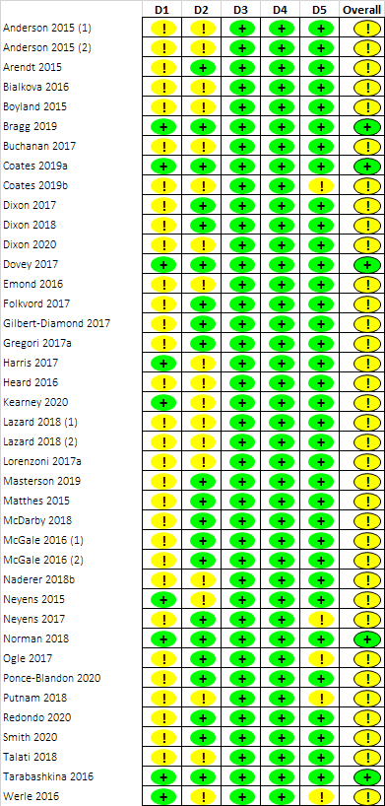
Key:

Domains
D1 Randomisation process
D2 Deviations from the intended interventions
D3 Missing outcome data
D4 Measurement of the outcome
D5 Selection of the reported result
Risk of bias
Low risk
Some concerns
High risk
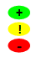

Table S2: Quality Assessment summary: review authors’ judgements about each quality domain for included cross-sectional studies (NOS, maximum score 10).
 |  | Selection |  |  |  | Comparability | Outcome
 |  | Representativeness of the sample | Sample size | Non-respondents | Ascertainment of the exposure (risk factor) | Comparability | Assessment of outcome | Statistical test | Total score
Aerts (1) | 2018 | b | b | c | a | a | b | a | 8
Aerts (2) | 2018 | d | b | c | a | b | b | a | 5
Agante | 2019 | c | b | c | c | b | b | a | 3
Baldwin | 2018 | b | b | c | c | a | b | a | 6
Bollard | 2016 | b | a | c | a | b | c | a | 6
Boyland | 2017 | c | b | c | a | b | b | a | 5
Boyland | 2018 | b | b | c | c | a | c | a | 5
Brown | 2017 | c | b | c | a | a | c | a | 6
Bruce | 2016 | d | b | c | a | b | a | a | 5
Buchanan | 2018 | c | b | c | c | a | c | a | 5
Cohen | 2015 | b | b | b | c | b | c | a | 4
Critchlow | 2020 | b | b | c | c | a | c | a | 5
Dalton | 2017 | b | b | b | b | a | b | a | 7
Domoff | 2021 | d | b | c | c | a | b | a | 5
Egbert | 2020 | c | b | b | a | a | a | a | 7
Ejlerskov | 2018 | a | b | a | a | a | b | a | 9
Emond | 2019b | b | b | b | b | a | b | a | 7
Forde | 2019 | b | a | a | c | a | b | a | 8
Gatou | 2016 | b | b | c | a | a | b | a | 8
Giese | 2015 | c | b | c | c | a | b | a | 5
Girju | 2019 | b | b | c | c | a | b | a | 6
Guan | 2018 | c | b | c | c | b | b | a | 3
Ham | 2016 | c | b | c | a | b | c | a | 4
Hennessy | 2015 | a | b | b | c | a | c | a | 5
Heredia | 2017 | c | b | c | c | b | c | a | 2
Kelly | 2016 | b | b | c | c | a | c | a | 5
Leonard (1) | 2019 | b | b | c | b | b | b | a | 5
Leonard (2) | 2019 | b | b | c | b | b | b | a | 5
Leonard (3) | 2019 | b | b | c | b | b | b | a | 5
Mann | 2018 | c | b | c | a | b | c | a | 4
Mathe-Soulek | 2016 | b | b | c | a | a | c | a | 7
Naderer | 2018a | d | b | c | a | a | b | a | 7
Newman | 2020 | b | b | c | c | a | c | a | 5
Nguyen | 2017 | b | b | c | a | a | c | a | 7
Reimann | 2017 | b | b | c | a | b | c | a | 5
Royne | 2017 | c | b | c | a | b | c | a | 4
Schumacher | 2020 | d | b | c | a | a | a | a | 7
Velazquez | 2016 | c | b | c | c | a | c | a | 4
Yau | 2021 | b | a | c | c | a | c | a | 6
Key:
Studies shaded in grey used commercial data rather than human participant samples, so this necessitated pragmatic judgements for domains related to sampling (e.g., representativeness, size) based on information provided in the publications.
a, b, c, d = these letters denote the study quality rating for each item across all domains on the NOS scale, with ‘a’ indicating the highest quality.

Table S3: Quality Assessment summary: review authors’ judgements about each quality domain for included cohort studies (NOS, maximum score 9).
 |  | Selection |  |  |  | Comparability |  | Outcome
 |  | Representativeness of the exposed cohort | Selection of the non-exposed cohort | Ascertainment of exposure | Demonstration that outcome of interest was not present at start of study | Comparability a | Comparability b | Assessment of outcome | Was follow-up long enough for outcomes to occur? | Adequacy of follow up | Total score
Emond | 2019a | b | a | c | b | a |  | c | a | b | 6
Powell | 2017 | b | a | a | b | a | b | a | a | c | 7
Smit | 2020 | c | a | c | b | a |  | c | a | d | 3
Key:
a, b, c, d = these letters denote the study quality rating for each item across all domains on the NOS scale, with ‘a’ indicating the highest quality.

