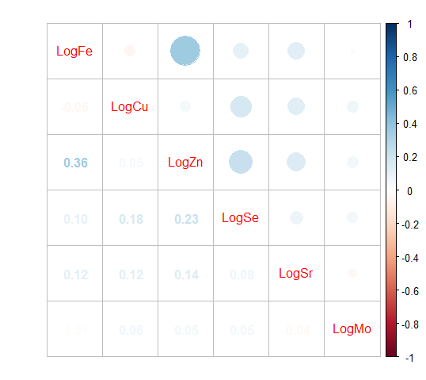 Figure S1. Pearson correlation between the concentrations (log₁₀-transformed) among six trace elements in maternal serum (N=474).

Table S1 verification results of detection methods for 6 elements in serum
Element | Linear range  （μg/L） | LOD （μg/L） | LOQ （μg/L） | Regression equation | Correlation coefficiens（r）
Fe | 0~100 | 12.20 | 40.26 | Y=0.0398X-0.0916 | 0.9999
Cu | 0~100 | 4.96 | 16.52 | Y=0.0913X+0.0669 | 0.9980
Zn | 0~100 | 15.90 | 52.95 | Y=0.0121X+0.0599 | 0.9989
Se | 0~100 | 9.88 | 32.90 | Y=4.2612E-004X+2.0328E-006 | 0.9936
Sr | 0~10.0 | 0.72 | 2.40 | Y=0.01966X+0.011 | 0.9995
Mo | 0~2.0 | 0.42 | 1.40 | Y=0.0427X+5.57921E-004 | 0.9999

Table S2 The results of serum quality control samples (n=5)
Element | Control Range(mg/L) | Mean Value(mg/L) | Measured value(mg/L)
Fe | 0.703 - 0.951 | 0.827 | 0.728-0.945
Cu | 0.630 - 0.852 | 0.741 | 0.631-0.848
Zn | 0.879 - 1.19 | 1.03 | 0.883-1.16
Se* | 43.9 - 65.8 | 54.8 | 46.3-62.5
Mo* | 1.36 - 2.27 | 1.82 | 1.38-2.08
*µg/L

Table S3. Posterior inclusion probabilities estimated by BKMR model.

Element | PIPª
Sr | 0.9760
Mo | 0.9612
Cu | 0.6016
Zn | 0.6016
Fe | 0.5544
Se | 0.5364
a: Posterior inclusion probabilities for each trace element in component-wise variable selection.

D

