Minimal processed infant formula vs conventional shows comparable protein quality and increased postprandial plasma amino acid kinetics in rats

Juliane Calvez¹, Amélie Deglaire², Anne Blais¹, Claire Gaudichon¹, François Blachier¹, Anne-Marie Davila¹
¹ Université Paris-Saclay, AgroParisTech, INRAE, UMR PNCA, 91123, Palaiseau, France
² STLO, INRAE, Institut Agro, 35042, Rennes, France

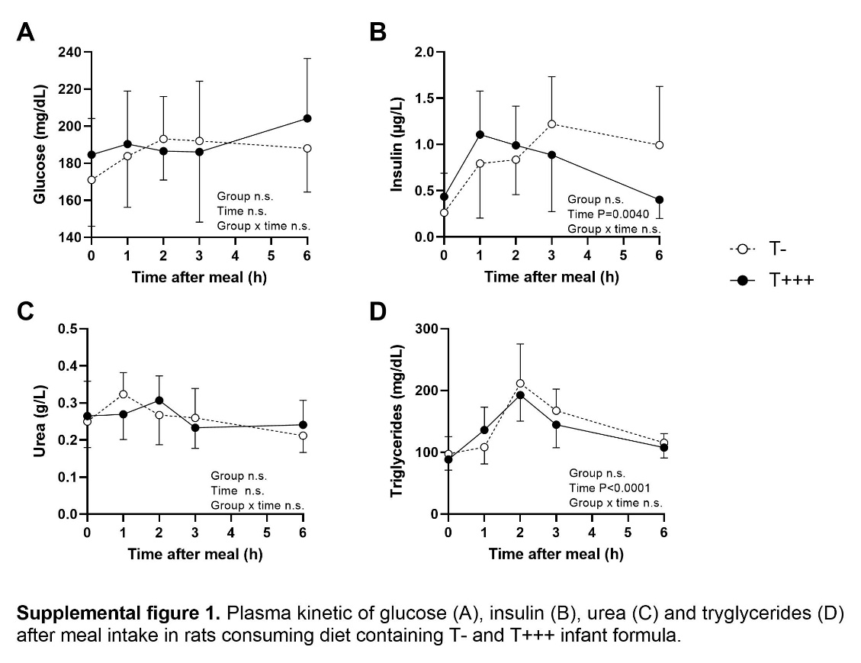
Supplementary Tables and Figures

Supplemental Table 1. Amino acid composition and nitrogen content of T+++ and T- diets given to rats
 | T+++ diets | T- diets
Indispensable amino acid (mg/g DM)
Histidine | 4.7 | 4.8
Isoleucine | 8.3 | 8.6
Leucine | 15.4 | 15.8
Lysine | 13.4 | 13.8
Methionine | 3.5 | 3.6
Phenylalanine | 7.0 | 7.3
Threonine | 7.0 | 7.2
Tryptophan | 2.5 | 2.5
Valine | 9.1 | 9.4
Dispensable amino acid (mg/g DM)
Alanine | 4.8 | 4.9
Arginine | 5.0 | 5.1
Asx | 12.3 | 12.6
Cysteine | 1.1 | 1.1
Glx | 29.9 | 31.1
Glycine | 2.4 | 2.4
Proline | 13.6 | 14.0
Serine | 8.6 | 8.6
Tyrosine | 6.9 | 7.2
N (%) | 2.43 | 2.45
Asx, aspartate + asparagine; Glx, glutamate + glutamine.

Supplemental Table 2. Amino acid composition of T+++ and T- infant formula
 | T+++ | T-
Indispensable amino acid (g/100 g protein*)
Histidine | 2.4 | 2.2
Isoleucine | 5.4 | 5.1
Leucine | 11.3 | 10.7
Lysine | 9.4 | 8.9
Methionine | 4.0 | 3.5
Phenylalanine | 4.3 | 4.1
Threonine | 4.9 | 4.6
Tryptophan | 1.8 | 1.8
Valine | 5.8 | 5.6
Dispensable amino acid (g/100 g protein*)
Alanine | 4.2 | 4.0
Arginine | 3.0 | 2.8
Asx | 10.2 | 9.7
Cysteine | 3.1 | 2.2
Glx | 18.5 | 17.4
Glycine | 2.0 | 1.9
Proline | 7.3 | 6.9
Serine | 4.9 | 4.6
Tyrosine | 3.9 | 3.7
* protein content = N x 6.38. Asx, aspartate + asparagine; Glx, glutamate + glutamine.

Supplemental Table 3. Cecal endogenous amino acid losses determined in 6 h after protein-free meal intake.
Endogenous losses (mg)
Indispensable amino acids
Histidine | 0.5 ± 0.1
Isoleucine | 1.4 ± 0.3
Leucine | 1.8 ± 0.4
Lysine | 1.9 ± 0.4
Methionine | 0.6 ± 0.1
Phenylalanine | 1.0 ± 0.2
Threonine | 1.4 ± 0.4
Tryptophan | 0.4 ± 0.1
Valine | 1.6 ± 0.3
Dispensable amino acids
Alanine | 1.6 ± 0.4
Arginine | 1.2 ± 0.3
Asx | 2.8 ± 0.7
Cysteine | 0.2 ± 0.0
Glx | 4.0 ± 0.9
Glycine | 0.9 ± 0.2
Proline | 1.0 ± 0.3
Serine | 1.6 ± 0.4
Tyrosine | 1.0 ± 0.2
Values are means ± SD, with n = 8. Asx, aspartate + asparagine; Glx, glutamate + glutamine.

