Supplementary material
Table S1. Summary of sequencing data at the end of 8 weeks of treatment.
Treatment | Good's coverage | Raw sequences | Filtered reads |  | Normalized reads
 |  | Reads | Reads | OTUs | Reads | OTUs
CD | 0.9931 ± 0.0012 | 170640 ±11239 | 102676±7532 | 507±108 | 28376 ±96 | 157±21
HF | 0.9966 ± 0.0028 | 167168±15164 | 87476±23744 | 570±162 | 28027 ±665 | 162 ±28
HFM | 0.9931 ± 0.0012 | 167168±15164 | 38307±3678 | 678±110 | 27082±509 | 200 ±10
Values expressed as mean ± standard deviation. n=10 animals/group. CD: control diet– AIN93M, HF: high-fat diet, HFM: high-fat diet with macauba pulp oil; OTUs: operational taxonomic units.

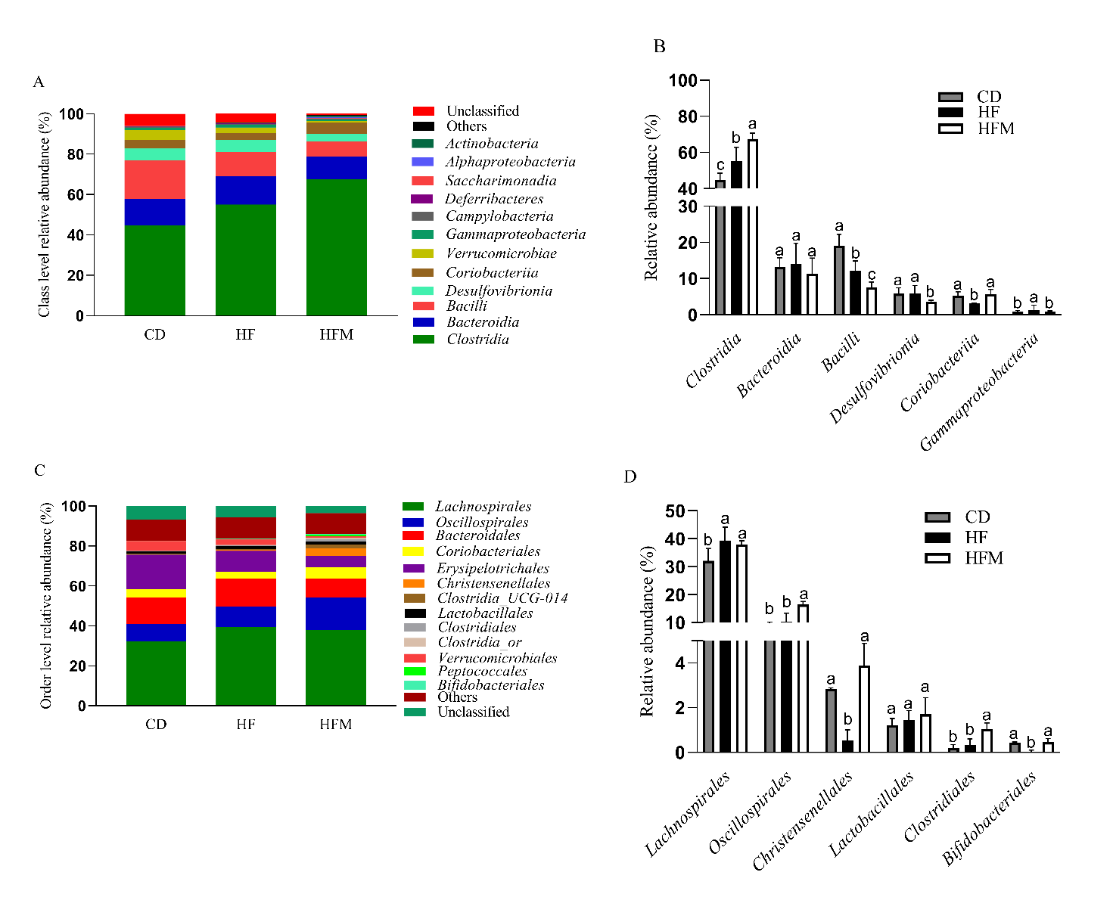
Fig. S1. Gut microbiota at Class and Order classification levels. (A) Distribution of mice gut microbiota at the level of Class classification; (B) Relative abundance of the gut microbiota at the level of Class classification; (C) Distribution of mice gut microbiota at the level of Order classification; (D) Relative abundance of the gut microbiota at the level of Order classification. CD: control diet – AIN93M, HF: high-fat diet, HFM: high-fat diet with macauba pulp oil. Different letters indicate a statistical difference by Tukey test (p≤0.05).

