Supplementary Methods
Values for 6 h post-feeding are shown below to exemplify the calculations. The mean DM intake and DM in pooled digesta, terminal ileum, and the large intestine were 213, 31.6, 1.97, and 240 g respectively. The TiO₂ concentrations were 0.43, 1.55, 4.15, and 0.14% respectively, while the lysine concentrations (except large intestine) were 2.86, 7.74, and 8.60% respectively.
Lysine intake _{Pooled digesta} (g) = 2.86% x 213 g / 100% = 6.09 g
Lysine content _{Pooled digesta} (g) = 0.774% x 31.6 g / 100% = 0.245 g
Lysine content _{Terminal ileal digesta} (g) = 0.86% x 1.97 g / 100% = 0.017 g

To determine the amount of lysine released into the small intestine two different methods (direct and indirect) were determined as follows:
TiO₂ intake (g) = 0.43% x 213 g / 100% = 0.916 g
TiO₂ content _{Pooled digesta} (g) = 1.55% x 31.6 g / 100% = 0.490 g
TiO₂ content _{Terminal ileal digesta} (g) = 4.15% x 1.97 g / 100% = 0.082 g
TiO₂ content _{Large intestinal digesta} (g) = 0.14% x 240 g / 100% = 0.336 g

Direct method: Lysine released into the large intestine_{Direct method} (g) = 0.336 g x 0.017 g / 0.082 g = 0.070 g
Apparent lysine unabsorbed (g) = 0.245 g + 0.017 g + 0.070 g = 0.332 g
Apparent lysine disappeared (g) = 6.09 g – 0.332 g = 5.758 g
Apparent lysine disappearance (%) = (6.09 g – 0.332 g) / 6.09 g x 100 = 94.5%

Indirect method: Lysine released into the large intestine_{Direct method} (g) = (0.916 g – (0.490 g + 0.082 g) x 0.017 g / 0.082 g = 0.072 g
Apparent lysine unabsorbed (g) = 0.245 g + 0.017 g + 0.072 g = 0.334 g
Apparent lysine disappeared (g) = 6.09 g – 0.334 g = 5.756 g
Apparent lysine disappearance (%) = (6.09 g – 0.334 g) / 6.09 g x 100 = 94.5%

Supplementary Table 1. R² and variance values were obtained after fitting different non-linear models to the apparent amino acid absorption data of growing pigs fed a whey protein isolate containing test meal
 | Asp |  |  | Glu |  |  | Leu
 | R² | Variance |  | R² | Variance |  | R² | Variance
Weibull equation | 0.9505 | 232.5 |  | 0.9585 | 190.4 |  | 0.9737 | 153.1
Chapman-Richard’s equation | 0.9735 | 128.2 |  | 0.9735 | 128.2 |  | 0.9813 | 112.2
Logistic function | 0.9739 | 122.6 |  | 0.9754 | 113.0 |  | 0.9813 | 108.9
Gompertz function | 0.9741 | 121.5 |  | 0.9761 | 109.6 |  | 0.9815 | 107.7

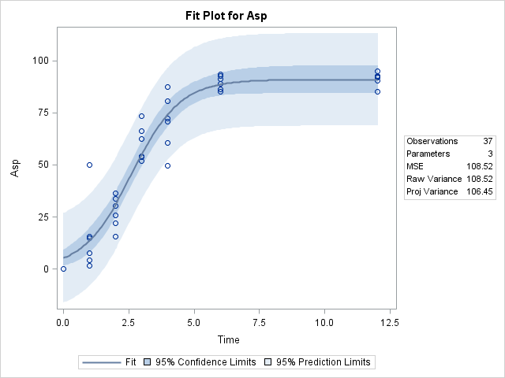

Supplementary Figure 1. Observed values and fitted Logistic function for the apparent amino acid absorption of asparagine (Asp) for growing pigs fed a whey protein isolate containing test meal

