Table S1 A quantitative sample menu in 1-week run-in period (2150 kcal/d)
Meals | Dishes | Ingredients | Weights (g)
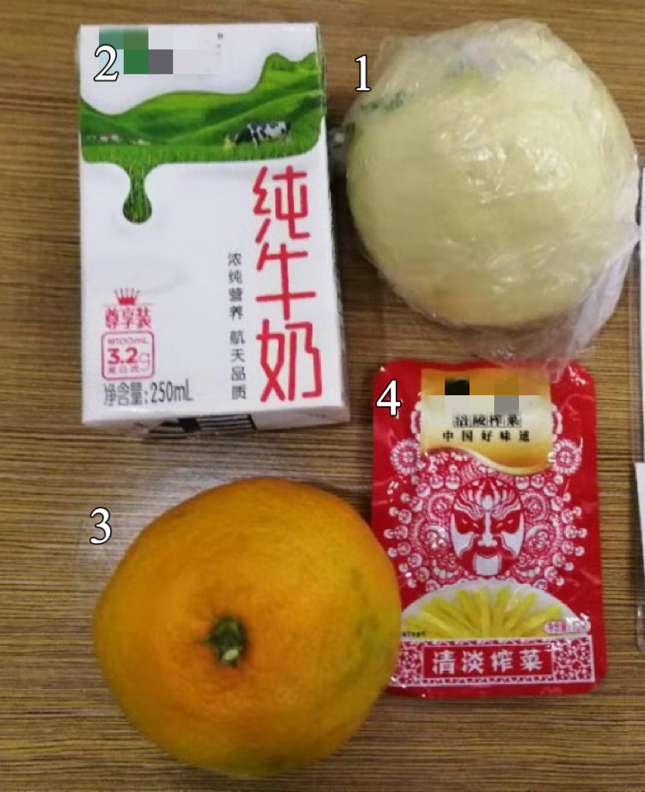  Breakfast | 1 Steamed Corn Bun | Wheat Flour | 60.00
 |  | Yellow Cornmeal | 10.00
 | 2 Milk | Full-fat Milk | 250.00
 | 3 Mandarin Orange | Mandarin Orange | 114.00
 | 4 Pickled Vegetables | Mustard Tuber | 15.00
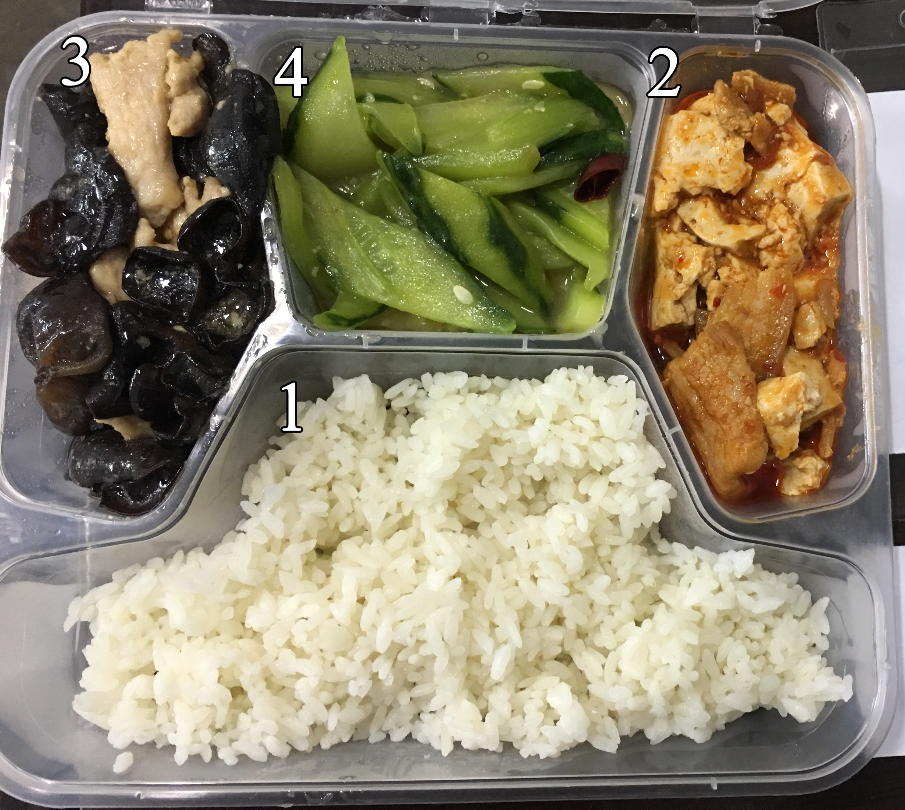  Lunch | 1 Rice | Rice | 90.00
 | 2 Homestyle Tofu | Pork Belly | 34.00
 |  | Tofu | 85.00
 |  | Bean Paste in Chili Oil | 6.00
 |  | Soybean Oil | 4.00
 |  | Corn Starch | 1.53
 |  | Rock Salt | 1.00
 |  | Chicken Powder Seasoning | 0.60
 |  | Soy Sauce | 2.00
 | 3 Stir Fried Pork Slices | Pork Tenderloin | 40.00
 |  | Fungus (dry) | 6.00
 |  | Rock Salt | 1.50
 |  | Soy Sauce | 3.00
 |  | Chicken Powder Seasoning | 0.60
 |  | Pickled Red Pepper | 5.00
 |  | Corn Starch | 2.00
 |  | Soybean Oil | 12.45
 | 4 Stir-fry Cucumber | Cucumber | 138.00
 |  | Rock Salt | 1.40
 |  | Corn Starch | 0.54
 |  | Chicken Powder Seasoning | 0.60
 |  | Lard | 5.00
Dinner  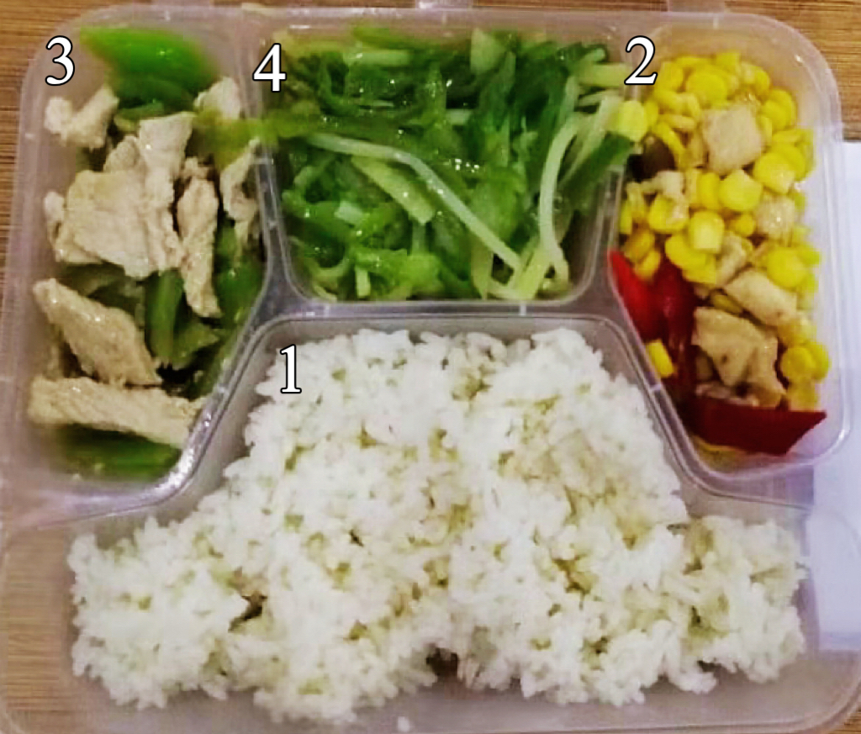 | 1 Rice | Rice | 90.00
 | 2 Diced Chicken with Corn | Drumstick | 41.00
 |  | Corn (fresh) | 69.00
 |  | Rock Salt | 1.30
 |  | Chicken Powder Seasoning | 0.60
 |  | Soybean Oil | 5.00
 |  | Pickled Red Pepper | 5.00
 |  | Corn Starch | 1.40
 | 3 Sautéed Pork Slices with Asparagus Lettuce | Pork Tenderloin | 40.35
 |  | Asparagus Lettuce | 74.00
 |  | Rock Salt | 0.80
 |  | Chicken Powder Seasoning | 0.60
 |  | Soy Sauce | 2.00
 |  | Corn Starch | 2.00
 |  | Soybean Oil | 6.00
 | 4 Potatoes Slivers with Green Chilies | Sweet Pepper | 66.00
 |  | Potato | 47.50
 |  | Corn Starch | 0.55
 |  | Soybean Oil | 6.00
 |  | Rock Salt | 1.30
 |  | Chicken Powder Seasoning | 0.60

Table S2 A quantitative sample menu of Control-SC group in 4-week intervention period (2150 kcal/d)
Meals | Dishes | Ingredients | Weights (g)
Breakfast  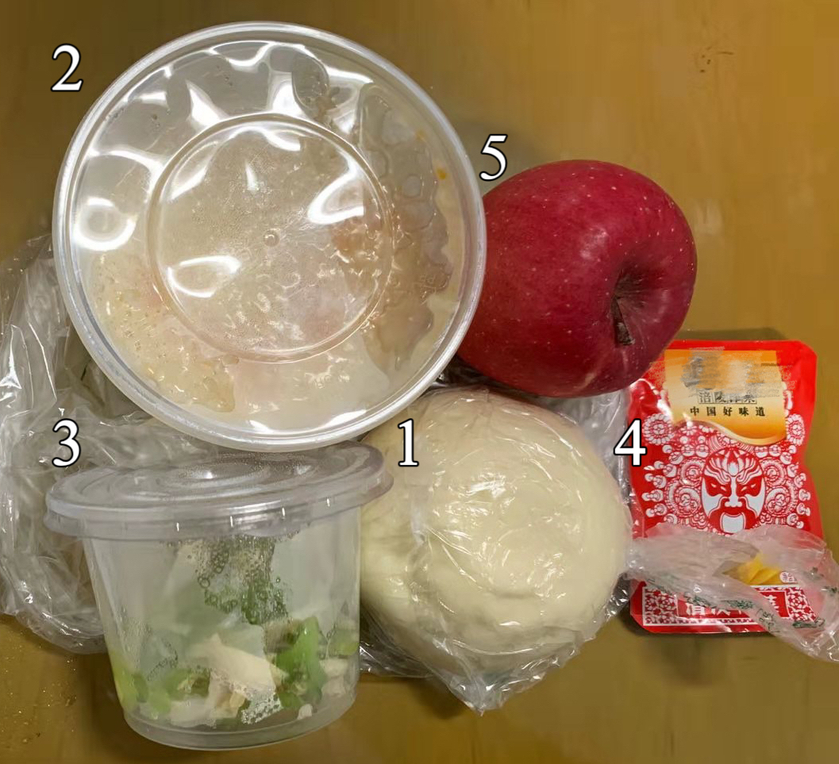 | 1 Steamed Bun | Wheat Flour | 50.00
 | 2 Pumpkin Congee with Millet | Millet | 20.00
 |  | Pumpkin | 33.89
 | 3 Abalone Mushrooms with Asparagus Lettuce and Tofu Skin | Abalone Mushrooms | 30.56
 |  | Asparagus Lettuce | 31.67
 |  | Tofu Skin | 5.00
 |  | Soybean Oil | 5.00
 |  | Chicken Powder Seasoning | 0.60
 |  | Corn Starch | 0.40
 |  | Rock Salt | 0.70
 | 4 Pickled Vegetables | Mustard Tuber | 15.00
 | 5 Apple | Apple | 140.00
Lunch  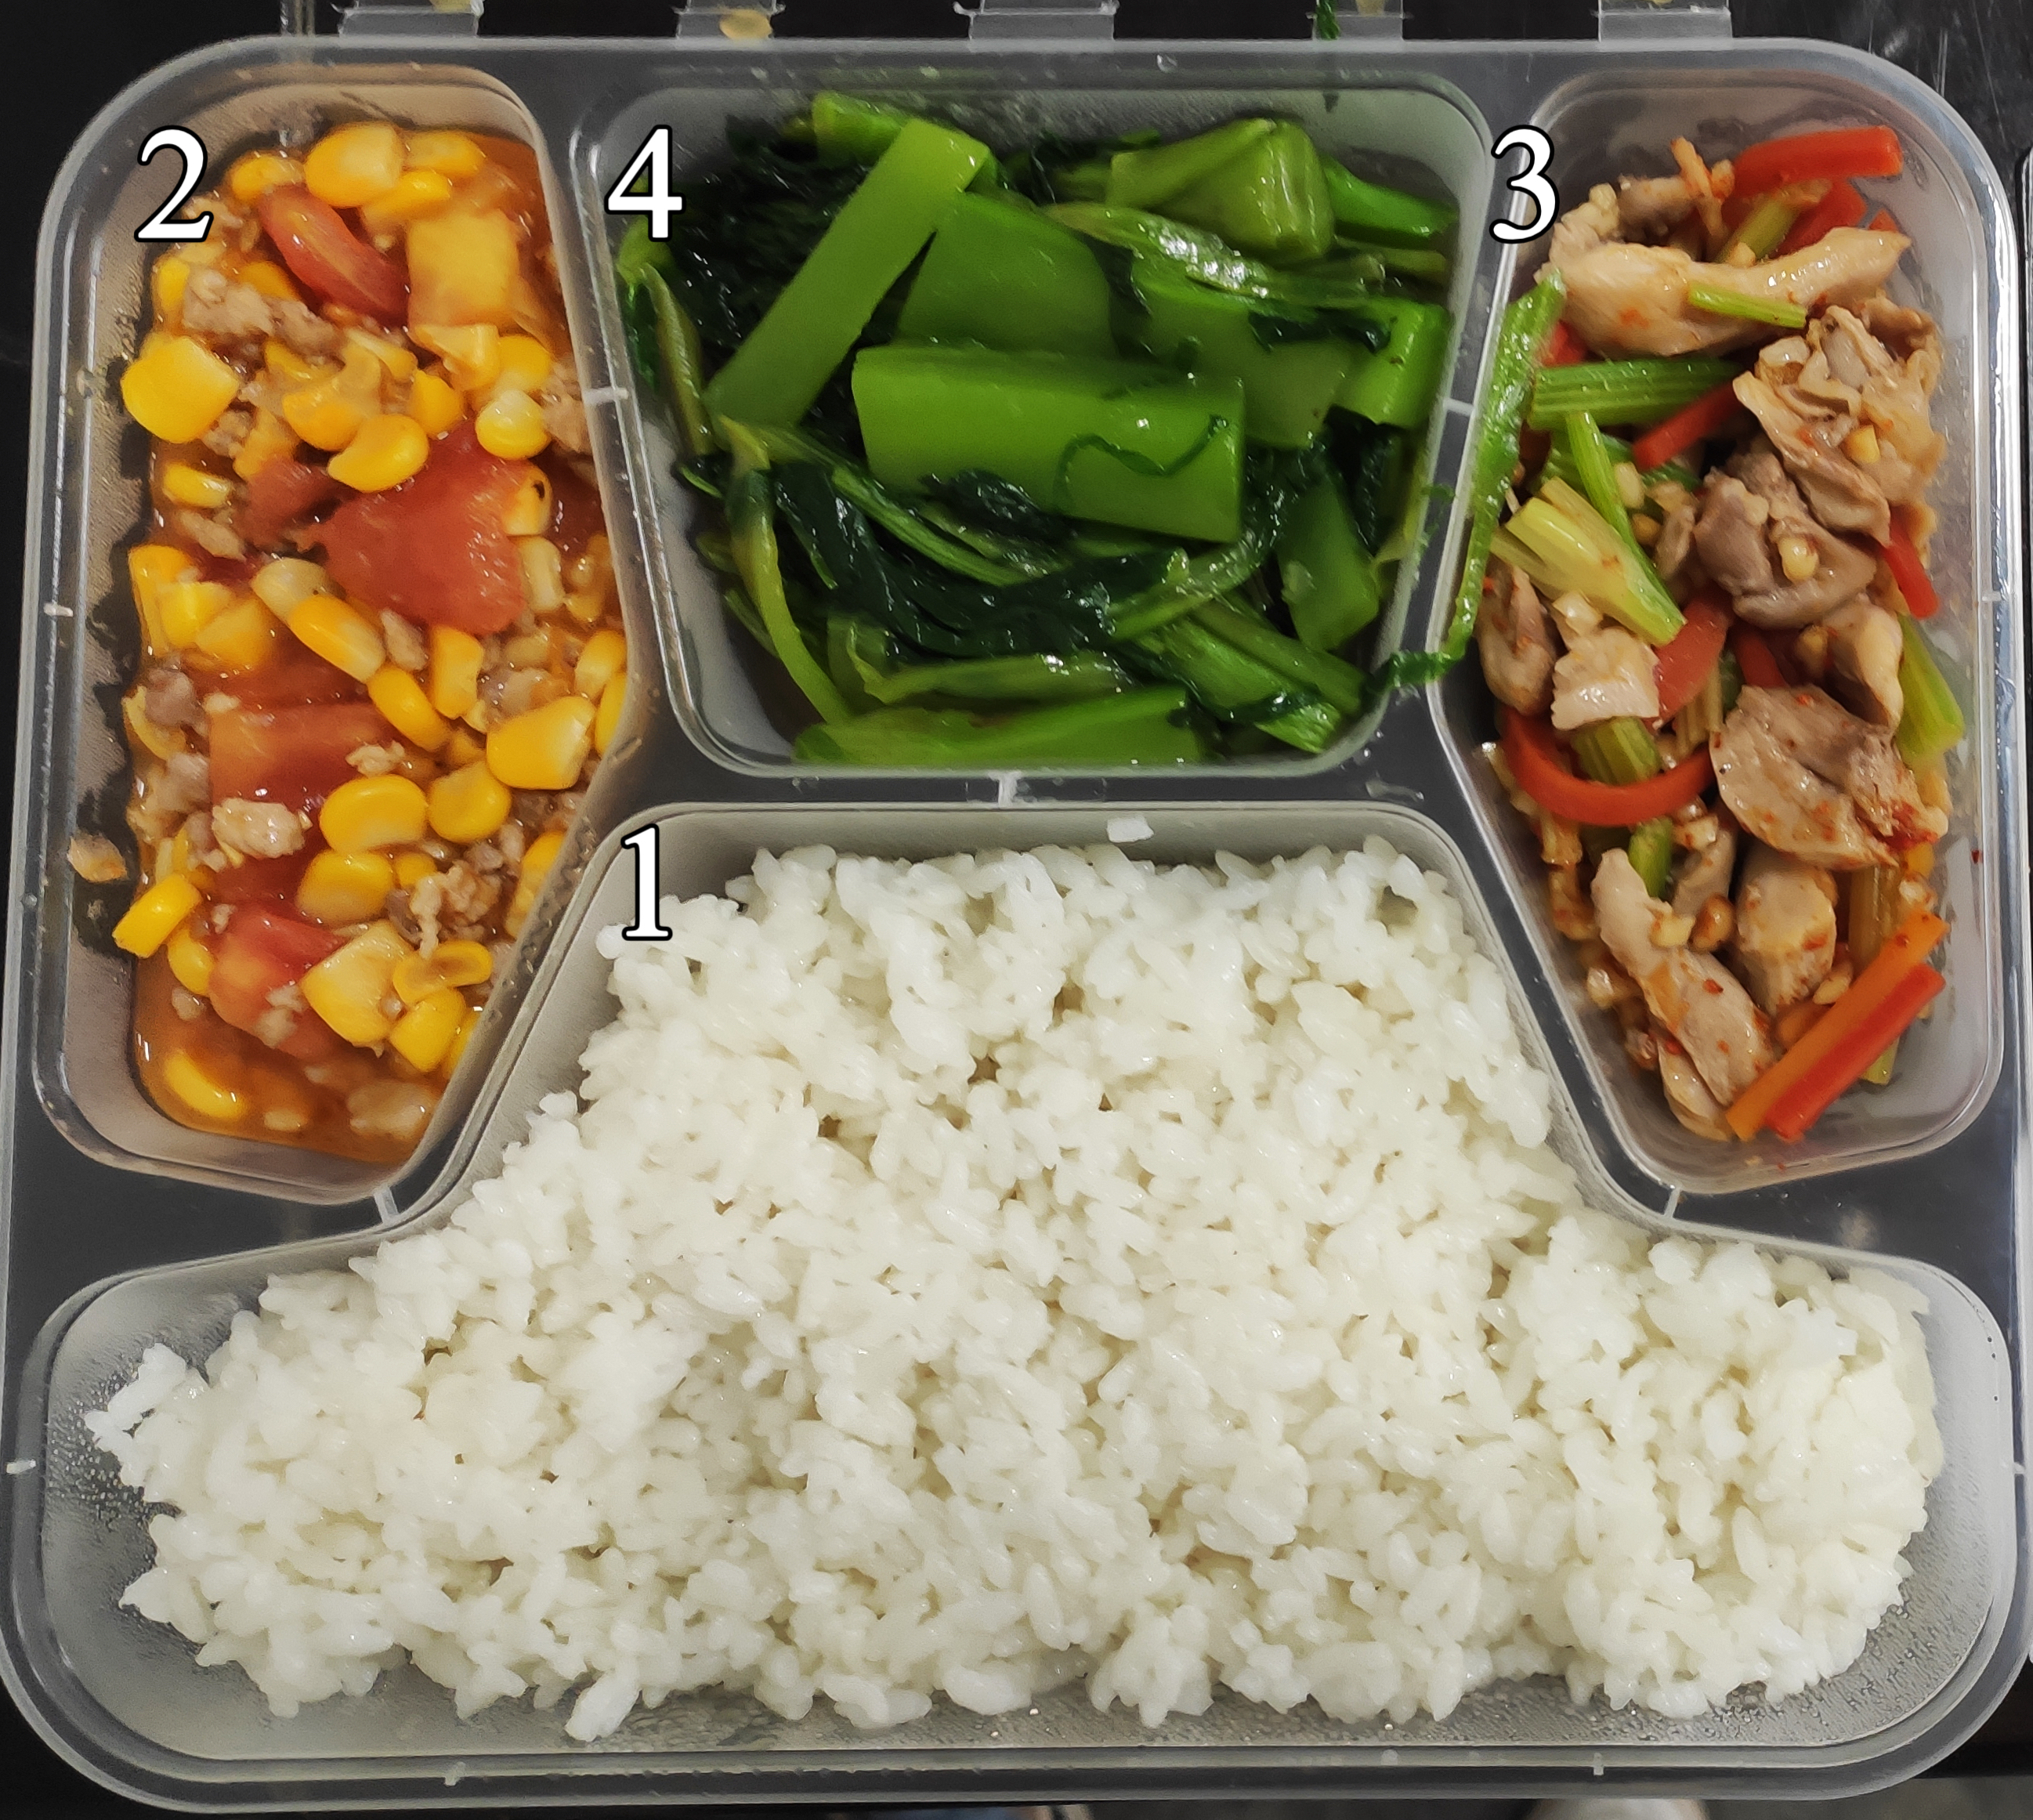 | 1 Rice | Rice | 100.00
 | 2 Multi-ingredient Braising Pork Filling and Corns with Tomato Sauce Flavor | Corn (fresh) | 40.00
 |  | Tomato | 50.67
 |  | Pork Belly | 40.28
 |  | Soybean Oil | 6.00
 |  | Corn Starch | 1.28
 |  | Chicken Powder Seasoning | 0.60
 |  | Soy Sauce | 3.00
 |  | Rock Salt | 0.69
 | 3 Hand-Shredded Chicken | Drumstick | 55.00
 |  | Peanut Kernel (fried) | 8.00
 |  | Sesame Oil | 6.00
 |  | Carrot | 20.00
 |  | Celery Stem | 17.22
 |  | Rock Salt | 0.78
 |  | Chicken Powder Seasoning | 0.60
 |  | Sugar | 1.00
 |  | Soy Sauce | 3.00
 | 4 Scorching Stir Frying Green Vegetables | Lettuce Leaves | 156.11
 |  | Lard | 5.00
 |  | Soy Sauce | 3.00
 |  | Corn Starch | 2.00
 |  | Chicken Powder Seasoning | 0.60
 |  | Rock Salt | 1.17
Dinner  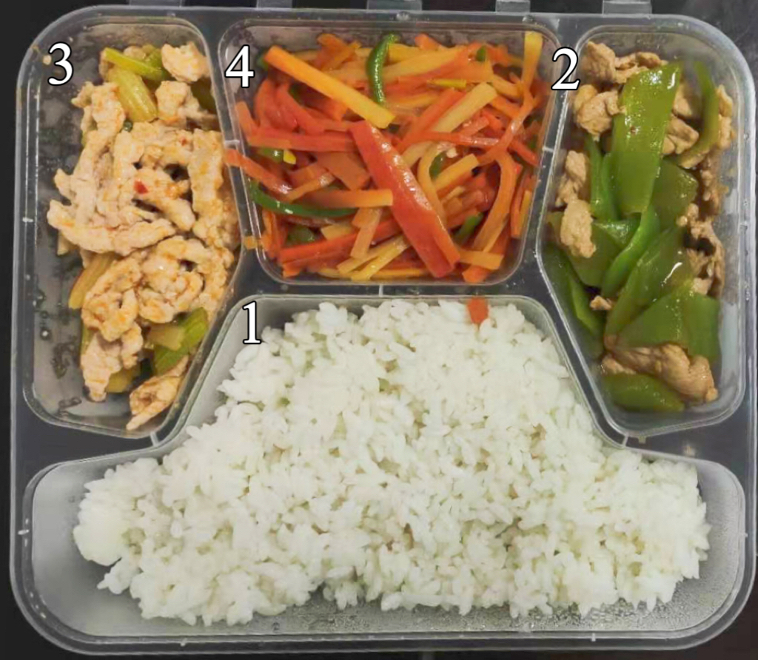 | 1 Rice | Rice | 100.00
 | 2 Frying Pork Slices with Lettuce | Asparagus Lettuce | 55.00
 |  | Pork Trotter | 50.00
 |  | Soybean Oil | 5.00
 |  | Rock Salt | 0.86
 |  | Pickled Red Pepper | 2.97
 |  | Chicken Powder Seasoning | 0.60
 |  | Dark Soysauce | 0.50
 |  | Corn Starch | 0.50
 | 3 Frying Pork Slivers with Celery | Celery Stem | 35.28
 |  | Pork Tenderloin | 50.00
 |  | Soybean Oil | 6.00
 |  | Chicken Powder Seasoning | 0.60
 |  | Rock Salt | 0.80
 |  | Bean Paste in in Chili Oil | 2.00
 |  | Corn Starch | 1.83
 | 4 Carrot with Sweet Pepper | Carrot | 97.22
 |  | Lard | 7.00
 |  | Chicken Powder Seasoning | 0.60
 |  | Soy Sauce | 3.00
 |  | Sweet Pepper | 18.33
 |  | Rock Salt | 1.50
 |  | Corn Starch | 0.67

Table S3 A quantitative sample menu of CHH-SC group in 4-week intervention period (2050 kcal/d)
Meals | Dishes | Ingredients | Weights (g)
Breakfast  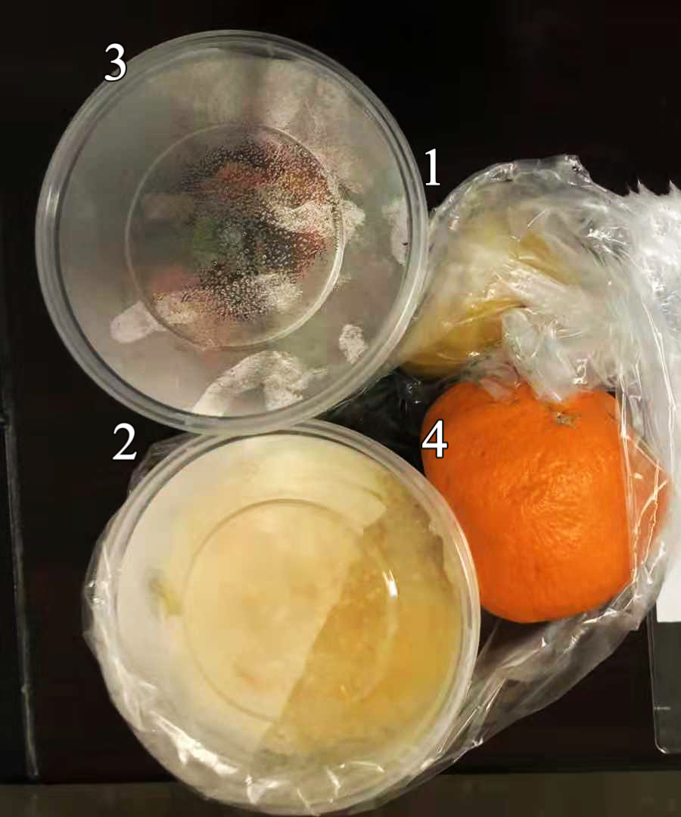 | 1 Creamy Wowotou | Yellow Cornmeal | 40.00
 |  | Wheat Flour | 20.00
 |  | Jujube (dry) | 6.00
 |  | Full-fat Milk | 25.00
 | 2 Pumpkin Congee with Millet | Millet | 20.00
 |  | Pumpkin | 34.06
 | 3 Mushrooms with Asparagus Lettuce and Carrot | Mushroom (dried) | 6.11
 |  | Carrot | 50.00
 |  | Asparagus Lettuce | 30.00
 |  | Sesame Oil | 5.00
 |  | Low-sodium Salt | 1.00
 | 4 Mandarin Orange | Mandarin Orange | 158.00
Lunch  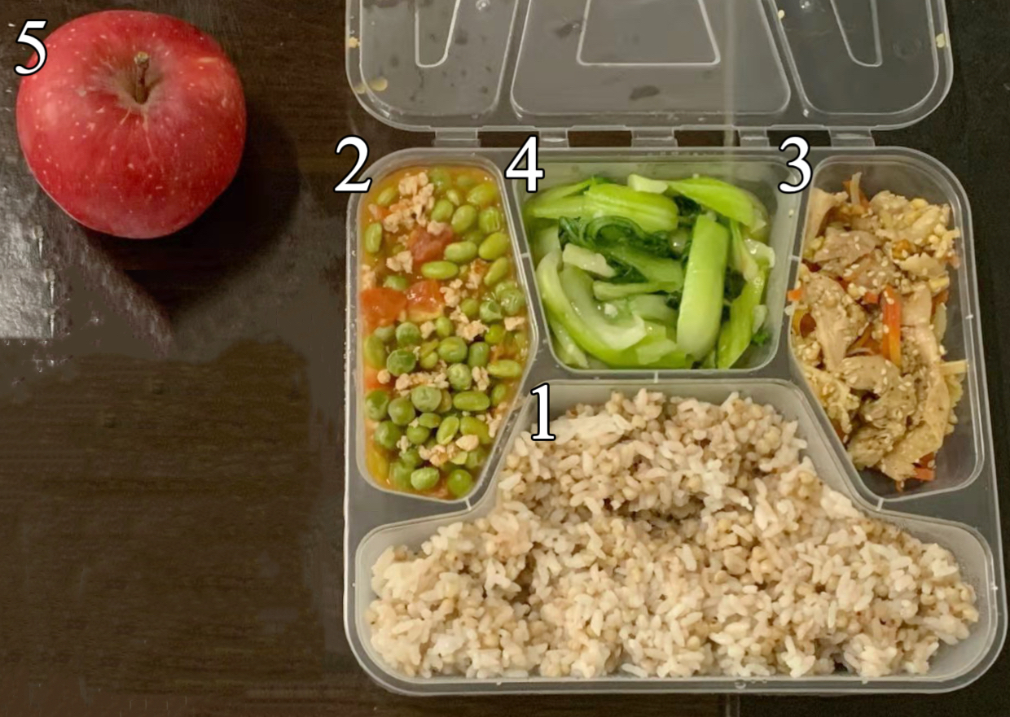 | 1 Grain Rice | Rice | 60.00
 |  | Buckwheat | 30.00
 | 2 Multi-ingredient Braising Pork Filling and Green Beans with Tomato Sauce Flavor | Green Beans | 52.78
 |  | Tomato | 47.44
 |  | Pork Tenderloin | 30.00
 |  | Soybean Oil | 4.00
 |  | Corn Starch | 1.00
 |  | Low-sodium Salt | 1.20
 | 3 Mild Spicy Chicken | Drumstick | 50.28
 |  | Peanut Kernel (fried) | 8.00
 |  | Celery Stem | 10.00
 |  | Carrot | 10.00
 |  | Sesame (white) | 5.00
 |  | Sesame Oil | 2.00
 |  | Sugar | 2.00
 |  | Soy Sauce | 1.00
 |  | Low-sodium Salt | 0.40
 | 4 Scorching Stir Frying Green Vegetables | Brassica Plant | 143.89
 |  | Soybean Oil | 4.00
 |  | Low-sodium Salt | 0.60
 |  | Corn Starch | 0.60
 | 5 Apple | Apple | 147.00
Dinner  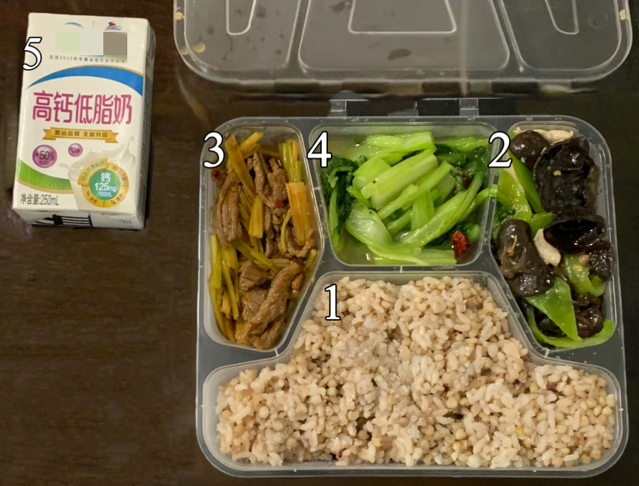 | 1 Grain Rice | Buckwheat | 30.00
 |  | Rice | 60.00
 | 2 Stir Fried Pork Slices | Asparagus Lettuce | 43.06
 |  | Fungus (dry) | 5.00
 |  | Pork Tenderloin | 40.00
 |  | Soybean Oil | 6.00
 |  | Low-sodium Salt | 1.20
 |  | Pickled Red Pepper | 5.00
 |  | Corn Starch | 2.50
 | 3 Frying Beef Slices with Celery | Celery Stem | 34.17
 |  | Beef Tenderloin | 40.00
 |  | Soybean Oil | 5.00
 |  | Bean Paste in in Chili Oil | 2.00
 |  | Soy Sauce | 2.00
 |  | Low-sodium Salt | 0.30
 |  | Corn Starch | 1.81
 | 4 Chinese Cabbage with garlic flavor | Chinese Cabbage | 131.11
 |  | Soybean Oil | 3.00
 |  | Corn Starch | 1.00
 |  | Low-sodium Salt | 1.00
 | 5 Milk | High-calcium and Low-fat Milk | 250.00

