1.
a.
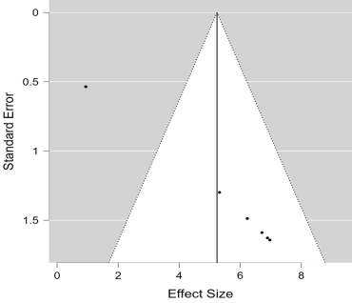
Egger’s test: p < 0.001

b.
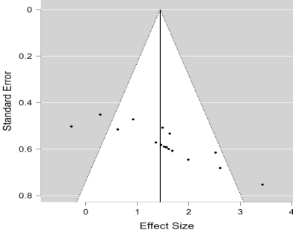
Egger’s test: p < 0.001

c.
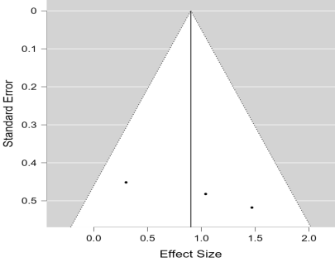

Egger’s test: p = 0.086

d.
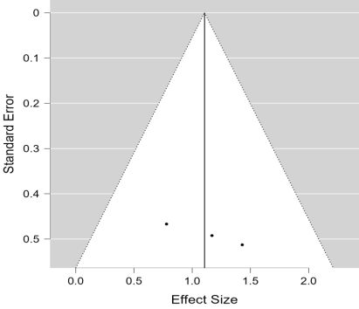
Egger’s test: p = 0.342
e.
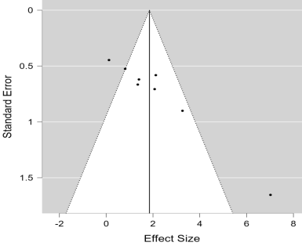
Egger’s test: p < 0.001

f.
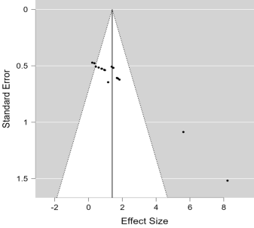
Egger’s test: p < 0.001

g.
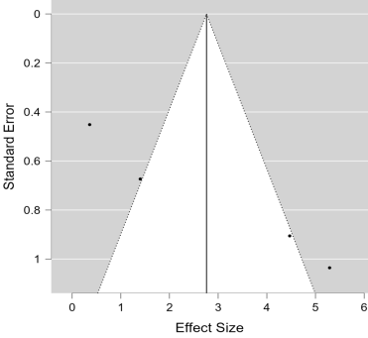
Egger’s test: p < 0.001

h.
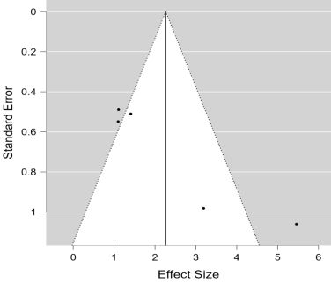
Egger’s test: p < 0.001

Fig.1: Funnel plots and p value for Egger’s test conducted on BMD of a. Femur total, b. Femur trabecular, c. Tibia trabecular, d. Tibia cortical and e. vertebra and BV/TV of a. Femur, b. Tibia and c. Vertebra
2.
a.
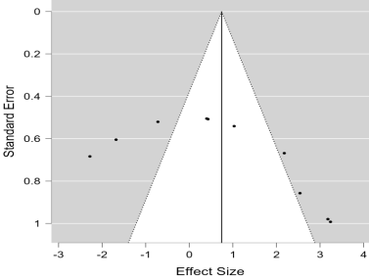
Egger’s test: p = 0.018

b.
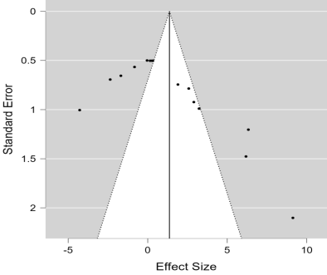
Egger’s test: p < 0.001

c.
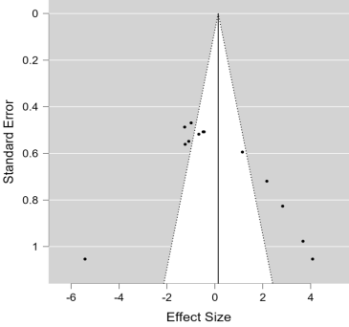
Egger’s test: p = 0.254

d.
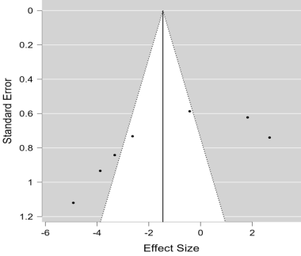
Egger’s test: p = 0.012

e.
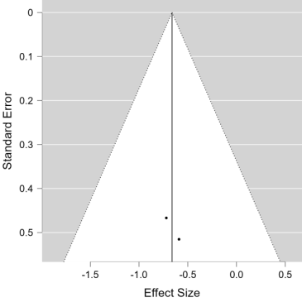

f.
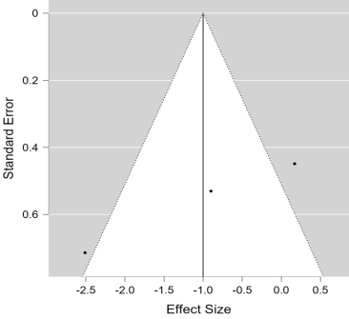
Egger’s test: p = 0.001

Fig.2: Funnel plot and p value for egger’s test conducted on a. serum osteocalcin, b. serum calcium, c. serum ALP, d. serum CTX, e. BFR and f. Oc.S/B.S

3.
a.(i)
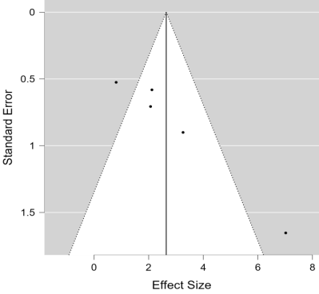
Egger’s test: p < 0.001

(ii)
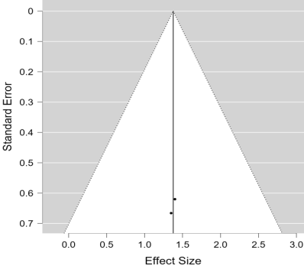

b. (i)
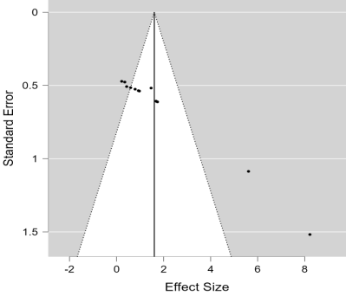
Egger’s test: p < 0.001

(ii)
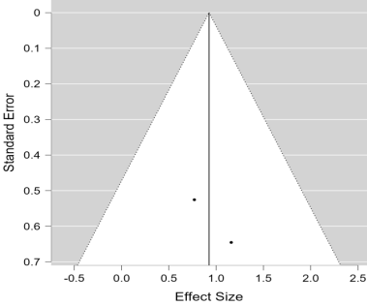
c. (i)
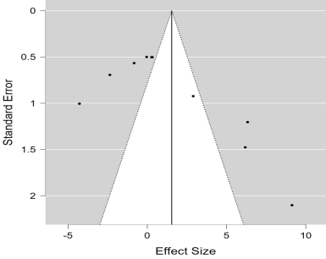
Egger’s test: p = 0.001

(ii)
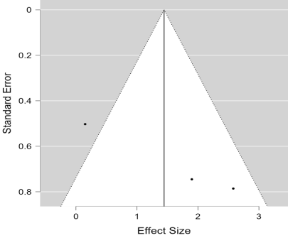
Egger’s test: p = 0.004

Fig.3. Funnel plot and egger’s test for comparative analysis conducted on (i) Lactobacillus and (ii) Bifidobacterium using a. Vertebral BMD, b. Femur BV/TV and c. serum calcium

4.
 | Random sequence generation (Selection bias) | Baseline characteristics (Selection bias) | Allocation concealment (Selection bias) | Random housing (Performance bias) | Blinding (Performance bias) | Random Outcome Assessment (Outcome bias) | Blinding of outcome assessment (Detection bias) | Incomplete outcome data (attrition bias) | Selective reporting (reporting bias) | Other bias
Parvaneh et. al., 2018 | ? | + | ? | ? | ? | ? | ? | + | + | +
Narva et.al., 2007 | ? | + | ? | ? | ? | ? | ? | + | + | +
Shim et. al., 2012 | ? | + | ? | ? | ? | ? | ? | + | + | +
Lee et. al., 2019 | ? | + | ? | ? | ? | ? | ? | + | + | +
Britton et. al., 2014 | ? | ? | ? | ? | ? | ? | + | + | + | +
Shim et. al., 2013 | ? | + | ? | ? | ? | ? | ? | + | + | +
Yu et. al., 2022 | + | + | ? | ? | ? | ? | ? | + | + | +
Sapra et. al., 2021 | ? | + | ? | ? | ? | ? | ? | + | + | +
Dar et. al., 2018 | ? | + | ? | ? | ? | ? | ? | + | + | +
Lim et. al., 2021 | ? | + | ? | ? | ? | ? | ? | + | + | +
Lee et. al., 2021 | ? | + | ? | ? | ? | ? | ? | + | + | +
Chiang et. al., 2011 | ? | + | ? | ? | ? | ? | ? | + | + | +
Ohlsson et.al., 2014 | ? | + | ? | ? | ? | ? | ? | + | + | +
Yang et. al., 2020 | ? | + | ? | ? | ? | ? | + | + | + | +
Lee et. al., 2020 | ? | + | ? | ? | ? | ? | ? | + | + | +
H Y Dar et. al., 2018 | ? | + | ? | ? | ? | ? | ? | + | + | +
Parvaneh et. al., 2015 | ? | + | ? | ? | ? | ? | ? | + | + | +
Wallimann et. al., 2021 | ? | + | ? | ? | ? | ? | ? | + | + | +
Sapra et al., 2022 | ? | + | ? | ? | ? | ? | ? | + | + | +
Yamada et al., 2019 | ? | + | ? | ? | ? | ? | ? | + | + | +
Montazeri Najafabady et. al., 2019 | ? | + | ? | ? | ? | ? | ? | + | + | +
Kim et. al., 2019 | ? | + | ? | ? | ? | ? | ? | + | + | +
Key
+ : low risk of bias
? : Unclear risk of bias
Fig.4: Risk of bias assessment of the 22 included studies using SYRCLE tool.

