Table 1. Sequence of genes primers
PPAR-α | Forward | ATG GTG GAC ACG GAA AGC C
 | Reverse | CGA TGG ATT GCG AAA TCT CTT GG
PPAR-γ | Forward | TAC TGT CGG TTT CAG AAA TGC C
 | Reverse | GTC AGC GGA CTC TGG ATT CAG
TGF-β | Forward | CTA ATG GTG GAA ACC CAC AAC G
 | Reverse | TAT CGC CAG GAA TTG TTG CTG
Nrf-2 | Forward | TTC CCG GTC ACA TCG AGA G
 | Reverse | TCC TGT TGC ATA CCG TCT AAA TC
GAPDH | Forward | ACAACTTTGGTATCGTGGAAGG
 | Reverse | GCCATCACGCCACAGTTTC
PPAR-α: Peroxisome proliferator-activated receptor alpha, PPAR-γ: Peroxisome proliferator-activated receptor gamma, TGF-β: Transforming growth factor beta, Nrf-2: Nuclear factor erythroid 2–related factor 2, GAPDH: Glyceraldehyde 3-phosphate dehydrogenase.

Table 2. General characteristics of DN patients in the two study groups
 | DOE (n=32) | Placebo (n=32) | P-value
Age (year) | 61.53 ± 7.11 | 61.29 ± 8.77 | 0.905*
Sex (n)  Male  Female | 12 (37.5)  20 (62.5) | 10 (31.2)  22 (68.8) | 0.595^
BMI (kg/m²) | 30.77 ± 5.15 | 29.41 ± 4.34 | 0.263
Physical activity (Mets) | 771.75 (42.37, 2674.87) | 1290.00 (297.00, 3810.70) | 0.611
Drugs  OHAs, Anti-DSLDs and Anti-HTNDs  Ins, Anti-DSLDs and Anti-HTNDs | 15  17 | 17  15 | 0.703
DOE: dried okra extract, BMI: body mass index, DN: diabetic nephropathy, Ins: insulin, OHAs: oral hypo-glycemic agents, Anti-HTNDs: Anti-hypertensive drugs, Anti-DSLDs: Anti-Dyslipidemic drugs
MET: metabolic equivalent
* Obtained from Independent Samples t-test
^ Obtained from Fisher's exact test

Table 3. Urine analysis and hs-CRP of DN patients in the two study groups
 | DOE (n=32) | Placebo (n=32) | Between-group changes, P-value
Urine protein (mg/24hrs)  Baseline  End  Median Dif (%change)  P-value** | 488 (139.25, 1084.44)  491 (192.75, 1530.75)  42.41 (0.61)  0.184 | 450 (135, 1134)  594 (180, 820)  61.00 (32)  0.186 | -14.0 (8.44%), 0.762##  62.0 (20.9%), 0.573##, 0.880$, 0.917≠, 0.902▲
Urine creatinine (g/24hrs)  Baseline  End  Mean Dif (95%CI)  P-value* | 1.41 ± 0.37  1.45 ± 0.24  0.04 (-0.09, 0.17)  0.550 | 1.30 ± 0.32  1.42 ± 0.21  0.11 (-0.009, 0.24)  0.068 | -0.105 (-0.282, 0.072), 0.240#  -0.029 (-0.146, 0.087), 0.614#, 0.859^, 0.677&, 0.648▼
hs-CRP (mg/L)  Baseline  End  Median Dif (%change)  P-value** | 0.78 (0.09, 1.58)  1.95 (0.93, 4.19)  1.03 (95)  0.006 | 0.76 (0.10, 1.48)  2.14 (1.40, 2.89)  1.41 (178.4)  0.002 | -0.03 (2.63%), 0.825##  -0.07 (-8.8%), 0.863##, 0.499$, 0.135≠, 0.141▲
AGE: advanced glycation end products; BMI: Body Mass Index; DN: diabetic nephropathy; DOE: dried okra extract; Dif: difference; hs-CRP: High-sensitivity C-reactive Protein;
*Obtained from Paired samples t-test
**Obtained from Wilcoxon rank-sum test
# Obtained from Independent samples t-test
## Obtained from Mann-Whitney U test
^ Obtained from ANCOVA, adjusted for baseline values (Model 1).
& Obtained from ANCOVA, adjusted for model 1 plus age, changes in BMI, energy intake, and physical activity (Model 2).
▼ Obtained from ANCOVA, adjusted for Model 2 plus changes in AGE (Model 3).
$ Obtained from Quantile regression, adjusted for baseline values (Model 1).
≠ Obtained from Quantile regression, adjusted for Model 1 plus age, changes in BMI, energy intake, and physical activity (Model 2).
▲ Obtained from Quantile regression, adjusted for Model 2 plus changes in AGE (Model 3 for urine protein).
▲ Obtained from Quantile regression, adjusted for Model 2 plus changes in HbA1c (Model 3 for hs-CRP).

Table 4. Glycemic parameters of patients in the two study groups
 | DOE (n=32) | Placebo (n=32) | Between-group changes, P-value
FBG (mg/dl)  Baseline  End  Mean Dif (95%CI)  P-value* | 158.28 ± 51.49  138.64 ± 46.10  -19.64 (-36.12, -3.16)  0.021 | 116.86 ± 29.62  129.79 ± 53.46  12.92 (-8.87, 34.63)  0.234 | -41.41 (-62.67, -20.16), <0.001#  -8.85 (-33.97, 16.27), 0.485#, 0.529^, 0.577&
Insulin (IU/mlµ)  Baseline  End  Median Dif (%change)  P-value** | 16.55 (6.53, 25.07)  12.22 (5.99, 25.50)  -1.63 (% -26.19)  0.495 | 22.75 (12.51, 31.54)  13.46 (7.63, 18.29)  -9.06 (% -40.83)  0.005 | -10.44 (-27.25%), 0.158##  0.31 (-9.21%), 0.925##, 0.487$, 0.519≠
HOMA-IR  Baseline  End  Median Dif (%change)  P-value** | 2.42 (1.86, 6.06)  3.48 (1.81, 5.48)  0.10 (% 43.8)  0.896 | 3.88 (2.65, 5.93)  2.74 (1.47, 4.96)  -0.77 (% -29.38)  0.036 | -0.75 (-37.62%), 0.169##  0.66 (9.95%), 0.425##, 0.480$, 0.864≠
HbA1c (%)  Baseline  End  Mean Dif (95%CI)  P-value* | 8.83 ± 2.04  8.20 ± 1.68  -0.63 (-1.14, -0.11)  0.018 | 7.91 ± 1.26  7.76 ± 1.40  -0.15 (-0.46, 0.15)  0.312 | -0.91 (-1.77, -0.05), 0.037#  -0.43 (-1.21, 0.34), 0.270#, 0.506^, 0.935&
DOE: dried okra extract, Dif: difference, FBG: fasting blood glucose, HOMA-IR: homeostatic model assessment for insulin resistance, HbA1c: hemoglobin A1c
* Obtained from Paired sample t-test
**obtained from Wilcoxon rank-sum test
# Obtained from Independent samples t-test
## Obtained from Mann-Whitney U test
^ Obtained from ANCOVA adjusted for baseline variable (model 1)
& Obtained from ANCOVA adjusted for baseline variable, age, change of BMI, change of energy intake, change of physical activity (model 2)
$ Obtained from Quantile regression adjusted for baseline variable (model 1)
≠ Obtained from Quantile regression adjusted for baseline variable, age, change of BMI, change of energy intake, change of physical activity (model 2)

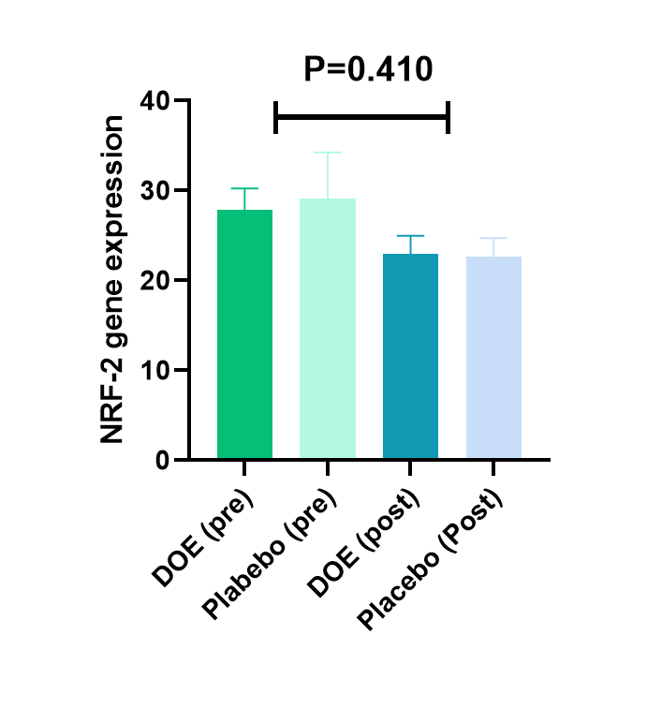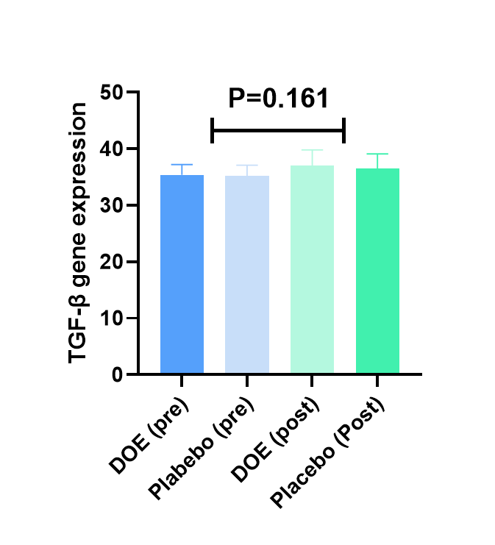
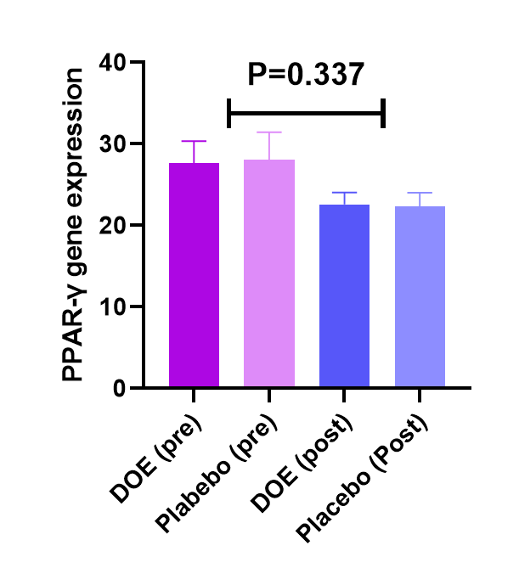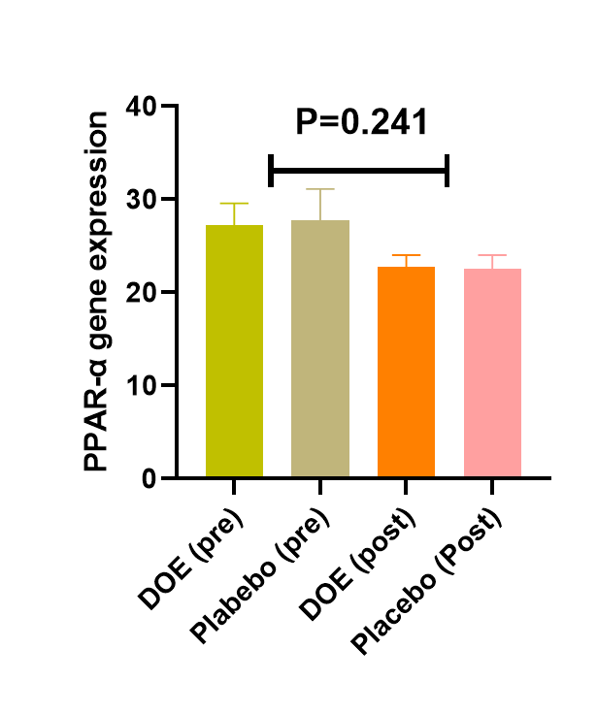
Effects of DOE on genes expression level of PPAR-α, PPAR-γ, TGF-β, and Nrf-2 in DN patients
DOE: dried okra extract, PPAR-α: peroxisome proliferator-activated receptor alpha, PPAR-γ: peroxisome proliferator-activated receptor gamma, TGF-β: transforming growth factor beta, Nrf-2: nuclear factor-erythroid factor 2-related factor 2, DN: diabetic nephropathy

