|  |  |
| --- | --- |
|  | Supplementary material for  Blanchard, A., J.-N. Guyodo, B. Schulz Paulsson & F. Montassier. 2025. **Le Plasker in Plouharnel (fifth millennium cal BC): a newly discovered section of the megalithic complex of Carnac.** *Antiquity* 99.  Author for correspondence ✉ audrey.blanchard@univ-nantes.fr |

Supplementary information on methodology

Stone architecture, both domestic and funerary, involves using a considerable amount of raw material (Blanchard *et al*. 2021). In recent years, geological and geomorphological methodologies have been refined to explore the management of stone resources including their provenance, type, exploitation and utilisation. These specialised studies aim to evaluate the geological opportunities within a radius of a few kilometres of a site and to reveal the interplay between builders and their mineral environment. Such studies include analysing the different ways that materials were exploited and used (Guyodo & Mens 2013).

The methodology used in this study is based on a geomorphological reading of large-volume assemblages, such as the monoliths, standing stones and stelae of the Carnac region (Sellier 2023). It can also be standardised to apply to all architectural blocks and stone building types, as well as to accessible natural outcrops and surface quarries (Guyodo *et al.* 2020). At the Le Plasker site, all blocks, from monoliths to rubble, were examined for evidence as to how they were produced, where they came from and how they might have been used. In particular, the study focused on extraction marks and evidence and observation of surface conditions, as well as of any traces of pre-megalithic or post-megalithic use. Alongside a study of the lithic assemblages, attempts were made to physically reassemble the monoliths.

The funerary architecture was preserved in a thin layer. Micromorphological analyses were carried out on the cist and the sediments covering the construction in order to reconstruct its original shape. Sediment samples were taken from all the structures but neither ancient Neolithic levels, nor any classic domestic structures like postholes, were found.

**References**

Blanchard, A., S. Cassen & J.N. Guyodo. 2021. *Architectures néolithiques de l’île d’Yeu (Vendée)*. Oxford: Archaeopress.

Guyodo, J.N. & E. Mens. 2013. *Les Premières architectures en pierre en Europe occidentale du Ve au IIe millénaire avant J.-C*. Rennes: Presses Universitaires de France.

Guyodo, J.N., A. Blanchard & L. Laporte. 2020. Stone architectures: entrances of Neolithic enclosures in Western France (5th–3rd millennium BC), in F. Cousseau & L. Laporte (ed.) *Pre and Protohistoric stone architectures. Comparisons of the social and technical contexts associated to their building*: 130–43. Oxford: Archaeopress.

Sellier, D. 2023. *Les champs de menhirs du Pays de Carnac. Patrimoine archéologique et géomorphologique*. Rennes: Presses Universitaires de France.

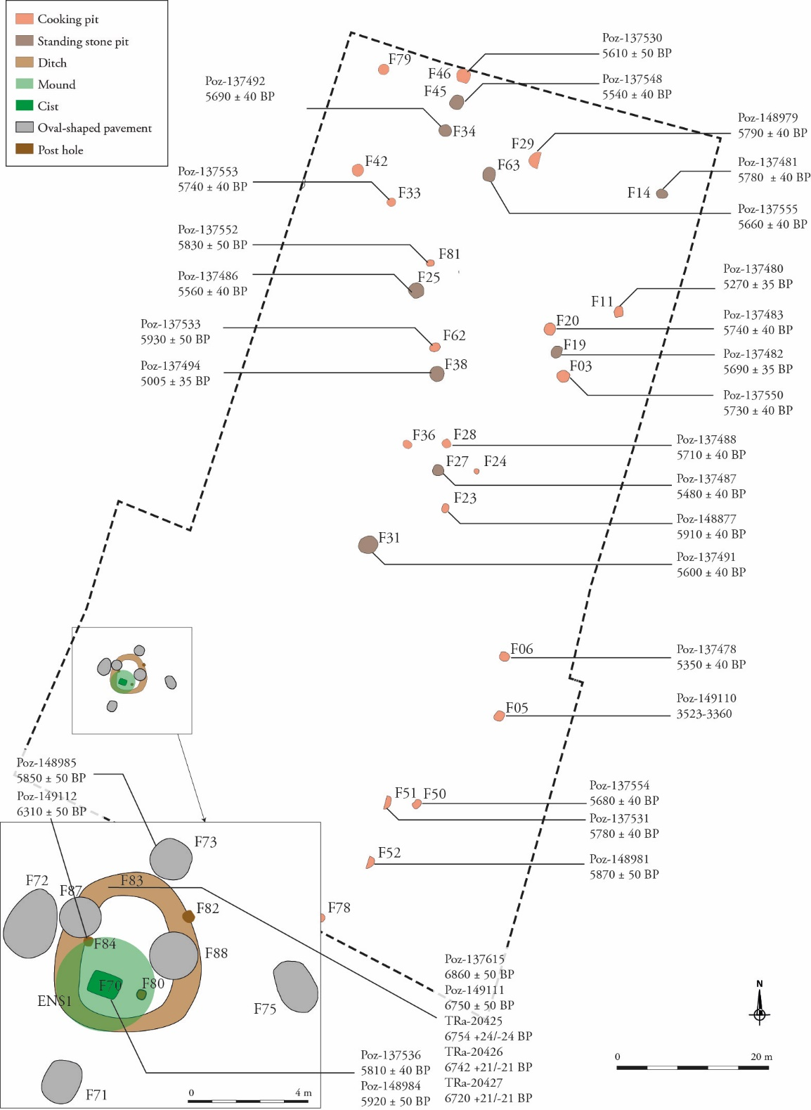

*Figure S1. Plan of Le Plasker with uncalibrated radiocarbon dates.*