 | Supplementary material for  Wallin, P. & H. Martinsson-Wallin. 2025. From ritual spaces to monumental expressions: rethinking East Polynesian ritual practices. Antiquity 99.  Author for correspondence ✉ paul.wallin@arkeologi.uu.se

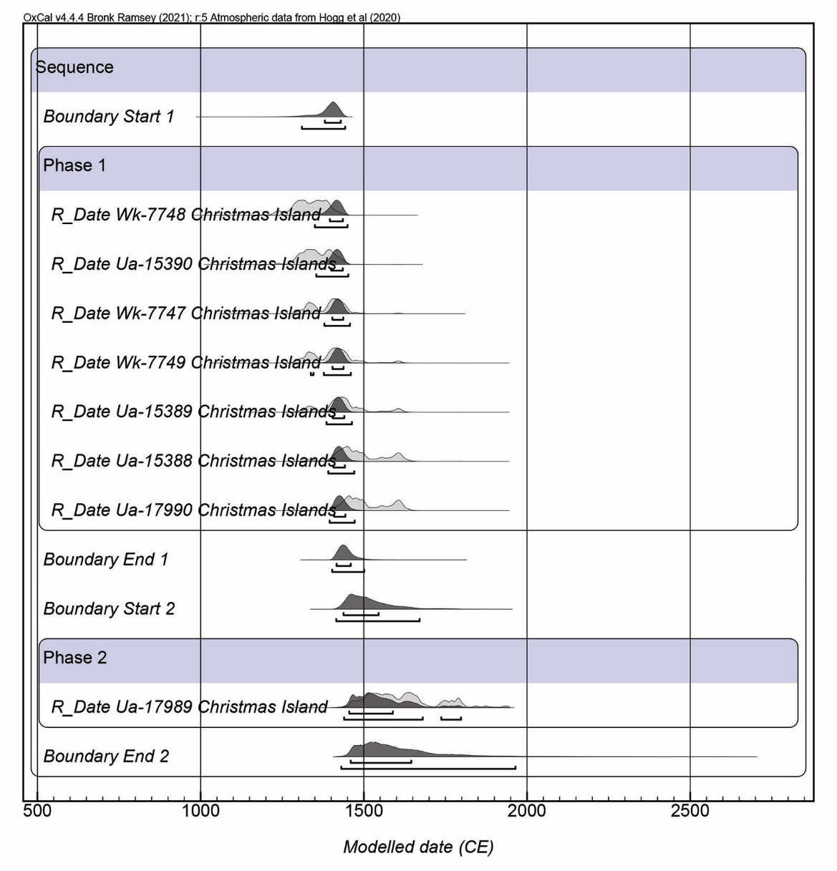
Figure S1. Modelled radiocarbon dates for ritual sites on Christmas Island.

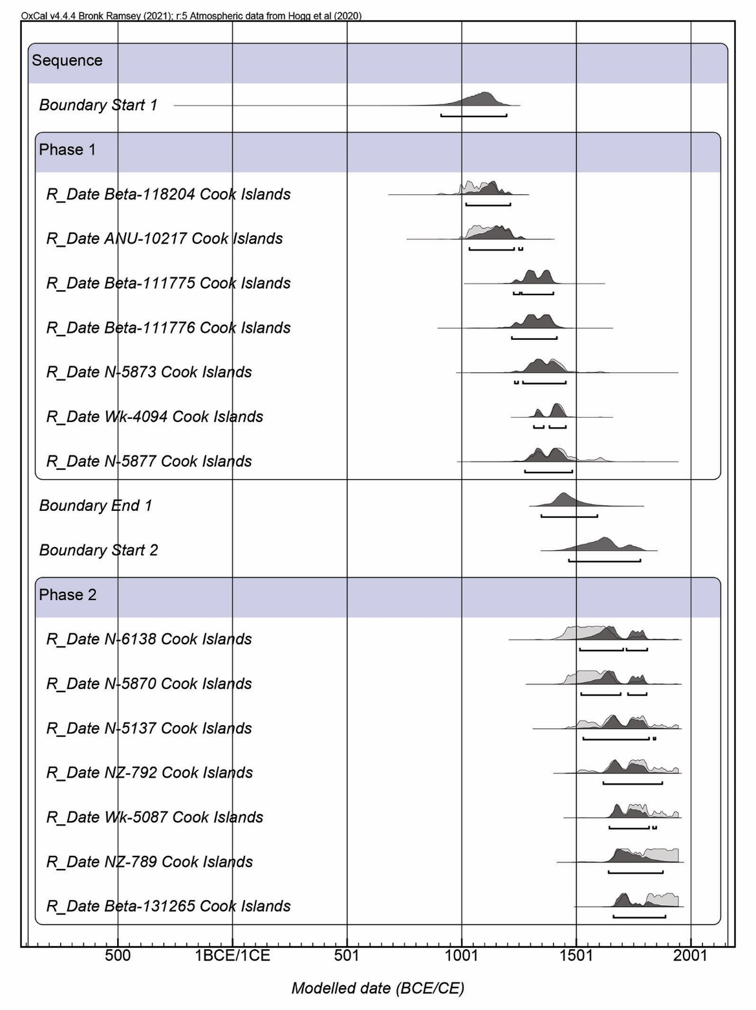
Figure S2. Modelled radiocarbon dates for ritual sites in the Cook Islands.

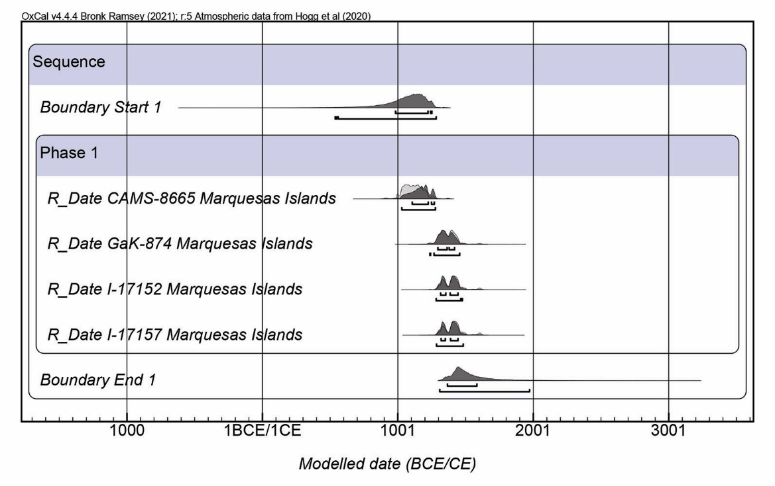
Figure S3. Modelled radiocarbon dates for ritual sites in the Marquesas Islands.

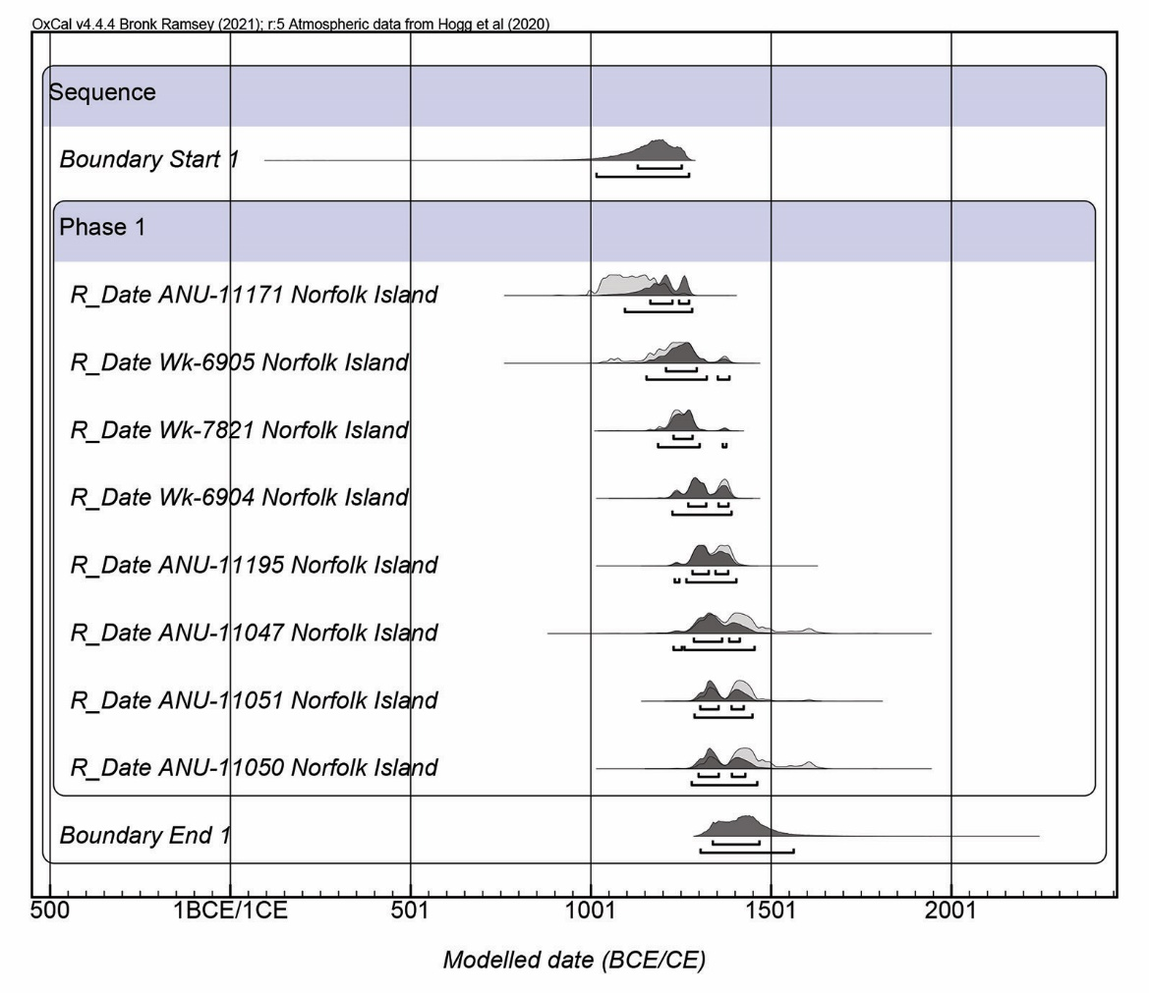
Figure S4. Modelled radiocarbon dates for ritual sites on Norfolk Island.

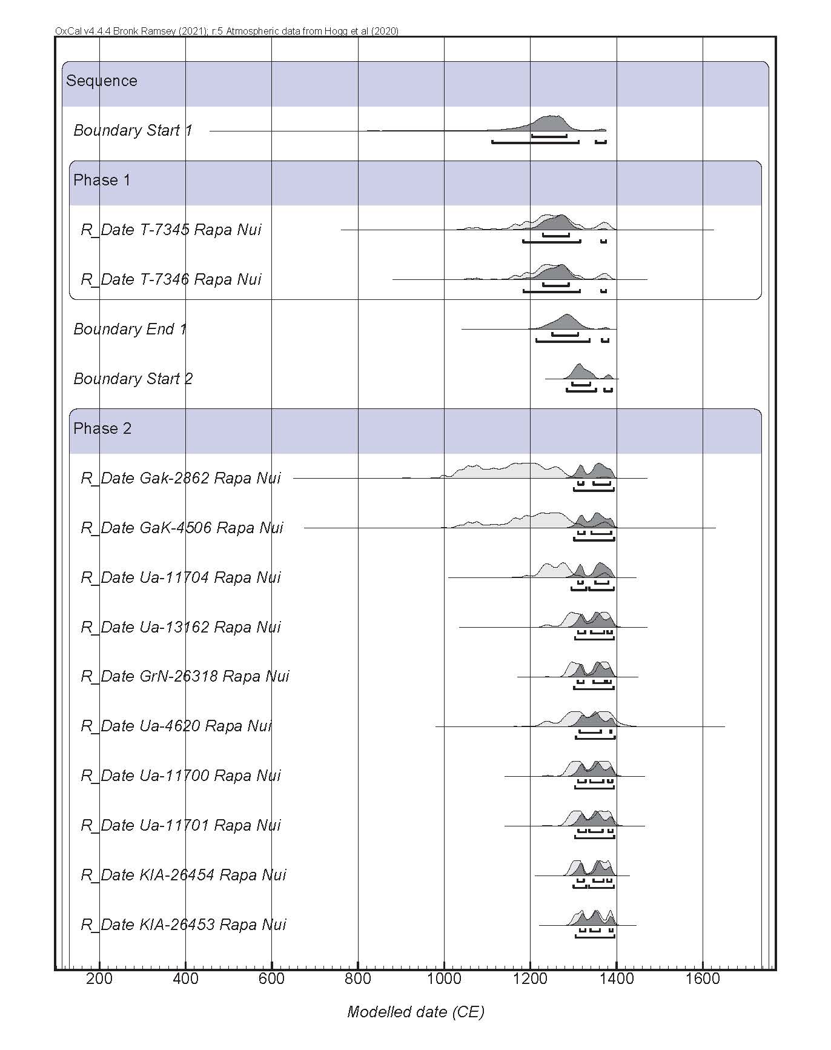
Figure S5. Modelled radiocarbon dates for ritual sites on Rapa Nui.

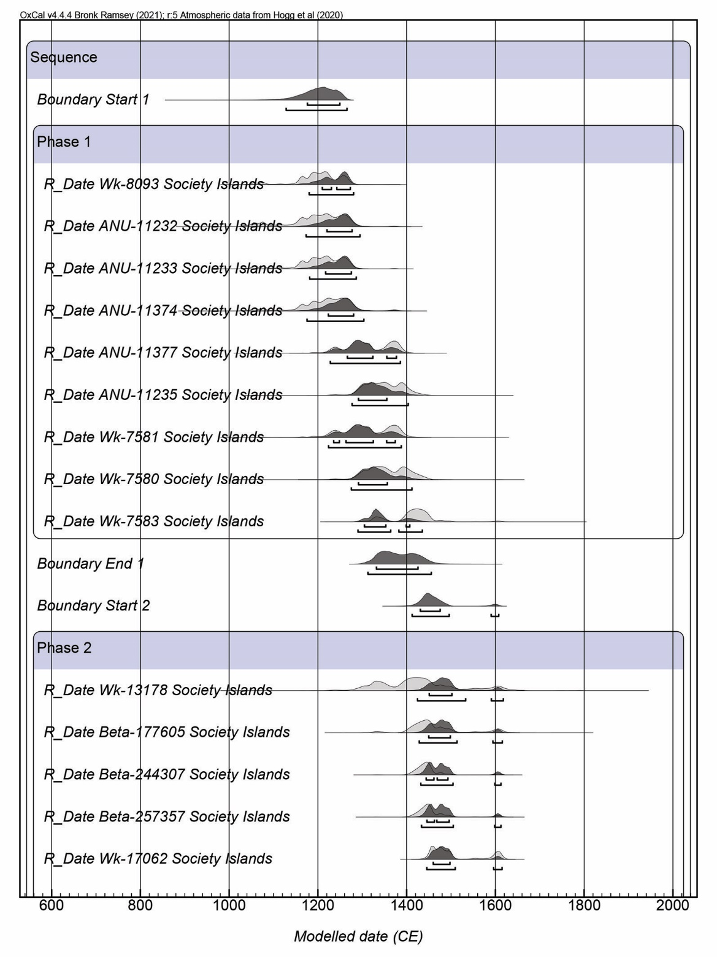
Figure S6. Modelled radiocarbon dates for ritual sites in the Society Islands.

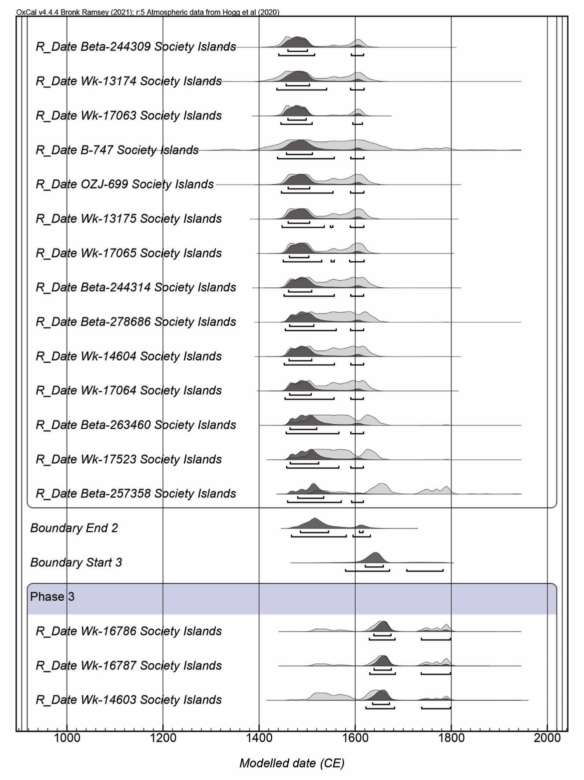
Figure S6 continued.

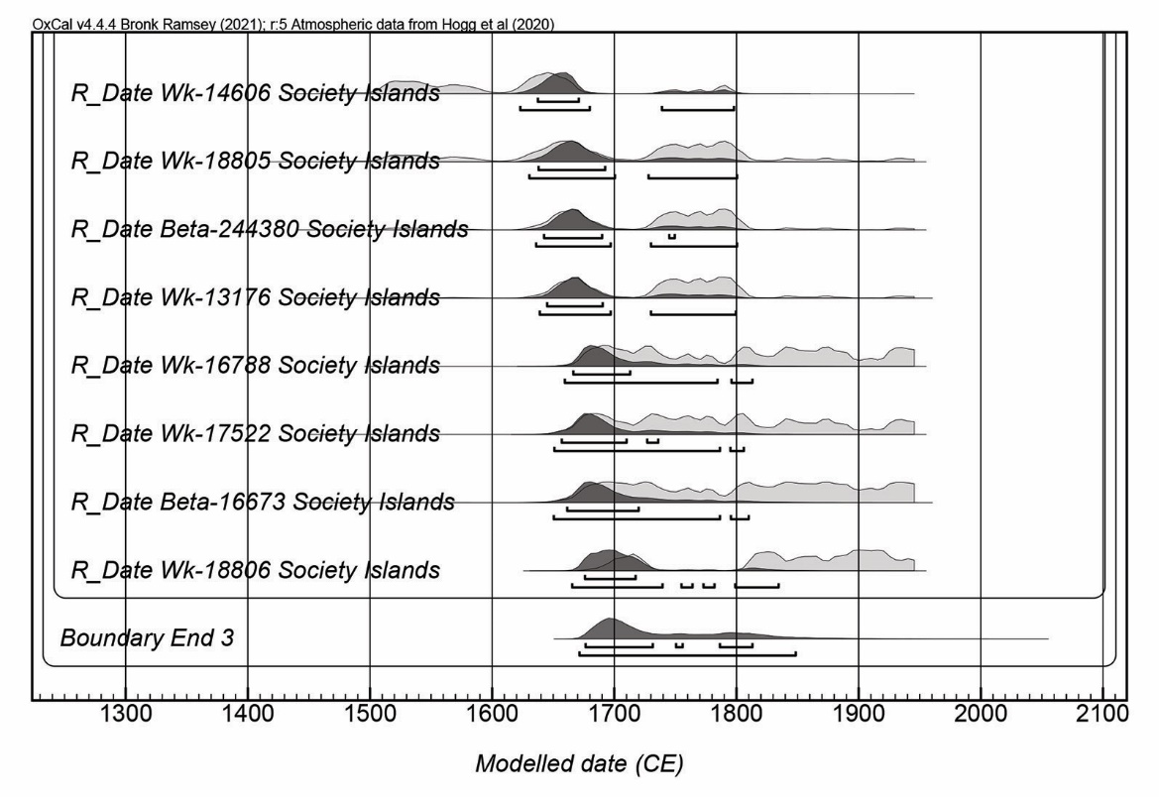
Figure S6 continued.

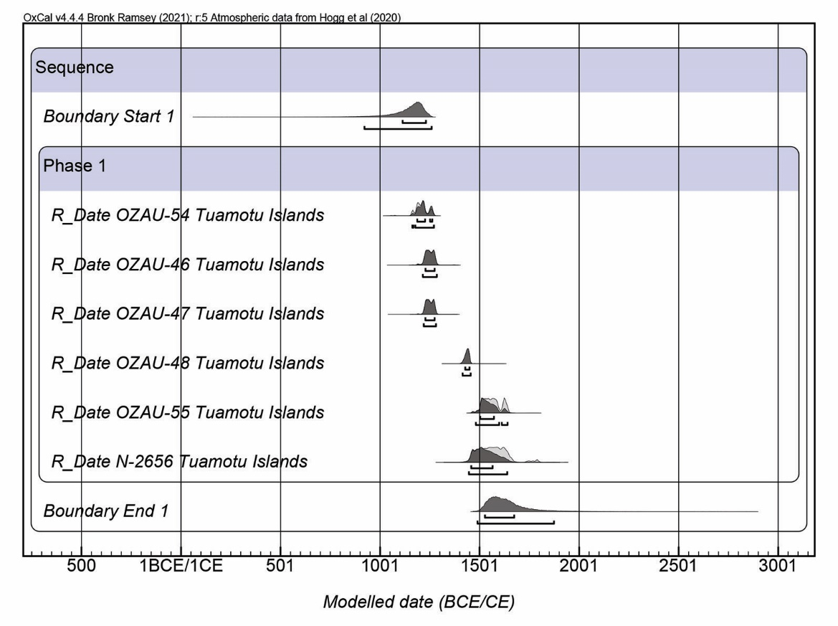
Figure S7. Modelled radiocarbon dates for ritual sites in the Tuamotu Islands.

