|  |  |
| --- | --- |
|  | Supplementary material for  Monteith, F., Z. Tang, L. Chen, L. Tang, L. Liu, K. He & C. Yu. 2025. **Building on written texts****: anthropological and archaeometric approaches to post-Qin archaeology in China.** *Antiquity* 99.  Author for correspondence ✉ 9768612@qq.com |

# Section 1: Bibliometric analysis of articles and conferences

China has a substantial body of archaeological research, but language barriers restrict global access. Wei *et al*. (2023) report that over 40,000 archaeology papers were published in Chinese Core Journals (CCJs) in the past 30 years, compared to only about 1200 in World Core Journals (WCJs), making just 1% of Chinese research accessible to non-Chinese-speaking scholars. Wei *et al*. (2022) also find that only 16% of CCJ articles involve interdisciplinary research, compared to 84% in WCJs. Additionally, 72% of WCJ papers focus on the pre-Qin period, while only 48% of CCJ articles cover the post-Qin era. However, no direct comparison was made between these two categories.

**Table S1. Number of Papers published in CCJs 2004–2023**

|  |  |  |
| --- | --- | --- |
| Journal | 期刊 | Number of papers published 2004–2023 |
| *Kaogu (Archaeology)* | 考古 | 2067 |
| *Wenwu (Cultural Relics)* | 文物 | 2087 |
| *Kaogu Xuebao (Acta Archaeologica Sinica)* | 考古学报 | 367 |
| *Huaxia Kaogu (Chinese Archaeology)* | 华夏考古 | 1312 |
| *Renleixue Xuebao (Acta Anthropologica Sinica)* | 人类学学报 | 710 |
| *Nongye Kaogu (Agricultural Archaeology)* | 农业考古 | 355 |
| *Disiji Yanjiu (Quaternary Studies)* | 第四纪研究 | 306 |

In order to investigate the perception that there is limited archaeometric research being undertaken in post-Qin archaeology in China the papers published in 7 CCJ (Table S1) were analysed. These journals were selected on the basis of their perceived significance within China. Kaogu and Kaogu Xuebao are both published by CASS (Chinese Academy of Social Sciences), while Wenwu is published by the National Cultural Heritage Administration. Renlei Xuebao and Disiji Yanjiu published by CAS (Chinese Academy of Science). Nongye Kaogu was selected as an example of a specialised, in this case archaeobotanical journal in Chinese which has been publishing for over 20 years. The papers published in each of these journals were categorised according to the focus (pre-Qin, post-Qin, methodology/theory and non-Chinese) and article type (traditional research papers (i.e. those focusing on the typological or iconographic study of artefacts, excavation reports, reviews) and archaeometric). Although the number of pre- and post-Qin papers published in these journals (52% to 41%), significantly more papers use traditional methods (84%) than archaeometric methods (16%). Since these statistics align with the findings presented by Wei *et al* (2022, 2023). we take this to mean that our sample size is sufficient. In comparing these two categories we find that 95% of the post-Qin papers use traditional methods, in contrast to 77% of pre-Qin papers, although this varies between journals. Both the number of articles and the type of article published in each of these journals varies (Figure S1).

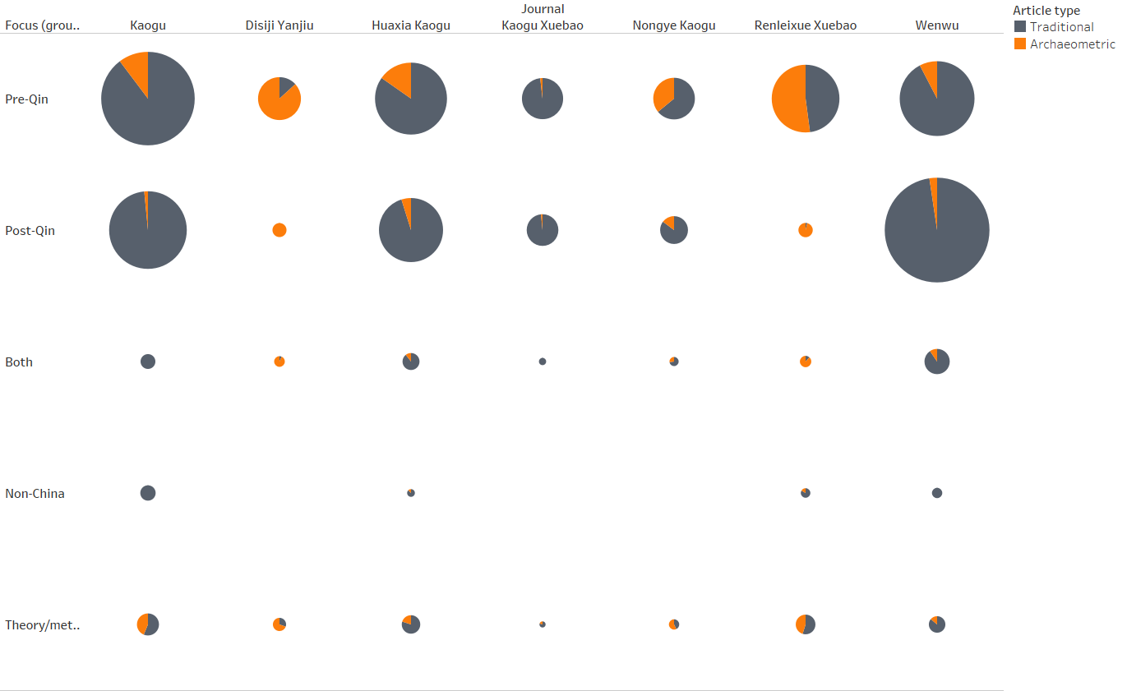**Figure S1. Pie charts showing the number of articles published in each journal divided by time period and research methods.**

In examining articles published in CCJs over the course of the 20 years from 2003 –2023, the number of articles based on archaeometric analyses has gradually increased (Figure S2a). However, when this is divided by the time period on which the articles are focused it can be seen that this increase in archaeometric analyses is focused on pre-Qin period research (Figure S2b). This holds true across all six of the journals analysed (Figure S3).

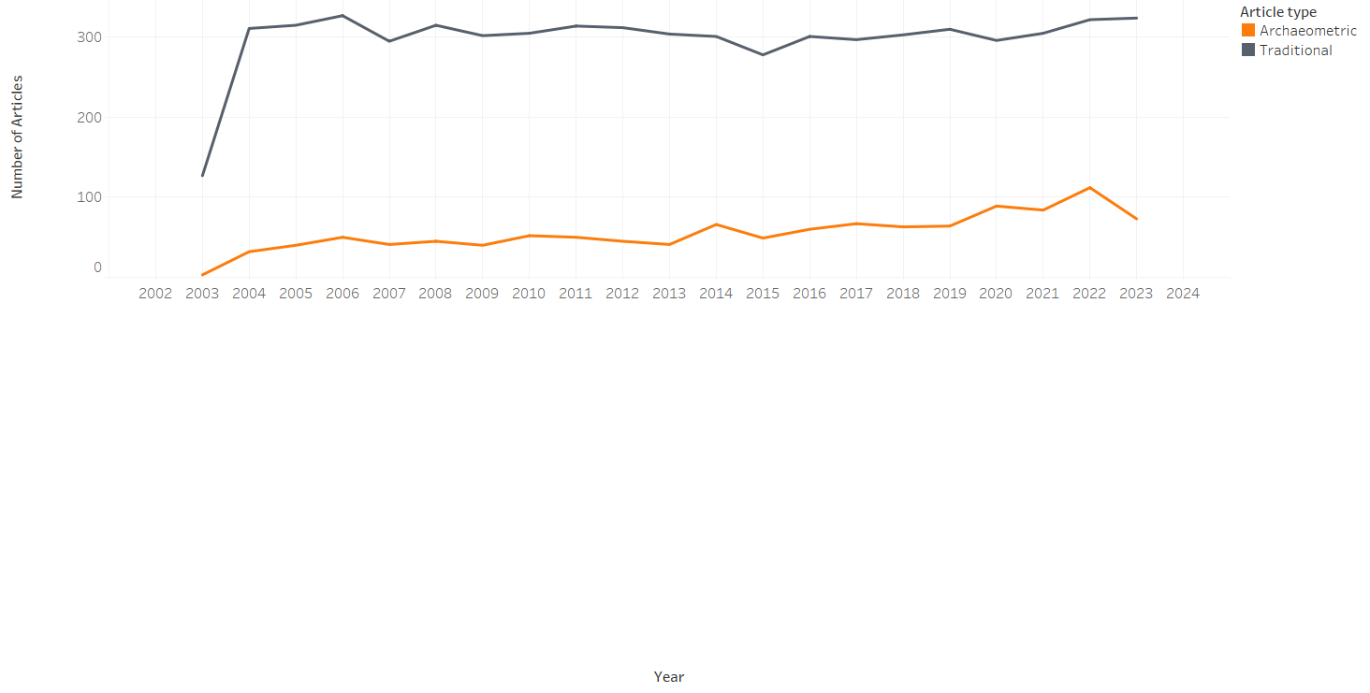

(a)

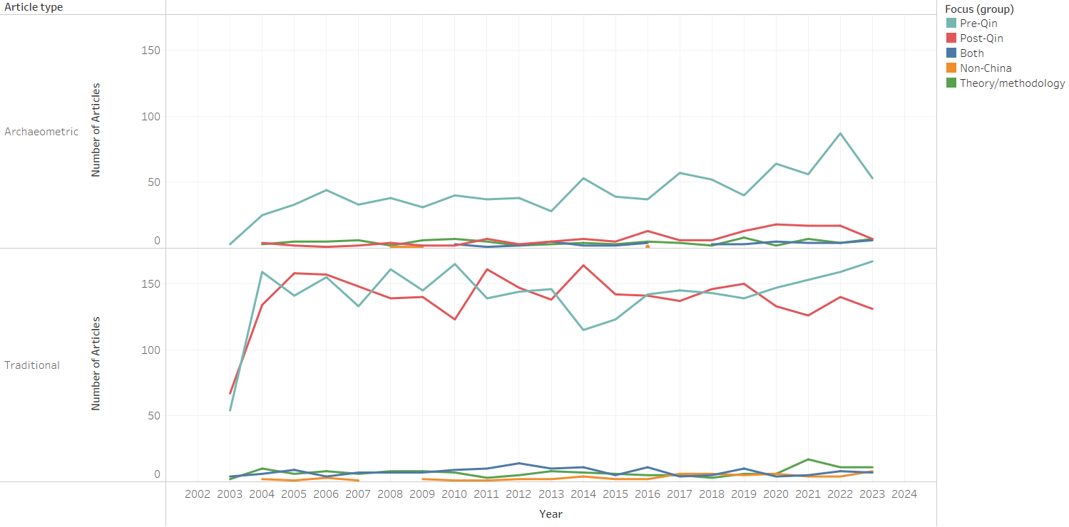

(b)

**Figure S2. a) Graph showing the research methods (traditional versus archaeometric) used in articles published in CCJs from** **2003 –2023; b) Graph showing the research methods used in articles published in CCJs from 2004–2023 divided by time period, region and research type.**

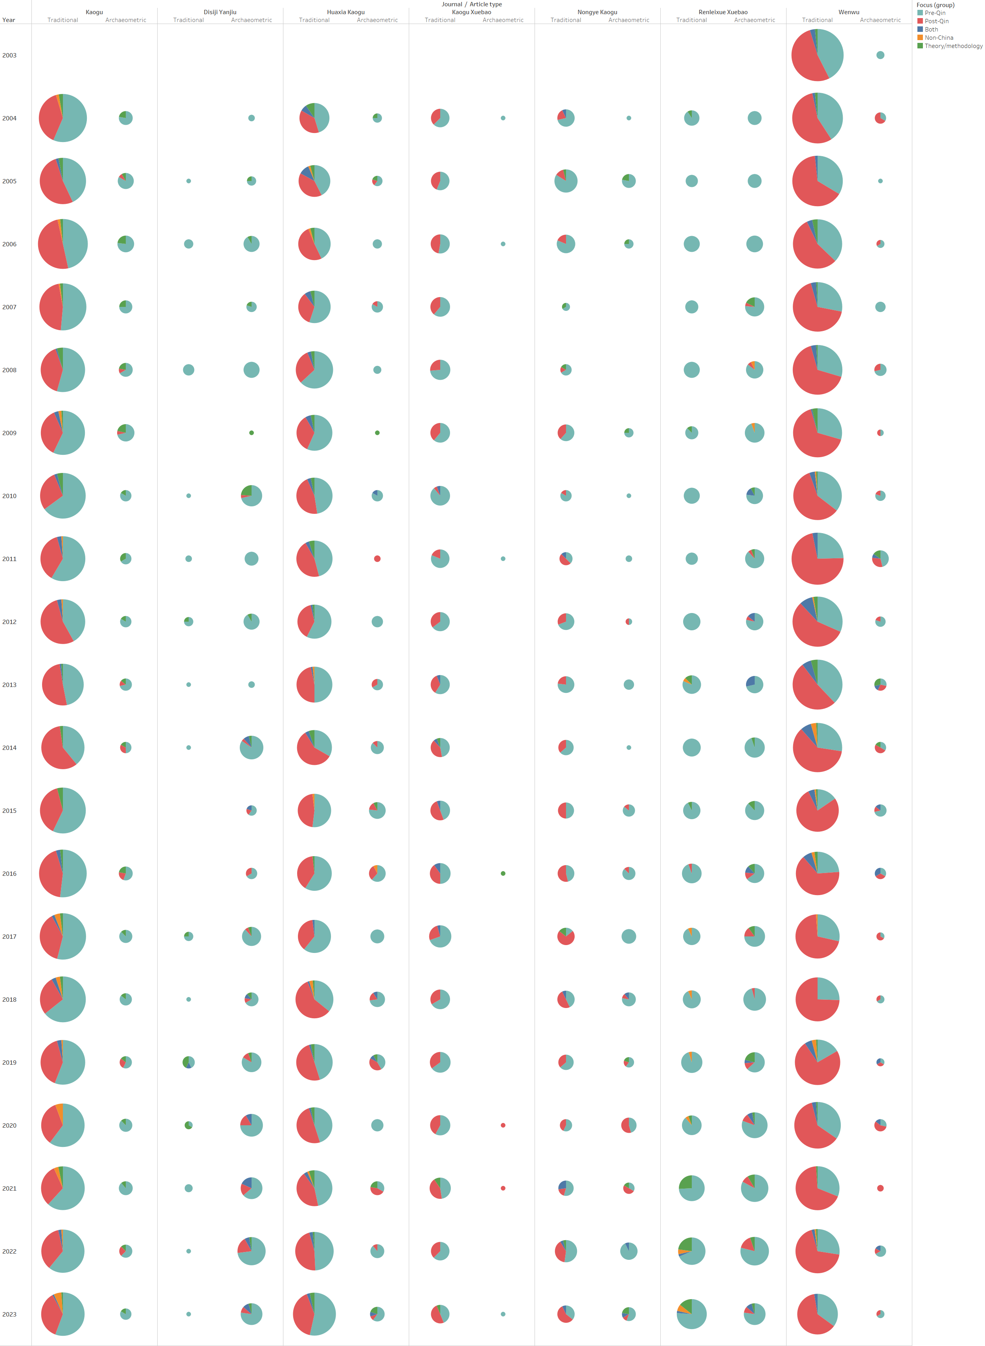

**Figure S3. Pie charts showing articles published in CCJ from 2004–2023 divided by research type, time period and journal.**

# Section 2: History of research

Chinese archaeology has its own clear characteristics and methodologies based on a clear historiographic orientation (von Falkenhausen 1993). The first scientific excavation of a site in China was the excavation of the Yinxu site in Anyang, Henan Province, in the 1920s and 1930s. The site was located by tracing oracle bones, which had attracted the attention of antiquarians for their inscriptions, back to the site from which they were being dug and sold as medicinal dragon bones (Liu & Chen 2012). These excavations are generally regarded as the beginning of archaeometrical archaeology and saw the preliminary metallurgical analyses of a portion of the bronzes excavated (Carpenter 1933; Liu 1933), along with studies on the minerals required for metal production and the development of smelting techniques (Liu 1933). Nascent zooarchaeological research was also undertaken, including the examination of turtle shells and mammals excavated from the site (Bing 1931; De & Yang 1949), although significantly more attention was paid to their inscriptions.

Metallurgical research continued with analyses of Central Plains (Hanqing 1954) and Shizhaishan Culture bronzes from Yunnan Province (Yang 1958), in addition to studies of metalworking technologies (Zhou 1956; Hua *et al.* 1960; Shu 1973). In parallel, archaeologists began to raise some important questions concerning animal domestication and migration and introduced new concepts such as taphonomy (Yang 1956), with pig domestication examined using age profiles at the Neolithic site of Banpo, in Xi’an (Li & Han 1959), and Zhou (1963) undertaking some of the first pollen spore analyses on the cultural layers therein.

The opening of China during the 1980s saw the introduction of new theoretical and methodological models, including Processual Archaeology, which encouraged a more conscious appreciation of the significance of archaeometrical evidence for understanding ancient societies (Chang 1986). Osteoarchaeology, centred in the craniofacial morphological characteristics and measurement data of ancient peoples, began to be used to discuss the ethnicity and biological distances of different populations (Han & Pan 1987), while an increasing number of archaeobotanical studies were devoted to phytolith examination (Huang 1982, 1986) as well as plant pollen analysis (Chen 1984). It was also in the 1980s that lead isotope analysis started to be systematically applied to the provenancing of Chinese bronzes (Jin 2004).

From the early 1990s archaeobotanical analysis made inroads into archaeological practice in China. While focusing on rice phytoliths (Gu 1994; Jin *et al*. 1999; Zheng and Fujiwara. 1999), this period also saw the first starch grain analysis on pottery unearthed from the Wubao cemetery in Hami, Xinjiang (Yu 1993). In the meantime, the first generation of zooarchaeologists who were trained in the scientific analysis of animal bones, such as Jing Yuan and Ma Xiaolin, started to promote systematic zooarchaeological methodologies to record finds, such as the use of the Minimum Number of Individuals (MNI).

From the 2000s the increasing number of salvage excavations associated with national developmental projects (e.g., *The Great Development of the Western Regions*), has allowed the investigation of a variety of sites, prompting the emergence of new research questions and analytical methods. Zooarchaeology has become an increasingly prominent component of archaeological studies in China. It is strongly rooted in prehistory with the main focuses of interest being domestication (Ma 2007; Yuan 2010; You *et al*. 2016), regional trajectories (Flad *et al*. 2007; Yuan *et al*. 2007), secondary products (Li *et al*. 2014; Brunson *et al*., 2016; Yu 2020), craftsmanship (Campbell *et al*. 2011; Hou *et al*. 2018) and, more recently, the relationship between animal resources exploitation strategies and evolving socio-economic complexity (Hou *et al*. 2019; Li *et al*. 2020; Festa *et al*. 2023). Innovative analytical methods – such as ancient DNA, isotopes and teeth thin section analysis – have been gradually introduced, allowing the investigation of different aspects of human-animals interaction, such as ancient diets and mobility (Zhao *et al*. 2015; Cheng *et al*. 2017; Qu 2019). The early 2000s saw a marked increase in archaeobotanical research in China, with flotation starting to be used systematically (Zhao 2004). Greater collection of data has allowed to trace the domestication and spread of different crops across China, including millets, barley and wheat (see e.g., Jin 2007; Liu & Chen 2012: 92). In the same period, there was an increase in research focusing on lead isotopes (Zheng 2008) and trace elements (Qin *et al*. 2005) provenance methods were introduced into archaeometallugurical research in China.

Domestication and the spread of animals and plants have remained major research focuses in both zooarchaeology and archaeobotany, therefore most research has centred in the Neolithic and Bronze Age. Similarly, the analysis of pre-Qin and prehistoric bronzes and copper-alloys has dominated the archaeometallurgy discipline. The Beijing University of Science and Technology, the largest metallurgical archaeological institution in China, for instance, published a total of 25 articles and 19 masters and doctoral theses during the period 1985 to 2010 (Sun *et al.* 2010), yet of these only three articles and two masters theses focus on the post-Qin period.

In contrast, the study of human remains, is relatively more accepted and understood in post-Qin era sites although again with caveats, in that the majority of studies focus on those bones recovered from elite contexts. In the pre-Qin period the craniofacial morphological characteristics are still largely used to categorize regional population according to physical types (Zhu 1998, 2002a, 2002b, 2006). Relatively less work done in the post-Qin period has been aimed at presenting evidence of the presence or absence of ‘non-Han’ individuals in the archaeological record. This focus has led to multiple studies on human bones in Datong, originally the capital of the Northern Wei Dynasty (386CE-354CE) Pingcheng (平城), since the dynasty is a ‘known’ conquest dynasty with the Northern Touba people coming in from the north west to rule the central plains (Cui 2019; Li J. 2021; Li P. 2021). This emphasis also spurred detailed analyses of remains from the Ming and Qing Dynasties (Li *et al.* 2022). Analyses have also been undertaken on human remains excavated from Chang'an, the capital of the Western Han Dynasty (206 BCE–25 CE) and subsequently the eponymous capital of the Tang Dynasty. Analyses of human remains recovered during rescue archaeology projects have shown evidence of populations from a variety of backgrounds living in Xi’an during both the Han and Tang Dynasties (Chen 2008), however these studies have almost exclusively focused on the morphology, age and gender of the tomb occupants. Similar research undertaken on human remains recovered from Han, Tang, and Song dynasty contexts in Zhengzhou, Henan province found that the ancient population of northern China was ethnically diverse, with the significant presence of Han people only beginning to emerge during the Song Dynasty (Sun 2013). Studies relating to the development, evolution, lifestyle and nutritional health of the historical population remain scarce. Similarly, research is generally focused on the areas surrounding the historical capitals.

Landscape archaeology has only recently been applied to Chinese archaeology, with most studies focusing on the pre-Qin period, particularly settlement patterns and resource exploitation (Qin *et al*. 2010; Zhang 2010; Peterson & Shelach 2012; Festa & Monteith 2022). The Yiluo project, launched in 1997 in the Central Plains, is a notable exception. It sought to trace socio-political developments from the Neolithic to the Zhou period, using full-coverage surveys, geoarchaeology, palaeobotany, and object analysis to explore changes in population, environment, land use, agriculture, and craft production (Chen *et al*. 2003; Liu & Chen 2007). However, in the post-Qin period, landscape archaeology is often seen as a secondary discipline to 'historical geography' (lishi dili 历史地理), with its application largely limited to regions with fewer historical texts (Feng 2018; Luo 2021).

An underlying issue is that archaeometrical analyses are generally not included in the initial excavation research plans. However, in recent years there has been a significant push from Central Government to increase the analysis of previously excavated sites. This has led to an increase in publication of analyses from well and less well-known sites. For instance, there has been a flurry of publications associated with the terracotta warriors (Yang *et al.* 2019, 2020; Huang *et al.* 2022); these are following on from the third stage of excavation of pit one at the site from 2009-2012. Similarly, the Mawangdui site which was excavated from 1972-1974 has also had a number of archaeometric papers published in recent years (Li 2022; Shen 2022; Liu *et al*. 2024). (See also the Astana Graveyard (Gao *et al* 2021; Liu *et al.* 2022); the tomb of the Tang Princess Yongtai (Yan *et al.* 2016; Fu *et al.* 2022) and Hejia Cun (Lu *et al*. 2017).)

# References

Bing, Z. 1931. 河南安阳之龟壳 [Turtle Shells from Anyang, Henan], in 安阳发掘报告 [Anyang excavation report]:443–46. Beiping Guoli Zhongying Yanjiuyuan Lishi Yuyan Yanjiusuo.

Brunson, K.R., N. He & X. Dai. 2016. Sheep, cattle, and specialization: new zooarchaeological perspectives on the Taosi Longshan. *International Journal of Osteoarchaeology*: 26: 460–75. https://doi.org/10.1002/oa.2436

Campbell, R., L. Zhipeng, H. Yuling & Y. Jing. 2011. Consumption, exchange and production at the Great Settlement Shang: Bone-working at Tiesanlu, Anyang. *Antiquity*: 85: 1279–97. https://doi.org/10.1017/S0003598X00062050

Carpenter, H. 1933. Preliminary report on Chinese bronzes, in 安阳发掘报告 [Anyang excavation report, part 4].Beijing: Academia Sinica National Research Institute of History and Philology.

Chang, K.C. 1986. 考古学专题六讲 *[Six lectures in archaeology]*. Beijing: Wenwu.

Chen, J. 1984.用自然科学方法进行农业考古研究的新途径 [A new approach to agricultural archaeology research using natural science methods]. 农业考古*[Agricultural Archaeology]* 2: 33–35+403.

Chen, L. 2008. 西安紫薇田园都市唐墓人骨种系初探 [A preliminary study on the human bones from the Tang Tombs in Xi'an Ziwei Garden City]. 考古与文物 *[Archaeology and Cultural Relics]* 5: 95–105.

Chen, X., L. Liu, Y. Li, R. Li, H. Wright & A. Rosen. 2003.《中国文明腹地的社会复杂化进程——伊洛河地区的聚落形态研究 [The process of social complexation in the hinterland of Chinese civilization: a study on the settlement forms in the Ilo River Region]. 考古学报 *[Acta Archaeologica Sinica]* 2003(2): 161–218.

Cheng, P., W. Zhou, W. Gong, Y. Zhu, Y. Yang, G.S. Burr & H. Du. 2017. Paleodietary analysis of humans in Guanzhong Basin, Shaanxi Province since 8000 BP. *Radiocarbon* 59: 1435–46. https://doi.org/10.1017/RDC.2017.66

Cui, J. 2019. 山西大同华宇墓地北魏时期人骨研究(2019年度) [Study on human bones from the Northern Wei Dynasty at Huayu cemetery in Datong, Shanxi (2019)]. Unpublished PhD dissertation, Jilin University.

De, R. & Z. Yang. 1949. 安阳殷墟之哺乳动物群補遗 [Mammals from Yinxu, Anyang], in 考古学报 *[Acta Archaeologica Sinica]*. 1949,(04):145–53.

Feng, F. 2018. 川南唐宋摩崖造像选址的景观考古研究》[Analysing rock carvings of the Tang and Song Dynasties in southern Sichuan using landscape archaeology]. 南方民族考古 *[Archaeology of Southern Ethnic Groups]* 2018(02): 188–208.

Festa, M. & F. Monteith. 2022. Between plain and plateau: micro-transitions in zooarchaeological landscapes in the Guanzhong region of northwest China. *Land* 11. https://doi.org/10.3390/land11081269

Festa M. *et al*. 2023. Faunal exploitation during the ProtoZhou period in the Jing River Valley: evidence from Sunjia and Xitou. *Frontiers in Earth Science* 10. https://doi.org/10.3389/feart.2022.1072897

Flad, R., J. Yuan & S. Li. 2007. Zooarchaeological evidence for animal domestication in northwest China, in D.B. Madsen, F. Chen & X. Gao (ed.) *Late Quaternary climate change and human adaptation in arid China*: 167–203. Amsterdam: Elsevier.

Fu, W. *et al*. 2022. 永泰公主墓出土彩绘骑马俑的科技研究 [A scientific study on the painted funerary statues of horsepersons unearthed from the tomb of Princess Yongtai]. 文博 [*Culture and Museum*] 2022(04): 89–96.

Gao, Y. *et al*. 2021. 新疆吐鲁番阿斯塔那墓葬出土壁画颜料分析 [Analysis of pigments in murals unearthed from the Astana tombs in Turpan, Xinjiang]. 吐鲁番学研究*[Turpan Studies]* 2: 108–112+5+156.

Gu, H. 1994. 澧阳平原四个新石器遗址水稻硅酸体的初步研究 [Preliminary study on rice phytoliths from four Neolithic sites in the Liyang Plain]. 湖南考古辑刊 *[Hunan Archaeological Journal]* 00: 125–35.

Han, K. & Q. Pan. 1987. 新疆昭苏土墩墓古人类学材料的研究 [A study on paleoanthropological materials of Tudun Tombs in Zhaosu, Xinjiang]. 考古学报 *[Acta Archaeologica Sinica]* 4: 503–523+541–44.

Hanqing, Y. 1954. 我国古代人民的炼铜技术 [Ancient Chinese copper smelting technologies]. 化学通报 *[Chemistry Reports]* 2: 97–101.

Hou, Y., R. Campbell, Z. Li, Y. Zhang, S. Li & Y. He. 2018. The Guandimiao bone assemblage (and what it says about the Shang economy). *Asian Perspectives* 57: 281–310. https://doi.org/10.1353/asi.2018.0018

Hou, Y., R. Campbell, Y. Zhang & S. Li. 2019. Animal use in a Shang Village: the Guandimiao zooarchaeological assemblage. *International Journal of Osteoarchaeology* 29: 335–45. https://doi.org/10.1002/oa.2745

Hua, J., G. Yang & E. Liu. 1960. 战国两汉铁器的金相学考查初步报告 [Preliminary report on the metallurgical analyses of ironware from the Warring States and Han Dynasties]. 考古学报 *[Acta Archaeologica Sinica]* 1: 73–88+136–43.

Huang, J. *et al*. 2022. 秦兵马俑一号坑出土彩绘陶俑的颜料种类分析 [Analysis of the pigment types of the painted pottery figurines unearthed from the Qin Terracotta Warriors and Horses Pit No. 1]. 西北大学学报(自然科学版) *[Journal of Northwest University* *(Natural Sciences Edition)]* 52(4): 691–99.

Huang, Q. 1982. 灰像法”在考古学中的应用 [The use of ‘phytolith analysis’ in archaeology]. 考古 *[Archaeology]* 4: 418–420+460.

Huang, Q. 1986. 考古发掘工作中回收植物遗存的方法之一——泡沫浮选法 [An archaeological method for recovering botanical remains – flotation method]. 农业考古*[Agricultural Archaeology]* 2: 95–99.

Jin, G. 2007. 中国早期小麦的考古发现与研究 [Archaeological discoveries and research on early wheat in China]. 农业考古 [*Agricultural Archaeology*] 2007(04): 11–20.

Jin, G., H. Lu & C. Wei. 1999. 东临淄田旺龙山文化遗址植物硅酸体研究 [A study on phytoliths at the Tianwanglongshan site in Linzi, Shandong Province] 考古 *[Archaeology]* 2: 82–87+104.

Jin, Z. 2004.中国学者的首篇铅同位素考古研究论文 [The first lead isotope archaeological research papers by Chinese scholars]. 文物保护与考古科学 *[Sciences of Conservation and Archaeology]* 4: 64–66. https://doi.org/10.16334/j.cnki.cn31-1652/k.2004.04.015

Li, F., L. Qiu & C. Zhao. 2022. 天津蓟州区桃花园墓地明清时期缠足女性的足骨形变 [The foot bone deformation of women with bound feet during the Ming and Qing dynasties at the Taohuayuan Cemetery in Jizhou District, Tianjin] 人类学学报 *[Acta Anthropologica Sinica]* 41(4): 674–85.

Li, J. 2021. 山西大同御府墓地北魏时期人骨研究 [A Study on the human bones from the Northern Wei Yufu Cemetery]. Unpublished Masters dissertation, Jilin University. https://doi.org/10.27162/d.cnki.gjlin.2021.003867

Li, M. 2022. 马王堆一号汉墓竹笥上红色麻绳研究及科技分析 [Research and scientific analysis on the red hemp rope on the bamboo box in Mawangdui Han Tomb No. 1]. 湖南博物院院刊 *[Hubei Museum Journal]* 00: 43–57.

Li, P. 2021. 山西大同东信广场北魏墓地人骨研究 [A study on the human bones from the Northern Wei Tomb in Dongxin Square, Datong, Shanxi Province]. Unpublished PhD dissertation, Jilin University. https://doi.org/10.27162/d.cnki.gjlin.2021.000327

Li, Y. & D. Han. 1959. 陕西西安半坡新石器时代遗址中之兽类骨骼 [Mammal bones from the Banpo Neolithic site in Xi’an, Shaanxi]. 古脊椎动物学报 *[Acta Vertebrate Palaeontology]* 1(4): 173–86.

Li, Y. *et al*. 2020. Animal use in the late second millennium BCE in northern China: evidence from Zaoshugounao and Zaolinhetan in the Jing River valley. *International Journal of Osteoarchaeology* 30: 318–329. https://doi.org/10.1002/oa.2860

Li, Z., R. Campbell, K.R. Bronson, J. Yang & Y. Tao. 2014. The exploitation of domestic animal products from the Late Neolithic Age to the Early Bronze Age in the heartland of Ancient China, in H.J. Greenfield (ed.) *Animal secondary products: domestic animal exploitation in prehistoric Europe, the Near East and the Far East*: 56–79. Oxford: Oxbow. <https://doi.org/10.2307/j.ctvh1dr4j.8>

Liu, X. 1933殷代冶铜术之研究［Research on Bronze Smelting Techniques in the Shang Dynasty ］in 安阳发掘报告（第四. 期）[*Anyang Excavation Report (Vol. 4)*]. Nanjing: Institute of History and Philology, Academia Sinica: Nanjing. 681

Liu, L, & X. Chen. 2007. Multidisciplinary research in the Yiluo Project: after 10 years. *Indo-Pacific Prehistory Association Bulletin* 27: 37–38. https://doi.org/10.7152/bippa.v27i0.11974

Liu, L. & X. Chen. 2012. *The archaeology of China. From the Early Paleolithic to the Early Bronze Age*. Cambridge: Cambridge University Press.

Liu, L. *et al*. 2022. 彩绘蛋白质类胶料来源的ZooMS鉴定——以阿斯塔那墓地泥塑为例 [ZooMS identification of the source of painted protein glue: a case study of clay sculptures from the Astana cemetery]. 考古学研究 *[Archaeological Research]* 1: 707–716.

Liu, Q. *et al*. 2024 马王堆一号汉墓内棺出土“黑色菱形纹罗地信期绣”的科技分析 [Scientific and technological analysis of the "black diamond pattern Luodi Xinqi embroidery" unearthed from the inner coffin of Mawangdui Han Tomb No. 1]. 文物天地 *[Cultural Relics World]* 4: 47–50.

Lu, X. *et al*. 2017 何家村唐代窖藏宝石及玻璃碗检测报告 [Test report on gemstones and glass bowls from the Tang Dynasty in Hejiacun]. 考古与文物 *[Archaeology and Cultural Relics]* 2017(6): 114–120.

Luo, L. 2021. 汉代西域屯田景观空间考古研究——以米兰遗址为例 [A study on the spatial archaeology of the landscape in the Western Regions of Han Dynasty -- a case study of the site of Milan]. 风景园林 *[*Landscape and Gardens*]* 28(11): 39–43. https://doi.org/10.14085/j.fjyl.2021.11.0039.05

Ma, X. 2007. 灵宝西坡遗址家猪的年龄结构及相关问题 [Mortality profiles and related issues for domestic pigs at the Lingbao Xipo Site]. 华夏考古 *[Chinese Archaeology]* 2007(1): 55–74.

Peterson, C.E. & G. Shelach. 2012. Jiangzhai: social and economic organization of a Middle Neolithic Chinese village. *Journal of Anthropological Archaeology* 31: 265–301. https://doi.org/10.1016/j.jaa.2012.01.007

Qin, L., D. Fu & H. Zhang. 2010. 早期农业聚落的野生食物资源域研究——以长江下游和中原地区为例 [A study on the use of wildlife food resources in early agricultural settlements: taking the lower reaches of the Yangtze River and the Central Plains as examples]. 第四纪研究 *[Quaternary Studies]* 30(2): 245–61.

Qu, Y. 2019. 稳定同位素食谱分析视角下的考古中国 *[Examining ancient diet in archaeological China from the perspective of stable isotope analysis]*. Beijing: Beijing Kexue.

Shen, G. 2022. 马王堆汉墓出土鱼骨整理及初步研究 [Arrangement and preliminary study of fish bones unearthed from Mawangdui Han Tomb]. 湖南博物院院刊 *[Hubei Museum Journal]* 00: 94–104.

Shu, Q. 1973. 我国古代的金错工艺 [Ancient Chinese gold inlay technology]. 文物 *[Cultural Relics]* 6: 71.

Sun, L. 2013. 郑州汉唐宋墓葬出土人骨研究——以荥阳薛村遗址和新郑多处遗址为例究 [Research on human bones excavated from Han, Tang, and Song tombs in Zhengzhou -- taking the Xuecun site in Xingyang and multiple sites in Xinzheng as examples]. Unpublished PhD dissertation, Jilin University.

Sun, S., R. Han & X. Li (ed.). 2010. 中国古代金属材料显微组织图谱·有色金属卷 *[Microstructure atlas of ancient Chinese metal materials, non-ferrous metal volume]*. Beijing: Science.

WEI, X. et al. 2022. Understanding Chinese archaeology by statistical analysis of papers published by Chinese researchers in Chinese and world core journals during the past century (1920–2020). World Archaeology 54: 647–66. https://doi.org/10.1080/00438243.2022.2156592

WEI, X., W. LOU, T. LI, R. YANG & Y. LI. 2023. “Bringing in” and “going abroad”: a bibliometric evaluation of the internationalization of archaeology in Mainland China. Humanities and Social Sciences Communication 10. https://doi.org/10.1057/s41599-023-01800-0

Yan, J. *et al*. 2016. 永泰公主墓出土彩绘陶器颜料的无损及微损调查与研究 [Non-destructive and micro-destructive analyses of the pigments used on painted pottery unearthed from the tomb of Princess Yongtai]. 文博 *[Culture and Museum]* 2016(1): 93–100+92.

Yang, G. 1958. 云南晋宁青铜器的化学成分分析 [Chemical analyses of bronze artefacts from Yunnan Jinning]. 考古 *[Archaeology]* 3: 75–77.

Yang, L. *et al*. 2019. 秦始皇兵马俑彩绘胶料的气相色谱-质谱联用分析 [Analysis of the painted glue of Qin Shi Huang's terracotta warriors and horses by gas chromatography-mass spectrometry]. 分析化学 *[Analytical Chemistry]* 47(5): 695–701.

Yang, L*. et al*. 2020. 秦始皇兵马俑一号坑出土弓韬表面纺织品残留物的红外光谱及显微分析研究 [Infrared spectroscopy and microscopic analysis of textile residues on the surface of bows and horses unearthed from Pit 1 of the Terracotta Warriors and Horses of Qin Shi Huang]. 光谱学与光谱分析 *[Spectroscopy and Spectral Analysis]* 40(11): 3623–27.

Yang, Z. 1956. 考古工作和人骨兽骨等遗存问题 [Archaeological work and issues related to traces such as human bones, animal bones, and the like]. 文物 *[Cultural Relics]* 1956(3): 7–10.

You, Y., P. Lu, J. Wang, J. Ma & M. Ren. 2016. 新疆地区家养绵羊的出现及早期利用 [The emergence and early utilization of domestic sheep in Xinjiang region]. 考古 *[Archaeology]* 2016(12): 104–114.

Yu, C. 2020. *The origin of cattle in China from the Neolithic to the Early Bronze Age* (British Archaeological Reports International Series 2959). Oxford: BAR.

Yu, X. 1993. 新疆哈密市五堡152号古墓出土农作物分析 [Analysis of crops excavated from Tomb 152 Wubao in Hami City, Xinjiang]. 农业考古 *[Agricultural Archaeology]* 3: 185–89.

Yuan, J. 2010. Zooarchaeological study on the domestic animals in ancient China. *Quaternary Sciences* 30(2): 298–306. https://doi.org/10.3969/j.issn.1001-7410.2010.02.06

Yuan, J., Y. Huang, M. Yang, J. Yang, P. Lu & Y. Tao. 2007. 公元前2500年-公元前1500年中原地区动物考古学研究 ――以陶寺、王城岗、新砦和二里头遗址为例 [An overview of zooarchaeology in the Central Plains Region from 2500 BC to 1500 BC - taking the sites of Taosi, Wangchenggang, Xinzhai, and Erlitou as examples], in 中国社会科学院考古研究所考古科技中心 [Centre for Archaeology, CASS] eds. 科技考古 *[Scientific archaeology]*: 12–34.Beijing: Bejing Kexue.

Zhang, H. 2010. 景观考古学——理论、方法与实践 [Landscape Archaeology, theory, methods and practice].南方文物 *[Southern Cultural Relics]* 4: 8–17.

Zhao, X., Y. Li, H. Chen, Z. Wang, J. Yuan & D. Yang. 2015. 陕西省淳化县枣树沟脑遗址马坑出土马骨的DNA初步研究 [Preliminary study of DNA from horse bones excavated from Ma Keng at Zaoshugounao site in Chunhua County, Shaanxi Province]. 南方文物 *[Southern Cultural Relics]* 2015(3): 70–76

Zhao, Z. 2004. 植物考古学的田野工作方法——浮选法 [The field work method of plant archaeology - flotation method]. 考古 *[Archaeology]* 2004(3): 80–87+2.

Zheng, Y. 2008. 中国铅同位素考古 *[Lead isotope analysis in Chinese archaeology]*. Hefei: Zhongguo Kexue Jishu Daxue.

Zheng, Y. & H. Fujiwara. 1999. 太湖地区部分新石器时代遗址水稻硅酸体形状特征初探 [Preliminary study on the shape characteristics of rice silicates from some Neolithic sites in the Taihu Lake region]. 中国水稻科学 *[Chinese Rice Science]* 1: 25–30.

Zhou, C. 1956. 试论中国古代冶金史的几个问题 [A tentative discussion on several issues in the history of metallurgy in ancient China]. 中南矿冶学院学报 *[Journal of Central South University of Mining and Metallurgy]* 1: 79–99.

Zhou, K. 1963. 西安半坡新石器时代遗址的孢粉分析 [Pollen analysis of the Neolithic site of Banpo in Xi’an, Shaanxi]. 考古 *[Archaeology]* 9: 520–22.

Zhu, H. 1998. 中国东北地区的古代种族 [Historical minorities of China’s northeast]. 文物 *[Cultural Relics]* 1998(1): 3–5.

Zhu, H. 2002a. 中国南方地区的古代种族 [Historical minorities of China’s south]. 吉林大学社会科学学报 *[Journal of Social Sciences of Jilin University]* 2002(3): 5–12.

Zhu, H. 2002b. 内蒙古长城地带的古代种族 [Historical minorities of Inner Mongolia and the Great Wall Region]. 边疆考古研究 *[Frontier Archaeology Research]* 2002(1): 301–313.

Zhu, H. 2006. 中国西北地区的古代种族 [Historical minorities of China’s northwest]. 考古与文物 *[Archaeology and Cultural Relics]* 2006(5): 60–65.