|  |  |
| --- | --- |
|  | Supplementary material for  Espregueira-Themudo, G., A. Fernández-Fernández, P. Valle Abad, A.A. Rodríguez Nóvoa, C. Fernández-Rodriguez, E. González-Gómez de Agüero, R.R. da Fonseca & P.F. Campos. 2025. **Roman Atlantic *garum*: DNA confirms sardine use and population continuity in north-western Iberia.** *Antiquity* 99.  Author for correspondence ✉ campos.f.paula@gmail.com |

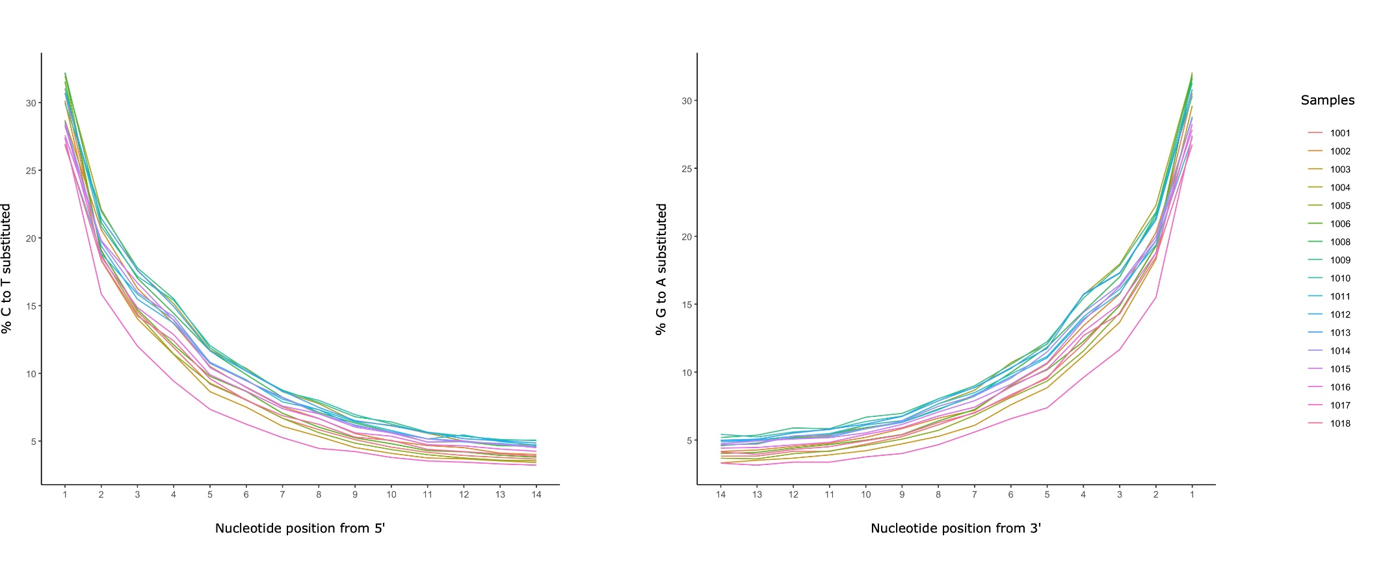

*Figure S1. DNA damage profiles for samples 1001–1018 (except 1007).*