 | Supplementary material for  Brown, P.J. J. Jotheri, L. Rayne, N.S. Abdalwahab & E. Andrieux. 2025. The landscape of the Zanj Rebellion? Dating the remains of a large-scale agricultural system in southern Iraq. Antiquity 99.  Author for correspondence ✉ peter.brown@ru.nl

1: Excavation Data
1.1: Sample Site 1
Coordinates: 30.38236 N, 48.08957 E
Site Elevation (MAMSL): 1.10
Date sampled: 27/01/2022

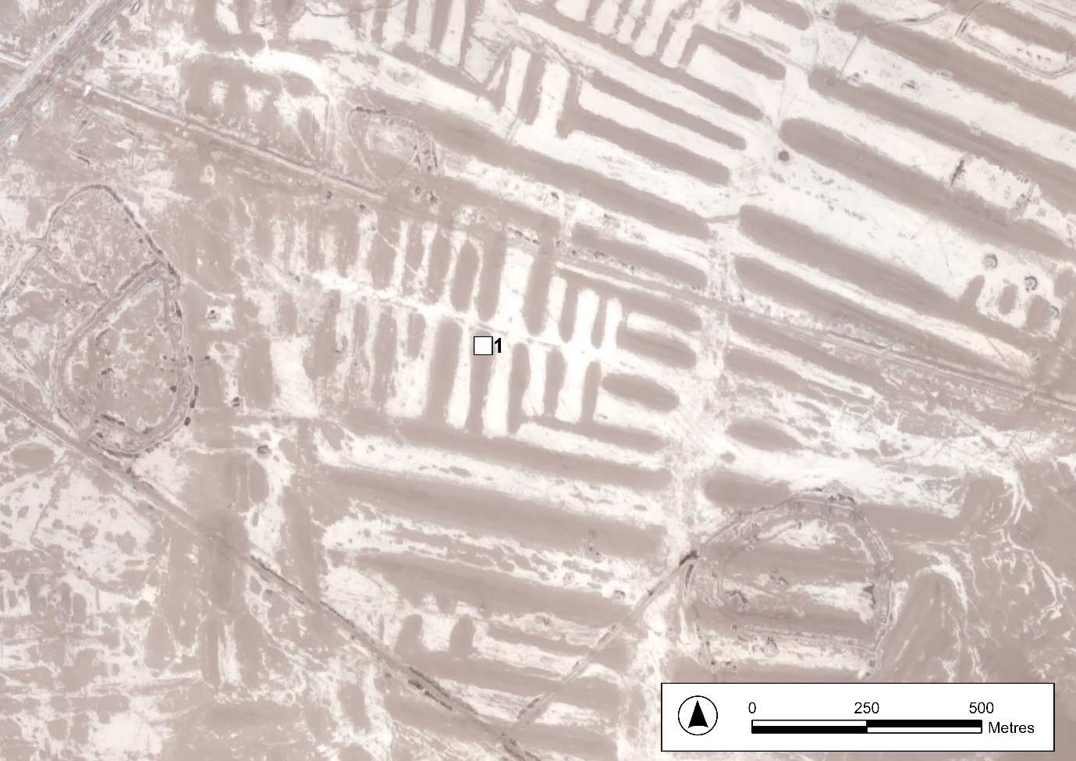
Figure S1. PLEIADES Satellite photograph showing the location of sample site 1. Captured 06/08/2022. © CNES 2022, Distribution Airbus DS.
Figure S2. Sketch diagram of sample site 1 showing sample depth from the ground surface and relationship to excavation units. Excavation units are described in Table S1 below. Horizontal axis not to scale.
Table S1. Description of Excavation Units at Sample Site 1.
Excavation Unit | Layer Thickness (cm) | Description of Lithology
1 | 5 | Topsoil containing crystals of gypcrete
2 | 25 | Light brown silty clay with patches of very fine sand and crystals of gypcrete
3 | 45 | Dark brown silty clay with patches of very fine sand and crystals of gypcrete

Table S2. Samples Taken at Sample Site 1.
Depth from surface (cm) | Samples Taken
25 | Sediment Sample Bag 1.1S
30 | OSL Sample Tube 1.1
45 | Sediment Sample Bag 1.2S
50 | OSL Sample Tube 1.2
60 | Sediment Sample Bag 1.3S
65 | OSL Sample Tube 1.3
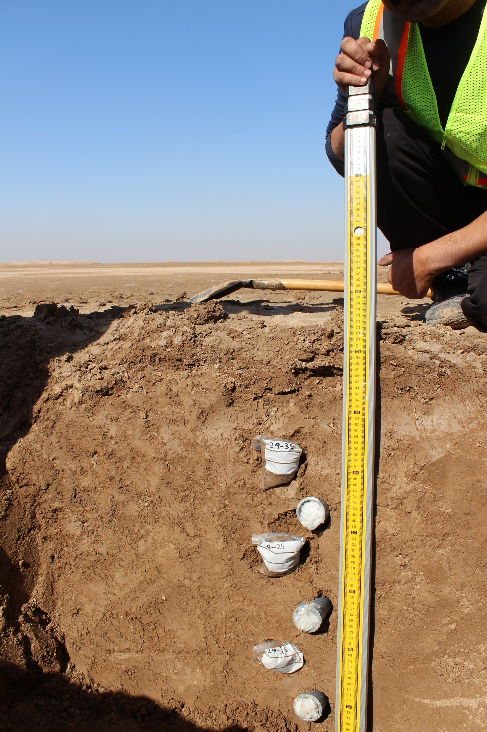
Figure S3. Photograph of sampling site 1 showing the location of samples collected.
1.2: Sample Site 2
Coordinates: 30.39632 N, 47.90780 E
Site Elevation (MAMSL): 4.50
Date sampled: 28/01/2022

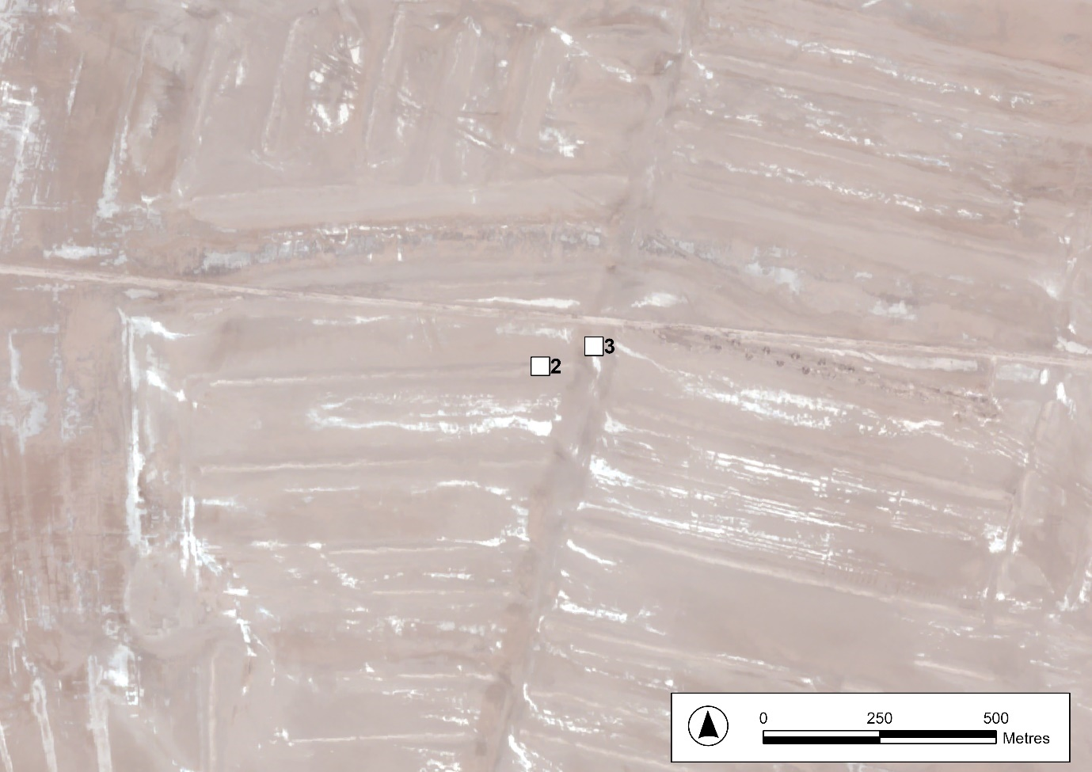
Figure S4. PLEIADES Satellite photograph showing the locations of sample site 2 and 3. Captured 06/08/2022. © CNES 2022, Distribution Airbus DS.
Figure S5. Sketch diagram of sample site 2 showing sample depth from the ground surface and relationship to excavation units. Excavation units are described in Table S3 below. Horizontal axis not to scale.

Table S3. Description of Excavation Units at Sample Site 2.
Excavation Unit | Layer Thickness (cm) | Description of Lithology
1 | 20 | Topsoil containing crystals of gypcrete
2 | 80 | Mixture of silty clay to clay with patches of green clay and very fine sand with pottery fragments

Table S4. Samples Taken at Sample Site 2.
Depth from surface (cm) | Samples Taken
30 | Sediment Sample Bag 2.1S
40 | OSL Sample Tube 2.1
50 | Sediment Sample Bag 2.2S
60 | OSL Sample Tube 2.2
60 | Shell Sample 2.3
70 | Sediment Sample Bag 2.4S
90 | OSL Sample Tube 2.4
90 | Shell Sample 2.5
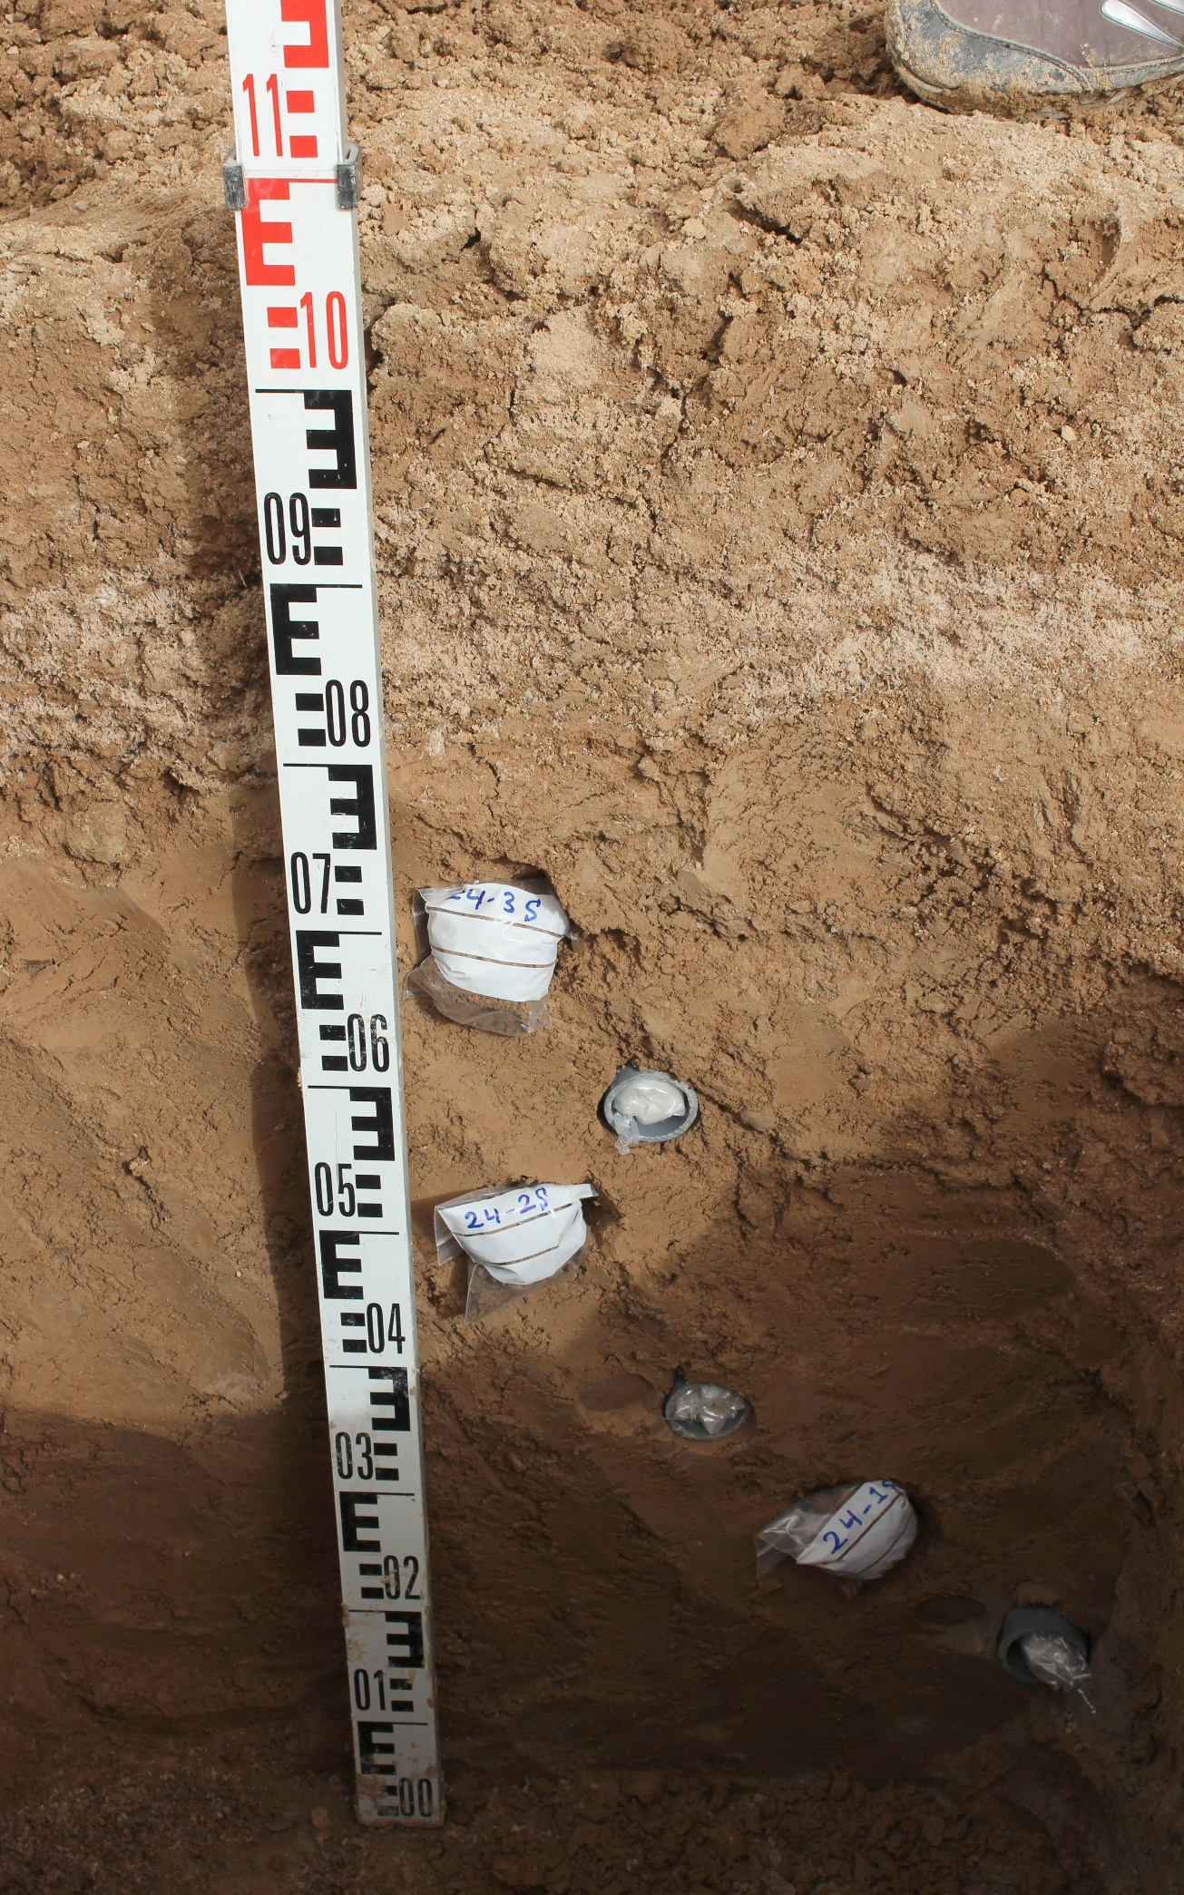
Figure S6. Photograph of sampling site 2 showing the location of samples collected.
1.3: Sample Site 3
Coordinates: 30.39668 N, 47.90901 E
Site Elevation (MAMSL): 1.25
Date sampled: 28/01/2022

Figure S7. Sketch diagram of sample site 3 showing sample depth from the ground surface and relationship to excavation units. Excavation units are described in Table S5 below. Horizontal axis not to scale.

Table S5. Description of Excavation Units at Sample Site 3.
Excavation Unit | Layer Thickness (cm) | Description of Lithology
1 | 5 | Topsoil containing crystals of gypcrete
2 | 10 | light green silty clay
3 | 10 | red silty clay with pottery fragments.*
4 | 10 | red clay
5 | 10 | dark green clay
6 | 50 | red silty clay with laminations of very fine sand

*Small fragments of green-glazed pottery of the type commonly produced in the local area in the Sasanian and early Islamic periods. It may be residual in this context and does not provide a definitive age estimation.

Table S6. Samples Taken at Sample Site 3.
Depth from surface (cm) | Samples Taken
20 | Sediment Sample Bag 3.1S
30 | OSL Sample Tube 3.1
40 | Sediment Sample Bag 3.2S
50 | OSL Sample Tube 3.2
55 | Sediment Sample Bag 3.3S
65 | OSL Sample Tube 3.3
70 | Sediment Sample Bag 3.4S
85 | OSL Sample Tube 3.4
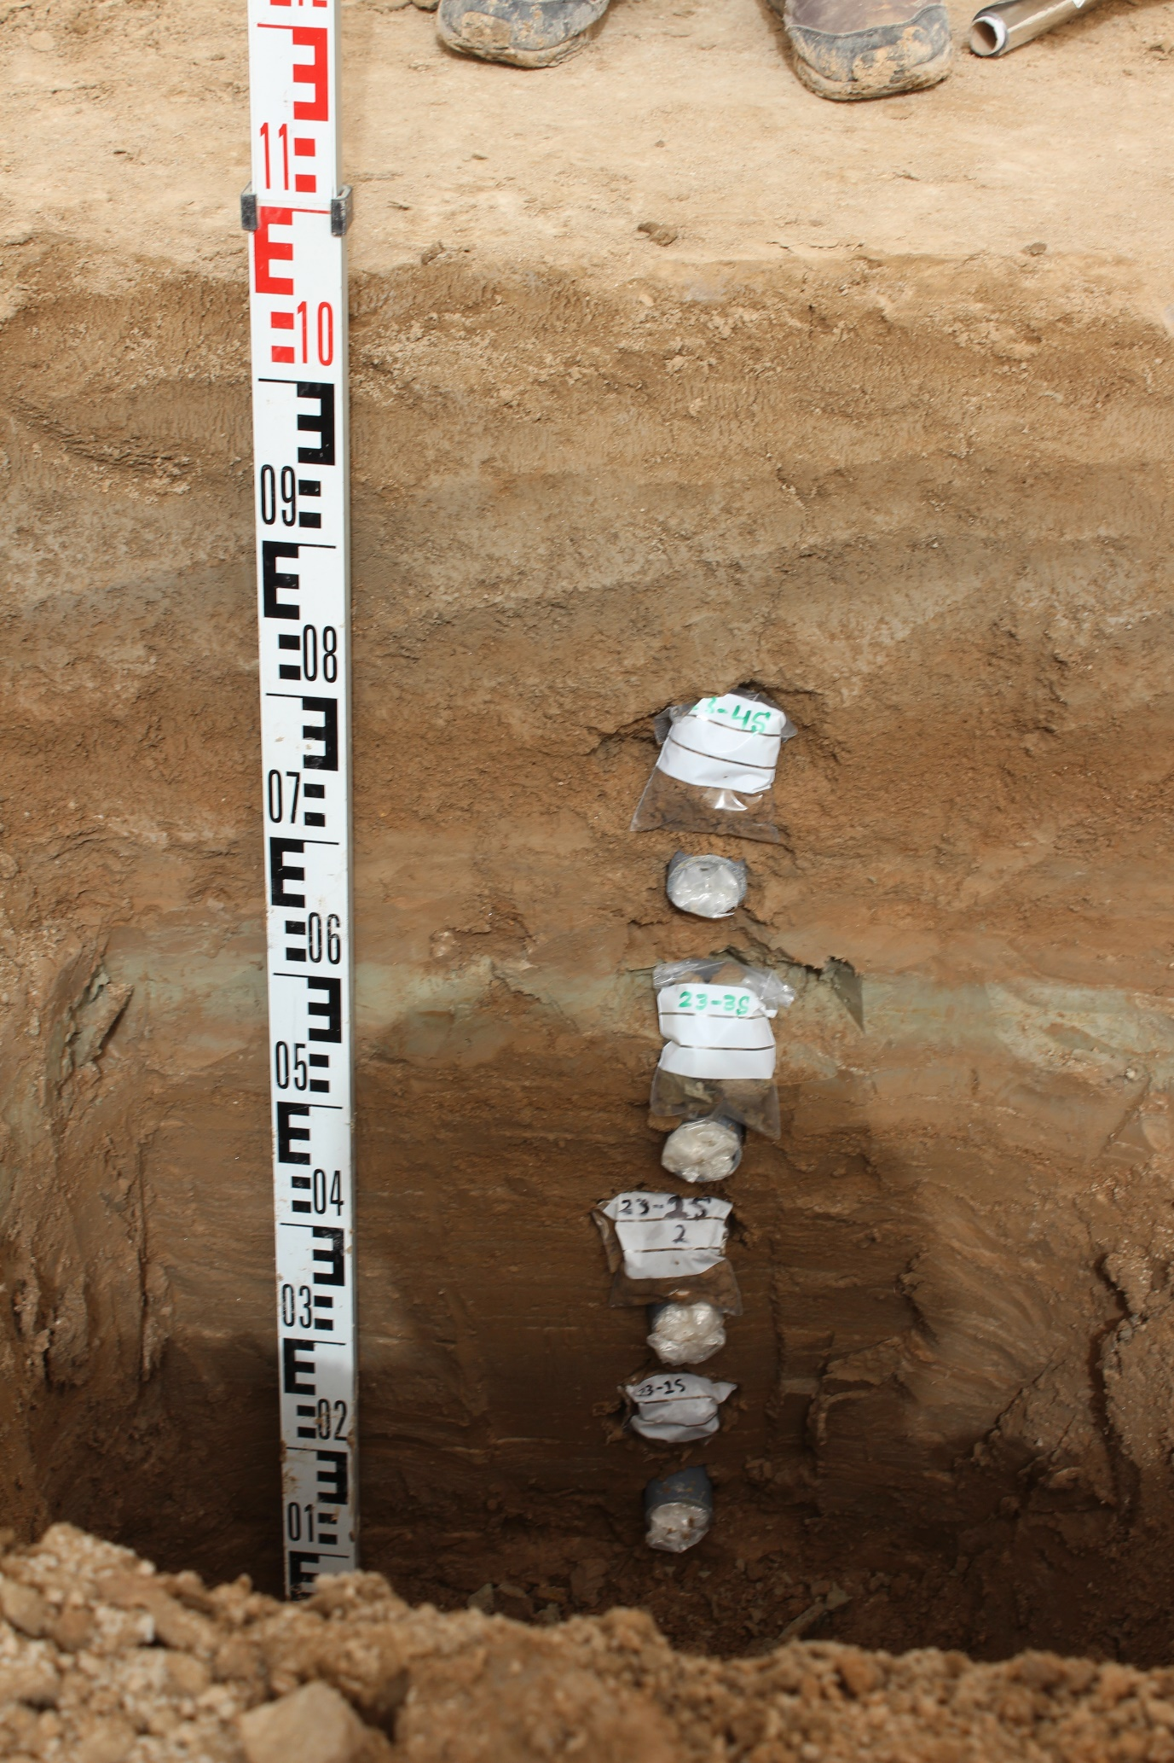
Figure S8. Photograph of sampling site 3 showing the location of samples collected.
1.4: Sample Site 4
Coordinates: 30.34953 N, 47.92501 E
Site Elevation (MAMSL): 2.35
Date sampled: 29/01/2022

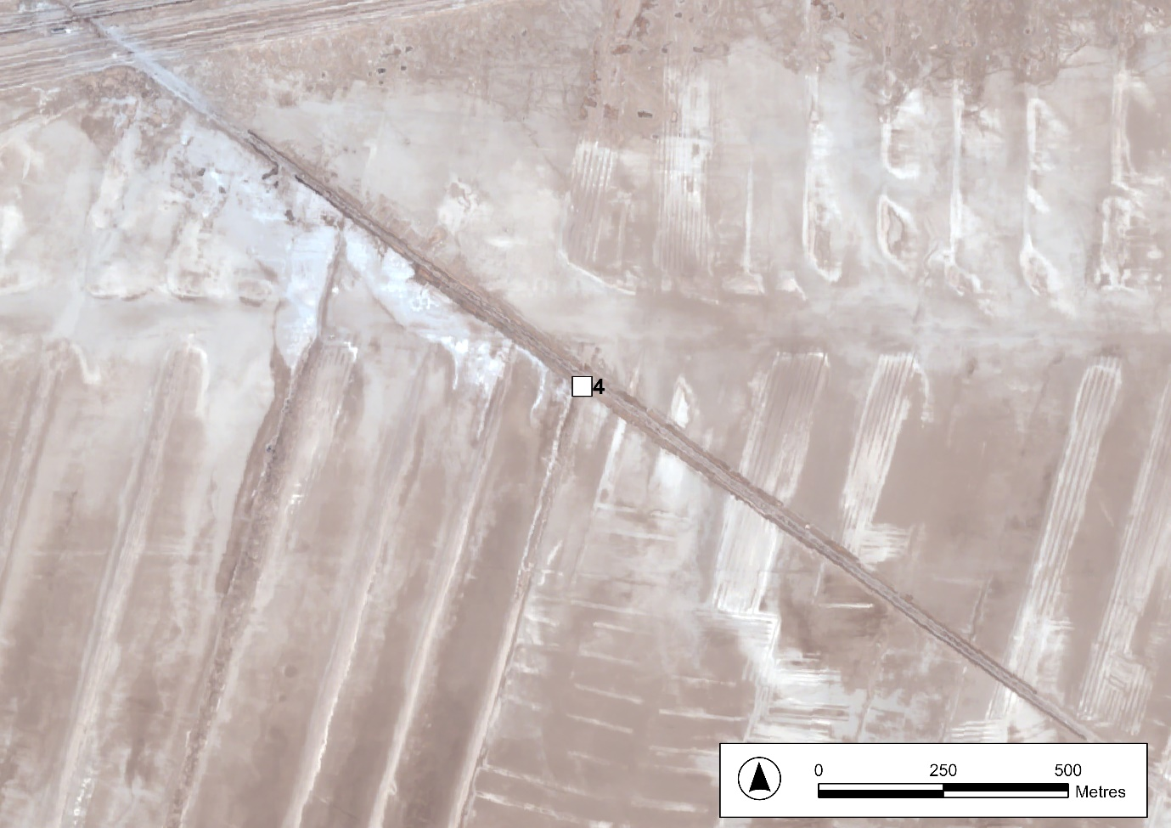
Figure S9. PLEIADES Satellite photograph showing the location of sample site 4. Captured 06/08/2022. © CNES 2022, Distribution Airbus DS.

Figure S10. Sketch diagram of sample site 4 showing sample depth from the ground surface and relationship to excavation units. Excavation units are described in Table S7 below. Horizontal axis not to scale.

Table S7. Description of Excavation Units at Sample Site 4.
Excavation Unit | Layer Thickness (cm) | Description of Lithology
1 | 20 | Topsoil containing crystals of gypcrete
2 | 80 | Mixture of silty clay to clay with patches of green clay and very fine sand

Table S8. Samples Taken at Sample Site 4.
Depth from surface (cm) | Samples Taken
30 | Sediment Sample Bag 4.2S
40 | Shell Sample 4.1
45 | OSL Sample Tube 4.2
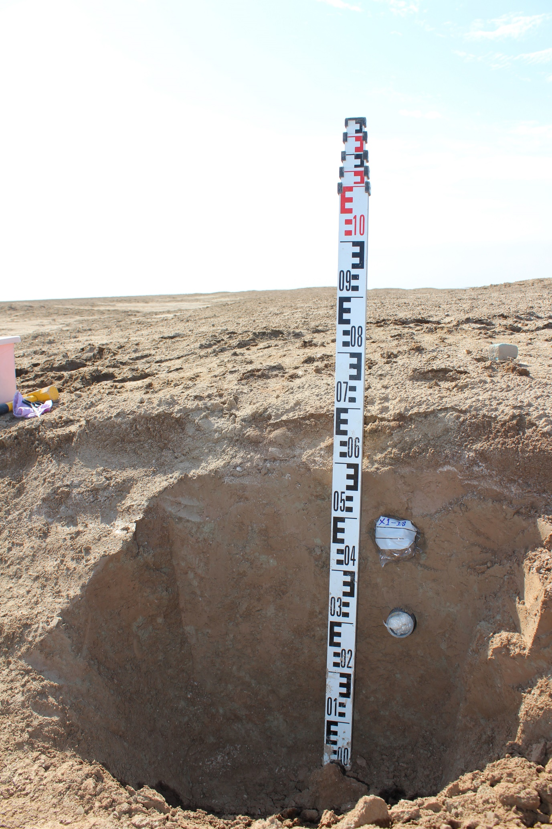
Figure S11. Photograph of sampling site 4 showing the location of samples collected.
1.5: Sample Site 5
Coordinates: 30.31703 N, 47.94190 E
Site Elevation (MAMSL): 3.20
Date sampled: 29/01/2022

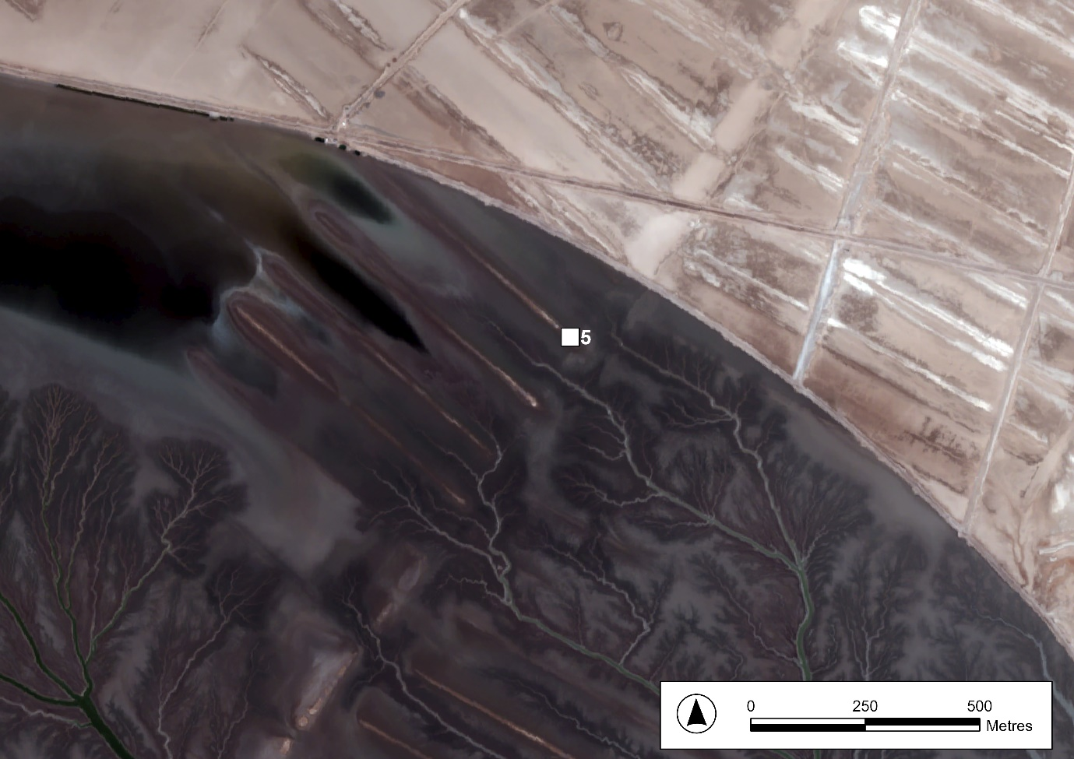
Figure S12. PLEIADES Satellite photograph showing the location of sample site 5. Captured 06/08/2022. © CNES 2022, Distribution Airbus DS.
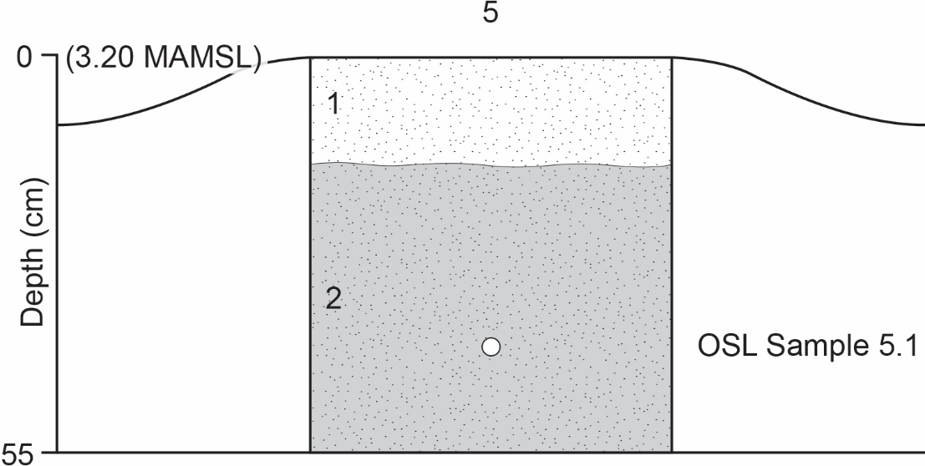
Figure S13. Sketch diagram of sample site 5 showing sample depth from the ground surface and relationship to excavation units. Excavation units are described in Table S9 below. Horizontal axis not to scale.

Table S9. Description of Excavation Units at Sample Site 5.
Excavation Unit | Layer Thickness (cm) | Description of Lithology
1 | 5 | Topsoil containing crystals of gypcrete
2 | 50 | Mixture of silty clay to clay with some very fine sand

Table S10. Samples Taken at Sample Site 5.
Depth from surface (cm) | Samples Taken
30 | Sediment Sample Bag 5.1S
40 | OSL Sample Tube 5.1

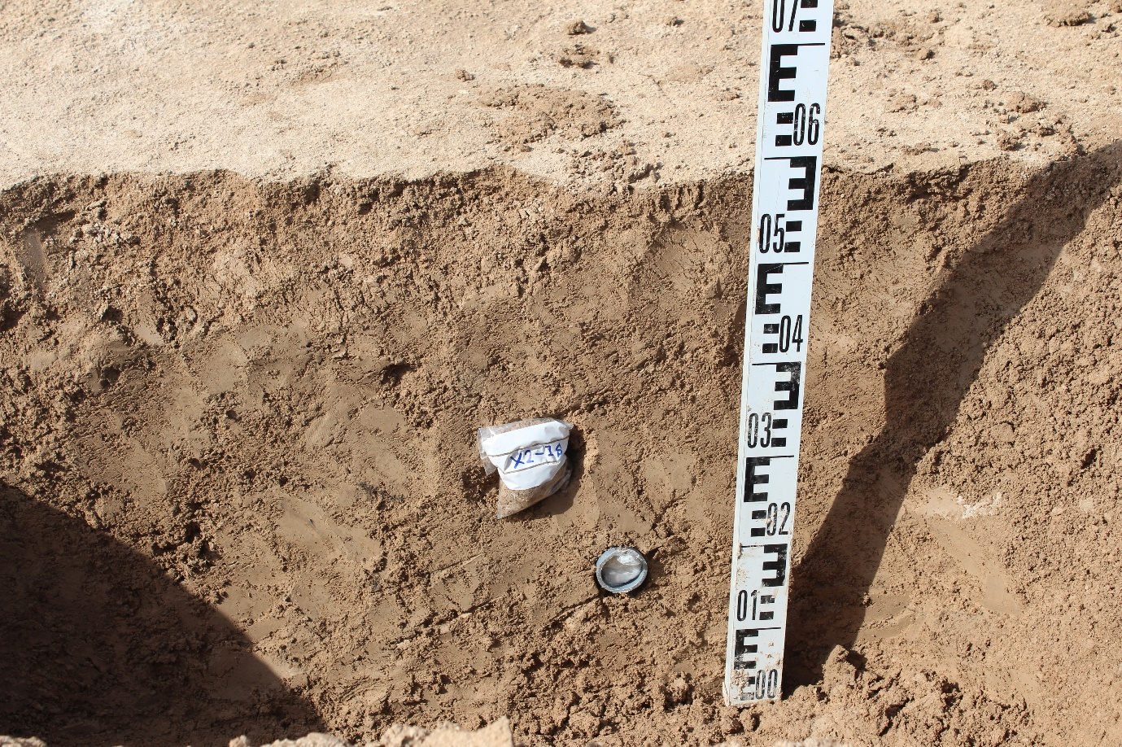
Figure S14. Photograph of sampling site 5 showing the location of samples collected.

2: Chronology
2.1: Radiocarbon dating
Three shell samples were recovered from ridge crest sampling sites—two from site 2 (Shell Sample 2.3 and Shell Sample 2.5) and one from site 4 (Shell Sample 4.1). All three samples were submitted to the Beta Analytic Radiocarbon Dating Laboratory for AMS dating. One of the samples from site 2 (Shell Sample 2.3; see Figure S5) contained only small fragments of non-diagnostic shell which did not provide sufficient material and was not subjected to further analysis. The other shell sample from sampling site 2 (Shell Sample 2.5; see Figure S5) was a species of Melanoides. The sample from site 4 (Shell Sample 4.1; see Figure S10) was a non-diagnostic shell fragment.
2.1.1: Sample preparation
All shell samples were pretreated following the acid etch method. Samples were washed with deionized water to remove any organic sediments or debris. The samples were then crushed and subjected to repeated HCl etches in order to eliminate secondary carbonate components.
2.1.2: Equipment
All chemistry was performed at the Beta Analytic Testing Laboratory and counted using their own accelerators. Results are reported according to ISO/IEC 17025:2017 Testing Accreditation PJLA #59423 standards.
2.1.4: Results
Table S11. Radiocarbon Results for Shell Sample 2.5.
Laboratory Number | Beta - 621635
Sample Code Number (Original) | 24-Shell-2
Sample | Shell Sample 2.5
Pretreatment | (shell) acid etch
Analyzed Material | Shell
Analysis | AMS
Percent Modern Carbon | 78.84 +/- 0.29 pMC
Fraction Modern Carbon | 0.7884 +/- 0.0029
D14C | -211.62 +/- 2.94 o/oo
∆14C | -218.45 +/- 2.94 o/oo (1950:2022)
Measured Radiocarbon Age | (without d13C correction): 1590 +/- 30 BP
IRMS δ13C | -5.3 o/oo
IRMS δ18O | -3.8 o/oo

Table S12. Radiocarbon Results for Shell Sample 4.1.
Laboratory Number | Beta - 621636
Sample Code Number (Original) | X1-Shell-1
Sample | Shell Sample 4.1
Pretreatment | (shell) acid etch
Analyzed Material | Shell
Analysis | AMS
Percent Modern Carbon | 81.13 +/- 0.30 pMC
Fraction Modern Carbon | 0.8113 +/- 0.0030
D14C | -188.72 +/- 3.03 o/oo
∆14C | -195.75 +/- 3.03 o/oo (1950:2022)
Measured Radiocarbon Age | (without d13C correction): 1420 +/- 30 BP
IRMS δ13C | -9.1 o/oo
IRMS δ18O | -9.3 o/oo

Table S13. Samples submitted for radiocarbon dating and results.
Original Sample Site ID | Sample Site No. | Sample Number | Conventional C14 Age | Laboratory Code | Sample Type
24 | 2 | Shell Sample 2.5 | 1910 ± 30 BP | Beta-621635 | Shell (Melanoides)
X1 | 4 | Shell Sample 4.1 | 1680 ± 30 BP | Beta-621636 | Shell (non-diagnostic)
Shell sample 2.5 gave a conventional radiocarbon age of 1910±30 BP while shell sample 4.1 gave a conventional radiocarbon age of 1680±30 BP.
2.1.5: Calibration
Local estimation of the marine reservoir effect in southern Iraq is not possible due to the absence of pre-1950 samples (Hirtz et al. 2012: 75; Al-Ameri & Briant 2018). However, δ13C measurements for both samples, -5.3 o/oo for shell sample 2.5 and -9.1 o/oo for shell sample 4.1, are indicative of freshwater samples. Previous studies have not applied a marine reservoir correction to Melanoides samples (Hirtz et al. 2012: 75; Al-Ameri & Briant 2018) which, as a short-lived grazer, is thought to have limited exposure to old carbon in comparison with marine species (Hirtz et al. 2012: 75). While the impact of freshwater reservoir effects (FREs) in southern Iraq has previously been regarded as minor due to the local geology (Hirtz et al. 2012: 75; Al-Ameri & Briant 2018), more recent studies suggest that shell samples can be affected by significant and variable FREs (Egberts et al. 2023). Although a terrestrial correction appears to be most appropriate, uncertainty over the mixture of salt- and fresh- water in the study area, as well the impact of FREs, mean that the C14 ages from these samples should be taken only as dates terminus post quem.
Using OxCal v4.4.4 and the IntCal20 calibration curve (Reimer et al. 2020), at 95.4% probability, shell sample 2.5 gives a calendar age of either AD 28–44 (2.9%) or AD 58–215 (92.6%) (Figure S15). Shell sample 4.1 gives a calendar age of either AD 255–286 (13.8%) or AD 326–433 (81.7%) (Figure S16).
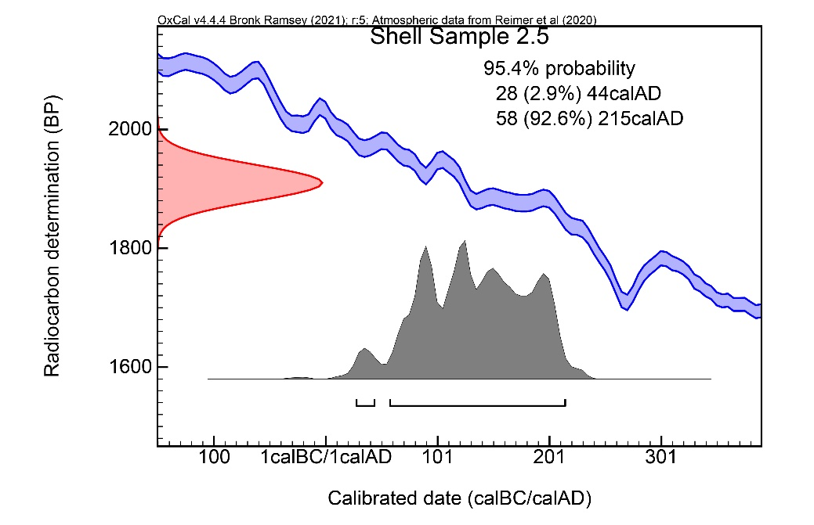
Figure S15. Calibrated radiocarbon ages for Shell Sample 2.5.
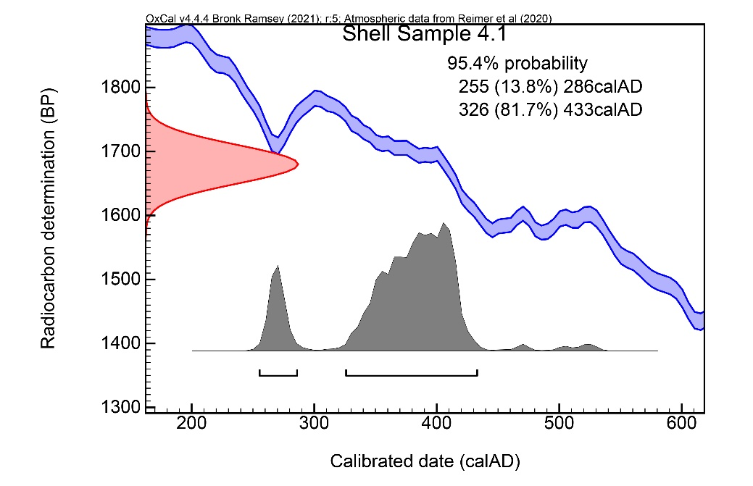
Figure S16. Calibrated radiocarbon ages for Shell Sample 4.1.
2.2: Luminescence dating
Note: The sample numbers referred to elsewhere in this document, and accompanying documents, have been changed from those used during the original analysis. This section refers to the original sample references. Both the original sample reference and the sample numbers referred to elsewhere are given in Tables S15 and S16.
2.2.1: Sample preparation
The samples were prepared under subdued red-light conditions in the Durham University Luminescence Laboratory (DLL). The outer, light-exposed portions of each sample were removed and used for environmental dose rate measurements and estimation of the sample’s moisture content. The remaining sediment was treated with hydrochloric acid (1M HCl) and hydrogen peroxide (H₂O₂) to remove carbonate and organic matter respectively. The samples were wet sieved to isolate the 90-150 µm and 4-11 µm sediment fraction sizes. Enough coarse material was extracted for the samples 24.1, 24.2, 24.3. For these samples Quartz was extracted from the 90-150 µm fraction size by using density separations at 2.62 and 2.70 g/cm³ and a subsequent HF acid etch (23M HF for 40 minutes, followed by a 10M HCl rinse). These samples were then re-sieved to remove acid-soluble fluorides and any grains that had been significantly reduced in size by etching. For the other samples that did not provide sufficient coarse material for measurements we used 4-11 µm polymineral grains in subsequent analyses (samples 23.1, 23.2, 23.3, 23.4, B29.1, B29.2, B29.3, BX1.1, BX2.1).
2.2.2: Equipment
Luminescence measurements were performed at aliquots level on a Riso reader TL/OSL-DA-20 automated dating system. Optical stimulation of single aliquots was carried out using a blue (470nm) light emitting diode (LED). All infra-red (IR) stimulation was carried out using an IR (870nm) laser diode. The luminescence emissions were detected through a Hoya U-340 filter (7.5mm), or a combination of Hoya and Schott BG39 filters and using a photomultiplier tube. The readers are equipped with 90Sr/90Y beta sources that were used for irradiations.
2.2.3: De determination
Equivalent dose (De) determination was carried out using the Single-Aliquot Regenerative-dose (SAR; Murray & Wintle 2000, 2003). A four-point SAR protocol was used to bracket the expected palaeodoses with an additional recycling point to check for uncorrected sensitivity changes. A number of additional regeneration points were also included to monitor the quality of the data generated (1) a zero dose point to measure recuperation and thermal transfer; (2) a repeat measurement of the initial regeneration dose to calculate the recycling ratio, which tests the internal consistency of the growth curve and thus the applicability of the SAR protocol; (3) a second repeat of the initial regeneration dose followed by a room temperature IR bleach and subsequent OSL measurement to calculate the IR depletion ratio, which allows contaminating feldspar grains to be detected (Duller 2003). Preheat temperatures were determined using dose recovery preheat plateau tests (Murray & Wintle 2003). Following these tests we adopted a 200°C, 10s for preheat with a second preheat of 160°C, 10s for the quartz samples. The PM aliquots were measured using the IRSL Single-Aliquot Regenerative-dose technique (SAR; Murray & Wintle 2000, 2003) and stimulated at 50°C and 290°C to extract the IR50 and pIR-IR290 signals following a protocol outlined in Table S14.
The dose response curves were fitted with a saturating exponential function. The D_{e} values for individual aliquots were calculated by projecting the sensitivity-corrected natural luminescence intensity onto the dose response curve. D_{e} values were estimated from the initial 0.2 s of OSL decay, and the 0.3 s was subtracted as background. The standard error associated with each individual D_{e} determination was estimated by Monte Carlo simulation. Curve fitting, D_{e} determination and Monte Carlo simulation were performed using version 4.31.9 of the Luminescence Analyst software (Duller 2007).
D_{e} values were only accepted when (1) the natural signal could be distinguished from the background signal (determined using Luminescence Analyst ‘sig. >3 sigma above BG’ rejection criterion); (2) the recycling ratio was within 10% of unity; (3) the recuperation on zero dose was lower than 5%; (4) the error on D_{e} was less than 30%; and for the quartz aliquots when (5) the IR-depletion ratio was lower than two standard errors below unity.
2.2.4: Dose rate determination
To determine dose rates, both the samples themselves and bulk samples collected from surrounding sediments were analysed. Doses for each sample were calculated from the content of Uranium (U), Thorium (Th), and Potassium (K) (extracted from the samples using ICP-MS analyses). The doses were then converted to dose rates using Guérin et al. (2011) conversion factors.
For the quartz measurements, these values were corrected for i) 90-150 µm grain size attenuation factors from Guérin et al. (2012), ii) etch attenuation factors (Bell 1979) and iii) for water content with an associated error of 5% to take into account past changes.
For the polymineral fine grain samples, an internal dose rate for the feldspar grains relative to their K and Rb content was assumed to be 12.5 ± 0.5% and 400 ± 100 ppm respectively following Huntley and Baril (1997) and Readhead (2002).
Laboratory analyses were conducted on each sample to ascertain water content. Considering the seasonal fluctuations in moisture levels within these sediments, the results were then averaged and rounded (14.80%) to 15% for coarse-grained samples and (20.42%) 20% for fine-grained samples. Additionally, a 5% margin of error was incorporated into our calculations, ensuring coverage within a range of 5-25% for coarse grains and 10-30% for fine-grained material at a 2-sigma confidence level. These figures encompass a spectrum from nearly desert-dry moisture levels to fully saturated conditions, thus accommodating any seasonal variations or significant changes such as variations in sea level during the burial time of the samples.
Cosmic dose rates were calculated from the site altitude / coordinates and the burial depth of the samples assuming an overburden density of 1.8 g/cm³.
2.2.5: Residual Dose
To test for potential residual dose, 6 aliquots of sample BX1.1 were exposed to sunlight for a period of 15, 20 and 30 days. Their luminescence was then measured, and yielded results comprised between 0.06 and 0.09 Gy/ka, which corresponds between 2.4 and 3.6% of the total dose rate. Consequently, residual doses were considered negligible.
2.2.6: Results
8 fine-grains 9 mm aliquots for each PM sample were measured. These samples each contain hundreds of thousands of grains (4-11µm) and therefore have a very low overdispersion. They all passed our rejection criteria. 16 aliquots were measured for the quartz samples. They all display low overdispersion with nearly all data fitting within the 2 sigma values centred around the mean Db. The Central Age Model (CAM; Galbraith et al. 1999) was used to calculate the burial doses for these samples and in subsequent age calculations. Doses and ages are presented in Table S15 and Table S16. Datum is 2022 (i.e. all ages are to be calculated as time from 2023). Radial plots showing the dispersion of the luminescence data for each sample are available in Figures S17–S28.

Table S14. IR50 and pIR-IR290 SAR protocols used in this study.
Regeneration step | Fine grain IR50 | Fine grain pIR-IR290
1 | Irradiation (regeneration only) | Irradiation (regeneration only)
2 | Preheat 320⁰C (ramp 5⁰C/s, hold 60 s) | Preheat 320⁰C (ramp 5⁰C/s, hold 60 s)
3 | IRSL 50⁰C, 200 s simulation | IRSL 50⁰C, 200 s simulation
4 | -- | IRSL 290⁰C, 200 s simulation
5 | Irradiation (test dose) | Irradiation (test dose)
6 | Preheat 320⁰C (ramp 5⁰C/s, hold 60 s) | Preheat 320⁰C (ramp 5⁰C/s, hold 60 s)
7 | IRSL 50⁰C, 200 s simulation | IRSL 50⁰C, 200 s simulation
8 | -- | IRSL 290⁰C, 200 s simulation
9 | IRSL 320⁰C, 100 s simulation | IRSL 320⁰C, 100 s simulation

Table S15. Dose rates.
Original  Sample Reference | Sample | Mineral | Alpha dose rate (Gy/ka) | Beta dose rate (Gy/ka) | Gamma dose rate (Gy/ka) | Internal dose rate (Gy/ka) | Cosmic dose rate (Gy/ka) | Total dose rate (Gy/ka)
B29.3 | 1.1 | Polymineral | 0.318 ± 0.026 | 1.548 ± 0.123 | 0.627 ± 0.043 | 0.027 ± 0.012 | 0.218 ± 0.022 | 2.738 ± 0.135
B29.2 | 1.2 | Polymineral | 0.288 ± 0.025 | 1.721 ± 0.125 | 0.68 ± 0.044 | 0.027 ± 0.012 | 0.2 ± 0.02 | 2.915 ± 0.137
B29.1 | 1.3 | Polymineral | 0.315 ± 0.029 | 1.608 ± 0.125 | 0.655 ± 0.045 | 0.027 ± 0.012 | 0.189 ± 0.019 | 2.794 ± 0.138
24.3 | 2.1 | Quartz | 0.029 ± 0.008 | 1.312 ± 0.111 | 0.576 ± 0.046 | 0 | 0.208 ± 0.021 | 2.126 ± 0.122
24.2 | 2.2 | Quartz | 0.03 ± 0.008 | 1.321 ± 0.112 | 0.582 ± 0.046 | 0 | 0.193 ± 0.019 | 2.125 ± 0.123
24.1 | 2.4 | Quartz | 0.033 ± 0.009 | 1.464 ± 0.108 | 0.642 ± 0.047 | 0 | 0.178 ± 0.018 | 2.317 ± 0.12
23.4 | 3.1 | Polymineral | 0.262 ± 0.035 | 1.836 ± 0.142 | 0.696 ± 0.052 | 0.027 ± 0.012 | 0.218 ± 0.022 | 3.039 ± 0.158
23.3 | 3.2 | Polymineral | 0.283 ± 0.039 | 1.528 ± 0.12 | 0.608 ± 0.046 | 0.027 ± 0.012 | 0.2 ± 0.02 | 2.645 ± 0.136
23.2 | 3.3 | Polymineral | 0.313 ± 0.043 | 1.611 ± 0.118 | 0.649 ± 0.047 | 0.027 ± 0.012 | 0.189 ± 0.019 | 2.789 ± 0.136
23.1 | 3.4 | Polymineral | 0.34 ± 0.046 | 1.562 ± 0.122 | 0.646 ± 0.049 | 0.027 ± 0.012 | 0.179 ± 0.018 | 2.752 ± 0.141
BX1.1 | 4.2 | Polymineral | 0.287 ± 0.025 | 1.401 ± 0.133 | 0.566 ± 0.045 | 0.027 ± 0.012 | 0.218 ± 0.022 | 2.499 ± 0.145
BX2.1 | 5.1 | Polymineral | 0.313 ± 0.028 | 1.352 ± 0.108 | 0.568 ± 0.039 | 0.027 ± 0.012 | 0.208 ± 0.021 | 2.468 ± 0.121

Table S16. Palaeodoses (Db) and calculated ages.
Original Sample  Reference | Sample | Mineral | Total dose rate (Gy/ka) | Db (Gy) | Age (ka)
B29.3 | 1.1 | Polymineral | 2.738 ± 0.135 | 2.78 ± 0.14 | 1.016 ± 0.072
B29.2 | 1.2 | Polymineral | 2.915 ± 0.137 | 2.75 ± 0.16 | 0.943 ± 0.071
B29.1 | 1.3 | Polymineral | 2.794 ± 0.138 | 2.96 ± 0.17 | 1.059 ± 0.08
24.3 | 2.1 | Quartz | 2.126 ± 0.122 | 1.84 ± 0.171 | 0.866 ± 0.095
24.2 | 2.2 | Quartz | 2.125 ± 0.123 | 1.91 ± 0.148 | 0.899 ± 0.087
24.1 | 2.4 | Quartz | 2.317 ± 0.12 | 1.96 ± 0.159 | 0.846 ± 0.081
23.4 | 3.1 | Polymineral | 3.039 ± 0.158 | 1.7 ± 0.09 | 0.559 ± 0.041
23.3 | 3.2 | Polymineral | 2.645 ± 0.136 | 3.1 ± 0.195 | 1.172 ± 0.095
23.2 | 3.3 | Polymineral | 2.789 ± 0.136 | 3.05 ± 0.198 | 1.093 ± 0.089
23.1 | 3.4 | Polymineral | 2.752 ± 0.141 | 3.14 ± 0.211 | 1.141 ± 0.096
BX1.1 | 4.2 | Polymineral | 2.499 ± 0.145 | 2.51 ± 0.12 | 1.005 ± 0.075
BX2.1 | 5.1 | Polymineral | 2.468 ± 0.121 | 2.11 ± 0.15 | 0.855 ± 0.074

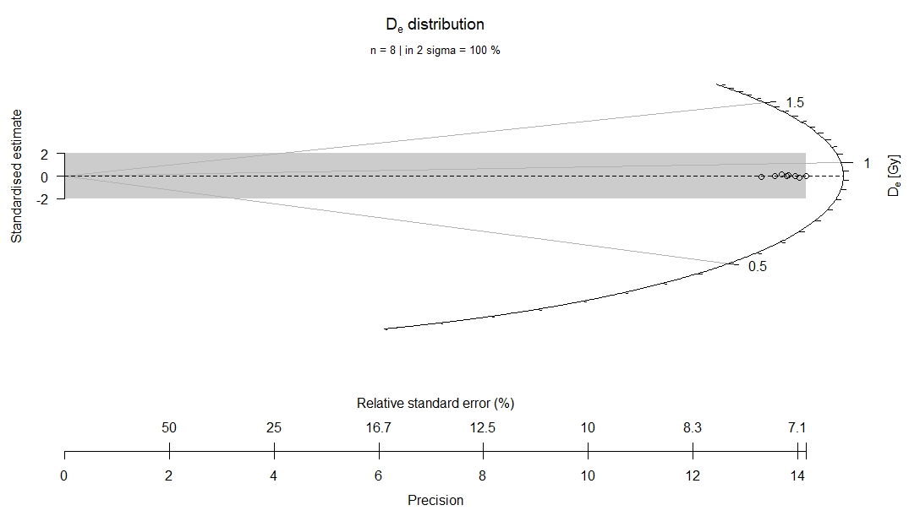
Figure S17. Radial plot of OSL Sample 1.1 centred around the CAM.

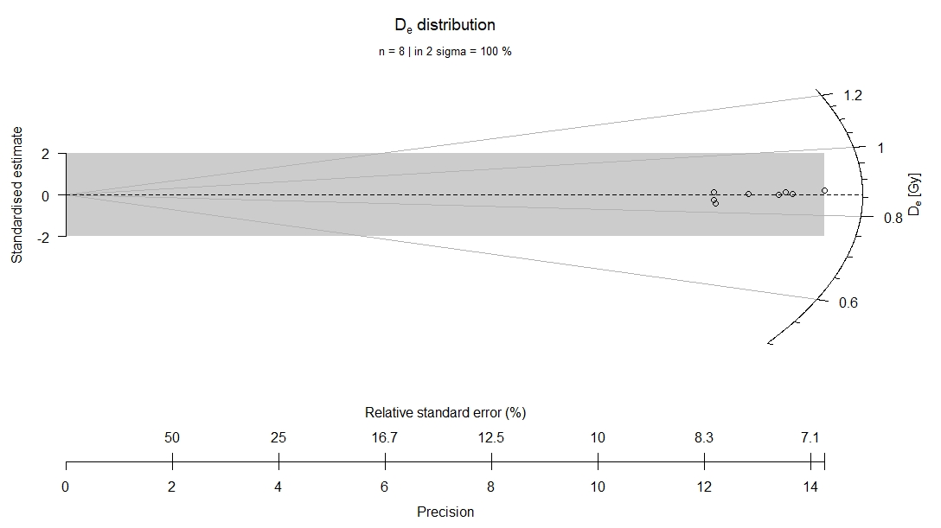
Figure S18. Radial plot of OSL Sample 1.2 centred around the CAM.

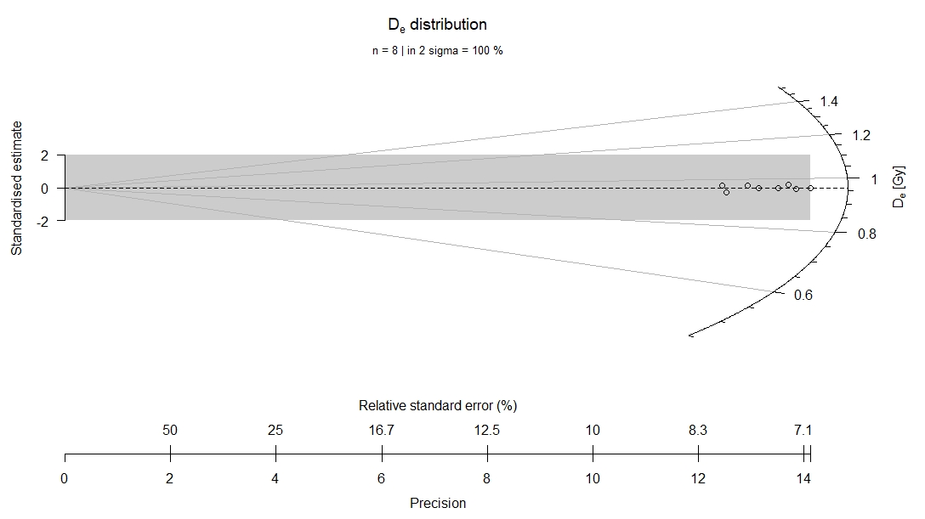
Figure S19. Radial plot of OSL Sample 1.3 centred around the CAM.
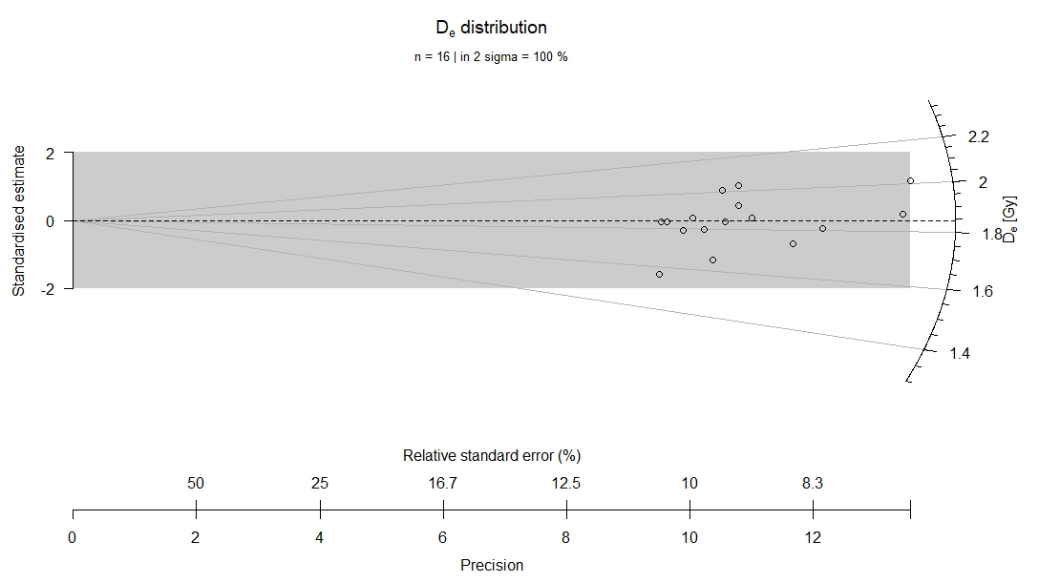Figure S20. Radial plot of OSL Sample 2.1 centred around the CAM.

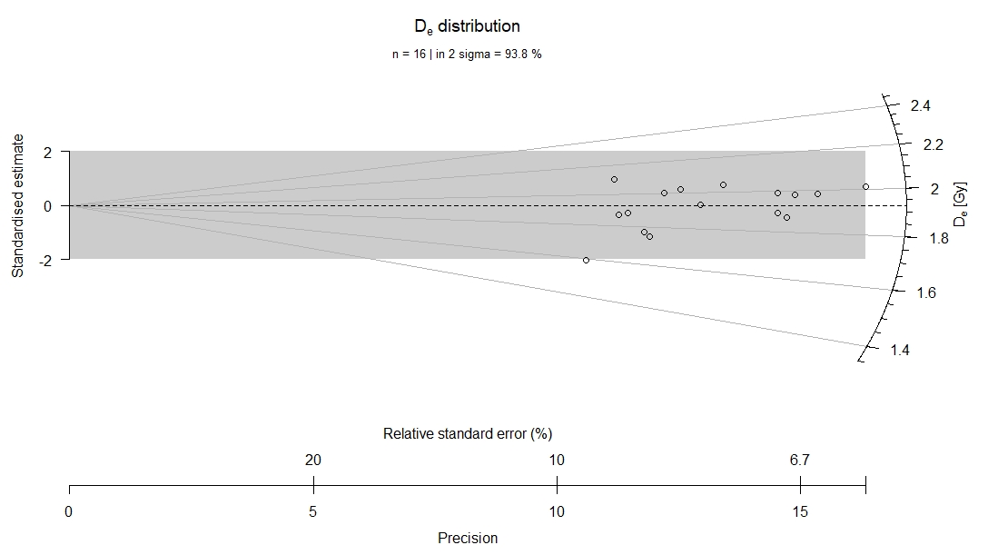
Figure S21. Radial plot of OSL Sample 2.2 centred around the CAM.

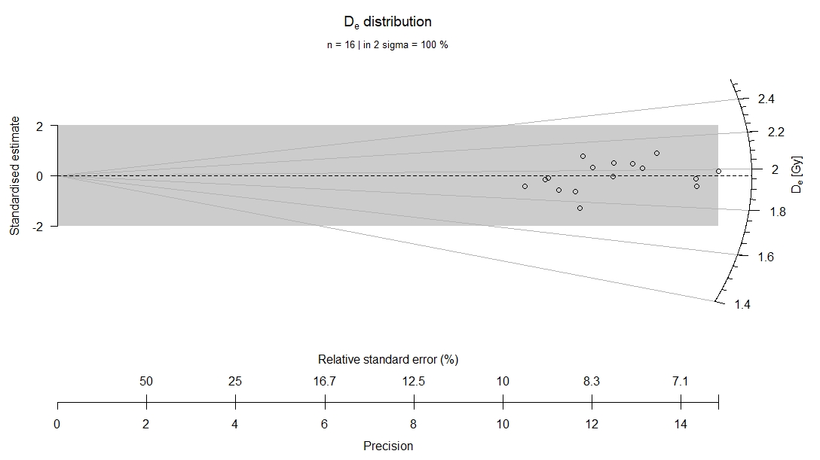
Figure S22. Radial plot of OSL Sample 2.4 centred around the CAM.

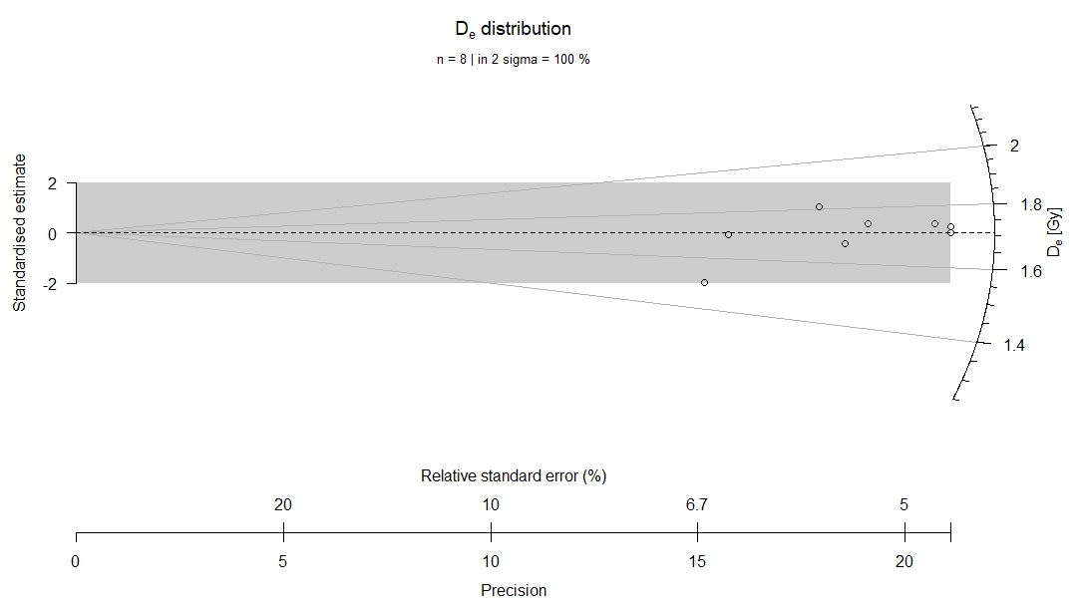
Figure S23. Radial plot of OSL Sample 3.1 centred around the CAM.

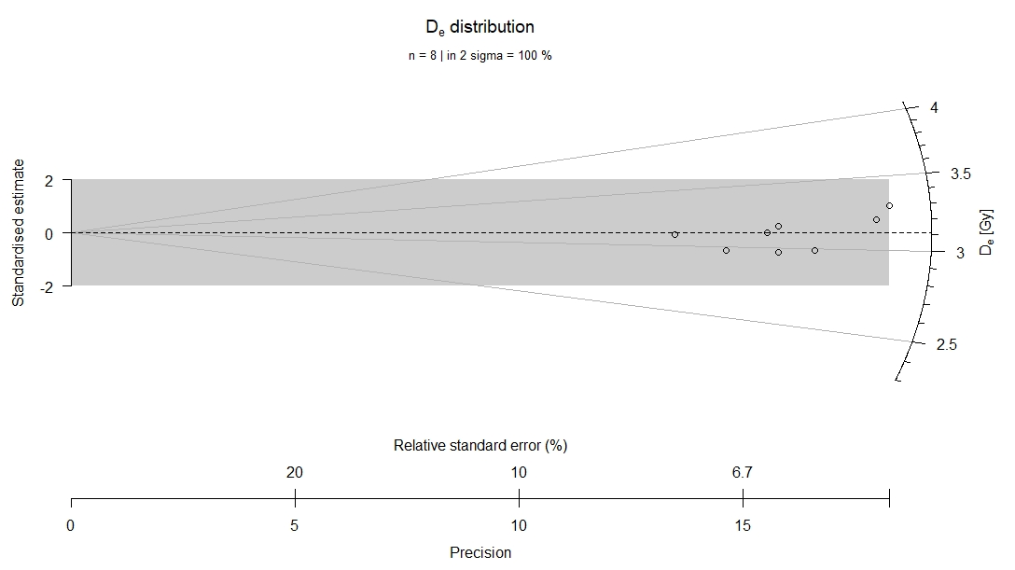
Figure S24. Radial plot of OSL Sample 3.2 centred around the CAM.

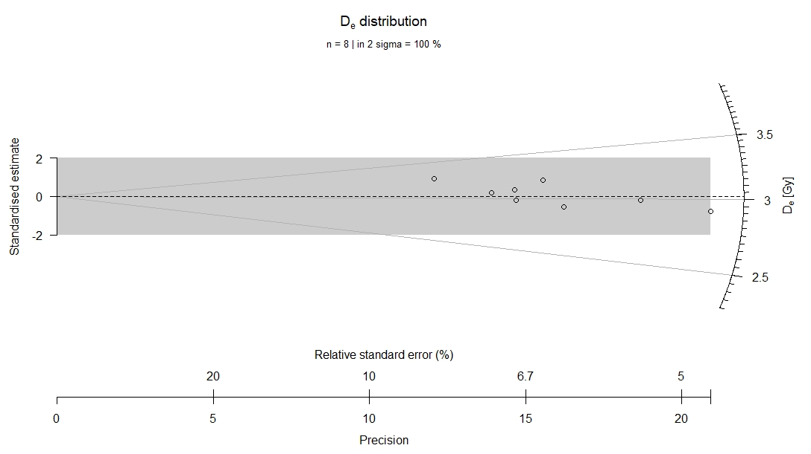
Figure S25. Radial plot of OSL Sample 3.3 centred around the CAM.

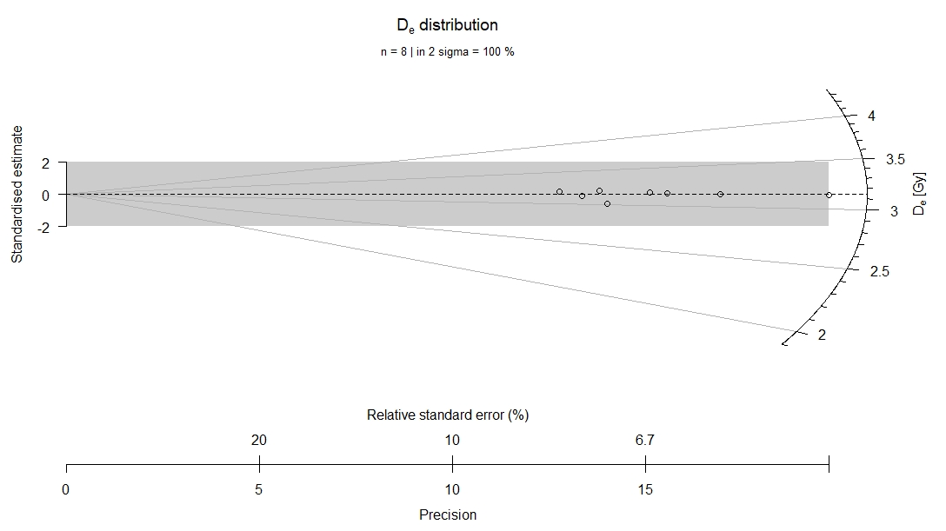
Figure S26. Radial plot of OSL Sample 3.4 centred around the CAM.

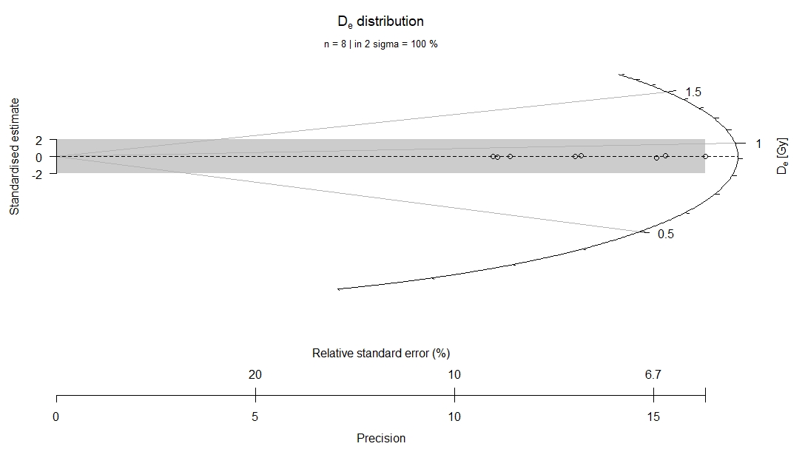
Figure S27. Radial plot of OSL Sample 4.2 centred around the CAM.

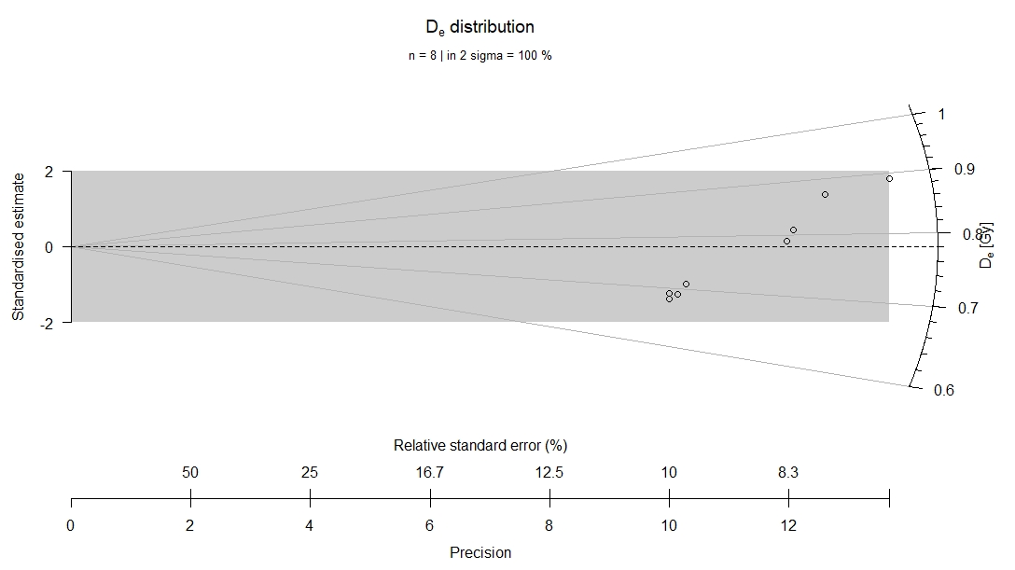
Figure S28. Radial plot of OSL Sample 5.1 centred around the CAM.

References
Al-Ameri, I.D.S. & R.M. Briant. 2018. A late Holocene molluscan-based palaeoenvironmental reconstruction from southern Mesopotamia: implications for the palaeogeographic evolution of the Arabo-Persian Gulf. Journal of African Earth Sciences 152: 1–9. https://doi.org/10.1016/j.jafrearsci.2018.12.012
Bell, W.T. 1979. Attenuation factors for the absorbed radiation dose in quartz inclusions for thermoluminescence dating. Ancient TL 3: 2–13. https://doi.org/10.26034/la.atl.1979.022
Duller, G.A.T. 2003. Distinguishing quartz and feldspar in single grain luminescence measurements. Radiation Measurements 37: 161–65. https://doi.org/10.1016/S1350-4487(02)00170-1
– 2007. Assessing the error on equivalent dose estimates derived from single aliquot regenerative dose measurements. Ancient TL 25: 15–24. https://doi.org/10.26034/la.atl.2007.403
Egberts, E., J. Jotheri, A. Di Michele, A. Baxter. & S. Rey. 2023. Dating ancient canal systems using radiocarbon dating and archaeological evidence at Tello/Girsu, southern Mesopotamia, Iraq. Radiocarbon 65: 979–1002. https://doi.org/10.1017/RDC.2023.40
Galbraith, R., R.G. Roberts, G. Laslette & J. Yoshidha Olley. 1999. Optical dating of single and multiple grain quartz from Jinmium Rock Shelter, northern Australia. Part I, experimental design and statistical models. Archaeometry 41: 339–64. https://doi.org/10.1111/j.1475-4754.1999.tb00987.x
Guérin, G., N. Mercier & G. Adamiec. 2011. Dose-rate conversion factors: update. Ancient TL 29: 5–8. https://doi.org/10.26034/la.atl.2011.443
Guérin, G., N. Mercier, R. Nathan, C. Adamiec & Y. Lefrais. 2012. On the use of the infinite matrix assumption and associated concepts: a critical review. Radiation Measurements 47: 778–85. https://doi.org/10.1016/j.radmeas.2012.04.004
Hirtz, C., J. Pournelle, J. Smith, B. Albadran, B.M. Issa & A. Al-Handal. 2012. Mid-Holocene dates for organic-rich sediment, palustrine shell, and charcoal from southern Iraq. Radiocarbon 54: 65–79. https://doi.org/10.2458/azu_js_rc.v54i1.12362
Huntley, D.J. & M.R. Baril. 1997. The K content of the K-feldspars being measured in optical dating or in thermoluminescence dating. Ancient TL 15: 11–13. https://doi.org/10.26034/la.atl.1997.271
Readhead, M.L. 2002. Absorbed dose fraction for 87Rb beta particles. Ancient TL 20: 25–28. https://doi.org/10.26034/la.atl.2002.342
Murray, A.S. & A.G. Wintle. 2000. Luminescence dating of quartz using an improved single-aliquot regenerative-dose protocol. Radiation Measurements 32: 57–73. https://doi.org/10.1016/S1350-4487(99)00253-X
– 2003. The single aliquot regenerative dose protocol: potential for improvements in reliability. Radiation Measurements 37: 377–81. https://doi.org/10.1016/S1350-4487(03)00053-2
Reimer, P. et al. 2020. The IntCal20 Northern Hemisphere radiocarbon age calibration curve (0–55 cal kBP). Radiocarbon 6: 725–57. https://doi.org/10.1017/RDC.2020.41

