 | Supplementary material for  Jun Yi Wong. 2025. The afterlife of Hatshepsut’s statuary. Antiquity 99.  Author for correspondence ✉ jun.wong@mail.utoronto.ca

Table S1. Extent of recovery for the freestanding statues discovered by Winlock’s excavation: part recovered completely or virtually complete (XXX); significant portions recovered (XX); only minor portions recovered (X); none recovered (-). Only the tip of the crown has been recovered.
Statue | Head and Crown | Torso | Lower Body | Base
Cairo JE 52458 (Standing statue, granite) | XXX | XXX | XXX | X
MMA 28.3.18 (Standing statue, granite) | XXX | XXX | XXX | -
MMA 27.3.163 (Seated statue, granite) | XXX | XXX | XX | X
MMA 29.3.2 (Seated statue, indurated limestone) | XX | XX | XX | XXX
MMA 29.3.3 (Seated statue, granite) | XXX | XXX | X | X
MMA 30.3.3 (Seated statue, diorite) | X | X | XX | X
MMA 31.3.168 (Seated statue, diorite) | - | X | XXX | XXX
Seated Statue F (granite; identification uncertain) | - | X | - | -
Seated Statue G (diorite; identification uncertain) | - | X | - | -
Seated Statue H (alabaster; identification uncertain) | - | X | - | -
MMA 30.3.1 (Large kneeling statue, granite) | XXX | X | XX | X
Cairo JE 53115 (Large kneeling statue, granite) | XXX | XX | XXX | -
MMA 29.3.1 (Large kneeling statue, granite) | XXX | XX | XX | XX
Large Kneeling Statue D (diorite) | - | X | X | -
Large Kneeling Statue E (diorite) | X¹ | X | - | -
MMA 30.3.2 (Large kneeling statue, granite) | XX | X | X | -
Large Kneeling Statue G (granite) | XX | XX | X | X
Large Kneeling Statue H (granite) | Unknown | X | Unknown | Unknown
Cairo JE 47702 (Small kneeling statue, granite) | XXX | XXX | XXX | -
Cairo JE 47703 (Small kneeling statue, granite) | XXX | XXX | XXX | -
MMA 31.3.160 (Small kneeling statue, granite) | - | XXX | XXX | -
MMA 31.3.161 (Small kneeling statue, granite) | XXX | X | XXX | -
MMA 23.3.1 (Small kneeling statue, granite) | XXX | XXX | XXX | -
MMA 23.3.2 (Small kneeling statue, granite) | XXX | XXX | XXX | -
Berlin ÄM 22883 (Small kneeling statue, granite) | XXX | XXX | XXX | -
MMA 31.3.162 (Small kneeling statue, granite) | XX | XXX | XXX | -

Table S2. Detailed description of findspots for freestanding statues that did not sustain significant facial damage (Group A).
Statue | Findspot(s)
Cairo JE 52458  (MMATE VIII: 151-4) | Almost the entirety of the statue was found in 3b. Leg fragments found in 4c.
MMA 28.3.18  (MMATE VIII: 155-7) | Almost the entirety of the statue was found in 3b. Left hand found in 3a, arm and crown fragments in 4a.
Cairo JE 47702 (MMATE VIII: 207-8) | Found entirely in the Hatshepsut Hole.
Cairo JE 47703 (MMATE VIII: 209) | Found entirely in the Hatshepsut Hole.
MMA 23.3.1  (MMATE VIII: 213) | Found entirely in the Hatshepsut Hole.
MMA 23.3.2  (MMATE VIII: 214) | Found entirely in the Hatshepsut Hole.
Berlin ÄM 22883  (MMATE VIII: 215) | Found entirely in the Hatshepsut Hole.
MMA 30.3.1  (MMATE VIII: 165-73) | Unspecified fragments found in 4a; knees and head fragments found in 5. The head (formerly Berlin ÄM 2279) was brought to Berlin by Karl Richard Lepsius, and was likely found near 4a or 5 as well (MMATE VIII: 166).  An arm fragment was found in the tomb of Nespekashuty (TT 312), which dates to the 26th Dynasty (c. 664-332 BCE).
MMA 31.3.161 (MMATE VIII: 212) | Head found in 4a; lower body found in the Hatshepsut Hole. Note that it is possible that the head and lower body might not have originated from the same statue (the two parts are not contiguous).

Table S3. Detailed description of findspots for freestanding statues that sustained significant facial damage (Group B).
Statue | Findspots
Cairo JE 53115 (MMATE VIII: 174-80) | Top of back pilaster found in 4a; fragments of torso, leg and back pilaster found in 5.  Head and arms found in TT 117. The construction of this tomb (11th Dynasty) predates Hatshepsut’s time, hence the fragments were probably brought here when its roof was removed during the ‘quarrying’ in the 18th Dynasty, or when the tomb was reused in the 21st/22nd Dynasty (Polz 1990: 312; PM I, 1²: 233).  A piece of the base or back pilaster (‘presumably from this statue’), was found in Tomb MMA 820 (TT 336). Winlock noted that a hand that is ‘undoubtedly of this statue’ was taken to Berlin by Lepsius and subsequently lost.
MMA 29.3.1 (MMATE VIII: 181-9) | Crown fragments found in 1; fragments from nose, head, chest in 3b; fragments from base, body, beard, right hand, and other unspecified parts in 3a; another head fragment in 3c; left hand in 4c. Many fragments appear to have been exposed until the Ptolemaic period (332-30 BC).
MMA 30.3.2 (MMATE VIII: 194-7) | One hand found in 2 (60cm from the bottom of the brick dump); most of the arms and parts of torso in 3b; head fragments in 3c; another hand in 4a. Part of face found at the temple causeway of Mentuhotep II/Thutmose III.
Large Kneeling Statue G (MMATE VIII: 198-200) | Fragments of torso and head found in 5. Fragment of one hand found on the Sheikh Abd el-Qurnah hills.
MMA 31.3.162 (MMATE VIII: 216) | Fragments from torso, shoulder, and head found in 2. Body and head fragments found in the Hatshepsut Hole.
MMA 27.3.163 (MMATE VIII: 223-6) | Fragments from throne found in 1; head, torso, legs and throne found in 4a. Other throne fragments found in the Lower Court of Hatshepsut’s temple and behind the Priests’ House.
MMA 29.3.2 (MMATE VIII: 227-41) | Head fragment found in 3b, near the entrance of TT 108 (‘on about 1 meter of drift sand’); fragments of crown, arms and throne found in 4a.  Another head fragment was found in TT 116, where it is ‘covered with bat dung and also badly sunburned’. This tomb is dated to the period between Thutmose IV and Amenhotep III, c.1400-1352 BCE (PM I, 1²: 233).  Most fragments from the body were brought to Berlin by Lepsius in 1845, allegedly having been found near the Temple of Seti in Old Gourna and “beside the Asasif road” (MMATE VIII: 228).
MMA 30.3.3 (MMATE VIII: 253-8) | Fragments from ‘upper part’ (head and/or torso), feet and base found in 4a; leg fragments in 4b. Fragments from head and torso found at the Lower Court of Hatshepsut’s temple (Winlock noted that these fragments ‘had been used as mauls, and may have been brought back to the temple court at a much later date’).
MMA 29.3.3 (MMATE VIII: 242-52) | Fragments of throne and legs found in 4a; head fragments in 4b. Other fragments from the throne were found in the Lower Court of Hatshepsut’s temple and behind the Priests’ House.  The torso of the statue was brought from Egypt in 1869 by Prince Henry of the Netherlands. A note found with the torso at the Soestdijk Palace (dated 1928) states that it was ‘trouvée à Thebes dans la Plaine entre Der-el-Bahri et le Temple de Koorna’.

Details on the Hatshepsut Hole
At the time of the Hatshepsut Hole’s excavation, Winlock (1923: 32–4) had assumed that the avenue above it led to the temple of Mentuhotep II. It was later realised that the avenue led to Djeser-Akhet, a construction by Thutmose III (Winlock 1932: 30–1, fig. 24). The true extent of the Djeser-Akhet temple was not known until its discovery in 1961-2 (Lipińska 1966: 64–5; 1977: 9, 64; Dąbrowski 1968: 131, 137).
The Hatshepsut Hole is located about 125m east of the temple court wall (MMATE VII: 156). Hatshepsut’s statue fragments are found at about 250cm below the level of the court wall, along with objects such as bricks, pottery and ostraca (MMATE VII: 156). Most of the inscribed material can be dated to the time of Hatshepsut and Thutmose III. They include a scarab inscribed with Hatshepsut’s throne name (MMA 23.3.175), as well as ostraca that describe the construction of Djeser-Akhet, dating to Years 43, 44, 45, and 49 of Thutmose III’s reign (Winlock 1923: 35–38; Hayes 1960). While the statue fragments are generally associated with these objects, little detail was provided on their exact stratigraphic relationship. Winlock noted that the statues were buried ‘only because the hole was being filled up’, and that the ostraca indicate that the filling of the Hatshepsut Hole was finished ‘in the latter years of Thutmose III’ (MMATE VIII: 22).
The small kneeling statues of Hatshepsut lay on top of an accumulation of building material, which Winlock (1923: 33) assumed to be refuse from the construction of Hatshepsut’s temple. Hatshepsut’s statue fragments were scattered throughout the hole, which suggests they were buried without much deliberation, unlike the statue caches mentioned in the main article. Instead, it appears the statues (much like the building material and ostraca) were simply discarded here for practical reasons, likely to act as in-fill for the construction of the causeway.
The origin of the statues in the Hatshepsut Hole remains disputable. I favour interpreting this as a secondary deposit, in that they were moved to the Hatshepsut Hole from their initial deposition in and around the Quarry. This interpretation is based on the fact that many statues have their fragments divided between the Hatshepsut Hole and the western part of the Quarry (e.g. MMA 31.3.157, 31.3.160, 31.3.162, 31.3.163, 31.3.164). If one assumes that the fragments were moved from one of these contexts to the other, a Quarry → Hatshepsut Hole direction of travel would appear to be likelier than the reverse, given that it fulfils a practical purpose in the construction of the causeway.

Details on findspots in the Quarry
Winlock provided only a rough sketch of the longitudinal section of the Quarry (see Dorman 1991: 83, fig. 18). Its depth was approximately ‘six or seven meters’ in 1926-27, the first season of excavation (Winlock 1942: 154). A prominent feature is the so-called ‘Quarry Hole’, where the deepest part (apart from the well) is roughly 91-92m a.s.l. Lying within a rectangular depression of about three metre deep is the unfinished well, which is 20m in depth (69m a.s.l) and 152m in diameter (MMATE VII: 191–2).
Figure 5 was reproduced based on a map by Dorothea Arnold, after verification and modifications by the present author. It is based on a number of sources in the Department of Egyptian Art Archives (Metropolitan Museum of Art, New York), including a map drawn by Walter Hauser (AM 143), a plan of the western part of the Quarry (AM 843; Dorman 1991: pl. 40b), and a longitudinal section of the Quarry (MMATE VII: 193; Dorman 1991: 83, fig. 18).
In Winlock’s notes (MMATE VII, VIII), the findspots are typically described in relation to major features in the Quarry. The names in bold below are based on Winlock’s designations, with the exception of 4c. It should be noted that these terminologies are often ambiguous, and the delineation between each findspot is not necessarily clear. Therefore, reconstructing ancient deposition processes based on this documentation is often problematic. For instance, Winlock noted that certain fragments have rolled into 4b from 4a (MMATE VIII: 37). In turn, fragments found in 4b can be separated by up to 60-70cm of sediments (MMATE VIII: 34). In other words, the proximity between fragments from the same findspot can at times be overstated, whereas those listed with different findspots might in fact be relatively close to one another. In the main article, I have divided the Quarry into several general areas, each containing one or several findspots as documented by Winlock. This is intended to mitigate the ambiguity presented by the documentation, even though it is an imperfect solution to a complex issue.
Area 1
1. Outside N.E. Corner of the Court and Wilkinson’s “Much Pottery”
Excavated in 1926-7. MMATE VIII: 23.
This refers to the area between the northeast corner of Hatshepsut’s temple court and the west end of the Quarry. The name “Much Pottery” was derived from a map drawn by Sir Gardiner Wilkinson (Arnold & Winlock 1979: 8). According to Winlock, statues found in this area were likely brought out from a gate located at the northeast corner of the temple court.

Area 2
2. Extreme West End of the Quarry
Excavated in 1926-7. MMATE VIII: 24.

This refers to fragments found near the entrance of Senenmut’s tomb (TT 353), as well as the ‘brick dump’ located to its east. The fragments found near TT 353 lay above rubbish which covered the mouth of the tomb. The remaining fragments are mostly found to the south of the brick dump (i.e. southeastern part of Area 2).

Area 3
3a. At the Foot of the Causeway Embankment
Excavated in 1927-8. MMATE VIII: 24-5.

This refers to the southernmost part of Area 3, which consists of the area between the north wall of Hatshepsut’s causeway and the southern edge of the Quarry. Finds in 3a tend to consist of smaller fragments; larger fragments from the same statues have typically been rolled into the area to the north (3b, 3c).

3b. Pocket in the Quarry Floor
Excavated in 1927-8. MMATE VIII: 29-30.

This pocket is found around the northwestern part of Area 3, near the opening of TT 108. It is about 0.5m in depth, measuring roughly 5.5m (north-south) by 4m (east-west). Winlock noted that the fragments were found above 5-10cm of tafl (laminated shale) dust mixed with 18th Dynasty pottery. The two standing statues (Cairo JE 52458 and MMA 28.3.18) are both found almost entirely within this pocket.

3c. In West Side of the Big Hole in Quarry floor
Excavated in 1927-8. MMATE VIII: 32-3.

This refers to the northeastern part of Area 3, i.e. the western half of the ‘Quarry Hole’. Some of the fragments were found laying above the gebel (bedrock), while others were found above a layer of tafl chips that were ‘cut ready for transport’.

Area 4
4a. From the Large Quarry Hole in the East End of the West Bay
Excavated in 1926-7. MMATE VIII: 37-8.

The fragments were found in a continuous line along the edge of the Quarry (i.e. the southern part of Area 4). Some of the lighter fragments appear to have rolled into the 4b. Area 5 might be a continuation of 4a.

4b. Large Pile on the East Side of the Big Quarry Hole – “The Cascade”
Excavated in 1927-8. MMATE VIII: 34.

This refers to the southeastern part of the Quarry Hole, where a large pile of statue fragments was found. The pile is about 1.5m in height, measuring 9m (north-south) by 6m (east-west). Winlock noted that the area was ‘continuously soaked’, to the point that the limestone statues were ‘rotted almost to the point of dissolution’.

4c. The well and the area directly above
Excavated in 1927-8. MMATE VII: 191-2, VIII: 152, 182.

A relatively small number of fragments were found in the area. The well appears to be unfinished, and the fragments found within it lay on roughly 4m of sediments.
Area 5
5. West End of the East Bay
Excavated in 1926-7. MMATE VIII: 21.

This was described as a continuation of 4a, with similar burial conditions.

Abbreviations
MMATE: Metropolitan Museum of Art Theban Excavations. Notebook, New York: Department of Egyptian Art Archives, The Metropolitan Museum of Art.
PM I, 1²: Portha, B. & R.I.B. Moss. 1960. Topographical bibliography of ancient Egyptian hieroglyphic texts, reliefs, and paintings. 1. The Theban necropolis. Part 1. Private tombs. Oxford: Griffith Institute.

References
Arnold, D. & Winlock, H. 1979. The Temple of Mentuhotep at Deir el-Bahari. New York: The Metropolitan Museum of Art.
Dąbrowski, L. 1968. Preliminary report on the reconstruction works of Hatshepsut’s Temple at Deir el Bahari. During the seasons 1962/63 and 1963/64. Annales du Service des Antiquités de l’Égypte 60: 131–37.
Dorman, P.F. 1991. The tombs of Senenmut: the architecture and decoration of tombs 71 and 353. New York: The Metropolitan Museum of Art.
Hayes, W.C. 1960. A selection of Tuthmoside Ostraca from Der El-Bahri. Journal of Egyptian Archaeology 46: 29–52. https://doi.org/10.2307/3855661
Lipińska, J. 1966. List of the objects found at Deir el-Bahari temple of Thutmosis III. Season 1961/62. Annales du Service des Antiquités de l’Égypte 59: 63–98.
– 1977. Deir el-Bahari 2. The Temple of Tuthmosis III: architecture. Warsaw: Centre d’Archéologie Méditerranéenne de l’Académie Polonaise des Sciences & Centre Polonais d’Archéologie Méditerranéenne dans la Republique Arabe d’Egypte au Caire.
Polz, D. 1990. Bemerkungen zur Grabbenutzung in der thebanischen Nekropole. Mitteilungen des Deutschen Archäologischen Instituts, Abteilung Kairo 46: 301–336. https://doi.org/10.11588/propylaeumdok.00001914
Winlock, H.E. 1923. The museum’s excavations at Thebes. The Metropolitan Museum of Art Bulletin 18(12): 11–39. https://doi.org/10.2307/3254661
– 1932. The museum’s excavations at Thebes. The Metropolitan Museum of Art Bulletin 27(3):5 4–37. https://doi.org/10.2307/3255360
– 1942. Excavations at Deir el Bahri 1911–1931. New York: MacMillan.

Figures
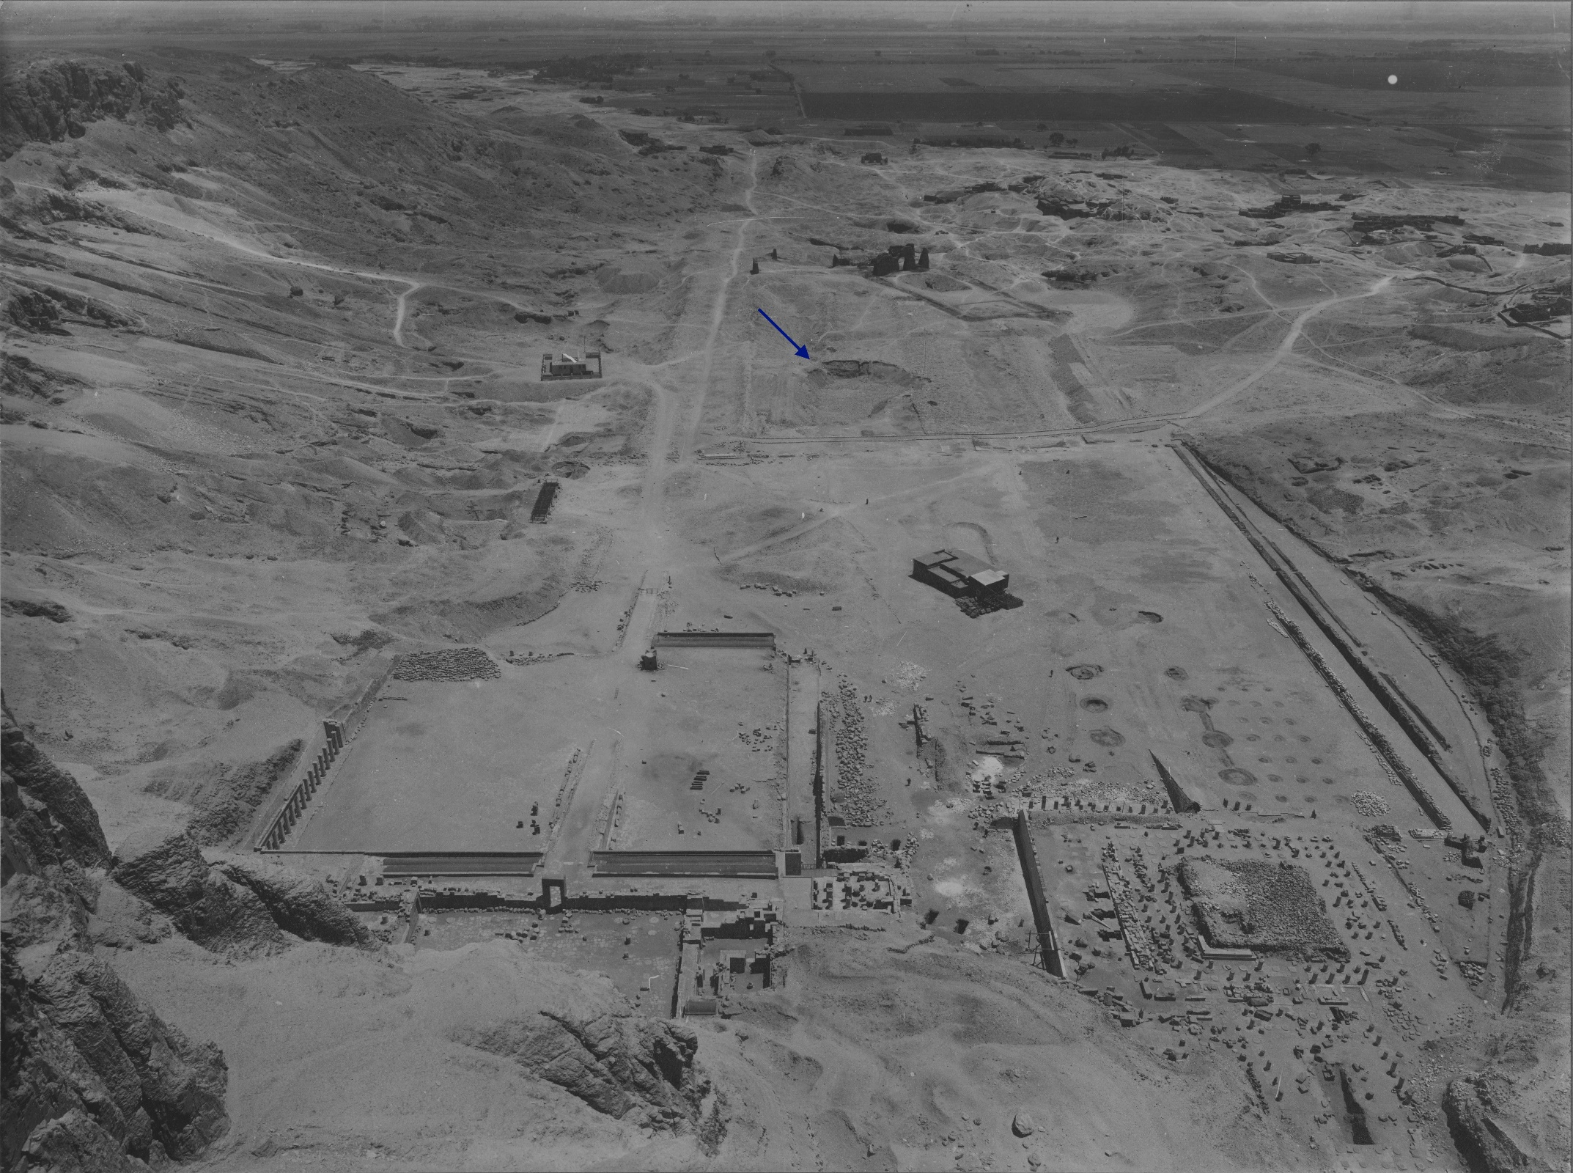
Figure S1: Photograph taken at the end of the 1922–23 season, with arrow pointing at the location of the Hatshepsut Hole. At this point, the Hatshepsut Hole has been refilled to about half its depth; the statues at the Quarry had yet to be discovered. Photograph by Harry Burton, 1922–23. © The Metropolitan Museum of Art, Department of Egyptian Art Archives (M4C 243).
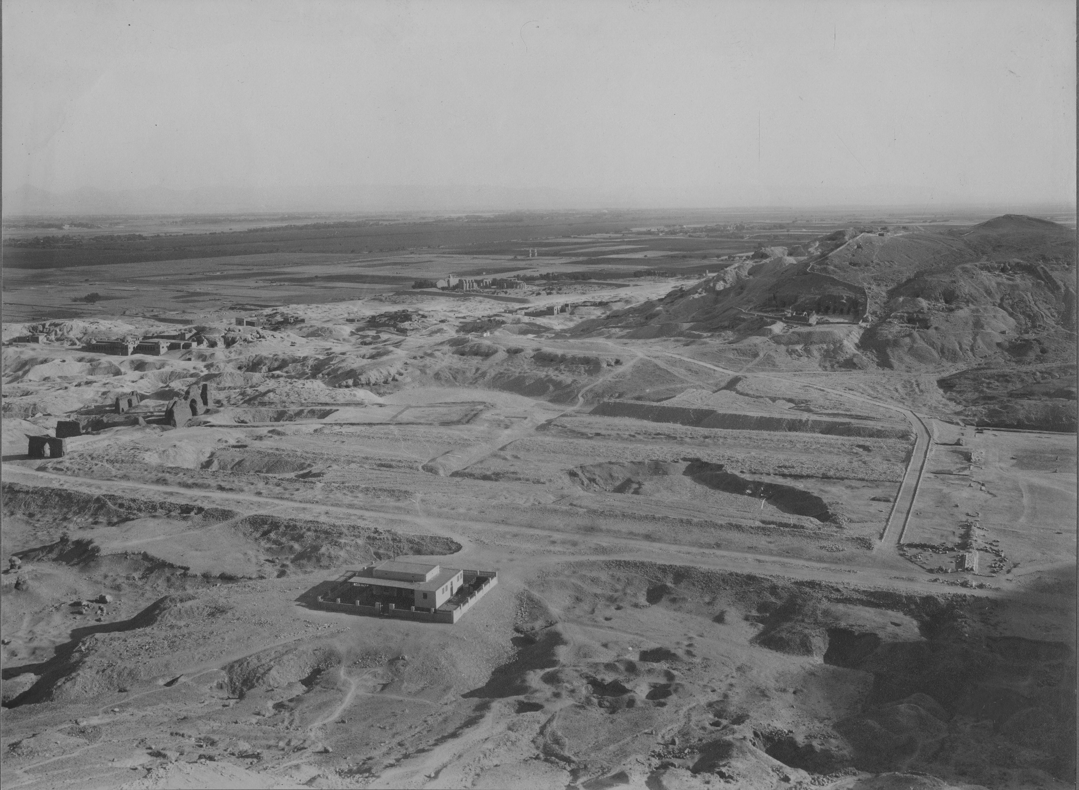
Figure S2: Photograph taken in the 1922–23 season (looking south), showing the location of the Hatshepsut Hole. Photograph by Harry Burton, 1922–23. © The Metropolitan Museum of Art, Department of Egyptian Art Archives (M4C 240).
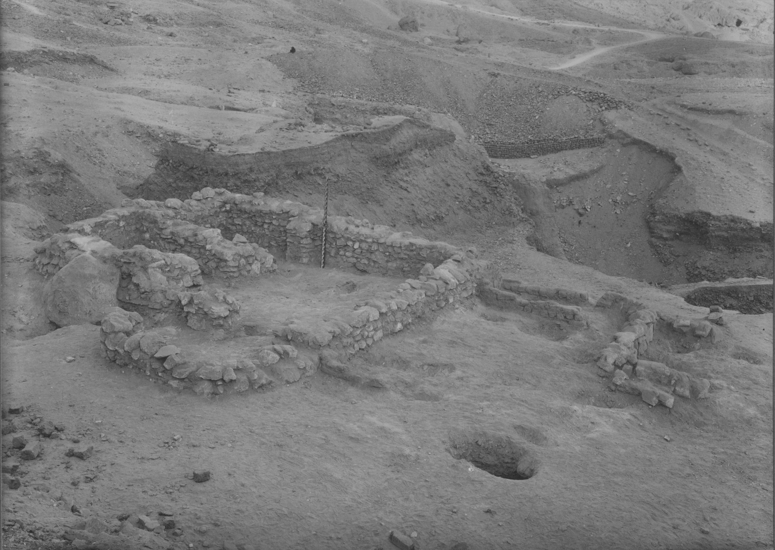
Figure S3: Remains of the stone house at the edge of the Quarry. Photograph by Harry Burton, 1926-27. © The Metropolitan Museum of Art, Department of Egyptian Art Archives (M8C 73).
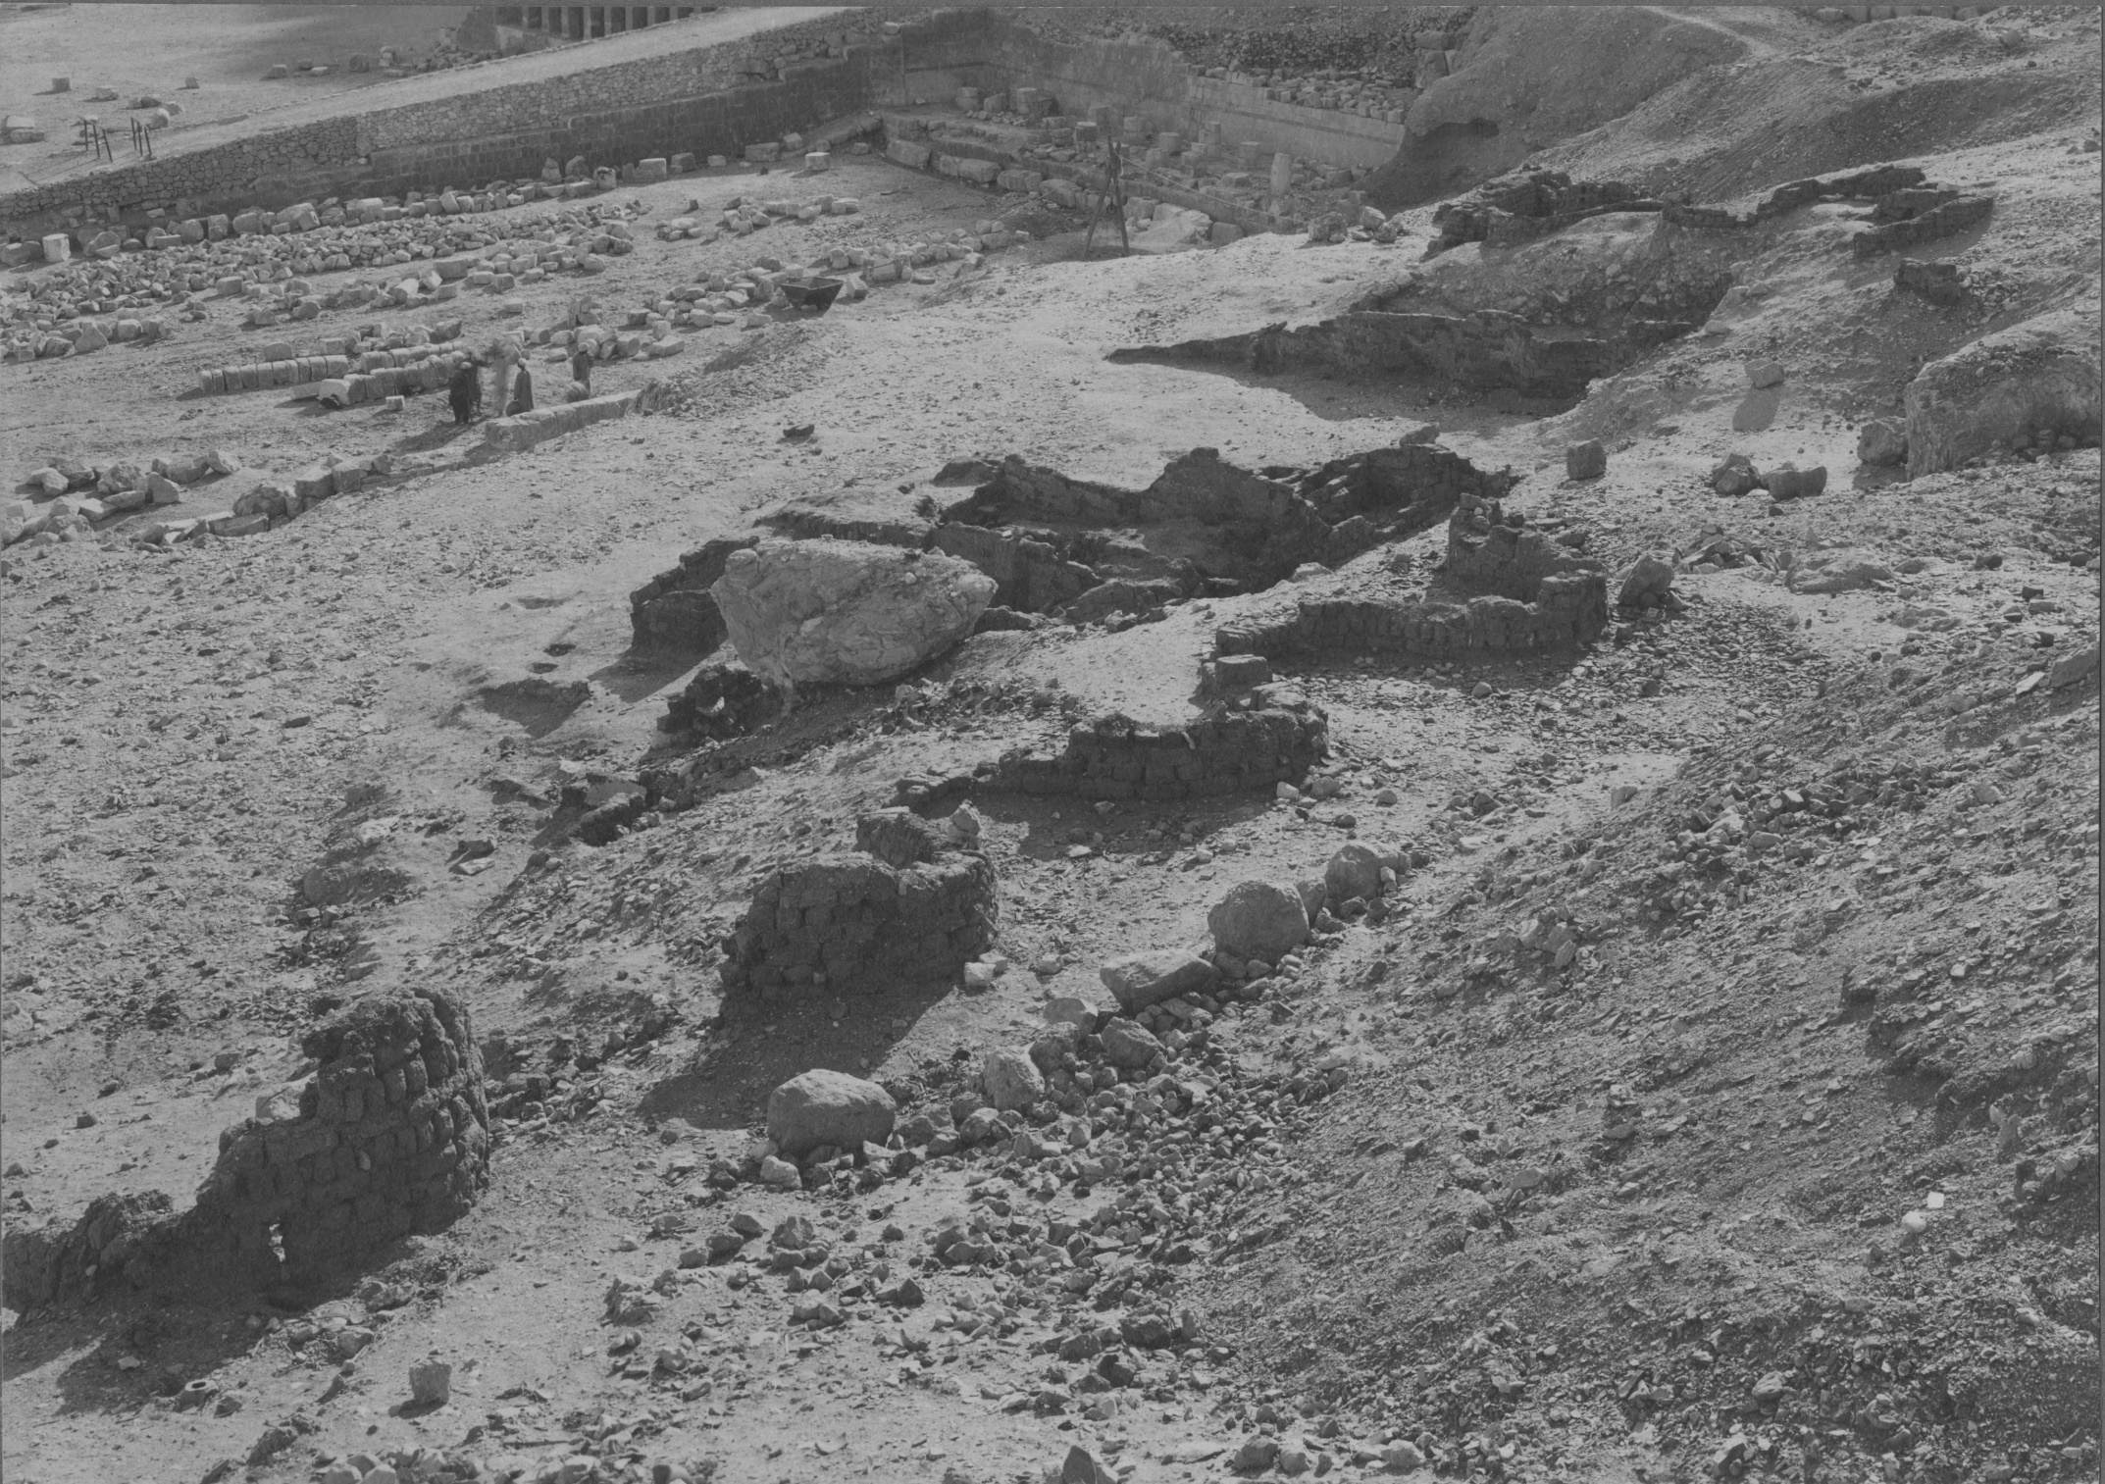
Figure S4: The “Priests’ Houses” to the north of Hatshepsut’s Temple. Photograph by Harry Burton, 1923–24. © The Metropolitan Museum of Art, Department of Egyptian Art Archives (M5C 231).

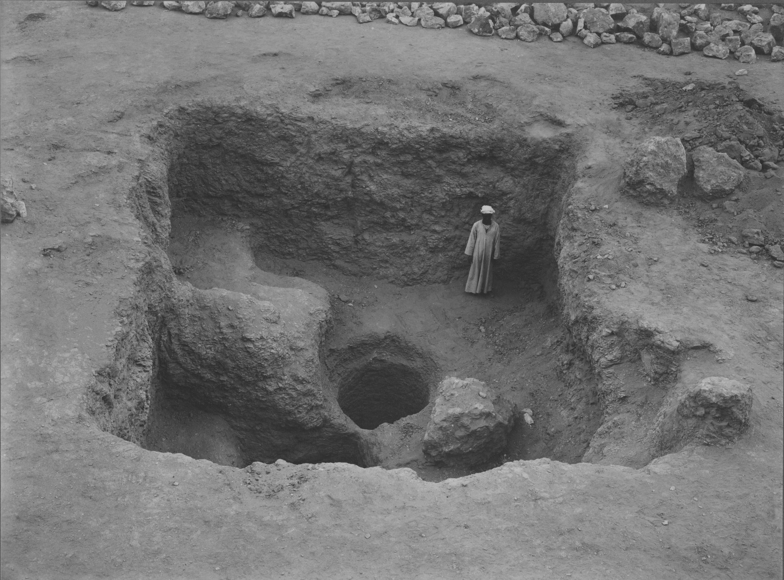
Figure S5: The square depression and well in the Quarry Hole (looking south). Photograph by Harry Burton, 1928. © The Metropolitan Museum of Art, Department of Egyptian Art Archives (M9C 316).

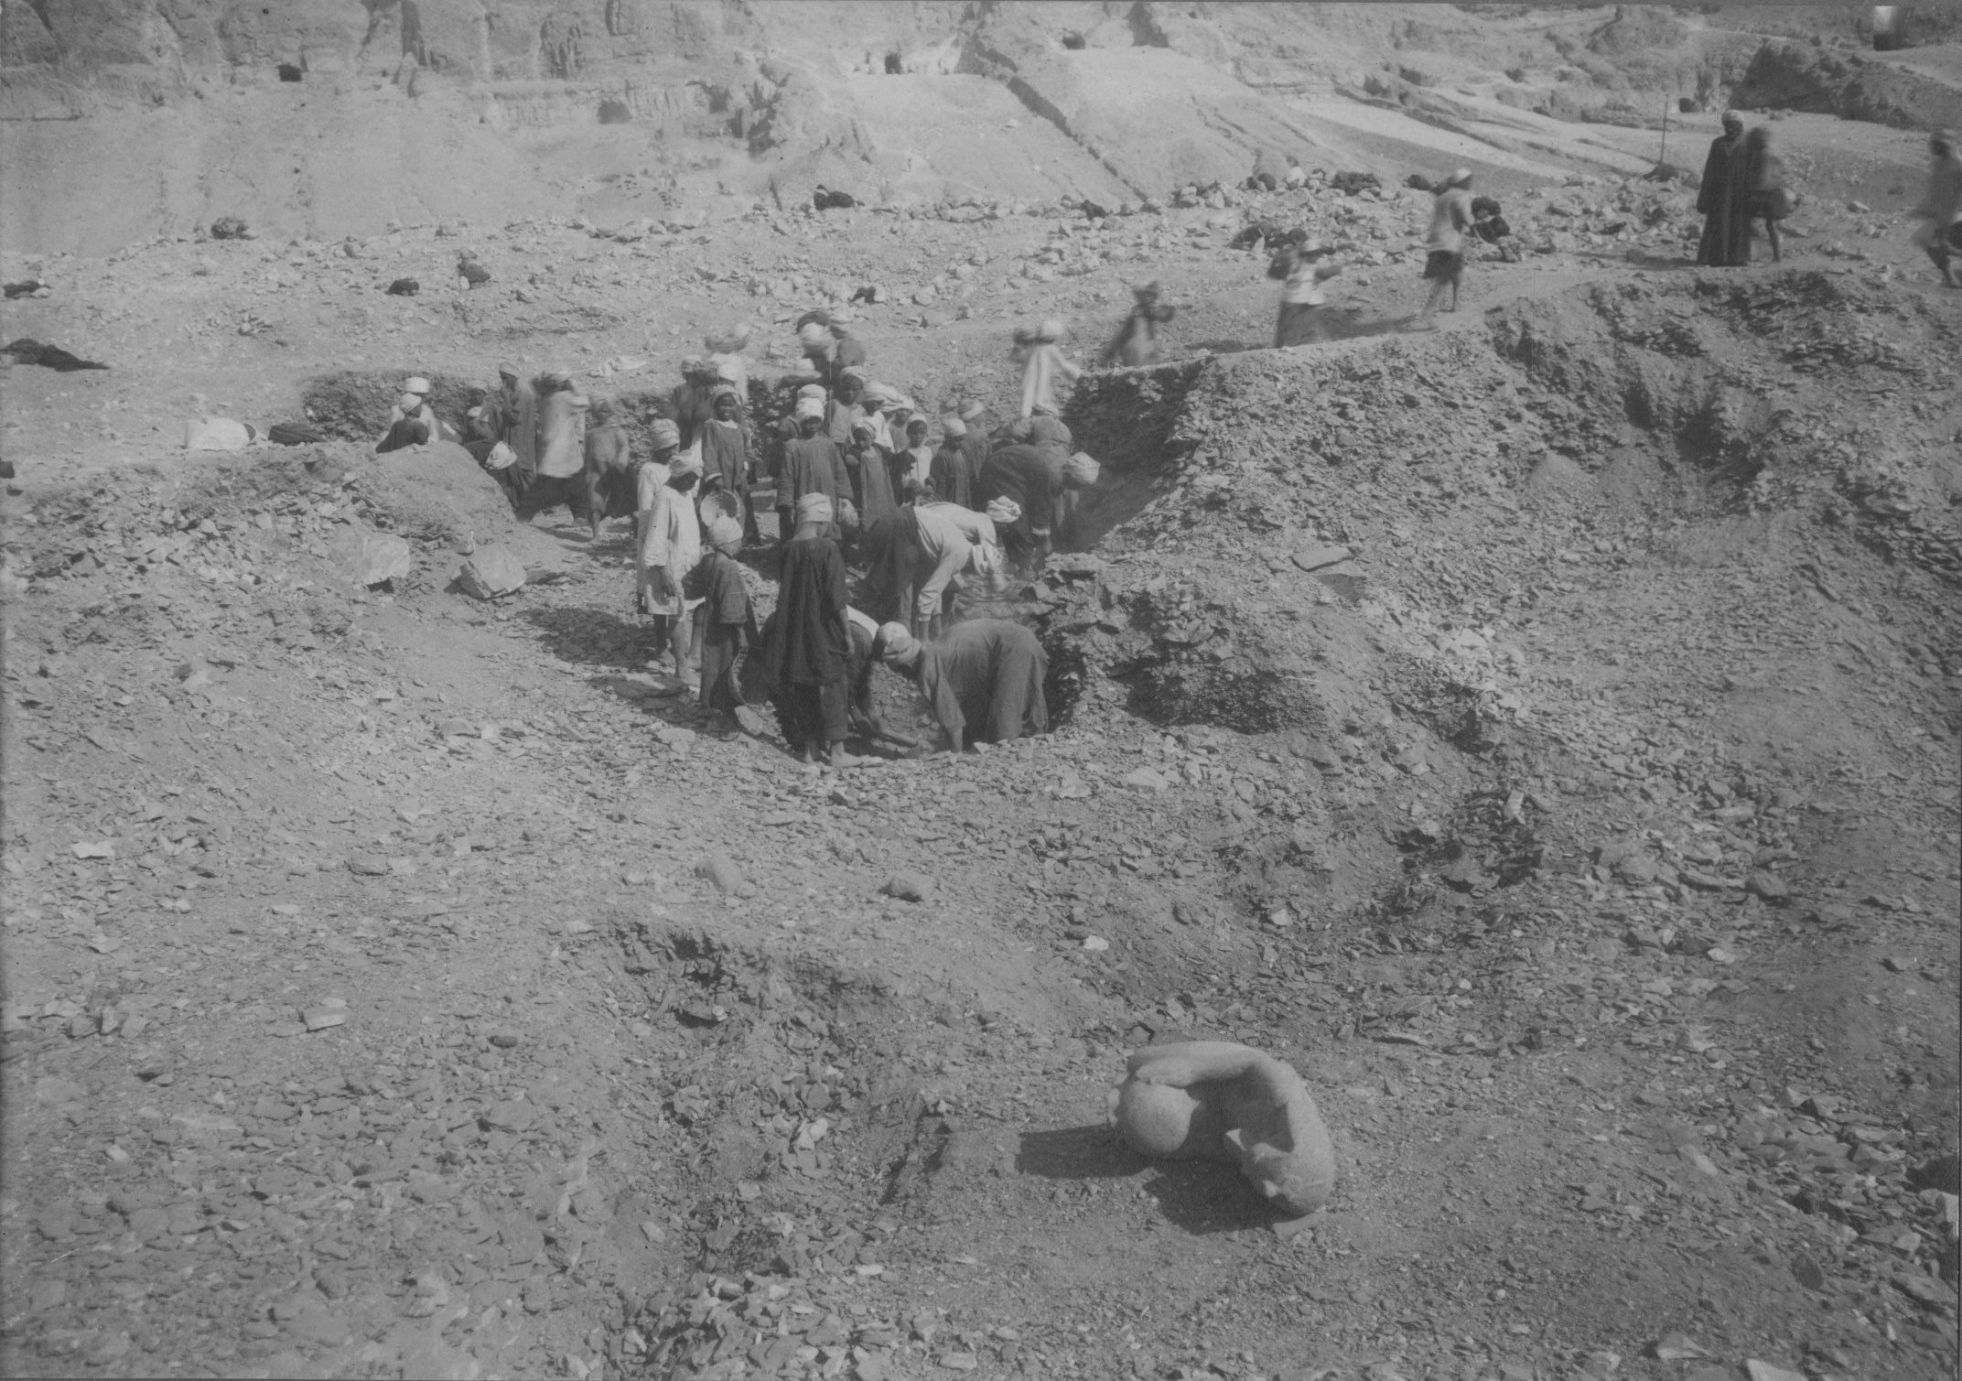
Figure S6: Fragment from MMA 23.3.1 in situ in the foreground. Photograph by Harry Burton, 1922–23. © The Metropolitan Museum of Art, Department of Egyptian Art Archives (M4C 41).
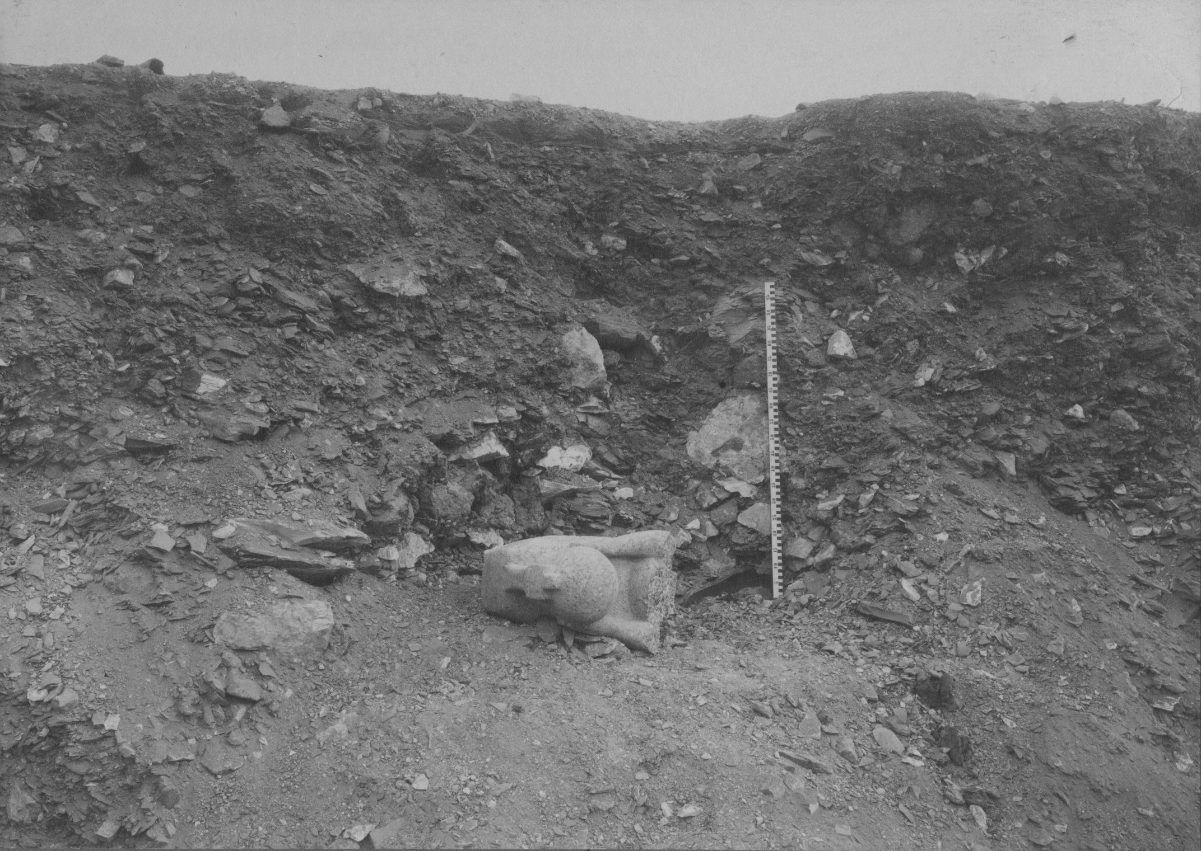
Figure S7: Body fragment of MMA 23.3.2 in situ. Photograph by Harry Burton, 1922–23. © The Metropolitan Museum of Art, Department of Egyptian Art Archives (M4C 81).
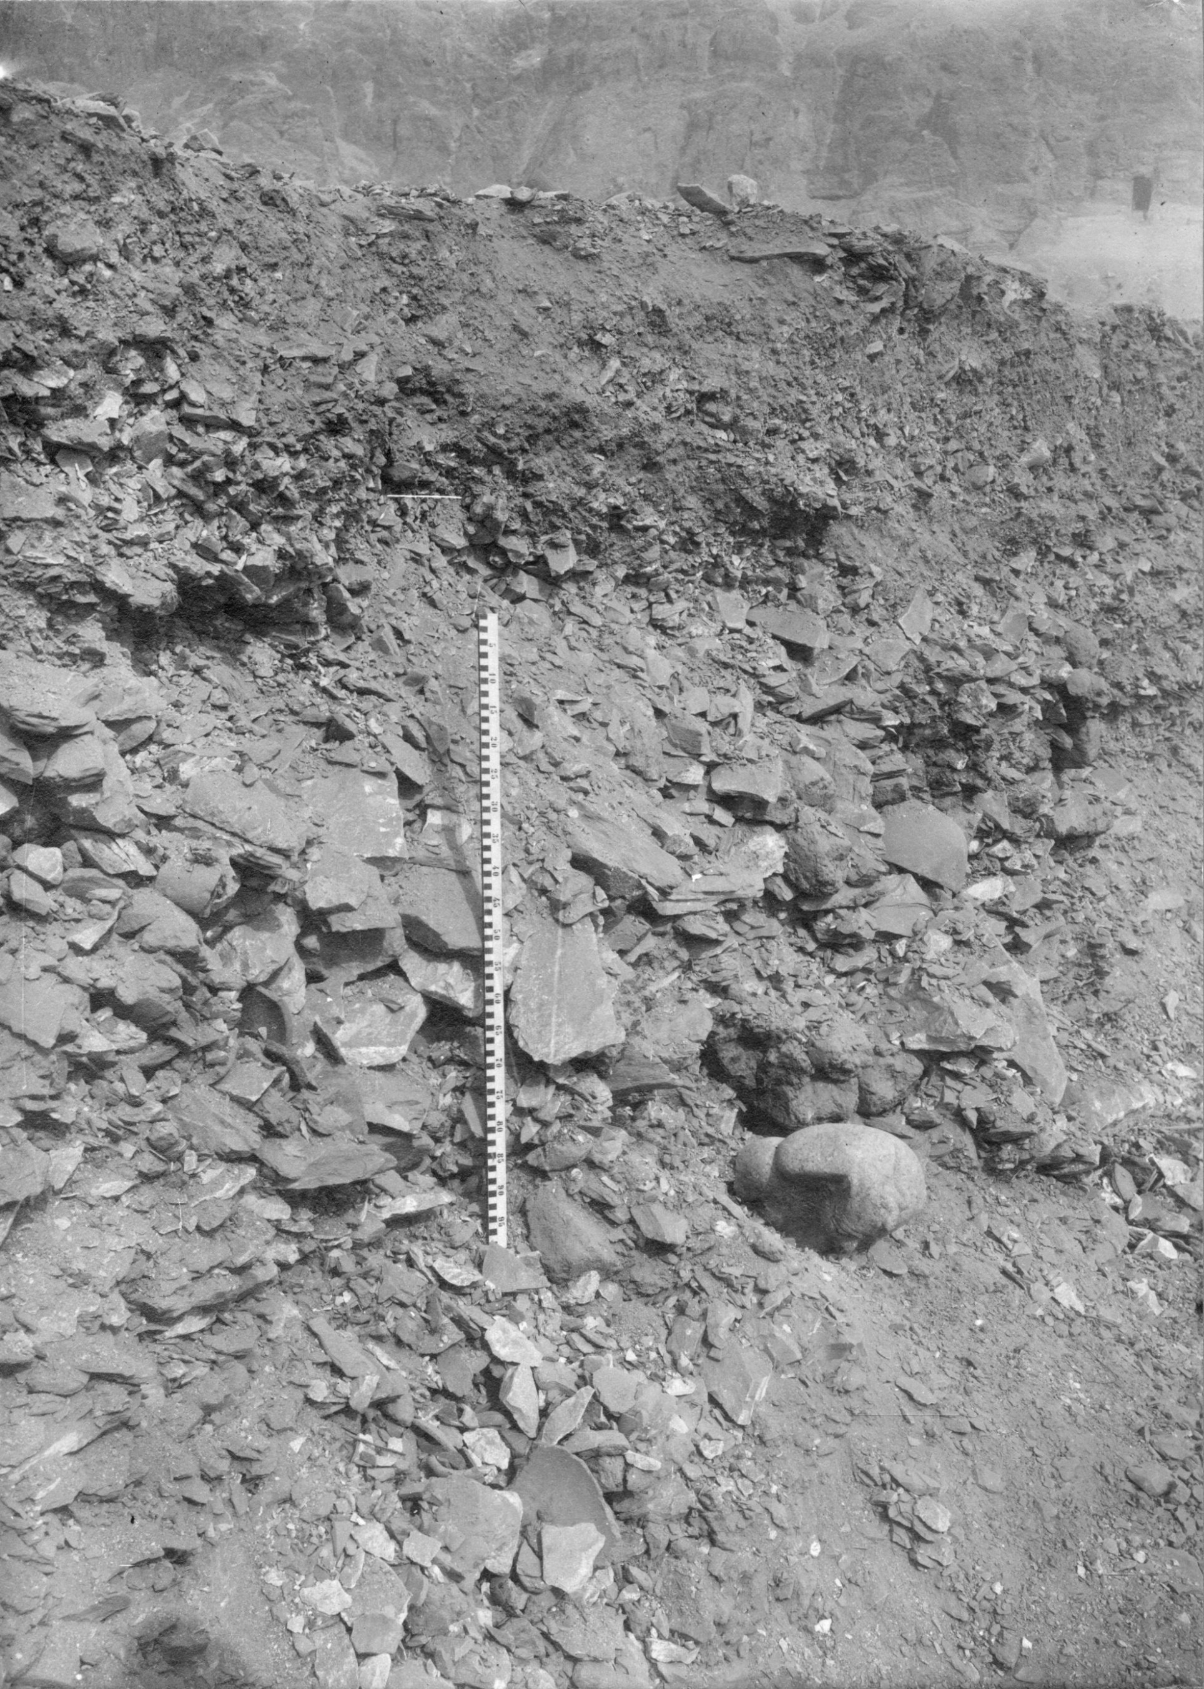
Figure S8: Head fragment of Cairo JE 47702 in situ. The caption from another photograph (M4C 84) describes this fragment as being ‘1½ meters below surface’. Photograph by Harry Burton, 1922–23. © The Metropolitan Museum of Art, Department of Egyptian Art Archives (M4C 83).
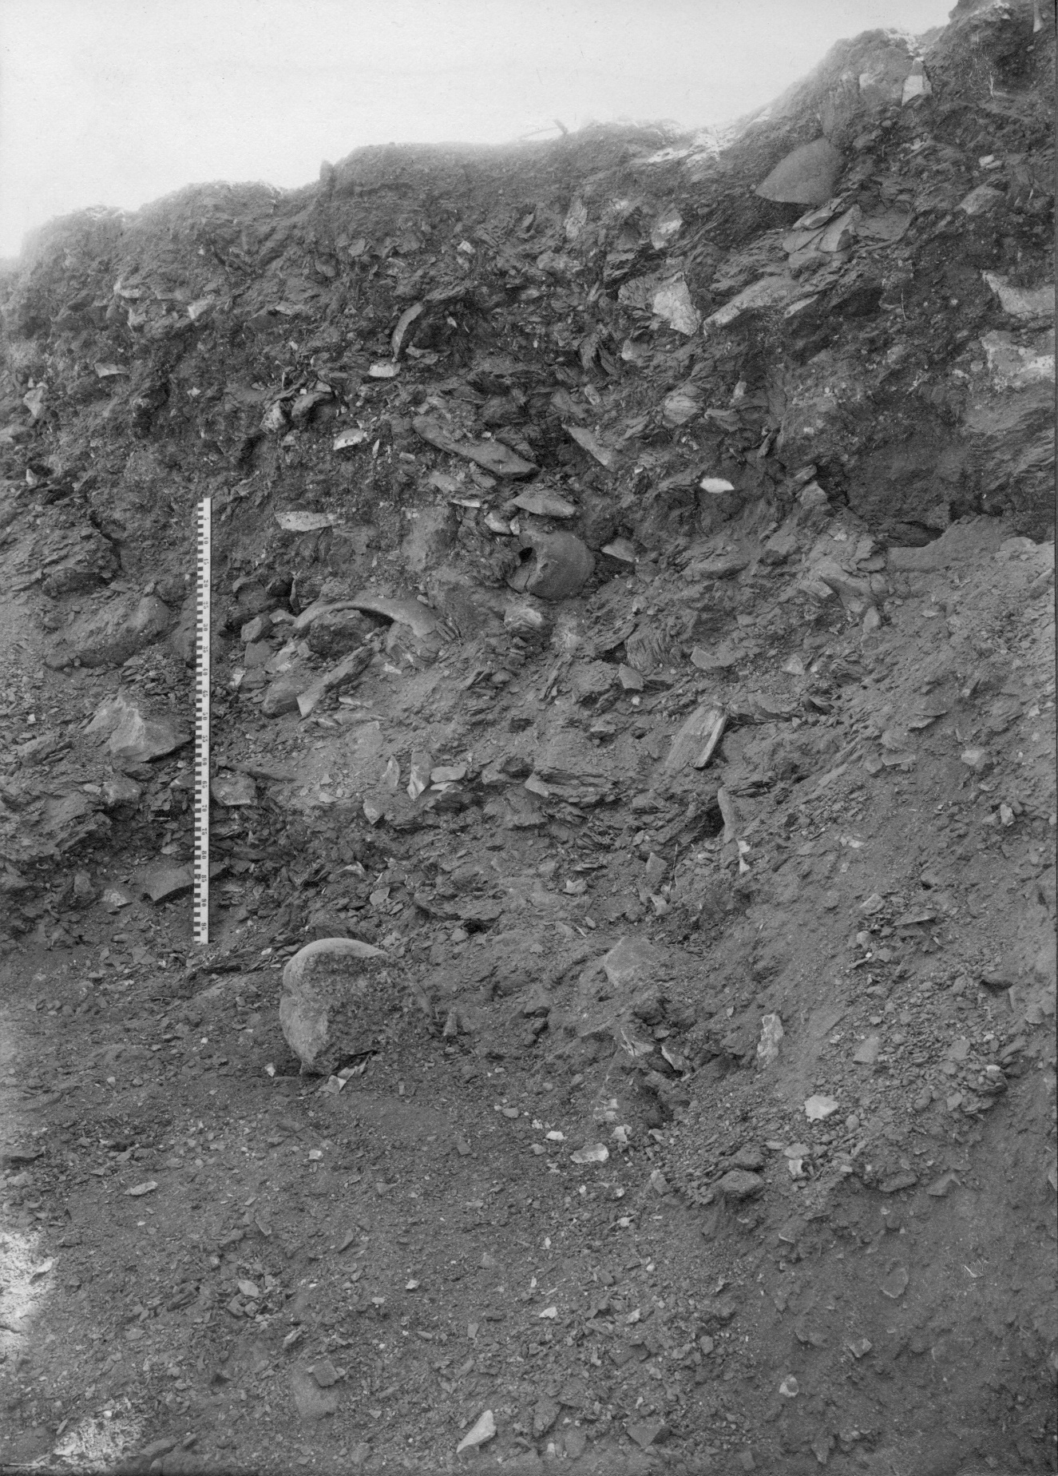
Figure S9: Fragment from Cairo JE 47703 in situ. Photograph by Harry Burton, 1922–23. © The Metropolitan Museum of Art, Department of Egyptian Art Archives (M4C 85).
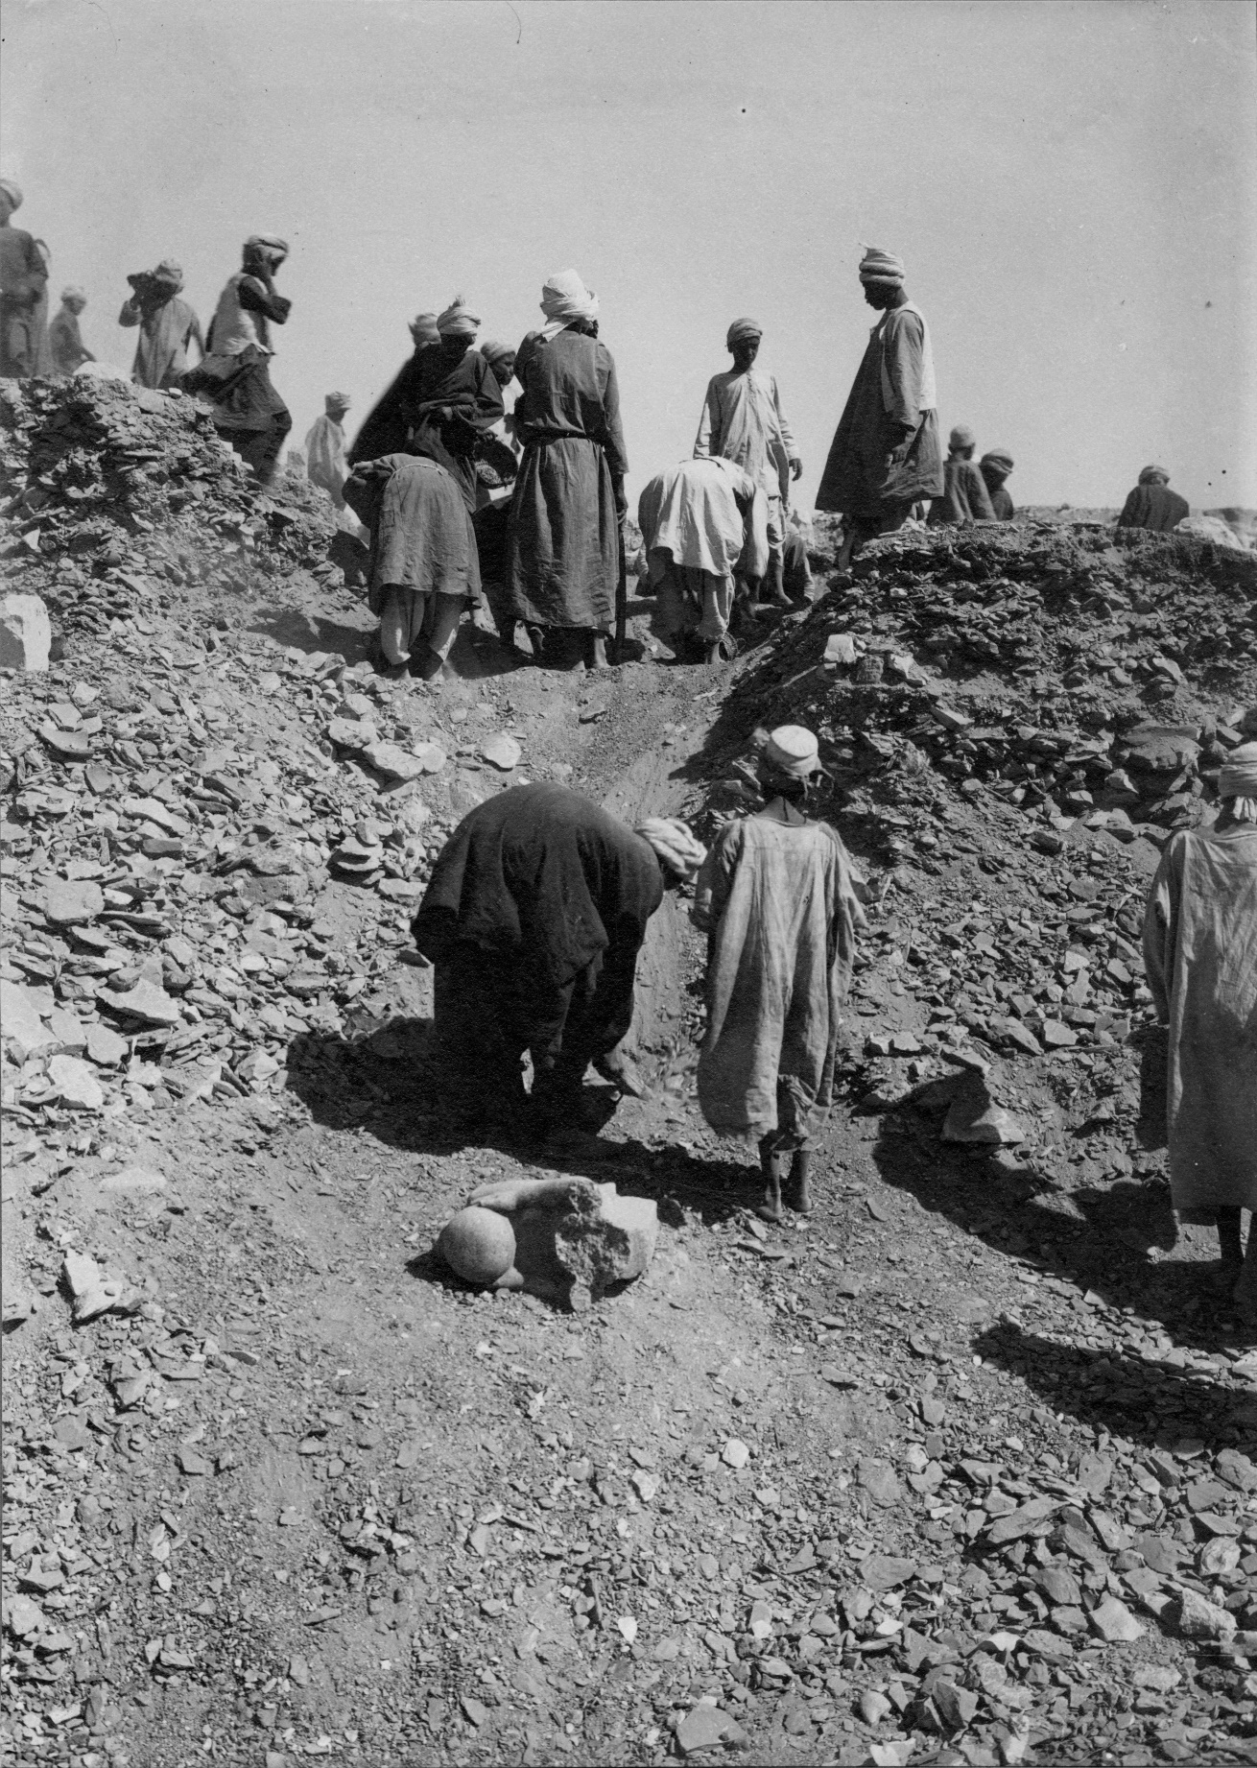
Figure S10: Body fragment of MMA 23.3.2 in situ. Photograph by Harry Burton, 1922–23. © The Metropolitan Museum of Art, Department of Egyptian Art Archives (M4C 102).

