|  |  |
| --- | --- |
|  | Supplementary material for  Wang, X., Z. Tang, Y. Li, G. Zhang, L. Lu, B. Wang, W. Wang, H. Lu & P. Roberts. 2025. **Illuminating** **interaction networks along the Silk Roads: a multi-isotopic analysis of the Zaghunluq Cemetery, southern Xinjiang, China.** *Antiquity* 99.  Authors for correspondence ✉ tangzihua@mail.iggcas.ac.cn & li.yuqi@nankai.edu.cn |

**Isotopic Backgrounds**

Isotopic analysis of human biological tissues, such as bones and teeth, is extensively employed to directly reconstruct ancient mobility patterns and diets over the course of individual lifetimes (Makarewicz & Sealy 2015). Notably, strontium isotope (87Sr/86Sr) measurements of tooth enamel bioapatite reflect the underlying geology of where an individual lived during the period of tissue formation through water imbibed and food consumed. Meanwhile, stable oxygen isotope measurements (δ18O), although often complex to interpret, are linked to climate and hydrological conditions (Pederzani & Britton 2019), providing further insights into the geographical region where an individual lived in early life. Dentine collagen carbon (δ13Ccoll) and nitrogen isotope (δ15Ncoll) analyses primarily reflect the sources of protein in diets, while enamel carbon isotopes (δ13Cca) reflect food sources of the diet as a whole (Froehle *et al.* 2012).

**Materials and Methods**

***Sr isotope analysis***

400mg of dried plant sample were ashed in a muffle furnace at 550°C for 12 hours and digested in 2mL of 14N HNO3 on a hot plate (Lugli *et al.* 2017). The supernatant was then dried and re-dissolved in 0.4mL of 3.5N HNO3. The separation of Sr was based on the column gravity chromatography approach using Eichrom Sr-Spec resin. Human enamels were first cleaned with MilliQ H2O water and dissolved in 2mL of 0.2N HCl. The supernatant was then dried and re-dissolved in 1.1mL of 2.5N HCl for the separation of strontium. According to a previous methodology (Li *et al.* 2012), we used AG50W×12 cation-exchange resin (200-400 mesh) to separate from the matrix.

All 87Sr/86Sr ratios were determined using a Triton Plus thermal ionization mass spectrometer (TIMS) (Thermo Fisher Scientific) at the State Key Laboratory of Lithospheric Evolution at the Institute of Geology and Geophysics, Chinese Academy of Sciences. We used an 88Sr/86Sr ratio of 8.375209 to correct for mass fractionation. The standard NIST SRM-987 yielded an average 87Sr/86Sr ratio of 0.710248 ± 0.000018 (2σ, n = 8), in agreement with the SRM-987 standard value of 0.710250.

***Carbon and oxygen isotope analysis of tooth enamel***

For each sample, we weighed ~10mg of enamel powder and cleaned with 1.5% NaClO for one hour, followed by three rinses in MilliQ H2O. We then added 0.1M acetic acid to the samples for 10 minutes, followed by another three rinses in MilliQ H2O (Roberts *et al.* 2020). The analyses of carbonate δ13C and δ18O values were carried out using a Thermo Fisher Scientific GasBench II interfaced with a Delta V plus isotope ratio mass spectrometer at the Key Laboratory of Cenozoic Geology and Environment, IGGCAS. The measured δ13C and δ18O values are reported in the delta per mil notation (δ, ‰) relative to the V-PDB standard. δ13C and δ18O values were corrected using a three-point calibration compared against three reference materials, including one international reference material NBS-19 calcite (δ13C = +1.95‰, δ18O = −2.20‰), NBS-18 calcite (δ13C = −5.01‰, δ18O = −23.2‰), and one national reference material of China GBW04416 calcite (δ13C = +1.61‰, δ18O = −11.59‰). Another national reference material of China, GBW04405 calcium carbonate (δ13C = 0.57‰, δ18O = −8.49‰), was inserted into the measurement sequence as a quality control (Wang *et al.* 2021). Reproducibility of δ13C and δ18O for this standard was better than ± 0.1‰ and ± 0.2‰, respectively. We also performed duplicate analyses of six enamel sub-samples to determine their isotopic reproducibility. The maximum difference between duplicate enamel analyses was 0.2‰ for δ13C and 0.3‰ for δ18O.

***Stable isotope analysis of archaeological human dentine collagen***

Dentine collagen was extracted for analysis using the previous method (Richards & Hedges 1999). Dirt and other surface contaminants were removed with a diamond tipped dental drill and a subsequent rinse with MilliQ H2O. Then ~700mg of dentine samples were weighed and demineralized in 0.5M HCl for several weeks until no CO2 emerged from the sample. Then samples were placed in an alkali bath (~20 hours) in 0.125N NaOH at 4°C. After samples were rinsed with MilliQ H2O to neutrality, samples were gelatinized in 0.001N HCl for 48 hours at 70°C. The insoluble fractions of the samples were then filtered, frozen and freeze dried.

The δ13C and δ15N values of dentine collagen were performed using an Isoprime 100 IRMS (Elementar, UK) coupled with an Elementar Vario (Elementar, UK) at the Environmental Stable Isotope Laboratory, Institute of Environment and Sustainable Development of Agriculture, Chinese Academy of Agricultural Sciences. A two-point calibration curve anchored to USGS40 and USGS41a (Table S3) (Qi *et al.* 2003; Qi *et al.* 2016) was used to calibrate isotopic compositions relative to AIR and VPDB. Analytical accuracy was monitored using a laboratory reference-Gelatin from bovine skin that had long-term average δ13C and δ15N values of −14.7 and +6.9, respectively (Table S3). Standard deviations and numbers for calibration standards (Table S4), and check standards (Table S5) are also provided. Isotopic analyses followed established protocols and quality control parameters, including %C, %N and C:N (Table S1) (Ambrose 1990; Richards & Hedges 1999). Following the methods from Szpak and colleagues (Szpak *et al.* 2017), for δ13C and δ15N systematic errors [u(bias)] were ± 0.18‰ and ± 0.19‰; random errors [uR(w)] were ±0.03‰ and ±0.16‰; and standard uncertainty was ± 0.19‰ and ± 0.25‰.

***Isoscape modelling approach and data visualization***

All isoscape modelling and visualizations were conducted in the computational environment R (version 4.2) and ArcGIS (version 10.2).We used a random forest (RF) algorithm (Bataille *et al.* 2018) to model bioavailable 87Sr/86Sr ratios in the Tarim Basin and its surrounding areas. The RF method is described in detail in previous papers (Bataille *et al.* 2018; Bataille *et al.* 2020; Wang *et al.* 2023). Firstly, we first chose 24 potential predictors, including geological, climatic, topographic, and environmental variables, and then collected 462 bioavailable 87Sr/86Sr data from our study and previous studies (Bataille *et al.* 2020; Li *et al.* 2020; Wang & Tang 2020; Lazzerini *et al.* 2021; Kroll *et al.* 2022; Yang *et al.* 2022; Tang & Wang 2023) which were used as a response variable to calibrate a multivariate regression model. Next, we optimized the selection of significant predictors by using a mix of methods, including the VSURF algorithm (Genuer *et al.* 2019), reduction of multicollinearity with Pearson’s correlation, and variance inflation factor (Benito 2021). Finally, six predictors were selected, and the RF model was trained and validated using 5-fold cross-validation. The modelling accuracy was assessed by the mean R2 and RMSE values.

For the oxygen isoscape, we did not directly use modern precipitation as an oxygen isotope baseline due to many factors (Pederzani & Britton 2019), such as climate change from the Iron Age to the present, errors related to the conversion from δ18Oca to δ18Odrinking water, and the difference between δ18Odrinking water and δ18Oprecipitation because of evaporation and human behavior (e.g. cooking and boiling). One of the factors that cannot be ignored is that ancient settlements in oases were mainly fed by rivers originating from the glacier-melt nearby mountains (e.g. Tianshan and Altyn Tagh Mountains) instead of local precipitation. Notably, stable oxygen isotope values of modern precipitation in the Turpan Basin are relatively very high, while the measured archaeological human tooth enamel of this region is very low (Li 2019). In this study, we use the cokriging interpolation methods (Willmes *et al.* 2018) to incorporate stable oxygen isotope data from both human tooth enamel from different archaeological sites (Tang *et al.* 2025) and modern mean annual precipitation (Terzer *et al.* 2013) to establish a tooth enamel oxygen isoscape.

To access the geographical probability of origins for the outlier individuals discovered at Zaghunluq, we used a Bayesian spatial assignment of the strontium and oxygen isotope data and computed the posterior probability of individual origins using the ‘assignR’ package (Ma *et al.* 2020) and our strontium and oxygen isoscapes. Considering the potential difference within human populations and climate change, we increased the uncertainty of the tooth enamel oxygen isoscape by 1‰ in our model (as per Bataille *et al.* 2021).

The published bioavailable 87Sr/86Sr data from contemporaneous sites in Xinjiang and Central Asia are collected from the following references (Zhang & Li 2006; Zhang *et al.* 2009; Si *et al.* 2013; Zhang *et al.* 2014; Motuzaite Matuzeviciute *et al.* 2015; Wang *et al.* 2016; Wang 2017; Xiao 2019; Guo *et al.* 2020; Allen *et al.* 2022; Ananyevskaya *et al.* 2022).

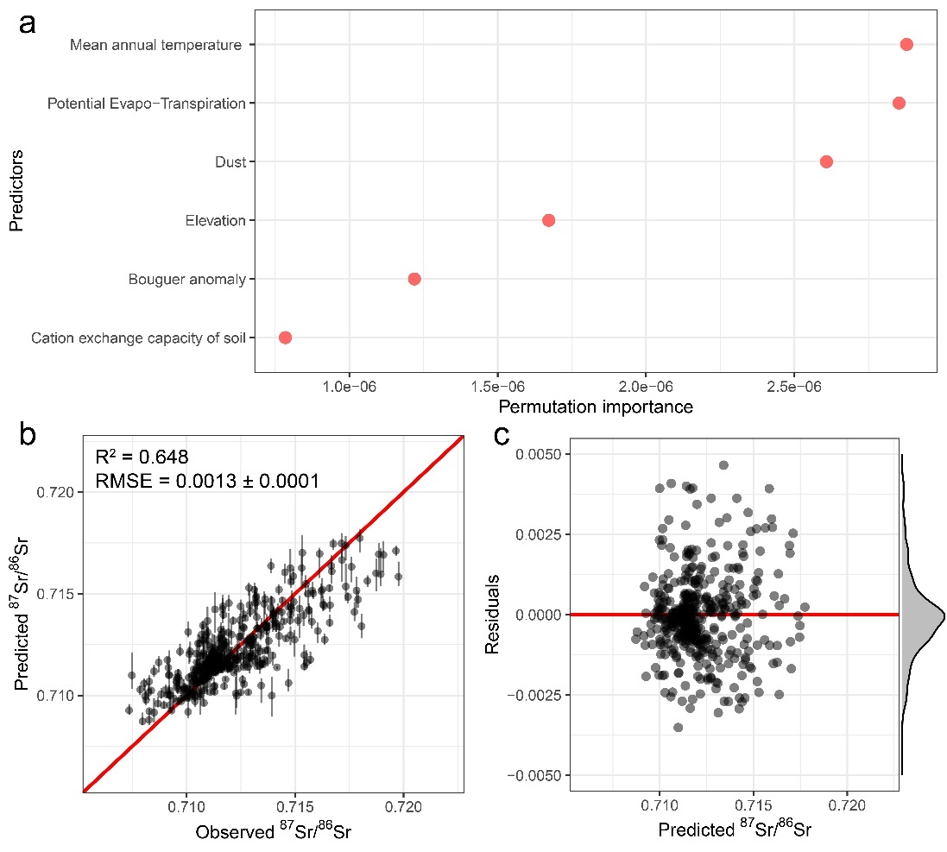

*Figure S1. Modelling results. a). Permutation importance for the random forest model using 6 variables. b). Predicted bioavailable 87Sr/86Sr vs observed bioavailable 87Sr/86Sr using the n-fold cross-validation test. c). Residuals of the random forest regression model against predicted bioavailable 87Sr/86Sr.*

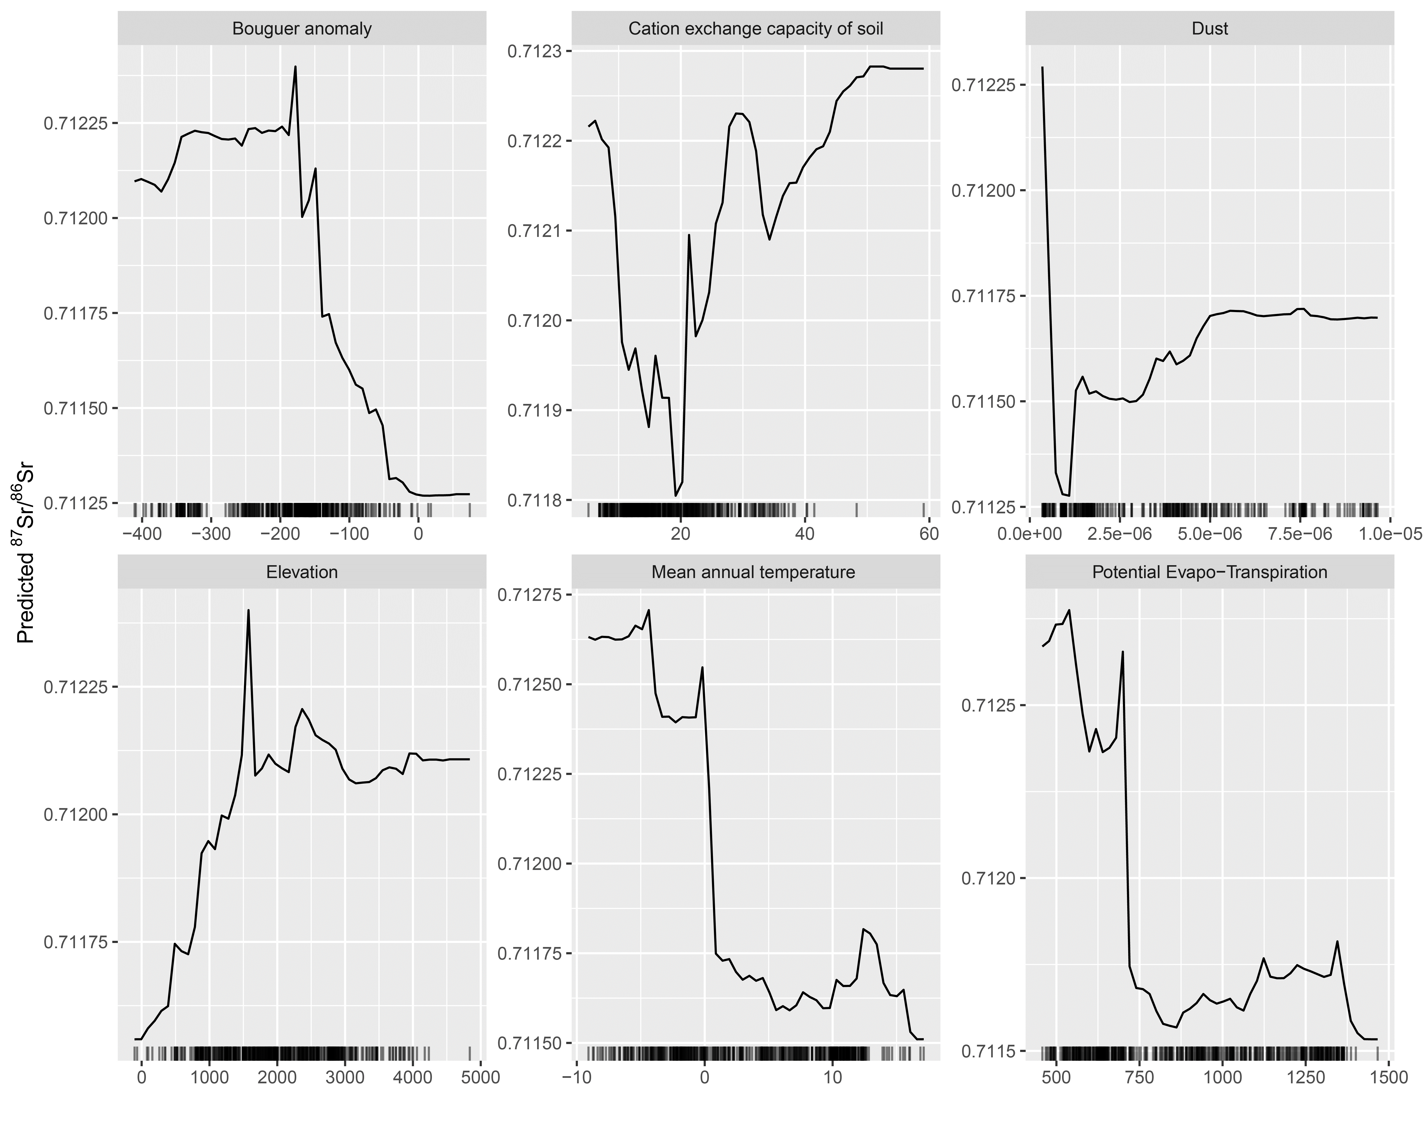

*Figure S2. Partial dependence plot between 87Sr/86Sr and 6 selected predictors.* *Our model suggests six predictors mostly influence the bioavailable 87Sr/86Sr ratios across the Tarim Basin: mean annual temperature, potential evaporation-transpiration, dust, elevation, bouguer anomaly, and cation exchange capacity of soil.*

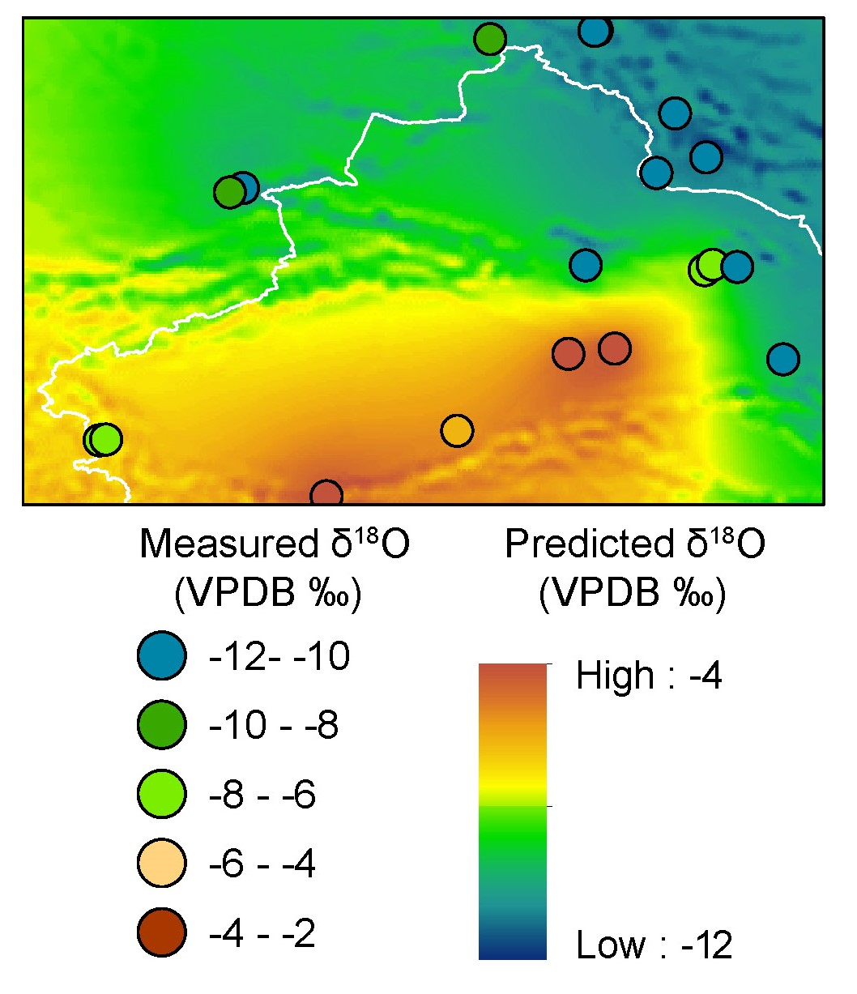

*Figure S3. Tooth enamel oxygen isoscape across the Tarim Basin using cokriging interpolation model. δ18Oca values reveal a contrast between northern and southern Xinjiang. Values in the southern Tarim Basin (> -6‰, VPDB) significantly exceed those in the northern Tarim Basin and northern western Central Asia (< -6‰, VPDB), a trend particularly evident in the Lop Nur region which has the highest values.*

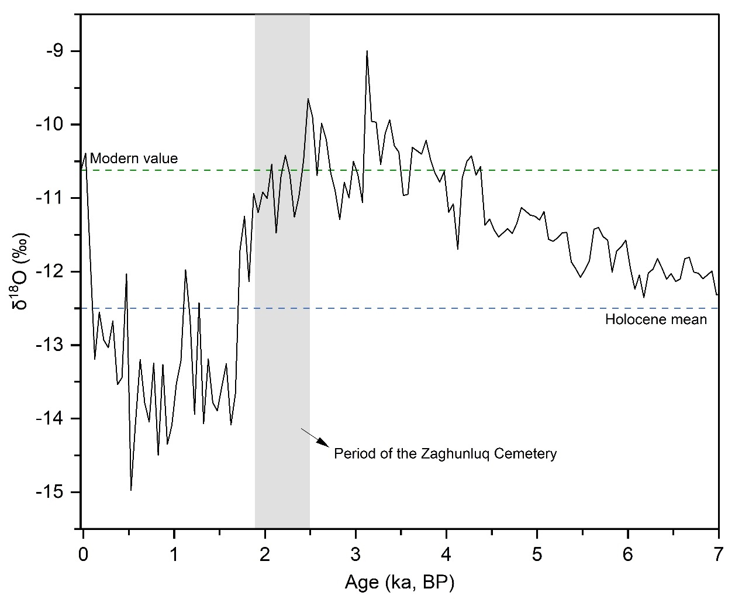

*Figure S4. The δ18O records from the Chongce ice cores relative to the Holocene mean and modern value (the black line indicates 50-year means; the blue dashed lines represent the Holocene mean, and the green dashed lines represent the modern time, respectively; the green rectangle represents the chronology of the Zaghunluq Cemetery).*

**Table. S1 Isotopic result in human enamel and dentine collagen. Note: the individual analyzed for radiocarbon dating is named 96QZⅠM144D (Kumar *et al*. 2022). His individual ID should be corrected to 98QZⅠM144D according to the fact that this burial was excavated in 1998 (XUARM 2016), as shown in the table.**

|  |  |  |  |  |  |  |  |  |  |  |  |  |  |  |
| --- | --- | --- | --- | --- | --- | --- | --- | --- | --- | --- | --- | --- | --- | --- |
| Individual ID | Age | Sex | Tooth Type | Enamel | | | | | | Dentine collagen | | | | |
| 87Sr/86Sr | 2σ | *δ*13C  VPDB‰ | Std. dev. | *δ*18O  VPDB‰ | Std. dev. | *δ*13C VPDB‰ | *δ*15N  AIR‰ | N% | C% | C:N  (molar) |
| 96QZⅠM2④ | 30-35 | Male | M2 | 0.710889 | 0.000014 | -13.2 | 0.2 | -6.3 | 0.2 | -18.9 | 13.5 | 15.2 | 42.0 | 3.2 |
| 96QZⅠM92B | 23-27 | Female | M2 | 0.710785 | 0.000014 | -12.5 | 0.1 | -5.1 | 0.1 | -19.1 | 14.7 | 16.6 | 45.8 | 3.4 |
| 96QZⅠM34A? | 25-30 | Female | M2 | 0.710833 | 0.000015 | -12.4 | 0.1 | -5.2 | 0.1 | -18.2 | 13.6 | 12.5 | 36.1 | 3.2 |
| 98QZⅠM104C | 22-24 | Female | P3 | 0.710804 | 0.000012 | -12.2 | 0.1 | -4.9 | 0.1 | -18.4 | 14.5 | 16.5 | 45.3 | 3.2 |
| 98QZⅠM139H | 28-32 | Male | M1 | 0.710845 | 0.000015 | -13.3 | 0.1 | -4.1 | 0.1 | -19.0 | 13.9 | 16.5 | 45.7 | 3.2 |
| 98QZⅠM65J | 28-32 | Female | M2 | 0.710461 | 0.000015 | -13.1 | 0.0 | -2.3 | 0.1 | -17.5 | 15.7 | 16.5 | 45.3 | 3.2 |
| 96QZⅠM2M | adult | ? | M3 | 0.710862 | 0.000015 | -12.8 | 0.2 | -5.8 | 0.1 | -17.1 | 13.2 | 16.8 | 46.2 | 3.2 |
| 98QZⅠM104D | adult | Male | M3 | 0.710606 | 0.000015 | -14.0 | 0.2 | -4.4 | 0.1 | -19.4 | 13.1 | 16.3 | 44.8 | 3.2 |
| 98QZⅠM154Q | 24-30 | Male | P3 | 0.710882 | 0.000015 | -12.9 | 0.2 | -6.1 | 0.1 | -19.1 | 13.9 | 16.5 | 45.3 | 3.3 |
| 98QZⅠM144D | adult | Male | M2 | 0.710865 | 0.000014 | -10.8 | 0.2 | -4.6 | 0.1 | -18.8 | 11.6 | 16.5 | 45.5 | 3.4 |
| 96QZⅠM65O | adult | Male | M1 | 0.710872 | 0.000014 | -13.3 | 0.2 | -5.4 | 0.1 | -14.7 | 11.8 | 16.6 | 45.8 | 3.3 |
| 96QZⅠM34K | 25-30 | Male | M2 | 0.710824 | 0.000015 | -9.8 | 0.2 | -5.4 | 0.1 | -19.1 | 14.0 | 16.5 | 45.2 | 3.3 |
| 96QZⅠM34G | 30-35 | Male | M1 | 0.711222 | 0.000014 | -9.9 | 0.2 | -4.6 | 0.1 | -18.6 | 11.3 | 15.4 | 42.2 | 3.3 |
| 96QZⅡM2n | 45-50 | Female | M3 | 0.710908 | 0.000015 | -14.1 | 0.2 | -6.3 | 0.2 | -19.3 | 13.7 | 15.8 | 44.0 | 3.2 |
| 96QZⅠM91A | 20-25 | Female | P3 | 0.710856 | 0.000013 | -13.2 | 0.2 | -6.1 | 0.1 | -17.8 | 15.7 | 16.6 | 45.9 | 3.2 |
| 98QZⅠM141 | 22-25 | Male | M2 | 0.710875 | 0.000013 | -12.3 | 0.3 | -5.1 | 0.1 | -18.8 | 13.7 | 16.7 | 46.0 | 3.4 |
| 96QZⅠM69 | 25-30 | Female | M1 | 0.711057 | 0.000015 | -9.9 | 0.2 | -5.0 | 0.1 | -19.1 | 14.0 | 16.6 | 46.0 | 3.2 |
| 96QZⅠM1G | 25-28 | Male | M3 | 0.710792 | 0.000013 | -12.7 | 0.2 | -3.9 | 0.1 | -15.7 | 12.2 | 16.5 | 45.5 | 3.2 |
| 96QZⅠM2C | 25-28 | Female | M2 | 0.710801 | 0.000015 | -12.5 | 0.2 | -6.1 | 0.1 | -17.0 | 14.2 | 15.9 | 44.1 | 3.2 |
| 96QZⅠM19C | ? | ? | M2 | 0.710847 | 0.000015 | -12.9 | 0.1 | -6.0 | 0.1 | -18.1 | 13.9 | 15.6 | 43.2 | 3.2 |
| 96QZⅡM1HP | 25-30 | Male | M2 | 0.710863 | 0.000014 | -13.0 | 0.0 | -5.9 | 0.1 | -19.2 | 14.1 | 15.1 | 43.1 | 3.2 |
| 96QZⅠM20B | 25-30 | Female | M2 | 0.710802 | 0.000015 | -12.4 | 0.1 | -5.4 | 0.1 | -19.1 | 15.4 | 15.1 | 43.6 | 3.2 |
| 96QZⅠM83A | 22-28 | Female | P3 | 0.711229 | 0.000015 | -8.9 | 0.1 | -3.9 | 0.1 | -17.6 | 13.4 | 16.0 | 44.9 | 3.2 |
| 96QZⅡM1DH | 25-30 | Female | P3 | 0.710865 | 0.000013 | -12.8 | 0.1 | -6.3 | 0.1 | -16.2 | 11.3 | 15.9 | 44.3 | 3.2 |
| 96QZⅠM24C | 25-30 | Male | M2 | 0.709382 | 0.000015 | -11.4 | 0.2 | -6.6 | 0.1 | -18.8 | 13.6 | 15.6 | 43.7 | 3.2 |
| 96QZⅠM67C | 18-24 | Female | P3 | 0.710826 | 0.000014 | -11.7 | 0.1 | -5.1 | 0.1 | -18.4 | 15.3 | 15.5 | 44.5 | 3.3 |
| 96QZⅠM41A | 22-25 | Female | M2 | 0.710912 | 0.000014 | -10.0 | 0.2 | -3.1 | 0.1 | -17.5 | 13.3 | 15.6 | 43.3 | 3.2 |
| 98QZⅠM154K | 25-30 | Male | M3 | 0.710874 | 0.000013 | -12.3 | 0.1 | -6.3 | 0.1 | -19.1 | 14.8 | 15.9 | 43.7 | 3.3 |
| 96QZⅠM24A | 25-30 | Male | M2 | 0.710828 | 0.000014 | -11.8 | 0.1 | -4.7 | 0.1 | -17.1 | 13.3 | 14.5 | 40.1 | 3.4 |
| 98QZⅠM147Ⅰ | 30-35 | Male | M3 | 0.710837 | 0.000014 | -12.4 | 0.1 | -5.0 | 0.1 | -18.8 | 14.3 | 15.2 | 42.5 | 3.2 |
| 96QZⅠM34C | 25-28 | Female | M2 | 0.710988 | 0.000015 | -10.6 | 0.2 | -4.3 | 0.1 | -18.5 | 14.4 | 15.3 | 44.1 | 3.2 |
| 96QZⅠM87B | 30-35 | Male | M2 | 0.710878 | 0.000015 | -12.3 | 0.1 | -4.5 | 0.1 | -17.9 | 13.3 | 15.7 | 43.6 | 3.3 |
| 98QZⅠM151A | 25-30 | Female | M1 | 0.710853 | 0.000014 | -12.5 | 0.1 | -4.6 | 0.1 | -14.8 | 12.7 | 15.5 | 44.5 | 3.2 |

**Table. S2 87Sr/86Sr ratios of plant samples collected in the surroundings of the cemetery from this study and published studies.**

|  |  |  |  |  |  |  |
| --- | --- | --- | --- | --- | --- | --- |
| Sample ID | Latitude | Longitude | Material | 87Sr/86Sr | 2σ | References |
| Zagunluke-04 | 37.599 | 83.816 | plant | 0.711086 | 0.000003 | this study |
| Zagunluke-05 | 37.963 | 84.444 | plant | 0.710731 | 0.000005 | this study |
| Zagunluke-07 | 38.099 | 84.807 | plant | 0.710918 | 0.000004 | this study |
| Zagunluke-10 | 38.215 | 85.185 | plant | 0.710937 | 0.000005 | this study |
| Zagunluke-28 | 37.108 | 85.271 | plant | 0.711078 | 0.000008 | this study |
| Zagunluke-31 | 37.244 | 85.338 | plant | 0.71148 | 0.000009 | this study |
| Zagunluke-12 | 38.150 | 85.350 | plant | 0.71103 | 0.000005 | this study |
| Zagunluke-13 | 38.133 | 85.414 | plant | 0.710759 | 0.000004 | this study |
| Zagunluke-27 | 37.570 | 85.450 | plant | 0.711327 | 0.000009 | this study |
| Zagunluke-17 | 38.197 | 85.450 | plant | 0.710954 | 0.000005 | this study |
| Zagunluke-32 | 37.311 | 85.474 | plant | 0.711011 | 0.000005 | this study |
| Zagunluke-18 | 38.251 | 85.532 | plant | 0.710947 | 0.000004 | this study |
| Zagunluke-22 | 38.071 | 85.578 | plant | 0.710965 | 0.000008 | this study |
| Zagunluke-23 | 37.981 | 85.592 | plant | 0.711243 | 0.000005 | this study |
| Zagunluke-20 | 38.173 | 85.599 | plant | 0.710981 | 0.000006 | this study |
| Zagunluke-24 | 37.897 | 85.623 | plant | 0.710905 | 0.000005 | this study |
| Zagunluke-34 | 37.390 | 85.674 | plant | 0.712633 | 0.00001 | this study |
| Zagunluke-37 | 37.741 | 85.688 | plant | 0.71102 | 0.000005 | this study |
| Zagunluke-38 | 38.472 | 85.719 | plant | 0.711035 | 0.000005 | this study |
| Zagunluke-36 | 37.608 | 85.727 | plant | 0.710882 | 0.000004 | this study |
| Zagunluke-39 | 38.547 | 86.174 | plant | 0.711024 | 0.000005 | this study |
| ZW021 | 38.682 | 87.317 | plant | 0.712953 | 0.000008 | (Kang *et al.* 2017) |
| ZW020 | 38.682 | 87.336 | plant | 0.712909 | 0.000013 | (Kang *et al.* 2017) |
| ZW019 | 38.687 | 87.349 | plant | 0.712847 | 0.000011 | (Kang *et al.* 2017) |
| ZW018 | 38.686 | 87.361 | plant | 0.713084 | 0.000014 | (Kang *et al.* 2017) |
| ZW017 | 38.683 | 87.372 | plant | 0.712903 | 0.000014 | (Kang *et al.* 2017) |
| ZW023 | 38.700 | 87.374 | plant | 0.713065 | 0.000007 | (Kang *et al.* 2017) |
| ZW022 | 38.704 | 87.382 | plant | 0.712768 | 0.000009 | (Kang *et al.* 2017) |
| ZagunlukeZW13 | 38.122 | 85.477 | plant | 0.710832 | 0.000014 | (Wang & Tang 2020) |
| ZagunlukeZW08 | 38.121 | 85.477 | plant | 0.710848 | 0.000013 | (Wang & Tang 2020) |
| ZagunlukeZW12 | 38.123 | 85.478 | plant | 0.710816 | 0.000014 | (Wang & Tang 2020) |
| ZagunlukeZW10 | 38.122 | 85.478 | plant | 0.710867 | 0.000015 | (Wang & Tang 2020) |
| ZagunlukeZW01 | 38.121 | 85.474 | plant | 0.710869 | 0.000015 | (Wang & Tang 2020) |
| 16Hydro-58 | 38.471 | 85.780 | river water | 0.710942 | 0.000013 | (Wang & Tang 2020) |
| 16Hydro-57 | 38.686 | 87.359 | river water | 0.713118 | 0.000013 | (Wang & Tang 2020) |

**Table S3. Accepted (calibration) and observed long-term (check) isotopic compositions and standard deviations (1*σ*) for standards used in this study.**

|  |  |  |  |  |
| --- | --- | --- | --- | --- |
| Name | Material | *δ*13C (‰, VPDB) | *δ*15N (‰, AIR) | Standard Type |
| USGS-40 | Glutamic acid | −26.39 | −4.52 | Calibration standard |
| USGS-41a | Glutamic acid | 36.55 | 47.55 | Calibration standard |
| STD | Gelatin from bovine skin | −14.7±0.2‰ | 6.9±0.2‰ | Check standard |

**Table S4. Standard deviations for calibration standards for all analytical batches.**

|  |  |  |  |  |
| --- | --- | --- | --- | --- |
| Batches | Standard | Number | *δ*13C (1σ) | *δ*15N (1σ) |
| CN-202202-1 | USGS-40 | 4 | 0.05 | 0.17 |
| CN-202202-2 | USGS-40 | 4 | 0.05 | 0.07 |
| CN-202202-1 | USGS-41a | 4 | 0.09 | 0.23 |
| CN-202202-2 | USGS-41a | 4 | 0.06 | 0.06 |

**Table S5. Means and standard deviations for check standards for all analytical batches.**

|  |  |  |  |  |
| --- | --- | --- | --- | --- |
| Batches | Standard | Number | *δ*13C (mean±1σ) | *δ*15N (mean±1σ) |
| CN-202202-1 | STD | 5 | −14.85±0.03 | −7.01±0.1 |
| CN-202202-2 | STD | 5 | −14.88±0.03 | −7.10±0.1 |

**Table S6. AMS dating results for six human bone samples from Zaghunluq 1. While the calibrated dates have been previously published in Kumar *et al*. (2022), this article presents their lab IDs and conventional ages for the first time. All the dates have been recalibrated using Oxcal v4.4 with the IntCal20 atmospheric curve (Bronk Ramsey 2009; Reimer *et al*. 2020).**

|  |  |  |  |  |  |
| --- | --- | --- | --- | --- | --- |
| **Lab ID** |  | **Individual NO.** | **Burial** | **14C age (BP)** | **Calibrated date**  **(95.4% confidence)** |
| BA212955 |  | 96QZIM144D | M144 | 2015±20 | 50 BC (95.4%) AD 61 |
| BA190052 |  | 96QZIIM1DH | M1 | 2065±25 | 161 BC (83.0%) 26 BC  19 BC (12.4%) AD 8 |
| BA212953 |  | 96QZIM44E | M44 | 2130±20 | 342 BC (7.2%) 322 BC  201 BC (79.9%) 92 BC  77 BC (8.4%) 54 BC |
| BA212952 |  | 96QZIM14A | M14 | 2160±20 | 352 BC (39.4%) 287 BC  228 BC (1.3%) 219 BC  211 BC (54.7%) 109 BC |
| Beta-556616 |  | 96QZIM14n | M14 | 2370±30 | 541 BC (95.4%) 389 BC |
| BA212954 |  | 96QZIM44Q | M44 | 2370±20 | 515 BC (4.6%) 496 BC  491 BC (90.9%) 392 BC |

**References**

Allen, E. *et al.* 2022. Multidisciplinary lines of evidence reveal East/Northeast Asian origins of agriculturalist/pastoralist residents at a Han dynasty military outpost in ancient Xinjiang. *Frontiers in Ecology and Evolution* 10: 932004. https://doi.org/10.3389/fevo.2022.932004

Ambrose, S.H. 1990. Preparation and characterization of bone and tooth collagen for isotopic analysis. *Journal of Archaeological Science* 17: 431–51. https://doi.org/10.1016/0305-4403(90)90007-R

Ananyevskaya, E. *et al.* 2022. The integration of millet into the diet of Central Asian populations in the third millennium BC. *Antiquity* 96: 560–74. https://doi.org/10.15184/aqy.2022.23

Bataille, C.P., B.E. Crowley, M.J. Wooller & G.J. Bowen. 2020. Advances in global bioavailable strontium isoscapes. *Palaeogeography, Palaeoclimatology, Palaeoecology* 555: 109849. https://doi.org/10.1016/j.palaeo.2020.109849

Bataille, C.P. *et al.* 2018. A bioavailable strontium isoscape for Western Europe: a machine learning approach. *PLOS ONE* 13: e0197386. https://doi.org/10.1371/journal.pone.0197386

Bataille, C.P. *et al.* 2021. Triple sulfur-oxygen-strontium isotopes probabilistic geographic assignment of archaeological remains using a novel sulfur isoscape of western Europe. *PLOS ONE* 16: e0250383. https://doi.org/10.1371/journal.pone.0250383

Benito, M. 2021. spatialRF: easy spatial regression with random forest. R package version 1.1.0. Available at: https://blasbenito.github.io/spatialRF/

Bronk Ramsey, C. 2009. Bayesian analysis of radiocarbon dates. *Radiocarbon* 51: 337–60. https://doi.org/10.1017/S0033822200033865

Genuer, R., J. Poggi & C. Tuleau-Malot. 2019. VSURF: variable selection using random forests. R package version 1.1.0. Available at: https://CRAN.R-project.org/package=VSURF

Guo, Y. *et al.* 2020. Isotopic reconstruction of human diet in the Ji'erzankale site, Xinjiang Uyghur Autonomous Region, China. *International Journal of Osteoarchaeology* 30: 65–72. https://doi.org/10.1002/oa.2831

Kang, L. *et al.* 2017. Strontium isotopes to trace the geographical origin of Ruoqiang Jujube. *Xinjiang Agricultural Sciences* 54: 1066–75 (in Chinese).

Kroll, S. *et al.* 2022. Mobility and land use in the Greater Khorasan Civilization: isotopic approaches (87Sr/86Sr, δ18O) on human populations from southern Central Asia. *Journal of Archaeological Science: Reports* 46: 103622. https://doi.org/10.1016/j.jasrep.2022.103622

Kumar, V. *et al.* 2022. Bronze and Iron Age population movements underlie Xinjiang population history. *Science* 376: 62–69. https://doi.org/10.1126/science.abk1534

Lazzerini, N. *et al.* 2021. Monthly mobility inferred from isoscapes and laser ablation strontium isotope ratios in caprine tooth enamel. *Scientific Reports* 11: 2277. https://doi.org/10.1038/s41598-021-81923-z

Li, C.F. *et al.* 2012. Rapid and precise determination of Sr and Nd isotopic ratios in geological samples from the same filament loading by thermal ionization mass spectrometry employing a single-step separation scheme. *Analytica Chimica Acta* 727: 54–60. https://doi.org/10.1016/j.aca.2012.03.040

Li, L. *et al.* 2020. Riverine Mg isotopes response to glacial weathering within the Muztag catchment of the eastern Pamir Plateau. *Applied Geochemistry* 118: 104626. https://doi.org/10.1016/j.apgeochem.2020.104626

Li, Y. 2019. Primary research on human mobility in Turpan-Hami Basin Xinjiang during the Bronze to the Iron Age transitional period. PhD dissertation, University of Science and Technology of China (in Chinese).

Lugli, F. *et al.* 2017. Suspected limited mobility of a Middle Pleistocene woman from Southern Italy: strontium isotopes of a human deciduous tooth. *Scientific Reports* 7: 8615. https://doi.org/10.1038/s41598-017-09007-5

Ma, C., H.B. Vander Zanden, M.B. Wunder & G.J. Bowen. 2020. assignR: an R package for isotope-based geographic assignment. *Methods in Ecology and Evolution* 11: 996–1001. https://doi.org/10.1111/2041-210X.13426

Makarewicz, C.A. & J. Sealy. 2015. Dietary reconstruction, mobility, and the analysis of ancient skeletal tissues: expanding the prospects of stable isotope research in archaeology. *Journal of Archaeological Science* 56: 146–58. https://doi.org/10.1016/j.jas.2015.02.035

Motuzaite Matuzeviciute, G. *et al.* 2015. The extent of cereal cultivation among the Bronze Age to Turkic period societies of Kazakhstan determined using stable isotope analysis of bone collagen. *Journal of Archaeological Science* 59: 23–34. https://doi.org/10.1016/j.jas.2015.03.029

Pederzani, S. & K. Britton. 2019. Oxygen isotopes in bioarchaeology: principles and applications, challenges and opportunities. *Earth-Science Reviews* 188: 77–107. https://doi.org/10.1016/j.earscirev.2018.11.005

Qi, H. *et al.* 2003. Two new organic reference materials for δ13C and δ15N measurements and a new value for the δ13C of NBS 22 oil. *Rapid Communications in Mass Spectrometry* 17: 2483–87. https://doi.org/10.1002/rcm.1219

Qi, H. *et al.* 2016. A new organic reference material, L-glutamic acid, USGS41a, for δ13C and δ15N measurements − a replacement for USGS41. *Rapid Communications in Mass Spectrometry* 30: 859–66. https://doi.org/10.1002/rcm.7510

Reimer, P.J*. et al*. 2020. The IntCal20 Northern Hemisphere radiocarbon age calibration curve (0–55 cal kBP). *Radiocarbon* 62: 725–57. https://doi.org/10.1017/RDC.2020.41

Richards, M.P. & R.E.M. Hedges. 1999. Stable isotope evidence for similarities in the types of marine foods used by Late Mesolithic humans at sites along the Atlantic coast of Europe. *Journal of Archaeological Science* 26: 717–22. https://doi.org/10.1006/jasc.1998.0387

Roberts, P. *et al.* 2020. Isotopic evidence for initial coastal colonization and subsequent diversification in the human occupation of Wallacea. *Nature Communications* 11: 2068. https://doi.org/10.1038/s41467-020-15969-4

Si, Y. *et al.* 2013. Exploration of human diets and populations from the Yanghai Tombs, Xinjiang. *Science Bulletin* 58: 1422–29 (in Chinese).

Szpak, P., J.Z. Metcalfe & R.A. Macdonald. 2017. Best practices for calibrating and reporting stable isotope measurements in archaeology. *Journal of Archaeological Science: Reports* 13: 609–616. https://doi.org/10.1016/j.jasrep.2017.05.007

Tang, Z. & X. Wang. 2023. A score of bioavailable strontium isotope archaeology in China: retrospective and prospective. *Frontiers in Earth Science* 10: 1094424. https://doi.org/10.3389/feart.2022.1094424

Tang, Z. *et al.* 2025. Bronze Age Tarim Basin mummies show evidence for shifting arid-land adaptation strategies (In preparation).

Terzer, S., L.I. Wassenaar, L.J. Araguás-Araguás & P.K. Aggarwal. 2013. Global isoscapes for δ18O and δ2H in precipitation: improved prediction using regionalized climatic regression models. *Hydrology and Earth System Sciences* 17: 4713–28. https://doi.org/10.5194/hess-17-4713-2013

Wang, T. 2017. Wheat, millet or animal? Isotopic perspective on early East-West Interactions in ancient Xinjiang. PhD dissertation, University of Chinese Academy of Sciences (in Chinese).

Wang, T.T. *et al.* 2016. Investigating dietary patterns with stable isotope ratios of collagen and starch grain analysis of dental calculus at the Iron Age cemetery site of Heigouliang, Xinjiang, China. *International Journal of Osteoarchaeology* 26: 693–704. https://doi.org/10.1002/oa.2467

Wang, X. & Tang, Z. 2020. The first large-scale bioavailable Sr isotope map of China and its implication for provenance studies. *Earth-Science Reviews* 210: 103353. https://doi.org/10.1016/j.earscirev.2020.103353

Wang, X. *et al.* 2021. Climatic quantification and seasonality of the late MIS 3 in North China: a perspective from carbon and oxygen isotopes of fossil mammal teeth. *Quaternary Science Reviews* 272: 107222. https://doi.org/10.1016/j.quascirev.2021.107222

Wang, X. *et al.* 2023. A bioavailable strontium isoscape of Angola with implications for the archaeology of the transatlantic slave trade. *Journal of Archaeological Science* 154: 105775. https://doi.org/10.1016/j.jas.2023.105775

Willmes, M. *et al.* 2018. Mapping of bioavailable strontium isotope ratios in France for archaeological provenance studies. *Applied Geochemistry* 90: 75–86. https://doi.org/10.1016/j.apgeochem.2017.12.025

Xiao, Q. 2019. Discussion on diets and subsistence economy of ancient people in Bizili cemetery in Luopu county, Xinjiang. PhD dissertation, University of Chinese Academy of Sciences (in Chinese).

XUARM (Xinjiang Uighur Autonomous Region Museum). 2016. *Textile treasures of Zaghunluq*.Beijing: Cultural Relics (in Chinese).

Yang, Y. *et al.* 2022. Intense metamorphism-generated radiogenic Sr regulated Cenozoic water Sr isotope evolution on the NE Tibetan Plateau: a perspective on Qilian orogen denudation and Asian eolian transport. *GSA Bulletin* 135: 2237–54. https://doi.org/10.1130/B36525.1

Zhang, Q. & S. Li. 2006. The dietary practice of the first Qiongkeke cemetery at Nileke Xinjiang. *Xiyu Yanjiu (The Western Regions Studies)* 4: 83–86 (in Chinese).

Zhang, Q., X. Chang & G. Liu. 2009. Stable isotopic analysis of the human bones at Heigouliang Balikun Xinjiang. *Xiyu Yanjiu (The Western Regions Studies)* 3: 45–49 (in Chinese).

Zhang, X., S. Chou, J. Zhang & W. Guo. 2014. Carbon and Nitrogen stable isotope analysis at Duogang Xinjiang. *Nafang Wenwu (Cultural Relics in South China)*3: 79–91 (in Chinese).