|  |  |
| --- | --- |
|  | Supplementary material for  Weiner, R.S., R.A. Friedman & J.R. Stein. 2025. **Parallel roads, solstice and sacred geography at the Gasco Site: a Chacoan ritual landscape.** *Antiquity* 99.  Author for correspondence ✉ Robert.S.Weiner@dartmouth.edu |

**Table S1. Tally of ceramics in the “total site area” of the Gasco Herradura by the Bureau of Land Management Chacoan Roads Project (BLMCRP) (Nials et al. 1987:148).**

|  |  |  |
| --- | --- | --- |
| **Type** | **Form** | **Count** |
| Cibola Gray Ware,  coarse temper | Jar | 1 |
| Cibola Gray Ware,  coarse temper | Indeterminate | 9 |
| Tusayan Gray Ware,  indented corrugated | Indeterminate | 1 |
| Cibola White Ware, fine temper, undiagnostic | Bowl | 8 |
| Cibola White Ware, fine temper, undiagnostic | Jar | 1 |
| Cibola White Ware, fine temper, undiagnostic | Indeterminate | 1 |
| Escavada Black-on-White | Jar | 3 |
| Gallup Black-on-White | Jar | 5 |
|  | **Total** | 29 |

**Table S2. 100% tally of all ceramics within a 10 x 2m concentration of artefacts 25m downslope from the Gasco Herradura by the authors.**

|  |  |  |  |
| --- | --- | --- | --- |
| **Type** | **Form** | **Count** | **Comments** |
| Cibola Gray Ware,  plain | Jar | 2 | 1 olla bottom |
| Cibola Gray Ware, indented corrugated | Jar | 3 |  |
| Cibola White Ware, undiagnostic | Jar | 2 |  |
| Red Mesa Black-on-White | Jar | 1 |  |
|  | **Total** | 8 |  |

**Table S3. Tally of lithics in the “total site area” of the Gasco Herradura by the BLMCRP (Nials et al. 1987:148).**

|  |  |  |
| --- | --- | --- |
| **Type** | **Count** | **Comments** |
| Grey Chert | 3 |  |
| White Chert | 3 |  |
| Quartzite | 2 |  |
| Petrified Wood | 1 |  |
| Narbona Pass Chert | 1 |  |
| Chinle Chert | 2 |  |
| Grants Obsidian | 2 |  |
| Jemez Obsidian | 1 | Projectile point fragment |
| **Total** | 15 |  |

**Table S4. 100% tally of ceramics within 3m of Little Gasco Herradura by the authors.**

|  |  |  |
| --- | --- | --- |
| **Type** | **Form** | **Count** |
| Cibola Gray Ware, plain | Jar | 2 |
| Cibola Gray Ware,  indented corrugated, | Jar | 3 |
| Cibola White Ware, undiagnostic | Jar | 1 |
| Red Mesa Black-on-White | Jar | 1 |
| Gallup Black-on-White | Bowl | 8 |
| Gallup Black-on-White | Jar | 1 |
| Wingate Black-on-Red | Bowl | 1 |
| Wingate Black-on-Red | Indeterminate | 1 |
|  | **Total** | 18 |

**Figure S1. Gasco Site, unmarked lidar image.**

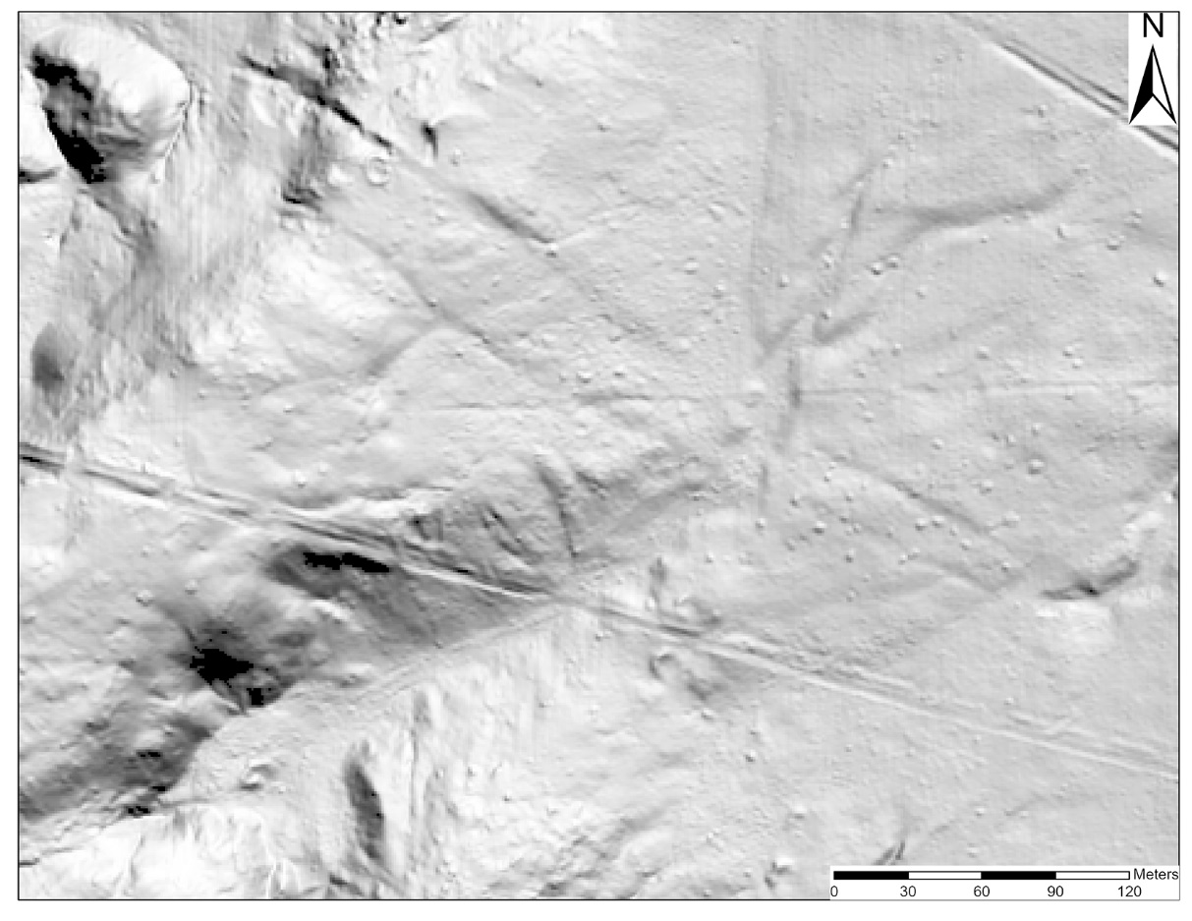

**Reference**

Nials, F.L., J.R. Stein & J.R. Roney. 1987. *Chacoan roads in the southern periphery: results of phase II of the BLM Chaco Roads Project*. Albuquerque (NM): Bureau of Land Management.