|  |  |
| --- | --- |
|  | Supplementary material for  Wright, E., C. Davies, A. Lamb, H. Miller, K. Rielly, S. Charlton, A. Kesson, G. Larson, L. Lewis & H.J. O’Regan. 2025. **What does a bear-baiting assemblage look like? Interdisciplinary analysis of an Early Modern ‘sport’.** *Antiquity* 99.  Author for correspondence ✉ hannah.oregan@nottingham.ac.uk |

**Background and Methodology**

**1.1 A brief overview of baiting**

In England, bear baiting appears to have medieval origins, but became formally linked with the crown through the creation of the role of Master of the King’s Bears by Richard III in 1484 (Cerasano 1991). This title changes through time and individual uses, and it also picked up other animals; by the seventeenth century, its occupants were known as the Master of King’s Bulls, Bears and Mastiff Dogs. Legally, butchers were required to bait bulls before their meat could be sold, owing to a suggestion that otherwise the meat would be tainted and bad to ingest. Butchers were often, and repeatedly, fined for selling meat ‘unbayted’. Alongside this legal requirement, bear-baiting became common as a commercial enterprise throughout England, with bearwards being included in the 1572 Vagabond Act, which, like players, required them to have a patron or a licence, else they would be considered vagrants (Dionne 2004). Some aristocrats patronised both actors and bearwards; the Earl of Leicester, for example, gave his name to a major dramatic troupe as well as a roaming bearward in the 1570s (see Johnston n.d. for 1574-5 and 1575-6, the years following a patent awarded to Leicester’s players, as per Wickham *et al.* 2000).

While baiting is often considered to result in the death of the animal, from our zooarchaeological work it is apparent that some animals did survive. This is also attested by documentary records; for example, a document attached to the sale of the bear-ring in London listed named bears and named bulls, which suggests they had survived for some time to be named. A handbill for the London arena (Dulwich Archives MSS 002-041) says one baiting will “worry” a bull to death, which implies that this was not always the case, and Stokes’ (1996) work in Somerset identified a man who travelled with his bull to baitings in multiple towns.

Baiting formed a key part of early modern entertainment economically, as well as socially, with multiple trades being involved in its activities, from vittailing and ale-selling to proximate or overlapping forms of commercial leisure (such as cockfighting, archery, and music and drama) (Davies 2023). It was also highly popular, with audience numbers possibly reaching over 1000 (though exact figures remain unclear) (Brownstein 1969); certainly, at the point when the Paris Garden structure known as Payne’s Standings collapsed in 1583, it was thought to be full to overcapacity (see correspondence transcribed in Chambers 1923: 292). These structures continued to develop, expand, and adapt through these decades, making fixed audience capacities tricky to pin down.

Both men, women, and youths attended baitings, and Elizabeth I was a major patron - Robert Dudley put on a baiting of 13 bears at Kenilworth Castle in 1575 in an attempt to impress her. Although Parliament during the Interregnum passed two ordinances for the Lord Mayor of London to suppress playhouses, rope-dancing, and bear baitings, its jurisdiction was not wholly effective in bringing London to heel and indeed evidence suggests bear gardens continued to thrive through the 1650s (Hotson 1925). The official restriction was overturned by Charles II following his restoration in 1660. Baitings happened indoors and out, including in or around the Banqueting Hall at Westminster (The National Archives E351/544, 10b, April 1613). Both bear and bull baiting were finally banned nationally in 1835 (Cowie 2017: 160–61).

**1.1.2 Baiting on Bankside**

**1.1.2.1 Baiting on Bankside - named structures**

**Bear Gardens** are numbered 1 through 5, following the demarcations of Braines (1924), with “3a” introduced by Bowsher (2012). Bear Garden 1 abutted the Thames by Mason’s Stairs, while Bear Garden 2 is thought to have been near Maid Lane. Little is known of these two structures. **Bear Garden 3** was also known as “**Payne’s Standings**” and sat behind the existing Bell and Cock (a stew and food and drink venue). This structure collapsed on 13 January 1583 during a show. Bowsher (2012) labels its replacement on the same site–which was built within five months as a larger venue–**Bear Garden 3a**. This lasted until 1613, when Philip Henslowe and Jacob Meade built the Hope playhouse (see Davies 2023 for more detail).

**Hope Playhouse (Bear Garden 4)** - Henslowe and Meade contracted the carpenter Gilbert Katherens in 1613 with meticulous instructions to create a dual-purpose playhouse: both a game place and a theatrical stage, with a removable stage structure on trestles. The contract instructed Katherens to look to the Swan playhouse in its architectural features and to re-use timber, benches, and seats, as useful, from the previous structure (as well as material Henslowe had lately bought from an old house in Thames Street) (Wickham *et al.* 2000: 598–9). Although there are limited records about the Hope, it appears in Wenceslaus Hollar’s view of London in 1647 and was home to Ben Jonsons’ *Bartholomew Fair* (the prologue to which makes reference to the bears that shared the space). After three years, no major theatrical troupe used the structure, raising questions about the suitability of acting companies working alongside animals, though three years is itself a long time for such an operation and there are many factors in early seventeenth century London playing industry that might explain why a company was not housed long term at a given playhouse. The Hope survived as a baiting and entertainment arena into the 1650s and was replaced by Davies’ Bear Garden in 1662–3 (though sometimes still continued to be known as the Hope) (Wickham *et al.* 2000: 596–7)

**The Globe** playhouse was built by a group of sharers formed from the Burbage family and lead sharers in the Lord Chamberlain’s Men acting company in 1599. The playhouse was a solution to the legal difficulties around the Burbages’ previous theatrical space, the Theatre in Shoreditch. It was likely ready by May or June 1599 (Wickham *et al*. 2000: 493–4.) There is no evidence the playhouse hosted animal sports, though its proximity to the other named structures listed here puts it in a wider recreational hub that prominently included commercial baiting.

**The Rose** playhouse was built by Philip Henslowe and John Cholmondley in 1587, and expanded and altered in 1592. Greenfield (2007) called attention to the unusual difference in height between the floor and the first layer of seating in the original playhouse. He proposes that it could have been used as a multipurpose arena like the Hope - for baiting, sword-fighting and playing - before being remodelled into a playhouse more primarily suited to acting in 1592.

**Davies Bear Garden (Bear Garden 5)** was built in 1662–3 and demolished in 1882 and was not replaced (Capon & Rielly 2020). It was the last formal ‘bear garden’ to have been present on Bankside, thereby bookending at least 140 years of animal baiting in the area.

**1.1.2.2 Baiting on Bankside - archaeological sites included in the text**

Although the excavated sites cover parts of multiple playhouses and bear gardens, the associated animal bone assemblages do not always belong to the closest arena, e.g. the footprint of the BAK99 excavation contains part of the Hope playhouse but the bones are from earlier and later arenas (see Table 1, and further details below).

The site of **20-22 New Globe Walk (NGW00**) sits to the south of Benbow House (BAN95) and to the north of 60 Park Street (PSE02) on the western side of the excavated areas shown in Figure 2 (main text). Together the sites fill the area between the modern roads of New Globe Walk and Bear Gardens. Limited areas of NGW00 were excavated in 2000, as described in Mackinder *et al*. (2013: 1). The main deposit of interest to our study was designated B: Open Area 1, and consisted of waterlain deposits with large quantities of animal bone, mainly horse, and dog with some bear. NGW00 contexts 45, 63, 65 and 66 are thought to relate to a “pond for dead dogs” associated with one of the bear gardens. Alongside the bones were found pottery for food preparation and serving. It is suggested that these deposits were formed by filling in the earlier fishponds on the site, and that they are associated with Payne’s Standings (Bear Garden 3) and Bear Garden 3a. Also on the site was a possible stable or kennel (B:S1) associated with an undated deposit of straw or rushes B[61] containing dog bones. All information above from Mackinder *et al.* (2013).

**Riverside House** **(BAK99)** comprises the northeast quadrant of the area studied here (Figure 2), and fronts onto the modern River Thames, between the roads of Bear Gardens and Southwark Bridge. A considerable area of BAK99 was excavated, and waterlain deposits containing horse, dog and bear remains were designated A: OA1 (Open Area 1). These deposits are very similar to those from NGW00 and it is also thought they are associated with Payne’s Standings (Bear Garden 3) and Bear Garden 3a. Later material designated disuse deposits A: Structure 11, included six horse bones, two dog bones and a bear humerus. These are thought to be associated with Davies Bear Garden (Bear Garden 5), sited to the southwest in 60 Park Street (PSE02). Despite the excavated area covering part of the Hope Playhouse site, no animal bones directly associated with the Hope were recovered. All information above from Mackinder *et al.* (2013).

**Benbow House (BAN95)** was subject to limited excavation and watching briefs between 1995 and 1997 (Mackinder & Blatherwick 2000). It sits in the most northwest part of the area under consideration with NGW00 to the south, and BAK99 to the east. Excavation of wooden pilings belonging to ‘Building 12’ led to it being identified as the site of Payne’s Standings (Bear Garden 3) and Bear Garden 3a. Some horse and dog bones were found in waterlain deposits in Open Area 12. Organic deposits containing dog remains were also found to the North of Building 12 (Mackinder & Blatherwick 2000: 26–28). Some horse remains were found in a pit [394] in open area 7; Open area 11 had three horse bones and three dog bones that were eroded and clearly redeposited. Open area 13 had two large dumps of secondarily deposited dog and horse remains - there was no dating material but the excavators associated them with Bear Garden 3a. The sediments within the dumps are not discussed in the report. All information above from Mackinder and Blatherwick (2000).

**Empire Warehouse (EMH12)** covers the same footprint as two earlier evaluations with different site codes - **Empire Warehouse (EWH08)**, and **1 Bear Gardens/ 2 Rose Alley (BGU08)**. EWH08 formed the northern half of the site in Figure 2, and included parts of the Hope Playhouse (Bear Garden 4), while BGU08 formed the southern half and touched the edge of Davies Bear Garden (Bear Garden 5). Despite the footprint of the area covering parts of Bear Gardens 4 and 5, it is thought on the basis of ceramic dating that the majority, if not all, of the faunal material from these sites relates to Bear Gardens 3 and 3a. All three excavations are unpublished, but some details of the sites and the horses, dogs and bears recovered are given in Capon & Rielly (2020).

The **Union Works, 60 Park Street (PSE02)** lies to the south of NGW00, and west of BGU08, PRU05 and EWH12 (Figure 2). Much of Davies Bear Garden (Bear Garden 5) lies beneath this location, but very few faunal remains have been recovered here compared to other areas (Rielly 2004, number of bone fragments thought to be related to baiting = 5). The PSE02 bone assemblage was not examined for our study, although one bear metapodial and one bear mandible fragment were included in the isotope and ancient DNA analyses.

**58 Park Street (PRU05)** lies to the south of EWH12 and to the east of PSE02, with the modern road of Bear Gardens lying between them. Part of the structure of Davies Bear Garden (Bear Garden 5) underlies PRU05, but few faunal remains were recovered (Pipe 2009a, n=4). The PRU05 bone assemblage was not examined for our study.

**The Rose (2-10 Southwark Bridge)** has two site codes **SBH88** and **PR441**, both lie in the southern half of the Rose site as seen in Figure 2 (main text). Animal bones were recovered from Open Area 2 (period 2) which predated the Playhouse. The assemblage contained sheep and goat bones, plus horse and dog remains in contexts A[434] and A[469] suggested to be from baiting (Bowsher & Miller 2009: 32). As they predate the Rose (built 1587), they are most likely to have been associated with Bear Gardens 3 and 3a, although they are at some distance from it. Animal bones from Building 2, Phase 1 (the early Rose), again included sheep, goat, dogs, horses and a single bear bone (Bowsher & Miller 2009: 53). Animal bones from Building 2, Phase 2 (the remodelled Rose) were largely domesticates, with one small fragment of turtle (Bowsher & Miller 2009: 53). Following the closure of the Rose, further animal bones were found in the demolition dumps, which included domesticates and fish, while dog, horse and bear remains were found in the backfills of the north ditch and demolition dumps near the back of the stage (Bowsher & Miller 2009: 74, 76). Post-playhouse bone assemblages were identified in Open Area 3, which again included large numbers of domesticates, and limited dog, horse and bear bones likely to be associated with the Hope (Bear Garden 4) (Bowsher & Miller 2009: 78–79).

**The Globe** comprises several site codes of which only fauna from **ACT89**, a watching brief in Anchor Terrace car park, have been examined here. Few animal bones were found and those from Open Area 4 comprised sheep and cattle, roe deer, fallow deer, and fish (Bowsher & Miller 2009: 100).

**1.2. Methods**

**1.2.1 Zooarchaeology**

*Material recovery and selection*

Analyses focused on the hand-collected materials from all sites, as the taxa of interest here tend to be large, and relatively few contexts had been sieved.

Due to issues of access during the Covid pandemic there was some variation in the way that the different assemblages were studied. The assemblages curated by MOLA (BAN95, BAK99, NGW00, BGU08) were re-recorded in full. For assemblages held at the Museum of London Archaeological Archive (LAARC) (PR441, SBH88, EWH08, EMH12) only the dog and bear remains were fully re-recorded, while ACT89 (also held at LAARC) was fully re-recorded. Kevin Rielly’s full database for the Empire Warehouse material (EWH08 and EMH12) and data from the MOLA ORACLE database for the Rose and the Globe (PR441, SBH88) were used to supplement the data that Elizabeth Wright recorded.

Owing to the intensity of early modern activity on Bankside it was not always possible to attribute individual contexts to specific baiting arenas (see Table 1 in the main text), however it was possible to split the material between playhouse contexts (those related to the Rose and the Globe) and baiting arenas (all other contexts). This approach has allowed us to look for features that define the different types of activity taking place at these sites. The Hope was used as both a playhouse and a baiting arena, however over time activities became dominated by baiting (see section 1.1.2.1 above), confirmed by both archival details and our results (below). As a result the Hope material has been considered a “baiting assemblage” for the purposes of this analysis.

*Recording system*

The animal bones from Bankside were recorded using a standardised protocol involving the diagnostic zones laid out in [Bertini Vacca (2012)](https://paperpile.com/c/PFUAsP/idfr). This involves the recording of a predefined set of skeletal parts, defined as ‘countable’, which are then used in the quantification of species and body parts.

*Quantification*

Species frequencies are presented using the Number of Identified Specimens (NISP) and Minimum Number of Individuals (MNI). Body part frequencies are presented using Minimum Animal Units (MAU).

NISP was obtained by tallying the number of ‘countable’ identified specimens for each taxon. This number was adjusted in order to make the counts from different species more comparable: partial skeletons were counted as 1 bone, pig and dog metapodials were divided by two, upper incisors and pig first premolars (P1) have been excluded. The MAU was obtained by dividing the number of fragments for each element by the number of times that each is present in a complete animal, without taking side into account (sensu Binford 1984 – these formulae are laid out in Table S1 below).

**Table S1: Formulae used to calculate Minimum number of Animal Units (MAU) and Minimum Number of Individuals (MNI).** n=Minimum Number of skeletal Elements (MNE). The count of the most common zone for each bone was used as the MNE.

|  |  |
| --- | --- |
| **Element** | **Calculation** |
| **Upper or lower incisors** | Bos and Ovis/Capra = n/8 |
|  | Sus, Canis and Ursus = n/6 |
| **Unidentified incisors** | Bos and Ovis/Capra = n/8 |
|  | Sus, Canis and Ursus = n/12 |
| **Premolars** | n/6 |
| **P/M** | n/12 |
| **M1/2** | n/4 |
| **M3** | n/2 |
| **Phalanges** | Bos, Ovis/Capra, Sus = n/8  Ursus = n/10 |
|  | Horse = n/4 |
| **Atlas/axis** | n/1 |
| **Metapodials** |  |
| Metacarpal | Bos and Ovis/Capra = n/2; n=(MC1=MC2/2) |
|  | Sus, Canis and Ursus = n/2; n = (MCIII+MCIV/2 + MP/4) |
| Metatarsal | Bos and Ovis/Capra = n/2; n=(MT1=MT2/2) |
|  | Sus, Canis and Ursus = n/2; n = (MTIII+MTIV/2 + MP/4) |
| Metapodial | Bos and Ovis/Capra = n/4; n=(MP1+MP2/2) |
|  |  |
| **All other body parts** | n/2 |

*Bone modification and pathology*

When present, butchery marks were recorded as ‘cuts’, ‘chops’ and ‘saw marks’ (or combinations of these). Thermally altered bones were recorded as ‘singed’ (smaller brown or black burnt patches), ‘burned’ (fully brown or black) and ‘calcined’ (burnt to white). The presence of gnawing marks by carnivores and rodents was recorded, along with all pathologies and trauma.

*Ageing*

Age at death was reconstructed using bone fusion and tooth eruption and wear. For fusion we used the ages given by [Silver (1969](https://paperpile.com/c/PFUAsP/KVFT)) for dog and [Weinstock (2009](https://paperpile.com/c/PFUAsP/ty5t)) for bear. Dog tooth wear was recorded causing the system described by [Horard-Herbin (2000](https://paperpile.com/c/PFUAsP/XW4X)). Very few bear teeth were available for analysis.

*Biometry*

A series of measurements were taken on bones and teeth according to the criteria described by Payne and Bull (1988) and [von den Driesch (1976)](https://paperpile.com/c/PFUAsP/kbze). Measurements were taken with digital callipers or a measuring board, and approximated to the nearest tenth of millimetre (callipers) or millimetre (measuring board).

Dog biometrical data were analysed using log ratio histograms, scatterplots and shoulder height calculations. Shoulder heights are included as much of the available comparative data for this period came in this form, but it is important to remember that shoulder height calculations are estimates and do not necessarily reflect actual size.

Measurements were analysed using a log ratio index scaling technique (Meadow 1999; Simpson *et al*. 1960). This technique involves the comparison of measurements from a dataset to that of a standard individual or population, by calculating what is known as the log size index (LSI). Through this, multiple different measurements can be combined on the same scale, and sample sizes can be enhanced. In this study a standard individual was used from the reference collection at the *Tony Legge Zooarchaeology Laboratory* at the University of Sheffield. This was a male adult dog of unknown breed, originally from Assiros in Greece (accession no. 0546) - this was the most complete individual in the collection and so allowed for the most measurements to be included in the log ratio analysis.

Shoulder height estimations were calculated using the greatest length (GL) of all measurable dog radii, humeri, femora and tibiae using equations in Harcourt (1974). All estimated shoulder heights were then amalgamated into a ‘Bankside’ grouping (n = 117) for comparison with dogs from other sites of the period. Comparative dog data included here are from England (Welker & Dunham 2019), Northern Ireland (Murphy 2001), British Museum site (MPB09; Rielly 2015), Bishopsgate Goods Yard (BGX05; Pipe 2009b) and Elverton Street (EVT95; Cowie *et al.* 1998; Pipe n.d.).

Limb-bone lengths of early modern dogs were taken from the literature and shoulder heights calculated, with the exception of the English sample from Welker & Dunham (2019) where only published shoulder height estimates were included in their dataset. The Elverton Street site comprised four complete dog burials found in individual pits (Cowie *et al.* 1998). Although there was no direct dating of the dog skeletons, horse remains found at the site were radiocarbon dated to the medieval and post-medieval periods, with an end date for site use of c. 1600 provided by historical sources (Cowie *et al*. 1998). The dog remains from the British Museum site phase 5.1 had an MNI of 42, and were largely disarticulated with some butchery marks (Rielly 2015). The dog data from Northern Ireland were published by Murphy (2001) and only contexts from the 16th and 17th century have been included in our stature estimates. One interesting item of note is that a very large canid found at Carrickfergus and dating to the 16th-17th centuries was not included in the data tables in Murphy (2001) as its size (estimated shoulder height of 74.8 cm) was thought to potentially bring it into the wolf (*Canis lupus*) size-range. However, this size is also well within the range of dogs found at Bankside, and given the role of Carrickfergus in Northern Irish history it is not impossible that it could have been an import from England. We have therefore included it in our analyses. The dog measurement data from Bishopsgate Goods Yard and Elverton Street are from unpublished reports that have kindly been shared with us by Alan Pipe. For the British Museum site (MPB09) only data from phases 4.2 and 5.1 (i.e. mid 17th to late 18th centuries) were included from Rielly (2015). For Bishopsgate Goods Yard (BGX05) only data from periods 9 and 10 (i.e. AD 1500–1700) were included from Pipe (2009b). All early modern data from England (c. 1500–1900) from the Supplementary Information of Welker and Dunham (2019) were used, which includes dogs from the Royal Naval Victualling Yard, and Witney Palace.

**1.2.2 Stable isotope analysis**

Stable isotope analysis of δ13C, δ15N and δ34S was undertaken on bone collagen (n =106) and tooth dentine (n = 2) to examine the diet of the animals at Bankside. We analysed δ13C, δ15N and δ34S from 49 dogs and 20 bears, as well as 8 cattle and 31 equids. Where possible we sampled a limited range of elements from each species at each site in order to avoid duplicating results from the same individual.

Bone and dentine sampling for bears was conducted at the British Geological Survey (BGS), and dog, equid and cattle bones were sampled at LAARC and the University of Nottingham Isotope Laboratory. Collagen was extracted at the University of Nottingham Isotope Laboratory for cattle, equids and dogs, and at BGS (Keyworth, UK) for bears. δ13C, δ15N and δ34S stable isotope analysis of bone collagen and tooth dentine was undertaken at the Stable Isotope Facility, BGS.

Bone powder samples (>0.1g) were obtained from bear bones from areas of cortical bone using a rotary dental drill at low speed, following cleaning of the outer surfaces with a diamond burr to remove surface contamination. Equid, cattle and dog samples (>0.3g) were either cut using a rotary blade from the broken ends of cortical bones, or cores were extracted from cortical bone using a diamond corer of 8mm diameter. Collagen was extracted from all samples using a modified Longin protocol (Brown *et al.* 1988). The bone samples were demineralised in 0.5M aq. HCl solution, which was regularly replaced until full demineralisation was determined to have occurred. Each sample was then rinsed with purified water (MilliQ) and gelatinised in pH3 HCl at 70˚C for 48-72 hours. The supernatant solution was then filtered (8μm Ezee-filter, Elkay, Basingstoke), frozen and freeze dried. The lyophilised collagen (2mg) was analysed for concurrent δ34S, δ13C and δ15N using a Thermo Finnigan EA IsoLink coupled to a Delta V Plus isotope ratio mass spectrometer via a Conflo IV interface at the Stable Isotope Facility at BGS (Keyworth, UK). Ratios of δ34S, δ13C and δ15N are reported in per mil (‰) relative to VCDT, VPDB and AIR standards respectively. Carbon was standardised using a 2-point correction using USGS 40 (-26.39‰) & USGS 41 (37.63‰), Nitrogen using a 2 point correction using USGS 40 (-4.52‰) & USGS 41 (47.57‰), and sulfur standardised using a 2 point correction using IAEA S2 (22.6‰) and M1360P (Lab standard gelatine calibrated to IAEA S1 and IAEA S2 = 2.99‰). Normalisation and analytical error were checked using the well characterised Elemental Microanalysis IRMS fish gelatine standard B2215 (δ13CVPDB = –22.92 ± 0.10‰, δ15NAIR = 4.26 ± 0.12‰, and δ34SVCTD = 1.21 ± 0.24‰), which gave the values detailed in Table S2 below. Weight % was calculated using B2215 (N%= 16.55, C% = 43.78, S% = 0.51).

**Table S2. Results of fish gelatine standard B2215 for all δ13C VPDB, δ15N AIR and δ34S VCDT runs.**

|  |  |  |  |
| --- | --- | --- | --- |
| **B2215/Run** | **δ13C VPDB ‰** | **δ15N AIR ‰** | **δ34S VCDT ‰** |
| 1 | -22.97 ± 0.14 (n=6) | 4.39 ± 0.08 (n=6) | 0.97 ± 0.46 (n=6) |
| 2 | -23.10 ± 0.18 (n=7) | 4.58 ± 0.12 (n=7) | 1.14 ± 0.92 (n=7) |
| 3 | -22.96 ± 0.20 (n=8) | 4.48 ± 0.26 (n=8) | 1.07 ± 0.84 (n=8) |
| 4 | -22.84 ± 0.08 (n=6) | 4.42 ± 0.12 (n=6) | 1.29 ± 0.17 (n=6) |
| 5 | -22.74 ± 0.11 (n=6) | 4.22 ± 0.08 (n=6) | 0.78 ± 0.27 (n=6) |
| 6 | -22.90 ± 0.11 (n=4) | 4.24 ± 0.06 (n=4) | 0.81 ± 0.04 (n=4) |
| Runs 1-6 combined | -22.92 ± 0.18 (n=37) | 4.41 ± 0.19 (n=37) | 1.03 ± 0.59 (n=37) |

Collagen quality was examined using prescribed quality ranges (De Niro 1985; Nehlich & Richards 2009). Atomic C/N ratios between 2.9–3.6, atomic C/S ratios between 300–900 and atomic N/S ratios between 100–300 are indicative of well-preserved collagen. All samples met the C/N ratios but C/S and N/S were variable (of 109 samples in total, 37 met the N/S thresholds, 42 met C/S) - see section 2.6.2 for discussion of why this might be the case. All data obtained are given in OSM2 (worksheet 3).

**1.2.3 Archival research**

Multiple different sources were used to interrogate baiting, from eyewitness accounts to details of the places where the ‘sport’ took place (Table S3). Much information is centred on Bankside, but records from around England have helped to give context to the archaeological evidence at hand:

**Table S3. Archival sources used for this project.**

|  |  |
| --- | --- |
| **Archive** | **Details** |
| Dulwich College Archives | Papers from Philip Henslowe and Edward Alleyn as Masters of the Bulls, Bears, and Mastiff Dogs in the early seventeenth century |
| The National Archives | Various documentation related to Bankside baiting, including leases, lawsuits, and Privy Council orders |
| London Metropolitan Archives | London-based records pertaining to drama, including London Corporation details; also including Sewer Records of Kent and Surrey, which holds details about the land uses and occupants on Bankside around baiting arenas |
| Local records (various) | Records from English local archives (such as Lancashire, Kent, Suffolk, Bristol, Cheshire) with evidence on social practices connected to bloodsports |
| British Library | Documents pertaining to entertainment and activity on Bankside, such as collapse of the Paris Garden scaffolds (Lansdowne MS 37) |
| *Records of Early English Drama* (University of Toronto Press) | A published collection of transcribed primary sources arranged by counties, concerning all forms of performance, drama, or display, including baiting. |
| Print and other MS sources | Various printed texts that include accounts of baiting such as Thomas Dekker’s *Worke for Armorers* (1609) and manuscript accounts such as Lupold von Wedel’s account of baiting performance (*Transactions of the Royal History Society* n.s. 9 (1895): 223–70). |

**2. Results**

**2.1 Species representation**

*Summary data for NISP and MNI*

**Table S4. Summary NISP data for the six main species present at sites on Bankside.** This study focused on a number of taxa (cattle, pigs, sheep/goat, dogs, equids and bears) and the NISPs presented here are for these taxa only. The number displayed is an adjusted NISP (see section 1.2 for details). Some assemblages were only partially recorded for this study, so NISPs for these have been calculated using database data from past studies. For SBH88 and PR441 these data were taken from MOLA’s ORACLE database, and for EWH08 and EMH12 data were taken from a database compiled by Kevin Rielly.

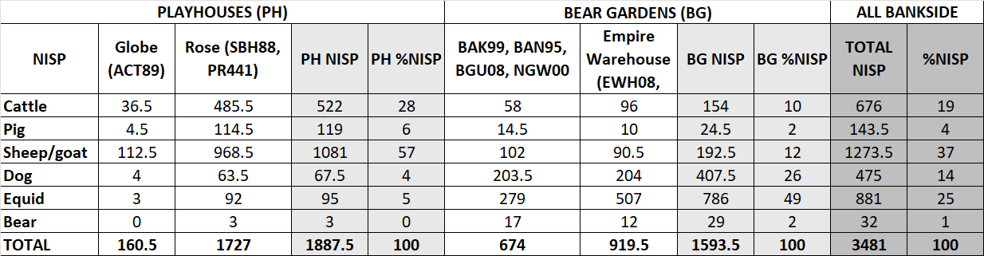

**Table S5. Summary MNI data for the six main species present at sites on Bankside.**

The formulae used to calculate MNI are presented in section 1.2.1

|  |  |  |  |  |  |  |
| --- | --- | --- | --- | --- | --- | --- |
|  | **ALL** | | **PLAYHOUSES** | | **BEAR GARDENS** | |
| **MNI** | **%** | **MNI** | **%** | **MNI** | **%** |
| Cattle | 56 | 22 | 45 | 28 | 11 | 10 |
| Pig | 12 | 5 | 9 | 6 | 6 | 6 |
| Sheep/goat | 113 | 44 | 88 | 55 | 27 | 25 |
| Dog | 39 | 15 | 12 | 8 | 34 | 32 |
| Equid | 30 | 12 | 4 | 3 | 26 | 24 |
| Bear | 4 | 2 | 1 | 1 | 3 | 3 |
| **Total** | **254** | **100** | **159** | **100** | **107** | **100** |

**2.2. Dog body part representation**

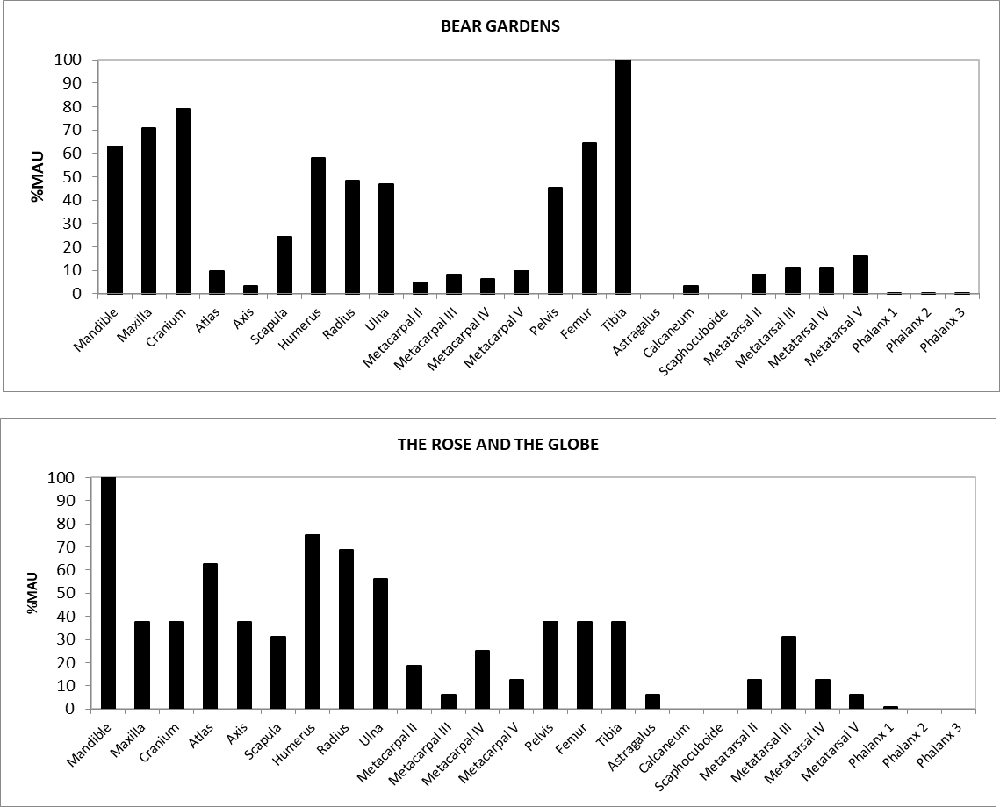

**Figure S1. Dog body part representation (shown using %Minimum Anatomical Units - MAU) from bear garden (top diagram) and playhouse (bottom diagram) contexts.**

**2.3. Dog body size**

Raw measurement data can be found in the accompanying spreadsheet (OSM2)

**2.3.1 Scatterplots**

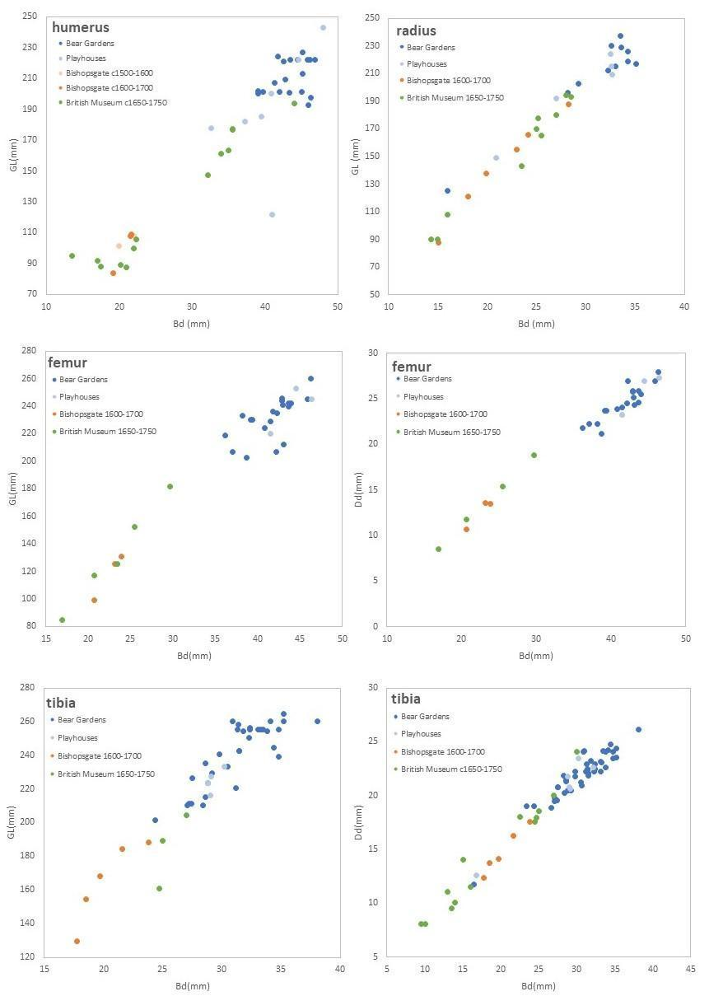

**Figure S2a. Scatterplots investigating the size of dog postcranial remains comparing dogs from Bankside playhouse and bear garden contexts to other contemporary London sites.** British Museum data from Rielly (2015), Bishopsgate Good’s Yard data from Pipe (2009b).

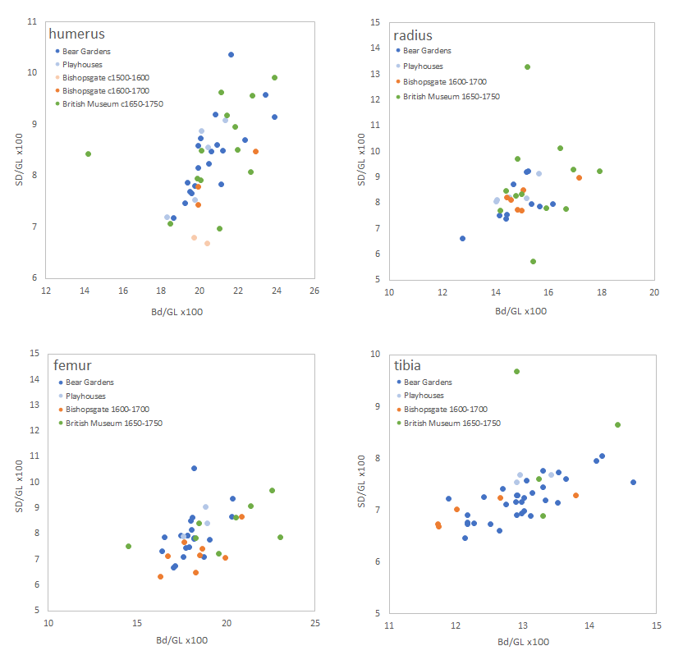

**Figure S2b. Scatterplots investigating the shape of dog postcranial remains comparing dogs from Bankside playhouse and bear garden contexts to other contemporary London sites.** British Museum data from Rielly (2015), Bishopsgate Good’s Yard data from Pipe (2009b).

**2.3.2 Log ratios**

Only measurements from the Bankside assemblages were included in the tooth log ratio analysis due to the small sample sizes available from other sites. These results fit with those from the postcrania in that they confirm the large size of the Bankside dogs and the lack of variation within the population.

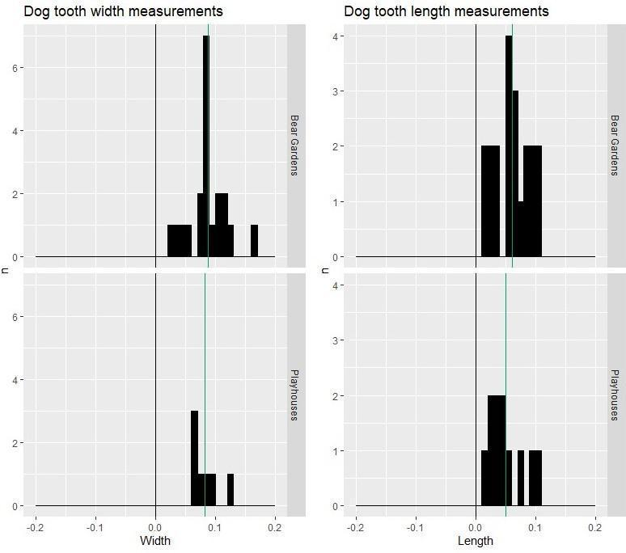

**Figure S3. Log ratio histograms for dog tooth length and width measurements.** The standard is marked with a black line and the mean with a green line.

**2.3.3 Stature estimates**

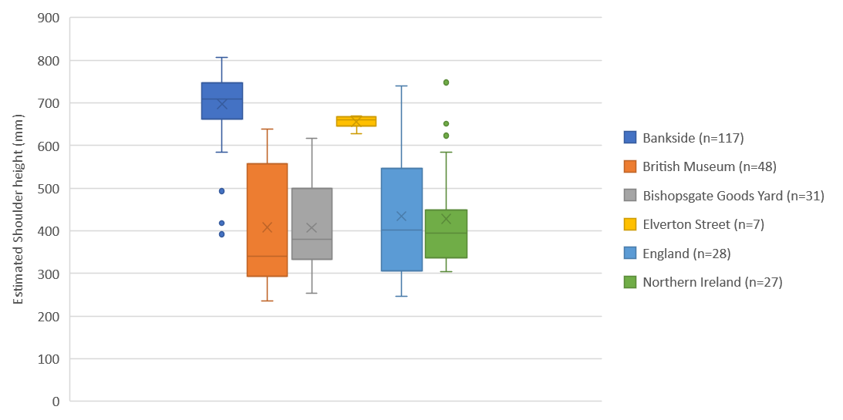

**Figure S4. Comparison of estimated shoulder height (mm) using the equations of Harcourt (1974) for early modern dogs from Bankside, England and Northern Ireland.** British Museum data from Rielly (2015), Bishopsgate Good’s Yard data from Pipe (2009b), Elverton Street data from Pipe (n.d.), English data from Welker & Dunham (2019) and Irish data from Murphy (2001).

Shoulder height estimations for all measurable Bankside dog radii, humerii, femora and tibiae are shown in Figure S5. Very similar size ranges are seen across all available bones from all site codes. The three outliers are a radius from the Rose from the lifetime of the playhouse, a radius from Empire Warehouse (EWH08) which dates to the period of Davies Bear Garden, and a small humerus from the post-Playhouse levels at the Rose.

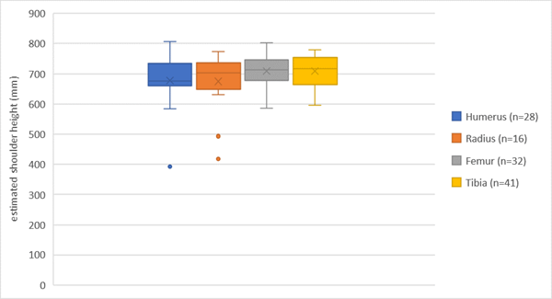

**Figure S5. Bankside dog stature (mm) calculated from each long bone using equations in Harcourt (1974).**

Summary statistics for the data shown in Figure S5 are shown in Table S6 (raw data are presented in OSM2).

**Table S6. Summary data for elements shown in Figure S5.**

|  |  |  |  |
| --- | --- | --- | --- |
| **Element** | **n** | **Mean (mm)** | **Range (mm)** |
| Humerus | 28 | 678.04 | 391.92 – 806.95 |
| Radius | 16 | 675.09 | 418.60 – 773.17 |
| Femur | 32 | 709.14 | 586.78 – 803.44 |
| Tibia | 41 | 709.5 | 596.33 – 780.29 |

**2.4. Age**

**2.4.1 Dog age**

**Table S7. Summary dog epiphyseal fusion data.** Fusion ages according to Silver (1969). F=fused, G=fusing, ud=unfused diaphysis, ux=unfused diaphysis + epiphysis.

|  |  |  |  |  |  |
| --- | --- | --- | --- | --- | --- |
| **SITE GROUP** | **FUSION STAGE** | **GRAND TOTAL** | **TOTAL F+G+H** | **%** | **ud+ux** |
| **ALL BANKSIDE** | earliest | 55 | 55 | 100 | 0 |
| early | 80 | 79 | 99 | 0 |
| intermediate | 63 | 62 | 98 | 1 |
| late | 186 | 179 | 96 | 7 |
| **PLAYHOUSES** | earliest | 11 | 11 | 100 | 0 |
| early | 24 | 24 | 100 | 0 |
| intermediate | 20 | 20 | 100 | 0 |
| late | 55 | 55 | 100 | 0 |
| **BEAR GARDENS** | earliest | 44 | 44 | 100 | 0 |
| early | 56 | 55 | 98 | 0 |
| intermediate | 43 | 42 | 98 | 1 |
| late | 131 | 124 | 95 | 7 |

**Table S8. Summary MNE and MNI for dog tooth wear data.** Categories after Horard-Herbin (2000).

|  |  |  |  |  |  |  |
| --- | --- | --- | --- | --- | --- | --- |
| **MNE** | **ALL BANKSIDE** | | **PLAYHOUSES** | | **BEAR GARDENS** | |
| **MNE** | **%MNE** | **MNE** | **%MNE** | **MNE** | **%MNE** |
| **A (6-24)** | 0 | 0 | 0 | 0 | 0 | 0 |
| **B (6-24)** | 1 | 2 | 0 | 0 | 1 | 3 |
| **C (6-36)** | 7 | 16 | 0 | 0 | 7 | 22 |
| **D (15-36)** | 7 | 16 | 3 | 23 | 4 | 13 |
| **E (24-36)** | 25 | 56 | 8 | 62 | 17 | 53 |
| **F (36-48)** | 2 | 4 | 2 | 15 | 0 | 0 |
| **G (48+)** | 3 | 7 | 0 | 0 | 3 | 9 |
| **Total** | **45** | **100** | **13** | **100** | **32** | **100** |
| **MNI** | **ALL BANKSIDE** | | **PLAYHOUSES** | | **BEAR GARDENS** | |
| **MNI** | **%MNI** | **MNI** | **%MNI** | **MNI** | **%MNI** |
| **A (6-24)** |  | 0 | 0 | 0 | 0 | 0 |
| **B (6-24)** | 1 | 3 | 0 | 0 | 1 | 5 |
| **C (6-36)** | 4 | 14 | 0 | 0 | 4 | 19 |
| **D (15-36)** | 4 | 14 | 3 | 30 | 3 | 14 |
| **E (24-36)** | 15 | 52 | 5 | 50 | 10 | 48 |
| **F (36-48)** | 2 | 7 | 2 | 20 | 0 | 0 |
| **G (48+)** | 3 | 10 | 0 | 0 | 3 | 14 |
| **Total** | **29** | **100** | **10** | **100** | **21** | **100** |

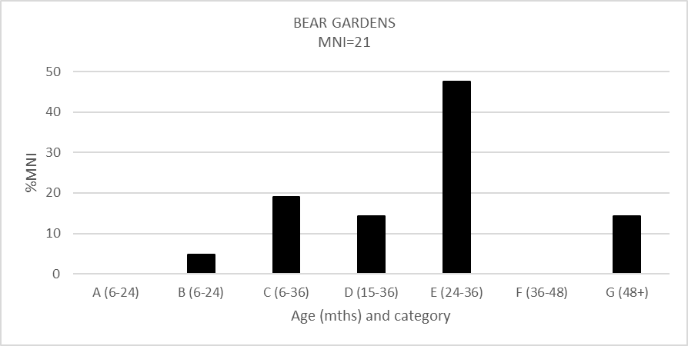

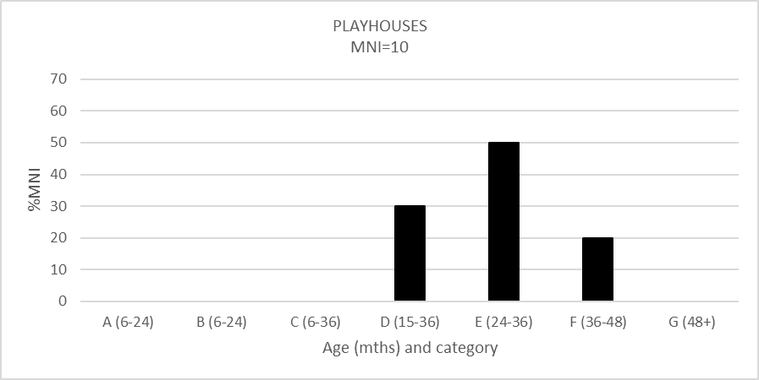

**Figure S6. Dog tooth wear data according to %MNI.** Categories after Horard-Herbin (2000).

**2.4.2. Bear age**

**Table S9. Summary bear epiphyseal fusion data.** Fusion ages after Weinstock (2009)

|  |  |  |  |  |  |
| --- | --- | --- | --- | --- | --- |
|  | **FUSION STAGE** | **GRAND TOTAL** | **TOTAL F+G+H** | **%** | **ud+ux** |
| **ALL BANKSIDE** | earliest | 14 | 14 | 100 | 0 |
| early | 10 | 9 | 90 | 1 |
| intermediate | 7 | 4 | 57 | 3 |
| late | 10 | 5 | 50 | 5 |

**2.5. Trauma**

**Table S10. Description of trauma on dog remains from Bankside.** n.b.A number of these remains displayed multiple instances of trauma (see “Pathology” column).

|  |  |  |  |  |  |
| --- | --- | --- | --- | --- | --- |
| **Database ID** | **Site Code** | **Context** | **Element** | **Pathology** | **Comments** |
| B72 | NGW00 | 45 | Rib | rib with rehealed fracture |  |
| B112 | NGW00 | 63 | Rib | rib with rehealed fracture | Photo included in Figure 7 |
| B113 | NGW00 | 63 | Rib | rib with rehealed fracture |  |
| B161 | NGW00 | 63 | Fibula | fibula with rehealed fracture | Photo included in Figure 7 |
| B567 | BGU08 | 48 | Cranium | almost complete skull; looks like may have received blow to the head on right side - no sign of rehealing. |  |
| B651/652 | SBH88 | 347 | Cranium | trauma and rehealing above left and right eye sockets |  |
| B846 | EMH12 | 403 | Rib | rib with rehealed fracture |  |
| B861/862 | EMH12 | 403 | Cranium | Skull marked BN26332 and "photo"; depressed fracture on left frontal; fracture lines on nasal | Photo included in Figure 7 |
| B896/897/T225 | EMH12 | 605 | Cranium | depressed fracture with rehealing on frontal (both left and right), broken right canine (M3 is also missing in this mandible) | Photo included in Figure 7 |

**Table S11. Summary trauma data for dogs from sites on Bankside according to NISP (top table) and MNI (bottom table).**

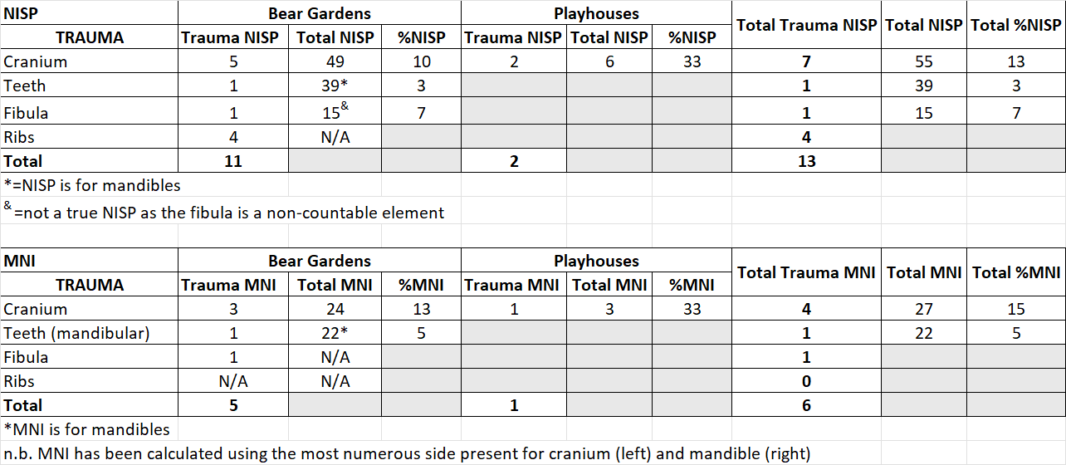

**2.6. Diet**

**2.6.1. δ13C and δ15N stable isotope data.**

All stable isotope data can be found in OSM2.

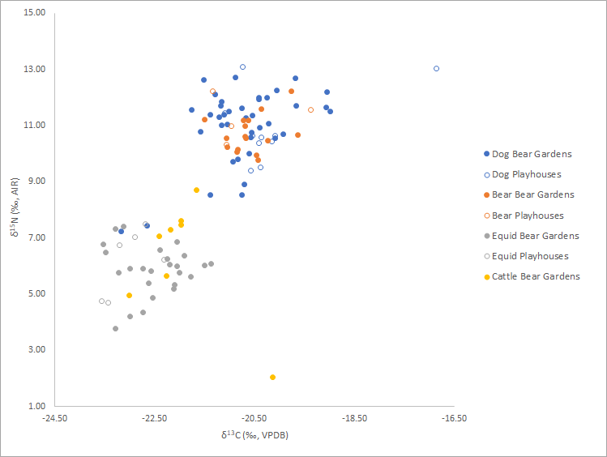

**Figure S7. δ13C and δ15N values from bone collagen of faunal remains recovered from early modern sites on Bankside.** They aresplit according to our dramatic playhouse (Rose and Globe) and bear garden (all other sites) definitions. These data also include two *Ursus* dentine samples, identified in OSM2.

**2.6.2 Sulfur results and discussion**

δ34S stable isotope analysis was also undertaken on the same taxa (horse, cattle, dog, bear) from Bankside. The results are provided in OSM2 but have not been presented beyond this as the majority of the samples had a very high sulfur concentration, and only 37 passed the C/S and N/S collagen checks (see section 1.2.2). For these animals only the results were: cattle (n=8) 1.6 ± 8.2 ‰; equid (n = 11) -0.5 ± 6.9 ‰; dog (n = 17) 0.3 ± 5.9 ‰; bear (n = 1) = 1.6. It is likely that the very high sulfur concentrations in the other bones relate to the location of the sites on the bank of the Thames and the fact that the bones were from predominantly waterlogged contexts. The potential for exogenous contamination from sulfur in bone from riverbank contexts is discussed by Bocherens *et al*. (2011). Mackinder *et al*. (2013) describe the sites as probably being located in the mouth of a substantial channel (The “Bankside Channel”) which emptied into the Thames. This channel was not reached during excavations of New Globe Walk or Riverside House, but it was underlying the sediments from which the animal bone assemblages were recovered. The Thames was highly polluted during the early modern period and after, with organic matter (e.g. sewage and industrial waste) leading to extensive anoxic conditions (Chapra 2011). Waterlogged sediments are well-known for releasing large amounts of hydrogen sulfide as a result of microbial putrefaction of organic sulfur (Fenchel *et al*. 1998). The combination of highly polluted Thames water and waterlogging may at least in part account for our unusual results.

**2.6.3 Butchery and Gnawing**

It is only possible to present full butchery and gnawing data for dogs and bears, as these were the only species that were fully recorded across all sites (see methods for explanation).

Cattle, sheep/goat, pig and equid data were only fully recorded at selected sites (BAK99, BAN95, BGU08, NGW00 and ACT89), so it is only possible to present the data from these sites in full.

**Table S12. Summary butchery data from animal bone assemblages on Bankside.** Sites that were not fully re-recorded are highlighted in orange.

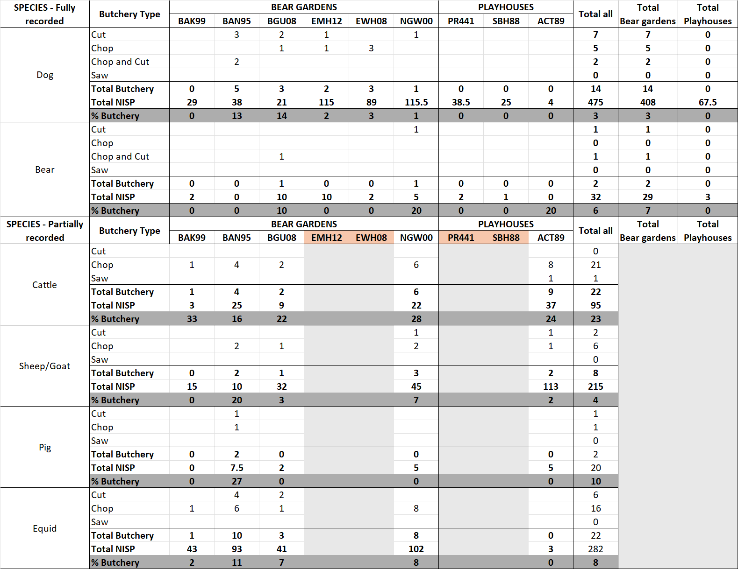

**Table S13. Summary gnawing data from animal bone assemblages on Bankside.** Sites that were not fully re-recorded are highlighted in orange.

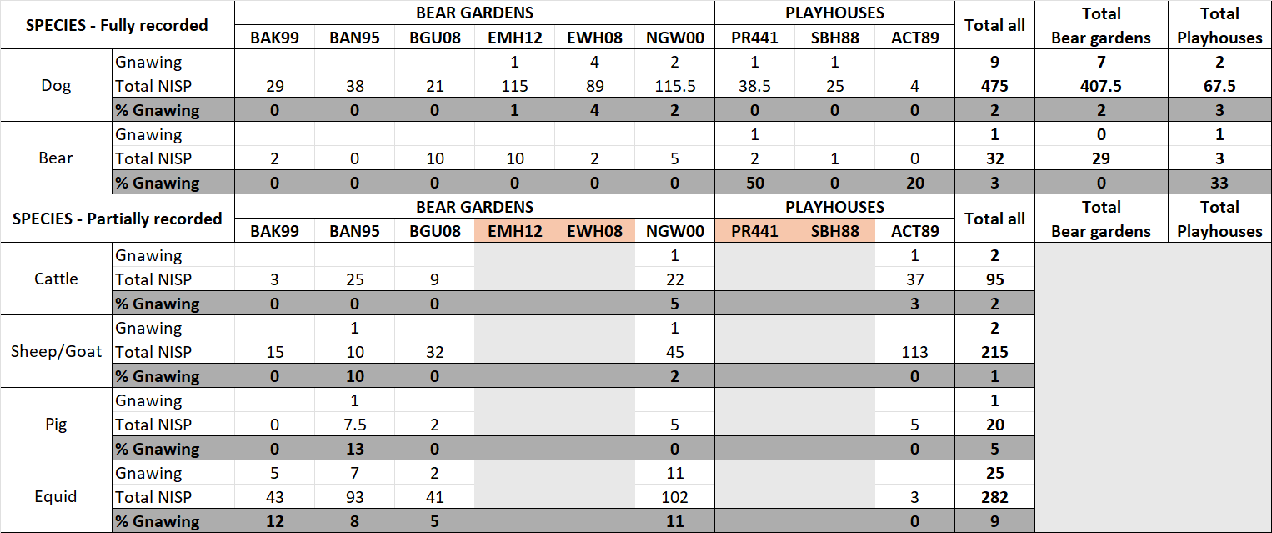

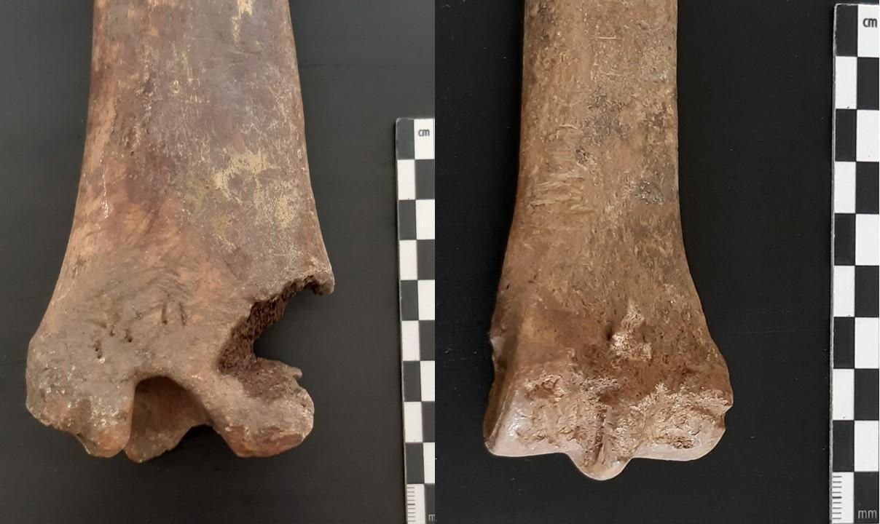

**Figure S8. Examples of carnivore gnawing on an equid tibia and distal metapodial (NGW00, context 43).**

**Archival sources and detail**

**3.1 Records referring to bear age**

Ravelhofer’s (2002) work on two polar bear cubs presented to James I in 1609 demonstrates that cubs were imported, and it has been suggested that the ‘white bear’ which was baited before the Spanish Ambassador in 1623 may have been one of these two animals, which would imply survival for 14 years. It was also in bearwards’ interests for the bears to survive, as they had to be imported and were expensive to procure: in 1607, masters of the game Edward Alleyn and Philip Henslowe petitioned the King for more fees, given the prior “smallness of the fee,” recent restrictions on the game (including plague), and the costly loss of “a goodly bear called George Stone” alongside “4 of our best bears” at the last baiting (their costs being estimated at £300) (Dulwich Archives MSS002, 009). Bears were routinely distinguished in correspondence and notes by their age and stature, but only in vague terms indicating youth, adulthood, or old age. The famous bear Tom Hunks is mentioned in a list of animals at the Bear Garden dated to 1590 (The National Archives C146/8581), and Thomas Dekker (1609) makes a topical reference to likely the same ‘celebrity’ bear, indicating a near 20-year career as a known name. Prolific Cheshire bearward John Seckerston sold a bear cub in Bristol in 1564, suggesting that (like dogs, as above) bears were transported and exchanged at different ages throughout the country and were understood to have youthful potential as well as established prowess (Baldwin 1998). For instance, Sir William Faunt asks Edward Alleyn (in an undated letter) “to send me a couple of he bear cubs [...] let me have them black ones and such as you think will make great bears” (Dulwich Archives MSS002, 039). This fascinating insight suggests that owners and wards considered bear development (alongside sex) from an early age.

**3.2 Records referring to animal injury**

The Dulwich College Archives hold the papers of the college’s founder, Edward Alleyn, who was joint lessee of the Bear Garden on Bankside and the Master of the Game. These archives suggest that baiting resulted not only in harm to the animals but widespread damage to surroundings as well as fatalities. One bearward’s memorandum book expends money “for the harme wich the bares the did” (MSS 002, 010, 3r), while a spectator describes the bear Little Bess of Bromley being particularly aggressive with dogs: “some she killed out righte & the moste parte shee sent halting awaie” (MSS 002, Article 013). Alleyn and Henslowe lamented in 1607, after several games shown before royal guests and “the house” (i.e. the Bankside arena), that “our whole store of dogges are wasted and spent” (MSS 002, Article 008). Such loss of animal life and destruction is accordingly bound up with the physical and cultural history of Bankside (and other locations where baiting regularly took place). Here, then, we might have one articulation of what a ‘baiting assemblage’ might represent for early modern individuals involved in the sport.

The presence of large numbers of dogs south of the Thames, which we can connect with the zooarchaeological evidence, is not only confirmed by correspondence among Alleyn’s papers but by visual depictions of Bankside in maps from the sixteenth and seventeenth centuries. Here we can see precisely where dogs were situated (e.g. Figure 1).

**3.3 Records referring to animal diet**

Archival sources hint at some of the other dietary components for the animals involved in baiting, but there is often a lack of specific information due to the vagueness of some of the terms used in writing at this time. For example both “bread” and “meat” are referred to (Dulwich Archives MSS002-010; Baldwin *et al.* 2007: 725–6), but these are umbrella terms typically used to denote ‘food’ and so do not take us very far. Meat is more specifically mentioned in the wider baiting literature where, for example, there is mention of bearward Peter Broome upsetting the neighbours “by the stench of Carrion, hee provides for his beares" (Baldwin *et al*. 2007: 724). One of the other more specific references to food type is the mention of “apples for the bears” (Jonson 2002 [1641]).

**3.4 Contemporary understanding and use of ‘mastiff’**

Early modern individuals understood specific types or species of dogs. Proto-taxonomic texts from the period (Caius 1576) foregrounded mastiffs’ size and particular uses (including, prominently, baiting). One of the most reprinted texts about animals from the period emphasised their stature and temperament, observing them to be “vast, huge, stubborn, ugly, and eager” (Topsell 1607). Individuals in daily life around the country presumably took these distinctions and descriptions into account when describing their own dogs: not only was ‘mastiff’ frequently used in legislative and civic or municipal documentation (conferring on it a defined and presumably widely agreed status), but people described and registered their own dogs by describing them as ‘mastiffs’ (as opposed to spaniels, greyhounds, and so forth) (Book of Note, Kent Archives, NR/JBr1, fos. 135r-v).

**Primary Archival Sources**

Dulwich College Archives, MSS002

Kent Archives, NR/JBr1

The National Archives, C146/8581

**References**

Baldwin, E. 1998. John Seckerston: the Earl of Derby’s bearward. *Medieval English Theatre* 20: 95–103.

Baldwin, E., L.M. Klopper & D. Mills. 2007. *Cheshire including Chester* (Records of Early English Drama). Toronto: University of Toronto Press.

[Bertini Vacca, B. 2012. The hunting of large mammals in the Upper Palaeolithic of southern Italy: a diachronic case study from Grotta del Romito. *Quaternary International* 252: 155–64.](http://paperpile.com/b/PFUAsP/idfr) https://doi.org/10.1016/j.quaint.2011.06.054

Binford, L.R. 1984. *Faunal remains from Klasies River Mouth*. New York: Academic.

Bocherens, H., D.G. Drucer & H. Taubals. 2011. Preservation of bone collagen sulphur isotopic compositions in an Early Holocene river-bank archaeological site. *Palaeogeography, Palaeoclimatology, Palaeoecology* 310: 32–38. https://doi.org/10.1016/j.palaeo.2011.05.016

Bowsher, J. 2012. *Shakespeare’s London theatreland: archaeology, history, drama*. London: Museum of London Archaeology.

Bowsher, J. & P. Miller (ed.). 2009. *The Rose and the Globe: playhouses of Tudor Bankside, Southwark. Excavations 1988–91*. (Museum of London Archaeology Monograph Series 48). London: Museum of London Archaeology.

Braines, W.W. 1924. *The site of the Globe Playhouse, Southwark*. London: Hodder & Stoughton.

Brown, T.A., D.E. Nelson, J.S. Vogel & J.R. Southon. 1988. Improved collagen extraction by modified Longin method. *Radiocarbon* 30: 171–77. https://doi.org/10.1017/S0033822200044118

Brownstein, O. 1969. The popularity of baiting in England before 1600: a study in social and theatrical history. *Educational Theatre Journal* 21: 237–50. https://doi.org/10.2307/3205465

Caius, J. 1576. *Of Englishe dogges, the diversities, the names, the natures and the properties.* John Charlewood: London.

Capon, L. & K. Rielly. 2020. Excavations at Empire Warehouse, Bankside: new evidence for bear-baiting in Southwark, 1522–1682. *London Archaeologist* 15: 312–20. https://doi.org/10.5284/1081335

Cerasano, S. 1991. Master of the bears in art and enterprise. *Medieval and Renaissance Drama in England* 5: 95–209.

Chambers, E.K. 1923. *The Elizabethan stage, vol. 4*. Oxford: Clarendon.

Chapra, S.C. 2011. Rubbish, stink, and death: the historical evolution, present state and future direction of water quality management and modelling. *Environmental Engineering Research* 16: 113–19. https://doi.org/10.4491/eer.2011.16.3.113

Cowie, H. 2017. “A disgusting exhibition of brutality”: animals, the law and the Warwick lion fight of 1825, in S. Cockram & A. Wells (ed.) *Interspecies interactions: animals and humans between the Middle Ages and modernity*: 149–68. Abingdon: Routledge.

Cowie, R., A. Pipe, J. Clark & J. Pearce. 1998. A late medieval and Tudor horse burial ground: excavations at Elverton Street, Westminster. *Archaeological Journal* 155: 226–51. https://doi.org/10.1080/00665983.1998.11078850

Davies, C. 2023. *What is a playhouse? England at play, 1520–1620*. London: Routledge.

Dekker, T. 1609. *Worke for Armorers*. London: Nathaniel Butter.

DeNiro M.J. 1985. Postmortem preservation and alteration of in vivo bone collagen isotope ratios in relation to palaeodietary reconstruction. *Nature* 317: 806–9. https://doi.org/10.1038/317806a0

Dionne, C. 2004. Fashioning outlaws: the early modern rogue and urban culture, in C. Dionne & S. Mentz (ed.) *Rogues and early modern English culture*: 33–61. Ann Arbor: University of Michigan Press.

[Driesch von den, A. 1976. *A guide to the measurement of animal bones from archaeological sites*.](http://paperpile.com/b/PFUAsP/kbze) Harvard: Peabody Museum of Archaeology and Ethnography.

Fenchel, T., G.M. King & T.H. Blackburn. 1998. *Bacterial biogeochemistry: the ecophysiology of mineral cycling*. London: Academic.

Greenfield, J. 2007. Reconstructing the Rose: development of the playhouse building between 1587 and 1592, in P. Holland (ed.) *Shakespeare survey, volume 60: theatres for Shakespeare*: 23–35. Cambridge: Cambridge University Press. https://doi.org/10.1017/CCOL052187839X.002

Harcourt, R.A. 1974. The dog in prehistoric and early historic Britain. *Journal of Archaeological Science* 1: 151-75. https://doi.org/10.1016/0305-4403(74)90040-5

Horard-Herbin, M. 2000. Dog management and use in the Late Iron Age: the evidence from the Gallic site of Levroux (France), in S.J. Crockford (ed.) *Dogs through time: an archaeological perspective* (British Archaeological Reports International Series 889): 115–21*.* Oxford: Archaeopress.

Hotson, J.L. 1925. Bear gardens and bear-baiting during the Commonwealth. *Proceedings of the Modern Language Association* 40: 276–88. https://doi.org/10.2307/457224

Johnston, A.F. (ed.) n.d. *Berkshire*. Records of Early English Drama Online. Available at: https://ereed.library.utoronto.ca/collections/berks/ (accessed January 2024).

Jonson, B. 2002 [1641]. *Bartholomew Fair*, in D. Bevington, L. Engle, K. Eisaman Maus & E. Rasmussen (ed.) *English Renaissance drama: a Norton anthology:* 961–1066. New York: W.W. Norton.

Mackinder, A. & S. Blatherwick. 2000. *Bankside: excavations at Benbow House Southwark, London SE1* (Archaeology Studies Series 111). London: Museum of London Archaeology Service.

Mackinder, A., L. Blackmore, J. Bowsher & C. Phillpotts. 2013. *The Hope Playhouse, animal baiting and later industrial activity at bear gardens on Bankside: excavations at Riverside House and New Globe Walk, Southwark, 1999–2000* (Archaeology Studies Series 25). London: Museum of London Archaeology.

Meadow, R. 1999. The use of size index scaling techniques for research on archaeological collections from the Middle East, in C. Becker, H. Manhart, J. Peters & J. Schribler (ed.) *Historia Animalium Ex Ossibus: Festschrift Fur Angela von Den Driesch*: 285–300. Rahden/Westfalen: Marie Leidorf.

Murphy, E.M. 2001. Medieval and post-medieval butchered dogs from Carrickfergus, Co. Antrim, Northern Ireland. *Environmental Archaeology* 6: 13–22. https://doi.org/10.1179/env.2001.6.1.13

Nehlich, O. & M.P. Richards. 2009. Establishing collagen quality criteria for sulphur isotope analysis of archaeological bone collagen. *Archaeological and Anthropological Sciences* 1: 59–75. https://doi.org/10.1007/s12520-009-0003-6

Payne, S. & G. Bull. 1988. Components of variation in measurements of pig bones and teeth, and the use of measurements to distinguish wild from domestic pig remains. *Archaeozoologia* 2: 27–66.

Pipe, A. 2009a. *Assessment of the hand-collected animal bone from 58 Park Street, London SE1, London Borough of Southwark (PRU05)* (BON/ASS/27/2009). London: Museum of London Archaeology.

– 2009b. *Hand-collected and wet-sieved animal bone from Bishopsgate Goods Yard periods 11 and 12 (BGX05)* (BON/REP/17/2009). London: Museum of London Archaeology.

– n.d. *Summary of animal remains from Elverton Street*. Unpublished report, MOLA.

Ravelhofer, B. 2002. “Beasts of Recreacion”: Henslowe’s white bears. *English Literary Renaissance* 32: 287–323. https://doi.org/10.1111/1475-6757.00012

Rielly, K. 2004. *Assessment of the faunal remains from Union Works, 60 Park Street, London SE1 (PSE02)* (BON/ASS/26/2004)*.* London: Museum of London Archaeology.

– 2015. The animal bone recovered from the British Museum North-West Development, Bloomsbury, London, WC1 (MPB09). Unpublished report, Pre-Construct Archaeology Ltd.

[Silver, I.A. 1969. The ageing of domestic animals, in D.R. Brothwell & E.S. Higgs (ed.) *Science in archaeology: a survey of progress and research*: 282–302. London: Thames & Hudson.](http://paperpile.com/b/PFUAsP/KVFT)

Simpson, G., A. Roe & R. Lewontin. 1960. *Quantitative zoology*. New York: Harcourt, Brace, and World.

Stokes, J. 1996. Bull and bear baiting, the Gentles’ sport, in A.F. Johnston & W.N.M. Hüsken (ed.) *English parish drama*: 65–80. Amsterdam: Rodopi.

Topsell, E. 1607. *A history of four footed beasts*. London: William Iaggard.

Wedel, Lupold von, 1895. *Transactions of the Royal History Society* n.s. 9 (1895): 223–70.

Weinstock, J. 2009. Epiphyseal fusion in brown bears: a population study of grizzlies (*Ursus arctos horribilis*) from Montana and Wyoming. *International Journal of Osteoarchaeology* 19: 416–23. https://doi.org/10.1002/oa.980

Welker, M.H. & R. Dunham. 2019. Exploring the introduction of European dogs to North America through shoulder height. *International Journal of Osteoarchaeology* 29: 325–34. https://doi.org/10.1002/oa.2744

Wickham, G., H. Berry & W. Ingram (ed.). 2000. *English professional theatre*: 206. Cambridge: Cambridge University Press.