 | Supplementary material for  Solheim, S., K. Zilmer, J. Zawalska, K.S.K. Vasshus, A. Sand-Eriksen, J. Kimball & J.A. Havstein. 2025. Inscribed sandstone fragments of Hole, Norway. Radiocarbon dates provide insight into rune-stone tradition. Antiquity 99.  Author for correspondence ✉ steinar.solheim@khm.uio.no

Part I of the supplementary materials contains additional information about the archaeological site Svingerud where the rune-stone fragments Hole 1,2 and 3 were found. The find contexts are described here. All radiocarbon dates from the site as well as information on the chronological models were created using OxCal v. 4.4.
Part II of the supplementary materials contains additional information about the main runic and other inscribed fragments. We also explain the practices involved in runological autopsy and presentation of inscriptions, and the methods used for digital documentation of inscribed artefacts.
Supplementary materials I

1. Svingerud grave field
The Svingerud grave field was first surveyed by archaeologists from the Buskerud county municipality in 2016 (Carrasco 2018) and was excavated in 2021–2023 by the Museum of Cultural History. The excavations were carried out as part of Ringeriksporteføljen, a large-scale road and railway development project (Solheim 2020). Nye Veier AS was the contractor.
The grave field was located at Prestemoen, Hole municipality. The river Storelva runs approximately 1.8 km to the west and the large Lake Tyrifjorden is found 2.3 km to the south of the site. The region’s geology is characterised by river and clay deposits in the lowlands around Lake Tyrifjorden. The natural forest vegetation is dominated by coniferous forest while species-rich calcareous pine forests are also found. The region is characterised by large contiguous agricultural landscapes and is one of the best agricultural areas in Norway. The distance to the inland forest region and southern Norway’s high altitude mountain range is relatively short when following the inland river valleys and lake systems westwards and northwards.
The Svingerud grave field (650 m², national monument id 222033) was situated on a large terrace consisting mainly of river deposits of sand and silt. Prior to excavation it was covered by mixed forest with mostly coniferous trees. There was virtually no naturally deposited stone in the sandy underground, indicating that almost all stone found on-site is related to anthropogenic activity.
The Ringerike region is known for a large assemblage of archaeological sites dating to the Iron Age, and some of the richest archaeological finds in south-eastern Norway are found here. This includes Veien, one of the largest grave fields in south-eastern Norway, with approximately 144 grave mounds, situated 7.5 km to the north of Svingerud (Gustafson 2016). Approximately 7 km northeast the rich Roman Iron Age grave at Sætrang, (Slomann 1959) was discovered in the early 19th century, while 11.5 km to the northeast is the grave at Gjermundbu, where Norway’s only Viking age helmet was found (Grieg 1947).

1.1 Grave construction and details
Prior to the excavation, three grave mounds were known at Svingerud. After topsoil stripping and during the excavation in 2021 an additional mound was discovered along with two flat graves. Several other features of anthropogenic origin were also uncovered and documented (Figure S1).
Mixing of different burial types is common for the period, and the presence of both mounds and flat graves during the Early/Roman Iron Age is known from other parts of south-eastern Norway (e.g. Gustafson 2016).
In the following, we briefly describe the three graves discussed in the main article. The mounds were earthen mounds, and all four had traces of disturbance pits (visible as depressions in the middle of the mounds in Figure S1), common for Iron Age grave mounds in this region (e.g. Rødsrud 2020). Flat grave A4367 was slightly disturbed by a small cut in the eastmost part of the structure, and by the ring ditch of the overlying mound A140, although not in a manner conflicting with the find context of the rune stone.
All mounds had ditches and the two westernmost mounds, A140 and A105, had encircling stone kerbs (Figures S1 & S2). The mounds contained remains of cremation patches, consisting of a mixture of sand, charcoal and cremated human bones. Flat graves A4367 and A1790 were situated next to each other, with A4367 below mound A140.
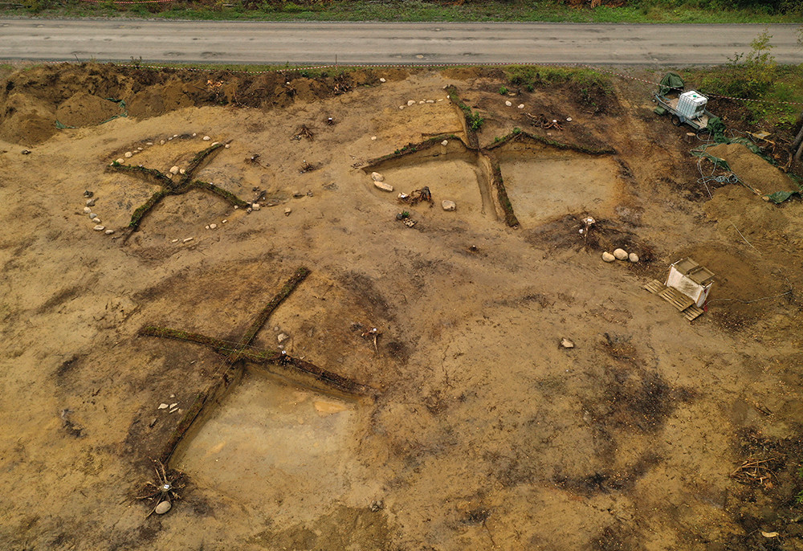
Figure S1. Overview of the mounds at Svingerud, A140 in upper left corner. Seen towards north. Photo: The Museum of Cultural History (MCH).
Mound A140 measured 800 x 900 x 130 cm. It was disturbed by a centrally placed disturbance pit, possibly a combination of modern and prehistoric activity. The burial mound contained two stone circles. One was in the middle of the structure, possibly surrounding a burial chamber. The other circle marked the edge of the grave immediately inside of the ring ditch, although many of the stones were now situated in the ring ditch, probably as a result of erosion. Four different layers were observed and can be described as 1) turf, 2) grey sand with remains of turf, 3) yellow sand layer, interpreted as the mound’s fill, and 4) cremation patch on top of the old surface.
Flat grave A4367 was located on the north-eastern outer edge of burial mound A140, beneath the ring ditch and the remains of the stone kerb. The grave was uncovered at a depth of approximately minus 60 cm from the surface level. It measured 280 x 110 x 60 cm, but with the addition of the removed upper 60 cm, the original depth would have been c. 120 cm. There were no traces indicating that A4367 was dug into or through the above lying mound, rather field photos of the section through A1790 show that the ring ditch is dug into the (undocumented? removed?) topmost layer of A4367. This is an important observation as it informs us of the stratigraphical relation and relative age of the two graves. In addition, it provides a secure context for sampling of radiocarbon dates and establishing a relation between dated samples, grave fill and objects found in the grave fill. This is essential in dating the rune-stone fragment Hole 2.
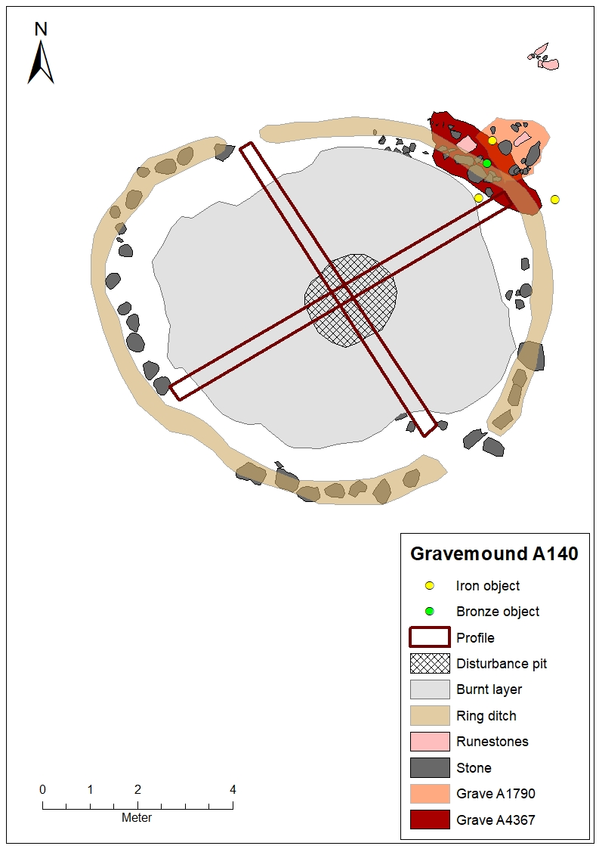
Figure S2. Plan of gravemound A140 and the relation between the grave mound and flat grave A4367 containing Hole 2 and adjacent flat grave A1790 containing Hole 1. Illustration: Charlotte Nueva Finnebråten, MCH.
Like the other graves, the grave fill consisted of a mixture of sand, charcoal and cremated human bones. Three different layers were distinguished in the profile. Layer 1 consisted of grey-brown silty sand with charcoal, burnt bones, and bronze spur. Layer 2 contained grey-brown silty sand and resembled layer 1 with concentrated charcoal spots. The largest amount of cremated human bones was also found in this layer. The fragment with runic inscription, Hole 2, was discovered in this layer, in the northern part of the profile (Figure S3). Layer 3 was composed of yellow and orange silty sand with fewer charcoal pieces and bones. The transition between layer 2 and 3 was diffuse. Altogether the grave had few distinct stratigraphic features, although five approximately equally long charcoal patches in layer 2, situated at an equal distance to each other, could represent some sort of constructional feature.
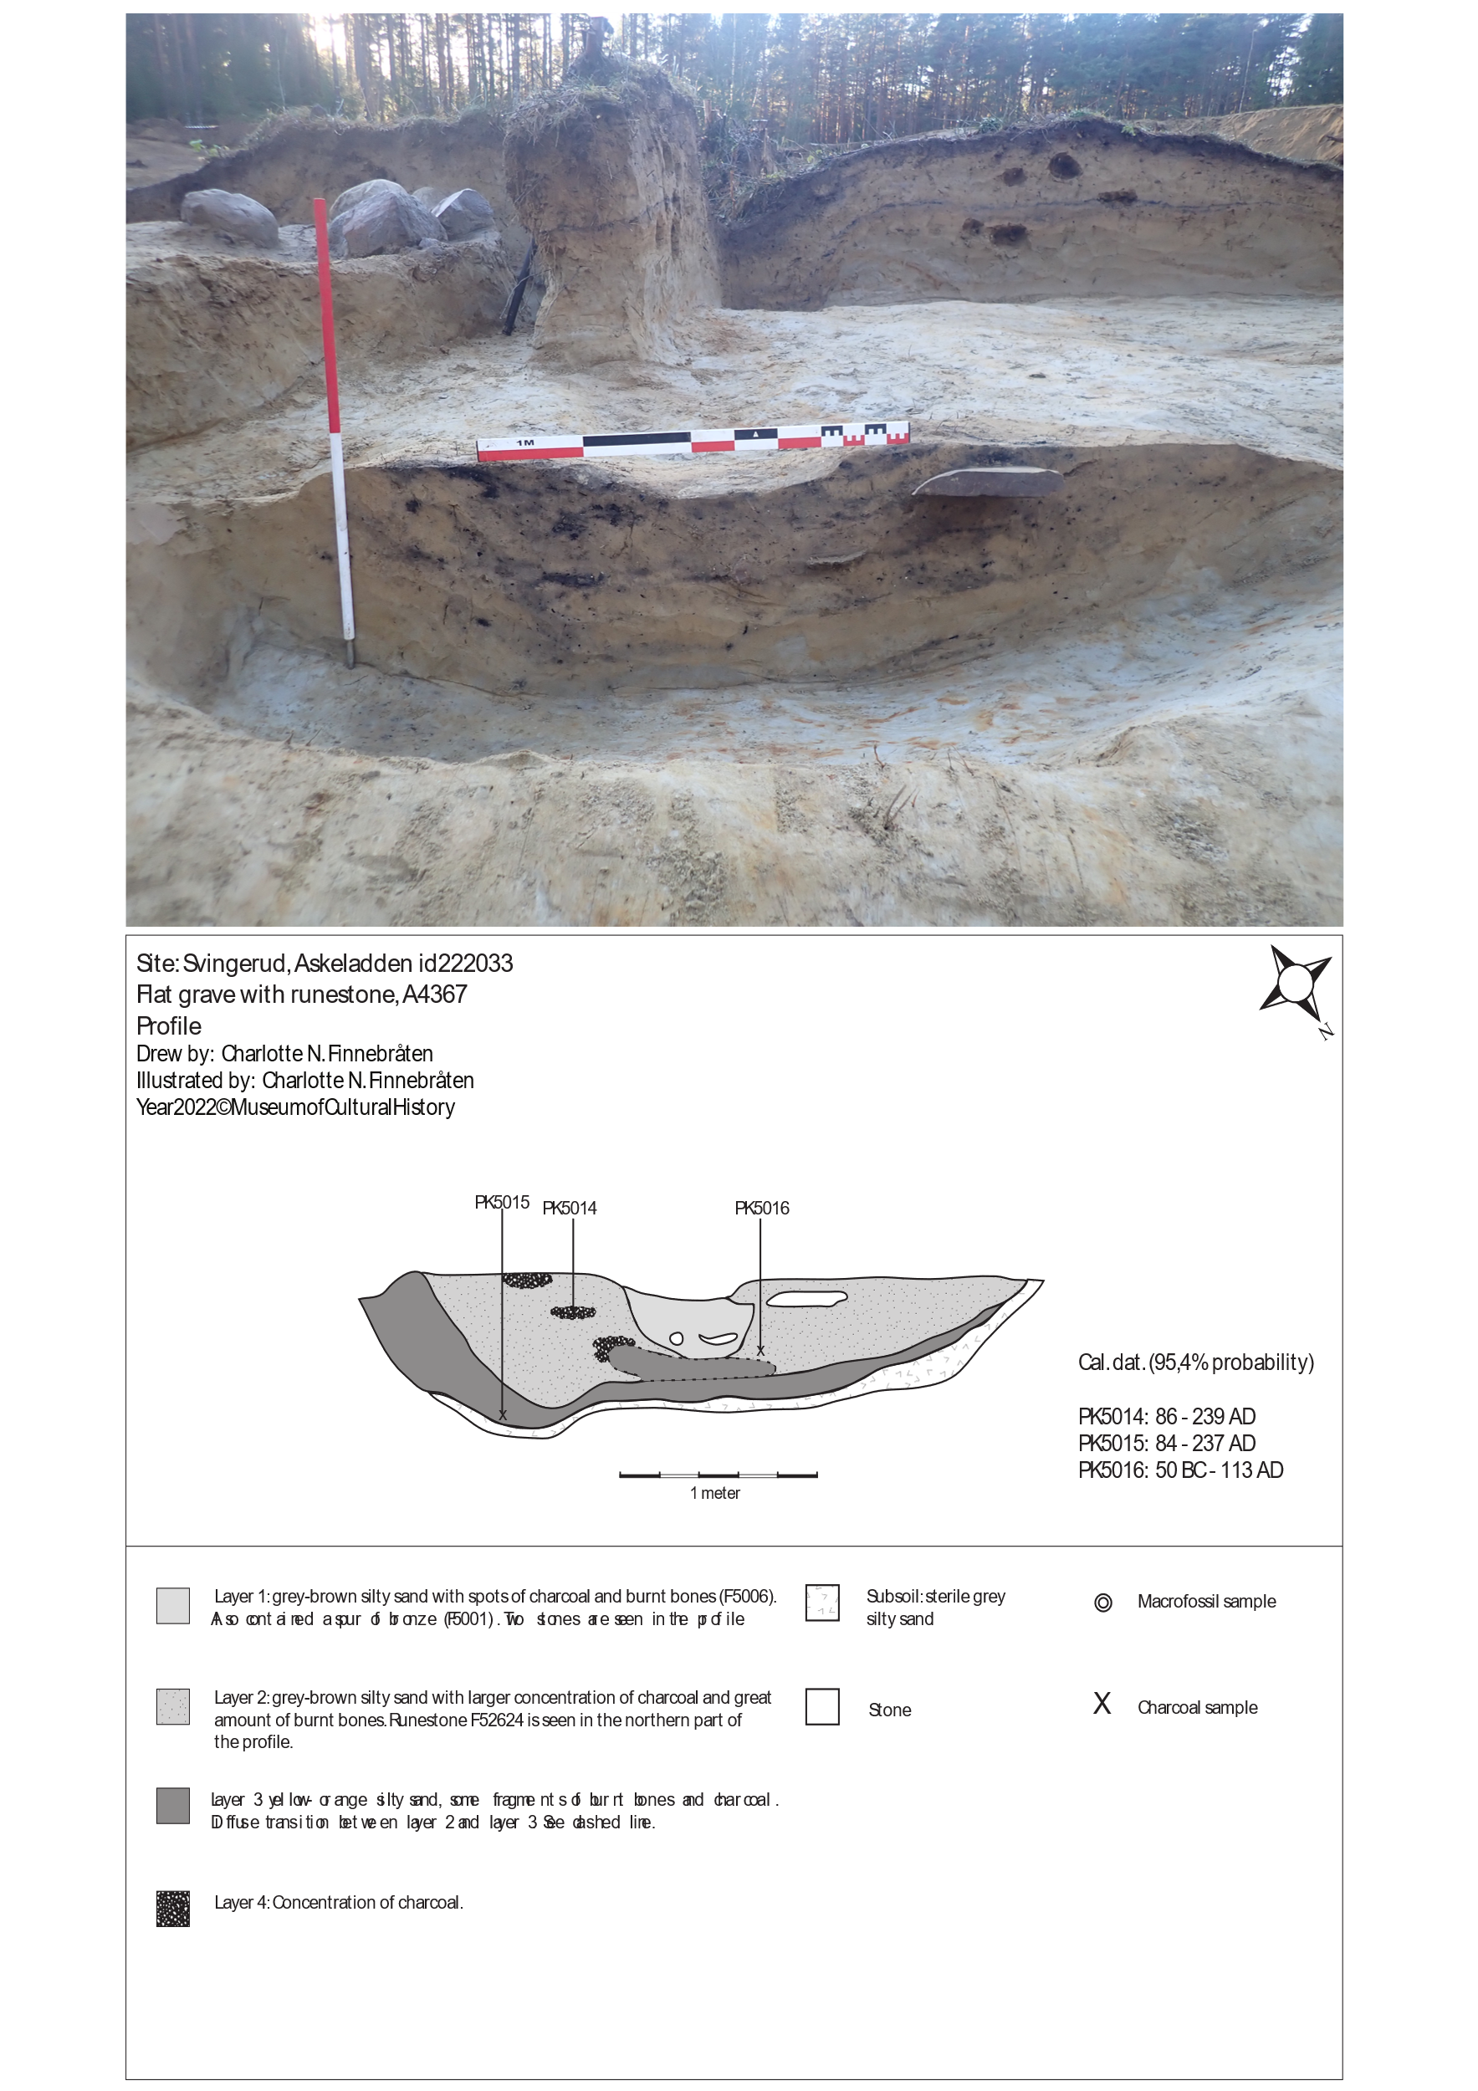
Figure S3. Section of A4367, with rune-stone fragment Hole 2 clearly visible in the profile. The remains of the excavated mound A140 is situated above, seen towards the south-west. Below: Drawing of the profile of A4367 with description of layers and location of samples of charcoal for radiocarbon dating. Photo and drawing: MCH.
In the north-eastern part of the section, a bronze heel spur was found (Figure S4). The spur is well-preserved, most likely due to heat patination. It consists of a thick bow-shaped triangle in cross-section, wider at the midpoint and tapering towards the knobs. The bow is slightly curved, with both ends terminating in a knob. From the middle of the bow, there is a thick, short spike tapering to a point, square in cross-section. A parallel find is found in Martin Jahn's typology (1921, Abb. 56), where it is placed in the fourth century AD. The nearest type in Oluf Rygh's (1919) classification system is R.225 from Brunsberg farm (C3160, grave find), Østre Toten, south-eastern Norway, which matches the bow size and material (bronze/copper alloy). There is a slight difference in spike length and decoration. There is also a similar find (C3117) from Vesten Vestre farm (grave field), Fredrikstad in Østfold, and a stray find (T28144/3) from near a grave mound in Steinkjer in Trøndelag. All these are typologically dated to the early Iron Age. More recently Kontny and Natuniewicz-Sekula (2013) describe two almost identical spurs found in grave A564 in Weklice, northern Poland, a grave dated to the B2 phase of the Roman Iron Age.
A1790 was recorded during the topsoil stripping and interpreted as a flat grave after identification of cremated human bones. The context measured 130 x 140 cm and consisted of sand, charcoal and cremated human bones (220 g), with a few rocks situated on top. Its extent was, however, difficult to demarcate from the surrounding subsoil, and, based on the available field documentation, the structure as originally defined seems to comprise more than one element.
The sandstone fragment Hole 1 could be seen protruding from the central part of the structure. After sectioning of the structure, Hole 1 was found to be positioned upright in a clearly defined pit c. 50 cm deep. Two large stones positioned in the bottom of the pit are interpreted as support for the raised sandstone slab.
A fibula, typologically dated to Roman Iron age period C1 – C2 (AD 160–310) was found in the northwestern part of A4367. The shallow depth of this find and the part of the structure where it was located, a somewhat darker patch of sand reaching only 5 cm below the turf layer, is taken to indicate that this is not a preserved flat grave, but rather disturbed soil from a grave context. Variation in the composition and colour of this soil patch compared to the pit containing Hole 1 indicate that these two should probably not be considered the same structure.
As the exact location of bone finds within A1790 is not documented it cannot be ascertained whether the pit containing Hole 1 is in fact a grave, or whether, for example, the digging of the ring ditch through A4367 or the disturbance pit into grave mound A140 might have led to the accumulation of soil containing cremated bones and the fibula on top of and adjacent to the pit. Despite some uncertainties, we here label this feature as a flat grave.

1.2 Burials and grave goods
Altogether nine individuals of different sex and age were buried at the Svingerud site (Table 1).
Out of approximately 318 g of burnt bones found in A4367, c. 47 g were identified as belonging to an adult individual (possibly a younger adult). Sex could not be determined (Arcini & Magnell 2022: 22).
In addition to radiocarbon dating, grave goods typical for the Early Iron Age were encountered in several of the burials (Table S1, Figure S4). For example, a decorated spindle whorl and a hairpin in A140, the mound above flat grave A4367 in which the rune-stone was encountered, while flat grave A1790 contained a fibula.
Grave | Type | Measures  (meters) | Osteological information  Gram No. Sex Age |  |  |  | Grave goods | Date
A4367 | Flat grave | 1.1 x 2.8 | 318.6 | 1 | NA | (young) Adult | Spur (bronze), rune stones | Pre-Roman / Roma iron Age
A140 | Mound | 8 x 9 | 625.7 | 1 | NA | Adult | Spindle whorl, hairpin, iron buckle | Roman Iron Age
A105 | Mound | 12,5 x 13 | 672.1 | 2 | F, NA | Adult, child | Comb, cattle (Bos taurus) | Roman Iron Age
A160 | Mound | φ 11 | 2176.4 | 2 | M, NA | Adult (45>), child (c. 3) | Cattle (Bos taurus) | Roman Iron Age (main)
A300 | Mound | φ 9 | 273.7 | 1 | F? | Adult | Comb, needle, pottery | Pre-Roman / Roman Iron Age
A1790 | Flat grave | 1.3 x 1.38 | 219.9 | 1 | NA | Adult | Fibula (iron) | Pre-Roman / Roman Iron Age
A2737 | Cremation grave | 0.31 x 0.45 | 0.6 | 1 | NA | Possibly an adult? | Pottery | Pre-Roman Iron Age
A2797 | Cremation grave | 0.38 x 0.45 | 8.6 | 1 | NA | Child (infant) | - | Pre-Roman / Roman Iron Age
Table S1. Overview of all burials at Svingerud, with details on measurements of grave, finds and summarised information from osteological analysis. The osteological analysis was carried out by Caroline Arcini and Ola Magnell (2022).
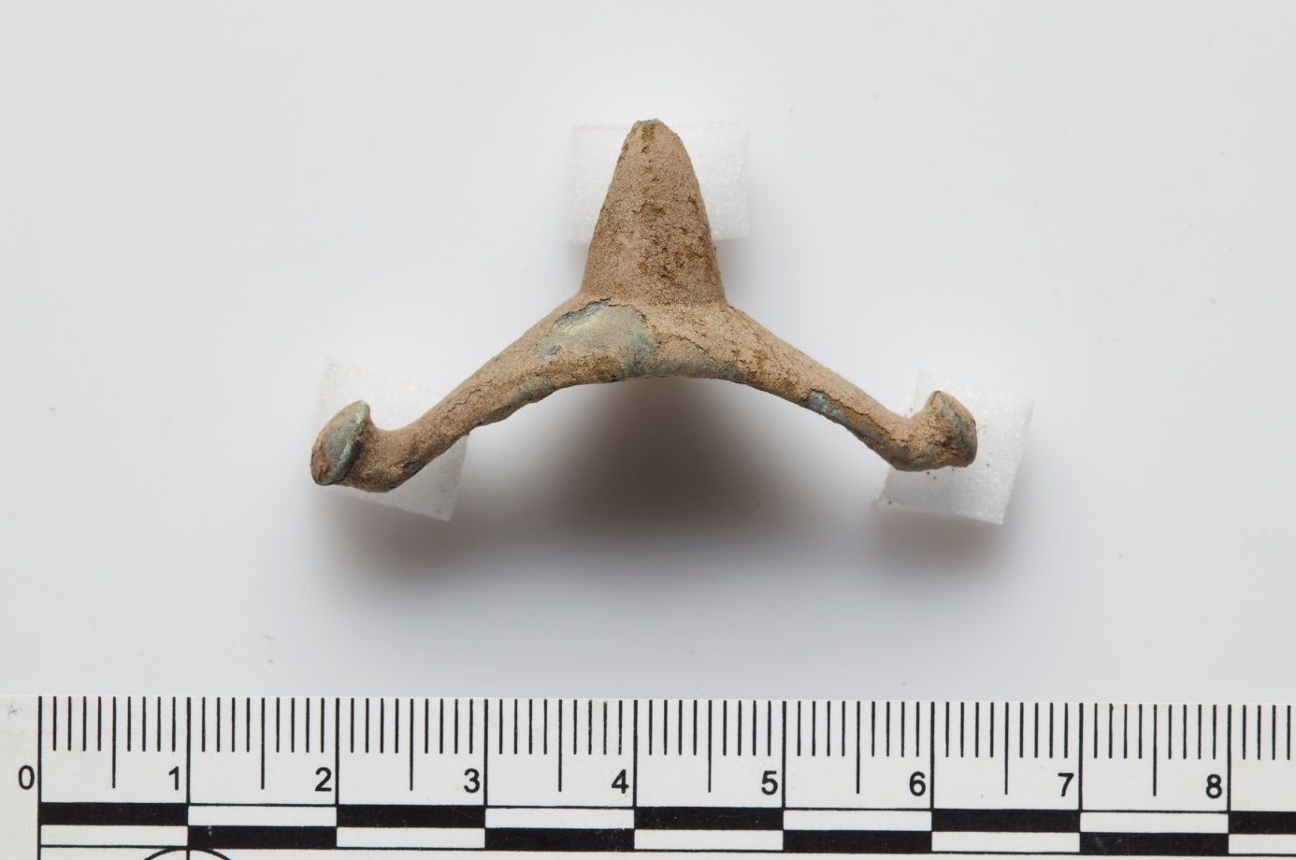
Figure S4. The spur from flat grave A4367. Photo: George Alexis Pantos, MCH.

1.3 Excavation methods
The topsoil/turf was stripped from the entire grave field. The mounds were excavated stratigraphically in four quadrants, divided by two cross-sections leaving 30 cm profile benches for documentation and sampling (Figure S1). Apart from one quadrant, where a mechanical excavator was used to remove soil in thin layers, the mounds were excavated manually. Soil from individual layers was water and dry sieved using 4 mm mesh in field. At MCH laboratories, mesh down to 0.5 mm was used to sieve soil from the graves. The flat graves, including A4367 containing the main fragment with runic inscriptions, were sectioned in half (Figure S2), leaving one part for sampling and documentation. The second half was later excavated and sieved. Layers and soils were treated in the same manner as the mounds. All structures and samples were measured digitally using a Trimble R6 GPS/CPOS.

1.4 The discovery of the sandstone fragments with runic inscriptions
The first observation of the runic inscriptions was done in 2021. The main fragment is here called Hole 2. The fragment Hole 1, located in grave A1790, was also brought to the Museum of Cultural History for closer examination by the end of November 2021 (more information on the inscribed fragments is given in Part II of Supplementary materials).
During new investigations in 2022, additional fragments were discovered. Four fragments of the same appearance as Hole 2, with intentional marking, were found at the site.
During the late part of the excavation in 2022 additional fragments were recovered in already excavated soils at the site. One of the fragments had several runes. Post-excavation work showed that several of the newly found pieces could be refitted with already collected samples.
A systematic investigation of the fragments from Svingerud was carried out during the winter of 2023, assembling the parts identified as Hole 1–3. It was also confirmed that some of the smaller fragments could be assembled with the other fragments, despite several missing pieces. Originally, all the fragments must have been parts of one sandstone slab. At some point, the stone was divided or broken. A few cut marks near the edge of the slab indicate that it may have been divided, whereas further fragmentation may also have natural causes. Parts of the stone may have been used in different ways in the flat grave burials at the site.
In May 2023, a team of archaeologists systematically sieved through all the excavated soils using a machine sieve (30x30 mm mesh) and secondly a hand sieve (4x4 mm mesh). Around 160 additional fragments of sandstone, ranging from c. 1–20 cm in size were found. Several fragments had (parts of) runes or incised lines; all such fragments may potentially be refitted with other fragments into one large rune-stone.

1.5 Radiocarbon dates
All radiocarbon dated samples from the grave field are presented in Table 2. The dates are used to produce a summed probability distribution and the chronological models provided in the paper and in Figure S5 here. Samples that are highlighted red are not included in the SPD or in the calibration plot. These dates are interpreted as not being part of the activity related to the grave site and burials but representing either later activity, natural layers, or disturbances.
This section also contains information on the chronological models created using OxCal v. 4.4 (Bronk Ramsey 2009) and IntCal 20 calibration curve (Reimer et al. 2020). An overview of dates and information on posterior density estimates are provided along with the OxCal model codes. This allows our models to be reproduced.
Context | Context type | Lab. ref. | C14 age | StD | Calibrated, 68 % | Calibrated, 95 % | Median | Material | Taxa
A105 | Mound layer 5 | Ua-73680 | 1851 | 30 | AD 130-235 | AD 120-305 | 190 | Charcoal | Pinus
A105 | Mound, layer | Ua-73684 | 1372 | 29 | AD 640-670 | AD 600-775 | 655 | Charcoal | Pinus
A105 | Mound, layer | Ua-73685 | 2077 | 30 | 150-40 BC | 175 BC-AD 10 | -90 | Charcoal | Pinus
A105 | Mound, layer | Ua-73686 | 2185 | 30 | 355-175 BC | 370-155 BC | -280 | Charcoal | Pinus
A105 | Mound, layer | Ua-73688 | 1906 | 29 | AD 80-205 | AD 30-220 | 140 | Charcoal | Pinus
A105 | Mound, layer 4 (AL2318) | Ua-73876 | 1901 | 30 | AD 85-205 | AD 60-225 | 145 | Cremated bone | Human
A140 | Mound, cremation later (A3871) | Ua-72459 | 1818 | 30 | AD 205-320 | AD 125-330 | 235 | Charcoal | Pinus
A140 | Mound, layer | Ua-73676 | 1853 | 29 | AD 130-235 | AD 120-250 | 185 | Charcoal | Alnus
A140 | Mound, layer | Ua-73678 | 2210 | 30 | 360-200 BC | 380-175 BC | -280 | Charcoal | Ericaceae
A140 | Mound layer 5 (AL3836) | Ua-73878 | 1953 | 31 | AD 25-120 | 40 BC - AD 205 | 70 | Cremated bone | Human
A140, AL3871 | Mound, layer | Ua-73677 | 1859 | 29 | AD 130-230 | AD 120-245 | 180 | Charcoal | Pinus
A160 | Mound, layer | Ua-73671 | 1763 | 30 | AD 240-340 | AD 230-385 | 300 | Charcoal | Betula
A160 | Mound, layer | Ua-73672 | 2452 | 31 | 750-420 BC | 755-410 BC | -575 | Charcoal | Pinus
A1776 | Charcoal patch | Ua-73656 | 1728 | 29 | AD 255-385 | AD 245-410 | 335 | Charcoal | Betula
A1790 | Flat grave | Ua-72458 | 1976 | 30 | AD 5-110 | 45 BC - AD 125 | 45 | Charcoal | Pinus
A1790 | Flat grave | Ua-73875 | 1992 | 30 | 40 BC - AD 65 | 50 BC – AD 120 | 25 | Cremated bone | Human
A180 | Stone pack | Ua-73654 | 1990 | 30 | 40 BC - AD 65 | 50 BC - 120 | 25 | Charcoal | Pinus
A226 | Charcoal patch | Ua-73655 | 1840 | 30 | AD 130-245 | AD 120-315 | 205 | Charcoal
A2737 | Cremation patch | Ua-73657 | 2202 | 30 | 360-195 BC | 370-170 BC | -280 | Charcoal | Betula
A2797 | Cremation patch | Ua-73658 | 2073 | 30 | 150-1 BC | 175 BC - AD 10 | -85 | Charcoal | Pinus
A300 | Mound, layer AL3542 | Ua-73877 | 1847 | 31 | AD 130-240 | AD 120-315 | 195 | Cremated bone | Human
A300, AL3542 | Mound, layer | Ua-73666 | 2692 | 31 | 900-805 BC | 905-800 BC | -845 | Charcoal | Pinus
A300, AL3708 | Mound, layer | Ua-73670 | 1922 | 29 | AD 60-205 | AD 25-210 | 110 | Charcoal | Pinus
A300, AL4340 | Mound, cremation later | Ua-73668 | 2425 | 31 | 715-410 BC | 750-400 BC | -505 | Charcoal | Pinus
A300, AL4745 | Mound, layer | Ua-73669 | 2055 | 31 | 105 BC - AD 10 | 165 BC - AD 25 | -55 | Charcoal | Pinus
A3418 | Pit | Ua-73659 | 1927 | 30 | AD 30-200 | AD 25-205 | 105 | Charcoal | Pinus
A4300 | Stone cist mound A160 | Ua-73879 | 1823 | 30 | AD 175-320 | AD 125-325 | 225 | Cremated bone | Human
A4300 | Stone cist mound A160 | Ua-73674 | 1809 | 30 | AD 210-320 | AD 130-340 | 245 | Charcoal | Betula
A4367 | Flat grave | Ua-72460 | 2005 | 30 | 45 BC - AD 60 | 55 BC - AD 115 | 10 | Charcoal | Pinus
A4367 | Flat grave | Ua-73661 | 1867 | 30 | AD 125-215 | AD 80-240 | 175 | Charcoal | Betula
A4367 | Flat grave | Ua-73662 | 1872 | 30 | AD 125-210 | AD 80-240 | 170 | Charcoal | Betula
A4367 | Flat grave | Ua-73663 | 1842 | 29 | AD 130-245 | AD 120-310 | 205 | Charcoal | Betula
A4367 | Flat grave | Ua-73880 | 1955 | 31 | AD 25-120 | 40 BC - AD 205 | 70 | Cremated bone | Human
A4915 | Charcoal patch | Ua-73664 | 1908 | 30 | AD 80-205 | AD 30-215 | 135 | Charcoal | Pinus

Table S2. All dated samples from the contexts in relation to the burials at the Svingerud grave site. Samples marked red are omitted from the analysis as these are interpreted as results of disturbances and/or natural processes or undefined contexts.

Chronological model
Model 1. Posterior density estimates.
Name |  | Unmodelled (BC/AD) |  |  |  | Modelled (BC/AD) |  |  |  | Indices
 |  |  |  |  |  |  |  |  |  | Amodel | 80.4
 |  |  |  |  |  |  |  |  |  | Aoverall | 79"
 |  | from 68.3 | to 68.3 | from 95.4 | to 95.4 | from 68.3 | to 68.3 | from 95.4 | to 95.4 | A | C
Phase
Mound Sequence
Start A140 Boundary |  |  |  |  |  | 35 | 190 | -160 | 215 |  | 97.4
1 Phase
Ua-73878 | R_Date (1953, 31) | 25 | 120 | -40 | 205 | 70 | 210 | 30 | 215 | 67.7 | 99
Ua-73677 | R_Date (1859, 29) | 130 | 230 | 120 | 245 | 130 | 220 | 120 | 240 | 103.2 | 99.7
Ua-73676 | R_Date (1853, 29) | 130 | 235 | 120 | 250 | 130 | 225 | 120 | 240 | 102.1 | 99.6
Ua-72459 | R_Date (1818, 30) | 205 | 320 | 125 | 330 | 130 | 245 | 125 | 310 | 84.5 | 99.7
End A140 Boundary |  |  |  |  |  | 165 | 295 | 125 | 470 |  | 98.3
Flat grave Sequence
Start A4367 Boundary |  |  |  |  |  | -55 | 105 | -200 | 120 |  | 98
2 Phase
Ua-72460 | R_Date (2005, 30) | -45 | 60 | -55 | 115 | 5 | 120 | -40 | 125 | 75.6 | 99.4
Ua-73880 | R_Date (1955, 31) | 25 | 120 | -40 | 205 | 35 | 125 | -25 | 200 | 102.9 | 99.8
Ua-73662 | R_Date (1872, 30) | 125 | 210 | 80 | 240 | 120 | 195 | 80 | 235 | 100.7 | 99.8
Ua-73661 | R_Date (1867, 30) | 125 | 215 | 80 | 240 | 120 | 195 | 80 | 235 | 100.3 | 99.8
Ua-73663 | R_Date (1842, 29) | 130 | 245 | 120 | 310 | 125 | 225 | 120 | 245 | 90.5 | 99.6
End A4367 Boundary |  | 160 | 275 | 125 | 420 | 98.1
Grave A1790 Sequence
Start A1790 Boundary |  |  |  |  |  | -125 | 65 | -955 | 110 |  | 98.8
3 Phase
Ua-72458 | R_Date (1976, 30) | 5 | 110 | -45 | 125 | -30 | 80 | -45 | 120 | 104 | 99.8
Ua-73875 | R_Date (1992, 30) | -40 | 65 | -50 | 120 | -30 | 70 | -45 | 115 | 102.6 | 99.8
End A1790 Boundary |  |  |  |  |  | -20 | 195 | -40 | 850 |  | 98.5
Model 2. Posterior density estimates.
In this model cremated human bones and wood charcoal with potential high own age (Pinus) are removed to check if this pushes the date frame back in time. The remaining charcoal samples are Betula, a species with relatively short own age that is well-suited for radiocarbon dating.
Name |  | Unmodelled | (BC/AD) |  |  | Modelled | (BC/AD) |  |  | Indices
 |  |  |  |  |  |  |  |  |  | Amodel | 112.6
 |  |  |  |  |  |  |  |  |  | Aoverall | 112.4"
 |  | from 68.3 | to 68.3 | from 95.4 | to 95.4 | from 68.3 | to 68.3 | from 95.4 | to 95.4 | A | C
Phase
Mound Sequence
Start A140 Boundary |  |  |  |  |  | 120 | 225 | -90 | 240 |  | 97.1
1 Phase
Ua-73677 | R_Date (1859, 29) | 130 | 230 | 120 | 245 | 170 | 235 | 130 | 240 | 104.7 | 99.3
Ua-73676 | R_Date (1853, 29) | 130 | 235 | 120 | 250 | 170 | 240 | 130 | 245 | 108.4 | 99.3
Ua-72459 | R_Date (1818, 30) | 205 | 320 | 125 | 330 | 170 | 250 | 125 | 310 | 104.2 | 99.6
End A140 Boundary |  |  |  |  |  | 180 | 285 | 130 | 490 |  | 96.8
Flat grave Sequence
Start A4367 Boundary |  |  |  |  |  | 105 | 210 | -75 | 235 |  | 97.5
2 Phase
Ua-73662 | R_Date (1872, 30) | 125 | 210 | 80 | 240 | 150 | 220 | 120 | 235 | 106.2 | 99.5
Ua-73661 | R_Date (1867, 30) | 125 | 215 | 80 | 240 | 150 | 220 | 125 | 235 | 106.3 | 99.3
|Ua-73663 | R_Date (1842, 29) | 130 | 245 | 120 | 310 | 155 | 235 | 125 | 240 | 99.7 | 99.4
End A4367 Boundary |  |  |  |  |  | 160 | 260 | 125 | 435 |  | 97

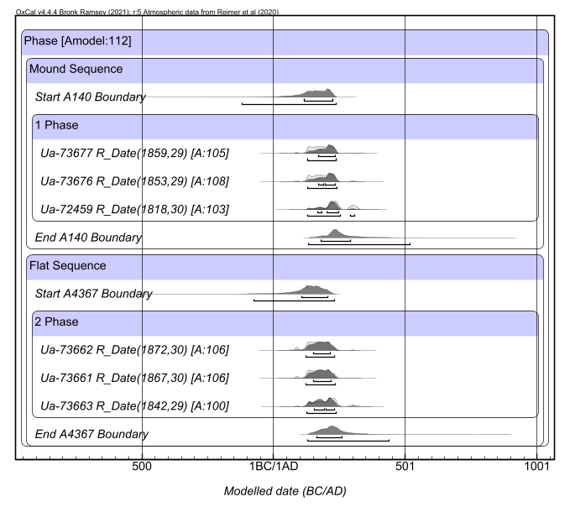

Figure S5. Chronological model based on short-lived charcoal samples from mound A140 and flat grave A4367.

OxCal model code – model 1.
Plot()
{
Phase()
{
Sequence(Mound A140)
{
Boundary("Start A140");
Phase("1")
{
R_Date("Ua-73878",1953,31)
{
color="Red";
};
R_Date("Ua-73677",1859,29);
R_Date("Ua-73676",1853,29);
R_Date("Ua-72459",1818,30);
};
Boundary("End A140");
};
Sequence(Flat grave A4367)
{
Boundary("Start A4367");
Phase("2")
{
R_Date("Ua-72460",2005,30);
R_Date("Ua-73880",1955,31)
{
color="red";
};
R_Date("Ua-73662",1872,30);
R_Date("Ua-73661",1867,30);
R_Date("Ua-73663",1842,29);
};
Boundary("End A4367");
};
Sequence("Grave A1790")
{
Boundary("Start A1790");
Phase("3")
{
R_Date("Ua-72458",1976,30);
R_Date("Ua-73875",1992,30);
};
Boundary("End A1790");
};
};
};

OxCal model code – model 2.

Plot()
{
Phase()
{
Sequence(Mound A140)
{
Boundary("Start A140");
Phase("1")
{
R_Date("Ua-73677",1859,29);
R_Date("Ua-73676",1853,29);
R_Date("Ua-72459",1818,30);
};
Boundary("End A140");
};
Sequence(Flat grave A4367)
{
Boundary("Start A4367");
Phase("2")
{
R_Date("Ua-73662",1872,30);
R_Date("Ua-73661",1867,30);
R_Date("Ua-73663",1842,29);
};
Boundary("End A4367");
};
};
}

Supplementary materials II

2. Main runic and other inscribed fragments
The inscribed sandstone fragments were found at the Svingerud site between September 2021 and May 2023. The fragments of interest are all of red sedimentary rock, known as Ringerike sandstone, determined by geologists Axel Müller and Hans Arne Nakrem of the Museum of Natural History, University of Oslo. Other rock types used at the Svingerud grave field are granite and limestone. According to geologist Øyvind Hammer, Ringerike sandstone is naturally found along the eastern and northern shores of Steinsfjorden and by Sundvollen. The assessment of the fragments and their find circumstances is based on the examinations conducted up until August/September 2023. Work on numerous smaller fragments – many of which were discovered during the sieving of excavated soil in May 2023 – is ongoing. There may be additional matches to the main fragments among these newest finds.

Sandstone slab from flat grave A1790 (Hole 1)
The largest part of the original sandstone slab (Hole 1) was discovered in connection with flat grave A1790 (Figure S6; cf. Part I of Supplementary materials). The stone was first spotted August 18–19, 2021, after the stripping of top soil in the area. A1790 was excavated in mid-September. The stone was measured by GPS and documented with photographs and drawings. The upper part of the slab was observed sticking above the surface; the bottom reached approx. 50 cm below the ground. The context indicates that Hole 1 may have been a (raised) stone possibly marking a grave. The stone was transported to the Museum of Cultural History (MCH) on November 26, 2021. The location is east of the main runic fragment Hole 2 (see below, 2.2.).
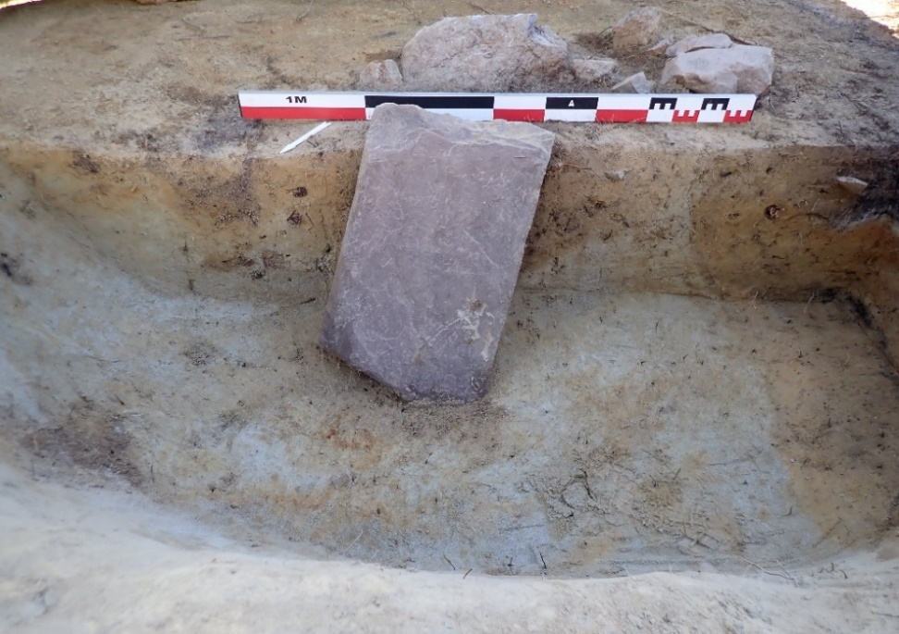
Figure S6. Hole 1 in flat grave A1790. Photo: Charlotte Nueva Finnebråten, MCH.
Hole 1 is approx. 60 cm at its longest and 34 cm at its widest; it is up to 20 cm thick and weighs around 67 kg. Initial inspections did not detect any inscriptions on its surface. In February/March 2023, additional examinations at the archaeological laboratory of MCH confirmed the presence of some faint intentional marks on one side. A few curving and intersecting incisions appear close to the broken edge of the slab. Some lines form X-like shapes (which could, for example, resemble runic g), but this is likely coincidental (Figure S7). There are traces of cuts running across the fractured edge; this indicates that some lines were incised after the splitting of the slab.
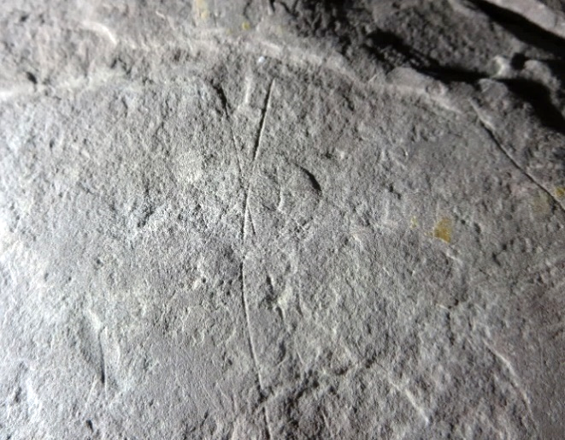
Figure S7. Sample motif (incised intersecting lines) on Hole 1. Photo: Kristel Zilmer, MCH.
One small fragment was discovered as a stray find on the site on September 1, 2022. It is c. 10.6 cm at its longest, 8.4 cm at its widest, up to 2.6 cm thick, and weighs 0.21 kg. This fragment matches with Hole 1 as its top corner piece. It has no visible marks (Figure S8a & b).
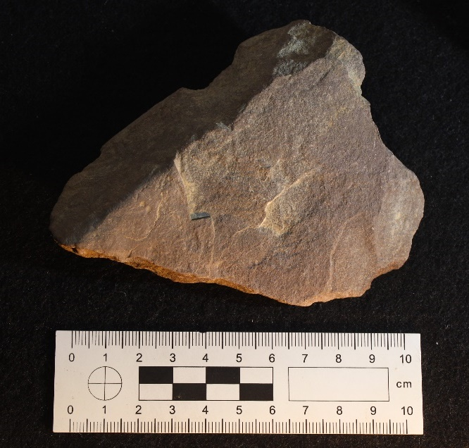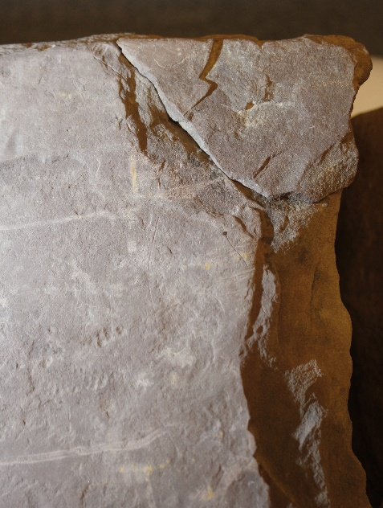
Figure S8a & S8b. Extra fragment, corner piece of Hole 1. Photo: Kristel Zilmer, MCH.
Various fragments of Ringerike sandstone – placed in close proximity to Hole 1 – are detectable on photographic documentation from the excavation in 2021. Unfortunately, their certain identification and therefore location is not possible.

2.2 Runic fragment from flat grave A4367 (Hole 2)
The main runic fragment was found inside flat grave A4367. The grave was uncovered in its entirety on November 9, 2021, and excavated the following day by two archaeologists. The distinctive sandstone fragment from the grave was transported to MCH for further assessment by the excavation leader. The excavation leader Judyta Zawalska discovered the runic inscriptions on the fragment upon the arrival at the museum on November 12, 2021, which was the final day of the excavation.
The inscribed face of Hole 2 (side A) measures c. 30 x 31 cm; the opposite side is c. 31 x 32 cm. Maximum thickness is around 6.5 cm, and the stone weighs 9.6 kg. The fragment is narrower and thinner in the middle, especially along the curving broken edge, which is around 0.5–1 cm thick. There is visible damage along the edges and on the back. The back is uneven and partially thinned out, which according to geologist Øyvind Hammer, shows natural fragmentation typical for this type of sandstone. Side A shows patches of flaking, and there are damaged sections, as well as natural fractures and random marks in its surface. Some fractures have affected the narrow side B, with an additional runic inscription. Hole 2 aligns with Hole 1 along that side.
The fragment has several runic inscriptions and other markings. We identify five sequences on side A, and a sixth one on side B (Figure S9 & Figure S10). Side A also exhibits other elements of graphic expression, potentially merging writing, script-like imitations and ornamental motifs. Some sections of side A display a grid pattern, which is formed by a series of intersecting lines. Additional faint lines run across the inscribed face in various directions; some merge with natural cracks. The multiple inscriptions give the impression of several events of carving. In addition to inscriptions on sides A and B, there are detectable incised lines and marks on two other narrow sides (C and D, Figure S11 & Figure S12). The lines on side C intersect and form a grid similar to that on side A. Side D displays faint traces of shapes, which cannot be determined more precisely.
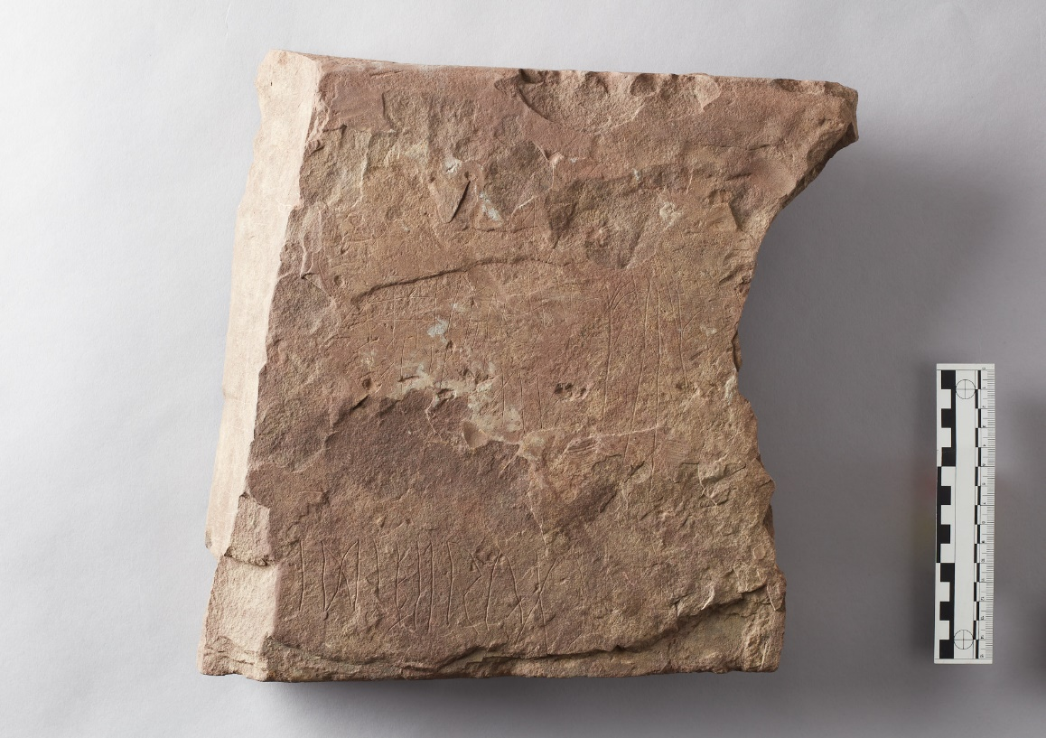
Figure S9. Hole 2, side A with multiple inscriptions. Photo: George Alexis Pantos, MCH.
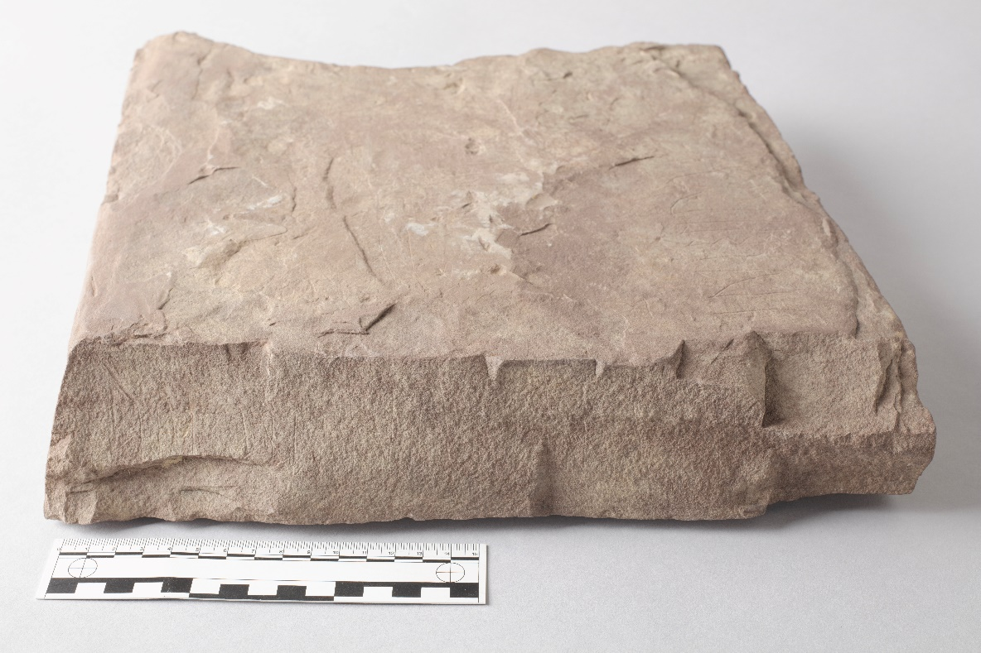
Figure S10. Hole 2, side B with an additional inscription. Photo: George Alexis Pantos, MCH.
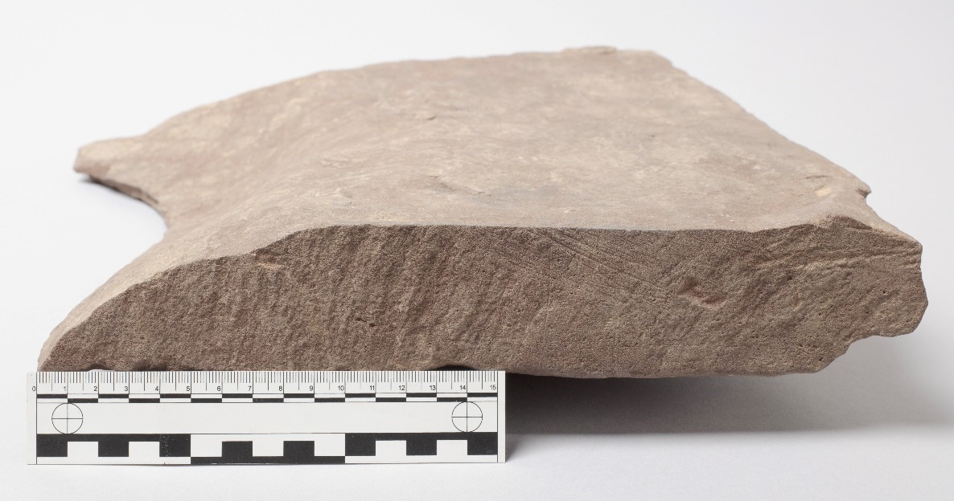
Figure S11. Hole 2, side C with multiple intersecting lines. Photo: George Alexis Pantos, MCH.
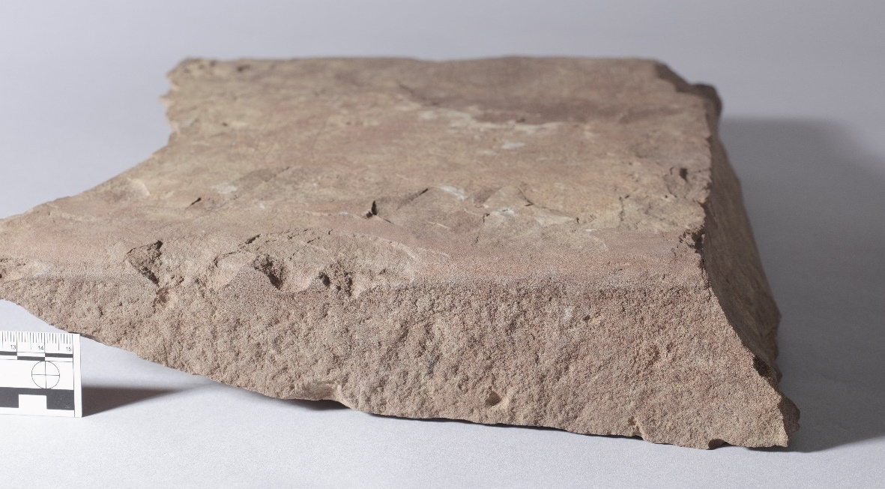
Figure S12. Hole 2, side D with traces of markings. Photo: George Alexis Pantos, MCH.

2.3 Additional fragments of Hole 2
Three fragments found in August/September 2022 match with Hole 2, and extend its inscribed side A. The largest fragment has a triangular shape (Figure S13a & b). It is c. 25.5 cm at its longest, 19.5 cm at its widest, up to 4.3 cm thick, and weighs 1.95 kg. The excavation leader Zawalska spotted the fragment on August 31, 2022. It was then lying next to the grave mound A105. According to Zawalska, it is theoretically possible that someone moved the stones around at the site between late autumn 2021 and summer 2022. The fragment does not feature in the excavation documentation from 2021 and is not detectable on photographs. It has multiple incised intersecting lines on its flat surface, like the main fragment, Hole 2. A few detectable inscribed lines are present on one narrow side. Although weathered, two of the shapes look like upper parts of runes, with some resemblance to r and u (the latter is made up of multiple strokes).
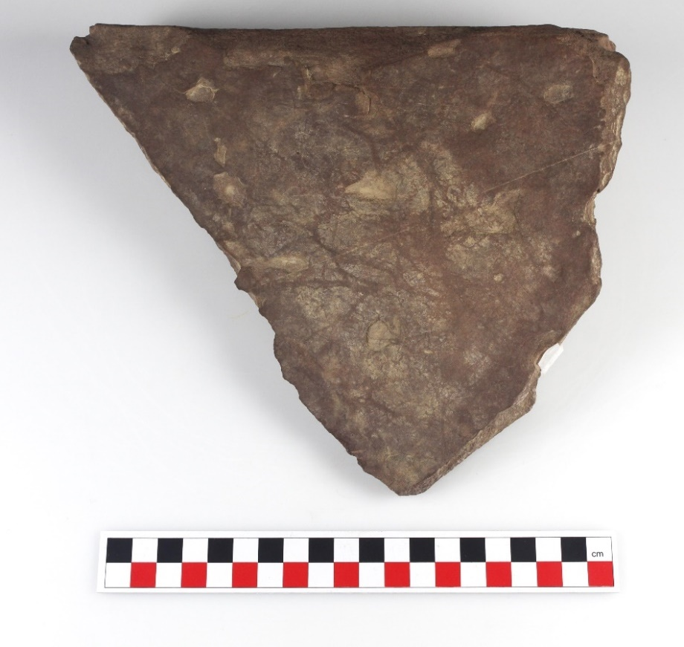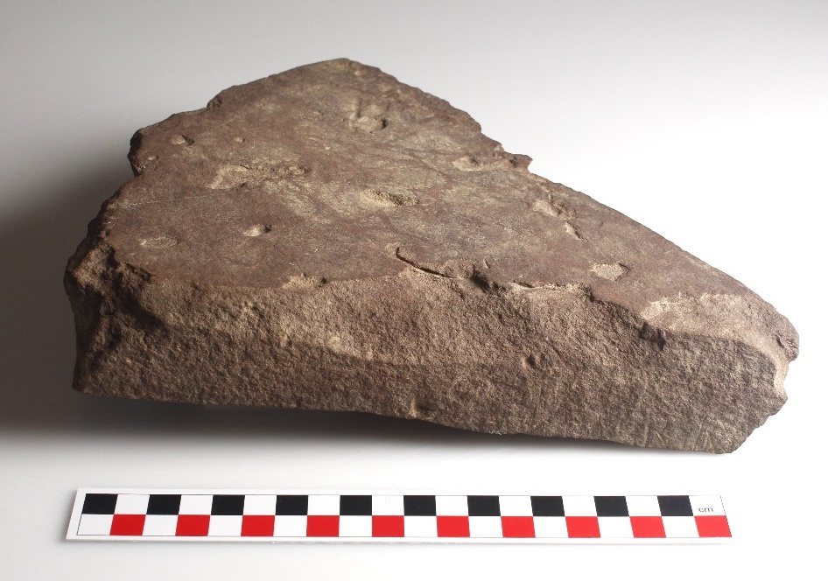
Figure S13a & S13b. Extra fragment 1 (Hole 2) has traces of inscribing. Photo: Kristel Zilmer, MCH.
The second fragment aligns with the triangular piece along one edge (Figure S14a & b). It measures roughly 12.5 x 8.6 x 4.3 cm and weighs 0.44 kg. This fragment was discovered on the site on September 1, 2022, and cannot be identified in the excavation materials and photographs from 2021. It has some incised lines that form a continuation to markings on the larger triangular fragment.
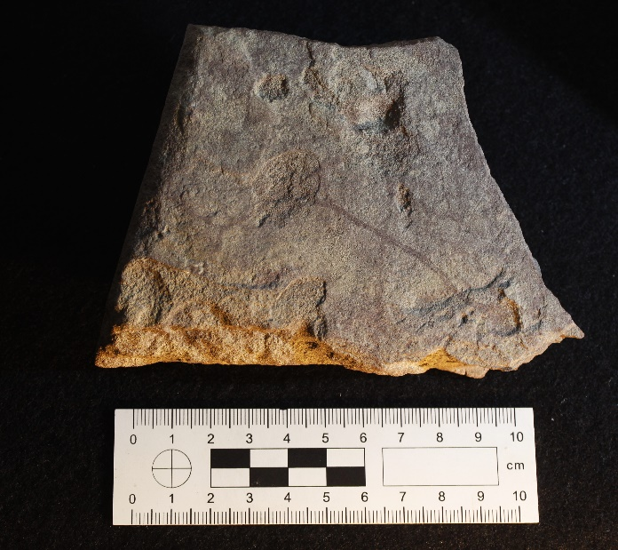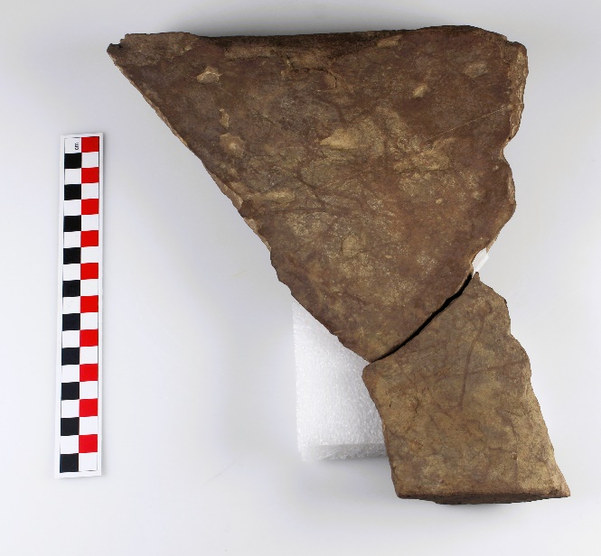
Figure S14a & S14b. Extra fragment 2 (Hole 2); fragments 1 & 2 assembled. Photo: Kristel Zilmer, MCH.
The third fragment is small and thin, measuring approx. 5.7 x 3.6 x 0.6 cm, and weighing 0.18 kg. It fits with Hole 2 along the thin fractured edge (Figure S15a & b). This piece was found on September 1, 2022, underneath a sieving station. The final sieving of soil in 2021 had been conducted in connection with grave A4367, and it is likely that this piece originates from the same grave. The fragment has several incised lines that align with those on the main fragment.
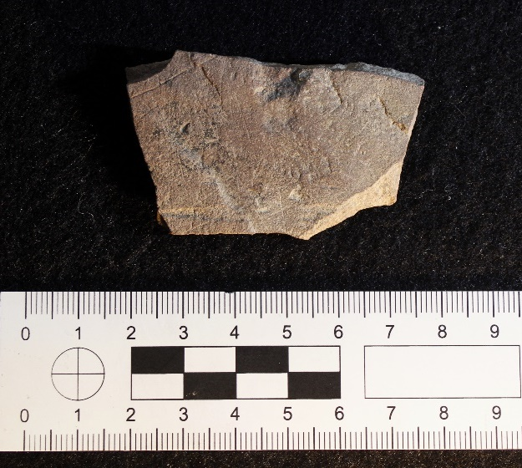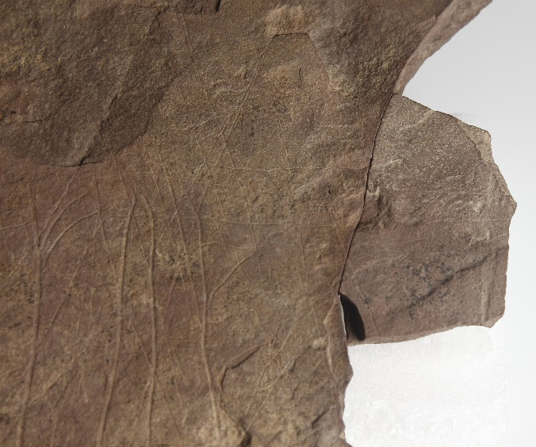
Figure S15a & S15b. Extra fragment 3 (Hole 2); aligned with the fractured edge of side A. Photo: Kristel Zilmer, MCH.
It is likely that additional matches will be established among the fragments found in 2023 as there are some that exhibit similar lines and incised shapes as Hole 2.

2.4 Six matching fragments, disturbed contexts near A1790 and A4367 (Hole 3)
After the discovery of additional fragments in August/September 2022, archaeologists examined the Svingerud site again in October 2022. The sediments beneath the sieving station and the excavated soil amidst the grave mounds A105 and A140 received extra scrutiny. A significant amount of stones had been deposited there during the excavations in 2021. Several fragments of Ringerike sandstone were discovered, some with visible markings. Two smaller fragments – one with runes, one with incised lines – could be pieced together. Examinations at MCH confirmed that these finds also matched with two larger fragments, first documented in 2021 (see below). Post-excavation analysis in February/March 2023 established that the four assembled fragments of Hole 3 were part of the same slab as Hole 1 and Hole 2, with Hole 3 fitting underneath Hole 2.
In May 2023, a small team of archaeologists returned to Svingerud and sieved through the deposited soil of the excavation area. They were equipped with an excavator for mechanical sieving of the deposited masses. The archaeologists also sieved manually in order to detect smaller fragments. A number of sandstone fragments of varying size and shape were collected. The most important find consisted of two fragments that provided missing pieces to Hole 3. At present, six fragments have been matched as components of Hole 3 (Figure S16). These are identified separately due to the find circumstances and the fact that they contain a separate runic inscription. It is unknown whether the inscriptions on Hole 2 and Hole 3 are contemporary.
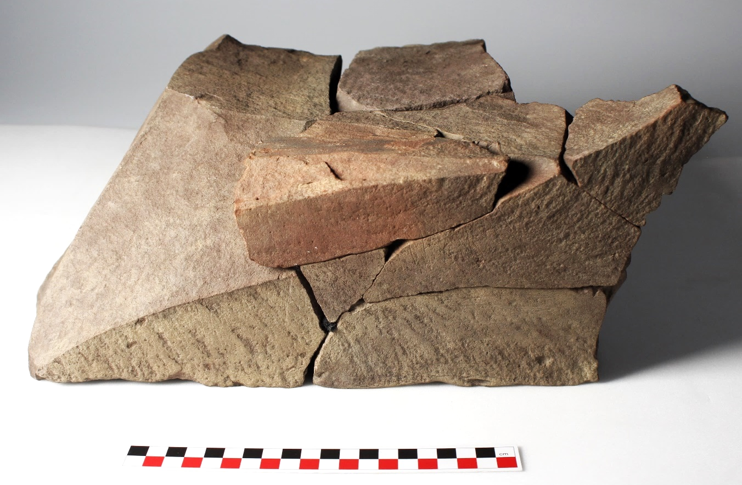
Figure S16. Hole 3, six fragments, runic inscription runs upwards along the side. Photo: Kristel Zilmer, MCH.

The six assembled fragments are as follows:
Fragment no. 1 (id. AX52029) was first documented on October 6, 2021, during the excavations (Figure S17a). The fragment was found beneath a few centimeters of sand. It was taken to MCH a year later, in October 2022, together with newly found smaller fragments. The approximate size of the fragment (measured along its flat bottom) is c. 31 cm x 18 cm; it is up to 15 cm high and weights 13.18 kg. Four to five thinly scratched runes are detectable on this fragment, placed close to its weathered upper edge.
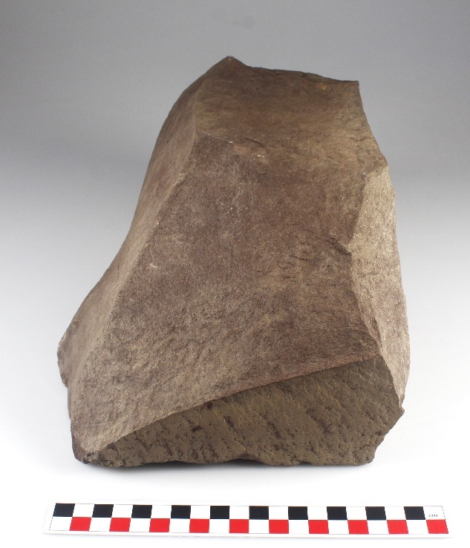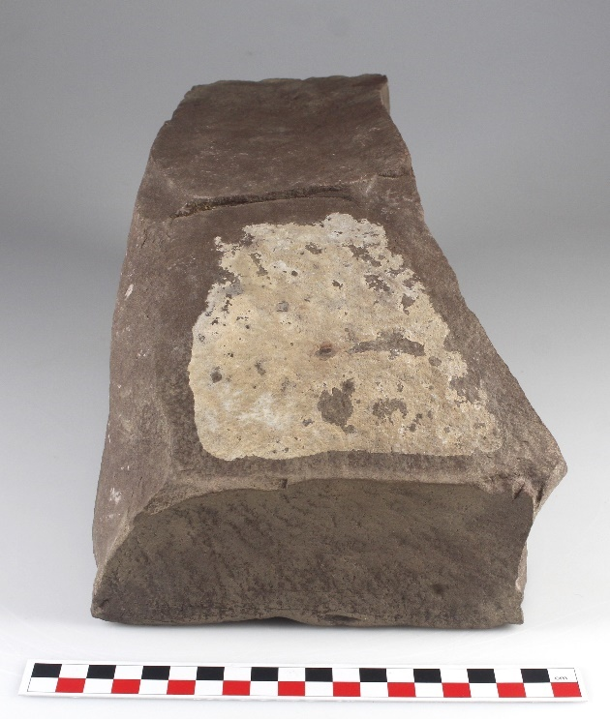
Figure S17a & S17b. Fragment 1 (AX52029, left) and Fragment 2 (AX51063, right) of Hole 3. Photo: Kristel Zilmer, MCH.
Fragment no. 2 (id. AX51063) was first documented on September 10, 2021, during the excavations (Figure S17b). This fragment was taken to MCH in November 2021, together with other samples of Ringerike sandstone. The measurements along its flat bottom are c. 31 cm x 17.8 cm; it is up to 15 cm high and weighs 12.84 kg. There are no visible markings along the side where fragment no. 1 has runes, but the opposite side has traces of incisions. These seem to align with faint marks on side D of Hole 2. The traces are unclear and too little is preserved in order to allow precise identification.
Fragment no. 3 was found on the site in October 2022 (Figure S18). The excavation documentation from 2021 does not allow us to identify its original placement. The measurements are c. 15 x 13.5 cm; height from top to bottom is around 7.3 cm, and weight is 0.91 kg. This fragment displays some remaining parts of runic staves as well as six partially or fully surviving runes and one separator mark. The runes provide the end to the inscription, which is introduced on fragment no. 1.

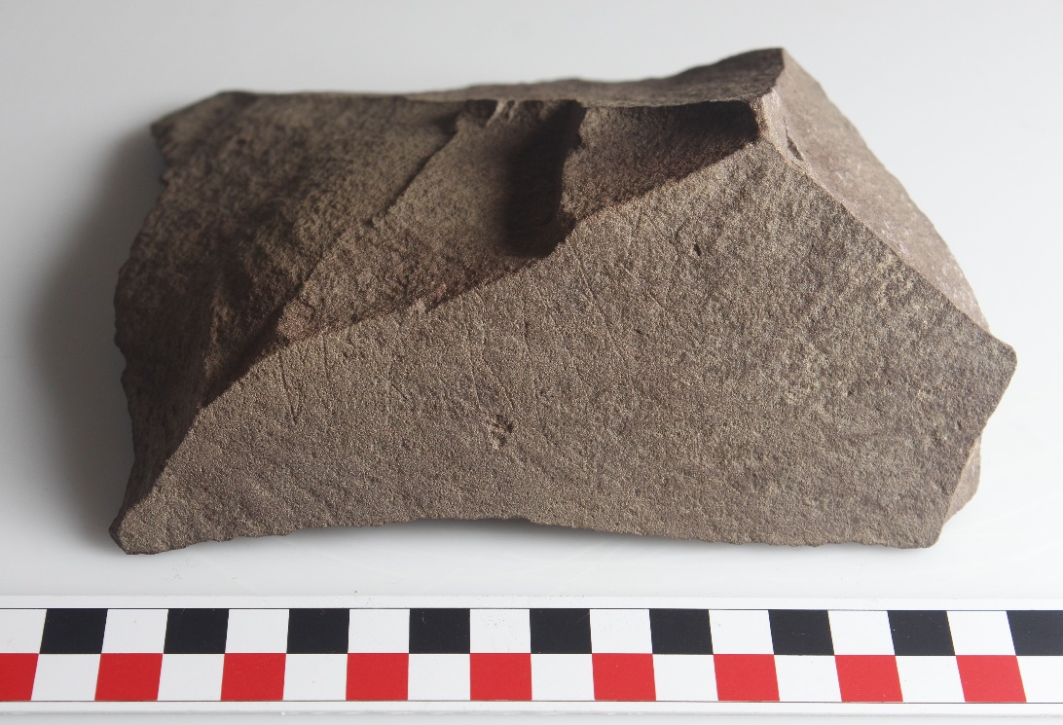
Figure S18. Fragment 3 of Hole 3. Photo: Kristel Zilmer, MCH.
Fragment no. 4 (id. AX51121) was first documented on September 10, 2021, during the excavations (Figure S19). It was detected again in October 2022 and taken to the museum. The measurements along the triangular bottom are c. 7.6 x 5.7 x 6 cm; height (upright) is around 7.4 cm, and weight is 0.16 kg. This fragment forms a top piece to fragment no. 3; it does not have any runes, but a few incised lines.
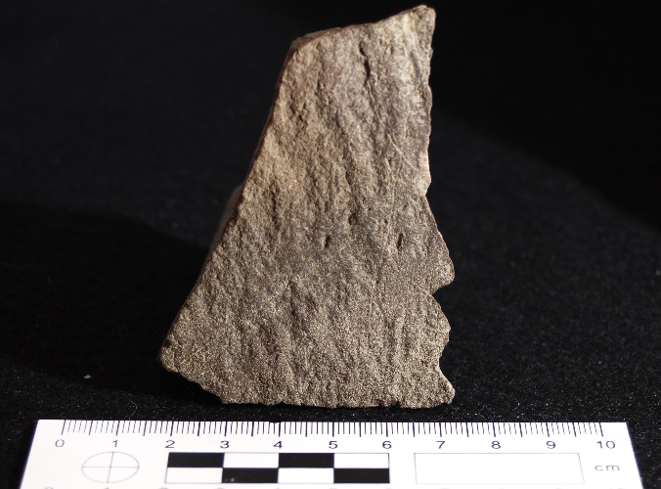
Figure S19. Fragment 4 (AX51121) of Hole 3. Photo: Kristel Zilmer, MCH.
Fragment no. 5 was found on May 3, 2023 during the sieving of soil on the site (Figure S20). It is c. 14.4 cm at its longest and 9.2 cm at its widest; thickness is up to 4 cm and weight is 0.24 kg. The V-shaped side with runes measures c. 5.7 x 4.8 x 3.9 cm. This piece fits in between the fragments 1 and 3 (resting partly upon no. 2). It displays up to five runes, together with a likely separator mark of multiple tiny dots. The tops of runes are found on fragment no. 6. The surviving traces on both fragments are weathered, causing some challenge in the identification of characters.
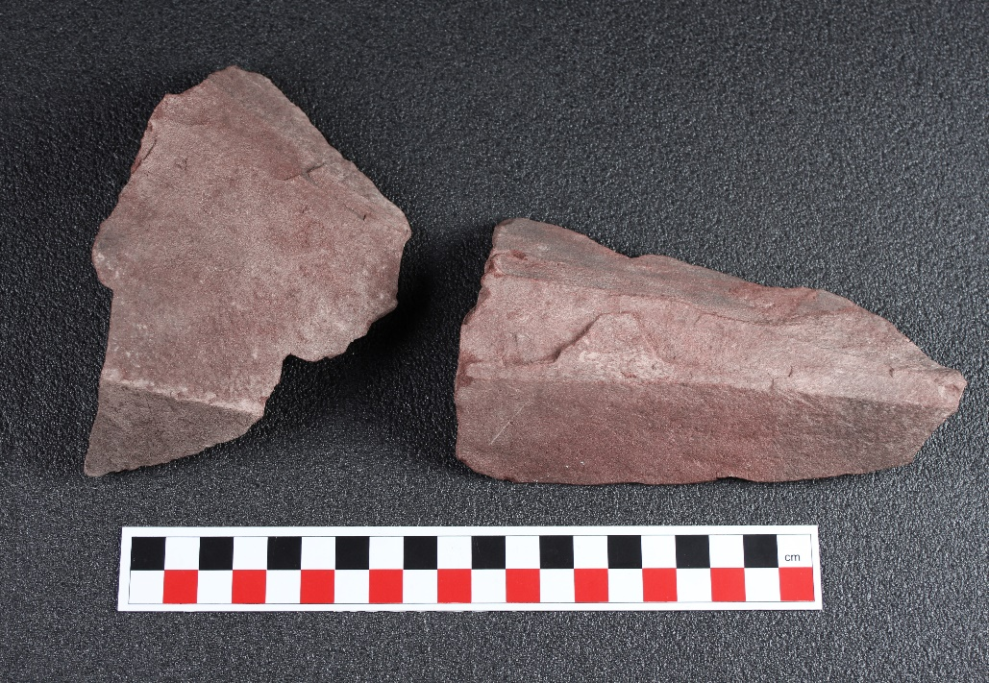
Figure S20. Fragment 5 (left) and Fragment 6 (AX51080, right) of Hole 3. Photo: Kristel Zilmer, MCH.
Fragment no. 6 (id. AX51080) was first documented in the field on September 10, 2021, and retrieved from the site on May 3, 2023 (Figure S20). It is c. 14.7 cm at its longest and c. 8.5 cm at its widest; thickness is 3.5–4 cm and weight 0.36 kg. The fragment fits above fragments no. 5 and 3 and bears the tops of several of their damaged runes. A small part is missing between these three fragments, and (at least) two runes are not fully preserved.
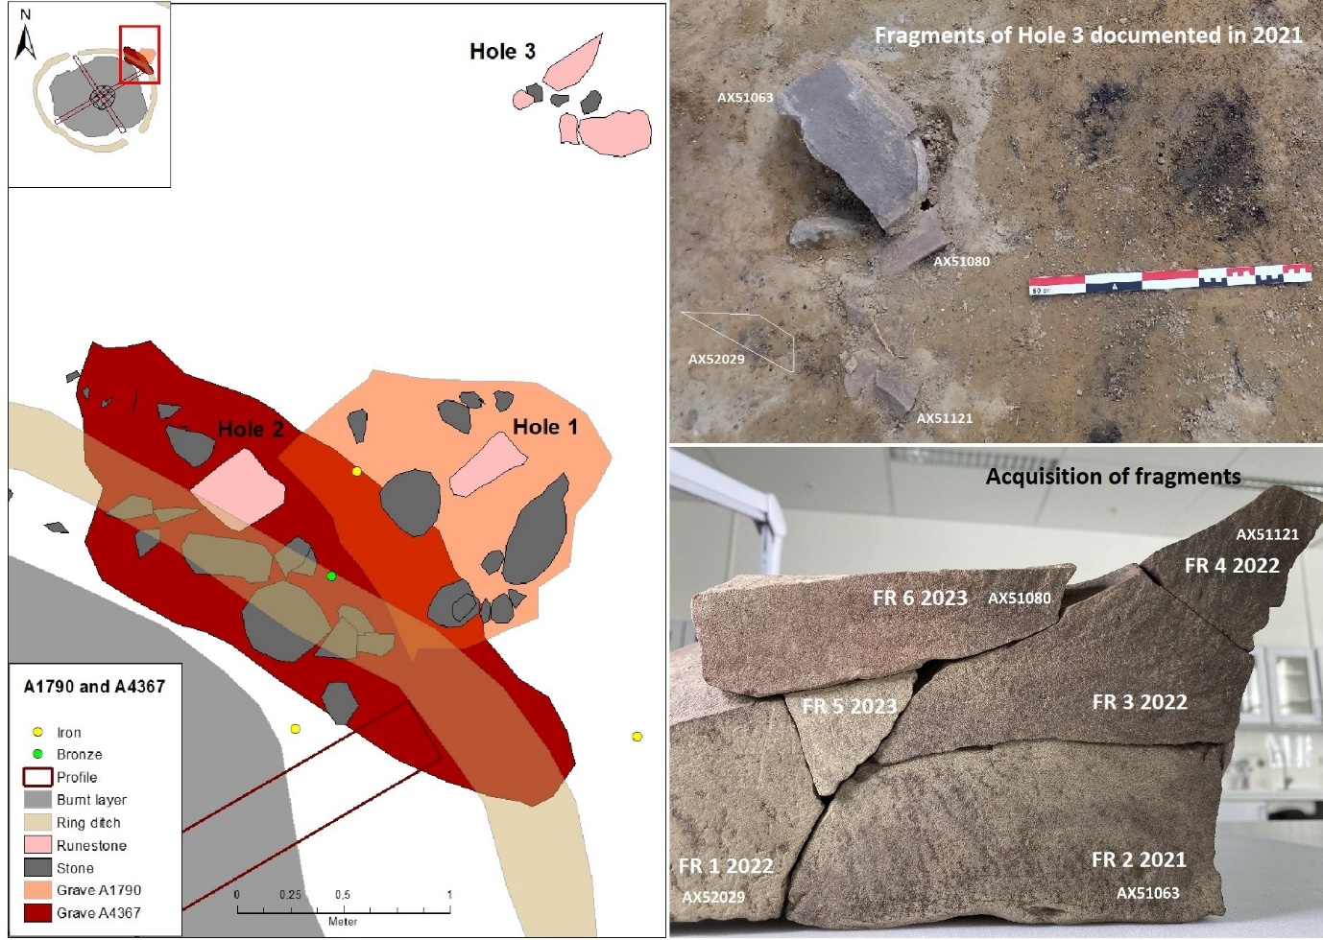
Figure S21. Find locations of Hole 1-3 and documentation of fragments of Hole 3. Map by Charlotte Nueva Finnebråten, photos by Judyta Zawalska, MCH.
The circumstances surrounding the further fragmentation of Hole 3 are unclear. As explained, some fragments were initially recorded in a disturbed context near A1790 and A4367, approximately 120 cm north-northeast from Hole 1 (Figure S21). This placement indicates that they were likely relocated from the main slab, for reasons that remain unknown.

3. Runological presentation of inscriptions
All the inscribed fragments were inspected on numerous occasions over an extended period (in the case of Hole 2 over two years), in varying conditions and with different sources of lighting and technical equipment. The inscriptions were documented with descriptive notes, sketches and photos. The runological-epigraphic autopsy formed the basis for a detailed description and assessment of the fragments and inscriptions that comprise runes, rune-like characters and other intentional markings. First-hand inspections were supplemented by close-up images of individual runic characters and other graphic elements. The images were captured with an AM7013MZT Dino-Lite microscope during the runological autopsy (Figure S22a & b; other digital documentation methods are explained in section 4). The LED light of the microscope was supplemented with external light sources, testing different angles.
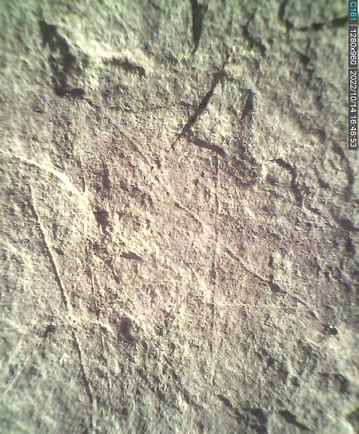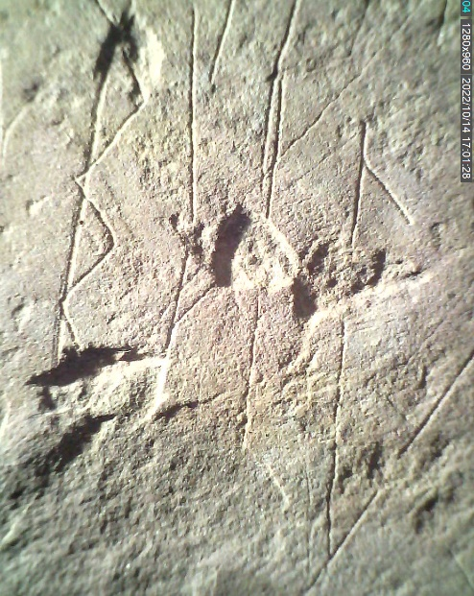
Figure S22a & S22b. Sample microscope captures of runic graphs. On the left: the final graphs of sequence 2 on Hole 2, showing an m-rune with an attached triangular element. On the right: details of sequence 3 on Hole 2, showing a possible damaged h-rune, in between b and l. Photo: Kristel Zilmer, MCH.

All the detectable marks were determined to the extent possible, taking into account various unclear features that characterise the find. The main challenges in the runological assessment were caused by shallow, faint and irregular incisions, weathered and damaged surfaces, casual execution and ambiguities of form. We have established transliterations of runic sequences to the extent possible, while also considering feasible alternatives to some identifications. The transliteration conventions used in this study are the following:
dot below character = uncertain identification due to damage, weathering or unclear outline of runic characters;
hyphen - = remains of characters that can be counted, but not securely identified;
question mark ? = ambiguous graphic elements (some may have rune-like features);
slash / = alternative identifications;
͡ = runic ligatures (bind-runes), i.e. runes that share the same vertical (stave);
colon : = different types of separator marks.
We have proposed interpretations of some sequences of runes, although those of Hole 2 pose numerous challenges. We propose that Hole 2 may feature a legible (primary) sequence (no. 1), providing a name/designation in the Ancient Nordic (AN) language. Some other sequences may have meaningful functional explanations. The inscription on Hole 3 provides a comprehensible utterance in AN. Detailed runological and linguistic assessments of all the inscriptions are provided in a separate specialised study by Zilmer & Vasshus (2023).
Additional runological commentary to Hole 2
The inscriptions on the main runic fragment are thin and have shallow grooves. Some are faint and barely visible as scratches in the surface (Figure S22a & b). Sequence no. 1 – idiberug (alternatively, idiberun/idiberu?) – on side A has the most distinctly inscribed runes, with wider grooves. These measure around 3.5–4.5 cm; the final character exceeds 5 cm; the whole sequence covers nearly 12 cm from left to right. Sequence no. 2 consists of five to six faint characters; some are identifiable as runes, while others have ambiguous rune-like features. A possible reading is: zḅb?m͡?. Two characters may repeat the b-shape present in idiberug. The first character exceeds 5 cm in height; the rest vary between 3.5–6 cm. Sequences 3 and 4 contain altogether around fourteen runes: five belong to the upper line, around nine to the bottom. The runes are smaller than elsewhere on side A, mainly 2.5–3 cm in height, with some exceptions. The proposed reading is: ^{m}/_{m͡a}zabṭ (top) and ?izb^{h}/_{ii}laes (bottom), but some identifications are uncertain. Possible links between these two lines also remain uncertain, although the placement would suggest a joints inscription that could go from top to bottom, or the other way around. Sequence no. 5 has three large characters, read as fuþ. The grooves are comparable to the runes of the first sequence. The largest character, u, is over 11 cm high. The longish sequence on side B, which goes from right to left, consists of twenty or more runes, all thinly incised (Figure S23a & b). Uneven surface features have impacted their sizes and shapes; the sizes vary between 1 and 4 cm. Some incisions are faint, and there are some unclear marks at the beginning and end of the sequence. Nineteen runes can be determined more or less clearly. The proposed transliteration is ^{s}/_{b}ehkḷgatfuṭþmdŋfiḍm???, but there are alternative identifications to consider with some characters.
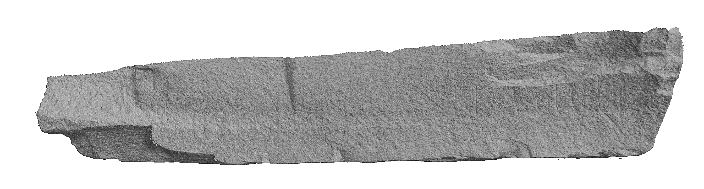
Figure S23a & S23b. Side B of Hole 2. Sample models by Justin Kimball, MCH.

Additional runological commentary to the inscription on Hole 3
Runes appear on fragments no. 1, 3, 5 and 6; some incised lines are present on fragment no. 4. The incisions are faint and shallow, like scratchings. We identify sixteen or seventeen runes; some are damaged or have an unclear shape. Additionally, there are two separator marks, both consisting of multiple vertically aligned small dots. The shallow incisions on Hole 3 resemble those of Hole 2, but some runic features differ. The inscription begins on fragment no. 1, approx. 10 cm to the right of its narrow tip. The runes run upwards along the flat side, from left to right, and cover around 19.4 cm (measured diagonally across). The presented transliteration is: ek-^{g}/_{w}ụlu:faḥido:runo. The runes on fragment no. 1 seem to have full height, measuring around 2.5–2.9 cm (the short k-rune is roughly 1 cm); the runes on other fragments are for the main part 2–3.2 cm (with a few exceptions). Some damaged staves are a few millimetres in size. Faint marks that resemble a zigzag are visible between r.2 and r.3 and may indicate an additional rune, such as s. Alternatively, this could be a third separator mark. The shape of r.3 suggests that the rune may be w or g (with a faint imprint remaining of its bottom left part); other options also have to be considered as the surface is tricky at this spot. The following rune is similarly unclear, but its most distinctly incised part looks like a pointy u. The u-shape has some surrounding lines, but these are likely casual scratches in the surface. Most of the following runes are divided between different fragments. The mid-part, with fragments 5 and 6, displays a likely l, followed by a pointy shape that may be another u, a tightly placed separator mark of multiple small dots, then f, a and a possible damaged h. Some of the incisions on fragment 5 are worn and challenging to determine. This complicates the reading of this part of the inscription, which contains a person’s name or title. The rest of the inscription (detectable on fragment no. 3, with tops on fragment no. 6) consists of a partly damaged i, followed by d, o, a separator mark, r, u, n, and o. The last rune is fully preserved on fragment 3. A tiny mark between the vertical strokes belonging to h and i on fragment 6 could suggest an extra runic stave, but it has no evident continuation on the fragment below and may be a random mark. The word separator on fragment no. 5 has around six little dots; the one on fragment no. 3 has three or possibly more dots.

4. Digital documentation of runic fragments
The runic fragments were documented utilising various 3D documentation techniques, including micro computed tomography (μCT), photogrammetry, and structured-light scanning. The main purpose of such documentation was to facilitate the runological-epigraphic examination of the fragments and explore methods for documenting inscribed objects of varying size and features. Of the three, μCT scanning proved to be the most challenging owing to the current technological limitations at the University of Oslo. Most of the runic fragments — including the primary fragment, Hole 2 — are outside of the physical capabilities of the scanner as the fragments are too large to fit inside of the cabinet and the source cannot generate sufficient power to penetrate the thickest parts of the fragments. μCT scanning, however, remains a viable method for the documentation of the runic fragments; further directions to have the rune-stone analysed via CT-methods will be explored. While μCT scanning does also document surface features of an object, the strength of the method lies in its ability to ‘see inside’ of an object (Figure S24). μCT scanning therefore provides an important resource for conservation has it can help reveal structural problems with the runic fragments and thus be utilised to develop conservation and handling strategies.
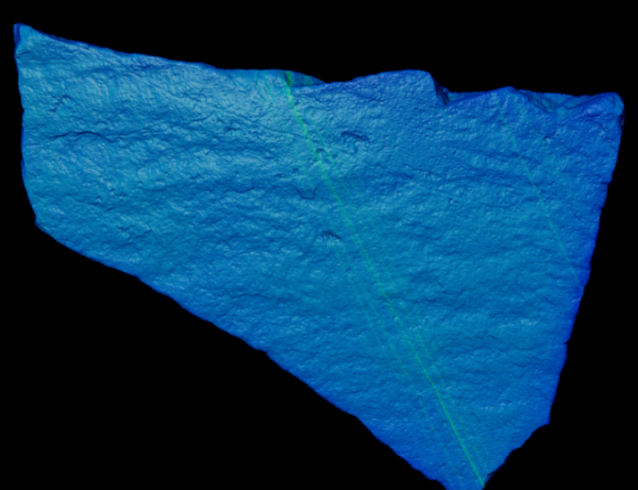
Figure S24. Sample μCT scan, fragment 4 (AX5112) of Hole 3, by Justin Kimball, MCH.
Photogrammetry was utilised to efficiently document the surfaces of the runic fragments. It also functioned to determine the amount of detail required to properly capture the incised lines that make up both the runic inscriptions and various other forms of marking. The resulting photogrammetric models were sufficient to capture all but the most superficial incisions. To achieve higher resolution for the incisions, a structured-light scanner was used. While the Museum of Cultural History owns and operates a high-quality structured-light scanner, this scanner was deployed for an intensive and time-sensitive documentation project. As such, an arrangement was made to loan a handheld structured-light scanner from the Norwegian Maritime Museum in Oslo. With this scanner, even the faintest of the incisions were discernible in the resulting 3D models. Links to a selection of 3D models from the structured-light scanning is included immediately following this paragraph. These include three of the four sides of Hole 2 (A, B and C, with most inscriptions and markings) and five of the fragments of Hole 3 (nos. 1, 2, 3, 5, 6, see explanations above) reassembled. The photogrammetric and 3D models have thus formed useful secondary resources in the runological-epigraphic examination, but, as with any form of documentation, these are intended to supplement first-hand inspections due to ambiguities of interpretation regarding the intentionality and nature of different markings. Future work will continue with the 3D documentation of the rune-stone to explore the application of individual technologies and paired technologies and how these may help to further explore the inscriptions within the framework established by the runological specialists.

Hole 2, side A:
https://3d.unimus.no/data/64d1dc4f-35da-470e-b47f-8c2db355fcb2/
Hole 2, side B:
https://3d.unimus.no/data/bce7e1ea-9ea5-4aab-9538-38fa4f38b36d/
Hole 2, side C:
https://3d.unimus.no/data/c62a3030-3c8f-4938-a378-1b30abad5978/
Hole 3, five fragments reassembled:
https://3d.unimus.no/data/d00125aa-3d3f-4e87-8b68-50986c4c4ad1/

References
Arcini, C. & O. Magnell. 2022. Osteologisk analys. Brandgravarna från Ringeriksbanen. Arkeologerna.
Bronk Ramsey, C. 2009. Bayesian analysis of radiocarbon dates. Radiocarbon 51: 337–60. https://doi.org/10.1017/S0033822200033865
Carrasco, L. 2018. Ringeriksbanen og E16 – fellesprosjektet. 17/417 – Hole og Ringerike kommune. Unpublished report for Buskerud fylkeskommune Utviklingsavdelingen.
Grieg, S. 1947. Gjermundbufunnet (Norske Oldfunn 8). Oslo: Universitetets Oldsaksamling.
Gustafson, L. 2016. Møter på Veien: kultplass gjennom 1500 år: et maktsenter på Ringerike i eldre jernalder. Oslo: Universitetet i Oslo Portal. https://doi.org/10.23865/noasp.59
Jahn, M. 1921. Der reitersporn, Seine Entstehung Und früheste Entwicklung. Poznań: Polskie Towarzystwo Prehistoryczne.
Kontny, B. & M. Natuniewicz-Sekuła. 2013. Astonishing finds in a well-known site. Newly found spurs from Weklice (the wielbark culture). Fasciculia Archaeologiae Historicae 26: 11–24.
Reimer, P.J. et al. 2020. The IntCal20 Northern Hemisphere radiocarbon age calibration curve (0–55 cal kBP). Radiocarbon 62: 725–57. https://doi.org/10.1017/RDC.2020.41
Rødsrud, C.L. 2020. Burial mounds, ard marks, and memory: a case study from the Early Iron Age at Bamble, Telemark, Norway. European Journal of Archaeology 23: 207–26. https://doi.org/10.1017/eaa.2019.74
Slomann, W. 1959. Sætrangfunnet (Norske Oldfunn 9). Oslo: Universitetets Oldsaksamling.
Solheim, S. 2020. Prosjektplan – Undersøkelse av automatisk fredete kulturminner (24 lokaliteter). Reguleringsplan for Fellesprosjektet Ringeriksbanen og E16 (FRE16). Diverse gårdere, Hole og Ringerike kommuner, Viken. Unpublished report for Kulturhistorisk museum, Universitetet i Oslo.
Zilmer, K. & K.S.K. Vasshus. 2023. Runic fragments from the Svingerud grave field in Norway. Earliest datable evidence of runic writing on stone. NOWELE: North-Western European Language Evolution 76: 233–303. https://doi.org/10.1075/nowele.00080.zil

Personal communication by Axel Müller 03.02.2022; Hans Arne Nakrem investigated the stones at MCH 10.02.2022.
Personal communication 13.09.2022 and 21.09.2022.
The Natural History Museum at the University of Oslo has a Nikon XT H 225 ST industrial μCT scanner with a Varian 4343 detector. This scanner can achieve a maximum of 225 kv with a scan surface area of 26x26 cm.
For photogrammetry a Sony A7R IV camera with a 50 mm fixed-focal length lens was used to capture the images. Agisoft’s Metashape was used to process the photogrammetric models.
GOM ATOS Q.
Artec Spyder.

