|  |  |
| --- | --- |
|  | Supplementary material for  James, N., A. Decaix, I. Villasana, J.M. Kenoyer, R.H. Meadow, G.F. Dales, S.A Weber & J. d’Alpoim Guedes. 2024. **Taphonomy and labour at the Indus site of Harappa, Pakistan (3700–1300 BC).** *Antiquity* 98.  Author for correspondence ✉ jguedes@ucsd.edu |

Contents

**1. Details on Calculations 1**

**2. Tables 2**

Table S1. Summarized counts of domesticated taxa by time period. 2

Table S2. Summarized counts of domesticated taxa by context. 3

Table S3. Individual samples containing predominantly clean grain. All whole seeds within the sample shown. 5

Table S4. Weed Categorizations & Counts 5

Table S5. Distinguishing Crop Processing and Dung Burning in the Macrobotanical Record. 7

**3. Figures. 7**

Figure S1. Proportions of cereal crops by weight. n=1144 7

Figure S2. Bar Chart of raw counts of Chaff by period. 8

Figure S3. Biplot of Large Weed:Small weed ratios by Weed:Grain ratios. n=1144 9

Figure S4. Biplot of Grain:Weed seeds by Grain:Chaff. n=1144 10

Figure S5. Biplot of Grain:Weed seeds by Grain:Chaff by context. n=1144 11

Figure S6. Triplot of grain, chaff and weed proportions by Time Period. With cf. Suaeda . n=1144 12

Figure S7. Triplot of grain, chaff and weed proportions by Context. With Suaeda n=1144 13

# Additional Acknowledgements

A dataset of this complexity would be impossible to curate without the work of many people. We are grateful for the years of careful excavation, sampling, sifting, floatation and initial sorting by members of the Harappa Archaeological Research Project, with special thanks to Heather M.-L. Miller and numerous local assistants. We also want to thank the contributions in sorting, documenting and curating samples made by numerous lab members and students. In alphabetical order: William Damitio, Jessica Devio, Laura Ellyson, Sydney Hanson, Bianca Loyola, Kat Meza, Andrew Gilreath-Brown, Wu Yaohan, You Yawei, Hao Xiaoxiao and the many other laboratory volunteers who assisted with work on this large assemblage.



# Details on Samples & Calculations

Manual flotation was performed on site by Heather M.-L. Miller and other trained local staff members as, well as by Steven A. Weber. Different botanical sampling strategies were used depending on the type of excavation and the areas being excavated. It is not possible to provide details for each sample set, but this information will be included in final area excavation reports. Floated botanical samples were exported to the USA with permission from the Department of Archaeology and Museums, Government of Pakistan. The assemblages were initially sorted and analysed by Seetha Reddy and Heather M.-L. Miller. Subsequent analysis of the samples was carried out by Steven A. Weber at Washington State University, then by the Washington State University a 2018 palaeoethnobotany class under the direction of Jade d’Alpoim Guedes. All samples were then checked by Jade d’Alpoim Guedes and Alexia Decaix at the University of California, San Diego.

Percentage ratios for each category were calculated by dividing the numerator by the sum of the two categories, multiplied by 100 (*ex:* ((A / (B+A))*100)). Percentage ratios were plotted against each other, per standard practice in crop processing models. Following Marston (2012), Jones (1987), and Fuller & Stevens (2009), cumulative weed to grain ratios were calculated for each Harappan time period. Following van der Veen (1984) and Jones (1985) trinary plots of the relative proportions of grain, chaff and weeds have been made. Sum proportions of grain, chaff and weeds have been calculated and displayed ((*ex:* ((A / (C+B+A)) *100)). Triplots are a useful addition to bivariate ratio plots as it allows the direct comparisons between the three variables. Barley, wheat, and Cerealia fragments were converted to whole grain counts by converting the total fragment weights of each category. The total count of whole barley, wheat, & Ceralia grains were first divided by the total weight those grains, this quotient was then multiplied by the categories fragment weight, creating an approximation of potential grains represented by each fragment category (e.g. (Whole Grain #/Whole Grain Weight (g)) *Fragment Grain Weight (g)=Fragment Grain #). Given that Ceralia as a category is highly charred and unidentifiable to species, and the differences between wheat and barley species, tying derived counts to each category's weight gives a bounded category specific estimate. Grain counts and proportions in figures include all Whole *Triticum*, *Hordeum*, and Cerealia as well as our calculated approximations. (Whole +Fragment estimates).

# Tables

## Table S1. Summarized counts of domesticated taxa by time period.

|  |  |  |  |  |  |  |  |
| --- | --- | --- | --- | --- | --- | --- | --- |
| **Taxa** | **Period 1** | | **Period 2** | **Period 3** | **Period 4** | **Period 5** | **Unknown** |
| ***Hordeum vulgare* Whole** | 53 | | 561 | 938 | 736 | 5 | 0 |
| ***Hordeum vulgare* hulled Whole** | 191 | | 183 | 620 | 1075 | 5 | 0 |
| ***Hordeum vulgare* var. nudum Whole** | 4 | | 40 | 1 | 0 | 0 | 0 |
| ***Hordeum vulgare* hulled asymmetrical Whole** | 1 | | 36 | 9 | 2 | 0 | 0 |
| ***Hordeum vulgare* asymmetrical Whole** | 0 | | 16 | 4 | 22 | 0 | 0 |
| ***Hordeum vulgare* hulled symmetrical Whole** | 0 | | 2 | 2 | 0 | 0 | 0 |
| ***Hordeum vulgare* rachis** | 4 | | 30 | 17 | 1 | 0 | 0 |
| ***Hordeum vulgare* hulled rachis** | 0 | | 0 | 2 | 0 | 0 | 0 |
| ***Hordeum vulgare* rachis 6 rowed naked rachis** | | 16 | 11 | 1 | 1 | 0 | 0 |
| ***Hordeum vulgare* rachis 6 rowed hulled rachis** | | 1 | 3 | 2 | 0 | 1 | 0 |
| ***Hordeum vulgare* 6 rowed rachis** | | 0 | 61 | 1 | 4 | 0 | 0 |
| ***Hordeum vulgare* 2 rowed rachis** | | 2 | 12 | 3 | 1 | 0 | 0 |
| ***Hordeum vulgare 2* rowed hulled rachis** | | 0 | 0 | 0 | 0 | 1 | 0 |
| ***Hordeum* fgmt #** | | 92 | 992 | 2147 | 1110 | 26 | 374 |
| ***Hordeum* fgmt weight (g)** | | 0.41 | 4.38 | 9.48 | 4.90 | 0.11 | 1.65 |
| ***Hordeum* estimated whole grain from fgmt #** | | 0 | 34 | 15 | 355 | 2 | 4 |
| ***Triticum aestivum*/*durum* whole** | | 0 | 39 | 247 | 7 | 0 | 0 |
| ***Triticum dioccocum* whole** | | 0 | 3 | 23 | 0 | 0 | 0 |
| ***Triticum* sp. whole** | | 0 | 19 | 23 | 14 | 0 | 0 |
| ***Triticum aestivum*/*durum* rachis** | | 0 | 0 | 7 | 0 | 0 | 0 |
| ***Triticum aestivum* rachis** | | 0 | 1 | 2 | 4 | 0 | 0 |
| ***Triticum durum* rachis** | | 0 | 0 | 2 | 0 | 0 | 0 |
| ***Triticum dioccocum rachis*** | | 0 | 24 | 0 | 0 | 0 | 0 |
| ***Triticum* 4 rowed rachis** | | 0 | 0 | 0 | 0 | 0 | 0 |
| ***Triticum* sp. Rachis** | | 0 | 1 | 4 | 1 | 0 | 0 |
| ***Triticum* fgmt #** | | 0 | 1 | 38 | 57 | 4 | 0 |
| ***Triticum* fgmt weight (g)** | | 0.00 | 0.00 | 0.29 | 0.51 | 0.27 | 0.00 |
| ***Triticum* estimated whole grain from fgmt #** | | 0 | 1 | 39 | 69 | 36 | 1 |
| **Cerealia Whole** | | 28 | 41 | 169 | 440 | 39 | 12 |
| **Cerealia fgmt weight (g)** | | 0.85 | 0.80 | 8.07 | 30.17 | 2.17 | 0.30 |
| **Cerealia estimated whole grain from fgmt #** | | 354 | 335 | 3381 | 12642 | 908 | 125 |
| **cf. *Oryza*** | | 0 | 0 | 1 | 1 | 0 | 0 |
| ***Setaria pumila*** | | 15 | 203 | 9435 | 9 | 0 | 0 |
| ***Setaria* sp.** | | 3 | 6 | 229 | 0 | 0 | 0 |
| ***Eragrostis sp.*** |  | 6 | 11 | 13 | 1 | 0 | 0 |
| ***Paspalum sp.*** |  | 0 | 0 | 2 | 0 | 0 | 0 |
| ***Lens culinaris*** | | 1 | 89 | 27 | 6 | 0 | 0 |
| ***Pisum/Lens*** | | 0 | 4 | 15 | 0 | 0 | 0 |
| ***Pisum sativum*** | | 2 | 17 | 22 | 0 | 1 | 0 |
| **cf. *Pisum*** | | 0 | 0 | 0 | 0 | 0 | 0 |
| **cf. *Lathyrus*** | | 0 | 3 | 8 | 0 | 0 | 0 |
| ***Pisum/Vicia*** | | 0 | 1 | 30 | 0 | 0 | 0 |
| **cf. *Vigna unguiculata*** | | 0 | 2 | 2 | 0 | 0 | 0 |
| **cf. *Vigna* sp.** | | 0 | 43 | 60 | 0 | 0 | 0 |
| ***Cicer* sp.** | | 0 | 0 | 0 | 0 | 0 | 0 |
| ***Cajanus* sp. Fragment** | | 0 | 0 | 3 | 0 | 0 | 0 |
| ***Acacia/Mimosa*** | | 3 | 3 | 25 | 5 | 1 | 0 |
| **cf. *Linum*** | | 0 | 5 | 6 | 0 | 0 | 0 |
| **cf. *Sesamum*** | | 0 | 5 | 8 | 2 | 1 | 0 |
| ***Sesamum*/*Linum*** | | 1 | 11 | 4 | 3 | 0 | 0 |
| ***Capparis* sp. Whole** | | 0 | 2 | 0 | 0 | 0 | 0 |
| ***Praecitrillus* sp.** | | 0 | 1 | 0 | 0 | 0 | 0 |
| ***Cucumis* sp.** | | 0 | 0 | 10 | 0 | 0 | 0 |
| ***Cucumis* cf*. melo*** | | 0 | 0 | 13 | 0 | 0 | 0 |
| ***Cucumis* cf. *sativa*** | | 0 | 0 | 0 | 0 | 0 | 0 |
| ***Gossypium* sp. Whole** | | 3 | 1 | 101 | 0 | 0 | 0 |
| ***Phoenix dactylifera* frgmt** | | 0 | 0 | 3 | 3 | 0 | 0 |
| ***Vitis*** | | 0 | 5 | 32 | 0 | 0 | 0 |
| **cf. *Vitis* fruit** | | 0 | 0 | 1 | 0 | 0 | 0 |
| ***Cordia* sp. Fragment** | | 0 | 0 | 74 | 0 | 0 | 0 |
| **cf. *Brassicaceae*** | | 0 | 2 | 0 | 0 | 0 | 0 |
| ***Brassica/Raphanus*** | | 0 | 0 | 1 | 0 | 0 | 0 |
| **cf. *Sisymbrium*** | | 1 | 0 | 0 | 1 | 0 | 0 |
| ***Ziziphus*** | | 2 | 14 | 5 | 0 | 0 | 0 |

## 

## 

## Table S2. Summarized counts of domesticated taxa by context.

|  | **Burial Contexts** | **Ceramic Fill** | **Hearth** | **Kiln** | **Oven** | **Pit** | **Room & Floor Fill** | **Street, Drain, Secondary** | **Unknown** |
| ***Hordeum vulgare* Whole** | 0 | 26 | 132 | 1 | 9 | 326 | 1023 | 677 | 61 |
| ***Hordeum vulgare* hulled Whole** | 0 | 10 | 59 | 3 | 0 | 53 | 1872 | 22 | 6 |
| ***Hordeum vulgare* var. nudum Whole** | 0 | 0 | 0 | 0 | 0 | 0 | 45 | 0 | 0 |
| ***Hordeum vulgare* hulled asymmetrical Whole** | 0 | 2 | 3 | 0 | 0 | 1 | 37 | 1 | 4 |
| ***Hordeum vulgare* asymmetrical Whole** | 0 | 2 | 2 | 0 | 0 | 3 | 35 | 0 | 0 |
| ***Hordeum vulgare* hulled symmetrical Whole** | 0 | 0 | 0 | 0 | 0 | 1 | 2 | 0 | 1 |
| ***Hordeum vulgare* rachis** | 0 | 1 | 1 | 0 | 0 | 5 | 37 | 0 | 7 |
| ***Hordeum vulgare* hulled rachis** | 0 | 0 | 0 | 0 | 0 | 1 | 1 | 0 | 0 |
| ***Hordeum vulgare* rachis 6 rowed naked rachis** | 0 | 0 | 8 | 0 | 0 | 0 | 14 | 0 | 3 |
| ***Hordeum vulgare* rachis 6 rowed hulled rachis** | 0 | 0 | 1 | 0 | 0 | 0 | 6 | 0 | 0 |
| ***Hordeum vulgare* 6 rowed rachis** | 0 | 1 | 0 | 0 | 0 | 1 | 60 | 0 | 4 |
| ***Hordeum vulgare* 2 rowed rachis** | 0 | 0 | 1 | 0 | 0 | 1 | 13 | 2 | 1 |
| ***Hordeum vulgare 2* rowed hulled rachis** | 0 | 0 | 1 | 0 | 0 | 0 | 0 | 0 | 0 |
| ***Hordeum* fgmt #** | 0 | 10 | 219 | 3 | 4 | 257 | 2313 | 1160 | 375 |
| ***Hordeum* fgmt weight (g)** | 0.00 | 0.03 | 1.71 | 0.01 | 0.02 | 1.03 | 11.98 | 4.23 | 2.10 |
| ***Hordeum* estimated whole grain # from fgmt** | 0 | 34 | 355 | 2 | 4 | 194 | 2729 | 986 | 15 |
| ***Triticum aestivum*/*durum* whole** | 0 | 4 | 26 | 0 | 5 | 115 | 108 | 32 | 3 |
| ***Triticum dioccocum* whole** | 0 | 3 | 2 | 0 | 0 | 4 | 14 | 3 | 0 |
| ***Triticum* sp. whole** | 0 | 4 | 5 | 0 | 0 | 5 | 24 | 13 | 4 |
| ***Triticum aestivum*/*durum* rachis** | 0 | 0 | 0 | 0 | 0 | 3 | 3 | 0 | 1 |
| ***Triticum aestivum* rachis** | 0 | 0 | 1 | 0 | 0 | 0 | 6 | 0 | 0 |
| ***Triticum durum* rachis** | 0 | 0 | 0 | 0 | 0 | 0 | 2 | 0 | 0 |
| ***Triticum dioccocum rachis*** | 0 | 0 | 0 | 0 | 0 | 0 | 21 | 0 | 3 |
| ***Triticum* 4 rowed rachis** | 0 | 0 | 0 | 0 | 0 | 0 | 0 | 0 | 0 |
| ***Triticum* sp. Rachis** | 0 | 0 | 2 | 0 | 0 | 0 | 2 | 1 | 1 |
| ***Triticum* fgmt #** | 0 | 2 | 8 | 0 | 1 | 32 | 51 | 6 | 0 |
| ***Triticum* fgmt weight (g)** | 0 | 0.25 | 0.04 | 0 | 0.01 | 0.22 | 0.47 | 0.08 | 0 |
| ***Triticum* estimated whole grain # from fgmt** | 0 | 34 | 6 | 0 | 1 | 30 | 64 | 11 | 0 |
| **Cerealia Whole** | 0 | 6 | 220 | 23 | 0 | 37 | 1762 | 1268 | 14 |
| **Cerealia fgmt weight (g)** | 0 | 3 | 4.86 | 0.10 | 0.34 | 5.71 | 20.54 | 6.87 | 0.23 |
| **Cerealia estimated whole grain # from fgmt** | 0 | 1258 | 2035 | 42 | 144 | 2392 | 8607 | 2880 | 96 |
| **cf. *Oryza*** | 0 | 0 | 0 | 0 | 0 | 1 | 1 | 0 | 0 |
| ***Setaria pumila*** | 0 | 0 | 1 | 0 | 0 | 9618 | 34 | 0 | 0 |
| ***Setaria* sp.** | 0 | 0 | 221 | 0 | 0 | 3 | 6 | 8 | 0 |
| ***Paspalum sp.*** | 0 | 0 | 0 | 0 | 0 | 2 | 0 | 0 | 0 |
| ***Eragrostis* sp.** | 0 | 1 | 2 | 0 | 0 | 9 | 19 | 0 | 0 |
| ***Lens culinaris*** | 0 | 1 | 1 | 0 | 3 | 21 | 91 | 4 | 1 |
| ***Pisum/Lens*** | 0 | 0 | 3 | 0 | 0 | 15 | 1 | 0 | 0 |
| ***Pisum sativum*** | 0 | 0 | 6 | 0 | 0 | 14 | 18 | 1 | 2 |
| **cf. *Pisum*** | 0 | 0 | 0 | 0 | 0 | 1 | 10 | 1 | 2 |
| **cf. *Lathyrus*** | 0 | 0 | 1 | 0 | 0 | 3 | 7 | 0 | 0 |
| **Pisum/Vicia** | 0 | 0 | 0 | 0 | 0 | 12 | 4 | 0 | 15 |
| **cf. *Vigna unguiculata*** | 0 | 0 | 0 | 0 | 0 | 2 | 2 | 0 | 0 |
| **cf. *Vigna* sp** | 0 | 0 | 0 | 0 | 0 | 56 | 46 | 0 | 1 |
| ***Cicer* sp.** | 0 | 0 | 0 | 0 | 0 | 1 | 0 | 0 | 1 |
| ***Cajanus* sp. Fragment** | 0 | 0 | 0 | 0 | 0 | 3 | 0 | 0 | 0 |
| **cf *Acacia/Mimosa*** | 0 | 0 | 0 | 24 | 0 | 0 | 1 | 9 | 0 |
| **cf. *Linum*** | 0 | 0 | 0 | 0 | 3 | 9 | 0 | 0 | 15 |
| **cf. *Sesamum*** | 0 | 0 | 3 | 0 | 0 | 8 | 4 | 1 | 0 |
| ***Sesamum*/*Linum*** | 0 | 0 | 2 | 0 | 0 | 5 | 8 | 0 | 4 |
| ***Capparis* sp. Whole** | 0 | 0 | 0 | 0 | 0 | 1 | 1 | 0 | 0 |
| ***Praecitrillus* sp.** | 0 | 0 | 0 | 0 | 0 | 0 | 1 | 0 | 0 |
| ***Cucumis* sp.** | 0 | 0 | 0 | 0 | 1 | 9 | 0 | 0 | 0 |
| ***Cucumis* cf*. melo*** | 0 | 0 | 0 | 0 | 0 | 13 | 0 | 0 | 0 |
| ***Cucumis* cf. *sativa*** | 0 | 0 | 0 | 0 | 0 | 0 | 0 | 0 | 0 |
| ***Gossypium* sp. Whole** | 0 | 0 | 1 | 0 | 0 | 93 | 9 | 0 | 0 |
| ***Phoenix dactylifera* frgmt** | 0 | 0 | 0 | 0 | 0 | 2 | 1 | 3 | 0 |
| ***Vitis*** | 0 | 0 | 0 | 0 | 0 | 2 | 30 | 1 | 4 |
| **cf. *Vitis* fruit** | 0 | 0 | 0 | 0 | 0 | 1 | 0 | 0 | 0 |
| ***Cordia* sp. Fragment** | 0 | 0 | 2 | 0 | 0 | 72 | 0 | 0 | 0 |
| cf. ***Brassicaceae*** | 0 | 0 | 0 | 0 | 0 | 0 | 2 | 0 | 2 |
| ***Brassica/Raphanus*** | 0 | 0 | 0 | 0 | 0 | 1 | 0 | 0 | 0 |
| cf. ***Sisymbrium*** | 0 | 1 | 0 | 0 | 0 | 1 | 0 | 0 | 0 |
| ***Ziziphus*** | 0 | 0 | 16 | 0 | 0 | 4 | 0 | 1 | 0 |

## 

## Table S3. Individual samples containing predominantly clean grain. All whole seeds within the sample shown.

|  |  |  |  |  |  |  |  |
| --- | --- | --- | --- | --- | --- | --- | --- |
| **SampleID#** | **Feature#** | **Time Period** | ***Hordeum vulgare* whole** | ***Hordeum vulgare* hulled whole** | ***Triticum* sp. whole** | **Cerealia whole** | **Weed Seeds** |
| 4159 | 166 | 3B/C | 6 | 0 | 0 | 764 | 1 |
| 8023 | 791 | 3B/C | 1 | 0 | 0 | 393 | 0 |
| 9815 | 422 | 3C | 0 | 325 | 0 | 281 | 0 |
| 9816 | 423 | 3C/4/5 | 376 | 0 | 9 | 1 | 0 |
| 9818 | 425 | 3C/4/5 | 92 | 696 | 2 | 0 | 0 |

## 

## Table S4. Weed Categorizations & Counts

|  |  |  |  |
| --- | --- | --- | --- |
| **LARGE WEEDS** |  |  |  |
| cf. *Aegilops* | 6 | *Buglossoides arvensis* | 3 |
| cf. *Abutilon* | 1 | cf. *Cephalaria* | 6 |
| Unidentified type *Abutilon* | 1 | *Liliaceae* | 6 |
| *Avena* cf. *fatua* | 10 | *Vicia* sp. | 65 |
| cf. *Bromus* sp. | 43 |  |  |
|  |  |  |  |
| **SMALL WEEDS** |  |  |  |
| Amaranthaceae | 1 | Polygonaceae/Cyperaceae | 15 |
| cf. *Astragalus* | 31 | Polygonaceae cf. *Persicaria* | 3 |
| Caryophyllaceae | 56 | *Polygonum/Fallopia* large | 1 |
| Caryophyllaceae cf. *Saponaria* type | 1 | *Polygonum/Fallopia* small | 12 |
| cf. *Cenchrus* | 1 | *Salsola* type | 6 |
| *Suaeda* | 7428 | cf. small Fabaceae (*Medicago/Meliotus/ Trifolium*) | 1873 |
| *Chenopodium* large | 159 | small Fabaceae fragments | 25 |
| Chenopodium fragments | 57 | small Fabaceae no *Medicago* no *Astragalus* | 1 |
| Chenopodiaceae-Amaranthaceae perisperm | 45 | cf. *Scirpus* | 1 |
|  |  | *Scleria* | 70 |
| Chenopodiaceae-Amaranthaceae | 148 | cf. *Scleria* | 22 |
| *Cleome* | 2 | *Scleria* fragments | 35 |
| Cyperaceae | 345 | *Trianthema portulacastrum* | 93 |
| cf. Cyperaceae | 4 | *Trianthema* cf. *portulacastrum* | 15 |
| Cyperaceae type A *Bolboschoenus* glaucus | 26 | *Trianthema triquetra* | 964 |
| Cyperaceae type A fragments *Bolboschoenus* glaucus | 1 | *Trianthema* cf. *triquetra* | 5 |
| Cyperaceae type B cf. *Schoenoplectus* sp. | 66 | *Trianthema triquetra* fragments | 22 |
| cf. Cyperaceae type B cf. *Schoenoplectus* sp. | 4 | *Trianthema* sp. | 205 |
| Cyperaceae type B/D | 139 | cf. *Trianthema* sp. | 10 |
| Cyperaceae type C *Eleocharis* large | 26 |
| Cyperaceae type C fragments *Eleochari*s | 3 | *Vaccaria* type | 7 |
| Cyperaceae type D cf. *Carex* sp. small type | 226 | Ranunculaceae | 1 |
| Cyperaceae type E cf. *Eleochari*s small type | 17 | Unidentified #67 (Whorl) *Salsola* species | 5 |
| Cyperaceae type F *Eleocharis* Medium | 61 | Wild Poaceae | 1 |
|  |  | Unidentified tiny Poaceae | 48 |
| Cyperaceae type 3? | 1 | *Digitaria* sp. | 89 |
| Cyperaceae type G *Schoenoplectus supinus* | 11 | cf. *Imperata* | 46 |
| Cyperaceae type H *Cyperus* sp. | 411 | *Festuca* | 11 |
|  |  | *Chloris* sp | 18 |
| Cyperaceae type I | 2 | cf. *Chloris* | 68 |
| Cyperaceae embryo | 3 | *Lolium* cf*. temulentum* | 9 |
| Cyperaceae cotyledon | 753 | *Lolium* cf*. remotum* | 4 |
| cf Cyperaceae cotyledon | 16 | *Lolium perenne*/*rigidum* | 7 |
| Cyperaceae type cotyledon | 22 | cf. *Denebra*/*Leptochloa* | 8 |
|  |  | cf. *Arrehenatherum* | 4 |
| *Eleusine indica* | 2 | cf. *Bolboschoenus* cotyledon | 1 |
| cf. *Fimbristylis* | 2 | cf. *Celosia* | 3 |
| *Fimbristylis* | 621 | cf. *Saccharum* | 1 |
| *Galium* sp. | 1 | *Arundo* spp. | 3 |
| cf. *Heliotropium* fragment | 1 | *Eremopyrum* cf. *bonaepartis* | 1 |
| *Medicago* sp. | 37 | *Andropogon* | 1 |
| Poaceae | 155 | cf. *Cynodon* sp. | 3 |
| cf. *Lolium* | 15 | cf. *Phragmites* | 12 |
| cf. *Poaceae* | 7 | *Phalaris* | 1 |
| Tiny Poaceae | 7 | cf. *Dactyloctenium* | 1 |
| Small Poaceae | 10 | Panicoideae | 1704 |
| Undet tiny Poaceae fragments | 10 | *Setaria verticillata* | 52 |
| Undet wild Poaceae fragment | 40 |  |  |
| Polygonaceae/Cyperaceae perisperm | 1 |  |  |
| Polygonaceae internal | 1 |  |  |

## .

## Table S5. Samples & contexts containing evidence of dung.

|  |  |  |  |  |  |  |  |  |  |  |  |
| --- | --- | --- | --- | --- | --- | --- | --- | --- | --- | --- | --- |
| **SampleID** | **FeatureID** | **Time Period** | **Context Category** | **From HARP Field Notes** | **Dung identified in Samples** | **Small Weeds (all)** | **Large Weeds** | **Crop Processing Debris** | **Barley (whole)** | **Wheat (whole)** | **Cerealia (est. whole)** |
| 9549 | 481 | Period 1 | Room & Floor Fill | "black ashy dump" "some grey silt" -2000 | Yes | 283 | 0 | 2 | 1 | 0 | 11 |
| 9550 | 482 | Period 1 | Room & Floor Fill | "black ashy dump" "some grey silt" -2000 | Yes | 766 | 0 | 4 | 6 | 0 | 38 |
| 9565 | 501 | Period 1 | Room & Floor Fill | "Yellow-brown silty layer above red burned layer" -2000 | Yes | 14 | 0 | 0 | 0 | 0 | 3 |
| 9590 | 528 | Period 1 | Room & Floor Fill | "red burn wash above white ashy layer" -2000 | Yes | 0 | 0 | 0 | 0 | 0 | 0 |
| 11034 | 684 | Period 1 | Room & Floor Fill | "compact mottled white ashy floor" -2000 | Yes | 73 | 0 | 0 | 2 | 0 | 16 |
| 1053 | 700 | Period 2 | Hearth | "burned orange substance with straw impressions which appear to be cow dung patties, possibly used as fuel for the hearth" -1989 | No | 48 | 0 | 0 | 9 | 1 | 19 |
| 8980 | 197 | Period 2 | Hearth | "white ash and red burned in top of hearth" - 2000 | Yes | 4 | 0 | 0 | 0 | 1 | 22 |
| 1168 | 325 | Period 2 | Room & Floor Fill | "Burnt area" -1990 | Yes | 3 | 1 | 0 | 5 | 0 | 131 |
| 1175 | 332 | Period 2 | Room & Floor Fill | "charcoal ash" -1990 | Yes | 12 | 0 | 0 | 11 | 0 | 0 |
| 9508 | 434 | Period 2 | Hearth | "white ash in hearth" -2000 | Yes | 2 | 0 | 0 | 0 | 0 | 4 |
| 11008 | 658 | Period 2 | Ceramic Fill | "fill in pot… with lots of charcoal" -2000 | Yes | 15 | 0 | 1 | 8 | 0 | 103 |
| 2009 | 513 | Period 3 | Kiln | "Ashy dump in front of kiln" -1989 | Yes | 3 | 0 | 0 | 7 | 0 | 29 |
| 3271 | 264 | Period 3 | Pit | "ashy fill in pit" -1990 | Yes | 4 | 0 | 0 | 2 | 0 | 25 |
| 3065 | 73 | Period 3 | Street, Drain Fill, Secondary Deposits | "green stained compact mottled silt" -1990 | Yes | 1 | 0 | 0 | 0 | 1 | 0 |
| 3271 | 264 | Period 3 | Pit | "ashy fill in pit" -1990 | Yes | 4 | 0 | 0 | 2 | 0 | 25 |

## Table S6. Distinguishing crop processing and dung burning in the macrobotanical record.

|  |  |
| --- | --- |
| **Dung Burning Indicators** | **Crop Processing Indicators** |
| Extremely high cumulative weed to grain ratios in secondary refuse contexts. | Variable ratios of grain to chaff depending on settlement size or function. |
| The high representation of weed species related to foddering or grazing. | Variable ratios of large to small weeds. |

# Figures.

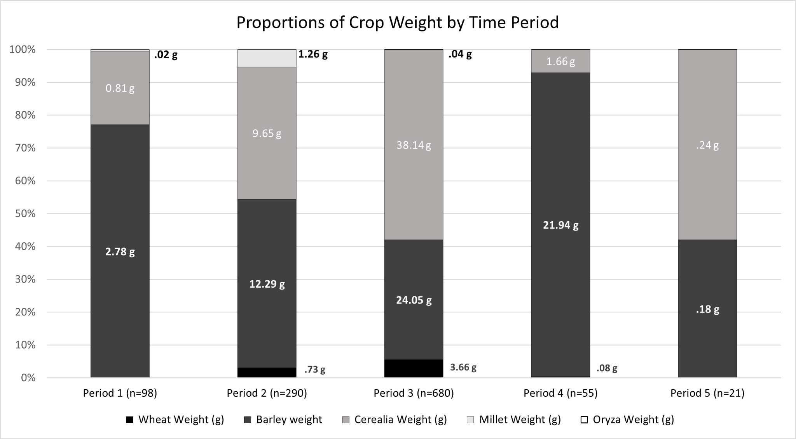

## *Figure S1. Proportions of cereal crops by weight. n=1144 Includes all weights of all whole and fragmented listed taxa. Cumulative weight of all crops listed by time period. Barley is far more ubiquitous than other taxa in the assemblage, and it is presumed most Cerealia is likely barley. n=1144.*

## *Figure S2. Bar Chart of raw counts of Chaff by period.*

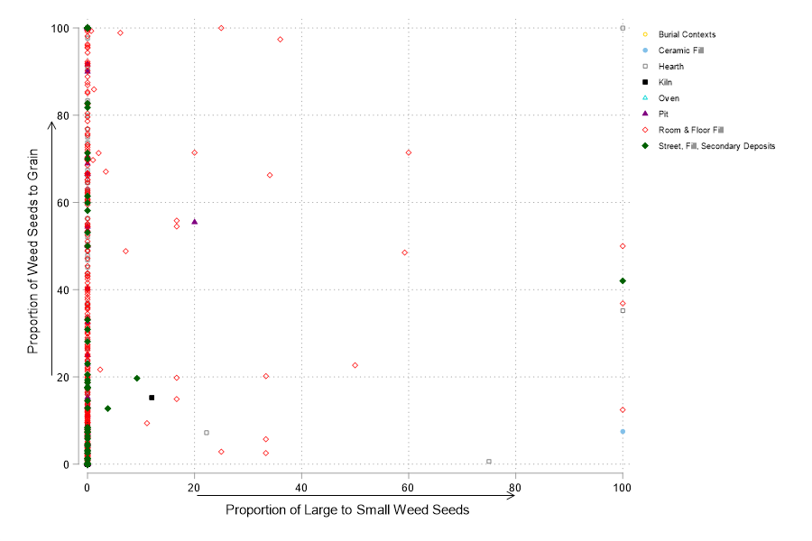

## *Figure S3. Biplot of Large Weed:Small weed ratios by Weed:Grain ratios by context. n=1144*

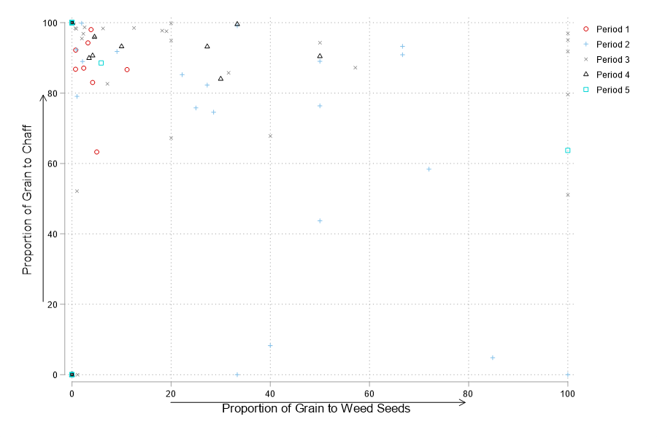

## *Figure S4. Biplot of Grain:Weed seeds by Grain:Chaff by time. n=1144*

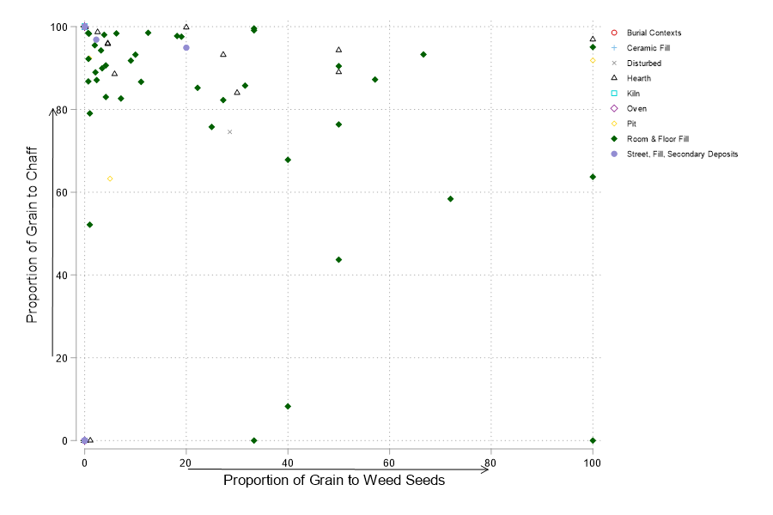

## *Figure S5. Biplot of Grain:Weed seeds by Grain:Chaff by context. n=1144*

## *Figure S6. Triplot of grain, chaff and weed proportions by Time Period. With cf. Suaeda. n=1144*

## *Figure S7. Triplot of grain, chaff and weed proportions by Context. With cf. Suaeda. n=1144*

**References**

Fuller, D.Q. & C.J. Stevens. 2009 Agriculture and the development of complex societies: an archaeobotanical agenda, in A. Fairbairn & E. Weiss (ed.) *From foragers to farmer: papers in honour of Gordon Hillman*: 36-57. Oxford: Oxbow.   
Jones, G. 1987. A statistical approach to the archaeological identification of crop processing. *Journal of Archaeological Science* 14: 311–23.  
Jones, M. 1985. Archaeobotany beyond subsistence reconstruction, in G. Barker & C. Gamble (ed.) *Beyond domestication in prehistoric Europe*: 107–28. Orlando: Academic.  
Marston, J.M. 2012. Agricultural strategies and political economy in ancient Anatolia. *American Journal of Archaeology* 116: 377–403. https://doi.org/10.3764/aja.116.3.0377  
van der Veen, M. 1984. Sampling for seeds, in W.V. Zeist & W. Casparie (ed.) *Plants and ancient man*: 193–200. Rotterdam: A.A. Balkema.