 | Supplementary material for  Kelley, K., M. Cartolano & S. Ferrara. 2024. Seals and signs: tracing the origins of writing in ancient south-west Asia. Antiquity 99.  Author for correspondence ✉ s.ferrara@unibo.it

Appendix 1: Vessels in a Net and/or Fringed Cloths - Seal Motifs
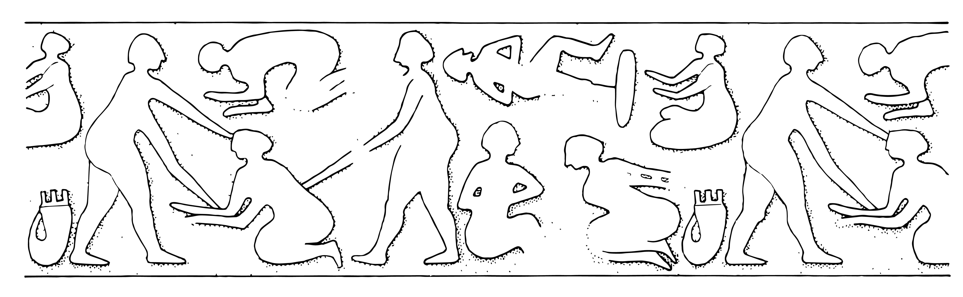
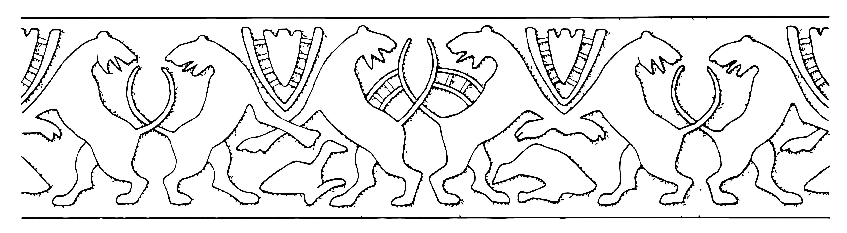
Pre-literate Finds
Nr. 17 sealing
Nr. 9 sealing
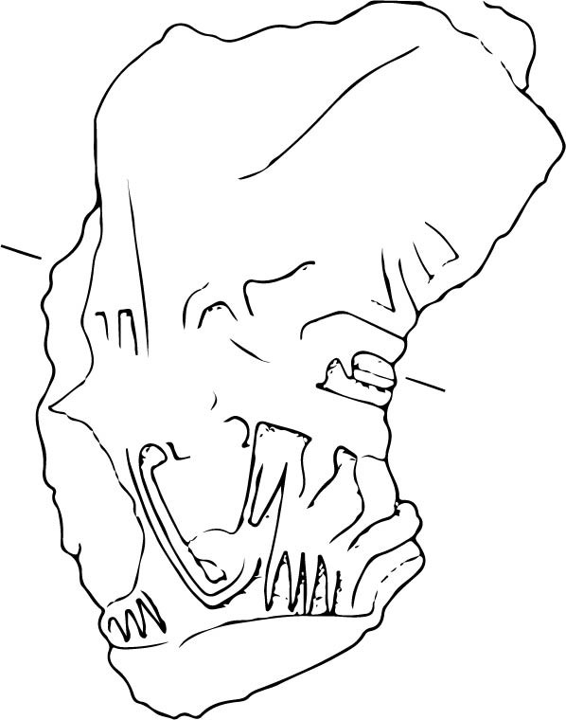
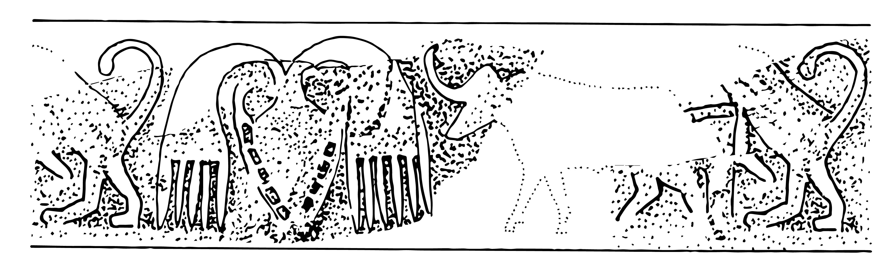
Nr. 23 sealing
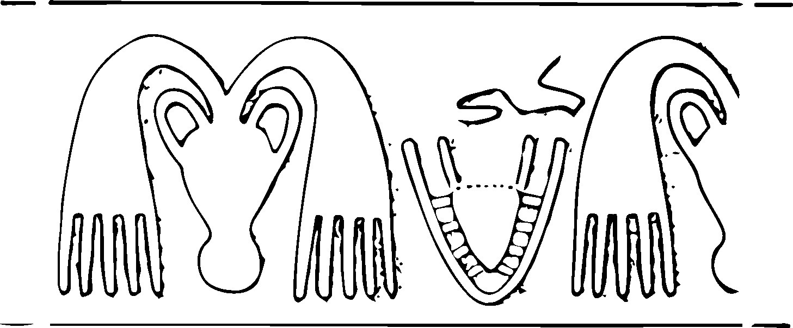
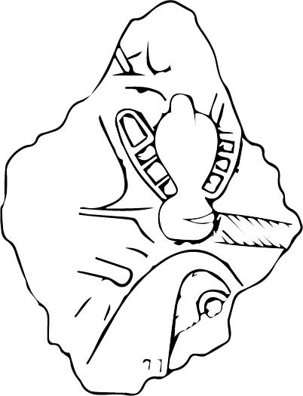
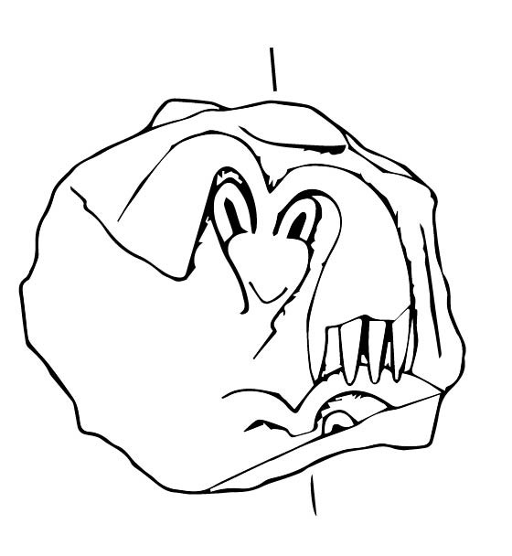
Nr. 25 sealing
Nr. 24 sealing

Nr. 26 sealing
Nr. 27 sealing

Uruk - Eanna precinct - Uruk V (Boehmer 1999)

Pre-literate Finds
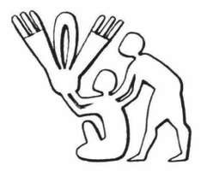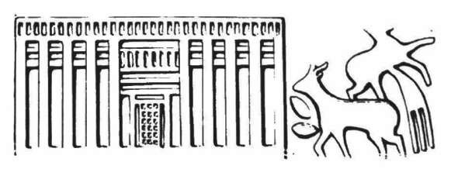
2067.1 sealing
2130.4 bulla
2130.3 sealing
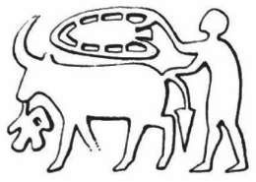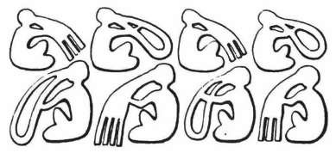
2162.2 bulla 2128.2 tablet
2130.1 bulla
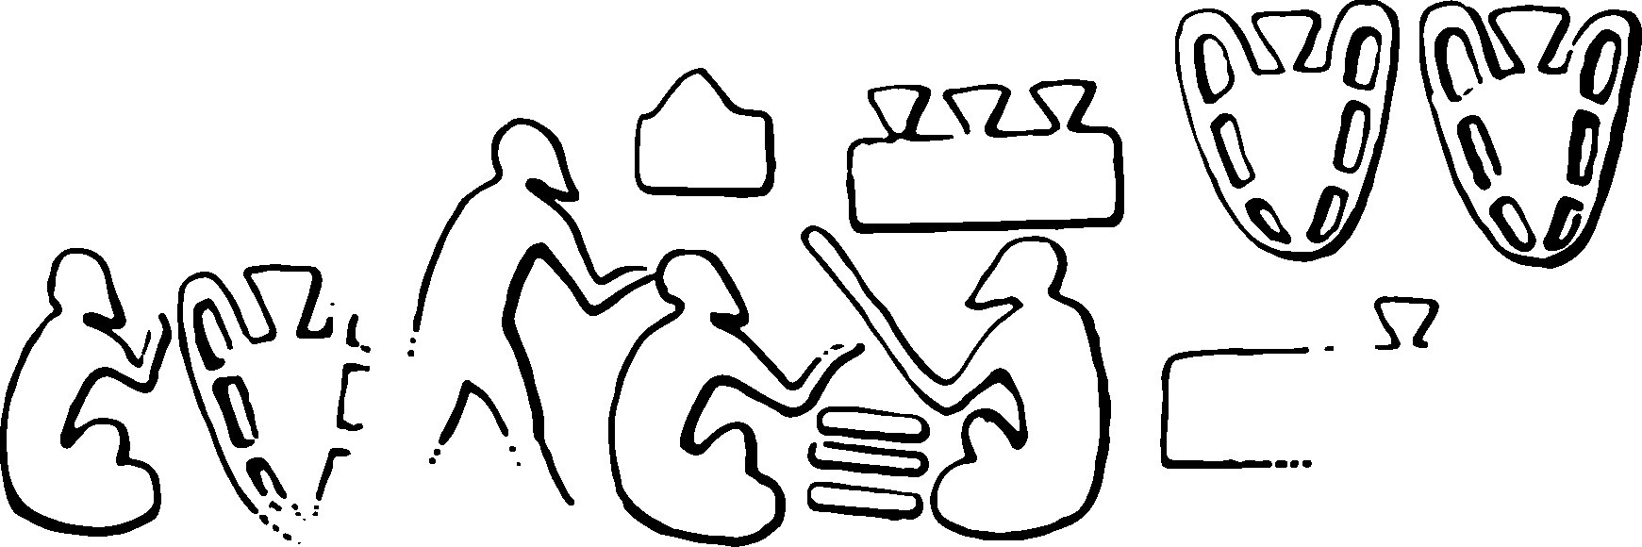
2142.2 bulla

Susa – Acropole 18 – LC 4 (Le Brun, Vallat 1978: fig. 6–4,9,13 and 7–2,3,7,8)
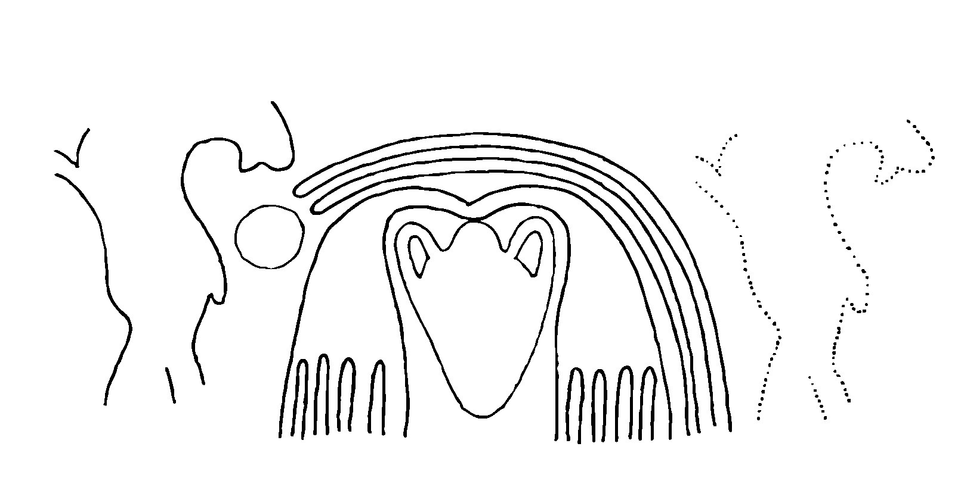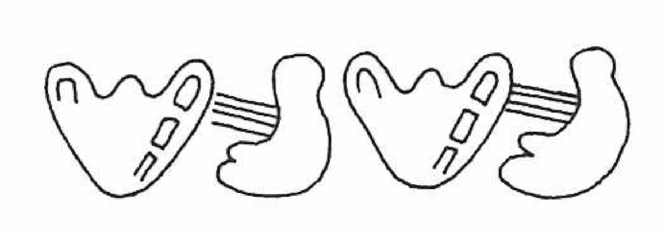
S.65
sealing
S.57
sealing

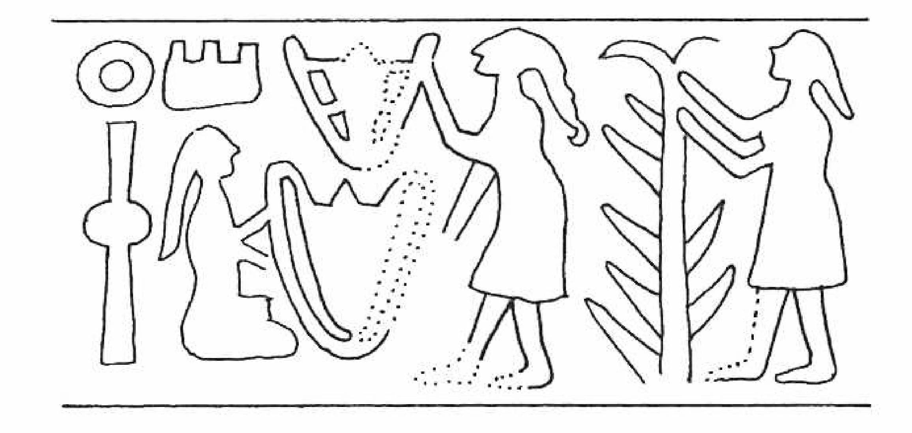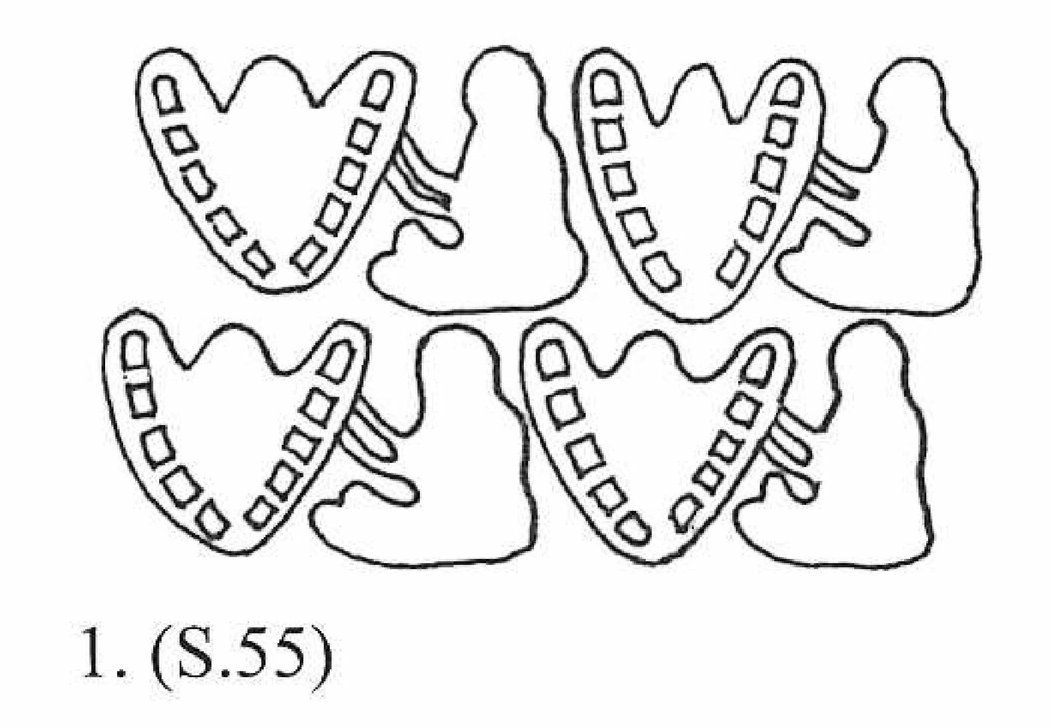
S.55
sealing
S.42
sealing

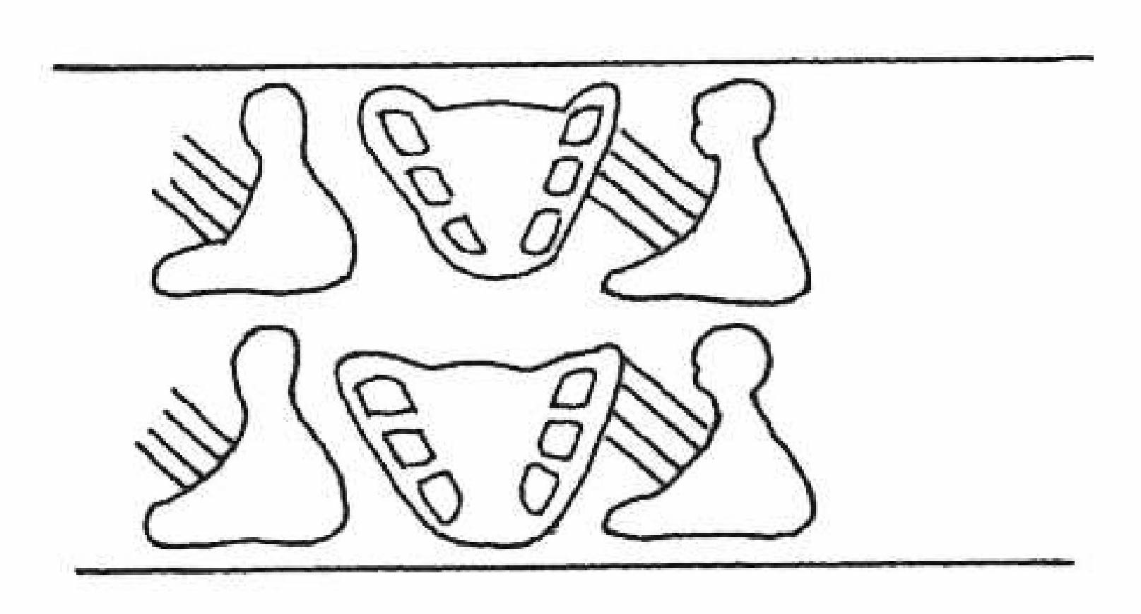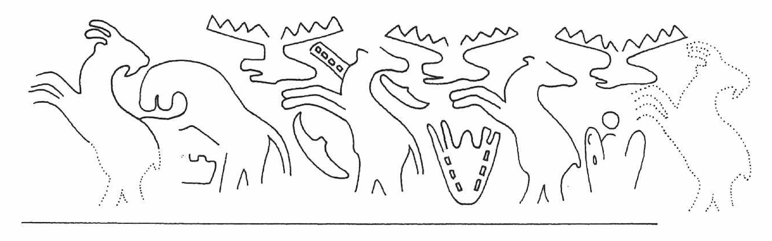
S.56
sealing
S.63
tablet

Habuba Kabira – Late Uruk (Strommenger et al. 2014)

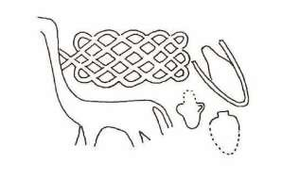
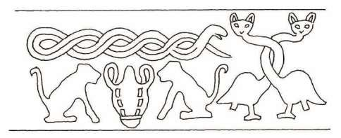

S.92
bulla
S.93
sealing
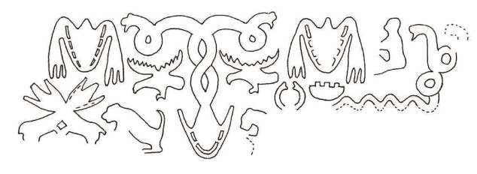
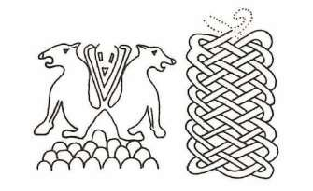
S.91
tablet
S.94
tablet
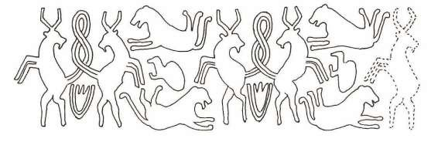
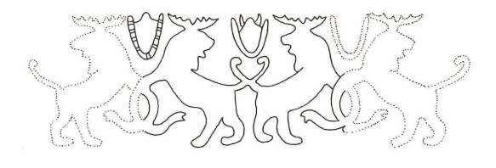
S.96
bulla
S.98
bulla
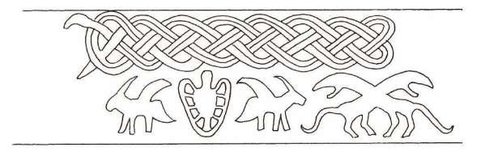
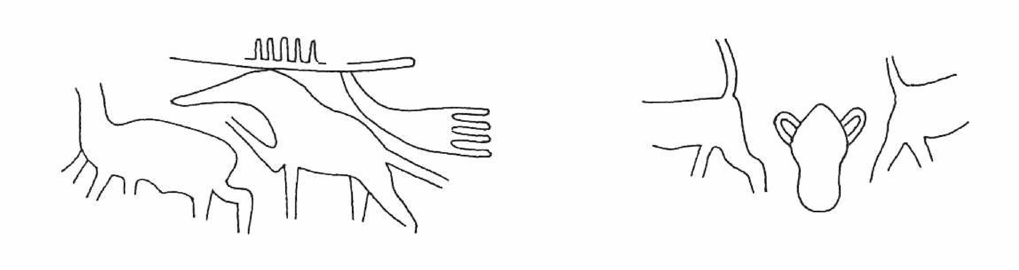

S.66
bulla
S.90
sealing

Habuba Kabira – Late Uruk (Strommenger et al. 2014)

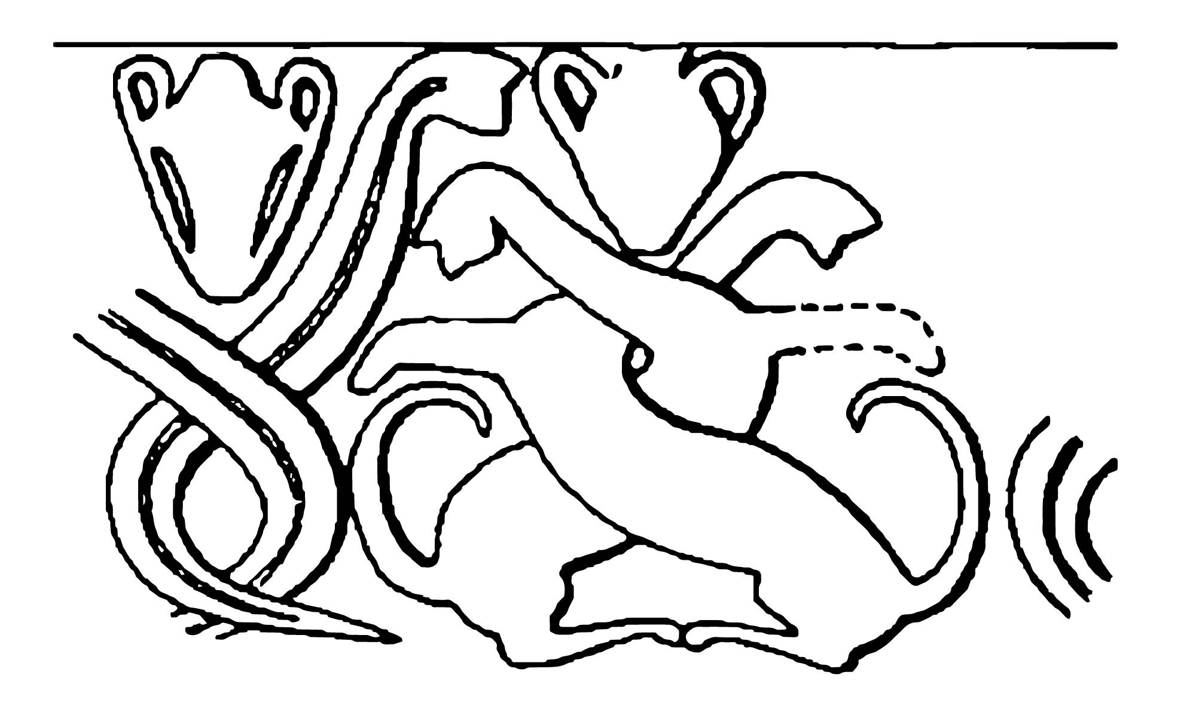
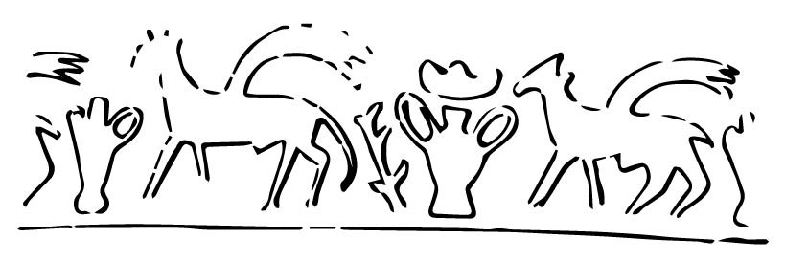

Abb.88 sealing | Abb.35 sealing

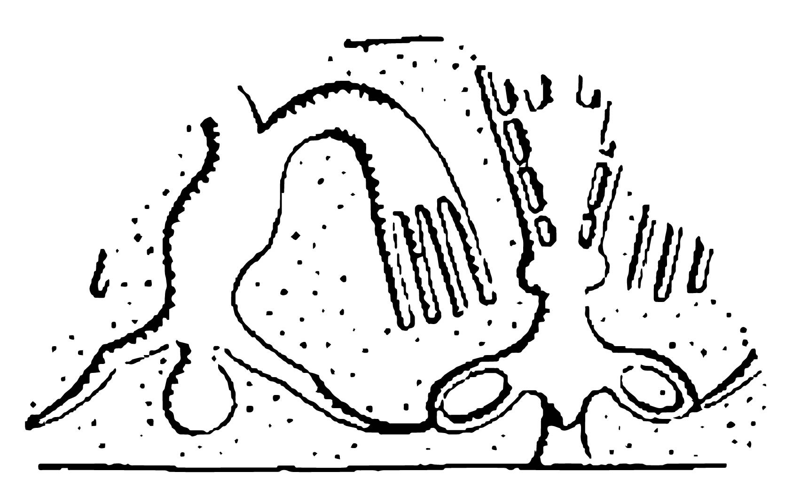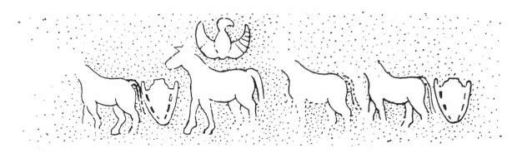
Abb.46 sealing | Abb.81 sealing
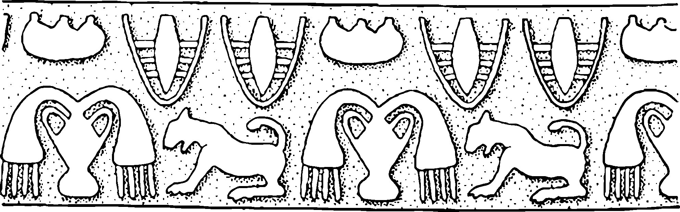
Abb.33 sealing

Uruk - Eanna and Anu Ziggurat - Uruk IV (Boehmer 1999)
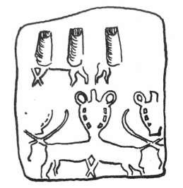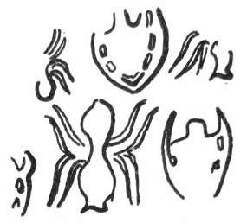
N. 1661
–
tablet
N. 1663
–
sealing
Susa – Acropole 17 – LC 5 (Le Brun 1971: fig. 44, 1 and 4; Amiet 1980: N.1661 and 1663)
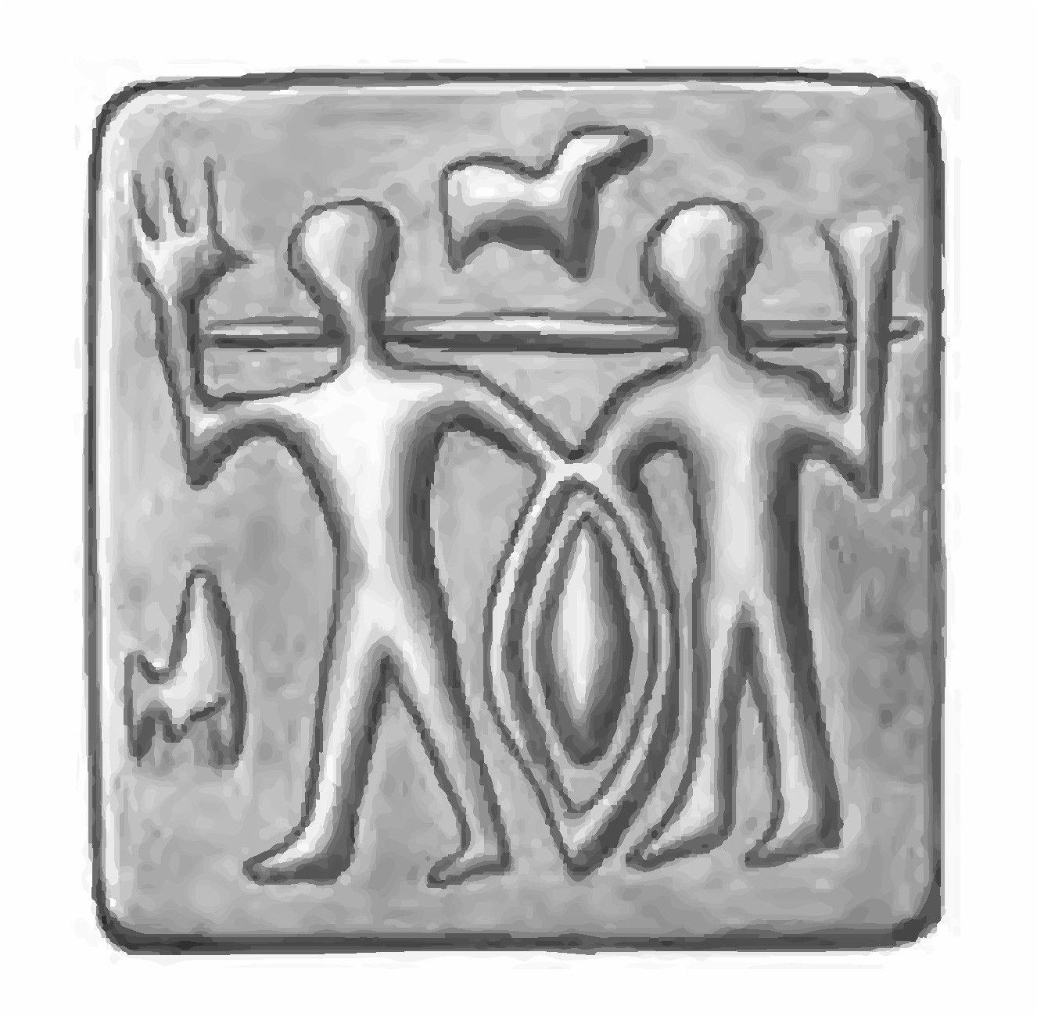
A206-011 – sealing

Arslantepe – Layer 7b - LC 5 (Frangipane et al. 2007)
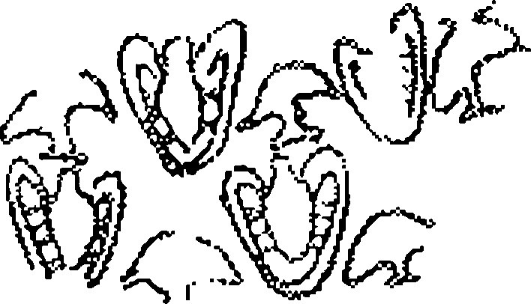
4D 378 – sealing

Nippur – Late Uruk (McCown et al 1978: pl. 63.4; Rova 1994: N. 821)
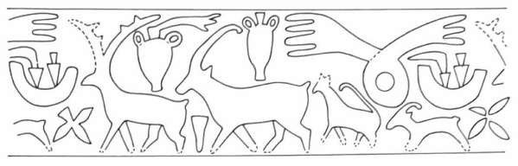
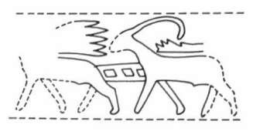
S.6
sealing
S.12
sealing
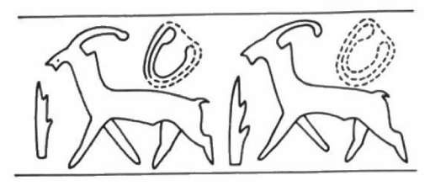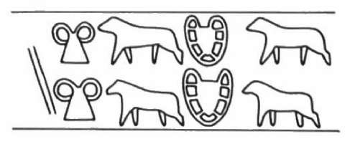
S.15
sealing
S.13a
sealing

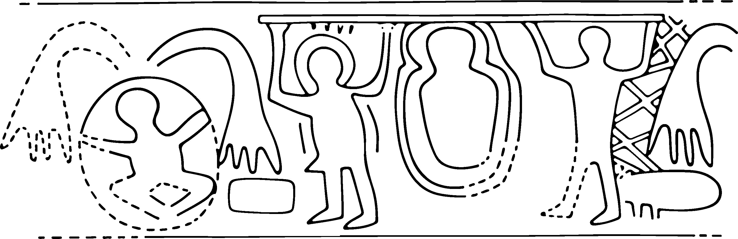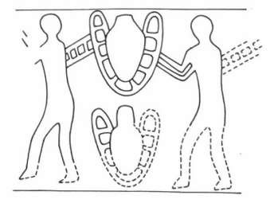
S.20
sealing
S.19b
sealing

Jebel Aruda – Late Uruk (van Driel 1983)

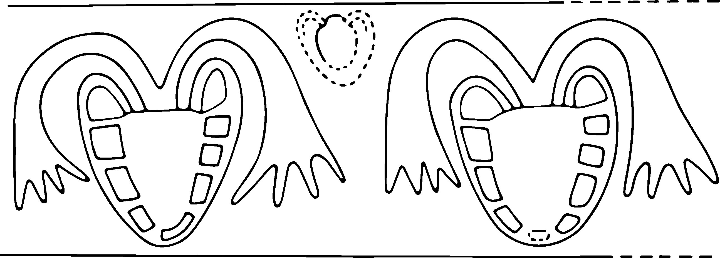
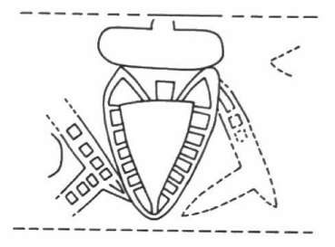
S.25
sealing
S.24
sealing
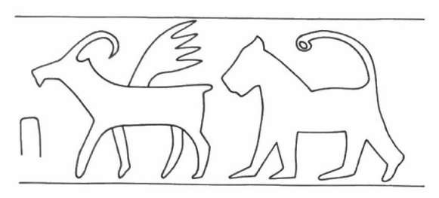
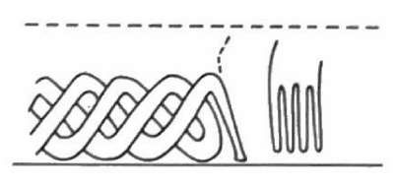
S.33
sealing
S.28
sealing

Jebel Aruda – Late Uruk (van Driel 1983)
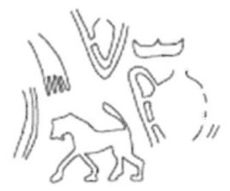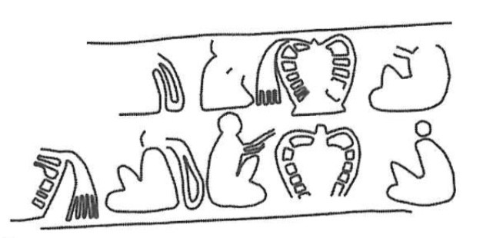
TB 19032 – sealing TB 19052 – sealing

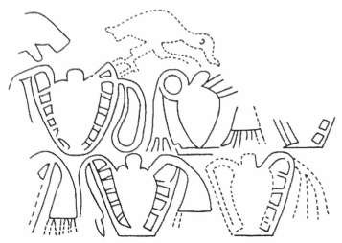
Tell Brak – TW level 12 – LC 5 (Pittman 2013: fig. 16.13dv, 16.15b)
Abb.24u
–
sealing

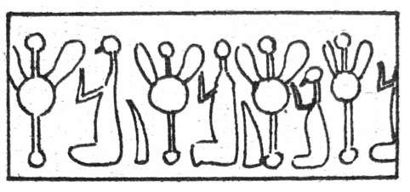
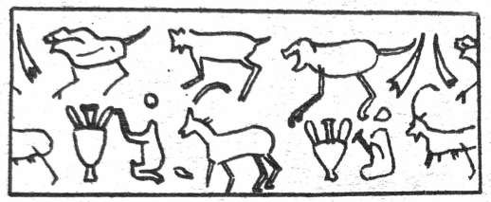
Tell Brak – LC 5 (Boehmer 1999)
S.79
–
sealing
S.89
–
sealing

Tepe Sialk - Period IV (Ghirshman 1938: pl. XCIV)
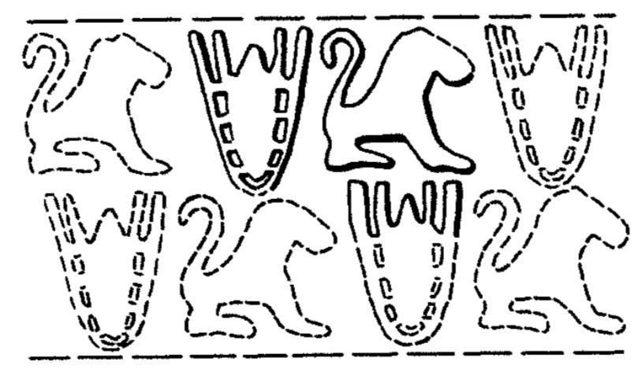
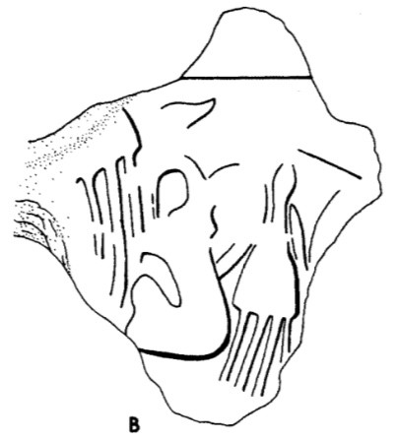
III–927
sealing
II–396
sealing
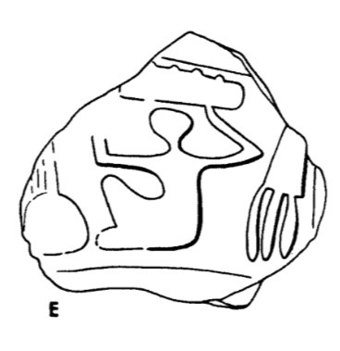
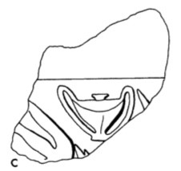
II–512
sealing
III–929
sealing
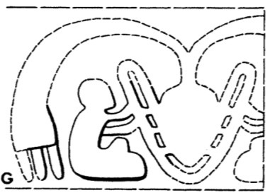
II–361 sealing

Chogha Mish – R17 and P17 – Proto-literate (Delougaz & Kantour 1996: pl. 147, 153, 156)
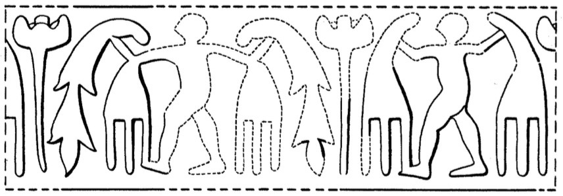
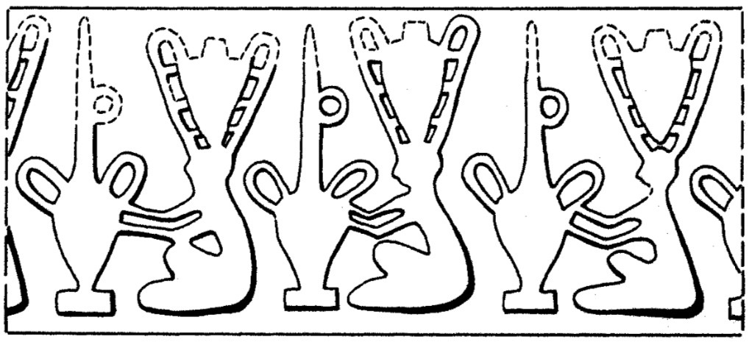
II–288
sealing
II–432a–b tablet

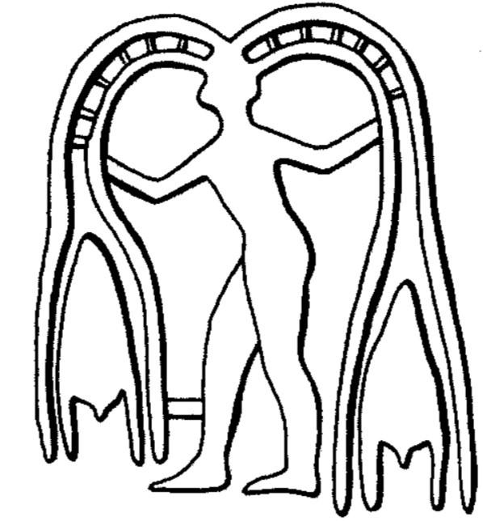
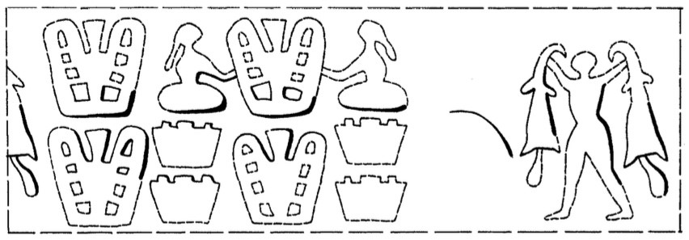
III–81
bulla
III–801–4
sealing
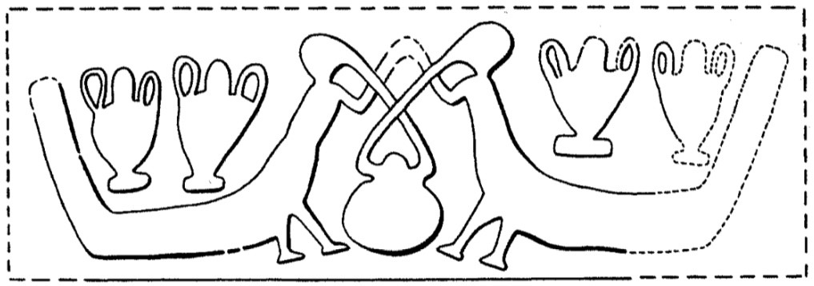
9.872 sealing

Chogha Mish – R17 and P17 – Proto-literate (Delougaz & Kantour 1996: pl. 147, 153, 156)

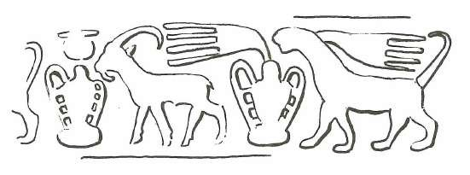
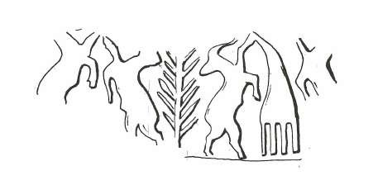

N. 489
tablet
N. 469
bulla
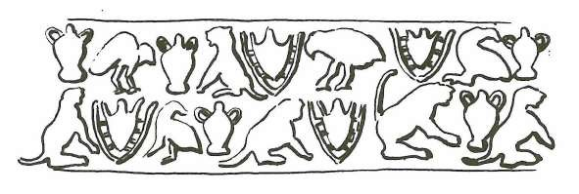
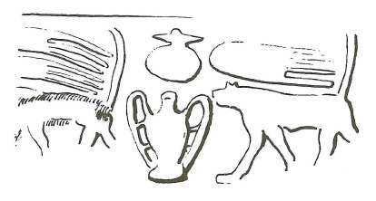
N. 536
tablet
N. 494
tablet
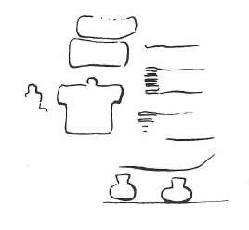
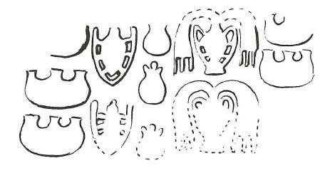
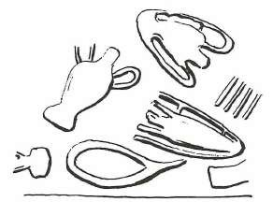
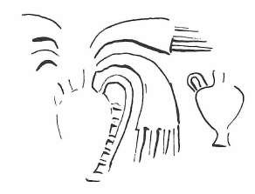
N. 630
tablet
N. 629
tablet
Susa – uncertain (Amiet 1972)
N. 632
tablet
N. 631
sealing

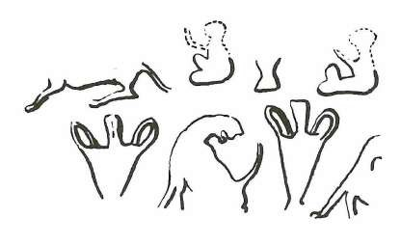
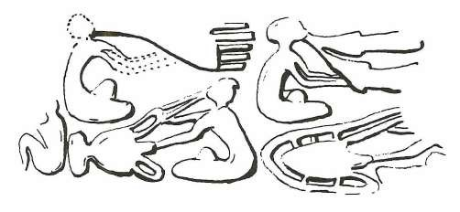
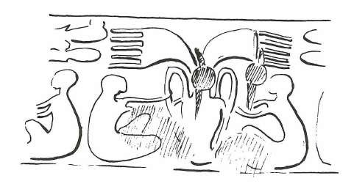
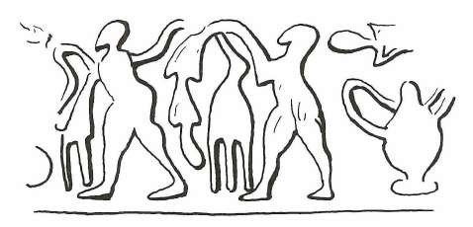
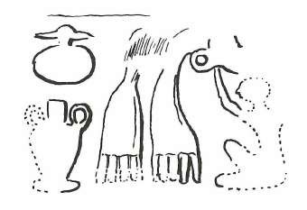
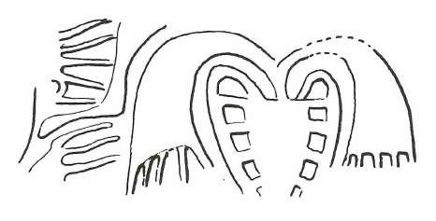
N. 634
sealing
N. 633
tablet

N. 641
tablet
N. 635
sealing

N. 642
tablet
N. 643
sealing
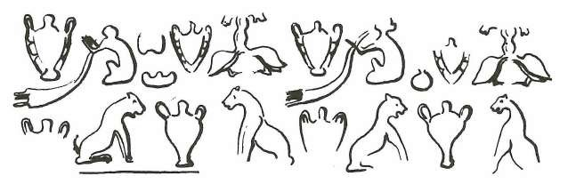
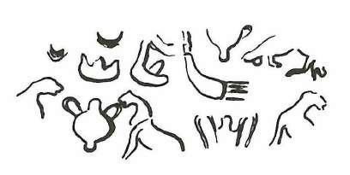
N. 645
sealing
N. 644
bulla

Susa – uncertain (Amiet 1972)

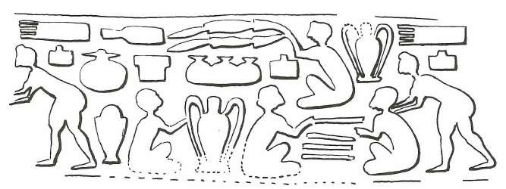
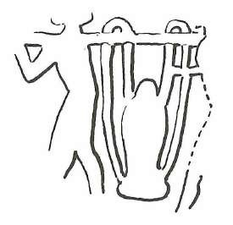

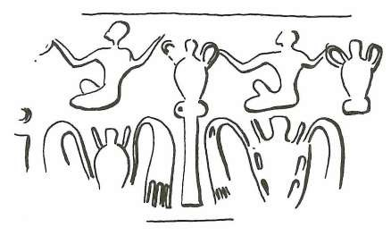
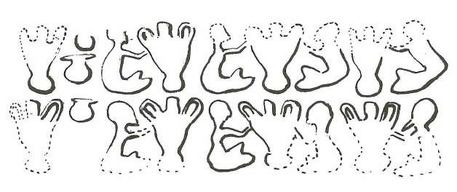
N. 651
sealing
N. 650
tablet
N. 667
bulla
N. 646
bulla
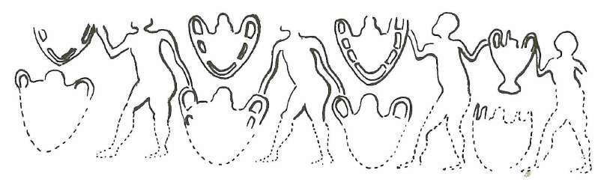
N. 649 bulla

Susa – uncertain (Amiet 1972)
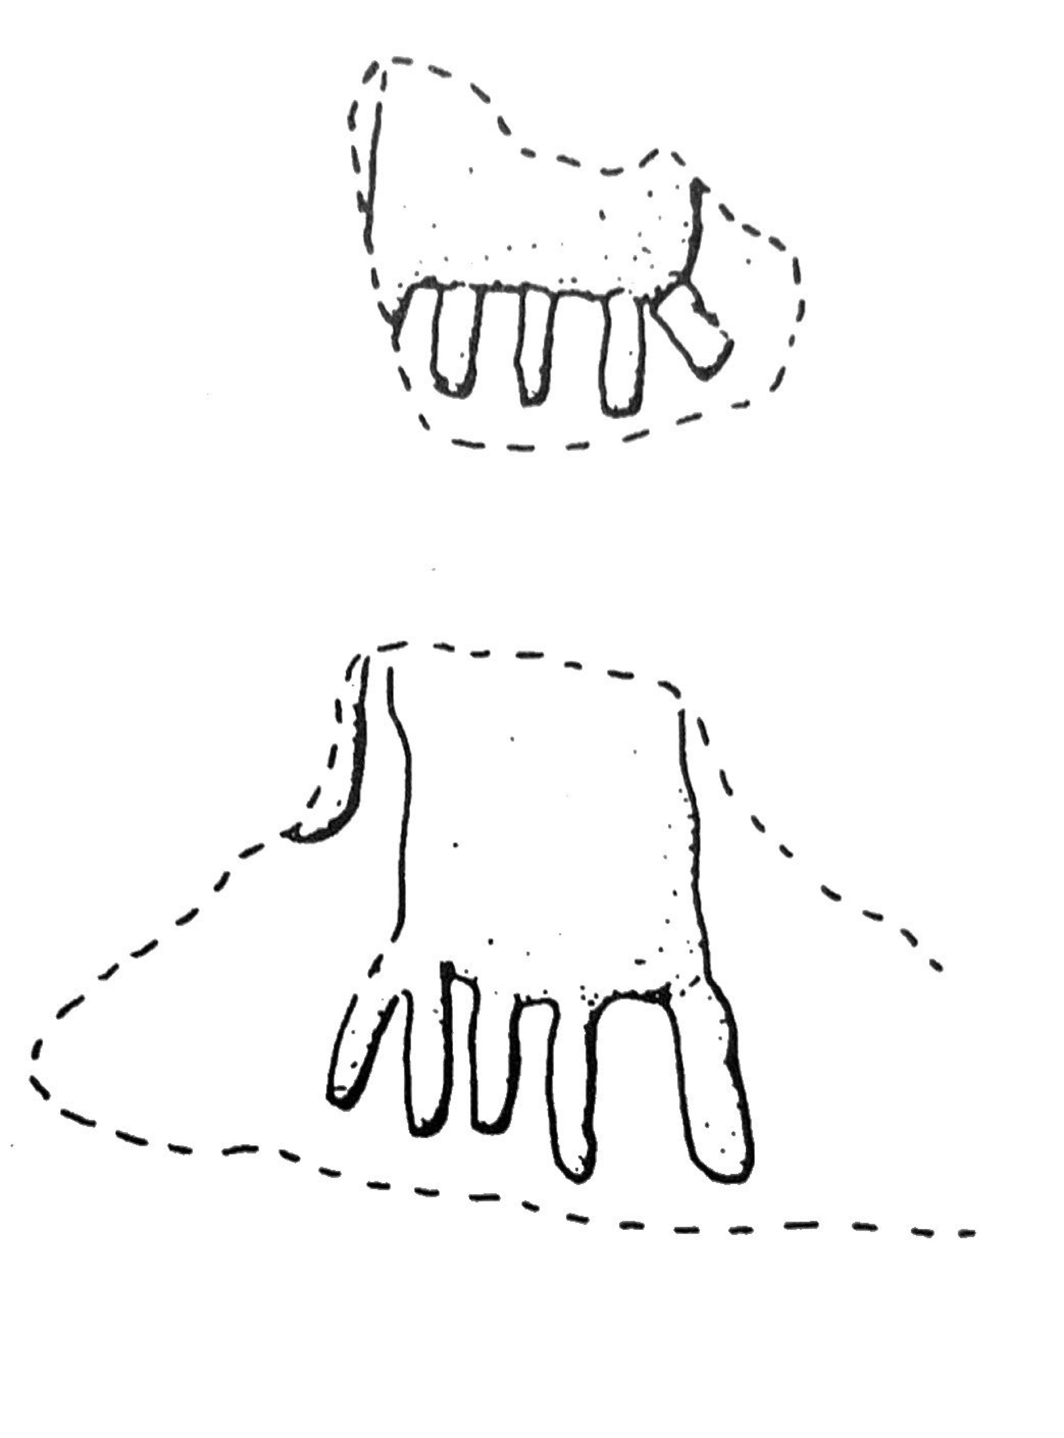
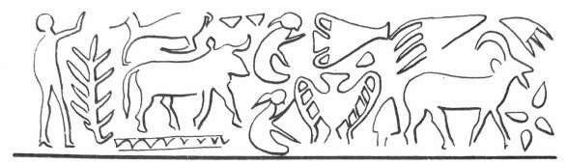
Abb. 109K,L – sealing
N. 314 – cylinder seal

Chata Höyük (Amuq) – uncertain
(Braidwood et al 1960: fig. 381:7; Amiet 1980)
Sharafabad – uncertain (Boehmer 1999)

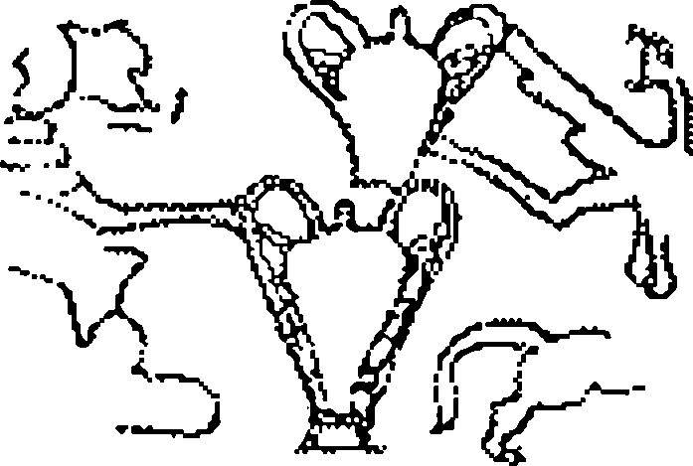

N. 896 – sealing

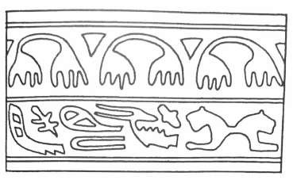
Ur – uncertain (Woolley 1956: 67; Rova 1994)
Saqqara (Egypt) – uncertain (Boehmer 1999) – sealing

Abb. 24a – sealing

Appendix 1: Vessels in a Net and/or Fringed Cloths - Seal Motifs

References
AMIET, P. 1972. Glyptique susienne des origines à l’époque des Perses Achéménides. Paris: P. Geuthner.
AMIET, P. 1980. La glyptique mésopotamienne archaïque. Paris: CNRS.
BOEHMER, R.M. 1999. Uruk: früheste siegelabrollungen. Ausgrabungen in Uruk-Warka. Endberichte. Mainz am Rhein: Philipp Von Zabern.
BRAIDWOOD, R.J., L.S. BRAIDWOOD & R.C. HAINES. 1960. Excavations in the plain of Antioch I. The earlier assemblages phases A-J. Chicago: Oriental Institute.
DELOUGAZ, P., H.J. KANTOR & A. ALIZADEH. 1996. Chogha Mish. Chicago: Oriental Institute.
FRANGIPANE, M. et al. 2007. Arslantepe - Cretulae: an early centralised administrative system before writing. Roma: Università di Roma" La Sapienza".
GHIRSHMAN, R. 1938. Fouilles de Sialk: près de Kashan, 1933, 1934, 1937 (Serie Archéologique 4). Paris: Musée du Louvre, dept. des Antiquités Orientales.
LE BRUN, A. 1971. Recherches stratigraphiques à l’acropole de Suse (1969–1971). Cahiers de la Délégation Archéologique Française en Iran (DAFI) 1: 163–216.
LE BRUN, A. & F. VALLAT. 1978. L'origine de l'écriture à Suse. Cahiers de la Délégation Archéologique Française en Iran (DAFI) 8: 7-59.
MCCOWN, D.E., R.C. HAINES & R.D. BIGGS. 1978. Nippur, vol. 2: the north temple and sounding E. Chicago: Oriental Institute.
PITTMAN, H. 2013. Imagery in administrative context: susiana and the west in the fourth millennium BC, in C.A. Petrie (ed.) Ancient Iran and its neighbours: 293–336. Oxford: Oxbow.
ROVA, E. 1994. Ricerche sui sigilli a cilindro vicino-orientali del periodo di Uruk, Jemdet Nasr. Roma: Istituto per l'Oriente C.A. Nallino.
STROMMENGER, E., K. KOHLMEYER, D. SÜRENHAGEN, D. RITTIG & O.-G. DEUTSCHE. 2014. Ausgrabungen in Habuba Kabira. Wiesbaden: Harrassowitz.
VAN DRIEL, G. 1983. Seals and sealings from Jebel Aruda 1974–1978. Akkadica Bruxelles 33: 34–62.
WOOLLEY, L. 1958. Ur excavations, vol. 4: the early periods. Philadelphia: The British Museum and the University of Pennsylvania.

Appendix 2 – Publication Details of Article Figures

Proto-cuneiform signs are referred to by their ZATU number (Green & Nissen 1987). Sign images courtesy of the Cuneiform Digital Library Initiative. Signs are turned 90 degrees from usual publication orientation to highlight their relationship to iconography.

Figure 3
Pre-literate (LC 1–4) seal images:
- Kelly-Buccellati 2010: fig. 19 (Urkesh – J3 trench – LC-3) sealing
- Boehmer 1999: Nr. 55 (Uruk Eanna V) - bulla; Boehmer 1999: Nr. 10 (Uruk Eanna V) - sealing
- Boehmer 1999: Abb. 102a (Susa Acr. 18) - stamp seal
- Boehmer 1999: Nr. 25 (Uruk Eanna V) - sealing
Late Uruk (LC 5) seal images:
- Delougaz & Kantor 1996: Pl.143H (Chogha Mish - Late Uruk) - sealing
- Roach 2009: n.449 (Susa Acr. 17) - sealing
- Van Driel 1983: n. 40 (Jebel Aruda - Temples area - Late Uruk) - sealing; Boehmer 1999: Abb. 80 (Uruk Eanna IV) - sealing
- Rova 1994: N.123; Amiet 1980: N. 1654 (Susa Acr. 17b) - tablet

Figure 4
- Seal impression on a bulla after Amiet 1973: no.15
- Uruk IV Tablet; Englund 1994: pl. 71 (W 9579,cc / P001326)

Figure 5
- Reconstructed seal image after Le Brun & Vallat 1978: fig. 6.13
- Le Brun & Vallat 1978: fig. 3.2 (Sealed numerical bulla from Susa Acr. 18)
- Englund 1994: pl.18
- Schmandt-Besserat 1992: fig. 31.21

Figure 6
- Reconstructed seal image after Le Brun & Vallat 1978: fig. 7.2
- Le Brun & Vallat 1978: fig. 4.3 (Sealed numerical tablet from Susa Acr. 18)
- Le Brun & Vallat 1978: fig. 3.3 (Sealed numerical bulla from Susa Acr. 18)
- Unpublished Uruk IV tablet from Uruk, in the National Museum of Iraq IM 073483 / P003977

Figure 7
For details and bibliographic references of the seal images, see Appendix 1

Figure 8
- Le Brun & Vallat 1978: fig. 3.1 (Bulla from Susa Acr. 18)
- Green & Nissen 1987 (ATU 2): pl. 19. Uruk III tablet from Uruk (W 20274,004), in the National Museum of Iraq. IM 67381 / P003502
- Englund 1994 (ATU 5): pl. 59. Uruk IV tablet from Uruk. W 9578,h / P001240
- Reconstructed seal image (see bulla in A above) after Le Brun & Vallat 1978: fig. 7.8

Figure 9
Reconstructed seal image after:
- Collon & Reade 1983: 34
- Rova 1994: no. 603
- Rova 1994: no. 749
- Rova 1994: no. 665
- Rova 1994: no. 761
- Amiet 1980: no. 609
- Amiet 1980: no. 1605
- Rova 1994: no. 592
- Frangipane et al. 2007: A206-001

Figure 10
- Englund & Nissen 2001 (ATU 7): pl. 38. Uruk III tablet from Uruk. W 20237 / P003482
- Rova 1994: no. 749. Uruk III (uncertain context) - sealing from Uruk
- Unpublished Uruk IV tablet from Uruk, in the National Museum of Iraq. IM 74213 / P004112

References
AMIET, P. 1973. Glyptique Élamite, à propos de nouveaux documents. Arts Asiatiques 6: 3–45.
AMIET, P. 1980. La Glyptique mésopotamienne archaïque. Paris: Centre National de la Recherche Scientifique.
BOEHMER, R.M. 1999. Uruk: früheste Siegelabrollungen. Ausgrabungen in Uruk-Warka. Mainz am Rhein: Philipp Von Zabern.
COLLON, D. & J. READE. 1983. Archaic Nineveh. Baghdader Mitteilungen 14: 33–41.
DELOUGAZ, P. & H. KANTOR. 1996. Chogha Mish, volume 1: the first five seasons of excavations, 1961–1971. Chicago (IL): The Oriental Institute of the University of Chicago.
ENGLUND, R.K. 1994. Archaic administrative texts from Uruk: the early campaigns (ATU 5). Berlin: Gebr. Mann.
ENGLUND, R.K. & J.H. NISSEN. 2001. Archaische Verwaltungstexte aus Uruk. Die Heidelberger Sammlung. Archaische Texte Aus Uruk (ATU 7). Berlin: Gebr. Mann.
FRANGIPANE, M. et al. 2007. Arslantepe—Cretulae: an early centralised administrative system before writing. Roma: Università di Roma La Sapienza.
GREEN, M.W. & H.J. NISSEN. 1987. Zeichenliste der archaischen Texte aus Uruk. Berlin: Mann.
KELLY-BUCCELLATI, M. 2010. Mozan/Urkesh in the Late Chalcolithic Period, in J. Becker et. al. (ed.) Kulturlandschaft Syrien: Zentrum und Peripherie (Alter Orient und Altes Testament 371): 261–90. Münster: Ugarit.
ROACH, K. 2009. The Elamite cylinder seal corpus, c.3500–1000 BC. Unpublished PhD dissertation, Sydney University.
ROVA, E. 1994. Ricerche sui sigilli a cilindro vicino-orientali del periodo di Uruk, Jemdet Nasr.
Roma: Istituto per l’Oriente C.A. Nallino.
SCHMANDT-BESSERAT, D. 1992. Before writing. Austin: University of Texas Press.
Strommenger, E., D. Sürenhagen & D. Rittig. 2014. Die Kleinfunde von Habuba Kabira Süd, Ausgrabungen in Habuba Kabira Süd II (WVDOG 141). Wiesbaden: Harrassowitz.
VAN DRIEL, G. 1983. Seals and sealings from Jebel Aruda 1974–1978. Akkadica Bruxelles 33: 34–62.

