 | Supplementary material for  Johnson, T., B., Hockett & A. Linderholm. 2024. DNA metabarcoding and macroremains from coprolites reveals insights into Middle and Late Holocene inhabitants of Bonneville Estates Rockshelter, Nevada. Antiquity 98.  Author for correspondence ✉ archaeobotaryn@gmail.com

- Environmental and cultural background of Bonneville Estates Rockshelter
Prior to c. 9500 cal BP, and particularly prior to c. 10 500 cal BP, much cooler temperatures and increased effective precipitation prevailed near the shelter. Consequently, sagebrush-obligate animal species including sage-grouse (Centrocercus urophasianus) and pygmy rabbit (Brachylagus idahoensis) were prevalent, and their bones were common inside the shelter (Hockett 2007, 2015). During the Younger Dryas (c. 12 900 to 11 650 cal BP) limber pines (Pinus flexilis) grew directly outside the shelter entrance, but during the earliest Holocene they quickly retreated upslope to alpine settings of the nearby Goshute Mountains (Rhode & Madsen 1995). The region around Bonneville Estates became increasingly dry and hot in the Early-Mid-Holocene (c. 10 500 to 8000 cal BP) with little evidence of human occupation (Louderback & Rhode 2009; Schmitt & Lupo 2016; Thompson et al. 2016; Goebel et al. 2021). Evidence of pinyon pine (Pinus monophylla) did not appear in the Goshute Mountains until c. 8000 cal BP (Madsen & Rhode 1990; Rhode & Madsen 1998), and after 6000 cal BP the climate oscillated between moister, cooler conditions and drier, hotter ones (Louderback & Rhode 2009; Thompson et al. 2016; Goebel et al. 2021). Inhabitants of the rockshelter would have had nearby access to artiodactyls, including pronghorn (Antilocapra americana), mule deer (Odocoileus hemionus) and bighorn sheep (Ovis canadensis), from lower and higher elevations at various times depending upon prevailing climate conditions (Chamberlin 1911; Goebel et al. 2021).

Component V: the Middle Holocene
During the Early to Early-Middle Holocene, increased aridity was accompanied by a decrease in wetlands and their associated resources and a concomitant increase in desert-adapted plants in the lowlands. Mesic-adapted plants were either constrained to small, well-watered lowland areas, or retreated upslope into the mountains (Rhode 2008). Pollen records show significant increases in Chenopodiaceae and Amaranthaceae pollen, likely representing Atriplex sp., indicating a regional increase in shadscale and decrease in sagebrush (Artemisia sp.) (Currey & James 1982; Madsen 2000; Louderback & Rhode 2009). Climate was not monolithically hot and dry, however, as mesic spikes occurred periodically. These spikes appear to correspond to significant episodes of human occupation of Bonneville Estates followed by re-abandonment of the rockshelter as precipitation decreased again (Hockett 2007; Goebel et al. 2021). Humans focused subsistence on small-seed collecting and processing, as seen in the increased presence of ground-stone technology, charred seeds in hearths, and associated basketry technology related to winnowing and parching necessary to prepare small-seeds for consumption (Rhode & Louderback 2007; Coe 2021). At other nearby sites like Danger Cave, foragers preferentially utilised local wetland resources (Rhode 2008); however, these were not the focus of subsistence activities at Bonneville Estates. The more mesic-adapted fauna present during the Younger Dryas and earliest Holocene, especially small mammals, likely left the region, retreated to higher elevations in the Goshute Mountains, or saw population decreases (Hockett 2007). Human subsistence shifted from rabbit (Sylvilagus sp.) to hare (Lepus sp.), and artiodactyl hunting increased in importance (Hockett 2015). Regularly procured fauna includes pronghorn, bighorn sheep, mule deer and jackrabbit (Lepus californicus), although bison (Bison bison), bobcat (Lynx rufus), badger (Taxidea taxus) and weasel (Mustela sp.) also occur in the rockshelter's component V assemblage.

Components III and II: the Late Holocene
Climatologically, components III and II are associated with the Late Holocene (c. 4000–150 cal BP), characterised by fluctuations between cooler and warmer conditions and an overall shift from warmer, drier conditions to cooler, wetter conditions (Janetski 1997; Madsen 2000; Madsen et al. 2001; Hockett 2015; Schmitt & Lupo 2016). Sagebrush and conifer communities expanded during cooler periods, while cheno-am communities decreased and pinyon woodlands spread across lower mountain slopes (Louderback & Rhode 2009). The increase in effective precipitation correlated to the expansion of grasses and the return of various highly abundant wetland resources as wetlands and lakes re-appeared (Kelly 1997; Hockett 2005, 2015; Grayson 2011). More mesic-adapted fauna including bison, other large artiodactyls, and rodents such as bushy-tailed woodrat (Neotoma cinerea), sage vole (Lemmiscus curtatus) and western harvest mouse (Reithrodontomys megalotis), which rely on grasses for food and habitat, returned to the region or increased their populations and ranges (Madsen 2000; Hockett 2005, 2015; Schmitt & Lupo 2016). People made frequent visits to the rockshelter during this time, as shown by the high number of cultural features found and dated at Bonneville Estates (Kelly 1997; Grayson 2011; Goebel et al. 2021). Human occupants at Bonneville Estates increasingly relied on artiodactyl species such as pronghorn, with additional use of mountain sheep, deer, bison, hare, rabbit, sage-grouse, bobcat, badger and weasel (Hockett 2015).

Table S1. Contemporary vegetation zones in the eastern Great Basin. Sources: Chamberlin 1911; Steward 1938; Kelly 1997; Madsen 2000; Rhode 2008; Goebel et al. 2021.
Name | Description | Taxa found in each zone
Playa | Halophytic plants, marsh resources and waterfowl at margins | Pickleweed (Allenrolfea occidentalis)
Valley floor | Desert shrubs and flora | Shadscale (Atriplex), greasewood (Sarcobatus vermiculatus), saltbush (Amaranthaceae), jackrabbits (Lepus californicus)
Lower foothills | Shrubs and grasses | Sagebrush (Artemisia), horsebrush (Tetradymia), rabbitbrush (Chrysothamnus), wild rye (Elymus), wheatgrass (Agropyron), bluegrass (Poa)
Lower mountain slopes | Pinyon-juniper woodlands, sagebrush-grass zone recurrence | Pinyon pine (Pinus monophyla), juniper (Juniperus), mountain mahogany (Cercocarpus ledifolius), Mormon tea (Ephedra)
Subalpine forests | Xeric conifers, herbaceous resources, some fruits | Douglas fir (Pseudotsuga menziesii), white fir (Abies concolor), limber pine (Pinus flexilis), wheatgrass, redtop grass (Agrostis), bluegrass, needlegrass (Stipa), gooseberry/currant (Ribes), elderberry (Sambucus)

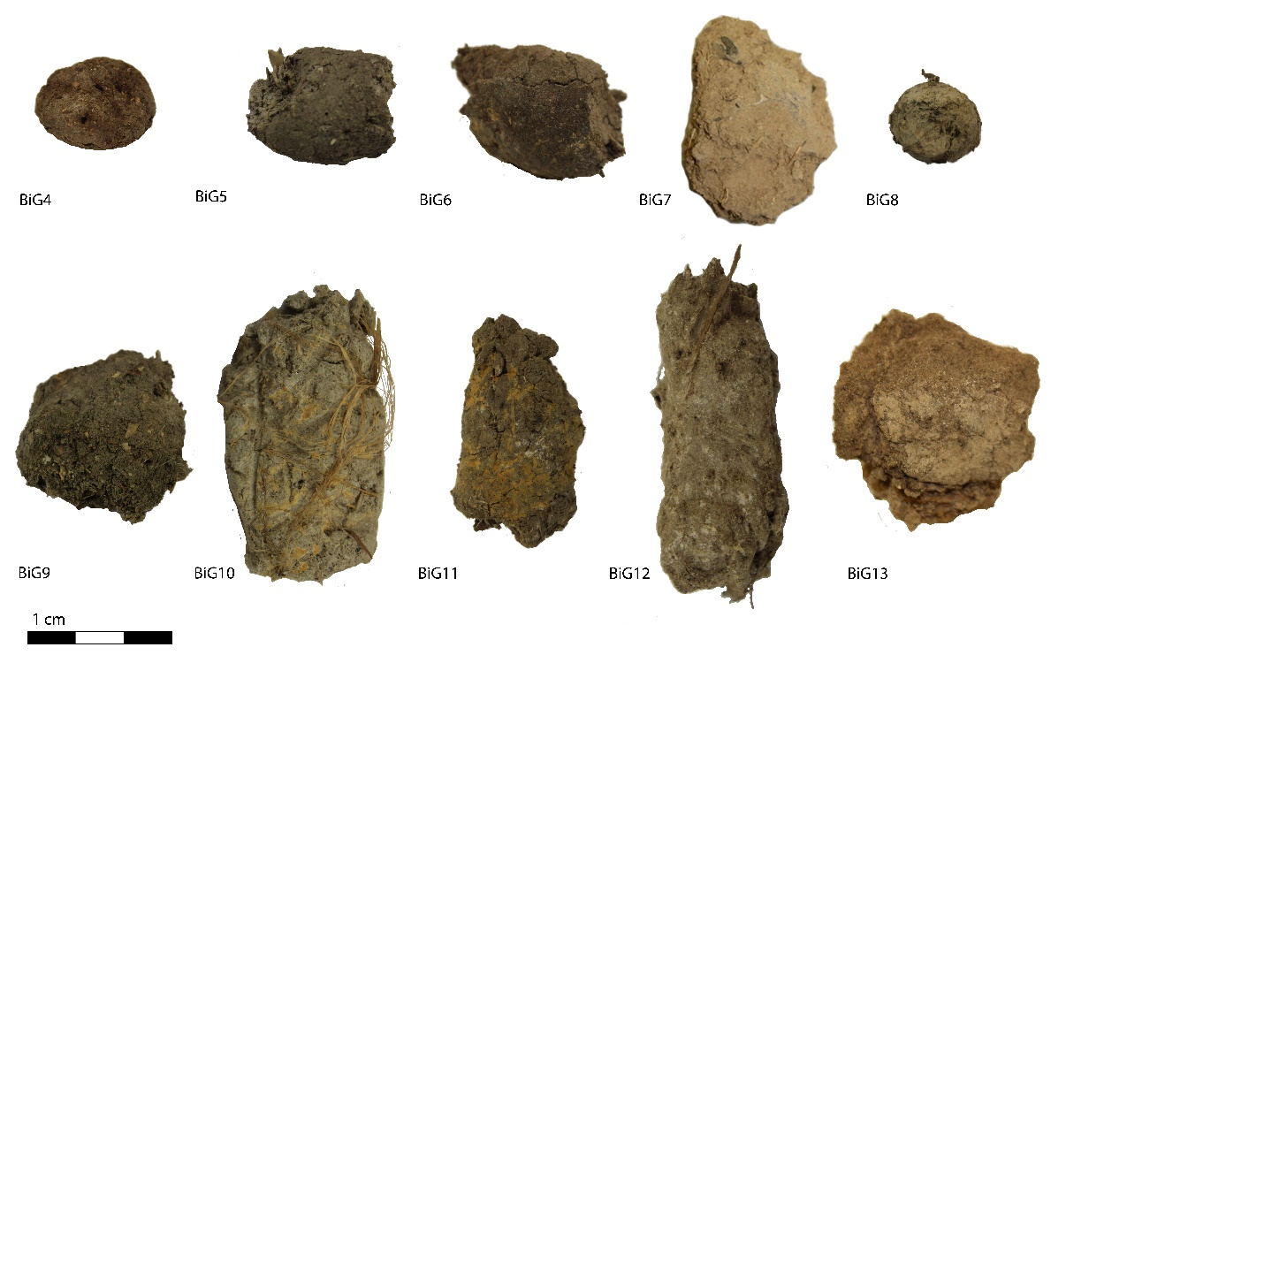
Figure S1. Coprolites processed for DNA and macroremains in this study (figure by authors).

- Expanded genetic methods
Amplification and library preparation
We set up each polymerase chain reaction (PCR) as a 25μL solution containing 2μL DNA extract, 2.5μL 1x PCR Gold buffer, 2.0μL magnesium chloride (MgCl₂), 0.25μL 25mM dNTPs, 0.5μL 10mM forward and reverse primers, 0.25μL AmpliTaq Gold DNA Polymerase, 0.6μL SYBR Green, 1.0μL bovine serum albumin, and ultrapure water. PCR cycling started with a 5-minute denaturation at 95°C, followed by 40 cycles of 30 seconds at 30°C, 30 seconds at 57°C for 12sv5 and 52°C for trnL-gh, and extension at 72°C for 2 minutes. This was followed by a final extension of 10 minutes at 72°C. The primer names, sequences and annealing temperatures are in Table S2.

Table S2. Primers.
Primer | Forward Primer | Reverse Primer | Annealing Temp
12SV5 | TAGAACAGGCTCCTCTAG | TTAGATACCCCACTATGC | 57°C
trnL-gh | GGGCAATCCTGAGCCAA | CCATTGAGTCTCTGCACCTATC | 52°C

After amplification, we placed samples in minipools according to similar cycle threshold values and cleaned with a QIAquick PCR Purification Kit (Qiagen) using the standard protocol with variations. We washed samples with 650μL of Qiagen buffer PE and eluted with 30μL of Qiagen buffer EB. We combined equimolar amounts of each minipool into a single library, size selected on a Pippin Prep to 160–450bp and cleaned using the protocol described above before sequencing.

Downstream analysis
After sequencing, we demultiplexed reads and then trimmed adaptors and primers in Geneious v11.1.5. We then utilised the USEARCH pipeline (Murray et al. 2013) to dereplicate and remove chimeric reads and singletons, after which we grouped reads into operational taxonomic units (OTUs) using the UPARSE-OUT algorithm (Edgar 2013). Each OTU was aligned to reference DNA sequences in the NCBI nr database (accessed 30 July 2018) using BLASTn v2.7.1 which assigned taxonomic identifications. We identified OTUs to at least the family level, with some OTUs identified at lower taxonomic levels, and visualised the results in MEtaGenome ANalyzer v6 (MEGAN) using the lowest common ancestor assignment algorithm with a minimum score of 65, minimum support of 1 and a top percentage of 5 to analyse the taxonomic content of individual coprolites (Huson et al. 2016).

- Methodological considerations
Sampling and quantification
Few studies have looked at how the human gut digests different materials (Calder 1977; Jones 1986, 1990; Nicholson 1993; Butler & Schroeder 1998; Shillito et al. 2020; Blong & Shillito 2021). Results generally show that harder, less digestible foodstuffs such as bone, seeds and plant fibre are more likely to be present in a paleofecal assemblage than softer, more digestible foodstuffs such as meat, fruits and legumes. Additionally, less processed, raw materials are more likely to be detected than processed or heavily chewed materials (O’Meara 2014). Materials also differ in how long they remain in the gut; macrofossils and DNA may move through the gut in a number of days while pollen may take up to a few weeks (Battillo 2019). Battillo’s (2017, 2019) work on coprolites from Turkey Pen Ruin in Utah further demonstrates that DNA, macroremains and pollen in a single coprolite may represent different meals. Additionally, each line of evidence is better suited to the detection of different dietary elements. DNA analysis can contain more evidence for meat consumption while macro- and microremains data can contain more evidence for plant consumption (Battillo 2017). The frequencies of identified constituents could be more related to differential preservation and processing than to amount of use or relative importance, and one coprolite could represent multiple days of consumption. The uneven distribution of materials in coprolites (Reinhard & Hevly 1991; Beck et al. 2019) means the chosen sampling method can affect results. Current sampling recommendations for macro- and microremains analysis are to subsample half of a given coprolite lengthwise to gain a representative sample (Beck et al. 2019), while sampling for DNA analysis often involves cutting coprolites in half and subsampling from the centre (Wood & Wilmshurst 2016) or homogenisation of a whole or partial sample (Hagan et al. 2020). Sampling from the centre for DNA analysis allows for other analyses to be performed on the remaining material but risks not having a representative sample, while homogenisation ensures that a representative genetic sample has been collected but at the expense of opportunities to conduct other analyses. Sampling considerations extend to the number of coprolites needed for analysis. Approximately 15–20 coprolites from a particular context are needed to detect the majority of dietary components (Reinhard & Bryant 1992). Although a larger number of coprolites yield more data, individual coprolites can still give novel findings (Reinhard & Bryant 1992; Reinhard 1988; Blong & Shillito 2021). Efforts to quantify coprolite constituents include using percentage estimates, ranking items by abundance using ordinal scales (Rhode 2003; Albush 2010; McDonough et al. 2022), summarising quantity according to weight and doing visual abundance rankings. However, each method favours different items, be they heavier, bulkier or more numerous (Bryant & Dean 2006; Blong & Shillito 2021).
The sampling method for genetic analysis used in this paper was centre sampling. Care was taken to remove material from both halves and as far into each half as possible to sample from a larger portion of each coprolite. While the genetic data only represent part of each coprolite, sampling from the centre resulted in the minimal amount of destruction needed for DNA analysis and allowed for macroremains analysis to be performed on one half while saving the other for curation. The main consideration when choosing quantification methods was to ensure comparability between data. Unidentified material may be present in both the genetic data and in the macroremains. The genetic data may contain DNA sequences that have no hits, meaning the DNA sequences are not significantly similar to any DNA sequences in a comparative database, or may contain DNA sequences that are unassigned, meaning the DNA sequences have similarity to sequences in a comparative database but cannot be definitively identified as a given taxa. Unidentified material in macroremains are generally materials with little to no distinct morphology or materials that are common to multiple taxa such as undifferentiated plant fibres.
DNA metabarcoding and macroremains data were considered using presence or absence on a per coprolite and per component basis. A taxon was considered present in a coprolite if it contained DNA sequences or macroremains representing said taxon. A taxon was considered present in a component if at least one coprolite from that component contained traces of the taxon. The chosen quantification method for macroremains analysis was abundance ranking on an ordinal scale and percent composition for the genetic data, as both the genetic and macroremains data can be analysed based on counts; abundances and compositions were determined using the counts of seeds and other identifiable materials for the macroremains data and the number of DNA sequences attributed to each taxonomic group in the genetic data.

Defecator identification: macroremains
Another major consideration in coprolite research is defecator identification. Coprolites may be initially identified as human based on their size, shape, colour, inclusions and provenience (Fry 1970; Reinhard & Bryant 1992; Gilbert et al. 2008; Shillito et al. 2020). Human coprolites are identified as those that turn a trisodium phosphate solution dark brown or black, are opaque and have a strong fecal smell (Figure S2). Carnivore and herbivore feces turn the liquid a translucent pale yellow or brown, and herbivore feces have a musty smell (Fry 1976; Shillito et al. 2020). However, as there are exceptions to the above trends, coprolite contents are also used to identify fecal sources. Human coprolites are expected to represent a wider dietary breadth than those of other organisms, but the diets of foraging groups could greatly vary across days (Reinhard & Bryant 1992). Coprolites that contain either a variety of known dietary elements or large amounts of fewer dietary elements could be considered human, but the presence of high amounts of large, undigestible faunal elements such as bone and hair could be indicative of a carnivore (Albush 2010; Wood et al. 2016; Witt et al. 2021). If a coprolite contains bone, the size of bone fragments could indicate whether the depositor is human. In studies of Great Basin human paleofeces, many of the recovered bone fragments were under 5mm in length with few examples of larger sizes. Carnivore scat often contains larger bone fragments, and bone fragments in both human and carnivore feces are often stained and pitted (Schmitt & Juell 1994). Coprolites with predominantly smaller (<5mm) bone fragments are more likely human than those with larger (>5mm) bone fragments. The presence of human-associated parasites in paleofeces could also indicate a human source.

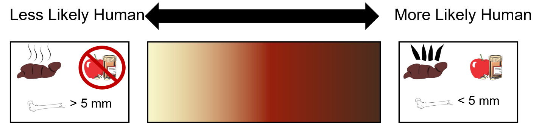
Figure S2. Defecator identification using traditional methods.

We considered five factors when identifying likely human coprolites during macroremains analysis: colour, smell and translucence of the rehydrating liquid, bone fragment size and presence of dietary taxa as described in publications on Bonneville Estates Rockshelter. Of the five factors, smell was identified as unreliable. None of the coprolites had the strong fecal smell expected of human coprolites, but the highly subjective nature of smell suggests other researchers may have different results. Colour and translucence appear to be more reliable methods; of the ten coprolites, eight (coprolites 4, 6–7, 9–12) turned the rehydrating liquid dark brown and opaque indicating a human source, while the other two (coprolites 5, 8) turned the liquid a lighter, translucent colour. Of the eight coprolites identified as more likely human based on the rehydration process, five (coprolites 4, 6, 11–13) contained bone fragments small enough to be clearly placed in the human category, while the other three (coprolites 7, 9–10) contained a slightly higher range of fragment sizes but could still indicate a human source. All eight of the coprolites with darker rehydration liquids additionally contained known dietary taxa, so each was labelled as a human coprolite based on the above factors. Of the two coprolites with lighter rehydration liquids, one (coprolite 5) contained known dietary elements and a range of bone fragment sizes that could be present in a human coprolite. However, the large number of bone fragments along with other undigestible materials suggests a canine source. The other coprolite (coprolite 8) contained no bone fragments or identifiable dietary material and was labelled as having an unknown source. Overall, the macroremains data suggest eight of the coprolites are human (coprolites 4, 6–7, 9–13), one is canine (coprolite 5), and one has an unknown source (coprolite 8).

Defecator identification: molecular remains
Molecular identification methods were initially focused on detecting defecator DNA (Hofreiter et al. 2000; Poinar et al. 2001). Based primarily on the presence or absence of human DNA, human coprolites are those containing identifiable, endogenous human DNA. The sources of nonhuman coprolites, which may be more morphologically consistent and distinct from human coprolites, are confirmed by the presence of the DNA of the suspected species. More recently, gut microbiome composition has been used in conjunction with defecator DNA to identify fecal sources (Schnorr et al. 2016; Witt et al. 2021). Hagan et al. (2020) used SourceTracker (Knights et al. 2011), a tool made to predict the sources of microbial communities in a given sample, to confirm coprolite sources using gut microbiomes, while Borry et al. (2020) developed a bioinformatics tool called CoproID that infers and authenticates coprolite sources using gut microbiome composition and defecator DNA data from shotgun-sequenced datasets. If gut microbiome data are unavailable or if a sample contains no detectable defecator DNA, the presence of DNA from known dietary or medicinal taxa could indicate a source. The use of dietary or medicinal taxa for source identification would require knowledge of the paleofeces’ provenience, along with data of what taxa were utilised by the traditional inhabitants of the site.
Molecular identification methods in this paper are primarily focused on the presence/absence of human, canine, dietary or medicinal DNA, as the data do not contain microbial DNA. Four coprolites were identified as likely human based on the presence of endogenous human DNA (coprolites 7, 9–11), while one was identified as likely canine based on the presence of large amounts of canine DNA (coprolite 5). An additional coprolite contained both human and canine DNA, but as human DNA was present in significantly larger amounts it was labelled as human (coprolite 8). It is unknown if the dog DNA represents intentional ingestion or environmental contamination. The remaining four coprolites contained DNA that can be linked to known dietary or medicinal taxa, suggesting they may be human coprolites, but they are largely dominated by single taxa or speculatively identified taxa (coprolites 4, 6, 12–13). Overall, the five coprolites containing human DNA and the four containing known dietary and/or medicinal taxa were considered as human coprolites, and the final coprolite was labelled as canine.

Defecator identification: limitations
There are limitations to the above methods of defecator identification. A major limitation of the genetic identification is the use of human DNA to identify the defecator. 12s reads in metabarcoded datasets cannot be analysed beyond presence/absence. These identifications could be bolstered via shotgun sequencing, which could allow us to identify human haplotypes, detect human or canine gut microbiomes and observe damage patterns to separate endogenous and exogenous DNA (Borry et al. 2020). A minor limitation is the detection of dietary taxa. Unassigned DNA reads most closely resemble the identified floral taxa in any given coprolite. For example, in coprolites with predominantly Atriplex DNA, the unassigned reads most closely resemble cheno-ams. In coprolites with Boraginaceae DNA, unassigned reads most closely resemble borages. While there are no taxonomic identifications, the unassigned DNA resembles identified taxa in the same coprolite that has known dietary uses. For defecator identification in these coprolites, we considered unassigned reads as representing dietary taxa. For coprolites that contained no identified reads, we looked at the macroremains data. For example, the unassigned reads in coprolites 12 and 13 most closely resemble cheno-ams. The macroremains in those two coprolites are predominantly pickleweed, so we inferred the DNA likely represents dietary use of small seeds, likely pickleweed.

References
Albush, C.J. 2010. Prehistoric diet at Bonneville Estates Rockshelter, Nevada. Unpublished Masters dissertation, University of Nevada, Reno.
Battillo, J. 2017. Supplementing maize agriculture in Basketmaker II subsistence: dietary analysis of human paleofeces from Turkey Pen Ruin (42SA3714). Unpublished PhD Dissertation, Southern Methodist University, Texas.
– 2019. Farmers who forage: interpreting paleofecal evidence of wild resource use by early corn farmers in the North American Southwest. Archaeological and Anthropological Sciences 11: 5999–6016. https://doi.org/10.1007/s12520-019-00944-y
Beck, C.W., V.M. Bryant & K.N. McDonough. 2019. Evidence for non-random distribution of pollen in human coprolites. Archaeological and Anthropological Sciences 11: 5983–98. https://doi.org/10.1007/s12520-019-00839-y
Blong, J.C. & L.-M. Shillito. 2021. Coprolite research: archaeological and paleoenvironmental potentials. Archaeological and Anthropological Sciences 13. https://doi.org/10.1007/s12520-020-01242-8
Borry, M. et al. 2020. CoproID predicts the source of coprolites and paleofeces using microbiome composition and host DNA content. PeerJ 8. https://doi.org/10.7717%2Fpeerj.9001
Bryant, V.M. & G.W. Dean. 2006. Archaeological coprolite science: the legacy of Eric O. Callen (1912–1970). Palaeogeography, Palaeoclimatology, Palaeoecology 237: 51–66. https://doi.org/10.1016/j.palaeo.2005.11.032
Butler, V.L. & R.A. Schroeder. 1998. Do digestive processes leave diagnostic traces on fish bones? Journal of Archaeological Science 25: 957–71. https://doi.org/10.1006/jasc.1997.0725
Calder, A.M. 1977. Survival properties of organic residues through the human digestive tract. Journal of Archaeological Science 4: 141–51. https://doi.org/10.1016/0305-4403(77)90061-9
Chamberlin, R.V. 1911. Memoirs of the American Anthropological Association, volume 11: the ethno-botany of the Gosiute Indians of Utah. Lancaster: New Era Printing Company.
Coe, M.M. 2021. Basketry, cordage, and perishable artifact manufacture at Bonneville Estates Rockshelter: diachronic technological variation. Journal of Anthropological Archaeology 64. https://doi.org/10.1016/j.jaa.2021.101325
Currey, D.R. & S.R. James. 1982. Paleoenvironments of the northeastern Great Basin and northeastern basin rim region: a review of geological and biological evidence, in D.B. Madsen & J.F. O’Connell (ed.) Man and environment in the Great Basin (Society for American Archaeology Papers 2): 27–52. Washinton, D.C.: Societry for American Archaeology.
Edgar, R.C. 2013. UPARSE: highly accurate OTU sequences from microbial amplicon reads. Nature Methods 10: 996–8. https://doi.org/10.1038/nmeth.2604
Fry, G.F. 1970. Preliminary analysis of the Hogup Cave coprolites, in M. Aikens (ed.) Hogup Cave (Anthropological Papers of the University of Utah 93): 247–50. Salt Lake City: University of Utah Press.
– 1976. Analysis of prehistoric coprolites from Utah. Salt Lake City: University of Utah Press.
Gilbert, M.T. et al. 2008. DNA from pre-Clovis human coprolites in Oregon, North America. Science 320: 786–9. https://doi.org/10.1126/science.1154116
Goebel, T., B. Hockett, D. Rhode & K. Graf. 2021. Prehistoric human response to climate change in the Bonneville basin, western North America: the Bonneville Estates Rockshelter radiocarbon chronology. Quaternary Science Reviews 260. https://doi.org/10.1016/j.quascirev.2021.106930
Grayson, D. 2011. The Great Basin: a natural prehistory. Berkeley: University of California Press.
Hagan, R.W. et al. 2020. Comparison of extraction methods for recovering ancient microbial DNA from paleofeces. American Journal of Physical Anthropology 171: 275–84. https://doi.org/10.1002/ajpa.23978
Hockett, B. 2005. Middle and Late Holocene hunting in the Great Basin: a critical review of the debate and future prospects. American Antiquity 70: 713–31. https://doi.org/10.2307/40035871
– 2007. Nutritional ecology of Late Pleistocene to Middle Holocene subsistence in the Great Basin: zooarchaeological evidence from Bonneville Estates Rockshelter, in K.E. Graf & D.N. Schmitt (ed.) Paleoindian or paleoarchaic? Great Basin human ecology at the Pleistocene/Holocene transition: 204–30. Salt Lake City: University of Utah Press.
– 2015. The zooarchaeology of Bonneville Estates Rockshelter: 13,000 years of Great Basin hunting strategies. Journal of Archaeological Science: Reports 2: 291–301. https://doi.org/10.1016/j.jasrep.2015.02.011
Hofreiter, M., H.N. Poinar, W.G. Spaulding, K. Bauer, P.S. Martin, G. Possnert & S. Pääbo. 2000. A molecular analysis of ground sloth diet through the last glaciation. Molecular Ecology 9: 1975–84. https://doi.org/10.1046/j.1365-294x.2000.01106.x
Huson, D.H. et al. 2016. MEGAN community edition-interactive exploration and analysis of large-scale microbiome sequencing data. PLoS Computational Biology 12. https://doi.org/10.1371/journal.pcbi.1004957
Janetski, J.C. 1997. Fremont hunting and resource intensification in the eastern Great Basin. Journal of Archaeological Science 24: 1075–88. https://doi.org/10.1006/jasc.1996.0187
Jones, A.K.G. 1986. Fish bone survival in the digestive systems of the pig, dog and man: some experiment, in D.C. Brinkhuizen & A.T. Clason (ed.) Fish and archaeology: studies in osteometry, taphonomy, seasonality and fishing methods (British Archaeological Reports International Series 294): 53–61. Oxford: BAR.
– 1990. Experiments with fish bones and otoliths: implications for the reconstruction of past diet and economy, in D.E. Robinson (ed.) Experimentation and reconstruction in environmental archaeology: 143–6. Oxford: Oxbow.
Kelly, R.L. 1997. Late Holocene Great Basin prehistory. Journal of World Prehistory 11: 1–49. https://doi.org/10.1007/BF02221200
Knights, D. et al. 2011. Bayesian community-wide culture-independent microbial source tracking. Nature Methods 8: 761–3. https://doi.org/10.1038/nmeth.1650
Louderback, L.A. & D.E. Rhode. 2009. 15,000 years of vegetation change in the Bonneville basin: the Blue Lake pollen record. Quaternary Science Reviews 28: 308–326. https://doi.org/10.1016/j.quascirev.2008.09.027
Madsen, D.B. 2000. Late Quarternary paleoecology in the Bonneville Basin, volume 130. Salt Lake City: Utah Geological Survey.
Madsen, D.B. & Rhode, D. 1990. Early Holocene pinyon (Pinus monophylla) in the northeastern Great Basin. Quaternary Research 33: 94–101. https://doi.org/10.1016/0033-5894(90)90087-2
Madsen, D.B. et al. 2001. Late Quarternary environmental change in the Bonneville basin, western USA. Palaeogeography, Palaeoclimatology, Palaeoecology 167: 243–71. https://doi.org/10.1016/S0031-0182(00)00240-6
McDonough, K.N., J.L. Kennedy, R.L. Rosencrance, J.A. Holcomb, D.L. Jenkins & K. Puseman. 2022. Expanding paleoindian diet breadth: paleoethnobotany of Connley Cave 5, Oregon, USA. American Antiquity 87: 303–32. https://doi.org/10.1017/aaq.2021.141
Murray, D.C. et al. 2013. Scrapheap challenge: a novel bulk-bone metabarcoding method to investigate ancient DNA in faunal assemblages. Scientific Reports 3. https://doi.org/10.1038/srep03371
Nicholson, R.A. 1993. An investigation into the effects on fish bone of passage through the human gut: some experiments and comparisons with archaeological material. Circaea 10(1): 38–51.
O’Meara, D.P. 2014. Ruminating on the past. A history of digestive taphonomy in experimental archaeology, in J.R. Flores & R. Paardekooper (ed.) Experiments past: histories of experimental archaeology: 131–46. Leiden: Sidestone.
Poinar, H.N. et al. 2001. A molecular analysis of dietary diversity for three archaic Native Americans. Proceedings of the National Academy of Sciences 98: 4317–22. https://doi.org/10.1073/pnas.061014798
Reinhard, K.J. 1988. Cultural ecology of prehistoric parasitism on the Colorado Plateau as evidenced by coprology. American Journal of Physical Anthropology 77: 355–66. https://doi.org/10.1002/ajpa.1330770308
Reinhard, K.J. & V.M. Bryant. 1992. Coprolite analysis: a biological perspective on archaeology. Archaeological Method and Theory 4: 245–88.
Reinhard, K.J. & R.H. Hevly. 1991. Dietary and parasitological analysis of coprolites recovered from Mummy 5, Ventana Cave, Arizona. Kiva 56: 319–25. https://doi.org/10.1080/00231940.1991.11758174
Rhode, D. 2003. Coprolites from Hidden Cave, revisited: evidence for site occupation history, diet and sex of occupants. Journal of Archaeological Science 30: 909–922. https://doi.org/10.1016/S0305-4403(02)00270-4
– 2008. Dietary plant use by Middle Holocene foragers in the Bonneville Basin, western North America. Before Farming 3: 1–17. https://doi.org/10.3828/bfarm.2008.3.2
Rhode, D. & L.A. Louderback. 2007. Dietary plant use in the Bonneville Basin during the Terminal Pleistocene/Early Holocene transition, in K.E. Graf & D.N. Schmitt (ed.) Paleoindian or paleoarchaic? Great Basin human ecology at the Pleistocene/Holocene transition: 231–47. Salt Lake City: University of Utah Press.
Rhode, D. & D.B. Madsen. 1995. Late Wisconsin/Early Holocene vegetation in the Bonneville Basin. Quarternary Research 44: 246–56. https://doi.org/10.1006/qres.1995.1069
– 1998. Pine nut use in the Early Holocene and beyond: the Danger Cave archaeobotanical record. Journal of Archaeological Science 25: 1199–210. https://doi.org/10.1006/jasc.1998.0290
Schmitt, D.N. & K.E. Juell. 1994. Toward the identification of coyote scatological faunal accumulations in archaeological contexts. Journal of Archaeological Science 21: 249–62. https://doi.org/10.1006/jasc.1994.1025
Schmitt, D.N. & K.D. Lupo. 2016. Changes in Late Quaternary mammalian biogeography in the Bonneville Basin, in C.G. Oviatt & J.F. Shroder (ed.) Lake Bonneville: a scientific update (Developments in Earth Surface Processes 20): 352–70. New York: Elsevier.
Scnhorr, S.L., K. Sankaranarayanan, C.M. Lewis Jr & C. Warinner. 2016. Insights into human evolution from ancient and contemporary microbiome studies. Current Opinion in Genetics & Development 41: 14–26. https://doi.org/10.1016/j.gde.2016.07.003
Shillito, L.-M., J.C. Blong, E.J. Green & E. van Asperen. 2020. The what, how and why of archaeological coprolite analysis. Earth-Science Reviews 207. https://doi.org/10.1016/j.earscirev.2020.103196
Steward, J.H. 1938. Basin-plateau Aboriginal sociopolitical groups. Salt Lake City: University of Utah Press.
Thompson, R.S., C.G. Oviatt, J. Honke & J. McGeehin. 2016. Late Quaternary changes in lakes, vegetation, and climate in the Bonneville basin reconstructed from sediment cores from Great Salt Lake, in C.G. Oviatt & J.F. Shroder (ed.) Lake Bonneville: a scientific update (Developments in Earth Surface Processes 20): 221–91. New York: Elsevier.
Witt, K.E. et al. 2021. Integrative analysis of DNA, macroscopic remains and stable isotopes of dog coprolites to reconstruct community diet. Scientific Reports 11. https://doi.org/10.1038/s41598-021-82362-6
Wood, J.R. & J.M. Wilmshurst. 2016. A protocol for subsampling Late Quaternary coprolites for multi-proxy analysis. Quaternary Science Reviews 138: 1–5. https://doi.org/10.1016/j.quascirev.2016.02.018
Wood, J.R., A. Crown, T.L. Cole & J.M. Wilmshurst. 2016. Microscopic and ancient DNA profiling of Polynesian dog (kurī) coprolites from northern New Zealand. Journal of Archaeological Science: Reports 6: 496–505. https://doi.org/10.1016/j.jasrep.2016.03.020

