[For SUPPLEMENTARY MATERIAL]
Human dispersal and plant processing in the Pacific 55 000–50 000 years ago
Dylan Gaffney^{1,2,*} [ORCID: 0000-0003-4869-9730], Daud A. Tanudirjo^{3,*} [ORCID: 0000-0003-3002-4161], Erlin Novita Idje Djami⁴ [ORCID: 0000-0002-7330-721X], Zubair Mas’ud⁵ [ORCID: 0000-0001-8956-5806] Abdul Razak Macap⁶, Tristan Russell^{2,7}, Moses Dailom⁸, Yulio Ray³, Thomas Higham⁹ [ORCID: 0000-0002-5949-598X], Fiona Bradshaw¹ [ORCID: 0000-0002-9690-2484], Fiona Petchey¹⁰ [ORCID: 0000-0002-3308-9983], S. Anna Florin¹¹ [ORCID: 0000-0001-6229-900X], Patrick Roberts^{12,13} [ORCID: 0000-0002-4403-7548], Mary Lucas¹² [ORCID: 0000-0002-6394-0345], Monica Tromp^{2,7} [ORCID: 0000-0002-0747-9099], Karen Greig^{2,7} [ORCID: 0000-0002-9566-9983], Hermine Xhauflair¹⁴ ORCID: 0000-0002-7148-3164], Alvaro Montenegro¹⁵ [ORCID: 0000-0001-6848-1996], Robert Hall¹⁶ [ORCID: 0000-0003-1693-6914], Clara Boulanger^{17,18,19} [ORCID: 0000-0002-5358-6477], Rintaro Ono¹⁷ [ORCID: 0000-0002-0431-2007], Annette Oertle²⁰ [ORCID: 0000-0001-9697-2725], Denis Scholz²¹ [ORCID: 0000-0002-0055-8915], Megan Spitzer²² [ORCID: 0000-0002-8878-2443], Katherine Szabo²³ [ORCID: 0000-0002-9542-6535], Irene Bertelli²⁴ [ORCID: 0000-0003-2057-1540], Erika Ribechini²⁴ [ORCID: 0000-0002-4978-2782] & Simon Haberle²⁵ [ORCID: 0000-0001-5802-6535]

¹ School of Archaeology, University of Oxford, UK
² Archaeology Programme, University of Otago, Dunedin, New Zealand
³ Department of Archaeology, Universitas Gadjah Mada, Yogyakarta, Indonesia
⁴ Pusat Riset Arkeologi Prasejarah dan Sejarah, Badan Riset dan Inovasi Nasional, Jayapura, Indonesia
⁵ Pusat Riset Arkeologi Prasejarah dan Sejarah, Badan Riset dan Inovasi Nasional, Makassar, Indonesia
⁶ Balai Pelestarian Kebudayaan Wilayah XXIII, Manokwari, Indonesia
⁷ Southern Pacific Archaeological Research, University of Otago, Dunedin, New Zealand
⁸ Kampung Warsambin, Warsambin, Indonesia
⁹ Department of Evolutionary Anthropology, University of Vienna, Austria
¹⁰ Waikato Radiocarbon Dating Laboratory, University of Waikato, New Zealand
¹¹ School of Archaeology and Anthropology, Australian National University, Canberra, Australia
¹² Department of Archaeology, Max Planck Institute of Geoanthropology, Jena, Germany
¹³ isoTROPIC Research Group, Max Planck Institute for Geoanthropology, Jena, Germany
¹⁴ Archaeological Studies Program, University of the Philippines, Quezon City, Philippines
¹⁵ Department of Geography, The Ohio State University, Columbus, USA
¹⁶ Department of Earth Sciences, Royal Holloway University, London, UK
¹⁷ Department of Modern Society and Civilization, Minpaku Museum of Ethnology, Osaka, Japan
¹⁸ Japan Society for the Promotion of Science, Tokyo, Japan
¹⁹ Histoire Naturelle de l’Homme Préhistorique, Muséum National d’Histoire Naturelle, Paris, France
²⁰ Human Evolution and Archaeological Sciences, University of Vienna, Austria
²¹ Institute for Geosciences, Johannes Gutenberg University of Mainz, Germany
²² Department of Vertebrate Zoology, Smithsonian Institute, Washington D.C., USA
²³ Pre-Construct Archaeology, Cambridge, UK
²⁴ Department of Chemistry and Industrial Chemistry, University of Pisa, Italy
²⁵ School of Culture, History and Language, Australian National University, Canberra, Australia
* Authors for correspondence ✉ dylan.gaffney@arch.ox.ac.uk & daud.tanudirjo@ugm.ac.id
Received: 11 June 2023; Revised: 23 September 2023; Accepted: 5 December 2023

Detailed methods
Palaeo-coastline reconstruction
Reconstructions were produced with high-resolution multibeam imagery (cell size=25m) and the GEBCO_14 bathymetry grid (Smith & Sandwell 1997) (cell size= approximately 1km). Wallacean uplift and subsidence rates for the Late Pleistocene are highly variable and poorly resolved; we do not include an uplift offset but, at the short timescale of 50ka, the possible post-last interglacial uplift rate of 0.15m/ka for Mololo (see Detailed results) would impact minimally on the model given the deep (>200m) Sagewin Strait.

The present position of Mololo relative to modern mean sea level was measured using a digital theodolite (Leica Builder 100). A depth profile of the Rabia Strait was produced by dropping an anchor and tether with a metre scale at 50m intervals across the strait. This resulted in a provisional reconstruction of site position and timing at which the Rabia Strait would have been breached by marine transgression.

Seafaring simulations
Agent-based simulations of drifted, paddled and sailed trips aimed to define plausible source areas of humans arriving at Waigeo. Displacement was a function of environmental conditions, vessel type and navigation strategy (Callaghan et al. 2022). In drift experiments, movement was determined exclusively by ocean current and wind patterns. In paddling and sailing experiments, movement was the sum of current, wind and propulsion velocities, with the latter continuously oriented toward a specific target. Sailing speeds depended on wind velocity and vessel bearing. Paddling speeds were constant, one set to 0.5kt (0.26m/s), another to 1.5kt (0.77m/s), with the latter based on actualistic raft trips (Kaifu et al. 2019, 2021). Drift and paddling experiments adopted parameters from a simple raft (Montenegro et al. 2006). Sailing parameters came from a balsa log sailing raft (Callaghan et al. 2022), with sailing efficiency reduced by half.

Simulations were conducted for nine environmental conditions (combinations of three sea level and three surface current and wind (CW) states) (Table S1). Present day surface currents were daily averages of the first 0.5m of the water column from the GLORYS12VI ocean reanalysis with ~8km spatial resolution (Jean-Michel et al. 2021). Surface winds were six-hourly values from the ERA5 reanalysis (Hersbach et al. 2018) with ~25km resolution. To account for interannual variability, simulations were conducted using CW data from years with neutral (1993), El Niño (1998) and La Niña (2010) conditions. Changes in sea level were based on the GORYSS12VI bathymetry and generated by lowering present day sea level by 30 and 50 metres.

Estimates of Last Glacial Maximum (LGM) CW fields were generated by blending the CW data described above and global climate model based LGM–present day CW anomalies (D’Cunha et al. 2021). LGM CW estimates were calculated using data from two global models: GISS-E2 (Miller et al. 2014) and MIROC (Sueyoshi et al. 2013). Given uncertainties from rapid fluctuations to MIS-3 sea levels, we substantially increased the accuracy of results by only analysing trips that took place under all nine environmental conditions, and trips that took place under all six lower sea level states (Table S1). If a crossing takes place under non-glaciated and fully glaciated climate states, it is a good indication that it would occur between these two extremes. Due to its proximity to Bird’s Head Peninsula, trips involving Misool were only analysed for present sea level conditions.

For each of the three analysed years, trips lasting five days were initiated every five days. An arrival was recorded when a vessel came within 5km of land. Number of trips per departure day varied with sea level. In drift simulations, separate trips started from 180–182 points distributed over 14 locations (Figure S2). Some of these locations were used as departure and destination pairs in the paddling and sailing experiments, and result in 154–276 trips for each departing day (Table S2). When all years, environmental states and navigation strategies are considered, a total of ~2.7 million five-day trips were simulated.

Presently, Sagewin Strait is ~2.5–7.5km wide and ~36km long (GEBCO Bathymetric Compilation Group 2021). Given its steep boundaries, these values are similar for the evaluated sea level states and too narrow to be addressed by our model (Figure S2). Paddling across the straight was evaluated using: 1) ranges of along-channel wind (1.0–5.5m/s) and current (0.5–1.0m/s) speeds estimated using the adopted reanalysis and LGM data for wind and current observations made to the northeast of the straight with maximum values of 0.45m/s (Kim et al. 2013); 2) duration of crossings under calm WC conditions, with displacement determined exclusively by paddling velocity, obtained using the channel width range and paddling speeds of 0.5kt, 1.0kt and 1.5kt; 3) duration values obtained by Step 2 and along channel speeds from Step 1, used to calculate the along channel displacement caused by CW; 4) along-channel CW induced displacements, compared to the channel length to estimate the likelihood of vessels being swept away to the open sea prior to arrival at the other side of the straight.

Excavation
Mololo was test-pitted in 2012 but excavations were stopped at 0.8m below surface. The excavations upon which this article is based were undertaken over a 2.5 month field season from November 2018–January 2019 (Gaffney 2021). All excavation units were orientated along magnetic north–south gridlines. Small test pits were excavated using trowels following 100mm spits (unsieved). Larger excavation units followed sedimentological and cultural stratigraphic horizons along with discrete lenses, features and lithofacies, recorded under a single context numbering system. Excavation depth was constrained to 50mm spits. Vertical controls were taken from a fixed datum if ground surface was flat, or from the ground surface if the unit lay on a slope (>0.2m vertical difference between excavation unit corner points).
Archaeological contexts were excavated separately to prevent mixing material from distinct deposits.

Excavations were completed using small hand tools, and a circular saw and chisel were used to cut through limestone boulders. Trenches were subdivided into 1 × 1m squares and 0.5 × 0.5m quadrants to provide spatial control. Archaeological material was excavated in situ where possible and plotted in three-dimensions relative to the site datum. All sediment was bulk collected and dry sieved through 2mm mesh. Dense midden material (trench 1, layers 2–3) was bulk bagged and later wet sieved with freshwater. Excavated deposit was weighed to establish the relative density of archaeological material per layer/spit. Site mapping and transects were produced with digital theodolite. Cave roofs were recorded using a laser distometer, and an aerial drone was used to photograph the surrounding topography.

Radiocarbon dating
Organic samples of sufficient mass that had been excavated and bagged in situ, or collected from clean excavation walls, were preferentially selected for accelerator mass spectrometry radiocarbon dating. Charcoal samples were pretreated for contamination with the routine acid/base/acid (ABA) method and coral samples with acid etching. The standard pre-treatment method for shells (code OX) involved surface cleaning by air abrasion with aluminium oxide powder to remove the outer surface and rinsing with ultrapure water, using ultrasonication if required, to clean the shell (Brock et al. 2010). The resin artefact (WAI-11024) was treated (code UW) with a standard pre-treatment for plant cellulose, involving a sequential ABA pre-treatment consisting of initial hydrochloric acid wash, followed by a sodium hydroxide wash, and a final acid wash (Brock et al. 2010). An acid-base-oxidation/stepped combustion [ABOxSC], used for removing contamination on charcoal over 20 000 years old (Bird et al. 1999; Higham et al. 2009), was not considered appropriate because this method has not been tested on resins. All terrestrial ¹⁴C determinations were calibrated in OxCal 4.4 using the IntCal20 calibration curve (Reimer et al. 2020).

Urianum-series dating
One calcite and two coral specimens from trench 1 were sampled for U-series dating. Subsamples of approximately 300mg were prepared by column chemistry and analysed using a Neptune Plus multicollector inductively coupled plasma mass spectrometer (MC-ICPMS). The weighed samples were dissolved in 7N HNO₃, and a mixed ²²⁹Th–²³³U–²³⁶U spike was added (see Gibert et al. 2016 for details on spike calibration). Potential organic material was removed by adding a mixture of concentrated HNO₃, HCl and H₂O₂. The dried samples were dissolved in 6N HCl, and U and Th were separated using ion exchange columns (Yang et al. 2015). Technical details about the MC-ICPMS procedures are described in Obert et al. (2016). All ²³⁰U-Th ages were calculated using published decay constants (Cheng et al. 2013) and corrected for detrital contamination assuming a ²³²Th/²³⁸U weight ratio of 3.8 for the detritus and ²³⁰Th, ²³⁴U and ²³⁸U in secular equilibrium.

Material culture
Artefacts and possible artefacts were individually bagged and transported to Universitas Gadjah Mada where they were rinsed gently to remove sediment and catalogued. Artefacts were then exported to the University of Cambridge for analysis. Resin and sea urchin artefacts were examined under optical and scanning electron microscopy (SEM) to describe surface topography and technological modifications reflecting production and use. All stone recovered from excavation was examined for evidence of fracturing; fractured stone was further investigated for either heat induced fracture or percussive fracture (i.e. natural rock fall or stone tool making). Those objects that were described as possible flakes (preserving a platform, lateral margins and a dorsal and ventral surface) and angular fragments (fractured debris not preserving landmarks to characterise it as a flake or core) were categorised following attribute analyses developed for New Guinea stone tools (Gaffney et al. 2015; Gaffney & Summerhayes 2019).

These pieces were further examined under a magnifying glass, a macroscope Leica Z16 APO, a reflexive light microscope Leica DMRM, an Hirox Digital microscope and a SEM to look for marks and residues related to use. Objects were cleaned using an ultrasonic tank, placed individually in zip-lock bags filled with demineralised water and a drop of soap. They were rinsed using demineralised water and left to dry naturally, placed on fibre free precision wipes. Some areas were briefly cleaned with the tip of a precision wipe soaked in 90% ethanol. To reduce the possibility of contamination during the observations in the laboratory, the objects were placed each time on a new piece of Parafilm to separate them from the Patafix and mounts on which they rested under the microscopes. The objects were always manipulated using gloves. Based on combined technological, usewear and residue results, we classified objects into four categories: 1) clearly anthropic (100% likelihood); 2) probably anthropic (75% likelihood); 3) possibly anthropic (50% likelihood); 4) natural (0% likelihood).

Gas chromatography/mass spectrometry
The resin artefact (WAI-1-1024) was analysed with gas chromatography/mass spectrometry (GC/MS), to determine from which tree species it derived. The results of the GC/MS analysis were compared with ethnographic reference specimens: Agathis labillardierei (locally ‘damar putih’) and Vatica cf. rassak (‘damar merah’) from Waigeo Island. These reference specimens were supplemented by Agathis labillardierei (KEW EBC 28752) and Agathis dammara (KEW EBC 27227) from the Kew Economic Botany Collection (EBC), Royal Botanic Gardens.

A 1mg sub-sample of each resin transferred into separate 2mL glass vials, along with 20μL (1mg/mL) C34 n-alkane as an internal standard. Each sub-sample was solvent extracted in 2:1 dichloromethane:methanol and derivatised via methylation, using trimethylsilyl (diazomethane), reduced to dryness and re-constituted in dichloromethane.

The prepared samples were analysed using an Agilent 8890 GC system connected to an Agilent 5977B MSD. For the chromatographic separation, an HP-5MS fused silica capillary column (5% diphenyl/95% dimethyl-polysiloxane, 30m × 250μm i.d. × 0.25μm film thickness) was used with helium as the carrier gas at a constant flow rate of 1.2mL/min. 1μL of sample was injected onto the column at a 20:1 split ratio, with the GC inlet maintained at 300°C. The temperature of the oven was programmed at 50°C, held for 2 minutes, then increased to 300°C at 10°C/min, where the temperature remained constant for 10 minutes.

The column was directly inserted into the MS ion source, maintained at 230°C, where electron impact (EI) spectra were obtained at 70eV with full scan from m/z 50 to 800. The data were interpreted by the visual profile of the chromatogram, in conjunction with the mass spectral fingerprint for each compound represented as a peak on the chromatogram. The data from the unknown sample were directly compared to the data from the reference samples and data from previously analysed samples (Bradshaw 2019), and the mass spectral data were compared against the NIST11 mass spectra library.

Pyrolysis coupled gas chromatography/mass spectrometry
Pyrolysis coupled gas chromatography/mass spectrometry (Py-GC/MS) analysis was undertaken to provide further detail about species attribution and post-depositional diagenesis of WAI-1-1024. Two sub-samples of WAI-1-1024 were analysed, alongside reference specimens: Agathis labillardierei and Vatica cf. rassak from Waigeo, Vatica rassak (KEW EBC 78755) and Canarium salomonense (KEW EBC 63237) from the Royal Botanic Gardens, Kew Economic Botany Collection (EBC), Prumnopitys ladei (S19) from the Royal Botanic Garden Sydney, and benzoe, styrax and elemi resins.

Experiments were performed with a Frontier Laboratories (Japan) EGA/PY-3030D microfurnace pyrolyser coupled to an Agilent 6890 gas chromatograph connected to an Agilent 5973 mass spectrometric detector single-quadrupole mass spectrometer. All experiments were performed with a pyrolysis temperature of 480°C and a pyrolysis time of 0.2min, while the interface between the furnace and the GC injector was kept at 280°C. The GC was equipped with a split/splitless injector, with a split ratio of 20:1. For the analyses around 150μg of sample was used, with 2μL of HMDS as derivatising agent.

For the chromatographic separation, an HP-5MS fused silica capillary column (5% diphenyl/95% dimethyl-polysiloxane, 30m × 0.25mm i.d., 0.25μm film thickness), with a deactivated silica precolumn (2m × 0.32mm i.d.) was used. The mass spectrometer was operated in the EI positive mode (70eV) analysing mass in the range m/z 50-600. Peak assignment was based on the comparison with libraries of mass spectra (NIST 20 main EI MS library).

Zooarchaeology
Bone was identified to the lowest order of taxonomic classification possible, adhering to standard protocols for zooarchaeological research (Reitz & Wing 1999; Lyman 2008). Total number of fragments (TNF) were counted and weighed (g). The number of identified specimens (NISP) was counted following the identification of each element to at least taxonomic class. NISP was aggregated by stratigraphic context.

Baseline identification data were compiled from regional literature and morphological information was collected from skeletal specimens of species currently living in Raja Ampat.
Cranial, mandibular and dental elements were identified using photographic and illustrated keys (Husson 1955; Menzies & Dennis 1979; Flannery 1990, 1995; Menzies 1991; Cohen & Serjeantson 2015). Identifications were confirmed using modern reference collections at the Naturalis Biodiversity Center, Leiden, and the Grahame Clark Laboratory, Cambridge.

Species level assignments for the Raja Ampat sites were conservative and recorded alongside diagnostic characteristics used for identification. Identification was assisted by microCT and photogrammetric models available online at Morphosource (Martín-Serra & Benson 2020) and Sketchfab (e.g. those produced by Sofia Samper-Carro for the Australian National University). Micromammal remains were examined under SEM. Microbat mandibles and humeri were compared with taxonomic keys (Earl of Cranbrook 1968; Stimpson 2010, 2012) to assign the specimens to a genus. Images of bird bones were compared with reference collections at the Smithsonian. Postcranial identification of other taxa was limited by fragmentation and the lack of reference material available for small fauna (even in natural history museums). Post-cranial remains that could not be identified to genus were assigned a relative size class (large, medium or small bodied).

Freshwater shell and sea urchin remains from pre-Late Holocene deposits were examined individually under optical microscope and SEM. A visual appraisal of post-depositional diagenesis (recrystalisation) was made, including evidence for reworking and lamination. Species attribution was made relative to published images of hinge and umbo shape.

Zooarchaeology by Mass Spectrometry
To test if collagen was present in bones associated with a date of 50–55ka at Mololo, seven sub-samples were taken from unidentified bone fragments in trench 2, layer 7 (see Table S25). An acid-insoluble protocol was used to extract collagen (Welker et al. 2015; Buckley & Herman 2019). Bone chips (~30mg) underwent demineralisation in 500µl of 0.6M hydrochloric acid (HCl), the supernatant was then removed, and samples were washed two times in 200µl of 50mM ammonium bicarbonate (AmBic). Samples were then gelatinised in 100µl of 50mM AmBic. for 1 hour at 65°C. 50µl of the resulting supernatant was then digested using 1µl of 0.4µg/µl of trypsin solution (Promega™ Sequencing Grade Modified Trypsin) overnight (18 h) at 37°C. 1µl of 5% TFA was then added to stop the digestion and peptides were then purified and concentrated using C18 ZipTips (Pierce™ C18 Tips, Thermo Scientific). Samples were then spotted in triplicate onto a Bruker MTP Ground Steel 384-target plate with matrix solution (10mg of α-cyano-4-hydroxycinnamic acid in 1mL of conditioning solution (0.1% TFA in 50% Acetonitrile (ACN)). The plate was then run on a MALDI-TOFMS (autoflex Max, Bruker Daltonics).

Archaeobotany
Hand collected charcoal samples were examined using a light microscope. Samples suspected to be vegetative parenchyma were fractured using a scalpel to form a clean section and analysed using SEM. Identifications were made based on the anatomical structure of the fragments. Large wood charcoal and vegetative parenchyma samples not mounted for SEM analysis were sent for radiocarbon analysis.

Sediment from eight spits in trench 1 were sampled and preliminarily screened for pollen grains. An additional forty sediment samples were selected from key stratigraphic contexts in trench 1 and trench 2 for more detailed phytolith and pollen analysis. Five experimental blank samples (i.e. an empty tube treated in the same manner as the samples) were included to detect contamination. A dry weight was taken of each sample. Approximately 3g was subsampled for analysis and placed in a 50ml tube. The phytolith extraction protocol is a modified version of Yost and colleagues (Yost et al. 2013). The tubes were then topped off with 5% sodium hexametaphosphate and shaken every 30 minutes over 8 hours to deflocculate the samples. 10ml of concentrated HCl (37%) was added to each sample and the reaction noted, followed by the addition of 50ml of concentrated HNO₃ (70%) which was boiled until the liquid was light yellow (an indication that most of the organic material had been digested). Samples were poured back into 50ml tubes and rinsed three times with 18 MΩ water, followed by filtration over a 250µm mesh filter; everything that passed through the filter was used for all subsequent processing. Particles larger than 250µm were dried and stored in separate 50ml tubes. Samples were freeze dried over two days to avoid clay clumping together. Finally, 2.3g/ml of heavy liquid (LST) was added to each sample and vortexed several times. After settling for approximately three hours, the top 2ml of sample was placed into a 15ml tube and rinsed three times, ending with the sample in approximately 3ml of water.

50µl of each sample was mounted on a glass slide for analysis. The samples were very microparticle poor so every identifiable microparticle was counted. Phytoliths were identified based on a reference collection from several botanic gardens and herbariums in the Pacific, as well as other published material (Piperno 2006). Phytoliths were described based on the International Code for Phytolith Nomenclature 2.0 (Neumann et al. 2019).

Isotopes
Fruit bat (Pteropodidae; n=43) and rodent (Muridae; n=30) teeth in key stratigraphic contexts from Mololo trench 1 and trench 2 were selected for stable carbon and oxygen isotopic analysis. Carbon isotope values from these samples were used to estimate the proportion of C₃ and C₄ biomass in the animal diet (Roberts et al. 2017); samples with lower δ¹³C values tend to reflect depleted C₃ environments such as dense forest, owing to low light levels under the canopy (Farquhar et al. 1989), and those with higher values reflect enriched ¹³C environments like C₄ grasslands and open woodlands (Kohn 2010). Stable oxygen isotope values estimated δ¹⁸O uptake from drinking water/foods, with lower isotopic values characteristic of wet conditions driven by high rainfall or plant evapotranspiration in tropical forest settings (Gourcy et al. 2005).

Extraction followed established methods (Roberts et al. 2017). Adhering material was removed with air-abrasion. Molar teeth roots were removed, and teeth were sectioned to remove internal sediment. Teeth were crushed using an agate mortar and pestle. An attempt was made to remove dentine from enamel where possible. However, given the relatively short formation times for these small teeth, we assume that dentine apatite and enamel apatite represent the same period and conditions.

Enamel powder was pretreated to remove organic or secondary carbonate contaminates. This consisted of a series of washes in 1.5% sodium hypochlorite for 60 minutes, followed by three rinses in purified H₂O and centrifuging, before 0.1M acetic acid was added for 10 minutes, followed by another three rinses in purified H₂O. Following reaction with 100% phosphoric acid, gases evolved from the samples were analysed to stable carbon and oxygen isotopic composition using a Thermo Gas Bench 2 connected to a Thermo Delta V Advantage Mass Spectrometer. Carbon and oxygen isotope values were corrected using international standards registered by the International Atomic Energy Agency: IAEA-603 (δ¹³C=2.46‰; δ¹⁸O=−2.37‰), IAEA-CO-8 (δ¹³C=−5.8‰; δ¹⁸O=−22.7‰) and IAEA NBS-18 (δ¹³C =5.014‰, δ¹⁸O= -23.2‰). USGS44 (δ¹³C=−42.2‰; δ¹⁸O = -13.8‰) was used as a standard to assess measurement error, which was c. ± 0.1‰ for d¹³C and ± 0.2‰ for d¹⁸O.

Detailed results
Palaeo-coastline and seafaring simulation results
Multibeam imagery used to calculate palaeo-coastline extent is presented in Figure S1. Considering the two most distant potential source areas evaluated, a northern pathway originating in Taliabu is considerably more likely than a route starting from Talaud (Figure S2, Tables S3, S6 & S8). In the areas to the north of Waigeo, strong currents tend to push vessels westward and north-westward. This is compounded by mean westward to south-westward winds over the same region. These general patterns are not significantly dependent on climate state. No matter the propulsion, no successful Talaud–Halmahera or Talaud–Morotai trips take place. The only successful trip from Morotai is to Waigeo and that only takes place for paddling trips at 1.5kt. But note the low probability (~8%) of this crossing, compared to all the other trips in Table S6. Paddled crossings between Waigeo and the Bird’s Head Peninsula across the Sagewin Strait are likely to take less than 10 hours and, given the straight dimensions, are safe even under unfavourable environmental conditions for paddling speeds of, or above, 1kt. Crossings at lower paddling speeds (0.5kt) are still safe under favourable conditions (Table S10)

Several pathways to Waigeo are feasible with 1.5kt paddling speed. Trips lasting less than five days are feasible for departures from Morotai, Halmahera, Gebe and Kofiau, with trips from the latter two source areas having higher probability of success and requiring significantly shorter trips. Trips from Gebe and Kofiau can be accomplished in as little as 15 and 18 hours, respectively, with the fastest Halmahera trips lasting 39 hours. The high probabilities of the Taliabu to Obi and Obi to Kofiau trips, in the light of the low probability of the Morotai to Waigeo trips and absence of any successful crossing from Talaud, reinforce the finding that movement into Waigeo would be more feasible in the areas to the south of Halmahera (Tables S6 & S7).

Drift/accidental voyages to Waigeo are possible assuming human presence in Taliabu, Seram or Halmahera. These trips involve movement along islands to the south of Waigeo (Tables S3–S5; Figure S2).

Although several options for direct arrival at Waigeo were generated, movement from the east in the Bird’s Head Peninsula is, in general terms, more feasible (Tables S3 & S6). Under the sailing efficiency values adopted by simulations, arrival at Waigeo would be more viable via paddling than via sailing trips (Tables S3 & S8).

Under zero winds and currents, Sagewin Strait crossing duration estimates range from ~1–8 hours, resulting in potential along-channel deflections ranging from ~2km to ~36km (Table S10). For paddling speeds of 1.5kt, even crossings performed under the most adverse tested conditions result in along-channel deflections of only ~12km, or 1/3 of channel length. While crossings at slower paddling speeds suffer larger deflections, particular combinations of channel width and environmental conditions still generate deflections much shorter than channel length. We take these values to indicate that Sagewin crossings would be, even under less-than-ideal conditions, a relatively safe endeavour for travellers paddling at 1.5m/s. Risks are larger for slower paddling speeds, but still small under favourable winds and currents.

Excavation results
Mololo Cave: site overview

Mololo (Ambel: mo- ‘current’, lol- ‘seawards’) is located at S 0°18’21.0” E 130°55’01.4”, 1.3km north of Warsambin village, and refers to a corner point within Rabia Strait at the entrance to Waigeo’s Mayalibit Bay (Figure S3). This is where the tides pull water into and out of the bay at a high rate making the currents unpredictable and sometimes dangerous. The cave itself, located about 20m above the present-day mean sea level, sits within limestone forest claimed by Dam clan members at the nearby Warsambin and Lopintol villages. This is the same cave as Aleg Arabyai (in Ma’ya language), although it is commonly known as Abiap Mangkwai (Ambel: abiap- ‘cave’, mangkwai- ‘bat’) or Goa Paniki (Papua Malay: goa- ‘cave’, paniki- ‘bat’). A transect across this part of the strait suggests it is maximally 46m deep, and as such it would have been a low energy valley system throughout the Pleistocene, with Mololo Cave situated up a steep cliff along its southern flank. About 1km across the strait, the mouth of the freshwater Rabia River (also known as Kalibiru; Papua Malay: kali- ‘river’, biru- ‘blue’) contains good quality chalcedony, limestone and chert pebbles and cobbles; this river, or ones like it, probably fed into a larger watercourse or lake at the centre of the Pleistocene Mayalibit valley system, which became Mayalibit Bay at the beginning of the Holocene.

Mololo Cave measures over 100m deep, 30m wide and 23m between the cave floor and the roof. The small cave mouth in the east opens to a large outer chamber, which is exposed to sunlight because of substantial roof collapse sometime in the past. This has resulted in massive limestone boulders dominating the northern side of the site. Flat sediment is present on the cave floor near the entrance area (Area 1), associated with shell midden beneath crevices along the southern overhang, and to the west, atop a gentle slope (Area 2). Further west, one enters the cave’s inner chamber, which becomes dark and eventually pitch black, dominated by limestone boulders, speleothems and guano mounds. A variety of large fruit bats (Dobsonia magna, Dobsonia beauforti) and smaller bat species (Emballonura raffrayana, Hipposideros cf. maggietaylorae, Rhinolophus euryotis, Myotis propritristis, Myotis schreibersii, Myotis moluccarum) roost in the deepest part of the inner chamber, where a small vertical shaft allows them to exit (see Meinig 2002 ‘Waigeo Lopintol I’). A flat area of clayey sediment (Area 3) at the eastern end of the inner chamber is dimly lit but relatively dry. Throughout the cave, humidity is about 75% and temperatures are stable, around 25°C.

Area 1
Area 1 refers to the north-eastern part of the outer chamber, consisting of flat sediment underlying a limestone overhang near the cave mouth. In a small crevice, 3.5m up this overhang, a large Trochus sp. shell was found associated with plain pottery sherds and land snail shells. A 1 × 1m test pit excavated in 2012 by Balai Arkeologi Papua was relocated in the north-east corner of the area. A fresh 0.5 × 0.5m test pit (TP1) was then excavated about 5m to the south-west, near shell midden exposed along the southern wall. This revealed subsurface archaeological remains down to 0.8m below surface, but the base was not reached prompting excavation of a larger 1 × 2m unit (trench 1, TR1), 0.5m to the north of TP1. This trench was aligned N–S to assess the build-up of archaeological material relative to the cave wall.

TR1 was excavated over 44 spits, to a maximum depth of 2.57m below surface. The TR1 stratigraphy was characterised by interleaved clays, midden material and fire ash overlying natural guano deposits and coral limestone bedrock (Table S11). Layer 1 (context 001) consists of loose clay indicating probable erosional activity from Area 2. Because these areas of the cave are dry and sheltered even during heavy rain, it is likely that this sediment movement has been relatively slow. The ashy sediments of layer 2 (002) and 3 (017), along with associated features and lenses, attest to intensive cooking and deposition of shell midden. These layers represent several phases of discard, which have been lightly mixed by bioturbation at the interface of layer 3–4 (026). Within layer 2 (002), context 015 is a circular arrangement of water-rolled volcanic stones indicating a central cooking area. The midden is most dense in the south of square A, implying that shell refuse was discarded towards the cave wall and away from living surfaces in the centre of Area 1.

Below the upper midden layers, layer 4 (028) constitutes a mix of large clay particles and limestone fragments, associated with animal long bones and occasional specks of charcoal. These materials continue into layer 5 (030), which contains numerous animal bones, as well as limestone inclusions with evidence of burning. In square A, the base of this layer is marked by larger clay particles (~20–40mm in size), interspersed with soft red clays associated with charcoal and bone, representing several hearths and bone middens. The largest of these bone accumulations is context 035, spanning four spits in the southwest corner of square A.

A dark line of black gritty sediment (context 044/046) marks the transition from layer 6 (042) capping a mound of brown clay that is layer 7 (049). This black grit implies that the flat surfaces that characterised the upper levels, with a slight contour towards the cave mouth, originally sloped in the opposite direction towards the cave wall in the southeast. At this depth, about 1.5m below the surface, the stratigraphy and sediment topography in TR1 becomes complex. There is an area of unclear stratigraphy possibly representing mixing in square A, spits 27–29. This may account for why several lithofacies, such as context 042 and context 044/046, have been truncated and are now lenses. Below this, context 054 is a compact black-brown material, probably representing guano deposited by small bats roosting on the roof above the trench. This feature overlies layer 10 (062/065) which is a looser dark brown guano deposit associated with numerous small bat bones.

By 1m deep, the deposit began to be obscured by large, but friable, coral limestone boulders in the north of the unit. These boulders were associated with loose coral gravel amongst the crevices, which characterise the base of the deposit at layer 12 (061), extending to 2.57m deep in the southeast corner of the unit. Owing to space restrictions, spit 44, the final level, was uncontrolled and extended from 2.20m to 2.57m deep in order to expose the coral gravel fully.

The majority of archaeological material from TR1 is restricted to the upper ten spits, which includes layer 1 (001), layer 2 (002) and layer 3 (017) alongside a number of grey ash lenses and hearth features (e.g. 003, 004, 014, 018, 021, 024). These contexts primarily included marine shell, volcanic oven stones and burned limestone fragments. Pottery is also restricted to the upper spits. Layer 2 (002) dates the majority of ceramics at TR1 by association to 3091–2725 years ago. Three sherds are present in layer 3 (017), spits 5 and 7, dating to 3821–3493 years old; a more detailed analysis of the pottery presented by Gaffney (2021) examines whether these sherds are in primary deposition or intrusive from layer 2 (002). Lithics made on materials from outside of the cave are almost totally absent in TR1, and almost exclusively restricted to the upper ten spits of layer 2 (002) to layer 3 (017). The dearth of lithics may be related to the placement of the excavation unit about 1m away from the cave wall or may reflect a regional trend towards using organic cutting tools (Bellwood 1992). Below, in spit 19 a possible manuport or implement (awaiting analysis) was found in situ at 1.28m deep, associated with the transitional clay layer 5–6 (036). Other possible lithics made on limestone local to the cave itself are recorded from spits 3–18, in layer 2 (002) down to layer 8 (052). Bone was more regularly recovered from the area, although these remains were also more common in the upper spits, and almost absent from below spit 30. Within layers 2 (002) to 8 (052) bone was recorded from middens (especially context 035 and 048), but in guano deposits (062/065) most bone is likely naturally deposited.

Area 2
Area 2 is a flat space underlying the southern end of a limestone overhang, approximately 10m upslope from Area 1. There is likely to be some sediment wash from the limestone boulder area in the north, which is exposed to rain. A 0.5 × 0.5m test pit (TP2) was placed 0.5m north of the cave wall. TP2 revealed similar cultural material as TP1 and was excavated down to 0.4m deep without reaching the base of deposit. A larger 1 × 2m unit (Trench 2, TR2) orientated E–W was then opened 0.5m west of TP2 to expand the excavation sample and to establish the depth of the sedimentary deposit.

TR2 was excavated down 23 spits to a maximum depth of 1.68m below the surface (Table S14). Spits 1–22 were controlled 50mm levels and spit 23 was a deep sounding to fully expose bedrock. At TR2, the stratigraphy is like that at TR1, with interleaved middens and clays overlying limestone bedrock. Layer 1 (context 070) is similar to TR1 context 001. This clayey soil contains occasional terrestrial snail shells and transitions gradually into layer 2 (072), an anthropogenic midden containing marine shells. This is particularly dense in the southern quadrants of square B suggesting people discarded sharp refuse towards the cave walls. As at TR1, there is mixing above and below the midden presumably driven by minor bioturbation, and these contexts were excavated as transitional layer 1–2 (071) and layer 2–3 (079). A second humic clay representing habitation is present as a midden lens (083), less densely packed with material than layer 2 (072) above.

Below this, a series of clays varying in compactness and colour probably reflect intermittent periods of surface trampling, along with fluctuations in humidity and erosional activity. Layer 5 (086), a bright-coloured and compact clay, grades gradually into layer 6 (087), a darker and looser clay containing small bone fragments. Layer 5’s compactness may reflect surface trampling and sustained occupation, or a period of reduced precipitation. Below this, layer 7 (088) is a brighter clay, mottled with layer 6 in the upper spits, but becoming highly compact towards the base. Context 090 consists of gritty sand formed from black limestone particles. Below spit 20, digging was encumbered by indurated sediment transitioning into flowstone, which was difficult to control stratigraphically. The flowstone itself is banded with context 090 grading into a white and friable flow band (089), in turn overlying a hard, yellow flow band (098), which eventually overlies hard black (091) and white (092) limestone bedrock.

The distribution of archaeological material at TR2 is generally bimodal, representing two major pulses of activity in Area 2: one during the Late Holocene, associated with layer 2 (072), layer 3 (082) and lens 1 (083), and another related to the Early Holocene and Late Pleistocene associated with layer 6 (087) and layer 7 (088). This pattern is particularly clear in the distribution of volcanic oven stones, shell and bone. Shell and volcanic oven stones were more frequent in the upper spits, and bone was more frequent, relative to the weight of deposit excavated, in the deeper layers. Bone and terrestrial shell were present in the deepest layers, especially in non-compacted clays of spit 17–18 and in compact clay immediately above a flowstone in the southeast corner of square B.

Burnt limestone fragments are restricted to the upper layers. Likewise, ceramics are only present in layer 2 (072) and the transitional layer 2–3 (079). This suggests that, like at TR1, pottery was primarily deposited about 3023–2681 years ago. Most of these sherds seem to derive from a single discard event, recorded at the base of spit 5. No lithics made on raw materials external to the cave were recovered from TR1. Possible lithics made on the cave’s limestone are present throughout the middle of the sequence, primarily in lens 1 (083) to layer 6 (087).

Area 3
Area 3 at Mololo is located immediately within the cave’s inner chamber, the entrance to which is marked by a change from the well-lit Area 2 to a dimly lit rocky slope. Test Pit 3 (TP3), a 1 × 0.5m unit, was placed on a flat clay surface which acted as a sediment trap between the rocky limestone slope to the northeast and a large guano dome to the southwest. The unit was placed 0.26m from a large limestone boulder abutting the southern cave wall.

Test Pit 3 was excavated down fourteen 100mm spits (Table S15). The stratigraphy was formed of several clay layers—layer 1 (100), layer 2 (101), layer 3 (103) and layer 4 (106)—overlying a dark clay mixed with guano, layer 5 (107/108). Below this, a brown clay layer 6 (109) sat on top of limestone bedrock. There is no evidence for midden formation like at Area 1 and 2, suggesting that any activity in Area 3 was brief and infrequent, likely owing to the low lighting of the inner chamber.

Apart from natural limestone cobbles and blocks, the only material recovered from TP3 comprised bone, shell and charcoal. Almost all of the shell is land snail except for bivalve recorded in spit 5. The bone may primarily reflect natural deaths of bats roosting in the cave system. Unlike in Area 1 and Area 2, naturally deposited bone was present near the surface of Area 3. However, one bone tool was also present in spit 5.

Radiocarbon chronology
AMS dating at TR1 (Table S12) represents several time periods from the Late Holocene to the Late Pleistocene. Owing to physical erosion and the cave’s high humidity and temperature, charcoal preserved poorly in TR1, meaning that most samples below layer 3 (017) produced no yield. However, two in-situ determinations (OxA-39443 and Wk-53105) indicate that the base of layer 4 (028) and layer 5A (030), including associated bone middens, date to the Mid Holocene. Below this, layer 5B (033) dates to the Early Holocene, and the transitional layer 5–6 (036) dates to the Terminal Pleistocene. Two specimens (Wk-53038 and Wk-53043) excavated in layer 5–6 (036) overlap in age with samples from layer 1 (001) and 3 (017), and are intrusive. Because these specimens were very small (<0.01g), it is likely that there was downwards movement of material, possibly related to crevices around large limestone boulders in the north of the excavation unit (square B).

The earliest successful determination (Wk-51945) at TR1 must also be regarded with caution. Because the wood charcoal sample was small (60mg) and degraded, it could not be pretreated with ABOx-SC and therefore may actually be older than the determination suggests (owing to trace contamination). 44 013–42 521 years old is therefore a minimum calendar range for context 056, which overlies layer 10 (058/062). Calcite (Wk-53111) associated with small bat bone accumulations in layer 9A (075) dated to the Terminal Pleistocene, c. 12 500–12 100 year ago. Based on the sample’s stratigraphic position, this date likely represents a more recent calcification owing to ground water percolating through the limestone rich sediments and provides a minimum age for these bone accumulations (although we note that this process may be complicated by the presence of limestone bedrock at the cave, an ancient carbon source). Several attempts to directly date small bat bones from layer 9A (075) and layer 10 (058/062) failed because of a lack of collagen.

Two ¹⁴C determinations (Wk-51946 and Wk-53047) excavated in situ in square A, spit 31, layer 9 (057) are intrusive from layer 3 (017) which has produced almost identical dates. This likely represents similar downwards movement from Late Holocene middens identified above, as well as possible mixing identified in layer 8–9 (053).

A heavily recrystalised piece of coral (Porites sp.) was AMS dated from the peri-basal layer 9B (061) and returned a date of 16 480±50 BP. A U-series date on the same specimen (see Table S14) provides a more accurate date for the coral and dates to the last interglacial period; this indicates the coral has been diagenetically contaminated from more recent ¹⁴C owing to percolating groundwater and high precipitation (Chappell & Polach 1972). This is supported by the low δ¹³C that is substantially below the expected 2‰ for marine samples (Tanaka et al. 1986). No local ΔR was applied to this calibration due to unknown temporal fluctuations in the marine reservoir during the Late Pleistocene. We were unable to disentangle contamination incorporated by ‘new’ carbon from groundwater from ‘ancient’ carbon which may have been incorporated from the limestone bedrock, and the basal coral gravel should be considered an open system.

The AMS dating at TR2 supports the results from TR1 and demonstrates that Mololo was occupied intermittently from the Late Pleistocene to the Late Holocene (Table S12). A charcoal date (Wk-53102) from layer 2 (072) provides the latest date of occupation in Area 2, at c. 2350–2160 years old. This overlaps with the most recent occupation at TR1, layer 1 (001). The single charcoal specimen (Wk-53103) from TR2 layer 1 (070) dates to c. 2960–2860 years ago and has probably been redeposited from primary deposition in the centre of layer 2 (072). A charcoal sample (Wk-53101) from layer 2 (072) spit 5 has produced a similar distribution at 2850–2750 years old. Similarly, TR2 lens 1 (083) overlaps chronologically with TR1 layer 3 (017).

The Early Holocene is represented by dates from the base of layer 3 (082), below lens 1 (083) in terms of depth, and from layer 4 (084) and 5 (086). Three dates (Wk-53035, Wk-53033, and OxA-40982) broadly overlap at around 7660 to 7260 years old. The lower parts of layer 4 (084) date to about 8590–8430 and 9260–9010 years old. Below this, three charcoal specimens collected from sieves in layer 5 (086) and 6 (087) are likely intrusive from layer 1 (070) and 2 (072). Another specimen (Beta-523980) excavated in situ from the NW quadrant of square B produced a similarly late date, which implies the intrusive specimens were introduced by vertical movement of small (<0.05g) charcoal specimens rather than excavation error. There was no visible disturbance in this part of the excavation, but small insect or crab burrows were noted in other parts of the trench.

A direct determination for a tree resin artefact (WAI-1-1024) from layer 7 (088) provides the earliest date for human frequentation at Mololo. Owing to its pristine preservation OxA-39939 provided a pretreatment yield of 94.5% (%C=65.7), higher than many of the most recent wood charcoal samples, which were much more degraded. As such, the determination pushes the upper limit of the radiocarbon barrier but can be considered extremely reliable. The calibrated date range is upwards of 49 620 years old, but the maximum of this range lies beyond the IntCal20 calibration curve (sometime earlier than 55 000 years before the present). Two Dobsonia magna fruit bat bones were also submitted for dating layer 7 (088) but produced no yield owing to a lack of collagen.

Area 3 was frequented during the Early and Mid to Late Holocene (Table S12). The most recent evidence for charcoal at TP3 occurs immediately before initial midden formation at TR2 (lens 1, 083) and TR1 (layer 3, 017). Two wood charcoal samples from layer 5 (108) and layer 6 (109) produced low yields and could not be dated.

Uranium series chronology
The three U-series dated specimens provide age estimates for the base of TR1 and the period of pre-human site formation in Mololo Cave, Area 1 (Table S14). WAI-1-1721-A, a gritty sedimentary calcite overlying the limestone bedrock (067), dates to 50.69 ± 0.13ka. This specimen is stratigraphically lower than the earliest radiocarbon date from TR1, which is c. 43ka. Two Porites sp. specimens (WAI-1-2210-A and WAI-1-1173) from a coral gravel context (061) date to 124.77 ± 0.28 and 200.02 ± 0.73ka. These dates equate to sea level high-stands in MIS-5e (last interglacial) and MIS-7, respectively (Stirling & Andersen 2009). The context (061) was loosely compacted meaning that carbonate-rich water or groundwater likely accumulated in the crevices below the coral on the limestone bedrock, which is why WAI-11721 presents a younger date despite deriving from a deeper spit.

Precise and accurate U-series dating of sedimentary calcites is limited by large amounts of detrital Th and potential open system behaviour (Rixhon et al. 2017). Due to the high U content, the effect of detrital contamination on sample WAI-1-1721-A can be considered as negligible, which is also evident from the good agreement of the uncorrected and corrected age within uncertainty. Open-system behaviour is more difficult to test, in particular, if no independent ages are available. Thus, we cannot exclude that sample WAI-1-1721-A suffered postdepositional U loss or gain, which would result in apparently too old and young ages, respectively. However, the general magnitude of the age (Late Pleistocene) should be correct.

In order to test the reliability of the coral ages, we can apply reliability criteria (e.g. Scholz & Mangini 2007). These include (i) 238U content in the range of modern corals of the same species, (ii) 232Th concentration below a certain limit, (iii) initial (234U/238U) ratio similar to the modern seawater value. While the U content of sample WAI-1-2210-A is within the range of the U content of modern Porites corals, the U content of sample WAI-1-1173 is slightly lower. This may suggest that WAI-1-1173 suffered post-depositional U loss and the U-series age is apparently too old. The 232Th content of both samples is slightly elevated, but as for the sedimentary calcite, the effect on the age can be considered as negligible due to the high U content. The initial (234U/238U) ratios of both samples are substantially lower than the value of modern seawater (1.145, see Chutcharavan et al. 2018). This shows that both samples did not behave as closed systems and their ages cannot be considered as strictly reliable within the quoted age uncertainties. However, as for the sedimentary calcite sample, the general magnitude of the ages and the assignment to specific sea level highstands (MIS 5e and 7) should still be correct.

Specimen WAI-1-2210-A provides a post-last interglacial uplift rate for Mololo Cave, and by extension the Miocene era Waigeo Limestone formation, which is estimated to be 0.15m/ka. This is based on the specimen’s present-day height above sea level being 18.58m, and its corrected U-series age of 124.77ka. The corals WAI-1-2210-A and WAI-1-1173 were excavated in close proximity: the former from spit 30 and the latter from spit 36. The specimens are seemingly in primary deposition with the older coral underlying the younger coral. This suggests that uplift was not constant and may have occurred rapidly in one or more successions at some time after the last interglacial. It also suggests that uplift may have been minimal in the northern Raja Ampat area. By comparison, uplifted terraces on Biak Island, 500km east of Waigeo, are estimated to have emerged at 0.35–4.5m/ka (see Tjia et al. 1974; however, that study did not account for the recrystalisation of dated corals and likely overestimates the maximum rate of uplift), and islands in the Lesser Sunda Chain, 800–1500km south-west of Waigeo, are thought to have uplifted at 0.2–1.2m/ka (Pirazzoli et al. 1991; Hantoro et al. 1994; Major et al. 2013; Nexer et al. 2015). Alternatively, but less likely, rapid subsidence events may mask actual uplift rates in Raja Ampat, accounting for the comparatively low-lying position of the WAI-1-2210-A and WAI-1-1173 specimens.

Ethnographic tree resins on Waigeo
Tree resins—known locally by the Malay word damar—were widely used until the twentieth century in the Raja Ampat Islands as fuel for torches. Cheesman (1949: 96) noted that in the early twentieth century both damar and candlenuts were used on Waigeo for light sources. Today, the collection and use of damar is uncommon in most villages, having been replaced by gas and electric lighting.

Ethnographic recordings were made of modern resin collecting around Mololo Cave by the people of Warsambin village, to provide a comparative example of the production process (Figure S4). In December 2018, Dylan Gaffney accompanied Moses Dailom to record resin producing trees south of Warsambin Village and to collect small resin samples for a modern reference collection later used in GC-MS analyses. These trees were 3–4km from the coast at about 30m above sea level and growing on the Rumai Formation, an Oligocene geology which consists of siltstones, claystones and tuff, with sandstone and conglomerate intercalation, formed as turbiditic sedimentation. A knife was used to pierce the bark to allow resin to flow out and small samples were collected several days later after hardening. Botanical identifications were made by Cam Webb at the University of Alaska, Fairbanks, from photographs taken of the trees and their leaves.

Trees recently and today used for resins around the entrance to Mayalibit Bay come in two varieties: 1) ‘damar putih’ or white damar (Agathis labillardieri), which produces high quality resin but the trees are less common and grow further from the coast, and 2) ‘damar merah’ or red damar (probable Vatica rassak), which produces low quality resin and grows more commonly in the area. There were clear differences between the specimens derived from deliberately cut bark, and naturally occurring resin accumulations, with the former forming flat, linear surfaces with snap fractures for extraction and the latter being globular and amorphous. According to interlocutors at Warsambin Village, in the past damar was commonly collected by using a metal knife or axe to slice the bark of specific trees deep in the forest. The resins would be left to flow down the tree trunk and collect in the bark of the tree itself or at the base of the tree in porcelain and glazed plates, which had been placed at ground level. After several days, people would return to separate the hardened resin from the tree or the plates. At the time of field survey, relict cutmarks and sap offcuts at the base of the trees demonstrated that people had visited the trees to collect resin recently.

GC/MS and Py-GC/MS results of resin artefact
The GC/MS chromatograms comprise a summary of a multi-step analysis aiming to identify the origin of the archaeological resin. Initial research hypothesised Agathis labillardierei as the main source of the Mololo resin. GC/MS analysis was used firstly to identify the locally procured reference samples. Chromatograms D and E (Figure 6) confirm the identity of the ethnographic 'damar putih' as the conifer resin from the species Agathis labillardierei. Chromatogram B confirms the identity of 'damar merah' as a triterpenoid resin from the Dipterocarpaceae family, which required a GC/MS programme with a longer run-time than diterpenoid resin. Very high consistency between the damar merah sample and the species Vatica rassak was later found by comparison to results from a previous analysis, shown in chromatogram C.

The long GC/MS programme was used to analyse the Mololo resin for the detection of both diterpenoids and triterpenoids. Only trace analytes were detected in both samples. The presence of the internal standard peak demonstrated the method was effective, the analytes occur at a very low level (as expected for such an aged resin), and enabled contamination checks against blank runs at the correct level. Fatty acid and phthalate contamination was from the resin, not the method. Trace amounts of unknown complex compounds were detected, suggesting the presence of preserved components. High maturation of the resin involving polymerisation was hypothesised as the reason for low analyte detection by GC/MS. The samples were sent for further analysis by pyrolysis-GC/MS, which can analyse the polymerised fraction of resin.

Trace amounts of free lipids were detected in the archaeological resin sample (Figure 6, main text). Three peaks were recognised as complex compounds of possible interest. The first of these peaks at 13.2 minutes was identified using the NIST11 mass spectral library as the alcohol hydroxydicyclopentadiene, and the latter two peaks are unknown. No similarities to any of the reference samples were found. Hexadecanoic acid, methyl ester was identified but is a very common compound. Both hexadecanoic acid (palmitic acid) and its methyl ester (methyl palmitate) occur naturally in several sources and can also be from modern contamination. Trace amounts of phthalates and other contamination were also present as expected. The source of the archaeological resin was not successfully identified using GC/MS. Due to the age and maturity of the resin, it is likely that it is highly polymerised and thus solvent soluble compounds are not present. For this reason, we then selected Pyrolysis-GC/MS, an effective tool to study highly polymerised materials, to study the composition of the resin.

Based on Py-GC/MS analysis, Figure S6 shows the pyrograms of the two samples extracted from the archaeological resin (WAI-1-1024). In both pyrograms, the main peak is due to styrene followed by other aromatic compounds such as benzoic and cinnamic acids. Notably, some triterpenes including α-amyrin and β-amyrin have been identified.

The reference plant resins showed different pyrolytic profiles, easily distinguishable. Due to the complexity of the pyrograms and mass spectra, an exact identification of the compounds has not always been possible. However, thanks to specific m/z values in the mass spectra, it was possible to classify most of the compounds. Compounds belonging at the same class of organic compounds are highlighted with the same colour in Figure S6.

The pyrolytic profiles of the archaeological samples did not correspond to any of the reference samples and it is currently not possible to assign the resin to botanical species (or mixture of resinous species). However, the presence of α-amyrin and β-amyrin indicate that the archaeological resin is a triterpenoid resin. As triterpenoids and diterpenoids do not occur in the same plants, evidently the main source of the resin is not a conifer, which produces diterpenoid-based resin, and therefore is not 'damar putih’ or white damar (reference sample identified by botanist Cam Webb and corroborated by GC-MS analysis as Agathis labillardierei, in the Araucariaceae family of conifers).

The chemical profile of the archaeological resin also does not match with the reference sample of locally collected 'damar merah' or red damar, or the highly similar reference sample of Vatica rassak, from the triterpenoid-resin-producing Dipterocarpaceae family. A presence of aromatic compounds shows similarities with the reference samples of Canarium salomonense (Burseraceae), benzoe (Styraceae) and styrax (Liquidambar Altingiaceae) resins, but none are a match. The presence of amyrin triterpenoids and aromatic compounds suggests another member of the Burseraceae family as a possible source of the archaeological resin (Bradshaw 2019), and the high abundance of styrene along with other aromatic and triterpenoid compounds may suggest a member of the Hamamelidaceae (related to styrax) family as a possible source (Pastorova et al. 1998).

Lithic technology, usewear and residue results
A variety of raw materials were used to produce lithics at Mololo, including limestone, silicified limestone, fine grained radiolarite chert or red jasper, and sandstone. All of these materials are available from the cave itself (limestone and silicified limestone) or from nearby streams such as Rabia River, less than 1km away (radiolarite chert and sandstone). The radiolarite is high quality and produced sharp edges. The limestone is coarse and poor quality. Knapping limestone leaves very discreet traces of production on an artefact, making it difficult to identify anthropic products and distinguish them from natural fragments of the cave deriving from roof fall.

The assemblage also shows heavy post-depositional surface modifications. Some of the microscars identified might therefore be taphonomic owing to movement in the sediments. In addition, several edges were partly covered by concretions and cemented sediments, which prevented a thorough use analysis. Plant residues were observed, but always on top of these concretions, showing that they derived from the sediments and are not related to the use of the tools.

In the whole assemblage (Table S17), six artefacts made of limestone were identified as anthropic (100% certainty), five from TR2, one from TR1. Six objects were identified as probably anthropic (75% certainty), five from TR2 and one from TR1, and 13 were identified as possibly anthropic (50% certainty), ten from TR2 and three from TR1. The remaining limestone pieces were classified as natural products with no evidence for manual production or use. Mololo produced four lithics made of radiolarian chert and two small angular fragments. One unstratified sandstone piece was used to make a polisher at TR2.

Radiolarian artefacts were only recovered in the upper layers of TR1 (layer 2 and 3) and derive from the Late Holocene. The retouching or production of radiolarian flakes might have taken place in situ, as indicated by the very small size of the flake WAI-1-1799-D and WAI-1-2211B-i and WAI-1-2211-B-ii which are small rougher pieces that broke off during knapping. The knapping techniques used to produce these artefacts include direct percussion with hard hammer. The tools were used primarily for scraping motions, of hard materials such as wood or bone, although one tool might have been used to process a mineral material (WAI-1-1799D). The small size of the artefacts is curious, given that raw material can be found nearby across the Rabia Strait, and they derive from contexts associated with shellfish and fish, indicative of a marine focus (implying the Rabia Strait would not have been a barrier to access).

At TR1, the earliest possible limestone artefact is WAI-1-2133-E, from layer 5–6 (context 036), dating to the Terminal Pleistocene. All other definite, probable, and possible limestone artefacts derive from Late Holocene contexts.

At TR2, numerous definite, probable and possible limestone artefacts derive from an artefact scatter in spit 8 of lens 1 (context 083), dating to the Late Holocene about 3800–3700 years ago. Like the radiolarite, most flakes were used for scraping hard materials, but one flake was used to scrape softer ones like hide or tubers (WAI-1-2164-B). One anthropic flake, WAI-1701-B-ii (Figure 7), is from spit 14 in layer 6 (087). The flake might be a siret, and its distal part is missing. However, given the presence of very small and intrusive fragments of Late Holocene charcoal in this layer it is not possible to provide a precise age for the artefact. Either the flake is in situ and dates to sometime between the Late Pleistocene to Early Holocene, or the artefact is intrusive and relates to limestone flaking in the Late Holocene. Two other limestone flakes from layer 6 (087) are possibly anthropic and one silicified limestone fragment from layer 7 (088) is possibly anthropic. The latter, WAI-1-1005-C, has one cortical face and one face with two concavities (if they are flake removals the object is a core). The raw material is finely grained in the silicified area and would be of relatively good quality for knapping and producing tools with sharp edges. It presents rounding and polish all over the non-cortical area pointing towards a taphonomic origin, due to motions in the sediments.

Zooarchaeological results
At Mololo, 29 780 bone fragments were excavated, of which 4983 (16.7%) were assigned to a taxonomic grouping, owing to high levels of fragmentation. Fruit bats (Pteropodidae) dominate the assemblage, forming 68.9% of the sub-class level NISP at TR1, 87.7% at TR2 and 96.7% at TP3. At TR1, numerous fruit bats co-occur alongside fish (Osteichthyes) and rarer small animals like microbats (Yangochiroptera and Yinpterochiroptera), rats (Muridae), reptiles (Squamata), marsupials (Marsupialia) and birds (Aves) in Late Holocene contexts. In Terminal Pleistocene to Mid Holocene contexts, the fauna similarly includes abundant fruit bats, but there is a distinct increase in the NISP of rats, marsupials and reptiles. Microbats continue to be a minor component in these contexts, and fish, birds and amphibians are rare. Below these layers, fruit bats continue to dominate, with small numbers of rats and microbats, but total NISP is substantially reduced.

Below these contexts in TR1, from spit 29 at the top of layer 8 (052), there is a marked change to the faunal assemblage, where microbats become more common. Particularly in guano layer 9A (057) and layer 10 (062/65) and coral layer 12 (061) at TR1, denoting the Late Pleistocene ground surface, fruit bats are uncommon and microbats dominate the assemblage. In these deeper contexts, reptiles, amphibians and rats form minor components. The calcite cementing microbat bones together in TR1, layer 9 (057), corresponding with the highest abundance of these animals at the site, directly dates to the Terminal Pleistocene but provides only a minimum age for these remains. The bones themselves could not be directly dated owing to a lack of collagen and accumulated sometime in the Pleistocene, probably prior to roof collapse and when the outer chamber near the cave mouth was also dark. Time averaging over several centuries or millennia has likely taken place in the lower stratigraphic contexts, and individual specimens excavated in close association may not be contemporaneous.

At Mololo, TR2, large numbers of fruit bat remains were recovered in layer 2 (072) and 2–3 (079), lens 1 (083) and layer 6 (087). Smaller numbers of fruit bat bones are present throughout the sequence. Fish form a minor component of the total NISP in layer 2 (072), corresponding with the presence of fish in Late Holocene deposits at TR1. Rare specimens of fish are also present between TR2, layer 1 (070) and layer 3 (082), and in layer 6 (087). Rat bones increase in numbers in TR2, layer 5 (086) and layer 6 (087).

Human predation is the parsimonious explanation for most of the faunal remains in Terminal Pleistocene and Holocene contexts at Mololo Cave, with minor contributions from non-human predators and natural deaths. High incidences of burning suggests that Terminal Pleistocene to Holocene fruit bats were cooked after butchery at TR1. At TR2, there is strong evidence for humans hunting fruit bats in Holocene contexts (layer 1–5) and Early Holocene or pre-Holocene layer 6 (087). This evidence is in the form of cut marks and, particularly in Late Holocene contexts, burning. Moreover, tooth wear again suggests that most of the bats were caught in their prime.

The bones in Late Pleistocene contexts likely derive from natural deaths as well as non-intensive human foraging and possibly non-human predation. There is no clear evidence for humans hunting, butchering and cooking fruit bats before the Terminal Pleistocene at TR1; the small number of fruit bat remains in Late Pleistocene contexts (layer 9 and layer 10) may reflect human discard or may be natural accumulations. At TR2, it is highly likely that fruit bats in Late Pleistocene layer 7 (088), dated to >50 000 years ago, were accumulated by humans because the large proportion of fruit bat bones in this context is identical to anthropogenic accumulations in the Late Holocene middens. Despite a small sample size (n=4), all Late Pleistocene tooth wear suggests the animals died as young adults. However, a more even distribution of fruit bat skeletal elements in the TR2 Late Pleistocene contexts perhaps suggests less intensive capture and processing by humans compared with during the Holocene. There is no evidence for the Late Pleistocene fruit bats at TR2 having been cooked, but it was difficult to distinguish possible burning from chemical oxidisation in these contexts. Bleaching and natural bone colouration on most specimens indicates the bats were deposited onto clays exposed to light rather than into guano like that which characterises the dark inner chamber where D. magna presently roost. Below TR2 layer 7 (088), it is possible that fruit bats in context 090 reflect natural deposition, but there is a conspicuous lack of microbat remains that tend to characterise natural cave floors. By contrast, the Phasianidae and mid-sized marsupial remains from Late Pleistocene contexts at TR2 are unlikely to be the result of non-human predation.

Archaeomalacological results
Sea urchin (Echinodermata) spines provide the earliest evidence for marine exploitation at Mololo. All specimens appear to be recrystalised and are therefore unsuited to direct dating. One specimen from TR1, layer 10 (062), is stratigraphically below a date of 43 000 years before present, when the sea was about 15km from the site. Another specimen (WAI-1-696B) from TR2 in layer 6 (086) dates sometime between 55 000 and 9000 years ago and has the same form as abraders reported from other Pacific sites where urchins are found in larger quantities (Weisler et al. 2019). A small number of spines are also present at TR1 in the Terminal Pleistocene layer 5–6 (036) and in layer 5A (030) and 5B (033), suggesting that urchin collecting continued to the Mid Holocene.

Marine shell is restricted to the Late Holocene at Mololo. At Mololo TR1, marine shell midden occurs between layer 1 (001) and layer 3–4 (026) and includes bivalves and gastropods. In Mololo TR2, a small number (NISP=56) of shell fragments are present in Early to Mid Holocene layers—layer 4 (084), 5 (086), 6 (087)—and Pleistocene layer 7 (088). However, further analysis is needed to assess whether these specimens are marine, freshwater or represent natural inclusions from the karstic clay. Confirmed marine shell from TR2 is currently restricted to layer 1 (070), 2 (071) and 3 (082), and lens 1 (083). In TP3, 11 fragments of bivalve and gastropod shell were recorded from layer 2 (101) and layer 3 (103). Although the Mololo shell assemblage remains to be fully analysed, preliminary ethnotaxonomic survey of marine shells recovered from Late Holocene contexts at Mololo TR1 suggest that a variety of environmental zones were present around Mayalibit Bay and were used for shellfish collecting. These zones include coral reefs, sandy floors and mangroves. Quantification and taxonomic analysis of the shell will show whether different environments were targeted preferentially at different times over the past 3600 years.

In TR1, layer 2 (002), the presence of barnacles that attach themselves to sea animals, particularly sea turtle carapace, may indicate that large marine animals were also hunted. However, an alternative explanation is that the barnacles were brought in attached to driftwood for fire-making. In the same layer there is also evidence for the consumption of Thorny Oysters (Spondylidae), which are toxic without processing.

Three fragments of freshwater mussel shell were identified in Mololo Cave, TR2, layer 5 (086), spit 10. One specimen (WAI-1-1022) is a juvenile Hyridella cf. misoolensis, and this preserves small fragments of charcoal adhering to the interior and exterior surface. The charcoal is small, and the shell is recrystalised, making both unsuitable for AMS dating. A fragment of land snail shell was also recovered from the same spit. This specimen (WAI-11021) also shows signs of isomorphic recrystalisation.

Plant macrofossil results
Of the 31 hand-collected charcoal samples analysed, four from TR1 were not composed of wood charcoal (see Table S22). Three samples (WAI-1-1159, WAI-1-1161, WAI-1-1236) were instead fragments of charred monocotyledonous stem tissue, likely derived from underground storage organs. This identification is made on the characteristic presence of randomly spaced vascular bundles within a parenchyma matrix (see Figure 9). The fourth (WAI1-1880) was smaller and heavily vitrified, but also likely composed of monocotyledonous stem tissue.

Microbotanical results
At TR1, none of the sediment samples initially screened for pollen at the ANU contained pollen grains, probably owing to oxidation or coarse grain physical erosion (Table S23). In more detailed analyses at the University of Otago, phytolith and pollen grains were also shown to be poorly preserved; however, several silica microparticles were identified particularly in the upper deposits at TR1 and TR2 (Figure 9, Table S23). In these Late Holocene contexts, microparticle content was dominated by sponge spicules, microcharcoal and bone fragments, along with occasional fern phytoliths, grass and palm phytoliths, pine pollen and possible spherulites. Only two pre-Late Holocene samples contained identifiable microparticles. WAI1-2113-B dating to the Mid Holocene in TR1 contained sponge spicules and WAI-1-424B from pre-8150-BP sediment in TR2 contained fern spores and possible spherulites.

Isotope results
At TR1, isotopic δ¹⁸O values covered a wide range; fruit bats ranged between -4.2±0.1 to -8.7±0.1, and murids ranged from -4.5±0.1 to -8.4±0.1, consistent with lowland tropical forests that experience seasonal rainfall (e.g. Marryanna et al. 2017). This wide range may also reflect bats and rodents often drinking from open water sources nocturnally (see Roberts et al. 2017). When considered by chronological period, the widest range in combined bat and rat samples (-4.5±0.1 to -8.7±0.1) derives from Late Holocene layer 2 (002), midden (003), and layer 3 (017), which may indicate periods of higher rainfall or evapotranspiration at this time (Figure S5). The range of values (-4.2±0.1 to -6.2±0.1) was reduced in Terminal Pleistocene contexts layer 5–6 (036), layer 6 (042), layer 7 (049) and layer 8 (052); in the Early Holocene (-4.9±0.1 to -5.8±0.1) layer 5B (033); and Mid Holocene (-4.8±0.1 to -6.3±0.1) contexts layer 4 (028) and layer 5A (030). The single rodent incisor sampled from the Late Pleistocene context layer 10 (062) produced a δ¹⁸O value of -6.5±0.1. This is broadly consistent with δ¹⁸O values from modern fruit bat teeth from Mololo (-6.5±0.3 to -7.0±0.2).

Isotopic δ¹³C values displayed a similarly wide range; fruit bats ranged between -8.1±0.1 to 14.6±0.1, and murids ranged from -8.6±0.2 to -13.0±0.1. The range of δ¹³C was broadly similar throughout the Terminal Pleistocene contexts (-9.4±0.1 to -12.8±0.1), Early Holocene contexts (-8.1±0.1 to -12.3±0.1), Mid Holocene contexts (-9.5±0.1 to -13.0±0.1) and Late Holocene contexts (-8.6±0.1 to -14.6±0.1). The single rodent tooth from layer 10 (062) produced a δ¹³C value of -12.5±0.1. These ranges are notably higher than modern Mololo fruit bat teeth (18.5±0.1 to -19.4±0.2). This suggests that bats and rats were foraging in more open conditions than those that characterise Rabia Strait today, incorporating both closed and open canopy forests. Those animals displaying particularly high values of >-12.0 are typical of wet open canopy forests and woodlands (see Kita et al. 2014; Roberts et al. 2020). No values were substantially higher than about -8.0, which can signal mixed open woodland savannah and grasslands.

Isotopic results at TR2 support the results from TR1. δ¹⁸O values range between -4.8±0.1 to 8.7±0.1 amongst fruit bats, and -4.0±0.1 to -5.8±0.1 in rodents. By chronological period, the combined bat and rat δ¹⁸O values from Late Pleistocene contexts layer 7 (088) and context 090 range between -4.6±0.1 to -7.4±0.0, and approximately Early Holocene contexts layer 4 (084) and layer 5 (086) range between -4.0±0.1 to -7.9±0.1 (Figure S5). However, Late Holocene contexts layer 2 (072), layer 2–3 (079) and lens 1 (083) range between -6.0±0.1 to -8.7±0.1 and generally indicate higher precipitation later in the sequence, consistent with δ¹⁸O values from modern fruit bat teeth from Mololo (-6.5±0.3 to -7.0±0.2).

Stable carbon isotope values at TR2 tend to be higher than those from TR1. δ¹³C values for fruit bats range between -5.4±0.2 and -12.0±0.1, and rodents range between -7.5±0.1 and 11.3±0.2. Combined bat and rat δ¹³C values were notably higher in the Late Pleistocene contexts (-5.4±0.2 to -8.9±0.1) compared with Early Holocene (-7.2±0.2 to -9.6±0.1) and Late Holocene (-7.2±0.1 to -12.0±0.1) contexts. These results imply that, later in the sequence, fruit bats and rats were feeding in wet open canopy forest with some closed forest. This suggests that during the Late Pleistocene, some fruit bats were feeding on vegetation from more open habitats such as woodlands and mixed savannah grasslands, before forest cover became much denser in the Holocene, particularly the Late Holocene.

References
Bellwood, P. 1992. New discoveries in Southeast Asia relevant for Melanesian (especially Lapita) prehistory, in J.-C. Galipaud (ed.) Poterie Lapita et Peuplement: 49–66. Noumea:
Orstom.
Bird, M.I., L.K. Ayliffe, L.K. Fifield, C.S.M. Tumey, R.G. Cresswell, T.T. Barrows & B. David. 1999. Radiocarbon dating of “old” charcoal using a wet oxidation, stepped combustion procedure. Radiocarbon 41: 127–40. https://doi.org/10.1017/S0033822200019482
Bradshaw, F. 2019. Exploitation, technology and function of plant resins in Oceania:
molecular analysis of ethnographic museum artefacts and the implications for archaeological resin analysis. Unpublished PhD dissertation, University of Oxford.
Brock, F., T.F.G. Higham, P. Ditchfield & C. Bronk Ramsey. 2010. Current pretreatment methods for AMS radiocarbon dating at the Oxford Radiocarbon Accelerator Unit (ORAU). Radiocarbon 52: 103–12.
https://doi.org/10.1017/S0033822200045069
Buckley, M. & J. Herman. 2019. Species identification of Late Pleistocene bat bones using collagen fingerprinting. International Journal of Osteoarchaeology 29: 1051–59. https://doi.org/10.1002/oa.2818
Callaghan, R., A. Montenegro & S.M. Fitzpatrick. 2022. The effects of intra and inter annual wind and current variation on sailing raft travel along the Pacific coast of the Americas, in C.S. Beekman & C. McEwan (ed.) Waves of influence: Pacific maritime networks connecting Mexico, Central America, and northwestern South America: 93–120. Washington, D.C: Dumbarton Oaks Research Library and Collection.
Chappell, J. & H.A. Polach. 1972. Some effects of partial recrystallisation on 14C dating Late Pleistocene corals and molluscs. Quaternary Research 2: 244–52.
Cheesman, E. 1949. Six legged snakes of New Guinea. London: Harrap.
Cheng, Hai. et al. 2013. Improvements in 230Th dating, 230Th and 234U half-life values, and U-Th isotopic measurements by multi-collector inductively coupled plasma mass spectrometry. Earth and Planetary Science Letters 371–372: 82–91. https://doi.org/10.1016/j.epsl.2013.04.006
Chutcharavan, P.M., A. Dutton & M.J. Ellwood. 2018. Seawater 234U/238U recorded by modern and fossil corals. Geochimica et Cosmochimica Acta 224: 1–17. https://doi.org/10.1016/j.gca.2017.12.017
Cohen, A. & D. Serjeantson. 2015. A manual for the identification of bird bones from archaeological sites. London: Archetype.
Earl of Cranbrook. 1968. Identification of bat mandibles from Malaysian caves. Malayan Nature Journal 21: 51–62.
D’Cunha, M.G.T., A. Montenegro & J.S. Field. 2021. Modeling water crossings leading to the arrival of early Homo in Sulawesi, Indonesia, via paleoclimate drift experiments. Journal of Archaeological Science: Reports 40. https://doi.org/10.1016/j.jasrep.2021.103194
Farquhar, G.D., J.R. Ehleringer & K.T. Hubick. 1989. Carbon isotope discrimination and photosynthesis. Annual Review of Plant Physiology and Plant Molecular Biology 40: 503–40. https://doi.org/10.1146/annurev.pp.40.060189.002443
Flannery, T.F. 1990. Mammals of New Guinea. Carina: Robert Brown and Associates.
– 1995. Mammals of the south-west Pacific & Moluccan Islands. Chatswood: Reed Books.
Gaffney, D. 2021. Human behavioural dynamics in island rainforests: evidence from the Raja Ampat Islands, West Papua. Unpublished PhD dissertation, University of Cambridge.
Gaffney, D. & G.R. Summerhayes. 2019. Coastal mobility and lithic supply lines in northeast New Guinea. Archaeological and Anthropological Sciences 11: 2849–78. https://doi.org/10.1007/s12520-018-0713-8
Gaffney, D., A. Ford & G. Summerhayes. 2015. Crossing the Pleistocene-Holocene transition in the New Guinea Highlands: evidence from the lithic assemblage of Kiowa rockshelter. Journal of Anthropological Archaeology 39: 223–46. https://doi.org/10.1016/j.jaa.2015.04.006
GEBCO Bathymetric Compilation Group 2021. 2021. GEBCO_2021 Grid - a continuous terrain model of the global oceans and land. Liverpool: NERC EDS British Oceanographic Data Centre NOC.
Gibert, L. et al. 2016. Chronology for the Cueva Victoria fossil site (SE Spain): evidence for Early Pleistocene Afro-Iberian dispersals. Journal of Human Evolution 90: 183–97. https://doi.org/10.1016/j.jhevol.2015.08.002
Gourcy, L.L., M. Groening & P.K. Aggarwal. 2005. Stable oxygen and hydrogen isotopes in precipitation, in P.K. Aggarwal, J.R. Gat & K.F. Froehlich (ed.) Isotopes in the water cycle: past, present and future of a developing science: 39–51. Dordrecht: Springer.
Hantoro, W.S. et al. 1994. Quaternary uplifted coral reef terraces on Alor Island, East Indonesia. Coral Reefs 13: 215–23. https://doi.org/10.1007/BF00303634
Hersbach, H. et al. 2018. ERA5 hourly data on single levels from 1959 to present. Copernicus Climate Change Service (C3S) Climate Data Store (CDS). John Wiley and Sons Ltd.
Higham, T.F.G., H. Barton, C.S.M. Turney, G. Barker, C. Bronk Ramsey & F. Brock. 2009. Radiocarbon dating of charcoal from tropical sequences: results from the Niah Great Cave, Sarawak, and their broader implications. Journal of Quaternary Science 24: 189–97. https://doi.org/10.1002/jqs.1197
Husson, A.M. 1955. Tabel voor het determineren van de landzoogdieren van Nederlands Nieuw-Guinea. Zoologische Bijdragen 1: 1–35.
Jean-Michel, L. et al. 2021. The Copernicus Global 1/12° Oceanic and Sea Ice GLORYS12 Reanalysis. Frontiers in Earth Science 9. https://doi.org/10.3389/feart.2021.698876
Kaifu, Y. et al. 2019. Palaeolithic seafaring in East Asia: testing the bamboo raft hypothesis. Antiquity 93: 1424–41. https://doi.org/10.15184/aqy.2019.90
Kaifu, Y., J. Ishikawa, M. Muramatsu, G. Kokubugata & A. Goto. 2021. Establishing the efficacy of reed-bundle rafts in the paleolithic colonization of the Ryukyu Islands. Journal of Island and Coastal Archaeology 17: 571–84. https://doi.org/10.1080/15564894.2021.1872120
Kim, E., D. Jeon & Hadikusumah. 2013. The westward intrusion of south Pacific water at the western tip of the New Guinea Island. Acta Oceanologica Sinica 32: 24–31. https://doi.org/10.1007/s13131-013-0264-x
Kita, Z.A., R. Secord & G.S. Boardman. 2014. A new stable isotope record of Neogene paleoenvironments and mammalian paleoecologies in the western Great Plains during the expansion of C4 grasslands. Palaeogeography, Palaeoclimatology, Palaeoecology 399: 160–72. https://doi.org/10.1016/j.palaeo.2014.02.013
Kohn, M.J. 2010. Carbon isotope compositions of terrestrial C3 plants as indicators of (paleo)ecology and (paleo)climate. Proceedings of the National Academy of Sciences 107: 19691–95. https://doi.org/10.1073/pnas.1004933107
Lyman, R.L. 2008. Quantitative paleozoology. Cambridge: Cambridge University Press.
Major, J. et al. 2013. Quaternary hinterland evolution of the active Banda Arc: surface uplift and neotectonic deformation recorded by coral terraces at Kisar, Indonesia. Journal of Asian Earth Sciences 73: 149–61. https://doi.org/10.1016/j.jseaes.2013.04.023
Marryanna, L. et al. 2017. Temporal variation in the stable isotopes in precipitation related to rainfall pattern in a tropical rainforest in peninsular Malaysia. Journal of Tropical Forest Science 29: 349–62.
Martín-Serra, A. & R.B.J. Benson. 2020. Developmental constraints do not influence longterm phenotypic evolution of marsupial forelimbs as revealed by interspecific disparity and integration patterns. The American Naturalist 195: 547–60. https://doi.org/10.1086/707194
Meinig, H. 2002. New records of bats (Chiroptera) from Indonesian islands. Myotis 40: 59– 79.
Menzies, J.I. 1991. A handbook of New Guinea marsupials and monotremes. Port Moresby: University of Papua New Guinea Press.
Menzies, J.I. & E. Dennis. 1979. Handbook of New Guinea rodents. Wau: Wau Ecology Institute.
Miller, R.L. et al. 2014. CMIP5 historical simulations (1850–2012) with GISS ModelE2. Journal of Advances in Modeling Earth Systems 6: 513–26. https://doi.org/10.1002/2013MS000266
Montenegro, Á., R. Hetherington, M. Eby & A.J. Weaver. 2006. Modelling pre-historic transoceanic crossings into the Americas. Quaternary Science Reviews 25: 1323–38. https://doi.org/10.1016/j.quascirev.2005.11.008
Neumann, K., C.A.E. Strömberg, T. Ball, R.M. Albert, L. Vrydaghs & L.S. Cummings. 2019. International Code for Phytolith Nomenclature (ICPN) 2.0. Annals of Botany 124: 189–99. https://doi.org/10.1093/aob/mcz064
Nexer, M. et al. 2015. Evaluation of morphometric proxies for uplift on sequences of coral reef terraces: a case study from Sumba Island (Indonesia). Geomorphology 241: 145–59. https://doi.org/10.1016/j.geomorph.2015.03.036
Obert, J.C., D. Scholz, T. Felis, W.M. Brocas, K.P. Jochum & M.O. Andreae. 2016. 230Th/U dating of Last Interglacial brain corals from Bonaire (southern Caribbean) using bulk and theca wall material. Geochimica et Cosmochimica Acta 178: 20–40. https://doi.org/10.1016/j.gca.2016.01.011
Pastorova, I., T. Weeding & J.J. Boon. 1998. 3-Phenylpropanylcinnamate, a copolymer unit in Siegburgite fossil resin: a proposed marker for the Hammamelidaceae. Organic Geochemistry 29: 1381–93. https://doi.org/10.1016/S0146-6380(98)00068-0
Piperno, D.R. 2006. Phytoliths: a comprehensive guide for archaeologists and paleoecologists. Lanham: Altamira.
Pirazzoli, P.A., U. Radtke, W.S. Hantoro, C. Jouannic, C.T. Hoang, C. Causse & M. Borel Best. 1991. Quaternary raised coral-reef terraces on Sumba Island, Indonesia. Science 252: 1834–36. https://doi.org/10.1126/science.252.5014.1834
Reimer, P.J. et al. 2020. The IntCal20 Northern Hemisphere radiocarbon age calibration curve (0–55 cal kBP). Radiocarbon 62: 725–57. https://doi.org/10.1017/RDC.2020.41
Reitz, E. & E. Wing. 1999. Zooarchaeology. Cambridge: Cambridge University Press.
Rixhon, G., R.M. Briant, S. Cordier, M. Duval, A. Jones & D. Scholz. 2017. Revealing the pace of river landscape evolution during the Quaternary: recent developments in numerical dating methods. Quaternary Science Reviews 166: 91–113. https://doi.org/10.1016/j.quascirev.2016.08.016
Roberts, P., D. Gaffney, J. Lee-Thorp & G. Summerhayes. 2017. Persistent tropical foraging in the highlands of terminal Pleistocene/Holocene New Guinea. Nature Ecology and Evolution 1. https://doi.org/10.1038/s41559-016-0044
Roberts, P. et al. 2020. Late Pleistocene to Holocene human palaeoecology in the tropical environments of coastal eastern Africa. Palaeogeography, Palaeoclimatology, Palaeoecology 537. https://doi.org/10.1016/j.palaeo.2019.109438
Scholz, D. & A. Mangini. 2007. How precise are U-series coral ages? Geochimica et Cosmochimica Acta 71: 1935–48. https://doi.org/10.1016/j.gca.2007.01.016
Smith, W.H.F. & D.T. Sandwell. 1997. Global sea floor topography from satellite altimetry and ship depth soundings. Science 277: 1956–62. https://doi.org/10.1126/science.277.5334.1956
Stimpson, C.M. 2010. Late quaternary environments and human impact in north-western Borneo: the evidence from the bird (Aves) and bat (Mammalia: Chiroptera) faunas from the archaeology of the Great Cave of Niah, Sarawak. Unpublished PhD dissertation, University of Cambridge.
– 2012. Local scale, proxy evidence for the presence of closed canopy forest in North-western Borneo in the late Pleistocene: bones of Strategy I bats from the archaeological record of the Great Cave of Niah, Sarawak. Palaeogeography, Palaeoclimatology, Palaeoecology 331–332: 136–49. https://doi.org/10.1016/j.palaeo.2012.03.007
Stirling, C.H. & M.B. Andersen. 2009. Uranium-series dating of fossil coral reefs: Extending the sea-level record beyond the last glacial cycle. Earth and Planetary Science Letters 284: 269–83. https://doi.org/10.1016/j.epsl.2009.04.045
Sueyoshi, T. et al. 2013. Set-up of the PMIP3 paleoclimate experiments conducted using an Earth system model, MIROC-ESM. Geoscientific Model Development 6: 819–36. https://doi.org/10.5194/gmd-6-819-2013
Tanaka, N., M.C. Monaghan & D.M. Rye. 1986. Contribution of metabolic carbon to mollusc and barnacle shell carbonate. Nature 320: 520–23. https://doi.org/10.1038/320520a0
Tjia, H.D., S. Fujii, K. Kigoshi & A. Sugimura. 1974. Late Quaternary uplift in eastern Indonesia. Technophysics 23: 427–33. https://doi.org/10.1016/0040-1951(74)90079-1
Weisler, M.I., M. Mihaljević & A.J. Rogers. 2019. Sea urchins: improving understanding of prehistoric subsistence, diet, foraging behavior, tool use, and ritual practices in Polynesia. Journal of Island and Coastal Archaeology 15: 547–75. https://doi.org/10.1080/15564894.2019.1679293
Welker, F., M. Soressi, W. Rendu, J.J. Hublin & M. Collins. 2015. Using ZooMS to identify fragmentary bone from the Late Middle/Early Upper Palaeolithic sequence of Les Cottés, France. Journal of Archaeological Science 54: 279–86. https://doi.org/10.1016/j.jas.2014.12.010
Yang, Qichao. et al. 2015. Lead isotope variability in speleothems-A promising new proxy for hydrological change? First results from a stalagmite from western Germany. Chemical Geology 396: 143–51. https://doi.org/10.1016/j.chemgeo.2014.12.028
Yost, C.L., M.S. Blinnikov & M.L. Julius. 2013. Detecting ancient wild rice (Zizania spp. L.) using phytoliths: A taphonomic study of modern wild rice in Minnesota (USA) lake sediments. Journal of Paleolimnology 49: 221–36. https://doi.org/10.1007/s10933-012-9670-x

Supplementary figures

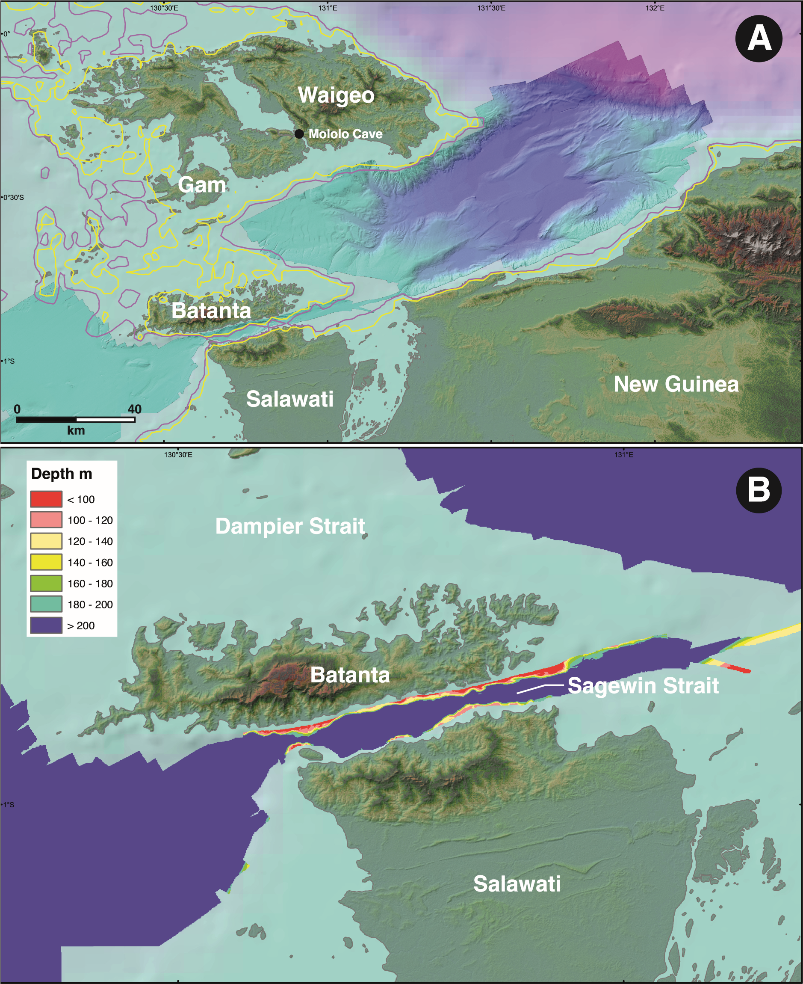
Figure S1. Palaeo-coastline reconstructions for Waitanta Island: A) multibeam imagery of the northern Raja Ampat area showing depth of seabed; B) multibeam imagery of Sagewin Strait, showing narrow and deep separation of Batanta Island from Salawati (formerly Sahul) (Images: R. Hall 2020).
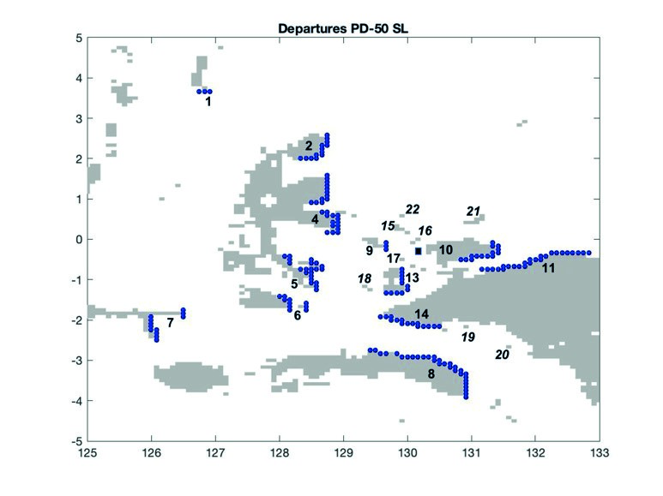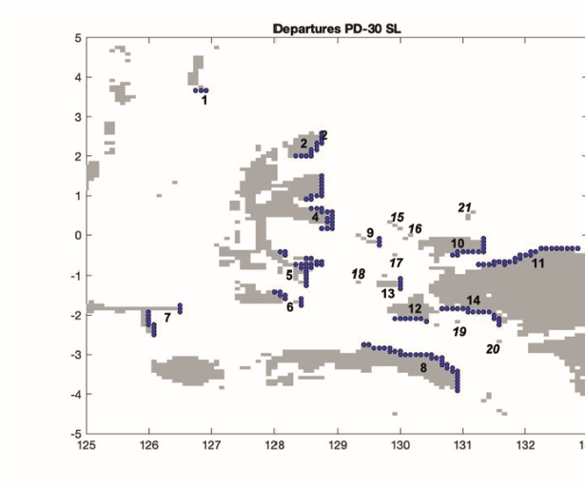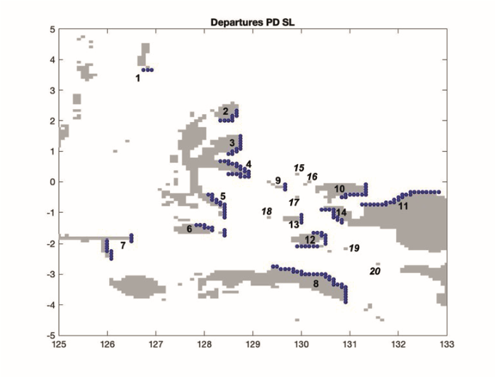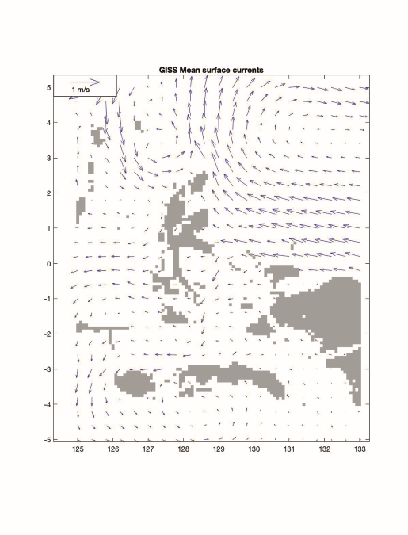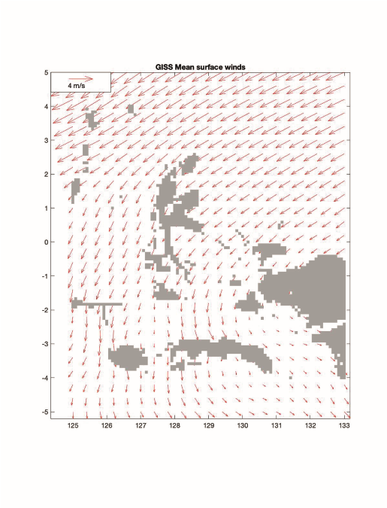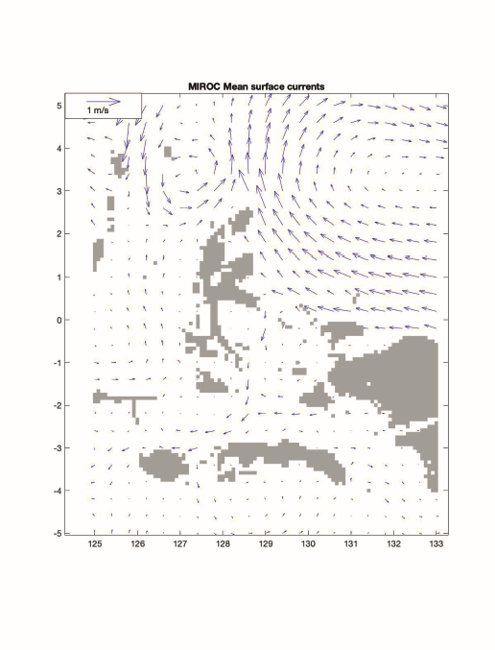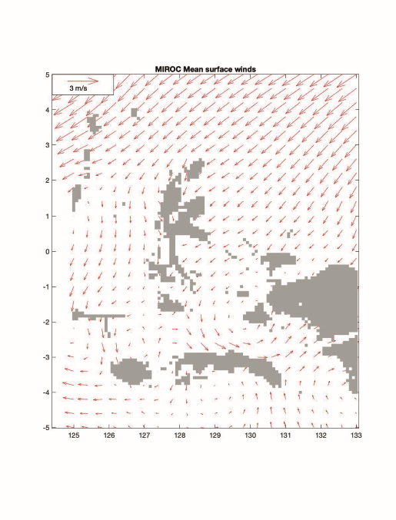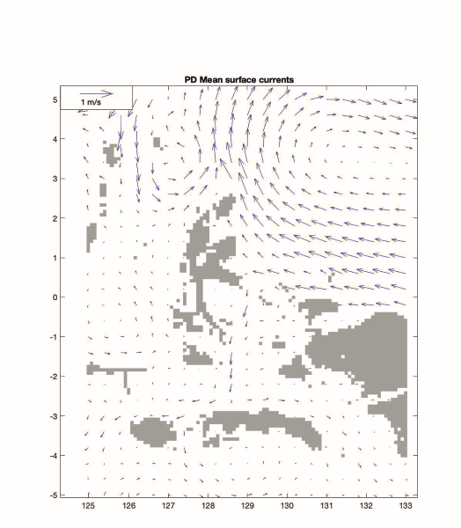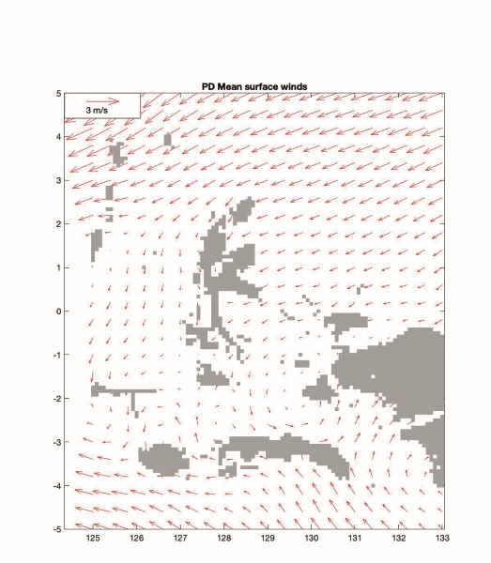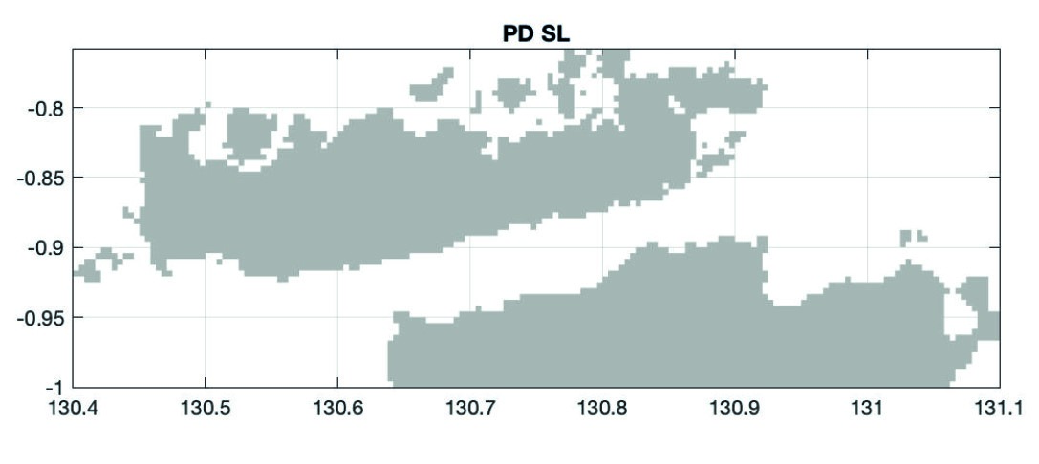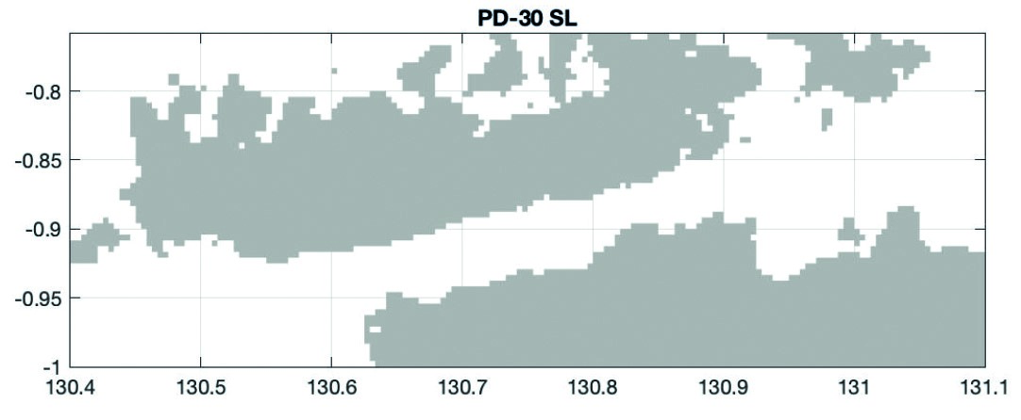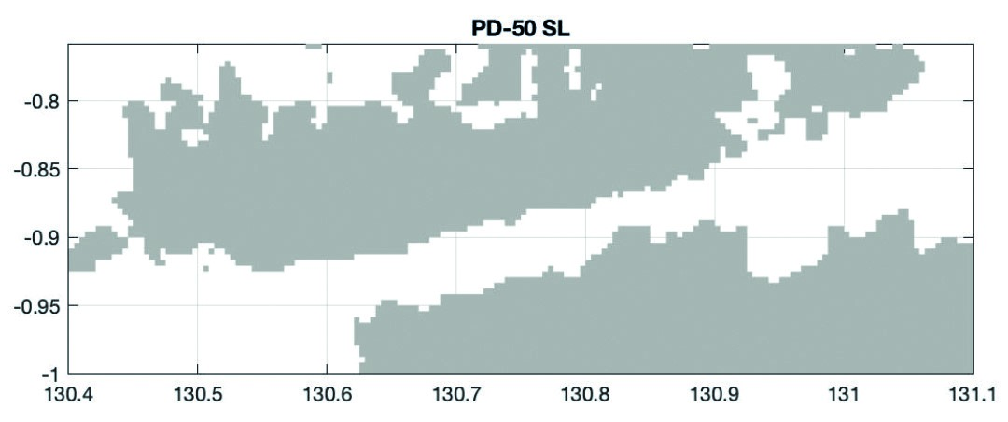

Batanta
Salawati
Salawati
Sagewin Strait
Sagewin Strait
Sagewin Strait
Batanta
Batanta
Salawati
D
E
F
G
H
I
A
B
C
Figure S2. Seafaring simulations modelling overwater movements to Waitanta. A–C) land distribution, departure and destination locations of simulated trips for the three adopted sea levels: A) present day sea level; B) present day sea level -30m; C) present day sea level -50m. Blue circles indicate departure points (1. Talaud; 2. Morotai; 3 Northern Halmahera; 4. Central Halmahera; 5. South Halmahera; 6. Obi; 7. Taliabu; 8. Seram; 9. Gebe; 10. Waigeo; 11. North Bird’s Head; 12. Misool; 13. Kofiau; 14. South Bird’s Head; 15. Sayang/Wayag; 16. Kawe; 17. Gag; 18. Boo; 19. Daram; 20. Sabuda; 21. Ayu; 22. Ormsbee Bank; locations 1–14 act as departures for drift, paddle and sail experiments and as targets for paddle and sail experiments; locations 15–20 represent areas where arrivals took place, but that were not set as targets and from which no departures were simulated). D–F) vector plots of average surface currents (left, blue) and winds (right, red) adopted by the simulation: D) LGM GISS; E) LGM MIROC; F) present day. G–I) land distribution of the Sagewin Straight area, based on GEBCO (2021) bathymetric grid, used for crossing experiments: G) present day sea level; H) present day sea level -30m; I) present day -50m sea level (Images: A. Montenegro 2022).

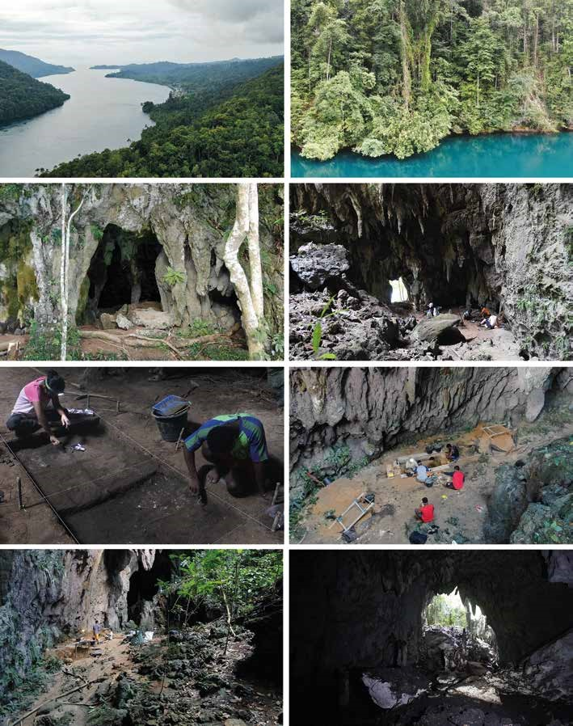

A
B
C
D
E
F
G
H
Figure S3. Mololo Cave excavations and surrounding environment: A) a view south from immediately above Mololo Cave towards Warsambin Village and the entrance to Rabia Strait; B) a view of the entrance to Mololo Cave, looking south from Rabia Strait; C) Mololo Cave entrance; D) looking to Area 1 from Area 2 showing overhang; E) Erlin Novita and Moses Dailom excavating Trench 1; F) drone photograph looking south at Trench 2 excavations; G) looking southwest to Area 2 from Area 1; H) view of limestone rocky slope from inner chamber (Photographs: T. Russell and D. Gaffney 2018).
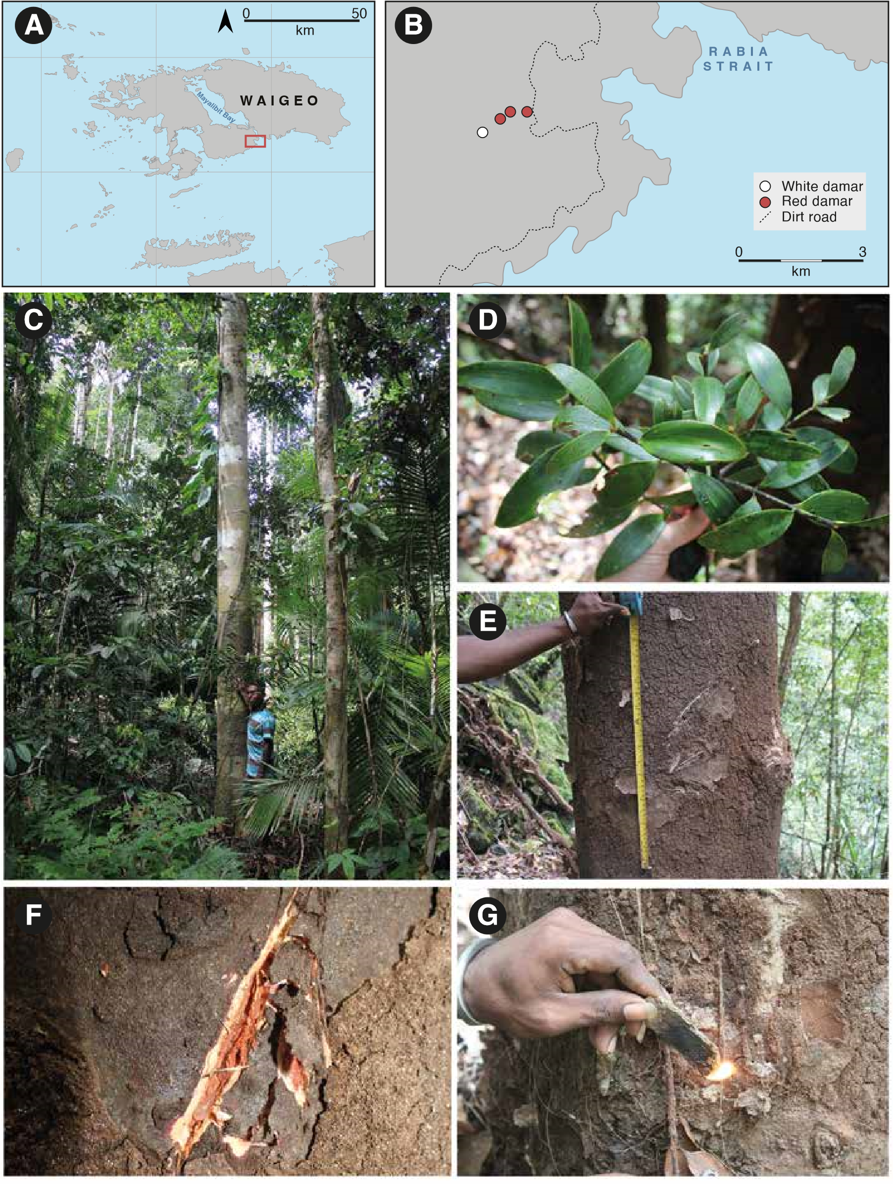
Figure S4. Ethnographic resins collected on Waigeo Island, 2018: A–B) map of Waigeo and locations of resin producing trees visited during survey; C) white damar tree (Agathis labillardieri); D) leaves of white damar; E) bark of white damar tree showing scars from former collecting; F) cut mark on white damar bark showing resin seeping out; G) piece of hardened white damar being used as a fuel for portable fire (Images: D. Gaffney 2018).

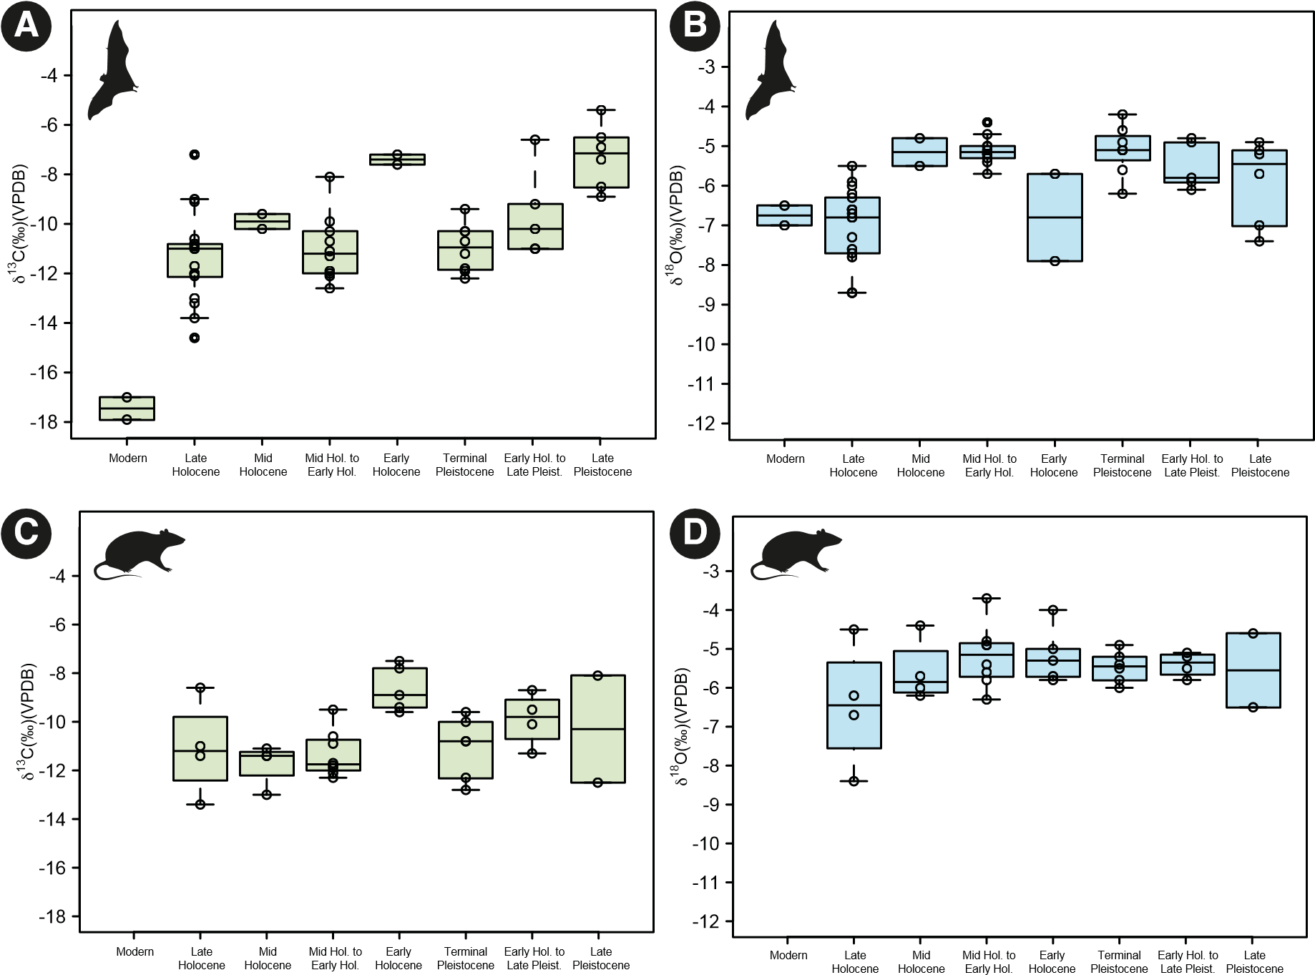

Figure S5. Faunal isotope ranges from Mololo Trench 1 and Trench 2. A–B) isotopic ranges for fruit bats (Pteropodidae): A) δ¹³C and B) δ¹⁸O. C–D) isotopic ranges for rats (Muridae): C) δ¹³C and D) δ¹⁸O (Images: P. Roberts and M. Lucas 2022).

