[For SUPPLEMENTARY MATERIAL]
Early animal management in northern Europe: new multi-proxy evidence from Swifterbant, the Netherlands

Nathalie Ø. Brusgaard^{1,*} [ORCID: 0000-0003-1085-7844], Jildou Kooistra², Mans Schepers³ [ORCID: 0000-0001-5819-2920], Michael Dee⁴ [ORCID: 0000-0002-3116-453X], Daan Raemaekers² [ORCID: 0000-0001-8665-9065] & Canan Çakırlar² [ORCID: 0000-0002-7994-0091]

¹ Faculty of Archaeology, Leiden University, the Netherlands
² Groningen Institute of Archaeology, University of Groningen, the Netherlands
³ Centre for Landscape Studies, University of Groningen, the Netherlands
⁴ Centre for Isotope Research, University of Groningen, the Netherlands
* Author for correspondence ✉ n.o.brusgaard@arch.leidenuniv.nl
Received: 10 August 2022; Revised: 1 February 2023; Accepted: 20 July 2023

Detailed materials & methods
At S3, all bone fragments larger than 10mm were collected by hand and the soil was wet-sieved (3mm mesh) (Zeiler 1997; Prummel et al. 2009: 33). The postcranial suid remains were fewer and highly fragmented compared to the dental elements; for cattle, it was the opposite.
Seven Bos specimens from the neighbouring S4 were also analysed as part of the stable isotope analysis. Additionally, the stable isotope data for three specimens (two cattle and one caprine), were provided by ADC Archeoprojecten. These specimens were collected by hand during excavations across the Swifterbant area, carried out as part of the development-led ‘Windplan Blauw’ archaeology project. The coordinates of one Windplan Blauw sample, number 25, are unknown.
The sites S2, S3 and S4 were located in a freshwater wetland area that consisted of a system of small rivers with river banks (Figure S15). The Windplan Blauw excavations were also carried out in this area. The reconstruction of the river system and the major landscape units (Figure 1) are based on extensive excavation and coring data from this region (Dresscher & Raemaekers 2010; Schepers 2014; Raemaekers & de Roever 2020; Schepers & Woltinge 2020).

Biometric analysis
Logarithmic Size Index (LSI) analysis of metric data is one of the most applied methods to investigate domestication (Zeder 2006). It alleviates the problem of small sample sizes and recent studies continue to show that it is a better method than using direct assessment of single measurements (Wolfhagen 2020). The method compares the logarithm of recorded measurements to the same measurements of a ‘standard’ (Meadow 1999). Specimens that are smaller than the standard will scale negatively while specimens that are larger will scale positively, thereby providing insight into the size of the site’s suids and cattle and their possible domestic status.
We measured all measurable Sus teeth and postcranial elements and Bos postcranial elements from S3 following published standards (Von den Driesch 1976; Payne & Bull 1988; Albarella & Payne 2005; Jones 2007). The LSI analysis was carried out following Meadow (1999) (base = 10). In the case of an associated left and right element, the left element was excluded from analysis. Unfused postcranial elements and not (fully) erupted teeth are shown in Figures S3–5 but excluded from further analyses. The measurements were taken as part of a study by Kooistra (2022).
For the Sus postcranial analysis, we used a wild boar standard (Hongo & Meadow 2000—a female wild boar from Eastern Turkey). Scapula measurements were excluded to eliminate possible age bias (Albarella & Payne 2005; Zeder & Lemoine 2020). None of the astragali were light and porous, indicating a juvenile individual and therefore did not need to be excluded (Albarella & Payne 2005: 597).
For the Bos postcranial analysis, we used the aurochs standard established by Degerbøl and Fredskild (1970) and republished (with one amended measurement) in Grigson (1989—the Ullerslev specimen, a Mesolithic female aurochs). LSI values represent the average LSI of all measurements on one element, excluding length measurements except in the case of astragali and calcanea, following Meadow (1999) and Albarella and Payne (2005).
For the Sus dental analysis, we used the wild boar standard established by Payne and Bull (1988—the mean of a wild boar population). LSI values were calculated per tooth and represent the average LSI of the width measurements on one tooth; length measurements are excluded and upper and lower teeth are analysed separately, following Zeder and Lemoine (2020) and Meadow (1999).
Statistical analyses were carried out using IBM SPSS Statistics 28. No extreme outliers were identified in the Sus or Bos dataset.

Age estimation
Harvesting profiles can provide insight into hunting practices and potential herd management based on the survivorship of specific age classes (Magnell 2005; Albarella et al. 2006). Cattle tooth wear was recorded following Grant (1982) and wear stages and age classes following Legge (1992) (Table S5). Loose M1/M2s were identified where possible following the method of Beasley et al. (1993) based on the length of the cervical (CervL) and the width of the anterior (WA) compared to known M1 and M2 specimens from S3 and the Schipluiden data as a reference size (Kamjan et al. 2020) (Figure S8). Cattle postcranial fusion data were taken from (Zeiler 1997), which was calculated following Habermehl (1975) (Table S6).
We recorded suid tooth wear and tooth eruption and calculated survivorship following Lemoine et al. (2014) (System A) (Tables S7 & 8). In the case of an associated left and right side of a mandible or maxilla, tooth wear was scored for the most complete side or, in the case of a tie, for the right side. When possible, age class B in Lemoine et al.'s System A was broken down into age groups 3–5 months and 6–8 months (Lemoine et al.'s Specific System age classes 2 and 3) based on tooth wear and eruption state of the dP4 and M1 to allow for more detail on number of unweaned vs weaned piglets. Postcranial fusion and survivorship was carried out following Zeder et al. (2015) (Table S9).

Stable isotope analysis
A total of 73 bone samples and 18 dentine samples was selected, which included suids, cattle, and baseline animals. For one individual (EDAN0376), we sampled the mandible bone and tooth dentine to test whether there would be a difference between bone and dentine values.
Pretreatment and collagen extraction was performed following a modified Longin (1971) protocol at the Centre for Isotope Research, University of Groningen (Dee et al. 2020). Briefly, the samples were first demineralised in an HCl (4% w/vol) solution, replenished several times over 24 hours. This was followed by NaOH (1% w/vol) to remove humic acids, and then a final HCl (4% w/vol) treatment to eliminate any CO2 absorbed during the base phase. Each step was followed by a triplicate rinse in deionised and decarbonised water. The samples were then denatured to gelatin in deionised and decarbonised water (pH 3, 80°C, 18 hr) and dried.
For the first 66 samples, approximately 5–6mg aliquots of extracted collagen were weighed out per sample. Samples yielding less than 0.5% collagen were rejected for quality control; this applied to nine samples. The δ¹³C and δ¹⁵N values were obtained via combustion in an elemental analyser (EA, Elementar Vario Isotope Cube) coupled to an Isotope Ratio Mass Spectrometer (IRMS, IsoPrime 100).
Due to instrument availability, for the remaining 25 samples, approximately 1mg aliquots of extracted collagen were weighed out per sample. These were combusted in another EA (PyroCube) coupled to another IRMS (PrecisION). Again, samples yielding less than 0.5% collagen were rejected for quality control; this applied to one sample.
The C:N range of 2.9–3.6 from DeNiro (1985) is often cited as acceptable for collagen purity, but the CIO prefers to investigate results if they fall outside 3.1–3.3 (Dee et al. 2020), and is moving to rejection for all samples outside 2.9–3.5. All results fell within this range. For quality control, each pretreatment batch included a secondary standard, with known isotope ratios, and a duplicate. The δ¹³C and δ¹⁵N data were obtained at the following 1σ precisions: δ13C = 0.15‰ and δ15N = 0.3‰. For one sample (EDAN0160), the measurement of the δ¹⁵N values failed in the IRMS.
Two samples were radiocarbon dated. The 5–6 mg of collagen from each sample were combusted in an EA (Elemental Vario Isotope Cube) coupled to an IRMS (IsoPrime 100) with an automated cryogenic system which traps the CO₂ into sealable glass vessels. This combination allows for δ¹³C and δ¹⁵N measurements on all samples submitted for radiocarbon dating. The trapped CO₂ is then graphitized over an iron catalyst in a stoichiometric excess of H₂. Finally, the graphite is pressed into Al cathodes and transferred to the MICADAS mass spectrometer (Ionplus AG, 200kV) for radioisotope analysis.
The four bone samples from the Windplan Blauw project were also radiocarbon dated at the Centre for Isotope Research following the same protocol, upon which δ¹³C and δ¹⁵N values were obtained.
We submitted six of the collagen samples (EDAN0286, 352, 353, 357, 373 and 349) for identification via Zooarchaeology by Mass Spectrometry (ZooMS) at the BioArch laboratory at the University of York, which used the protocol outlined in Dierickx et al. (2022).

Vegetation analysis
Extensive archaeobotanical analyses have been carried out on multiple sites in the Swifterbant area (Casparie et al. 1977; Van Zeist & Palfenier-Vegter 1981; Raemaekers et al. 2014; Schepers & Bottema-Mac Gillavry 2020). We re-examined previous phytosociological vegetation analyses (Schepers et al. 2013). Phytosociology is the study of plant communities. More than using individual plants would do, it allows for the understanding of vegetation on a landscape ecological level. Using palaeoassocia (Schepers et al. 2013), the data collected for the previous studies were split into overlapping species groups, which were subsequently assigned to the most similar present-day plant communities (Schepers 2014). The plant communities (syntaxa) thus identified are inspected more closely for the nutrient availability generally associated with them, using SynBioSys (Hennekens et al. 2010). We look at both the nutrient values as calculated for these syntaxa using Ellenberg nutrient values for vascular plants (Ellenberg et al. 1991), as well as the nitrogen content measured in soils associated with plant species (Wamelink et al. 2005). We chose to focus on the most frequently identified syntaxa identified for the S3 and S4 sites. By doing so, we obtain a more nuanced view of the expected variation in nutrient availability in the region.

Detailed results
Size
The Bos postcranial elements scale small on the LSI scale with a mean of -0.081 and show little deviation (Figures 3a, S1 & S2). There is one exception: a specimen (910083/EDAN0263) that is larger than the standard Mesolithic female aurochs and was also identified as an aurochs by Zeiler (1997). One Bos M3 (9910142/EDAN0380) stands out as being an exceptionally large M3 and may be an aurochs.
The S3 Bos are significantly smaller than the (i) Mesolithic aurochs and Bos sp. from Ertebølle culture sites (Independent Samples T-Test, p = <0.001; Table S11-13), (ii) Bos sp. from the partly contemporary (4800–3800 BC) Swifterbant Culture site at Bazel, Belgium (Mann-Whitney U Test, p = 0.027), and (iii) primarily domestic cattle bones from Linearbandkeramik culture sites (Mann-Whitney U Test, p = <0.001). They are significantly larger than the cattle from Schipluiden (Mann-Whitney U Test, p = 0.008).
The Sus dental elements scale slightly small with a mean of -0.03 (lower teeth) and -0.046 (upper teeth) (Figures 3b & S3–7). They are significantly smaller than the Mesolithic wild boar specimens from Polderweg 1 (lower teeth: Independent Samples T-Test, p = <0.001; upper teeth: Mann-Whitney U Test, p = <0.001) and De Bruin 2 (lower: Independent Samples T-Test, p = <0.001; no upper) (Table S14). There is no significant difference with the Mesolithic wild boar from De Bruin 1 (lower: Independent Samples T-Test, p = 0.479; no upper). They are significantly larger than the Neolithic pigs from Durrington Walls (lower: Independent Samples T-Test, p = <0.001; upper: Mann-Whitney U Test, p = <0.001).
The postcranial elements also scale small (mean -0.024). They are significantly smaller than Polderweg 1 and De Bruin 2 (Independent Samples T-Test, p = <0.001, p = 0.002, respectively). They are significantly larger than Durrington Walls (Independent Samples T-Test, p = <0.001). There is no significant difference with De Bruin 1, De Bruin 4, or Schipluiden (Independent Samples T-Test, p = 0.391, p = 0.577, p = 0.458, respectively). There is one specimen that scales particularly large (a humerus, LSI of 0.061), which may be a wild boar.

Mortality profile
For the Bos, other than the young calves (<6 months), all ages are represented. The dentition-based profile presents a majority of adults in the assemblage, where most are between six and eight years old (n = 6), followed by three- to six-year-olds (n = 4) (Figure 3a, Table S6). One individual is between six and ten years old. There are no individuals younger than six months. The long bones reveal comparable results, whereby the majority of specimens are aged 24 to 30 months or older (n = 12) and there are none younger than seven months (Table S7). The assemblage yielded one fetal metatarsus (Zeiler 1997: 51). The results contrast with Schipluiden, where young cattle are more strongly represented.
The Sus dentition-based profile shows an emphasis on individuals between eight and twelve months old (n = 6) and 18 to 52 months (n = 7.5) (Table S9). Survivorship declines steadily through the age classes with the sharpest drop after 52 months old (Figure 3b). The survivorship compares closely with that of Polderweg, while it shows a higher survivorship of young suids than at Durrington Walls. When loose teeth and maxilla are included per Lemoine et al. (2014), the assemblage also presents a high number of suids aged three to five months olds (n = 24.5), followed by the six to eight month olds (n = 19.5) (Table S9). There are several individuals one month old or younger and two older than 96 months. Among the postcranial elements, the majority of specimens are aged seven to eight months (n = 4) (Table S10). There are no specimens younger than seven months and none older than five years.

ZooMS
Using ZooMS, individual EDAN0353 (initially identified as a caprine) was identified as a Bos sp., individual EDAN 0286 (initially identified as a Bos sp.) was identified as a Cervidae (elk, red deer or roe deer), individuals EDAN0352, 357, and 373 (initially identified as caprines) were identified as sheep (Ovis aries), and EDAN0349 (initially identified as an otter) was identified as a badger (Meles meles) (Table S17).

Diet and environment
The stable isotope analysis reveals clear distinctions within the δ¹³C and δ¹⁵N values of the sampled specimens (Table S15, Figure 5). The Bos specimens appear to form two groups in terms of both δ¹³C and δ¹⁵N values. Using these values, we performed a hierarchical agglomerative cluster analysis using Ward’s linkage. The results present two strong clusters (Figures S9 & S10). Cluster 1 consists of Bos with very elevated δ¹⁵N values (mean +11.6‰). They are much higher than the Cervidae (mean +5.4‰), higher even than the otter and badger, and in same range as the dog and the humans. This cluster also has slightly elevated δ¹³C values (mean -21.1‰) compared to the Cervidae (-22.1‰). The caprines, of which three were identified as sheep (Ovis aries) using ZooMS, exhibit similar values to Cluster 1. The Bos from Swifterbant Windplan Blauw all fall within Cluster 1 whereas of the S4 samples, six fall within Cluster 1 and one within Cluster 2. Cluster 1 exhibits even higher δ¹⁵N values than the coastal grazing cattle and cervidae at Schipluiden (Figure S10).
Cluster 2 has more depleted δ¹³C values (mean -23.1‰) than the Cervidae, but the δ¹⁵N values (mean +5.6‰) are within the wild herbivore range. This Cluster has δ¹³C and δ¹⁵N values comparable to the cattle from Hardinxveld and δ¹³C values that are more depleted than the Schipluiden cattle. The caprine data from Windplan Blauw are more comparable to the Cluster 2 cattle than the S3 sheep.
The two clusters are significantly different from one another in both their δ¹³C values (Independent Samples T-Test, p = <0.001) and their δ¹⁵N values (Independent Samples T-Test, p = <0.001) (Table S16). Each cluster contains specimens represented by different skeletal elements, including cranial and postcranial. It is therefore possible that some correspond to the same individual. However, based on biometrics, fusion state and stable isotope values it is possible to discern at least several individuals in each cluster.
The large, likely aurochs, specimen (EDAN0263) sits in Cluster 2. The rest of the measurable specimens all scale small in the LSI analysis (mean -0.081) and are divided across Clusters 1 and 2, indicating no link between size and stable isotope values (Figure S11).
There appears to be no difference between the δ¹³C and δ¹⁵N values of bone and dentine (Figure S12). Bone and dentine samples fall within both clusters and the bone and dentine results of EDAN0376 are very similar.
The Sus specimens exhibit an almost equally wide range of δ¹³C values (between -22.5‰ and -19.6‰) and δ¹⁵N (between +4.5‰ and +11.9‰) but with less clustering (Figure S13). The Sus δ¹³C values are comparable to those of the wild boar from Hardinxveld and slightly elevated compared to the S3 wild herbivores. They present overall more elevated δ¹⁵N values (mean +7.9‰) than the Hardinxveld wild boar (mean +5.3‰) and the S3 wild herbivores. Two individuals (EDAN0266 and EDAN0162) have particularly elevated δ¹⁵N values of +11.9‰ compared to the rest of the Sus; they fall within the same range as the Bos Cluster 1 and are more elevated than the dog. EDAN0162 could potentially be a suckling piglet as it is between 1 and 5 months old; EDAN0266 is, however, an adult (18 to 96 months old). This specimen also scales small in the LSI analysis (-0.064). Other than these specimens, there is no discernible correlation between size (LSI value) and δ¹³C and δ¹⁵N values (Figure S14).

Figure S1. Metrics of each Bos postcranial element on a Logarithmic Size Index scale, labelled by specimen number.

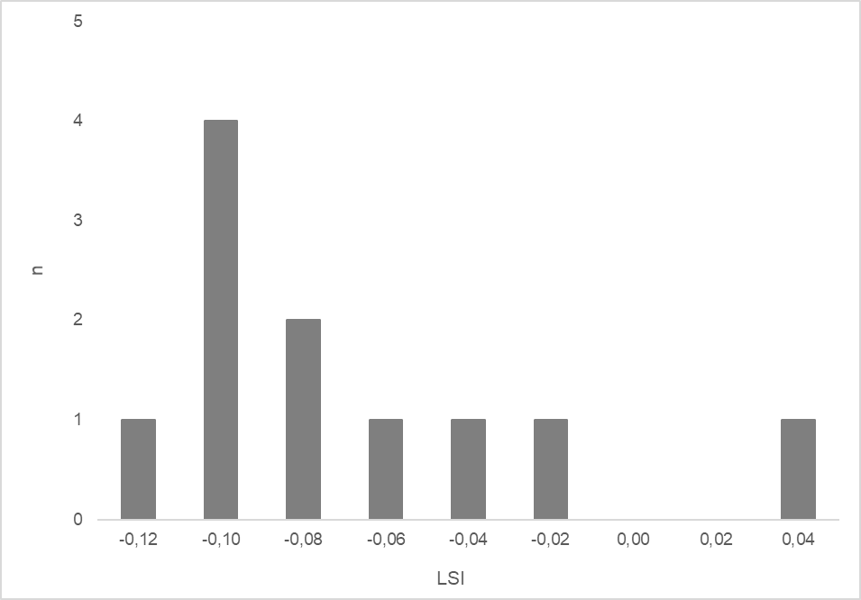
Figure S2. Histogram of Logarithmic Size Index (LSI) analysis of Bos postcranial elements.
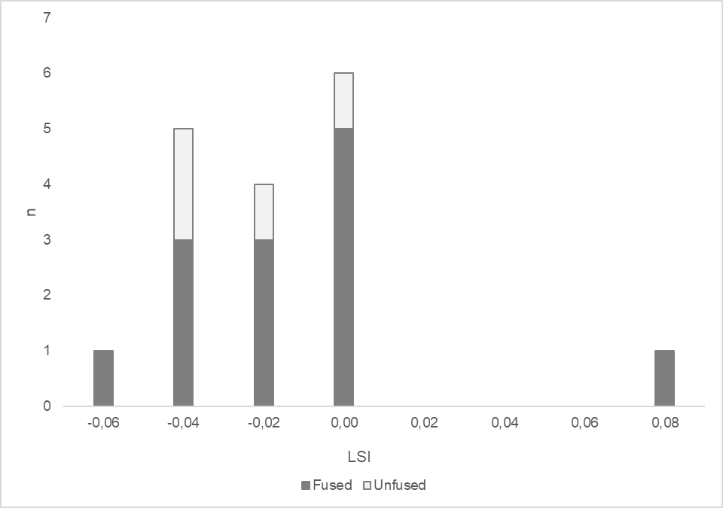
Figure S3. Histogram of Logarithmic Size Index (LSI) analysis of Sus postcranial elements.
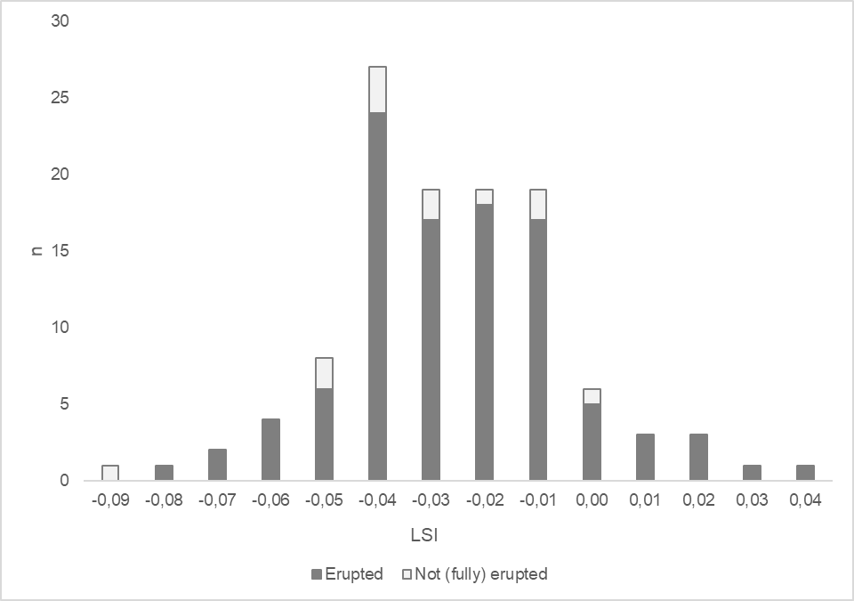
Figure S4. Histogram of Logarithmic Size Index (LSI) analysis of Sus lower teeth breadths.
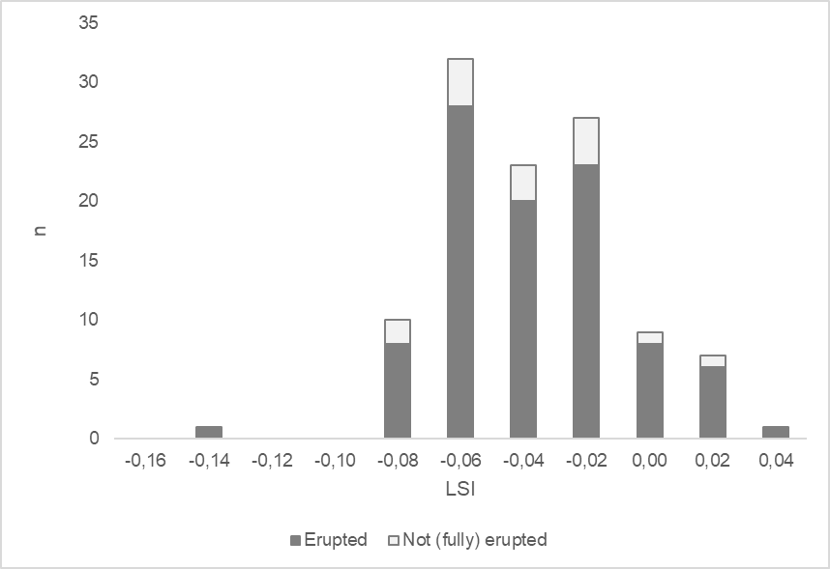
Figure S5. Histogram of Logarithmic Size Index (LSI) analysis of Sus upper teeth breadths.

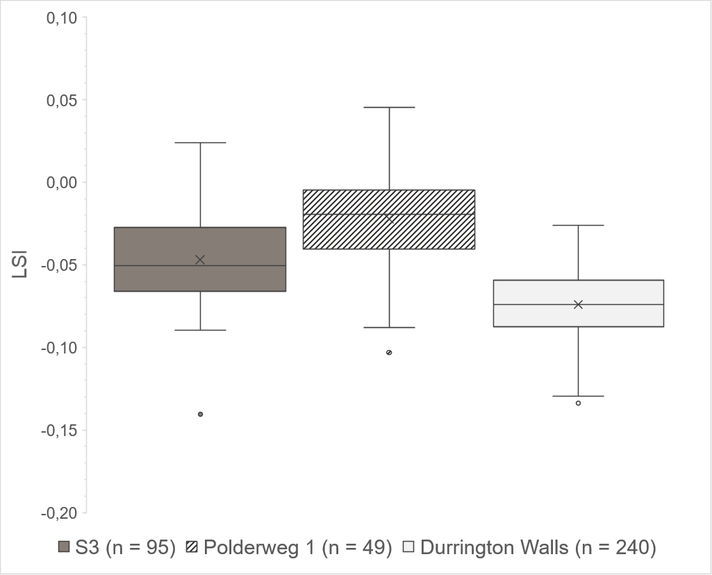
Figure S6. Boxplot of Logarithmic Size Index (LSI) analysis of Sus upper teeth breadths compared to Polderweg (Brusgaard et al. 2022) and Durrington Walls (Albarella & Payne 2005).
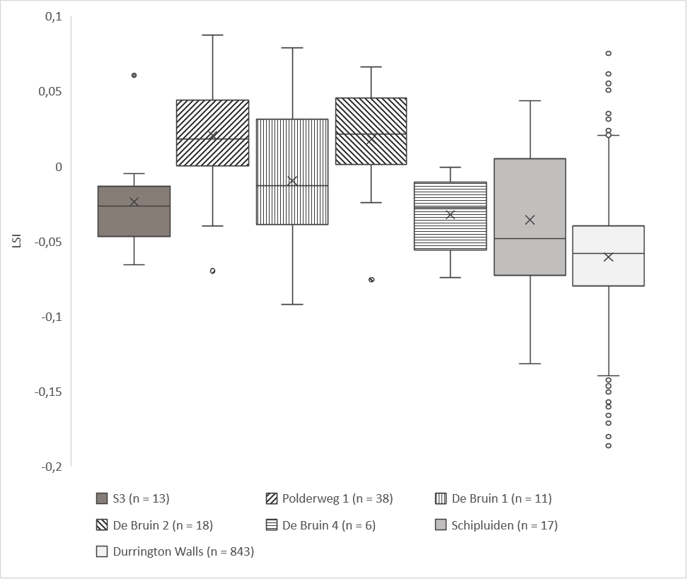
Figure S7. Boxplot of Logarithmic Size Index (LSI) analysis of Sus postcranial elements compared to Polderweg and De Bruin (Brusgaard et al. 2022), Schipluiden (Manning et al. 2015) and Durrington Walls (Albarella & Payne 2005).

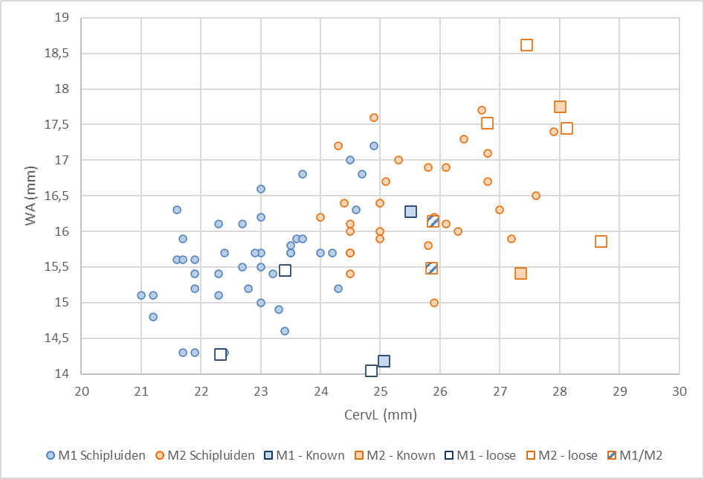Figure S8. Identification of loose mandibular M1/M2s based on the length of cervical (CervL) and width of the anterior (WA) compared to four known M1 and M2 specimens from S3 and to Schipluiden reference data from Kamjan et al. (2020). Two specimens could not be identified due to their ambiguous size.

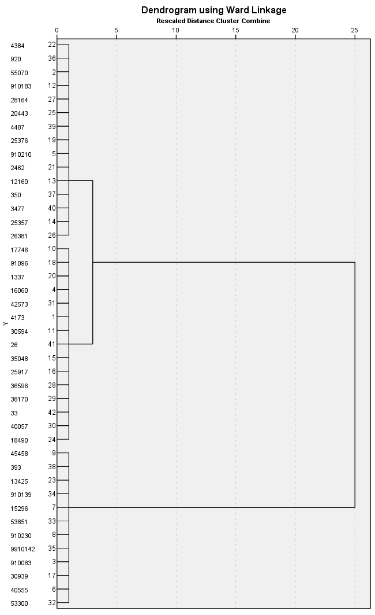
Figure S9. Hierarchical agglomerative cluster analysis using Ward’s linkage of Bos stable isotope results from Swifterbant S3, S4, and Windplan Blauw, presenting two well-defined clusters. Specimens are labelled by their Faunal ID.

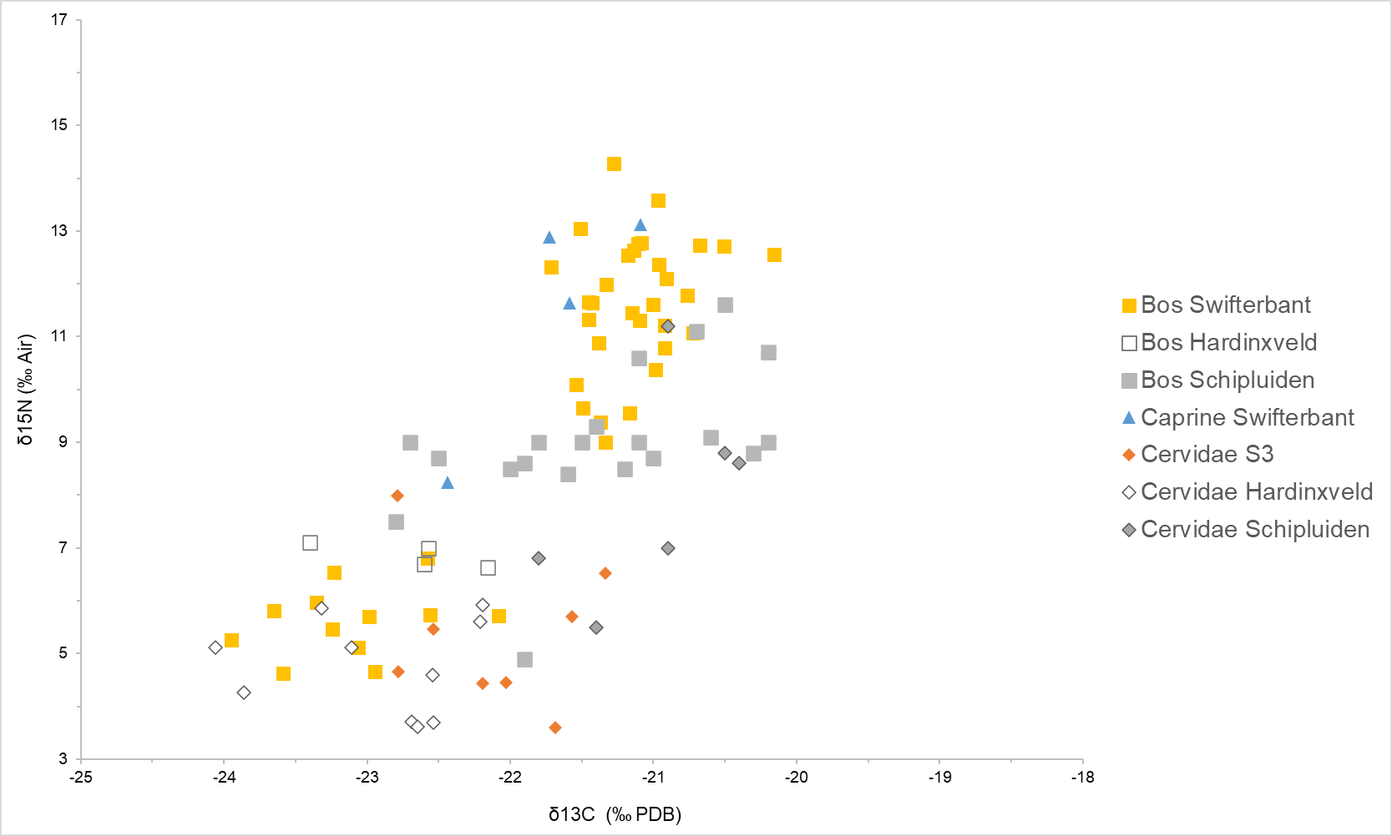
Figure S10. The Bos and caprine δ¹³C and δ¹⁵N values at Swifterbant as compared to Bos and cervidae from other Dutch Neolithic sites (data for other sites from Smits et al. 2010; Çakırlar et al. 2020; Kamjan et al. 2020; Brusgaard et al. 2022).

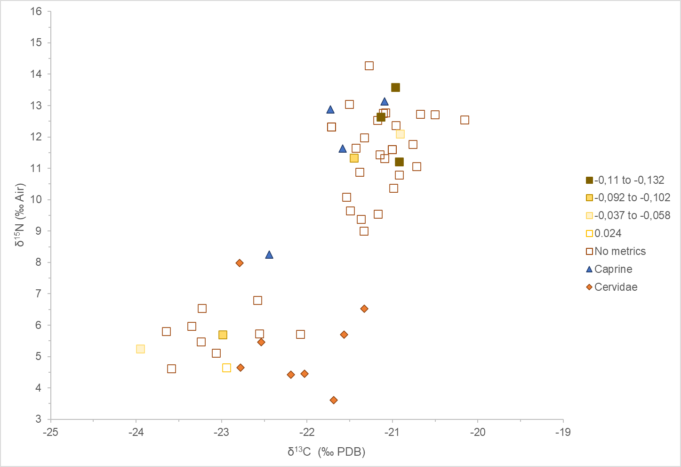
Figure S11. δ¹³C and δ¹⁵N values of Bos compared to their LSI values. LSI categories: -0.265 (n = 1); -0.11 to -0.132 (n = 3); -0.092 to -0.102 (n = 2); -0.037 to -0.058 (n = 2); 0.024 (n = 1); no metrics (n = 10).

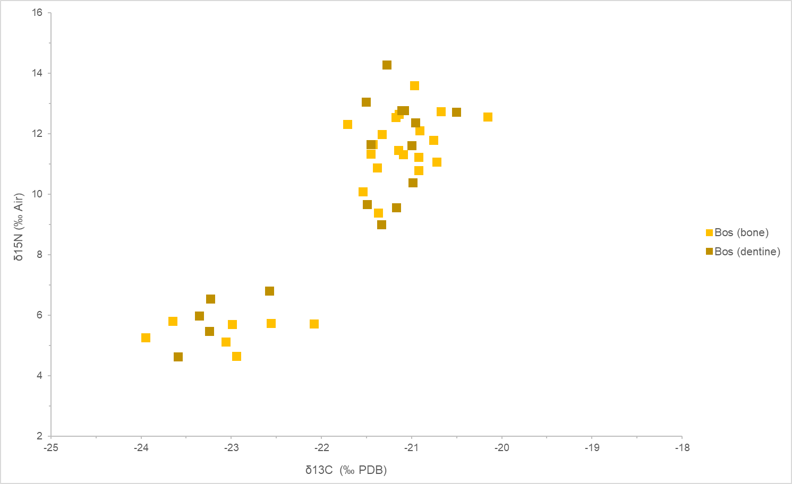
Figure S12. δ¹³C and δ¹⁵N results of Swifterbant Bos comparing bone collagen values and dentine collagen values.

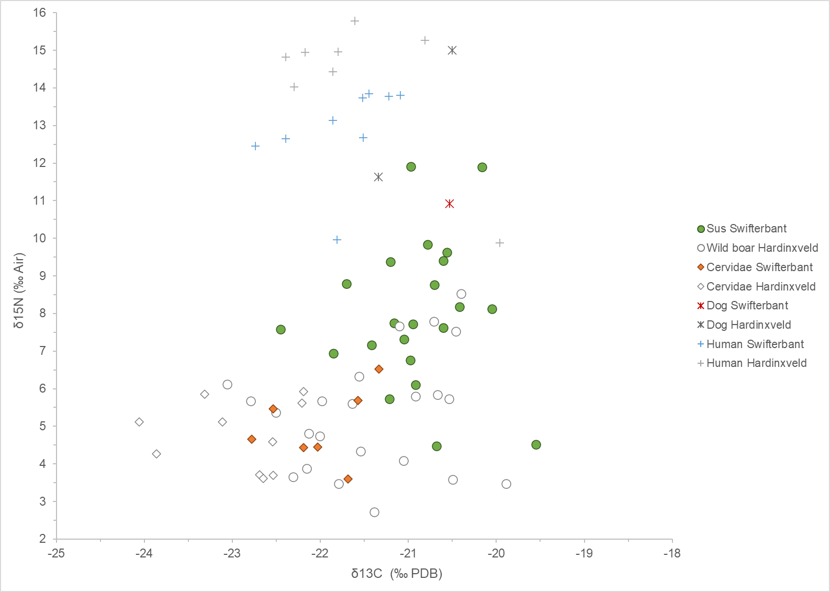
Figure S13. Suid δ¹³C and δ¹⁵N values at S3 compared to the wild boar from Hardinxveld Polderweg and De Bruin (data from Brusgaard et al. 2022).

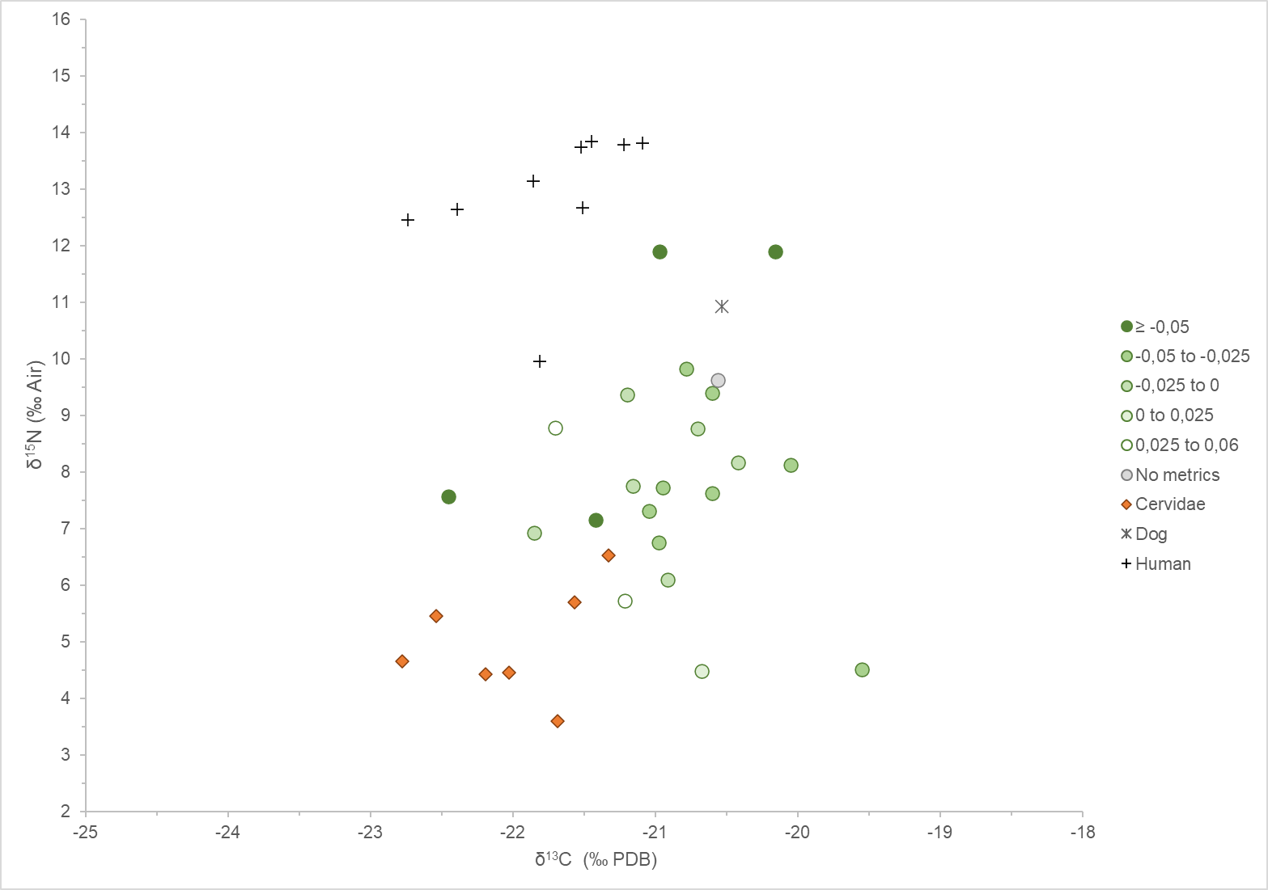
Figure S14. δ¹³C and δ¹⁵N values of suids compared to their LSI values. LSI categories: ≥ -0.05 (n = 4); -0.05 to -0.025 (n = 8); -0.025 to 0 (n = 6); 0 to 0.025 (n = 1); 0.025 to 0.06 (n = 2); no metrics (n = 1). Note that this includes skeletal elements measured on two different LSI scales (postcranial and dental).

Figure S15. Map of the Swifterbant sites S2, S3 and S4 and the Windplan Blauw samples, along the contemporary freshwater river system.

References
Albarella, U. & S. Payne. 2005. Neolithic pigs from Durrington Walls, Wiltshire, England: a biometrical database. Journal of Archaeological Science 32: 589–99. https://doi.org/10.1016/j.jas.2004.11.008
Albarella, U., K. Dobney & P. Rowley-Conwy. 2006. The domestication of the pig (Sus scrofa): new challenges and approaches., in M. Zeder, D.G. Bradley, E. Emshwiller & B.D. Smith (ed.) Documenting domestication: new genetic and archaeological paradigms: 209–27. Berkeley: University of California Press.
Beasley, M.J., W.A.B. Brown & A.J. Legge. 1993. Metrical discrimination between mandibular first and second molars in domestic cattle. International Journal of Osteoarchaeology 3: 303–14. https://doi.org/10.1002/oa.1390030409
Brusgaard, N.Ø., M. Dee, M. Dreshaj, J. Erven, Y. van den Hurk, D.C.M. Raemaekers & C. Çakırlar. 2022. Hunting before herding: a zooarchaeological and stable isotopic study of suids (Sus sp.) at Hardinxveld-Giessendam, the Netherlands (5450–4250 cal BC). PLoS ONE 17: e0262557. https://doi.org/10.1371/journal.pone.0262557
Çakırlar, C., R. Breider, F. Koolstra, K.M. Cohen & D.C.M. Raemaekers. 2020. Dealing with domestic animals in the fifth millennium cal BC Dutch wetlands: new insights from old Swifterbant assemblages, in K.J. Gron, L. Sørensen & P. Rowley-Conwy (ed.) Farmers at the frontier: a pan European perspective on neolithisation: 263–87. Oxford: Oxbow.
Casparie et al. 1977. The palaeobotany of Swifterbant. A preliminary report. Helinium 17: 28–55.
Dee, M.W. et al. 2020. Radiocarbon dating at Groningen: new and updated chemical pretreatment procedures. Radiocarbon 62: 63–74. https://doi.org/10.1017/RDC.2019.101
Degerbøl, M. & B. Fredskild. 1970. The Urus (Bos primigenius bojanus) and Neolithic domesticated cattle (Bos taurus domesticus Linné) in Denmark. With a revision of Bos-remains from the Kitchen Middens. Zoological and palynological investigations. Vol. 17 (Det Kongelige Danske Videnskabernes Selskab Biolo-Giske Skrifter). Copenhagen: Munksgaard.
DeNiro, M.J. 1985. Postmortem preservation and alteration of in vivo bone collagen isotope ratios in relation to palaeodietary reconstruction. Nature 317: 806–9. https://doi.org/10.1038/317806a0
Dierickx, K. et al. 2022. Peptide mass fingerprinting of preserved collagen in archaeological fish bones for the identification of flatfish in European waters. Royal Society Open Science 9: 220149. https://doi.org/10.1098/rsos.220149
Dresscher, S. & D.C.M. Raemaekers. 2010. Oude geulen op nieuwe kaarten. Het krekensysteem bij Swifterbant (prov. Flevoland). Paleo-aktueel 21: 31–37.
Ellenberg, H., H.E. Weber, R. Düll, V. Wirth, W. Werner & D. Paulissen. 1991. Zeigerwerte von Pflanzen in Mitteleuropa. Scripta Geobotanica 18: 1–248.
Grant, A. 1982. The use of tooth wear as a guide to the age of domestic animals, in B. Wilson, C. Grigson & S. Payne (ed.) Ageing and sexing animal bones from archaeological sites (British Archaeological Reports British Series 109): 91–108. Oxford: BAR.
Grigson, C. 1989. Size and sex: evidence for the domestication of cattle in the Near East, in A. Milles, D. Williams & N. Gardner (ed.) The beginnings of agriculture (British Archaeological Reports International Series 496): 77–109. Oxford: BAR.
Habermehl, K.-H. 1975. Die Altersbestimmung bei Haus- und Labortieren. Berlin/Hamburg: Paul Parey.
Hennekens, S.M., N.A.C. Smits & J.H.J. Schaminée. 2010. SynBioSys Nederland versie 2. Wageningen: Alterra.
Hongo, H. & R.H. Meadow. 2000. Faunal remains from Pre-pottery Neolithic levels at Çayönü, southeastern Turkey: a preliminary report focusing on pigs (Sus sp.), in M. Mashkour, A.M. Choyke, H. Buitenhuis & F. Poplin (ed.) Archaeozoology of the Near East IV A. Proceedings of the fourth international symposium on the archaeozoology of southwestern Asia and adjacent areas: 121–39. Groningen: ARC Publications.
Jones, G. 2007. Variations of mandibular tooth accessory pillars, and metrical and morphological differences between M1 and M2, in the cattle associated with the chariot burial, appendix 11, in F.C. Brown et al. (ed.) The archaeology of the A1 (M) Darrington to Dishforth DBFO road scheme: 615–25. Oxford: Oxford Archaeology North, Lancaster Imprints.
Kamjan, S., R.E. Gillis, C. Çakırlar & D.C.M. Raemaekers. 2020. Specialized cattle farming in the Neolithic Rhine-Meuse Delta: results from zooarchaeological and stable isotope (δ18O, δ13C, δ15N) analyses. PLoS ONE 15: e0240464. https://doi.org/10.1371/journal.pone.0240464
Kooistra, J. 2022. Suids of Swifterbant S3. An early case of animal husbandry in the Dutch wetlands? Unpublished MA dissertation, University of Groningen.
Legge, A. 1992. Exacavations at Grimes Graves Norfolk 1972–1976. Fascicule 4: animals, environment and the Bronze Age economy. London: British Museum Press.
Lemoine, X., M.A. Zeder, K.J. Bishop & S.J. Rufolo. 2014. A new system for computing dentition-based age profiles in Sus scrofa. Journal of Archaeological Science 47: 179–93. https://doi.org/10.1016/j.jas.2014.04.002
Longin, R. 1971. New method of collagen extraction for radiocarbon dating. Nature 230: 241–42.
Magnell, O. 2005. Harvesting wild boar—a study of prey choice by hunters during the Mesolithic in south Scandinavia by analysis of age and sex structures in faunal remains. Archaeofauna 14: 27–41.
Manning, K., A. Timpson, S. Colledge, E. Crema & S. Shennan. 2015. The cultural evolution of Neolithic Europe. EUROEVOL dataset. Available at: https://discovery.ucl.ac.uk/id/eprint/1469811 (accessed 29 June 2023).
Meadow, R.H. 1999. The use of size index scaling techniques for research on archaeozoological collections from the Middle East, in C. Becker, H. Manhart, J. Peters & J. Schibler (ed.) Historia Animalium Ex Ossibus: Beitrage zur Palaoanatomie, Archaologie, Agypto-logie, Ethnologie, und Geschichte der Tiermedizin. Festschrift ftir Angela von den Driesch zurn 65. Geburtstag.: 285–300. RahdenlWestf.: Marie Leidorf.
Payne, S. & G. Bull. 1988. Components of variation in measurements of pig bones and teeth, and the use of measurements to distinguish wild from domestic pig remains. Archaeozoologia 2: 27–66.
Prummel, W. et al. 2009. Terug naar Swifterbant. Een kleinschalige opgraving te Swifterbant-S2 (gemeente Dronten). Archeologie 13: 17–45.
Raemaekers, D.C.M. & J.P. de Roever (ed.) 2020. Swifterbant S4 (the Netherlands). Occupation and exploitation of a Neolithic levee site (c. 4300–4000 cal. BC) (Groningen Archaeological Studies 36). Groningen: University of Groningen / Groningen Institute of Archaeology & Barkhuis.
Raemaekers et al. 2014. Swifterbant-S25 (gemeente Dronten, provincie Flevoland). Een bijzondere vindplaats van de Swifterbant-cultuur (ca. 4500–3700 cal. BC). Palaeohistoria 55/56: 1–56.
Schepers, M. 2014. Wet, wealthy worlds: The environment of the Swifterbant river system during the Neolithic occupation (4300–4000 cal BC). Journal of Archaeology in the Low Countries 5: 79–106.
Schepers & Bottema-Mac Gillavry. 2020. The vegetation and exploitation of plant resources, in D.C.M. Raemaekers & J.P. de Roever (ed.) Swifterbant S4 (the Netherlands). Occupation and exploitation of a Neolithic levee site (c. 4300–4000 cal. BC): 51–75 (Groningen Archaeological Studies 36). Groningen: University of Groningen / Groningen Institute of Archaeology & Barkhuis Publishing.
Schepers, M. & I. Woltinge. 2020. Landscape development and stratigraphy, in D.C.M. Raemaekers & J.P. de Roever (ed.) Swifterbant S4 (the Netherlands). Occupation and exploitation of a Neolithic levee site (c. 4300–4000 cal. BC): 15–23 (Groningen Archaeological Studies 36). Groningen: Groningen Institute of Archaeology & Barkhuis Publishing.
Schepers, M., J.F. Scheepens, R.T.J. Cappers, O.F.R. van Tongeren, D.C.M. Raemaekers & R.M. Bekker. 2013. An objective method based on assemblages of subfossil plant macro-remains to reconstruct past natural vegetation: a case study at Swifterbant, The Netherlands. Vegetation History and Archaeobotany 22: 243–55. https://doi.org/10.1007/s00334-012-0370-2
Smits, E., A.R. Millard, G. Nowell & D.G. Pearson. 2010. Isotopic investigation of diet and residential mobility in the Neolithic of the Lower Rhine Basin. European Journal of Archaeology 13: 5–31. https://doi.org/10.1177/1461957109355040
Van Zeist & Palfenier-Vegter. 1981. Seeds and fruits from the Swifterbant S3 site. Final reports on Swifterbant IV. Palaeohistoria, 105–68.
Von den Driesch, A. 1976. A guide to the measurement of animal bones from archaeological sites: as developed by the Institut für Palaeoanatomie, Domestikationsforschung und Geschichte der Tiermedizin of the University of Munich. Vol. 1. Cambridge (MA): Peabody Museum Press.
Wamelink et al. 2005. Plant species as predictors of soil pH: Replacing expert judgement with measurements. Journal of Vegetation Science 16. John Wiley & Sons, Ltd: 461–70.
https://doi.org/10.1111/j.1654-1103.2005.tb02386.xWolfhagen, J. 2020. Re-examining the use of the LSI technique in zooarchaeology. Journal of Archaeological Science 123: 105254. https://doi.org/10.1016/j.jas.2020.105254
Zeder, M.A. 2006. Archaeological approaches to documenting animal domestication, in M.A. Zeder, D.G. Bradley, E. Emshwiller & B.D. Smith (ed.) Documenting domestication: new genetic and archaeological paradigms: 171–80. Berkeley: University of California Press.
Zeder, M.A. & X. Lemoine. 2020. A method for constructing demographic profiles in Sus scrofa using Logarithm Size Index scaling. Journal of Archaeological Science 116: 105115. https://doi.org/10.1016/j.jas.2020.105115
Zeder, M.A., X. Lemoine & S. Payne. 2015. A new system for computing long-bone fusion age profiles in Sus scrofa. Journal of Archaeological Science 55: 135–50. https://doi.org/10.1016/j.jas.2014.12.017
Zeiler, J.T. 1997. Hunting, fowling and stock-breeding at Neolithic sites in the western and central Netherlands. Groningen: ArchaeoBone.

