[For SUPPLEMENTARY MATERIAL]
Bone-artefact production in late Neolithic central China: evidence from Pingliangtai
Xiaochen Pei^{1,†}, Yanpeng Cao^{2,†}, Yidi Yang¹, Chunmun Liew¹, Chi Zhang¹, Ling Qin¹, Zhenhua Deng¹ [ORCID: 0000-0002-6412-7399], Shuzheng Zhu², Yan Chen², Hao Zhao¹, Chao Ning¹, Mark J. Hudson³, Ying Zhang^{4,*} & Hai Zhang^{1,*}

¹ School of Archaeology and Museology, Peking University, Beijing, P.R. China
² Henan Provincial Institute of Cultural Heritage and Archaeology, Zhengzhou, P.R. China
³ Max Planck Institute of Geoanthropology, Jena, Germany
⁴ National Centre for Archaeology, Beijing, P.R. China

† These authors contributed equally to the paper
* Authors for correspondence ✉ haizhang@pku.edu.cn & zhangying8561@163.com
Received: 9 June 2022; Revised: 19 February 2023; Accepted: 20 July 2023

The radiocarbon dating results for some worked bones
The excavations at Pingliangtai revealed that the site was occupied during three non-successive phases. Taphonomically, early remains may be disturbed by later human activities and buried in later deposits together with later remains. The worked bones from the Longshan features show coherent characteristics of cutting: 1) cutting initiated on the distal end of plantar metapodial; 2) cutting striations parallel to the bone surface; 3) only half the depth of the metapodial cut through, and the distal end bashed off, leaving a scar on the dorsal half of the sectioning surface. Interestingly, there are two types of worked bones from the Bronze Age deposits: the typical Longshan type (Figure S1 1,3), and the ones with bone-working traces of metal tools (Figure S1 2,4). Theoretically, there are two assumptions for the Bronze Age bone-working: 1) they employ both the Longshan bone-working technology and metal tools to make bone artefacts, or 2) only use metal tools, with the Longshan types mixed into later deposits by Bronze Age or later activities.
We randomly selected 15 worked bones, including 12 samples of Longshan style and 3 of Bronze Age style, from the Bronze Age or later contexts for AMS radiocarbon dating. The results show that the samples with clear Longshan characteristics are all dated to the Longshan Period (Table S1), whereas the samples with working traces of metal tools all belong to the late Western Zhou (Table S2). This indicates the bone working activities occurred at both Longshan and Western Zhou periods at Pingliangtai when the site was occupied residentially. But the worked bones were frequently disturbed and mixed into the later deposits, especially in the late tomb fills. Since all these first-round randomly selected samples are dated in accordance with our hypotheses regarding their dates based on the observation of bone-working traces, we think this sampling number is sufficient to confirm the validity of our manual selection and inclusion of those Longshan worked bones deposited in the later contexts into our study.
Therefore, assumption 2 is supported by AMS radiocarbon dating. As a result, the Longshan style worked bones from the later contexts (275 pieces or 28.7% within the 959 in total) were included in our study. Our sampling strategy managed to separate the mixed specimens from their archaeological contexts, to avoid misunderstanding of the development of bone working technologies.

Zooarchaeological analysis
The identification of the animal remains, worked bones included, was undertaken with the aid of the reference collections in the zooarchaeology laboratory at Peking University; published atlases were also used in identification (Schmid 1972; Von den Driesch 1976; Hillson 1992; France 2011).

Methods to identify the size classes of bone products
Bone products with diagnostic features were identified to species or genus, and the unidentified specimens were classified by size, e.g. large, medium, medium-small, and small mammals, mainly based on shaft thickness. The distribution of different size class animals among the bone products is shown in Figure S2. Slim products such as needles and pins are usually highly processed and can be made from bone materials of a variety of thickness, so they are categorised in the ‘unidentifiable’ group. Other products, e.g. bone arrowheads, are generally thicker and have certain requirements for the thickness of raw material, so we measured and compared the thickness of bone fragments with arrowheads to identify their size classes.
Because metapodials were the most important material at Pingliangtai, before measuring the thickness of the bone arrowheads, we chose metapodial fragments of the cattle, large cervids, and medium cervids recovered from Pingliangtai as reference samples and measured their thickness (Figure S3A, Table S3). For the bone arrowheads whose thickness could not be directly measured, we measured the width of the three sides (Figure S3B) and took the minimum values (Table S4). Finally, we compared the thickness of the bone arrowheads with the reference samples, the results showing that the thickness of most bone arrowheads is more than 6mm (Figure 8B). Combined with other characteristics, such as the curvature of the bone wall, we think that most bone arrowheads are made from large mammal bones, especially cattle.

Taxonomic composition at Pingliangtai
The Pingliangtai site is located on the eastern part of the Yellow-Huai River floodplain in central China. More than 13 000 animal bones of the Longshan period were recovered during the excavations in 2016 and 2019, and 5656 mammals can be identified to species or genus. The identified animals are: pig (Sus scrofa domesticus), cattle (Bos taurus), dog (Canis familiaris), large cervid (mainly Milu deer, Elaphurus davidianus), medium cervid (mainly Sika deer, Cervus nippon), small cervid (water deer, Hydropotes inermis, and occasionally roe deer, Capreolus pygargus), and sheep (Ovis aries)/goat (Capra hircus). The different sizes of deer are categorised according to Sheng (1992). There are also a few remains of hare (Lepus sp.), bear (Ursus sp.), tiger (Panthera tigris), bird (Phasianidae, Anatidae), fish (Cyprinus sp., Mylopharyngodon sp., etc.), tortoise (Testudinidae), soft-shelled tortoise (Trionychidae) and many molluscs (Hyriopsis cumingii, Lamprotula leai, Unio douglasae, etc.) (Figure S4). The relative frequencies by number of identified specimens (NISP) can be found in Table S5.

Skeletal part frequencies of different animals at Pingliangtai
Analyses of skeletal parts were employed to reveal the survivorship of different skeletal elements of different animals at Pingliangtai. Skeletal parts of animals had been identified and recorded during the primary data collection procedure, and 20 skeletal parts (axis, mandible, humerus proximal end, etc), almost covering the whole skeleton, were used for analysis. The minimum number of elements (MNE) and the minimum number of animal units (MAU) could be calculated from the primary data, and we then used the %MAU to reflect the body part representation of different animals. The results are shown in Figure S5. There are both similarities and differences between the skeletal element profiles of different animals. Domesticated animals such as pig and dog show a typical distribution pattern of in situ processing and consumption. All skeletal elements of medium/small cervids, from head to toe, are present at the site and similar to the pattern of pig and dog, suggesting in situ processing and consumption. Nevertheless, large cervid skeletal element composition differs considerably and is characterised by dominance of metapodials, which seems to indicate the intentional selection of large cervid metapodials for bone-working. In addition, there is no considerable diversity in proportion on the skeletal elements of cattle, which just fell in the middle between pig and large cervid.

$$MAU=\frac{MNE of one element}{the number of one element present in a skeleton }$$

$$\%MAU=\frac{MAU }{the largest MAU value }×100\%$$

The production process for bone artefacts at Pingliangtai
The production process for bones
Five processing templates can be reconstructed at Pingliangtai, and each was used for specific raw materials and to produce specific products. The shapes and sizes (thickness, length, etc) of the raw materials and the expected products were the determinate factor for template design. Template A was used to process large metapodials from large cervid and cattle, and use their advantage of a thick shaft to make a wide range of products, especially the thick ones such as the triangular pyramid shaped arrowheads, hairpins, needles, etc. Template B was used to process medium metapodials and make spatulas and chisels. The proximal ends were kept for use as a haft. Template C was used to make expedient tools from bones and splinters. Template D was applied on ribs of large animals. Template E was used to retouch damaged tools.
In addition to these five common templates for making bone artefacts, weapons or hairpins, the Longshan people at Pingliangtai also produced oracle bones for divinations, mainly using the scapulae. However, the typical complex procedures for the retreatment of scapulae in Bronze Age, such as flattening the scapula and carving hollows to aid cracking when burning (Hou et al. 2018), are not present on these objects. This may represent more primitive and simple techniques without the particular need of a template.

The production process for antlers
Among the total 100 worked antlers, 59 of them could be identified to taxon. Large cervid was the most frequently used raw material (42) and the second most common species was medium cervid (17) (Table S6). Both shed antlers from gathering and antlers from hunted deer were found. Additionally, we found that almost all parts of the antlers could be used as raw materials.
The types of antler products can be simply divided into two categories. To take the milu deer antler as an example, the production process is shown in Figure S6: one was small-sized and had lost the diagnostic features of antler, whose production process was more complex, such as with antler arrowheads (Figure S6A); the other was larger in size, and the antler parts (antler base, burr, brow tine, main beam and so on) can be clearly recognised, e.g. in antler hoes (Figure S6B). A Keyence VHX-2000 microscope was then used to observe the working traces on these antler objects. We found that the cutting, chopping and grinding traces are similar to those of the bones, suggesting that the Pingliangtai Longshan people may have used the same tools to process both bones and antlers (Figure S7).

The production process for teeth
There were only 15 tooth artefacts at Pingliangtai, making it difficult to reconstruct their production process. According to our observations, some of them were produced by polishing the cusp of water deer canines or pig canines (Figure S8 A); the others were produced in a more complex fashion wherein the tooth was cut into blanks for further processing (Figure S8B).

Replicative experiments
To clarify the tool marks and tools for bone-working at Pingliangtai, we designed a series of experiments to replicate the production process. The shell knives recovered at Pingliangtai were mainly made of Hyriopsis cumingii, so we cut the metapodials of sika deer and cattle according to Template A with shell knives made of H. cumingii, then observed the micro-traces of the shell knives. Worked bones, offcuts, blanks and products made in our experiments are shown in Figure S9.

C/N stable isotope results
C/N stable isotopic analyses of cattle at Pingliangtai (Lin 2022) showed that their food was mainly C₄ plants, i.e. local millet crops, which is consistent with the pattern of plant remains discovered at Pingliangtai (Hu et al. 2022); and the food of large cervids was mainly C₃ plants, suggesting that cattle had been incorporated into the local millet farming systems in Longshan period and large cervids were hunted.

Some bone-working workshops during the Bronze Age
Cattle bones became the major raw material for bone-working during the Bronze Age in China, as shown at sites such as Erlitou, Tiesanlu, Zhouyuan Yuntang and Lijiayao.

Erlitou Site (Erlitou Culture c. 1750–1500 BC) (Chen & Li 2016)
During the excavations of 1999–2006, cattle was the top species in quantity among all the blanks and offcuts at the Erlitou site (Table S7). In terms of elements, the proportions of metapodials (metacarpal and metatarsal) were the highest, followed by rib, tibia and radius among the blanks and offcuts (Table S8). Several grinding stones for grinding or polishing were also recovered at Erlitou (Figure S10).

Tiesanlu Site (c.1200–1050 BC) (Campbell et al. 2011, CASS et al. 2015)
More than 1000 animal bones were excavated from H1 and H21 at Tiesanlu, most of them related to bone-working activities and can be classified into bone materials, semi-finished bone products and finished products. In terms of raw materials, the percentage of bovines is the highest (Table S7), and the proportions of metapodials (metacarpal and metatarsal) are the highest among cattle bones (Figure S11).

Yuntang locus of Zhouyuan City (Western Zhou Period 1046–771BC) (Zhao 2017)
At the Yuntang locus of the Zhouyuan site, metacarpals and metatarsals have the highest proportion among worked cattle bones, the humerus, tibia, fibula, radius and ulna all occupy a small proportion (Table S8). Grinding stones are also found at Yuntang (Figure S12).

Lijiayao Site (the Late Western Zhou Period) (Ma et al. 2015)
The Lijiayao site was a city during the Late Western Zhou Period. Over 1500 worked bones were recovered from a single ash pit H37. The offcuts were cattle bones, and the proportions of metapodials (metacarpal and metatarsal) were the highest among cattle offcuts, followed by radius and tibia (Table S8).

Table S1. AMS Radiocarbon dates on Longshan style worked bones from Bronze Age and later contexts at Pingliangtai.
Lab No. | Archaeological context | Sample material | Radiocarbon age (BP) | Calibrated age (cal BC)  2σ (95.4%)
BA191213 | H386① (Shang and Zhou Periods) | Cattle metacarpal | 3565±25 | 2014–1998 (2.7%)  1979–1876 (86.5%)  1842–1820 (3.9%)  1796–1781 (2.2%)
BA191216 | H407 (Warring States to Han Dynasties) | Cattle metatarsal | 3625±25 | 2116– 2098 (3.2%)  2038–1911 (92.2%)
BA191217 | H411 (Shang and Zhou Periods) | Large cervid metacarpal | 3640±25 | 2130–2087 (12.6%)  2049–1926 (82.8%)
BA191218 | H445(Warring States to Han Dynasties) | Large cervid metacarpal | 3585± 25 | 2021-1992 (11.3%) 1984–1884 (84.1%)
BA191252 | T3220B② (later period) | Cattle metacarpal | 3470±20 | 1880–1740 (91.3%) 1711–1700 (4.1%)
BA191253 | M281 (Warring States to Han Dynasties) | Large cervid metatarsal | 3640±20 | 2121–2094 (8.0%)  2042–1942 (87.4%)
BETA582107 | H692 (Shang and Zhou Periods) | Cattle radius | 3660±30 | 2137–1948 (95.4%)
BETA582108 | M373 (Warring States to Han Dynasties) | Cattle metatarsal | 3660±30 | 2137–1948 (95.4%)
BETA582112 | H436① (Shang and Zhou Periods) | Cattle radius | 3650±30 | 2137–1936 (95.4%)
BETA582113 | T3219A② (later period) | Cattle radius | 3600 ± 30 | 2035–1882 (95.1%)  1835–1831 (0.3%)
BETA582114 | T3021B② (later period) | Large Felidae femur | 3640 ± 30 | 2059–1919 (76.4%)  2135–2082 (18%)  1909–1900 (1%)
BETA582115 | M387 (Warring States to Han Dynasties) | Large cervid metatarsal | 3670±30 | 2141–1951 (95.4%)

Table S2. AMS Radiocarbon dates on Bronze Age style worked bones from Bronze Age or later contexts at Pingliangtai site.
Lab No. | Archaeological context | Sample material | Radiocarbon age (BP) | Calibrated age (cal BC) 2σ (95.4%)
BA191251 | T3018B②(later period) | Buffalo tibia | 2780±20 | 1000–892 (87.8%)  878–849 (7.6%)
BETA582106 | M387 (Warring States to Han Dynasties) | Cattle radius | 2760±30 | 991–826 (95.4%)
BETA582110 | M412 (Warring States to Han Dynasties) | Large cervid metatarsal | 2770 ±30 | 999–832 (95.4%)

Table S3. Measurement of metapodial fragments of large cervids, cattle and medium cervids at Pingliangtai.
Find number | Species | Element | Thickness range (mm)
739 | Large cervid | metacarpal | 3.90–7.87
n108 | Large cervid | metatarsal | 5.05–9.79
T3021B②：2 | Cattle | metacarpal | 4.73–10.02
4335 | Cattle | metatarsal | 5.89–10.55
z386 | Medium cervid (Larger) | metacarpal | 2.79–7.45
1062 | Medium cervid (smaller) | metacarpal | 1.38–5.09
1036 | Medium cervid (Larger) | metatarsal | 3.85–6.83
t37 | Medium cervid (smaller) | metatarsal | 2.71–6.36

Table S4. Thickness of bone arrowheads at Pingliangtai.
Find number | Element | Preservation | Thickness or width of the three sides of the arrowhead (mm) | Species
p67' | long bone | the thickest part remained | 5.31 | Unidentifiable
1499'' | long bone | the thickest part remained | 4.98 | Medium mammal
z140 | long bone | almost complete | 8.36 | Large mammal
783 | long bone | the thickest part remained | 8.64–9.06 | Large mammal
F141 | metatarsal | the thickest part remained | 7.5 | Medium cervid
4103 | long bone | the thickest part remained | 6.88 | Unidentifiable
z96 | long bone | the thickest part remained | 7.45–8.51 | Large mammal
z105 | long bone | the thickest part remained | 7.73–8.73 | Large mammal
z107 | long bone | the thickest part remained | 7.57–8.27 | Large mammal
z115 | long bone | the thickest part remained | 7.20 | Large mammal
z116 | long bone | the thickest part remained | 7.59–7.72 | Large mammal
z124 | long bone | almost complete | 5.21 | Medium mammal
z133 | long bone | the thickest part remained | 8.58–8.91 | Large mammal
z135 | long bone | the thickest part remained | 6.94–7.14 | Large mammal
z136 | long bone | the thickest part remained | 7.29–7.80 | Large mammal
z165 | long bone | the thickest part remained | 5.80, the curvature of the bone wall is relatively small | Large mammal
z193 | long bone | the thickest part remained | 8.02–8.58 | Large mammal
z225 | long bone | the thickest part remained | 6.81 | Unidentifiable
z231 | long bone | the thickest part remained | 7.02 | Large mammal
z235 | long bone | the thickest part remained | 7.71–8 | Large mammal
z103 | long bone | the thickest part remained | 6.33 | Unidentifiable
5325 | long bone | the thickest part remained | 8.58 | Large mammal
2489 | long bone | the thickest part remained | 5.62–6.04 | Unidentifiable
H710 layer1：1 | long bone | the thickest part remained | 6.05 | Unidentifiable
F43：1 | long bone | the thickest part remained | 4.53 | Unidentifiable
H687 layer2：2 | long bone | almost complete | 5.74, the curvature of the bone wall is relatively small | Large mammal
H687 layer2：87 | long bone | almost complete | 7.44, the curvature of the bone wall is relatively small | Large mammal
T3521A layer5b：1 | long bone | the thickest part remained | 7.99–8.94 | Large mammal
F44 layer1：2 | long bone | the thickest part remained | 8.04 | Large mammal
H713：24 | long bone | the thickest part remained | 6.01 | Unidentifiable
T3322B layer3b：7 | long bone | the thickest part remained | 6.30, the curvature of the bone wall is relatively small | Large mammal
T3522A layer 5b：3 | long bone | the thickest part remained | 8.85–9.17 | Large mammal
H671 layer1：131 | long bone | almost complete | 6.45–9.33 | Large mammal
H671 layer1：132 | long bone | the thickest part remained | 8.41–8.73 | Large mammal
H729 layer1：1 | long bone | almost complete | 8.19–8.52 | Large mammal
T2820B layer10：1 | long bone | almost complete | 7.23–7.51 | Large mammal
T3322B layer 3a：1 | long bone | the thickest part remained | 7.09–7.59 | Large mammal
H671 layer2：2 | long bone | the thickest part remained | 7.69 | Large mammal
H706 layer1：1 | long bone | the thickest part remained | 7.17, the curvature of the bone wall is relatively small | Large mammal
H653 layer2：8 | long bone | the thickest part remained | 7.35 | Large mammal
T3021D layer 4a：14 | long bone | the thickest part remained | 6.30 | Unidentifiable
H653 layer1：181 | long bone | the thickest part remained | Unidentifiable | Unidentifiable
T3021A layer 4a：38 | long bone | the thickest part remained | 7.09 | Unidentifiable

Table S5. Relative taxonomic abundance of mammals among the identified mammals at Pingliangtai by NISP and NISP%.
Taxon | NISP | NISP%
Pig (Sus scrofa domesticus) | 1556 | 27.51
Medium cervid (Cervus nippon) | 1432 | 25.32
Small cervid (Hydropotes inermis / Capreolus pygargus) | 699 | 12.36
Cattle (Bos taurus) | 517 | 9.14
Large cervid (Elaphurus davidianus) | 514 | 9.09
Dog (Canis familiaris) | 512 | 9.05
Sheep/Goat (Ovis aries / Capra hircus) | 19 | 0.34
Cervid | 126 | 2.23
Others | 281 | 4.97
Total | 5656 | 100
The table is based on preliminary analysis of data and may slightly differ in the final zooarchaeological report.

Table S6. Animal species and skeletal elements of the worked bones at Pingliangtai by NISP.
element  taxon | Metacarpal | Metatarsal | Metapodial | Ulna | Radius | Humerus | Tibia | Femur | Rib | Antler | Teeth | Long bone and others | Total | %
Large cervid | 83 | 110 | 12 |  | 3 |  |  | 1 |  | 42 |  | 1 | 252 | 26.3
Medium cervid | 73 | 81 | 30 | 2 | 1 |  |  |  |  | 17 |  | 1 | 205 | 21.4
Cattle | 19 | 22 | 6 |  | 3 | 1 | 5 | 3 |  |  |  | 2 | 61 | 6.4
Large cervid /Cattle |  | 3 | 16 |  |  |  |  |  |  |  |  |  | 19 | 2
Small cervid | 4 | 9 | 5 |  | 1 |  |  |  |  |  | 9 |  | 28 | 2.9
Pig |  |  |  |  | 2 |  |  | 1 |  |  | 4 |  | 7 | 0.7
Dog |  |  |  | 1 |  |  |  |  |  |  |  |  | 1 | 0.1
Buffalo |  | 1 |  |  |  |  |  | 1 |  |  |  |  | 2 | 0.2
Bear |  |  |  | 1 |  |  |  |  |  |  |  |  | 1 | 0.1
Elephant |  |  |  |  |  |  |  |  |  |  | 1 |  | 1 | 0.1
Tortoise |  |  |  |  |  |  |  |  |  |  |  | 1 | 1 | 0.1
Large felids |  |  |  |  |  |  |  | 1 |  |  | 1 |  | 2 | 0.2
Cervid |  |  |  |  |  |  |  |  |  | 41 |  |  | 41 | 4.3
Large mammal |  |  |  |  | 1 |  | 1 | 1 | 8 |  |  | 200 | 211 | 22
Medium mammal |  |  |  |  |  |  |  |  | 1 |  |  | 76 | 77 | 8
Medium-small mammal |  |  |  |  |  |  |  |  |  |  |  | 9 | 9 | 0.9
Unidentifiable |  |  |  |  |  |  |  |  |  |  |  | 41 | 41 | 4.3
Total | 179 | 226 | 69 | 4 | 11 | 1 | 6 | 8 | 9 | 100 | 15 | 331 | 959 | 100
% | 18.7 | 23.6 | 7.2 | 0.4 | 1.1 | 0.1 | 0.6 | 0.8 | 0.9 | 10.4 | 1.6 | 34.5 | 100

Table S7. Taxonomic composition of worked bones at Erlitou, Tiesanlu and Yuntang.
Taxon Site | Erlitou |  | unit 5 at Tiesanlu |  | Yuntang assemblage 2014
 | Number | Percentage | Number | Percentage | Number | Percentage
Cattle | 278 | 89.97 | 810 | 9.94 | 19276 | 99.27
Indeterminate large bovine |  |  | 3362 | 41.26
Sheep/Goat | 2 | 0.65 |  |  | 9 | 0.05
Pig | 1 | 0.32 | 579 | 7.11
Dog | 1 | 0.32 |  |  | 0 | 0.00
Cervid | 21 | 6.80 | 276 | 3.39 | 36 | 0.19
Sheep/Goat or Small cervid | 1 | 0.32
Tiger | 4 | 1.29
Human | 1 | 0.32
Horse |  |  |  |  | 77 | 0.40
Large mammal |  |  | 1749 | 21.46
Medium mammal |  |  | 334 | 4.10
Small mammal |  |  | 11 | 0.13
Other |  |  | 34 | 0.42 | 19 | 0.10
Unidentifiable |  |  | 994 | 12.20
Total | 309 | 100.00 | 8149 | 100.00 | 19417 | 100.00

Table S8. Element composition of worked bones at Lijiayao.
Site  Element | Lijiayao-cattle offcuts
 | Number | Percentage
Metacarpal | 157 | 24.08
Metatarsal | 171 | 26.23
Metapodial
Tibia | 107 | 16.41
Ulna | 13 | 1.99
Radius | 77 | 11.81
Radius-Ulna | 45 | 6.90
Tibia/Radius
Femur | 38 | 5.83
Humerus | 32 | 4.91
Rib
Mandible |  | 0.00
Scapular | 12 | 1.84
Calcaneus
Unidentifiable
Total | 652 | 100.00
Note: the element composition at Lijiayao is based on the cattle offcuts

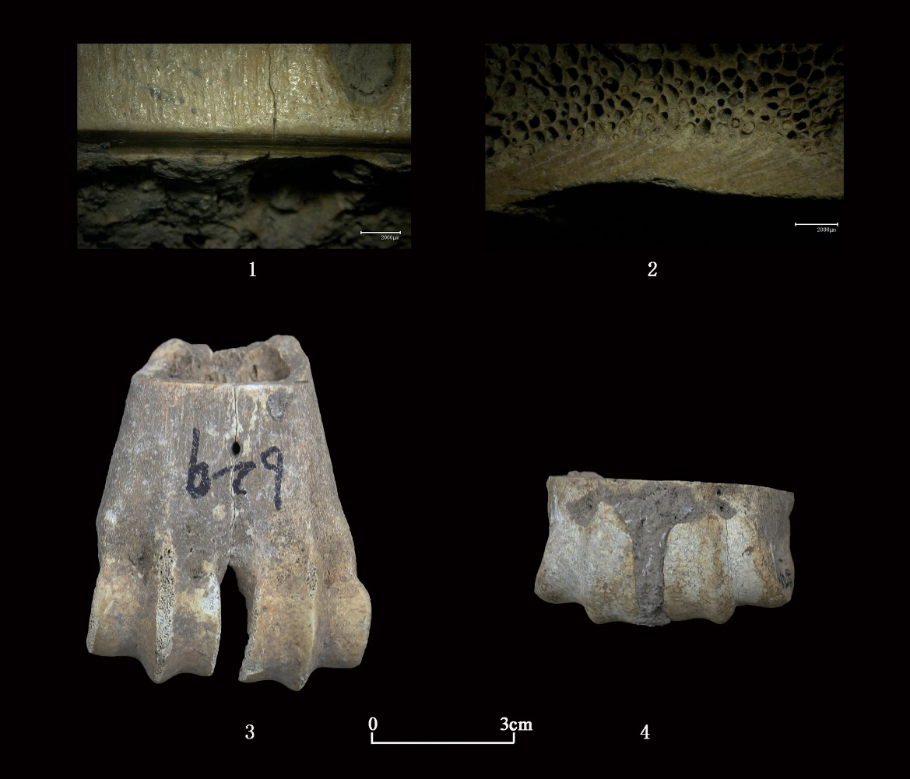
Figure S1. Comparison of offcuts and their micro-traces processed by metal and non-metal tools. 1. micro-traces of non-metal tool; 2. micro-traces on offcut sawed with metal tool; 3. offcut cut by non-metal tool; 4. offcut sawed with metal tool.

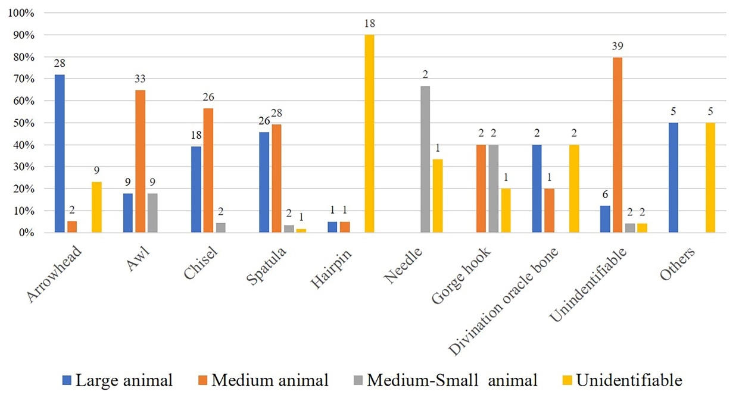
Figure S2. The distribution of different size animals among products. Large animals include cattle and large cervids, medium animals include medium cervids and pigs, medium-small animals include small cervids and dogs (figure by Xiaochen Pei).

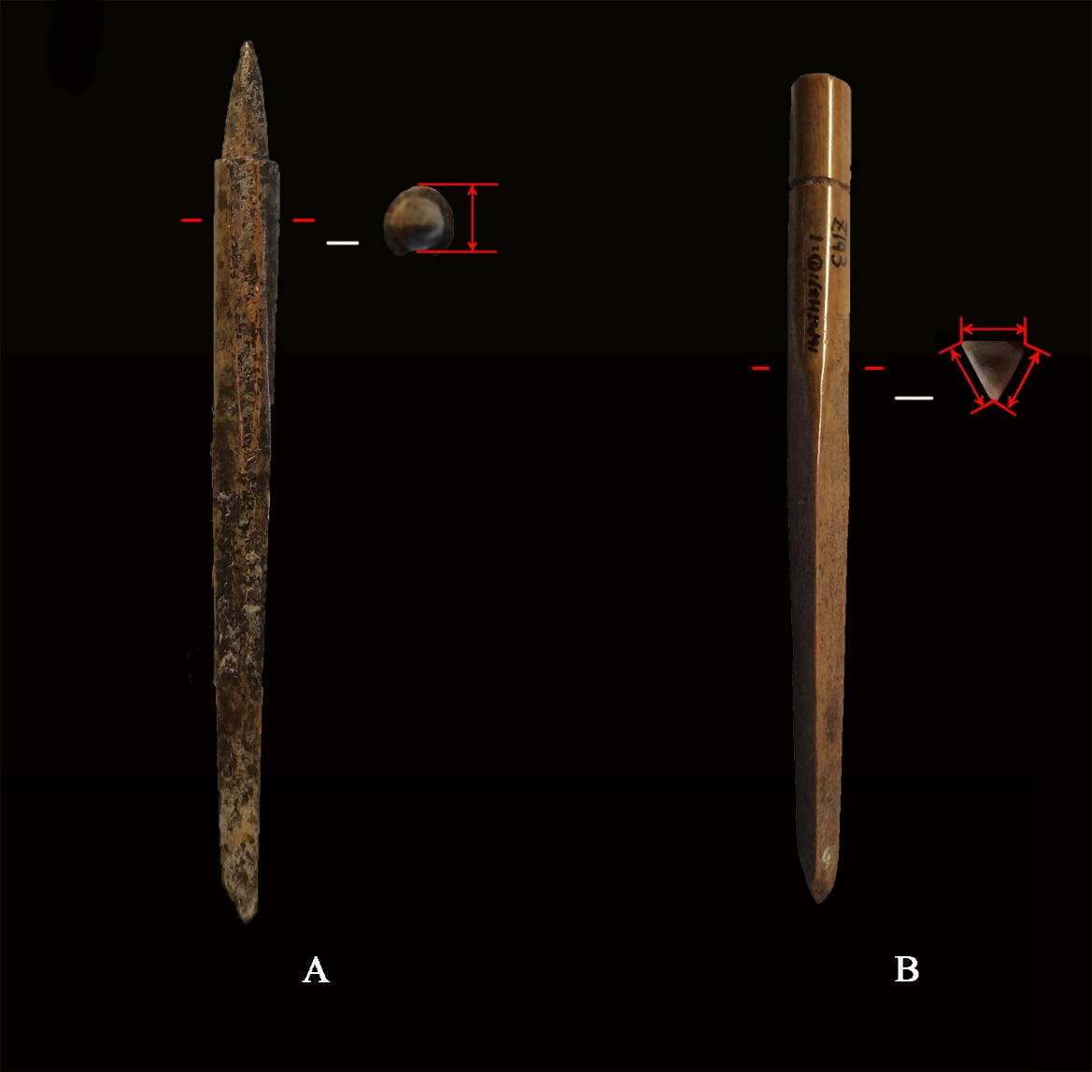
Figure S3. The method used to measure an arrowhead. A. the interior surface of the shaft can be observed on the arrowhead, so the shaft thickness can be measured directly; B. for arrowheads whose shaft interior surface could not be observed, the thickness could not be directly measured, so the width of the three sides at the thickest part was measured.

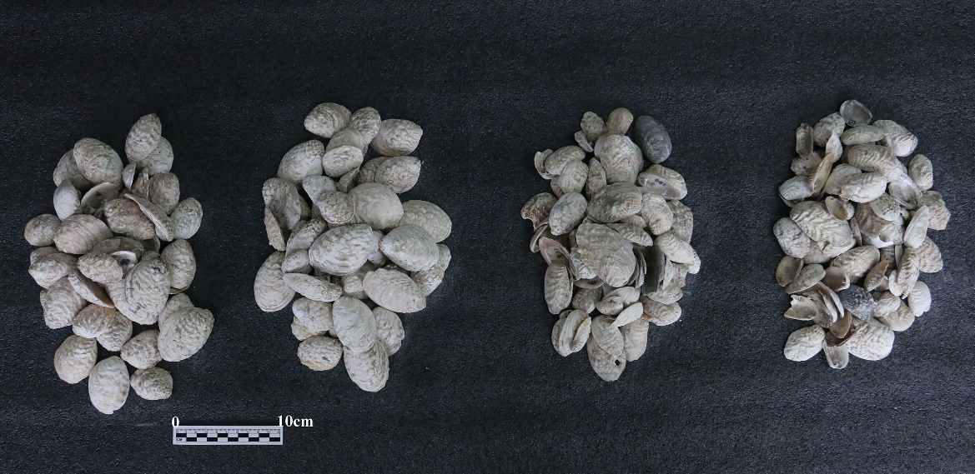
Figure S4. There are plenty of shells at Pingliangtai. For example, the NISP of shells (Lamprotula Sp.) retrieved from H396 layer 3 is nearly 400.

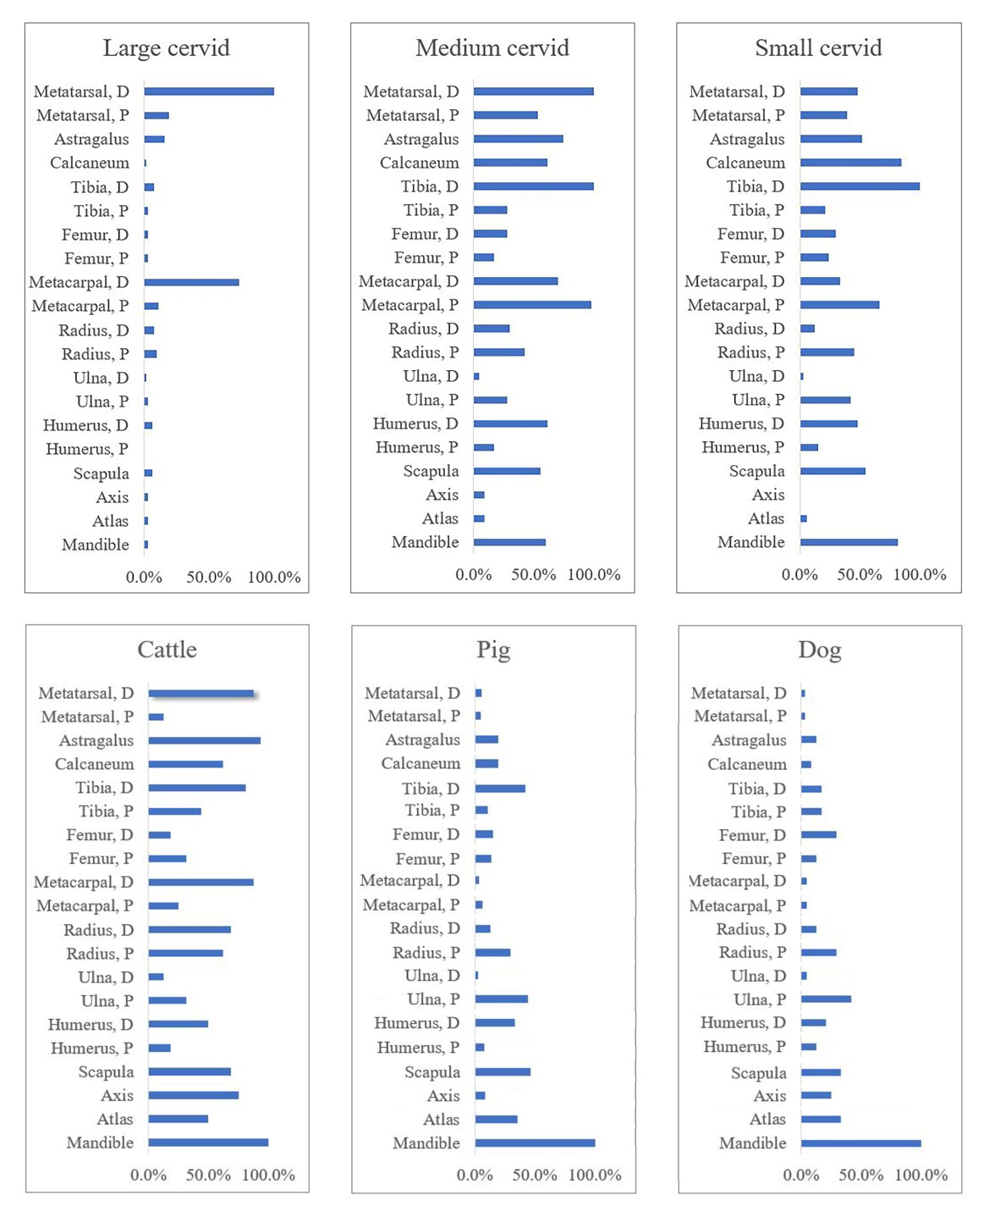
Figure S5. %MAU of large cervids, cattle, small cervids and medium cervids at Pingliangtai (figure by Xiaochen Pei).

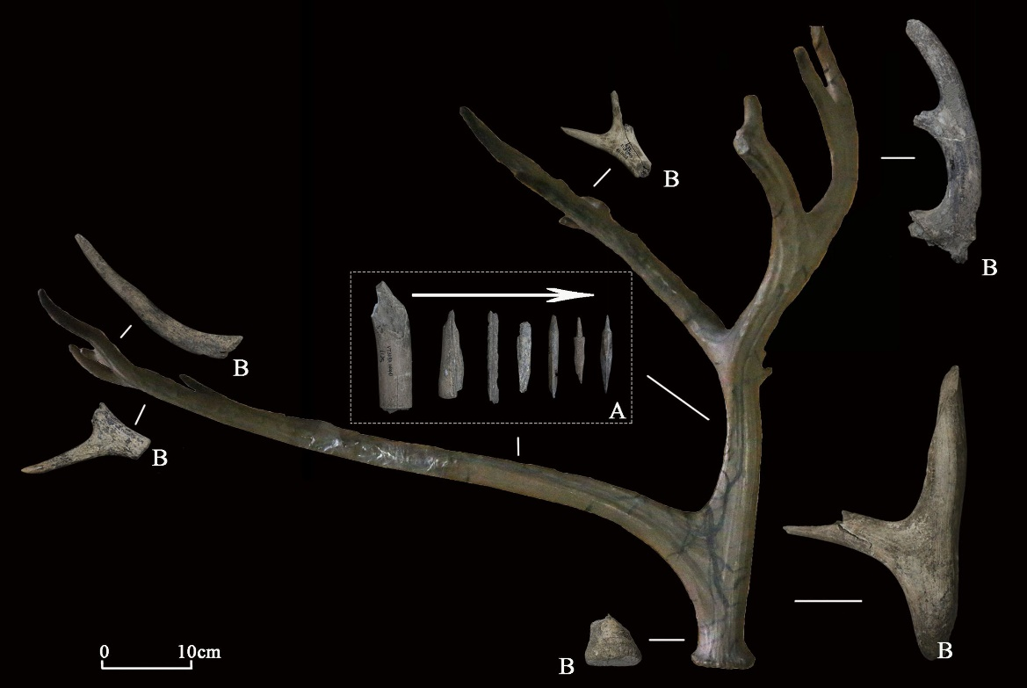
Figure S6. The production process of worked antlers (figure by Xiaochen Pei).

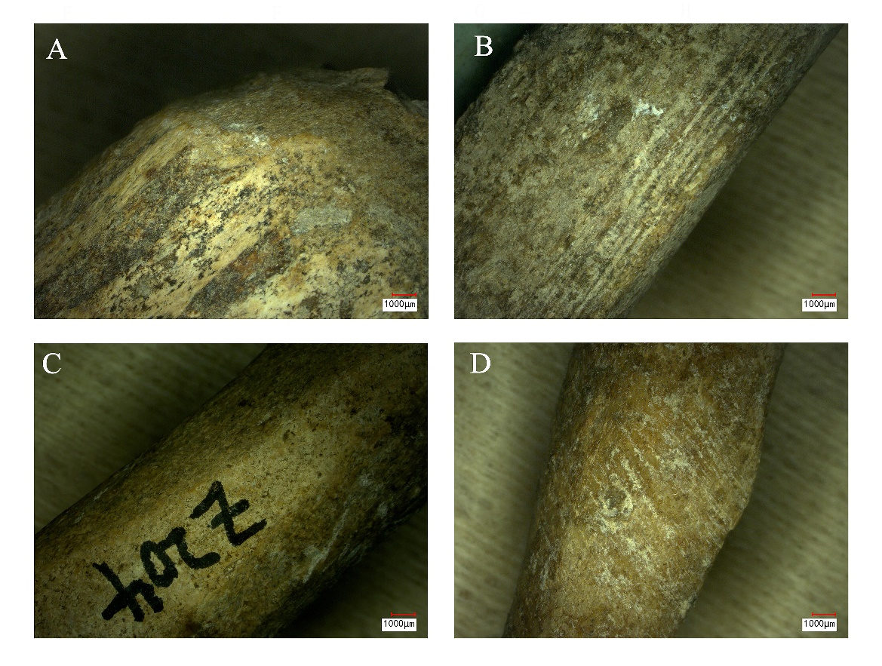
Figure S7. The micro-traces of worked antlers. A. chopping trace on blank; B. cutting trace on blank; C. chopping trace on preformed blank; D. grinding trace on antler arrowhead (figure by Xiaochen Pei).

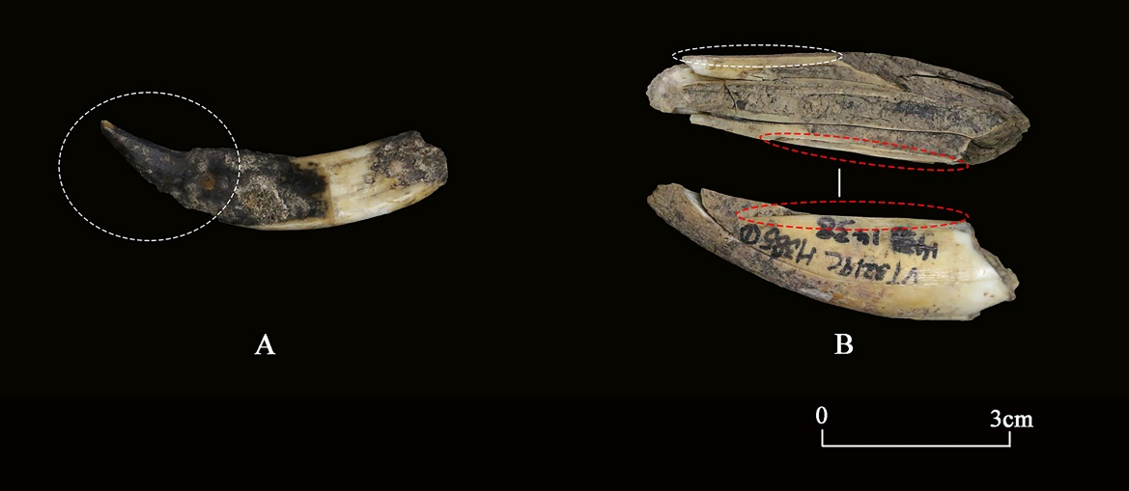
Figure S8. The production process for tooth artefacts; the parts marked with dotted lines in the figure show production traces (figure by Xiaochen Pei).
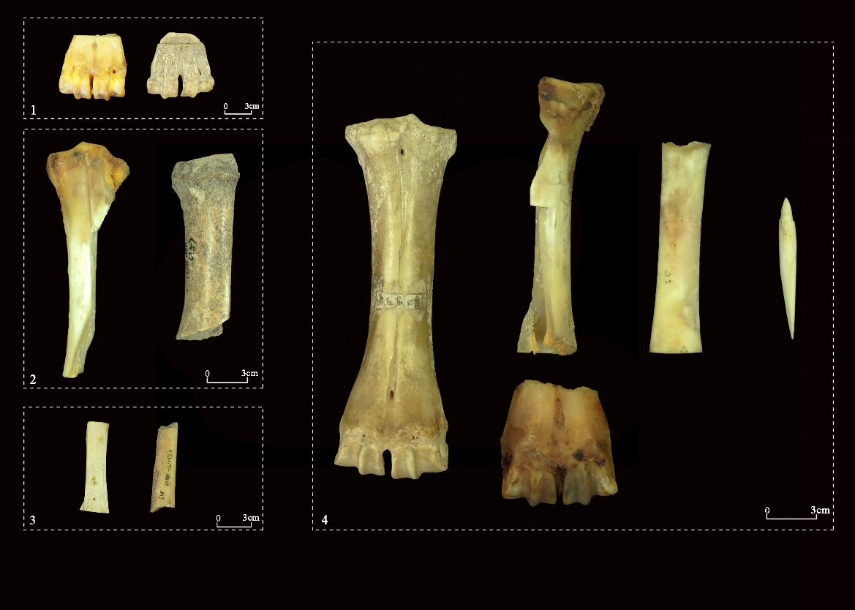
Figure S9. Experiment replicas and the reconstructed workflow of arrowheads. 1–3. replicas (left) and archaeological specimens (right): offcuts (1), ½ blanks (2), ¼ blanks (3), 4. reconstructed production sequence of arrowheads made from cattle metapodial (figure by Xiaochen Pei).

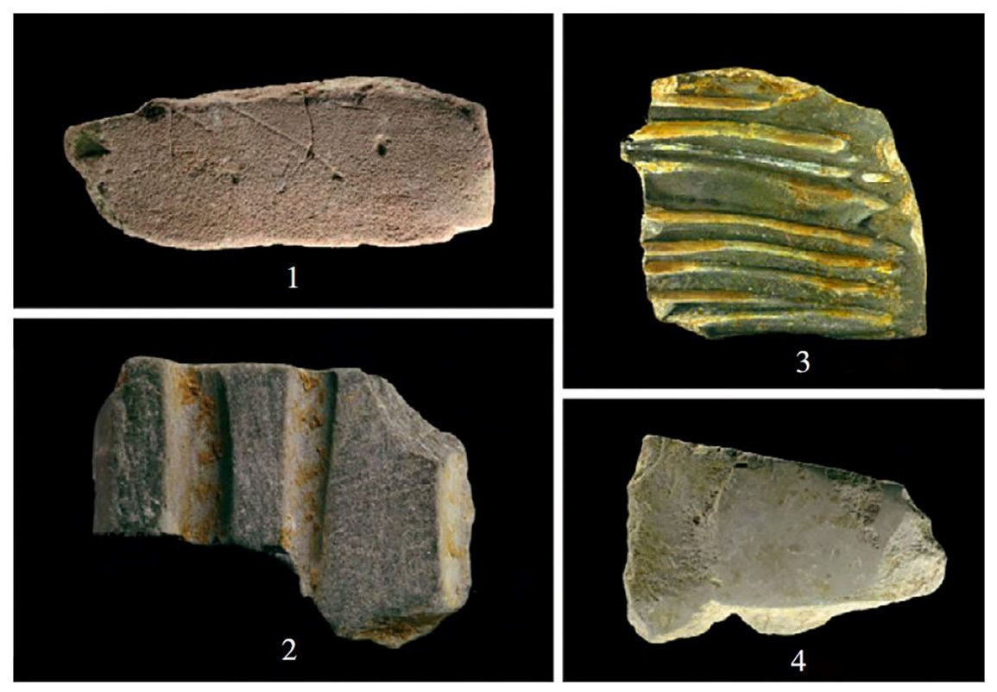
Figure S10. Grinding stones from the Erlitou site. 1.2004 ⅤH312:7; 2.2001ⅤT4⑤E:2; 3.2000ⅢT4⑪:2; 4.2000ⅢH13①:19 (from Chen & Li 2016).

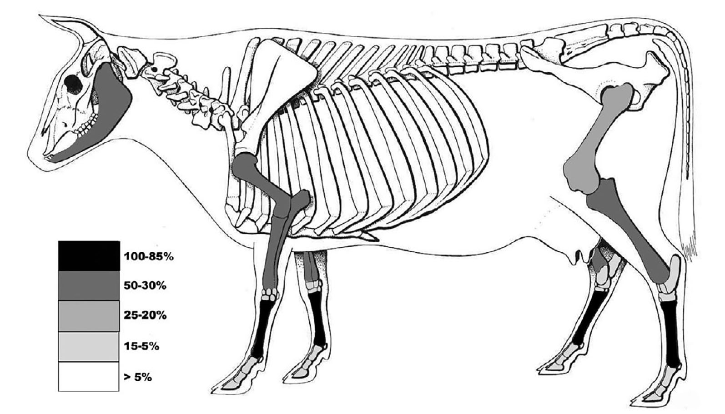
Figure S11. Relative element distribution for large bovines at Tiesanlu. Metacarpal=100% (from Campbell et al. 2011).

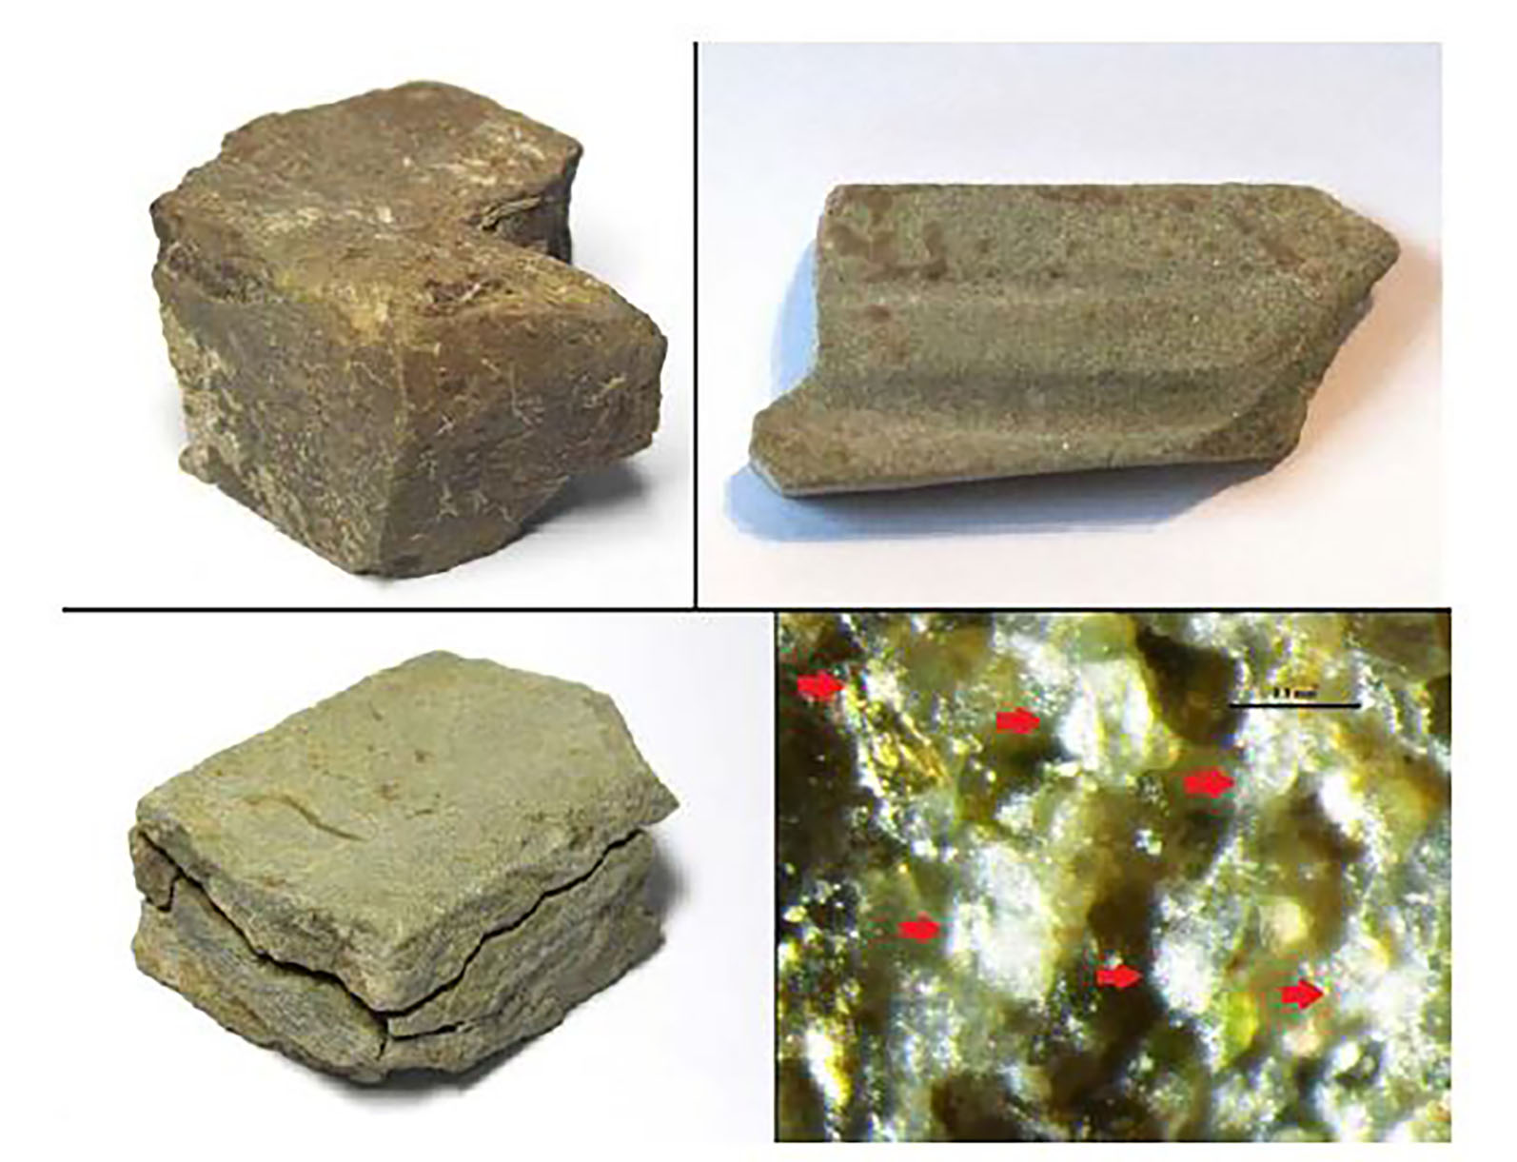
Figure S12. Grinding stones from Yuntang. Shallow grooves can be seen on some of them, probably resulting from long-term grinding operations. Bottom right: the particle size of sand stones is usually 100–150μm (from Zhao 2017).

References
Campbell, Roderick, Zhipeng Li, Yuling He & Yuan Jing. 2011. Consumption, exchange and production at the Great Settlement Shang: bone-working at Tiesanlu, Anyang. Antiquity 85: 1279–97. https://doi.org/10.1017/S0003598X00062050
CASS (Chinese Academy of Social Sciences), Yuling. He, Zhipeng. Li, Yude. Jiang & Zhanwei. Yue. 2015. Henananyang Tiesanlu Yinxuwenhuashiqi Zhiguzuofangyizhi. Kaogu (Archaeology) 8: 37-62+2 (in Chinese).
Chen, Guoliang. & Zhipeng. Li. 2016. Erlitouyizhi Zhiguyicun De Kaocha. Kaogu 5: 59–70 (in Chinese).
France, D.L. 2011. Human and nonhuman bone identification: a color atlas. New York: CRC.
Hillson, S. 1992. Mammal bones and teeth: an introductory guide to methods of identification. New York: Routledge. https://doi.org/10.4324/9781315425016
Hou, Yanfeng, Roderick Campbell, Zhipeng Li, Yan Zhang, Suting Li & Yuling He. 2018. The Guandimiao bone assemblage (and what it says about the Shang economy). Asian Perspectives 57: 281–310. https://www.jstor.org/stable/26775161
Hu Haoyue, Deng Zhenhua, Qin Ling, Zhang Hai, Zhang Chi & Cao Yanpeng. 2022. Yudongdiqu Zaoqishehuifuzahuajincheng de nongyejingjijichu--yi Pingliangtaiyizhi Weili. Quaternary Sciences 42: 1697–708. https://doi.org/10.11928/j.issn.1001-7410.2022.06.18 (in Chinese).
Lin, Yixian. 2022. The diet and subsistence study on sites of Central Plain in China from Late Neolithic to Early Bronze Age with stable isotope analysis. Unpublished PhD dissertation, Peking University.
Ma, Xiaolin., Xingtao. Wei & Yanfeng. Hou. 2015. Sanmenxia Lijiayaoyizhi Chutuguliaoyanjiu. Wenwu (Cultural Relics) 6: 39–48 (in Chinese).
Schmid, E. 1972. Atlas of animal bones. New York: Elsevier.
Sheng, H. 1992. The deer in China. Shanghai: Huadongshifandaxuechubanshe.
Von den Driesch, A. 1976. A guide to the measurement of animal bones from archaeological sites: as developed by the Institut für Palaeoanatomie, Domestikationsforschung und Geschichte der Tiermedizin of the University of Munich, vol. 1. Cambridge (MA): Peabody Museum.
Zhao, Hao. 2017. Mass bone-working industry in the western Zhou period (1046–771 BC). Unpublished PhD dissertation, Stanford University.

