[For SUPPLEMENTARY MATERIAL]
Seashells and sound waves: modelling soundscapes in Chacoan great-house communities

Ruth M. Van Dyke^{1,*} [ORCID: 0000-0002-4839-7962], K.E. Primeau² [ORCID: 0000-0001-7031-8258], Kellam Throgmorton³ & David E. Witt⁴ [ORCID: 0000-0001-8455-9167]

¹ Department of Anthropology, Binghamton University, State University of New York, USA
² Department of Anthropology, State University of New York at Albany, USA
³ Department of Anthropology, Northern Arizona University, Flagstaff, USA
⁴ Department of Anthropology, State University of New York at Buffalo, USA
* Author for correspondence ✉ rvandyke@binghamton.edu
Received: 18 May 2023; Revised: 3 August 2023; Accepted: 3 October 2023

Computer modelling & analyses
Soundshed Analysis Tool v.0.9.3
The Soundshed Analysis Tool is a geometric-type model which calculates sound propagation from a single point source to a single point receiver, and assumes sound is traveling through the air along straight-line paths. The development of this tool and related tools is discussed in greater detail in Primeau (2022). In short, a series of cultural and environmental data were selected to represent the sound produced by a conch trumpet being played at sunrise on the summer solstice. Environmental data used in modelling included: the air temperature (°F), the percentage of relative humidity, the ambient sound pressure level (SPL) of the study location measured in decibels (dB); an elevation raster dataset; and the resolution of the elevation raster dataset. Cultural data describing the source of the sound included: the study location saved as a GIS point feature class; the height of the sound source in feet measured between ground surface and the primary location where sound is produced (e.g. the ‘bell’ of the conch); the SPL of the source (dB); the predominant frequency (Hz) of the sound source; and the distance in feet between the sound source and the location where the SPL of the source was measured.
Modelling inputs for the conch were derived from Loose’s (2012) reproduction of a Strombus galeatus shell trumpet, an instrument consistent with the appropriate size range of Ancient Puebloan trumpets as reported by E. Brown (2005). Historic average air temperature and relative humidity data were used as a proxy for conditions in the Chacoan era, and background sound levels used in modelling were representative of pinyon-juniper shrubland as described in Primeau and Witt (2018). Among the four raster data modelling results produced by the Soundshed Analysis Tool are: estimated soundsheds indicating rise over ambient Sound Pressure Levels (SPL) as discussed here (see Figures 2, 4 & 6–9); and viewsheds calculated using the sound source height as an offset for each modelling location (e.g. Figure 10). For example, as seen in Figures 7 and 10, given the topography of the Padilla Wash community, most of the areas where the conch was audible aligned with areas visible to the individual playing the conch. Validation of the Soundshed Analysis Tool was performed using modern environmental data (Primeau & Witt 2018; Primeau 2022), however, estimated soundsheds produced for this research were not derived from in-situ performance with a conch trumpet.

Statistical analyses
We conducted a series of statistical analyses for each modelling scenario undertaken for this study to determine location randomness. The first, Fisher’s exact test, measures the probability that a non-random association exists between two categorical variables—in our case, whether habitations were located within modelled soundsheds as compared to randomly placed locations. The second, chi-square test for association, measures whether observed frequencies in categories match expected frequencies. Fisher’s exact test was used to analyse patterns within communities; chi-square was used to analyse patterns between communities. These were accomplished according to the following steps for each scenario: 1) a buffer of 2km was placed around the location of sound sources. For communities where multiple scenarios were modelled, we dissolved the 2km buffers to create a single community area. We chose a distance of 2km in order to capture the entirety of the model soundscape, as well as any outlying structures beyond that distance. 2) 250 points were randomly created within that 2km buffer. 3) Of those points, we selected all that were within 5m of any zone of audibility. The number of selected points was then compared to the habitation sites located within audibility zones for each community using Fisher’s exact test (see Table S1).

Table S1. Statistical tests for location randomness.

Site | Sound Source | Test Locations in AZ | Total Test Locations | Habs in AZ | Total Habs | Fisher's Exact p-value HAB | ERFs in AZ | Total ERFs | Fisher's Exact p-value ERFs
Bis sa’ani | 17286 | 73 | 250 | 5 | 8 | 0.057
Bis sa’ani | 17286 | 73 | 250 | 7 | 8 | 0.001
Bis sa’ani | 17287 | 64 | 250 | 5 | 8 | 0.034
Padilla Wash | LA40352GH | 27 | 250 | 4 | 8 | 0.009
Padilla Wash | LA40352K | 32 | 250 | 7 | 8 | 0.000
Kin Klizhin | GH | 46 | 250 | 16 | 23 | 0.000 | 1 | 3 | 0.462
Morris 40 | 180282 | 12 | 250 | 29 | 40 | 0.000
Morris 40 | 180197 | 9 | 250 | 29 | 40 | 0.000
Morris 40 | 1988 | 12 | 250 | 27 | 40 | 0.000
Pierres | 16509 | 37 | 250 | 6 | 9 | 0.001 | 7 | 8 | 0.000
Pierres | 16514 | 28 | 250 | 7 | 9 | 0.000 | 7 | 8 | 0.000

Table S2. Chi-Square test for association for location audibility – habitation sites – best case scenario.

 | Morris 40 |  | Padilla Wash |  | Pierre’s |  | Bis sa’ani |  | Kin Klizhin
 | Obs | Exp | Obs | Exp | Obs | Exp | Obs | Exp | Obs | Exp
In | 33 | 30.91 | 7 | 6.18 | 7 | 6.95 | 5 | 6.18 | 16 | 17.77
Out | 7 | 9.09 | 1 | 1.82 | 2 | 2.05 | 3 | 1.82 | 7 | 5.23
Total | 40 |  | 8 |  | 9 |  | 8 |  | 23
 |  |  |  |  |  |  | 𝝌² | 2.8723 | p-value | .579426

Table S3. Chi-Square test for association for location audibility - habitation sites - worst case scenario.
 | Morris 40 |  | Padilla Wash |  | Pierre’s |  | Bis sa’ani |  | Kin Klizhin
 | Obs | Exp | Obs | Exp | Obs | Exp | Obs | Exp | Obs | Exp
In | 27 | 26.36 | 4 | 5.27 | 6 | 5.93 | 5 | 5.27 | 16 | 15.16
Out | 13 | 13.64 | 4 | 2.73 | 3 | 3.07 | 3 | 2.73 | 7 | 7.84
Total | 40 |  | 8 |  | 9 |  | 8 |  | 23
 |  |  |  |  |  |  | 𝝌² | 1.1267 | p-value | .89001

Table S4. Percentage of habitations within audibility zone for each community.
 | Average of Percentage (Best) | Average of Percentage (Worst)
Ancestral | 74.42% | 62.36%
Kin Klizhin | 78.26% | 69.57%
Morris 40 | 82.50% | 67.50%
Padilla Wash | 62.50% | 50.00%
Scion | 88.19% | 64.58%
Bis sa'ani | 87.50% | 62.50%
Pierre's | 88.89% | 66.67%

Table S5. Chi-square and z-test results for differences between habitation location in scion vs. ancestral communities according to best and worst case scenarios.

 | 𝝌² Test with Yates correction |  | 2-tailed, 2 sample Z-test
 | 𝝌² | p value | z value | p value
Best case | 0.2876 | 0.591772 | -0.879 | 0.37886
Worst case | 0.0283 | 0.866347 | 0.1164 | 0.90448

Table S6. Chi-Square test for association for location audibility - enigmatic rock features (ERFs).
 | Pierre’s |  | Kin Klizhin
 | Obs | Exp | Obs | Exp
In | 7 | 5.82 | 1 | 2.18
Out | 1 | 2.18 | 2 | 0.82
Total | 8 |  | 3
 | 𝝌² | 3.2274 | p-value | 0.072414

Study locations: additional details
In this section, we offer more detailed descriptions of the five great house communities investigated in our study.

Bis sa’ani
Bis sa’ani is a ‘scion’ community located 12km north-east of Chaco Canyon along the Escavada Wash—one of the primary tributary washes on the north side of the Chaco River (Figure 1). The West Great House and the East Great House Complex are situated atop a prominent, isolated, 750m long, 20m high, 20–50m wide shale ridge on the south side of Escavada Wash (Powers et al. 1983: 21) (Figure S1). The West Great House (LA 17287) contains 12 rooms and a kiva. Just over 100m to the east, the East Great House Complex (LA 17286) contains at least 25 rooms and four kivas with a total floor area of at least 1040m². Small habitations and field houses form an associated community in the aeolian dunes to the south. Powers et al. (1983: 21–54) intensively surveyed a 2mi- (3.2km) diameter area around the great houses and mapped the great houses and community. Breternitz et al. (1982) conducted extensive excavations at the great houses and some of the small community sites. The viewscape at Bis sa’ani links the community with the greater Chacoan landscape. The builders of Bis sa’ani appear to have intentionally situated their great houses atop the shale ridge not for intervisibility with the immediate community of small sites, but to maintain connections with the greater Chacoan world (Van Dyke et al. 2021).

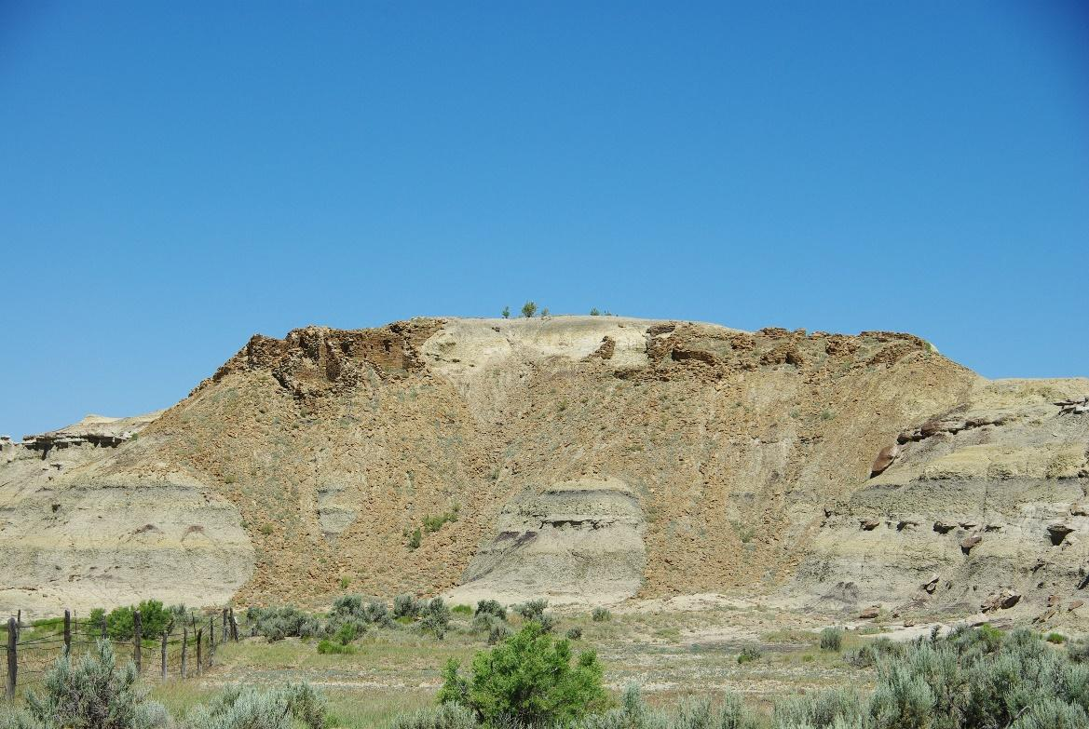
Figure S1. Bis sa’ani West Great House (LA 17287) and East Great House Complex (LA 17286) as seen from the valley floor, looking north. The two great houses are the areas of dark brown sandstone on top of the ridge, with associated rubble spilling down the slope (photograph by Van Dyke).

Kin Klizhin
Kin Klizhin is an ‘ancestral’ community located within the Kin Klizhin Unit of Chaco Culture National Historical Park, along an ephemeral wash 6km south-west of West Mesa (Figure 1). The site cluster consists of a great house with a tower kiva (Figure 3), habitation sites, irrigation features and several ERFs. Archaeological investigations at Kin Klizhin have included tree-ring dating, stabilisation, examination of associated irrigation features and a survey of the surrounding community (Morrison 1876; Holsinger 1901; Hewett 1905, 1936; Judd 1954: 57; Bannister 1964; Marshall et al. 1979: 69–72; Powers et al. 1983; Powers & Van Dyke 2015). The Kin Klizhin great house (LA 4975) is a 472m² imposing structure atop a sandy knoll. Tree-ring samples indicate the great house was constructed around 1087 (Bannister et al. 1970: 24). The tower kiva, described in detail by Marshall et al. (1979: 70), contains standing walls that reach 9m above the modern ground surface. Based on ceramics, dendrochronology and architectural features, the most intensive habitation of the surrounding community took place from AD 890 to 1130.

Morris 40
Morris 40 is a large ‘ancestral’ community located on Ute Mountain Ute Land west of the La Plata River in north-west New Mexico (Figure 1). It is situated on either side of a seasonal arroyo that flows to the San Juan River, with a sandstone uplift to the north-west and treeless grasslands to the south-east (Figure 5). Morris 40 has a long history of archaeological investigation (Nusbaum 1935; Morris 1939; Marshall & Stein 1978; Marshall et al. 1979; Robinson 2014). Throgmorton and colleagues remapped the community with handheld GPS, conducted geophysical survey with a dual-sensor magnetic gradiometer, and performed in-field pottery analysis (Throgmorton 2019). Based on uniform probability density analysis of pottery counts, the Morris 40 community was inhabited between AD 750 and 1300.
The community consists of a 450m², two-storey masonry great house with three kivas (LA 1988), two great kivas (LA 180282), a road segment, a tower (LA 180197) and over forty domestic habitations in the surrounding 1km². The road segment enters the community from the south and leads to the great house. The tower is indicated by a series of post holes in bedrock atop a sandstone butte located at the highest point in the community. The great house is located below the sandstone knob and is situated on a raised platform of architectural debris. It overlooks much of the surrounding community.
The configuration of the Morris 40 community changed through time. From AD 750 to 880 the community consisted of linear, multi-household structures positioned symmetrically on either side of the arroyo and a few scattered single-household dwellings. From AD 880 to the early 1000s Morris 40 decreased in size but continued to consist of both multi- and single-household dwellings and included a great kiva. In the late AD 1000s the construction of the great house coincided with a dramatic expansion of the community into surrounding terrain and a shift to smaller, single-household structures. A new great kiva was constructed in the mid- to late- AD 1100s and the scale of the community declined until it was fully depopulated in the AD 1200s.

Padilla Wash
Padilla Wash is an ‘ancestral’ great house community located near the western boundary of Chaco Culture National Historical Park, approximately 4km south-west of the Penasco Blanco great house (Figure 1). The community is situated on the west side of the Padilla Wash valley within rolling, treeless grasslands and occasional shale badland outcrops (Figure S2). Padilla Wash was first recorded in the 1970s by the Chaco Project and subsequently documented by Windes (2007, 2015). Throgmorton and colleagues (reported in Throgmorton 2019) remapped the community with GPS, performed geophysical survey with a dual-sensor magnetic gradiometer, and conducted in-field pottery analysis. Uniform probability density analysis of pottery counts indicate that the community was inhabited from AD 750 to 1125, with a brief reoccupation by a single household between AD 1225 and 1275 (Throgmorton 2019: tab. 6).
Padilla Wash consists of a two-storey, 315m² great house with about 25–30 rooms and an 8m-diameter kiva (LA 40352), an earlier proto-great house (LA 41882), a great kiva (LA 40352) and about 25 smaller habitations in the surrounding 1km². The great house and great kiva are connected by a road segment that passes through constructed mounds south of the great house. The focal point of the community was first the proto-great house (c. AD 850–950), then the great kiva (c. AD 950–1025) and finally the great house/great kiva complex (c. AD 1025–1125). Sites within the community tend to be located either atop or on the southern slope of sandy ridges south of the great house.

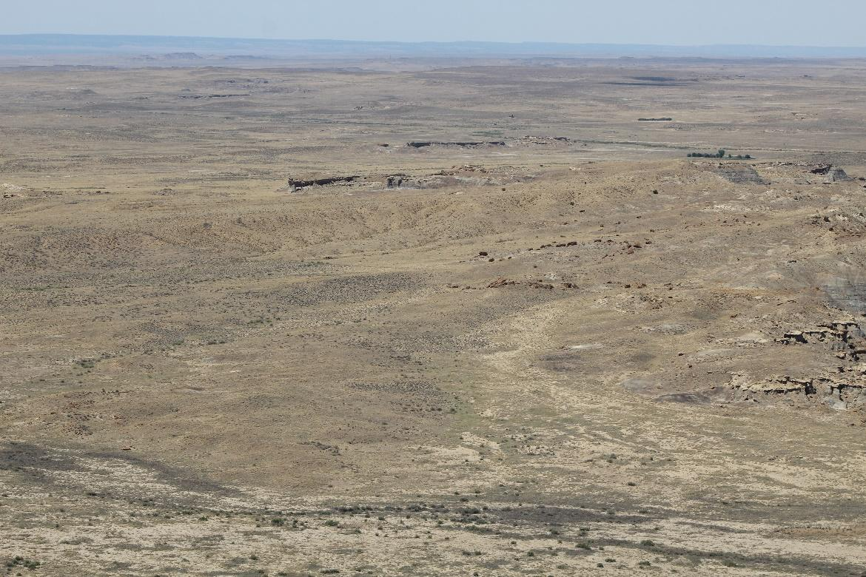
Figure S2. View of the Padilla Wash community, looking westward from West Mesa of Chaco Canyon (photograph by Throgmorton).

Pierre’s
Pierre’s is a ‘scion’ community situated 19km north of Chaco Culture National Historical Park, on the southern edge of the break between the Chaco Slope and the mesas and badlands of the Denazin and Ah-shi-sle-pah Washes (Figure 1). The community articulates with the Great North Road, which leaves the vicinity of Chaco Canyon near Pueblo Alto and, in a series of stages, heads north for 50.5km to Kutz Canyon. Powers et al. (1983: 94–122) and Harper et al. (1988) both conducted intensive survey and recording in the Pierre’s community during the 1980s. The community was also investigated by the Chaco Roads Project (Stein 1983) and the Solstice Project (Marshall & Sofaer 1988).
The core of the Pierre’s community involves at least five central structures. Two south-facing great houses (House A and House B) are located atop a large butte near the centre of the community (Figure S3). House A contains an estimated fifteen ground-floor rooms and three enclosed kivas over an area of 255m². House B, located 30m to the north-north-east contains an estimated thirteen ground-floor rooms and a single enclosed kiva and covers 315m². Nearby to the north, a sandstone pinnacle called El Faro (The Lighthouse) is topped by a three-room structure with an exposed hearth. At the base of this pinnacle, House C, another massive 505m² building, contains eighteen rooms and one enclosed kiva. A neighboring pinnacle 80m east-south-east of El Faro hosts a small room block that might be considered to represent an atalaya, or watchtower, following Marshall and Sofaer (1988).
The Pierre’s community is spatially distributed over an area of approximately 1.6km². Over the past decades, shifting dune sands have obscured and revealed sandstone masonry and artefact scatters. Powers et al. (1983) documented seventeen Ancient Pueblo sites in the surrounding community; Harper et al. (1988) added an additional nine. Throgmorton recently conducted a site visit that clarified the existence of several ERFs (enigmatic rock features) located on mesa tops forming the topographic boundary of the community. All but one small Basketmaker III–Pueblo I artefact scatter date from the Late Pueblo II or Early Pueblo III period.
There is little doubt that Chacoans located Pierre’s in this place because of the Great North Road and because of specific visible attributes of the local topography. Pierre’s is located on the first major topographic break in the landscape moving north from Chaco Canyon. The pinnacles and butte of Pierre’s are intervisible with Pueblo Alto and may have been involved with signaling down the line of the North Road.

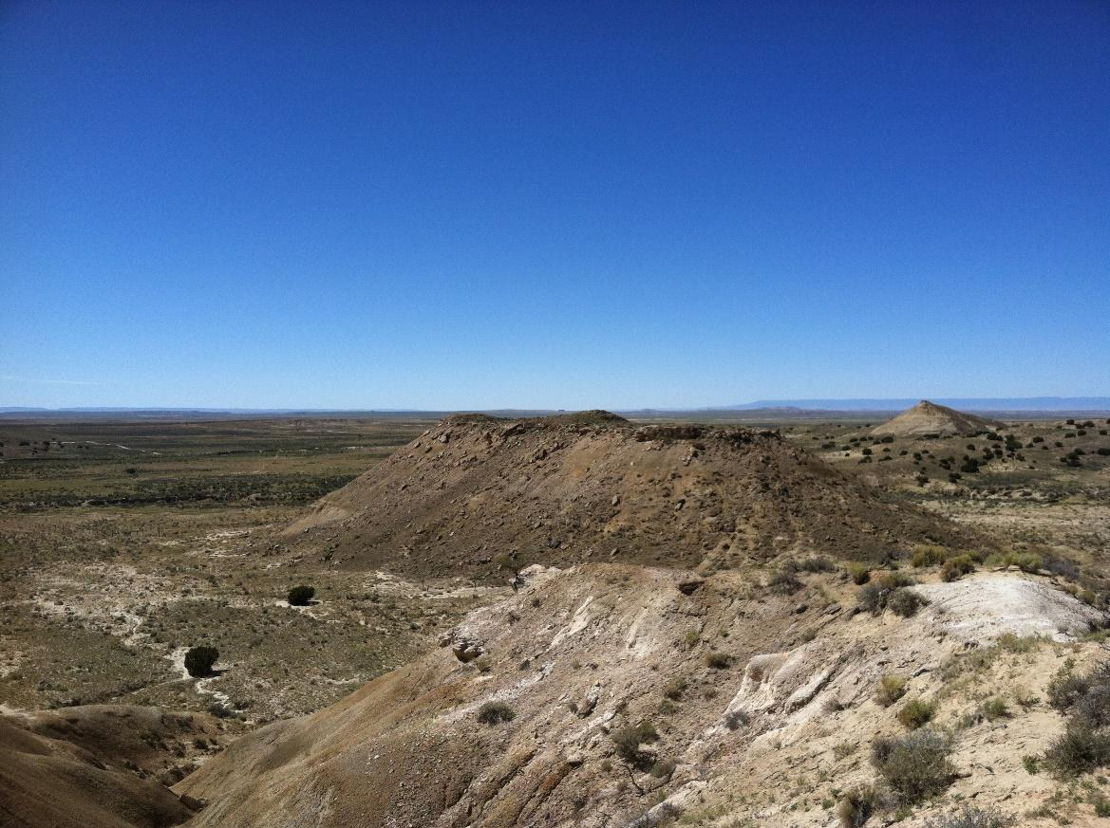
Figure S3. Looking westward towards Pierre’s Great Houses A and B—the two rubble mounds perched atop a large butte in the center of the photo (photography by Van Dyke).

References
Bannister, B. 1964. Tree ring dating of the archeological sites in the Chaco Canyon Region, New Mexico (Southwestern Monuments Association Technical Series Volume 6, Part 2). Globe (AZ): Southwestern Monuments Association.
Bannister, B., W.J. Robinson & R.L. Warren. 1970. Tree-ring dates from New Mexico A, G–H: Shiprock - Zuni - Mt. Taylor Area. Tucson: Laboratory of Tree-ring Research, University of Arizona.
Breternitz, C.D., D.E. Doyel & M.P. Marshall. (ed.) 1982. Bis sa’ani: a late Bonito phase community on Escavada Wash, northwest New Mexico (Navajo Nation Papers in Anthropology 14). Window Rock (AZ): Navajo Nation.
Brown, E.J. 2005. Instruments of power: musical performance in rituals of the ancestral Puebloans of the American Southwest. Unpublished PhD dissertation, Columbia University.
Harper, R., M.K. Swift, B.J. Mills, J. Brandi & J.C. Winter. 1988. The Casamero and Pierre's outliers survey: an archaeological class III inventory of the BLM lands surrounding the outliers. Albuquerque: Office of Contract Archeology, University of New Mexico.
Hewett, E.L. 1905. Prehistoric irrigation in the Navajo Desert. Records of the Past 4: 325–29.
– 1936. The Chaco Canyon and its monuments. Albuquerque & Santa Fe: University of New Mexico & School of American Research.
Holsinger, S.J. 1901. Report on prehistoric ruins of Chaco Canyon, New Mexico. Unpublished report for General Land Office Letter “P,” December 18, 1900. Washington, DC: General Land Office, National Anthropological Archive.
Judd, N.M. 1954. The material culture of Pueblo Bonito. Washington, D.C.: Smithsonian Miscellaneous Collections 124.
Loose, R.W. 2012. That old music: reproduction of a shell trumpet from Pueblo Bonito, in E.J. Brown, C.J. Condie & H.K. Crotty (ed.) Glen Canyon, legislative struggles, and contract archaeology: papers in honor of Carol J. Condie (Papers of the Archaeological Society of New Mexico 38): 127–33. Albuquerque: Archaeological Society of New Mexico.
Marshall, M.P. & A. Sofaer. 1988. Solstice project investigations in the Chaco District 1984 and 1985: the technical report. Unpublished report for the Laboratory of Anthropology, Santa Fe.
Marshall, M.P. & J.R. Stein. 1978. Archaeological investigations in the Squaw Springs District of the Ute Mountain Ute Indian Reservation, northwestern New Mexico. Albuquerque: Environmental Quality Services, Albuquerque Area Office, Bureau of Indian Affairs.
Marshall, M.P., J.R. Stein, R.W. Loose & J.E. Novotny. 1979. Anasazi communities of the San Juan Basin. Albuquerque: Public Service Company of New Mexico.
Morris, E.H. 1939. Archaeological studies in the La Plata District, southwestern Colorado and northwestern New Mexico (Carnegie Institution of Washington Publications 519). Washington, D.C.: Carnegie Institution of Washington.
Nusbaum, D. 1935. Diary of Deric Nusbaum, La Plata Ruin Survey, 1935. NMCRIS #869. Ms. on file, Records Management Division, Laboratory of Anthropology. Santa Fe, NM.
Powers, R. & R.M. Van Dyke. (ed.) 2015. An archaeological survey of the additions to Chaco Culture National Historic Park (Chaco Center Publications in Archaeology). Chaco Research Archive. Available at: http://www.chacoarchive.org/ChacoAdditionsSurveycover.html (accessed August 3, 2023).
Powers, R.P., W.B. Gillespie & S.H. Lekson. 1983. The outlier survey: a regional view of settlement in the San Juan Basin (Reports of the Chaco Center 3). Albuquerque: U.S. Department of the Interior, National Park Service.
Primeau, K.E. 2022. A GIS approach to landscape scale archaeoacoustics. Unpublished PhD dissertation, State University of New York at Albany.
Primeau, K.E. & D.E. Witt. 2018. Soundscapes in the past: investigating sound at the landscape level. Journal of Archaeological Science: Reports 19: 875–85. https://doi.org/10.1016/j.jasrep.2017.05.044
Robinson, H.L. 2014. Class III cultural resource survey of Bridgecreek Resources Verde Gallup 3D Seismic Project, Ute Mountain Ute Tribal Lands, San Juan County, New Mexico. NMCRIS #131363. Ms. on file, Records Management Division, Laboratory of Anthropology. Santa Fe, NM.
Stein, J.R. 1983. Road corridor descriptions, in C. Kincaid (ed.) Chaco roads project, phase i: a reappraisal of prehistoric roads in the San Juan Basin. Albuquerque (NM): Bureau of Land Management.
Throgmorton, K. 2019. Peoplehood and the political power of landscape change: Chacoan interventions in the northern San Juan. Unpublished PhD dissertation, State University of New York at Binghamton.
Van Dyke, R.M., T.S. De Smet & R.K. Bocinsky. 2021. Viewscapes and soundscapes, in R.M. Van Dyke & C.C. Heitman (ed.) The Greater Chaco Landscape: ancestors, scholarship, and advocacy: 195–224. Boulder: University Press of Colorado.
Windes, T.C. 2007. Gearing up and piling on: early great houses in the interior San Juan Basin, in S.H. Lekson (ed.) The architecture of Chaco Canyon, New Mexico: 45–82. Salt Lake City: University of Utah Press.
– 2015. Early Puebloan occupations in the Chaco Region, volume 1: excavations and survey of Basketmaker III and Pueblo I sites, Chaco Canyon, New Mexico (Arizona State Museum Archaeological Series 2010, Reports of the Chaco Center 13). Tucson: Arizona State Museum.

Additional references
We wish to acknowledge the following important contributions to Chacoan studies and to acoustic scholarship; although space constraints precluded these from citation in the body of the text, readers will find them of interest:
Begay, R.M. 2004. Tsé Bíyah ‘Anii’áhí: Chaco Canyon and its place in Navajo history, in D.G. Noble (ed.) In search of Chaco: 55–60. Santa Fe (NM): School of American Research.
Bernardini, W., A. Barnash, M. Kumler & M. Wong. 2013. Quantifying visual prominence in social landscapes. Journal of Archaeological Science 40: 3946–54. https://doi.org/10.1016/j.jas.2013.05.019
Carlson, D.R. & A.M.Y. Jordan. 2013. Visibility and power: preliminary analysis of social control on a Bandanese plantation compound, Eastern Indonesia. Asian Perspectives, 52: 213–243. https://doi.org/10.1353/asi.2013.0013
Chapman, H.P. 2003. Rudston 'Cursus A'- engaging with a neolithic monument in its landscape setting using GIS. Oxford Journal of Archaeology 22: 345–56. https://doi.org/10.1046/j.1468-0092.2003.00192.x
Crown, P.L. (ed.) 2020. The house of the cylinder jars. Albuquerque: University of New Mexico Press.
Crown, P.L. et al. 2015. Ritual drinks in the pre-Hispanic US Southwest and north Mexican northwest. Proceedings of the National Academy of Sciences 112: 11436–42. https://doi.org/10.1073/pnas.1511799112
Cummings, V. 2003. The origins of monumentality? Mesolithic world-views of the landscape in western Britain, in L. Larsson, H. Kindgren, K. Knutsson, D. Loeffler & A. Åkerlund (ed.) Mesolithic on the move: 74–81. Oxford: Oxbow.
Cummings, V. & A. Whittle. 2003. Tombs with a view: landscape, monuments and trees. Antiquity 77: 255–66. https://doi.org/10.1017/S0003598X00092255
Day, J. (ed.) 2013. Making senses of the past: toward a sensory archaeology. Carbondale (IL): Center for Archaeological Investigations, Southern Illinois University.
Dungan, K.A. 2009. Visibility, monumentality, and community in the Chacoan community at Kin Bineola, New Mexico. Unpublished M.A. dissertation, University of Arizona.
Ellenberger, K. 2012. Scales of visibility at a Chacoan outlier: the visual world of people at Kin Klizhin. Unpublished M.A. dissertation, State University of New York at Binghamton.
Elliot, B. & J. Hughes. 2014. Sonic horizons of the Mesolithic: using sound to engage wider audiences with Early Holocene research. World Archaeology 46: 305–318. https://doi.org/10.1080/00438243.2014.909097
Ferrari, A.A., I. Leibowicz & F. Acuto. 2017. Approaching imperial narratives one sense at a time: views and sounds at an Inka settlement in northwest Argentina. Time and Mind: The Journal of Archaeology, Consciousness, and Culture 10: 331–56. https://doi.org/10.1080/1751696X.2017.1375674
Fitzjohn, M. 2007. Viewing places: GIS applications for examining the perception of space in the mountains of Sicily. World Archaeology 39: 36–50. https://doi.org/10.1080/00438240601136439
Frieman, C. & M. Gillings. 2007. Seeing is perceiving? World Archaeology 39: 4–16. https://doi.org/10.1080/00438240601133816
Gladwin, H.S. 1945. The Chaco branch: excavations at White Mound and in the Red Mesa Valley (Medallion Papers 33). Globe (AZ): Gila Pueblo.
Hacigüzeller, P. 2012. GIS, critique, representation and beyond. Journal of Social Archaeology 12: 245–63. https://doi.org/10.1177/1469605312439139
Hamilakis, Y. 2013. Archaeology and the senses: human experience, memory, and affect. Cambridge: Cambridge University Press.
Hamilton, S., R. Whitehouse, K. Brown, P. Combes, E. Herring & M.S. Thomas. 2006. Phenomenology in practice: towards a p methodology for a `subjective' approach. European Journal of Archaeology 9: 31–71. https://doi.org/10.1177/1461957107077704
Heitman, C.C. 2015. The house of our ancestors: new research on the prehistory of Chaco Canyon, New Mexico, in C.C. Heitman & S. Plog (ed.) Chaco revisited: new research on the prehistory of Chaco Canyon, New Mexico: 215–248. Tucson: University of Arizona Press.
Jolie, E.A. & L.D. Webster. 2015. A perishable perspective on Chacoan identities, in C.C. Heitman & S. Plog (ed.) Chaco revisited: new research on the prehistory of Chaco Canyon, New Mexico: 96–131. Tucson: University of Arizona Press.
Jordan, P. & S. Mura. (organizers) Sensing the past: a workshop in applied sensory archaeology and heritage assessment, Amsterdam School for Heritage, Memory and Material Culture, University of Amsterdam, Netherlands, 7 October 2021.
Kantner, J. & R. Hobgood. 2003. Digital technologies and prehistoric landscapes in the American Southwest, in M. Forte, P.R. Williams & J. Wiseman (ed.) The reconstruction of archaeological landscapes through digital technologies: 117–123. Oxford: Archaeopress.
Kennett, D.J. et al. 2017. Archaeogenomic evidence reveals prehistoric matrilineal dynasty. Nature Communications 8. https://doi.org/10.1038/ncomms14115
Kincaid, C. (ed.) 1983. Chaco roads project, phase i: a reappraisal of prehistoric roads in the San Juan Basin. Albuquerque & Santa Fe: Bureau of Land Management, New Mexico State Office, Albuquerque District Office.
Kolar, M.A. 2013. Archaeological psychoacoustics at Chavín de Huántar, Perú. Unpublished PhD dissertation, Stanford University.
– 2017. Sensing sonically at Andean Formative Chavín de Huántar, Perú. Time and Mind 10: 39–59. https://doi.org/10.1080/1751696X.2016.1272257
Kolber, J. & D. Yoder. 2002. The great Anasazi rock art of Chaco Canyon: possible and probable implications, in A. Woody (ed.) American Indian rock art, Volume 28: 169–79. Tucson (AZ): American Rock Art Research Association.
Kuwanwisiwma, L.J. 2004. Yupköyvi: the Hopi story of Chaco Canyon, in D.G. Noble (ed.) In search of Chaco Canyon: 41–7. Santa Fe (NM): School of American Research.
Lekson, S.H. 1986. Great Pueblo architecture of Chaco Canyon, New Mexico. Albuquerque: University of New Mexico Press.
– (ed.) 2007. Chaco architecture: ancient buildings and landscapes of Chaco Canyon, New Mexico. Salt Lake City: University of Utah Press.
– 2018. A study of southwestern archaeology. Salt Lake City: University of Utah Press.
Llobera, M. 2007. Reconstructing visual landscapes. World Archaeology 39: 51–69. https://doi.org/10.1080/00438240601136496
Malville, J.M. (ed.) 2004. Chimney Rock: the ultimate outlier, Lanham (MD): Lexington.
Marshall, M.P. 1997. The Chacoan roads: a cosmological interpretation, in B.H. Morrow & V.B. Price (ed.) Anasazi architecture and American design: 62–74. Albuquerque: University of New Mexico Press.
Mathien, F.J. 2001. The organization of turquoise production and consumption by the prehistoric Chacoans. American Antiquity 66: 103–118. https://doi.org/10.2307/2694320
Mlekuz, D. 2004. Listening to landscapes: modelling past soundscapes in GIS. Internet Archaeology 16. https://doi.org/10.11141/ia.16.6
Morrizon, C.C. 1876. Executive and descriptive report of Lieutenant C. C. Morrison, Sixth Cavalry, on the operation of Party No. 2, Colorado Section, Field Session 1875. Appendix E in Annual Report Upon the Geographical Surveys West of the One-Hundredth Meridian, in California, Nevada, Utah, Colorado, Wyoming, New Mexico, Arizona, and Montana by George M. Wheeler, Being Appendix JJ of the Annual Report of the Chief of Engineers for 1876: 136-147. Washington, D.C.: Government Printing Office.
Renfrew, C. 2001. Production and consumption in a sacred economy: the material correlates of high devotional expression at Chaco Canyon. American Antiquity 66: 14–25. https://doi.org/10.2307/2694314
Scullin, D. 2019. Mapping sound: creating a static Stonehenge, in M. Gillings, P. Hacigüzeller & G. Lock (ed.) Re-mapping archaeology: critical perspectives. London: Routledge.
Seowtewa, O., C. Quam & P. Haskie. 2021. A:shiwi (Zuni) perspectives, in R.M. Van Dyke & C.C. Heitman (ed.) The greater Chaco landscape: ancestors, scholarship, and advocacy: 188–89. Boulder: University Press of Colorado.
Sofaer, A. 2007. Chaco astronomy: an ancient American cosmology. Santa Fe (NM): Ocean Tree.
Swentzell, R. 2004. A Pueblo woman’s perspective on Chaco Canyon, in D.G. Noble (ed.) In search of Chaco: new approaches to an archaeological enigma: 49–53. Santa Fe (NM): School of Advanced Research.
Till, R. 2014. Sound archaeology: terminology, Paleolithic cave art and the soundscape. World Archaeology 46: 292–304.
Truax, B. 1999. Handbook of acoustic ecology. Cambridge: Street Publishing.
Vallo, E.M. 2021. Acoma (Haaku) perspectives, in R.M. Van Dyke & C.C. Heitman (ed.) The greater Chaco landscape: ancestors, scholarship, and advocacy: 183. Boulder: University Press of Colorado.
Van Dyke, R.M. 2018. From enchantment to agencement: archaeological engagements with pilgrimage. Journal of Social Archaeology 18: 348–59. https://doi.org/10.1177/1469605318773846
Villanueva-Rivera, L.J., B.C. Pijanowski, J. Doucette & B. Pekin. 2011. A primer of acoustic analysis for landscape ecologists. Landscape Ecology 26: 1233–46. https://doi.org/10.1007/s10980-011-9636-9
Vivian, R.G. 1990. The Chacoan prehistory of the San Juan Basin. New York: Academic.
– 1997a. Chacoan roads: function. Kiva 63: 35–67.
– 1997b. Chacoan roads: morphology. Kiva 63: 7–34.
Vivian, R.G., D.N. Dodgen & G.H. Hartmann. 1978. Wooden ritual artifacts from Chaco Canyon, New Mexico: the Chetro Ketl collection (Anthropological Papers of the University of Arizona 32). Tucson: University of Arizona Press.
Vokes, A. & D.A. Gregory. 2007. Exchange networks for exotic goods in the Southwest and Zuni’s place in them, in D.A. Gregory & D.R. Wilcox (ed.) Zuni origins: toward a new synthesis of southwestern archaeology: 318–357. Tucson: University of Arizona Press.
Wheatley, D. 1995. Cumulative viewshed analysis: a GIS-based method for investigating intervisibility, and its archaeological application, in G.R. Lock & Z. Stančič (ed.) Archaeology and geographic information systems: a European perspective: 171–86. London: Taylor & Francis.
Wheatley, D. & M. Gillings. 2002. Spatial technology and archaeology: the archaeological applications of GIS. London: Taylor & Francis.
Wills, W.H. 2001. Ritual and mound formation during the Bonito phase in Chaco Canyon. American Antiquity 66: 433–51. https://doi.org/10.2307/2694243
– 2017. Water management and the political economy of Chaco Canyon during the Bonito phase (ca. AD 850 to 1200). Kiva 83: 369–413.
Windes, T.C. & D. Ford. 1992. The nature of the early Bonito phase, in D.E. Doyel (ed.) Anasazi regional organization and the Chaco system: 75–86. Albuquerque: Maxwell Museum of Anthropology, University of New Mexico Press.
Windes, T.C. & C.R. Van West. 2021. Landscapes, horticulture, and the early Chacoan Bonito phase, in R.M. Van Dyke & C.C. Heitman (ed.) The greater Chaco landscape: ancestors, scholarship, and advocacy: 41–92. Boulder: University Press of Colorado.
Windes, T.C. 1987. Investigations at the Pueblo Alto Complex, Chaco Canyon, New Mexico, 1975–1979 (Chaco Canyon Studies, Publications in Archeology 18F). Santa Fe (NM): National Park Service.
Witt, D.E. 2014. Chacoan hegemony in the middle San Juan Region, AD 1000–1140. Unpublished PhD dissertation, State University of New York at Buffalo.

