[For SUPPLEMENTARY MATERIAL]
Byzantine plate and Frankish mines: the provenance of silver in north-west European coinage during the Long Eighth Century (c. 660–820)
Jane Kershaw^{1,*}, Stephen W. Merkel², Paolo D’Imporzano² & Rory Naismith³

¹ School of Archaeology, University of Oxford, UK
² Faculty of Science, Vrije Universiteit Amsterdam, The Netherlands
³ Department of Anglo-Saxon, Norse and Celtic, University of Cambridge, UK
* Author for correspondence ✉ jane.kershaw@arch.ox.ac.uk
Received: 13 March 2023; Revised: 1 June 2023; Accepted: 20 July 2023

Section A: Pb isotope reference datasets
The following selection of ore reference data is based on the state of research on mining in Late Antiquity and the early Middle Ages; significantly more analyses of ore from a wider geographic framework were also consulted. During reference data selection, we chose to focus on ore deposits known or suspected to have produced silver in Late Antiquity and Middle Ages, located within the political boundaries of the kingdoms producing the relevant coins. This, however, could not explain the Pb-isotope ratios found in the early coin group, so we also made use of reference data from earlier Roman and Byzantine metalwork. Since analyses of late antique and early medieval metalwork are extremely limited, we supplemented East Roman/Byzantine silver analyses with analyses of lead artefacts.

Merovingian and Carolingian coin analyses
- 15 Carolingian coins with Melle-type lead isotope ratios, eighth–ninth centuries AD (Sarah 2008)
- Three Carolingian coins of Charlemagne: two monogram-type from Melle and a late issue (Tèreygeol et al. 2005)
- Eight Merovingian coins from Paris (Tèreygeol et al. 2005)

Byzantine silver and lead analyses
- 15 lead-alloy seals from seventh-century AD Syria, Constantinople and Cyprus (Morrisson et al. 1993) (²⁰⁴Pb ratios absent)
- Five lead seals from fourth–sixth centuries AD, Constantinople (Karagiorgou et al. 2021)
- Six East Roman/Byzantine silver plates from the fourth–seventh centuries AD (Scott 1990)
- 13 East Roman/Byzantine silver objects from the fifth–seventh centuries AD (Ströbele 2017); the two objects from Hüfingen, Germany, were excluded
- Seven coins from Laodicea (Turkey) from the end of the second century AD (Ponting et al. 2003)

West Roman silver analyses
- 14 silver objects from the Marengo hoard, Italy, second–third centuries AD (Angelini et al. 2019)
- One analysis of a silver coin (quinarius), London, AD 296 (Brill & Shields 1972)
- 17 Roman silver objects from the Allençon, Graincourt and Berthouville hoards, late second–fourth centuries AD (Baratte et al. 1985)
- Two phalera from Grave 1 Gierhalde Hüfingen, Germany, sixth century AD (Ströbele 2017)
- Seven denarii from Rome, late second–early third centuries AD (Ponting et al. 2003)

Western European ore analyses
- British Isles Pb ore (Rohl 1996; Scaife et al. 2001)
- Belgian/Ardenne Pb ore (Cauet et al. 1982; Goemaere et al. 2022)
- Blackforest Pb/Ag ore, Germany (Lippolt et al. 1983; Ströbele et al. 2012)
- Vosges/Sainte-Marie-aux-Mines, France (Forel et al. 2010)
- North Eifel, Germany (Bleialf, Mechernich, Maubach, Rescheid) (Bielicki & Tischendorf 1991; Schneider 1994; Krahn & Baumann 1996; Durali-Müller 2005; Bode 2008)
- Rammelsberg and Upper Harz/Bad Grund, Germany (Lehmann 2011)
- Mont-Lozère, Cévennes, France (Baron et al. 2006)
- Massif Central, France (Marcoux 1986)
- Melle Pb ore (Téreygeol et al. 2005; unpublished analyses G. Sarah) and medieval lead slag and vitreous material produced at Melle (Gratuze et al. 2017)
- Pyrennes Mountains (Munoz et al. 2016)
- Alps, Wallis area, Switzerland (Guénette-Beck et al. 2009)

Section B: Analytical methods
Elemental analysis
The coins were analysed at the University of Cambridge Department of Earth Science by in situ laser ablation using a NWR193 LA system coupled with a Nexion 350D ICP-MS. We tested the laser ablation settings (4Jcm² at 5Hz; 6Jcm² at 5Hz; 6 Jcm² at 10Hz) using a spot size of 80µm on five matrix-matched reference materials that were previously analysed by solution ICP-MS or optical emission spectroscopy in other laboratories. The study found, using silver as an internal standard, that the best analysis conditions were found at 6 Jcm2 at 10Hz.
During analysis, the samples and reference materials were ablated for 60 seconds. Glitter software was used to capture time-resolved spectra. After the first 30 seconds, surface enrichment effects subsided and signal intensities/ablation behaviour became more consistent between individual ablations. For quantification, the average background-subtracted signal intensity for the final 20 seconds of the ablation were used.
The isotopes ⁵³Cr, ⁵⁷Fe, ⁵⁹Co, ⁶⁰Ni, ⁶⁵Cu, ⁶⁶Zn, ⁷⁵As, ⁷⁷Se, ¹⁰⁵Pd, ¹⁰⁷Ag, ¹¹¹Cd, ¹¹³In, ¹¹⁸Sn, ¹²¹Sb, ¹²⁵Te, ¹⁹⁵Pt, ¹⁹⁷Au, ²⁰⁸Pb and ²⁰⁹Bi were selected for quantification. ⁵⁷Fe signal intensities were monitored but quantified values are not reported because the high background, isobaric interference with argon compounds and high variability make interpretations based on this element unreliable. Simple normalisation using ¹⁰⁷Ag intensities consistently indicated concentrations in the hundreds to low thousands of ppm in reference materials and samples.
Both MBH 133X-AGA1 and MBH 133X-AGA3 were measured as standards, but since the coins are made of silver with approximately 5% copper, MBH 133X-AGA3 was chosen to be the primary standard for all samples. Calibration and quantification were achieved by standard bracketing with AGA3 using the method described by Halter et al. (2002). The average compositions, the raw measurements, detection limits and analyses of reference materials are provided in OSM2.

Portable laser ablation sampling and Pb isotope analysis
The portable laser unit was set up at the Fitzwilliam Museum, Cambridge, UK, on a desk in the Department of Coins and Medals. The laser setup, described in Knaf et al. (2017) and Merkel et al. (2022), consists of an air-cooled λ 532nm pulsed diode pumped solid state (DPSS) laser (Wedge HB 532, Bright Solutions SRL, Cura Carpignano, Italy) with a pulse duration of <1ns and an out energy of 1.3mJ. The pulse frequency can be varied between 1–10000Hz, and the laser's light intensity (energy) can be varied between 0 and 100. For this study the laser was set to a frequency of 100Hz, beam intensity 95% and sampling time 60 seconds. An optical fibre connects the laser to the ablation module where the laser is focused on the object surface by an aspheric lens to a diameter of 100μm. The laser head is connected via a tube to the filter holder, on which the sample is collected by suction of a membrane pump. An eight-fold magnification monochromatic CCD camera (Chameleon, CMLN-13S2M-CS, Point Grey Research, Richmond, BC, Canada with the software package Fly Capture Point Grey SDK) and a microphone connected to the ablation module, help the operator to focus the laser on the right sampling spot. During sampling, the emission is turned on; the membrane pump is turned on 5 seconds after the slide is opened. After one minute of ablation, the slide is closed. Ten seconds after, the membrane pump and the emission are turned off.
The sample is collected onto pre-cleaned hydrophobic membrane filters (PTFE Mitex® LSWP01300, Merck Millipore Corporation, MA, USA) with a pore size of 0.5μm, a porosity of 60%, a diameter of 13 mm and a thickness of 170μm. The filters were cleaned with 2M HF and 6M HNO₃ on a hotplate, 100°C, for several days.
In this study, the sample wheel holding the filters described in Knaf et al. (2017) and Merkel et al. (2022) was replaced by a single-filter holder. The single filter holder can be cleaned and prepared in the clean lab, reducing environmental contamination and lowering memory effects. The filter holder is connected to the laser head by a pre-cleaned (10% double distilled HNO₃) tube shortened 5–10x times compared to Knaf et al. (2017), and replaced after each ablation, reducing loss of sample and memory effect. After each ablation the laser head is cleaned with 2M HNO₃, ethanol and Milli-Q, and dried using compressed air.
The Pb contents of the coins were known from prior LA-ICPMS analysis, and these Pb concentrations were used to determine the number of ablations needed to collect approximately 1000ng of Pb on the filter, which equated to, on average, six ablations (see OSM3). Before and after sampling, the individual single-filter holders were sealed with parafilm. Three coins were not sampled by pLA: two were suspected to be historical (27) and modern (43) forgeries, while one Pb-poor coin (17) was was drilled with a 0.5 mm bit to collect approximately 1 mg of metal.
All the sample preparation and labware cleaning was carried out in a clean lab class 1000. The filters holding the ablated silver were submerged in 1mL 7M HNO₃ in a 1.5mL Eppendorf centrifuge tube in the clean laboratory at the Vrije Universitieit Amsterdam. The samples were sonicated for 30 minutes in order to fully dissolve the silver. Once the samples were dissolved, the filters were removed using Teflon tweezers cleaned with HNO₃ and Milli-Q water between samples. The silver was precipitated adding 0.2mL 6.5M HCl to the sample solutions and centrifuged for 5 minutes. The supernatant solution was then moved into pre-cleaned 7mL Savillex vials. The samples were dried down on a hotplate at 110°C overnight and redissolved in 0.2mL 0.7M HBr. The Pb fraction was extracted via liquid chromatography using AG1-X8 mesh 200–400 as described in Merkel et al. (2022). After columns the samples were dried down and redissolved in 1% HNO₃. The Pb content was evaluated using an ICP-MS X series 2 (Thermo-Fisher™) and diluted to 4mL 25ppb for Pb isotope analysis.
The Pb isotope ratios were measured using a Thermo Scientific™ Neptune™ Series High-Resolution multicollector ICP-MS equipped with a nebuliser CETAC Aridus II system operating at approximately 4–5L min⁻¹ of Argon sweep gas and 0.01–0.02L min⁻¹ nitrogen. The temperature setting for the spray chamber is 110°C and 160°C for the membrane. The room temperature is kept at 20±1°C. The Pb ion beams are measured on Faraday cups equipped with 10¹¹Ω amplifiers. The Pb signals were usually around 0.2V/ppb. A gain calibration was performed once per week on the 10¹¹Ω amplifiers. The operating parameters of the instrument used are: RF power [W]: 1290, Faraday cup mass detectors: ²⁰¹Hg L4, ²⁰²Hg L3, ²⁰⁴Pb L2, ²⁰⁵Tl L1, ²⁰⁶Pb C, ²⁰⁷Pb H1, ²⁰⁸Pb H2, ²⁰⁹Bi H3. The samples are analysed in one block of 60 cycles with an integration time of 4 seconds. This method was used to analyse all samples, standards and blanks. The blanks’ Pb contents were determined via Pb isotope dilution using a ²⁰⁸Pb spike of known concentration.

Section C: Analytical results and data quality
Elemental analysis
A summary is provided in Figure S1 comparing LA results and reference values (non-certified) for most of the elements that are regularly measured in archaeological silver (see Sarah et al. 2007). The results closely conform to reference values for the elements most frequently used in interpretation, and most are within error of the reference value (Figure S1). Particularly with the highest gold and bismuth concentrations measured, there is a slight underestimation in the LA results compared to solution analyses: AGA3, the calibration standard, has relatively low values for these elements and is not optimal for quantifying Au and Bi in high concentrations. There was considerable variability in the measurements of lead, leading to high standard deviations, though the average concentrations are close to the reference value.
Only the element copper in one reference material (Denar27) is considerably different between the methods, but this a problem of sampling rather than an instrumental issue. This discrepancy is because the reference material is not homogeneous, and with careful observation of the cross-section it is clear that the coin was depletion silvered. Physical sampling for bulk analysis took place on the coin edge, which is richer in silver than the core, while the LA sampling was in cross-section, in the copper-rich core. At the time of measurement, such a discrepancy was not anticipated: it is an important reminder of how sample inhomogeneity and sampling method can create significant bias.
Triplicate analyses of the samples varied typically less than 25% (2SD) for the most important elements (Cu, Zn, As, Pd, Ag, Sn, Sb, Te, Pt, Au, Pb and Bi). Variation was the lowest for the elements Au (mean 6%), Cu (mean 17%) and Bi (mean 17%) and highest for As (mean 36%), Te (mean 44%) and Zn (mean 45%).
During elemental analysis it was discovered that two coins are forgeries. Coin 43 is made of 99.97% Ag with only traces of Au (230ppm), Cu (100ppm), Pt (15ppm) and Pd (0.2ppm). No other element was detected. This is likely modern and refined using electrochemical process. Coin 27 is made of copper. In depth profile of the spectra there is a slight trace of silver at the surface, so the coin may have once been silver coated but may have been lost through use and abrasion.

Pb isotope analysis
The pLA successfully sampled all material, all sample filters having between 500–1000ng of Pb. The calculated blanks were between 30 and 200pg, <0.1% of the average sampled Pb, therefore the blank contribution is considered negligible.
The three analysed reference materials were within error of the values obtained using the same method shown in Merkel et al. (2022). MBH 133X-AGA3, one of the three reference materials sampled in the present study, is the one that has the most similar matrix to the analysed silver coins. The long-term reproducibility of AGA3, based on the values obtained in Merkel et al. (2022): ²⁰⁶Pb/²⁰⁴Pb 0.006, ²⁰⁷Pb/²⁰⁴Pb 0.009, ²⁰⁸Pb/²⁰⁴Pb 0.028, ²⁰⁷Pb/²⁰⁶Pb 0.0002 and ²⁰⁸Pb/²⁰⁶Pb 0.0009). These values best estimate analytical precision for the present study.
Of the 33 duplicate filters, there was only one pair with discordant results. These are the two filters from Coin 13. Memory effect from the previous coin can be ruled out because the laser heads were alternated between samples to be cleaned. The previously measured coin is Coin 11 and bears no resemblance isotopically. The simplest explanation is that isotope ratios on the obverse and reverse are different, which was possibly caused by contamination of other metal in the burial environment. The results of Coin 13 were not considered in this study. The rest of the duplicates invariably show that discrepancies of this kind are extraordinarily rare.
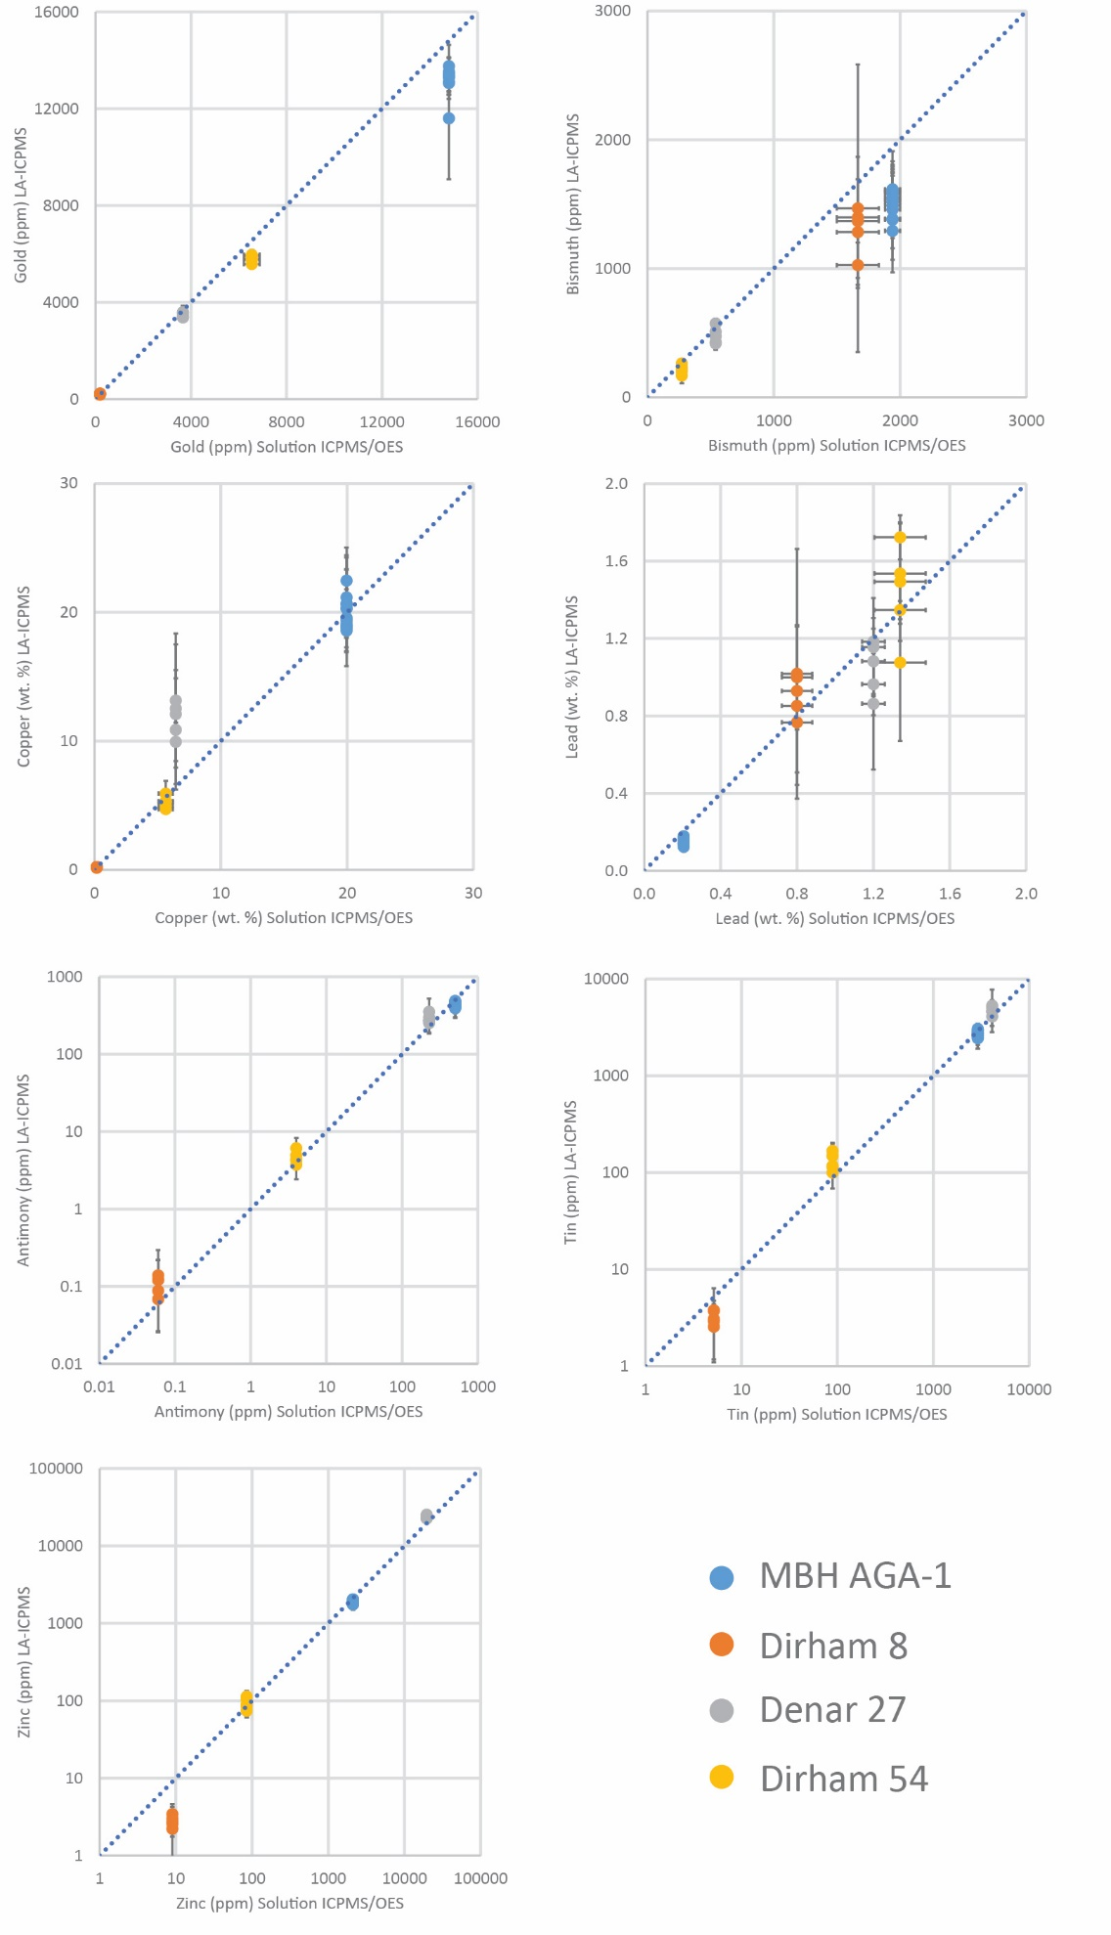
Figure S1. Analyses of MBH 133X-AGA-1 and three coin fragments used as reference materials. The y-axis are the LA-ICP-MS analyses from this study compared to x-axis solution-based ICPMS/OES results from other labs: MBH AGA-1, certificate value; Dirham Ph.8 and Ph.54, University of Oxford (Merkel et al. 2023); Denar 27, Deutsches Bergbau-Museum Bochum.

Section D: Data analysis
In addition to using traditional bi-variate plots to investigate patterns in the elemental and isotopic data, the program R was used to carry out a principal component analysis (PCA), combining the Pb isotope ratios and concentrations of source related elements (Au, Bi, Pt, Te and Pd) (Figure S3). The results indicate that the first three components contain 90% of the variability and that the most variation is found in the variables ²⁰⁶Pb/²⁰⁴Pb, ²⁰⁸Pb/²⁰⁴Pb, Au, Pt and Bi. The PCA analysis is plotted in Figure S2, which shows that the coin data divide into two main groups: those minted before AD 750 and those minted after. There are no systematic differences within the early group of coins (Merovingian denarii and early pennies from Frisia and England). In the late group, the PCA groups most of the Carolingian coins (Charlemagne and Louis the Pious) and the Anglo-Saxon coins (Offa/Coenwulf) together. The other coins, namely the denarius of Pipin and the KG3-type coin from Denmark, are more similar to the late group.
Individual two-variable scatter plots comparing the early (pre-750) and late (post-750) are shown in Figure S3. The scatterplots show that there is a nearly complete separation between the two groups using the variables ²⁰⁶Pb/²⁰⁴Pb, Au and Pt.

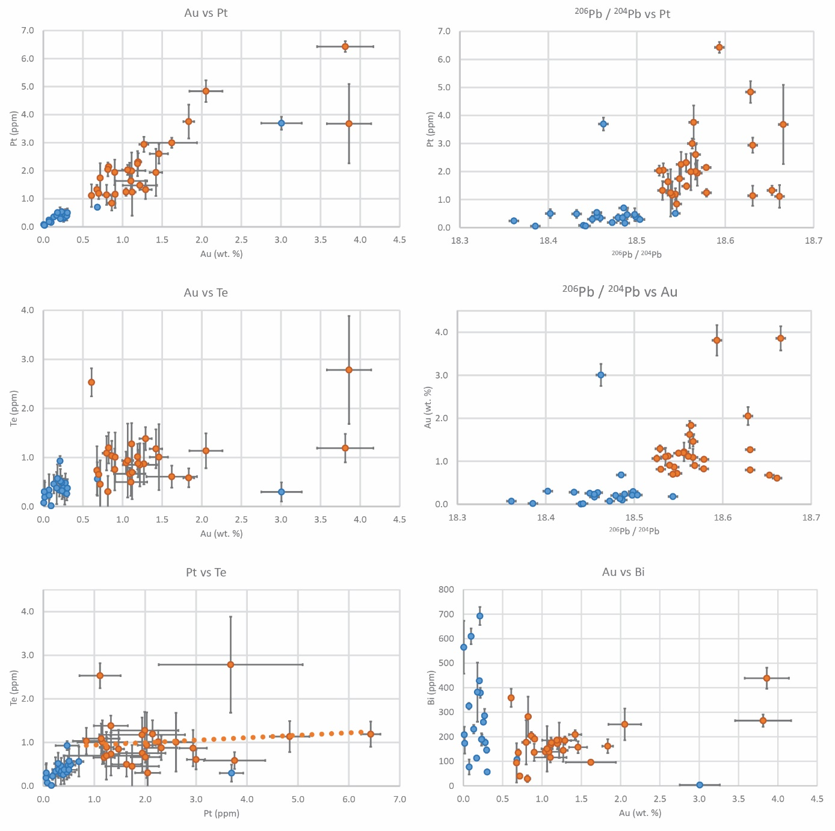
Figure S2. Analyses of the coins from this study separated by chronology: orange, early phase (c. 670–750) and blue, late phase (c. 754–822).

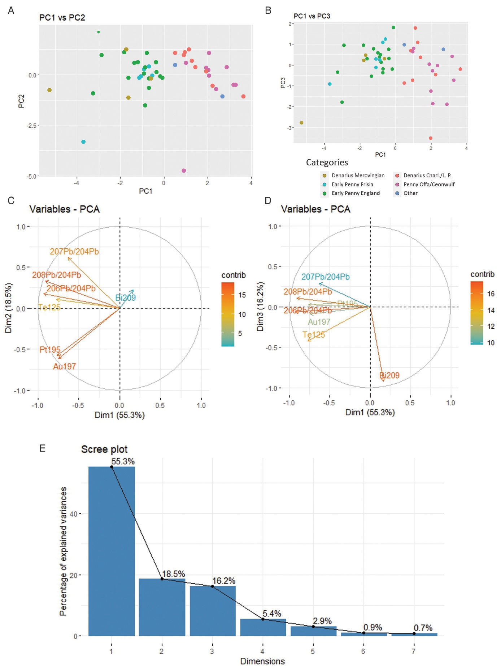
Figure S3. Principle component analysis of the investigated coins: A–B) bi-plots of the first three components, C–D) the variable contributions in the first three components and E) Scree plot indicating that the first three components explain most of the variability in the dataset.

References
Angelini, I., C. Canovaro, M. Venturino & G. Artioli. 2019. The silver treasure of Marengo: silver provenancing and insights into late antiquity Roman and Gallo-Roman hoards. Archaeological and Anthropological Sciences 11: 4959–70. https://doi.org/10.1007/s12520-019-00851-2
Baratte, F., M. Menu, T. Berthoud, L.P. Hurtel & I. Aghion. 1985. Trois trésors d’argenterie, in J. Hours (ed.) Recherches gallo-romaines I: 11–68. Paris: Editions de la Réunion des Musées Nationaux.
Baron, S., J. Carignan, S. Laurent & A. Ploquin. 2006. Medieval lead making on Mont-Lozère massif (Cévennes-France): tracing ore sources using Pb isotopes. Applied Geochemistry 21: 241–52. https://doi.org/10.1016/j.apgeochem.2005.09.005
Bielicki, K.H. & G. Tischendorf. 1991. Lead isotope and Pb-Pb model age determinations of ores from central Europe and their metallogenetic interpretation. Contributions to Mineralogy and Petrology 106: 440–61. https://doi.org/10.1007/BF00321987
Bode, M. 2008. Archäometallurgische Untersuchungen zur Blei-/Silbergewinnung im Germanien der Frühen Römischen Kaiserzeit. Unpublished PhD dissertation, Westfälische Wilhelms-Universität Münster.
Brill, R.H. & W.R. Shields. 1972. Lead isotopes in ancient coins, in E.T. Hall & D.M. Metcalf (ed.) Methods of chemical and metallurgical investigation of ancient coinage: 279–303. London: Royal Numismatic Society.
Cauet, S., D. Weis & A. Herbosch. 1982. Genetic study of Belgian lead zinc mineralization in carbonate environments through lead isotopic geochemistry. Bulletin BRGM, Orléans, II, 4: 329–41.
Durali-Müller, S. 2005. Roman lead and copper mining in Germany. Their origin and development trough time, deduced from lead and copper isotope provenance studies. Unpublished PhD dissertation, Goethe-Universität Frankfurt am Main.
Forel, B. et al. 2010. Historical mining and smelting in the Vosges Mountains (France) recorded in two ombrotrophic peat bogs. Journal of Geochemical Exploration 107: 9–20. https://doi.org/10.1016/j.gexplo.2010.05.004
Goemaere, E., S. Challe, S. de Longueville, T. Delbey & D. Demaiffe. 2022. Tracking the source of lead of medieval glazed pottery of the Meuse valley (Belgium) through lead isotope analysis. Journal of Archaeological Science: Reports 42. https://doi.org/10.1016/j.jasrep.2022.103366
Gratuze, B., C. Guerrot, D. Foy, A. Arles, F. Téreygeol & S. Baron. 2017. Les galets de verre au plomb carolingiens issus des scories de Melle: élaboration et distribution, in M. Bompaire & G. Sarah (ed.) Mine, métal, monnaie, Melle: 87–110. Genève: Droz.
Guénette-Beck, B., N. Meisser & P. Curdy. 2009. New insights into the ancient silver production of the Wallis area, Switzerland. Archaeological and Anthropological Science 1: 215–29. https://doi.org/10.1007/s12520-009-0014-3
Halter, W., T. Pettke, C.A. Heinrich & R. Rothen-Rutishauser. 2002. Major to trace element analysis of melt inclusions by laser-ablation ICP-MS: methods of quantification. Chemical Geology 183: 63–86. https://doi.org/10.1016/S0009-2541(01)00372-2
Karagiorgou, O., S. Merkel & M. Wołoszyn. 2021. A contribution to the technology and sources of lead in Byzantium: lead isotope analysis of ten Byzantine seals. Byzantinische Zeitschrift 114(3): 1161–204. https://doi.org/10.1515/bz-2021-0058
Knaf, C.S., J.M. Koornneef & G.R. Davies. 2017. “Non-invasive” portable laser ablation sampling of art and archaeological materials with subsequent Sr-Nd isotope analysis by TIMS using 10¹³ Ω ampliers. Journal of Analytical Atomic Spectrometry 32: 2210–16. https://doi.org/10.1039/C7JA00191F
Krahn, L. & A. Baumann. 1996. Lead isotope systematics of epigenetic lead-zinc mineralization in the western part of the Rheinisches Schiefergebirge, Germany. Mineralium Deposita 31: 225–37. https://doi.org/10.1007/BF00204029
Lehmann, R. 2011. Archäometallurgie von Mittelalterlichen Deutschen Silberbarren und Münzen. Unpublished PhD dissertation, Leibniz Universität Hannover.
Lippolt, H.-J., U. Schorn & R.T. Pidgeon. 1983. Genetic implications of new lead isotope measurements on Schwarzwald vein and Upper Triassic sediment galenas. Geologische Rundschau 72(1): 77–104.
Marcoux, E. 1986. Isotopes du plomb et parageneses metalliques, traceurs de l'histoire des gites mineraux. Illustration des concepts de source, d'heritage et de regionalisme dans les gites francais applications en recherche miniere. Unpublished PhD dissertation, Clermont-Ferrand, Document du B.R.G.M., No. 117.
Merkel, S.W., P. D’Imporzano, K. van Zuilen, J. Kershaw & G.R. Davies. 2022. “Non-invasive” portable laser ablation sampling for lead isotope analysis of archaeological silver: a comparison with bulk and in situ laser ablation techniques. Journal of Analytical Atomic Spectrometry 37: 148–56. https://doi.org/10.1039/D1JA00342A
Merkel, S., J. Oravisjärvi & J. Kershaw. 2023. Sources of early Islamic silver: lead isotope analysis of dirhams. Antiquity 97: 1564–80. https://doi.org/10.15184/aqy.2023.165
Morrisson, C., M.F. Guerra & J.-N. Barrandon. 1993. Premieres analyses de plombs byzantins: perspectives et impasses des recherches sur leur composition métallique, in N. Oikonomides (ed.) Studies in Byzantine sigillography: 1–17. Washington, D.C.: Dumbarton Oaks.
Munoz, M., S. Baron, A. Boucher, D. Béziat & S. Salvi. 2016. Mesozoic vein-type Pb-Zn mineralization in the Pyrenees: lead isotopic and fluid inclusion evidence from the Les Argentières and Lacore deposits. Comptes Rendus Geoscience 348: 322–32. https://doi.org/10.1016/j.crte.2015.07.001
Ponting, M., J.A. Evans & V. Pashley. 2003. Fingerprinting of Roman mints using laser ablation MC-ICP-MS lead isotope analysis. Archaeometry 45: 591–97. https://doi.org/10.1046/j.1475-4754.2003.00130.x
Rohl, B. 1996. Lead isotope data from the Isotrace Laboratory, Oxford: archaeometry data base 2, galena from Britain and Ireland. Archaeometry 38: 165–80. https://doi.org/10.1111/j.1475-4754.1996.tb00769.x
Sarah, G. 2008. Caractérisation de la composition et de la structure des alliages argent-cuivre par ICP-MS avec prélèvement par ablation laser. Application au monnayage carolingien. Unpublished PhD dissertation, Université d’Orléans.
Sarah, G., B. Gratuze & J.N. Barrandon. 2007. Application of laser ablation inductively coupled plasma mass spectrometry (LA-ICP-MS) for the investigation of ancient silver coins. Journal of Analytical Atomic Spectrometry 22: 1163–7. https://doi.org/10.1039/B704879C
Scaife, B., B.A. Barreiro, J.G, McDonnell & A.M, Pollard. 2001. Lead isotope ratios of 36 galenas from the northern Pennines. Available at: https://brettscaife.net/lead/npennine/npennine1-3.html (accessed 2 Feb 2023).
Schneider, J. 1994. Geochemische Untersuchungen zur Genese von Buntmetallvererzungen in der Nordeifel. Unpublished PhD dissertation, Justus-Liebig-Universität Gießen.
Scott, D.A. 1990. A technical analytical study of two silver plates in the collection of the J. Paul Getty Museum. The J. Paul Getty Museum Journal 18: 33–52.
Ströbele, F. 2017. Archäometrische Analysen, in F. Daim, B. Fourlas, K. Horst & V. Tsamakda (ed.) Spätantike und Byzanz: Bestandskatalog Badisches Landesmuseum Karlsruhe, Objekte aus Bein, Elfenbein, Glas, Keramik, Metall und Stein: 205–13. Mainz: Römisch-Germanischen Zentralmuseums. https://doi.org/10.11588/propylaeum.384
Ströbele, F. et al. 2012. Pb isotope constraints on fluid flow and mineralization processes in SW Germany. Neues Jahrbuch für Mineralogie – Abhandlungen 189(3): 287–309. https://doi.org/10.1127/0077-7757/2012/0225
Téreygeol, F., S. Hoelzl & P. Horn. 2005. Le monnayage de Melle au haut Moyen Age: état de la recherche. Bulletin Association des Archéologues de Poitou-Charentes 34: 49–56.

