[For SUPPLEMENTARY MATERIAL]
Mediterranean Early Iron Age chronology: assessing radiocarbon dates from a stratified Geometric period deposit at Zagora (Andros), Greece

Rudolph Alagich^{1,*} [ORCID: 0000-0002-2369-328X], Lorena Becerra-Valdivia² [ORCID: 0000-0001-5501-5347], Margaret C. Miller¹ [ORCID: 0000-0002-5210-3517], Katerina Trantalidou³ [ORCID: 0000-0002-3761-0481] & Colin Smith^{4,5} [ORCID: 0000-0001-5901-8780]
¹ Department of Archaeology, University of Sydney, Australia
² Oxford Radiocarbon Accelerator Unit, Research Laboratory for Archaeology and the History of Art, School of Archaeology, University of Oxford, UK
³ Hellenic Ministry of Culture, Athens, Greece
⁴ Department of Archaeology and History, La Trobe University, Bundoora, Australia
⁵ Laboratorio de Evolución Humana, Departamento de Historia, Geografía y Comunicación, Universidad de Burgos, Spain
* Author for correspondence ✉ rudy.alagich@sydney.edu.au
Received: 5 September 2022; Revised: 14 March 2023; Accepted: 25 May 2023

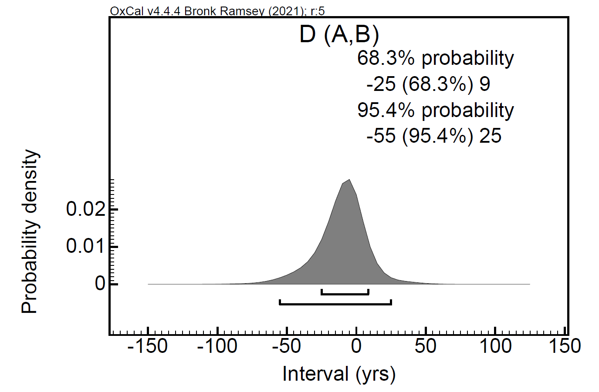
Figure S1. Probability density function for the difference (“D”) between the two boundaries between levels 15 and 7 (“A” and “B”). The results suggest that these are statistically comparable as the distribution includes zero at both 95.4% and 68.3% confidence interval (bars beneath distribution). This suggests that the occupation at this point in the sequence was continuous and short.

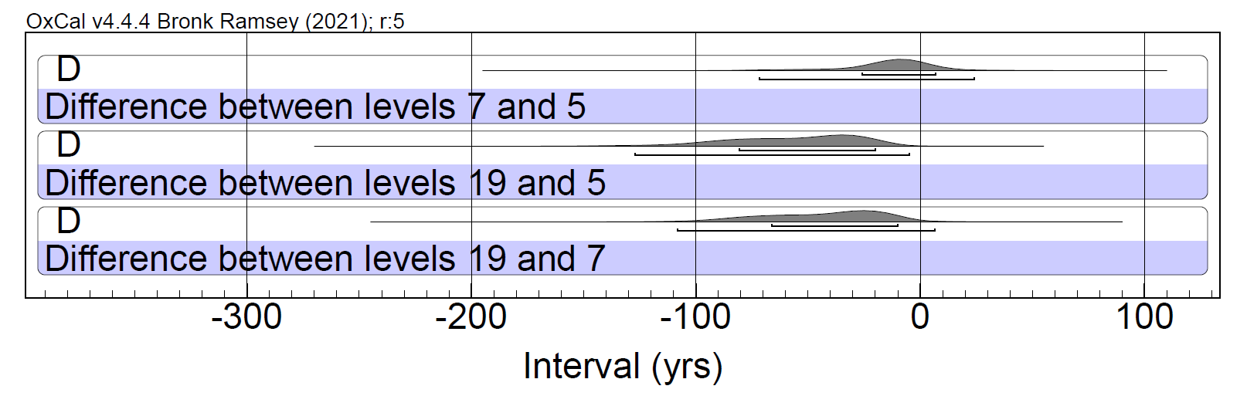
Figure S2. Probability density functions for the difference (“D”) between the start of levels 19, 7 and 5. These results suggest that, apart from levels 7 and 5, the distributions do not overlap at 68.3% confidence interval as they do not include zero. This suggests that the cultural events were generally temporally distinct, yet in close sequential order. Bars underneath the distributions denote confidence intervals.

OxCal code

Plot()
{
Outlier_Model("General",T(5),U(0,4),"t");
Sequence("Zagora")
{
Boundary("Start level 19");
Phase("Level 19")
{
R_Date("UNSW-219", 2826, 20)
{
Outlier("General", 0.05);
chronology="MG / SPG III";
level="19";
};
R_Date("UNSW-221", 2814, 20)
{
Outlier("General", 0.05);
chronology="MG / SPG III";
level="19";
};
};
Boundary("End level 19/Start level 18");
Label("Level 18");
R_Date("UNSW-214", 2815, 20)
{
Outlier("General", 0.05);
chronology="MG / SPG III";
level="18";
};
Boundary("End level 18/Start level 17");
Label("Level 17");
R_Date("UNSW-215", 2818, 20)
{
Outlier("General", 0.05);
chronology="MG / SPG III";
level="17";
};
Boundary("End level 17/Start level 16");
Label("Level 16");
R_Date("UNSW-217", 2810, 20)
{
Outlier("General", 0.05);
chronology="MG / SPG III";
level="16";
};
Boundary("End level 16/Start level 15");
Phase("Level 15")
{
R_Date("UNSW-213", 2809, 20)
{
Outlier("General", 0.05);
chronology="MG / SPG III";
level="15";
};
R_Date("UNSW-216", 2807, 20)
{
Outlier("General", 0.05);
chronology="MG / SPG III";
level="15";
};
};
Boundary("End level 15/Start gap");
Date("Date of gap");
Interval("Duration of gap");
Boundary("End gap/Start level 7");
Label("Level 7");
R_Date("UNSW-222", 2753, 20)
{
Outlier("General", 0.05);
chronology="MG II / SPG IIIb";
level="7";
};
Boundary("End level 7/Start level 6");
R_Date("UNSW-218", 2759, 20)
{
Outlier("General", 0.05);
chronology="MG II / SPG IIIb";
level="6";
};
Boundary("End level 6/Start level 5");
R_Date("UNSW-220", 2764, 20)
{
Outlier("General", 0.05);
chronology="LG I";
level="5";
};
Boundary("End level 5");
};
Sequence()
{
Boundary("=Start level 19");
Interval("Duration MG / SPG III");
Date("Date MG / SPG III");
Boundary("=End level 15/Start gap");
};
Sequence()
{
Boundary("=End gap/Start level 7");
Interval("Duration MG II / SPG IIIb");
Date("Date MG II / SPG IIIb");
Boundary("=End level 6/Start level 5");
};
Sequence()
{
Boundary("=End level 6/Start level 5");
Interval("Duration LG I");
Date("Date LG I");
Boundary("=End level 5");
};
Sequence()
{
Boundary("=End level 19/Start level 18");
Interval("Duration level 18 or surface 3");
Date("Date level 18 or surface 3");
Boundary("=End level 18/Start level 17");
};
};

