[Supplementary material]
Early architecture in Tonga: implications for the development of Polynesian chiefdoms
Geoffrey Clark^{1,*} [ORCID 0000-0002-9055-655X], Phillip Parton¹ [ORCID 0000-0002-2610-8787] & Christian Reepmeyer² [ORCID 0000-0002-3257-0898]
¹ Department of Archaeology and Natural History, College of Asia and the Pacific, Australian National University, Canberra, Australia
² Kommission für Archäologie Außereuropäischer Kulturen, Deutsches Archäologisches Institut, Bonn, Germany
* Author for correspondence ✉ geoffrey.clark@anu.edu.au
Received: 12 October 2022; Revised: 16 March 2023; Accepted: 18 May 2023

1. Bayesian model for Mala'e Vakapuna main excavation

Options()
{
Resolution=0.5;
};
Sequence("MVP Sequence")
{
After("Nukuleka")
{
C_Date("Nukuleka", BC(827), 4);
};
Boundary("Start Lapita Midden");
Sequence("Lapita Midden")
{
Phase("Layer 7 Midden")
{
Curve("shcal20", "shcal20.14c");
R_Date("57832", 2230, 24);
Curve("shcal20", "shcal20.14c");
R_Date("57831", 2179, 25);
Curve("shcal20", "shcal20.14c");
R_Date("59937", 2262, 27);
Curve("shcal20", "shcal20.14c");
R_Date("59938", 2199, 28);
Curve("shcal20", "shcal20.14c");
R_Date("57833", 2235, 25);
};
};
Boundary("End Lapita Midden");
Boundary("Start Topsoil Development");
Sequence("Topsoil Development")
{
Phase("Topsoil Development")
{
Curve("shcal20", "shcal20.14c");
R_Date("57835", 1698, 24);
};
};
Boundary("Start Mound Construction");
Sequence("Mound Construction")
{
Boundary("Start B6");
Phase("B6")
{
Curve("shcal20", "shcal20.14c");
R_Date("57836", 1669, 25);
};
Boundary("Transition B6/B5");
Phase("B5")
{
Curve("shcal20", "shcal20.14c");
R_Date("57837", 1627, 24);
};
Boundary("Transition B5/B4");
Phase("B4")
{
Curve("shcal20", "shcal20.14c");
R_Date("57605", 1672, 25);
};
Boundary("Transition B4/B3");
Phase("B3")
{
Curve("shcal20", "shcal20.14c");
R_Date("57838", 1637, 24);
};
Boundary("Transition B3/B2");
Phase("B2")
{
Curve("shcal20", "shcal20.14c");
R_Date("57839", 1517, 25);
};
Boundary("Transition B2/B1");
Phase("B1")
{
Curve("shcal20", "shcal20.14c");
R_Date("59931", 1541, 31);
};
Boundary("End B1");
Span("Span Mound Construction");
};
Boundary("End Mound Construction");
Boundary("Start Post Mound");
Sequence("Post Mound")
{
Boundary("Start Post Hole");
Curve("shcal20", "shcal20.14c");
R_Date("57903", 186, 22);
Boundary("End Post Hole");
};
Boundary("End Post Mound");
Before("Civil War")
{
C_Date("Civil War End", AD(1852), 1);
};
MCMC_Sample("MCMC_MVP", 50, 500000)
{
};
};

2. South mound stratigraphy and radiocarbon result
A small excavation 0.4m wide was placed on the south side of the mound that extended from the ground surface into the mound to 0.85m height. The basal stratigraphy consisted of a black mottled soil deposit that marked the mixed interface between the pre-mound topsoil and the first mound construction layer (Figure S1). Above the interface was layer A which was a relatively even mixture of organic soil and clay (0.4m) while layer B (0.3m) contained more humic soil and less clay. Charcoal, as fragments and flecks, was observed in both layers and likely derives from the removal of hill topsoil containing material deposited during ceramic and post-ceramic use of the hilltop prior to mound building. In colour and composition, layer A and layer B were comparable with the main excavation layers 5(a-d) and layer 4 in having more organic soil mixed with clay in which charcoal fragments were common. A charcoal sample collected from the interface between the mound topsoil and layer B that had been deposited after mound construction gave a calibrated radiocarbon age of 1472±22 BP (SANU-57907) and a 95.4% (2 sigma) calibrated age of 590–650 AD indicating the mound had been completed around the middle of the first millennium AD. As the charcoal sample was not from a recognised context compared to the burn layer samples in the main excavation, we did not include the determination in the Bayesian analysis, although its inclusion would significantly tighten the age of mound completion.

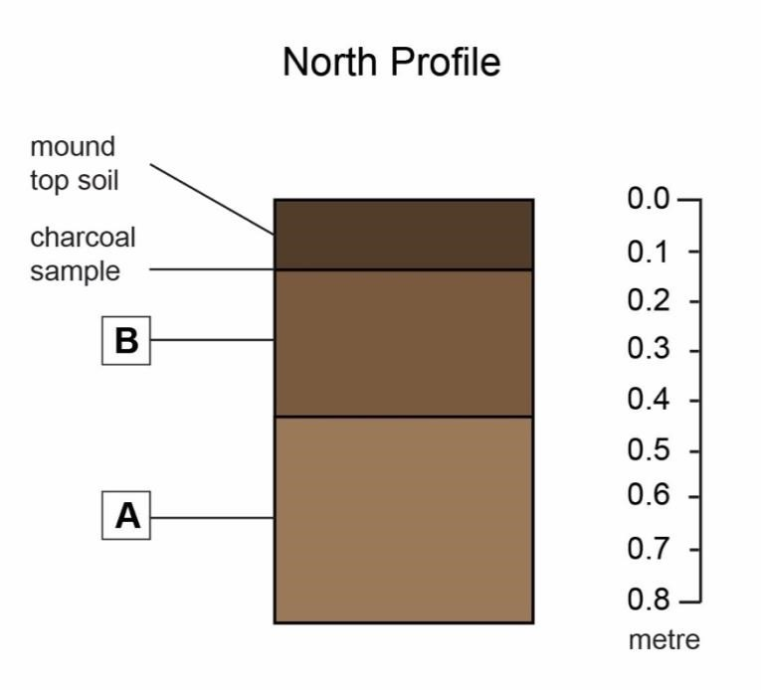

Figure S1. South mound excavation profile (north) showing location of SANU-57907 charcoal sample and the stratigraphy on the mound edge which is comparable to layers 4 and 5 in the main excavation.

3. Lidar estimate of ditch and bank volumes
Radiocarbon dates from Mala'e Vakapuna suggest that it was made over a relatively short interval. A reviewer suggested that the upper 0.46m of mound deposit overlying B1 could have been added later and therefore the mound made in the first millennium may have once been smaller. To test whether material in the final layer (layer 2a) of mound construction could have been sourced from the construction of the nineteenth century ditch and bank fortification surrounding Mala'e Vakapuna, we calculated the volume of the ditch excavation and the defensive bank fill using archaeological information to identify the depth of the ditch and the bank height. If the fortification ditch volume was significantly greater than the bank volume, then the missing fill could have been added to the mound. Heavy vegetation in the northwest of the fortification resulted in poor penetration of lidar pulses and a sparse terrain model. In these areas, the point density is not sufficient to accurately calculate ditch and bank volumes. We instead used three areas of the fortification where lidar points densely map the ground surface in the east and southern portion of the fortification (Figure S2). In this area the vegetation is higher with little undergrowth and there is good fidelity of the bare earth surface. To calculate volumes, we constructed one metre profile slices through sections and summed the volume of material in each portion of the excavated ditch and the fill deposited bank. There is no clear trend in the volume data for an excess of ditch fill that could have been added to the mound with averaged values indicating the ditch fill was entirely used to make the defensive bank. The similarity of the upper clay sediment in layer 2a to that in layer 2b suggests these layers were deposited closely in time in the first millennium AD. This is consistent with an age result of 1472±22 BP on a charcoal sample collected from the base of the topsoil that formed after mound construction (see above).

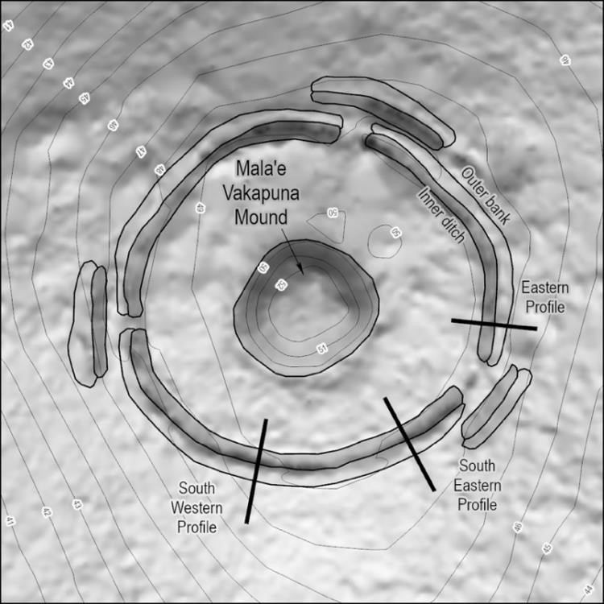
Figure S2. Lidar transects used to calculate the volume of the nineteenth century ditch and bank fortification.

Table S1. Fortification ditch and bank volumes derived from lidar transects.
Transect location | Ditch (m³) | Bank (m³)
East | 43 | 63
South-eastern | 35 | 36
South-western | 75 | 47
Average | 51 | 49

4. Association of large mounds, roads and potential ceremonial open area (Mala'e) at Holonga

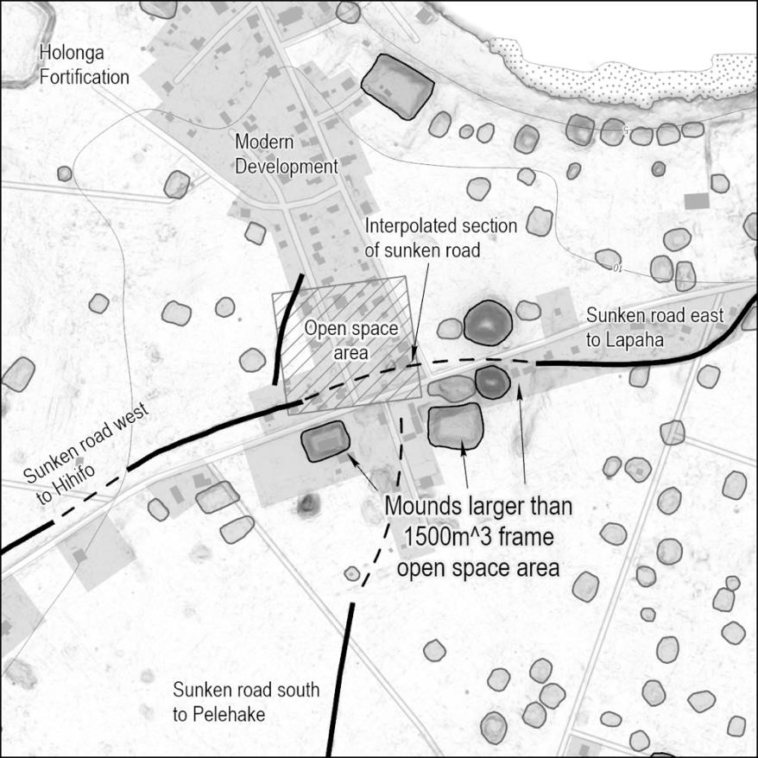

Figure S3. Lidar image of large mounds at Holonga showing the association of road(s), smaller mounds and open areas that likely represent open village area (mala'e). Grey areas mark modern development.

The association of large mounds with other structures is relatively common on Tongatapu and was described by Captain Cook (in Beaglehole 1967: 252) when he visited a burial mound in the west of Tongatapu in 1773: ‘This Mount stood in a kind of grove open only on one side which fronted the high road and green on which the people were seated, at this green was a junction of five roads and two or three of them appeared to be very publick ones ... near to which was a large House belonging to a Chief.’ Mala'e Vakapuna suggests that an association of large mounds with roads, plantations, and residential areas extends to the first millennium AD as indicated in Proto-Polynesian by terms for mound foundations (*qafu), roads (*hala), gardens (*maqala), an open meeting/ceremonial area (*malaqe) along with the presence of ranked kin-groups (*kainanga) who were led by a chief (*qariki).

5. Radiocarbon Dates for Durable Architecture in Fiji-West Polynesia potentially made in the first millennium AD

Location | Site | Structure | Sample | Context | CRAs | 14C  Ages | ¹³C | Cal. BP (95.4%) | Note,  Reference
Samoa  Savai'i | Pulemelei area, SS-Le-1 | Defensive stone wall (Pa Tonga) | Charcoal | Beneath wall | WK-  15504 | 992 ±  34 | -26.9 | 960–790 | 1, Wallin et al. 2007
Samoa,  Savai'i, | Pulemelei,  SS-Le-1 | Monument  al stone  mound | Charcoal | Oven beneath mound | WK-  16640 | 1135 ±  34 | - | 1180–960 | 1, Wallin et al. 2007
Samoa, Upolu | Luatuanu'u, SU-Lu-41 | Ridge fortification | Charcoal | Sample from  1st construction deposit | GaK799 | 1500 ±  80 | - | 1540–1280 | 3, Scott &  Green 1969
Samoa, Upolu | Su-Va-1 | Residential mound | Charcoal | Sample from top part of layer V | NZ-  361 | 1936 ±  60 | - | 1700–2000 | 1, Green  1969
Samoa, Upolu | Su-Va-4 | Residential mound | Charcoal | Oven toward base layer E | Gak-  1199 | 1693 ±  350 | - | 800–2350 | 1, 7, Terrell  1969
Samoa, Upolu | Su-Va-38 | Residential mound | Charcoal | fire pit under mound layer 14 | Gak-  1439 | 1597 ±  80 | - | 1300–1610 | 1, Hougaard  1969
Tonga,  Tongatapu | Popua, TO-Nu-38 | Pigeon snaring mound | Gafrarium tumidum | Complete  valve in construction layer | WK-  1417 | 1360 ±  60 | -2.4 | 680–440 | 6, 8,  Spennemann  1989a
Tonga,  Tongatapu | Nukuleka, TO.2 | Burial  mound | Charcoal | Oven M dug into Lapita midden | NZ-  635 | 1620 ±  60 | - | 1590–1320 | 4, see Burley et al. 2012
Tonga, Tongatapu  islet | Pangaimotu,  TO-Pi-5 | Residential mound | Tridacna shell adze (preform) | Pit dug into  mound  (Feature 4) | ANU-  6426 | 1800 ±  70 | 3.28 | 1370–990 | 2, 8,  Spennemann 1989b
Tonga, Tongatapu  islet | Pangaimotu,  TO-Pi-3 | Residential mound | Charcoal | Sample from  'living floor'  (Layer 3) | ANU-  6609 | 1010 ±  350 | -24 ±  2.0  Est | 1610–290 | 7, 8,  Spennemann  1989b
Tonga, Tongatapu  islet | Pangaimotu, TO-Pi-7 | Residential mound | Shell sample (mixture) | Mixed shells from Layer 3, 1st phase of low mound construction | ANU-  5726 | 2180 ±  70 | 1.62 | 1810–1390 | 3, 5, 8,  Spennemann  1989b
Tonga, Tongatapu  islet | Pangaimotu, TO-Pi-6 | Residential mound | Charcoal | Hearth beneath mound | ANU-  6427 | 1900 ±  160 | -24 ±  2.0  Est | 2290–1410 | 1, 7,  Spennemann  1989b
Tonga,  Tongatapu | Veitongo, TO-At-85 | Residential mound | Charcoal | Hearth associated with initial construction of low  mound | ANU-  5719 | 1270 ±  235 | -24 ±  2.0  Est | 1580–680 | 7, 8,  Spennemann  1989a
Fiji,  Sigatoka valley | Nokonoko,  2-NOK-009 | Burial  mound on  hilltop fortification | Charcoal | Fire feature (Feature 2) associated with human remains. Premound house (yavu) foundation | AA-  50283 | 1311 ±  39 | -25.0 | 1280–1080 | Field 2003
1. Sample predates structure, 2. Possibility of substantial inbuilt age, 3. Sample from structure fill, 4. Determination contradicted by new dating, 5. Sample age from layer above is significantly younger, 6. Calibrated age significantly younger after correction for hardwater effect (Petchey & Clark 2011), 7. Standard error > ± 150 years, 8. Single age determination used to date construction.

References
Beaglehole, J.C. (ed.) 1967. The journals of Captain James Cook on his voyages of discovery edited from the original manuscripts. The voyage of the Resolution and Adventure 1772–1775. Cambridge: Cambridge University Press for the Hakuluyt Society.
BURLEY D, M.I. WEISLER & J.-X. ZHAO. 2012. High precision U/Th dating of first Polynesian settlement. PLoS ONE 7: e48769. https://doi.org/10.1371/journal.pone.0048769.
FIELD, J.S. 2003. The evolution of competition and co-operation in Fijian prehistory: Archaeological research in the Sigatoka Valley, Fiji. Unpublished PhD dissertation, University of Hawai'i, Manoa.
GREEN, R.C. 1969. Excavations at Va-1, 1963-64, in R.C. Green & J.M. Davidson (ed.) Archaeology in western Samoa. Vol. 1: 114–137. Auckland: Auckland Institute and Museum Bulletin.
HOUGAARD, M.P. 1969. Investigations at inland Vailele, in R.C. Green & J.M. Davidson (ed.) Archaeology in western Samoa. Vol. 1: 177–81. Auckland: Auckland Institute and Museum Bulletin.
PETCHEY, F. & G. CLARK. 2011. Tongatapu hardwater: investigation into the ¹⁴C marine reservoir offset in lagoon, reef and open ocean environments of a limestone island. Quaternary International 6: 539–49. https://doi.org/10.1016/j.quageo.2011.08.001
SCOTT, S.D. & R.C. GREEN. 1969. Investigations of Su-Lu-41, a large inland fortification, in R.C. Green & J.M. Davidson (ed.) Archaeology in western Samoa. Vol. 1: 205–8. Auckland: Auckland Institute and Museum Bulletin.
TERRELL, J. 1969. Excavations at Su-Va-4, in R.C. Green & J.M. Davidson (ed.) Archaeology in western Samoa. Vol. 1: 158–75. Auckland: Auckland Institute and Museum Bulletin.
SPENNEMANN, D.H.R. 1989a. ‘Ata ‘a Tonga mo ‘ata ‘o Tonga: early and later prehistory of the Tongan Islands. Volume 1. Unpublished PhD dissertation, Australian National University.
– 1989b. ‘Ata ‘a Tonga mo ‘ata ‘o Tonga: early and later prehistory of the Tongan Islands. Volume 2. Unpublished PhD dissertation, Australian National University.
WALLIN, P., H. MARTINSSON-WALLIN & G. CLARK. 2007. A radiocarbon sequence for Samoan prehistory and the Pulemelei Mound. Archaeology in Oceania 42: 71–82. https://doi.org/10.1002/j.1834-4453.2007.tb00007.x

