[Supplementary material]
A Vasconic inscription on a bronze hand: writing and rituality in the Iron Age Irulegi settlement in the Ebro Valley
Mattin Aiestaran^{1,2,*} [ORCID 0000-0002-9013-5034], Javier Velaza³ [ORCID 0000-0002-5811-3345], Joaquín Gorrochategui⁴ [ORCID 0000-0001-5433-2156], Carmen Usúa⁵, Pablo Pujol⁶, Euken Alonso², Eneko Iriarte⁷ [ORCID 0000-0001-8365-5616], Josu Narbarte² [ORCID 0000-0002-0297-8526] , Dani Ruiz-González² [ORCID 0000-0002-6179-505X], Oihane Mendizabal-Sandonís² [ORCID 0000-0001-6337-6345], Jesús Sesma⁸, Jose Antonio Mujika-Alustiza¹ [ORCID 0000-0002-2130-6338], Jesús García Gazólaz⁸ [ORCID 0009-0000-6272-8054], Berta Balduz⁸ & Juantxo Agirre-Mauleon²

¹ Grupo de Investigación en Prehistoria, Universidad del País Vasco/Euskal Herriko Unibertsitatea, Bilbao, Spain
² Aranzadi Zientzia Elkartea/Sociedad de Ciencias Aranzadi, Donostia-San Sebastián, Spain
³ Facultat de Filología i Comunicació, Universidad de Barcelona, Catalunya, Spain
⁴ Lingüística Diacrónica, Tipología e Historia del Euskera, Universidad del País Vasco/Euskal Herriko Unibertsitatea, Vitoria/Gasteiz, Spain.
⁵ ARTUS S.L., Pamplona, Spain
⁶ Universidad Pública de Navarra/Nafarroako Unibertsitate Publikoa, Pamplona, Spain
⁷ Departamento de Historia, Geografía y Comunicación, Universidad de Burgos, Spain
⁸ Servicio de Patrimonio Histórico del Gobierno de Navarra, Pamplona, Spain
* Author for correspondence ✉ mattin.aiestaran@ehu.eus
Received: 11 September 2022; Revised: 6 March 2023; Accepted: 15 May 2023

1. Excavated structures within the settlement
Dwellings 6000 and 3000 are rectangular in plan and are oriented approximately south-north. They were built on stone footings, while the walls were constructed with adobe bricks interspersed with wooden posts. The roofs were originally made of a wooden structure with a plant cover. In their final phase, these dwellings had an approximate surface area of 70m². They were separated by streets or open spaces, and their general features were similar to the Iron Age dwellings recorded in the interior of the Iberian Peninsula (Ruiz-Zapatero 2018). They were probably occupied by members of the local society, articulated around the most important towns, such as Irulegi (Armendáriz 2008).

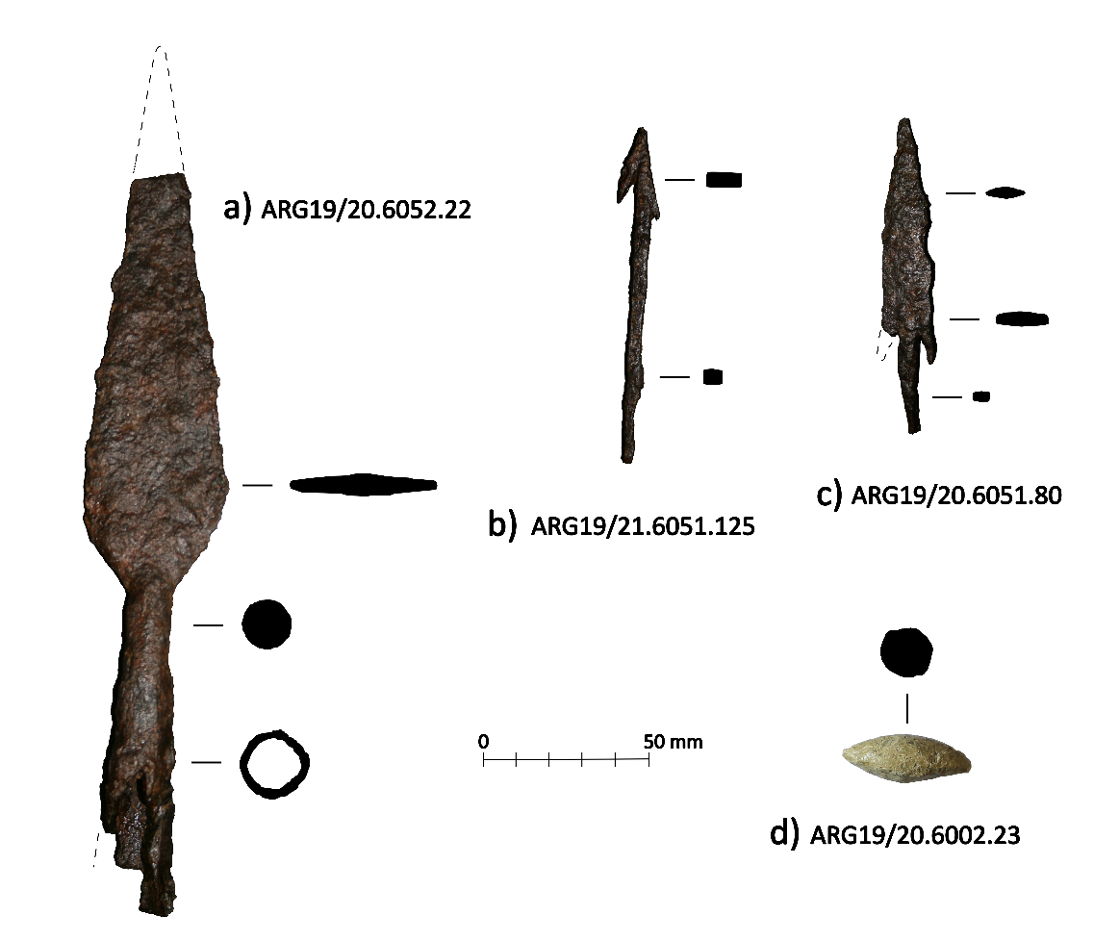
Figure S1. A selection of weapons recovered from Irulegi: a) spear, type 4a according to Quesada (1997) (ARG19/20.6052.22); b) iron rod arrowhead and double harpoon tip with herringbone-shaped handle, type 3G according to Ble (2016) (ARG19/201.6051.125), often interpreted as an incendiary projectile (Quesada 2007); c) triangular arrowhead with two long barbs and herringbone-shaped handle, type Cb according to Ble (2016) and C according to Quesada (2007) (ARG19/20.6051.80); d) lead slingshot, type II according to Ble (2016) and Völling (1990) (ARG19/20.6002.23) (figure by authors).

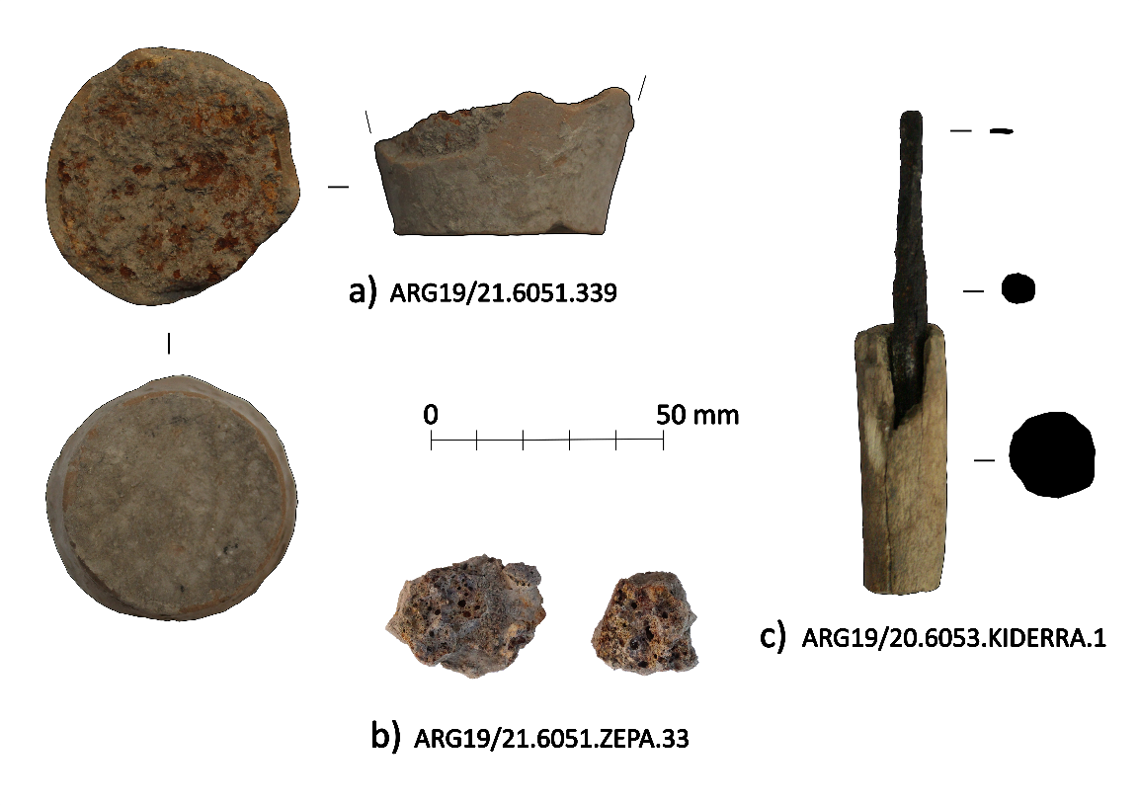
Figure S2. A selection of metalwork-related materials from Irulegi: a) crucible (ARG19/21.6051.339); b) fragments of slags (ARG19/21.6051.ZEPA.33); c) iron burin with bone handle, possibly used to make incisions on metal (ARG19/20.6053.KIDERRA.1), recovered from the same dwelling 6000 as the Irulegi Hand.

2. The layout process
The process of layout and writing on the Irulegi hand can be described as follows. Three guidelines were first incised in a rough and imprecise manner. The second guideline starts at a distance of 9.6mm from the first one on the left margin, but then drops downwards to reach a distance of 25.9mm on the right margin. This mistake in the layout of the guidelines was so obvious that they were not respected when incising the text. Line 1 of the text runs parallel to the uppermost guideline. In the case of line 2, the first 5 signs were traced on the second guideline but, from the sixth sign onwards, they run more or less parallel to the imaginary base of line 1. Line 3 was incised between the second and third guidelines, and line 4 below the latter, without a reference guideline below.

3. Discrepancies between the sgraffito and the stippled text
In this section we describe in detail the epigraphic problems resulting from these discrepancies, following the classical palaeographic classification by Untermann (1990: 246–47).
Line 1: Signs 1–7 do not present any special problem: the upper stroke of the first o is slightly inclined towards the right, but this does not appear to be a significant phenomenon. Sign 8 was drawn in the shape of a diamond without the lower right stroke, in a form equivalent to ke2 and similar to sign 4 in line 2; however, its punched shape is that of a complete diamond with the addition of an internal point, and therefore equivalent to ku1. After this sign, an interpunction has been punched in the form of three vertical dots, without any previous sgraffito.
Line 2: Sign 4 has the form of ke2, although the right stroke almost joins the upper point of the left one. Sign 5 was drawn as an upper diamond whose lower right stroke extends as far as the guideline; finally, a horizontal stroke was added cutting the former at the height of the diamond’s base (note that similar strokes were added in the sgraffiti of signs 8 in line 2 and 4 in line 3, both of them allographs of ŕ3; but, in those cases, the lower stroke is straight and independent from those of the diamond; signs 11 in line 2 and 2 in line 4 are also ŕ3, but lack the horizontal strokes in the sgraffiti). In this sign, the stippling clearly marked a be1 sign; while, in the case of the mentioned ŕ signs, the stippled text did not include them. Iberian and Celtiberian epigraphy lacks parallels for this type of additional horizontal strokes below the diamond, so, for the moment, we cannot decide whether these are diacritic marks or non-significant allographs.
Line 3: Sign 6 shows clear signs of vacillation and rectifications in the sgraffito, and a vertical line was drawn after it. At the time of stippling, an n sign was marked and then six points disposed vertically, separate from the sign described. We think that these should be interpreted as an interpunction; the fact that it has more dots than the remaining interpunctions in the text does not appear to be significant, since it is frequent in other Palaeohispanic texts and, thus, could be a consequence of the proximity of the previous sign’s strokes. The hypotheses of both signs being a single one, which should be read ś, or the vertical signs corresponding to a ba sign seem unlikely. Between the signs e and a, the separation is slightly larger than in the rest, but it remains unknown whether it was an intentional attempt to mark a separation between words.
Line 4: Sign 6 was written in a sloppy manner. The left vertical stroke was first marked; then a possibly mistaken horizontal stroke; next an oblique stroke beginning from the upper point of the former and crossing the latter; and, finally, a shorter vertical stroke on the right. When the text was stippled, it formed a n with a third stroke preceding the last one in the sgraffito, so the latter was used as a guide for three vertical points as a final interpunction.

4. The authorship of the artefact by one or more individuals
The question of whether the sgraffito and the stippled texts were made by the same person or not is highly problematic. As will be stated below and has been stated in section 3, there are discrepancies between the forms of the sgraffito signs and the stippled ones, but there is no definitive evidence of the participation of one or two hands. A single hand might have drawn a somewhat negligent draft and then have themselves stippled the text completing or correcting some signs, or the author of the draft and the stippled text might have equally well been different people. If the first hypothesis is correct, the definitive and therefore more correct text would be the stippled version; if the second hypothesis is correct, it could be thought in principle that the sgraffito text could have more authority, but its palaeographic quality is not good enough to support such an idea and, on the other hand, it is clear that the stippled text exhibits a willingness to correct the previous one with the addition of strokes or interpositions. Whatever the case, for the time being this question must still be considered open.

5. Glossary
Dental: A consonant articulated with the tongue against the upper teeth, as /t/ or /d/.
Desinence: A morphological ending or termination of a word, especially an inflectional ending.
Fortis lateral: A lateral consonant with a strong pronunciation.
Infix causative: It is an important derivation tool particularly applied to verbs.
Interpuncts: Punctuation marks.
Intervocalic position: Position between two vowels.
Nasal: An occlusive consonant produced with a lowered velum, allowing air to escape freely through the nose.
Post velar fricative: It is a type of consonantal sound used in some spoken languages, in English it is usually represented with /kh/.
Pre-dorsal affricate: It is a type of consonantal sound used in some spoken languages, in modern Basque it is usually represented with /tz/.
Pre-dorsal laminal: It is a type of consonantal sound used in some spoken languages, in modern Basque it is usually represented with /s/.
Rising diphthongs: A diphthong in which the first of two apparent vocalic elements is of lesser stress or sonority than the second.
Sibilant: A fricative consonant made by directing a stream of air with the tongue towards the teeth.
Syllabograms of the occlusive series: In Palaeohispanic writing systems, the syllabogramic signs that mark each of the sequences of an occlusive with the following vowel.
Syntagms: Syntagmatic structures, combinations of words according to the rules of syntax for that language.
Velar consonants: Consonants produced with the back of the tongue touching or near the soft palate.
Vibrant: A rhotic consonant which is either a tap or a trill.

References
Armendáriz, J. 2008. De aldeas a ciudades: el poblamiento durante el primer milenio a.C. en Navarra. Pamplona: Gobierno de Navarra.
Ble, E. 2016. Guerra y conflicto en el nordeste de Hispania durante el periodo romano republicano (218–45 a.C.). Barcelona: Universidad de Barcelona.
Untermann, J. (ed.) 1990. Monumenta linguarum Hispanicarum, volumen 3: die Iberischen Inschriften aus Spanien. Wiesbaden: Ludwig Reichert.
Quesada, F. 1997. El armamento ibérico: estudio tipológico, geográfico, funcional, social y simbólico de las armas en la cultura Ibérica (siglos VI-I a.C). Montagnac: Monique Mergoil.
Quesada, F. 2007. Armamento romano e ibérico en Urso (Osuna): testimonio de una época. Cuadernos de los Amigos de los Museos de Osuna 10: 13–19.
Ruiz-Zapatero, G. 2018. Casa, “hogares” y comunidades: castros y oppida prerromanos en la meseta, in A. Rodriguez Díaz, I. Pavón Soldevila & D.M. Duque Espino (ed.) Más allá de las casas: familias, linajes y comunidades en la protohistoria peninsular: 327–62. Badajoz: Universidad de Extremadura.
Völling, T. 1990. Funditores im Römischen Heer. Saalburg-Jahrbuch 45: 24–58.

