[Online supplementary material]
The origins of saddles and riding technology in East Asia: discoveries from the Mongolian Altai
Jamsranjav Bayarsaikhan^{1,2}, Tsagaan Turbat³, Chinbold Bayandelger², Tumurbaatar Tuvshinjargal², Juan Wang⁴, Igor Chechushkov⁵, Manabu Uetsuki⁶, Naoto Isahaya⁷, Mark Hudson^{8, 9}, Noriyuki Shiraishi¹⁰, Yue Li¹¹ [ORCID 0000-0002-2941-1490], Chengrui Zhang¹² [ORCID 0000-0003-3133-6319], Gelegdorj Eregzen¹³, Gino Caspari^{14, 15}, Paula López Calle¹⁶, Joshua L. Conver¹⁷, Gaetan Tressieres ¹⁸, Lorelei Chauvey¹⁸ [ORCID 0000-0002-5015-3924], Julie Birgel¹⁸, Nasan-Ochir Erdene-Ochir¹⁹, Jan Bemmann²⁰, Gregory Hodgins ²¹, Kristine K. Richter²², Ludovic Orlando ¹⁸, Christina Warinner^{22, 23}, William Timothy Treal Taylor^{24, 25,*}

¹ Department of Archaeology, Max Planck Institute for the Science of Human History, Jena, Germany
² National Museum of Mongolia, Ulaanbaatar, Mongolia
³ Archaeological Research Center and the Department of Anthropology and Archaeology, National University of Mongolia, Ulaanbaatar, Mongolia
⁴ Department for the History of Science and Scientific Archaeology, University of Science and Technology of China, Hefei, PR China
⁵ South Ural State University, Chelyabinsk, Russia
⁶ Research Institute of Cultural Properties, Teikyo University, Yamanashi, Japan
⁷ Faculty of Letters, Kyoto Prefectural University, Japan
⁸ Archaeolinguistic Research Group, Department of Archaeology, Max Planck Institute for the Science of Human History, Jena, Germany
⁹ Institut d’Asie Orientale, ENS de Lyon, France
¹⁰ Faculty of Humanities, Niigata University, Japan
¹¹ School of Cultural Heritage, Northwest University, Xi’an, PR China
¹² Department of Anthropology, Harvard University, Cambridge, Massachusetts, USA
¹³ Institute of Archaeology, Mongolian Academy of Sciences, Ulaanbaatar, Mongolia
¹⁴ Institute of Archaeological Sciences, University of Bern, Switzerland
¹⁵ Department of Archaeology, University of Sydney, Australia
¹⁶ Universidad Complutense de Madrid, Spain
¹⁷ Department of Geography, University of Colorado Boulder, USA
¹⁸ Centre for Anthropobiology & Genomics of Toulouse, France
¹⁹ Institute of Archaeology, Mongolian Academy of Sciences, Ulaanbaatar, Mongolia
²⁰ Department of Prehistory and Early Historical Archaeology, University of Bonn, Germany
²¹ Accelerator Mass Spectrometry Laboratory, University of Arizona, Tucson, USA
²² Harvard University, Department of Anthropology, Cambridge, Massachusetts, USA
²³ Department of Archaeogenetics, Max Planck Institute for Evolutionary Anthropology, Leipzig, Germany
²⁴ Museum of Natural History, University of Colorado Boulder, USA
²⁵ Department of Anthropology, University of Colorado Boulder, USA
* Author for correspondence ✉ william.taylor@colorado.edu
Received: 17 May 2022; Revised: 27 December 2022; Accepted: 26 January 2023

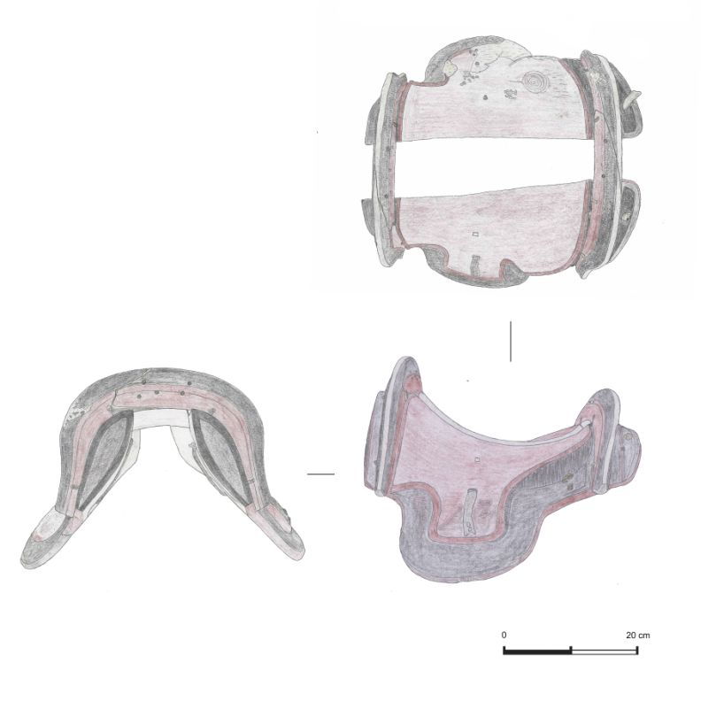

Figure S1. Detailed sketch of Urd Ulaan Uneet saddle, showing wooden nails joining halves of pommel and cantle.

Detailed methods
Radiocarbon dating
Previously unpublished radiocarbon dating of a human tooth from the burial of Urd Ulaan Uneet at the Laboratory of the Institute of Accelerator Analysis in Japan suggested that the burial and its contents, including the saddle, date to c. 1737±20 BP, or between c. cal AD 247–402 (at 95.4% confidence). Quality control measures suggest good collagen preservation associated with this date (Table S1), but recent studies have raised concerns over reservoir effects on radiocarbon dates from human bones in the region (Svyatko et al. 2022). To date the saddle directly, we also sampled a portion of animal-hide strap material. Sample cleaning, carbon extraction and graphite preparation from this specimen were carried out at the Accelerator Mass Spectrometry Laboratory at the University of Arizona before analysing 14C values at the University of Georgia Center for Applied Isotope Studies. The strap was dated to 1646±22 BP, or cal AD 267–535 (at 95.4% confidence). Because this date derives from horse material, we retain high confidence in its accuracy in dating the saddle’s construction, implying a reservoir offset of just over a century from the human remains (Figure 10). All radiocarbon dates were calibrated using the INTCAL20 calibration curve (Reimer et al. 2020).

ZooMS analysis of leather components
On the same sample, we performed collagen peptide mass fingerprinting, also known as Zooarchaeology by Mass Spectrometry (ZooMS) (Buckley et al. 2009) to identify the taxonomic origin of the leather components of the saddle. We extracted collagen protein from approximately 10mg of leather following the acid insoluble protocol described in Brown et al. (2020). Samples were analysed using a Bruker Ultraflex MALDI-TOF/TOF mass spectrometer at the Harvard Center for Mass Spectrometry. Spectra were visually inspected using mMass (Strohalm et al. 2008). Markers were compared to published marker lists (Buckley et al. 2017). Eight collagen marker peptides were successfully identified, allowing a confident identification of the leather as Equus (Figure 9, Table S2).

DNA analysis
To assess the species and sex of the horse interred along with the Urd Ulaan Uneet saddle, DNA extractions were carried out at the ancient DNA research facilities of the Centre for Anthropobiology and Genomics of Toulouse, France (CAGT, Université Paul Sabatier). We extracted DNA from 190mg of bone powder following the methodology presented by Librado and colleagues (2021). DNA extracts were treated with the USER enzyme mix (NEB) to limit the impact of post-mortem DNA damage in sequence analyses. Triple-indexed DNA libraries were then constructed, amplified, bead purified and quantified on a TapeStation 4200 instrument (Agilent technologies) before shallow sequencing on the Illumina Miniseq instrument (Paired-End mode, 81x2). Sequencing reads were demultiplexed based on their internal adapter indexes using AdapterRemoval2 (-minadapteroverlap 3 –mm 5 –barcode-mm-r[12]; Schubert et al. 2016) and provided to PALEOMIX v1.2.13.2 (Schubert et al. 2014) for alignment against the EquCab2 nuclear reference genome (Wade et al. 2009) and the horse mitochondrial reference genome (Accession nb=NC_001640; Xu & Arnason 1994). The resulting read alignment files were then processed with the Zonkey package (Schubert et al. 2017), disregarding PCR duplicates, low-quality alignments (mapping quality < 25) and reads shorter than 25 nucleotides.
We successfully extracted ancient DNA from the sample, recovering 301,925 nuclear and 347 mitochondrial sequences from a total of 2,683,260 demultiplexed reads (including 2,026,340 collapsed, 816 collapsed truncated and 328,052 uncollapsed read pairs). This provides sufficient data for identifying the sex and species and/or first-generation hybrid status of the specimen with maximal sensitivity and specificity (Schubert et al. 2017; Fages et al. 2020). Results indicate that the equid recovered in the Urd Ulaan Uneet cave burial is indeed the domestic E. caballus (Table S3), rather than a domestic donkey, wild equid, or a hybrid, and that this individual was male (OSM Appendix 1).

References
Brown, S., S. Hebestreit, N. Wang, N. Boivin, K. Douka & K.K. Richter. 2020. Zooarchaeology by Mass Spectrometry (ZooMS) for bone material – Acid insoluble protocol v1. protocols.io. Available at: https://doi.org/10.17504/protocols.io.bf43jqyn (accessedJanuary 2022)
Buckley, M., M. Collins, J. Thomas-Oates & J.C. Wilson. 2009. Species identification by analysis of bone collagen using matrix-assisted laser desorption/ionisation time-of-flight mass spectrometry. Rapid Communications in Mass Spectrometry 23: 3843–54. https://doi.org/10.1002/rcm.4316
Buckley, M., V.L. Harvey & A.T. Chamberlain. 2017. Species identification and decay assessment of Late Pleistocene fragmentary vertebrate remains from Pin Hole Cave (Creswell Crags, UK) using collagen fingerprinting. Boreas 46: 402–11. https://doi.org/10.1111/bor.12225
Fages, A., A. Seguin-Orlando, M. Germonpré & L. Orlando. 2020. Horse males became over-represented in archaeological assemblages during the Bronze Age. Journal of Archaeological Science: Reports 31: 102364. https://doi.org/10.1016/j.jasrep.2020.102364
Librado, P. et al. 2021. The origins and spread of domestic horses from the Western Eurasian steppes. Nature 598: 634–40.
Reimer, P.J. et al. 2020. The IntCal20 northern hemisphere radiocarbon age calibration curve (0–55 cal kBP). Radiocarbon 62: 725–57. https://doi.org/10.1017/RDC.2020.41
Schubert, M. et al. 2014. Characterization of ancient and modern genomes by SNP detection and phylogenomic and metagenomic analysis using PALEOMIX. Nature Protocols 9: 1056–82. https://doi.org/10.1038/nprot.2014.063
Schubert, M., S. Lindgreen & L. Orlando. 2016. AdapterRemoval v2: rapid adapter trimming, identification, and read merging. BMC Research Notes 9: 88. https://doi.org/10.1186/s13104-016-1900-2
Schubert, M. et al. 2017. Zonkey: A simple, accurate and sensitive pipeline to genetically identify equine F1-hybrids in archaeological assemblages. Journal of Archaeological Science 78: 147–57. https://doi.org/10.1016/j.jas.2016.12.005
Strohalm, M., M. Hassman, B. Kosata & M. Kodícek. 2008. mMass data miner: an open source alternative for mass spectrometric data analysis. Rapid Communications in Mass Spectrometry 22: 905–8. https://doi.org/10.1002/rcm.3444
Svyatko, S.V. et al. 2022. Freshwater reservoir effects in archaeological contexts of Siberia and the Eurasian Steppe. Radiocarbon 64: 377–88. https://doi.org/10.1017/RDC.2022.21
Wade, C.M. et al. 2009. Genome sequence, comparative analysis, and population genetics of the domestic horse. Science 326: 865–67.
Xu, X. & U. Arnason. 1994. The complete mitochondrial DNA sequence of the horse, Equus caballus: extensive heteroplasmy of the control region. Gene 148: 357–62.

Table S1. Radiocarbon date information for new early saddles and stirrups presented in this paper.
Site | Equipment | Material | Laboratory number | %C | C:N ratio | Radiocarbon age |  | Calibrated range (1 sigma) | Calibrated range (2 sigma) | Median date
Khukh Nuur | Single stirrup | Human bone | COL3892.1.1 | --- | --- |  | 1739 ± 37 | Cal AD 251–375 | Cal AD 243–405 | Cal AD 323
Urd Ulaan Uneet | Saddle with likely stirrups | Human tooth | IAAA-170205 | 42.7 | 3.2 |  | 1737 ± 20 | Cal AD 245–363 | Cal AD 247–402 | Cal AD 326
Urd Ulaan Uneet | Saddle with likely stirrups | Horse skin/leather | AA115726 (UGA57326) | 74.1 | 3.6 |  | 1646 ± 22 | Cal AD 384–529 | Cal AD 267–535 | Cal AD 420

Table S2. Collagen marker m/z identified from leather components of the Urd Ulaan Uneet saddle

ɑ-helix | COL1ɑ1 | COL1ɑ2 | COL1ɑ2 | COL1ɑ2 | COL1ɑ2 | COL1ɑ2 | COL1ɑ2 | COL1ɑ1 | COL1ɑ2
Position | 508–519 | 978–990 | 484–498 | 502–519 | 292–309 | 793–816 | 454–483 | 586–618 | 757–789
Marker | P1 | A | B | C | P2 | D | E | F | G
Equus sp. | 1105.6 | 1182.6/  1198.6 | 1427.7 | 1550.8 | 1649.8 | 2145.1 | 2820.4 | 2883.4/  2899.4 | 2983.4/  2999.4
Saddle | 1105.6 | 1182.6 | 1427.7 | 1550.8 | - | 2145.1 | 2820.4 | 2883.4 | 2983.5/  2999.5*
*mass shift due to oxidation

Table S3. Genetic identification of species and sex of Equus specimen from Urd Ulaan Uneet cave.

Specimen | Endogenous DNA content | Mitochondrial fold-coverage | Total number of reads sequenced | Reads uniquely mapping to nuclear reference | Reads uniquely mapping to mitochondrial reference | Species | Sex
Mon2017x150 | 11.26% | 1.41 | 2 683 260 | 301 925 | 347 | Horse (Equus caballus) | ♂

See also OSM Appendix I for Zonkey pipeline DNA results for Urd Ulaan Uneet horse.

