[Supplementary material]
Sources of early Islamic silver: lead isotope analysis of dirhams
Stephen W. Merkel^{1,2}, Jani Oravisjärvi^{1,3} & Jane Kershaw^{1,*}
¹ School of Archaeology, University of Oxford, UK
² Faculty of Science, Vrije Universiteit Amsterdam, The Netherlands
³ Department of Archaeology, University of Oulu, Finland
* Author for correspondence ✉ jane.kershaw@arch.ox.ac.uk
Received: 21 September 2022; Revised: 24 January 2023; Accepted: 22 February 2023

OSM 1 Materials and methods
The total dataset includes lead isotope data relating to 143 coins and elemental data relating to 142 (Tables S1–S4).

The dirhams analysed in this study were selected to encompass the four major geographical regions of the Caliphate (North Africa, Iraq, Iran and Central Asia) during the period AD 700–900, with particular emphasis on the most prolific mints during the periods of high output. We rely on global and relative numbers based on databases of documented dirham hoards as a proxy for mint output: though there may be inherent biases in this approach, this is the only available method that can be applied to dirhams from this period. Priority was given to the chief mints: Wasit and Damascus in the Umayyad period, and Baghdad and Tehran in the Abbasid period. Using the data from Gert Rispling’s dirham database, Wasit was the primary Umayyad dirham mint, making up two-thirds of Umayyad dirhams of identifiable mint, and 88 per cent of dirhams struck after AD 722 (104 AH). Dirhams struck at mints in Baghdad and Tehran comprise 56 per cent of known Abbasid dirhams (Noonan 1986). The peak of early Abbasid dirham production occurred in the last quarter of the eighth century to the first decade of the ninth century AD, and we mirror this concentration in our dataset.

The majority of the sampled dirhams were whole and all could be identified by mint, dynasty and date of issue (in some instances, to a defined window of time, rather than a specific year). These important identifying traits had already been identified by curators and were independently reviewed by Jani Oravisjärvi. In most cases, the second identification confirmed earlier ones, occasionally adding further detail. In the case of coins sampled in a previous study (Bychkov 2011), some previous identifications were overturned.

The analyses of 111 dirhams sampled for this study stem from three separate collections (Tables S1–S4). In most cases, the archaeological context of the original find circumstances is unfortunately unknown. Where documentation is more complete, the dirhams can be shown to derive from silver hoards deposited in Scandinavia in the ninth century: this is likely to be the case with most of the dirhams bereft of archaeological context, since they all stem from European museum collections. The dataset also includes a small number of dirhams metal-detected from the Viking-Age town of Hedeby (Schleswig, modern-day Germany) and from the winter camp of Torksey, Lincolnshire, England, occupied by the Viking Great Army in AD 872/3. The latter are fragmentary, but sufficient information survives for their dynasty, mint and date to be established.

Permission to sample was granted by Adi Popescu (Fitzwilliam Museum, University of Cambridge), Luke Treadwell (Faculty of Oriental Studies, University of Oxford) and Frida Ehrnsten (Coin Chamber, National Museum of Finland, Helsinki).

Fitzwilliam Museum, University of Cambridge
24 dirhams were analysed by nanosecond laser ablation multicollector inductively coupled plasma mass spectrometry (nsLA-MC-ICPMS).

Faculty of Oriental Studies, University of Oxford
58 dirhams were sampled (i.e. <30mg of material was taken from the coin edges).

Coin Chamber, National Museum of Finland, Helsinki
29 Abbasid dirhams were sampled (i.e. <30mg of material was taken from the coin edges).

Methods

University of Oxford
Elemental analysis (School of Geography)
Samples of 87 dirhams were taken for solution-based quadrupole ICP(Q)MS. All samples were cleaned of corrosion by abrasion and were analysed by portable X-ray fluorescence (Thermo Scientific Niton™ XL3T Analyzer) prior to sample dissolution. The elemental concentrations of a 26-dirham subset and the analytical methods have been published (Merkel 2021).

Lead isotope analysis (Department of Earth Sciences)
Solutions were prepared in the clean suite laboratory, and the analytical methods have been published (Standish et al. 2021). All Pb isotopic data have been normalised using the bracketing standard measurements to ²⁰⁸Pb/²⁰⁶Pb = 2.16701, ²⁰⁷Pb/²⁰⁶Pb = 0.91459, and ²⁰⁶Pb/²⁰⁴Pb = 16.9356 for NIST981. The average non-normalised values of NIST981 and normalised values of NIST SRM982 on the measurement days are listed in Table S12. The long-term variability of NIST981 over 1.5 years, expressed as 2SD, are 0.004 for ²⁰⁶Pb/²⁰⁴Pb, 0.005 for ²⁰⁷Pb/²⁰⁴Pb, 0.018 for ²⁰⁸Pb/²⁰⁴Pb, 0.0001 for ²⁰⁷Pb/²⁰⁶Pb and 0.0003 for ²⁰⁸Pb/²⁰⁶Pb.

University of Southampton
Lead isotope and Au, Pb and Bi concentration analyses
A total of 24 dirhams were analysed to capture, simultaneously, lead isotope ratios and Au, Pb and Bi concentrations by in situ nanosecond laser ablation (nsLA)-MC-ICPMS. Eight of these were published in a pilot study using this method (Standish et al. 2021).

Additional dirham lead isotope datasets
We merged this new data with 32 previous lead isotope analyses of dirhams.

The first lead isotope analysis of an early Islamic silver dirham used thermal ionisation mass spectrometry (TIMS) (Brill & Shields 1972). The analytical errors are described as ²⁰⁶Pb/²⁰⁴Pb = 0.6%, ²⁰⁸Pb/²⁰⁷Pb = 0.4% and ²⁰⁶Pb/²⁰⁷Pb = 0.3% (Brill & Wampler 1967).

Ten analyses of Abbasid-period dirhams were published in 2008 (Sarah 2008). Elemental concentrations were measured by LA-ICPQMS. The analytical uncertainties for elemental characterisation are described as < 5% in most cases and < 10% in all cases for the seven main and minor elements found in silver (Ag, Cu, Zn, Sn, Au, Pb and Bi) (Sarah et al. 2007). Lead isotope ratios were measured with TIMS at the BRGM using physical samples (protocols, see Pomiès et al. 1998). The reported errors based on repeat analyses of samples and standards are 0.12% for ²⁰⁶Pb/²⁰⁴Pb, 0.16% for ²⁰⁷Pb/²⁰⁴Pb and 0.22% for ²⁰⁸Pb/²⁰⁴Pb.

Twelve analyses of Abbasid-era dirhams were published in 2016 by one of the present authors (SM) (Merkel 2016). Lead isotope ratios were measured by in situ femtosecond (fs)LA-MC-ICPMS. Variation during measurement is usually < 0.1% (2RSD) for ²⁰⁴Pb normalised ratios and < 0.05% for non-²⁰⁴Pb ratios. Elemental concentrations were measured by in situ nsLA-ICPQMS and uncertainties, given as 95% confidence intervals, were between 5–10% relative to the measured value for most elements.

The final set of nine analyses were provided by Natasha Eniosova as part of a study carried out at Lomonosov State University, Moscow (Bychkov 2011). Micro-samples were taken and analysed by ICPMS (Thermo Scientific™ Element). The results were normalised to 100 wt. %. For lead isotope analysis, 5mg samples were digested and the matrix was separated using anion exchange chromatography (Bio-Rad AG-1X8 resin) with dilute HBr and HCl. Analysis was undertaken by MC-ICPMS (Thermo Scientific™ Neptune) at the Institute of Geology of Ore Deposits, Petrography, Mineralogy, and Geochemistry Russian Academy of Sciences (for methods, see below). Thallium was used to correct for mass fractionation (²⁰⁵Tl/²⁰³Tl = 2.3889±1) and long-term variability of NIST SRM981 over a three-year period are <0.02% (2SD) for ²⁰⁶Pb/²⁰⁴Pb, ²⁰⁷Pb/²⁰⁴Pb and ²⁰⁸Pb/²⁰⁴Pb. The reported NIST981 values are ²⁰⁸Pb/²⁰⁶Pb = 2.1677, ²⁰⁷Pb/²⁰⁶Pb = 0.91489, and ²⁰⁶Pb/²⁰⁴Pb = 16.9412.

Theoretical basis for provenance studies of silver
The use of geochemical signatures to characterise and provenance silver have been ongoing since the 1970s. Such efforts have relied largely on lead isotope analysis, a technique that measures the relationships between the radiogenic isotopes and the non-radiogenic isotope of lead, revealing detailed information about geologic age and ore genesis (Stos-Gale 1993; Stos-Gale & Gale 2009). Lead occurs naturally in silver ore and contains geochemical source-related information in its isotope ratios. The lead isotope ratios of end-products (e.g. silver coins) can be directly compared to those of ores, allowing potential sources to be identified.

For silver, it is possible that the lead isotope ratios directly relate to the source of metal. However, two anthropogenic processes can alter the lead isotope characteristics of silver, compromising the use of lead isotope analysis in provenance studies: mixing and cupellation.

- Mixing: mixing, through the recycling and melting down of metal from two or more sources, results in the homogenization of lead isotope ratios. In lead isotope diagrams, the isotopes of items produced from two mixed sources will plot along ‘mixing lines’ between the two sources (end-members) (Pernicka 2014). The mixing of three or more sources will produce a polygon region; items produced from this silver must lie in the volume of isotope space between the end-members, their precise position reflecting the relative contribution of each source.

Mixing also effects the calculated model ages (T) and U/Pb (µ) and Th/Pb (κ) ratios (Albarède et al. 2012). It has been noted that ore formation processes tend to produce isochron lines that relate T, µ and κ. An archaeological silver stock that matches the isochron defining a specific ore deposit could originate from that ore, but if the metal stock trends crosses several isochrons, it is more likely that mixing of ore sources occurred (Eshel et al. 2019). Therefore, the alignments of T, µ and κ, in comparison to know ore source alignments are important factors in identifying potential sources and mixing of metal stocks.

- Cupellation: cupellation is a process of refining impure silver. It involves the heating of silver with additional lead so that the lead reacts with oxygen to form a litharge. The litharge remains separate from the noble metal and can be drained or skimmed off to leave behind purified silver. Since the lead added to the silver to aid this process is far greater in quantity than that which occurs naturally within silver, the lead isotope ratios of the refined silver will reflect the source of the added lead, rather than that of the silver. This is especially detrimental to questions of provenance if the added lead and silver originate from different mining areas.

An additional limitation to the use of lead isotopes to provenance silver is ore overlap. Lead isotope ratios reflect geochemical and age-related factors of ore genesis, which are seldom unique to individual deposits. Commonly, several deposits share similar lead isotope characteristics, which means the deposits formed at similar ages and geological conditions. This often limits the resolution and interpretation of lead isotope data, especially in regions with widespread reoccurring geochemical characteristics, such as the Aegean (Killick et al. 2020).

However, in the case of early Islamic dirhams, these limitations are mitigated by several factors. The large size and wide geographical scope of the sampled material diminishes the risk of ore overlap, since the study area crosscuts a diverse range of geological units that formed under various conditions at different times (radiogenic future model ages to the Precambrian) and thus produces diverse lead isotope ratios with limited overlap between regions. Moreover, we find evidence suggesting a lack of both routine recycling of silver coinage and systematic cupellation at the mints over much of the study period, as described in the main text. In addition, concentration data relating to minor elements in the silver that stem from the original ore and are minimally affected or unaffected by cupellation convey additional source-related information. Gold is unaffected by cupellation, while bismuth remains in the silver until the final stages of cupellation (McKerrell & Stevenson 1972; Pernicka & Bachmann 1983; L’Héritier et al. 2015). The relative concentrations of these elements vary between regionally and temporally confined silver stocks, helping to further discriminate between potential sources.

Our dirham data can show correspondence between these source-indicator elements (gold and bismuth) and lead isotope characteristics, which are also dependent on geographical and chronological factors. These features point to a dynamic silver supply composed of discrete sources and reveal that mints were typically supplied with silver from a limited number of sources.

OSM 2 Interpretation of results

Interpretation of lead isotope results
Datasets were evaluated using both ²⁰⁴Pb and ²⁰⁶Pb normalised ratios. The geological history and setting of the ore are further useful parameters for distinguishing geological provinces. Alongside initial lead isotope (LI) values, we therefore also considered U and Th concentrations (expressed as ²³⁸U/²⁰⁴Pb (μ), ²³²Th/²³⁸U (κ)) and the model age (T) of lead in the silver (Albarède et al. 2012). The data were compared against ratios derived from regional ores and archaeological artefacts. Large collections of analyses have been combined into databases (e.g. Killick et al. 2020; OXALID database: Sasanian) we specifically considered data from Spain, North Africa, the Mediterranean, the Arabian Peninsula, the Near and Middle East, the Caucasus and Central Asia. Emphasis was given to sources with archaeological or historical evidence of use in the medieval or earlier periods, and ore and slag from lead-bearing polymetallic deposits known to contain significant quantities of silver were prioritised. We make the assumption that mints would have had a preference to use the nearest sources of metal and that these should first be excluded before considering more distant sources and sources in territories controlled by other political entities. The data are interpreted within their historical context and interpretations are made using abductive reasoning, starting with a set of observations and then seeking to find the simplest or most likely explanation, often through a process of elimination. Only lead isotope data obtained by MC-ICPMS and TIMS were used for comparison and, due to differences in methodology and analytical sensitivity, a range of tolerability of +/- 0.1% for ²⁰⁴Pb normalised ratios was given.

The following data sources, grouped by region, provided critical reference data:

Central Asian ore
Ore (tetrahedrite and secondary minerals) from the Laskherek mine (Merkel 2016)
Ore data from Middle Tien Shan west of Talas-Farghona fault (MTS-W) (Chiaradia et al., 2006)
Galena (with common lead) Chatkal-Kurama district (Chernyshev et al. 2017)

Arabian ore and slag
Ore and slag from Pb-Zn-Ag mine of Jabali (Merkel et al. 2016)
Ore (galena) Arabian Shield (Stacy et al. 1980)
Ore from Pb-Zn-Ag mine of Jabali (al-Ganad 1991)

Iranian ore, litharge, slag and Sasanian metalwork
Sasanian silver plate, only ‘good’ quality and better (OXALID)
Ore data Urumieh-Dokhtar and Sanadaj-Sirjan Zones in Iran (Mirnejad et al. 2011)
Ore data Alborz and Central Iran (Mirnejad et al. 2015)
Ore data Iran, various (Molasalehi & Mirnejad 2010)
Lead ore and slag Nakhlak (Pernicka et al. 2011)
Ore and slag Iran, various (Stos-Gale 2004)

North African ore and slag
Ore, Pb-Zn, Nappes zone Tunisia (Jemmali & Souissi 2018)
Ore, Ag-Hg deposit Zgounder, Anti-Atlas Morocco (Marcoux & Wadjinny 2005).
Ore, galena and secondary minerals, Morocco (Duthou et al. 1976)
Ore, Cu-Pb-Zn veins, Bouskour, Anti-Atlas, Morocco (Bouadbellah et al. 2016)
Ore, galena, Ag-Hg deposit Imiter, Anti-Atlas Morocco (Pasava 1994)
Ore and slag, Ag-Hg deposit Imiter, Anti-Atlas Morocco (Milot et al. 2018)
Ore and slag, Morocco, various (Baron et al. 2020)
Ore, polymetallic, Tighza Central Morocco (Tarrieu 2014)

Taurus ore, litharge and metalwork
Ore and slag, Taurus Mountains (Seeliger et al. 1985)
Metal artefacts, Turkey, Syria, Iraq (Sayre et al. 1992)
Ore and metal artefacts, Turkey (Yener et al. 1991)
Ore and litharge, Northern Syria (Pernicka et al. 1998)

Use of elemental legacy data
The first multi-element characterisation of Early Islamic dirhams was undertaken in the late nineteenth century (Fiala 1895). Since then, hundreds of dirhams have been subject to elemental analysis, using numerous analytical techniques with varying levels of quality and resolution. The primary motives for analysis have been to explore the use of dirhams as a raw material for western European coinage (McKerrell & Stevenson 1972; Ilisch et al. 2003; Sarah 2008; Merkel 2016) to determine silver fineness with an aim to reconstructing economic policy (Caley 1957; Gordus 1972; al-Saa’d 1999; Ilisch et al. 2003) and to identify patterns that relate to technological processes, metal stocks and/or ore sources (Brill & Shields 1972; Gordus 1972; Stos-Fertner 1975; Gondonneau & Guerra 2002; Ilisch et al. 2003; Bychkov 2011; Murillo-Barroso et al. 2012; Merkel 2021; Standish et al. 2021). These datasets have been important in developing the research trajectory of the Late Antique and Early Islamic economy and form a rich resource for the present study.

The large datasets obtained through dirham studies carried out over the last half century (particularly Caley 1957; Gordus 1972; Stos-Fertner 1975; Roux & Guerra 1998; Savage & Gordus 1998; al-Saa’d 1999; Gondonneau & Guerra 2002; Ilisch et al. 2003; Murillo-Barroso et al. 2012) were frequently consulted and were instrumental in the sample selection process, identifying temporal and regional patterns and influencing the interpretation of the analytical results.

Nonetheless, the diverse range of instrumentation, methodology and levels of awareness of analytical shortfalls can limit the direct comparability of many of these legacy data with the data presented in this study. For this reason, we have divided legacy datasets into three categories, according to the usability of the data: 1: quantitative, 2: qualitative, and 3: incompatible/unreliable.

1: Quantitative/thorough studies
Weight was given to studies using well-tested methods with published numerical values that are expected to be reliable and comparable. These data include minimally destructive LA-ICPMS (Sarah 2008) and studies where silver objects were destructively sampled for measurement by atomic absorption spectrometry (Caley 1957; McKerrell & Stevenson 1972; Murillo-Barroso 2012). They also include studies in which the analysts made efforts to counteract methodological shortfalls by abrasively polishing the area of analysis (al-Saa’d 1999) or micro-drilling (Harper & Meyers 1981). Photon activation analysis has the advantage of penetrating 300µm deep into the metal and can circumvent problems affecting other surface methods, and this method was applied to the study of pre-Islamic and Islamic silver coinage (Roux & Guerra 1998; Gondonneau & Guerra 2002).

2: Qualitative/descriptive studies
One of the most important issues is the incongruity of superficial surface compositions and the bulk metal. Numerous studies have shown that concentration of elements at the surface of silver objects can be impacted by enrichment and depletion processes to an uncertain degree (Condamin & Picon 1964; Meyers 1993; Beck et al. 2004; Merkel 2019). Two of the most sensitive elements in this regard are copper and gold, but mercury is also problematic for Islamic coinage. Copper is often depleted from the surface and gold often enriched. The concentrations of other elements can also have a degree of unpredictability, some uncertainty arising from enrichment/depletion process, superficial contamination and/or analytical interference. The problems are particularly relevant for widely used non-destructive surface-based analytical techniques, such as energy and wavelength dispersive X-ray fluorescence (XRF). Even the measurement of reference materials cannot ensure the reliability of non-destructive surface analyses because the reference materials were not subject to the same burial and treatment conditions as archaeological metals. Furthermore, archaeological metals are not all impacted to the same degree. For these reasons, non-destructive analyses of unprepared silver surfaces were used as a qualitative comparison (Stos-Fertner 1975; al-Kofahi et al. 1997; Ilisch et al. 2003). These problems can also apply to neutron activation analysis (NAA) performed on coin streaks if the surface is not first prepared by abrasive cleaning (Gordus 1972; Harper & Meyers 1981; Savage & Gordus 1998). In the case of NAA, these differences between the surface and the bulk are visible, though often minor.

3: Incompatible and/or unreliable studies
A recently published study of Umayyad dirhams using particle-induced X-ray emission (PIXE) (Jozi et al. 2019) is problematic because the reliability of the method was not demonstrated, and the results are highly inconsistent with the research of others using established methods. The results are thus judged to be unusable in a wider context.

Inter-laboratory compatibility
The data gathered in this study originate from different laboratories using differing analytical methodologies. While several studies were undertaken entirely independently, others can be directly compared through the analysis of common reference materials, which allow the evaluation of inter-laboratory comparability. Next to the universal lead isotope standards NIST981 and NIST982, a series of in-house and commercial reference materials were created and/or obtained (Tables S12–S17). Samples from two early medieval artefacts were used as secondary reference materials (RMAg3834 and RMAg12467) and have been characterised in four of the six laboratories used in this study. Additionally, these two secondary reference materials were independently characterised isotopically and elementally in a previous study (DBM-Bochum and Goethe-University Frankfurt-am-Main Department of Geoscience) (cat. nos. 180 and 187 in Merkel 2016).

Lead isotope analysis
All multi-collector ICPMS datasets used in this study are linked directly or indirectly to the lead isotope standard NIST981. The primary lead isotope standard for solution-based MC-ICPMS (Oxford/Moscow/Frankfurt-am-Main) is NIST981 and for the fsLA-MC-ICPMS analyses (Hanover), micro-homogenised silver doped with NIST981 was used (Chernyshev et al. 2007; Merkel 2016). The datasets from Frankfurt-am-Main, Oxford and Hanover are linked to common NIST981 values (Todt et al. 1996). The University of Southampton data are indirectly linked to the same values through calibration using RMAg3834 measurements in Frankfurt-am-Main and Hanover (Standish et al. 2021). In comparison, the reported NIST981 ²⁰⁴Pb-normalised ratios connected to the Moscow dataset (Bychkov 2011; Chernyshev et al. 2007) are heavier (c. 3%), so there is expected to be a slight offset towards higher ²⁰⁴Pb-normalised ratios, but the difference in the non-²⁰⁴Pb ratios is much smaller (-0.03%).

The best-characterised secondary reference materials are two archaeological silver fragments (RMAg3834 and RMAg12467) and allow isotopic results from three of the six laboratories to be directly compared (Figure S2). The analyses of these archaeological samples are identical (within analytical uncertainty) in each laboratory (Frankfurt-am-Main, sol. MC-ICPMS; Oxford, sol. MC-ICPMS; Hanover fsLA-MC-ICPMS; Southampton, nsLA-MC-ICPMS). Additionally, further reference materials were measured in both Southampton (nsLA-MC-ICPMS) and Oxford (sol. MC-ICPMS) and are all within their analytical uncertainty (2SD) (Figure S3). This confirms that the results from three laboratories used in this study are comparable.

The two datasets analysed by TIMS (Brill & Shields 1972; Sarah 2008) do not report the results of lead isotope standards, but the dirham results closely conform to the geochemical trends observed in the MC-ICPMS datasets. They are therefore deemed to be reliable within their reported analytical uncertainty.

Elemental analysis
The elemental datasets from four of the laboratories can be compared directly by using two archaeological silver samples used as secondary reference materials (RMAg12467 and RMAg3834). They were analysed with solution and surface-based laser ablation techniques. In addition to the analyses from four of the laboratories used in this dirham study, these reference materials were analysed independently at the DBM-Bochum by ICPMS (Merkel 2016). The results are highly consistent for most elements, despite major differences in the analytical methodology (Figure S4). Measurement uncertainty of the main source-related elements (Au and Bi) and the Bi/Pb ratio are better than 25% (2RSD). Variation of less than 20% (2RSD) can be assumed for the reproducibility of most elements in reference materials MBH 133x-AGA1 and AGA3 by comparing the results from Oxford (sol. ICPQMS) and Southampton (nsLA-MC-ICPMS) and the MBH given values (ICPOES) (Figure S5). Although the analyses from the Moscow laboratory cannot be directly compared with the other datasets through the analysis of joint reference materials, the dirham results are consistent with those analysed in other laboratories, within the variation describe above, and follow the same geographic and temporal trends.

Conclusions
Acknowledging the analytical uncertainties inherent to the methods used, all elemental and lead isotope datasets used in this study are concordant, and the geochemical patterns seen in the data crosscut laboratory and methodology. In four of the five laboratories contributing dirhams elemental concentration datasets, the inter-laboratory propagated uncertainty for the main source-related elements (Au and Bi and Bi/Pb) can be estimated to be ≤30% (2RSD). Where the comparability of lead isotope ratios could be directly compared through the analysis of joint reference materials, the results are shown to be reproducible within their range of long-term range precision. The chief systematic and methodologically related difference is the lower analytical precision of ²⁰⁴Pb-normalised ratios measured by TIMS and nsLA-MC-ICPMS compared to MC-ICPMS and fsLA-MC-ICPMS.

Figure S1. Number of dirhams (n) analysed by decade.
Orange = Umayyad; blue = Abbasid period (figure by the authors).
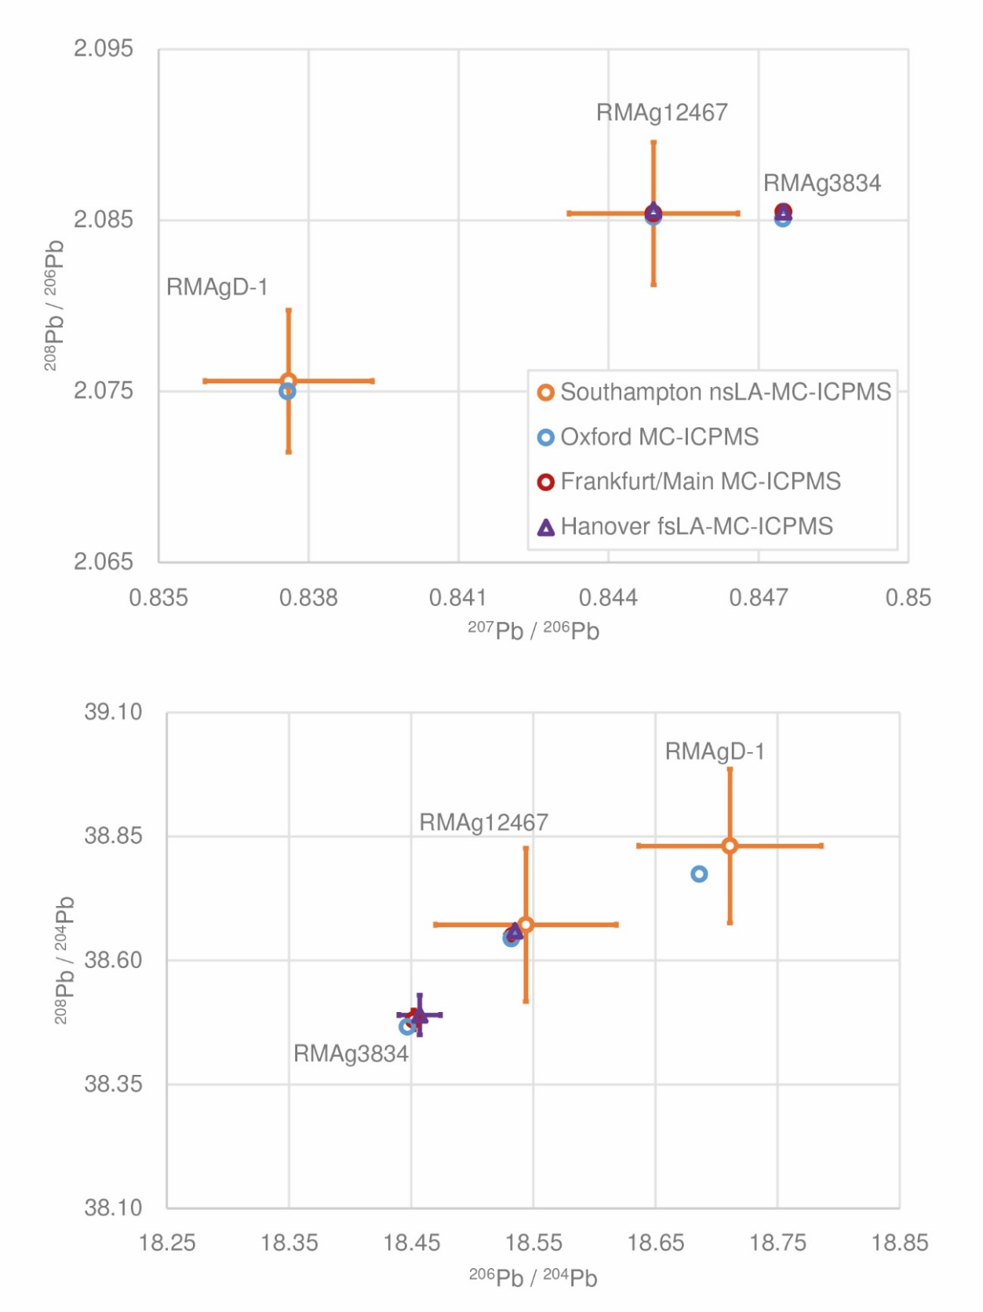
Figure S2. Comparison of three secondary silver reference materials in four laboratories using different methods.
The Oxford (this study and Standish et al. 2021) and Southampton values (Standish et al. 2021) are averages (uncertainties expressed as 2SD of repeat analyses), and the Hanover and Frankfurt-am-Main analyses (Merkel 2016) are single analyses (uncertainties expressed as 2SD of measurement cycles). The analytical uncertainty is smaller than the symbol unless otherwise shown (figure by the authors).
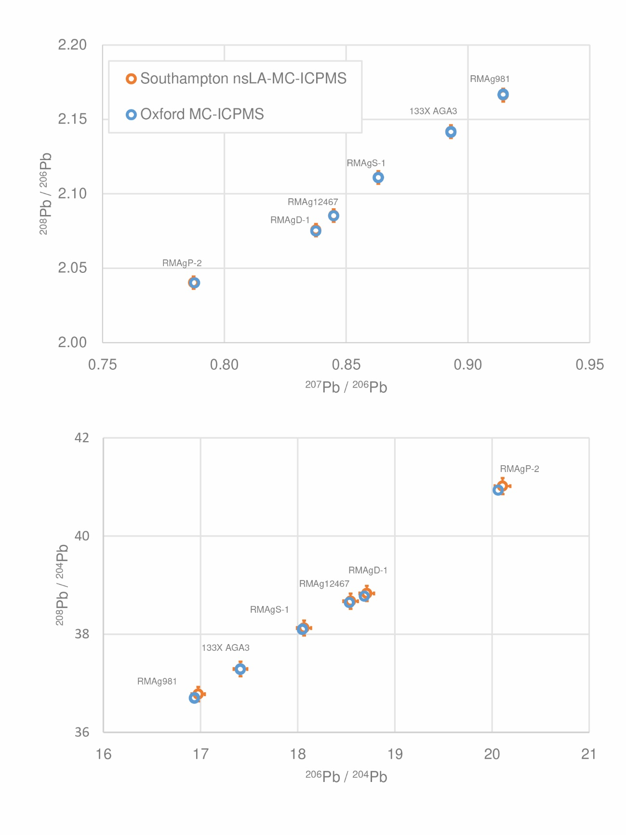
Figure S3. Comparison of lead isotope ratios from secondary silver reference materials measured in Oxford by MC-ICPMS and in Southampton by nsLA-MC-ICPMS (Standish et al. 2021).
The precisions are shown as 2SD of repeat measurements, which are in many cases smaller than the symbol. The laser ablation analyses are of lower resolution but are within analytical uncertainty (2SD) of the solution measurements (figure by the authors).
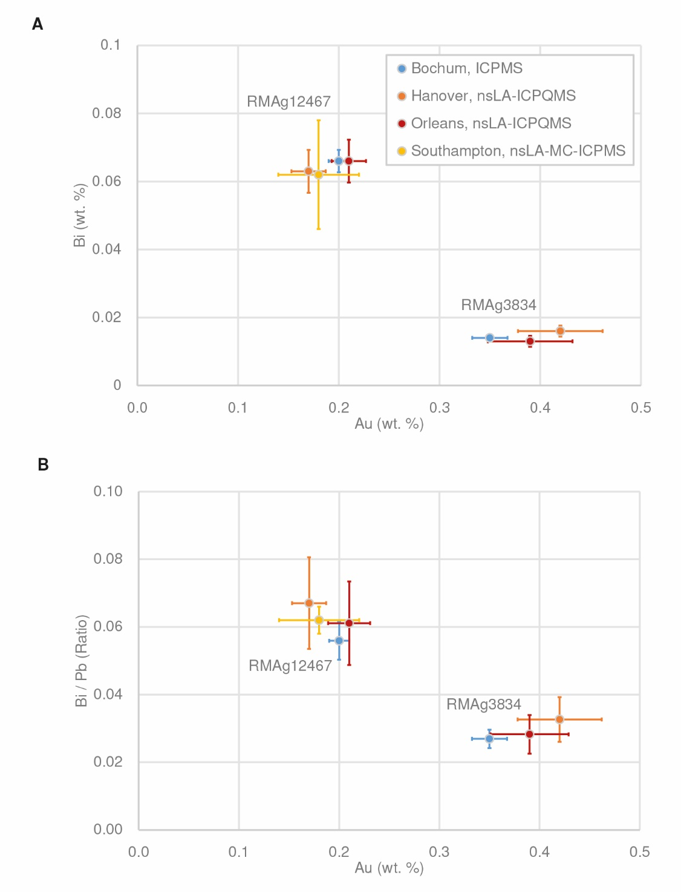
Figure S4. Comparison of secondary reference materials (archaeological silver samples) measured in four laboratories with different mass spectrometry techniques.
(A) Gold vs. bismuth and (B) gold vs. bismuth-to-lead ratio. RMAg3834 and RMAg12467 are Cat. 180 and 187 (Merkel 2016) and objects a and b (Merkel 2019), respectively. Uncertainty for solution ICPMS (Bochum) is estimated to be <5% and <10% for nsLA-ICPQMS (Hanover and Orleans), while for the Southampton analyses the uncertainty is represented as 2SD of replicate analyses (Standish et al. 2021) (figure by the authors).
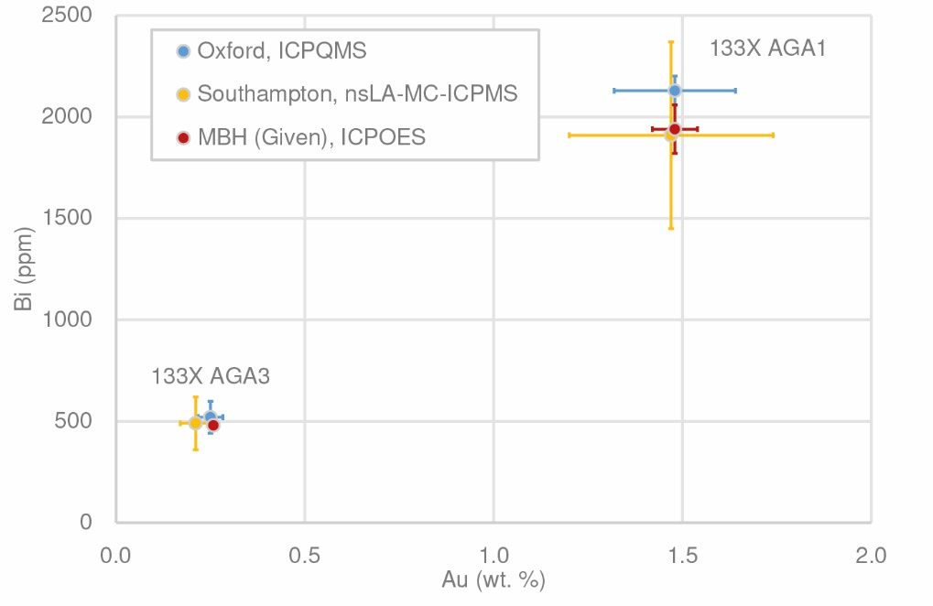
Figure S5. Comparison of commercial silver reference materials MBH 133X-AGA1 and AGA3.
Analyses by solution ICPQMS (Oxford) (this study) and by nsLA-MC-ICPMS (Southampton) (Standish et al. 2021) are given along with the concentrations determined by ICPOES (MBH Analytical Ltd.). Uncertainties are given as 2SD of three or more replicate analyses (figure by the authors).
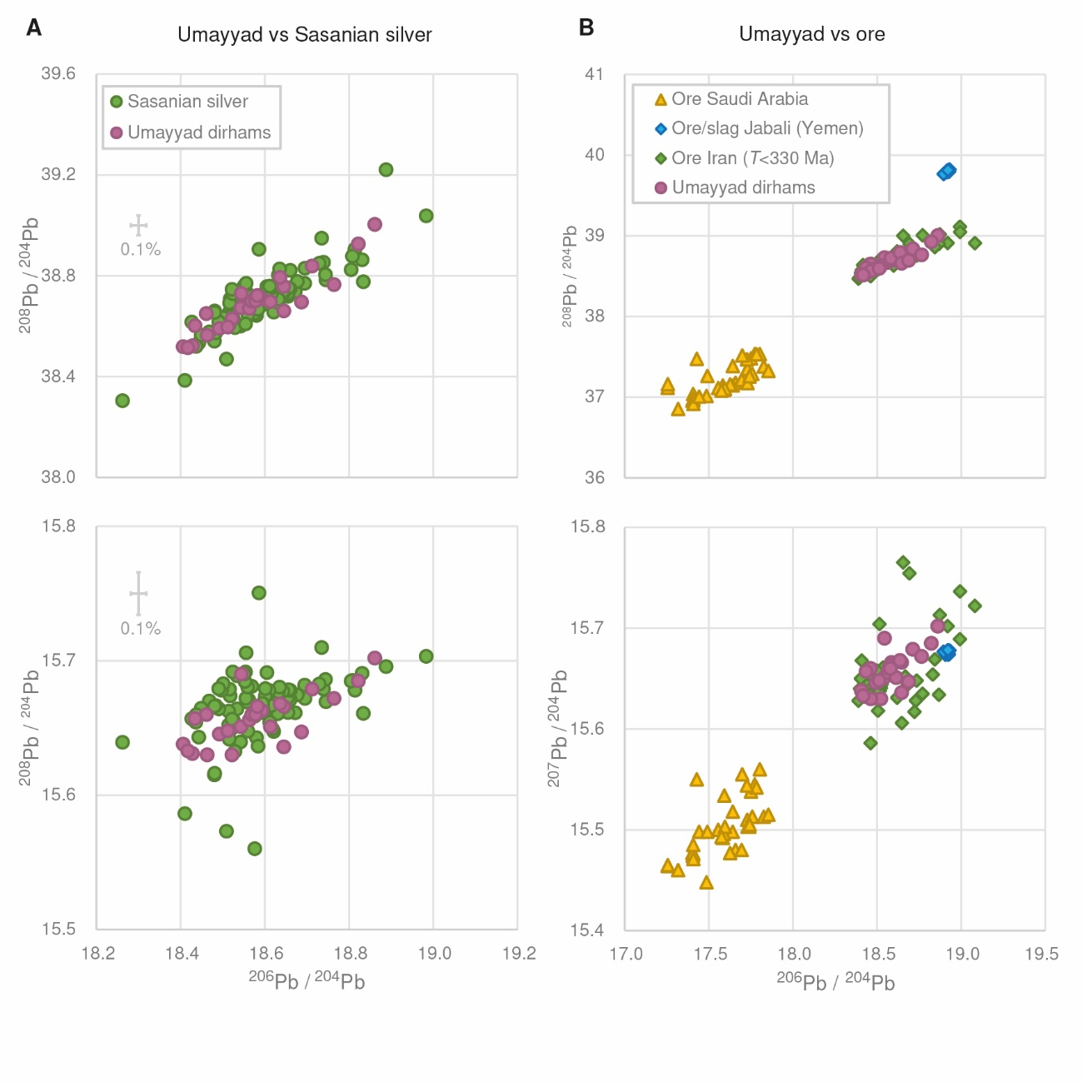
Figure S6. Umayyad dirham and reference lead isotope datasets normalised to ²⁰⁴Pb.
Supplementary data for Figure 4A. For reference, 0.1% is equal to or smaller than the symbol unless otherwise stated. For source data, see interpretation of results above (figure by the authors).
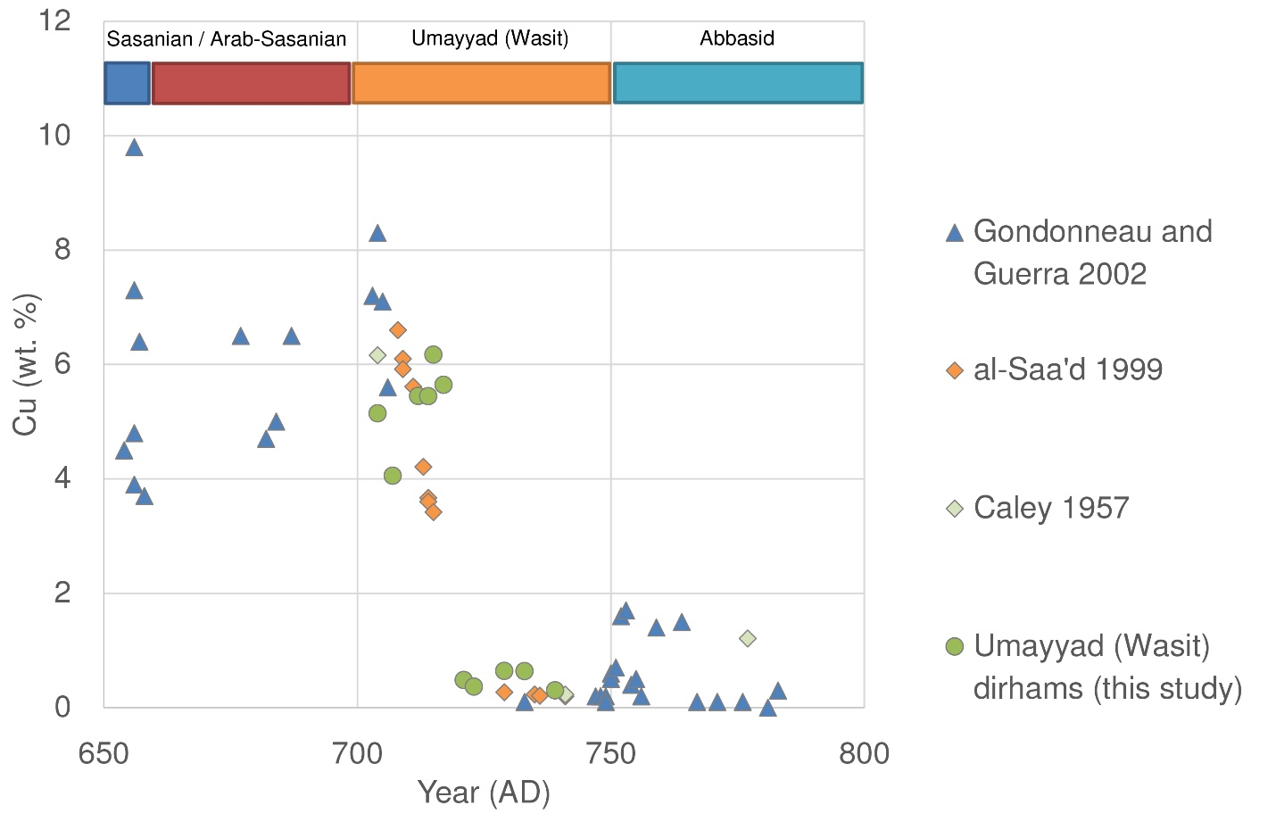
Figure S7. Scatterplot relating copper content of coins to the minting year.
The plot demonstrates the sudden drop in copper contents (= increase in fineness) in silver coins minted at Wasit during the Umayyad period and that the data from this study is consistent with previous studies (Caley 1957; al-Saa’d 1999; Gondonneau & Guerra 2002). This shift marks the change in silver standard from alloyed silver (roughly 6% copper) to fine, unalloyed silver around the year AD 722. Wasit was the dominant Umayyad mint, comprising 67% of Umayyad dirhams of known mint and 88% of dirhams minted after c. AD 722 (104 AH) (source: Gert Rispling’s dirham database) (figure by the authors).
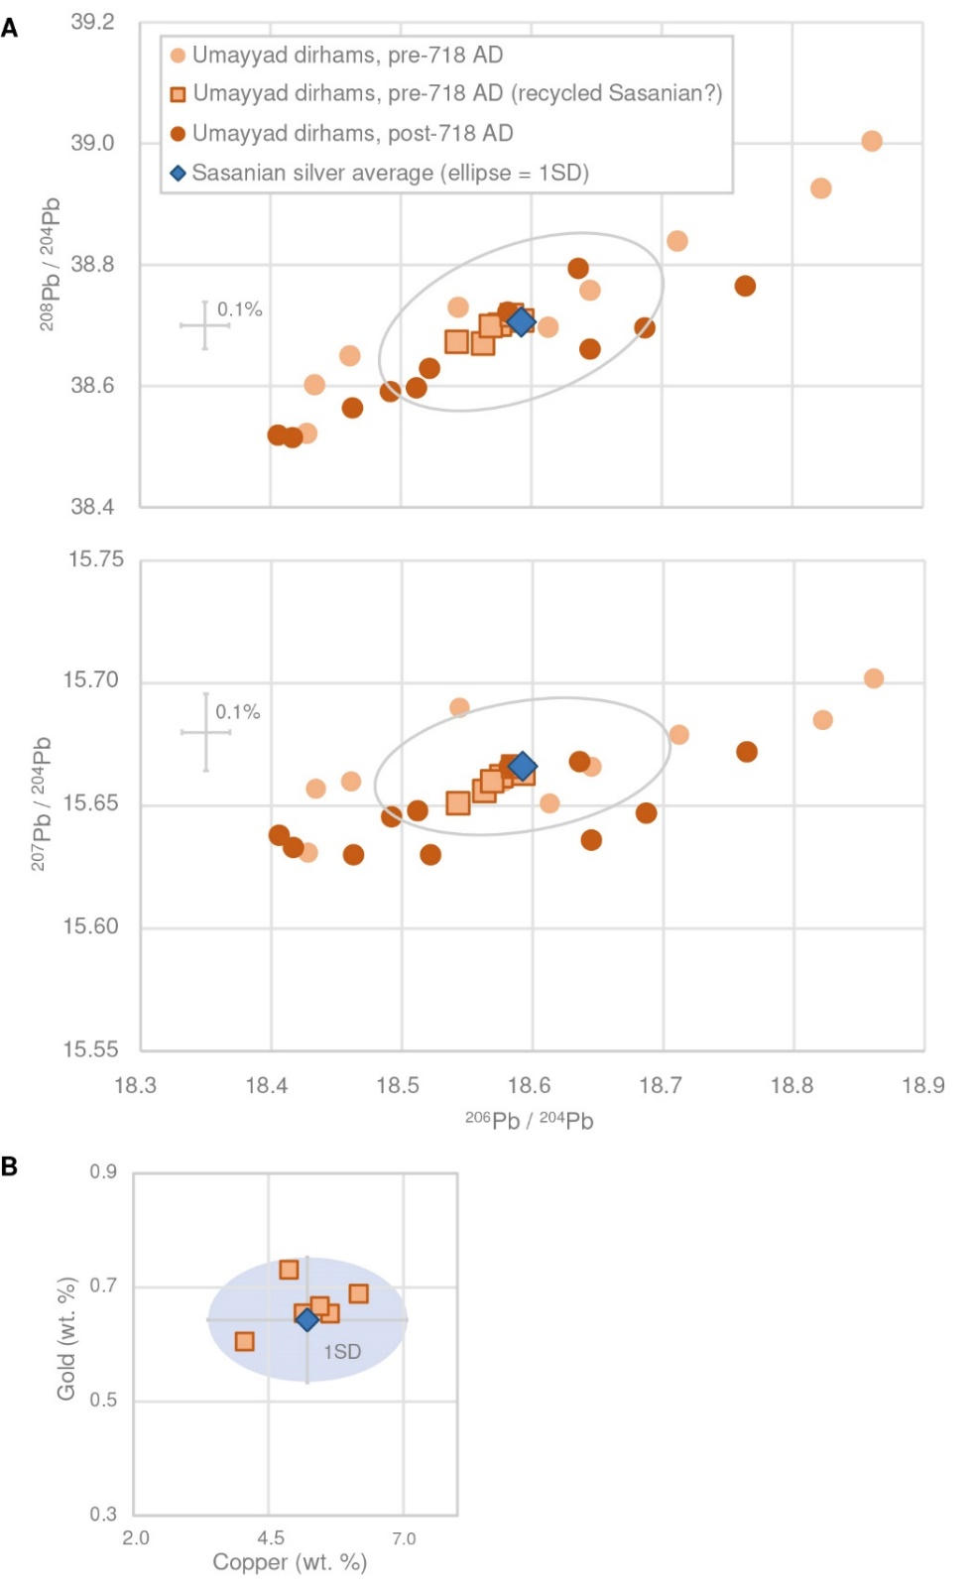
Figure S8. Lead isotope plots of Umayyad dirhams minted before and after AD 718, the year marking the transition to fine silver at the Wasit mint.
(A) The distribution of lead isotope ratios is constant over the Umayyad period. The average lead isotope ratios of Sasanian silver (Brill & Shields 1972; OXALID Sasanian) are at the centre of the distribution, but also correspond to a cluster of dirhams mostly minted before AD 718, which could reflect the recycling of Sasanian silver. (B) These are consistent with average Sasanian elemental compositions (Harper & Meyers 1981; Gondonneau & Guerra 2002); plate below mint quality (i.e. Cu>10%) was excluded (figure by the authors).
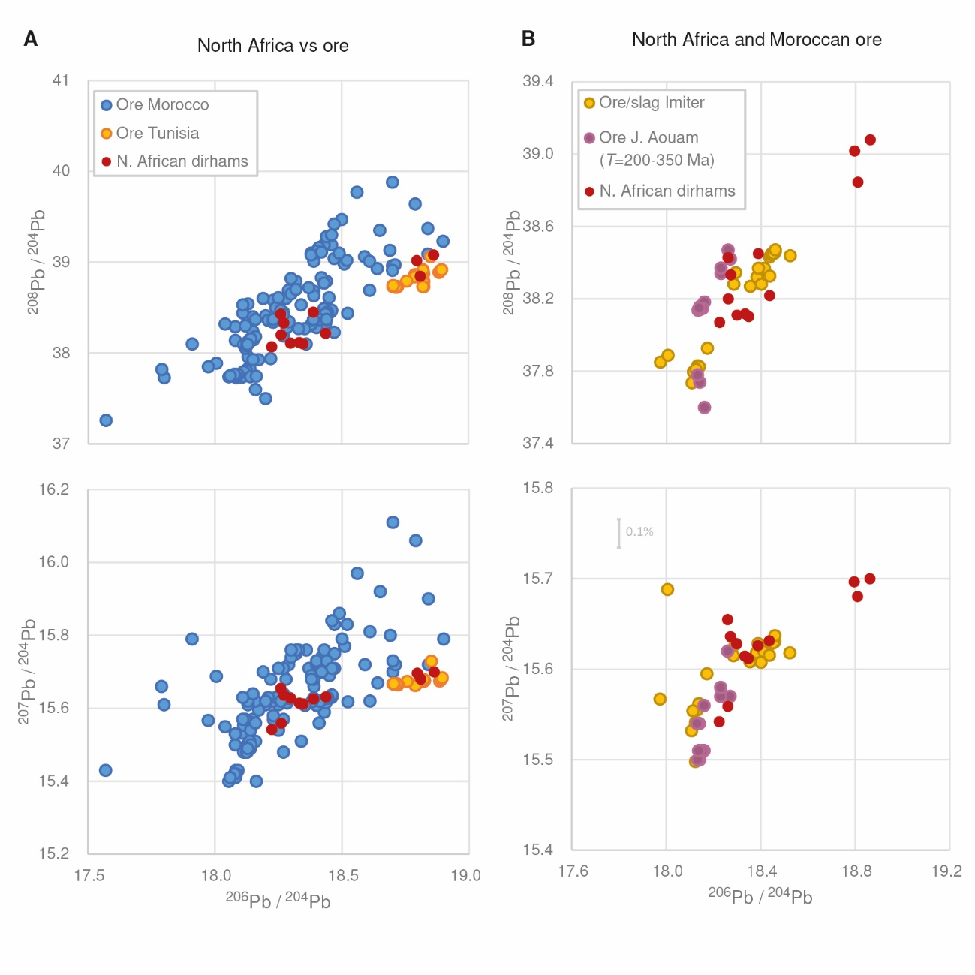Figure S9. North African dirhams and ore lead isotope datasets normalised to ²⁰⁴Pb. Supplementary data for Figure 4B. For reference, 0.1% is equal to or smaller than the symbol unless otherwise stated. For source data, see interpretation of results above (figure by the authors).

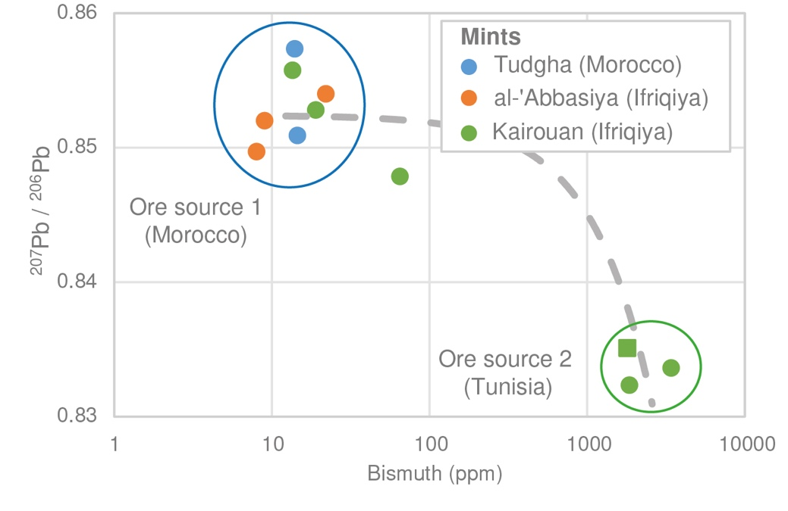
Figure S10. North African dirhams divide into two groups based on bismuth content and lead isotope ratios.
The dominant group is characterised by lower bismuth and has lead isotope ratios consistent with sources in Morocco, while a smaller group of dirhams minted in Tunisia has higher bismuth and lead isotope ratios consistent with ore from Tunisia. One dirham from Kairouan mint in Ifriqiya may represent a mixture of the two sources, falling near the hypothetical ‘mixing line’. The square symbol signifies that the bismuth content was measured by pXRF on a metallic surface cleaned by abrasion (see materials and methods above). For all other coins, the bismuth was measured by mass spectrometry (figure by the authors).
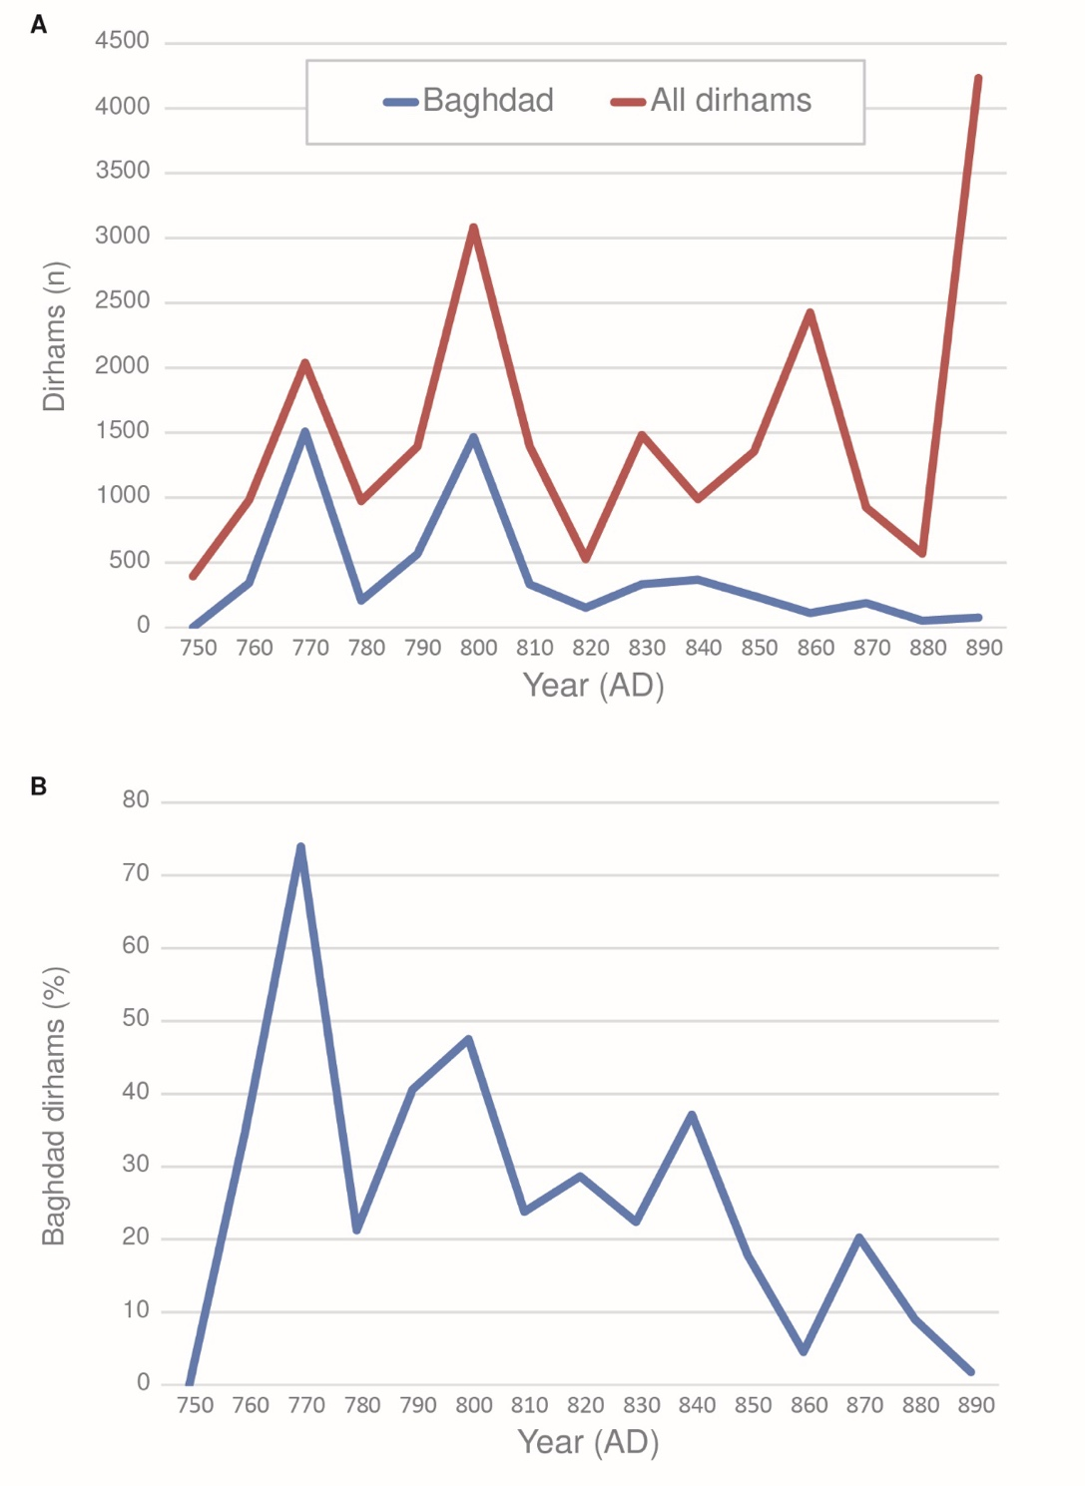

Figure S11. Breakdown of recorded early Abbasid dirhams per decade comparing the number of dirhams minted in Baghdad (Madinat-al-Salam) to all other dirhams.
(A) Numbers of Baghdad issues in relation to total number of known dirhams per decade. (B) Proportion of Baghdad issues. Information is based on Gert Rispling’s unpublished database of 22,735 dirhams minted AD 750–899, found both within the Islamic lands and in Scandinavia/ Baltic (figure by the authors).
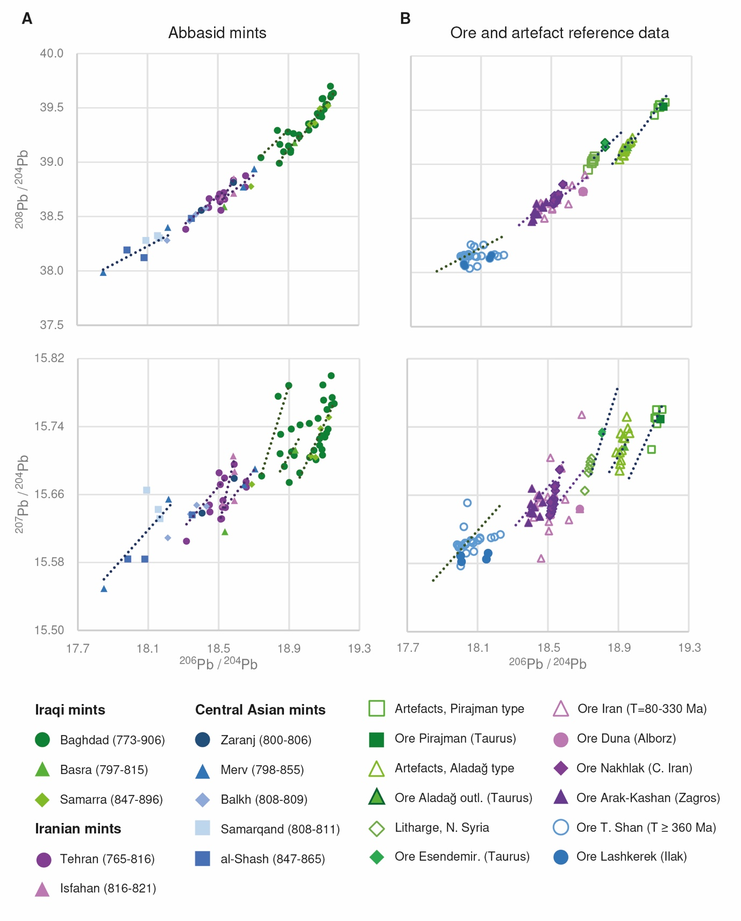

Figure S12. Abbasid dirhams and reference ore and artefact lead isotope datasets from Iraq, Iran and Central Asia normalised to ²⁰⁴Pb.
Supplementary data for Figure 4. For reference, 0.1% is equal to or smaller than the symbol. The linear alignments are those of Figure 6A in the main text. For source data, see interpretation of results above (figure by the authors).

Table S1. Summary of the data basis for this study.
Abbreviations: Abb. = Abbasid; Um. = Umayyad; N. Afr. = North Africa; C/E prov. = central and eastern provinces (Iraq, Iran and Central Asia). The study includes lead isotope data for 143 dirhams and elemental data for 142 (all except one Umayyad coin from Syria).

New samples
(n=) | Description | Elemental | LIA | Source | Ref.
24 | Abb., Iraq/Iran | nsLA-MC-ICPMS | nsLA-MC-ICPMS | Fitzwilliam Museum | This study; Standish et al. 2021
58 | Um., Abb. | ICPQMS | MC-ICPMS | Ox. Fac. Oriental Studies | This study
29 | Abb., N. Afr., C/E prov. | ICPQMS | MC-ICPMS | Coin Chamber Helsinki | This study
Previous studies
1 | Um., Syria | - | TIMS | - | Brill & Shields 1972
10 | Abb., N. Afr., C/E prov. | LA-ICPQMS | TIMS | - | Sarah 2008
9 | Um., Abb., Iraq/Iran | ICPMS | MC-ICPMS | - | Bychov 2011
12 | Abb., N. Afr., C/E prov. | LA-ICPQMS | fsLA-MC-ICPMS | - | Merkel 2016

Table S2. List of Umayyad dirhams.
Abbreviations: Ox FOS = University of Oxford Faculty of Oriental Studies; CC Helsinki = Coin Chamber Helsinki. Analyses: Ox = University of Oxford (this study); A. National Bureau of Standards Boulder (Brill & Shields 1972); B. Moscow (Bychov 2011).
Nr. | Analytical Ref. Nr. | Museum  ID | Mass (g) | Dynasty | Ruler | Mint | Date (AH) | Date (AD) | Obv. legend | Num. ref. to coin type | Arch context | Source | Analysis
1 | 1024-19 | - | 1.83 | Umayyad | al-Walid | Dimashq | 90 | 708-709 | بسم الله ضرب هذا الدرهم بدمشق سنة تسعون | Klat 2002, no. K7334.1 | unknown | Ox FOS | Ox
2 | 1025-19 | - | 1.27 | Umayyad | al-Walid or Sulayman | Wasit | 89-104 | 707-723 | بسم الله ضرب هذا الدرهم بواسط سنة ا[...] | Klat 2002, nos. 684-697 | unknown | Ox FOS | Ox
3 | 1042-19 | - | 2.00 | Umayyad | Yazid II | al-Andalus | 118 | 734/6-737 | بسم الله ضرب هذا الدرهم بالأندلس سنة ثمان و عشر و مئة | Klat 2002, nos. 129-131 | unknown | Ox FOS | Ox
4 | 1139-19 | - | 2.82 | Umayyad | Hisham | al-Mubarakah (Balkh) | 110 | 728-729 | بسم الله ضرب هذا الدرهم بالمبركة سنة عشر و مئة | Klat 2002, no. 573 | unknown | Ox FOS | Ox
5 | 1140-19 | - | 2.61 | Umayyad | Abd al-Malik | Shaqq al-Taymara | 83 | 702-703 | بسم الله ضرب هذا الدرهم بشق التيمارة سنة ثلث و ثمنين | Klat 2002, no. 205.b | unknown | Ox FOS | Ox
6 | 1141-19 | - | 2.00 | Umayyad | Umar | al-Basra | 100 | 718-719 | بسم الله ضرب هذا الدرهم بالبصرة سنة مئة | Klat 2002, no. 172 | unknown | Ox FOS | Ox
7 | 1142-19 | - | 2.88 | Umayyad | Abd al-Malik | al-Basra | 82 | 701-702 | بسم الله ضرب هذا الدرهم بالبصرة سنة اثنين و ثمانين | Klat 2002, no. 171 | unknown | Ox FOS | Ox
8 | 1143-19 | - | 2.64 | Umayyad | Abd al-Malik | Dimashq | 84 | 703-704 | بسم الله ضرب هذا الدرهم بدمشق سنة اربع و ثمانين | Klat 2002, no. 328 | unknown | Ox FOS | Ox
9 | 1144-19 | - | 2.8 | Umayyad | al-Walid | Dimashq | 92 | 710-711 | بسم الله ضرب هذا الدرهم بدمشق سنة ثنتين و تسعين | Klat 2002, no. 336 | unknown | Ox FOS | Ox
10 | 1145-19 | - | 2.67 | Umayyad | Sulayman or 'Umar | Abrashahr (Nishapur) | 99 | 717-718 | بسم الله ضرب هذا الدرهم بأبرشهر سنة تسع و تسعون | Klat 2002, no. 13 | unknown | Ox FOS | Ox
11 | 1146-19 | - | 2.59 | Umayyad | al-Walid | Nahr Tira | 95 | 713-714 | بسم الله ضرب هذا الدرهم بنهر تيرى سنة خمس و تسعين | Klat 2002, no. 646 | unknown | Ox FOS | Ox
12 | 1147-19 | - | 2.84 | Umayyad | al-Walid or Sulayman | Sabur, Bishapur S. Fars | 97 | 715-716 | بسم الله ضرب هذا الدرهم بسابور فى سنة سبع و تسعين | Klat 2002, no. 428 | unknown | Ox FOS | Ox
13 | 1148-19 | - | 2.89 | Umayyad | Sulayman or 'Umar | Dimashq | 99 | 717-718 | بسم الله ضرب هذا الدرهم بدمشق سنة تسع و تسعين | Klat 2002, no. 343 | unknown | Ox FOS | Ox
14 | 1149-19 Ph46 | - | 2.89 | Umayyad | Hisham | Wasit | 122 | 739-740 | بسم الله ضرب هذا الدرهم بواسط سنة إثنتين و عشرين و مئة | Klat 2002, no. 715 | unknown | Ox FOS | Ox
15 | 1151-19 | - | 1.9 | Umayyad | Hisham | Wasit | 111 | 729-730 | بسم الله ضرب هذا الدرهم بواسط سنة احدى عشرة و مئة | Klat 2002, no. 704 | unknown | Ox FOS | Ox
16 | 1152-19 Ph49 | - | 2.29 | Umayyad | Yazid II | Wasit | 105 | 723-724 | بسم الله ضرب هذا الدرهم بواسط سنة خمس و مئة | Klat 2002, no. 698.b | unknown | Ox FOS | Ox
17 | 1156-19 Ph53 | - | 2.73 | Umayyad | Yazid II | Wasit | 103 | 721-722 | بسم الله ضرب هذا الدرهم بواسط سنة ثلث و مئة | Klat 2002, no. 696 | unknown | Ox FOS | Ox
18 | 1157-19 Ph54 | - | 2.24 | Umayyad | Sulayman or 'Umar | Wasit | 99 | 717-718 | بسم الله ضرب هذا الدرهم بواسط سنة تسع و تسعين | Klat 2002, no. 694.a | unknown | Ox FOS | Ox
19 | 1158-19 Ph58 | - | 1.9 | Umayyad | Hisham | Wasit | 115 | 733-734 | بسم الله ضرب هذا الدرهم بواسط سنة خمس و عشرة و مئة | Klat 2002, no. 708 | unknown | Ox FOS | Ox
20 | 1160-19 | - | 2.59 | Umayyad | al-Walid or Sulayman | Wasit | 97 | 715-716 | بسم الله ضرب هذا الدرهم بواسط سنة سبع و تسعين | Klat 2002, no. 692.b | unknown | Ox FOS | Ox
21 | 1161-19 | - | 2.3 | Umayyad | al-Walid or Sulayman | Wasit | 96 | 714-715 | بسم الله ضرب هذا الدرهم بواسط سنة سيت و تسعين | Klat 2002, no. 691 | unknown | Ox FOS | Ox
22 | 1162-19 Ph59 | - | 2.56 | Umayyad | Abd al-Malik | Wasit | 85 | 704-705 | بسم الله ضرب هذا الدرهم بواسط سنة خمس و ثمانين | Klat 2002, no. 680.c | unknown | Ox FOS | Ox
23 | 1163-19 | - | 2.85 | Umayyad | al-Walid | Wasit | 94 | 712-713 | بسم الله ضرب هذا الدرهم بواسط سنة اربع و تسعين | Klat 2002, no. 689 | unknown | Ox FOS | Ox
24 | 1164-19 | - | 2.82 | Umayyad | Hisham | Dimashq | 110 | 728-729 | بسم الله ضرب هذا الدرهم بدمشق سنة عشرة و مئة | Klat 2002, no. 354 | unknown | Ox FOS | Ox
25 | 1165-19 | - | 2.64 | Umayyad | Hisham | Dimashq | 113 | 731-732 | بسم الله ضرب هذا الدرهم بدمشق سنة ثلث وعشرة و مئة | Klat 2002, no. 357 | unknown | Ox FOS | Ox
26 | 1166-19 | - | 2.85 | Umayyad | al-Walid or Sulayman | Mah | 96 | 714-715 | بسم الله ضرب هذا الدرهم بماهى سنة ست و تسعين | Klat 2002, no. 562.b | unknown | Ox FOS | Ox
27 | 1167-19 | - | 2.86 | Umayyad | al-Walid | Marw | 91 | 709-710 | بسم الله ضرب هذا الدرهم بمرو سنة احدى و تسعين | Klat 2002, no. 588.b | unknown | Ox FOS | Ox
28 | M-11 | - | - | Umayyad | 'Abd al-Malik | al-Kufa | 79-82 | 698-701 |  |  | unknown | - | B
29 | 757 | - | - | Umayyad | ‘Umar or Yazid II | Dimashq | 101-102 | 720 |  |  | unknown | - | A

Table S3. List of North African dirhams.
Abbreviations: NMF = National Museum Finland; WMH = Wikinger Museum Haithabu; BNdF = Bibliothèque nationale de France; Ox FOS = University of Oxford Faculty of Oriental Studies; CC Helsinki = Coin Chamber Helsinki. Analyses: Ox = University of Oxford (this study); B. Moscow (Bychov 2011); C. Orleans (Sarah 2008); D. Hanover (Merkel 2016).
Nr. | Analytical Ref. Nr. | Museum ID | Mass (g) | Dynasty | Ruler | Mint | Date (AH) | Date (AD) | Obv. legend | Actual coin published | Num. ref. to coin type | Archaeological context | Source
30 | 1058-19 | NMF RKHY921:106 | 1.98 | Idrisid | Idris I | Tudgha | 174 | 790-791 | بسم الله ضرب هذا الدرهم بتدغة سنة اربع و سبعين و مئة | Granberg 1967, no. 106 | Eustache 1970-1, no. 32 | Svedjelandet Hoard, Åland tpq 837 | CC Helsinki
31 | 1060-19 | NMF RKHY429:157 | 1.32 | Khajirites | Khalaf b. al-Muda' | Tudgha | c. 175 | 791-792 | بسم الله ضرب هذا الدرهم بتدغة سنة خمس و سبعين و مئة | Granberg 1967, no. 264 | Eustache 1970-1:291-3. | Hammarudda Hoard, Åland tpq 857 | CC Helsinki
32 | Han-1 | WMH Hb2007/14062 | 0.4 | Abbasid | al-Mahdi/al-Hadi/al-Rashid | al-'Abbasiya | 160-170 | 776-786 |  |  |  | Metal-detector find, Hedeby | -
33 | Han-2 | WMH Hb2006/12993 | 0.69 | Abbasid | Harun al-Rashid | al-'Abbasiya | 171-175 | 787-792 |  |  |  | Metal-detector find, Hedeby | -
34 | Han-4 | WMH Giekau Coin 34 | 0.47 | Abbasid | Harun al-Rashid | al-'Abbasiya | 170-173 | 786-790 |  | Wiechmann 1996, no. 9.34 |  | Giekau Hoard, Plön tpq 921/2 | -
35 | Han-3 | WMH Hb-LA48/9550 | 0.21 | Abbasid | Harun al-Rashid | Kairouan | 176-177 | 792-794 |  |  |  | Excavated find, Hedeby | -
36 | 1062-19 | NMF RKHY921:65 | 2.78 | Abbasid | al-Mahdi | Ifriqiya (Kairouan) | 166 | 782-783 | بسم الله ضرب هذا الدرهم بإفريقية في سنة سيت و سيتين و مئة | Granberg 1967, no. 65 |  | Svedjelandet Hoard, Åland tpq 837 | CC Helsinki
37 | 1063-19 | NMF RKHY921:72 | 2.66 | Abbasid | Harun al-Rashid | Ifriqiya (Kairouan) | 172 | 788-789 | بسم الله ضرب هذا الدرهم بإفريقية في سنة إثنتين و سباين و مئة | Granberg 1967, no. 72 | Nicol 2012a, 453 var. | Svedjelandet Hoard, Åland tpq 837 | CC Helsinki
38 | L-1.777 | BNdF L-1.777 | - | Abbasid | Harun al-Rashid | Kairouan | 174 | 790-791 |  | Lavoix 1887, no. 777 |  | unknown | -
39 | 1064-19 | NMF RKHY429:66 | 1.38 | Abbasid | al-Mahdi | Kairouan | 167 | 783-784 | بسم الله ضرب هذا الدرهم بإفريقية في سنة سبع و سيتين و مئة | Granberg 1967, no. 173 |  | Hammarudda Hoard, Åland tpq 857 | CC Helsinki
40 | 1065-19 | NMF RKHY1850 | 2.59 | Abbasid | Harun al-Rashid | Ifriqiya (Kairouan) | 174 | 790-791 | بسم الله ضرب هذا الدرهم بإفريقية في سنة اربع و سباين و مئة | Granberg 1967, no. 1470 | Nicol 2012a, 458-459 | Tampere area, stray find ca. 1850. | CC Helsinki
41 | M-10 | - | - | Abbasid | al-Hadi | Kairouan | 169 | 785-786 |  |  |  |  | -

Table S4. List of Abbasid-period dirhams from central and eastern mints. Abbreviations: FM = Fitzwilliam Museum, Cambridge; NMF = National Museum Finland; WMH = Wikinger Museum Haithabu; BNdF = Bibliothèque nationale de France; Ox FOS = University of Oxford Faculty of Oriental Studies; CC Helsinki = Coin Chamber Helsinki. Analyses: Ox = University of Oxford (this study); SH = University of Southampton (this study); B. Moscow (Bychov 2011); C. Orleans (Sarah 2008); D. Hanover (Merkel 2016); E. University of Southampton (Standish et al. 2021).

Nr. | Analytical Ref. Nr. | Museum ID | Mass (g) | Dynasty | Ruler | Mint | Date (AH) | Date (AD) | Obv. legend | Actual coin published | Num. ref. to coin type | Archaeological context | Source
42 | 1026-19 Ph24 | - | 2.65 | Abbasid | al-Mansur | M. al-Salam (Baghdad) | 157 | 773-774 | بسم الله ضرب هذا الدرهم بمدينة السلام سنة سبع و خمسين و مئة |  | Nicol 2012a, 1593-1596 | unknown | Ox FOS
43 | 1046-19 Ph14 | - | 2.92 | Abbasid | Harun al-Rashid | M. al-Salam | 179 | 795-796 | بسم الله ضرب هذا الدرهم بمدينة السلام سنة تسع و سبعين و مئة |  | Nicol 2012a, 1664-1666 | unknown | Ox FOS
44 | 1036-19 | - | 2.56 | Abbasid | Harun al-Rashid | al-Rafiqa | 190 | 805-806 | بسم الله ضرب هذا الدرهم بالرافقة سنة تسعين و مئة |  | Nicol 2012a, 765-766 | unknown | Ox FOS
45 | 1047-19 Ph10 | - | 2.89 | Abbasid | Harun al-Rashid | M. al-Salam | 188 | 803-804 | بسم الله ضرب هذا الدرهم بمدينة السلام سنة ثمان و ثمنين و مئة |  | Nicol 2012a, 1694-1695 | unknown | Ox FOS
46 | Fitz-6 | FM CM.147-1934 | 2.95 | Abbasid | al-Mansur | M. al-Salam | 157 | 773-774 | بسم الله ضرب هذا الدرهم بمدينة السلام سنة سبع و خمسين و مئة |  | Nicol 2012a, 1603-1609 | unknown | Fitzwilliam
47 | 1028-19 Ph28 | - | 1.43 | Abbasid | al-Mahdi | M. al-Salam | 161 | 777-778 | بسم الله ضرب هذا الدرهم بمدينة السلام سنة احدى و ستين و مئة |  | Nicol 2012a, 1622-1627 | unknown | Ox FOS
48 | 1029-19 Ph29 | - | 1.42 | Abbasid | al-Mahdi | M. al-Salam | 163 | 779-780 | بسم الله ضرب هذا الدرهم بمدينة السلام سنة ثلث و ستين و مئة |  | Nicol 2012a, 1632-1633 | unknown | Ox FOS
49 | Han-10 | WMH Hb2003/4191 | 2.7 | Abbasid | al-Mu'tamid | Surra man Ra'ā | 258 | 871/872 |  |  |  |  | -
50 | M-1 | - | - | Abbasid | Harun al-Rashid | M. al-Salam | 172 | 788-789 |  |  |  |  | -
51 | Fitz-12 | FM CM.IS.179-R | 2.7 | Abbasid | Harun al-Rashid | M. al-Salam | 175 | 791-792 | بسم الله ضرب هذا الدرهم بمدينة السلام سنة خمس و سبعين و مئة |  | Nicol 2012a, 1660-1663 | unknown | Fitzwilliam
52 | 1045-19 Ph11 | - | 2.8 | Abbasid | Harun al-Rashid | M. al-Salam | 190-193 | 805-809 | بسم الله ضرب هذا الدرهم بمدينة السلام سنة [...] تسعين و مئة |  | Nicol 2012a, 1698-1706 | unknown | Ox FOS
53 | 1044-19 Ph06 | - | 1.97 | Abbasid | al-Mansur | M. al-Salam | 161 | 777-778 | بسم الله ضرب هذا الدرهم بمدينة السلام سنة احدى و ستين و مئة |  | Nicol 2012a, 1622-1627 | unknown | Ox FOS
54 | Fitz-17 | FM CM.IS.191-R | 2.85 | Abbasid | Harun al-Rashid | M. al-Salam | 193 | 808-809 | بسم الله ضرب هذا الدرهم بمدينة السلام سنة ثلث و تسعين و مئة |  | Nicol 2012a, 1704-1706 | unknown | Fitzwilliam
55 | 1074-19 | NMF RKHY1876:374 | 2.93 | Abbasid | al-Mutawakkil | Surra man Ra'ā | 233 | 847-848 | بسم الله ضرب هذا الدرهم بسر من رأى سنة ثلث و ثلثين و مائتين | Granberg 1967, no. 638 |  | Bertby Hoard, Åland tpq 874 | CC Helsinki
56 | Fitz-13 | FM CM.IS.182-R | 2.9 | Abbasid | Harun al-Rashid | M. al-Salam | 188 | 803-804 | بسم الله ضرب هذا الدرهم بمدينة السلام سنة ثمان و ثمنين و مئة |  | Nicol 2012a, 1694-1695 | unknown | Fitzwilliam
57 | 1039-19 | - | 2.39 | Abbasid | al-Mutadid | Surra man Ra'ā | 282 | 895-896 | بسم الله ضرب هذا الدرهم بسر من رأى سنة ثنين و ثمنين و مائتين |  | Shams Eshragh 2010, no. 1365 | unknown | Ox FOS
58 | Fitz-23 | FM CM.141-2011 | 1.24 | Abbasid | al-Mahdi | M. al-Salam | 162 | 778-779 | بسم الله ضرب هذا الدرهم بمدينة السلام سنة اثنين و ستين و مئة | Blackburn 2011, no. 46 |  | MD find, Torksey | Fitzwilliam
59 | 1073-19 | NMF RKHY1876:384 | 2.6 | Abbasid | al-Mutawakkil | M. al-Salam | 237 | 851-852 | بسم الله ضرب هذا الدرهم بمدينة السلام سنة سبع و ثلثين و مائتين | Granberg 1967, no. 648 |  | Bertby Hoard, Åland tpq 874 | CC Helsinki
60 | 1075-19 | NMF RKHY1876:390 | 2.12 | Abbasid | al-Mutawakkil | Surra man Ra'ā | 239 | 853-854 | بسم الله ضرب هذا الدرهم بسر من رأى سنة تسع و ثلثين و مائتين | Granberg 1967, no. 654 |  | Bertby Hoard, Åland tpq 875 | CC Helsinki
61 | 1072-19 | NMF RKHY921:73 | 3.08 | Abbasid | Harun al-Rashid | M. al-Salam | 180 | 796-797 | بسم الله ضرب هذا الدرهم بمدينة السلام في سنة ثمانين و مئة | Granberg 1967, no. 73 |  | Svedjelandet Hoard, Åland tpq 837 | CC Helsinki
62 | M-2 | - | - | Abbasid | al-Mansur | M. al-Salam? | 154-158 | 770-774 |  |  |  |  | -
63 | M-9 | - | - | Abbasid | Harun al-Rashid | M. al-Salam | 191 | 806 |  |  |  |  | -
64 | Fitz-16 | FM CM.GC.1-R | 2.8 | Abbasid | Harun al-Rashid | M. al-Salam | 193 | 808-809 | بسم الله ضرب هذا الدرهم بمدينة السلام سنة ثلث و تسعين و مئة |  | Nicol 2012a, 1704-1706 | unknown | Fitzwilliam
65 | Fitz-21 | FM CM.76-2011 | 0.81 | Abbasid | al-Mahdi | M. al-Salam | 161 | 777-778 | بسم الله ضرب هذا الدرهم بمدينة السلام سنة احدى و ستين و مئة | Blackburn 2011, no. 45 |  | MD find, Torksey, Lincolnshire | Fitzwilliam
66 | M-7 | - | - | Abbasid | Harun al-Rashid | M. al-Salam? | 190-193 | 805-808 |  |  |  |  | -
67 | 1040-19 Ph23 | - | 2.35 | Abbasid | al-Muktafi | M. al-Salam | 293 | 905-906 | بسم الله ضرب هذا الدرهم بمدينة السلام سنة ثلث و تسعين و مائتين |  | Nicol 2012b, 1028-1029 | unknown | Ox FOS
68 | Fitz-7 | FM CM.IS.168-R | 2.93 | Abbasid | al-Mahdi | M. al-Salam | 160 | 776-777 | بسم الله ضرب هذا الدرهم بمدينة السلام سنة ستين و مئة |  | Nicol 2012a, 1618-1621 | unknown | Fitzwilliam
69 | 1033-19 Ph34 | - | 2.48 | Abbasid | Harun al-Rashid | M. al-Salam | 193 | 808-809 | بسم الله ضرب هذا الدرهم بمدينة السلام سنة ثلث و تسعين و مئة |  | Nicol 2012a, 1704-1706 | unknown | Ox FOS
70 | L-1.779 |  | - | Abbasid | Harun al-Rashid | al-Basra | 181 | 797-798 |  | Lavoix 1887, no. 779 |  |  | -
71 | Fitz-15 | FM CM.IS.187-R | 2.95 | Abbasid | Harun al-Rashid | M. al-Salam | 190 | 805-806 | بسم الله ضرب هذا الدرهم بمدينة السلام سنة تسعين و مئة |  | Nicol 2012a, 1698-1699 | unknown | Fitzwilliam
72 | L-1.861 | - | - | Abbasid | al-Amin | M. al-Salam | 193 | 808-809 |  | Lavoix 1887, no. 861 |  |  | -
73 | 1057-19 | - | 2.53 | Abbasid | al-Muttaqi | M. al-Salam / Basra | 330 | 941-942 | بسم الله ضرب هذا الدرهم [...] سنة ثلثين و ثلثمائة |  | cf. Nicol 2012b, 223 & 225, 1195-1198 | unknown | Ox FOS
74 | 1052-19 Ph15 | - | 2.67 | Abbasid | al-Ma'mun | M. al-Salam | 208 | 823-824 | بسم الله ضرب هذا الدرهم بمدينة السلام سنة ثمان و مئتين |  | Nicol 2012a, 1781-1782 | unknown | Ox FOS
75 | Fitz-20 | FM CM.IS.207-R | 2.94 | Abbasid | al-Ma’mun | M. al-Salam | 203 | 818-819 | بسم الله ضرب هذا الدرهم بمدينة السلام سنة ثلث و مايتين |  | Nicol 2012a, 1755-1761 | unknown | Fitzwilliam
76 | Han-9 | WMH Hb2003/4191 | 0.2 | Abbasid | al-Mutawakkil | M. al-Salam | (23)3 | (84)7 |  |  |  | MD find, Hedeby | -
77 | 1077-19 | NMF RKHY921:24 | 1.05 | Abbasid | ‘Umar ibn al-‘Alā | Tabaristan | 155 | 771 |  | Granberg 1967, no. 24 |  | Svedjelandet Hoard, Åland tpq 837 | CC Helsinki
78 | 1079-19 | NMF RKHY429:2 | 0.73 | Abbasid | ‘Umar ibn al-‘Alā | Tabaristan | 156 | 772 |  | Granberg 1967, no. 109 |  | Svedjelandet Hoard, Åland tpq 837 | CC Helsinki
79 | 1053-19 | - | 3.82 | Abbasid | al-Mutamid | al-Muhammadiya | 251-255 | 866-869 | بسم الله ضرب هذا الدرهم بالمحمدية سنة [...] مئتين |  |  | unknown | Ox FOS
80 | Fitz-14 | FM CM.IS.184-R | 2.63 | Abbasid | Harun al-Rashid | M. al-Salam | 188 | 803-804 | بسم الله ضرب هذا الدرهم بمدينة السلام سنة ثمان و ثمنين و مئة |  | Nicol 2012a, 1694-1695 | unknown | Fitzwilliam
81 | 1030-19 Ph26 | - | 2.48 | Abbasid | al-Mahdi | M. al-Salam | 165 | 781-782 | بسم الله ضرب هذا الدرهم بمدينة السلام سنة خمس و ستين و مئة |  | Nicol 2012a, 1639-1640 | unknown | Ox FOS
82 | 1088-19 | NMF RKHY1876:814 | 2.94 | Abbasid? | - | w/o writing | - | 9th C. | w/o writing | Granberg 1967, no. 1078 |  | Bertby Hoard, Åland tpq 874 | CC Helsinki
83 | Fitz-8 | FM CM.IS.169-R | 2.8 | Abbasid | al-Mahdi | M. al-Salam | 163 | 779-780 | بسم الله ضرب هذا الدرهم بمدينة السلام سنة ثلث و ستين و مئة |  | Nicol 2012a, 1630-1631 | unknown | Fitzwilliam
84 | Fitz-19 | FM CM.IS.206-R | 2.75 | Abbasid | al-Ma’mun | M. al-Salam | 198 | 813-814 | بسم الله ضرب هذا الدرهم بمدينة السلام سنة ثمان و تسعين و مئة |  | Nicol 2012a, 1733-1734 | unknown | Fitzwilliam
85 | 1082-19 | NMF RKHY429:129 | 0.94 | Abbasid | al-Ma'mun | Marw | 199 | 814-815 | بسم الله ضرب هذا الدرهم بمرو سنة تسع و تسعون و مئة | Granberg 1967, no. 236 |  | Hammarudda Hoard, Åland tpq 857 | CC Helsinki
86 | 1076-19 | NMF RKHY1876:367 | 3.05 | Abbasid | al-Mu`tazz | Surra man Ra'ā | 253 | 867 | بسم الله ضرب هذا الدرهم بسر من رأى سنة ثلث و خمسين و مائتين | Granberg 1967, no. 721 | cf. Nicol 2012b, 472 | Bertby Hoard, Åland tpq 874 | CC Helsinki
87 | Fitz-3 | FM CM.IS.147-R | 2.49 | Abbasid | al-Mansur | al-Muhammadiya | 154 | 771 | بسم الله ضرب هذا الدرهم بالمحمدية سنة اربع و خمسين و مئة |  | Nicol 2012a, 1328 | unknown | Fitzwilliam
88 | 1070-19 | NMF RKHY921:32 | 2.82 | Abbasid | al-Saffah | al-Basra | 134 | 751-752 | بسم الله ضرب هذا الدرهم بالبصرة في سنة اربعة و ثلاثون و مئة | Granberg 1967, no. 32 |  | Svedjelandet Hoard, Åland tpq 837 | CC Helsinki
89 | Han-7 | WMH Hb2003/247 | 0.73 | Abbasid | Harun al-Rashid | al-Muhammadiya | 178-187 | 794-803 |  |  |  | MD find, Hedeby | -
90 | 1084-19 | NMF RKHY1876:537 | 3.07 | Abbasid | al-Mutawakkil | Marw | 240 | 854-855 | بسم الله ضرب هذا الدرهم بمرو سنة أربعين و مائتين | Granberg 1967, no. 801 |  | Bertby Hoard, Åland tpq 874 | CC Helsinki
91 | Han-12 | WMH Hb2006/12246 | 0.67 | Saffarid | al-Mu'tamid | Shiraz | 265-270 | 878-884 |  |  |  | MD find, Hedeby | -
92 | 1034-19 | - | 3.01 | Abbasid | al-Ma'mun | Madinat Isfahan | 205 | 820-821 | سم الله ضرب هذا الدرهم بمدينة اصبهان سنة خمس و مئتين |  | Nicol 2012a, 395-400 | unknown | Ox FOS
93 | 1071-19 | NMF RKHY1876:288 | 2.94 | Abbasid | al-Ma'mun | al-Basra | 199 | 814-815 | بسم الله ضرب هذا الدرهم بالبصرة في سنة تسع و تسعون و مئة | Granberg 1967, no. 552 |  | Bertby Hoard, Åland tpq 874 | CC Helsinki
94 | M-5 | - | - | Abbasid | Harun al-Rashid | Zaranj | 184-185 | 800-801 |  |  |  |  | -
95 | Fitz-18 | FM CM.IS.199-R | 2.87 | Abbasid | al-Ma’mun | M. Isbahan | 201 | 816-817 | بسم الله ضرب هذا الدرهم بمدينة اصبهان سنة احدى و مئتين |  | Nicol 2012a, 375-380 | unknown | Fitzwilliam
96 | 1032-19 | - | 2.93 | Abbasid | Harun al-Rashid | al-Muhammadiya | 183 | 799-800 | بسم الله ضرب هذا الدرهم بالمحمدية سنة ثلث و ثمنين و مئة |  | Nicol 2012a, 1440-1445 | unknown | Ox FOS
97 | 1038-19 Ph25 | - | 1.74 | Abbasid | al-Amin | (M. al-Salam) Overstruck | 195 | 810-811 | بسم الله ضرب هذا الدرهم بمدينة السلام سنة خمس و تسعين و مئة |  | Nicol 2012a, 1720-1722 | unknown | Ox FOS
98 | Fitz-11 | FM CM.384-1991 | 0.56 | Abbasid | Harun al-Rashid | al-Muhammadiya | 188-189 | 803-805 | بسم الله ضرب هذا الدرهم بالمحمدية سنة --- |  | Nicol 2012a, 1484-1487, 1489-1491 | MD find Caldecote, Norfolk | Fitzwilliam
99 | Fitz-24 | FM CM.150-2011 | 0.78 | Abbasid | al-Ma'mun | al-Muhammadiya | 200 | 815-816 | بسم الله ضرب هذا الدرهم بالمحمدية سنة مئتين | Blackburn 2011, no. 73 | Nicol 2012a, 1530 | MD find Torksey, Lincolnshire | Fitzwilliam
100 | 1041-19 | - | 3.04 | Abbasid | al-Mansur | al-Rayy (al-Muhammadiya) | 148 | 765-766 | بسم الله ضرب هذا الدرهم بالرى سنة ثمان و أربعين و مئة |  | Nicol 2012a, 784-785 | unknown | Ox FOS
101 | 1080-19 | NMF RKHY921:26 | 1.21 | Abbasid | Hānī | Tabaristan | 173 | 788 |  | Granberg 1967, no. 26 | Malek 2004, 110.4 | Svedjelandet Hoard, Åland tpq 837 | CC Helsinki
102 | 1027-19 | - | 2.63 | Abbasid | al-Mansur | al-Muhammadiya | 149 | 766-767 | بسم الله ضرب هذا الدرهم بالمحمدية سنة تسع و أربعين و مئة |  | Nicol 2012a, 1304-1307 | unknown | Ox FOS
103 | M-4 | - | - | Abbasid | al-Mamun | M. Isbahan | [20]1 | 816-817 |  |  |  |  | -
104 | L-1.859 | - | - | Abbasid | al-Amin | al-Muhammadiya | 194 | 809-810 |  | Lavoix 1887, no. 859 |  |  | -
105 | 1035-19 Ph21 | - | 2.49 | Abbasid | al-Mansur | M. al-Salam | 151 | 768 | بسم الله ضرب هذا الدرهم بمدينة السلام سنة احدى و خمسين و مئة |  | Nicol 2012a, 1566-1569 | unknown | Ox FOS
106 | M-8b | - | - | Abbasid | al-Mamun | Isfahan | 205 | 820-821 |  |  |  |  | -
107 | Fitz-4 | FM CM.IS.152-R | 2.92 | Abbasid | al-Mansur | M. al-Salam | 152 | 769-770 | بسم الله ضرب هذا الدرهم بمدينة السلام سنة اثنتين و خمسين و مئة |  | Nicol 2012a, 1570-1573 | unknown | Fitzwilliam
108 | 1078-19 | - | 0.82 | Abbasid | ‘Umar ibn al-‘Alā | Tabaristan | 162 | 778 | بسم الله ضرب هذا الدرهم بطبرستان سنة اثنين و ستين و مئة | Granberg 1967, no. 25 |  | Svedjelandet Hoard, Åland tpq 837 | Ox FOS
109 | Fitz-5 | FM CM.IS.154-R | 2.76 | Abbasid | al-Mansur | M. al-Salam | 154 | 771 | بسم الله ضرب هذا الدرهم بمدينة السلام سنة اربع و خمسين و مئة |  | Nicol 2012a, 1576-1579 | unknown | Fitzwilliam
110 | Fitz-2 | FM CM.279-1939 | 2.86 | Abbasid | al-Mansur | al-Muhammadiya | 150 | 767-768 | بسم الله ضرب هذا الدرهم بالمحمدية سنة خمسين و مئة |  | Nicol 2012a, 1312-1314 | unknown | Fitzwilliam
111 | Fitz-10 | FM CM.IS.176-R | 2.8 | Abbasid | Harun al-Rashid | al-Muhammadiya | 184 | 800-801 | بسم الله ضرب هذا الدرهم بالمحمدية سنة اربع و ثمنين و مئة |  | Nicol 2012a, 1452-1459 | unknown | Fitzwilliam
112 | Fitz-1 | FM CM.IS.146-R | 2.93 | Abbasid | al-Mansur | al-Muhammadiya | 148 | 765-766 | بسم الله ضرب هذا الدرهم بالمحمدية سنة ثمان و أربعين و مئة |  | Nicol 2012a, 1302-1303 | unknown | Fitzwilliam
113 | Fitz-22 | FM CM.79-2011 | 0.39 | Abbasid | Harun al-Rashid | al-Muhammadiya | c. 186 | c. 802 | بسم الله ضرب هذا الدرهم بالمحمدية سنة ست و ثمنين و مئة | Blackburn 2011, no. 62 |  | MD find Torksey, Lincolnshire | Fitzwilliam
114 | 1043-19 Ph09 | - | 3.1 | Abbasid | Harun al-Rashid | al-Muhammadiya | 182-183 | 798-800 | بسم الله ضرب هذا الدرهم بالمحمدية سنة [...] |  | Nicol 2012a, 1675-1677, 1679-1681 | unknown | Ox FOS
115 | Han-5 | WMH Hb2003/4198 | 0.68 | Abbasid | al-Amin | Balkh | 193-195 | 808-811 |  |  |  | MD find Hedeby | -
116 | 1037-19 Ph27 | - | 2.63 | Abbasid | Harun al-Rashid | Zaranj | 190 | 805-806 | بسم الله ضرب هذا الدرهم بمدينة زرنج سنة تسعين و مئة |  | Nicol 2012a, 821 | unknown | Ox FOS
117 | L-1.787 | - | - | Abbasid | Harun al-Rashid | Balkh | 190 | 805-806 |  | Lavoix 1887, no. 787 |  | unknown | -
118 | Fitz-9 | FM CM.IS.175-R | 2.73 | Abbasid | Harun al-Rashid | al-Muhammadiya | 180 | 796-797 | بسم الله ضرب هذا الدرهم بالمحمدية سنة ثمنين و مئة |  | Nicol 2012a, 1409-1410 | unknown | Fitzwilliam
119 | 1087-19 | NMF RKHY1876:616 | 3.86 | Abbasid | al-Mustai`in | al-Shash | 251 | 865 | بسم الله ضرب هذا الدرهم بالشاش سنة إحدى و خمسين و مائتين | Granberg 1967, no. 880 |  | Bertby Hoard, Åland tpq 874 | CC Helsinki
120 | L-1.781 | - | - | Abbasid | Harun al-Rashid | Balkh | 182 | 798-799 |  | Lavoix 1887, no. 781 |  | unknown | -
121 | L-1.778 | - | - | Abbasid | Harun al-Rashid | Bukhara | 193 | 808-809 |  | Lavoix 1887, no. 778 |  | unknown | -
122 | 1048-19 Ph18 | - | 3.7 | Abbasid | Harun al-Rashid | Balkh | 189 | 804-805 | بسم الله ضرب هذا الدرهم بمدينة بلخ سنة تسع و ثمنين و مئة |  | Nicol 2012a, 692-695 | unknown | Ox FOS
123 | 1049-19 | - | 2.92 | Abbasid | Harun al-Rashid | Tabaristan | 190 | 805-806 | بسم الله ضرب هذا الدرهم بطبرستان سنة تسعين و مئة |  | Nicol 2012a, 933-934 | unknown | Ox FOS
124 | 1081-19 | NMF RKHY429:91 | 2.91 | Abbasid | Harun al-Rashid | Marw | 182 | 798-799 | بسم الله ضرب هذا الدرهم بمرو سنة اثنين و ثمنين و مئة | Granberg 1967, no. 198 |  | Hammarudda Hoard, Åland tpq 857 | CC Helsinki
125 | L-1.803 | - | - | Abbasid | Harun al-Rashid | Samarqand | 193 | 808-809 |  | Lavoix 1887, no. 803 |  | unknown | -
126 | 1965-171 | BNdF 1965-171 | - | Abbasid | Harun al-Rashid | Samarqand | 193 | 808-809 |  |  |  | unknown | -
127 | 1085-19 | NMF RKHY1876:522 | 2.7 | Abbasid | al-Mutawakkil | al-Shash | 233 | 847-848 | بسم الله ضرب هذا الدرهم بالشاش سنة ثلث و ثلثين و مائتين | Granberg 1967, no. 786 |  | Bertby Hoard, Åland tpq 874 | CC Helsinki
128 | 1050-19 Ph03 | - | 2.74 | Abbasid | Harun al-Rashid | Bukhara | 193 | 808-809 | بسم الله ضرب هذا الدرهم بمدينة بخارا سنة ثلث و تسعين و مئة |  | Nicol 2012a, 492-494 | unknown | Ox FOS
129 | 1051-19 Ph08 | - | 2.77 | Abbasid | Harun al-Rashid | Bukhara | 193 | 808-809 | بسم الله ضرب هذا الدرهم بمدينة بخارا سنة ثلث و تسعين و مئة |  | Nicol 2012a, 492-494 | unknown | Ox FOS
130 | 1970-335 | BNdF | - | Abbasid | Harun al-Rashid | Bukhara | 193 | 808-809 |  |  |  | unknown | -
131 | Han-6 | WMH Hb2003/3422 | 0.44 | Abbasid | al-Amin | Balkh | 193-195 | 808-811 |  |  |  | MD find Hedeby | -
132 | Han-8 | WMH Hb2011/14541 | 0.38 | Abbasid | al-Ma'mun | Samarqand | 195 | 810-811 |  |  |  | MD find Hedeby | -

Table S5. Umayyad dirhams LIA results.
Date = measurement in Oxford. Laboratory Ref: A. National Bureau of Standards Boulder (Brill & Shields 1972); B. Moscow (Bychov 2011).

Lab. Nr. | Mint | AH | AD | 206/204 | 2SD | 207/204 | 2SD | 208/204 | 2SD | 207/206 | 2SD | 208/206 | 2SD | T (Ma) | mu | kappa | Date/Ref.
1024-19 | Dimashq | 90 | 708-709 | 18.461 | 0.001 | 15.660 | 0.002 | 38.650 | 0.004 | 0.84831 | 0.00004 | 2.0936 | 0.00009 | 275 | 9.84 | 4.01 | Dec-19
1025-19 | Wasit | 89-104 | 707-723 | 18.576 | 0.001 | 15.6621 | 0.0003 | 38.7014 | 0.0004 | 0.84312 | 0.00002 | 2.08338 | 0.00003 | 200 | 9.83 | 3.96 | Nov-19
1042-19 | al-Andalus | 118? | 734-737 | 18.582 | 0.002 | 15.666 | 0.001 | 38.722 | 0.004 | 0.84310 | 0.00001 | 2.08384 | 0.00008 | 197 | 9.83 | 3.97 | Dec-19
1139-19 | al-Mubarakah | 110 | 728-729 | 18.636 | 0.002 | 15.668 | 0.002 | 38.794 | 0.006 | 0.84072 | 0.00002 | 2.08166 | 0.00008 | 161 | 9.83 | 3.97 | Mar-21
1140-19 | Shaqq al-Taymara | 83 | 702-703 | 18.434 | 0.001 | 15.6572 | 0.0004 | 38.602 | 0.002 | 0.84938 | 0.00002 | 2.09410 | 0.00002 | 290 | 9.83 | 4.00 | Mar-21
1141-19 | al-Basra | 100 | 718-719 | 18.492 | 0.001 | 15.6455 | 0.0004 | 38.591 | 0.002 | 0.84605 | 0.00001 | 2.08688 | 0.00003 | 229 | 9.78 | 3.95 | Mar-20
1142-19 | al-Basra | 82 | 701-702 | 18.578 | 0.002 | 15.663 | 0.002 | 38.701 | 0.005 | 0.84306 | 0.00002 | 2.08309 | 0.00006 | 198 | 9.83 | 3.96 | Mar-20
1143-19 | Dimashq | 84 | 703-704 | 18.645 | 0.002 | 15.666 | 0.001 | 38.758 | 0.002 | 0.84024 | 0.00001 | 2.07871 | 0.00002 | 156 | 9.83 | 3.95 | Mar-20
1144-19 | Dimashq | 92 | 710-711 | 18.613 | 0.003 | 15.651 | 0.002 | 38.697 | 0.005 | 0.84086 | 0.00004 | 2.07902 | 0.00013 | 151 | 9.78 | 3.93 | Mar-20
1145-19 | Abrashahr | 99 | 717-718 | 18.861 | 0.005 | 15.702 | 0.004 | 39.004 | 0.011 | 0.83247 | 0.00003 | 2.06794 | 0.00006 | 61 | 9.92 | 3.94 | Mar-21
1146-19 | Nahr Tira | 95 | 713-714 | 18.543 | 0.002 | 15.651 | 0.002 | 38.673 | 0.004 | 0.84407 | 0.00001 | 2.08565 | 0.00003 | 198 | 9.78 | 3.96 | Mar-21
1147-19 | Sabur | 97 | 715-716 | 18.712 | 0.002 | 15.679 | 0.001 | 38.839 | 0.003 | 0.83787 | 0.00003 | 2.07560 | 0.00014 | 130 | 9.87 | 3.95 | Mar-20
1148-19 | Dimashq | 99 | 717-718 | 20.325 | 0.003 | 15.846 | 0.002 | 39.171 | 0.006 | 0.77961 | 0.00001 | 1.92723 | 0.00003 | -725 | 10.27 | 3.28 | Mar-20
1149-19 | Wasit | 122 | 739-740 | 18.764 | 0.002 | 15.672 | 0.001 | 38.765 | 0.002 | 0.83520 | 0.00001 | 2.06587 | 0.00004 | 80 | 9.83 | 3.88 | Mar-20
1151-19 | Wasit | 111 | 729-730 | 18.522 | 0.001 | 15.630 | 0.001 | 38.629 | 0.002 | 0.84388 | 0.00001 | 2.08557 | 0.00004 | 178 | 9.72 | 3.95 | Mar-20
1152-19 | Wasit | 105 | 723-724 | 18.406 | 0.002 | 15.638 | 0.002 | 38.519 | 0.005 | 0.84965 | 0.00002 | 2.09281 | 0.00003 | 281 | 9.78 | 3.97 | Mar-20
1156-19 | Wasit | 103 | 721-722 | 18.463 | 0.001 | 15.630 | 0.001 | 38.564 | 0.003 | 0.84660 | 0.00002 | 2.08880 | 0.00001 | 223 | 9.73 | 3.96 | Mar-20
1157-19 | Wasit | 99 | 717-718 | 18.563 | 0.001 | 15.656 | 0.001 | 38.670 | 0.003 | 0.84338 | 0.00002 | 2.08317 | 0.00001 | 198 | 9.81 | 3.95 | Mar-20
1158-19 | Wasit | 115 | 733-734 | 18.417 | 0.002 | 15.633 | 0.001 | 38.515 | 0.004 | 0.84883 | 0.00001 | 2.09121 | 0.00002 | 262 | 9.75 | 3.96 | Mar-20
1160-19 | Wasit | 97 | 715-716 | 18.593 | 0.003 | 15.663 | 0.002 | 38.708 | 0.006 | 0.84240 | 0.00002 | 2.08187 | 0.00005 | 189 | 9.83 | 3.96 | Mar-20
1161-19 | Wasit | 96 | 714-715 | 18.5781 | 0.0004 | 15.6600 | 0.0002 | 38.700 | 0.002 | 0.84293 | 0.00002 | 2.08307 | 0.00009 | 194 | 9.82 | 3.96 | Mar-20
1162-19 | Wasit | 85 | 704-705 | 18.569 | 0.002 | 15.660 | 0.003 | 38.699 | 0.007 | 0.84335 | 0.00004 | 2.08402 | 0.00011 | 201 | 9.83 | 3.97 | Mar-20
1163-19 | Wasit | 94 | 712-713 | 18.5851 | 0.0002 | 15.666 | 0.001 | 38.717 | 0.001 | 0.84294 | 0.00002 | 2.08323 | 0.00004 | 201 | 9.85 | 3.97 | Mar-20
1164-19 | Dimashq | 110 | 728-729 | 18.645 | 0.004 | 15.636 | 0.004 | 38.661 | 0.009 | 0.83859 | 0.00002 | 2.07353 | 0.00008 | 95 | 9.71 | 3.89 | Mar-20
1165-19 | Dimashq | 113 | 731-732 | 18.687 | 0.003 | 15.647 | 0.002 | 38.696 | 0.005 | 0.83731 | 0.00002 | 2.07078 | 0.00005 | 86 | 9.75 | 3.88 | Mar-20
1166-19 | Mah | 96 | 714-715 | 18.428 | 0.002 | 15.631 | 0.002 | 38.522 | 0.007 | 0.84823 | 0.00004 | 2.09048 | 0.00018 | 249 | 9.74 | 3.96 | Mar-20
1167-19 | Marw | 91 | 709-710 | 18.822 | 0.004 | 15.685 | 0.004 | 38.926 | 0.009 | 0.83333 | 0.00001 | 2.06810 | 0.00003 | 62 | 9.87 | 3.93 | Mar-20
M-11 | al-Kufa | 79-82 | 698-701 | 18.544 | 0.004 | 15.690 | 0.003 | 38.730 | 0.008 | 0.8461 | - | 2.0886 | - | 271 | 9.93 | 4.01 | B
757 | Dimashq | 101-102 | 720 | 18.512 | 0.019 | 15.648 | 0.016 | 38.597 | 0.039 | 0.8453 | - | 2.0850 | - | 215 | 9.78 | 3.94 | A

Table S6. North African dirham LIA results.
Date = measurement in Oxford. Laboratory Ref: B. Moscow (Bychov 2011); C. Orleans (Sarah 2008); D. Hanover (Merkel 2016). *Poor blank (0.25%), could not be repeated.

Lab. Nr. | Mint | AH | AD | 206/204 | 2SD | 207/204 | 2SD | 208/204 | 2SD | 207/206 | 2SD | 208/206 | 2SD | T (Ma) | mu | kappa | Date/Ref.
1058-19 | Tudgha | 174 | 790-791 | 18.260 | 0.001 | 15.655 | 0.001 | 38.428 | 0.004 | 0.85735 | 0.00002 | 2.10449 | 0.00008 | 414 | 9.86 | 4.02 | Dec-19
1060-19 | Tudgha | c. 175 | 791-792 | 18.347 | 0.002 | 15.611 | 0.001 | 38.108 | 0.003 | 0.85088 | 0.00003 | 2.07707 | 0.00008 | 267 | 9.67 | 3.78 | Aug-20
Han-1 | al-'Abbasiya | 160-170 | 776-786 | 18.298 | 0.004 | 15.628 | 0.005 | 38.11 | 0.01 | 0.8540 | 0.0001 | 2.0841 | 0.0003 | 336 | 9.75 | 3.82 | D
Han-2 | al-'Abbasiya | 171-175 | 787-792 | 18.388 | 0.004 | 15.626 | 0.004 | 38.45 | 0.01 | 0.8497 | 0.0001 | 2.0925 | 0.0002 | 265 | 9.72 | 3.94 | D
Han-4 | al-'Abbasiya | 170-173 | 786-790 | 18.224 | 0.101 | 15.542 | 0.074 | 38.070 | 0.150 | 0.8528 | 0.0007 | 2.0904 | 0.0033 | 225 | 9.42 | 3.82 | D
Han-3 | Ifriqiya | 176-177 | 792-794 | 18.261 | 0.061 | 15.559 | 0.058 | 38.200 | 0.130 | 0.8520 | 0.0005 | 2.0933 | 0.0008 | 231 | 9.48 | 3.87 | D
1062-19 | Ifriqiya | 166 | 782-783 | 18.328 | 0.000 | 15.609 | 0.000 | 38.105 | 0.002 | 0.85167 | 0.00001 | 2.07912 | 0.00008 | 284 | 9.68 | 3.79 | Jan-20*
1063-19 | Ifriqiya | 172 | 788-789 | 18.274 | 0.001 | 15.638 | 0.001 | 38.346 | 0.003 | 0.85575 | 0.00001 | 2.09836 | 0.00006 | 372 | 9.79 | 3.96 | Aug-20
L-1.777 | Ifriqiya | 174 | 790-791 | 18.436 | 0.022 | 15.631 | 0.025 | 38.218 | 0.084 | 0.8479 | - | 2.0730 | - | 239 | 9.73 | 3.79 | C
1064-19 | Ifriqiya | 167 | 783-784 | 18.866 | 0.001 | 15.703 | 0.001 | 39.096 | 0.001 | 0.83237 | 0.000004 | 2.07233 | 0.00003 | 60 | 9.92 | 3.98 | Aug-20
1065-19 | Ifriqiya | 174 | 790-791 | 18.796 | 0.002 | 15.696 | 0.001 | 39.017 | 0.002 | 0.83509 | 0.00003 | 2.07579 | 0.00010 | 98 | 9.91 | 3.99 | Dec-19
M-10 | Ifriqiya | 169 | 785-786 | 18.810 | 0.004 | 15.680 | 0.003 | 38.845 | 0.008 | 0.8336 | - | 2.0652 | - | 56 | 9.84 | 3.89 | B

Table S7. Abbasid-period dirhams from central and eastern mints LIA results.
Laboratory Ref: Date = measurement in Oxford; SH = University of Southampton (this study); B. Moscow (Bychov 2011); C. Orleans (Sarah 2008); D. Hanover (Merkel 2016); E. Southampton (Standish et al. 2021). *Poor blank (0.25%), measurement could not be repeated.

Lab. Nr. | Mint | AH | AD | 206/204 | 2SD | 207/204 | 2SD | 208/204 | 2SD | 207/206 | 2SD | 208/206 | 2SD | T (Ma) | mu | kappa | Date/Ref.
1026-19 | M. al-Salam (Baghdad) | 157 | 773-774 | 19.113 | 0.001 | 15.732 | 0.001 | 39.526 | 0.002 | 0.82313 | 0.00002 | 2.06799 | 0.00009 | -65 | 9.99 | 4.05 | Dec-19
1046-19 | M. al-Salam | 179 | 795-796 | 19.090 | 0.003 | 15.706 | 0.003 | 39.417 | 0.009 | 0.82274 | 0.00002 | 2.06479 | 0.00009 | -93 | 9.91 | 4.00 | Jan-20
1036-19 | al-Rafiqa | 190 | 805-806 | 19.094 | 0.002 | 15.712 | 0.002 | 39.445 | 0.004 | 0.82284 | 0.00002 | 2.06573 | 0.00005 | -93 | 9.91 | 4.01 | Dec-19
1047-19 | M. al-Salam | 188 | 803-804 | 19.122 | 0.002 | 15.737 | 0.002 | 39.530 | 0.005 | 0.82298 | 0.00001 | 2.06722 | 0.00005 | -63 | 10.00 | 4.04 | Dec-19
Fitz-6 | M. al-Salam | 157 | 773-774 | 19.156 | 0.036 | 15.767 | 0.029 | 39.635 | 0.077 | 0.8230 | 0.0002 | 2.0691 | 0.0018 | -28 | 10.11 | 4.08 | SH
1028-19 | M. al-Salam | 161 | 777-778 | 19.088 | 0.002 | 15.713 | 0.002 | 39.458 | 0.005 | 0.82320 | 0.00002 | 2.06711 | 0.00004 | -85 | 9.92 | 4.02 | Dec-19
1029-19 | M. al-Salam | 163 | 779-780 | 19.104 | 0.001 | 15.728 | 0.001 | 39.487 | 0.003 | 0.82327 | 0.00003 | 2.06689 | 0.00005 | -68 | 9.97 | 4.03 | Dec-19
Han-10 | Surra man Ra'ā | 258 | 871/872 | 19.126 | 0.009 | 15.751 | 0.008 | 39.52 | 0.03 | 0.8235 | 0.0002 | 2.0684 | 0.0007 | -37 | 10.06 | 4.04 | D
M-1 | M. al-Salam | 172 | 788-789 | 19.141 | 0.004 | 15.766 | 0.003 | 39.600 | 0.008 | 0.8237 | - | 2.0688 | - | -20 | 10.11 | 4.08 | B
Fitz-12 | M. al-Salam | 175 | 791-792 | 19.145 | 0.036 | 15.774 | 0.029 | 39.623 | 0.077 | 0.8239 | 0.0002 | 2.0697 | 0.0018 | -6 | 10.14 | 4.09 | SH
1045-19 | M. al-Salam | 190-193 | 805-809 | 19.053 | 0.001 | 15.701 | 0.001 | 39.343 | 0.004 | 0.82405 | 0.00001 | 2.06485 | 0.00007 | -84 | 9.88 | 3.98 | Dec-19
1044-19 | M. al-Salam | 161 | 777-778 | 19.074 | 0.001 | 15.718 | 0.001 | 39.444 | 0.004 | 0.82406 | 0.00003 | 2.06789 | 0.00014 | -65 | 9.94 | 4.03 | Dec-19
Fitz-17 | M. al-Salam | 193 | 808-809 | 19.115 | 0.036 | 15.760 | 0.029 | 39.532 | 0.077 | 0.8244 | 0.0002 | 2.0672 | 0.0018 | -12 | 10.09 | 4.06 | SH
1074-19 | Surra man Ra'ā | 233 | 847-848 | 19.050 | 0.001 | 15.704 | 0.001 | 39.361 | 0.001 | 0.82433 | 0.00001 | 2.06616 | 0.00006 | -69 | 9.91 | 4.00 | Jan-20
Fitz-13 | M. al-Salam | 188 | 803-804 | 19.073 | 0.036 | 15.726 | 0.029 | 39.426 | 0.077 | 0.8245 | 0.0002 | 2.0672 | 0.0018 | -49 | 9.97 | 4.02 | SH
1039-19 | Surra man Ra'ā | 282 | 895-896 | 19.079 | 0.002 | 15.738 | 0.001 | 39.494 | 0.005 | 0.82484 | 0.00001 | 2.06991 | 0.00007 | -30 | 10.01 | 4.05 | Dec-19
Fitz-23 | M. al-Salam | 162 | 778-779 | 19.140 | 0.036 | 15.800 | 0.029 | 39.699 | 0.077 | 0.8251 | 0.0002 | 2.0710 | 0.0018 | 48 | 10.24 | 4.14 | SH
1073-19 | M. al-Salam | 237 | 851-852 | 19.041 | 0.003 | 15.712 | 0.002 | 39.363 | 0.005 | 0.82514 | 0.00002 | 2.06723 | 0.00004 | -48 | 9.94 | 4.01 | Mar-20
1075-19 | Surra man Ra'ā | 239 | 853-854 | 19.024 | 0.003 | 15.705 | 0.002 | 39.348 | 0.006 | 0.82557 | 0.00001 | 2.06839 | 0.00004 | -46 | 9.92 | 4.01 | Jan-20
1072-19 | M. al-Salam | 180 | 796-797 | 19.017 | 0.001 | 15.704 | 0.001 | 39.296 | 0.001 | 0.82577 | 0.00002 | 2.06635 | 0.00006 | -44 | 9.91 | 3.99 | Jan-20*
M-2 | M. al-Salam? | 154-158 | 770-774 | 19.096 | 0.004 | 15.771 | 0.003 | 39.587 | 0.008 | 0.8259 | - | 2.0730 | - | 24 | 10.14 | 4.10 | B
M-9 | M. al-Salam | 191 | 806 | 19.065 | 0.004 | 15.750 | 0.003 | 39.447 | 0.008 | 0.8261 | - | 2.0691 | - | 4 | 10.06 | 4.05 | B
Fitz-16 | M. al-Salam | 193 | 808-809 | 19.092 | 0.036 | 15.789 | 0.029 | 39.583 | 0.077 | 0.8267 | 0.0003 | 2.0715 | 0.0018 | 61 | 10.21 | 4.11 | SH
Fitz-21 | M. al-Salam | 161 | 777-778 | 18.961 | 0.036 | 15.685 | 0.029 | 39.251 | 0.076 | 0.8275 | 0.0003 | 2.0702 | 0.0018 | -47 | 9.83 | 3.99 | SH
M-7 | M. al-Salam? | 190-193 | 805-808 | 19.015 | 0.004 | 15.744 | 0.003 | 39.354 | 0.008 | 0.8280 | - | 2.0696 | - | 29 | 10.05 | 4.03 | B
1040-19 | M. al-Salam | 293 | 905-906 | 19.085 | 0.001 | 15.729 | 0.001 | 39.486 | 0.004 | 0.82414 | 0.00002 | 2.06883 | 0.00007 | -51 | 9.98 | 4.04 | Dec-19
Fitz7 | M. al-Salam | 160 | 776-777 | 18.901 | 0.036 | 15.674 | 0.029 | 39.150 | 0.076 | 0.8293 | 0.0003 | 2.0715 | 0.0018 | -24 | 9.80 | 3.98 | SH
1033-19 | M. al-Salam | 193 | 808-809 | 18.929 | 0.001 | 15.706 | 0.001 | 39.263 | 0.003 | 0.82972 | 0.00003 | 2.07415 | 0.00009 | 18 | 9.92 | 4.03 | Dec-19
L- 1.779 | al-Basra | 181 | 797-798 | 18.936 | 0.023 | 15.712 | 0.025 | 39.180 | 0.086 | 0.8298 | - | 2.0691 | - | 26 | 9.94 | 3.98 | C
Fitz-15 | M. al-Salam | 190 | 805-806 | 18.962 | 0.036 | 15.742 | 0.029 | 39.233 | 0.076 | 0.8301 | 0.0003 | 2.0692 | 0.0018 | 64 | 10.05 | 4.00 | SH
L-1.861 | M. al-Salam | 193 | 808-809 | 18.914 | 0.023 | 15.710 | 0.025 | 39.110 | 0.086 | 0.8306 | - | 2.0678 | - | 38 | 9.94 | 3.96 | C
1057-19 | M. al-Salam/Basra | 330 | 941-942 | 18.869 | 0.002 | 15.685 | 0.001 | 39.033 | 0.003 | 0.83125 | 0.00002 | 2.06862 | 0.00012 | 28 | 9.87 | 3.95 | Jan-20
1052-19 | M. al-Salam | 208 | 823-824 | 18.873 | 0.002 | 15.693 | 0.002 | 39.096 | 0.003 | 0.83150 | 0.00000 | 2.07145 | 0.00003 | 34 | 9.88 | 3.98 | Dec-19
Fitz-20 | M. al-Salam | 203 | 818-819 | 18.913 | 0.036 | 15.737 | 0.029 | 39.091 | 0.076 | 0.8320 | 0.0003 | 2.0671 | 0.0018 | 91 | 10.04 | 3.96 | SH
Han-9 | M. al-Salam | (23)3 | (84)7 | 18.849 | 0.007 | 15.708 | 0.004 | 38.99 | 0.01 | 0.8333 | 0.0001 | 2.0698 | 0.0002 | 82 | 9.94 | 3.94 | D
1077-19 | Tabaristan | 155 | 771 | 18.746 | 0.001 | 15.638 | 0.001 | 38.966 | 0.002 | 0.83423 | 0.00001 | 2.07867 | 0.00008 | 20 | 9.69 | 3.97 | Aug-20
1079-19 | Tabaristan | 156 | 772 | 18.715 | 0.003 | 15.633 | 0.003 | 38.914 | 0.009 | 0.83536 | 0.00005 | 2.07931 | 0.00012 | 39 | 9.69 | 3.97 | Mar-20
1053-19 | al-Muhammadiya | 251-255 | 866-869 | 18.789 | 0.001 | 15.687 | 0.001 | 39.062 | 0.001 | 0.83490 | 0.00002 | 2.07895 | 0.00007 | 84 | 9.87 | 4.01 | Dec-19
Fitz-14 | M. al-Salam | 188 | 803-804 | 18.852 | 0.036 | 15.731 | 0.029 | 39.164 | 0.076 | 0.8344 | 0.0003 | 2.0776 | 0.0018 | 123 | 10.03 | 4.04 | SH
1030-19 | M. al-Salam | 165 | 781-782 | 18.744 | 0.000 | 15.682 | 0.001 | 39.042 | 0.002 | 0.83661 | 0.00004 | 2.0828 | 0.0001 | 108 | 9.86 | 4.03 | Dec-19
1088-19 | w/o writing | - | 9th C. | 18.717 | 0.002 | 15.675 | 0.001 | 39.032 | 0.004 | 0.83746 | 0.00001 | 2.0854 | 0.0001 | 121 | 9.86 | 4.04 | Jan-20
Fitz-8 | M. al-Salam | 163 | 779-780 | 18.898 | 0.036 | 15.788 | 0.029 | 39.278 | 0.076 | 0.8354 | 0.0003 | 2.0786 | 0.0018 | 199 | 10.24 | 4.08 | SH
Fitz-19 | M. al-Salam | 198 | 813-814 | 18.838 | 0.036 | 15.776 | 0.029 | 39.292 | 0.076 | 0.8372 | 0.0003 | 2.0838 | 0.0018 | 217 | 10.21 | 4.13 | SH
1082-19 | Marw | 199 | 814-815 | 18.706 | 0.002 | 15.690 | 0.002 | 38.938 | 0.004 | 0.83874 | 0.00000 | 2.08151 | 0.00002 | 152 | 9.90 | 4.00 | Aug-20
1076-19 | Surra man Ra'ā | 253 | 867 | 18.688 | 0.001 | 15.672 | 0.001 | 38.777 | 0.003 | 0.83861 | 0.00001 | 2.07494 | 0.00001 | 130 | 9.83 | 3.93 | Mar-21
Fitz-3 | al-Muhammadiya | 154 | 771 | 18.658 | 0.035 | 15.669 | 0.029 | 38.876 | 0.076 | 0.8397 | 0.0003 | 2.0837 | 0.0018 | 146 | 9.83 | 4.00 | E
1070-19 | al-Basra | 134 | 751-752 | 18.661 | 0.001 | 15.673 | 0.001 | 38.813 | 0.002 | 0.83990 | 0.00002 | 2.07992 | 0.00011 | 158 | 9.86 | 3.97 | Mar-20
Han-7 | al-Muhammadiya | 178-187 | 794-803 | 18.656 | 0.005 | 15.675 | 0.005 | 38.77 | 0.01 | 0.8401 | 0.0001 | 2.0798 | 0.0004 | 160 | 9.85 | 3.95 | D
1084-19 | Marw | 240 | 854-855 | 18.644 | 0.001 | 15.671 | 0.001 | 38.772 | 0.004 | 0.84055 | 0.00002 | 2.07960 | 0.00006 | 162 | 9.84 | 3.95 | Aug-20
Han-12 | Shiraz | 265-270 | 878-884 | 18.636 | 0.005 | 15.685 | 0.005 | 38.78 | 0.02 | 0.8416 | 0.0001 | 2.0825 | 0.0005 | 194 | 9.89 | 3.97 | D
1034-19 | Madinat Isfahan | 205 | 820-821 | 18.590 | 0.001 | 15.653 | 0.001 | 38.714 | 0.002 | 0.84203 | 0.00002 | 2.08250 | 0.00004 | 166 | 9.78 | 3.95 | Dec-19
1071-19 | al-Basra | 199 | 814-815 | 18.535 | 0.002 | 15.616 | 0.001 | 38.590 | 0.004 | 0.84250 | 0.00001 | 2.08197 | 0.00001 | 142 | 9.67 | 3.92 | Jan-20
M-5 | Zaranj | 184-185 | 800-801 | 18.589 | 0.004 | 15.679 | 0.003 | 38.813 | 0.008 | 0.8435 | - | 2.0880 | - | 217 | 9.88 | 4.01 | B
Fitz-18 | Madinat Isbahan | 201 | 816-817 | 18.591 | 0.035 | 15.687 | 0.029 | 38.849 | 0.076 | 0.8436 | 0.0003 | 2.0879 | 0.0018 | 231 | 9.91 | 4.03 | SH
1032-19 | al-Muhammadiya | 183 | 799-800 | 18.539 | 0.001 | 15.645 | 0.001 | 38.659 | 0.003 | 0.84390 | 0.00001 | 2.08526 | 0.00005 | 188 | 9.76 | 3.96 | Dec-19
1038-19 | (M. al-Salam) Ov. | 195 | 810-811 | 18.531 | 0.002 | 15.640 | 0.001 | 38.664 | 0.003 | 0.84398 | 0.00002 | 2.08640 | 0.00003 | 185 | 9.74 | 3.96 | Dec-19
Fitz-11 | al-Muhammadiya | 188-189 | 803-805 | 18.517 | 0.035 | 15.631 | 0.029 | 38.557 | 0.075 | 0.8441 | 0.0003 | 2.0821 | 0.0018 | 179 | 9.71 | 3.91 | E
Fitz-24 | al-Muhammadiya | 200 | 815-816 | 18.588 | 0.035 | 15.696 | 0.029 | 38.835 | 0.075 | 0.8443 | 0.0003 | 2.0886 | 0.0018 | 249 | 9.95 | 4.03 | E
1041-19 | al-Rayy Muhammadiya | 148 | 765-766 | 18.512 | 0.002 | 15.631 | 0.002 | 38.638 | 0.006 | 0.84437 | 0.00002 | 2.08713 | 0.00009 | 182 | 9.71 | 3.96 | Dec-19
1080-19 | Tabaristan | 172 | 788 | 18.504 | 0.001 | 15.626 | 0.001 | 38.621 | 0.001 | 0.84448 | 0.00001 | 2.08718 | 0.00006 | 185 | 9.71 | 3.96 | Jan-20
1027-19 | al-Muhammadiya | 149 | 766-767 | 18.521 | 0.001 | 15.645 | 0.001 | 38.676 | 0.002 | 0.84471 | 0.00000 | 2.08817 | 0.00003 | 202 | 9.76 | 3.98 | Dec-19
M-4 | Madinat Isbahan | [20]1 | 816-817 | 18.523 | 0.004 | 15.648 | 0.003 | 38.677 | 0.008 | 0.8448 | - | 2.0881 | - | 207 | 9.77 | 3.98 | B
L-1.859 | al-Muhammadiya | 194 | 809-810 | 18.525 | 0.022 | 15.653 | 0.025 | 38.672 | 0.085 | 0.8450 | - | 2.0876 | - | 214 | 9.79 | 3.97 | C
1035-19 | M. al-Salam | 151 | 768 | 18.527 | 0.002 | 15.657 | 0.002 | 38.625 | 0.004 | 0.84509 | 0.00002 | 2.08475 | 0.00009 | 221 | 9.81 | 3.95 | Dec-19
M-8b | Isfahan | 205 | 820-821 | 18.583 | 0.004 | 15.705 | 0.003 | 38.831 | 0.008 | 0.8451 | - | 2.0896 | - | 271 | 9.99 | 4.04 | B
Fitz-4 | M. al-Salam | 152 | 769-770 | 18.546 | 0.035 | 15.677 | 0.029 | 38.708 | 0.075 | 0.8453 | 0.0003 | 2.0873 | 0.0018 | 245 | 9.88 | 3.99 | SH
1078-19 | Tabaristan | 162 | 778 | 18.494 | 0.001 | 15.637 | 0.001 | 38.672 | 0.003 | 0.84554 | 0.00002 | 2.09107 | 0.00006 | 208 | 9.74 | 3.99 | Aug-20
Fitz-5 | M. al-Salam | 154 | 771 | 18.559 | 0.035 | 15.701 | 0.029 | 38.737 | 0.075 | 0.8460 | 0.0003 | 2.0874 | 0.0018 | 280 | 9.97 | 4.00 | Shm
Fitz-2 | al-Muhammadiya | 150 | 767-768 | 18.534 | 0.035 | 15.679 | 0.029 | 38.720 | 0.075 | 0.8459 | 0.0003 | 2.0892 | 0.0018 | 258 | 9.89 | 4.00 | E
Fitz-10 | al-Muhammadiya | 184 | 800-801 | 18.510 | 0.035 | 15.672 | 0.029 | 38.707 | 0.075 | 0.8466 | 0.0003 | 2.0913 | 0.0018 | 262 | 9.87 | 4.01 | E
Fitz-1 | al-Muhammadiya | 148 | 765-766 | 18.451 | 0.035 | 15.639 | 0.029 | 38.665 | 0.075 | 0.8476 | 0.0003 | 2.0957 | 0.0018 | 244 | 9.76 | 4.02 | E
Fitz-22 | al-Muhammadiya | c. 186 | c. 802 | 18.502 | 0.035 | 15.685 | 0.029 | 38.676 | 0.075 | 0.8477 | 0.0003 | 2.0902 | 0.0018 | 293 | 9.93 | 4.00 | E
1043-19 | al-Muhammadiya | 182-183 | 798-800 | 18.448 | 0.001 | 15.648 | 0.001 | 38.583 | 0.002 | 0.84822 | 0.00002 | 2.09143 | 0.00015 | 262 | 9.79 | 3.98 | Dec-19
Han-5 | Balkh | 193-195 | 808-811 | 18.431 | 0.005 | 15.646 | 0.006 | 38.58 | 0.01 | 0.8488 | 0.0001 | 2.0945 | 0.0004 | 271 | 9.79 | 3.99 | D
1037-19 | Zaranj | 190 | 805-806 | 18.406 | 0.002 | 15.638 | 0.002 | 38.557 | 0.005 | 0.84961 | 0.00002 | 2.09476 | 0.00004 | 274 | 9.76 | 3.99 | Dec-19
L-1.787 | Balkh | 190 | 805-806 | 18.3749 | 0.022 | 15.647 | 0.025 | 38.520 | 0.085 | 0.8516 | - | 2.0963 | - | 315 | 9.80 | 3.99 | C
Fitz-9 | al-Muhammadiya | 180 | 796-797 | 18.317 | 0.035 | 15.605 | 0.029 | 38.383 | 0.075 | 0.8519 | 0.0003 | 2.096 | 0.002 | 278 | 9.65 | 3.94 | E
1087-19 | al-Shash | 251 | 865 | 18.350 | 0.001 | 15.636 | 0.001 | 38.482 | 0.003 | 0.85210 | 0.00002 | 2.0972 | 0.0001 | 319 | 9.79 | 3.99 | Jan-20
L-1.781 | Balkh | 182 | 798-799 | 18.339 | 0.022 | 15.637 | 0.025 | 38.461 | 0.085 | 0.8527 | - | 2.0972 | - | 322 | 9.77 | 3.98 | C
L-1.778 | Bukhara | 193 | 808-809 | 18.365 | 0.022 | 15.665 | 0.025 | 38.588 | 0.085 | 0.8530 | - | 2.1012 | - | 356 | 9.88 | 4.04 | C
1048-19 | Balkh | 189 | 804-805 | 18.211 | 0.002 | 15.609 | 0.001 | 38.281 | 0.003 | 0.85709 | 0.00000 | 2.10196 | 0.00002 | 364 | 9.69 | 3.96 | Dec-19
1049-19 | Tabaristan | 190 | 805-806 | 18.230 | 0.001 | 15.632 | 0.001 | 38.260 | 0.004 | 0.85752 | 0.00002 | 2.09873 | 0.00004 | 394 | 9.78 | 3.95 | Dec-19
1081-19 | Marw | 182 | 798-799 | 18.215 | 0.001 | 15.654 | 0.001 | 38.400 | 0.002 | 0.85940 | 0.00002 | 2.1081 | 0.0001 | 445 | 9.87 | 4.04 | Aug-20
L-1.803 | Samarqand | 193 | 808-809 | 18.167 | 0.022 | 15.632 | 0.025 | 38.303 | 0.084 | 0.8605 | - | 2.1084 | - | 439 | 9.79 | 4.01 | C
1965-171 | Samarqand | 193 | 808-809 | 18.157 | 0.022 | 15.642 | 0.025 | 38.325 | 0.084 | 0.8615 | - | 2.1107 | - | 466 | 9.84 | 4.04 | C
1085-19 | al-Shash | 233 | 847-848 | 18.081 | 0.001 | 15.584 | 0.001 | 38.122 | 0.002 | 0.86192 | 0.00002 | 2.1084 | 0.0001 | 415 | 9.62 | 3.96 | Dec-19
1050-19 | Bukhara | 193 | 808-809 | 18.101 | 0.001 | 15.609 | 0.002 | 38.175 | 0.004 | 0.86232 | 0.00004 | 2.1090 | 0.0002 | 451 | 9.73 | 3.98 | Nov-19
1051-19 | Bukhara | 193 | 808-809 | 18.076 | 0.002 | 15.600 | 0.002 | 38.144 | 0.005 | 0.86304 | 0.00001 | 2.11014 | 0.00002 | 449 | 9.69 | 3.98 | Dec-19
1970-335 | Bukhara | 193 | 808-809 | 18.050 | 0.022 | 15.612 | 0.025 | 38.197 | 0.084 | 0.8649 | - | 2.1161 | - | 490 | 9.75 | 4.03 | C
Han-6 | Balkh | 193-195 | 808-811 | 18.114 | 0.004 | 15.672 | 0.004 | 38.31 | 0.01 | 0.8651 | 0.0001 | 2.1167 | 0.0003 | 550 | 9.97 | 4.07 | D
Han-8 | Samarqand | 195 | 810-811 | 18.091 | 0.004 | 15.665 | 0.005 | 38.28 | 0.01 | 0.8658 | 0.0001 | 2.1175 | 0.0004 | 554 | 9.95 | 4.06 | D
1086-19 | al-Shash | 239 | 853-854 | 17.984 | 0.002 | 15.584 | 0.002 | 38.192 | 0.005 | 0.86655 | 0.00001 | 2.1237 | 0.0001 | 488 | 9.65 | 4.06 | Aug-20
1083-19 | Marw | 225 | 839-840 | 17.848 | 0.002 | 15.549 | 0.001 | 37.986 | 0.002 | 0.87120 | 0.00001 | 2.12830 | 0.00008 | 532 | 9.57 | 4.04 | Jan-20
1068-19 | Ma’dan Bajunais | 195 | 810-811 | 18.951 | 0.001 | 15.677 | 0.001 | 39.028 | 0.003 | 0.82723 | 0.00004 | 2.05946 | 0.00010 | -49 | 9.82 | 3.89 | Jan-20
1069-19 | Ma’dan Bajunais | 204 | 819-820 | 18.942 | 0.002 | 15.696 | 0.002 | 39.006 | 0.005 | 0.82864 | 0.00003 | 2.05922 | 0.00009 | -4 | 9.90 | 3.89 | Jan-20
1067-19 | Ma’dan Bajunais | 191 | 806-807 | 18.906 | 0.002 | 15.691 | 0.002 | 38.983 | 0.004 | 0.82996 | 0.00003 | 2.06189 | 0.00011 | 14 | 9.89 | 3.90 | Jan-20
1031-19 | M. al-Salam | 299 | 911-912 | 18.916 | 0.002 | 15.701 | 0.002 | 38.931 | 0.006 | 0.83003 | 0.00003 | 2.05810 | 0.00015 | 18 | 9.90 | 3.87 | Dec-19
1054-19 | Surra man Ra'ā | 289? | 901-902 | 18.916 | 0.002 | 15.701 | 0.002 | 38.935 | 0.004 | 0.83000 | 0.00001 | 2.05828 | 0.00004 | 24 | 9.92 | 3.88 | Jan-20
1055-19 | M. al-Salam | 299 | 911-912 | 18.915 | 0.001 | 15.701 | 0.001 | 38.934 | 0.002 | 0.83010 | 0.00001 | 2.05835 | 0.00003 | 19 | 9.90 | 3.87 | Dec-19
1056-19 | M. al-Salam | 300 | 912-913 | 18.907 | 0.003 | 15.695 | 0.003 | 38.915 | 0.007 | 0.83017 | 0.00002 | 2.05825 | 0.00005 | 14 | 9.88 | 3.87 | Dec-19
1066-19 | Arminiya | 252 | 866-867 | 18.811 | 0.003 | 15.679 | 0.003 | 38.835 | 0.007 | 0.83353 | 0.00002 | 2.06454 | 0.00003 | 61 | 9.86 | 3.89 | Jan-20
Han-11 | Panjhir | 262 | 875-876 | 18.819 | 0.017 | 15.72 | 0.007 | 39.18 | 0.04 | 0.83520 | 0.00050 | 2.08330 | 0.00030 | 127 | 9.99 | 4.06 | D

Table S8. Umayyad dirhams elemental results acquired by ICPMS techniques.
‘-’ means below the detection limit, ‘nm’ means not measured. Total 100 (Italics) means normalised total. Laboratory Ref: B. Moscow (Bychov 2011).

 | Mint | Date (AD) | Ag(%) | Pb(%) | Cu (%) | Au | Cr | Fe | Co | Ni | Zn | As | In | Se | Pd | Sb | Te | Pt | Hg | Bi | Sn | Total (%) | Lab
1024-19 | Dimashq | 708-709 | 94.3 | 1.54 | 3.39 | 7576 | 0.9 | 12 | 0.2 | 2.8 | 19 | 12 | - | 3 | 1.8 | 2.6 | 3.8 | 3.6 | - | 545 | 36 | 102.7 | Ox
1025-19 | Wasit | 707-723 | 94.4 | 0.91 | 4.06 | 6053 | - | 8 | 0.3 | 13 | 71 | 5.7 | - | 3 | 1.6 | 1.8 | 1.5 | 1.8 | - | 289 | 102 | 97.5 | Ox
1042-19 | al-Andalus | 734-737 | 93.9 | 1.09 | 3.39 | 7674 | 0.9 | 666 | 0.1 | 4.4 | 17 | 7.7 | 0.08 | 5 | 1.8 | 7.7 | 2.3 | - | - | 336 | 47 | 100.0 | Ox
1139-19 | al-Mubarakah | 728-729 | 94.2 | 1.89 | 3.32 | 5602 | - | - | 0.1 | 2.6 | 64 | - | 0.08 | 5 | 1.7 | - | 1.5 | 2.1 | - | 132 | 18 | 95.6 | Ox
1140-19 | Shaq al-Taymara | 702-703 | 95.9 | 1.62 | 2.24 | 309 | - | - | 3.8 | 68 | 18 | 22 | 0.10 | 4 | 0.4 | - | 0.5 | 0.2 | - | 1577 | 56 | 96.8 | Ox
1141-19 | al-Basra | 718-719 | 96.4 | 0.62 | 2.49 | 4601 | - | - | 0.2 | 8.1 | 70 | 4.1 | 0.10 | 5 | 1.2 | 2.0 | 1.3 | 1.1 | - | 369 | 75 | 87.2 | Ox
1142-19 | al-Basra | 701-702 | 91.8 | 1.05 | 6.28 | 7734 | - | - | 1.1 | 63 | 202 | 18 | 0.13 | 7 | 1.9 | 5.8 | 2.7 | 2.1 | - | 293 | 216 | 94.9 | Ox
1143-19 | Dimashq | 703-704 | 90.6 | 1.47 | 7.06 | 8204 | 0.5 | - | 0.3 | 10 | 68 | 3.2 | 0.14 | 15 | 1.8 | 4.0 | 2.4 | 1.8 | - | 220 | 65 | 90.0 | Ox
1144-19 | Dimashq | 710-711 | 94.7 | 0.86 | 3.41 | 9853 | 0.7 | - | 0.1 | 1.4 | 41 | - | 0.07 | 7 | 2.1 | 2.7 | 2.3 | 3.1 | - | 149 | 86 | 89.8 | Ox
1145-19 | Abrashahr | 717-718 | 95.0 | 0.88 | 3.06 | 10634 | - | - | 0.1 | 0.4 | 35 | - | 0.19 | 8 | 2.2 | - | 2.0 | 3.1 | - | 26 | - | 90.8 | Ox
1146-19 | Nahr Tira | 713-714 | 92.3 | 2.05 | 4.88 | 7311 | - | - | 0.8 | 18 | 61 | 4.3 | - | 5 | 1.7 | 1.6 | 2.4 | 1.2 | - | 193 | 125 | 95.9 | Ox
1147-19 | Sabur | 715-716 | 92.4 | 1.52 | 5.28 | 7185 | - | - | 0.1 | 4.6 | 37 | 4.7 | 0.10 | 5 | 1.8 | 1.4 | 2.0 | 1.9 | - | 203 | 15 | 91.2 | Ox
1148-19 | Dimashq | 717-718 | 91.4 | 1.86 | 6.49 | 2566 | - | - | 0.1 | 1.1 | 20 | - | 0.12 | 9 | 6.8 | 30 | 1.5 | 0.6 | - | 5.9 | 4.3 | 90.4 | Ox
1149-19 Ph46 | Wasit | 739-740 | 98.5 | 0.80 | 0.30 | 1342 | 0.1 | 11 | 0.1 | 0.9 | 40 | - | - | 3 | 0.6 | - | 0.2 | 0.4 | 0.7 | 1989 | 653 | 95.7 | Ox
1151-19 | Wasit | 729-730 | 98.2 | 0.83 | 0.64 | 2735 | - | - | 0.2 | 1.2 | 33 | 2.0 | 0.27 | 8 | 0.6 | - | 0.3 | 0.7 | 1.8 | 48 | 12 | 97.6 | Ox
1152-19 Ph49 | Wasit | 723-724 | 98.7 | 0.25 | 0.37 | 6581 | - | - | 0.2 | 1.5 | 25 | - | 0.08 | 3 | 2.1 | - | - | 2.2 | 0.4 | 0.5 | - | 95.8 | Ox
1156-19 Ph53 | Wasit | 721-722 | 98.5 | 0.33 | 0.49 | 6663 | - | - | 0.2 | 1.4 | 34 | - | 0.16 | 6 | 2.1 | - | - | 2.1 | 1.5 | 4.6 | - | 97.4 | Ox
1157-19 Ph54 | Wasit | 717-718 | 92.3 | 1.34 | 5.64 | 6545 | - | 29 | 0.3 | 15 | 85 | 8.9 | 0.15 | 7 | 1.7 | 3.7 | 2.1 | 2.1 | - | 272 | 89 | 90.0 | Ox
1158-19 Ph58 | Wasit | 733-734 | 98.5 | 0.14 | 0.64 | 7310 | 0.3 | - | 0.1 | 0.5 | 42 | - | 0.23 | 6 | 2.3 | - | - | 2.2 | - | 74 | - | 90.1 | Ox
1160-19 | Wasit | 715-716 | 91.9 | 1.20 | 6.17 | 6888 | - | - | 0.2 | 14 | 89 | 7.8 | 0.15 | 8 | 1.9 | 3.8 | 2.1 | 1.9 | - | 289 | 83 | 90.0 | Ox
1161-19 | Wasit | 714-715 | 92.8 | 0.89 | 5.45 | 7833 | - | - | 0.1 | 3.3 | 48 | - | 0.15 | 8 | 2.0 | 1.8 | 2.0 | 2.1 | 0.7 | 237 | 39 | 90.1 | Ox
1162-19 Ph59 | Wasit | 704-705 | 92.4 | 1.71 | 5.15 | 6548 | - | - | 0.2 | 14 | 93 | 10 | 0.02 | 7 | 1.7 | 6.3 | 1.9 | 1.9 | - | 274 | 128 | 89.2 | Ox
1163-19 | Wasit | 712-713 | 92.8 | 1.00 | 5.45 | 6673 | 0.1 | 53 | 0.3 | 16 | 140 | 11 | 0.03 | 5 | 2.0 | 3.9 | 2.1 | 2.0 | - | 246 | 138 | 89.5 | Ox
1164-19 | Dimashq | 728-729 | 97.1 | 0.30 | 1.83 | 7194 | 0.3 | - | 0.1 | 0.7 | 36 | - | 0.13 | 4 | 2.1 | - | 0.8 | 2.3 | - | 71 | 25 | 85.2 | Ox
1165-19 | Dimashq | 731-732 | 97.7 | 0.45 | 1.37 | 4248 | - | - | 0.1 | 1.5 | 40 | - | 0.14 | 2 | 1.2 | - | 0.3 | 1.4 | - | 38 | 9.4 | 90.4 | Ox
1166-19 | Mah | 714-715 | 96.5 | 0.52 | 2.58 | 1671 | - | - | 1.8 | 69 | 16 | 5.7 | 0.18 | 6 | 0.6 | 0.7 | 1.1 | 0.2 | - | 2177 | 13 | 89.2 | Ox
1167-19 | Marw | 709-710 | 96.2 | 0.92 | 2.01 | 8968 | - | - | 0.1 | 2.8 | 19 | 12 | - | 3 | 1.8 | 2.6 | 0.8 | 2.6 | - | 26 | 8.4 | 90.2 | Ox
M-11 | al-Kufa | 698-701 | 93.7 | 0.56 | 4.57 | 11680 | - | nm | 4 | - | - | nm | nm | nm | nm | nm | nm | nm | nm | 225 | - | 100 | B

Table S9. North African dirhams elemental results acquired by ICPMS techniques.
The full range of elements was not measured in two samples due to lack of sufficient sample material. *Analyses in parentheses are pXRF analyses on cleaned (abraded) surfaces. ‘-’ means below the detection limit, ‘nm’ means not measured. Total 100 (Italics) means normalised total. Laboratory Ref: B. Moscow (Bychov 2011); C. Orleans (Sarah 2008); D. Hanover (Merkel 2016).

*Due to insufficient sample material, we report the bismuth and copper concentrations measured by pXRF for two dirhams (1062-19 and 1065-19). Since all the dirhams analysed by (bulk) ICPQMS at the School of Geography, University of Oxford, were also analysed by pXRF (Thermo Scientific Niton™ XL3T Analyzer) after abrasive cleaning, it is possible to compare the data directly. Copper was strongly correlated (r²= 0.92). The comparison indicated that the detection limit for bismuth was between 300-400ppm and above this concentration, the values are strongly correlated (r²=0.94) and this is independent of the lead content. The analytical resolution for bismuth contents above 400ppm are adequate and we report no issues with spectral peak overlap or interference for bismuth above this concentration.

Lab. Nr. | Mint | Date (AD) | Ag(%) | Pb(%) | Cu (%) | Au | Cr | Fe | Co | Ni | Zn | As | In | Se | Pd | Sb | Te | Pt | Hg | Bi | Sn | Total(%) | Lab
1058-19 | Tudgha | 790-791 | 97.4 | 1.86 | 0.72 | 11 | - | - | 0.3 | 4.4 | 36 | - | 0.5 | 8.4 | 1.0 | - | - | - | 1 | 14 | - | 99 | Ox
1060-19 | Tudgha | 791-792 | 92.5 | 0.87 | 6.63 | - | - | - | 0.1 | 1.4 | 10 | - | 0.2 | 5.5 | 0.8 | - | - | - | - | 15 | - | 100 | Ox
Han-1 | al-'Abbasiya | 776-786 | 95.4 | 0.62 | 4.56 | 4 | nm | - | 0.6 | 8.6 | 6 | - | 0.2 | 24 | 3.0 | 3.1 | nm | - | 187 | 22 | 1 | 101 | D
Han-2 | al-'Abbasiya | 787-792 | 97.9 | 1.28 | 2.04 | 13 | nm | - | 0.6 | 16.4 | 20 | 1.3 | - | 19 | 1.4 | 2.0 | nm | - | 211 | 8 | 3 | 101 | D
Han-4 | al-'Abbasiya | 786-790 | 97.8 | 0.74 | 2.17 | 24 | nm | - | 0.1 | 4.7 | 41 | 1.3 | - | 18 | 1.4 | 128 | nm | - | 195 | 19 | 3 | 101 | D
Han-3 | Ifriqiya | 792-794 | 94.0 | 1.03 | 6.01 | 1 | nm | - | - | 1.9 | - | 5.1 | - | - | 3.6 | 6.3 | nm | - | 303 | 9 | 2 | 101 | D
1062-19 | Ifriqiya | 782-783 | 94.3 | 0.72 | (4.9) | nm | nm | nm | nm | nm | nm | nm | nm | nm | nm | nm | nm | nm | nm | (<400) | nm | 92 | Ox
1063-19 | Ifriqiya | 788-789 | 95.1 | 2.58 | 2.33 | - | - | - | 0.2 | 1.3 | 50 | - | 0.4 | 15 | 1.2 | 52 | 0.6 | - | - | 14 | - | 95 | Ox
L-1.777 | Ifriqiya | 790-791 | 79.7 | 1.48 | 18.2 | 11 | nm | 25 | nm | 18 | 10 | 42 | 0.1 | - | 2.3 | 765 | 0.2 | 0.04 | 4598 | 65 | 14 | 100 | C
1064-19 | Ifriqiya | 783-784 | 97.0 | 2.26 | 0.58 | 23 | - | - | 0.2 | 1.2 | 30 | - | 0.3 | 4.6 | 0.8 | 8.1 | 0.4 | 0.30 | - | 1853 | - | 96 | Ox
1065-19 | Ifriqiya | 790-791 | 97.3 | 2.09 | (0.7) | nm | nm | nm | nm | nm | nm | nm | nm | nm | nm | nm | nm | nm | nm | (1800) | nm | 98 | Ox
M-10 | Ifriqiya | 785-786 | 97.6 | 0.25 | 1.57 | 1 | - | nm | - | - | 1810 | nm | nm | nm | nm | nm | nm | nm | nm | 3411 | - | 100 | B

Table S10. Abbasid-period dirhams from central and eastern mints - elemental results acquired by ICPMS techniques.
‘-’ means below the detection limit, ‘nm’ means not measured. Total 100 (Italics) means normalised total. Laboratory Ref: Ox = University of Oxford (this study); SH = University of Southampton (this study); B. Moscow (Bychov 2011); C. Orleans (Sarah 2008); D. Hanover (Merkel 2016); E. Southampton (Standish et al. 2021).

Lab. Nr. | Mint | AD | Ag  (%) | Pb  (%) | Cu  (%) | Au | Cr | Fe | Co | Ni | Zn | As | In | Se | Pd | Sb | Te | Pt | Hg | Bi | Sn | Total  (%) | Lab
1026-19 | M. al-Salam | 773-774 | 99.3 | 0.26 | 0.17 | 2505 | 0.1 | 280 | 0.1 | 1.1 | 31 | - | - | 1.2 | 0.9 | 3.1 | 1.2 | 0.5 | - | 54 | 200 | 98.3 | Ox
1046-19 | M. al-Salam | 795-796 | 98.0 | 0.17 | 1.50 | 1827 | - | - | 0.1 | 1237 | 21 | - | 0.16 | 5.1 | 0.3 | - | 0.2 | 0.1 | 0.2 | 14 | - | 103.6 | Ox
1036-19 | al-Rafiqa | 805-806 | 99.5 | 0.25 | 0.09 | 1357 | - | - | 0.2 | 2.4 | 24 | 23 | 0.15 | 3.7 | 0.9 | 13 | 0.2 | 0.6 | - | 1.4 | - | 92.1 | Ox
1047-19 | M. al-Salam | 803-804 | 99.5 | 0.30 | 0.08 | 687 | - | 513 | 0.1 | 2.3 | 21 | 20 | 0.07 | 3.2 | 0.4 | 28 | 0.2 | 0.9 | - | 4.4 | 24 | 94.0 | Ox
Fitz-6 | M. al-Salam | 773-774 | 0.0 | 0.17 | nm | 3000 | nm | nm | nm | nm | nm | nm | nm | nm | nm | nm | nm | nm | nm | 10.3 | nm | nm | SH
1028-19 | M. al-Salam | 777-778 | 99.6 | 0.10 | 0.09 | 2289 | - | 16 | 0.05 | 2.1 | 16 | - | 0.04 | 2.3 | 0.9 | 2.9 | - | 0.7 | - | 10 | 8.8 | 98.5 | Ox
1029-19 | M. al-Salam | 779-780 | 99.5 | 0.17 | 0.11 | 2234 | - | 104 | 0.1 | 1.0 | 32 | - | 0.06 | 3.4 | 1.4 | 4.3 | 0.2 | 0.5 | 0.1 | 94 | 11 | 97.2 | Ox
Han-10 | Surra man Ra'ā | 871/872 | 99.0 | 0.33 | 0.62 | 2521 | nm | - | 0.2 | 0.4 | 1086 | 1.2 | - | 2.7 | 1.1 | 0.8 | nm | 0.9 | 59 | 12 | 16 | 100.3 | D
M-1 | M. al-Salam | 788-789 | 98.5 | 0.26 | 0.20 | 10330 | - | nm | - | - | - | nm | nm | nm | nm | nm | nm | nm | nm | 6.0 | 7.0 | 100 | B
Fitz-12 | M. al-Salam | 791-792 | nm | 2.30 | nm | 9600 | nm | nm | nm | nm | nm | nm | nm | nm | nm | nm | nm | nm | nm | 200 | nm | nm | SH
1045-19 | M. al-Salam | 805-809 | 99.1 | 0.66 | 0.08 | 1733 | - | 14 | 0.1 | 2.3 | 21 | 25 | 0.08 | 2.0 | 0.7 | 15 | - | 0.6 | 0.1 | 4.2 | - | 93.7 | Ox
1044-19 | M. al-Salam | 777-778 | 99.6 | 0.07 | 0.12 | 2044 | - | - | 0.4 | 2.2 | 30 | - | 0.15 | 8.3 | 1.1 | 2.1 | - | 0.7 | - | 24 | 9.4 | 97.5 | Ox
Fitz-17 | M. al-Salam | 808-809 | nm | 1.85 | nm | 1600 | nm | nm | nm | nm | nm | nm | nm | nm | nm | nm | nm | nm | nm | 4.0 | nm | nm | SH
1074-19 | Surra man Ra'ā | 847-848 | 98.3 | 0.17 | 1.03 | 5431 | - | - | 0.2 | 0.8 | 45 | 15 | 0.25 | 15 | 1.0 | - | - | 0.9 | - | 7.5 | - | 98.2 | Ox
Fitz-13 | M. al-Salam | 803-804 | nm | 0.42 | nm | 1400 | nm | nm | nm | nm | nm | nm | nm | nm | nm | nm | nm | nm | nm | 1.0 | nm | nm | SH
1039-19 | Surra man Ra'ā | 895-896 | 97.0 | 1.00 | 1.56 | 3803 | - | 13 | 0.1 | 3.8 | 52 | - | 0.16 | 12 | 1.0 | 4.8 | 1.4 | 4.3 | 3.3 | 269 | 30 | 89.5 | Ox
Fitz-23 | M. al-Salam | 778-779 | nm | 0.23 | nm | 3400 | nm | nm | nm | nm | nm | nm | nm | nm | nm | nm | nm | nm | nm | 50 | nm | nm | SH
1073-19 | M. al-Salam | 851-852 | 98.3 | 0.14 | 1.04 | 4719 | - | - | 0.2 | 0.4 | 37 | 2.9 | 0.37 | 8.1 | 1.0 | - | - | 0.7 | 0.2 | 12 | - | 95.5 | Ox
1075-19 | Surra man Ra'ā | 853-854 | 98.9 | 0.16 | 0.58 | 2699 | - | - | 0.2 | 0.6 | 30 | 3.6 | - | 2.6 | 0.6 | 0.8 | - | 0.6 | 26 | 24 | 497 | 77.9 | Ox
1072-19 | M. al-Salam | 796-797 | 96.2 | 0.44 | 2.48 | 8160 | - | - | 0.3 | 1.3 | 80 | - | 0.46 | 18 | 1.1 | 24 | 1.0 | 0.5 | 62 | 87 | - | 95.7 | Ox
M-2 | M. al-Salam? | 770-774 | 99.3 | 0.11 | 0.08 | 3770 | - | - | - | - | 1080 | nm | nm | nm | nm | nm | nm | nm | nm | 149 | - | 100 | B
M-9 | M. al-Salam | 806 | 99.0 | 0.55 | 0.08 | 3570 | - | - | - | - | - | nm | nm | nm | nm | nm | nm | nm | nm | 8.0 | - | 100 | B
Fitz-16 | M. al-Salam | 808-809 | nm | 2.64 | nm | 700 | nm | nm | nm | nm | nm | nm | nm | nm | nm | nm | nm | nm | nm | 1.0 | nm | nm | SH
Fitz-21 | M. al-Salam | 777-778 | nm | 0.15 | nm | 2000 | nm | nm | nm | nm | nm | nm | nm | nm | nm | nm | nm | nm | nm | 29 | nm | nm | SH
M-7 | M. al-Salam? | 805-808 | 99.1 | 0.54 | 0.08 | 3100 | - | - | - | - | - | nm | nm | nm | nm | nm | nm | nm | nm | 4.0 | - | 100 | B
1040-19 | M. al-Salam | 905-906 | 96.4 | 2.45 | 0.83 | 2369 | - | 27 | 0.1 | 2.3 | 30 | 2.4 | 0.07 | 1.9 | 0.7 | - | 1.3 | 0.5 | 0.1 | 736 | 4.0 | 98.9 | Ox
Fitz-7 | M. al-Salam | 776-777 | nm | 0.26 | nm | 1600 | nm | nm | nm | nm | nm | nm | nm | nm | nm | nm | nm | nm | nm | 9.3 | nm | nm | SH
1033-19 | M. al-Salam | 808-809 | 97.7 | 1.65 | 0.54 | 451 | - | - | 0.1 | 9 | 128 | 86 | 0.20 | 10 | 0.6 | 136 | - | 0.3 | - | 89 | 15 | 98.1 | Ox
L-1.779 | al-Basra | 797-798 | 98.8 | 0.39 | 0.20 | 3656 | nm | 72 | nm | - | 19 | 18 | 0.03 | - | 1.3 | 3.2 | 0.27 | 1.0 | 1748 | 2.7 | 2.9 | 100 | C
Fitz-15 | M. al-Salam | 805-806 | nm | 0.59 | nm | 3400 | nm | nm | nm | nm | nm | nm | nm | nm | nm | nm | nm | nm | nm | 2.0 | nm | nm | SH
L-1.861 | M. al-Salam | 808-809 | 98.5 | 1.12 | 0.20 | 1895 | nm | 92 | nm | 2.94 | 25 | 27 | 0.03 | - | 0.7 | 14 | 0.16 | 0.5 | 498 | 1.22 | 1.29 | 100 | C
1057-19 | M. al-Salam/Basra | 941-942 | 96.6 | 1.12 | 1.86 | 3485 | - | 67 | 0.2 | 2 | 49 | 14 | 0.06 | 2.5 | 0.7 | 0.7 | 2.7 | 0.6 | 0.1 | 836 | 29 | 93.1 | Ox
1052-19 | M. al-Salam | 823-824 | 99.3 | 0.11 | 0.17 | 2876 | 0.1 | 223 | 0.5 | 1472 | 17 | 7.2 | 0.03 | 1.5 | 0.9 | 2.2 | 0.1 | 0.9 | 0.6 | 6.2 | 12 | 100.8 | Ox
Fitz-20 | M. al-Salam | 818-819 | nm | 2.13 | nm | 3700 | nm | nm | nm | nm | nm | nm | nm | nm | nm | nm | nm | nm | nm | 190 | nm | nm | SH
Han-9 | M. al-Salam | (84)7 | 94.7 | 0.25 | 5.30 | 10 | nm | - | 3.4 | 12.1 | 9.0 | 1.5 | 0.30 | 11.6 | 3.4 | 2.4 | nm | - | 124 | 204 | 17 | 100.3 | D
1077-19 | Tabaristan | 771 | 92.1 | 1.08 | 6.74 | 121 | - | - | 1.7 | 83 | 35 | 14 | 0.26 | 13 | 0.6 | 3.1 | 1.7 | 0.4 | - | 689 | 18 | 97.1 | Ox
1079-19 | Tabaristan | 772 | 90.7 | 0.90 | 7.90 | 3795 | - | - | 2.7 | 120 | 71 | 95 | 0.25 | 23 | 0.6 | 27 | 3 | 0.4 | - | 327 | 179 | 100.1 | Ox
1053-19 | al-Muhammadiya | 866-869 | 93.8 | 1.66 | 3.27 | 1385 | - | 219 | 0.4 | 16 | 133 | 63 | 0.05 | 4.6 | 0.6 | 9.0 | 6.7 | 0.3 | - | 11176 | 82 | 98.8 | Ox
Fitz-14 | M. al-Salam | 803-804 | nm | 0.56 | nm | 1700 | nm | nm | nm | nm | nm | nm | nm | nm | nm | nm | nm | nm | nm | 80 | nm | nm | SH
1030-19 | M. al-Salam | 781-782 | 97.5 | 0.32 | 1.81 | 788 | 0.1 | 597 | 5.5 | 16 | 89 | 10 | - | 2.9 | 0.4 | 5.0 | 0.7 | 0.3 | - | 2500 | 119 | 96.1 | Ox
1088-19 | w/o writing | 9th C. | 99.0 | 0.35 | 0.27 | 642 | - | - | 0.2 | 0.8 | 55 | 4.7 | 0.10 | 5.6 | 0.4 | - | 0.4 | 0.3 | - | 2850 | 20 | 96.3 | Ox
Fitz-8 | M. al-Salam | 779-780 | nm | 0.04 | nm | 1900 | nm | nm | nm | nm | nm | nm | nm | nm | nm | nm | nm | nm | nm | 19 | nm | nm | SH
Fitz-19 | M. al-Salam | 813-814 | nm | 1.81 | nm | 3500 | nm | nm | nm | nm | nm | nm | nm | nm | nm | nm | nm | nm | nm | 830 | nm | nm | SH
1082-19 | Marw | 814-815 | 97.3 | 0.59 | 1.53 | 5794 | - | - | 0.4 | 2.0 | 78 | 7.0 | 0.53 | 16 | 1.0 | 6 | - | 0.7 | 0.9 | 100 | - | 99.2 | Ox
1076-19 | Surra man Ra'ā | 867 | 78.3 | 1.23 | 20.00 | 2880 | - | 34 | 0.9 | 84 | 386 | 679 | 0.18 | 12 | 0.7 | 128 | 7.9 | 0.6 | - | 171 | 63 | 101.7 | Ox
Fitz-3 | al-Muhammadiya | 771 | nm | 0.19 | nm | 1800 | nm | nm | nm | nm | nm | nm | nm | nm | nm | nm | nm | nm | nm | 220 | nm | nm | E
1070-19 | al-Basra | 751-752 | 91.2 | 1.71 | 5.76 | 13272 | - | - | 0.5 | 2.2 | 98 | - | 0.47 | 35 | 2.1 | - | 3.7 | 1.7 | - | 219 | - | 98.7 | Ox
Han-7 | al-Muhammadiya | 794-803 | 98.8 | 1.24 | 1.04 | 489 | nm | - | 0.1 | 1.0 | 40 | - | - | 15.3 | 1.0 | 0.3 | nm | 0.2 | 180 | 450 | 2 | 101.2 | D
1084-19 | Marw | 854-855 | 94.5 | 1.01 | 3.94 | 3932 | - | - | 0.3 | 13 | 174 | 142 | - | 6.4 | 0.9 | 18 | 1.9 | 0.8 | - | 718 | 906 | 97.1 | Ox
Han-12 | Shiraz | 878-884 | 97.0 | 0.92 | 2.68 | 2338 | nm | - | 0.3 | 3.1 | 306 | 36.5 | 0.70 | 5.1 | 2.4 | 13.4 | nm | 0.7 | 192 | 737 | 200 | 101.0 | D
1034-19 | Madinat Isfahan | 820-821 | 97.7 | 1.59 | 0.42 | 2761 | 2.4 | 56 | 0.1 | 1.9 | 0.9 | 6.3 | - | 4.5 | 0.7 | - | - | 0.8 | - | 43 | 2.0 | 100.2 | Ox
1071-19 | al-Basra | 814-815 | 98.4 | 0.18 | 0.91 | 5358 | - | - | 0.2 | 0.3 | 27 | - | 0.29 | - | 1.3 | - | 0.9 | 0.7 | 0.3 | 3.5 | - | 95.5 | Ox
M-5 | Zaranj | 800-801 | 98.1 | 1.01 | 0.58 | 1400 | - | - | nm | - | - | nm | nm | nm | nm | nm | nm | nm | nm | 2258 | - | 100 | B
Fitz-18 | Madinat. Isbahan | 816-817 | nm | 1.49 | nm | 2400 | nm | nm | nm | nm | nm | nm | nm | nm | nm | nm | nm | nm | nm | 20 | nm | nm | SH
1032-19 | al-Muhammadiya | 799-800 | 97.8 | 1.46 | 0.63 | 269 | - | - | 0.1 | 1.4 | 22 | - | 0.11 | 4.6 | 0.4 | - | 0.6 | 0.2 | - | 738 | - | 97.8 | Ox
1038-19 | (M. al-Salam) Ov. | 810-811 | 98.7 | 0.91 | 0.17 | 1733 | 0.2 | 401 | 0.1 | 1.0 | 16 | 1 | 0.07 | 2.9 | 0.6 | 3.1 | 0.2 | 1.1 | 11 | 2 | 12 | 99.9 | Ox
Fitz-11 | al-Muhammadiya | 803-805 | nm | 0.06 | nm | 200 | nm | nm | nm | nm | nm | nm | nm | nm | nm | nm | nm | nm | nm | 17 | nm | nm | E
Fitz-24 | al-Muhammadiya | 815-816 | nm | 2.33 | nm | 300 | nm | nm | nm | nm | nm | nm | nm | nm | nm | nm | nm | nm | nm | 230 | nm | nm | E
1041-19 | al-Rayy (Muham.) | 765-766 | 98.3 | 1.12 | 0.28 | 2485 | - | 329 | 0.03 | 0.7 | 43 | - | 0.09 | 2.1 | 0.8 | 0.7 | 0.4 | 1.0 | 4.8 | 153 | 6.1 | 98.9 | Ox
1080-19 | Tabaristan | 788 | 93.3 | 0.58 | 6.00 | 701 | - | - | 1.1 | 13 | 65 | 6.8 | 0.37 | 15 | 0.9 | 3.2 | - | 0.4 | - | 389 | - | 94.4 | Ox
1027-19 | al-Muhammadiya | 766-767 | 56.4 | 0.68 | 42.70 | 2328 | 1.2 | - | 0.1 | 3.0 | 28 | - | 0.11 | 4.3 | 1.7 | 3.1 | 0.5 | 0.6 | - | 26 | 16 | 96.0 | Ox
M-4 | M. Isbahan | 816-817 | 99.4 | 0.14 | 0.06 | 4210 | - | - | nm | - | - | nm | nm | nm | nm | nm | nm | nm | nm | 13 | - | 100 | B
L-1.859 | al-Muhammadiya | 809-810 | 99.7 | 0.07 | 0.10 | 330 | nm | 98 | nm | 2.3 | 72 | 0.6 | 0.03 | - | 0.3 | 0.1 | 0.7 | 0.2 | 374 | 42 | 1.1 | 100 | C
1035-19 | M. al-Salam | 768 | 99.3 | 0.19 | 0.13 | 3306 | - | - | 0.1 | 2.3 | 22 | - | 0.09 | 3.4 | 1.3 | 2.4 | 0.4 | 0.6 | - | 20 | 12 | 97.2 | Ox
M-8b | Isfahan | 820-821 | 97.5 | 0.75 | 1.31 | 4170 | - | - | nm | - | - | nm | nm | nm | nm | nm | nm | nm | nm | 29 | - | 100 | B
Fitz-4 | M. al-Salam | 769-770 | nm | 0.07 | nm | 3500 | nm | nm | nm | nm | nm | nm | nm | nm | nm | nm | nm | nm | nm | 14 | nm | nm | SH
1078-19 | Tabaristan | 778 | 91.6 | 1.03 | 6.96 | 3245 | - | - | 0.5 | 18 | 63 | 23 | 0.43 | 10 | 0.6 | 13 | 1.4 | 0.4 | - | 594 | 121 | 99.4 | Ox
Fitz-5 | M. al-Salam | 771 | nm | 0.03 | nm | 1600 | nm | nm | nm | nm | nm | nm | nm | nm | nm | nm | nm | nm | nm | 12 | nm | nm | SH
Fitz-2 | al-Muhammadiya | 767-768 | nm | 0.63 | nm | 2000 | nm | nm | nm | nm | nm | nm | nm | nm | nm | nm | nm | nm | nm | 990 | nm | nm | E
Fitz-10 | al-Muhammadiya | 800-801 | nm | 1.39 | nm | 400 | nm | nm | nm | nm | nm | nm | nm | nm | nm | nm | nm | nm | nm | 540 | nm | nm | E
Fitz-1 | al-Muhammadiya | 765-766 | nm | 1.57 | nm | 1300 | nm | nm | nm | nm | nm | nm | nm | nm | nm | nm | nm | nm | nm | 540 | nm | nm | E
Fitz-22 | al-Muhammadiya | c. 802 | nm | 1.25 | nm | 300 | nm | nm | nm | nm | nm | nm | nm | nm | nm | nm | nm | nm | nm | 680 | nm | nm | E
1043-19 | al-Muhammadiya | 798-800 | 98.5 | 0.86 | 0.49 | 412 | - | 43 | 0.1 | 3.9 | 44 | - | 0.12 | 2.8 | 0.4 | - | 0.6 | 0.1 | 0.2 | 1405 | - | 92.4 | Ox
Han-5 | Balkh | 808-811 | 95.6 | 1.00 | 4.18 | 385 | nm | - | 3.0 | 9.1 | 44 | 48 | 0.30 | 14 | 2.8 | 22 | nm | - | 160 | 1470 | 4 | 101.0 | D
1037-19 | Zaranj | 805-806 | 98.1 | 1.07 | 0.69 | 562 | 5.4 | 65 | 0.2 | 2.2 | 28 | - | 0.14 | 5.2 | 0.2 | 2.0 | 1.4 | 0.5 | 0.2 | 1114 | 13 | 91.9 | Ox
L-1.787 | Balkh | 805-806 | 99.2 | 0.42 | 0.20 | 252 | nm | 3.6 | nm | - | 0.5 | 0.1 | - | - | 0.24 | 0.01 | 0.13 | 0.1 | 411 | 885 | 1.9 | 100 | C
Fitz-9 | al-Muhammadiya | 796-797 | nm | 0.34 | nm | 500 | nm | nm | nm | nm | nm | nm | nm | nm | nm | nm | nm | nm | nm | 760 | nm | nm | E
1087-19 | al-Shash | 865 | 96.1 | 1.27 | 1.80 | 5442 | - | - | 0.3 | 1.2 | 46 | - | 0.19 | 14 | 0.5 | 5.7 | 4.0 | 0.2 | - | 2409 | - | 98.2 | Ox
L-1.781 | Balkh | 798-799 | 96.2 | 0.91 | 2.70 | 323 | nm | - | nm | 3.2 | 0.8 | 6.8 | 0.22 | - | 0.82 | 1.4 | 0.27 | 0.04 | 635 | 1177 | 6.4 | 100 | C
L-1.778 | Bukhara | 808-809 | 99.4 | 0.24 | 0.10 | 212 | nm | 10 | nm | - | 0.4 | - | - | - | 0.18 | 0.01 | 0.23 | - | 391 | 1969 | 0.33 | 100 | C
1048-19 | Balkh | 804-805 | 99.1 | 0.49 | 0.18 | 199 | - | 17 | 0.1 | 6.0 | 30 | - | 0.10 | 2.0 | 0.2 | - | 0.3 | 0.03 | 0.1 | 1845 | - | 89.7 | Ox
1049-19 | Tabaristan | 805-806 | 99.5 | 0.30 | 0.17 | 228 | - | 12 | 0.1 | 5.8 | 57 | - | 0.18 | 4.5 | 1 | - | - | 0.3 | 0.2 | 71 | - | 96.2 | Ox
1081-19 | Marw | 798-799 | 96.6 | 0.97 | 1.96 | 4146 | - | - | 1.8 | 3.5 | 36 | 3 | 0.34 | 10 | 0.5 | - | 0.6 | 0.2 | - | 571 | 11 | 97.4 | Ox
L-1.803 | Samarqand | 808-809 | 98.9 | 0.44 | 0.30 | 247 | nm | 2.6 | nm | - | 0.9 | 0.8 | 0.01 | - | 0.26 | 0.06 | 1.4 | 0.03 | 940 | 2332 | 0.41 | 100 | C
1965-171 | Samarqand | 808-809 | 98.8 | 0.46 | 0.20 | 273 | nm | 15 | nm | - | 0.9 | 0.23 | - | - | 0.29 | 0.73 | 0.02 | 0.02 | 2942 | 2763 | 1.4 | 100.1 | Ox
1085-19 | al-Shash | 847-848 | 99.3 | 0.38 | 0.13 | 131 | - | - | 0.1 | 1.7 | 36 | - | 0.24 | 7.7 | 0.4 | - | 1.2 | 0.03 | - | 2018 | - | 99.8 | Ox
1050-19 | Bukhara | 808-809 | 99.0 | 0.63 | 0.18 | 168 | - | 84 | 0.1 | 1.1 | 8.9 | - | 0.06 | 1.1 | 0.1 | - | 0.4 | 0.03 | 0.3 | 1822 | - | 93.9 | Ox
1051-19 | Bukhara | 808-809 | 98.6 | 0.80 | 0.16 | 185 | 0.7 | 2310 | 0.8 | 2.7 | 9.4 | - | - | 7.0 | 0.1 | 5.6 | 0.6 | 1.0 | 2.7 | 1665 | 5.2 | 95.0 | Ox
1970-335 | Bukhara | 808-809 | 98.9 | 0.44 | 0.30 | 219 | nm | 1.6 | nm | - | 0.4 | 0.05 | - | - | 0.29 | 0.17 | 1.7 | 0.1 | 1013 | 2250 | - | 100 | C
Han-6 | Balkh | 808-811 | 99.3 | 0.45 | 0.63 | 738 | nm | - | 0.1 | 0.8 | 83 | - | - | 13.4 | 0.6 | 0.3 | nm | 0.2 | 158 | 40 | - | 100.5 | D
Han-8 | Samarqand | 810-811 | 99.3 | 0.63 | 0.43 | 1059 | nm | - | 0.1 | 0.5 | 650 | - | - | 10.7 | 0.6 | 0.2 | nm | 0.2 | 126 | 553 | - | 100.6 | D
1086-19 | al-Shash | 853-854 | 96.9 | 0.88 | 1.43 | 5262 | - | - | 0.1 | 0.3 | 42 | - | 0.21 | 13 | 0.4 | 2.2 | 8.4 | 0.1 | - | 2916 | - | 97.5 | Ox
1083-19 | Marw | 839-840 | 98.7 | 0.08 | 0.71 | 2844 | - | - | 0.3 | 0.9 | 55 | 9 | 0.13 | 6.2 | 0.3 | - | 1.7 | 0.1 | - | 2204 | - | 96.9 | Ox
1068-19 | M. Bajunais | 810-811 | 96.6 | 0.90 | 1.75 | 19 | - | - | 0.1 | 0.9 | 102 | 4 | 0.32 | 10 | 1.8 | 1.8 | 18 | 0.8 | 0.6 | 6903 | 4.2 | 96.8 | Ox
1069-19 | M. Bajunais | 819-820 | 96.8 | 2.89 | 0.21 | 6.5 | - | - | 0.2 | 0.9 | 53 | - | 0.31 | 11 | 0.5 | - | 0.5 | 0.1 | 0.8 | 1137 | 10 | 96.8 | Ox
1067-19 | M. Bajunais | 806-807 | 96.5 | 3.26 | 0.16 | 4.4 | - | - | 0.1 | 0.3 | 48 | - | 0.18 | 4.7 | 0.3 | - | 0.3 | 0.01 | 3.9 | 589 | - | 97.5 | Ox
1031-19 | M. al-Salam | 911-912 | 95.3 | 2.38 | 1.85 | 1982 | - | 47 | 0.1 | 3.9 | 42 | - | 0.09 | 5.8 | 0.6 | 1.1 | 7.1 | 0.6 | - | 2153 | 8.4 | 98.9 | Ox
1054-19 | Surra man Ra'ā | 901-902 | 94.8 | 2.22 | 2.49 | 3132 | 0.6 | 39 | 0.3 | 15 | 44 | 9 | 0.15 | 3.0 | 0.6 | 0.9 | 2.9 | 0.5 | - | 1655 | - | 98.6 | Ox
1055-19 | M. al-Salam | 911-912 | 96.0 | 2.01 | 1.51 | 2269 | - | 416 | 0.3 | 6.3 | 18 | - | - | 7.1 | 0.6 | 1.7 | 6.2 | 33.6 | 0.2 | 1903 | 554 | 96.8 | Ox
1056-19 | M. al-Salam | 912-913 | 95.4 | 2.26 | 2.07 | 507 | - | 667 | 0.1 | 3.0 | 55 | 7 | 0.03 | 3.3 | 0.7 | 12 | 7.1 | 0.5 | - | 1703 | 53 | 94.7 | Ox
1066-19 | Arminiya | 866-867 | 67.3 | 1.21 | 30.67 | 5899 | - | - | 4.4 | 144 | 76 | 1135 | 1.30 | 31 | 1 | 400 | 13 | 0.6 | - | 115 | 59 | 94.5 | Ox
Han-11 | Panjhir | 875-876 | 98.7 | 0.36 | 0.12 | 3.0 | nm | - | 0.1 | 0.8 | 20 | 5.4 | 0.10 | 7.9 | - | 6.5 | nm | 0.2 | 132 | 11788 | 4.0 | 100.4 | D

Table S11. Statistical tests comparing different categories of dirhams: Umayyad (c. AD 698–740), Abbasid-era North African (c. AD 776–794), Iranian (Tehran AD 765–869), Iraqi (Baghdad AD 773–906), and Central Asia (AD 798–865).
The Mann-Whitney U Test was used to compare two datasets, and, using the Bonferroni correction, the significance limit for vertical columns is p<0.005 and for horizontal rows p<0.0167. The three variables used are the LIRI (lead isotope ratio index, see D’Imporanzo et al. 2021), the two most important source related elements, gold and bismuth. The values in italics fail the vertical significance test and those in bold fail horizontally. Those failing the statistical test indicate that the two datasets are not significantly different.

Sample 1 | Sample 2 | LIRI | Au | Bi
Umayyad | N. Africa | 0.15272 | <0.00001 | 0.1010
Umayyad | Iran | 0.08544 | <0.00001 | 0.11876
Umayyad | Iraq | <0.00001 | <0.00001 | 0.00030
Umayyad | C. Asia | <0.00001 | <0.00001 | <0.00001
N. Africa | Iran | 0.78716 | <0.00001 | 0.06876
N. Africa | Iraq | <0.00001 | <0.00001 | 0.25848
N. Africa | C. Asia | 0.00158 | <0.00001 | 0.00480
Iran | Iraq | <0.00001 | 0.00026 | 0.00014
Iran | C. Asia | 0.00016 | 0.65272 | 0.00228
Iraq | C. Asia | <0.00001 | 0.00804 | <0.00001

Table S12. Oxford Geography solution-based ICPQMS analyses of silver reference materials.
MBH-133X-AGA3 and MBH 133X-AGA1 compared to the given values. Elements are in ppm unless otherwise stated. Ag given values are calculated assuming it makes up the rest. The standard deviations of the Oxford analyses are two or more measurements from different digestions in different sessions. n.g. means not given and n.d. means not detected.

AGA3 | Ag(%) | Pb(%) | Cu (%) | Au(%) | Cr | Fe | Co | Ni | Zn | As | In | Se | Pd | Sb | Te | Pt | Hg | Bi | Sn | Total (%)
Measured | 86.3 | 2.13 | 5.03 | 0.250 | 85 | 240 | 53 | 417 | 8559 | 68 | 154 | 45 | 273 | 3914 | 28 | 349 | n.d. | 520 | 8068 | 96.0
Measured SD | ±1.1 | - | ±0.11 | ±0.16 | ±9 | ±29 | ±2 | ±3 | ±88 | - | - | ±4 | ±111 | ±400 | - | ±1 | - | ±39 | - | -
Given | 91.0 | 1.89 | 4.91 | 0.258 | 86 | 150 | 50 | 450 | 8160 | 80 | 134 | 44 | 156 | 4590 | 54 | 256 | n.g. | 480 | 9210 | 100
Given Uncertainty | n.g. | ±0.05 | ±0.08 | ±0.002 | ±17 | n.g. | ±1 | ±47 | ±100 | ±2 | ±2 | ±1 | ±1 | ±20 | n.g. | ±4 | n.g. | ±10 | ±70 | n.g.
Recovery | 95% | 113% | 102% | 97% | 88% | 88% | 103% | 92% | 104% | 85% | 115% | 103% | 103% | 85% | 52% | 136% | - | 108% | 88% | -
AGA1 | Ag(%) | Pb(%) | Cu (%) | Au(%) | Cr | Fe | Co | Ni | Zn | As | In | Se | Pd | Sb | Te | Pt | Hg | Bi | Sn | Total (%)
Measured | 79.1 | 0.193 | 19.27 | 1.48 | 40 | 338 | 401 | 115 | 2055 | 243 | 40 | 166 | 69 | 474 | 250 | 73 | 0.4 | 2129 | 2388 | 100.9
Measured SD | ±0.1 | ±0.01 | ±0.8 | ±0.08 | ±24 | ±160 | ±34 | ±8 | ±79 | ±1 | - | ±20 | ±29 | ±22 | ±4 | ±3 | ±<0.1 | ±36 | ±193 | -
Given | 77.4 | 0.207 | 19.95 | 1.48 | 20 | 390 | 406 | 118 | 2110 | 255 | 37 | 169 | 54 | 500 | 271 | 67 | n.g. | 1940 | 2910 | 100
Given Uncertainty | n.g. | ±0.007 | ±0.21 | ±0.03 | ±2 | ±10 | ±7 | ±3 | ±50 | ±9 | ±4 | ±5 | ±<1 | ±10 | n.g. | ±1 | n.g. | ±60 | ±100 | n.g.
Recovery | 102% | 93% | 97% | 100% | 198% | 87% | 99% | 98% | 97% | 95% | 108% | 98% | 128% | 95% | 92% | 109% | - | 110% | 82% | -

Table S13. Oxford Earth Sciences lead isotope analyses of NIST981 and NIST982 lead isotope standards.
These are average values during the measurement sessions. NIST981 are the measured values and the NIST982 are adjusted values after normalising to the NIST981 values of Todt et al. 1996. NIST982 was not measured in Mar-21.

 | Date | ²⁰⁶Pb/²⁰⁴Pb | 2SD | ²⁰⁷Pb/²⁰⁴Pb | 2SD | ²⁰⁸Pb/²⁰⁴Pb | 2SD | ²⁰⁷Pb/²⁰⁶Pb | 2SD | ²⁰⁸Pb/²⁰⁶Pb | 2SD
NIST981 | Sep-19 | 16.933 | 0.002 | 15.485 | 0.002 | 36.678 | 0.005 | 0.91449 | 0.00010 | 2.16615 | 0.00032
 | Nov-19 | 16.932 | 0.002 | 15.485 | 0.002 | 36.681 | 0.006 | 0.91457 | 0.00004 | 2.16641 | 0.00019
 | Dec-19 | 16.932 | 0.002 | 15.485 | 0.002 | 36.680 | 0.008 | 0.91453 | 0.00006 | 2.16629 | 0.00034
 | Jan-20 | 16.932 | 0.002 | 15.485 | 0.002 | 36.682 | 0.007 | 0.91454 | 0.00005 | 2.16640 | 0.00026
 | Mar-20 | 16.932 | 0.002 | 15.485 | 0.002 | 36.683 | 0.005 | 0.91453 | 0.00003 | 2.16642 | 0.00008
 | Aug-20 | 16.934 | 0.002 | 15.487 | 0.002 | 36.689 | 0.005 | 0.91454 | 0.00002 | 2.16658 | 0.00007
 | Mar-21 | 16.938 | 0.003 | 15.492 | 0.002 | 36.706 | 0.006 | 0.91464 | 0.00006 | 2.16703 | 0.00009
NIST982 | Sep-19 | 36.724 | 0.003 | 17.154 | 0.001 | 36.735 | 0.002 | 0.46710 | 0.00002 | 1.00029 | 0.00007
 | Nov-19 | 36.731 | 0.005 | 17.152 | 0.002 | 36.727 | 0.006 | 0.46696 | 0.00002 | 0.99988 | 0.00006
 | Dec-19 | 36.728 | 0.006 | 17.153 | 0.002 | 36.730 | 0.003 | 0.46701 | 0.00004 | 1.00003 | 0.00013
 | Jan-20 | 36.729 | 0.002 | 17.151 | 0.001 | 36.726 | 0.002 | 0.46696 | 0.00001 | 0.99991 | 0.00003
 | Mar-20 | 36.735 | 0.004 | 17.154 | 0.002 | 36.733 | 0.005 | 0.46697 | 0.00002 | 0.99995 | 0.00005
 | Aug-20 | 36.730 | 0.003 | 17.155 | 0.001 | 36.734 | 0.003 | 0.46707 | 0.00001 | 1.00012 | 0.00004

Table S14. List of secondary silver reference materials.
Analyses are by solution ICPQMS measured at the Oxford School of Geography unless otherwise stated. Uncertainties estimated based on repeat measurements of reference materials (15% 2RSD). * given MBH values, **Multi-laboratory averages (Merkel 2019), uncertainties represent 2SD of multiple analyses, ***Lead contents were estimated using pXRF on fresh metal surface, uncertainty is the given instrumental error during measurement.

Reference Material | Description/Production | Pb (%) | Cu (%) | Au (ppm) | Bi (ppm)
AgD-1 | Ag, produced from smelting and cupelling silver ore and argentiferous galena | 0.39 ± 0.06 | 0.12 ± 0.02 | < 10 | < 10
RMAg981-1*** | Ag, commercial MBH 131X AGP4 melted with metal NIST981 and cast into water | ≈ 1.7 ± 0.2 | nm | nm | nm
RMAg981-3 | Ag, commercial MBH 131X AGP4 melted with metal NIST981 and cast into water | 0.86 ± 0.13 | 0.03 ± 0.01 | < 10 | < 10
MBH-133x-AGA3* | Ag, commercial reference material with 5% Cu and minor and trace elements | 1.89 ± 0.01 | 4.91 ± 0.08 | 2580 ± 40 | 480 ± 20
RMAgS-1 | Ag, produced from smelting and cupelling argentiferous galena | 2.49 ± 0.37 | 0.03 ± 0.01 | < 10 | < 10
RMAg3834** | Ag, archaeological silver sample (= object a) | 0.49 ± 0.02 | 3.4 ± 0.6 | 3870 ± 270 | 145 ± 12
RMAg12467** | Ag, archaeological silver sample (= object b) | 1.07 ± 0.10 | 5.5 ± 1.5 | 1920 ± 195 | 650 ± 14
RMAgP-2*** | Ag, silver melted with lead and cast into water | ≈ 0.5 ± 0.1 | nm | nm | nm

Table S15. Published analyses of RMAg3834 (Object a) and RMAg12467 (Object b) (Merkel 2019).
Laboratory references: A. Goethe-University Frankfurt/Main, LIA internal measurement precision (2SD); B. DBM Bochum, reported precision are 1–6% 2RSD, 5% used here; C. Leibniz-University Hanover, LIA internal measurement precision (2SD), precision of elemental results is the 95% confidence interval; D. Orleans, reported precision are <10% for these elements.

 | Method | 206/204 | 207/204 | 208/204 | 207/206 | 208/206 | Au (wt. %) | Bi (wt. %) | Pb (wt. %) | Lab Ref
RMAg12467 | Solution MC-ICPMS* | 18.533±6 | 15.660±6 | 38.650±10 | 0.84490±10 | 2.0854±3 | - | - | - | A
 | Solution ICPMS | - | - | - | - | - | 0.20±1 | 0.066±3 | 1.18±6 | B
 | fs-LA MC-ICPMS | 18.535±4 | 15.662±4 | 38.660±10 | 0.84490±10 | 2.0856±3 | - | - | - | C
 | ns-LA ICPQMS | - | - | - | - | - | 0.17±1 | 0.063±3 | 0.94±4 | C
 | ns-LA ICPQMS | - | - | - | - | - | 0.21±2 | 0.066±6 | 1.08±11 | D
RMAg3834 | Solution MC-ICPMS | 18.452±4 | 15.639±4 | 38.480±20 | 0.84750±10 | 2.0855±4 | - | - | - | A
 | Solution ICPMS | - | - | - | - | - | 0.35±2 | 0.014±1 | 0.52±3 | B
 | fs-LA MC-ICPMS | 18.457±17 | 15.643±16 | 38.490±40 | 0.84750±40 | 2.0855±11 | - | - | - | C
 | ns-LA ICPQMS | - | - | - | - | - | 0.42±4 | 0.016±1 | 0.49±2 | C
 | ns-LA ICPQMS | - | - | - | - | - | 0.39±4 | 0.013±1 | 0.46±5 | D

Table S16. Oxford Earth Sciences lead isotope analyses of secondary reference materials.
The values represent averages of three replicate analyses from the same stock solution.

Name | 206/204 | 2SD | 207/204 | 2SD | 208/204 | 2SD | 207/206 | 2SD | 208/206 | 2SD | Measured | Matrix
RMAg3834 | 18.447 | 0.002 | 15.634 | 0.002 | 38.466 | 0.005 | 0.84749 | 0.00001 | 2.0851 | 0.0001 | Dec-19 | w/o
RMAg3834 | 18.447 | 0.001 | 15.633 | 0.002 | 38.461 | 0.004 | 0.84745 | 0.00004 | 2.0850 | 0.0001 | Mar-21 | w/o
RMAg12467 | 18.532 | 0.001 | 15.657 | 0.001 | 38.644 | 0.002 | 0.84490 | 0.00002 | 2.0852 | 0.0001 | Dec-19 | w/o
RMAg12467 | 18.533 | 0.002 | 15.659 | 0.002 | 38.646 | 0.005 | 0.84492 | 0.00001 | 2.0853 | 0.0001 | Mar-21 | w/o
RMAg981-3 | 16.938 | 0.002 | 15.490 | 0.001 | 36.706 | 0.004 | 0.91452 | 0.00002 | 2.1670 | 0.0001 | Dec-19 | w/o
RMAg981-3 | 16.937 | 0.0001 | 15.488 | 0.0001 | 36.694 | 0.001 | 0.91445 | 0.00002 | 2.1665 | 0.0001 | Nov-19 | w/o
RMAgD-1 | 18.686 | 0.001 | 15.651 | 0.002 | 38.774 | 0.005 | 0.83758 | 0.00003 | 2.0750 | 0.0002 | Dec-19 | w/o
RMAgS-1 | 18.051 | 0.001 | 15.582 | 0.001 | 38.104 | 0.002 | 0.86328 | 0.00008 | 2.1110 | 0.0003 | Sep-19 | Ag
RMAgS-1 | 18.048 | 0.004 | 15.579 | 0.003 | 38.096 | 0.008 | 0.86321 | 0.00002 | 2.1108 | 0.0001 | Dec-19 | w/o
MBH-133x-AGA-3 | 17.409 | 0.001 | 15.545 | 0.001 | 37.280 | 0.005 | 0.89304 | 0.00005 | 2.1413 | 0.0001 | Sep-19 | Ag
MBH-133x-AGA-3 | 17.411 | 0.002 | 15.549 | 0.002 | 37.291 | 0.006 | 0.89304 | 0.00003 | 2.1418 | 0.0002 | Nov-19 | w/o
RMAgP-2 | 20.077 | 0.004 | 15.820 | 0.003 | 40.984 | 0.007 | 0.78797 | 0.00002 | 2.04131 | 0.00011 | Mar-21 | w/o

Table S17. Southampton lead isotope analyses and Pb, Au and Bi contents/ratios of secondary reference materials (Standish et al. 2021). Precision is 2SD of repeat analyses in the last decimal place.

Reference Material | 206/204 | 207/204 | 208/204 | 207/206 | 208/206 | Au (%) | Bi (%) | Pb (%) | Au/Pb | Bi/Pb
RMAg981-1 | 16.976±41 | 15.525±39 | 36.779±120 | 0.9145±6 | 2.1663±43 | - | - | 1.52±61 | - | -
RMAg12467 | 18.544±29 | 15.668±25 | 38.672±68 | 0.8449±2 | 2.0854±16 | 0.18±4 | 0.062±16 | 0.96±25 | 0.179±20 | 0.062±4
RMAgD-1 | 18.711±8 | 15.672±4 | 38.831±10 | 0.8376±1 | 2.0756±3 | - | - | 0.44±7 | - | -
RMAgS-1 | 18.065±12 | 15.591±8 | 38.126±23 | 0.8632±2 | 2.1110±7 | - | - | 3.07±32 | - | -
RMAgP-2 | 20.108±31 | 15.832±30 | 41.017±84 | 0.7874±1 | 2.0403±6 | - | - | 0.44±6 | - | -
133X AGA3 | 17.411±16 | 15.549±14 | 37.292±26 | 0.8930±1 | 2.1418±2 | 0.211±41 | 0.049±13 | 1.57±34 | 0.137±10 | 0.031±2

References
Al-Ganad, I. 1991. Etude Geologique et Metallogenique du Gisement Zn-Pb-Ag de Jabali. Unpublished PhD dissertation, Académie d’Orléans.
al-Kofahi, M. M., K. F. al-Tarawneh & J. M. Shobaki. 1997. Analysis of Abbasid dirhams using XRF techniques. X-Ray Spectrometry 26: 10–14. https://doi.org/10.1002/(SICI)1097-4539(199701)26:1%3C10::AID-XRS179%3E3.0.CO;2-3
al-Saa’d, Z. 1999. Chemical analysis of some Umayyad dirhems minted at Wasit. Journal of the Economic and Social History of the Orient 42: 351–63. https://doi.org/10.1163/1568520991208608
Albarède, F., A.-M. Desaulty & J. Blichert-Toft. 2012. A geological perspective on the use of Pb isotopes in archaeometry. Archaeometry 54: 853–67. https://doi.org/10.1111/j.1475-4754.2011.00653.x
Baron, S., M. Souhassou & F.-X. Fauvelle. 2020. Medieval silver production around Sijilmâsa. Archaeometry 62: 593–611. https://doi.org/10.1111/arcm.12546
Beck, L., S. Bosonnet, S. Réveillon, D. Eliot & F. Pilon. 2004. Silver surface enrichment of silver-copper alloys: a limitation for the analysis of ancient silver coins by surface techniques. Nuclear Instruments and Methods in Physics Research B 226: 153–62. https://doi.org/10.1016/S0168-583X(04)00831-6
Blackburn, M. A. S. 2011. The Viking winter camp at Torksey, 872-3, in M.A.S. Blackburn (ed.) Viking coinage and currency in the British Isles: 221–64. London: Spink
Bouabdellah, M., L. Maacha M. Jébrak & M. Zouhair. 2016. Re/Os age determination, lead and sulphur isotope constraints on the origin of the Bouskour Cu–Pb–Zn vein-type deposit (eastern Anti-Atlas, Morocco) and its relationship to neoproterozoic granitic magmatism, in M. Bouabdellah & J. Slack (ed.) Mineral deposits of North Africa. Mineral resource reviews: 277–90. New York: Springer. https://doi.org/10.1007/978-3-319-31733-5_10
Brill, R.H. & W.R. Shields. 1972. Lead isotopes in ancient coins, in E.T. Hall & D.M. Metcalf (ed.) Methods of chemical and metallurgical investigation of ancient coinage: 279–303. London: Royal Numismatic Society.
Brill, R.H. & J.M. Wampler. 1967. Isotope studies of ancient lead. American Journal of Archaeology 71: 63–77. https://doi.org/10.2307/501589
Bychkov. J.A. 2011. Comparative analysis of the isotopic composition of medieval Arab coins and ores of silver deposits in Central Asia. Unpublished MA dissertation, Lomonosov State University.
Caley, E.R. 1957. Chemical composition of some early dirhems. Museum Notes 7: 211–7.
Chernyshev, I. V., A. V. Chugaev & K. N. Shatagin. 2007. High-precision Pb isotope analysis by multicollector-ICP-mass-spectrometry using 205Tl/ 203Tl normalization: optimization and calibration of the method for the studies of Pb isotope variations. Geochemistry International 45: 1065–76. https://doi.org/10.1134/S0016702907110018
Chernyshev, I.V., V.N. Golubev & A.V. Chugaev. 2017. Anomalous lead isotopic composition of galena and age of altered uranium minerals: a case study of Chauli deposits, Chatkal-Qurama district, Uzbekistan. Geology of Ore Deposits 59(6): 551–60.
Chiaradia, M., D. Konopelko, R. Seltmann & R.A. Cliff. 2006. Lead isotope variations across terrane boundaries of the Tien Shan and Chinese Altay. Mineralium Deposita 41: 411–28. https://doi.org/10.1007/s00126-006-0070-x
Condamin, J. & M. Picon. 1964. The influence of corrosion and diffusion on the percentage of silver in Roman denarii. Archaeometry 7: 98–105. https://doi.org/10.1111/j.1475-4754.1964.tb00603.x
D’Imporanzo, P., K. Keune, J.M. Koorneef, E. Hermens, P. Noble, A.L.S. Vandivere & G.R. Davies. 2021. Time-dependent variation of lead isotopes of lead white in 17th century Dutch paintings. Science Advances 7: eabi5905. https://doi.org/10.1126/sciadv.abi5905
Duthou, J.-L., A. Emberger & M. Lasserre. 1976. Résultats graphiques et interpretation de mesures isotopiques du plomb de galènes et de minéraux oxydés du Maroc. Mémoires de la Société géologique de France 7: 221–6.
Eshel, T., Y. Erel, N. Yahalom-Mack, O. Tirosh & A. Gilboa. 2019. Lead isotopes in silver reveal earliest Phoenician quest for metals in the west Mediterranean. Proceedings of the National Academy of Sciences 116: 6007–12. https://doi.org/10.1073/pnas.1817951116
Eustache, D. 1970-1. Corpus des dirhams idrissides et contemporains, collection de la Banque du Maroc et autres collections mondiales, publiques et privées. Rabat: Banque du Maroc.
Fiala, E. 1895. České Denáry.Prague: A. Haase.
Gondonneau, A. & M. Guerra. 2002. The circulation of precious metals in the Arab Empire: the case of the Near and the Middle East. Archaeometry 44: 573–99. https://doi.org/10.1111/1475-4754.t01-1-00087
Gordus, A.A. 1972. Neutron activation analysis of coins and coin-streaks, in E.T. Hall & D.M. Metcalf (ed.) Methods of chemical and metallurgical investigation of ancient coinage: 127–48. London: Royal Numismatic Society.
Granberg., B. 1967. Förteckning över kufiska myntfynd i Finland. Helsinki: Societas Orientalis Fennica.
Harper, P.O. & P. Meyers. 1981. Silver vessels of the Sasanian Period: Royal imagery. New York: Metropolitan Museum of Art.
Ilisch, L., S. Lorenz, W.B. Stern & H. Steuer. 2003. Dirham und Rappenpfennig. Mittelalterliche Münzprägung in Bergbauregionen. Zeitschrift für Archäologie des Mittelalters, Beiheft 17. Bonn: Habelt.
Jemmali, N. & F. Souissi. 2018. Lead isotopes as tracers of metal sources and timing of the carbonate-hosted Pb-Zn deposits in the Nappes zone, northern Tunisia, in A.I. Al-Juboury (ed.) Contributions to mineralization: 111–25. London: IntechOpen, https://doi.org/10.5772/intechopen.72690
Jozi, Z., P. Masjedi Khak & A. Nosrati. 2019. Elemental analysis of silver coins during the Umayyads through the PIXE method. Interdisciplinaria archaeologica 10: 65–75. https://doi.org/10.24916/iansa.2019.1.5
L’Héritier, M., S. Baron, L. Cassayre & F. Téreygeol. 2015. Bismuth behaviour during ancient processes of silver-lead production. Journal of Archaeological Science 57: 56–68. https://doi.org/10.1016/j.jas.2015.02.002
Lavoix, H., 1887. Catalogue des Monnaies Musulmanes de la Bibliothèque Nationale. Paris: Imprimerie Nationale.
Killick, D.J., J.A. Stephens & T.R. Fenn. 2020. Geological constraints on the use of lead isotopes for provenance in archaeometallurgy. Archaeometry 62: 86–105. https://doi.org/10.1111/arcm.12573
Klat, M.G. 2002. Catalogue of the post-reform dirhams. The Umayyad Dynasty. London: Spink.
Malek, H.M. 2004. The Dabuyid Ispahbads and Early 'Abbasid Governors of Tabaristan: History and Numismatics. Royal Numismatic Society Special Publication 39. London: Royal Numismatic Society.
Marcoux, É. & A. Wadjinny. 2005. Le gisement Ag–Hg de Zgounder (Jebel Siroua, Anti-Atlas, Maroc): un épithermal néoprotérozoïque de type Imiter. C. R. Geoscience 337: 1439–46. https://doi.org/10.1016/j.crte.2005.09.005
McKerrell, H. & R.B.K. Stevenson. 1972. Some analyses of Anglo-Saxon and associated oriental silver coinage, in E.T. Hall & D.M. Metcalf (ed.) Methods of Chemical and Metallurgical Investigation of Ancient Coinage: 279–303. London: Royal Numismatic Society.
Merkel, S.W. 2016. Silver and the silver economy at Hedeby. Rahden: Marie Leidorf.
– 2019. Provenancing Viking age silver: methodological and theoretical considerations and a case study, in J. Kershaw & G. Williams (ed.) Silver, butter, cloth: monetary and social economies in the Viking Age: 206–26. Oxford: Oxford University Press.
– 2021. Evidence for the widespread use of dry silver ore in the Early Islamic period and its implications for the history of silver metallurgy. Journal of Archaeological Science 135: 105478. https://doi.org/10.1016/j.jas.2021.105478
Merkel S.W., A. Hauptmann, T. Kirnbauer & F. Tèreygeol. 2016. Silver production at al-Radrad: archaeometallurgical analysis of ore, slag and technical ceramics from early medieval Yemen. Arabian Archaeology and Epigraphy 27: 107–26. https://doi.org/10.1111/aae.12070
Meyers, P. 1993. Elemental composition of the Sion Treasure and other Byzantine objects, in S.A. Boyd & M.M. Mango (ed.) Ecclesiastical silver plate in sixth-century Byzantium: 169–89. Washington (DC): Dumbarton Oaks.
Milot, J., S. Baron & F. Poitrasson. 2018. Potential use of Fe isotopes for ancient non-ferrous metals tracing through the example of a lead-silver production site (Imiter mine, Anti-Atlas, Morocco). Journal of Archaeological Science 98: 22–33. https://doi.org/10.1016/j.jas.2018.07.004
Mirnejad, H., A. Simonetti & F. Molasalehi. 2011. Pb isotopic compositions of some Zn-Pb deposits and occurrences from Urumieh-Dokhtar and Sanadaj-Sirjan Zones in Iran. Ore Geology Reviews 39: 181–7. https://doi.org/10.1016/j.oregeorev.2011.02.002
– 2015. Origin and formational history of some Pb-Zn deposits from Alborz and Central Iran: Pb isotope constraints. International Geology Review 57: 463–71. https://doi.org/10.1080/00206814.2015.1013510
Molasalehi, F. & H. Mirnejad. 2010. Comparison of lead isotope composition of Kuh Sormeh deposit with some of the Pb-Zn deposits of central Iran. Journal of Science, University of Tehran 36: 11–7.
Murillo-Barroso, M., M. Bartelheim, F. Cortés, A. Onorato & E. Pernicka. 2012. The silver of the South Iberian El Argar Culture: A first look at production and distribution. Trabajos de Prehistoria 69: 293–309. https://doi.org/10.3989/tp.2012.12093
Nicol, N.D. 2012a. Sylloge of Islamic coins in the Ashmolean, Volume 3: Early ‘Abbasid precious metal coinage (to 218 AH). Oxford: Ashmolean Museum.

— 2012b. Sylloge of Islamic coins in the Ashmolean, Volume 4: Later ‘Abbasid precious metal coinage (from 219 AH). Oxford Ashmolean Museum.
Noonan, T.S. 1986. Early ‘Abbāsid mint output. Journal of the Economic and Social History of the Orient 29: 113–75. https://doi.org/10.2307/3631784
OXALID Database, Sasanian http://oxalid.arch.ox.ac.uk/Download%20Files/Sasanian.xlsx
Pasava, J. 1994. Geochemistry and the role of anoxic sediments in the origin of the Imiter silver deposit in Morocco. Vestnik Ceskeho geologickeho ustavu 69: 1–11.
Pernicka, E. 2014. Provenance determination of archaeological metal objects, in B.W. Roberts & C.P. Thornton (ed.) Archaeometallurgy in global perspective: methods and syntheses: 239–68. New York: Springer. https://doi.org/10.1007/978-1-4614-9017-3_11
Pernicka, E. et al. 2011. Archaeometallurgical Research on the Western Central Iranian Plateau, in A.R. Vatandoust, H. Parzinger & B. Helwing, (ed.) Early Mining and Metallurgy on the Western Central Iranian Plateau (Archäologie in Iran und Turan 9): 631–88. Mainz: Philipp Von Zabern.
Pernicka, E., Th. Rehren & S. Schmitt-Strecker. 1998. Late Uruk silver production by cupellation at Habuba Kabira, Syria, in Th. Rehren, A. Hauptmann, & J. Muhly (ed.) Metallurgica antiqua (Der Anschnitt Beiheft 8): 123–34. Bochum: Deutsches Bergbau-Museum Bochum.
Pernicka, E. & H.-G. Bachmann. 1983. Archäometallurgische Untersuchungen zur antiken Silbergewinnung in Laurion: III. Das Verhalten einiger Spurenelemente beim Abtreiben des Bleis. Erzmetall 36: 592–7.
Pomiès, C., A. Cocherie, C. Guerrot, E. Marcoux & J. Lancelot. 1998. Assessment of the precision and accuracy of lead-isotope ratios measured by TIMS for geochemical applications: example of massive sulphide deposits (Rio Tinto, Spain). Chemical Geology 144: 137–49. https://doi.org/10.1016/S0009-2541(97)00127-7
Roux, C. & M.F. Guerra. 1998. A moeda almorávida: estudio do título e caracterização do metal, in F.A. Magro (ed.) Actas do IV Congresso Nacional de Numismática: 145–68. Associação Numismática de Portugal.
Sarah, G. 2008. Caractérisation de la composition et de la structure des alliages argent-cuivre par ICP-MS avec prélèvement par ablation laser. Application au monnayage carolingien. Unpublished PhD dissertation, Université d’Orléans.
Sarah, G., B. Gratuze & J.-N. Barrandon. 2007. Application of laser ablation inductively coupled plasma mass spectrometry (LA-ICP-MS) for the investigation of ancient silver coins. Journal of Analytical Atomic Spectrometry 22: 1163–7. https://doi.org/10.1039/b704879c
Sayre, E.V., K.A. Yener, E.C. Joel & I.L. Barnes. 1992. Statistical evaluation of the presently accumulated lead isotope data from Anatolia and surrounding regions. Archaeometry 34: 73–105. https://doi.org/10.1111/j.1475-4754.1992.tb00479.x
Savage, E. & A.A. Gordus. 1998. Dirhams for the empire, in P. Cressier & M. Garcia-Arenal (ed.) Genèse de la ville islamique en al-Andalus et au Maghreb occidental: 377–402. Madrid: Casa de Velázquez.
Seeliger, T.C., E. Pernicka, G.A. Wagner, F. Begemann, S. Schmitt-Strecker, C. Eibner, Ö. Öztunali & I. Baranyi. 1985. Archäometallurgische Untersuchungen in Nord-und Ostanatolien. Jahrbuch des Römischen-Germanischen Zentralmuseums 32: 597–659.
Shams Eshragh, A. 2010. Silver coinages of the Caliphs. London: Spink.
Standish, C.D., S.W. Merkel, Y.-T. Hsieh & J. Kershaw. 2021. Simultaneous lead isotope ratio and gold-lead-bismuth concentration analysis of silver by laser ablation MC-ICP-MS. Journal of Archaeological Science 125: 105299. https://doi.org/10.1016/j.jas.2020.105299
Stacy, J.S., B.R. Doe, R.J. Roberts, M.H. Delevaux & J.W. Gramlich. 1980. A lead isotope study of mineralization in Saudi Arabian Shield. Contributions to Mineralogy and Petrology 74: 175–88. https://doi.org/10.1007/BF01132003
Stos-Fertner, Z. 1975. Zastosowanie radioizotopowej analizy fluorescencyjnej do oznaczania zanieczyszczen ciezkimi metalami srebra dirhemow arabskich. Wiadomości Numizmatyczne 19: 207–24.
Stos-Gale, Z. 1993. Isotopic analyses of ores, slags and artefacts: the contribution to archaeometallurgy, in R. Francovich (ed.) Archeologia delle attivitá estrattive e metallurgiche: 593–627. Firenze: All‘Insegna del Giglio.
– 2004. Lead-isotope analyses of glass, glazes, and some metal artifacts, in G.G. Bass, S.D. Matthews, J.R. Steffy, & F.H. van Doorninck (ed.) Serçe Limani. An eleventh-century shipwreck. Volume 1: the ship and its anchorage, crew, and passengers: 453–67. College Station: Texas A&M University Press.
Stos-Gale, Z. & N.H. Gale. 2009. Metal provenancing using isotopes and the Oxford archaeological lead isotope database (OXALID). Archaeological and Anthropological Sciences 1: 195–213. https://doi.org/10.1007/s12520-009-0011-6
Tarrieu, L. 2014. Nouvelles données minéralogiques, géochimiques et géochronologiques Sur le gisement polymétallique de Tighza (Maroc-central): Contribution à la métallogénie des gisements de métaux de base filoniens en contexte post-collisionnel, Unpublished PhD dissertation, University of Grenoble.
Todt, W., R.A. Cliff, A. Hanser & A.W. Hofmann. 1996. Evaluation of a 202Pb–205Pb double spike for high-precision lead isotope analysis. Geophysical Monographies 95: 429–37. https://doi.org/10.1029/GM095p0429
Vardanyan, A. R. 2011. Islamic coins struck in historic Armenia. I, Armīniya, Arrān (Madīnat Arrān), Bardaʻa, Dabīl, Hārūnabad / Hārūniya and MaʻDan Bājunays: early ʻAbbāsid period,142-277 AH / 759-891 AD. Yerevan: Tigran Mets.
Wiechmann, R. 1996. Edelmetalldepots der Wikingerzeit in Schleswig-Holstein: vom "Ringbrecher" zur Münzwirtschaft. Neumünster: Wachholtz.
Yener, K.A., E.V. Sayre, E.C. Joel, H. Özbal, I.L. Barnes & R.H. Brill. 1991. Stable lead isotope studies of central Taurus ore sources and related artifacts from eastern Mediterranean Chalcolithic and Bronze Age sites. Journal of Archaeological Science 18: 541–77. https://doi.org/10.1016/0305-4403(91)90053-R

