A large fifth-millennium BC cemetery in the subarctic north of the Baltic Sea?
Aki Hakonen^{1,*} [ORCID: 0000-0002-6286-6040], Noora Perälä¹, Samuel Vaneeckhout¹, Tuija Laurén² & Jari Okkonen [ORCID: 0000-0001-6488-9118]¹
¹ Department of Archaeology, University of Oulu, Finland
² Independent researcher, Tampere, Finland
* Author for correspondence ✉ aki.j.hakonen@gmail.com
Received: 10 March 2022; Revised 30 January 2023; Accepted: 22 February 2023
1. Pottery and radiocarbon date series
The temporal context of Tainiaro is revealed by two material sources: ceramic typology and a radiocarbon series. Three pottery types have been identified at the site. Out of 340 shards (3.3kg), 111 (2.0kg) can be typologically associated with Ka I:1-style Comb Ware, to a date range 5200–4400 calBC, along with four (50g) mainly contemporary Säräisniemi 1-style shards (Nordqvist & Mökkönen 2016: Fig. 2:1; Pesonen 2021: Fig. 6.8). The two styles are the earliest examples of ceramic use in Finland, i.e. Early Comb Ware, heralding the local transition from the Mesolithic to the Neolithic (e.g. Nordqvist 2018; Pesonen 2021; cf. Hakonen 2021b: 76). Only five shards (100g) represent a slightly later Ka I:2-style dated to 4550–4250 calBC. The diminutive quantity of pottery and variety in decoration suggests less than a dozen vessels broken on-site.
The radiocarbon series with 11 dates supports the chronology with a combined range of 5100–4000 calBC (2σ; article Figure 6). Six samples, Hel-2107–2109 and Hel-2977–2979, are conventional dates taken from charcoal collected inside some of the pit features. Two, Hela-79 and 80, are early AMS-dates of pottery crust with large error margins. The three latest ones, GrA-63478, 63480, and 63483 (Nordqvist & Mökkönen 2016), are superior AMS-dates of pottery crust.
The series does not adequately represent the site as a whole. All but one of the samples, Hel-2978, originate from the eastern zone, within a 10-m radius (see article Figure 7). Furthermore, Hela-79 and 80 are seemingly from the same vessel. Only the six inaccurate charcoal samples and one of the pottery crust samples, GrA-63480, originate inside pits, and the latter, being a small individual shard, is likely from a secondary context. The rest of the practically three samples originate from the mixed upper layers. Thus, in lieu of a more complete and systematic series the overall chronology rests on uncertain foundations.
Table S1. Radiocarbon datings from Tainiaro (see article Figures 6 and 7) and their sources.
Lab. id. | BP | Material | Source
Hel-2107 | 5780±110 BP | Charcoal | ¹⁴CARHU database
Hel-2108 | 5800±100 BP | Charcoal | ¹⁴CARHU database
Hel-2109 | 5850±100 BP | Charcoal | ¹⁴CARHU database
Hel-2977 | 5410±120 BP | Charcoal | ¹⁴CARHU database
Hel-2978 | 5760±120 BP | Charcoal | ¹⁴CARHU database
Hel-2979 | 5430±120 BP | Charcoal | ¹⁴CARHU database
Hela-79 | 5920±100 BP | Pottery crust | ¹⁴CARHU database
Hela-80 | 5940±100 BP | Pottery crust | ¹⁴CARHU database
GrA-63478 | 5615±40 BP | Pottery crust | Nordqvist & Mökkönen 2016
GrA-63480 | 5735±40 BP | Pottery crust | Nordqvist & Mökkönen 2016
GrA-63483 | 5775±40 BP | Pottery crust | Nordqvist & Mökkönen 2016

References
¹⁴CARHU database: https://www.oasisnorth.org/carhu.html (Accessed January 2023).
Hakonen, A. 2021b. Local communities of the Bothnian Arc in a prehistoric world. PhD dissertation. Oulu: University of Oulu.
Nordqvist, K. 2018. The Stone Age of north-eastern Europe 5500–1800 calBC. Bridging the gap between the East and the West. PhD dissertation. Oulu: University of Oulu.
Nordqvist, K. & T. Mökkönen 2016. New radiocarbon dates for early pottery in North-Eastern Europe, in O. Lozovskaya, A. Mazurkevich & E. Dolbunova (eds.) Traditions and innovations in the study of earliest pottery: 204–214. St. Petersburg: The State Hermitage Museum.
Pesonen, P. 2021. Continuity and discontinuity in Early, Middle and Late Neolithic pottery types of Eastern Fennoscandia. Reflections from Bayesian chronologies. PhD dissertation. Helsinki: University of Helsinki.

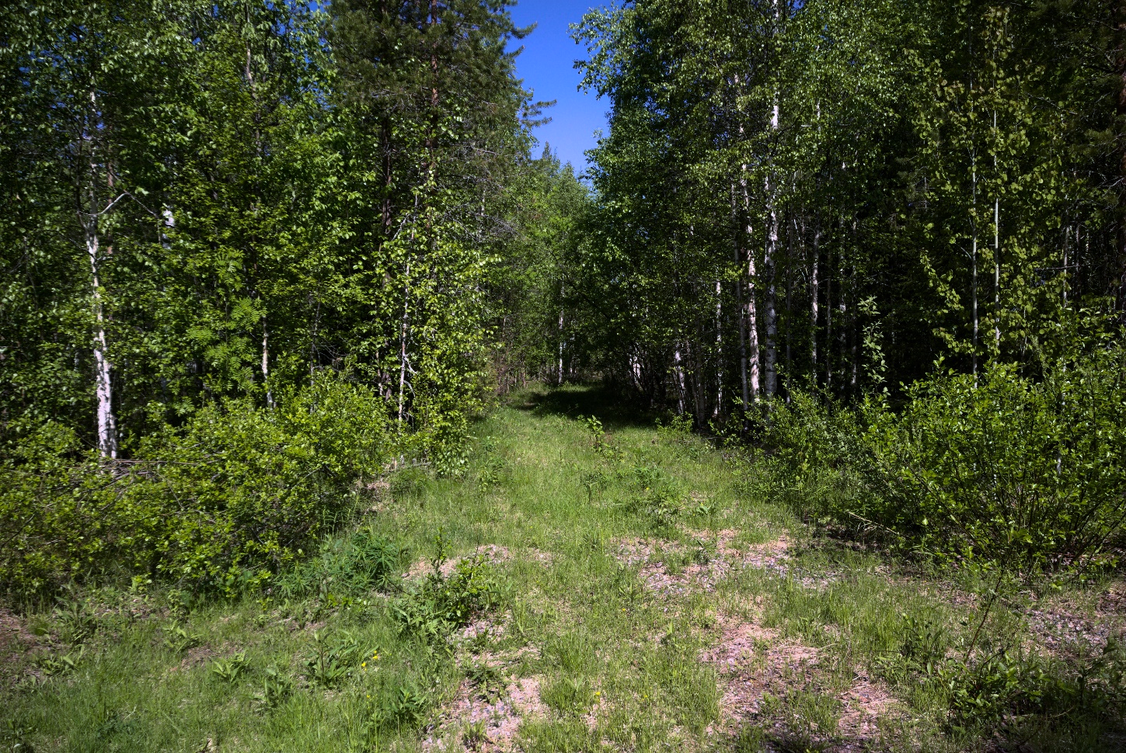
Supplement Figure 1. The entrance to Tainiaro in June 2023, facing the site’s interior to the north-northwest. Photograph by Aki Hakonen.
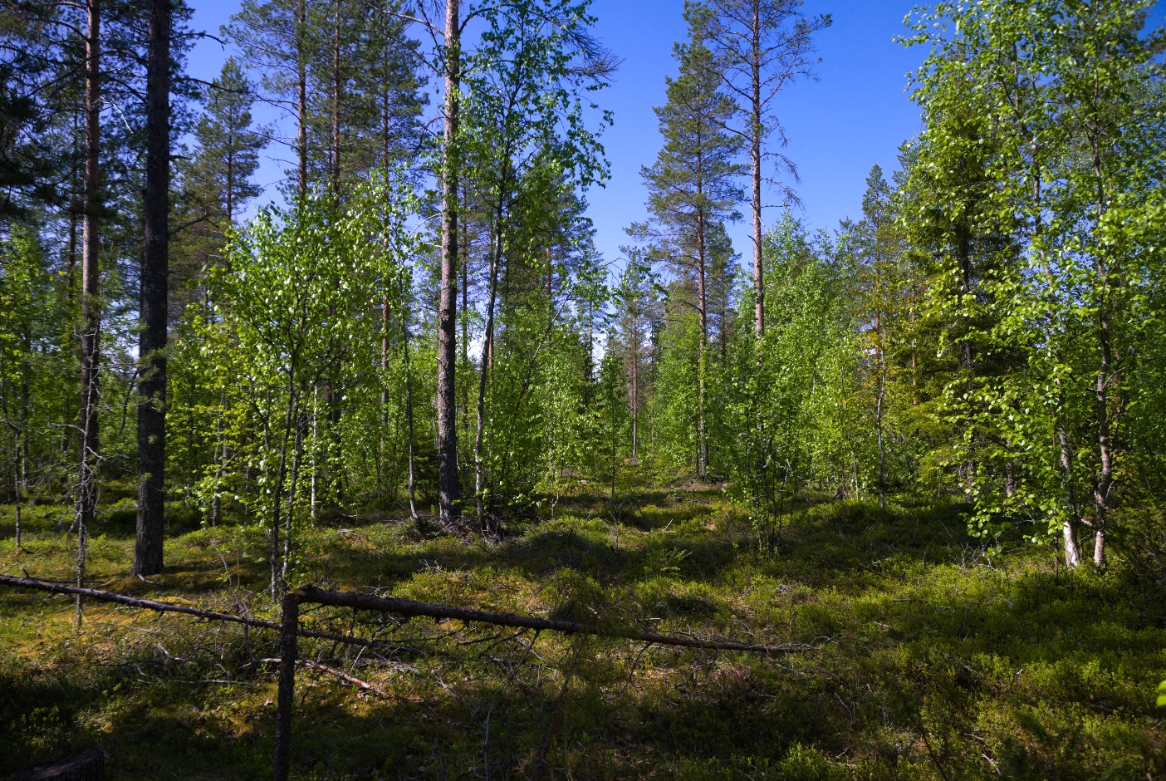
Figure S2. Tainiaro landscape in June 2023, taken at the foot of Area 9 (Figure S7) facing west. Photograph by Aki Hakonen.
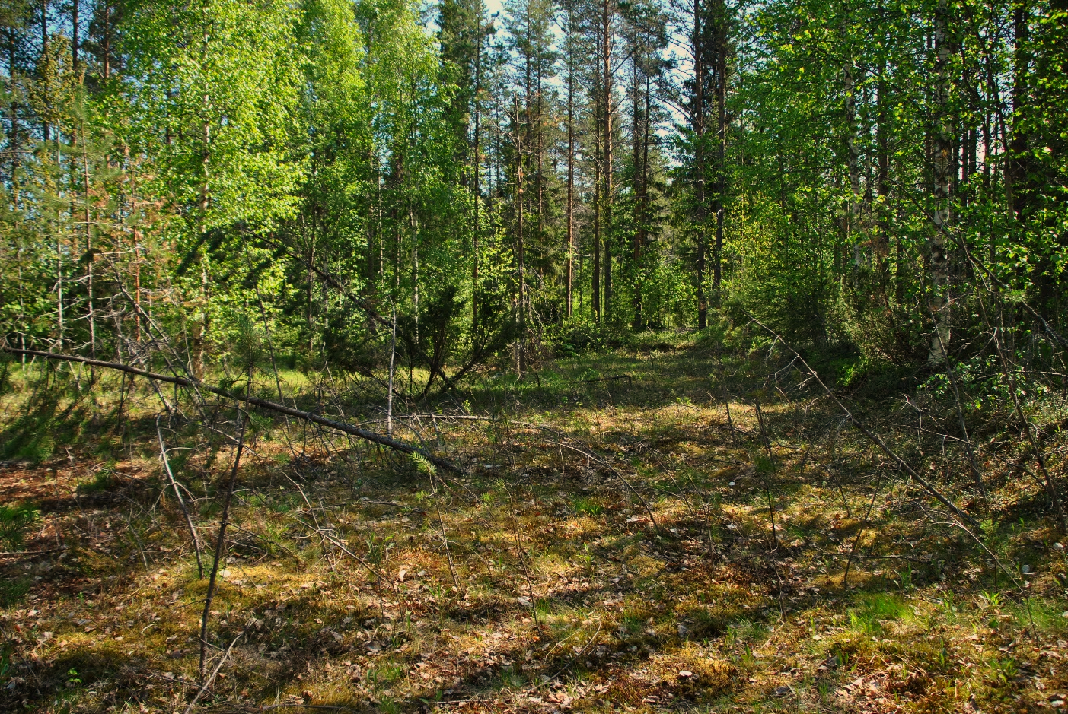
Figure S3. Backfilled area from 1984 and 1990 excavations in June 2023, looking to the east toward the overgrown sand pit (far left) where the first artefacts were discovered. Photograph by Aki Hakonen.
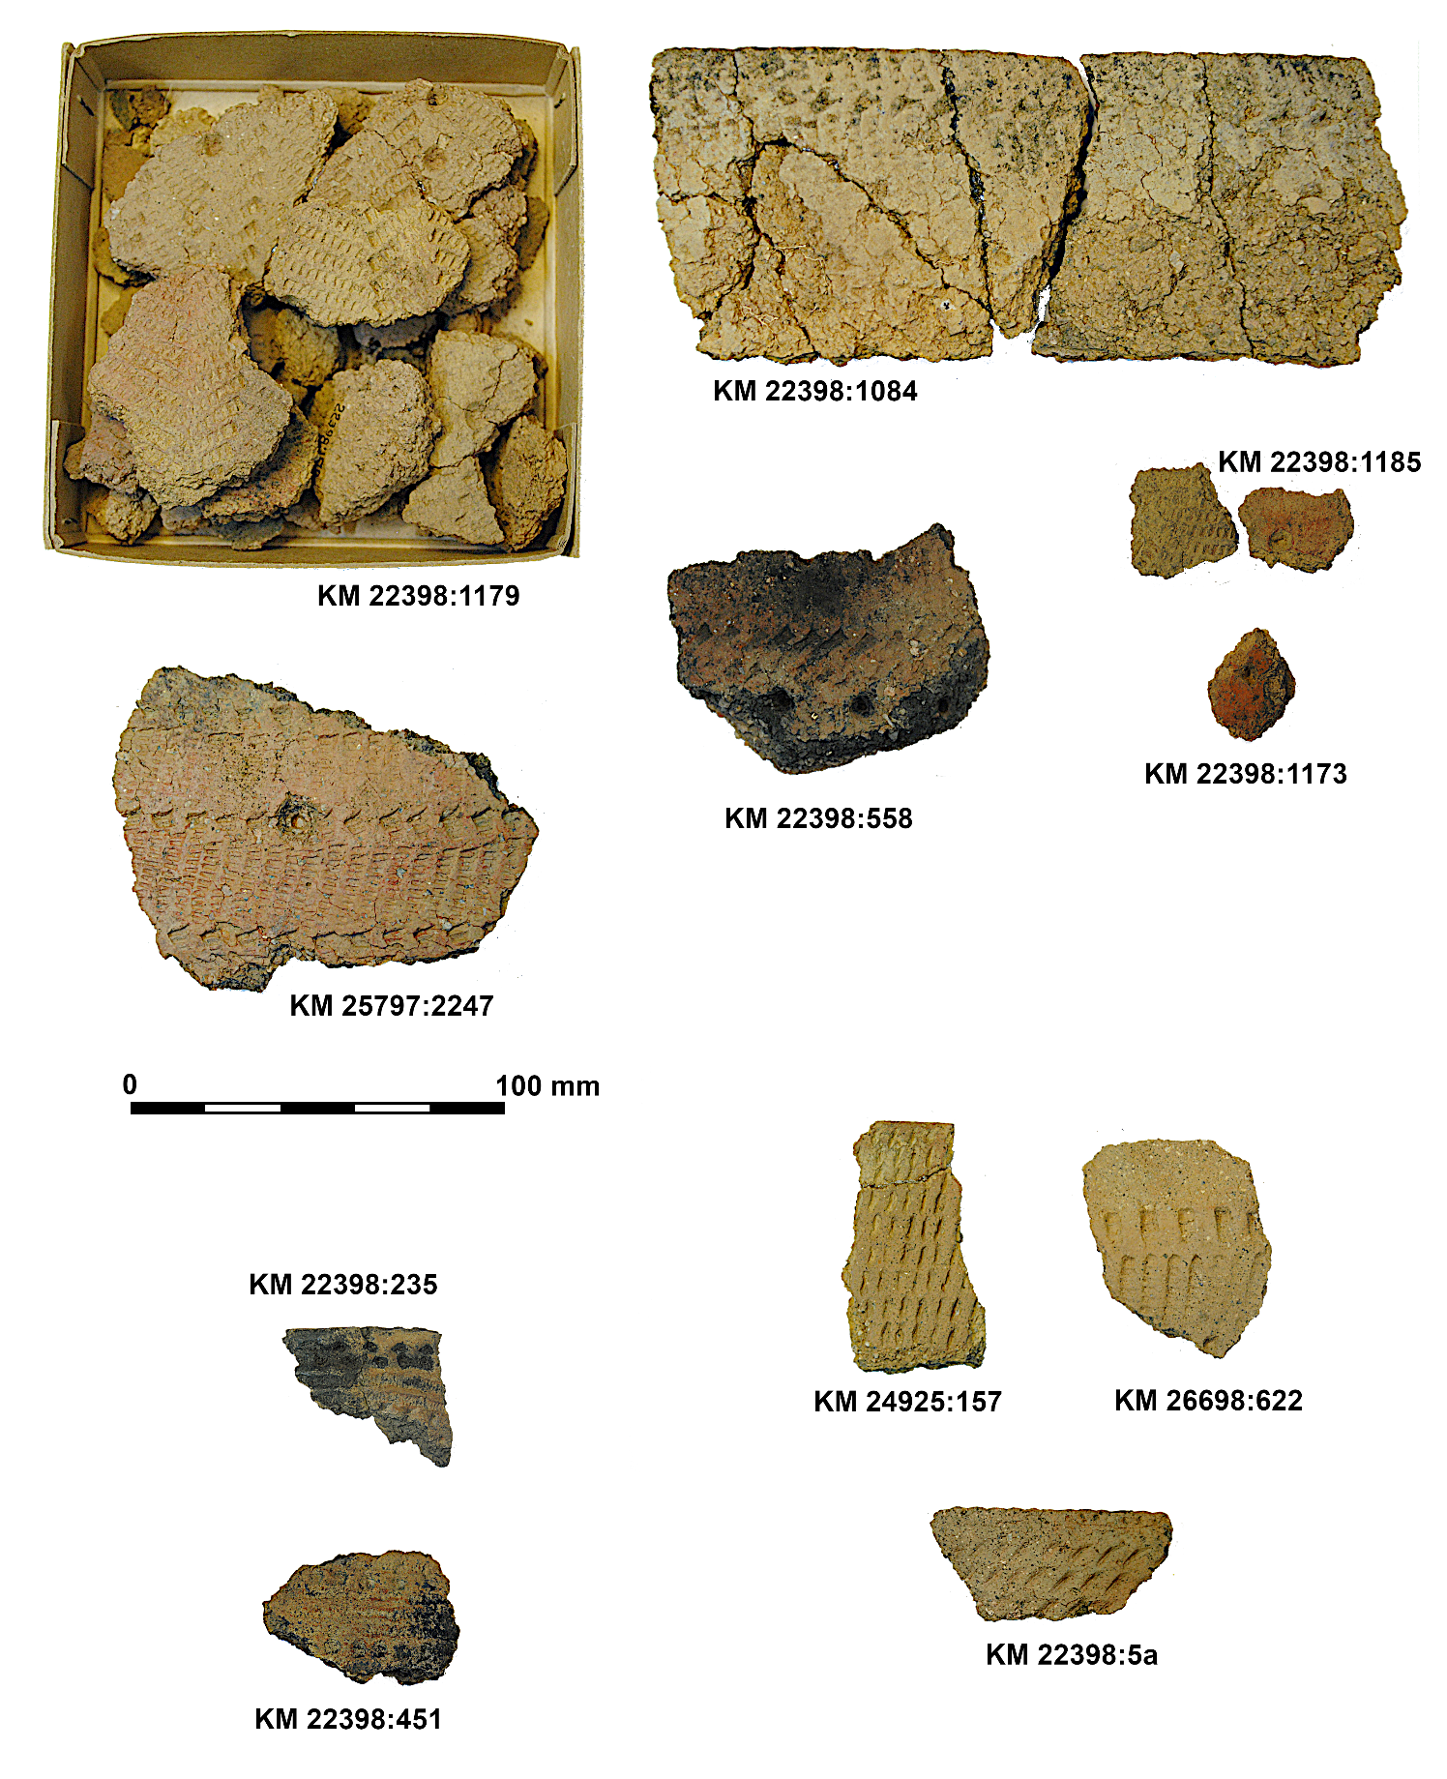
Figure S4. Examples of pottery from Tainiaro. The top half represents the dominant style Ka I:1, two shards on the lower left (KM 22398:235 and 451) are Säräisniemi 1-style, and the three shards on the lower right represent Ka I:2. Photographs by Aki Hakonen.

2. Supplemental maps from Tainiaro, Finland
Figure S5. Excavated areas of Tainiaro [registry id 751010040] and Tainilanrotko [751010051] as grey-shaded polygons. Elevation model, converted from 0.5 dots per m² lidar (2021), overlayed on a 2-m resolution elevation model. Geographical data produced by the National Land Survey of Finland (NLSF).
Figure S6. A false colored elevation model of the upper terrace, with a range of 77.5–80.3 m above sea level. Elevation model converted from 0.5 dots per m² lidar (by NLSF 2021).

Figure S7. New area divisions by year (different from main article Figure 3A). Areas 1–3 excavated in 1984, 4–7 in 1989, 8–9 and 13 in 1990, 10–12 in 1991, and Area 14 in 2018. Elevation model converted from 0.5 dots per m² lidar (by NLSF 2021).
Figure S8. Northern part of the east zone, view centered on Areas 1a, 1b and 5. Pit features 1–12 are class 5–6, features 21–23 class 4, features 35–42 class 3, features 54–63 class 2, and features 72–87 class 1. Elevation model converted from 0.5 dots per m² lidar (by NLSF 2021).
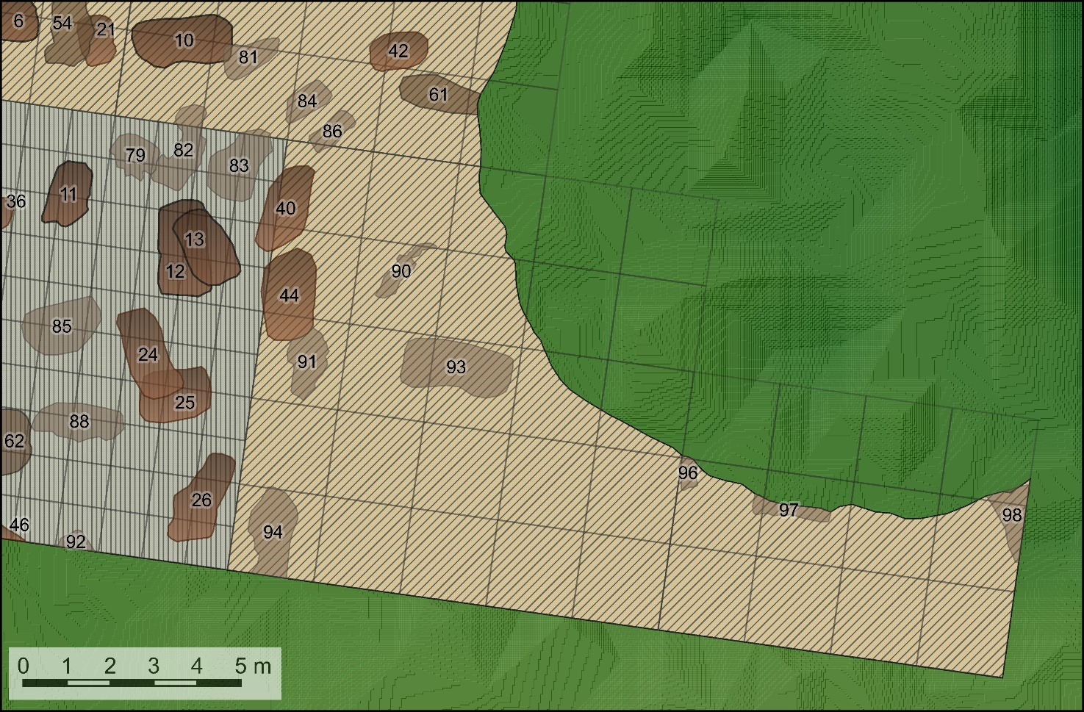
Figure S9. Southern part of the east zone, view centered on Areas 2 and 3. Pit features 6–13 are class 5–6, features 21–26 class 4, features 36–46 class 3, features 54–62 class 2, and features 79–98 class 1. Elevation model converted from 0.5 dots per m² lidar (by NLSF 2021).

Figure S10. Southeastern part of the east zone, view centered on Area 8. Pit features 3–13 are class 5–6, features 21–26 class 4, features 32–46 class 3, features 54–62 class 2, and features 73–94 class 1. Grey rectangular feature on the lower left corner is a small cabin built sometime between 1991 and 2018. Elevation model converted from 0.5 dots per m² lidar (by NLSF 2021).

Figure S11. Eastern part of the east area, view centered on Areas 6d, 14, and 4. Pit features 5–7 are class 5–6, feature 27 class 4, features 33–45 class 3, features 58–65 class 2, and features 73–95 class 1. Elevation model converted from 0.5 dots per m² lidar (by NLSF 2021).

Commentary (Figure S11)
Note, the 2018 excavation area no. 14 (in blue) was measured in place with a Total Station and is not aligned with other areas.
Figure S12. Central trial trench, Area 6c. Pit features 99 and 100 designated class 1. Grey round feature is a makeshift goahti-tent present on the site in 2018. Elevation model converted from 0.5 dots per m² lidar (by NLSF 2021).

Figure S13. Central trial trench, view centered on Area 6b. Pit feature 14 designated class 5 and features 101–113 class 1. Elevation model converted from 0.5 dots per m² lidar (by NLSF 2021).

Figure S14. Northern part of the central zone, view centered on Areas 6a, 7a, and 10. Pit features 16–17 are class 5–6, features 67–68 class 2, and features 109–125 class 1. Elevation model converted from 0.5 dots per m² lidar (by NLSF 2021).

Figure S15. Southern part of the central zone, view centered on Areas 9, and 7b. Pit features 15–16 are class 5–6, features 28–30 class 4, features 47–52 class 3, and features 112–123 class 1. Elevation model converted from 0.5 dots per m² lidar (by NLSF 2021).

Figure S16. Trial trench to the south, Area 7c. Pit features 116–121 are class 1. Elevation model converted from 0.5 dots per m² lidar (by NLSF 2021).
Commentary (Figure S16)
These possible pit features are unlikely burials. Only 20 individual finds were recovered, all from the upper layers 1–3.

Figure S17. Northern part of the west zone, Area 11. Pit feature 20 designated class 5, feature 53 class 3, features 69–71 class 4, and features 126–127 class 1. Elevation model converted from 0.5 dots per m² lidar (by NLSF 2021).

Commentary (Figure S17)
Note that according to the RTK-GPS measurements, Areas 11 and 12, excavated in 1991, were aligned to map north, whereas the rest of the areas were aligned to compass north (map NNE). Contrarily the 1991 excavation report places all areas in the same alignment.

Figure S18. Southern part of the west zone, Area 12. Pit features 18 and 19 designated classes 5 and 6. Small x indicates an RTK-GPS measurement point of a corner of the excavation area. Elevation model converted from 0.5 dots per m² lidar (by NLSF 2021).

Commentary (Figure S18)
Crosses in Figure S18 mark the RTK-GPS measurements taken in 2018 that were used for georeferencing Areas 11 and 12. As the Tainiaro terrace consists of a forest partly cut and thinned around 40 years ago, with a young canopy obstructing the satellite connection, the expected accuracy was roughly ±1 m. The measurements indicate that the western alignments correspond more with map north than compass north. The majority of 50 x 50cm test pits were dug in 1991, so they may also have similar alignments to Areas 11 and 12. Yet, as there was no effort to document their locations in 2018, the current georeferencing places these test pits on the compass north alignment (north-northeast on the map) in which they were originally documented. It is likely that either the alignments of Areas 11 and 12 or the 1991 test pits are georeferenced incorrectly in this study since they in all likelihood shared the same coordinate system.
Figure S19. Tainilanrotko excavation area, Area 13. No documented features. Elevation model converted from 0.5 dots per m² lidar (by NLSF 2021).
Figure S20. Phosphorus analyses conducted in 1984 (polygons from orange to dark red) and 1991 (levels rising from white to dark red). Elevation model converted from 0.5 dots per m² lidar (by NLSF 2021).

Figure S21. Distribution of pottery (dark red dots) and possible ground-level hearths (orange blobs). Elevation model converted from 0.5 dots per m² lidar (by NLSF 2021).

