[Supplementary material]
A wall or a road? A remote sensing-based investigation of fortifications on Rome’s eastern frontier
Jesse Casana*, David D. Goodman & Carolin Ferwerda
Department of Anthropology, Dartmouth College, Hanover, USA
*Author for correspondence ✉ Jesse.J.Casana@dartmouth.edu
Received: 10 February 2023; Accepted: 12 May 2023

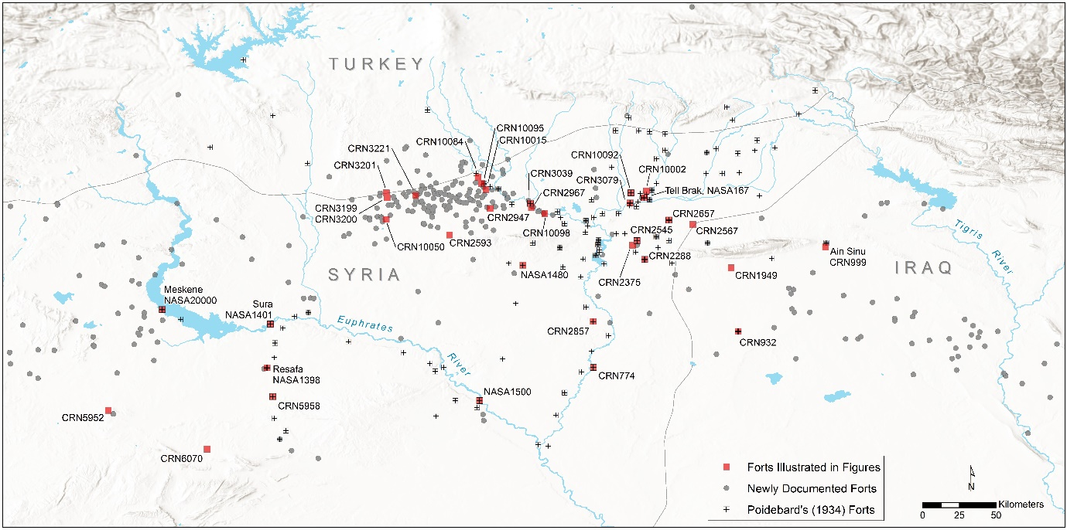

Figure S1. Distribution map of forts documented by Poidebard (1934) and in the present study.

