[Supplementary material]
Shark-tooth artefacts from middle Holocene Sulawesi
Michelle C. Langley^{1,2,*} [ORCID 0000-0002-0299-5561], Akin Duli³ [ORCID 0000-0002-3320-4435], Birgitta Stephenson⁴, Muhammad Nur³ [ORCID 0000-0002-1561-8781], Carney Matherson^{1,2}, Basran Burhan¹ [ORCID 0000-0002-9172-5888], Budianto Hakim⁵ [ORCID 0000-0003-0979-9798], Iwan Sumantri³, Adhi Agus Oktaviana^{6,7} [ORCID 0000-0002-9140-497X], Fardi Ali Syahdar⁸, David McGahan¹ & Adam Brumm¹ [ORCID 0000-0002-2276-3258]
¹ Australian Research Centre for Human Evolution, Griffith University, Brisbane, Australia
² School of Environment and Science, Griffith University, Brisbane, Australia
³ Departemen Arkeologi Fakultas Ilmu Budaya, Universitas Hasanuddin, Makassar, Indonesia
⁴ In the Groove Analysis Pty Ltd, Gold Coast, Australia
⁵ Research Center for Prehistoric and Historical Archaeology, BRIN, Makassar, Indonesia
⁶ Griffith Centre for Social and Cultural Research, Griffith University, Gold Coast, Australia
⁷ Research Center for Archeometry, BRIN, Jakarta, Indonesia
⁸ Independent researcher, Makassar, Indonesia
*Author for correspondence ✉ m.langley@griffith.edu.au
Received: 20 May 2021; Revised: 11 September 2022; Accepted: 23 September 2022

This file includes:

Supplementary text
Figures S1 to S13
Tables S1 to S3
SI References

- Tiger Sharks

1.1 Behaviour
Sharks with serrated teeth commonly number among the largest apex predators in modern marine ecosystems. Tiger sharks (Galeocerdo cuvier) can grow to over 5 meters and is a solitary, mostly nocturnal hunter. They have a widespread distribution across the globe, including in the waters surrounding Indonesia. Tiger sharks have the widest food spectrum of all sharks, feeding on fish, seals, birds, squid, turtles, dolphins, and smaller sharks. It is commonly known as the “garbage can with fins” owing to its habit of also consuming inedible, human-made objects (Ebert et al. 2013).

1.2 The teeth
Sharks shed their teeth continually. This loss and replacement cycle varies between species and individuals, and can be influenced by age, diet, water temperature, and damage sustained during feeding. As such, the process of a whole row of teeth being replaced can last anywhere in between a few days to several months (Ebert et al. 2013). Luckily, the morphology of shark teeth differs between species, and tiger shark teeth are distinctive enough to allow easy species identification (Figure 1).

Tiger sharks have between 18 and 26 teeth on each of their upper and lower series. The upper and lower teeth have the same morphology, with the only change being that the teeth get progressively smaller moving from the anterior to posterior sections of the jaw (Ebert et al. 2013).

Research undertaken by Pillay (2004) found that there is a relationship between the size of a tooth and the size of the tiger shark from which it came. Specifically, the length of the base, the length of the mesial serrations, and the maximum thickness of the tooth call all be used to estimate shark length. We used their correlation date to determine that the tooth recovered from Leang Bulu’ Sipong 1 came from a shark between 2.068-2.085 meters long and that from Leang Panninge between 1.900-2.070 meters long.

- Ethnographically observed use of shark teeth as tool components
Shark teeth – both fresh and fossilised – have seen extensive use in the Pacific, North America, South America, Australia, the Arabian Peninsula, and elsewhere.

2.1 Fighting Knives and other inter-personal weapons
The shark-tooth fighting knifes of northern Queensland are perhaps the most well-know of fighting tools in the Australian context (Figure S1). These weapons were restricted to fighting, and when to be used were hidden from view under an armpit or by hanging it down behind the head, the twine loop resting across the forehead. It was used to strike at an adversary’s flank or buttocks (Roth 1904). These weapons have been collected from both East and West Cape York and Torres Strait, as well as from the Batavia River in Western Australia. Of interest also, is a very similarly designed weapon utilising tiger shark teeth was also made by the Calusa of Southwest Florida (Lowery et al. 2011).

An exceptional example of a warfare weapon comes from Mer in the Torres Strait. This implement consists of a bamboo shaft about a meter long, with the top third covered in rows of shark teeth. Examination finds that the shark teeth have been attached in strips, still attached to the membrane in which they grew within the shark’s mouth. These strips were removed in sections, whole, from the shark’s mouth and then attached to the bamboo shaft using plant fibre ligatures. The result is tightly packed shark teeth surrounding the circumference of the pole (Langley pers. obs.).

From Wuvulu Island (situated north of mainland New Guinea, Micronesia), a number of shark tooth weapons have been described and include lances, knives, and clubs (Edge-Partington 1896). The hafting of the shark teeth is described by Edge-Partington (1896:291-292) as “the teeth fixed in a hollow cut to receive them and lashed on by fine cord. For this purpose each tooth is perforated”. No mention of an adhesive is mentioned here, but from looking at very similar weapons collected from the smaller island of Aua just north of Wuvulu (curated by the University of Queensland Anthropology Museum, Figures 7 and S1-3), we can see that an adhesive was used in addition to the ligature.

Next, a suite of fighting implements featuring shark teeth were made by the Gilbertese people of the Gilbert Islands, Kiribati and were recorded by early European observers (Murdoch 1923). These daggers, swords, spears, and lances were used in highly ritualised, and often fatal, conflicts (Maude and Maude 1981; Murdoch 1923). Murdoch (1923) reports that these conflicts were in tribal warfare, between or within family units, and any other feud which resulted in fighting. Such weapons are mentioned as used by both men and women, the latter using a tebutu, a tool from four to six inches in length, featured one to four shark teeth attached to one side, and was “used by the women to cut and disfigure each other when quarrelling” (Murdoch 1923:175). In this context, the shark teeth were fixed to the wooden shaft using a single hole drilled through the root, through which a string made of braided coconut fibre and human hair was threaded. No mention of an adhesive being used to haft the shark teeth has been found in this context. It is important to note that, the abundant use of shark teeth in this culture is support by a complex shark fishing tradition, that is to say the teeth were sourced by their own catches of these animals (Loumala 1984).

In Polynesia, lances tipped with a series of shark teeth down one side have also been observed. Here such a lance was part of the Tahitian mourning costume (Illidge 2002). Again, the teeth are perforated through the root for attachment. A similar sounding weapon was described by Gapar de Espina in 1516 when describing coastal peoples of Panama, “they had pikes and lances fashioned like pikes…studded for a distance of half a yard from the tip with the teeth of the shark and other fish” (cited in Charpentier et al. 2009:15).

Shark teeth are also known to have been embedded into a long, straight piece of wood to make cudgel in Florida, USA (Martin et al. 1947; Kozuch and Fitzgerald 1989). Travellers accounts of Arabia mention that some groups specialized in shark fishing (Miles 1919; Thomas 1929), suggesting that as in Kiribati, the more extended use of their teeth to arm weapons was supported by active fishing practices.

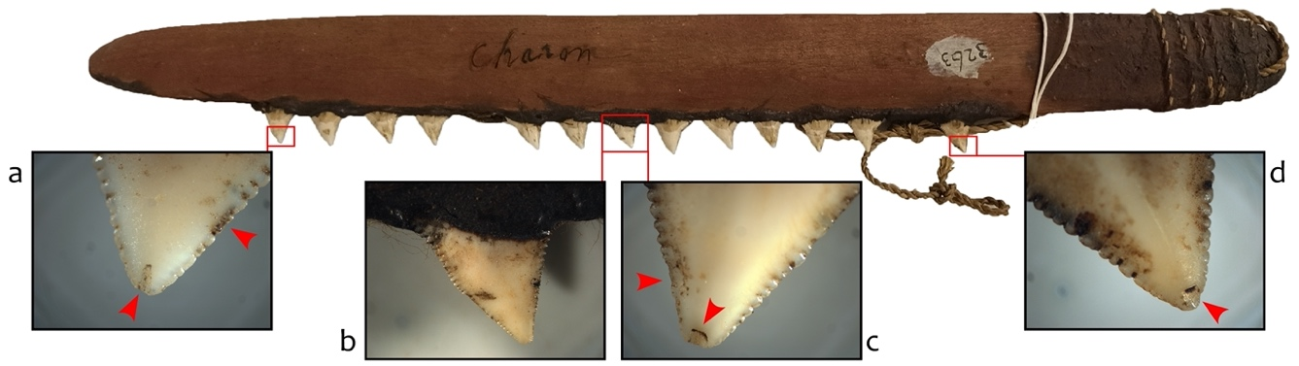

Figure S1. Example of a shark-tooth fighting knife from Arukun, Queensland, Australia (The University of Queensland Anthropology Museum, no. 3263). Red arrows highlight use-related wear.

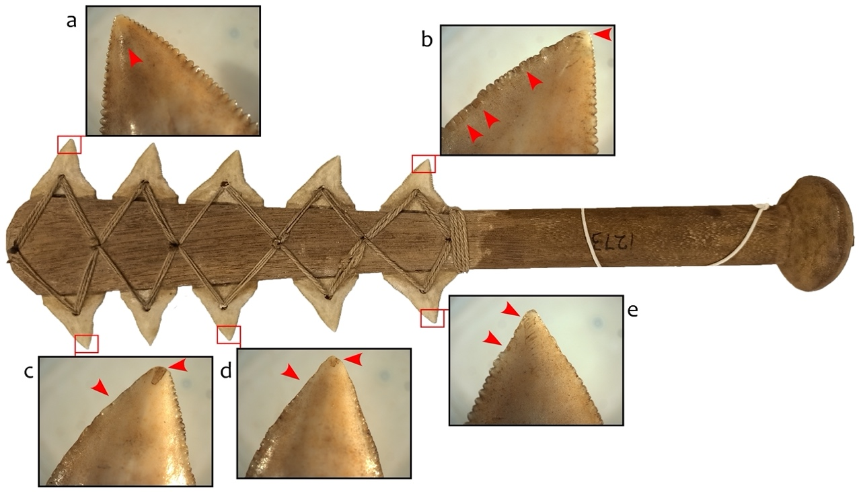

Figure S2. Example of a shark-tooth knife from Aua Island, Papua New Guinea (The University of Queensland Anthropology Museum, no. 1273). Red arrows highlight use-related wear.

2.2 Other knives
Dodge (1939) describes what he calls “shark-tooth cutters” which were collected from Hawaii between 1820 and 1864. These implements feature a single line of shark teeth set into a hardwood handle using resin and copper pegs. He describes how shark-tooth implements in Hawaii were known to be used for wood-carving, as concealed weapons, and for “cutting up dead chiefs and cleaning their bones preparatory to the customary burials” (Dodge 1939:157). Dodge is unable to assign a clear function to the two particular “cutters” he describes in detail but suggests that they may have been used in either of these last two functions (fighting or ritual body preparation).

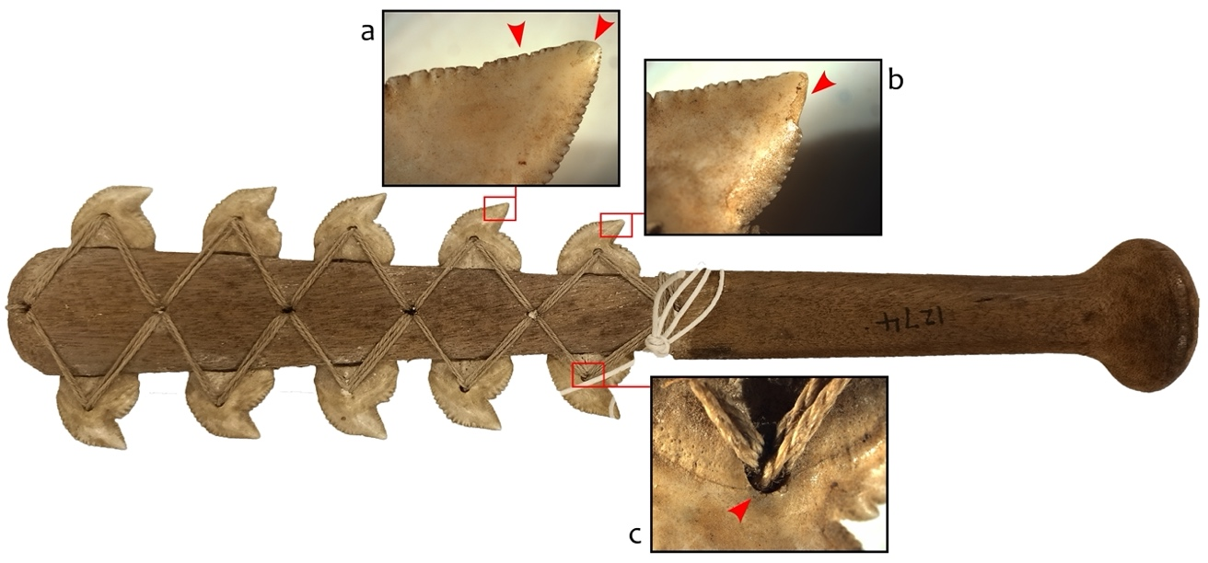

Figure S3. Example of a shark-tooth knife from Aua Island, Papua New Guinea (The University of Queensland Anthropology Museum, no. 1274). Red arrows highlight use-related wear.

2.3 Tattooing implements
Finally, shark teeth are known to have been used as tattooing blades in the Pacific, with specific mentions for Tonga, Aotearoa, and Kiribati (Drew et al. 2013; Roth 1906:8). Tattooing implements typically accrue significant staining from the ink utilised (Clark and Langley 2019), and as such staining was not present on any part of the Sulawesi teeth edges, such a use was dismissed.

2.4 Blood-letting implements
Shark teeth found in Mayan and Mexican sites are believed to have been used as blood-letting tools (Borhegyi 1961).

- Previous archaeological finds

3.1 Shark tooth tools and ornaments
Utilized shark teeth are not an overly common find from archaeological contexts globally, with the oldest examples currently found in the Pacific (Table S1). Where identification or suggestions of the function of manipulated shark teeth are given by authors, they are usually as ornaments, cutting implements, or weapons. For example, in northeast USA and adjoining Canada (Maritime Peninsula), shark teeth have sometimes been suggested to have been used as arrowpoints when not found in ceremonial contexts (that is, burials) (e.g., Smith and Wintemberg 1929:26). This function is considered improbable by Betts et al. (2012) owing to the majority of shark teeth being recovered from ceremonial contexts. In eastern Arabia, however, evidence for the use of shark teeth as arrow points has been found – there a shark tooth point found embedded within the lumbar vertebrae of an adult individual buried in the necropolis of Ra’s al-Hamra 5 (dated to 3700-3300 BP) (Santini 2002).

In Florida (USA), shark teeth found in situ and still within their hafts at Key Marco were suggested to have been tools for carving bone, horn, and wood (Cushing 1896). Interestingly, Cushing (1896:371) states that “as soon as we discovered a few of them I secured fresh teeth and experimentally made knives and cutters of the various kinds I have described. I found these diminutive shark-tooth blades -- the one edge of each outwardly, the other inwardly, curved – by far the most effective primitive caring tools I have ever learned of, and therein perceived on of the principal causes of the preeminence of the ancient key dwellers in the wood carver’s art, so constantly evidenced in our collections”. He does also describe fighting weapons; “wooden sabres—for they were armed along one edge with keen shark-teeth” as well as a club edged with Tiger shark teeth (Cushing 1896:372). Regarding the club, Cushings (1896:373) sums up his description by saying “it was, at any rate, a most formidable weapon and a superb example of primitive workmanship and ingenuity”.

Table S1. Previous finds of utilized shark tooth from archaeological contexts. Utilized fossil shark teeth are not included here and listed function is as suggested by the source publication.
Site |  | Age | Function | Find Description | Reference
Pacific & Australasia
Buang Merabak, New Ireland | Papua New Guinea | c.39,500-28,00 BP | Ornament | Single Tiger Shark (Galeocerdo cuvier) tooth with single perforation through root. Tooth is 2.7 cm long and 1.6cm high, = 4 m long shark. Perforation is c. 2 mm diameter, bifacially drilled. Identification as ornament based only on single perforation. | Leavesley 2007
Kilu, Buka Island | Papua New Guinea | c.9,000 - 5,000 BP | Ornament | “Shark teeth, reminiscent of the finds from Balof 2, but here with drilled suspension holes”; 2 drilled shark teeth from “Mixed Levels” and 9 drilled shark teeth from Holocene levels; “shark teeth with drilled suspense holes” - present throughout Holocene deposit. | Wickler 1990
Maivipi, Orokolo Bay | Papua New Guinea | 655-430 cal. BP | Unid. | Single shark tooth, fractured at root end - not perforated, use not determined. Species not identified. | Basiaco et al. 2020
Goodwood Beach, near Otago Harbour | New Zealand |  | Ornament | Necklace of 46 altered Carcharodon teeth strung as a necklace. | Duff et al. 1977
Karitane, near Otago Harbour | New Zealand |  | Ornament | 10 Carcharodon teeth – part of a necklace – found in a burial context. | Duff et al. 1977
Wairu | New Zealand | c. 200 BP | Ornament / Tattooing blade | Shark teeth found in burial context as a necklace (38 teeth) as well as modified others which are suggested to have been ornaments. Another (Carcharodon) tooth was altered for use as a tattooing blade, | Duff et al. 1977
East Asia
Nong Nor, coastal Central Thailand | Thailand | Bronze Age | Ornament | 160 burials have been found at Nong Nor, in coastal Central Thailand, all dating to the Bronze Age period. These all contained bangles, bracelets, earrings, necklaces, pendants and miscellaneous loose beads manufactured from shells, soft stones, hard stones, bronze, tin, tiger teeth and shark teeth, which presents some similarities with other archaeological sites like Samrong Sen. | Chang 1996
Naton Beach, Guam | Mariana Islands | ca. 730 BC to 1600/1700  (3409 - 250 BP) | Ornament | 12 Drilled Tiger shark (Galeocerdo cuvier) teeth in Pre-Latte burials (all female burials) and 2 Drilled Silky Shark (Carcharhinus falciformis) teeth both in Latte/post-contact burials (1 male and 1 Gender unknown burial). Silky shark teeth both have single central perforation. Tiger shark teeth have two small perforations in the roots. Found in Burials. | Amesbury et al. 2020
Powa Site (FSPO), Fais Island | Fais Island | 1360 ± 40 BP | Unid. | “Perforated shark tooth (1 hole) 3 in FSPO (3,4,8 and 9; 8 found in “lowest layer found”. Function unidentified. | Intoh 2008
Central America
Multiple Mayan sites | Mexico and Guatemala | Mayan contexts | Ritual | Non-perforated shark teeth, found either as burials offerings or in votive vases and caches. | Borhegyi 1961
South America
Garivaldino RS-TQ-58, Rio Grande do Sul State | Brazil | 9.4-7.2 kyr BP | Ornament | Carcharhinus shark teeth interpreted as pieces of necklaces | Mentz Ribeiro and Torrano Ribeiro 2001
Nutria Mansa 1, eastern Pampas | Argentina | Early to middle Holocene; ca.130 to 8.5 ky BP | Ornament/ Tool | Two great white shark (Carcharodon carcharias) teeth found in a terrestrial mammal hunter-gatherer context. Edges of basal section (root) grooved for stringing and apical edge “strongly eroded”, suggesting they were used as pendants and/or tools. | Cione and Bonomo 2003
Multiple shell midden sites (Major, Ilha do Cabo Frio, Caieira, Algodão, Acaiá), Rio de Janeiro coast | Brazil | c.5595-3000 cal. BP | Ornament | Carcharodon carcharias, Carcharhinus altimus, C. leucas, C. plumbeus, Galeocerdo cuvier, Sphyrna mokarran teeth with single drilled perforation found. Authors state that some of these were recovered as pendant necklaces associated with human burials | Lopes et al. 2016; Gonzalez 2005
Piaçaguera, Mar Casado, & Buracão, São Paulo State | Brazil | 4.9 kya BP  4.4 kya BP  1.95-1.24 kya BP | Ornament/ Tool | Burials associated with funerary goods which include decorated and perforated shark teeth and tools made with shark teeth. | Uchôa 1980
Corondó (RJ-JC-64), Rio de Janeiro coast | Brazil | 4.2-3 kyr BP | Ornament | Perforated shark teeth and vertebrae found associated with burials. | Machado 1984
Rio do Meio, Santa Catarina Island | Brazil | 500-700 cal. BP | Cutting tool | Carcharodon carcharias shark teeth double-perforated through the roots, used as hafted cutting tools. | Gilson and Lessa 2021
North America
Maritime Peninsula (multiple sites) | Canada/USA | ca.5,000 BP to 950 BP | Ornament | Multiple burials contexts dating to the Late Archaic through to the Late Woodland periods which included shark teeth and jaw parts. Some of these teeth were ochre-covered, some were apparently worn as ornaments on the head or chest, and some display use wear. Several are suggested to have been held in medicine bundles interred with the individual. | Betts et al. 2012
Key Marco, Florida | USA | c. 2,000 to 1,000 BP | Carving tool / Weapons | Shark teeth found still within their hafts, evidence for the use of ligatures and adhesive for the hafting. Suggested to be wood, bone, and horn carving implements. Shark-tooth sabers and clubs also described which used Tiger shark teeth. | Cushing 1896
Boca Weir, Florida | USA | c. 1450 to 350 BP | Cutting tool / Carving tool | 175 teeth from Galeocerdo cuvieri, Negaprion brevirostris, Hemipristis serra, Odontaspis taurusm Carcharodon carcharias, Isurus oxyrhincus exhibiting use wear and evidence for hafting. Analyst suggest their use as cutting tools and in some cases, possible fine woodworking tools. Two appear to have been used as drills. | Furrey 1977
Fort Center, Florida | USA | c. 2,450 BP to c. 300 BP | Carving tool | 197 Galeocerdo cuvieri, Negaprion brevirostris, and Hemipristis serra teeth exhibited use wear and evidence for having been hafted; Also found were Odontaspis tarus, Carcharodon carcharias, Isurus oxyrinchus, and Carchardon meglodon teeth with signs have use. Use in woodcarving is suggested. | Steinen 1982
Palmer site, Florida | USA | c. 1850 to 750 BP | Unid. | Three shark teeth (2 x tiger shark and 1 x blacktip shark) with evidence for having been hafted. Use wear analysis not completed. | Kozuch 1998
Arabia
Suwayh 1, Suwayh 2, Ruwayz 1, Ra’s al-Khabbah 1, Wadi Shab 1, Ra’s al-Hamra 5 and 10, Ra’s al-Jins 6, Ra’s al Hadd 10 | Saudi Arabia, UAE, Oman | c. 5300-2700 BP | Weapons | Suggested use of shark (Carcharhinus leucas) teeth as projectile points during the Neolithic and persist into the early Bronze Age. These have their bases abraded with two perforations. One such tooth was found embedded in the lumbar vertebrae of an adult individual at Ra’s al-Hamra 5 dated to 3700-3300. Some could be ornamental (those with one perforation). Sharks greater than 2 m were targeted for fishing. | Charpentier et al. 2009; Santini 2002

- Identifying manufacturing and use traces on the shark tooth artefacts

The Sulawesi artefacts were examined on the Nathan Campus of Griffith University by MCL with macrophotograph completed with a Canon digital SLR camera, before examination using a Zeiss Stemi 508 stereomicroscope fitted with an Axiom 105 camera, as well as an Olympus DSX1000 digital microscope. Metrics were collected using Mitutoyo CD-6” digital calipers, their metal arms coated with a thin plastic layer to protect the artefacts from damage.

4.1 Natural damage patterns
Study of modern sharks with serrated teeth, including the tiger shark (Galeocerdo cuvier), finds that damage in the form of splintering, cracking, and flaking near the cusp apex is common (Becker and Chamberlain 2012). This damage is the result of the forces applied by the animal during feeding, sharks of this type being able to apply enormous bite force (Frazzetta 1988; Wroe et al. 2008). When damaged, the teeth are rapidly replaced (usually in less than a week) by new teeth which move forward in a conveyor belt fashion to ensure maximum sharpness is available to the animal at all times (Becker and Chamberlain 2012). Indeed, examination of three sets of intact tiger shark jaws curated in the Queensland Museum (Brisbane) found that teeth exhibiting damage while still in the jaw were relatively rare – only a handful with damage were seen in this context (Figure S4a-b).

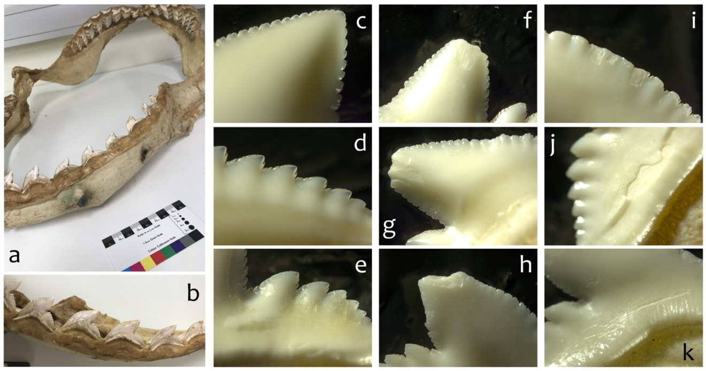

Figure S4. Appearance of tiger shark (Galeocerdo cuvier) teeth in natural state, with the exception of (k) which exhibits a cut mark from being cut free of the cartilage. Intact jaw of tiger shark (a and b) curated in the Queensland Museum (yes, those are bullets); (c – k) tiger shark teeth sold individually through jewellery supplier which displayed naturally accrued damage.

Becker and Chamberlain (2012) found four general types of damage to serrated shark teeth on a sample of 50 shark jaws belonging to great white shark (Carchaodon carcharias), bull shark (Carcharhinus leucas), and tiger shark (Galeocerdo cuvier): (1) labial damage on the tooth cusp apex; (2) labial damage on the mesial edge; (3) lingual damage on the tooth cusp apex; and (4) lingual damage on the mesial edge. Our own study of 250 individual tiger shark teeth bought from an (ethical) jewellery supplier found this same distribution of damage, with about 40% of the teeth displaying some form of damage (from minimal, small flakes through to larger breakage of the apical cusp) (Figure S4f-i). The remaining 60% of the teeth exhibited no damage whatsoever (Figure S4c-e).

4.2 Experimentally produced damage patterns
To determine what kinds of damage shark teeth used as tools accrue, a small experiment was completed. Eva Martellotta and Tessa Knights assisted with the experimental use of the replicated shark-tooth tools.

Having determined that shark teeth perforated through the root were most commonly used to construct knives and fighting tools, and on such tools one tooth was hafted below another in a series, we made several tools with such an arrangement. Specifically, we selected tiger shark teeth from among the store-bought assemblage which were found to display no prior damage. Two of these teeth were hafted inside a plywood shaft – into a groove made to house the basal section (Figure S5a-b). These grooves fit the two teeth snuggly, and then cotton string twine was passed through the perforations to tie them down. To secure the haft further, we used a commercial super glue to fill the groove around the tooth base. Such modern materials were suitable for this experiment as we were only interested in what use wear developed on the apical section of the shark teeth.

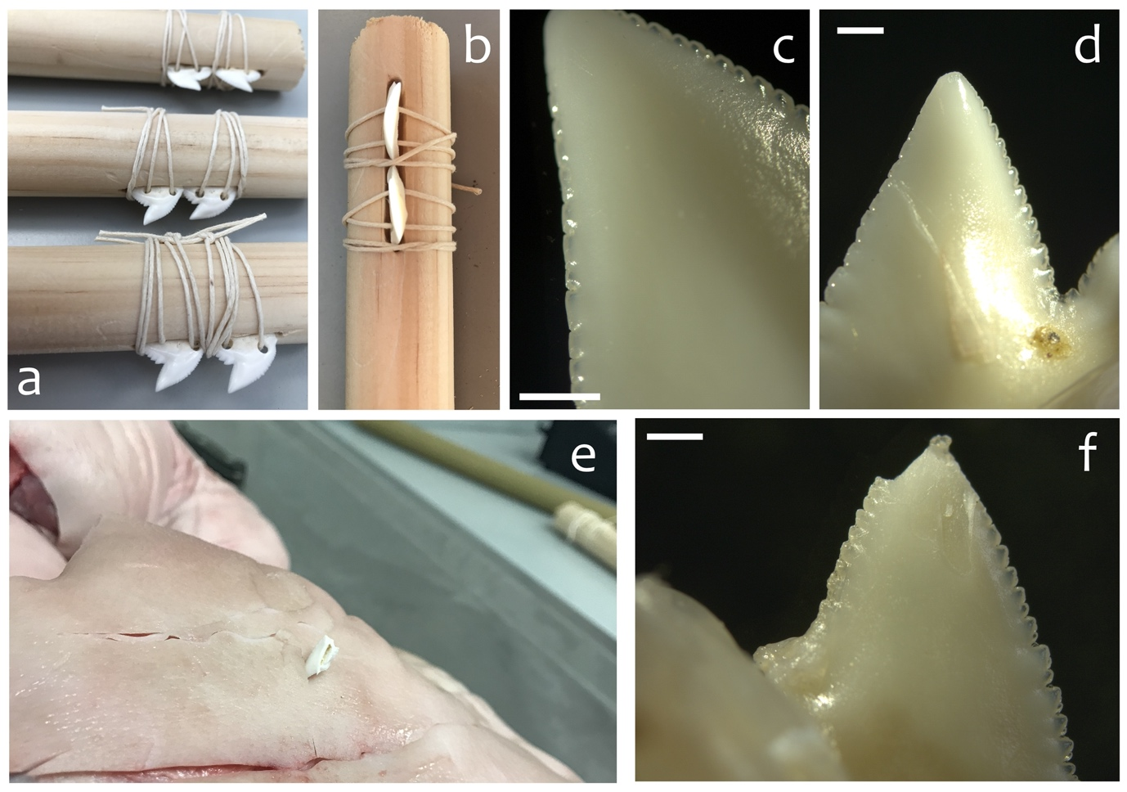
Figure S5. Experimental use of tiger shark teeth as cutting and fighting knives: (a-b) hafting arrangement of the experimental tools; (c) flattened aspect of the mesial serrations after scraping bamboo; (d) chipping and crushing of apex and mesial serrations after butchering a pork leg; (e) deep, long gashes created by the shark tooth fighting knife and fragment of shark tooth left embedded; (f) large chips off apex and chipping of mesial and distal serrations on the remaining tooth of the fighting knife. Scale bar = 1 mm.

We then used one tool to scrape fresh bamboo, the second to butcher a leg of pork, and the third in the striking manner of a fighting knife. As might be expected, the shark-tooth edge was very efficient for cutting softer surfaces. The tool used to butcher the leg of pork easily managed this task, and though it was only used for less than 30 minutes, it developed chipping and crushing wear to the apex and mesial serrations (Figure S5d). The tooth-tool used to scrape bamboo similarly developed wear after a short period of 20 minutes, the mesial serrations wearing down to an almost flat aspect (Figure S5c). Finally, the tool used as a fighting knife – where it was repeatedly struck into a leg of fresh pork using a swift down-and-slicing motion with force -- created deep, long gashes and resulted in one of the shark teeth fracturing at the haft level on the 30th blow (Figure S5e). The remaining hafting tooth on this tool had suffered significant chipping to the cusp apex (Figure S5f).

These results support those described by Gilson et al. (2021) who explored use wear which developed on shark teeth when used in a variety of functions including as arrowheads, cutting tools, piercing tools, scraping tools, and sawing tools. Also of interest here is that Gilson and Lessa (2021) report that in their experiments, shark teeth are easily extracted from the jaw using heat, either using hot water or directly heating the toother over a fire. They noted that this second method resulted in burn marks on the teeth, marks which they were able to identify on archaeological specimens excavated from their Brazilian context. No such burning marks were present on the Sulawesi specimens.

4.3 Damage patterns observed on the Sulawesi artefacts
Figure S6 presents additional images of the use-related damage observed on the Sulawesi artefacts. Both small (Figure S6a and f) and large (Figure S6b-c) chips were observed along the tooth edges. Long striations were clearly visible on the lingual surface of the Leang Panninge artefact (Figure S6e), and this tooth may have been subjected to resharpening through the grinding of lingual and labial surfaces of the cusp (Figure S6d and f).

The small orange discoloration visible at the tip of the Leang Panninge tooth was carefully examined, and found to be a dental carie, and thus of natural origin.

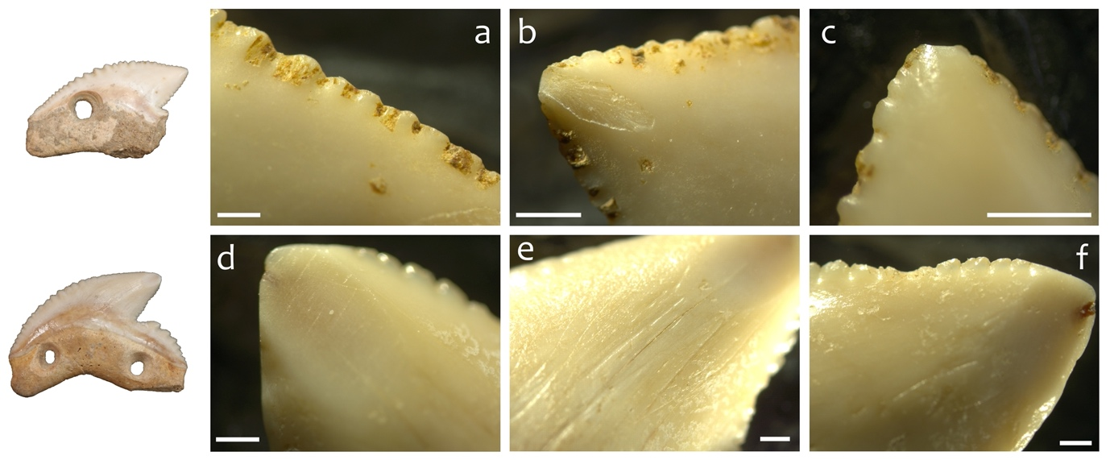

Figure S6. Use-related damage observed on the Sulawesi tiger shark teeth artefacts. Scale bars = 1 mm.

Figures S7 and 8 present detailed images (created from micrographs) of the lingual surfaces of each of the Sulawesi artefacts. These images highlight the portion of the tooth edge which accrued the most use-related damage.

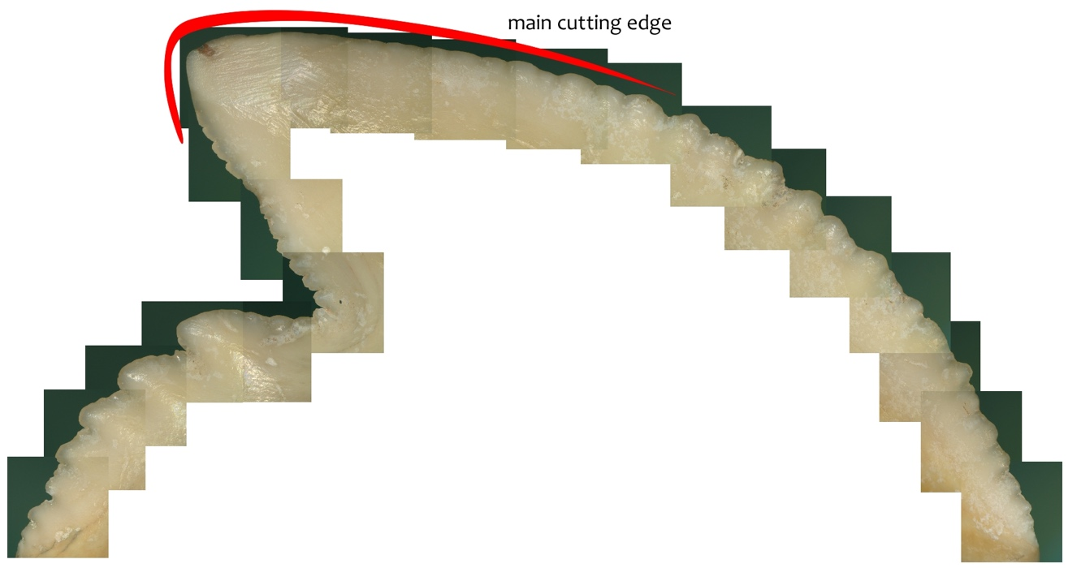

Figure S7. Use-related damage observed on the Leang Panninge tooth -- lingual surface.

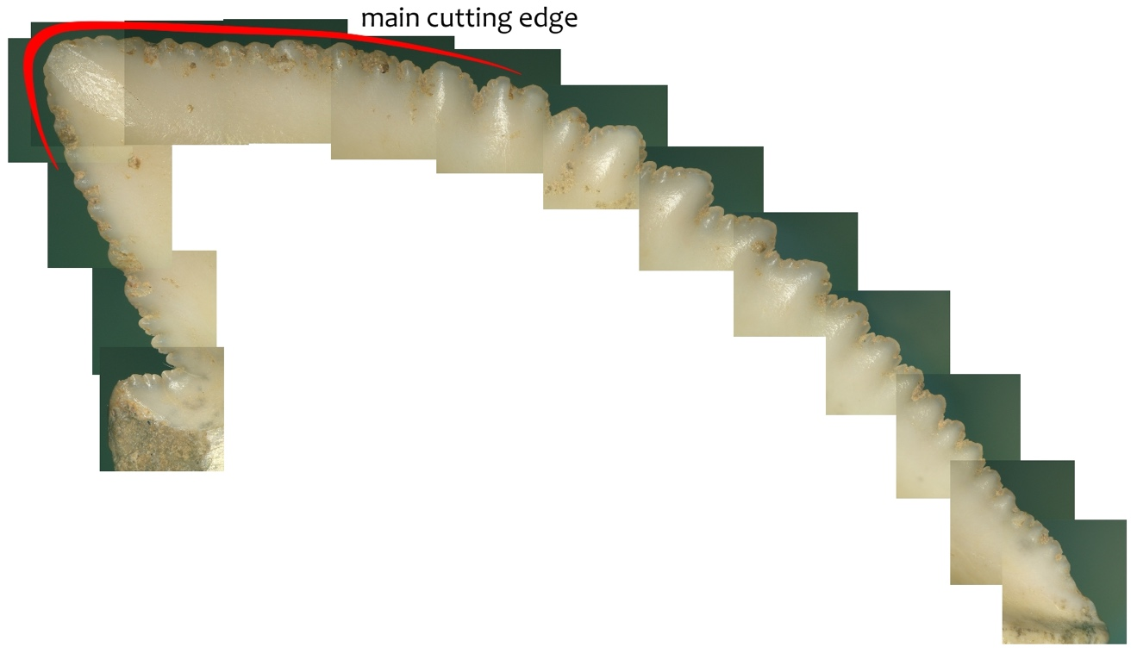

Figure S8. Use-related damage observed on the Leang Bulu’ Sipong 1 tooth -- Lingual surface.

4.4 Perforations
The perforations on both artefacts were drilled using a stone-tipped drill, as indicated by the presence of consecutive striations running around the interior of the perforation walls (Figure S9). Figure S9 provides additional images of these perforations.

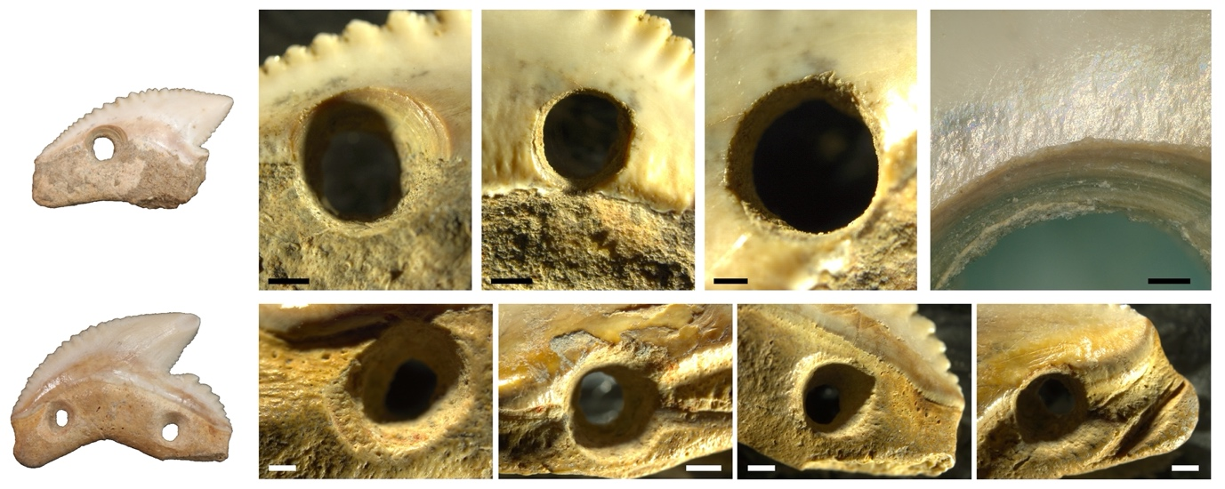
Figure S9. Detail of perforations on the Sulawesi shark teeth. Scale bars = 1 mm.

4.5 Hafting-related wear
Figure S10 provides additional images of the hafting-related wear and residues observed on each of the Sulawesi teeth.

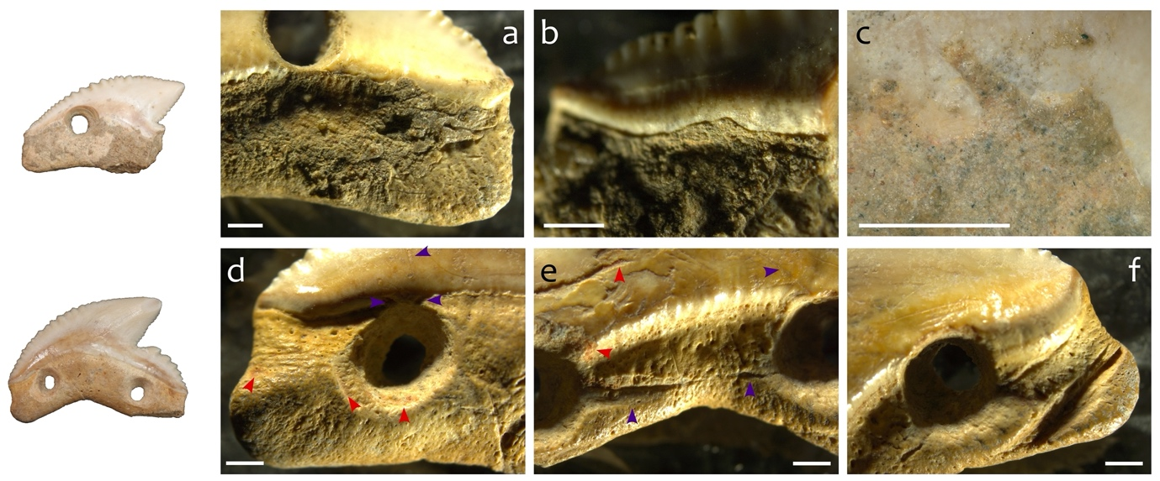
Figure S10. Detail of evidence for ligature and adhesive hafting on the Sulawesi shark teeth. (a-c) Leang Bulu’ Sipong 1; (d-f) Leang Panninge. Red arrows are indicating presence of red residue, while blue arrows are indicating ligature related grooves and notches. Scale bars = 1 mm.

Figure S11 presents a composite of micrographs taken of the middle section of the Leang Panninge artefact. These sections presented a bright, high polish overlaid with grooves and striations from the hafting material.

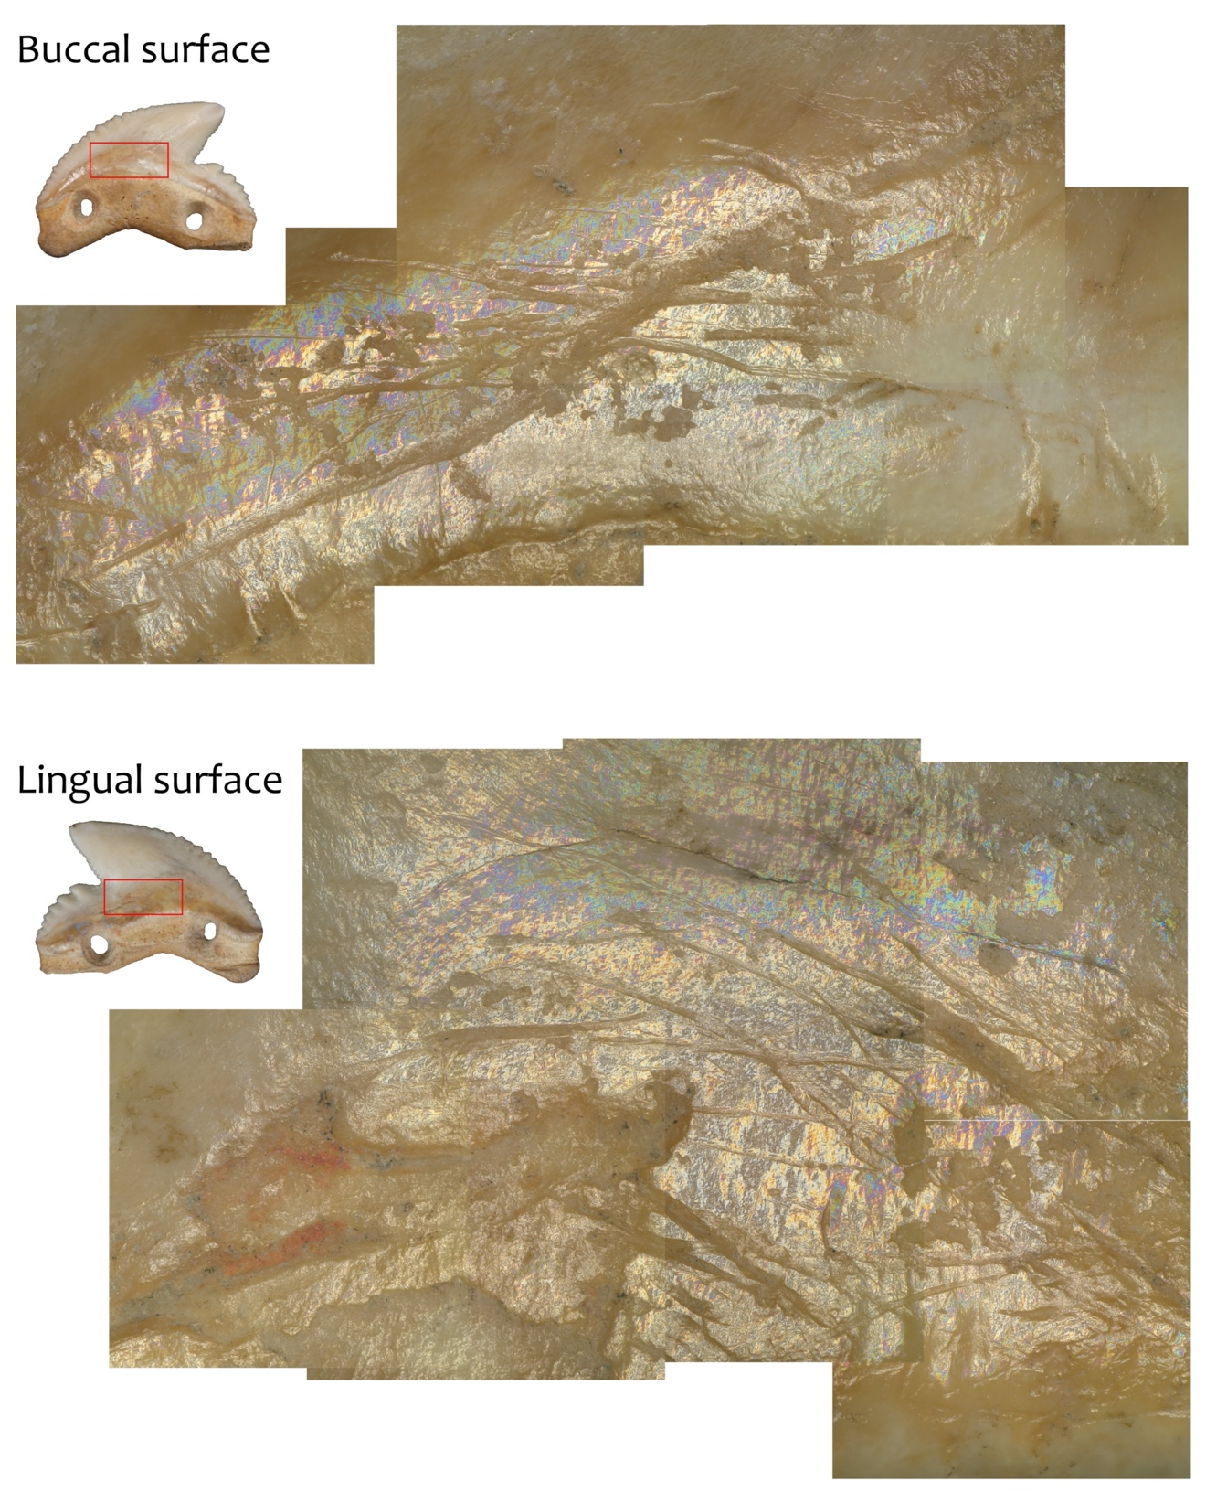

Figure S11. Hafting-related polish and striations exhibited on the Leang Panninge tiger shark tooth. Traces of a red residue possibly related to the adhesive utilized is also visible.
- Residues

Residue analysis was completed by BS using a Dino-lite to guide focused, ultra-purified water pipette removal of residues onto pre-cleaned microscope slides. This procedure was specific and targeted with the majority of residues left in situ on the artefact surface. High-powered microscopy (200-400x) of residues was completed using a Leitz Dialux 22 microscope with polarizing capability. A Tucsen ISH 500 camera was used to photograph lifted residues in plane, part polarised, and cross polarised light at magnifications of 250x and 400x.

Table S2. Residues observed on the Leang Panninge tiger shark tooth. Photographs taken by Birgitta Stephenson.
As found | Description
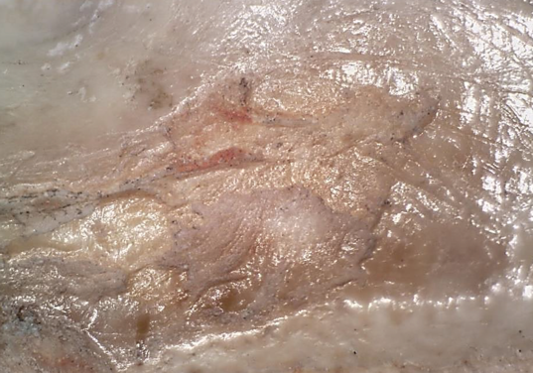  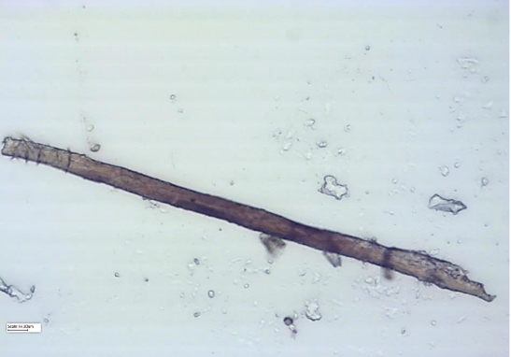  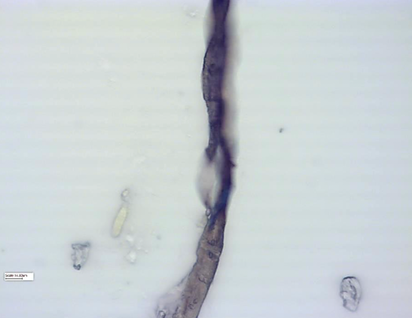  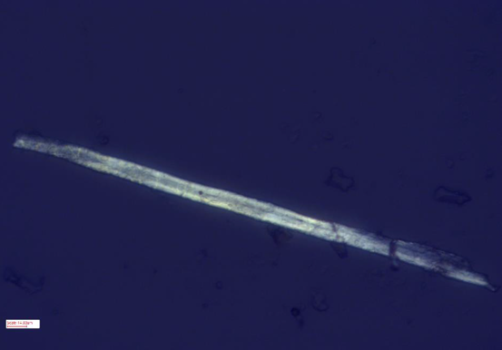 | Lingual surface – mesial section.  Residue with red colouration visible.  Damaged plant fibre (400x, part polarised).  Same damaged plant fibre (400x, part polarised).  Same damaged plant fibre (400x, cross polarised).
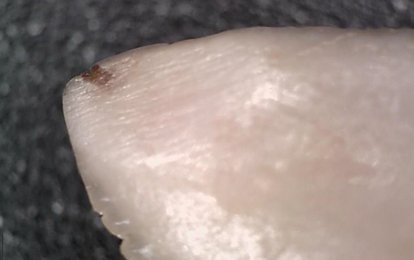  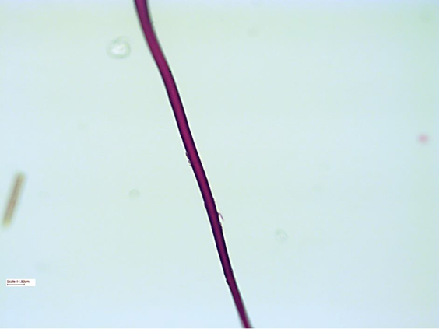  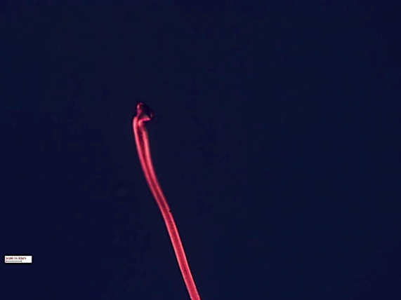 | Lingual surface – apical point.  Orange discolouration is the dental carie.  Collagenous structure (400x, part polarised).  Same collagenous structure, showing shaft (400x, cross polarised).

Table. S3. Residues observed on the Leang Bulu’ Sipong 1 tiger shark tooth. Photographs taken by Birgitta Stephenson.

As found | Description
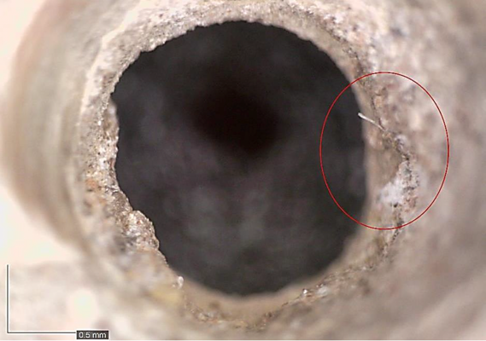  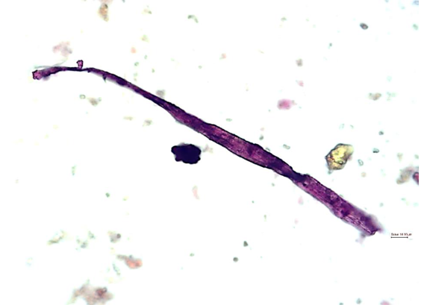  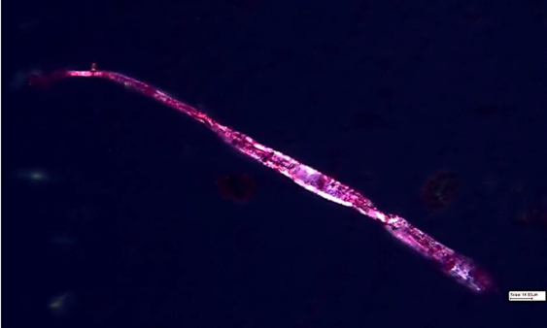  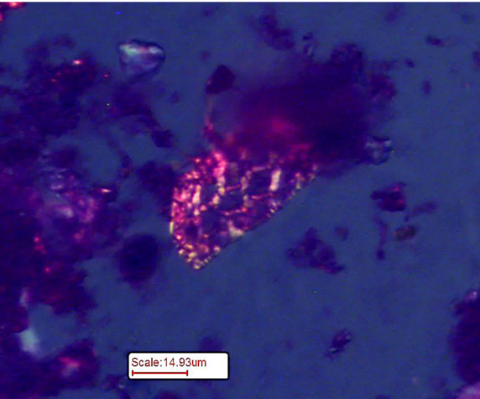 | Fibre inside perforation.  Damaged structured plant fibre (400x, part polarised).  Same damaged structured plant fibre (400x, cross polarised).  Collagenous cellular structure from same extraction (400x, cross polarised).
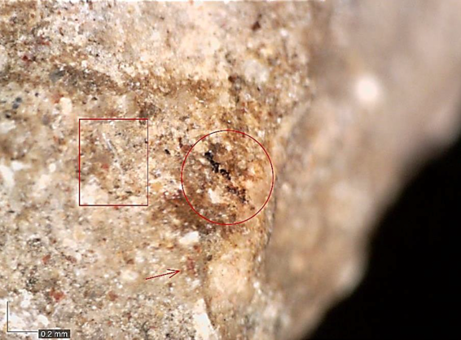  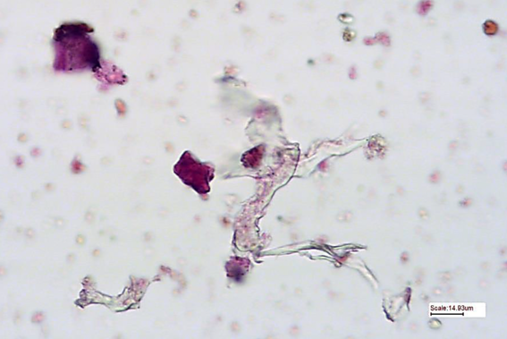  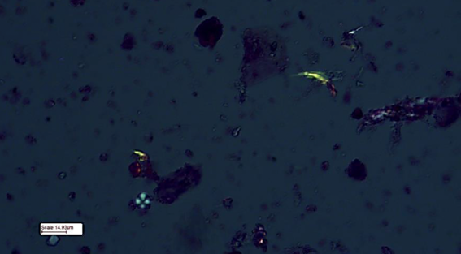  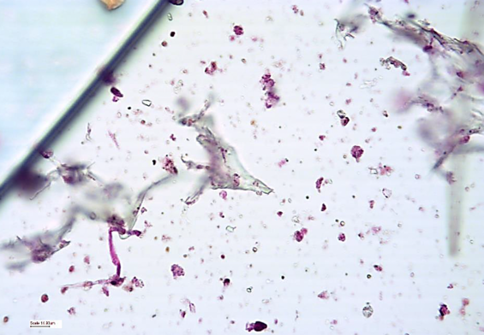  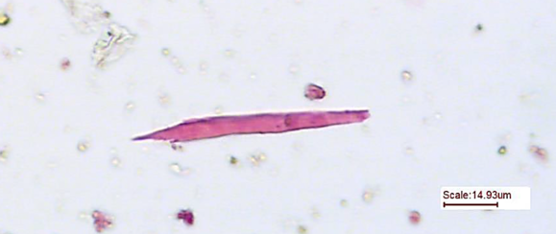  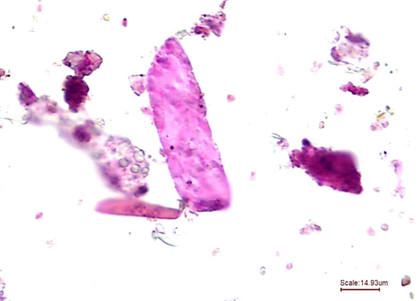  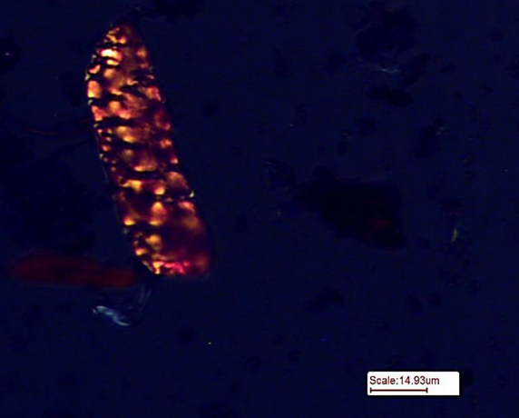 | Lingual surface of basal section on distal side.  Amorphous cellulose (400x, part polarised).  Isolated starch granule and Type III collagen (400x, part polarised).  Amorphous cellulose and collagen fibre (400x, part polarised).  Collagenous structure (400x, part polarised).  Elastin-like collagenous structure (400x, part polarised).  Same elastin-like collagenous structure (400x, cross polarised).
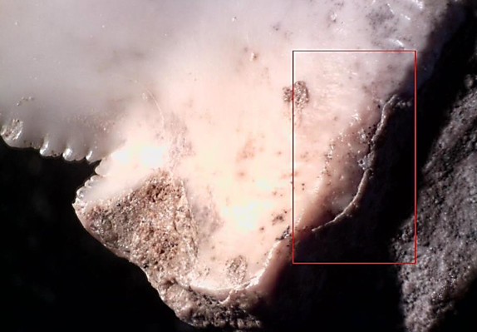  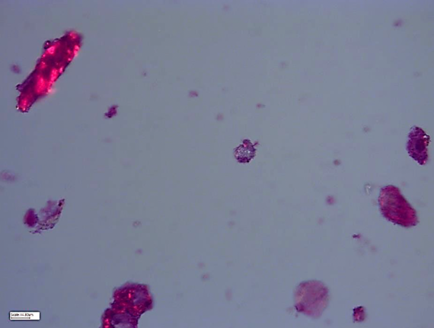  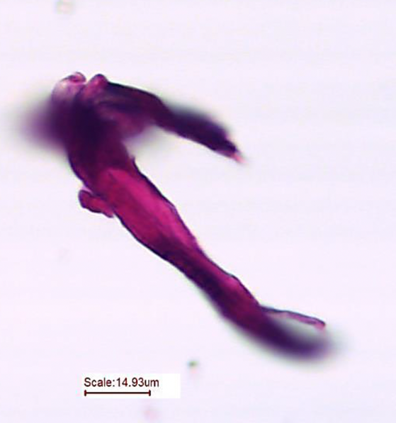  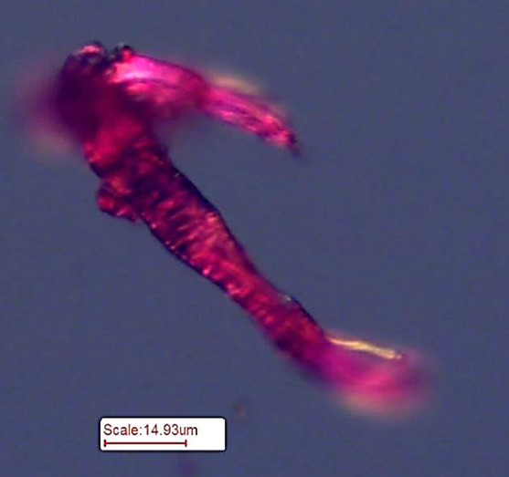  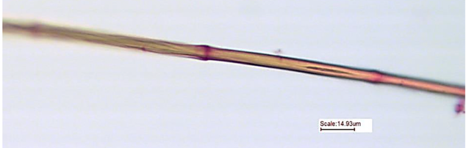  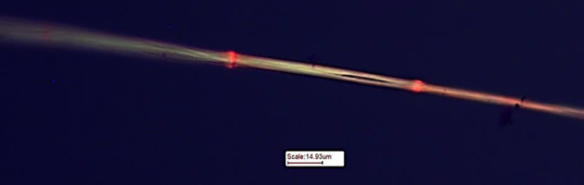  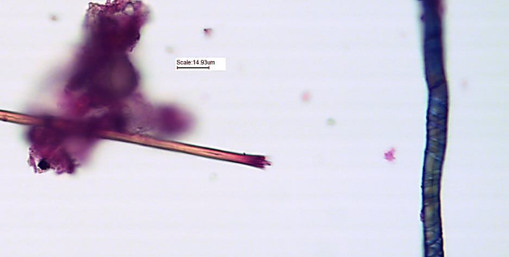  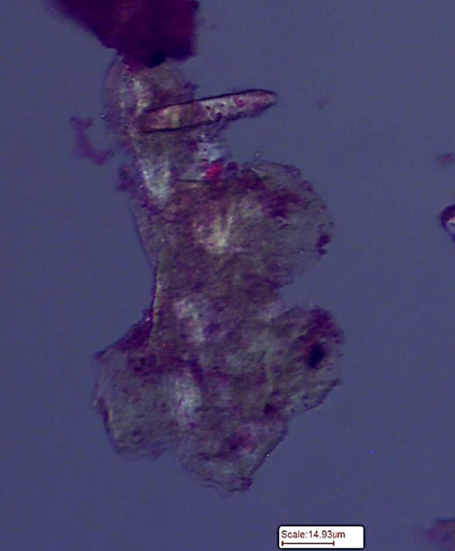  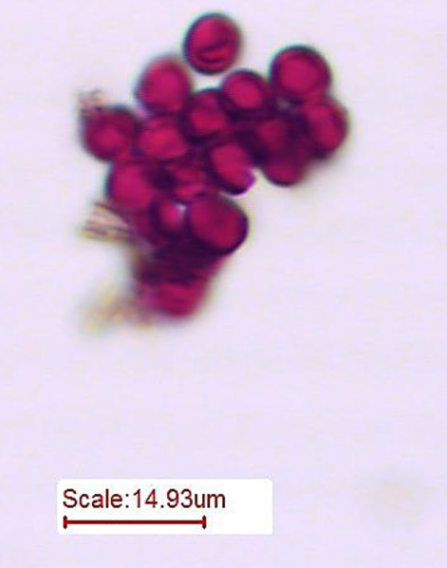  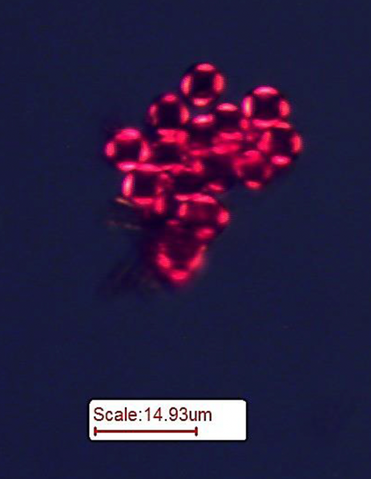 | Labial surface – Distal side of intersection of shoulder and basal sections.  Collagenous residues (400x, cross polarised).  Large collagen fibre bundle (400x, part polarised).  Same large collagen fibre bundle (400x, cross polarised).  Potential barbule (400x, part polarised).  Same barbule (400x, cross polarised).  Baruble and plant fibre with wall thickening (400x, part polarised).  Lipid-like structure (400x, cross polarised).  Faecal spherulites (400x, part polarised).  Faecal spherulites (400x, cross polarised).
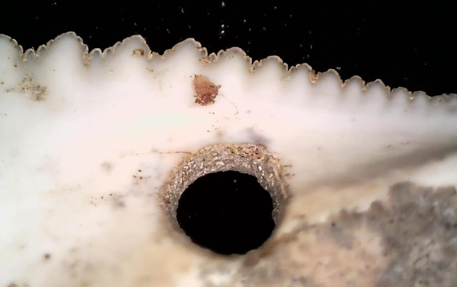  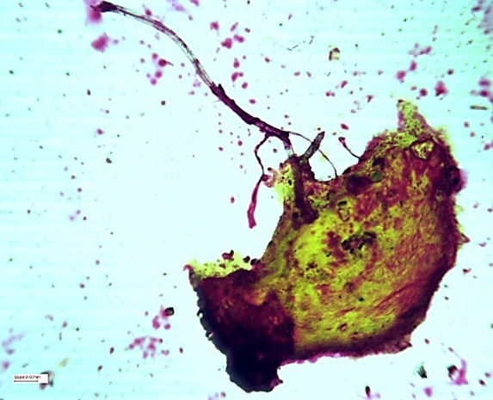  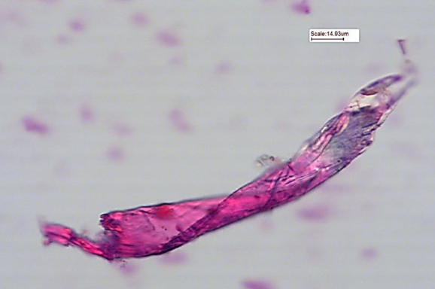 | Labial surface – below complex serrations on mesial side.  Lipid and plant fibres (100x, part polarised).  Damaged collagen fibre (400x, part polarised).
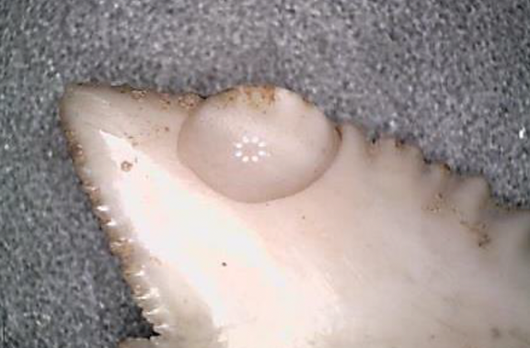  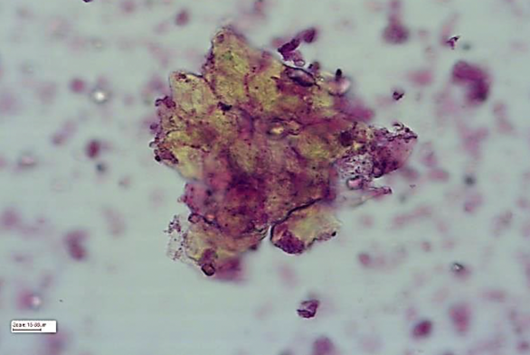  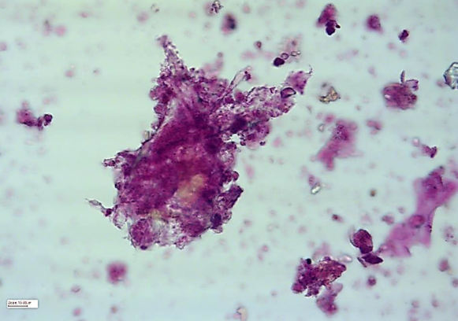  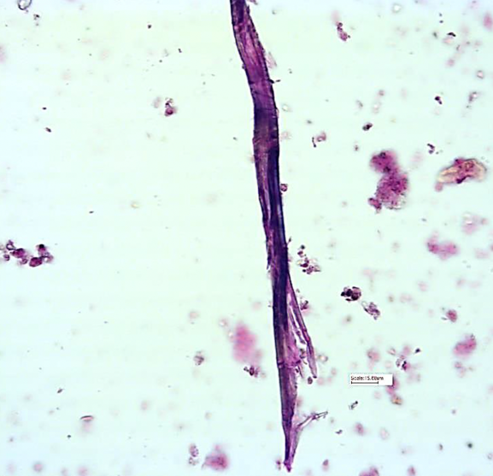  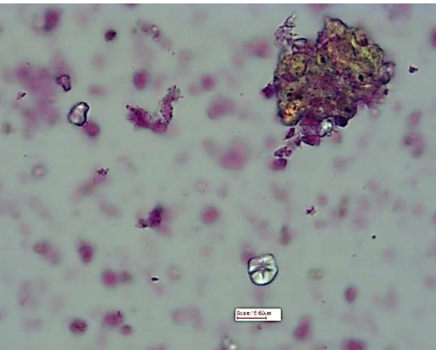 | Labial surface – along apical edge.  Lipid (400x, part polarised).  Amorphous cellulose and collagen (400x, part polarized).  Damaged plant fibres (400x, part polarised).  Isolated starch granule (400x, part polarised).
- FTIR

FTIR, undertaken by CM, the artefacts were analysed non-destructively using the Spotlight 400 infrared microscope (Perkin Elmer) in combination with the Spectrum 3 FTIR (Perkin Elmer). The FTIR spectra were acquired between 4000cm-1 and 650cm−1 with a resolution of 8cm−1 using the SpectrumIMAGE software. Each tooth was placed on the microscope and spectra from multiple locations were generated and analysed with the Spectrum MultiSearch software and the NIST spectral database.

Fourier transform infrared spectroscopy (FTIR) has been used extensively in archaeological and paleontological science to understand the preservation of biological material, mineralisation, and crystallinity (Beasley et al. 2014; Botha et al. 2004; France et al. 2020; Roche et al. 2010; Thompson et al. 2013). It has also been employed as a screening method for molecular analysis (Chowdhury et al. 2021) and as an analytical tool for the characterisation and identification of materials and trace residues (Dunseth and Shahack-Gross 2018; Matheson and McCollum 2014; Mizzoni and Nunziante Cesaro 2007; Monnier et al. 2017; Prinsloo et al. 2014; Truică et al. 2012). Here it has been applied simply to determine the presence of a residue and characterise the material.

Shark teeth are similar to mammalian teeth in the fact they have dentin in the interior of the tooth but differ in that they have enameloid instead of enamel on the outside of the tooth. The biological apatite composition of shark teeth is fluoroapatite (Ca₅(PO₄)F) with carbonate substitutions for some phosphates and hydroxide substitutions with fluoride (Dahm and Risnes 1999; Enax et al. 2012). Previous FTIR research has shown that shark teeth have characteristic spectra with biological apatite (phosphate: 490–640 cm⁻¹ and 900–1360 cm⁻¹, carbonate: 875 cm⁻¹ and 1360–1590 cm⁻¹, water: 3010–3660 cm⁻¹) (Dahm and Risnes 1999; Enax et al 2012). The broad water peak (3010-3660 cm⁻¹) in shark teeth are very low or absent as they have a very low water content in their enameloid. The characteristic CH₂ and CH₃ peaks in the (2800-2950 cm⁻¹) and C=O peaks (1600-1800 cm⁻¹) are also very low or absent in sharks due to the very low organic content in the enameloid (Dahm and Risnes 1999; Enax et al. 2012).

Twenty different locations on these teeth were analysed with FTIR. These analyses produced two different spectra. One of spectrum represents both the residue and the enameloid (Figure S12). While the other spectrum is predominantly but not exclusively from the residue (Figure S13). When the spectra generated in this study are compared it shows that the shark teeth are low in water and organic content which is expected with aged samples. All spectra had a peak between 2916-2918 cm⁻¹ and 2848-2850 cm⁻¹, these correlate with the C-H methyl and methylene peaks of organic material and are consistent with corresponding peaks in ceresin wax processed from ozokerite (Baglioni et al 2018). There were numerous peaks represented as shoulder peaks found between 2920 cm⁻¹ and 2985 cm⁻¹ which are also methyl and methylene peaks from the ozokerite or from other organic material associated with this residue (Nissenbaum and Aizenshtat 1975). If these peaks are from ozokerite there would be a slight position shift due to some degree of degradation of the hydrocarbons in the waxy material over time. All spectra had various peaks between 1360-1590 cm⁻¹, which correlates with carbonate peaks from the shark enameloid (Enax et al. 2012). However, within this region there was a peak at 1464-1470 cm⁻¹ in every spectra that represents a methylene peak consistent with the ceresin and ozokerite spectra (Baglioni et al 2018, Nissenbaum and Aizenshtat 1975). In many of the spectra there was a peak at 1397-1400 cm⁻¹ which could be a methyl peak. With a slight position shift due to degradation, age or other modification, this could correspond with the 1375 cm⁻¹ peak of the ceresin wax and the 1370 cm⁻¹ of the ozokerite (Nissenbaum and Aizenshtat 1975).

The FTIR analysis indicates that the spectra represent shark enameloid with a wax residue with minor component of other compounds. The wax can only be ‘earth wax’ which is a naturally occurring mineral wax from ozokerite. Earth wax is found all over the world and has recently been identified in antiquity (Connan et al. 2018; Jagošová et al. 2021). There is also evidence that this material has been processed. The evidence that demonstrates processing is through the shift in peak position and changes in peak intensity indicating greater purity than ozokerite alone. This is best demonstrated with the peaks around 2915 cm⁻¹, 2848 cm⁻¹ and 1464 cm⁻¹ being identical to ceresin wax which is processed from ozokerite. However, we are not proposing how this material was processed or suggesting that it was processed in the same manner as ceresin wax is today simply indicating that it is of a slightly more purified form or wax than ozokerite. The other component within the residue is hard to characterize but may contain aromatic hydrocarbons, aliphatic alcohols and amines, carbohydrates or substituted alkanes. This excludes many natural substances except for starchy material possibly from plant storage organs (rhizomes, tubers or corms) and some plant exudates like simple resins, oleoresins, gums or latex.

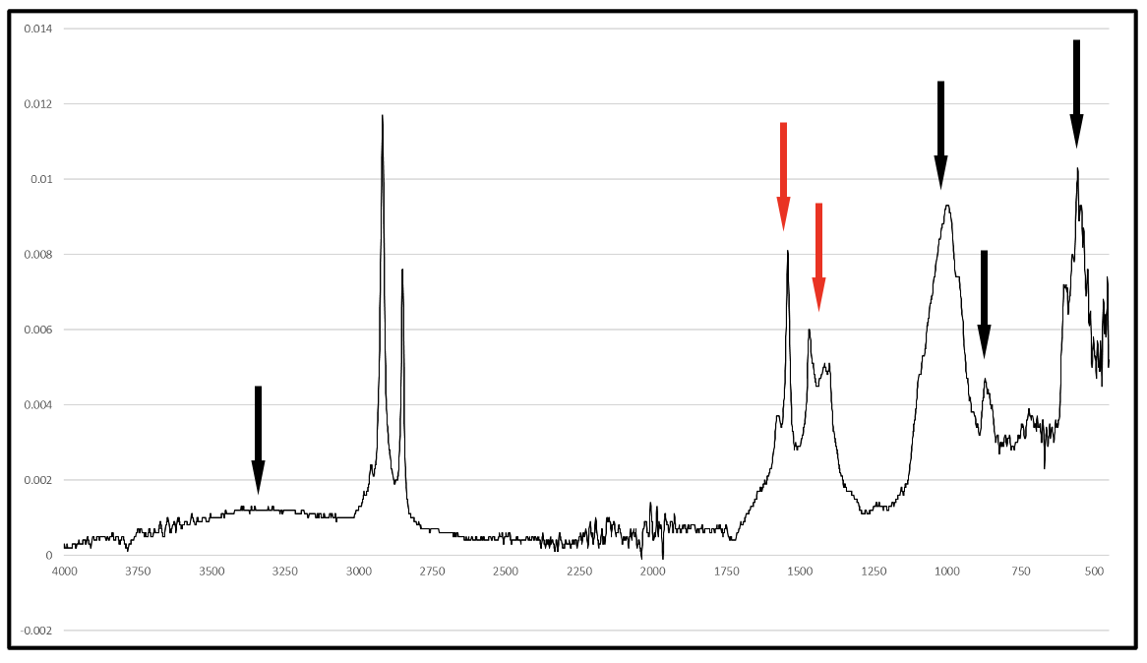
Figure S12. The FTIR spectrum of the stain on the dorsal side of the tooth. The peaks denoted by the black arrows are peaks that are found in shark enameloid. The peaks denoted by the red arrows are a combination of the enameloid and the residue. The remaining peaks are from the residue or environment.

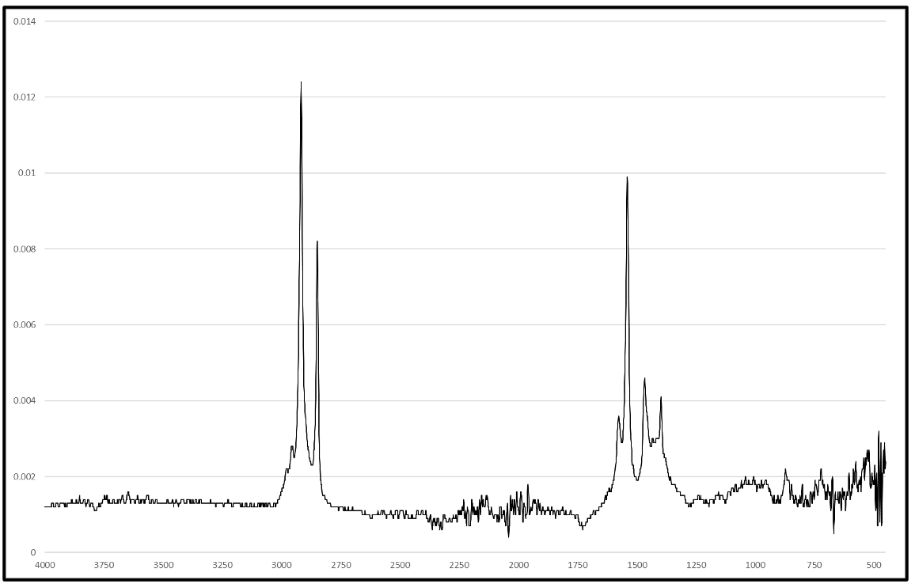
Figure S13. The FTIR spectrum of a clump of residue on the base of the tooth.

SI References
Amesbury, J.R., Walth, C.K. & Bayman, J.M. Marine shell ornaments and the political economy of gendered power in the Mariana Islands. J. Island Coastal Archaeol. DOI:10.1080/15564894.2020.1838972 (2020).

Basiaco, A., Urwin, C. & Manne, T. Worked bone and teeth from Orokolo Bay in the Papuan Gulf (Papua New Guinea). Aust. Archaeol. 86, 226-237 (2020).

Beasley, M.M., Bartelink, E.J., Lacy, T., & Miller, R.M. Comparison of transmission FTIR, ATR, and DRIFT spectra: implications for assessment of bone bioapatite diagenesis. J. Archaeol. Sci. 46, 16-22 (2014).

Becker, M.A. & Chamberlain, J.A. Squalicorax chips a tooth: A consequence of feeding-related behavior from the lowermost Navesink Formation (Late Cretaceous: Campanian-Masstrichtian) of Monmouth County, New Jersey, USA. Geosci. 2, 109-129 (2012).

Betts, M.W., Blair, S.E. & Black, D.W. Perspectivism, mortuary symbolism, and human-shark relationships on the Maritime Peninsula. Am. Antiq. 77, 621-645 (2012).

Borhegyi, S.F. Shark teeth, stingray spines, and shark fishing in ancient Mexico and central America. Southwest. J. Anthropol. 17, 273-296 (1961).

Botha, J., Lee-Thorp, J. & Sponheimer, M. An examination of Triassic Cynodont tooth enamel chemistry using Fourier Transform Infrared Spectroscopy. Calcified Tissue Intern. 74, 162-169 (2004).

Chang, N.J. Personal ornaments in Thai prehistory: Some preliminary observations from Nong Nor, Central Thailand. Bull. Indo-Pac. Prehist. Assoc. 14, 140-150 (1996).

Charpentier, V., Méry, S., Fortini, E. & Pellé, E. <<Un chef est un requin qui voage par terr>> : Fonctions et statuts des armatures de projectile en dent de Carcharhinus leucas et aiguillon caudal de raie dans l’Arabie des Vie-IIIe millénaires av. notre ère. Arab Archaeol. Epigr. 20, 9-17 (2009).

Chowdhury, M.P. et al. Machine learning ART-FTIR spectroscopy data for the screening of collagen for ZooMS analysis and mtDNA in archaeological bone. J. Archaeol. Sci. 126, 105311 (2021).

Cione A.L. & Bonomo, M. Great white shark teeth used as pendants and possible tools by early-middle Holocene terrestrial mammal hunter-gatherers in the eastern Pampas (Southern South America). Int. J. Osteoarchaeol. 13, 222-231 (2003).

Clark, G. & Langley, M.C. Ancient tattooing in Polynesia. J. Island Coast Archaeol. 15, 407-420 (2019).

Connan, J., Joliot, C. & Mathe, C. Frankincense and bitumen of the middle period (1st century-5th century AD) from the ancient harbour of Qâni’ (Yemen). J. Hist. Archaeol. Anthropol. Sci. 3, 696-722 (2018).

Cushing, F.H. Exploration of ancient key dwellers’ remains on the Gulf Coast of Florida. Proc. Am. Phil. Soc. 35, 329-448 (1896).

Dahm, S. & Risnes, S. A comparative infrared spectroscopic study of hydroxide and carbonate absorption bands in spectra of shark enameloid, shark dentin, and a geological apatite. Calcified Tissue Intern. 65, 459-465 (1999).

Dodge, E.S. Four Hawaiian implements in the Peabody Museum of Salem. J. Polyn. Soc. 48, 156-157 (1939).

Drew, J., Philipp, C. & Westneat, M.W. Shark tooth weapons from the 19th century reflect shifting baselines in central Pacific Predator assemblies. PLoS One 8, e59855 (2013).

Dunseth, Z.C. & Shahack-Gross, R. Calcitic dung spherulites and the potential for rapid identification of degraded animal dung at archaeological sites using FTIR spectroscopy. J. Archaeol. Sci. 97, 118-124 (2018).

Ebert, D.A., Fowler, S. & Compagno, L. Sharks of the World. A Fully Illustrated Guide. Wild Nature Press, Plymouth (2013).

Edge-Partington, J. The ethnography of Matty Island. J. Anthropol. Inst. Great Brit. Irel. 25, 287-295 (1896).

Enax, J., Prymak, O., Raabe, D. & Epple, M. structure composition and mechanical properites of shark teeth. J. Struct. Biol. 178, 290-299 (2012).

France, C.A.M., Sugiyama, N. & Aguayoa, E. Establishing a preservation index for bone, dentin, and enamel bioapatite mineral using ATR-FTIR. J. Archaeol. Sci. Rep. 33, 102551 (2020).

Frazzetta, T.H. The mechanics of cutting and the form of shark teeth (Chondrichthyes, Elasmobranchii). Zoomorph. 108, 93-107 (1988).

Furrey, J.F. An analysis of shark tools from the Boca Weir site in south Florida. Florida Anthropol. 30, 89-102 (1977).

Gilson, S.-P. & Lessa, A. Capture, processing and utilization of sharks in archaeological context: its importance among fisher-hunter-gatherers from southern Brazil. J. Archaeol. Sci. Rep. 35, 102693 (2021).

Gilson, S.-P., Gates St-Pierre, C., Lominy, M. & Lessa, A. Shark teeth used as tools: An experimental archaeology study. J. Archaeol. Sci. Rep. 35, 102733 (2021).

Gonzalez, M.M.B. Use of Pristis spp. (Elasmobranchii: Pristidae) by hunter-gatherers on the coast of São Paulo, Brazil. Neotrop. Ichthyol. 3, 421–426 (2005).

Illidge, P. The Tahitian mourner’s costume: A description of use, composition and relevant artefacts from HMS Pandora. Bull. Australas. Inst. Marit. Archaeol. 26, 65-74 (2002).

Intoh, M. Ongoing archaeological research on Fais Island, Micronesia. Asian Persp. 47, 121-138 (2008).

Jagošová, K. et al. First evidence of “earth wax” inside the casting moulds from the Roman era. Molecules 26, 4259 (2021).

Kozuch, L. & Fitzgerald, C. A guide to identifying shark centra from southeastern archaeological sites. Southeast Archaeol. 8, 146-157 (1989).

Leavesley, M.G. A shark-tooth ornament from Pleistocene Sahul. Antiquity 81, 308-315 (2007).

Lopes M.S. et al. The Path towards Endangered Species: Prehistoric Fisheries in Southeastern Brazil. PLoS ONE 11, e0154476 (2016).

Loumala, K. Sharks and shark fishing in the culture of Gilbert Islands, Micronesia. In: The Fishing Culture of the World: Studies in Ethnology, Cultural Ecology and Folklore (Ed. Gunda, B.) Akademiai Kaido, Budapest (1984).

Lowery, D., Godfrey, S.J. & Eshelman, R. Integrated geology, paleontology, and archaeology: Native American use of fossil shark teeth in the Chesapeake Bay region. Archaeol. East North Am. 39, 93-108 (2011).

Machado, L.M.S. Análise de remanescentes ósseos humanos do sítio arqueológico Corondó, R.J. Aspectos biologicos e culturais. IAB, Serie Monografias 1 (1984).

Martin, P.S., Quimby, G.I. & Collier, D. Indians before Columbus. University of Chicago Press, Chicago (1947).

Matheson, C.D. & McCollum, A.J. Characterising native plant resins from Australian Aboriginal artefacts using ATR-FTIR and GC/MS. J. Archaeol. Sci. 52, 116-128 (2014).

Maude, H.C. & Maude, H.E. Tioba and the Tabiteuean religious wars. J. Polyn. Soc. 90, 307-336 (1981).

McCarthy, F.D. Australian Aboriginal Stone Implements. The Australian Museum Trust, Sydney (1976).

Mentz Ribeiro, P.A. & Torrano Ribeiro, C. Excavaçes arqueológicas no sítio RS-TQ-58, Montenegro, RS, Brasil. Libro de Resúmenes del XIV Congreso Nacional de Arqueología Argentina (2001).

Mizzoni, F. & Nunziante Cesaro, S. Study of the organic residue from a 2600-year-old Etruscan plumpekanne. Spectrochimica Acta Part A 68, 377-381 (2007).

Monnier, G., Frahm, E., Luo, B. & Missal, K. Developing FTIR microspectroscopy for analysis of plant residues on stone tools. J. Archaeol. Sci. 78, 158-178 (2017).

Murdoch, G.M. Gilbert Islands weapons and armour. J. Polyn. Soc. 32, 174-175 (1923).

Nissenbaum, A. Aizenshtat, Z. Geochemical studies on ozokerite from the Dead Sea area. Chem. Geol. 16, 121-127 (1975).

Pillay, K. Movement patterns and feeding behaviour of tiger sharks, Galeocerdo cuvier, at the Aliwal Shoal, Umkomaas, KwaZulu-Natal, South Africa. Unpublished Honours Thesis, University of KwaZulu-Natal, South Africa (2004).

Prinsloo, L.C., Wadley, L. & Lombard, M. Infrared reflectance spectroscopy as an analytical technique for the study of residues on stone tools: potential and challenges. J. Archaeol. Sci. 41, 732-739 (2014).

Roche, D., Ségalen, L., Balan, E. & Delattre, S. Preservation assessment of Miocene-Pliocene tooth enamel from Tugen Hills (Kenyan Rift Valley) through FTIR, chemical and stable-isotope analyses. J. Archaeol. Sci. 37, 1690-1699 (2010).

Roth, W.E. Domestic Implements, Arts and Manufactures, North Queensland Ethnography, Bulletin no. 7. Government Printer, Brisbane (1904).

Roth, H.L. Tonga Islanders’ skin-marking. Man 6, 6–9 (1906).

Santini, G. Burial Complex 43 at the prehistoric graveyard of Ra’s al-Hamra in the Northern Oman. In: Arabia Antiqua, Essays on the Late Prehistory of the Arabian Peninsula (Eds Tosi, M. & Zarins, J.) Serie Orientale XCIII, IsIAO, Rome (2002).

Smith, H.I. & Wintemberg, W.J. Some Shell-Heaps in Nova Scotia. National Museum of Canada Bulletin No. 47, Anthropological Series No. 9, Ottawa (1929).

Steinen, K.T. Other nonceramic artifacts. In: Fort Center: An archaeological site in the Lake Okeechobee Basin (Ed Sears, W.H.) University Presses of Florida, Gainesville (1982).

Thompson, T.J.U., Islam, M. & Bonniere, M. A new statistical approach for determining the crystallinity of heat-altered bone mineral from FTIR spectra. J. Archaeol. Sci. 40, 416-422 (2013).

Truică, G.I., Teodor, E.D., Teodor, E.S., Liţescu, S.C. & Radu, G.L. FTIR and statistical studies on amber artefacts from three Romanian archaeological sites. J. Archaeol. Sci. 39, 3524-3533 (2012).

Uchôa, D.P. Sinópse do ‘Arcaico’ do litoral de São Paulo. Anuário de Divulgação Científica 7, 15–32 (1980).

Wicker, S. Prehistoric Melanesian exchange and interaction: Recent evidence from the Northern Solomon Islands. Asian Persp. 29, 135-154 (1990).

S. Wroe et al. Three-dimensional computer analysis of white shark jaw mechanics: How hard can a great white bite? J. Zool. 276, 336-342 (2008).

