SUPPORTING INFORMATION

Table of Contents

- SI-A: Survey Results
- SI-B: Case Selection
- SI-C: Robustness Test without Population Weights
- SI-D: Trends Measured Using Democratic Vote Share in Senatorial Race
- SI-E: Covariate Balance Tables
- SI-F: Complete Model Results
- SI-G: Continuous Measures of Distance
- SI-H: Simple Models
- SI-I: Sensitivity Analysis for Omitted Variable Bias
- SI-J: Placebo Tests
- SI-K: Effect of Proximity on Support for Clinton
- SI-L: Heterogeneous Responses by Prior Support for Obama and Gun Control
- SI-M: Replication Tests
- SI-N: Meta-Analysis

SI-A: Survey Results

Table SI-A1 presents findings from national and statewide polls asking respondents to report the most important issue to them in deciding who to vote for in federal and state elections. Americans rarely report using guns as the focal issue in deciding their vote; instead, and unsurprisingly, they rely most strongly on issues that are typically the centerpiece of electoral campaigns: jobs, the economy, taxes, and healthcare.

Table SI-A1. Most Important Issue in Deciding Vote in Federal and State Elections
Federal Elections
Your vote for Congress in 2014 Midterm Election? [National Sample]
- Guns control / rights |  | 2%
- Vote for preferred Party / Get rid of out Party |  | 27%
- Candidate’s Platform |  | 18%
- Economy and Jobs |  | 17%
Your vote for Congress in 2018 Midterm Election? [National Sample*]
- Guns |  | 5%
- Economy and jobs |  | 20%
- Healthcare |  | 17%
- Immigration |  | 17%
Your vote for Senate in 2018 Midterm Election? [NV / FL Samples*]
- Gun policy |  | 8 / 14%
- The economy |  | 23 / 23%
- Healthcare |  | 28 / 26%
- Immigration |  | 23 / 15%
Your vote for Congress / Senate in 2022 Midterm Election? [National / GA Samples*]
- Gun policy |  | 7 / 8%
- Abortion |  | 15 / 17%
- The economy and inflation |  | 51 / 48%
- Voting rights and election integrity |  | 9 / 12%
Your vote for President in 2024? [National / NH Samples]
- Gun violence / control |  | 4 / 3%
- The economy |  | 33 / 17%
- Preserving / future of American democracy |  | 26 / 30%
- Immigration |  | 8 / 24%
State Elections
Your vote for Governor in 2013? [NJ Sample]
- Gun issues |  | 3%
- Economy and Jobs |  | 39%
- Taxes |  | 43%
- Education and Healthcare |  | 29%
Your vote for Governor in 2018? [NV / FL Samples]
- Gun control |  | 9 / 7%
- The economy |  | 20 / 22%
- Education and Healthcare |  | 45 / 39%
- Taxes |  | 8 / 12%
Your vote for Governor in 2022? [PA / OH Samples]
- Gun control |  | 16 / 9%
- The economy |  | 26 / 38%
- Abortion |  | 10 / 12%
- Education and Healthcare |  | 10 / 16%
Note: Information about surveys and samples included below.

Surveys Used for Table SI-A1 “Most Important Issue in Deciding Vote”
- Vote for Congress for 2014 Midterm Election
  - Henry J. Kaiser Family Foundation. Kaiser Family Foundation Poll: November Kaiser HealthTracking Poll--2010 Affordable Care Act/Cost of Health Insurance, Question 3. USPSRA.112114K.R03. Princeton Survey Research Associates International. Cornell University, Ithaca, NY: Roper Center for Public Opinion Research, 2014. National Adult Sample (N=1,501). Roper #31096991.
- Vote for Congress in 2018 Midterm Election
  - NPR/PBS NewsHour. NPR/PBS NewsHour/Marist Poll, Question 7. 31115637.00006. Marist College Institute for Public Opinion. Cornell University, Ithaca, NY: Roper Center for Public Opinion Research, 2018. National Adult Sample, Registered Voters (N=935). Roper #31115637.
- Vote for Senate in 2018 Midterm Election
  - CNN. CNN Nevada Poll, Question 8. 31116521.00007. Social Science Research Solutions (SSRS). Cornell University, Ithaca, NY: Roper Center for Public Opinion Research, 2018. Nevada Adult Sample, Registered Voters (N=998). Roper #31116521.
  - CNN. CNN Florida Poll, Question 8. 31116522.00007. Social Science Research Solutions (SSRS). Cornell University, Ithaca, NY: Roper Center for Public Opinion Research, 2018. Florida Adult Sample, Registered Voters (N=1,012). Roper #31116522.
- Vote for Congress / Senate in 2022 Midterm Election
  - CNN. CNN Poll, Question 5. 31119986.00004. SSRS. Cornell University, Ithaca, NY: Roper Center for Public Opinion Research, 2022. National Adult Sample, Registered Voters (N=1,290). Roper #31119986.
  - CNN. CNN Georgia Poll, Question 9. 31120014.00008. SSRS. Cornell University, Ithaca, NY: Roper Center for Public Opinion Research, 2022. Georgia Adult Sample, Registered Voters (N=1,886). Roper #31120014.
- Vote for President in 2024
  - Quinnipiac University Polling Institute. Quinnipiac University Poll, Question 28. 31120537.00027. Quinnipiac University Polling Institute. Cornell University, Ithaca, NY: Roper Center for Public Opinion Research, 2023. National Adult Sample (N=1,910). Roper #31120537.
  - Boston Globe/USA Today. Suffolk University USA Today/Boston Globe New Hampshire Primary Poll, Question 15. 31120713.00014. Suffolk University Political Research Center. Cornell University, Ithaca, NY: Roper Center for Public Opinion Research, 2024. New Hampshire Adult Sample, Likely Primary Voters (N=1,000). Roper #31120713.
- Vote for Governor in 2013
  - Quinnipiac University Polling Institute. Quinnipiac University New Jersey Poll, Question 11. 31116105.00010. Quinnipiac University Polling Institute. Cornell University, Ithaca, NY: Roper Center for Public Opinion Research, 2013. New Jersey Adult Sample, Registered Voters (N=1,129). Roper #31116105.
- Vote for Governor in 2018
  - Reno Gazette-Journal. Suffolk University/Reno Gazette-Journal Nevada Poll, Question 8. 31116494.00007. Suffolk University Political Research Center. Cornell University, Ithaca, NY: Roper Center for Public Opinion Research, 2018. Nevada Adult Sample, Likely Voters (N=500). Roper #31116494.
  - Suffolk University Political Research Center. Suffolk University Florida Poll, Question 8. 31116586.00007. Suffolk University Political Research Center. Cornell University, Ithaca, NY: Roper Center for Public Opinion Research, 2018. Florida Adult Sample, Likely Voters (N=500). Roper #31116586.
- Vote for Governor in 2022
  - USA Today. Suffolk University/USA Today Pennsylvania Poll, Question 9. 31119846.00008. Suffolk University Political Research Center. Cornell University, Ithaca, NY: Roper Center for Public Opinion Research, 2022. Pennsylvania Adult Sample, Likely Voters (N=500). Roper #31119846.
  - Cincinnati Enquirer. Suffolk University/Cincinnati Enquirer Ohio Poll, Question 8. 31119845.00007. Suffolk University Political Research Center. Cornell University, Ithaca, NY: Roper Center for Public Opinion Research, 2022. Ohio Adult Sample, Likely Voters (N=500). Roper #31119845.

SI-B: Case Selection
This table provides examples of ballot measures on firearms that are ineligible for analysis or incomparable as test cases to I-1491 in Washington (WA) state. Grounds for ineligibility: not having a mass shooting occurring within 3 years prior to the vote or the absence of state-wide precinct-level election results data. Similar to Reny et al. (2023), we define a “mass shooting” as an event where 3 or more persons (not including the victim) were killed and the event occurred in a public setting (i.e., not a private residence) where a shooter opened fire on people in a haphazard manner. Grounds for being deemed incomparable to I-1491 in WA include the absence of a pre-shooting ballot measure on firearms to serve as a pre-treatment control for prior voter preferences on gun control. The examples below are not exhaustive.
Table SI-B: Case Selection Criteria by Gun Control Ballot Measure Voted on Between 1990 and 2022
Ballot Measure | Mass shooting occurred in state within 3 years of ballot measure | Prior ballot measure on firearms within 8 years | State-wide precinct election results data collected and available
Alabama Right to Bear Arms, Amendment 3 (2014) | No | No | Yes
Alaska Right to Bear Arms, Measure 1 (1994) | No | No | No
California Proposition 15, Handgun Ownership and Registration Initiative (1982) | No | No | No
California Proposition 63, Background Checks for Ammunition Purchases and Large-Capacity Ammunition Magazine Ban (2016) | Yes | No | Yes
Colorado Amendment 22, Background Checks for Gun Sales Initiative (2000) | Yes | No | No
Iowa Amendment 1, Right to Keep and Bear Arms Amendment (2022) | No | No | Yes
Florida Amendment 12, Sales of Firearms Amendment (1998) | No | Yes | No
Florida Amendment 2, Three Day Waiting Period for Handgun Purchases Amendment (1990) | Yes | No | No
Missouri Concealed Firearms, Proposition B (April 1999) | No | No | No
Montana LR-130, Limit Local Government Authority to Regulate Firearms Measure (2020) | No | No | Yes
Nevada Background Checks for Gun Purchases, Question 1 (2016) | No | No | Yes
Oregon Measure 5, Background Checks for Firearm Transfers Initiative (2000) | No | No | No
Oregon Measure 114, Changes to Firearm Ownership and Purchase Requirements Initiative (2022) | No | No | Yes
Washington Initiative 676, Handgun Trigger-Locks and Safety Licenses Measure (1997) | Yes | No | No
Washington Gun Rights Measure, Initiative 591 (2014) | Yes | No | Yes
Washington Initiative 1639, Changes to Gun Ownership and Purchase Requirements Measure (2018) | Yes | Yes | Yes

SI-C: Main Analysis without Population Weights
Table SI-C provides a robustness test of Figures 1.1-1.3, conducting the same analysis without weighing precincts based on their voting age population. Given that some precinct voting age populations vary from 0 to 4623, we believe models should be specified using voting age population weights. Weighing precincts based on their population focuses the analysis on individuals, ensuring that less populated precincts do not have equal weight as more populated precincts. Table SI-C shows that our results are robust when these weights are dropped, and the estimated treatment effects increase by 0.3 – 0.5 percentage points.
Table SI-C: The Effects of Proximity to the Cascade Mall Shooting on Support for I-1491 with Weighing Precincts by Voting Age Population
 | Dependent variable:
 | Support for ‘Red Flag’ Laws (I-1491)
 | 5 Miles or Less Model | 10 Miles or Less Model | 15 Miles or Less Model
 | (1) | (2) | (3)
5 Miles or Less from CM Shooting | 0.036***
 | (0.005)
10 Miles or Less from CM Shooting |  | 0.036***
 |  | (0.004)
15 Miles or Less from CM Shooting |  |  | 0.033***
 |  |  | (0.003)
Proportion in Support of I-594 | 0.309*** | 0.310*** | 0.311***
 | (0.018) | (0.018) | (0.018)
Proportion Voted for Obama in 2012 | 0.412*** | 0.411*** | 0.410***
 | (0.016) | (0.016) | (0.016)
Change in Democratic Vote Share (President: 2012-2016) | 0.474*** | 0.473*** | 0.472***
 | (0.029) | (0.029) | (0.029)
Proportion Male | -0.068* | -0.067* | -0.067*
 | (0.031) | (0.031) | (0.031)
Proportion Black | -0.032 | -0.032 | -0.031
 | (0.020) | (0.020) | (0.020)
Proportion Latino | -0.025** | -0.025** | -0.024**
 | (0.009) | (0.009) | (0.009)
Proportion Asian or Pacific Islander | 0.045*** | 0.046*** | 0.047***
 | (0.009) | (0.009) | (0.009)
Proportion Native American | -0.077*** | -0.078*** | -0.077***
 | (0.016) | (0.016) | (0.016)
Proportion 55 Years Old or Older | -0.003 | -0.003 | -0.004
 | (0.012) | (0.012) | (0.012)
Proportion 18 Years Old or Younger | 0.030 | 0.031 | 0.031
 | (0.020) | (0.020) | (0.020)
Proportion with a College Degree | 0.025*** | 0.025*** | 0.025***
 | (0.004) | (0.004) | (0.004)
Median Income | -0.00000 | -0.00000 | -0.00000
 | (0.00000) | (0.00000) | (0.00000)
Population Density | -0.552 | -0.512 | -0.480
 | (0.307) | (0.305) | (0.305)
Proportion Owner Occupied | -0.002 | -0.002 | -0.002
 | (0.013) | (0.013) | (0.013)
Firearm Licenses (ATF) | 0.001*** | 0.001*** | 0.001***
 | (0.0002) | (0.0002) | (0.0002)
Constant | 0.305*** | 0.303*** | 0.303***
 | (0.022) | (0.021) | (0.021)
Observations | 6,905 | 6,905 | 6,905
R² | 0.907 | 0.907 | 0.907
Adjusted R² | 0.906 | 0.907 | 0.907
Residual Std. Error (df = 6888) | 0.046 | 0.045 | 0.045
Note: All models use heteroskedasticity robust standard errors. ⋆=p<0.05; ⋆⋆=p<0.01; ⋆⋆⋆=p<0.001

SI-D: Trends Measured Using Democratic Vote Share in Senatorial Race
Table SI-D presents robustness checks of the main findings in Figures 1.1 – 1.3, using change in support for Washington Senator Patricia Murray [D] to measure partisan trends instead of change in support for the Democratic presidential candidate. The results are robust to this different trend measure. The 10 and 15 miles or less coefficients remain substantively similar to the main models and statistically significant (p < 0.001), and the 5 miles or less coefficient is smaller by about 0.4 percentage points but also statistically significant (p < 0.001) and largely in line with previous estimates.
Table SI-D: The Effect of Proximity to the Cascade Mall Shooting on Support for ‘Red Flag’ Laws Controlling for Change in Support for Democratic Senator
 | Dependent variable:
 | Support for ‘Red Flag’ Laws (I-1491)
 | 5 Miles or Less Model | 10 Miles or Less Model | 15 Miles or Less Model
 | (1) | (2) | (3)
5 Miles or Less from CM Shooting | 0.027***
 | (0.004)
10 Miles or Less from CM Shooting |  | 0.034***
 |  | (0.005)
15 Miles or Less from CM Shooting |  |  | 0.031***
 |  |  | (0.004)
Proportion in Support of I-594 | 0.501*** | 0.502*** | 0.502***
 | (0.009) | (0.009) | (0.009)
Proportion Voted for Obama in 2012 | 0.241*** | 0.240*** | 0.239***
 | (0.010) | (0.010) | (0.010)
Change in Democratic Vote Share (Senator: 2010-2016) | 0.220*** | 0.221*** | 0.221***
 | (0.018) | (0.018) | (0.018)
Proportion Male | -0.041 | -0.041 | -0.042*
 | (0.021) | (0.021) | (0.021)
Proportion Black | 0.001 | 0.002 | 0.002
 | (0.011) | (0.011) | (0.011)
Proportion Latino | -0.021* | -0.021** | -0.020*
 | (0.008) | (0.008) | (0.008)
Proportion Asian or Pacific Islander | 0.060*** | 0.061*** | 0.061***
 | (0.006) | (0.006) | (0.006)
Proportion Native American | -0.067** | -0.068** | -0.068**
 | (0.025) | (0.025) | (0.025)
Proportion 55 Years Old or Older | -0.039*** | -0.040*** | -0.041***
 | (0.008) | (0.008) | (0.008)
Proportion 18 Years Old or Younger | -0.034** | -0.034** | -0.034**
 | (0.013) | (0.013) | (0.013)
Proportion with a College Degree | 0.014*** | 0.015*** | 0.015***
 | (0.003) | (0.003) | (0.003)
Median Income | 0.000 | 0.000 | 0.000
 | (0.00000) | (0.00000) | (0.00000)
Population Density | -0.494 | -0.478 | -0.454
 | (0.329) | (0.329) | (0.329)
Proportion Owner Occupied | 0.052*** | 0.053*** | 0.053***
 | (0.010) | (0.010) | (0.010)
Firearm Licenses (ATF) | -0.0001 | -0.0001 | -0.0002
 | (0.0002) | (0.0002) | (0.0002)
Constant | 0.267*** | 0.267*** | 0.267***
 | (0.013) | (0.013) | (0.013)
Observations | 6,736 | 6,736 | 6,736
R² | 0.916 | 0.917 | 0.917
Adjusted R² | 0.916 | 0.916 | 0.917
Residual Std. Error (df = 6719) | 0.967 | 0.964 | 0.963
Note: All models use heteroskedasticity robust standard errors. ⋆=p<0.05; ⋆⋆=p<0.01; ⋆⋆⋆=p<0.001

SI-E: Covariate Balance Tables
Table SI-E1 is a covariate balance table for the 5 miles or less treatment measure. Precincts 5 miles or less from the Cascade Mall shooting were more conservative prior to the shooting compared to the rest of Washington state, showing less support for Obama and gun control prior to the shooting and shifting more Republican in presidential elections between 2012 and 2016. Precincts near the shooting have more Latinos, higher median incomes, and more firearms.
Table SI-E1: Covariate Balance Table for Precincts 5 Miles or Less from the Cascade Mall Shooting
 | 0 | 1 | P-Value
 | N=7067 | N=53
Proportion in Support of I-594 | 0.58 (0.19) | 0.54 (0.10) | 0.005
Proportion Voted for Obama in 2012 | 0.55 (0.17) | 0.52 (0.10) | 0.031
Change in Democratic Vote Share (President: 2012-2016) | -0.01 (0.08) | -0.05 (0.06) | <0.001
Change in Democratic Vote Share (Senator: 2010-2016) | 0.06 (0.07) | 0.07 (0.06) | 0.489
Proportion Male | 0.50 (0.04) | 0.49 (0.08) | 0.401
Proportion White | 0.76 (0.18) | 0.72 (0.16) | 0.079
Proportion Black | 0.03 (0.05) | 0.01 (0.01) | <0.001
Proportion Latino | 0.09 (0.12) | 0.22 (0.15) | <0.001
Proportion Asian or Pacific Islander | 0.07 (0.09) | 0.02 (0.02) | <0.001
Proportion Native American | 0.01 (0.05) | 0.01 (0.01) | <0.001
Proportion 55 Years Old or Older | 0.27 (0.12) | 0.29 (0.14) | 0.391
Proportion 18 Years Old or Younger | 0.22 (0.07) | 0.24 (0.07) | 0.066
Proportion with a College Degree | 0.35 (0.21) | 0.33 (0.16) | 0.255
Median Income | 70632 (31848) | 79251 (29840) | 0.041
Population Density | 0.00 (0.00) | 0.00 (0.00) | <0.001
Proportion of Homes Owner Occupied | 0.27 (0.09) | 0.26 (0.13) | 0.708
Number of Firearm Licenses (ATF) | 3.08 (2.89) | 4.89 (2.28) | <0.001

Table SI-E2 is a covariate balance table for the 10 miles or less treatment measure. Precincts 10 miles or less from the Cascade Mall shooting were more conservative prior to the shooting compared to the rest of Washington state, showing less support for Obama and gun control prior to the shooting and shifting more Republican in presidential elections between 2012 and 2016. Precincts near the shooting have more Latinos, fewer college graduates, and more firearms.
Table SI-E2: Covariate Balance Table for Precincts 10 Miles or Less from the Cascade Mall Shooting
 | 0 | 1 | P-Value
 | N=7038 | N=82
Proportion in Support of I-594 | 0.58 (0.19) | 0.52 (0.11) | <0.001
Proportion Voted for Obama in 2012 | 0.55 (0.17) | 0.51 (0.09) | <0.001
Change in Democratic Vote Share (President: 2012-2016) | -0.01 (0.07) | -0.04 (0.09) | 0.020
Change in Democratic Vote Share (Senator: 2010-2016) | 0.06 (0.07) | 0.06 (0.06) | 0.349
Proportion Male | 0.50 (0.04) | 0.49 (0.08) | 0.337
Proportion White | 0.76 (0.18) | 0.76 (0.15) | 0.879
Proportion Black | 0.03 (0.05) | 0.01 (0.01) | <0.001
Proportion Latino | 0.09 (0.12) | 0.18 (0.14) | <0.001
Proportion Asian or Pacific Islander | 0.07 (0.09) | 0.02 (0.02) | <0.001
Proportion Native American | 0.01 (0.05) | 0.02 (0.05) | 0.714
Proportion 55 Years Old or Older | 0.27 (0.12) | 0.30 (0.13) | 0.034
Proportion 18 Years Old or Younger | 0.22 (0.07) | 0.23 (0.07) | 0.500
Proportion with a College Degree | 0.35 (0.21) | 0.31 (0.16) | 0.012
Median Income | 70680 (31874) | 72051 (28935) | 0.671
Population Density | 0.00 (0.00) | 0.00 (0.00) | <0.001
Proportion of Homes Owner Occupied | 0.27 (0.09) | 0.28 (0.12) | 0.734
Number of Firearm Licenses (ATF) | 3.07 (2.89) | 4.85 (2.65) | <0.001

Table SI-E3 is a covariate balance table for the 15 miles or less treatment measure. Precincts 15 miles or less from the Cascade Mall shooting were more conservative prior to the shooting compared to the rest of Washington state, showing less support for Obama and gun control prior to the shooting and shifting more Republican in presidential elections between 2012 and 2016. Precincts near the shooting have more Latinos, fewer college graduates, and more firearms.
Table SI-E3: Covariate Balance Table for Precincts 15 Miles or Less from the Cascade Mall Shooting
 | 0 | 1 | P-Value
 | N=6998 | N=122
Proportion in Support of I-594 | 0.58 (0.19) | 0.51 (0.11) | <0.001
Proportion Voted for Obama in 2012 | 0.55 (0.17) | 0.50 (0.09) | <0.001
Change in Democratic Vote Share (President: 2012-2016) | -0.01 (0.07) | -0.04 (0.08) | 0.003
Change in Democratic Vote Share (Senator: 2010-2016) | 0.06 (0.07) | 0.05 (0.05) | 0.038
Proportion Male | 0.50 (0.04) | 0.49 (0.07) | 0.335
Proportion White | 0.76 (0.18) | 0.80 (0.14) | <0.001
Proportion Black | 0.03 (0.05) | 0.01 (0.01) | <0.001
Proportion Latino | 0.09 (0.12) | 0.14 (0.13) | <0.001
Proportion Asian or Pacific Islander | 0.07 (0.09) | 0.02 (0.02) | <0.001
Proportion Native American | 0.01 (0.05) | 0.01 (0.04) | 0.852
Proportion 55 Years Old or Older | 0.27 (0.12) | 0.32 (0.13) | <0.001
Proportion 18 Years Old or Younger | 0.22 (0.07) | 0.22 (0.07) | 0.903
Proportion with a College Degree | 0.35 (0.21) | 0.30 (0.15) | <0.001
Median Income | 70693 (31927) | 70859 (26525) | 0.946
Population Density | 0.00 (0.00) | 0.00 (0.00) | <0.001
Proportion of Homes Owner Occupied | 0.27 (0.09) | 0.29 (0.11) | 0.107
Number of Firearm Licenses (ATF) | 3.06 (2.88) | 4.81 (2.84) | <0.001

SI-F: Complete Model Results
Table SI-F1 presents the complete model results for Figures 1.1 – 1.3 showing that all treatment measures are associated with increased support for I-1491.
Table SI-F1: Complete Model Results for Figures 1.1 – 1.3
 | Dependent variable:
 | Support for ‘Red Flag’ Laws (I-1491)
 | 5 Miles or Less Model | 10 Miles or Less Model | 15 Miles or Less Model
 | (1) | (2) | (3)
5 Miles or Less from CM Shooting | 0.031***
 | (0.004)
10 Miles or Less from CM Shooting |  | 0.033***
 |  | (0.004)
15 Miles or Less from CM Shooting |  |  | 0.029***
 |  |  | (0.003)
Proportion in Support of I-594 | 0.313*** | 0.314*** | 0.315***
 | (0.010) | (0.010) | (0.010)
Proportion Voted for Obama in 2012 | 0.381*** | 0.379*** | 0.378***
 | (0.009) | (0.009) | (0.009)
Change in Democratic Vote Share (President: 2012-2016) | 0.447*** | 0.447*** | 0.445***
 | (0.013) | (0.013) | (0.013)
Proportion Male | -0.068*** | -0.068*** | -0.069***
 | (0.019) | (0.019) | (0.019)
Proportion Black | -0.012 | -0.011 | -0.012
 | (0.010) | (0.010) | (0.010)
Proportion Latino | -0.025*** | -0.025*** | -0.024***
 | (0.006) | (0.006) | (0.006)
Proportion Asian or Pacific Islander | 0.037*** | 0.037*** | 0.038***
 | (0.005) | (0.005) | (0.005)
Proportion Native American | -0.081*** | -0.082*** | -0.081***
 | (0.022) | (0.021) | (0.022)
Proportion 55 Years Old or Older | -0.013* | -0.014* | -0.015*
 | (0.006) | (0.006) | (0.006)
Proportion 18 Years Old or Younger | 0.009 | 0.009 | 0.009
 | (0.011) | (0.011) | (0.011)
Proportion with a College Degree | 0.023*** | 0.023*** | 0.023***
 | (0.003) | (0.003) | (0.003)
Median Income | -0.00000 | -0.00000 | -0.00000
 | (0.00000) | (0.00000) | (0.00000)
Population Density | -0.672** | -0.659** | -0.635**
 | (0.237) | (0.237) | (0.237)
Proportion Owner Occupied | -0.015 | -0.015 | -0.014
 | (0.009) | (0.008) | (0.008)
Firearm Licenses (ATF) | 0.001** | 0.001** | 0.001**
 | (0.0002) | (0.0002) | (0.0002)
Constant | 0.335*** | 0.335*** | 0.335***
 | (0.011) | (0.011) | (0.011)
Observations | 6,905 | 6,905 | 6,905
R² | 0.930 | 0.931 | 0.931
Adjusted R² | 0.930 | 0.930 | 0.931
Residual Std. Error (df = 6888) | 0.880 | 0.878 | 0.877
Note: All models use heteroskedasticity robust standard errors. ⋆=p<0.05; ⋆⋆=p<0.01; ⋆⋆⋆=p<0.001

Table SI-F2 presents the complete model results for Figures 1.4 showing that distance-decay effects with the closest precincts seeing the most elevated support.
Table SI-F2: Complete Model Results for Figures 1.4
 | Dependent variable:
 | Support for ‘Red Flag’ Laws (I-1491)
0-5 Miles from CM Shooting | 0.032***
 | (0.004)
5-10 Miles from CM Shooting | 0.036***
 | (0.007)
10-15 Miles from CM Shooting | 0.022***
 | (0.005)
15-20 Miles from CM Shooting | 0.014**
 | (0.005)
20-25 Miles from CM Shooting | 0.005*
 | (0.002)
Proportion in Support of I-594 | 0.377***
 | (0.009)
Proportion Voted for Obama in 2012 | 0.315***
 | (0.010)
Change in Democratic Vote Share (President: 2012-2016) | 0.443***
 | (0.013)
Proportion Male | -0.069***
 | (0.019)
Proportion Black | -0.010
 | (0.010)
Proportion Latino | -0.023***
 | (0.006)
Proportion Asian or Pacific Islander | 0.040***
 | (0.005)
Proportion Native American | -0.081***
 | (0.021)
Proportion 55 Years Old or Older | -0.015*
 | (0.006)
Proportion 18 Years Old or Younger | 0.010
 | (0.011)
Proportion with a College Degree | 0.024***
 | (0.003)
Median Income | -0.00000
 | (0.00000)
Population Density | -0.533*
 | (0.237)
Proportion Owner Occupied | -0.012
 | (0.008)
Firearm Licenses (ATF) | 0.0005*
 | (0.0002)
Constant | 0.335***
 | (0.011)
Observations | 6,905
R² | 0.931
Adjusted R² | 0.931
Residual Std. Error | 0.875 (df = 6884)
Note: All models use heteroskedasticity robust standard errors. ⋆=p<0.05; ⋆⋆=p<0.01; ⋆⋆⋆=p<0.001

Table SI-F3 presents the full model results for the gradient-boosted propensity score analysis in Figure 2.
Table SI-F3: Complete Model Results for Propensity Score Matching Models in Figure 2
 | Dependent variable:
 | Support for ‘Red Flag’ Laws (I-1491)
 | 5 Miles or Less Model | 10 Miles or Less Model | 15 Miles or Less Model
 | (1) | (2) | (3)
5 Miles or Less from CM Shooting | 0.040***
 | (0.012)
10 Miles or Less from CM Shooting |  | 0.039***
 |  | (0.011)
15 Miles or Less from CM Shooting |  |  | 0.033***
 |  |  | (0.008)
Constant | 0.642*** | 0.635*** | 0.630***
 | (0.006) | (0.005) | (0.003)
Observations | 6,460 | 6,460 | 6,460
Log Likelihood | -8,580.152 | -8,683.593 | -434.317
Akaike Inf. Crit. | 17,164.310 | 17,371.190 | 872.633
Note: ⋆=p<0.05; ⋆⋆=p<0.01; ⋆⋆⋆=p<0.001

Table SI-F4 presents the full model results for the difference-in-differences-styled analysis in Figure 2.

Table SI-F4: Complete Model Results for DiD Models in Figure 2
 | Dependent variable:
 | Support for ‘Red Flag’ Laws (I-1491)
 | 5 Miles or Less Model | 10 Miles or Less Model | 15 Miles or Less Model
 | (1) | (2) | (3)
5 Miles or Less from CM Shooting | -0.034**
 | (0.011)
10 Miles or Less from CM Shooting |  | -0.061***
 |  | (0.011)
15 Miles or Less from CM Shooting |  |  | -0.073***
 |  |  | (0.010)
Year (2016) | 0.105*** | 0.105*** | 0.105***
 | (0.003) | (0.003) | (0.003)
5 Miles or Less from CM Shooting*Year (2016) | 0.031*
 | (0.013)
10 Miles or Less from CM Shooting*Year (2016) |  | 0.044**
 |  | (0.014)
15 Miles or Less from CM Shooting*Year (2016) |  |  | 0.045***
 |  |  | (0.013)
Constant | 0.586*** | 0.587*** | 0.588***
 | (0.002) | (0.002) | (0.002)
Observations | 14,176 | 14,176 | 14,176
R² | 0.119 | 0.120 | 0.121
Adjusted R² | 0.119 | 0.120 | 0.121
Residual Std. Error (df = 14172) | 3.868 | 3.866 | 3.864
Note: All models use heteroskedasticity robust standard errors. ⋆=p<0.05; ⋆⋆=p<0.01; ⋆⋆⋆=p<0.001

Table SI-F5 presents the full model results for the subset analysis in Figure 2, comparing treatment precincts only to other precincts at similar distances from shopping malls.
Table SI-F5: Complete Model Results for “Near Shopping Malls” Models in Figure 2
 | Dependent variable:
 | Support for ‘Red Flag’ Laws (I-1491)
 | 5 Miles or Less Model | 10 Miles or Less Model | 15 Miles or Less Model
 | (1) | (2) | (3)
5 Miles or Less from CM Shooting | 0.030***
 | (0.006)
10 Miles or Less from CM Shooting |  | 0.030***
 |  | (0.005)
15 Miles or Less from CM Shooting |  |  | 0.028***
 |  |  | (0.004)
Proportion in Support of I-594 | 0.245*** | 0.267*** | 0.270***
 | (0.032) | (0.024) | (0.023)
Proportion Voted for Obama in 2012 | 0.385*** | 0.384*** | 0.395***
 | (0.022) | (0.018) | (0.019)
Change in Democratic Vote Share (President: 2012-2016) | 0.504*** | 0.486*** | 0.483***
 | (0.051) | (0.038) | (0.037)
Proportion Male | -0.017 | -0.027 | -0.034
 | (0.046) | (0.037) | (0.036)
Proportion Black | -0.016 | -0.014 | -0.019
 | (0.023) | (0.020) | (0.020)
Proportion Latino | -0.019 | -0.033** | -0.042***
 | (0.012) | (0.010) | (0.010)
Proportion Asian or Pacific Islander | 0.039*** | 0.044*** | 0.046***
 | (0.010) | (0.009) | (0.009)
Proportion Native American | 0.034 | -0.048 | -0.059
 | (0.045) | (0.060) | (0.041)
Proportion 55 Years Old or Older | 0.027 | 0.017 | 0.018
 | (0.016) | (0.014) | (0.014)
Proportion 18 Years Old or Younger | 0.013 | 0.014 | 0.028
 | (0.021) | (0.019) | (0.021)
Proportion with a College Degree | 0.020*** | 0.021*** | 0.023***
 | (0.005) | (0.004) | (0.004)
Median Income | -0.000 | 0.000 | -0.000
 | (0.00000) | (0.00000) | (0.00000)
Population Density | -0.030 | -0.126 | -0.013
 | (0.285) | (0.288) | (0.321)
Proportion Owner Occupied | 0.0003 | -0.003 | -0.008
 | (0.016) | (0.014) | (0.013)
Firearm Licenses (ATF) | -0.002*** | -0.001* | -0.0002
 | (0.0004) | (0.0004) | (0.0003)
Constant | 0.344*** | 0.333*** | 0.324***
 | (0.031) | (0.027) | (0.026)
Observations | 3,599 | 4,889 | 5,294
R² | 0.907 | 0.910 | 0.908
Adjusted R² | 0.907 | 0.910 | 0.908
Residual Std. Error | 0.036 (df = 3582) | 0.037 (df = 4872) | 0.039 (df = 5277)
Note: All models use heteroskedasticity robust standard errors. ⋆=p<0.05; ⋆⋆=p<0.01; ⋆⋆⋆=p<0.001

SI-G: Continuous Measure of Distance
Table SI-G provides a robustness test of analysis in Figure 1, using two different continuous measures of distance to the Cascade Mall shooting instead of the dichotomous measures used in Figures 1.1-1.3 or the intervals used in Figure 1.4. Model 1 regresses a linear distance measure (in miles) between a precinct’s centroid and the Cascade Mall shooting on support for I-1491. It suggests that every 10 additional miles between a precinct and the Cascade Mall shooting reduces support for I-1491 by 0.1 percentage points. Therefore, precincts further away from the Cascade Mall shooting are less likely to support I-1491. Model 2 uses a logged transformed measure of distance, also suggesting that precincts further away from the Cascade Mall shooting are less likely to support I-1491.
Table SI-G: Measuring Treatment Effects using Linear and Logged Distance to Shooting
 | Dependent variable:
 | Support for ‘Red Flag’ Laws (I-1491)
 | Linear Distance | Logged Distance
 | (1) | (2)
Linear Distance (Miles) from CM Shooting | -0.0001***
 | (0.00001)
Logged Distance (Miles) from CM Shooting |  | -0.011***
 |  | (0.001)
Proportion in Support of I-594 | 0.344*** | 0.332***
 | (0.012) | (0.011)
Proportion Voted for Obama in 2012 | 0.325*** | 0.342***
 | (0.011) | (0.010)
Change in Democratic Vote Share (President: 2012-2016) | 0.407*** | 0.419***
 | (0.014) | (0.013)
Proportion Male | -0.081*** | -0.079***
 | (0.019) | (0.019)
Proportion Black | -0.005 | 0.001
 | (0.010) | (0.010)
Proportion Latino | -0.011 | -0.013*
 | (0.006) | (0.006)
Proportion Asian or Pacific Islander | 0.019*** | 0.028***
 | (0.005) | (0.005)
Proportion Native American | -0.068** | -0.071***
 | (0.021) | (0.021)
Proportion 55 Years Old or Older | -0.021** | -0.019**
 | (0.006) | (0.006)
Proportion 18 Years Old or Younger | 0.002 | 0.004
 | (0.011) | (0.010)
Proportion with a College Degree | 0.023*** | 0.025***
 | (0.003) | (0.003)
Median Income | -0.00000 | -0.00000
 | (0.00000) | (0.00000)
Population Density | -0.418 | -0.394
 | (0.235) | (0.233)
Proportion Owner Occupied | -0.021** | -0.015
 | (0.008) | (0.008)
Firearm Licenses (ATF) | 0.0005* | 0.0004*
 | (0.0002) | (0.0002)
Constant | 0.373*** | 0.400***
 | (0.012) | (0.012)
Observations | 6,905 | 6,905
R² | 0.934 | 0.933
Adjusted R² | 0.934 | 0.933
Residual Std. Error (df = 6888) | 0.857 | 0.861
Note: All models use heteroskedasticity robust standard errors. ⋆=p<0.05; ⋆⋆=p<0.01; ⋆⋆⋆=p<0.001

SI-H: Simple Models
Table SI-H presents robustness checks for Figures 1.1 – 1.3, dropping all controls besides the pre-treatment measure of revealed gun control preferences (Proportion in Support of I-594). While less rigorous, these models are not at risk of being biased by post-treatment controls or research degrees of freedom in covariate selection. The main findings are largely robust to this modeling specification, though the treatment effects are slightly weaker. The models suggest that proximity to the Cascade Mall shooting increased support for I-1491. Support for I-1491 was 2.1 percentage points higher in precincts 5 miles or less, 2.8 percentage points higher in precincts 10 miles or less, and 2.5 percentage points higher in precincts 15 miles or less from the Cascade Mall shooting compared to precincts further away, controlling only for previous support for gun control.
Table SI-H: Robustness Test of Main Models (Figure1.1 – 1.3) with Limited Covariates
 | Dependent variable:
 | Support for ‘Red Flag’ Laws (I-1491)
 | 5 Miles or Less Model from CM Shooting | 10 Miles or Less Model from CM Shooting | 15 Miles or Less Model from CM Shooting
 | (1) | (2) | (3)
5 Miles or Less | 0.021***
 | (0.005)
10 Miles or Less |  | 0.028***
 |  | (0.005)
15 Miles or Less |  |  | 0.025***
 |  |  | (0.004)
Proportion in Support of I-594 | 0.722*** | 0.723*** | 0.723***
 | (0.004) | (0.004) | (0.004)
Constant | 0.268*** | 0.268*** | 0.267***
 | (0.003) | (0.003) | (0.003)
Observations | 7,070 | 7,070 | 7,070
R² | 0.884 | 0.885 | 0.885
Adjusted R² | 0.884 | 0.885 | 0.885
Residual Std. Error (df = 7067) | 1.135 | 1.133 | 1.133
Note: All models use heteroskedasticity robust standard errors. ⋆=p<0.05; ⋆⋆=p<0.01; ⋆⋆⋆=p<0.001

SI-I: Sensitivity Analysis to Omitted Variable Bias
This section uses the sensmakr package in R (Cinelli and Hazlett 2020) to assess the sensitivity of the estimated effects of the 5- and 10-mile distance-from-shooting “treatment” variables to omitted variable bias. We use precincts’ prior vote on gun control (I-594) in 2014 as the benchmark variable, as this is the most predictive of our outcome variable—precinct support for gun control in 2016—and it represents the primary omitted variable we would worry about were it not included in our models. We present sensitivity contour and extreme scenario plots below.

A. 5-miles or less distance-from-shooting variable

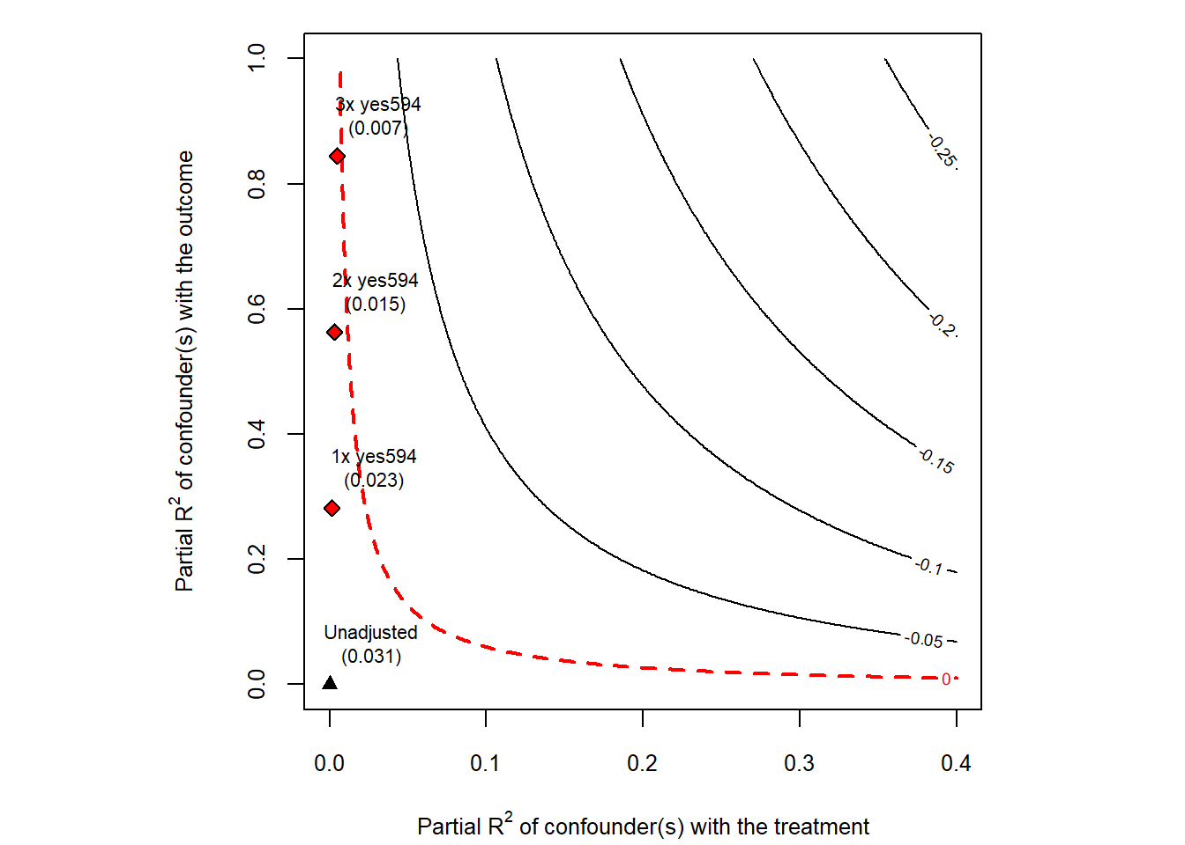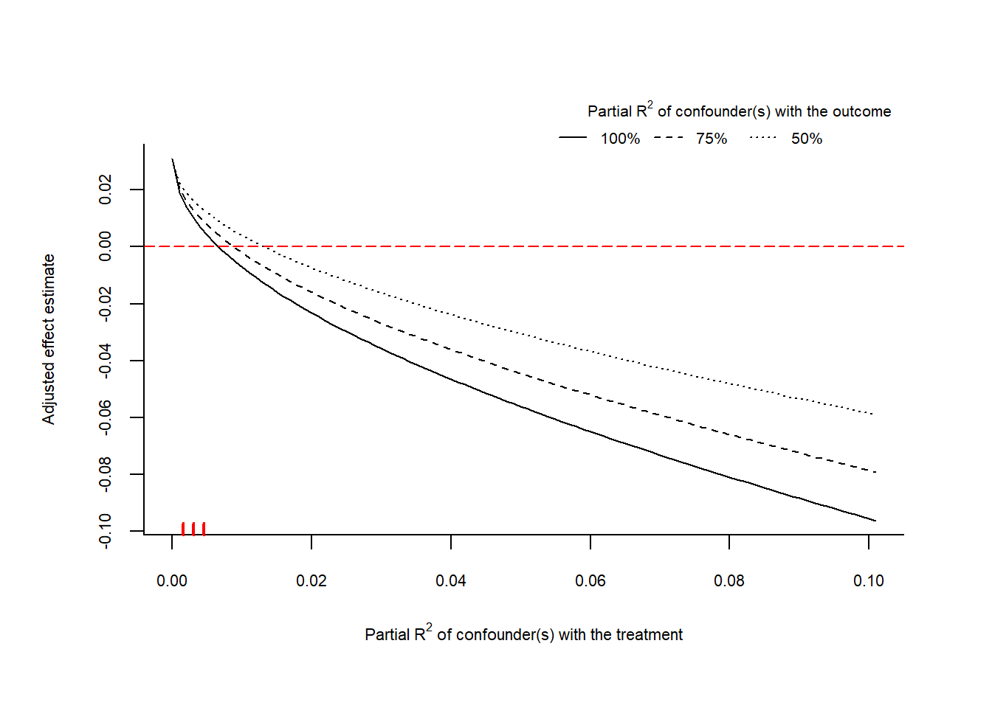

B. 10-miles or less distance-from-shooting variable
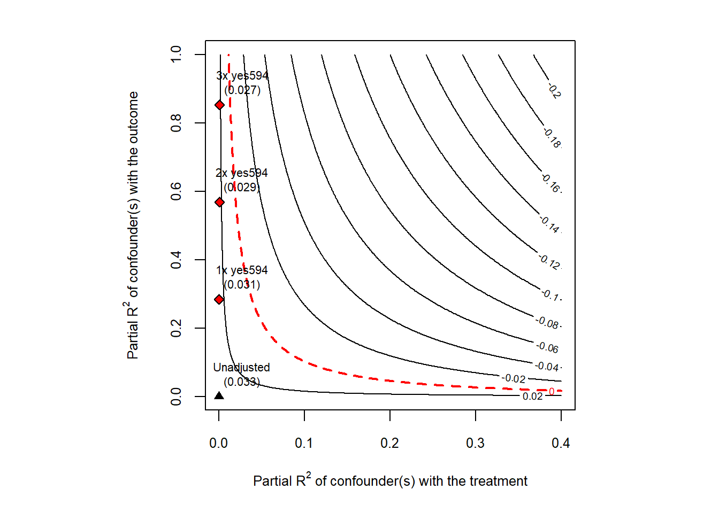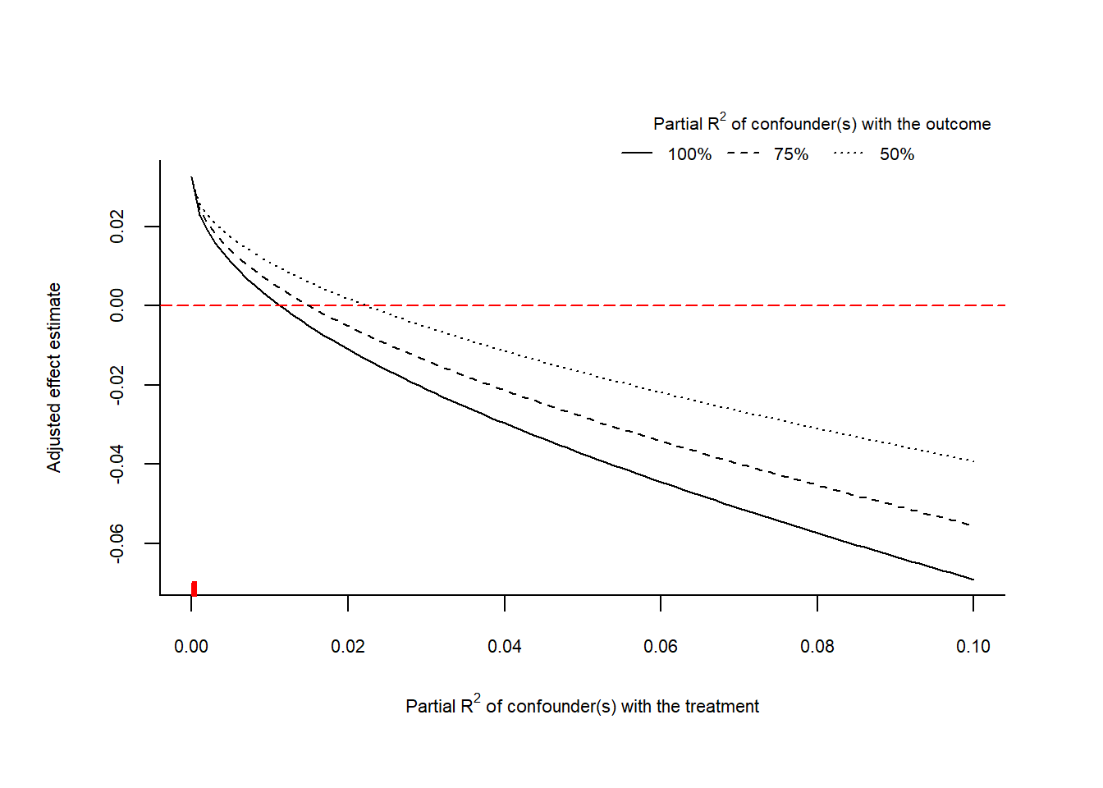

SI-J: Placebo Tests
Table SI-J1 presents a placebo test, analyzing whether proximity to the Cascade Mall shooting is associated with increased support for I-1433, an initiative on the November 8th, 2016, ballot focused on increasing the state minimum wage, using the same specification as our main models in Figures 1.1 – 1.3. According to Ballotpedia,
- A “yes” vote supported incrementally raising the state’s minimum wage from $9.47 to $13.50 by 2020 and mandating employers to offer paid sick leave.
- A “no” vote opposed both increasing the state minimum wage and mandating employers to offer paid sick leave.
As expected, proximity to the Cascade Mall shooting is not associated with increased support for the minimum wage across all of our treatment measures.
Table SI-J1: The Effects of Proximity to the Cascade Mall Shooting on Support for a Higher Minimum Wage
 | Dependent variable:
 | Support for Higher Minimum Wage (I-1433)
 | 5 Miles or Less Model | 10 Miles or Less Model | 15 Miles or Less Model
 | (1) | (2) | (3)
5 Miles or Less from CM Shooting | 0.003
 | (0.006)
10 Miles or Less from CM Shooting |  | 0.004
 |  | (0.005)
15 Miles or Less from CM Shooting |  |  | 0.005
 |  |  | (0.004)
Proportion in Support of I-594 | 0.015 | 0.015 | 0.016
 | (0.017) | (0.017) | (0.017)
Proportion Voted for Obama in 2012 | 0.809*** | 0.809*** | 0.809***
 | (0.016) | (0.016) | (0.016)
Change in Democratic Vote Share (President: 2012-2016) | 0.235*** | 0.236*** | 0.235***
 | (0.022) | (0.022) | (0.022)
Proportion Male | -0.015 | -0.015 | -0.015
 | (0.028) | (0.028) | (0.028)
Proportion Black | 0.121*** | 0.121*** | 0.121***
 | (0.013) | (0.013) | (0.013)
Proportion Latino | 0.028*** | 0.028*** | 0.028***
 | (0.008) | (0.008) | (0.008)
Proportion Asian or Pacific Islander | 0.044*** | 0.044*** | 0.045***
 | (0.007) | (0.007) | (0.007)
Proportion Native American | -0.004 | -0.004 | -0.004
 | (0.015) | (0.015) | (0.015)
Proportion 55 Years Old or Older | 0.069*** | 0.069*** | 0.069***
 | (0.011) | (0.011) | (0.011)
Proportion 18 Years Old or Younger | 0.019 | 0.019 | 0.019
 | (0.018) | (0.018) | (0.018)
Proportion with a College Degree | 0.023*** | 0.023*** | 0.023***
 | (0.004) | (0.004) | (0.004)
Median Income | -0.00000* | -0.00000* | -0.00000*
 | (0.00000) | (0.00000) | (0.00000)
Population Density | -0.352 | -0.350 | -0.344
 | (0.412) | (0.412) | (0.412)
Proportion Owner Occupied | -0.236*** | -0.236*** | -0.236***
 | (0.012) | (0.012) | (0.012)
Firearm Licenses (ATF) | 0.001*** | 0.001*** | 0.001***
 | (0.0002) | (0.0002) | (0.0002)
Constant | 0.153*** | 0.153*** | 0.153***
 | (0.018) | (0.018) | (0.018)
Observations | 6,905 | 6,905 | 6,905
R² | 0.919 | 0.919 | 0.919
Adjusted R² | 0.919 | 0.919 | 0.919
Residual Std. Error (df = 6888) | 1.099 | 1.099 | 1.098
Note: All models use heteroskedasticity robust standard errors. ⋆=p<0.05; ⋆⋆=p<0.01; ⋆⋆⋆=p<0.001
Table SI-J2 presents a placebo test, analyzing whether proximity to the Cascade Mall shooting is associated with increased support for I-1501, an initiative on the November 8th, 2016, ballot focused on increasing penalties for identity theft targeted at seniors and vulnerable populations, using the same specification as our main models in Figures 1.1 – 1.3. According to Ballotpedia,
- A “yes” vote supported increasing criminal identity-theft penalties, expanding civil liability for consumer fraud targeting seniors and vulnerable individuals, and exempting certain information of vulnerable individuals and in-home caregivers from public disclosure.
- A “no” vote opposed this measure increasing criminal identity-theft penalties, expanding civil liability for consumer fraud targeting certain individuals, and exempting certain information of vulnerable individuals and in-home caregivers from public disclosure.
As expected, proximity to the Cascade Mall shooting is not associated with support increasing penalties for identity theft across all of our measurements.
Table SI-J2: The Effects of Proximity to the Cascade Mall Shooting on Support for Stricter Carceral Penalties for Identity Theft
 | Dependent variable:
 | Support for Stricter Carceral Penalties for Identity Theft (I-1501)
 | 5 Miles or Less Model | 10 Miles or Less Model | 15 Miles or Less Model
 | (1) | (2) | (3)
5 Miles or Less from CM Shooting | -0.006
 | (0.007)
10 Miles or Less from CM Shooting |  | -0.005
 |  | (0.005)
15 Miles or Less from CM Shooting |  |  | -0.004
 |  |  | (0.004)
Proportion in Support of I-594 | 0.028 | 0.029 | 0.029
 | (0.021) | (0.021) | (0.021)
Proportion Voted for Obama in 2012 | -0.031 | -0.032 | -0.032
 | (0.022) | (0.022) | (0.022)
Change in Democratic Vote Share (Senator: 2010-2016) | -0.325*** | -0.325*** | -0.325***
 | (0.027) | (0.027) | (0.027)
Proportion Male | -0.192*** | -0.192*** | -0.192***
 | (0.040) | (0.040) | (0.040)
Proportion Black | 0.144*** | 0.144*** | 0.144***
 | (0.022) | (0.022) | (0.022)
Proportion Latino | 0.101*** | 0.101*** | 0.100***
 | (0.010) | (0.010) | (0.010)
Proportion Asian or Pacific Islander | 0.121*** | 0.121*** | 0.121***
 | (0.012) | (0.012) | (0.012)
Proportion Native American | 0.145*** | 0.146*** | 0.146***
 | (0.029) | (0.029) | (0.029)
Proportion 55 Years Old or Older | 0.036* | 0.036* | 0.036*
 | (0.016) | (0.016) | (0.016)
Proportion 18 Years Old or Younger | 0.100*** | 0.100*** | 0.100***
 | (0.021) | (0.021) | (0.021)
Proportion with a College Degree | 0.084*** | 0.084*** | 0.084***
 | (0.004) | (0.004) | (0.005)
Median Income | -0.00000*** | -0.00000*** | -0.00000***
 | (0.00000) | (0.00000) | (0.00000)
Population Density | -5.760*** | -5.762*** | -5.765***
 | (1.122) | (1.122) | (1.123)
Proportion Owner Occupied | -0.253*** | -0.253*** | -0.253***
 | (0.016) | (0.016) | (0.016)
Firearm Licenses (ATF) | 0.002*** | 0.002*** | 0.002***
 | (0.0003) | (0.0003) | (0.0003)
Constant | 0.802*** | 0.802*** | 0.802***
 | (0.024) | (0.024) | (0.024)
Observations | 6,905 | 6,905 | 6,905
R² | 0.402 | 0.403 | 0.402
Adjusted R² | 0.401 | 0.401 | 0.401
Residual Std. Error (df = 6888) | 1.548 | 1.548 | 1.548
Note: All models use heteroskedasticity robust standard errors. ⋆=p<0.05; ⋆⋆=p<0.01; ⋆⋆⋆=p<0.001
Table SI-J3 presents a placebo test, analyzing whether proximity to the Cascade Mall shooting is associated with increased support for I-732, an initiative on the November 8th, 2016, ballot focused on creating a carbon tax, using the same specification as our main models in Figures 1.1 – 1.3. According to Ballotpedia,
- A “yes” vote supported imposing a carbon emission tax on the sale or use of certain fossil fuels and fossil-fuel-generated electricity.
- A “no” vote opposed this proposal, keeping the tax structure unchanged.
Proximity to the Cascade Mall shooting is associated with higher support for a carbon tax in one model – the 5 miles or less treatment measure – but the substantive effects are relatively small – a 1.1 percentage point increase in support – and the, more importantly, the effect is not robust across the other distance measures. This may simply be a randomly occurring association, which is likely to be found given the number of placebos tests we conduct.
Table SI-J3: The Effects of Proximity to the Cascade Mall Shooting on Support for a Carbon Tax
 | Dependent variable:
 | Support for Carbon Tax (I-732)
 | 5 Miles or Less Model | 10 Miles or Less Model | 15 Miles or Less Model
 | (1) | (2) | (3)
5 Miles or Less from CM Shooting | 0.011*
 | (0.005)
10 Miles or Less from CM Shooting |  | 0.003
 |  | (0.005)
15 Miles or Less from CM Shooting |  |  | 0.002
 |  |  | (0.004)
Proportion in Support of I-594 | 0.474*** | 0.473*** | 0.473***
 | (0.033) | (0.033) | (0.033)
Proportion Voted for Obama in 2012 | 0.149*** | 0.150*** | 0.150***
 | (0.036) | (0.036) | (0.036)
Change in Democratic Vote Share (Senator: 2010-2016) | 0.348*** | 0.348*** | 0.348***
 | (0.040) | (0.040) | (0.040)
Proportion Male | -0.014 | -0.015 | -0.015
 | (0.056) | (0.056) | (0.056)
Proportion Black | -0.021 | -0.022 | -0.022
 | (0.016) | (0.016) | (0.016)
Proportion Latino | -0.007 | -0.007 | -0.006
 | (0.010) | (0.010) | (0.010)
Proportion Asian or Pacific Islander | -0.008 | -0.009 | -0.009
 | (0.009) | (0.009) | (0.009)
Proportion Native American | -0.019 | -0.019 | -0.019
 | (0.033) | (0.033) | (0.033)
Proportion 55 Years Old or Older | -0.076*** | -0.076*** | -0.076***
 | (0.016) | (0.016) | (0.016)
Proportion 18 Years Old or Younger | -0.185*** | -0.185*** | -0.185***
 | (0.020) | (0.020) | (0.020)
Proportion with a College Degree | -0.006 | -0.006 | -0.006
 | (0.005) | (0.005) | (0.005)
Median Income | -0.000 | -0.000 | -0.000
 | (0.00000) | (0.00000) | (0.00000)
Population Density | 1.772*** | 1.772*** | 1.773***
 | (0.397) | (0.397) | (0.397)
Proportion Owner Occupied | -0.212*** | -0.212*** | -0.212***
 | (0.018) | (0.018) | (0.018)
Firearm Licenses (ATF) | 0.0004 | 0.0004 | 0.0004
 | (0.0002) | (0.0002) | (0.0002)
Constant | 0.189*** | 0.189*** | 0.189***
 | (0.028) | (0.028) | (0.028)
Observations | 6,905 | 6,905 | 6,905
R² | 0.903 | 0.902 | 0.902
Adjusted R² | 0.902 | 0.902 | 0.902
Residual Std. Error (df = 6888) | 1.040 | 1.040 | 1.040
Note: All models use heteroskedasticity robust standard errors. ⋆=p<0.05; ⋆⋆=p<0.01; ⋆⋆⋆=p<0.001
Table SI-J4 presents a placebo test, analyzing whether proximity to the Cascade Mall shooting is associated with increased support for Advisory Vote 15, an initiative on the November 8th, 2016, ballot focused on repealing a limitation on electric vehicle subsidies, using the same specification as our main models in Figures 1.1 – 1.3. According to Ballotpedia,
- A “repealed” vote opposed House Bill 2778, thereby advising against this limitation of the tax exemption offered for certain alternative fuel vehicles.
- A “maintained” vote supported House Bill 2778, which limits the sales tax exemption available for certain alternative fuel vehicles, thereby increasing the tax revenue received by the state.
As expected, proximity to the Cascade Mall shooting is not associated with support for limiting electric vehicle subsidies across all of our measurements. [Note: the dependent variable measure was inversed so that it measures support for keeping EV subsidies making it more in line with the rest of the analysis.]
Table SI-J4: The Effects of Proximity to the Cascade Mall Shooting on Support for Keeping Electric Vehicle Subsidies
 | Dependent variable:
 | Support for Keeping Electric Vehicle Subsidies (M-15)
 | 5 Miles or Less Model | 10 Miles or Less Model | 15 Miles or Less Model
 | (1) | (2) | (3)
5 Miles or Less from CM Shooting | 0.006
 | (0.006)
10 Miles or Less from CM Shooting |  | 0.002
 |  | (0.005)
15 Miles or Less from CM Shooting |  |  | 0.002
 |  |  | (0.004)
Proportion in Support of I-594 | 0.534*** | 0.533*** | 0.533***
 | (0.016) | (0.016) | (0.016)
Proportion Voted for Obama in 2012 | 0.188*** | 0.188*** | 0.189***
 | (0.017) | (0.017) | (0.016)
Change in Democratic Vote Share (Senator: 2010-2016) | 0.692*** | 0.692*** | 0.692***
 | (0.022) | (0.023) | (0.022)
Proportion Male | 0.100** | 0.099** | 0.099**
 | (0.031) | (0.031) | (0.031)
Proportion Black | -0.230*** | -0.231*** | -0.231***
 | (0.020) | (0.020) | (0.020)
Proportion Latino | -0.181*** | -0.180*** | -0.180***
 | (0.010) | (0.010) | (0.010)
Proportion Asian or Pacific Islander | -0.173*** | -0.173*** | -0.173***
 | (0.012) | (0.012) | (0.012)
Proportion Native American | -0.115*** | -0.115*** | -0.115***
 | (0.033) | (0.033) | (0.033)
Proportion 55 Years Old or Older | -0.162*** | -0.162*** | -0.162***
 | (0.013) | (0.013) | (0.013)
Proportion 18 Years Old or Younger | -0.171*** | -0.171*** | -0.171***
 | (0.020) | (0.020) | (0.020)
Proportion with a College Degree | -0.033*** | -0.033*** | -0.033***
 | (0.004) | (0.004) | (0.004)
Median Income | 0.00000** | 0.00000** | 0.00000**
 | (0.00000) | (0.00000) | (0.00000)
Population Density | 2.402*** | 2.402*** | 2.404***
 | (0.497) | (0.497) | (0.497)
Proportion Owner Occupied | 0.015 | 0.015 | 0.015
 | (0.015) | (0.015) | (0.015)
Firearm Licenses (ATF) | -0.001*** | -0.001*** | -0.001***
 | (0.0003) | (0.0003) | (0.0003)
Constant | 0.073*** | 0.073*** | 0.073***
 | (0.021) | (0.021) | (0.021)
Observations | 6,905 | 6,905 | 6,905
R² | 0.868 | 0.868 | 0.868
Adjusted R² | 0.867 | 0.867 | 0.867
Residual Std. Error (df = 6888) | 1.396 | 1.396 | 1.396
Note: All models use heteroskedasticity robust standard errors. ⋆=p<0.05; ⋆⋆=p<0.01; ⋆⋆⋆=p<0.001

SI-K: Effect of Proximity on Support for Clinton
In this section, we test whether proximity to the four shootings analyzed in the main text and SI (Cascade Mall, Mulkiteo, Isla Vista, and San Bernardino) affected support for Democratic presidential candidate Hilary Clinton. In Washington state, we control for the change in support for Democratic Senator Murray (2010-2016) to account for Democratic-leaning trends. In California, we account for the change in support for Democratic Governor Jerry Brown (2010-2014) to account for Democratic-leaning trends [note: results are robust when these trends are not included].
We find no consistent patterns across the four shootings, with significant variation in the direction, size, and statistical significance of the effects. Near the Cascade Mall shooting, the 5-mile or less treatment measure suggests that proximity to the Cascade Mall shooting is associated with lower support for Hilary Clinton – an effect associated with movement in the opposite ideological direction than the gun control measure – this finding is not robust across treatment measures. The coefficient for the 10 miles or less treatment measure is negative but small and not statistically significant. The coefficient for the 15 miles or less treatment measure is positive but also small and not statistically significant. In sum, this analysis suggests that proximity to the Cascade Mall shooting is not consistently associated with support for or opposition towards Hilary Clinton in 2016, a finding in line with previous scholarship (Hans and Holbien forthcoming).
Table SI-K1 – Effect of the Cascade Mall Mass Shooting on Support for Clinton
 | Dependent variable:
 | Support for Hilary Clinton (2016)
 | 5 Miles or Less Model | 10 Miles or Less Model | 15 Miles or Less Model
 | (1) | (2) | (3)
5 Miles or Less from CM Shooting | -0.012*
 | (0.005)
10 Miles or Less from CM Shooting |  | -0.003
 |  | (0.006)
15 Miles or Less from CM Shooting |  |  | 0.002
 |  |  | (0.004)
Proportion in Support of I-594 | 0.432*** | 0.431*** | 0.431***
 | (0.012) | (0.012) | (0.012)
Proportion Voted for Obama in 2012 | 0.675*** | 0.676*** | 0.675***
 | (0.013) | (0.013) | (0.013)
Change in Democratic Vote Share (Senator: 2010-2016) | 0.385*** | 0.386*** | 0.386***
 | (0.023) | (0.023) | (0.023)
Proportion Male | 0.049 | 0.049 | 0.049
 | (0.029) | (0.029) | (0.029)
Proportion Black | 0.024 | 0.024 | 0.025*
 | (0.013) | (0.013) | (0.013)
Proportion Latino | 0.029** | 0.028** | 0.028**
 | (0.009) | (0.009) | (0.009)
Proportion Asian or Pacific Islander | 0.065*** | 0.065*** | 0.065***
 | (0.007) | (0.007) | (0.007)
Proportion Native American | 0.029* | 0.029* | 0.029*
 | (0.014) | (0.014) | (0.014)
Proportion 55 Years Old or Older | -0.063*** | -0.063*** | -0.063***
 | (0.010) | (0.010) | (0.010)
Proportion 18 Years Old or Younger | -0.096*** | -0.096*** | -0.096***
 | (0.014) | (0.014) | (0.014)
Proportion with a College Degree | -0.015*** | -0.014*** | -0.014***
 | (0.003) | (0.004) | (0.004)
Median Income | 0.00000* | 0.00000* | 0.00000*
 | (0.00000) | (0.00000) | (0.00000)
Population Density | 0.226 | 0.227 | 0.232
 | (0.391) | (0.391) | (0.391)
Proportion Owner Occupied | 0.149*** | 0.149*** | 0.149***
 | (0.011) | (0.011) | (0.011)
Firearm Licenses (ATF) | -0.002*** | -0.002*** | -0.002***
 | (0.0002) | (0.0002) | (0.0002)
Constant | -0.140*** | -0.140*** | -0.140***
 | (0.017) | (0.017) | (0.017)
Observations | 6,736 | 6,736 | 6,736
R² | 0.958 | 0.958 | 0.958
Adjusted R² | 0.957 | 0.957 | 0.957
Residual Std. Error (df = 6719) | 0.986 | 0.986 | 0.986
Note: All models use heteroskedasticity robust standard errors. ⋆=p<0.05; ⋆⋆=p<0.01; ⋆⋆⋆=p<0.001
Table SI-K2 analyzes the effects of the Mukilteo shooting on support for Democratic presidential candidate Hilary Clinton. While the analysis of the Cascade Mall shooting suggests that the shooting had a statistically significant negative effect on support for Clinton in the most narrow distance interval and a statistically insignificant effect at large distances, the Mukilteo shooting is associated with a negative but statistically insignificant effect at the most narrow interval and a small, positive, and statistically significant effect at the larger intervals.
Table SI-K2 – Effect of the Mukilteo Mass Shooting on Support for Clinton
 | Dependent variable:
 | Support for Hilary Clinton (2016)
 | 5 Miles or Less Model | 10 Miles or Less Model | 15 Miles or Less Model
 | (1) | (2) | (3)
5 Miles or Less from Mukilteo Shooting | -0.003
 | (0.003)
10 Miles or Less from Mukilteo Shooting |  | 0.005**
 |  | (0.002)
15 Miles or Less from Mukilteo Shooting |  |  | 0.009***
 |  |  | (0.001)
Proportion in Support of I-594 | 0.492*** | 0.492*** | 0.492***
 | (0.015) | (0.015) | (0.015)
Proportion Voted for Obama in 2012 | 0.623*** | 0.621*** | 0.616***
 | (0.017) | (0.017) | (0.017)
Change in Democratic Vote Share (Senator: 2010-2016) | 0.020 | 0.019 | 0.019
 | (0.047) | (0.047) | (0.047)
Proportion Male | 0.001 | 0.004 | 0.010
 | (0.015) | (0.015) | (0.015)
Proportion Black | 0.103*** | 0.104*** | 0.105***
 | (0.009) | (0.009) | (0.009)
Proportion Latino | 0.116*** | 0.113*** | 0.112***
 | (0.009) | (0.009) | (0.009)
Proportion Asian or Pacific Islander | 0.054*** | 0.055*** | 0.057***
 | (0.016) | (0.016) | (0.016)
Proportion Native American | -0.072*** | -0.073*** | -0.072***
 | (0.012) | (0.012) | (0.012)
Proportion 55 Years Old or Older | -0.093*** | -0.095*** | -0.097***
 | (0.017) | (0.017) | (0.017)
Proportion 18 Years Old or Younger | -0.012** | -0.012** | -0.011*
 | (0.004) | (0.004) | (0.004)
Proportion with a College Degree | 0.00000 | 0.00000 | 0.00000
 | (0.00000) | (0.00000) | (0.00000)
Median Income | -0.171 | -0.168 | -0.116
 | (0.435) | (0.436) | (0.435)
Population Density | 0.147*** | 0.148*** | 0.146***
 | (0.014) | (0.013) | (0.013)
Proportion Owner Occupied | -0.001*** | -0.001*** | -0.001***
 | (0.0002) | (0.0002) | (0.0002)
Firearm Licenses (ATF) | -0.117*** | -0.116*** | -0.114***
 | (0.025) | (0.025) | (0.025)
Observations | 6,906 | 6,906 | 6,906
R² | 0.947 | 0.947 | 0.947
Adjusted R² | 0.946 | 0.947 | 0.947
Residual Std. Error (df = 6890) | 1.104 | 1.104 | 1.102
Note: All models use heteroskedasticity robust standard errors. ⋆=p<0.05; ⋆⋆=p<0.01; ⋆⋆⋆=p<0.001

Table SI-K3 analyzes the effects of the Isla Vista shooting on support for Democratic presidential candidate Hilary Clinton. In this case, proximity to the shooting is positively and statistically significantly associated with support for Clinton at the smallest distance interval and the largest distance interval, but not in the middle distance interval.
Table SI-K3 – Effect of the Isla Vista Mass Shooting on Support for Clinton
 | Dependent variable:
 | Support for Hilary Clinton (2016)
 | 5 Miles or Less Model from SB Shooting | 10 Miles or Less Model from SB Shooting | 15 Miles or Less Model from SB Shooting
 | (1) | (2) | (3)
5 Miles or Less from IV Shooting | 0.020**
 | (0.006)
10 Miles or Less from IV Shooting |  | 0.009
 |  | (0.005)
15 Miles or Less from IV Shooting |  |  | 0.010*
 |  |  | (0.005)
Proportion Voted for Obama in 2012 | 0.758*** | 0.758*** | 0.758***
 | (0.024) | (0.024) | (0.024)
Proportion in Support of Reform 3-Strike Laws in 2012 (Prop. 36) | 0.193*** | 0.193*** | 0.193***
 | (0.049) | (0.049) | (0.049)
Change in Democratic Vote Share (Governor: 2010-2014) | 0.114*** | 0.114*** | 0.114***
 | (0.028) | (0.028) | (0.028)
Proportion Male | -0.012 | -0.013 | -0.013
 | (0.077) | (0.077) | (0.077)
Proportion Black | 0.082*** | 0.082*** | 0.082***
 | (0.012) | (0.012) | (0.012)
Proportion Latino | 0.136*** | 0.136*** | 0.136***
 | (0.006) | (0.006) | (0.006)
Proportion Asian or Pacific Islander | 0.070*** | 0.070*** | 0.070***
 | (0.006) | (0.006) | (0.006)
Proportion Native American | -0.250** | -0.250** | -0.250**
 | (0.089) | (0.089) | (0.089)
Proportion 55 Years Old or Older | 0.009 | 0.008 | 0.008
 | (0.007) | (0.007) | (0.007)
Proportion 18 Years Old or Younger | -0.049** | -0.049** | -0.049**
 | (0.016) | (0.015) | (0.015)
Proportion with a College Degree | 0.128*** | 0.128*** | 0.127***
 | (0.004) | (0.004) | (0.004)
Median Income | 0.00000*** | 0.00000*** | 0.00000***
 | (0.00000) | (0.00000) | (0.00000)
Population Density | 0.546** | 0.553** | 0.556**
 | (0.172) | (0.172) | (0.172)
Proportion Owner Occupied | 0.003 | 0.004 | 0.004
 | (0.008) | (0.008) | (0.008)
Firearm Licenses (ATF) | -0.002*** | -0.002*** | -0.002***
 | (0.0001) | (0.0001) | (0.0001)
Constant | -0.079* | -0.079* | -0.079*
 | (0.036) | (0.036) | (0.036)
Observations | 19,904 | 19,904 | 19,904
R² | 0.946 | 0.946 | 0.946
Adjusted R² | 0.946 | 0.946 | 0.946
Residual Std. Error (df = 19886) | 1.494 | 1.494 | 1.494
Note: All models use heteroskedasticity robust standard errors. ⋆=p<0.05; ⋆⋆=p<0.01; ⋆⋆⋆=p<0.001

Table SI-K4 analyzes the effects of the San Bernardino shooting on support for Democratic presidential candidate Hilary Clinton. In this case, proximity to the shooting is negatively and statistically significantly associated with support for Clinton only at the largest distance interval, with the coefficient becoming smaller at larger distances.

To summarize, no consistent pattern on two-party vote share for president is found across our four cases. In the first case, the association is negative and statistically significant only at the smallest distance interval. In the second case, the association is positive and statistically significant only at the two largest distance intervals. In the third case, the relationship is positive and statistically significant only in the smallest and largest distance intervals. In the fourth case, the correlation is negative and statistically significant only at the largest distance interval. See SI-N for a meta-analysis of these findings.

Table SI-K4 – Effect of the San Bernardino Mass Shooting on Support for Clinton
 | Dependent variable:
 | Support for Hilary Clinton (2016)
 | 5 Miles or Less Model from SB Shooting | 10 Miles or Less Model from SB Shooting | 15 Miles or Less Model from SB Shooting
 | (1) | (2) | (3)
5 Miles or Less from SB Shooting | 0.0002
 | (0.004)
10 Miles or Less from SB Shooting |  | -0.003
 |  | (0.002)
15 Miles or Less from SB Shooting |  |  | -0.008***
 |  |  | (0.002)
Proportion Voted for Obama in 2012 | 0.758*** | 0.758*** | 0.759***
 | (0.024) | (0.024) | (0.024)
Proportion in Support of Reform 3-Strike Laws in 2012 (Prop. 36) | 0.194*** | 0.193*** | 0.192***
 | (0.049) | (0.049) | (0.049)
Change in Democratic Vote Share (Governor: 2010-2014) | 0.115*** | 0.114*** | 0.112***
 | (0.028) | (0.029) | (0.029)
Proportion Male | -0.013 | -0.013 | -0.014
 | (0.077) | (0.077) | (0.077)
Proportion Black | 0.082*** | 0.082*** | 0.083***
 | (0.012) | (0.012) | (0.012)
Proportion Latino | 0.136*** | 0.136*** | 0.137***
 | (0.006) | (0.006) | (0.006)
Proportion Asian or Pacific Islander | 0.070*** | 0.070*** | 0.070***
 | (0.006) | (0.006) | (0.006)
Proportion Native American | -0.250** | -0.251** | -0.252**
 | (0.089) | (0.089) | (0.090)
Proportion 55 Years Old or Older | 0.008 | 0.008 | 0.007
 | (0.007) | (0.007) | (0.007)
Proportion 18 Years Old or Younger | -0.050** | -0.050** | -0.050**
 | (0.016) | (0.016) | (0.016)
Proportion with a College Degree | 0.128*** | 0.128*** | 0.128***
 | (0.004) | (0.004) | (0.004)
Median Income | 0.00000*** | 0.00000*** | 0.00000***
 | (0.00000) | (0.00000) | (0.00000)
Population Density | 0.550** | 0.540** | 0.520**
 | (0.172) | (0.172) | (0.172)
Proportion Owner Occupied | 0.004 | 0.004 | 0.004
 | (0.008) | (0.008) | (0.008)
Firearm Licenses (ATF) | -0.002*** | -0.002*** | -0.002***
 | (0.0001) | (0.0001) | (0.0001)
Constant | -0.079* | -0.078* | -0.077*
 | (0.036) | (0.036) | (0.036)
Observations | 19,904 | 19,904 | 19,904
R² | 0.946 | 0.946 | 0.946
Adjusted R² | 0.946 | 0.946 | 0.946
Residual Std. Error (df = 19886) | 1.494 | 1.494 | 1.493
Note: All models use heteroskedasticity robust standard errors. ⋆=p<0.05; ⋆⋆=p<0.01; ⋆⋆⋆=p<0.001

SI-L: Heterogeneous Responses by Prior Support for Gun Control
Figures SI-L1 – SI-L4 plot the marginal effects of proximity to the Cascade Mall shooting (based on 5- and 10-mile measures) by prior support for gun control (based on support for I-594) or Democratic preferences (based on support for Obama in 2012) on support for I-1491 using the interflex package on R (Hainmueller, Mummolo, and Xu 2018). The interflex package looks beyond linear interaction effects, focusing on “bins” in the moderator where there is common support. These models test whether prior support for gun control moderates the effect of proximity to a mass shooting on posterior support for gun control.
Neither treatment measure nor moderating variable combination suggests that there are heterogeneous treatment effects based on pre-existing political preferences. While the linear interactions provide some evidence that more conservative precincts shifted leftward more on gun control as a result of the proximal shooting, this finding does not hold when looking at “bins” with common support. The differences in marginal effects between all three bins are not statistically distinguishable from each other.

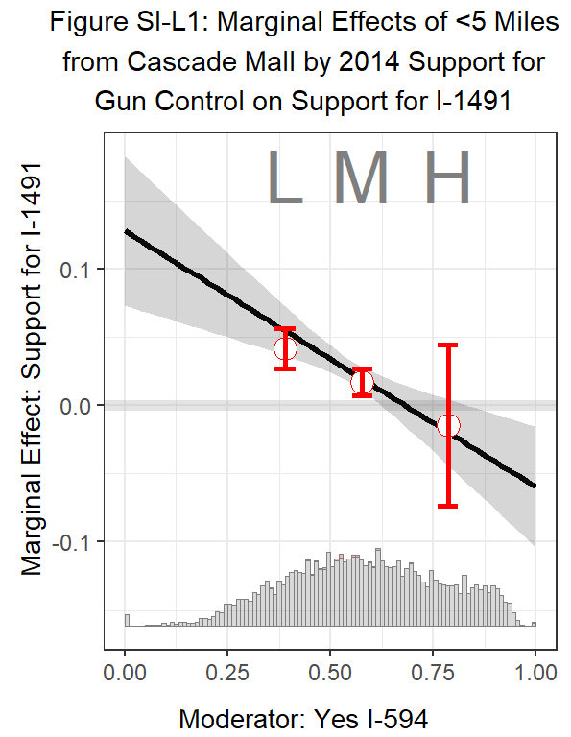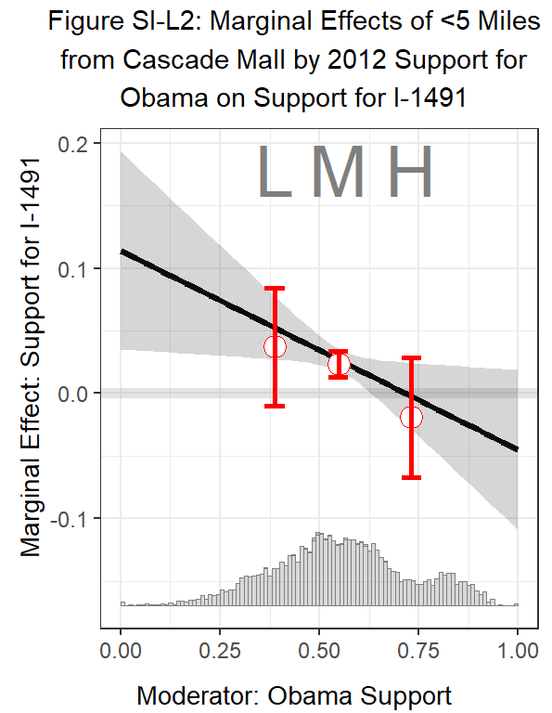
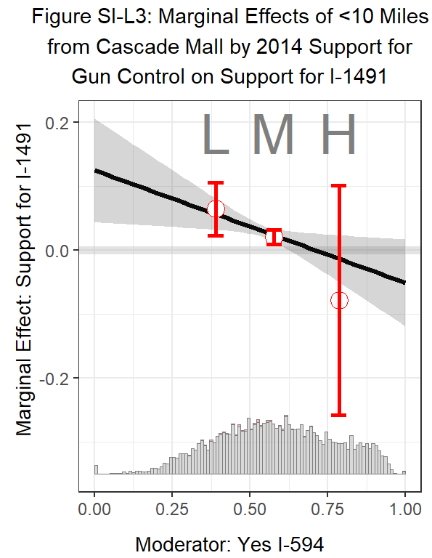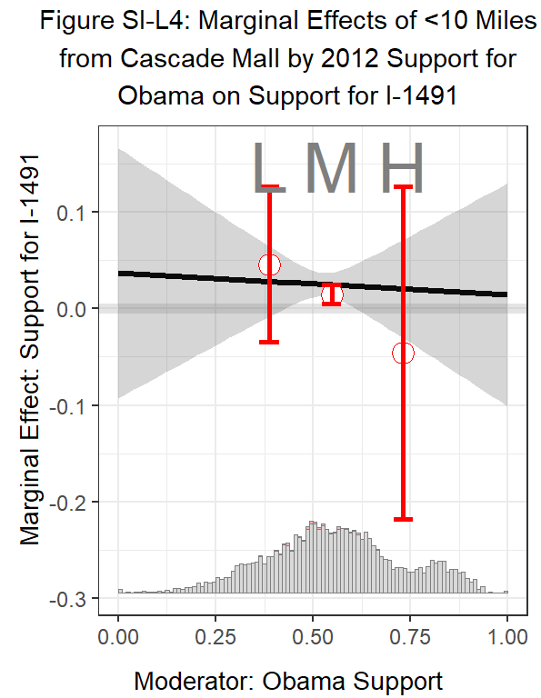

SI-M: Replication Tests
A mass shooting occurred in Mukilteo, Washington, on July 30th, 2016, offering an opportunity to test whether our findings for the Cascade Mall shooting replicate using a different mass shooting. While offering an opportunity to replicate results, the shooting in Mukilteo represents a weaker treatment event than the Cascade Mall shooting. The Mukilteo shooting occurred at a private residence, victims were known to the perpetrator, and it was less deadly (3 fatalities) compared to the Cascade Mall shooting (5 fatalities), and it happened over 3 months prior to the 2016 election, whereas the Cascade Mall shooting happened just over 6 weeks prior to the 2016 election.
Table SI-M1 tests whether proximity to the Mukilteo shooting affected support for I-1491 using the same modeling specifications as those used in Figures 1.1 – 1.3. While the treatment effects are smaller, they are positive and statistically significant. The Mukilteo shooting appears to have increased support for I-1491 by 0.6 percentage points in precincts within 10 miles of the shootings, and these effects are robust to different distance specifications.
Table SI-M1: Testing Generalizability by Looking at the Mukilteo Shooting
 | Dependent variable:
 | Support for ‘Red Flag’ Laws (I-1491)
 | 5 Miles or Less Model | 10 Miles or Less Model | 15 Miles or Less Model
 | (1) | (2) | (3)
5 Miles or Less from Mukilteo Shooting | 0.006*
 | (0.002)
10 Miles or Less from Mukilteo Shooting |  | 0.006***
 |  | (0.001)
15 Miles or Less from Mukilteo Shooting |  |  | 0.004***
 |  |  | (0.001)
Proportion in Support of I-594 | 0.315*** | 0.315*** | 0.315***
 | (0.010) | (0.010) | (0.010)
Proportion Voted for Obama in 2012 | 0.380*** | 0.378*** | 0.376***
 | (0.009) | (0.009) | (0.009)
Change in Democratic Vote Share (President: 2012-2016) | 0.445*** | 0.443*** | 0.442***
 | (0.013) | (0.013) | (0.013)
Proportion Male | -0.069*** | -0.069*** | -0.069***
 | (0.019) | (0.018) | (0.019)
Proportion Black | -0.013 | -0.011 | -0.010
 | (0.010) | (0.010) | (0.010)
Proportion Latino | -0.022*** | -0.021*** | -0.021***
 | (0.006) | (0.006) | (0.006)
Proportion Asian or Pacific Islander | 0.035*** | 0.034*** | 0.035***
 | (0.005) | (0.005) | (0.005)
Proportion Native American | -0.081*** | -0.080*** | -0.080***
 | (0.022) | (0.022) | (0.022)
Proportion 55 Years Old or Older | -0.013* | -0.013* | -0.013*
 | (0.006) | (0.006) | (0.006)
Proportion 18 Years Old or Younger | 0.009 | 0.008 | 0.007
 | (0.011) | (0.011) | (0.011)
Proportion with a College Degree | 0.022*** | 0.023*** | 0.023***
 | (0.003) | (0.003) | (0.003)
Median Income | -0.00000 | -0.00000 | -0.000
 | (0.00000) | (0.00000) | (0.00000)
Population Density | -0.684** | -0.670** | -0.649**
 | (0.238) | (0.237) | (0.237)
Proportion Owner Occupied | -0.015 | -0.014 | -0.015
 | (0.009) | (0.009) | (0.009)
Firearm Licenses (ATF) | 0.001** | 0.001** | 0.001**
 | (0.0002) | (0.0002) | (0.0002)
Constant | 0.335*** | 0.335*** | 0.336***
 | (0.011) | (0.011) | (0.011)
Observations | 6,905 | 6,905 | 6,905
R² | 0.930 | 0.930 | 0.930
Adjusted R² | 0.930 | 0.930 | 0.930
Residual Std. Error (df = 6888) | 0.883 | 0.882 | 0.882
Note: All models use heteroskedasticity robust standard errors. ⋆=p<0.05; ⋆⋆=p<0.01; ⋆⋆⋆=p<0.001

Beyond Washington State, we look at California in 2016 where Proposition 63, which would prohibit the possession of large-capacity ammunition magazines (more than 10 rounds) and require certain individuals to pass a background check in order to purchase ammunition (passed), was on the state ballot during the general presidential election and was proceeded by two public mass shootings in the previous three years. The Isla Vista killings were the first of these two mass shootings. It occurred near the University of California San Barabara in Isla Vista, California over two years before 2016 Proposition 63 was voted on. The perpetrator killed three victims with firearms in a public setting and three additional victims with knives hours earlier in their home.
Table SI-M2 analyzes the impact of the Isla Vista shooting on support for 2016 Proposition 63 at the three distance specifications used previously. We aim to use a similar model specification to that used in the Washington state analysis. However, unlike the Washington state analysis where a temporally proximal pretreatment measure of voter support for gun control is available at the precinct level, no such measure is available in California. Instead, we use 2012 support for Proposition 36 which relaxed California’s “three-strikes” criminal justice policy for non-violent offenders, a stronger predictor of support for Proposition 63 than 2010 Proposition 19 (marijuana legalization) or 2012 Proportion 66 (death penalty repeal). All other controls are the same as those used in the Washington state analysis. Importantly, the R² of this analysis is similar to the R² of the Washington state analysis, suggesting these models are well-define, explain a large amount of the variation in support for Proposition 63, and the analysis is unlikely to be affected by omitted variable bias.
The analysis suggests that the Isla Vista shooting increased support for Proposition 63 by about 1.7 percentage points in its 5-, 10-, and 15-mile radius, a smaller effect than the Cascade Mall shooting, but still of substantive importance and statistical significance.
Table SI-M2: Testing Generalizability by Looking at the Isla Vista Shooting
 | Dependent variable:
 | Support for Background checks for Ammunition Purchases (Prop. 63)
 | 5 Miles or Less Model | 10 Miles or Less Model | 15 Miles or Less Model
 | (1) | (2) | (3)
5 Miles or Less from IV Shooting | 0.017**
 | (0.006)
10 Miles or Less from IV Shooting |  | 0.017**
 |  | (0.005)
15 Miles or Less from IV Shooting |  |  | 0.016***
 |  |  | (0.005)
Proportion Voted for Obama in 2012 | 0.610*** | 0.610*** | 0.610***
 | (0.040) | (0.040) | (0.040)
Proportion in Support of Reforming 3-Strike Laws in 2012 (Prop. 36) | 0.246*** | 0.245*** | 0.245***
 | (0.063) | (0.063) | (0.063)
Change in Democratic Vote Share (President: 2012-2016) | 0.788*** | 0.788*** | 0.788***
 | (0.101) | (0.100) | (0.100)
Proportion Male | -0.255* | -0.255* | -0.255*
 | (0.105) | (0.105) | (0.105)
Proportion Black | -0.012 | -0.011 | -0.011
 | (0.010) | (0.010) | (0.010)
Proportion Latino | 0.033* | 0.033* | 0.033*
 | (0.013) | (0.013) | (0.013)
Proportion Asian or Pacific Islander | 0.095*** | 0.095*** | 0.095***
 | (0.008) | (0.008) | (0.008)
Proportion Native American | -0.510*** | -0.510*** | -0.510***
 | (0.121) | (0.121) | (0.121)
Proportion 55 Years Old or Older | 0.071*** | 0.071*** | 0.071***
 | (0.010) | (0.010) | (0.010)
Proportion 18 Years Old or Younger | -0.068** | -0.068** | -0.068**
 | (0.021) | (0.021) | (0.021)
Proportion with a College Degree | 0.093*** | 0.093*** | 0.093***
 | (0.013) | (0.013) | (0.013)
Median Income | 0.00000*** | 0.00000*** | 0.00000***
 | (0.00000) | (0.00000) | (0.00000)
Population Density | 2.225*** | 2.234*** | 2.238***
 | (0.243) | (0.244) | (0.244)
Proportion Owner Occupied | -0.094*** | -0.094*** | -0.093***
 | (0.008) | (0.008) | (0.008)
Firearm Licenses (ATF) | -0.002*** | -0.002*** | -0.002***
 | (0.0003) | (0.0003) | (0.0003)
Constant | 0.156*** | 0.156*** | 0.156***
 | (0.031) | (0.031) | (0.031)
Observations | 20,616 | 20,616 | 20,616
R² | 0.924 | 0.924 | 0.924
Adjusted R² | 0.924 | 0.924 | 0.924
Residual Std. Error (df = 20598) | 1.531 | 1.531 | 1.531
Note: | p<0.05; p<0.01; p<0.001
 | All models use heteroskedasticity robust standard errors. ⋆p<0.1; ⋆⋆p<0.05; ⋆⋆⋆p<0.01

As a final replication test, we analyze the effect of the 2015 San Bernardino mass shooting on voters’ support for Proposition 63 in California. We use the same model specification as that used in SI-M2. The covariate effects and R² are similar to those in SI-M2. The 2015 San Bernardino mass shooting happened approximately 11 months before the vote on Proposition 63 and was perpetrated by two people associated with the Islamic State of Iraq and Syria (ISIS) and resulted in 14 fatalities, not including the perpetrators.
The findings presented in Table SI-M3 suggest that the San Bernardino mass shooting increased proximal voters' support for gun control by about 0.7-0.9 percentage points in the 5-, 10-, and 15-mile radius, a smaller effect than the Cascade Mall shooting and more in line with the effects observed near the Mukilteo shooting.
Table SI-M3: Testing Generalizability by Looking at the San Bernardino Shooting
 | Dependent variable:
 | Support for Background checks for Ammunition Purchases (Prop. 63)
 | 5 Miles or Less Model | 10 Miles or Less Model | 15 Miles or Less Model
 | (1) | (2) | (3)
5 Miles or Less from SB Shooting | 0.009**
 | (0.004)
10 Miles or Less from SB Shooting |  | 0.007***
 |  | (0.002)
15 Miles or Less from SB Shooting |  |  | 0.008***
 |  |  | (0.001)
Proportion Voted for Obama in 2012 | 0.610*** | 0.609*** | 0.610***
 | (0.040) | (0.040) | (0.040)
Proportion in Support of Reforming 3-Strike Laws in 2012 (Prop. 36) | 0.247*** | 0.248*** | 0.248***
 | (0.063) | (0.063) | (0.063)
Change in Democratic Vote Share (President: 2012-2016) | 0.788*** | 0.789*** | 0.790***
 | (0.100) | (0.100) | (0.101)
Proportion Male | -0.255* | -0.254* | -0.254*
 | (0.105) | (0.105) | (0.105)
Proportion Black | -0.012 | -0.013 | -0.014
 | (0.010) | (0.010) | (0.010)
Proportion Latino | 0.033* | 0.033* | 0.032*
 | (0.013) | (0.013) | (0.013)
Proportion Asian or Pacific Islander | 0.095*** | 0.095*** | 0.095***
 | (0.008) | (0.008) | (0.008)
Proportion Native American | -0.510*** | -0.510*** | -0.509***
 | (0.121) | (0.121) | (0.121)
Proportion 55 Years Old or Older | 0.071*** | 0.071*** | 0.072***
 | (0.010) | (0.010) | (0.010)
Proportion 18 Years Old or Younger | -0.069*** | -0.069*** | -0.068***
 | (0.021) | (0.021) | (0.021)
Proportion with a College Degree | 0.093*** | 0.093*** | 0.093***
 | (0.013) | (0.013) | (0.013)
Median Income | 0.00000*** | 0.00000*** | 0.00000***
 | (0.00000) | (0.00000) | (0.00000)
Population Density | 2.238*** | 2.246*** | 2.252***
 | (0.244) | (0.245) | (0.244)
Proportion Owner Occupied | -0.093*** | -0.094*** | -0.095***
 | (0.008) | (0.008) | (0.008)
Firearm Licenses (ATF) | -0.002*** | -0.002*** | -0.002***
 | (0.0003) | (0.0003) | (0.0003)
Constant | 0.156*** | 0.155*** | 0.154***
 | (0.031) | (0.031) | (0.031)
Observations | 20,616 | 20,616 | 20,616
R² | 0.924 | 0.924 | 0.924
Adjusted R² | 0.924 | 0.924 | 0.924
Residual Std. Error (df = 20598) | 1.531 | 1.531 | 1.531
Note: | p<0.05; p<0.01; p<0.001
 | All models use heteroskedasticity robust standard errors. ⋆p<0.1; ⋆⋆p<0.05; ⋆⋆⋆p<0.01

While the substantive effect sizes across our four cases vary, we find positive and statistically significant effects in all four cases across all three distance specifications. In sum, the findings suggest that mass shootings have modest but consistently positive effects on voters’ support for gun control measures on the ballot.

SI-N: Meta-Analysis
Here we conduct a meta-analysis of the relationship between mass shootings and support for gun control on the ballot, treating each case as an individual study. Additionally, we do the same for Democratic Presidential vote share, estimating the meta-coefficient for each of our mass shooting proximity measures across our four cases. To do so, we use the metagen package in R programming. This requires us to standardize the dependent variables (support for Initiative 1491, support for Proposition 63, and support for 2016 Democratic presidential candidate Hilary R. Clinton) with a mean centered on 0 and a standard deviation of 1.
Results for random-effects meta-analysis models are reported in Table SI-N for each distance measure. The meta-analysis suggests that living within 5 miles of a mass shooting is associated with a 0.092 standard deviation increase, living within 10 miles with a 0.093 standard deviation increase, and living within 15 miles with a 0.083 standard deviation increase in support for gun control measures on the ballot with all three meta-coefficients being statistically significant. On the other hand, the meta-coefficients estimating the relationship between proximity to mass shootings and support for the Democratic Presidential candidate (Hilary Clinton) are not statistically significant for any of the three treatment measures.

Table SI-N: Meta-Analysis of Mass Shooting Effects on Support for Gun Control and Support for the 2016 Democratic Presidential Candidate
 | 5 Miles or Less Models | 10 Miles or Less Models | 15 Miles or Less Models
 | (1) | (2) | (3)
Support for gun control | 0.0921*  [0.0176; 0.1667] | 0.0927*  [0.0111; 0.1743] | 0.0830*  [0.0104; 0.1555]
Support for Democratic Presidential Candidate | 0.0045  [-0.0548; 0.0638] | 0.0083  [-0.0185; 0.0351] | 0.0147  [-0.0260; 0.0554]
Number of Studies | 4 | 4 | 4
Note: The dependent variable for all models is normalized. All models report the random effects coefficient using the R Programming metagen package and the default calculation of confidence intervals. ⋆=p<0.05; ⋆⋆=p<0.01; ⋆⋆⋆=p<0.001

