**Supplementary Information (SI) for “Partisans of Color”**

1) SI.1. Pre-Registration for Observational Analyses (Study 1)

2) SI.2. Wordings for Main IV and DV in Observational Analyses (Study 1)

3) SI.3. Coding for Covariates in Observational Analyses (Study 1)

4) SI.4. Correlates of Identity Prioritization Among Asian and Latino Adults

5) SI.5. Full Results for Observational Analyses in Table 3 (Study 1), Robustness Check on Identity Prioritization Measure (Studies 1 and 3-4), and Placebo Test (Study 1)

6) SI.6. Results for Identity Prioritization with National Origin ID instead of Latino ID

7) SI.7. Pre-Registration for IATs with Asian and Latino Adults(Study 2), with Stimuli

8) SI.8. Pre-Registration for Experiment with Latino Adults (Study 3)

9) SI.9. Pre-Registration for Experiment with Asian Adults (Study 4)

10) SI.10. IRB Certifications for Experimental Data

**SI.1. Pre-Registration for Observational Analyses (Study 1)**

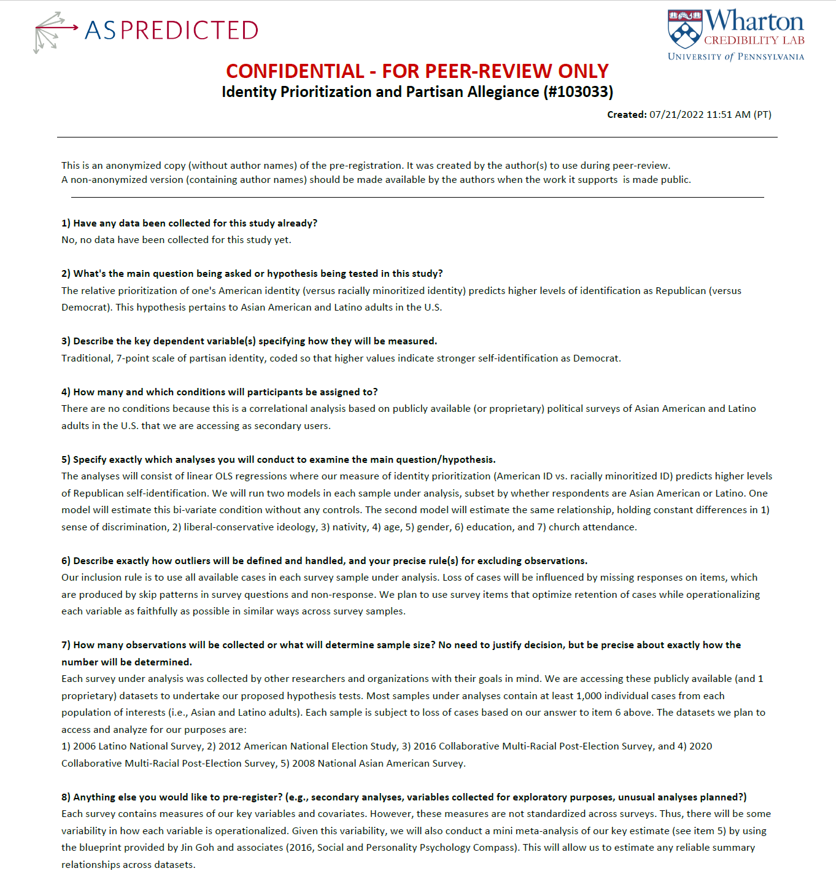

**SI.2. Wordings for Main IV and DV in Observational Analyses (Study 1)**

**DV: Latino Identity Items**

**2006 Latino National Survey (N = 8,634 Latinos)**

[LAIDENT: L10] *How strongly or not do you think of yourself as ANSWERFROM(AQS4B)?*

*Not at all (1)  
 Somewhat strongly (2)  
 Very strongly (3)  
 DK/NA (4)  
 Refused (6)*

**2012 American National Election Study (N = 1,005 Latinos)**

[IDENT_HISPID] *How important is being Hispanic to your identity [extremely important, very important, moderately important, a little important, or not at all important? / not at all important, a little important, moderately important, very important, or extremely important?]*

*Extremely important (1)  
 Very important (2)  
 Moderately important (3)  
 A little important (4)  
 Not at all important (5)*

**2016 Collaborative Multi-Racial Post-Election Survey (N = 3,002 Latinos)**

[L192] *How much is being {ANS to S10 / Latino ethnicity} an important part of how you see yourself?*

*Very important (1)  
 Somewhat important (2)  
 Not very important (3)  
 Not at all important (4)*

**2020 Collaborative Multi-Racial Post-Election Survey (N = 4,585 Latinos)**

[Q271] *How important is being [RACIAL GROUP] to your identity?*

*Extremely important (1)  
 Very important (2)  
 Moderately important (3)  
 Slightly important (4)  
 Not at all important (5)*

**DV: Asian American Identity Items**

**2008 National Asian American Survey (N = 5,159 Asian Americans)**

[QF2] *What happens to other Asians affects your life?*

*Yes (1)  
 No (2)  
 Don’t Know (98)  
 Refused (99)*

[QF2a] *[IF F2=“Yes”] Will it affect you a lot, some, or not very much?*

*A lot (1)  
 Some (2)  
 Not very much (3)  
 Skip/NA (4)  
 Don’t Know (5)  
 Refused (6)*

**2016 Collaborative Multi-Racial Post-Election Survey (N = 3,055 Asian Americans)**

[A192] *How much is being {ANS to S10 / Asian ethnicity} an important part of how you see yourself?*

*Very important (1)  
 Somewhat important (2)  
 Not very important (3)  
 Not at all important (4)*

**2020 Collaborative Multi-Racial Post-Election Survey (N = 3,956 Asian Americans)**

[Q271] *How important is being [RACIAL GROUP] to your identity?*

*Extremely important (1)  
 Very important (2)  
 Moderately important (3)  
 Slightly important (4)  
 Not at all important (5)*

**DV: American Identity Items**

**2006 Latino National Survey (N = 8,634 Latinos)**

[AMERICAN: L8] *How strongly or not do you think of yourself as an American?*

*Not at all (1)  
 Not very strongly (2)  
 Somewhat strongly (3)  
 Very strongly (4)  
 DK/NA (5)  
 Refused (6)*

**2008 National Asian American Survey (N = 5,159 Asian Americans)**

[QF8_C How much in common with whites] *Would you say Asian Americans have a lot in common, some, little in common, or nothing in common politically with [CATEGORY 3]?*

*A lot in common (1)  
 Some (2)  
 Little (3)  
 Nothing in common (4)  
 Don’t Know (98)  
 Refused (99)*

**2012 American National Election Study (N = 1,005 Latinos)**

[IDENT_WHITEID] *How important is being White to your identity [extremely important, very important, moderately important, a little important, or not at all important? / not at all important, a little important, moderately important, very important, or extremely important?]*

*Extremely important (1)  
 Very important (2)  
 Moderately important (3)  
 A little important (4)  
 Not at all important (5)*

**2016 Collaborative Multi-Racial Post-Election Survey (N = 3,055 Asian Americans and N = 3,002 Latinos)**

[C194] *How much is being American an important part of how you see yourself?*

*Very important (1)  
 Somewhat important (2)  
 Not very important (3)  
 Not at all important (4)*

**2020 Collaborative Multi-Racial Post-Election Survey (N = 3,956 Asian Americans and N = 4,585 Latinos)**

[Q154] *How much pride would you say you feel when: You see an American flag or hear the national anthem?*

*A lot (1)  
 Some (2)  
 A little (3)  
 None at all (4)*

*Don’t know (88)*

**IV: Partisanship Items**

**2006 Latino National Survey (N= 8,634 Latinos)**

[PARTYID: J1] *Generally speaking, do you usually consider yourself a Democrat, a Republican, an Independent, some other party, or what?*

*Democrat (1)  
Republican (2)  
Independent (3)  
Don’t care (4)  
Don’t know/other party (5)*

[STRDPARTN: J2] *Would you consider yourself a strong ANSWERFROM(QJ1), or a not very strong ANSWERFROM(QJ1)?*

*Strong ANSWERFROM(QJ1) (1)  
Not very strong ANSWERFROM(QJ1) (2)*

[INDPARTY: J3] *Do you think of yourself as closer to the Republican or Democratic Party?*

*Republican (1)  
Democrat (2)  
DK/Not Sure (3)*

[CLOPART: J4] *Do you think of yourself closer to the Republican or Democratic Party?*

*Closer to Republican (1)  
Closer to Democrat (2)  
DK/Ref (3)*

**2008 National Asian American Survey (N = 5,159 Asian Americans)**

[QD1. Party identification screener (rotated)] *Generally speaking, do you think of yourself as a [RANDOMIZE ORDER OF REPUBLICAN AND DEMOCRAT] Republican, Democrat, Independent, some other party, or do you not think in these terms?*

*Republican (1)  
 Democrat (2)  
 Independent (3)  
 Other party (Specify) (4)  
 Do not think in these terms (DO NOT READ) (5)  
 Don’t Know (98)  
 Refused (99)*

[QD1A] *[IF D1=”Republican”] Would you call yourself a strong Republican or not a strong Republican?*

*Strong Republican (1)  
 Not a strong Republican (2)  
 Skip/NA (97)  
 Don’t Know (98)  
 Refused (99)*

[QD1B] *[IF D1=”Democrat”] Would you call yourself a strong Democrat or not a strong Democrat?*

*Strong Democrat (1)  
 Not a strong Democrat (2)  
 Skip/NA (97)  
 Don’t Know (98)  
 Refused (99)*

[QD1C] *[IF D1=”Independent”] Do you think of yourself as closer to the Republicans or the Democrats?*

*Closer to Republicans (1)  
 Closer to Democrat (2)  
 Skip/NA (97)  
 Don’t Know (98)  
 Refused (99)*

**2012 American National Election Study (N = 1,005 Latinos)**

[CSES_PTYCLOST] *Which party do you feel closest to?*

*Democratic party (1)  
 Republican party (2)  
 Other {SPECIFY} (5)*

[CSES_DEGCLOSE] *Do you feel [very close to this party, somewhat close, or not very close / not very close, somewhat close, or very close to this party]?*

*Very close (1)  
 Somewhat close (2)  
 Not very close (3)*

**2016 Collaborative Multi-Racial Post-Election Survey (N = 3,055 Asian Americans and N = 3,002 Latinos)**

[C25] *Generally speaking, do you think of yourself as a Republican, a Democrat, an independent, or something else?*

*Republican (1)  
 Democrat (2)  
 Independent (3)  
 Other party (4)*

[C26] *[IF C25=1] Do you consider yourself to be a strong {Dem/Rep}, or not?*

*Strong (1)  
 Not strong (2)*

[C27] *[IF C25=3-4] If you had to choose, do you consider yourself closer to the Republican party or the Democratic party?*

*Republican (1)  
 Democrat (2)  
 Independent (3)  
 Other party (4)  
 Don’t know (88)*

**2020 Collaborative Multi-Racial Post-Election Survey (N = 3,956 Asian Americans and N = 4,585 Latinos)**

[Q21] *[IF S7=2 or 3 “When it comes to politics in the U.S.”] Generally speaking, do you think of yourself as a Republican, a Democrat, an independent, or something else?*

*Republican (1)  
 Democrat (2)  
 Independent (3)  
 Other party (4)*

[Q22] *[IF 21=1 or 2] Do you consider yourself to be a strong {Dem/Rep}, or not?*

*Strong (1)  
 Not strong (2)*

[Q23] *[IF 21=3-4] If you had to choose, do you consider yourself closer to the Republican party or the Democratic party?*

*Republican (1)  
 Democrat (2)  
 Independent (3)  
 Other party (4)  
 Don’t know (88)*

**SI.3. Coding for Covariates in Observational Analyses (Study 1)**

**Age**

**2006 LNS:** Higher value indicates older

**2008 NAAS:** Higher value indicates older

**2012 ANES:** Higher value indicates older

**2016 CMPS:** Higher value indicates older

**2020 CMPS:** Higher value indicates older

**Gender**

Female (1)

Other (0)

**Education**

College education or higher (1)

All other levels of education (0)

**Nativity**

U.S-born (1)

Foreign-born (0)

**Religion**

**2006 LNS:**

How often attend religious services?

More than once a week (5)

Once a week (4)

Once a month (3)

Only major religious holidays (2)

Never (1)

**2012 ANES:**

Attend religious services how often?

Every week (5)

Almost every week (4)

Once or twice a month (3)

A few times a year (2)

Never (1)

**Ideology**

**2006 LNS & 2008 NAAS:**

Create series of dichotomous indicators

Conservative (1)

Middle of the Road (2)

Liberal (3)

Don’t know (4)

Don’t think in these terms (5)

**2012 ANES:**

Extremely conservative (1)

Conservative (2)

Slightly conservative (3)

Moderate; middle of the road (4)

Slightly liberal (5)

Liberal (6)

Extremely liberal (7)

**2016 CMPS & 2020 CMPS:**

Very Conservative (1)

Somewhat Conservative (2)

Moderate (3)

Somewhat Liberal (4)

Very Liberal (5)

**Perceived Discrimination**

**2006 LNS:**

Latinos can get ahead in the United States if they work hard?

Strongly agree (1)

Somewhat agree (2)

Somewhat disagree (3)

Strongly disagree (4)

**2008 NAAS:**

Have been a victim of a hate crime (1)

Not a victim of a hate crime (0)

**2012 ANES & 2016 CMPS:**

Higher value indicates higher levels of discrimination (1-5)

**2020 CMPS:**

Higher value indicates higher levels of discrimination (1-4)

**SI.4. Correlates of Identity Prioritization Among Asian and Latino Adults**

Table SI.4. Correlates of Identity Prioritization Among Asian and Latino Adults

*Note:* Identity prioritization is coded so that positive scores reflect greater prioritization of one’s *pan-ethnic* versus *American* identity. The predictors are coded so that higher scores indicate higher levels of a variable. Interview language is dummy coded, where 1 = English, 0 = non-English. Nativity is dummy coded, with 1 = US born, and 0 = Foreign-born. College is dummy coded, with 1 = completed Bachelor’s degree or higher, and 0 = all others. Age is coded continuously in years.

*** p < .001, ** p < .01, * p < .05, two-tailed.

|  |  |  |  |  |  |  |  |
| --- | --- | --- | --- | --- | --- | --- | --- |
|  |  | Identity Prioritization | | | | | |
|  | CMPS 2016  (Latinos) | CMPS 2020  (Latinos) | LNS (2006)  (Latinos) | ANES (2012)  (Latinos) | CMPS 2016  (Asians) | CMPS 2020  (Asians) | NAAS (2008)  (Asians) |
| Nativity | -.030***  (.004) | .005  (.009) | -.503***  (.034) | -.063***  (.014) | -.104***  (.028) | .032***  (.007) | .025  (.035) |
| Age | -.002***  (.000) | -.369***  (.025) | -1.010***  (.067) | -.218***  (.026) | -.010***  (.001) | -.375***  (.022) | -.001***  (.000) |
| Interview language | -.066***  (.008) | .011  (.011) | -.706***  (.033) | -.053**  (.016) | .004  (.100) | .022  (.029) | -.010  (.010) |
| College | -.003  (.004) | .005  (.008) | -.186***  (.035) | .007  (.015) | -.017  (.030) | .002  (.008) | .051***  (.009) |
| N | 5,907 | 3,374 | 7,759 | 885 | 2,987 | 3,659 | 3,334 |

**SI.5. Full Results for Observational Analyses Reported in Table 3 (Study 1)**

|  |  |  |  |  |  |  |  |
| --- | --- | --- | --- | --- | --- | --- | --- |
|  | 2006 LNS  (Latinos) | 2012 ANES  (Latinos) | 2016 CMPS  (Latinos) | 2020 CMPS  (Latinos) | 2008 NAAS  (Asians) | 2016 CMPS  (Asians) | 2020 CMPS  (Asians) |
| Latino ID>  American ID | .145***  (.023) | .251***  (.062) | .214***  (.045) | .191***  (.027) | --- | --- | --- |
| AsianID>  American ID | --- | --- | --- | --- | .059***  (.020) | .076  (.048) | .121***  (.023) |
| Perc’d discrimination  (Latinos) | -.017  (.020) | .152***  (.044) | .256***  (.024) | .181***  (.020) | --- | --- | --- |
| Perc’d discrimination  (Asians) | --- | --- | --- | --- | -.005  (.015) | .169***  (.023) | .091***  (.017) |
| Ideology  (Liberal) | .182***  (.014) | .573***  (.048) | .356***  (.019) | .493*** (.021) | .230***  (.014) | .433***  (.017) | .685***  (.020) |
| Religious attendance | -.034**  (.014) | See notea | -.034*  (.019) | -.041**  (.015) | See notea | -.065***  (.018) | -.055***  (.013) |
| US-born | .045***  (.010) | .015  (.023) | -.004  (.014) | -.003  (.012) | .068***  (.015) | -.004  (.013) | .018*  (.009) |
| College | -.013  (.011) | -.049*  (.026) | -.020  (.013) | -.022*  (.011) | .047  (.011) | .027*  (.014) | -.003  (.011) |
| Female | .029***  (.009) | .025  (.021) | .054***  (.013) | .033***  (.011) | .020*  (.010) | .045***  (.013) | .051***  (.009) |
| Age | .168***  (.022) | .135**  (.050) | .113**  (.037) | .132***  (.037) | -.061**  (.026) | -.029 (.035) | .032  (.31) |
| N | 5,239 | 736 | 2,201 | 2,865 | 3,334 | 2,024 | 3,289 |

*Note:* For all regressions, the dependent variable is a continuous measure of partisanship, coded in a pro-Democrat direction (on a 0-1interval). Entries are OLS coefficients with standard errors in parentheses.

aThis variable consists of several dummy indicators capturing estimated regularity of church attendance (i.e., weekly to never). This was done to minimize missingness in this variable due to skip patterns in a survey.

\*\*\**p*<.001, \*\**p*<.05, \**p*<.10, two-tailed.

**SI.5.1 Racial and American Identities are Differentially Related to Pro-Democrat Partisanship Among Latino and Asian Adults**

Our paper relies on a differenced measure of racial and national identity to capture the relative prioritization of one group attachment over the other. When we unpack this relative measure into its component parts, we see that racial and national identity are differentially related to our main outcome in the paper, pro-Democrat partisanship. We see this pattern across all available studies, with most of these associations achieving statistical significance at conventional levels. Please see footnote 2 in the manuscript for published research validating this concept (identity prioritization) and differenced identity measure.

Table 5.1. Associations Between Pro-Democratic Partisanship and Latino and American Identities (Decoupled)

*Note:* Entries are OLS coefficients with standard errors in parentheses. All estimates adjusted for the following covariates (not shown): age, gender, education, nativity, religiosity, ideology, and perceived discrimination. \*\*\**p*<.01, \*\**p*<.05, \**p*<.10, two-tailed.

|  |  |  |  |  |
| --- | --- | --- | --- | --- |
|  | 2006 LNS  (Latinos) | 2012 ANES  (Latinos) | 2016 CMPS  (Latinos) | 2020 CMPS  (Latinos) |
|  | Democrat ID | Democrat ID | Democrat ID | Democrat ID |
| Latino ID | .107***  (.017) | .151***  (.038) | .148***  (.026) | .086***  (.020) |
| American ID | -.050***  (.014) | -.092**  (.042) | -.051*  (.029) | -.104***  (.017) |
| Constant | .478***  (.028) | .194***  (.057) | .151***  (.036) | .246***  (.027) |
| N | 5,239 | 736 | 2,201 | 2,865 |

Table 5.2. Associations Between Pro-Democratic Partisanship and Asian and American Identities (Decoupled)

*Note:* Entries are OLS coefficients with standard errors in parentheses. All estimates adjusted for the following covariates (not shown): age, gender, education, nativity, religiosity, ideology, and perceived discrimination. \*\*\**p*<.01, \*\**p*<.05, \**p*<.10, two-tailed.

|  |  |  |  |
| --- | --- | --- | --- |
|  | 2008 NAAS  (Asians) | 2016 CMPS  (Asians) | 2020 CMPS  (Asians) |
|  | Democrat ID | Democrat ID | Democrat ID |
| Latino ID | .043***  (.013) | .010  (.009) | .060***  (.017) |
| American ID | -.010  (.016) | -.016  (.010) | -.061*  (.014) |
| Constant | .423***  (.024) | .245***  (.041) | .180***  (.024) |
| N | 3,334 | 2,024 | 3,289 |

Table 5.3 Associations Between Pro-Democrat Partisanship and Racial and American Identities (Decoupled) in Experiments with Latino and Asian Adults

|  |  |  |
| --- | --- | --- |
|  | Democrat ID  (Latinos) | Democrat ID  (Asians) |
| Racial categorization | .067  (.117) | -.110  (.108) |
| American categorization | -.022  (.119) | .010  (.108) |
| Racial ID | .102***  (.038) | .167***  (.040) |
| American ID | -.119***  (.034) | -.211***  (.037) |
| N | 1,572 | 1,668 |

*Note:* Entries are OLS coefficients with standard errors in parentheses. \*\*\**p*<.01, \*\**p*<.05, \**p*<.10, two-tailed.

**SI.5.4 Black Adults as a Placebo Test of Identity Prioritization**

The results in table 5.4 serve as a placebo test of our proposed framework, which is applied to Asian Americans and Latinos. Here, we unpack our identity prioritization measure and predict pro-Democrat partisanship levels among Black adults. Net of various covariates (see note in table below), we find that racial identity is positively and robustly associated with pro-Democratic partisanship among Black people, but American identity is meagerly and insignificantly associated with the same outcome. We take this as provisional evidence that our framework is delimited to Asian and Latino adults in the U.S.

Table 5.4 Placebo Tests with Black Adults –Racial ID is Significantly Associated with Democratic Partisanship, but American ID is Not

*Note:* Entries are OLS coefficients with standard errors in parentheses. All estimates adjusted for the following covariates (not shown): age, gender, education, nativity, religiosity, ideology, and perceived discrimination. \*\*\**p*<.01, \*\**p*<.05, \**p*<.10, two-tailed.

|  |  |  |
| --- | --- | --- |
|  | 2012 ANES | 2020 CMPS |
|  | Democrat ID  (Blacks) | Democrat ID  (Blacks) |
| Racial ID | .122***  (.032) | .131***  (.015) |
| American ID | -.033  (.037) | -.014  (.011) |
| N | 732 | 3,306 |

**SI.6. Results for Identity Prioritization with National Origin ID instead of Latino ID**

Our paper conceptualizes national origin identities as being cognitively encapsulated by pan-ethnic identities. This means that if we can create a measure of identity prioritization that substitutes national origin identity for pan-ethnic identity, we should still find a positive association with Democratic partisanship.

We searched broadly for public datasets that contained measures of individual differences in national origin identity but found none. However, one of the authors on this paper possessed a 2017 online survey experiment on Dynata’s platform with a national sample of Latino adults. That experiment measured national origin identity and American identity post-treatment. We analyze those items here, restricting our attention to Latinos assigned to the control group (N= 444).

National origin identity among Latinos was measured with three items answered on a scale from 1-strongly disagree to 4-strongly agree: 1) “Identifying as [e.g., Mexican] is central to who I am as an individual; 2) “Being [e.g., Mexican] is unimportant to my sense of what kind of person I am; and 3) “I feel good about being [e.g., Mexican]”. Using the same scale, participants answered another three items with comparable wording, except with reference to the category, *American*.

We create our identity prioritization measure by taking the average score of replies across the three national origin identity items and subtracting from it the average score of replies on the American identity items. Thus, higher values on this score indicate prioritization of one’s national origin identity over one’s American identity (M = .060, SD = .855).

Using this measure, we predicted whether one self-reported being a Democrat or not (the partisan measure in this experiment did not probe intensity of partisanship in order to keep the pre-treatment module brief). We also include as covariates nativity, college education, age, and being female. These are the available covariates we measured pre-treatment. Except for age, which is coded continuously, all other covariates are each dummy coded, with 1 = being native-born, college education, or a female.

Our results are reported in table SI.6. The main takeaway is that, consistent with our findings in the text, this revised measure of identity prioritization is positively and reliably associated with reports of Democratic partisanship. We note that this relationship should be reassessed and extended to Asian adults in light of new data as it becomes available.

**Table SI.6. Results for Identity Prioritization with National Origin ID instead of Latino ID**

|  |  |
| --- | --- |
|  | Democrat (1=yes, 0=no) |
| Identity prioritization | .193**  (.076) |
| Nativity | .433**  (.162) |
| College educated | .737**  (.149) |
| Female | .112  (.129) |
| Age | .003  (.005) |
| N | 444 |

*Note:* Data are from a 2017 national experiment with U.S. Latino adults conducted on Dynata’s online platform. These observations are from the control group in that study.

The coefficients and standard errors are probits, given our outcome’s dichotomous nature.

\*\**p*<.01, two-tailed.

**SI.7. Pre-Registration for IATs with Asian and Latino Adults (Study 2), With Stimuli**

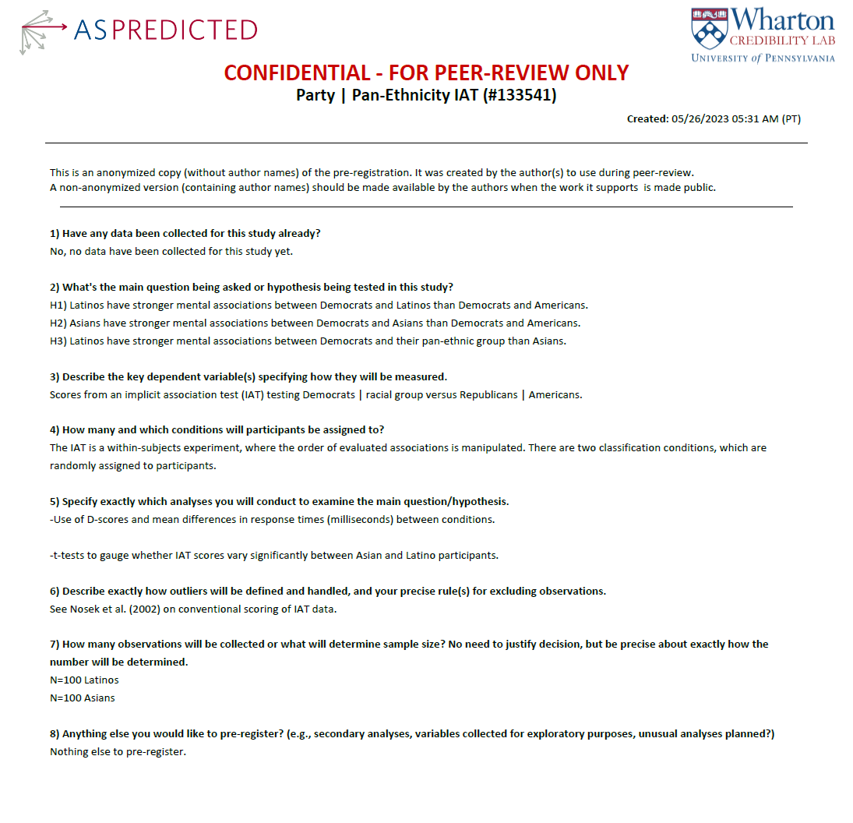

In implicit association tests (IATs), individuals sort stimuli that are randomly presented on a computer screen. These stimuli are sorted using two classification pairs depicted below. The stimuli for each category in a classification pair are included after.

*Classification pair #1*

Latinos Americans

Democrats Republicans



**Asian stimuli**

**Latino stimuli**

**American stimuli**

**Democrat stimuli**

**Republican stimuli**

*Classification pair #2*

Americans Latinos

Democrats Republicans



*Stimuli for categories in classification pairs*

Latinos

   

Asians

  

Americans

   

Democrats

  

Republicans

  

**SI.8. Pre-Registration for Experiment with Latino Adults (Study 3)**

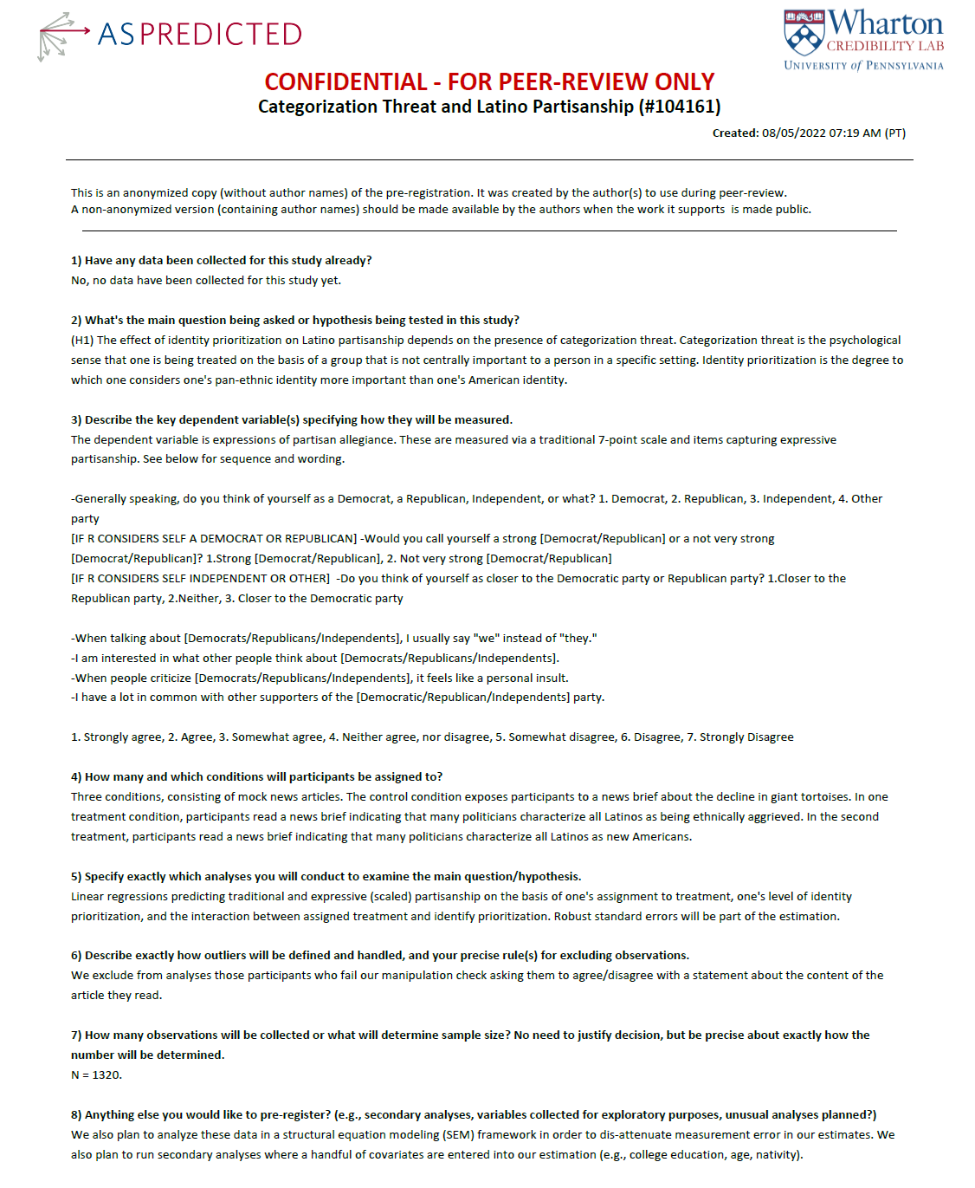

**SI.9 Pre-Registration for Experiment with Asian Adults (Study 4)**

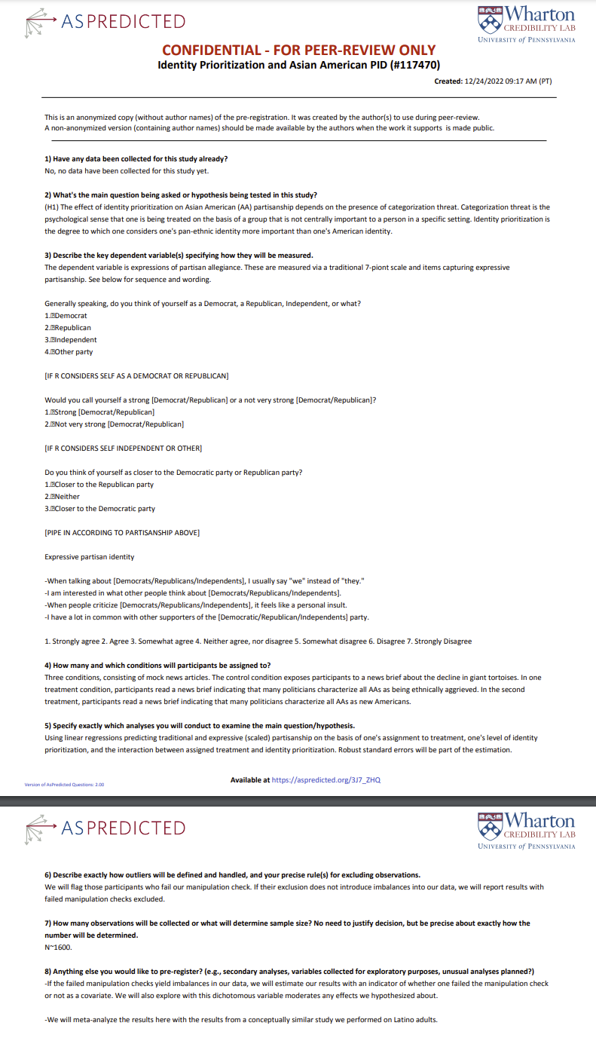

**SI.10. IRB Certifications for Experimental Data**

The IRB certification numbers for all our original experimental data are:

-IRB#22-000765

-IRB#23-000557