**Civic Organizations and the Political Participation of Cross-Pressured Americans: The Case of the Labor Movement**

Appendices for Online Publication

Table of Contents

Appendix 1: Details on the ISEA Member and Leader Surveys and 2023 NEA Survey 2

Appendix 2: Local Union Level Predictors of Orientations and Newsletters 6

Appendix 3: Summary Statistics for 2018-19 Matched Leader-Member-Local Analysis 7

Appendix 4: Summary Statistics for 2023 NEA Survey Analysis 8

Appendix 5: Example PAC Check-Off 9

Appendix 6: Excerpts from Local ISEA Newsletter 10

Appendix 7: Interview Details and Transcripts 13

# Appendix 1: Details on the ISEA Member and Leader Surveys and 2023 NEA Survey

*Member survey:* In May 2018, all ISEA members with valid email addresses (*N=*26,134) received an invitation to participate in a confidential online survey, distributed by ISEA’s communications team. In addition to the initial email invitation, ISEA sent three additional follow-up reminder emails and one text message reminder to union members with cell phone numbers on file with the union. On the advice of the ISEA, I used the promise of lotteried Amazon.com gift certificates to incentivize ISEA members to take the survey. In all, 1,904 ISEA union members responded to the survey, for a response rate of 7.3%. I left the survey open for responses for a month. Because we made clear that individual responses were voluntary and confidential—importantly from the ISEA itself—I did not consider the survey to raise any ethical issues.

In the figure below, I show balance of survey respondents compared to Bureau of Labor Statistics Current Population Survey (CPS) Monthly Outgoing Rotation Group (MORG) data on Iowa public school union members pooled from 2011 to 2017 and ISEA internal administrative records. As the figure indicates, survey respondents match the demographic profile of ISEA administrative record and CPS survey data very closely. Importantly, PAC participation rates were nearly equivalent for survey respondents and non-respondents.



*Leader survey*: In January 2019, all current ISEA local presidents with valid home emails (*N=*436) received an invitation from the researchers to participate in a confidential online survey. I sent out two follow-up reminder emails over the next three weeks to presidents who had not yet taken the survey. In all, 154 presidents completed some or all of the survey, for a response rate of 35% encompassing 147 locals. Unlike with the member survey, I did not use financial incentives to encourage greater participation on the advice of the ISEA leadership. I left the survey open for responses over a month. Again, because we made clear that individual responses were voluntary and confidential—including from the ISEA itself—I did not consider the survey to raise any ethical issues.

In the figure below, I compare local union presidents from responding and non-responding locals on three important measures: local membership rates (from 2018), participation in the ISEA PAC (from 2018), and share of bargaining unit members voting for recertification in the last recertification election (either 2017 or 2018). Compared to presidents from non-responding locals, responding locals tended to have higher membership rates, greater participation in the ISEA PAC, and higher recertification vote shares. The difference in ISEA PAC participation was the largest at around 11 percentage points, indicating that responding locals tended to be more politically engaged than non-responding locals.



In the second figure below, I compare the geographic distribution of responses to the survey among locals that were matched to specific geographic areas within counties and excluding area education associations and community colleges (which do not correspond to individual geographic locations within counties). Responding locals were generally spread out across the four U.S. House districts in the state quite similarly as non-responding locals.



One concern is that the presidents’ survey was fielded several months after the member survey, and that presidents might inflate their reporting of local union culture measures depending on survey participation in the member survey. In particular, presidents might respond to their survey strategically, inflating reports of local union culture in response to lower (or higher) survey response rates. Participation rates in the member survey were not available to local presidents, helping to assuage the concern that presidents may have responded strategically to participation rates and inflated reporting of activities that correspond to local union culture. Nevertheless, I can empirically check this concern by exploring the correlation between presidents’ reports of local union culture and member response rates on the first survey. There are no statistically significant correlations between member survey response rates and presidents’ reporting of new member orientations (*p*=0.33) and regular newsletters (*p* =0.19); I did find that local presidents reported lower levels of political activity in locals with lower levels of survey responses among members (*p* =0.04) but the substantive size of the correlation was not large (correlation coefficient: -0.18).

*2023 NEA Survey:* In February 2023, the National Education Association (NEA) fielded a survey of educators and educational support staff who were and were not members of the ISEA, on behalf of the ISEA. The NEA used statewide lists of educators and educational support staff eligible to be ISEA members to contact the 45,961 staff for whom email information was available, including a random sample of 1,199 staff who participated in a soft launch of the survey. Staff received three reminders. No incentives were offered for participation in the survey, which was identified as coming from the NEA on behalf of the ISEA. Balance for the 2023 NEA survey was very close to the targets provided by the ISEA though the NEA developed survey weights to match ISEA targets on gender, age, and partisanship. The targets, weighted distributions, and unweighted distributions appear below.

|  |  |  |  |
| --- | --- | --- | --- |
|  | **Target** | **Unweighted** | **Weighted** |
| **Gender** |  |  |  |
| Male | 26.2 | 23.36 | 26.2 |
| Female | 73.8 | 75.87 | 73.8 |
| Other | 0 | 0.76 | 0 |
| **Age** |  |  |  |
| 18-24 | 0.96 | 0.66 | 0.96 |
| 25-34 | 15.03 | 13.01 | 15.03 |
| 35-44 | 25.00 | 26.55 | 25.00 |
| 45-54 | 32.08 | 33.71 | 32.08 |
| 55-64 | 21.93 | 22.78 | 21.93 |
| 65+ | 5.00 | 3.29 | 5.00 |
| **Partisanship** |  |  |  |
| Democrat | 36.04 | 38.91 | 36.04 |
| Independent | 33.89 | 32.54 | 33.89 |
| Republican | 23.14 | 21.08 | 23.14 |
| Other | 6.93 | 7.48 | 6.93 |

# Appendix 2: Local Union Level Predictors of Orientations and Newsletters

Which locals were most likely to hold regular orientations for new members? There were a variety of leader, local, and contextual variables that were strongly associated with local unions holding orientations. On the leader level, locals with leaders who had previous leadership experience, had reported a greater variety of leadership experiences, and who were more engaged in politics were more likely to oversee locals with new member orientations. But new member orientations were not more likely in locals with more competitive leadership elections or with more politically liberal leaders. On the local union level, larger locals and locals with higher membership rates tended to be more likely to have new member orientations. Importantly, orientations were *not* more likely in locals with more conservative members. 51% of conservative members were in a local that reported holding regular orientations, compared to 53% of liberal members.

Regular newsletters were much less common across locals, with only 17% of local leaders reporting that they had regular communication with their members in this way. Unlike with new member orientations, there were not large differences in the kinds of locals that arranged newsletters and those that did not. There was, however, a strong relationship between newsletters and new member orientations: those locals that organized new member orientations were also substantially more likely to run regular newsletters. Of locals that had regular newsletters, nearly 60% were also conducting regular new member orientations. Regular newsletters were not more common in locals with more liberal members, and if anything, were slightly more common for conservatives: 27% of conservatives reported were in a local that reported regular newsletters, compared to 19% of liberals.

Interviews with local union leaders and statewide union staff suggest that local union leaders who had attended leadership trainings or statewide or national ISEA or NEA events tended to be more likely to adopt these practices associated with stronger union culture. Future research should examine how local leaders themselves learn about and consider these different strategies to adopt.

# Appendix 3: Summary Statistics for 2018-19 Matched Leader-Member-Local Analysis

The following table provides summary statistics for the 2018-19 matched leader-member-local analysis using PAC contributions and perceptions of ISEA’s representation of members in politics as outcomes (Table 1 and Figure 1).

|  |  |  |  |  |  |  |
| --- | --- | --- | --- | --- | --- | --- |
| **Variable** | **Source** | **Max N** | **Mean** | **SD** | **Min** | **Max** |
| ’18 ISEA PAC Contribution | ISEA Records | 1,886 | 0.78 | 0.41 | 0 | 1 |
| Liberal | Member Survey | 1,682 | 0.57 | 0.50 | 0 | 1 |
| Moderate | Member Survey | 1,682 | 0.18 | 0.38 | 0 | 1 |
| Conservative | Member Survey | 1,682 | 0.25 | 0.43 | 0 | 1 |
| Female | Member Survey | 1,714 | 0.80 | 0.40 | 0 | 1 |
| White | Member Survey | 1,682 | 0.96 | 0.20 | 0 | 1 |
| Age (Quartiles) | Member Survey | 1,650 | 2.44 | 1.10 | 1 | 4 |
| Membership (Quartiles) | Member Survey | 1,633 | 2.44 | 1.13 | 1 | 4 |
| Job Satisfaction | Member Survey | 1,661 | 3.88 | 0.92 | 1 | 5 |
| Occupation - Teacher | Member Survey | 1,622 | 0.74 | 0.44 | 0 | 1 |
| Occupation - ESP | Member Survey | 1,622 | 0.18 | 0.39 | 0 | 1 |
| Occupation - Postsecondary | Member Survey | 1,622 | 0.02 | 0.16 | 0 | 1 |
| President Participation | President Survey | 891 | 4.05 | 1.99 | 0 | 6 |
| New Member Orientation | President Survey | 891 | 0.51 | 0.50 | 0 | 1 |
| Regular Newsletter | President Survey | 889 | 0.21 | 0.41 | 0 | 1 |
| Local Recruits - Prof. Dev. | President Survey | 919 | 0.57 | 0.49 | 0 | 1 |
| Local Recruits - Prof. Com. | President Survey | 919 | 0.67 | 0.47 | 0 | 1 |
| Local Recruits - Legal | President Survey | 919 | 0.68 | 0.45 | 0 | 1 |
| Local Recruits - Voice | President Survey | 919 | 0.76 | 0.42 | 0 | 1 |
| Local Recruits - Politics | President Survey | 919 | 0.19 | 0.37 | 0 | 1 |
| Local Recruits - Finances | President Survey | 919 | 0.58 | 0.49 | 0 | 1 |
| Local Recruits - Solidarity | President Survey | 919 | 0.45 | 0.49 | 0 | 1 |
| Relationship with Admin. | President Survey | 874 | 4.11 | 0.75 | 0 | 5 |
| Local Leader Ideology | President Survey | 854 | 2.69 | 1.41 | 1 | 7 |
| Average Member Ideology | Member Survey | 1,685 | 3.31 | 0.65 | 1.5 | 6.5 |
| Bargaining Unit Size | ISEA Records | 1,743 | 564 | 868 | 8 | 3559 |
| Local Membership (%) | ISEA Records | 1,743 | 59.81 | 16.26 | 6.4 | 97.3 |
| 2018 County Dem Share (%) | U.S. Election Atlas | 860 | 51.90 | 9.27 | 26 | 72 |
| Perception of ISEA Representation in Politics – Education Spending | Member Survey | 1,622 | 4.11 | 0.94 | 1 | 5 |
| Perception of ISEA Representation in Politics – Other Policies | Member Survey | 1,602 | 3.55 | 1.03 | 1 | 5 |

# Appendix 4: Summary Statistics for 2023 NEA Survey Analysis

The following table provides weighted summary statistics for the 2023 NEA survey analysis reported in Figure 2.

|  |  |  |  |  |  |
| --- | --- | --- | --- | --- | --- |
| **Variable** | **Max N** | **Mean** | **SD** | **Min** | **Max** |
| Willingness to Take Anti-Voucher Action (1-4) | 1,300 | 2.94 | 0.64 | 1 | 4 |
| How Well Does ISEA Represent in Legislature (1-4) | 1,303 | 2.83 | 1.00 | 1 | 4 |
| General ISEA Performance (1-4) | 1,329 | 2.93 | 0.81 | 1 | 4 |
| How Much Should ISEA Prioritize Politics (1-4) | 1,426 | 2.98 | 0.92 | 1 | 4 |
| Importance of Politics to Your Membership (1-4) | 1,389 | 3.02 | 1.00 | 1 | 4 |
| Talked with Union about Your Preferences? | 1,426 | 0.74 | 0.44 | 0 | 1 |
| *Age* |  |  |  |  |  |
| 18-24 | 1,426 | 0.02 | 0.13 | 0 | 1 |
| 25-34 | 1,426 | 0.15 | 0.36 | 0 | 1 |
| 35-44 | 1,426 | 0.25 | 0.43 | 0 | 1 |
| 45-54 | 1,426 | 0.32 | 0.47 | 0 | 1 |
| 55-64 | 1,426 | 0.22 | 0.41 | 0 | 1 |
| 65+ | 1,426 | 0.04 | 0.20 | 0 | 1 |
| *Gender* |  |  |  |  |  |
| Male | 1,426 | 0.22 | 0.41 | 0 | 1 |
| Female | 1,426 | 0.78 | 0.41 | 0 | 1 |
| Other | 1,426 | 0.00 | 0.00 | 0 | 0 |
| *Occupation* |  |  |  |  |  |
| K-12 teacher | 1,426 | 0.82 | 0.38 | 0 | 1 |
| Other certified professional | 1,426 | 0.08 | 0.28 | 0 | 1 |
| College or university professor, lecturer, faculty, or adjunct | 1,426 | 0.02 | 0.13 | 0 | 1 |
| K-12 support staff | 1,426 | 0.04 | 0.19 | 0 | 1 |
| Higher education support | 1,426 | 0.00 | 0.04 | 0 | 1 |
| Other | 1,426 | 0.04 | 0.20 | 0 | 1 |
| *Tenure* |  |  |  |  |  |
| 0-5 | 1,426 | 0.08 | 0.27 | 0 | 1 |
| 6-10 | 1,426 | 0.16 | 0.37 | 0 | 1 |
| 11-20 | 1,426 | 0.29 | 0.46 | 0 | 1 |
| 20+ | 1,426 | 0.47 | 0.50 | 0 | 1 |
| *Political ideology* |  |  |  |  |  |
| Liberal | 1,322 | 0.43 | 0.49 | 0 | 1 |
| Moderate | 1,322 | 0.37 | 0.48 | 0 | 1 |
| Conservative | 1,322 | 0.21 | 0.40 | 0 | 1 |

# Appendix 5: Example PAC Check-Off

Below, I include a copy of PAC check-off form given to ISEA members for each payroll they receive each month:



# Appendix 6: Excerpts from Local ISEA Newsletter





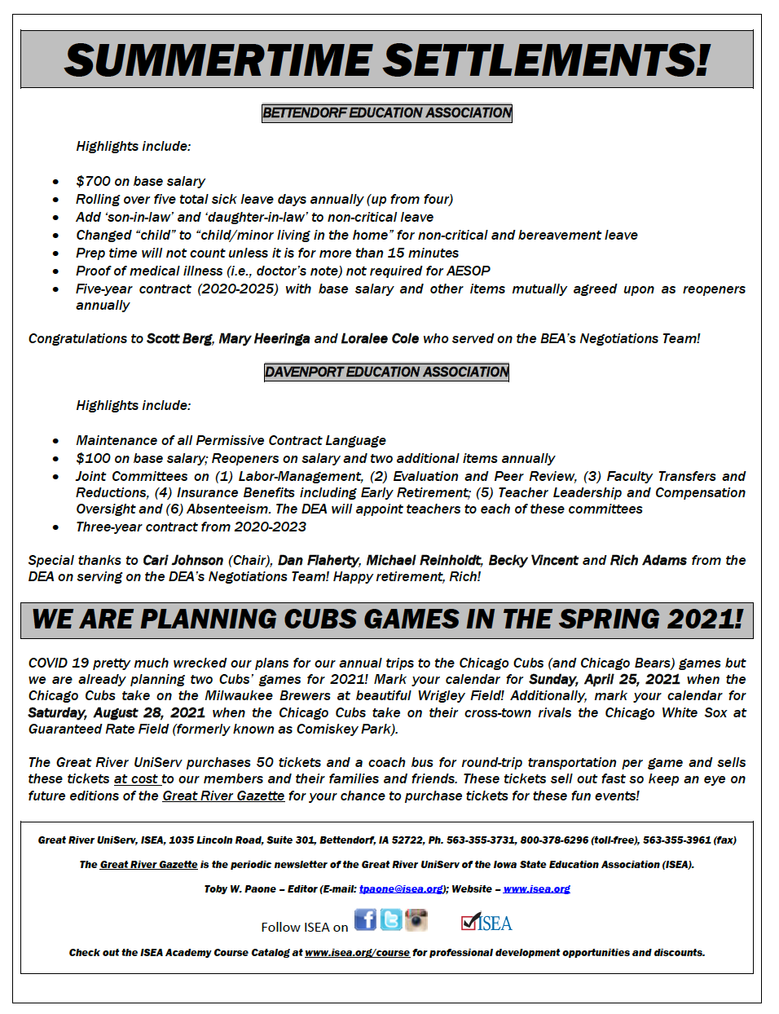

# Appendix 7: Interview Details and Transcripts

I originally selected 23 locals to contact for interviews, matched to be similar on several important characteristics including membership, size, and the relationship reported by local leaders to their school district but with half having low levels of union participatory practices and half having high levels. The statewide association then contacted a random subset of seven pairs of these locals to encourage their leaders to participate in the interviews, with half coming from the low participatory culture group and half from the high participatory culture group. Of those seven pairs, local presidents from four pairs completed phone interviews, which ranged from 30 minutes to 75 minutes, and typically an hour. Because I promised confidentiality to the local presidents as a condition of IRB approval, I do not provide other individually identifiable characteristics. The replication material for this paper includes excerpts from these interviews discussed in the main text.